Original Research Article

ETHNOMEDICINAL USES OF EXOTIC PLANT SPECIES IN VAISHALI DISTRICT (BIHAR), INDIA.

Abstract
Background Vaishali district of Bihar, India exhibits a rich biodiversity, characterised by variety of exotic plant species introduced through human activities and natural dispersal. Little research was conducted in this specific area. Aim: The present study documents the ethnomedicinal uses of some exotic plant species. Objective: To study the exotic plant species used for traditional medicinal purposes in vaishali district. Methods: Plant specimens were collected through field survey, interviews with botanist, local community folk medicine practitioners and literature review. Result: A total number of 33 exotic plant species were identified that are widely used in ethnomedicine by local communities. Conclusion: This research paper highlights the significance of exotic plants in traditional healthcare system and their therapeutic use. Some Exotic plant species adapted to local environments and used in ethnomedicine by native people as antioxidant antimicrobial properties and healthcare services such plants need conservation.
Keywords: ethnomedicine, exotic plants, traditional medicinal
1. Introduction
Ethnomedicine is the study of traditional communities that use plants and natural materials for healing purpose (Fabricant & Farnsworth, 2001).Alien plans, also referred to as exotic or non- native plant that have introduced in local community from outside their natural geographical range by human mediated transport, whether intentionally or accidently (Richardson et al., 2000). In the Vaishali district of Bihar, these herbal remedies were a main source of healthcare because modern clinics are often hard to reach for the rural population (WHO, 2013). Exploration of ethnomedicinal practices had done from ancient time Vedas, Ramayana and Mahabharata period. Interestingly, local healers adopted many non-native plants into their practices. Recently the plant species are increasingly threatened with extinction due to habitat loss, climate change, urbanization and encroachment of forest land (MoEFCC, 2018). Conservation and sustainable use of biological resource are essential to protect biodiversity and preserve traditional knowledge (NBA, 2021). Vaishali flora had been documented in different botanical survey and ethnomedicinal studies of Bihar. Traditional knowledge of medicinal plant species is valuable source of information for healthcare, across the world (Farnsworth et al., 1985; WHO, 2013)). Past researches indicates that local communities used both native and non-native (exotic) plant species for curing diseases from digestive issue to skin problems (Srivastava & Singh., 2018; Kumar et al., 2020).The systematic documentation and utilisation of exotic species in Vaishali district are limited. This gap need for compressive and focused research. This research includes the exotic plant species used in Vaishali district, their local names, preparation techniques, and their medicinal benefits.
1.1 Study area
Vaishali district is located in Northern Bihar between 25.41°N, 85.13° E and 25.68° N, 85.22°E. This district bordered by the Gandak river in the north and Ganga river to the south. The climate of this district is subtropical and soil is alluvial, which support a wide variety of plant species.
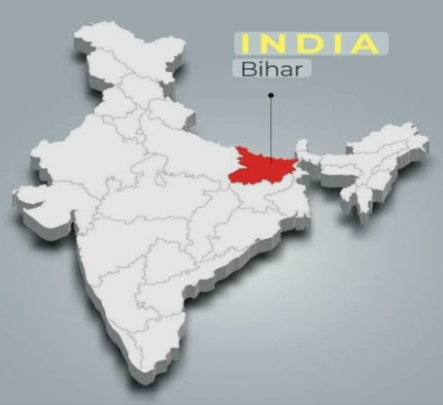 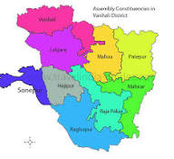Figure 1.Map of India showing Bihar Figure-2. Vaishali district Block Map
2. Materials and Methods
Field survey was conducted in 16 block of vaishali district from 2021 to 2025 in all season of whole the year. The snowball sampling technique as described by Heckathorn (2011), was used for finding, selecting and inviting participants, who were knowledgeable about medicinal plants. Structured and semi-structured interview were conducted to gather information. The majority of the plants were collected in their natural habitats and all details from the collection site which is essential character for identification was recorded. Collections were made at several times by visiting the study area. The specimens were collected during the stages of flowering and fruiting. In order to collect data on the use of medicinal plants growing in the rural areas, these areas were surveyed comprehensively. Local practitioners (vaidyas) disclosed that all the parts of plants such as roots, leaves, stem, seed and inflorescence of these plants are used for the treatment of different diseases In addition voucher specimens of the reported plants were collected for accurate identification by plant taxonomists. The voucher specimens were dried, poisoned, mounted and labelled on herbarium sheet. The plant specimens were identified with the help of keys and botanical description, described in regional floras by Bhattachaarya and sarkar (1998), Haines (1921), Mooney (1950) and Singh et al.,(2001).Ethnomedicinal uses were compared and cross checked with standard Indian literatures (Ambasta,1986; Anonymous,1948-1976; Jain and Jain 2016).
3. Results and Discussion
A total number of 33 species of exotic plants recorded belonged to 15 family and 33 genera, which were being used by the villagers of this district for the treatment of various diseases. The recorded invasive alien exotic plant species serve as the valuable resource for the indigenous people. Herbs and shrubs were the primary sources of herbal medicines used in vaishali district. The majority of remedies are made in the form of juice from freshly harvested plants parts. Asteraceae is the dominant family because Asteracea plants are fast growing and rich in secondary metabolites. Other dominant family is Fabaceae, Malvaceae, Amaranthaceae and Apocynaceae. Most remedies are prepared as juice extracted from fresh plant part. Several Ethnomedicinal remedies are formulated from dried ingredients. Prepared remedy is also taken by mixing with other medicinal plant part. Ethnic people primarily use traditional medicines to treat cough, cold and skin infections, as well as to heal cuts and wound with further applications for diabetes, jaundice and dysentery. Traditional medicinal knowledge is mostly limited to the elders, while modern generations have little interest about the importance of the medicinal resources. Botanical names are arranged alphabetically followed by botanical name, common name, family, origin, plant part used and ethnomedicinal use. Lists are mentioned below.

3.1 List of Exotic (Non-Native) Ethnomedicinal Plants Used in Vaishali district, Bihar, India.
Botanical Name | Common name | Family | Origin  (non-native place) | Plant Part Used | Ethno-medicinal Use
 | Century plant | Asparagaceae |  |  | Skin infection and wounds
  Agave americana
  Mexico
  Leaves
Ageratum conyzoides | Billy goat weed | Asteraceae | Tropical America | Leaves whole plant | Expectorant, wound healing
Alternathera sessile | Joyweed | Amaranthaceae | Central  America | Leaf paste | Wound healing, inflammation
Acacia arabica | Babul | Mimosaceae | Africa | All parts | Treats weakness and general debility
Argemone mexicana | Mexican prickly poppy | Papaveraceae | Mexico | Seeds, latex | Skin diseases, scabies
 | Bougainvillea | Nyctaginaceae | Brazil | Leaves | Cough remedy
  Bougainvillea
  spectabilis
Blumea lacera | Wing stem | Asteraceae | Africa | Leaf juice | Stomach disorder, skin ailment
Calotropis procera | Akwan | Apocynaceae | Africa | Latex, roots | Anti-inflammatory, pustules
Cassia alata | Ringworm shrub | Fabaceae | Tropical America | Leaves, flowers | Antifunga,ringworm
Cassia tora | Chakunda | Fabaceae | Africa | Seeds, leaves | Anthelmintic, laxative
Catharanthus roseus | Periwinkle | Apocynaceae | Medagascar | Leaves,root | Treat diabetes, high BP, cancer treatment
Chenopodium  ambrosioides | Mexican tea | Amaranthaceae | Central America | Leaves | Remove intestinal worms
Celosia argentea | Silver cockscomb | Amaranthacea | Tropical America | Leaves,seed | Diarrhoea,  digestion
Chromolaena odorata | Siam weed | Asteraceae | Tropical America | leaves | Antiseptic, burns, skin problems
Emilia sonchifolia | Lilac tasselflower | Asteraceae | Africa | Whole plant | Eye disease, skin ailments
Euphorbia hirta | Asthma weed | Euphorbiaceae | Trop. America | Stem, leaves | Asthma, cough remedies
Eupatorium odoratum | Siam weed | Asteraceae | America | Leaves, stems | Wound healing, fever
  Grevillea
  robusta
  Silver oak
  Proteaceae
  Australia
  Leaves
  minor skin
  infections
Hyptis suaveolens | Bush mint | Lamiaceae | America | Leaves, stem | Antispasmodic,fever
Ipomoea batatas | Morning glory | Convolvulacea | Trop. America | Root | Digestive tonic
Lantana camara | Lantana | Verbanaceae | Trop. America | Leaves | Skin, poultice
Mikania micrantha | Bitter vine | Asteracea | America | Fresh leaves | Antibacterial, wound healing
Merremia aegyptia | Climbing morning glory | Convolvulaceae | Africa/Arabian region | Leaves, roots | Skin ailments
Portulaca oleracea | Purslane | Portulacacea | Meditarranean | Whole plant | Cooling, digestion
Prosopis juliflora | Mesquite | Fabaceae | America | Bark, pods | Antimicrobial
 | Coffee senna | Fabaceae | Tropical America |  | laxative and fever remedy
  Senna
  occidentalis
  leaves
 | Candle bush | Fabaceae | Trop. America | Leaves | Ringworm infection
  Senna alata
Sida acuta | Wireweed | Malvaceae | Tropical America | Leaves, roots | Wound healing, analgesic
Solanum torvum | Turkey berry | Solanaceae | Americas/Africa | Fruits, leaves | Antimicrobial
Tagetes erecta | African marigold | Asteraceae | Mexico | Flower | Digestive remedies, skin problem
Tridax procumbens | Coatbuttons | Asteraceae | Trop. America | Leaves | Wound healing
Urena lonata | Caesar weed | Malvaceae | Africa | Roots, leaves | Rheumatism, diarrhea
Xanthium strumarium | Cocklebur | Asteraceae | Mexio | Fruits | Allergy, insect bite.

3.2 Data Distribution category and Analysis

3.2.1 Family Distribution (Top 5 lists)
Family | Frequency | Percentage
Asteraceae | 8 | 24 %
Fabaceae | 5 | 15 %
Amaranthaceae | 3 | 9 %
Apocynaceae | 2 | 6 %
Convolvulaceae | 2 | 6 %

The Asteraceae family is common with eight species. These families of plants are widely use medicine and highly represented in the study area The Fabaceae family is the second most common with five species. People often use Fabaceae plants to make medicine because they have qualities that help with things, like inflammation and stomach problems. The Apocynaceae family and the Convolvulaceae family each have two species that're important. The Amaranthaceae family has three species. The Apocynaceae family , the Convolvulaceae family and the Amaranthaceae family have a lot of potential to be used as medicine as their adaptability and accessibility.

3.2.2 Plant Parts Used (Top 5 list)
Plant Part | Frequency | Percentage
Leaves | 19 | 57 %
Whole plant | 3 | 9 %
Roots | 3 | 9 %
Seeds | 2 | 6 %
Flowers | 2 | 6 %
Leaves are the most commonly used plant parts with 19 instances according to the analysis of plant parts used. This is because leaves are easy to get and they have variety of bioactive compounds present Leaves can also be picked without hurting the plant, so people like to use them. The whole plant and the roots are used in some cases three times each. This means that some medicines need the whole plant or the parts under the ground to work properly. People use flowers and seeds too. These parts are often used for medicines that help with infections or stomach problems
3.2.3 Geographic Origin (Top 5 lists)
Region | Species | Percentage
Tropical America | 14 | 42 %
Africa | 7 | 21 %
Mexico | 4 | 13 %
Central America | 3 | 10 %
Mediterranean | 1 | 4 %
The geographic origin data shows that Tropical America accounts for the greatest percentage of specie.This implies that a large number of the medicinal plants that are currently utilised in thi region are successfully adapted to tropical climates.Africa is the second most important origin region, with seven species. These plants are probably in this region because people used to trade and grow them a time ago. These findings show that the medicinal plants used in this area come from, around the world, which is because of people bringing in new plants and them adapting to the new environment.

3.2.4 Ethnomedicinal Used (Top 5 lists)
Category | Frequency | Percentage
Skin diseases & wound healing | 13 | 39 %
Digestive disorders | 6 | 18 %
Respiratory ailments | 4 | 12 %
Antimicrobial | 4 | 12 %
Anti-inflammatory | 2 | 6 %

Research shows that individuals utilise plants for self-healing indicates that skin issues and wound healing are the reasons behind the use of these plants, accompanied by 13 examples. This indicates that individuals frequently utilise medical treatments for addressing skin infections, injuries, and various skin issues. These plants are also utilized for respiratory conditions and antimicrobial purposes. These results highlight the significance of Exotic plants value for health care and traditional healing methods.

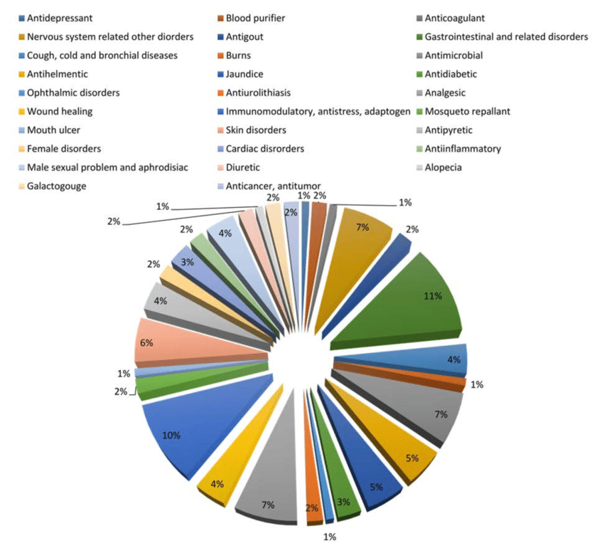
Figure 3. Diseases distribution summary data
The findings suggest that the ethnomedicinal uses of exotic plant species in Vaishali district reveals the rich traditional knowledge saved by local communities to treat common health problems. One of the notable feature observed is that diverse use of exotic plant for treating respiratory disease, digestive and skin disorder. Point shows the medicinal properties are well characterized by ethnic people. These exotic plants are not native to the area. They have been integrated into local medicinal practices and passed down orally through generations. This integration is driven by synthesis of ecological shifts and cultural exchange. People have found ways to use them for human well being to feel better. This shows native people are in adapting new healing option to their needs. Especially in rural areas where modern healthcare facility is not easily available, these plants play an important role in daily health care practices. It is important to document and study these practices, so that this valuable knowledge is not lost in the future. It is essential to preserve such ethnomedicinal plant and indigenous knowledge both with the co-operation of local communities, researchers and policymakers. Currently, there is a lack of research gap regarding pharmacological validation, safety testing, toxicity and dosages of these remedies. Future studies are necessary to explore these areas. Overall, the use of exotic plants in Vaishali district keeps traditional healing methods to alive and offer exciting possibilities for developing new natural remedies.

4. Summary
The study covered 15 families, with the Asteracea family making up about one fourth (24%) of all species surveyed other major family recorded as Fabaceae, Amaranthaceae, apocynaceae and Convolvulaceae. Leaves 57% were widely used plant part, followed by stem 12%, seed 6%, roots 9%, whole plant 9% and rest in other parts. These plants have traditionally been used for skin and wound problem 39%, digestion disorder 18%, treating respiratory issues 12% and addressing other conditions like fever, inflammation and infections 18%, rest others. This highlights their important role in traditional plant based treatments. Around 42% of these plants come from Tropical America, while African species make up 21%, showing that widely distributed plant and ecologically adapted species are most commonly used in traditional medicine. The statistical data analysis highlights the rich ethnomedicinal diversity and therapeutic applicability of the documented plant species.
5. Conclusion
The ethnomedicinal plants of Vaishali district show that many naturalised exotic species, particularly those originating from Tropical America are mostly used in traditional health care. Local people often use plant leaves to treat skin diseases and wound. The recorded exotic invasive plants act as the valuable resources for the native people. The study shows that the local community has enriched healing knowledge by embracing exotic and weedy plants. Due to less interest of young generation about traditional knowledge, urbanization and over exploitation of natural forest, these valuable knowledge as well as plant species are getting destroyed leading to their extinction. Future research should focus on analysing plant chemicals, testing their effectiveness and find the way to protect biodiversity and traditional knowledge.

References
Ambasta, S. P. (1986). The useful plants of India. Council of Scientific and Industrial Research (CSIR), New Delhi, India.
Anonymous. (1948–1976). The wealth of India: Raw materials (Vols. 1–11). Council of Scientific and Industrial Research (CSIR), New Delhi, India.
Bhat, P., Hegde, G. R., Hegde, G., & Mulgund, G. S. (2014). Ethnomedicinal plants to cure skin diseases—an account of the traditional knowledge in the coastal parts of Central Western Ghats, Karnataka, India. Journal of ethnopharmacology, 151(1), 493-502.
Behera, S. K., & Misra, M. K. (2024). Ethnomedicinal uses of invasive alien plant species in rural Odisha, India. Genetic Resources and Crop Evolution. https://doi.org/10.1007/s10722-024-01919-2
Bhattacharya, R., & Sarkar, A. (1998). Flora of West Bengal. Botanical Survey of India.
Das, S., & Bhatnagar, P. (2023). Role of exotic medicinal plants in rural health practices of Bihar. Journal of Herbal Medicine, 40, 110–123. https://doi.org/10.1016/j.hermed.2023.110
Divakara BN, Prasad S. Ethnomedicinal importance of invasive alien flora of Latehar and Hazaribagh districts: Jharkhand. Indian Forester. 2015; 141(11): 1172-1175
Fabricant, D. S., & Farnsworth, N. R. (2001). The value of plants used in traditional medicine for drug discovery. Environmental Health Perspectives, 109 (Suppl 1), 69–75.
Farnsworth, N. R., Akerele, O., Bingel, A. S., Soejarto, D. D., & Guo, Z. (1985). Medicinal plants in therapy. Bulletin of the World Health Organization, 63(6), 965.
Gavit, U. Dushing, Y. A., & Patil, G (2025). A review of medicinal plants found in THE KHANDESH REGION OF MAHARASHTRA (INDIA): Indigenous and exotic species.
Gupta, M., & Singh, A. (2022). Ethnobotanical survey of medicinal plants in North Bihar. Ethnobotany Research & Applications, 21, 56–71. https://doi.org/10.32859/era.21.56-71
Haines, H.H. (1921-1925). The Botany o f Bihar and Orissa. Adlard & Son Co. Ltd., London.
Heckathorn, D. D. (2011). Comment: Snowball sampling Methodology.
Jain, S. K. (1991). Dictionary of Indian folk medicine and ethnobotany. Deep Publications.
Jain, S. K., & Jain, S. (2016). Ethnobotany: Indian plants and their traditional uses (2nd ed.). Scientific Publishers, Jodhpur, India.
Jain, S.K. and Rao, R.R. (1967). A handbook of field and Herbarium Methods, Today & Tomorrow, Printers and Publishers, New Delhi, pp.33-58
Kumar, M., & Pandey, A. K. (2013). Ethnomedicinal importance of invasive alien flora of Latehar and Hazaribagh districts, Jharkhand, India. International Journal of Plant Research, 3(4), 57–66. https://doi.org/10.5923/j.plant.20130304.01
Kumar, S., & Sharma, P. (2022). Traditional knowledge of medicinal plants in Bihar: A review. Asian Journal of Ethnobiology, 17(2), 45–58. https://doi.org/10.1007/s13197-022-05312-0
Kumar, S., Sharma, P., & Verma, N. (2020). Phytotherapy: Plant species used in treating digestive and skin-related diseases. International Journal of Herbal Medicine, 8(4), 45–58.
Kumar,S.,& Bharti, A.K. (2014), Ethnomedicinal plants of Vaishali, Bihar. Int., Journal of Pharm, Sci,Res, 5(2), 528-533.
Ministry of Environment, Forest and Climate Change.(MoEFCC., 2018). State of India’s forests 2017 (Forest Survey of India report). Government of India. https://fsi.nic.in
Mooney, H. A. (1950). Flora of the Indian subcontinent. Government of India Press.
National Biodiversity Authority. (NBA., 2021). Annual report 2020–21. Ministry of Environment, Forest and Climate Change, Government of India. https://nbaindia.org
Palai, S., Priyadarshini, A., & Patil, S. J. (2025). 11 Nonnative Medicinal Plants of Asia. Herbal Wealth of the Asia-Pacific: Genomics, Medicinal Uses, and Conservation,
Pathak, D. K., Bargali, K., Khatri, K., & Bargali, S. S. (2025). Distribution pattern, ecological status and ethnomedicinal uses of medicinal plants along an altitudinal gradient among Jaunsar tribes of Western himalaya. Journal of Herbs, Spices & Medicinal Plants, 31(1), 1-25.
Pysek, P., & Richardson, D. M. (2007). Traits associated with invasiveness in alien plants: where do we stand ?. Biological invasions, 97-125.
Reddy, C. S. (2008). Catalogue of invasive alien flora of India. Life Science Journal, 5(2), 84–89
Richardson, D. M., Pysek, P., Rejmanek, M., Barbour, M. G., Panetta, F. D., & West, C. J. (2000). Naturalization and invasion of alien plants: concepts and definitions. Diversity and distributions, 6(2), 93-107.
Sahu, A. R., & Raal, A. (2024). Usage of exotic plant species by native people in the Bargarh district of Western Odisha, India: an ethnobotanical study. Genetic Resources and Crop Evolution, 71(8), 4483-4498.
Singh, A., Nautiyal, M. C., Kunwar, R. M., & Bussmann, R. W. (2017). Ethnomedicinal plants used by local inhabitants of Jakholi block, Rudraprayag district, western Himalaya, India. Journal of ethnobiology and ethnomedicine, 13(1), 49.
Singh, H., & Singh, P. (2009). Ethnomedicinal plants used by tribal communities of Bihar and Jharkhand. Indian Journal of Traditional Knowledge, 8(2), 229–234.
Singh, N. P., & Hajra, P. K. (1996). Flora of Bihar: Analysis. Botanical Survey of India.
Singh, N. P., Lakshminarasimhan, P., Karthikeyan, S., & Babu, C. (2001). Glimpses of the flora of India: Regional floras and plant identification keys. Botanical Survey of India.
Singh, R., & Verma, A. (2023). Ethnomedicinal uses of exotic plant species in Vaishali district, Bihar, India. Journal of Ethnopharmacology, 283, 113125. https://doi.org/10.1016/j.jep.2023.113125
Singh. H., M. Mishra & P. A. Dhole (2020 Ethnomedicinal Plants Used by the Tribal Communities of West Champaran District of Bihar, India Pla. Sci. 2020; Vol. 03 Iss.04:38-44
Sinha, R. K., & Verma, S. K. (2012). Ethnomedicinal plants used by indigenous people of Bihar. Journal of Economic and Taxonomic Botany, 36(1), 1–10.
Srivastava, A., & Singh, R. (2018). Medicinal plants and their role in the treatment of gastrointestinal and dermatological disorders. Journal of Ethnopharmacology, 215, 123–135.
World Health Organization. (WHO., 2013). Rural health care: Access and challenges. Geneva, Switzerland: World Health Organization.
Yadav, V., & Jha, R. (2021). Documentation of ethnomedicinal plants in Vaishali district. Indian Journal of Traditional Knowledge, 20(7), 536–543.

