Original Research Article
Comparative Morphology of Three Orthopteran Species (Microcentrum rhombifolium, Mecopoda elongata, Schistocerca americana) from Kalahandi, Odisha

Abstract
Background
Comparative morphological studies of orthopterans reveal evolutionary adaptations to ecological niches, informing biodiversity assessments in diverse regions like Odisha, India. This study examines external morphology of Microcentrum rhombifolium (Pseudophyllinae), Mecopoda elongata (Tettigoniinae), and Schistocerca americana (Acridinae) from Kalahandi District.
Objective
To compare body form, wing structure, leg morphology, and diagnostic traits, linking variations to habitat preference, locomotion, feeding, and survival mechanisms for enhanced form function understanding.
Methods
Specimens were collected across Kalahandi (19.3–21.5°N, 82.20–83.47°E), identified via taxonomic keys, photographed post freezer paralysis, measured with vernier calipers (0.1 mm precision), and selectively preserved in 70% ethanol.
Results
M. elongata showed largest dimensions (body 75.55 mm; hind limb 100.65 mm; antennae 49.88 mm), suited for acoustic signaling and foraging. S. americana had compact form (body 58.86 mm; pronotum 11.74 mm; hind femur 28.15 mm; tibia 29.97 mm) for jumping and swarming. M. rhombifolium (body 62.99 mm) featured rhomboidal tegmina with reticulate venation for crypsis. Wing morphologies diverged: cryptic in M. rhombifolium, aerodynamic in S. americana, multifunctional in M. elongata. Hind legs converged between S. americana and M. rhombifolium (femur ~28 mm; tibia ~30 mm) despite familial differences.
Conclusion
Distinct wing and leg adaptations underscore Orthoptera's morphological plasticity and taxonomic utility, with convergence highlighting biomechanical demands for jumping.
Key words: Orthoptera; katydid; bush-cricket; American grasshopper; morphometric
- INTRODUCTION
Orthopteran insects play pivotal roles in terrestrial ecosystems, functioning as herbivores, predators, prey, and bioindicators across diverse habitats (Samways et al., 2025). Members of the order Orthoptera, particularly katydids (Tettigoniidae) and grasshoppers (Acrididae) (Gutjahr & de Souza Braga, 2018; Song, 2019), have long attracted scientific interest due to their ecological significance, behavioural diversity, acoustic communication, and taxonomic complexity. Comparative studies among orthopteran species occupying different ecological niches and biogeographic regions provide valuable insights into evolutionary adaptation, ecosystem services, and species-specific interactions with plants and predators (Bidau, 2014). The present study focuses on a comparative assessment of three ecologically and biologically distinct orthopterans: Microcentrum rhombifolium (greater angle-wing katydid), Mecopoda elongata (Malaysian bush-cricket), and Schistocerca americana (American grasshopper).
Microcentrum rhombifolium (Saussure, 1859), a member of the subfamily Phaneropterinae, is widely distributed across North America, Asia-Pacific, Europe, and Australia, and India. The Tettigoniidae are large Orthopterans coming under super order Ensifera, popularly called Locustidae and are also known as katydids. They inhabit shrubs and trees in forests, gardens, and urban green spaces. Katydids are distinguished from grasshoppers by the length of filamentous antenna, which exceed their own body length, while grasshoppers’ antennae are always relatively short and thickened. This species is notable for its exceptional leaf mimicry, characterized by green rhomboid wings with prominent angles that provide effective camouflage against predators. Ecologically, M. rhombifolium occupies a dual trophic role as both herbivore and facultative predator. They feed on plant material as well as small arthropods such as aphids, thrips, spider mites, and their eggs. It contributes to the natural regulation of pest populations. Its presence is often considered indicative of healthy arboreal habitats (Isely, 1944).
In contrast, Mecopoda elongata (Linnaeus, 1758) is a large tropical tettigoniid widely distributed across the tropical Asia, including India, China, Malaysia, and Indonesia, commonly known as bush-cricket. This species is best known for its complex acoustic signalling system (Hartbauer, 2008; Hummel et al., 2014; Bayley & Hedwig, 2024). Remarkably, multiple sympatric populations of M. elongata coexist (Wee et al., 2015). It has distinct song patterns, pheromonal cues, genital morphology, and cuticular lipid profiles, promoting reproductive isolation and maintaining genetic diversity. These traits have positioned M. elongata as a model organism for studies in bioacoustics, sexual selection, and speciation. Ecologically, the species contributes to arthropod food webs both as a predator of smaller insects and as prey for birds and parasitoids. Its sensitivity to environmental noise and habitat structure makes it a useful indicator of tropical ecosystem health, particularly in the context of habitat disturbance and climate change.
Schistocerca americana, commonly known as the American grasshopper, belongs to the family Acrididae and represents a contrasting ecological strategy compared to tettigoniids. Distributed mainly in the Mexico, Bahamas, the southeastern United States, and India. This species is a well-known agricultural pest, particularly during episodic population outbreaks (Capinera & Froeba, 2007). It feeds voraciously on grasses and a wide range of crops, including citrus, corn, sugarcane, cotton, and vegetables, occasionally causing significant economic losses (Sandoval‐Mojica & Capinera, 2011). Ecologically, S. americana plays a central role as a primary herbivore, influencing plant community composition and nutrient cycling. Of particular interest is its production of caeliferins sulfated fatty acids present in regurgitant, which induce damaged plants to release volatile organic compounds that attract natural enemies (Tumlinson & Engelberth, 2008). This tri-trophic interaction has made S. americana a key model in studies of chemical ecology and plant—pest—predator interactions.
From a taxonomic perspective, these three species collectively represent major evolutionary lineages within Orthoptera, encompassing both Ensifera and Caelifera. Their contrasting morphological traits, acoustic mechanisms, life histories, and ecological roles offer an ideal framework for comparative analysis. While M. rhombifolium exemplifies crypsis and arboreal adaptation in temperate systems, M. elongata highlights the complexity of communication and reproductive isolation in tropical environments, and S. americana illustrates the ecological and economic consequences of herbivory and population dynamics in agroecosystems. The present study aims to compare the external morphological characteristics of Microcentrum rhombifolium, Mecopoda elongata, and Schistocerca americana from Kalahandi District, Odisha, with reference to their ecological adaptations and functional roles. Emphasis is placed on analysing variations in body form, wing structure, leg morphology, and other diagnostic traits in relation to habitat preference, locomotion, feeding strategies, and survival mechanisms. By linking morphological differences with ecological specialization, the study seeks to improve understanding of form function relationships among orthopteran species and to provide baseline data contributing to regional biodiversity and ecological assessments.

- MATERIALS AND METHODS
Study Area
The study was conducted in Kalahandi District, located in southern Odisha, India, cantered at approximately 19°55′09″N, 83°10′27″E. This district spans a broad geographical range between 19.3–21.5°N latitude and 82.20–83.47°E longitude. It has diverse topographical regions including plains, rolling hills, and rugged mountainous terrain. These landscapes form part of the extended Eastern Ghats biodiversity hotspot.
Specimen Collection and Handling
Specimens were collected from multiple sites across Kalahandi District using standardized field survey techniques appropriate for orthopteran insects, such as sweep netting, hand picking, and pitfall traps during active foraging periods. Following collection, each specimen underwent preliminary morphological examination and identification in the field or laboratory.
Paralysation, Photography, and Measurement
To facilitate accurate documentation and non-destructive analysis, specimens were temporarily paralyzed by exposure to a deep freezer at -20°C for 2–3 minutes, ensuring minimal physiological stress while immobilizing them for high-resolution photography. Digital photographs were captured using a stereomicroscope equipped with a DSLR camera, documenting key diagnostic features such as hind leg morphology, wing venation, and stridulatory structures from dorsal, lateral, and ventral views. Measurements of critical body parts were precisely recorded using a vernier caliper (vernier scale).
Preservation and Release Protocols
For long-term archival purposes, 2–3 representative specimens from each morphotype or taxonomic group were preserved in 70% ethanol solution in sealed glass vials, labelled with collection details (date, site coordinates, habitat type, and collector's name), and deposited in the institutional repository at Maa Manikeshwari University, Bhawanipatna. All remaining specimens were carefully revived post measurement and released unharmed at their exact points of capture to preserve natural population dynamics and comply with ethical field research standards.

Preparation of Line Illustrations
Line illustrations of the grasshopper wings were prepared from original digital photographs captured by the author using a mobile camera. High resolution images were taken under proper lighting conditions to clearly document venation patterns and marginal structures. The selected photographs were digitally enlarged to enhance visibility of fine morphological details.
For illustration, a clean white drawing sheet was carefully placed over the illuminated mobile screen displaying the enlarged image. The screen functioned as a light assisted surface (digital light box), enabling accurate visualization of wing venation and contour outlines through the paper. The wing structures were then manually traced using a sharp graphite pencil to ensure precision in replicating venation patterns, nodal points, cross-veins, and marginal features.
After tracing, the preliminary sketches were refined to improve clarity and remove visual noise while strictly maintaining morphological accuracy. Final line drawings were inked and digitized for plate preparation. All illustrations were prepared from the author’s original photographs to ensure authenticity and avoid secondary reproduction.

- RESULTS AND DISCUSSION
Descriptions of Microcentrum rhombifolium
In the dorsal side of M. rhombifolium the body appeared slender and elongate, predominantly green, facilitating camouflage among foliage (Figure 1, a). The tegmina were broad, rhomboidal to ovate, and extend beyond the abdominal apex. Their leaf like appearance was striking, with visible venation resembling natural leaf veins. The pronotum was smooth and moderately expanded, while the head possessed long, filiform antennae typical of Tettigoniidae. The hind legs were elongated and positioned laterally, contributing to the insect’s saltatorial adaptation. The ventral view (Figure 1, b) reveals clear segmentation of the thoracic sterna and abdomen. The legs raised distinctly from the thoracic segments, and the abdomen is narrow and tapering posteriorly. The overlapping tegmina conceal the folded hind wings beneath, indicating a protective function in repose. In the specimen with left wings spread (Figure 1, c), the functional wing structure becomes apparent. The tegmen served as a coriaceous protective forewing, while the hind wing expanded into a broad, fan-shaped membranous structure. The hind wing was hyaline and delicate, adapted for moderate flight. The expansion highlights the difference in texture between the leathery tegmen and the transparent hind wing. The enlarged view of the left wings spread (Figure 1, d) emphasizes the venation pattern. The tegmina exhibited dense reticulate venation forming irregular polygonal cells, closely resembling the venation of a leaf. This reticulation enhances structural support while contributing to camouflage. The hind wing showed radiating longitudinal veins extending from the wing base toward the margin, with a well-developed anal region that aids in flight control. The camera lucida drawing of the right wings (Figure 1, e) provides a simplified representation of wing venation and overall shape. The drawing highlights the proportional relationship between forewing and hind wing. The tegminal venation is more reticulate compared to acridid grasshoppers, serving as a key diagnostic feature (Figure 1, f).
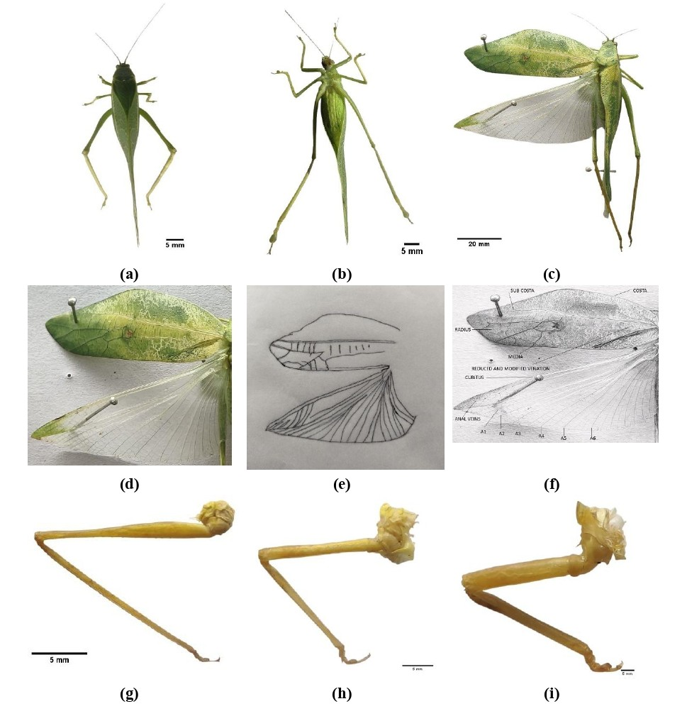
Figure 1. Microcentrum rhombifolium, (a) Dorsal view, (b) Ventral view, (c) Grasshopper with left wings spread, (d) Enlarged view of left wings spread, (e) Right wings spread (Line Illustrations), (f) Left wings spread with labels, (g) Foreleg, (h) Middle leg, (i) Hind leg
The appendages are depicted in figures (Figure 1, g–i). The foreleg (Figure 1, g) was slender and adapted for walking and clinging to vegetation. The middle leg (Figure 1, h) was slightly longer, aiding in stability and locomotion. The hind leg (Figure 1, i) was robust and specialized for jumping, with an enlarged femur containing strong musculature and a spined tibia. This saltatorial adaptation complements the species’ moderate flight capability.
Descriptions of Mecopoda elongata
The figure 2 presents comprehensive external morphology, emphasizing body form, wing structure, and appendage specialization of M. elongata. In the dorsal side (Figure 2, a), the body appeareed elongate and slender, with tegmina extending beyond the abdominal apex. The pronotum was well developed, slightly arched, and narrower than the tegmina. The forewings (tegmina) were elongate and moderately narrow, tapering posteriorly. Their texture was coriaceous, providing rigidity and protection to the membranous hind wings beneath. The ventral view (Figure 2, b) reveals clearly defined thoracic sterna and abdominal segmentation. The abdomen appeared elongated and cylindrical, characteristic of tettigoniids (Massa & Fontana, 2011). The tegmina overlapped along the midline, concealing the folded hind wings at rest. In the specimen with right wings spread (Figure 2, c) the functional wing arrangement becomes evident. The tegmen formed the protective anterior wing, while the hind wing expanded as a broad, fan-shaped membranous structure. The hind wing was hyaline and exhibits radiating venation from the basal region. This indicates moderate flight capability. The enlarged view of the right wings spread (Figure 2, d) highlights the venation pattern. The tegmen showed distinct longitudinal veins interconnected by cross-veins, forming a moderately reticulate network. Compared to acridids, the venation was more intricate. The hind wing displayed a well-developed anal area and clearly radiating veins, supporting aerodynamic function. The Line Illustrations (Figure 2, e) provides a precise outline of the expanded wing morphology, emphasizing proportional relationships between the tegmen and hind wing. In the labelled wing illustration (Figure 2, f), major venational elements are identified. These structures are taxonomically significant for species identification within Tettigoniidae.
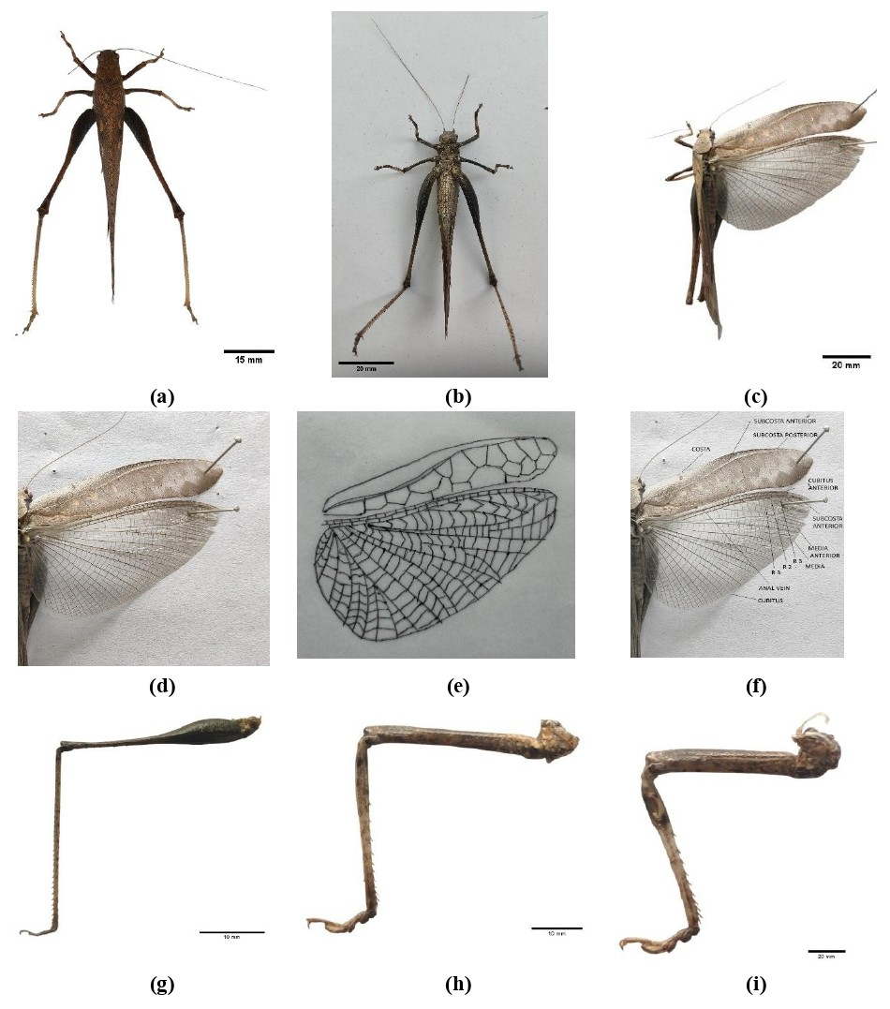
Figure 2. Mecopoda elongata, (a) Dorsal view, (b) Ventral view, (c) Grasshopper with right wings spread, (d) Enlarged view of right wings spread, (e) Right wings spread (Line Illustrations), (f) Right wings spread with labels, (g) Foreleg, (h) Middle leg, (i) Hind leg
The appendages are depicted in figures (Figure 2, g–i). The foreleg (Figure 2, g) was slender and adapted for walking and grasping vegetation. The middle leg (Figure 2, h) was longer and helped in locomotion and stability. The hind leg (Figure 2, i) was robust and specialized for saltatorial movement. The femur was enlarged and muscular, while the tibia possessed spines, facilitating powerful jumping (Chen & Liang, 2025). This adaptation complements moderate flight ability and aids in rapid escape responses. Overall, the illustrated morphology of M. elongata demonstrates a combination of flight capability, stridulatory specialization, and saltatorial adaptation. The elongate tegmina with moderately reticulate venation, broad membranous hind wings, and powerful hind legs collectively reflect ecological adaptation to vegetated habitats. The wing structure, particularly the presence of acoustic modifications in the tegmina, serves as a key diagnostic feature distinguishing this species within Tettigoniidae (Heller et al., 2015).
Descriptions of Schistocerca americana
In the dorsal view of S. americana (Figure 3, a), the body appears elongate and robust, with a well-developed pronotum and elongated tegmina extending distinctly beyond the abdominal apex. The tegmina were narrow and parallel sided, exhibiting prominent longitudinal venation. The head was hypognathous with prominent compound eyes, and the antennae were filiform and moderately long. In the ventral view (Figure 3, b), the thoracic sterna and abdominal sternites were clearly visible. The segmentation of the abdomen was distinct, and the insertion points of the legs were well defined. The grasshopper with right wings spread (Figure 3, c) illustrates the functional flight apparatus. When expanded, the membranous hind wing became fully visible, appearing broad and fan shaped. The tegmen acted as a protective and supportive structure, while the hind wing provided the primary aerodynamic surface. The enlarged view of the right wings spread (Figure 3, d) emphasizes venation patterns. The tegmen showed predominantly longitudinal veins with limited cross vein reticulation. The hind wing displayed radiating veins originating from the wing base, forming a typical acridid pattern. The anal lobe was well developed, enhancing lift during flight. The Line Illustrations (Figure 3, e) provides a precise morphological outline of the expanded wings, demonstrating proportional relationships between the tegmen and hind wing. The labelled illustration (Figure 3, f) identifies key venational elements, including the costal, subcostal, radial, medial, cubital, and anal veins, facilitating taxonomic interpretation.

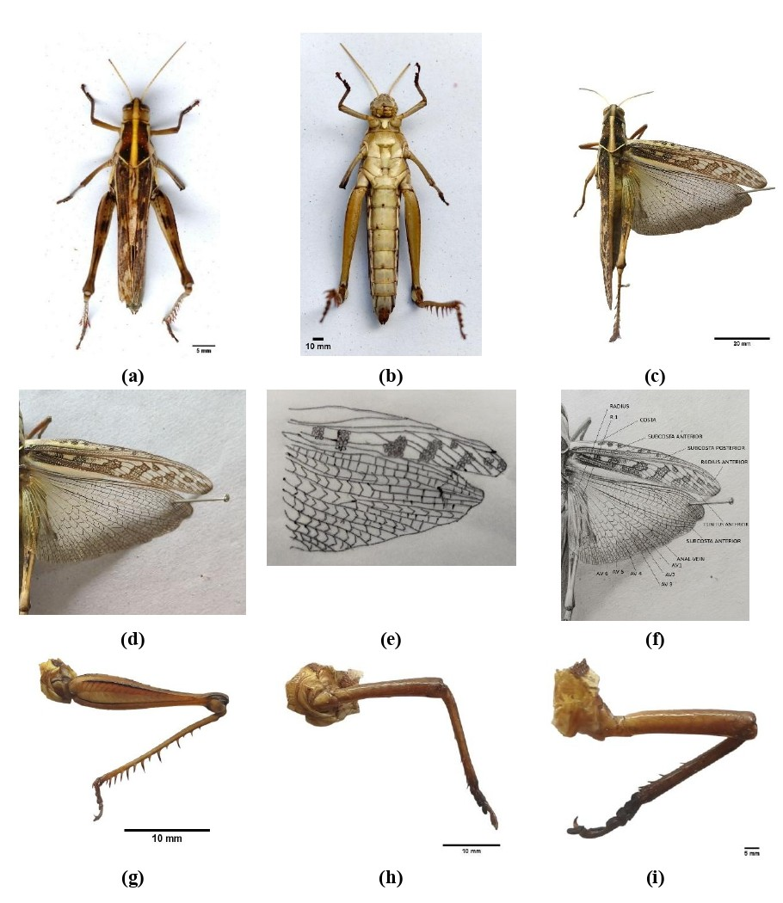
Figure 3. Schistocerca americana, (a) Dorsal view, (b) Ventral view, (c) Grasshopper with right wings spread, (d) Enlarged view of right wings spread, (e) Right wings spread (Line Illustrations), (f) Right wings spread with labels, (g) Foreleg, (h) Middle leg, (i) Hind leg

The appendages are shown in detail in figures (Figure 3, g–i). The foreleg (Figure 3, g) was comparatively shorter, adapted for walking and manipulation of food. The middle leg (Figure 3, h) was moderately elongated and supports locomotion. The hind leg (Figure 3, i) was highly specialized for jumping, characterized by an enlarged femur containing strong musculature and a long tibia equipped with spines. This saltatorial adaptation complements the species’ strong flight capability. Overall, the series of views highlights the aerodynamic specialization of S. americana. The narrow, coriaceous tegmina, expansive membranous hind wings, and powerful hind legs collectively reflect adaptation to open habitats requiring rapid escape and sustained flight. The venation pattern, wing proportions, and saltatorial hind limbs serve as key diagnostic features distinguishing this species within Acrididae (Sahayaraj & Hassan, 2023).
Comparative Morphometric Analysis
The morphometric comparisons across S. americana (Acrididae), M. rhombifolium (Tettigoniidae: Phaneropterinae), and M. elongata (Tettigoniidae: Mecopodinae) reveal distinct morphological adaptations reflecting ecological divergence within Orthoptera (Table 1). M. elongata consistently exhibited the largest dimensions, body length (75.55 mm), hind limb (100.65 mm), and antennae (49.88 mm), aligning with bush cricket traits optimized for long distance acoustic signalling and cursorial foraging in humid tropical habitats. The elongated antennae likely enhance chemosensory detection of mates and hosts, while proportionally massive hind femora (45.18 mm) and tibiae (44.68 mm) support sustained locomotion over vegetation. In contrast, S. americana displayed a more compact form (body 58.86 mm) with an exceptionally long pronotum (11.74 mm), characteristic of locust-grade acridids adapted for swarming and short-burst jumping. Its reduced antennae (18.40 mm) and shorter forewings (50.39 mm) suggest visual/pheromonal orientation over chemoreception, with hind leg proportions (femur 28.15 mm; tibia 29.97 mm) optimized for explosive saltatory escape. Notably, M. rhombifolium occupied an intermediate morpho space (body 62.99 mm), with specialized angle-wing morphology evident in shorter forelimb trochanters (0.41 mm) and claws (0.86 mm), facilitating cryptic perching on foliage.
Table 1. Comparative morphometric measurements of three orthopteran species (means, mm).
Body Part | S. americana (n=18) | M. rhombifolium (n=21) | M. elongata (n=21)
Body length | 58.86 | 62.99 | 75.55
Head length | 4.66 | 2.33 | 2.72
Antenna length | 18.40 | 20.22 | 49.88
Pronotum length | 11.74 | 7.75 | 8.15
Fore limb (total) | 22.84 | 18.14 | 31.06
- Coxa | 1.94 | 1.11 | 1.23
- Trochanter | 1.94 | 0.41 | 2.49
- Femur | 7.65 | 6.14 | 10.40
- Tibia | 6.99 | 7.64 | 11.88
- Tarsus | 2.64 | 1.98 | 3.89
- Claw | 1.68 | 0.86 | 1.17
Mid limb (total) | 27.22 | 25.77 | 37.69
- Coxa | 1.90 | 0.40 | 2.09
- Trochanter | 2.17 | 0.25 | 1.48
- Femur | 10.42 | 11.90 | 13.48
- Tibia | 9.32 | 9.88 | 14.26
Hind limb (total) | 71.28 | 68.07 | 100.65
- Femur | 28.15 | 28.11 | 45.18
- Tibia | 29.97 | 30.40 | 44.68
Palpi length | 4.54 | 4.27 | 7.65
Fore wing length | 50.39 | 45.83 | 63.74
Hind wing length | 47.41 | 51.44 | 62.40
Eye distance | 2.09 | 2.13 | 4.67
Wing veins | 2 | 21 | 18

Convergent evolution is evident in hind leg morphology between S. americana and M. rhombifolium (femur ~28 mm; tibia ~30 mm), despite familial divergence, highlighting shared biomechanical demands for jumping across Ensifera and Caelifera. Husemann et al. (2012) demonstrated convergence in wing morphology among grasshoppers (Orthoptera: Acrididae: Oedipodinae). Similarly, García-Navas et al. (2017) reported evidence that natural selection can drive convergent body plans even in highly divergent clades.
Comparative Wing Character
Comparative examination of wing morphology in M. rhombifolium, M. elongata, and S. americana demonstrates clear structural divergence (Table 2). Which is associated with ecological strategy and phylogenetic affiliation within Orthoptera. Although all three species possess fully developed tegmina and membranous hind wings, their structural organization reflects distinct adaptive priorities.

Table 2. Comparative Wing Character Matrix
Wing Character | Microcentrum rhombifolium | Schistocerca americana | Mecopoda elongata
Tegminal shape | Broad, rhomboidal to ovate | Narrow, elongate | Elongate, slightly tapering
Tegminal width | Broad | Narrow | Moderately narrow
Extension beyond abdomen | Slightly exceeding apex | Distinctly exceeding apex | Exceeding apex
Texture of tegmina | Thinly coriaceous, semi-membranous | Firmly coriaceous | Coriaceous
Venation pattern (forewing) | Densely reticulate, polygonal cells | Predominantly longitudinal, sparse cross-veins | Moderately reticulate
Leaf mimicry | Highly developed | Absent | Moderate
Stridulatory apparatus (♂) | Present | Weak or absent | Well developed (file & mirror distinct)
Hind wing development | Fully developed, membranous | Large, membranous | Fully developed, membranous
Hind wing function | Moderate flight | Strong sustained flight | Moderate flight
Anal lobe (hind wing) | Well developed | Well developed | Expanded

In M. rhombifolium, the broad, rhomboidal tegmina and densely reticulate venation create a conspicuous leaf like architecture. The polygonal network of cross veins closely resembles foliar venation, reinforcing crypsis in arboreal habitats. Such structural elaboration suggests that camouflage plays a dominant selective role, with flight capacity serving a secondary, moderate function primarily for short distance movement or escape (Awasthi, 2013). By contrast, S. americana exhibits elongate, narrow tegmina with predominantly longitudinal venation and reduced cross linking. This configuration likely enhances mechanical strength while minimizing weight, thereby supporting efficient aerodynamics. The enlarged membranous hind wings further indicate adaptation for sustained and powerful flight (Wootton & Kukalová-Peck, 2000). M. elongata occupies an intermediate morphological position. Its tegmina are moderately narrow with organized longitudinal veins and limited reticulation, ensuring both structural stability and flexibility. Thus, wing morphology in this species reflects a balance between locomotion and communication. Collectively, these patterns reveal three adaptive trajectories: structural crypsis, aerodynamic optimization, and multifunctional signalling. The observed variation highlights the evolutionary plasticity of tegminal form and venation, reinforcing their value in taxonomic diagnosis and ecological interpretation.
Dichotomous Key Based on Wing Morphology
1a. Tegmina narrow, elongate, venation predominantly longitudinal with sparse cross-veins; hind wings large, adapted for strong sustained flight ...................................................... Schistocerca americana
1b. Tegmina broader or moderately elongate, venation distinctly reticulate; hind wings membranous, not specialized for long-distance sustained flight ...................................................... 2
2a. Tegmina broad, rhomboidal to ovate, distinctly leaf-like; venation densely reticulate forming polygonal cells; strong resemblance to foliage ...................................................... Microcentrum rhombifolium
2b. Tegmina elongate, moderately narrow, tapering posteriorly; venation moderately reticulate; stridulatory apparatus (file and mirror) well developed in males ...................................................... Mecopoda elongata
Diagnostic Emphasis
- Strong longitudinal venation with narrow tegmina → Schistocerca americana
- Broad, leaf-mimicking tegmina with dense reticulation → Microcentrum rhombifolium
- Elongate tegmina with functional stridulatory structures → Mecopoda elongata
They also show corroborate family level distinctions: Acrididae favour robust thoracic shielding and visual cues, while Tettigoniidae emphasize acoustic and chemosensory specialization. M. rhombifolium's 10× higher wing vein count (21 vs. S. americana's 2) supports expanded wing surface for camouflage, contrasting M. elongata's streamlined tegmina (18 veins) for stridulatory efficiency.
- CONCLUSION
Comparative wing morphology in M. rhombifolium, M. elongata, and S. americana reveals distinct adaptations reflecting ecological specialization, underscoring wing plasticity, venation, shape, and modifications' taxonomic value in Orthoptera. Convergent hind leg evolution occurs between S. americana and M. rhombifolium despite familial divergence.

- REFERENCES
Awasthi, V. B. (2013). Principles of Insect Behaviour. Scientific Publishers.
Bayley, T., & Hedwig, B. (2024). Tonotopic Ca2+ dynamics and sound processing in auditory interneurons of the bush-cricket Mecopoda elongata. Journal of Comparative Physiology A, 210(3), 353-369.
Bidau, C. J. (2014). Patterns in Orthoptera biodiversity. I. Adaptations in ecological and evolutionary contexts. Journal of Insect Biodiversity, 2(20), 1-39.
Capinera, J. L., & Froeba, J. G. (2007). Behavioral responses of Schistocerca americana (Orthoptera: Acrididae) to azadirex (neem)-treated host plants. Journal of Economic Entomology, 100(1), 117-122.
Chen, X., & Liang, A. (2025). The Unilateral Jumping Structures of the Spotted Lanternfly, Lycorma delicatula (Hemiptera: Fulgoridae): A Highly Functional and Integrated Unit. Biomimetics, 10(7), 444.
García-Navas, V., Noguerales, V., Cordero, P. J., & Ortego, J. (2017). Phenotypic disparity in Iberian short-horned grasshoppers (Acrididae): the role of ecology and phylogeny. BMC Evolutionary Biology, 17(1), 109.
Gutjahr, A. L. N., & de Souza Braga, C. E. (2018). Order Orthoptera. In Thorp and Covich's Freshwater Invertebrates (pp. 143-168). Academic Press.
Hartbauer, M. (2008). Chorus model of the synchronizing bushcricket species Mecopoda elongata. Ecological modelling, 213(1), 105-118.
Heller, K. G., Hemp, C., Ingrisch, S., & Liu, C. (2015). Acoustic communication in Phaneropterinae (Tettigonioidea)-a global review with some new data. Journal of Orthoptera research, 24(1), 7-18.
Hummel, J., Wolf, K., Kössl, M., & Nowotny, M. (2014). Processing of simple and complex acoustic signals in a tonotopically organized ear. Proceedings of the Royal Society B: Biological Sciences, 281(1796).
Husemann, M., Namkung, S., Habel, J. C., Danley, P. D., & Hochkirch, A. (2012). Phylogenetic analyses of band‐winged grasshoppers (Orthoptera, Acrididae, Oedipodinae) reveal convergence of wing morphology. Zoologica Scripta, 41(5), 515-526.
Isely, F. B. (1944). Correlation between mandibular morphology and food specificity in grasshoppers. Annals of the Entomological Society of America, 37(1), 47-67.
Massa, B., & Fontana, P. (2011). Supraspecific taxonomy of Palaearctic Platycleidini with unarmed prosternum: a morphological approach (Orthoptera: Tettigoniidae, Tettigoniinae). Zootaxa, 2837(1), 1-47.
Sahayaraj, K., & Hassan, E. (2023). Identification of Various Insect Predators. In Worldwide Predatory Insects in Agroecosystems (pp. 71-94). Springer, Singapore.
Samways, M. J., Lecoq, M., & Charl, D. (2025). Orthoptera biodiversity for environmental assessment and agroecological advancement. Agronomy, 16(1), 57.
Sandoval‐Mojica, A. F., & Capinera, J. L. (2011). Antifeedant effect of commercial chemicals and plant extracts against Schistocerca americana (Orthoptera: Acrididae) and Diaprepes abbreviatus (Coleoptera: Curculionidae). Pest management science, 67(7), 860-868.
Song, H. (2019). Semiaquatic Orthoptera. An introduction to the aquatic insects of North America. 5th edn. Dubuque, IA: Kendall Hunt Publishing Company, 411-428.
Tumlinson, J. H., & Engelberth, J. (2008). Fatty acid-derived signals that induce or regulate plant defenses against herbivory. In Induced plant resistance to herbivory (pp. 389-407). Dordrecht: Springer Netherlands.
Wee, A. K., Takayama, K., Chua, J. L., Asakawa, T., Meenakshisundaram, S. H., Onrizal, ... & Kajita, T. (2015). Genetic differentiation and phylogeography of partially sympatric species complex Rhizophora mucronata Lam. and R. stylosa Griff. using SSR markers. BMC Evolutionary Biology, 15(1), 57.
Wootton, R. J., & Kukalová-Peck, J. (2000). Flight adaptations in Palaeozoic Palaeoptera (Insecta). Biological Reviews, 75(1), 129-167.

