Case report
ORAL MUCOCELE – A CASE REPORT

ABSTRACT:
Oral mucocele is one of the most frequently encountered benign lesions of the minor salivary glands, most commonly caused by trauma-induced rupture or obstruction of the salivary duct. Mucocele are defined as mucus- filled cavities, which can appear in the oral cavity, appendix, gallbladder, paranasal sinuses, and lacrimal sac. Clinically, it appears as a soft, fluctuant, bluish, dome-shaped swelling, predominantly affecting the lower lip. smaller mucoceles may resolve spontaneously, larger or persistent lesions typically require intervention through surgical excision, laser therapy, or cryosurgery. Accurate diagnosis is crucial to differentiate mucoceles from other cystic and neoplastic lesions of the oral cavity. Timely identification and appropriate treatment prevent recurrence and improve patient comfort and function Here in this article we presented a case of mucocele in 34-year-old female patient reported to our department oral medicine and radiology with complaint of swelling in left lower lip region for past 6 years.
Keywords: Mucocele, salivarygland, lower lip, excision, mucouscyst

INTRODUCTION :
Oral mucoceles are among the most common non-neoplastic lesions of the minor salivary glands[3], accounting for approximately 2.5% to 8% of all oral pathologies. They occur most frequently in children and young adults, particularly in the second and third decades of life. However, they may affect individuals of any age,[5] including infants and the elderly. There is no significant gender predilection, though some studies report a slight male predominance in pediatric cases due to higher incidence of trauma or habits like lip biting.[1]
The lower lip is the most commonly” affected site, accounting for nearly 60–80% of all mucoceles, primarily due to its susceptibility to mechanical trauma. Other sites include the buccal mucosa, ventral surface of the tongue, floor of the mouth (ranula), and retromolar area.[1]Mucoceles are more frequent in populations with habits such as chronic lip/cheek biting, orthodontic appliance use, or repetitive trauma from teeth or prostheses .They are mostly subdivided into two types : 1.Mucus extravasation type, which is regarded as being a result of trauma, like lip biting .2.Mucus retention type, which results from the obstruction of the duct of a minor or accessory salivary gland. Superficial mucoceles, although less common, are often multiple and tend to occur more frequently in middle-aged adults. Overall, the incidence and prevalence of mucoceles may be underreported, as small or spontaneously resolving lesions often go unrecorded in clinical settings. Deep mucocele granuloma, dome-shaped swelling in deeper connective tissue (floor of mouth, lips, ventral tongue, buccal mucosa); normal-colored, larger than superficial type, persistent and may resemble salivary gland tumor. Mucocele is a mucus extravasation phenomenon caused by rupture or obstruction of a minor salivary gland duct, leading to pooling of saliva in the surrounding connective tissue with a pseudocystic cavity lacking epithelial lining.
This case report aimes to explain the history, clinical features, and surgical removal of mucocele using a simple surgical technique which helps to enhance the knowledge of the general dental practitioner.

CASE REPORT:
A 34-year-old female came to the department of oral medicine and radiology with the chief compliant of swelling in left lower lip region (fig :1)for the past 6 years. No history of trauma. Patient is unaware of lip biting habits. Swelling was present on the labial aspect of the lower lip for the past six years. It was initially small in size and gradually increased to its current dimensions. The swelling was painless, and there was no associated history of fever or malaise. No other associated symptoms present.

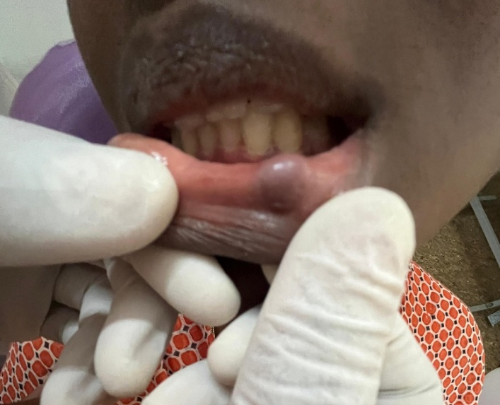
Figure 1: soft tissue growth in lower lip

On examination of the lesion,solitary swelling was evident on the lower labial mucosa of size 3*3mm measures approximately which was ovoid in shape bluish black colour extends 5 mm away from the vermilion border of lower lip on left side. The surrounding structures appear to be normal , no secondary changes. On palpation, all the inspectory findings are confirmed , it was soft to firm in consistency, oval in shape ,fluctuant , non tender with no increase in temperature. On Hard tissue examination restoration in 37 38 48,fixed partial denture in relation to 47 46 45, Generalised attrition present ,Dental caries in 16 15 .
Provisionally , the lesion was diagnosed as a mucocele based on clinical features and history.
Differential diagnosis :cystic swelling ,salivary gland tumors,vascular /lymphatic malformation, other benign swellings(fibroma,lipoma,abscess).
Routine Hematological investigation were done ,and the values were in the normal rage .The treatment were planned for surgical excision and procedures were explained to the patient. After obtaining consent from the patient and her family and, the procedure was performed.

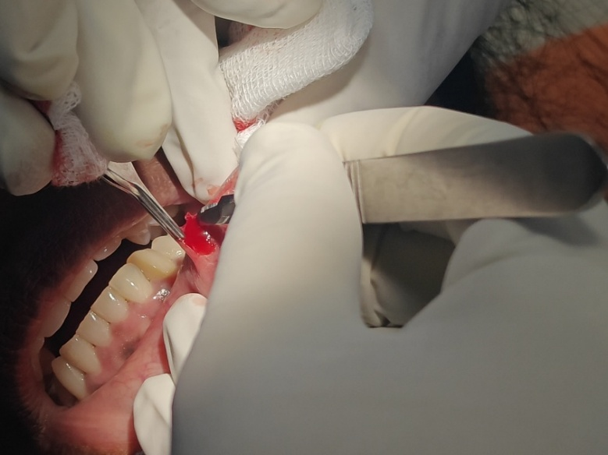
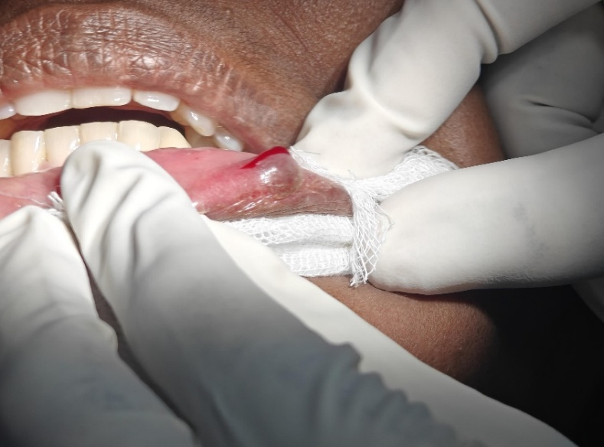
Figure 2 (a)preoperative image. ( b )Surgical excision was performed

Surgical excision was performed by placing the patient in semisupine position, left mental nerve block given. Subjective and objective signs checked and confirmed. (Fig :2 a,b)Horizontal incision placed over the most prominent area of the lesion, layer by layer blunt dissection done around the lesion. The lesion fully excised and specimen were sent for histopathology examination. hemostasis achieved, closure done with 3-0 silk, medications prescribed(cap.Amoxicillin 500 mg after food ,Tab.metronidazole 400mg after food ,Tab. Pantoprazole 40 mg before food ,for 3 days. postoperative instructions given.

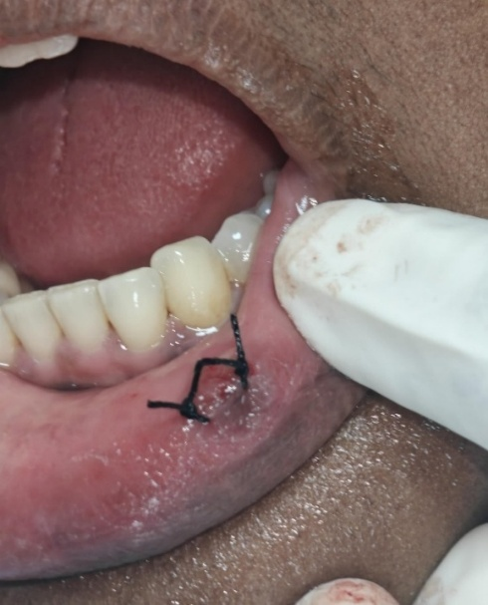
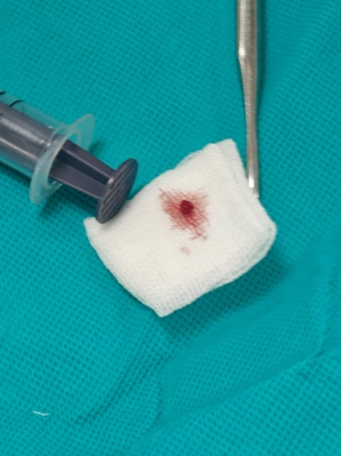
Fig 3: (a) (Excised lesion) (b)(immediate Post-operative image)

PATHOLOGY REPORT:
Microscopic Features:
The H&E-stained sections of the given soft tissue specimen reveals fibro cellular connective tissue areas with numerous blood vessels and extravasated RBCS

H/P DIAGNOSIS:
Histopathology suggestive of REGENERATING MUCOCELE
The case was finally diagnosed as Regenerating Mucocele based on histopath report .
Follow up: Patient was recalled followed up regularly .No evidence of recurrence.

DISCUSSION:
Mucoceles are common, non-malignant lesions of the oral mucosa, most often resulting from mucus retention or extravasation involving the minor salivary glands. As described by Yamasoba et al. (1990) [3], two primary etiological mechanisms extravasation and retention contribute to their formation: trauma and obstruction of salivary ductal flow [6]. Most mucoceles associated with minor salivary glands are superficial and rarely attain a large diameter. Extravasation mucoceles, the more prevalent type, result from the leakage of mucin into adjacent connective tissues following rupture of the salivary duct or acini—commonly secondary to mechanical trauma such as lip biting or sucking habits [8]. This may explain their higher incidence among younger individuals, who are more prone to such trauma.
A mucocele develops when the normal flow of saliva from the minor salivary glands is interrupted, typically following trauma that crushes or severs the duct, allowing mucus to extravasate into the surrounding connective tissues. Increased intraductal pressure may also cause acinar rupture, leading to mucin escape. In superficial mucoceles, inflammation of the ductal lining often results in obstruction, dilation, and eventual rupture, with mucus accumulating beneath the surface epithelium. Additionally, altered glandular activity, changes in saliva composition, or immune responses may contribute to lesion formation.
Biochemical studies have revealed elevated levels of enzymes such as metalloproteinases and collagenases, which promote tissue breakdown and facilitate lesion persistence.
Clinically, diagnosis is largely based on characteristic features, including lesion location, rapid onset, fluctuation in size, bluish translucency, soft consistency, and a history of local trauma—features often considered pathognomonic [2,7]. Palpation assists in differential diagnosis, as fluctuation is typically noted in mucoceles, cysts, abscesses, and hemangiomas, but not in lipomas or salivary gland tumors [9]. Radiographic imaging is generally unnecessary but may be indicated to exclude sialolithiasis in suspected ranulas. Advanced imaging modalities such as CT and MRI can help localize and characterize the lesion.
Histopathological examination of excised tissue is crucial to confirm the diagnosis and rule out neoplastic processes involving the salivary glands. Oral mucoceles must be differentiated from lesions such as lipoma, oral hemangioma, oral lymphangioma, pyogenic granuloma, and benign or malignant salivary gland neoplasms. Superficial mucoceles, in particular, may be mistaken for vesiculobullous conditions like bullous lichen planus and cicatricial pemphigoid [12,13].
The management of mucocele is Surgical excision, including removal of the adjacent minor salivary gland, remains the gold standard for definitive treatment. Simple incision alone often leads to recurrence, as the mucin source persists [10]. Marsupialization, though occasionally employed, carries a high recurrence risk [11]. Alternative therapies such as laser ablation, cryosurgery, and electrocautery have demonstrated variable success rates [6].
Top of Form

CONCLUSION:
Mucous cysts are usually non-threatening and may disappear without treatment. Diagnosis is commonly made through physical examination and confirmed by microscopic analysis of the excised tissue. A substantial body of research indicates that lesions typically develop in response to injury before they become problematic through repeated habits such as lip chewing. Injuries caused by trauma account for the highest incidence; consequently, extravasations of fluids occur more frequently compared to other types.
Type of retention cyst requires thorough histological analysis as part of its diagnostic process and appropriate treatment planning. The most straightforward method for treating lesions is complete removal; however, incomplete resection often leads to recurrences.The management of mucocele is Surgical excision, including removal of the adjacent minor salivary gland, remains the gold standard for definitive treatment.

REFERENCES:
- Baurmash HD. Mucoceles and ranulas. J Oral Maxillofac Surg. 2003;61(3):369–78.
- Yagüe-García J, España-Tost AJ, Berini-Aytés L, Gay-Escoda C. Treatment of oral mucocele: scalpel versus CO₂ laser. Med Oral Patol Oral Cir Bucal. 2009;14(9):e469–74.
- Bagán Sebastián JV, Silvestre Donat FJ, Peñarrocha Diago M, Milián Masanet MA. Clinico-pathological study of oral mucoceles. Av Odontoestomatol. 1990;6:389–94.
- Eveson JW. Superficial mucoceles: pitfall in clinical and microscopic diagnosis. Oral Surg Oral Med Oral Pathol. 1988;66(3):318–22.
- Neville B, Damm DD, Allen CM, Bouquot JJ. Oral and Maxillofacial Pathology. 2nd ed. Philadelphia: W.B. Saunders; 2002. P. 389–92.
- Yamasoba T, Tayama N, Syoji M, Fukuta M. Clinicostatistical study of lower lip mucoceles. Head Neck. 1990;12(4):316–20.
- Andiron N, Sarikayalar F, Unal OF, Baydar DE, Ozaydin E. Mucocele of the anterior lingual salivary glands: from extravasation to an alarming mass with a benign course. Int J Pediatr Otorhinolaryngol. 2001;61(2):143–7.
- Barbería E, Lucavechi T, Cárdenas D, Maroto M. An atypical lingual lesion resulting from the unhealthy habit of sucking the lower lip: clinical case study. J Clin Pediatr Dent. 2006;30(4):280–2.
- Guimarães MS, Hebling J, Filho VA, Santos LL, Vita TM, Costa CA. Extravasation mucocele involving the ventral surface of the tongue (glands of Blandin-Nuhn). Int J Paediatr Dent. 2006;16(6):435–9.
- Huang IY, Chen CM, Kao YH, Worthington P. Treatment of mucocele of the lower lip with carbon dioxide laser. J Oral Maxillofac Surg. 2007;65(5):855–8.
- McDonald RE, Avery DR, Dean JA. Dentistry for the Child and Adolescent. 8th ed. St. Louis: Mosby; 2004.
- Ashika BK, Bagchi A, Chawla R, Kumar N, Sowmya K, Shetty RR. Intraoral lipoma: a case report. J Pharm Bioallied Sci. 2023;15(Suppl 2):S1338–40. Doi:10.4103/jpbs.jpbs_143_23.
- Kannan N, Ramalingam K, Ramani P, Krishnan M. Mucocele of the lower lip and its surgical management. Cureus. 2024;16(10):e70874. Doi:10.7759/cureus.70874.

