Case report

Case report on oral lichen planus

Abstract

Lichen planus is a chronic mucocutaneous disease that is caused by the immune system and affects about 1.5–2% of the world's population. It primarily impacts women, particularly those over 50 years old. Lichen planus is thought to be an immune-mediated disease, even though the exact cause is still unknown. There are two types of lesions that can happen with lichen planus: mucosal and cutaneous.

The skin lesions of lichen planus are described by the “6 Ps” (purple, polygonal, planar, pruritic papules, and plaques) and are often accompanied by lacy white Wickham striae. The lesions primarily affect the inner wrists, forearms, ankles, and lower back, but can also occur as thickened patches on the shin or annular lesions on the genitalia.

Oral lichen planus (OLP) is a bilateral lesion, and the buccal mucosa is involved in about 90% of the cases. Other sites involved, in order of frequency, include the tongue, gingiva, alveolar ridge, lips, and rarely, the palate.

This article describes a case of oral lichen planus in a 32-year-old female patient who reported to the Department of Oral Medicine and Radiology.
Keywords:OralLichenPlanus,,WickhamStriae,Immunofluroscence,
corticosteroids,
Introduction
Oral Lichen Planus is a chronic, T-cell-mediated autoimmune disease that affects the stratified squamous epithelium of the oral mucosa. It is marked by the presence of persistent inflammatory lesions that usually appear as bilateral, symmetrical white lacy patches (Wickham striae), red and swollen areas, or painful ulcers. It is most common in women in their fifth and sixth decades of life[3,4,5].Lichen planus (LP) is categorized according to several systems, which classify its varied manifestations according to the body site, clinical features, and ICD-10 coding systems.Mucosal disease, which may occur alone or in conjunction with cutaneous lesions, commonly involves the oral mucosa (oral lichen planus), genitalia, and esophagus(1,2). Appendageal disease is limited to the hair follicles (lichen planopilaris) and nails (nail lichen planus), which have the potential to result in scarring or tissue loss.
Morphologically, lichen planus is characterized by several different subtypes, which differ in intensity and appearance. The typical papular variant is often accompanied by the presence of Wickham striae, which are fine, lace-like white lines seen on the surface of the lesions(5,12).Apart from these main categories, some specific clinical syndromes are identified when LP manifests in particular patterns or in association with other diseases. Vulvovaginal-gingival syndrome is a particular severe variant that involves simultaneous desquamative lesions of the gums and female genitalia.other syndrome associated are Grinspan syndrome,Metabolic syndrome, Autoimmune disease.
The etiology of OLP is complex and associated with genetic predisposition, systemic diseases, and hypersensitivity reaction.Genetic predisposition, infectious agents, systemic diseases, graft versus host disease (GVHD), drug reactions, vitamin deficiencies, and hypersensitivity to dental materials are all factors that can make someone more likely to get sick (6).Lichen planus is linked to various autoimmune disorders, such as lupus erythematosus, pemphigus, Sjögren’s syndrome, and autoimmune liver disease (7,8).An accurate diagnosis of OLP relies on the synthesis of clinical and histopathological evaluations.Common histopathological features include hyperkeratosis, acanthosis, degeneration of basal keratinocytes, and a band-like infiltrate of T lymphocytes (16, 17, 18).Direct immunofluorescence frequently functions as a critical diagnostic instrument to distinguish OLP from other autoimmune disorders.
Management focuses on alleviating symptoms and reducing inflammation, with topical corticosteroids serving as the primary therapy(1). For refractory cases, calcineurin inhibitors or laser ablation may be employed. Given the potential for malignant transformation, a multidisciplinary approach emphasizing longterm monitoring and patient education is essential for effective care.

Case Report

A 32-year-old female patient reported to the Department of Oral Medicine and Radiology complaining of a persistent burning sensation in the oral cavity of one month's duration. The discomfort was significantly aggravated by the consumption of spicy foods,and burning sensation severely impacting her quality of life. The patient’s medical history was unremarkable, with no reported history of local trauma or tobacco use, though she disclosed experiencing substantial psychological stress—a known catalyst for the exacerbation of Oral Lichen Planus (OLP).

Intraoral examination of soft tissue revealed a classic clinical presentation of bilateral lesions on the buccal mucosa,which was characterized by Wickham’s striae, appearing as grayish-white, lace-like elevated lines, interspersed with diffuse erythematous patches. This specific appearance indicated a mixed reticular-atrophic clinical subtype. The lesions exhibited an extensive linear distribution,anteriorly originating at the commissures of the lips and extending posteriorly along the entire length of the internal cheek to the retromolar trigone bilaterally; a similar lesion was also noted on the left lateral border of the tongue and ventral surface of the tongue. Upon palpation, the mucosal surface remained soft and delicate, and the white striations were confirmed to be non-scrappable, and non tender.

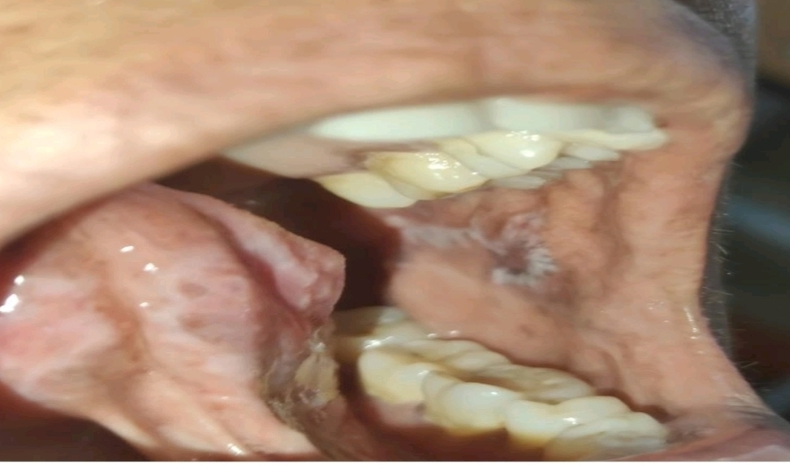

Figure 1:Lesion present on buccal mucosa,irregular erythematous patch with greyish white appearance,extending anteriorly 4 cm away from the commisure of the lips and and posteriorly till the retromolar pad

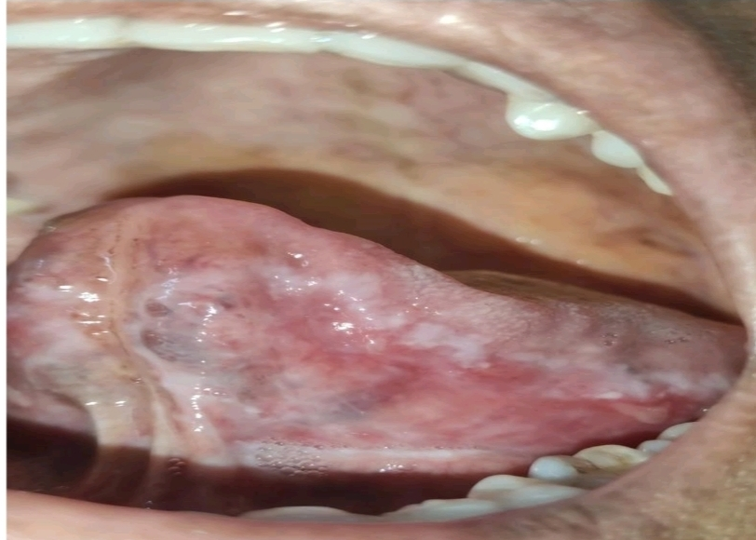

Figure 2:Lesion involving lateral border of the tongue and buccal mucosa,,diffuse erythematous patch,greyish white with wrinkled appearance.

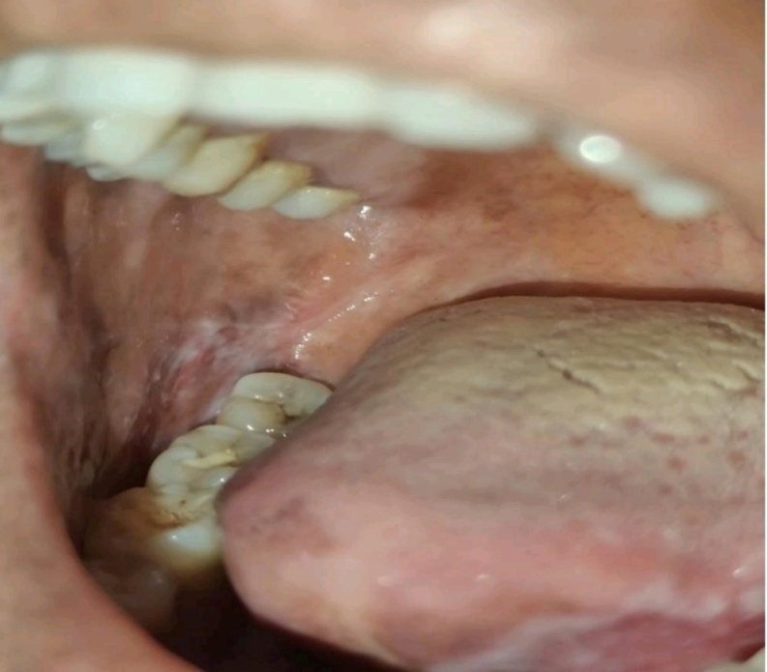

Figure 3:Lateral border and ventral surface of the tongue involved,greyish white interlinked patches

Examination of the hard tissues shows that the 47 is restored and there is supragingival calculus all over the teeth region.Provisional diagnosis of the lesion was oral lichen planus,considering the clinical presentation and history given by the patient. Though Leukoplakia was also a differential diagnosis, the pathognomonic symmetry and lace pattern made it possible to make a clinical diagnosis of OLP.Other differential diagnoses include secondary syphilis and Grapht versus host disease(GVHD).After a systemic workup revealed normal haematological values, the patient was conservatively managed. Management included relieving the burning sensation and decrease in size of the lesion by topical steroids and stress management counseling. In the absence of histopathological diagnosis, a protocol for strict clinical followup was developed to monitor the lesions for any changes in morphology or the rare event of malignant transformation.

The patient learned about and was motivated to follow a good plaque and denture control plan that included brushing three times a day with a soft brush and toothpaste and rinsing twice a day with alcohol-free chlorhexidine for two weeks.The patient was told not to eat spicy foods while her lichen planus was active and to use topical corticosteroid cream with 0.1 percent triamcinolone acetonide (Kenacort with systemic steroids) for three weeks.At first, she was being checked on every week.

Given the symptomatic atrophic-reticular presentation, topical corticosteroid therapy was initiated as the first-line treatment. The patient was prescribed 0.1% Triamcinolone acetonide in an adhesive dental paste (such as Kenalog in Orabase), to be applied thinly to the affected areas three times daily after meals. This vehicle is specifically designed to adhere to moist oral mucosa, ensuring prolonged contact with the lesions. To prevent secondary Oral Candidiasis—a common side effect of local steroid use—the patient was advised to rinse her mouth thoroughly and was monitored for any white, scrappable coatings. For immediate symptomatic relief during meals, a topical anesthetic like 2% Viscous Lidocaine was recommended for use as needed.
Upon clinical follow-up at the two-week interval, the patient reported a significant reduction in the burning sensation, and a visual inspection confirmed a marked regression of the inflammatory components and a decrease in the overall extent of the lesions.
At 2nd week follow up reveals marked reduction in appearance of the lesion (Figure 4).

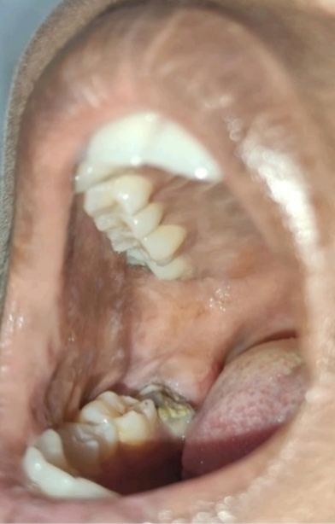
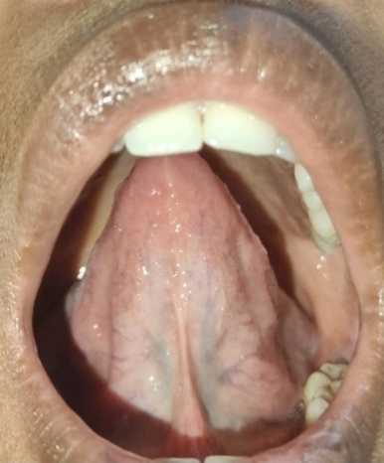
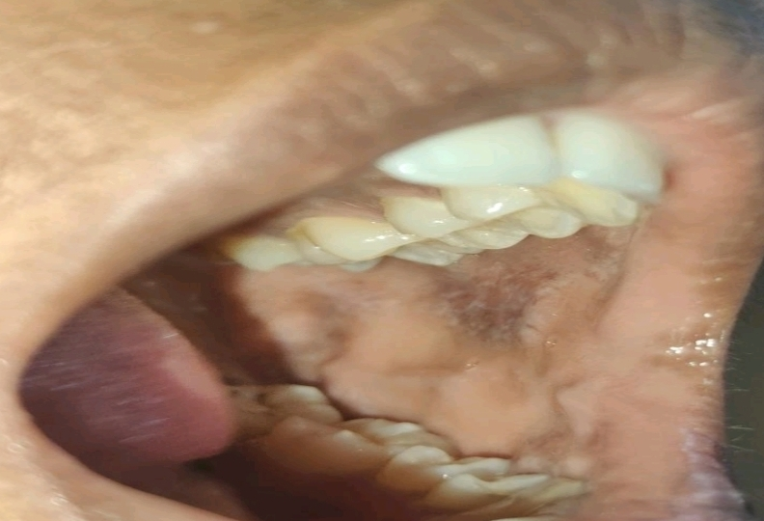
Figure 4: Reduction of the lesion

Discussion:
Lichen planus (LP) is a T-cell-mediated inflammatory condition, which appears on the skin as the characteristic "6 Ps": purple, polygonal, planar, pruritic papules, and plaques, often characterized by a fine, lacy network of white lines called Wickham striae. Lichen planus typically occurs on the flexor surfaces of the body, particularly the inner wrists and forearms, as well as the dorsal hands and lower back. It also tends to occur on the lower legs and ankles, where it may appear as thick, scaly hypertrophic lesions on the shins. Moreover, it also tends to involve the genitalia, where it appears as annular lesions on the glans penis in males or on the vulva and vagina in females(23).Cutaneous lesions are usually self-limiting and resolve spontaneously within two years, but oral lichen planus (OLP) is a chronic condition that persists for decades, either as asymptomatic reticular lesions or as painful, erosive ulcers on the buccal mucosa(12).Epidemiologically, LP tends to affect the middle-aged and elderly; although the mean age of onset ranges between 30 and 70 years, the data shows that the standardized prevalence peaks in the 70-79 years age group.The condition also shows a marked female preponderance, especially in its oral form, and is remarkably rare in children, constituting less than 5% of all cases.Oral Lichen Planus (OLP) is a chronic inflammatory disease that may present either as a standalone condition or in association with cutaneous lichen planus. In the current case, the patient had oral lesions alone without any cutaneous lesions. This is not an unusual presentation, as cutaneous lesions are seen in only 15% of patients with OLP. Globally, the prevalence of OLP has been estimated to affect 1-2% of the population. The condition also shows a marked female predominance, with a male to female ratio of 1:2, especially in middle-aged patients. The current patient, however, was in her third decade of life, which is consistent with the usual age of presentation of OLP.Several factors have been proposed as possible contributors to the development of lichen planus, including genetic predisposition, medication use, autoimmune disorders, immunodeficiency, psychological stress, systemic conditions like diabetes and hypertension, malignant neoplasms, and gastrointestinal diseases[21].Some Koebnerizing causes have been recognized in the pathogenesis or worsening of oral lichen planus (OLP), such as dental materials, infections like human papillomavirus (HPV), food allergies, habitual habits like lip biting, and mechanical irritation like that caused by sharp cusp. In the present case, the palatal lesion was probably induced by chronic irritation from an old denture(11).
The most commonly affected areas of the oral cavity, in order of frequency, are the buccal mucosa, lips, gingiva, floor of the mouth, and palate(16). The lesions are usually bilateral and symmetric. They may occur in one or more of six forms: reticular, papular, plaque-like, erosive, atrophic, and bullous. Of these, the buccal mucosa, tongue, and gingiva are the most commonly affected.
Histopathological changes include shaggy or fibrillar band of fibrinogen deposited along the basement membrane zone. This, although not specific for lichen planus, is a very important diagnostic feature. Moreover, positive staining for immunoglobulins (IgM, IgG) and complement component 3 (C3) was noted in a granular or "globular" pattern within the colloid bodies (Civatte bodies) in the superficial lamina propria. These features, taken together with clinical features and routine histopathology, are very specific for oral lichen planusHistopathological examination of the biopsy sample taken from the alveolar mucosa revealed epithelial ulceration, with focal hyperkeratosis, wedge-shaped hypergranulosis, irregular acanthosis, and degeneration of basal keratinocytes. A dense, band-like subepithelial infiltrate, predominantly composed of lymphocytes, was also evident. These changes were diagnostic of oral lichen planus(2).
Management of lichen planus involves the regulation of the immune-mediated inflammatory response. Topical corticosteroids are considered the gold standard for the treatment of lichen planus, while calcineurin inhibitors such as tacrolimus are considered effective alternatives. In the case of systemic or resistant lichen planus, phototherapy and systemic immunosuppressive agents are used to induce clinical remission and prevent malignant transformation.
Conclusion:
Oral lichen planus most commonly affects the buccal mucosa and gingiva in its classical presentation. However, this case underscores an atypical distribution, involving the buccal mucosa, and lower anterior gingiva. Management typically begins with topical corticosteroids, either alone or in combination with other topical immunomodulatory agents, which are considered the first-line treatment for symptomatic relief in most patients. In more persistent or severe cases, the use of systemic therapy may be warranted. Additionally, identifying and eliminating potential triggering factors is crucial for achieving long-term disease control and preventing recurrence.
References
- Sugerman PB, Savage NW, Walsh LJ, Zhao ZZ, Zhou XJ,
Khan A, et al. The pathogenesis of oral lichen planus. Crit Rev Oral Biol Med. 2002;13(4):350-65.
- Patil A, Prasad S, Ashok L, Sujatha GP. Oral bullous lichen planus: Case report and review of management. Contemp Clin Dent. 2012;3(3):344-8.
- Handa S, Sahoo B. Childhood lichen planus: a study of 87 cases. Int J Dermatol. 2002;41(7):423-7.
- Kumar V, Garg BR, Baruah MC, Vasireddi SS. Childhood lichen planus (LP). J Dermatol. 1993;20(3):175-7.
- Eisen D, Carrozzo M, Bagan JV, Thongprasom K. Oral lichen planus: clinical features and management. Oral Dis. 2005;11(6):338-49.
- Soames JV, Southam JC. Oral Pathology. 3rd ed. Oxford: Oxford University Press; 1998. p.151-6.
- Scully C, Beyli M, Ferreiro MC, et al. Update on oral lichen planus: etiopathogenesis and management. Crit Rev Oral Biol Med. 1998;9(1):86-122.
- Alam F, Hamburger J. Oral mucosal lichen planus in children. Int J Paediatr Dent. 2001;11(3):209-14.
- McCreary CE, McCartan BE. Clinical management of oral lichen planus. Br J Oral Maxillofac Surg. 1999;37(5):338-43.
- Scully C, Carrozzo M. Oral mucosal disease: Lichen planus. Br J Oral Maxillofac Surg. 2008;46(1):15-21.
- Gorouhi F, Davari P, Fazel N. Cutaneous and mucosal lichen planus: A comprehensive review of clinical subtypes, risk factors, diagnosis, and prognosis. Sci World J. 2014;2014:742826.
- Laeijendecker R, van Joost T, Tank B, Oranje AP, Neumann HA. Oral lichen planus in childhood. Pediatr Dermatol. 2005;22(4):299304.
- Xue JL, Fan MW, Wang SZ, Chen XM, Li Y, Wang L. A clinical study of 674 patients with oral lichen planus in China. J Oral Pathol Med. 2005;34(8):467-72.
- Eisen D. The clinical features, malignant potential, and systemic associations of oral lichen planus: a study of 723 patients. J Am Acad Dermatol. 2002;46(2):207-14.
- Ingafou M, Leao JC, Porter SR, Scully C. Oral lichen planus: a retrospective study of 690 British patients. Oral Dis. 2006;12(5):463-8.
- Ismail SB, Kumar SK, Zain RB. Oral lichen planus and lichenoid reactions:Etiopathogenesis, diagnosis, management and malignant transformation. J Oral Sci. 2007;49(2):89-106
- Anuradha CH, Reddy BV, Nandan SR, Kumar SR. Oral lichen planus: A review. N Y State Dent J. 2008;74(3):66-8.
- Mollaoglu N. Oral lichen planus: a review. Br J Oral Maxillofac Surg. 2000;38(4):370-7.
- Greenberg MS, Glick M, Ship JA. Burket’s Oral Medicine. 11th ed. Hamilton: BC Decker Inc.; 2008.
- Rajendran R. Oral lichen planus. J Oral Maxillofac Pathol. 2005;9(1):3-5.
- Roopashree MR, Gondhalekar RV, Shashikanth MC, George J, Thippeswamy SH, Shukla A. Pathogenesis of oral lichen planus - A review. J Oral Pathol Med. 2010;39(10):72934.
- Eisen D. The evaluation of cutaneous, genital, scalp, nail, esophageal, and ocular involvement in patients with oral lichen planus. Oral Surg Oral Med Oral Pathol Oral Radiol Endod. 1999;88(4):431-6.
- Silverman S Jr. Oral lichen planus: A potentially premalignant lesion. J Oral Maxillofac Surg. 2000;58(11):1286-8.

