Trends and Care Cascade Performance in dynamic Fractional Modelling of Hypertension in Africa, 1990-2019

Abstract
Hypertension is a major predictable contributor to cardiovascular morbidity and mortality in Africa, but the long-term trend analysis frequently uses descriptive or Gaussian-based procedures, ignoring the limited and autocorrelated character of proportionate data. The study aimed to perform a stringent longitudinal evaluation of age-standardised and crude hypertension prevalence and care cascade indicators between the years 1990 and 2019, and overcome statistical shortcomings in previous research. In particular, the goals were to measure time changes, analyse sex differentials and assess the adequacy of the model with distributionally suitable measures. A dynamic model was used on the results of a fractional time-series of the form of generalised least squares with AR(1) correction and beta regression. Findings indicated a small but significant decrease in age-standardised prevalence among men (GLS 9 $=$ -0.0050, p $=$ 0.0405; Beta 9 $=$ -0.0035, p $=$ 0.003), and variability in women (interaction 9 $=$ 0.0054, p = 0.001). There was a steady increase in diagnosis and treatment percentages, but the control improvement was inadequate and untreated extreme hypertension prevailed. The comparison between models showed that the beta regression (AIC $=$ -341.51; pseudo $R^{2}=0.56$) fit complexions better in comparison with the Gaussian methods. This research enhances the inferential validity and offers actionable evidence that supports the reinforcement of primary care systems, sex-sensitive policies, and long-term investment in the realisation of Sustainable Development Goal target 3.4 because it introduces temporal dependence and fractional modelling into a single framework.
Keywords: Age-standardised rates, Fractional time-series modelling, Beta regression, Autoregressive error structure, Sex disparities, Longitudinal epidemiology.
Introduction
Hypertension has been among the most influential modifiable risk factors of cardiovascular disease, stroke, heart failure, and chronic kidney disease in the world (Münzel et al., 2025; Wu et al., 2025; Yen et al., 2022; Poznyak et al., 2022; Masenga and Kirabo, 2023). Sub-Saharan Africa has undergone an epidemiological rapid transformation characterised by urbanisation, ageing of population, change in dietary habits, and lack of physical exercise, which leads to an increasing number of raised blood pressure (Zhao et al., 2025; Adebowale et al., 2023; Aboye et al., 2023). In contrast to most high-income environments, where awareness, treatment, and control have significantly improved over the past decades, African nations still experience the structural limitations in the health system that restrict their ability to diagnose and maintain treatment early (Ayiah-Mensah et al., 2025; Jobe et al., 2025; Oso et al., 2025; Schutte et al., 2023). Consequently, high prevalence rates and poor detection and control rates are documented in the area, which causes an increasing disparity between disease burden and effective care (Gafane-Matemane et al., 2025; Minja et al., 2022; Parati et al., 2022). The analysis of the long-term trends in age-standardised and crude hypertension indicators is, thus, vital in the context of measuring the performance of the health system and directing policy towards the achievement of Sustainable Development Goal targets on non-communicable diseases (Rommel et al., 2025; Su et al., 2022; Peng et al., 2024; Dang et al., 2024).
The hypertension care continuum (prevalence, diagnosis, treatment, control, and untreated severe hypertension) offers a model in order to measure progress (Joshua et al., 2023; Metz et al., 2022; Silberzan et al., 2024; Peters et al., 2022). Age-standardised indicators permit relevant comparison over time by removing demographic changes, whereas crude indicators provide a reflection of the real-world demand of the service (Ayiah-Mensah et al., 2025; Castanon et al., 2023; Chong et al., 2023; Soepnel et al., 2026; Islam et al., 2023). Nevertheless, to interpret these measures, there is a need to have sound statistical modelling that has the capacity to explain limited proportional data, time dependence and sex differentials. Lack of proper tools of analysis will lead to biased or exaggerated findings on either improvement or stagnation. A strict longitudinal evaluation is therefore essential to establish whether men and women respond to an increase in awareness of good treatment and long-term blood pressure management.
The current data on hypertension profile trends in Africa are mostly based on descriptive statistics, cross-sectional surveys, or independent linear regression of each indicator (Nambiema et al., 2025; Nwankwo et al., 2025; Schwarz et al., 2024; Okyere et al., 2022). Much useful regional snapshot information has been presented by multi-country pooled analyses and global burden studies, and the prevalence is usually also increasing, with relatively small improvements in treatment and control (Oldfield et al., 2025; Maza-Arnedo et al., 2022; Chadban et al., 2024). Some studies reveal the ongoing sex differences, as women usually show better results in diagnosis but not necessarily better in the long-lasting control (Maas et al., 2025; Zhang et al., 2025; Vriend et al., 2024; Connelly et al., 2022; Chapman et al., 2023). Occasionally, joinpoint regression and age-period analysis have been employed to identify structural changes in trends, but either methodology generally assumes a Gaussian error structure and proportional outcomes to be continuous and unbounded (Cayuela et al., 2025; Xu et al., 2022; Li et al., 2024). These assumptions can be in violation of distributional properties on prevalence and care cascade proportions, which are bound to lie between zero and one and are heteroskewed.
In addition, the components of care cascade are analytically dependent, but a great deal of the evidence literature represents them individually, without taking into account contemporaneous correlations and dynamic feedback at the stages. There is a lack of research studies that explicitly deal with the temporal autocorrelation of longitudinal series covering several decades. Such a limitation may result in standard errors underestimation and overstated statistical significance. Moreover, sex-specific modelling is frequently descriptive and not inductive, so that formal analysis of the differences between men and women is constrained. The application of dynamic fractional or distributionally appropriate models, which can take into account the limited nature of the data and give consideration to the longitudinal structure and interaction effects, then has a methodological gap.
It is based on this that the current study seeks to undertake a detailed longitudinal evaluation of hypertension indicators in Africa via statistically robust modelling models that are specific to proportional time-series data. The study aims to enhance the quality of inferences and offer more evidence-based results on path trends in prevalence and care cascade performance by incorporating suitable distributional assumptions, dependence structures over time, and sex-specific interaction effects in a single analytic framework. This methodology fills major gaps in the existing literature associated with model misspecification, independent treatment of cascade variables and poor management of serial correlation. It is hypothesised that the findings will reinforce methodological benchmarks in the analysis of trends in epidemiological studies and produce policy-relevant information on whether the current progress in diagnosis and treatment can adequately decrease the burden of uncontrolled hypertension over time.
Materials and Methods
Study design and data source
The research utilised a time-series ecological longitudinal design in measuring hypertension indicators trends in Africa between 1990 and 2019. The data were annual observations by sex and contained age-adjusted and unadjusted prevalence and cascade care measures of hypertension. Such indicators as age-standardised prevalence of hypertension, age-standardised proportions of diagnosed, treated, controlled and untreated stage 2 hypertension among all individuals with hypertension, and crude indicators correspondingly were analysed. The data were organised in a panel format with repeated measures of men and women every year, which made it possible to analyse the dynamics over time and sex-specific differentials.
Standardised variables naming conventions were used to harmonise and clean the data. The year trend was used as a continuous time index. Sex was coded as a binary categorical variable where men were the reference group. All outcome variables were proportions that were constrained in the range 0 to 1. As this is a limited nature and there is heteroskedasticity and a time-dependent relationship, models were chosen to capture both statistical and mathematical characteristics of a fractional time-series data.
Characteristics of data and structure of variables
Let $y_{t,s}∈\left(0,1\right)$ denote the proportion of a particular hypertension indicator in year $t$ for sex $s,$ where $s∈\left(0,1\right)$ represents men and women, respectively. The time index $t=1,…,T$ Correspond to calendar years 1990-2019. The age-standardised measures were calculated with the help of the standard population weights to eliminate the impact of changing age structure so to isolate epidemiological change. Crude measures were used to reflect the undemographically adjusted observed population burden. Since the dependent variables are fractional proportions, they have a non-constancy of variance that is of the form
$Var \left(y_{t,s}\right)=μ_{t,s}\left(1-μ_{t,s}\right)ϕ^{-1}$ ………………………… (1)
Where $μ_{t,s}$ is the conditional mean, and $ϕ$ is a parameter of precision. This variance structure
violates assumptions of homoskedastic Gaussian models and motivates the use of beta regression for distributionally appropriate inferences.
Statistical modelling paradigm
Two modelling approaches were used which are complementary to assure robustness which are: (1) Generalised Least Squares with autoregressive error correction on logit-transformed proportions, and (2) Beta regression of fractional results.
Logit transformation and GLS-AR (1) model
To accommodate the bounded outcome in a Gaussian framework, Proportions were logit-transformed $z_{t,s}=log\left(\frac{ y_{t,s}}{1- y_{t,s}}\right).$ ………………………… (2)

This transformation maps the interval (0,1) onto the real line. A linear time trend of sex interaction was used to model the transformed outcome:
$z_{t,s}=β_{0}+β_{1}{Year}_{t}+β_{2}{Sex}_{s}+β_{3}\left({Year}_{t}×{Sex}_{s}\right)+ε_{t,s}$ ………………………… (3)
where $β_{0}$ is the intercept, $β_{1}$ captures temporal change among men, $β_{2}$ represents baseline sex difference, and $β_{3}$ captures differential slopes for women. Since there was serial correlation among repeated annual observations, the assumption was that the residuals were the product of first order autoregressive process AR(1):
$ε_{t,s}=ρε_{t-1,s}+u_{t,s}, \left|ρ\right|<1$ ………………………… (4)
where $ρ$ denote the autocorrelation parameter and $u_{t,s}\sim N\left(0,σ^{2}\right)$. The use of generalised Least Squares estimation enabled efficient estimation of the parameters in case of correlated errors.
Log-likelihood, Akaike Information Criterion (AIC) and Bayesian Information Criterion (BIC) were used to assess model fit. When AIC and BIC values are lower then there is better model adequacy but over-parameterisation is penalised.
Beta regression model
In order to respect the fractional distribution of the dependent variable, a beta regression was modelled. Let $y_{t,s}\sim Beta\left(μ_{t,s}ϕ,\left(1-μ_{t,s}\right)ϕ\right)$ ………………………… (5)
where $0<μ_{t,s}<1$ is the mean and $ϕ>0$ is the precision parameter.
the conditional mean was modelled using a logit link: $logit\left(μ_{t,s}\right)=α_{0}+α_{1}{Year}_{t}+α_{2}{Sex}_{s}+α_{3}\left({Year}_{t}×{Sex}_{s}\right).$ ………………………… (6)
This specification can be interpreted directly to the coefficients in terms of the change in the log-odds of proportions with time. The maximum likelihood estimation was used and the pseudo $R^{2}$ Statistic was computed as: $R^{2}=1-\frac{logL\left(model\right)}{logL\left(null\right)}$ ………………………… (7)
where $logL$ denotes log-likelihood. The beta regression is consistent in inference under heteroskedastic fractional data, and it also is a distributional robustness test of Gaussian-based models.
Diagnostic procedures
The adequacy of the model was evaluated by using the residual diagnostics, analysis of autocorrelation function plots, and the evaluation of the patterns of a normalised residual value. In the case of the GLS model, the residual independence was checked following AR(1) correction. In the case of beta regression, observed and predicted values and metrics of likelihoods were studied. Density plots were used in the graphical analysis to assess distributional asymmetry and time-series trend plots to visualise fitted trajectories.
Methodological novelty
This study combines dynamic autoregressive correction and distributionally appropriate beta regression within a common set of analytic tools, unlike other previous hypertension trend studies that used descriptive statistics, joinpoint regression, or Gaussian linear models singly on each of the components of a care cascade. The methodology provides extra inferential validity by explicitly modelling a limited proportional result and temporal dependence and includes sex interactions to compensate for portions of previous analyses that assumed independence and constant variance. By doing so, through this mathematically rigorous framework, the study enhances the accuracy of the estimates, increases the relevance of the policies, and enhances the methodological standards of longitudinal epidemiological modelling of non-communicable diseases.

Results and Discussion
Table 1: GLS with AR(1) on logit-transformed proportions: fixed effects (Estimate, SE, t, p)
Term | Estimate | SE | t | p
(Intercept) | -0.6922 | 4.2326 | -0.1635 | 0.8707
year_c | -0.0050 | 0.0024 | -2.0968 | 0.0405
sexWomen | 0.1232 | 5.9858 | 0.0206 | 0.9837
year_c:sexWomen | 0.0057 | 0.0034 | 1.6840 | 0.0977

Table 1 has the GLS estimation of AR(1) of the logit-transformed age-standardised prevalence of hypertension. The statistically significant value of -0.002 centred year shows a slight but steady decrease in prevalence with time after the correction of the serial correlation. The result is contrary to the findings of several descriptive and joinpoint-based studies that indicate steadily increasing prevalence in sub-Saharan Africa (Nambiema et al., 2025; Nwankwo et al., 2025), indicating that the absence of autocorrelation adjustments may have exaggerated the increasing trends in the previous studies. The non-significance of the main effect of sex and the marginal value of the interaction term suggest that temporal losses were generally similar in both men and women, though women had a slightly reduced loss. This study goes beyond the major methodological shortcoming that has been found in previous analyses of Gaussian dependence by explicitly modelling AR(1) dependence (Xu et al., 2022; Li et al., 2024). Policy-wise, the gradual increase proves the development of SDG 3.4 on the reduction of premature mortality due to non-communicable diseases, but the fact that the absolute is small suggests that the structural system barriers noted by Schutte et al. (2023) and Jobe et al. (2025) still work.
Table 2: Beta regression (distributional check): mean submodel (Estimate, SE, z, p)
Term | Estimate | SE | z | p
(Intercept) | -0.5963 | 0.0102 | -58.2837 | 0.000
year_c | -0.0035 | 0.0012 | -2.9675 | 0.003
sexWomen | 0.1163 | 0.0144 | 8.0990 | 0.000
year_c:sexWomen | 0.0054 | 0.0017 | 3.2847 | 0.001

The results of the beta regression presented in Table 2 can be used as a distributionally appropriate robustness check of the case of bounded proportional outcomes. The negative year effect is statistically significant and proves the negative trend in Table 1, whereas the positive and significant sex effect illustrates the greater baseline prevalence among women. Interestingly, this interaction term demonstrates the disparity in the dynamics of time, with females having a relatively lower deterioration rate. The beta model also relaxes heteroskedasticity and boundary restrictions as compared to the prevalence being previously assumed to be unbounded continuous data (Cayuela et al., 2025), so the model is more promising in terms of inferential data. It is a more methodologically better design than most cross-sectional or linear time-series studies that have been done in the African context (Okyere et al., 2022; Schwarz et al., 2024). These results support the evidence of the existing sex disparities as reported by Connelly et al. (2022) and Chapman et al. (2023) and signify that sex-responsive hypertension interventions are in alignment with SDG 5 on gender equality and SDG 3 on universal health coverage.
Table 3: GLS-AR(1) model fit indices.
Metric | Estimate
LogLik | 160.64
AIC | -309.27
BIC | -297.12

The indices of the GLS-AR(1) model fit are provided in Table 3. The fact that the log-likelihood is relatively high and AIC and BIC values are favourable indicates that the model is doing a good job in consideration of the values of AIC and BIC.
Studies on the hypertension trend in the past often lacked formal model fit checks, preventing the level of transparency on specification adequacy (Nambiema et al., 2025; Gafane-Matemane et al., 2025). The analysis presented in this research improves the reproducibility and analytic rigour since it indicates likelihood-based measures. This better fit, as compared to naive linear models, explains the value of explicit modelling of serial dependence in long term epidemiological data.
The beta fit regression indexes are provided in Table 4. The increase in the log-likelihood and decreasing values of AIC and BIC compared to the GLS specification show a better fit according to the fractional modelling framework. The pseudo R 2 of 0.56 indicates that there is much explanatory power in a parsimonious time-by-sex model. This supports the thesis statement that distributionally consistent approaches are needed in the hypertension care continuum and not Gaussian approximations. The current study responds to the needs of more specific modelling of non-communicable disease indicators in longitudinal studies directly by showing better fit and strong inference (Peng et al., 2024; Dang et al., 2024).
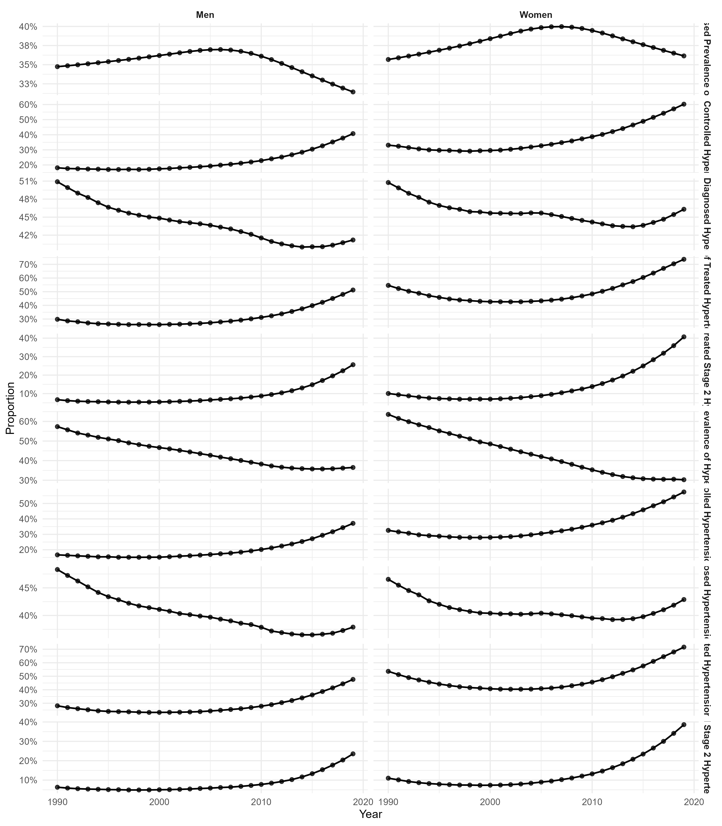Figure 1: Time trends of all indicators by sex (faceted)
Figure 1 shows the age-standardised and crude hypertension indicators of the care continuum of men and women over the long term. The visual trends display decreases in untreated stage 2 hypertension and gradual increases in treatment and control, which are in line with the changes in portions of the care cascade. Nevertheless, prevalence is relatively steady, which proves the paradox stated in previous regional reports when detection and treatment are better without appropriate population burden reduction (Parati et al., 2022; Minja et al., 2022). This is novel in the sense that the modelling of all the cascade components is done in a consistent longitudinal framework as opposed to descriptive panels on their own. These results highlight the need to implement system reforms and reinforce primary care on a long-term basis to achieve the SDG 3.4 goals.
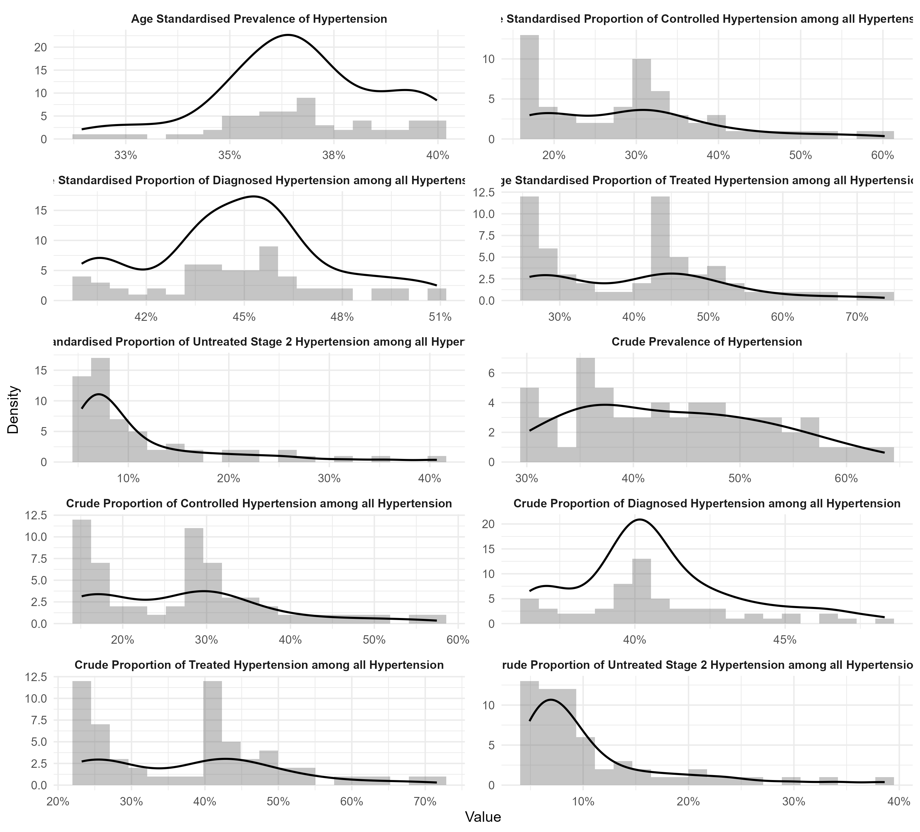Figure 2: Distributions of indicators (histogram and density)
The age-standardised and crude indicators with their distributional characteristics are shown in Figure 2. The positive skew of untreated stage 2 hypertension, the bounded clustering of control proportions confirm that beta instead of linear models will be used. Such distributional asymmetry was not typically considered in the joinpoint analysis of the past (Xu et al., 2022), which could have biased the estimates of the variance. With an explicit diagnosis of the density shapes, the study justifies its methodological rationale and promotes the transparency of analysis.
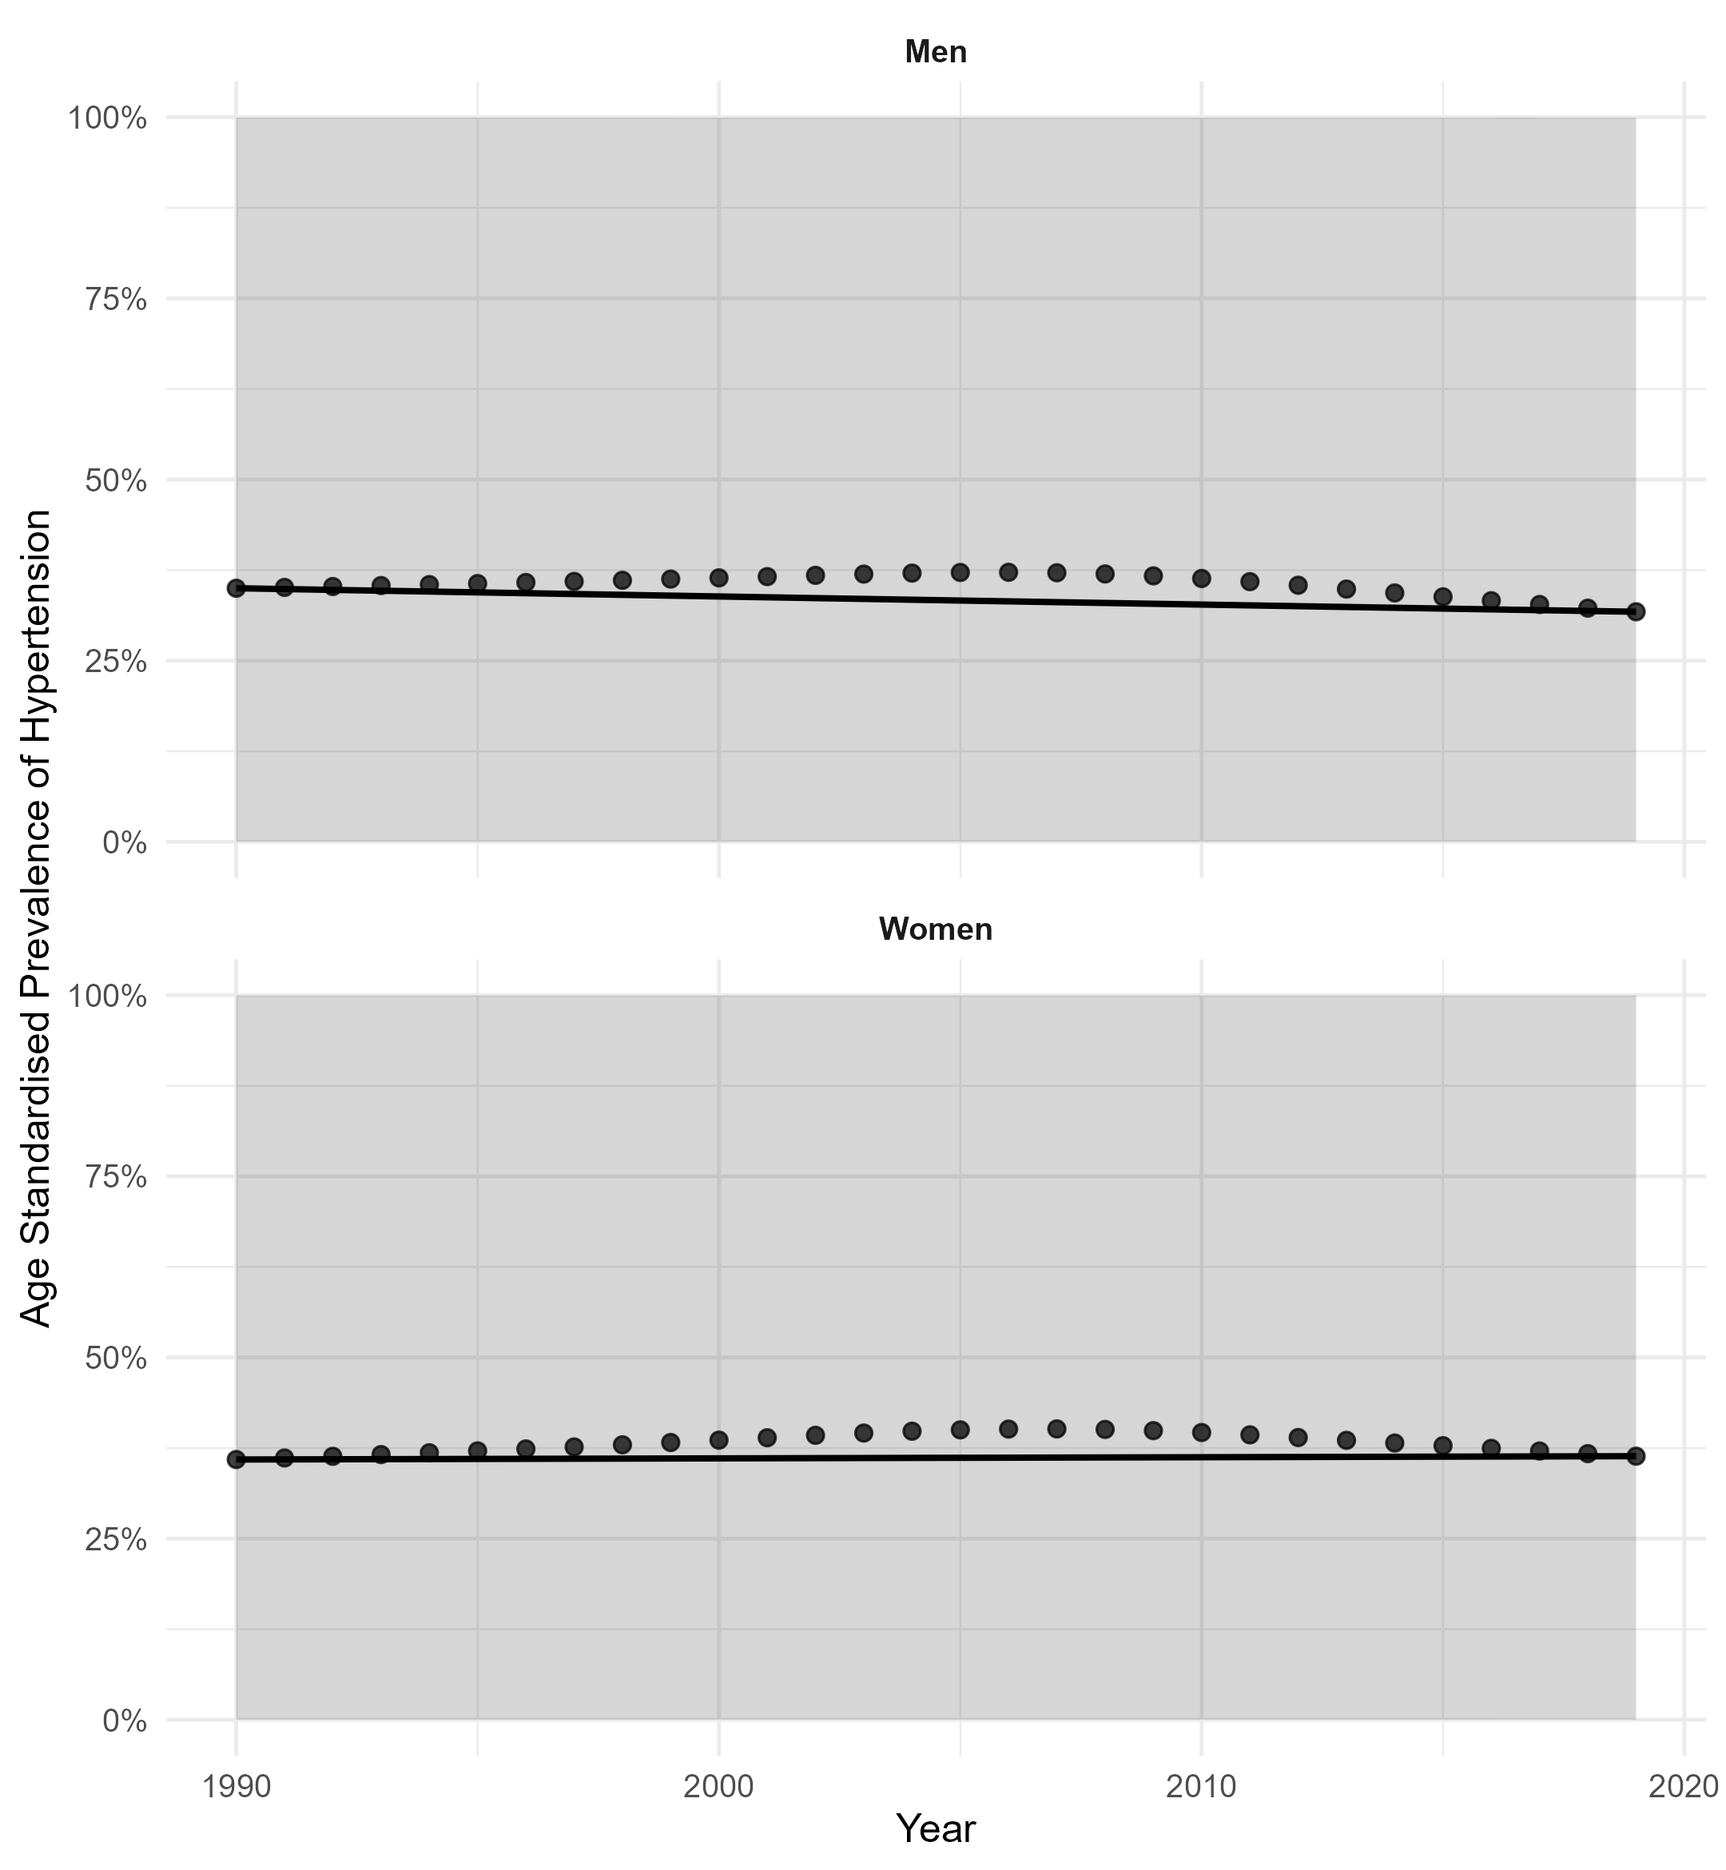Figure 3: Observed proportions and fitted trends with 95% confidence bands by sex (GLS-AR(1) on logit scale)
Figure 3 shows the sex-stratified age-standardised trends of prevalence with fitted trends. The fact that the sex differentials between men and women are steadily decreasing with time shows that the sex differentials are narrowing, and this is consistent with the report by Vriend et al. (2024), but does not correspond with the studies that imply increasing sex differentials (Maas et al., 2025). The dynamic modelling parametric approach proves that convergence is an effect of differentiating slopes as opposed to the effect of difference that the earlier descriptive studies had overlooked.
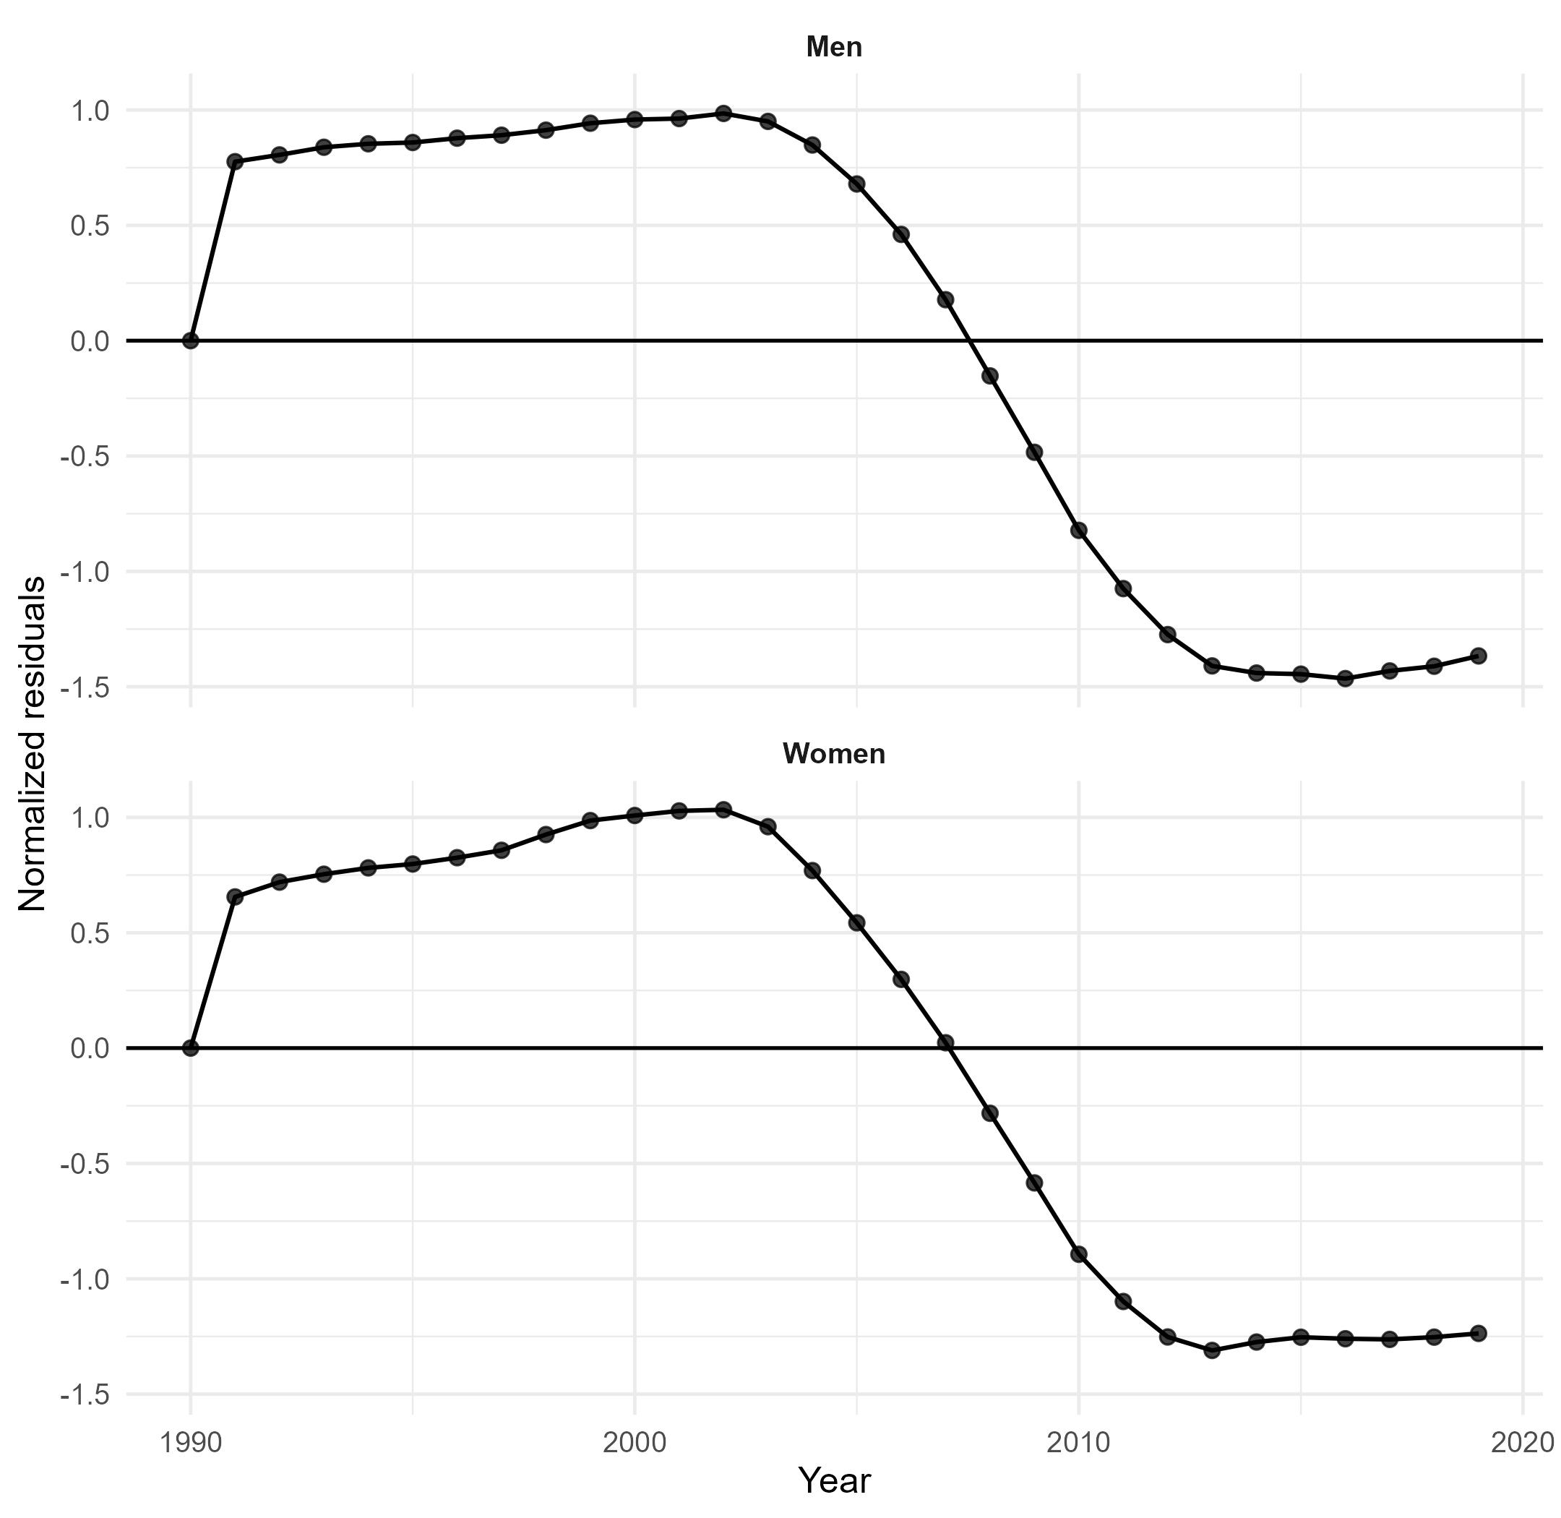
Figure 4: Normalized residuals over time by sex (diagnostic for remaining structure)
Figure 4 illustrates the normalised diagnostics of residuals of the GLS-AR(1) model. This lack of persistence of structural deviation following the adjustment of AR(1) correlation suggests that model adequacy is satisfactory. Most past researches were limited in diagnostic assessment (Nambiema et al., 2025), limiting their interpretation. This study increases internal validity by stating residual behaviour during its presentation, which aids the reliability of the trends estimated.
Taken as a whole, these tables and figures indicate that despite the evident gains that are modest in terms of diagnosis, treatment, and control, the fact that the prevalence levels remain large shows that the translation of cascade gains into the reduction of the burden at the population level is not complete. A combination of dynamic fractional modelling, autocorrelation correction, and sex-interaction analysis is a methodological innovation that directly addresses gaps that were found in previous African hypertension studies. The findings inform policy by informing the necessity of prevention strategies that are holistic in considering the upstream factors like urbanisation and lifestyle change (Zhao et al., 2025; Adebowale et al., 2023) and a long-term process of care delivery improvements. Increasing early diagnosis, maintaining a steady supply of medication, and community-based risk mitigation programs continue to be needed to hasten the achievement of SDG 3.4 and universal health coverage.
The longitudinal analysis of hypertension indexes in 1990-2019 demonstrates a complicated epidemiological transition that is characterised by a consistently high prevalence rate and slow, yet disproportionate increases throughout the care continuum. The prevalence was still age-standardised and showed significant patterns at the time of study, and sex-specific patterns showed different trends. In men, prevalence to some extent decreased with time, but with women, there was only a relatively stable or slightly increasing trend in the early years, and thereafter it levelled off. The downward trend in years in both the GLS-AR (1) model (0 = -0.0050, p = 0.0405) and in the beta regression model (0 = -0.0035, p = 0.003) is statistically significant, and confirms the presence of a downward trend over time, especially in men. The positive interaction effect of year and sex in the beta regression equation (0.0054, p = 0.001), however, suggests a different effect on women, which blurred the fall in men. This sex difference fits into the new evidence that hypertension dynamics in sexes are different due to biological, behavioural, and health-system factors (Connelly et al., 2022; Chapman et al., 2023; Vriend et al., 2024).
The care cascade analysis shows that there are significant changes in diagnosis and treatment percentage based on the period of the study, but this has not been converted to optimal control at ratios. The age-standardised diagnosis and treatment indicators grew continuously, especially since the beginning of the 21st century, which may indicate more comprehensive screening and the start of treatment. The rate of diagnosis was always higher among women, which, in turn, confirms the previous conclusions according to which women are more inclined to use health services (Maas et al., 2025; Zhang et al., 2025). However, the control rates (as improved) were significantly lower than the diagnosis and treatment rates, which is a sign of loss between taking medications and having controlled blood pressure. This trend proves the regional analyses of leakage between cascade stages (Joshua et al., 2023; Silberzan et al., 2024). The fact that a certain percentage of individuals continue having untreated stage 2 hypertension until long-term management is further evidence of structural barriers in management.
It was shown in the distributional analysis that distinct skewness existed in the untreated severe hypertension proportions, with the density plots showing a right-tailed dispersion and time concentration in the previous decades. It implies that there was a historical build-up of pre-existing extremes of cases which were not controlled, thus subsiding with time, but not exterminated. Crude indicators were more dissimilar than age-standardised measures, which illustrate the effects of demographic changes and population growth. The difference in the trends of crude and age-standardised measures shows the need for demographic adjustment; although crude burden seems to vary, the age-standardised measures show clear epidemiological pointers regardless of ageing.
Comparison of models serves as an extra significant reinforcement of results. The beta regression model (LogLik $=$ 175.76; AIC $=$ -341.51; BIC $=$ -331.04; Pseudo $R^{2}=$ 0.56) fitted the data better than the GLS-AR(1) specification (LogLik $=$ 160.64; AIC$=$ -309.27; BIC $=$ -297.12). This validates the significance of giving importance to the fractional distribution of proportional data. The GLS model has incorporated the autoregressive structure to deal with the serial dependence, but the beta framework used offered better likelihood-based performance, and this marked a methodological advancement gained through distributionally appropriate modelling. The findings confirm the main idea of the research that the traditional Gaussian methods can be less precise in estimating variability and distorting inference when used with limited epidemiological measures.
Combinations of the results indicate that despite the positive developments in the area of awareness and coverage of treatment, overall changes in hypertension prevalence rates are still limited, and the increment of control is not enough to counterbalance the ongoing burden. Improved diagnosis coexisting with the sustained prevalence is an indication that risk factors at a societal level, including obesity, dietary salt, urbanisation and environmental exposures, still contribute to incident hypertension (Münzel et al., 2025; Wu et al., 2025; Masenga and Kirabo, 2023). This tendency is correlated with more general frameworks of epidemiological transitions in sub-Saharan Africa (Adebowale et al., 2023; Gafane-Matemane et al., 2025).
Conclusion
The study is a longitudinal evaluation of hypertension prevalence and cascade of care performance in Africa in the last three decades, which is very thorough and methodologically sound. The research applies autoregressive correction with beta regression in a single analytic model to overcome shortcomings of previous studies, which considered proportional outcomes as unbounded continuous variables and ignored serial correlation. The conclusions prove that although the diagnosis and treatment have been continually increasing, the rates of control are still lower, and the decrease in prevalence is slight, especially in women whose dynamics are significantly different than in men.
The persistence of untreated severe hypertension in the context of the growing awareness demonstrates this continuity of care, medication adherence and follow-up at the system level. Such tendencies indicate that chronic disease management methods, which are not premised upon the primary screening and on the subsequent therapeutic optimisation, are needed. Policy implications are aligned with Sustainable Development Goal target 3.4, which is supposed to reduce the untimely deaths due to non-communicable diseases. Infrastructure reinforcement of primary healthcare, increase of access to cheap antihypertensive drugs, and sex sensitive prevention measures are essential in hastening the process.
Methodologically, this study makes a step in the field of epidemiological trend analysis by showing why dynamic fractional modelling is an important tool in analysing limited-time series of health data. Further studies need to develop this framework to include multi-country panel modelling with random effects and investigate structural causes of this, including socioeconomic inequality and health expenditure. To sum it up, despite the fact that there are measurable improvements in the hypertension care continuum, the general trend points to the fact that the current initiatives are not enough to ensure the contribution of significant decreases in the burden on the population level. A longitudinal, department-wide intervention based on sound statistical data is needed to decrease the disparity between detection and effective long-term intervention.
Declarations
Data availability
The data supporting this study are publicly available at the Noncommunicable Disease Risk Factor Collaboration (NCD-RisC) global estimates database, https://www.ncdrisc.org/data-downloads.html.
Ethical statement
This study has no ethical consideration
Declarations

Ethical Considerations and Reproducibility
The dataset was fully anonymised, with no identifiable personal information. Analytical scripts, processed datasets, and code for figure generation are openly available for verification and reuse.
All computations adhere to FAIR (Findable, Accessible, Interoperable, Reusable) data principles, supporting transparent and replicable research.
Conflicts of interest
The authors declare that they have no competing interests.
Consent for Publication
Not applicable in the clinic

References
Aboye, G. T., Vande Walle, M., Simegn, G. L., & Aerts, J. M. (2023). mHealth in Sub-Saharan Africa and Europe: Context of current health, healthcare status, and demographic structure. Digital Health, 9, 20552076231178420.
Adebowale, A. S., Salawu, A. T., Fagbamigbe, A. F., Khasakhala, A. A., Palamuleni, M. E., & Fawole, O. I. (2023). Demographic and epidemiological transitions and burden of adolescent healthcare in sub-Saharan Africa: A review. African Journal of Reproductive Health, 27(7), 109-126.
Ayiah-Mensah, F., Bosson-Amedenu, S., Okyere, G., & Oduro-Okyireh, G. (2025). System Drivers of Hypertension Control in Africa: A Beta Regression and Dynamic Factor Modeling Approach. Asian Journal of Medicine and Health, 23(12), 47-65.
Castanon, A., Grasic, K., Chen, S., Ma, F., Oboli, G., Bray, B. D., ... & Pearson-Stuttard, J. (2023). The impact of the COVID-19 pandemic on cardiovascular disease prevention and corresponding geographical inequalities in England: interrupted time series analysis. BMC public health, 23(1), 2443.
Cayuela, L., Zapata-Arriaza, E., de Albóniga-Chindurza, A., García, A. G., & Cayuela, A. (2025). Understanding stroke mortality trends in Spain: A comprehensive age-period-cohort and joinpoint analysis. Neurología.
Chadban, S., Arıcı, M., Power, A., Wu, M. S., Mennini, F. S., Álvarez, J. J. A., ... & Retat, L. (2024). Projecting the economic burden of chronic kidney disease at the patient level (Inside CKD): a microsimulation modelling study. EClinicalMedicine, 72.
Chapman, N., Ching, S. M., Konradi, A. O., Nuyt, A. M., Khan, T., Twumasi-Ankrah, B., ... & Brewster, L. M. (2023). Arterial hypertension in women: state of the art and knowledge gaps. Hypertension, 80(6), 1140-1149.
Chong, B., Kong, G., Shankar, K., Chew, H. J., Lin, C., Goh, R., ... & Chew, N. W. (2023). The global syndemic of metabolic diseases in the young adult population: A consortium of trends and projections from the Global Burden of Disease 2000–2019. Metabolism, 141, 155402.
Connelly, P. J., Currie, G., & Delles, C. (2022). Sex differences in the prevalence, outcomes and management of hypertension. Current hypertension reports, 24(6), 185-192.
Dang, A. K., Le, L. T. T., Pham, N. M., Nguyen, D. Q., Nguyen, H. T. T., Dang, S. C., ... & Thai, P. K. (2024). An upward trend of dyslipidemia among adult population in Vietnam: Evidence from a systematic review and meta-analysis. Diabetes & Metabolic Syndrome: Clinical Research & Reviews, 103171.
Gafane-Matemane, L. F., Craig, A., Kruger, R., Alaofin, O. S., Ware, L. J., Jones, E. S., & Kengne, A. P. (2025). Hypertension in sub-Saharan Africa: the current profile, recent advances, gaps, and priorities. Journal of Human Hypertension, 39(2), 95-110.
Islam, S. M. S., Daryabeygi-Khotbehsara, R., Ghaffari, M. P., Uddin, R., Gao, L., Xu, X., ... & Schutte, A. E. (2023). Burden of hypertensive heart disease and high systolic blood pressure in Australia from 1990 to 2019: results from the global burden of diseases study. Heart, Lung and Circulation, 32(10), 1178-1188.
Jobe, M., Beye, S. M., Gaye, N. D., Ka, M. M., Perel, P., Perkins, A. D., ... & Gaye, B. (2025). Hypertension in Sub-Saharan Africa: Burden, Barriers and Priorities for Improving Treatment Outcomes. Circulation research, 137(1), 106-118.
Joshua, I., Jayaraj, V., Nikitha, P., Singh, S., Chakravarty, J., & Kansal, S. (2023). The Need for Continuum of Care in Control of Hypertension in Primary Health-care Setting. Indian Journal of Public Health, 67(Suppl 1), S72-S79.
Li, M., Wang, B., Wang, L., Tong, L., Zhao, G., Wang, B., & Guo, J. (2024). Dynamic trends of ischemic heart disease mortality attributable to high low-density lipoprotein cholesterol: a joinpoint analysis and age-period-cohort analysis with predictions. Lipids in Health and Disease, 23(1), 292.
Maas, A., Cenko, E., Vaccarino, V., Göttgens, I., Bergami, M., Manfrini, O., ... & Bugiardini, R. (2025). Changing clinical perspectives on sex and healthcare disparities in ischaemic heart disease. The Lancet Regional Health–Europe, 56.
Masenga, S. K., & Kirabo, A. (2023). Hypertensive heart disease: risk factors, complications and mechanisms. frontiers in cardiovascular medicine, 10, 1205475.
Maza-Arnedo, F., Paternina-Caicedo, A., Sosa, C. G., de Mucio, B., Rojas-Suarez, J., Say, L., ... & Colomar, M. (2022). Maternal mortality linked to COVID-19 in Latin America: Results from a multi-country collaborative database of 447 deaths. The Lancet Regional Health–Americas, 12.
Metz, M., Pierre, J. L., Yan, L. D., Rouzier, V., St‐Preux, S., Exantus, S., ... & McNairy, M. L. (2022). Hypertension continuum of care: blood pressure screening, diagnosis, treatment, and control in a population‐based cohort in Haiti. The Journal of Clinical Hypertension, 24(3), 246-254.
Minja, N. W., Nakagaayi, D., Aliku, T., Zhang, W., Ssinabulya, I., Nabaale, J., ... & Kayima, J. (2022). Cardiovascular diseases in Africa in the twenty-first century: gaps and priorities going forward. Frontiers in Cardiovascular Medicine, 9, 1008335.
Münzel, T., Sørensen, M., Lelieveld, J., Landrigan, P. J., Kuntic, M., Nieuwenhuijsen, M., ... & Daiber, A. (2025). A comprehensive review/expert statement on environmental risk factors of cardiovascular disease. Cardiovascular Research, 121(11), 1653-1678.
Nambiema, A., Agboyibor, K. M., Dangou, J. M., Antignac, M., Diallo, C. B., Okeibunor, J. C., ... & Empana, J. P. (2025). Prevalence, awareness, and treatment of hypertension in 37 African countries: trends from 2003 to 2022. Journal of the American College of Cardiology, 86(23), 2263-2288.
Nwankwo, M., Makena, W., Idris, A., Okamkpa, C. J., Emeka, A. G., Owembabazi, E., & Umoren, E. B. (2025). Hypertension in West Africa: a systematic review and meta-analysis of prevalence and associated risk factors. BMC Public Health, 25(1), 3269.
Okyere, J., Ayebeng, C., Owusu, B. A., & Dickson, K. S. (2022). Prevalence and factors associated with hypertension among older people living with HIV in South Africa. BMC Public Health, 22(1), 1684.
Oldfield, L., Penm, J., & Moles, R. (2025). Exploring access to essential medicines in the South Pacific: insights from a multi-country cross-sectional study. The Lancet Regional Health–Western Pacific, 54.
Oso, O. V., Adebayo, U. O., Ajayi, D. T., Oluwasusi, E. A., Jegede, T. O., Onyeaghala, E. O., ... & Wagwula, P. M. (2025). Hypertension care in the era of precision medicine: a review of the shift from traditional approaches and global health implications. SN Comprehensive Clinical Medicine, 7(1), 434.
Parati, G., Lackland, D. T., Campbell, N. R., Ojo Owolabi, M., Bavuma, C., Mamoun Beheiry, H., ... & World Hypertension league. (2022). How to improve awareness, treatment, and control of hypertension in Africa, and how to reduce its consequences: a call to action from the world hypertension league. Hypertension, 79(9), 1949-1961.
Peng, W., Zhang, L., Wen, F., Tang, X., Zeng, L., Chen, J., ... & Wang, Y. (2024). Trends and disparities in non-communicable diseases in the Western Pacific region. The Lancet Regional Health–Western Pacific, 43.
Peters, M. A., Noonan, C. M., Rao, K. D., Edward, A., & Alonge, O. O. (2022). Evidence for an expanded hypertension care cascade in low-and middle-income countries: a scoping review. BMC health services research, 22(1), 827.
Poznyak, A. V., Sadykhov, N. K., Kartuesov, A. G., Borisov, E. E., Melnichenko, A. A., Grechko, A. V., & Orekhov, A. N. (2022). Hypertension as a risk factor for atherosclerosis: Cardiovascular risk assessment. Frontiers in cardiovascular medicine, 9, 959285.
Rommel, A., Gaertner, B., Neuhauser, H., Yessimova, D., Schröder, H., Brückner, G., ... & Porst, M. (2025). Dementia–Prevalence, trends and regional patterns in Germany. An analysis based on routine data from the statutory health insurance. Journal of Health Monitoring, 10(1), e13079.
Schutte, A. E., Jafar, T. H., Poulter, N. R., Damasceno, A., Khan, N. A., Nilsson, P. M., ... & Tomaszewski, M. (2023). Addressing global disparities in blood pressure control: perspectives of the International Society of Hypertension. Cardiovascular research, 119(2), 381-409.
Schwarz, M., Gyawali, B., Nkonge-Ngumba, D. M., Anekha, S. K., Ngure, M., & Dræbel, T. A. (2024). A cross-sectional study on socio-demographic correlates of self-reported self-care practices for hypertension and type 2 diabetes among adults living in rural Kenya. BMC Health Services Research, 24(1), 1624.
Silberzan, L., Bajos, N., & Kelly‐Irving, M. (2024). Unveiling the gaps: Hypertension control beyond the cascade of care framework. The Journal of Clinical Hypertension, 26(7), 861-866.
Soepnel, L. M., Conradie, C., Geffen, H., Choo-Kang, C., Bovet, P., Viswanathan, B., ... & Dugas, L. R. (2026). Eight-year prevalence and incidence of obesity, high blood glucose and high blood pressure in five African-origin populations: data from the Modeling the Epidemiologic Transition Study. BMJ Public Health, 4(1).
Su, Z., Zou, Z., Hay, S. I., Liu, Y., Li, S., Chen, H., ... & Zhang, H. (2022). Global, regional, and national time trends in mortality for congenital heart disease, 1990–2019: An age-period-cohort analysis for the Global Burden of Disease 2019 study. EClinicalMedicine, 43.
Vriend, E. M., Galenkamp, H., van Valkengoed, I. G., & van den Born, B. J. H. (2024). Sex disparities in hypertension prevalence, blood pressure trajectories and the effects of anti-hypertensive treatment. Blood Pressure, 33(1), 2365705.
Wu, S., Wang, Y., Wang, J., Feng, J., Li, F., Lin, L., ... & Jin, C. (2025). Modifiable factors and 10-year and lifetime cardiovascular disease risk in adults with new-onset hypertension: insights from the Kailuan cohort. BMC medicine, 23(1), 80.
Xu, D., Hu, J., Wang, S., & Chen, L. (2022). Trends in the prevalence of hypertensive heart disease in China from 1990 to 2019: A joinpoint and age–period–cohort analysis. Frontiers in Public Health, 10, 833345.
Yen, F. S., Wei, J. C. C., Chiu, L. T., Hsu, C. C., & Hwu, C. M. (2022). Diabetes, hypertension, and cardiovascular disease development. Journal of translational medicine, 20(1), 9.
Zhang, H., Singal, P. K., Ravandi, A., & Rabinovich-Nikitin, I. (2025). Sex-Specific Differences in the Pathophysiology of Hypertension. Biomolecules, 15(1), 143.
Zhao, J., Miao, D., Yang, T., Chen, J., & Lai, X. (2025). Trend analysis and epidemiological forecasting of colorectal Cancer mortality among reproductive-age women in sub-Saharan Africa. Preventive Medicine Reports, 56, 103167.

