Original Research Article

Association Between a Composite Lifestyle Risk Score and Urinary Polycyclic Aromatic Hydrocarbon Levels in a Pilot Nigerian Male Cohort: A Multicenter Cross-Sectional Study

ABSTRACT
Background: Polycyclic aromatic hydrocarbons (PAHs) from dietary, occupational, domestic, and tobacco sources contribute to cumulative internal PAH burden. Whether a composite lifestyle score integrating these exposures predicts urinary PAH concentrations in sub-Saharan African populations with high baseline dietary PAH exposure remains unknown.
Objective: To examine the association between a four-component composite lifestyle PAH risk score (range 0–4) and total urinary PAH biomarker concentrations in Nigerian men with prostate diseases, and to evaluate whether smoking history modifies this association.
Methods: This multicenter cross-sectional pilot study enrolled 25 men (15 prostate cancer, 10 benign prostatic hyperplasia) from two tertiary hospitals in southeastern Nigeria (January–August 2025). The composite lifestyle risk score summed four binary components: smoking history, above-median dietary PAH score, high-risk occupation, and physical inactivity. Total urinary PAH (sum of 16 EPA-priority congeners) was quantified by gas chromatography with flame ionisation detection (GC-FID). Notably, analysis was performed on unconjugated parent PAH without enzymatic hydrolysis or creatinine correction. Spearman rank correlations and linear regression models assessed score–biomarker associations; smoking-stratified analyses evaluated effect modification.
Results: Of 25 participants, 11 (44.0%) were former smokers and 14 (56.0%) were never smokers. Median total urinary PAH was 24.3 mg/L (interquartile range [IQR] 6.75–88.86). The composite lifestyle score (mean 2.33 ± 0.97; range 1–4) showed no significant overall association with urinary PAH (Spearman ρ = −0.147, p = 0.524). Smoking-stratified analysis revealed opposing directional trends: among former smokers, higher lifestyle scores showed a non-significant positive trend with urinary PAH (ρ = +0.512, p = 0.089), while among never smokers the trend was inverse (ρ = −0.287, p = 0.366). Individual dietary components showed significant inverse associations with urinary PAH, consistent with the dietary PAH paradox described in preliminary analyses of this cohort.
Conclusions: In this pilot study of 25 Nigerian men with prostate diseases, a composite lifestyle risk score did not significantly predict urinary PAH concentrations, although wide confidence intervals preclude definitive conclusions. Smoking history emerged as a qualitative effect modifier producing opposing directional associations—a hypothesis-generating finding that warrants confirmation in adequately powered, smoking-stratified study designs.
GRAPHICAL ABSTRACT

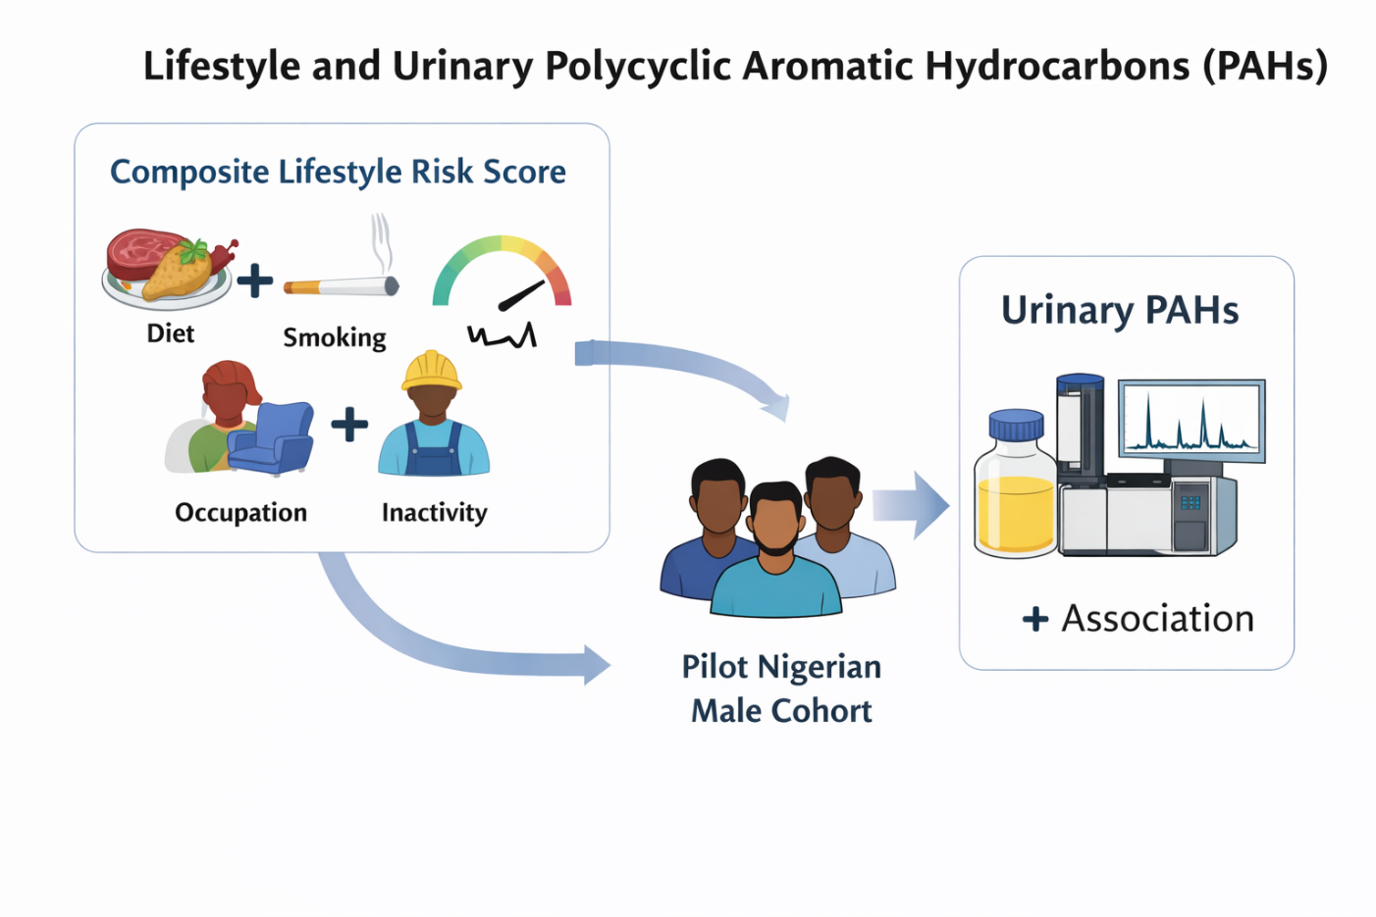

Keywords: polycyclic aromatic hydrocarbons; urinary biomarkers; composite lifestyle score; prostate disease; smoking; Nigeria; environmental epidemiology

1. INTRODUCTION
Polycyclic aromatic hydrocarbons (PAHs) are a class of persistent organic pollutants generated by the incomplete combustion of organic matter, including fossil fuels, biomass, and foodstuffs [1,2]. Human exposure occurs through multiple concurrent routes—inhalation of tobacco smoke and ambient air pollutants, ingestion of grilled, smoked, and charred foods, occupational contact with petroleum-derived products, and domestic use of biomass fuels for cooking [3,4]. Once absorbed, PAHs undergo hepatic biotransformation via cytochrome P450 enzymes (primarily CYP1A1 and CYP1B1) and phase II conjugation, yielding hydroxylated metabolites excreted in urine [5,6]. Urinary PAH concentrations therefore serve as integrated short-term biomarkers of internal PAH dose, reflecting aggregate exposure across all sources within the preceding 24–48 hours [7,8].
The relevance of PAH exposure to cancer epidemiology is well established. The International Agency for Research on Cancer (IARC) classifies benzo[a]pyrene as Group 1 (carcinogenic to humans) and several other PAH congeners as Group 2A or 2B [9]. Prostate tissue possesses the enzymatic machinery for PAH metabolic activation, and PAH–DNA adducts have been detected in prostate specimens, particularly among men of African descent [10,11]. Epidemiological evidence from large prospective cohorts has linked consumption of grilled and barbecued meats with increased risk of advanced prostate cancer [12,13]. These observations are particularly concerning for sub-Saharan African populations, where dietary PAH exposure is exceptionally high owing to culturally prevalent cooking practices involving charcoal grilling and smoking of meats and fish [14,15].
Nigeria, the most populous country in Africa, exemplifies this convergence of high PAH exposure and rising prostate cancer burden. Prostate cancer is the leading male malignancy in Nigeria, with 18,019 new cases and 11,443 deaths reported in 2022, representing the highest cancer mortality among Nigerian men [16,17]. Street foods, including the ubiquitous charcoal-grilled meat preparation known as suya, contain benzo[a]pyrene concentrations that exceed European Union regulatory limits by orders of magnitude [14,18]. Concurrently, occupational PAH exposure from the petroleum industry and informal-sector activities compounds the dietary burden, while widespread biomass fuel use introduces additional inhalational exposure [19,20].
Despite recognition that PAH exposure in Nigeria is multifactorial, epidemiological studies have predominantly examined single exposure sources in isolation [21,22]. We have recently conducted preliminary analyses of this same cohort examining the paradoxical inverse association between dietary PAH intake and urinary PAH biomarker concentrations (Teme RE et al., manuscript in preparation), and the differential smoking-related modification of PAH metabolism (Teme RE et al., manuscript in preparation). The present study extends those findings by evaluating whether a composite lifestyle score integrating all four major exposure pathways—smoking history, dietary PAH, occupational risk, and physical inactivity—provides predictive utility for urinary PAH concentrations beyond its individual components.
Composite exposure scores integrating multiple lifestyle determinants into a single metric have proven informative in high-income settings for predicting biomarker concentrations [23,24]. However, their utility in low- and middle-income countries (LMICs) with fundamentally different exposure profiles remains untested. Whether such composite indices capture meaningful variance in urinary PAH levels when baseline exposure from a single dominant source (diet) is already high is an important translational question. This pilot study addresses this gap and evaluates smoking history as a potential effect modifier of the composite score–biomarker relationship.

2. MATERIALS AND METHODS
2.1 Study design and setting
This multicenter cross-sectional pilot study was conducted at two tertiary hospitals in southeastern Nigeria: Nnamdi Azikiwe University Teaching Hospital (NAUTH), Nnewi, Anambra State, and Rivers State University Teaching Hospital (RSUTH), Port Harcourt, Rivers State, between January and August 2025.
2.2 Participants
Eligible participants were men aged ≥40 years with a confirmed or suspected diagnosis of prostate adenocarcinoma or benign prostatic hyperplasia (BPH). Exclusion criteria included unresolved diagnostic uncertainty at the time of analysis, known high-intensity occupational PAH exposure within the preceding six months (refinery work, road paving, aluminium smelting), use of prescribed enzyme-inducing medications, and inability to provide informed consent.
Twenty-six men were enrolled (17 from NAUTH, 9 from RSUTH). Four participants had indeterminate histopathological diagnoses at enrolment. Three were subsequently confirmed through consensus machine learning prediction (using logistic regression, random forest, and gradient boosting classifiers trained on the confirmed cases with leave-one-out cross-validation, achieving an area under the curve of 0.75–0.95 [25]) and later validated by histopathology (two adenocarcinoma, one BPH). One participant remains awaiting histopathological confirmation and was excluded. The analytical sample therefore comprised n = 25 (15 prostate cancer, 10 BPH).
2.3 Ethical considerations
The study protocol was approved by the Research Ethics Committees of both participating institutions: NAUTH (NAUTH/CS/66/VOL.17/VER.3/22/2024/83) and RSUTH (RSUTH/REC/2025708). All procedures conformed to the Declaration of Helsinki. Written informed consent was obtained from all participants.
2.4 Lifestyle and dietary assessment
A structured interviewer-administered questionnaire captured smoking history (never, former, or current), occupational category (high-risk or low-risk), physical activity level, and dietary habits. A weighted Dietary PAH Score was computed as: (Red Meat × 1.0) + (Processed Meat × 1.5) + (Grilled/Smoked × 2.0) – (Cruciferous Vegetables × 0.3) – (Tomatoes × 0.3), with weighting coefficients reflecting published relative PAH generation potentials in the Nigerian dietary context [14,18]. The composite Lifestyle PAH Risk Score (range 0–4) summed four binary components: (i) smoking history (former or current = 1); (ii) dietary PAH score above the sample median (= 1); (iii) high-risk occupation (= 1); and (iv) physical inactivity (= 1).
2.5 Urine collection and PAH analysis
To minimise procedural contamination, pre-digital rectal examination (pre-DRE) voided urine samples were collected in methanol-rinsed, light-protected polypropylene containers, immediately placed in insulated transport boxes with dry ice packs (~4°C), and delivered to the laboratory within four hours. Upon receipt, aliquots were stored at −80°C until analysis. This protocol was designed to prevent PAH volatilisation, photodegradation, and enzymatic breakdown.
Urinary concentrations of 16 US Environmental Protection Agency (EPA) priority PAH congeners were determined by gas chromatography with flame ionisation detection (GC-FID) using certified EPA 610 reference standards. The target analytes comprised: naphthalene, acenaphthylene, acenaphthene, fluorene, phenanthrene, anthracene, fluoranthene, pyrene, benzo[a]anthracene, chrysene, benzo[b]fluoranthene, benzo[k]fluoranthene, benzo[a]pyrene, indeno[1,2,3-cd]pyrene, dibenzo[a,h]anthracene, and benzo[g,h,i]perylene. Recovery rates ranged from 88% to 107%; detection limits ranged from 0.01 to 0.05 mg/L. Total urinary PAH was computed as the sum of all 16 detectable congeners and reported in mg/L.
Critically, analysis was performed on unconjugated parent PAH without prior enzymatic hydrolysis and without creatinine correction. This means the assay measured free parent compounds in urine rather than the glucuronide- and sulphate-conjugated hydroxylated metabolites (OH-PAHs) that are the standard endpoint of human biomonitoring studies employing β-glucuronidase/arylsulphatase hydrolysis [7,26]. This distinction is essential for interpreting the present findings and limits direct comparability with studies reporting hydroxylated metabolite concentrations.
2.6 Statistical analysis
Total urinary PAH concentrations were natural log-transformed (ln[PAH + 0.001]) for parametric analyses. Descriptive statistics included medians with interquartile ranges (IQR) for continuous variables and frequencies with percentages for categorical variables. Between-group comparisons used Mann–Whitney U tests. Spearman rank correlations (ρ) assessed bivariate associations between lifestyle/dietary variables and log-PAH. Two ordinary least-squares regression models assessed the composite score as a predictor of log-PAH: Model 1 (unadjusted) and Model 2 (adjusted for age and BMI). All tests were two-sided with α = 0.05. Analyses were performed in R version 4.3.2.

3. RESULTS
3.1 Sample characteristics
Demographic and clinical characteristics are summarised in Table 1. The analytical sample comprised 25 participants (15 prostate cancer, 10 BPH). Mean age was 66.4 ± 8.8 years. Smoking history was mixed: 11 men (44.0%) were former smokers and 14 (56.0%) were never smokers; no current smokers were enrolled. Eleven participants (44.0%) reported high-risk occupations, and 13 (52.0%) were classified as physically inactive. The composite lifestyle score had a mean of 2.33 ± 0.97 (range 1–4); no participant scored 0, indicating universal presence of at least one lifestyle risk factor.

Table 1. Demographic and clinical characteristics of the study cohort (n = 25).
Characteristic | Overall (n = 25) | Cancer (n = 15) | BPH (n = 10)
Age, years, mean ± SDᵃ | 66.4 ± 8.8 | 67.0 ± 9.0 | 65.3 ± 8.5
BMI, kg/m², mean ± SDᵇ | 26.5 ± 3.5 | 27.0 ± 3.7 | 25.6 ± 2.9
Smoking status, n (%)
Former | 11 (44.0) | 7 (46.7) | 4 (40.0)
Never | 14 (56.0) | 8 (53.3) | 6 (60.0)
High-risk occupation, n (%) | 11 (44.0) | 6 (40.0) | 5 (50.0)
Physical inactivity, n (%) | 13 (52.0) | 8 (53.3) | 5 (50.0)
Lifestyle risk score, mean ± SD | 2.33 ± 0.97 | 2.40 ± 1.02 | 2.20 ± 0.89
Total PAH, mg/L, median (IQR) | 24.3 (6.75–88.86) | 55.3 (8.4–161.0) | 14.6 (4.8–28.5)
ᵃ Age data missing for 2 participants.
ᵇ BMI data missing for 9 participants.
ᶜ Three participants with initially indeterminate diagnoses were subsequently confirmed via machine learning prediction validated by histopathology; one participant awaiting confirmation was excluded.
BPH, benign prostatic hyperplasia; IQR, interquartile range; SD, standard deviation.
3.2 Lifestyle risk score distribution and urinary PAH levels
The distribution of composite lifestyle scores, stratified by smoking status, is shown in Figure 1A. Former smokers were disproportionately represented in higher score categories (scores 3–4), consistent with the smoking component contributing one additional point. Urinary PAH concentrations were highly variable across the cohort, ranging from 0.05 to 471.0 mg/L (Figure 1B). For descriptive purposes, cancer cases had numerically higher median PAH than BPH cases (55.3 vs 14.6 mg/L; Mann–Whitney p = 0.15), though disease status was not the focus of this analysis. Two participants with exceptionally high values (310.2 and 471.0 mg/L) were both former smokers employed as auto mechanics, illustrating the potential multiplicative interaction between smoking history and occupational exposure.

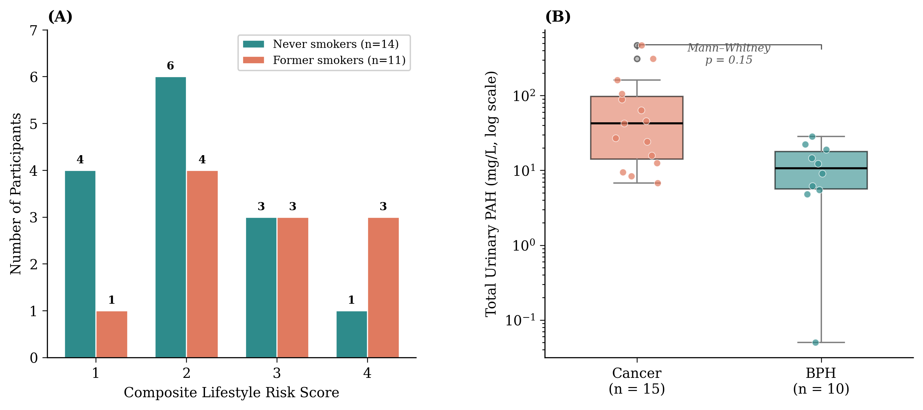
Figure 1. Distribution of the composite lifestyle risk score and urinary PAH concentrations. (A) Score distribution stratified by smoking status; former smokers were over-represented in higher score categories. (B) Box-and-jitter plots of total urinary PAH by disease group (log scale). Cancer (n = 15), BPH (n = 10). Mann–Whitney p = 0.15.
3.3 Bivariate correlation analyses
Spearman rank correlations are presented in Table 2 and Figure 2. Three dietary predictors showed statistically significant inverse correlations with urinary PAH: the composite dietary PAH score (ρ = −0.515, p = 0.017), grilled/smoked food frequency (ρ = −0.469, p = 0.024), and red meat servings (ρ = −0.445, p = 0.038). These paradoxical inverse associations, whereby higher self-reported dietary PAH exposure was associated with lower urinary PAH concentrations, are examined in depth in preliminary analyses of this cohort (Teme RE et al., manuscript in preparation). The composite lifestyle risk score showed only a weak, non-significant inverse association (ρ = −0.147, p = 0.524).

Table 2. Spearman rank correlations between dietary/lifestyle variables and log-transformed total urinary PAH.
Variable | n | ρ | p-value | Interpretation
Red meat (servings/week) | 22 | −0.445 | 0.038* | Significant inverse
Processed meat (servings/week) | 22 | −0.278 | 0.210 | NS
Grilled/smoked food frequency | 23 | −0.469 | 0.024* | Significant inverse
Dietary PAH score (composite) | 21 | −0.515 | 0.017* | Significant inverse
Lifestyle risk score (0–4) | 21 | −0.147 | 0.524 | NS
* p < 0.05. NS, not significant. ρ, Spearman rank correlation coefficient. Note: sample sizes vary due to missing questionnaire data for some dietary variables.

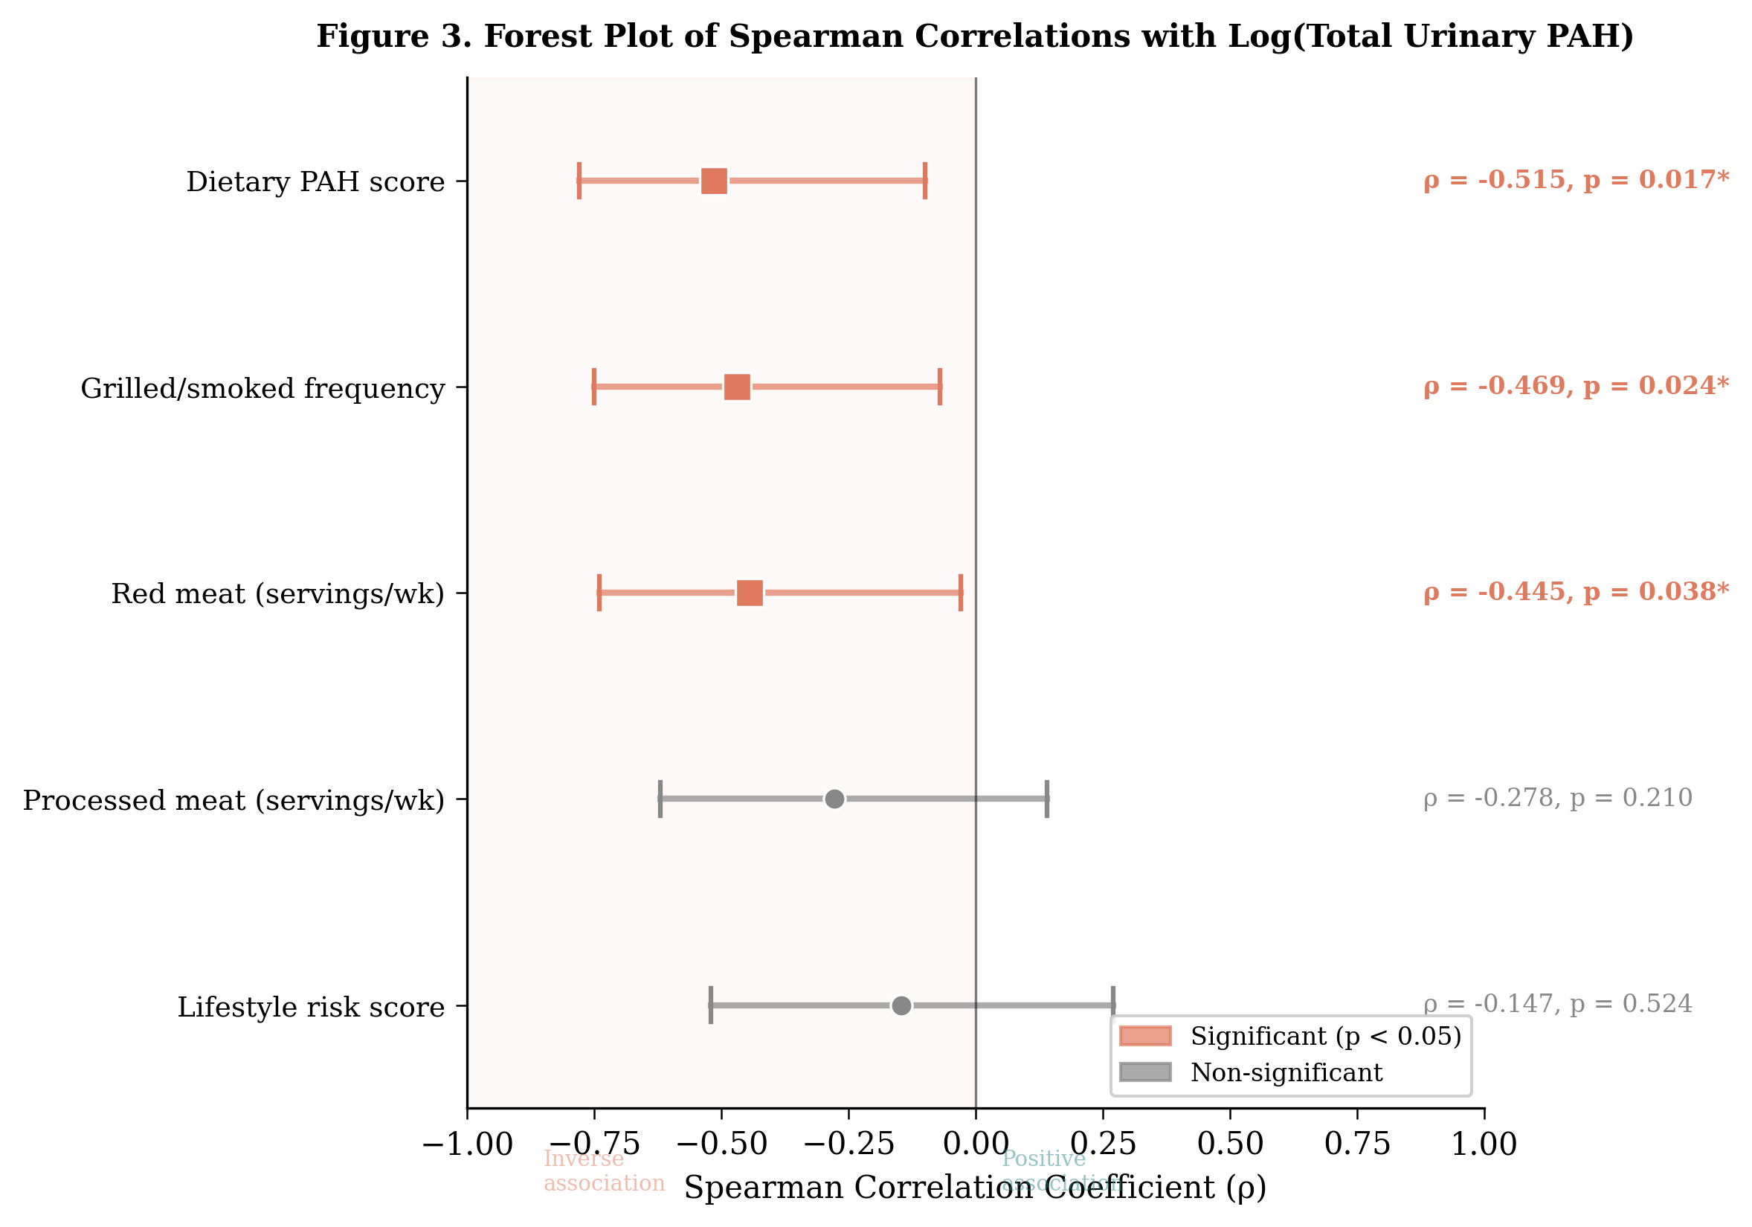
Figure 2. Forest plot of Spearman rank correlations between dietary/lifestyle variables and log-transformed total urinary PAH. Square markers with horizontal bars represent point estimates and approximate 95% confidence intervals. Orange markers indicate statistically significant associations (p < 0.05); grey markers indicate non-significant associations.
3.4 Smoking-stratified analysis: evidence of qualitative effect modification
To investigate whether the null composite-score association reflected opposing effects within smoking strata, Spearman correlations were computed separately for former and never smokers (Figure 3). Among former smokers (n = 11), the lifestyle score showed a positive trend that approached but did not reach statistical significance (ρ = +0.512, p = 0.089). Among never smokers (n = 14), the association was inverse (ρ = −0.287, p = 0.366). These opposing directional trends constitute a qualitative interaction: smoking history reverses the direction of the lifestyle score–PAH relationship. When the two strata are pooled, the positive and negative trends cancel, producing the spurious null overall result (ρ = −0.147, p = 0.524). This is the most important finding of the present study and is explored further in the Discussion.

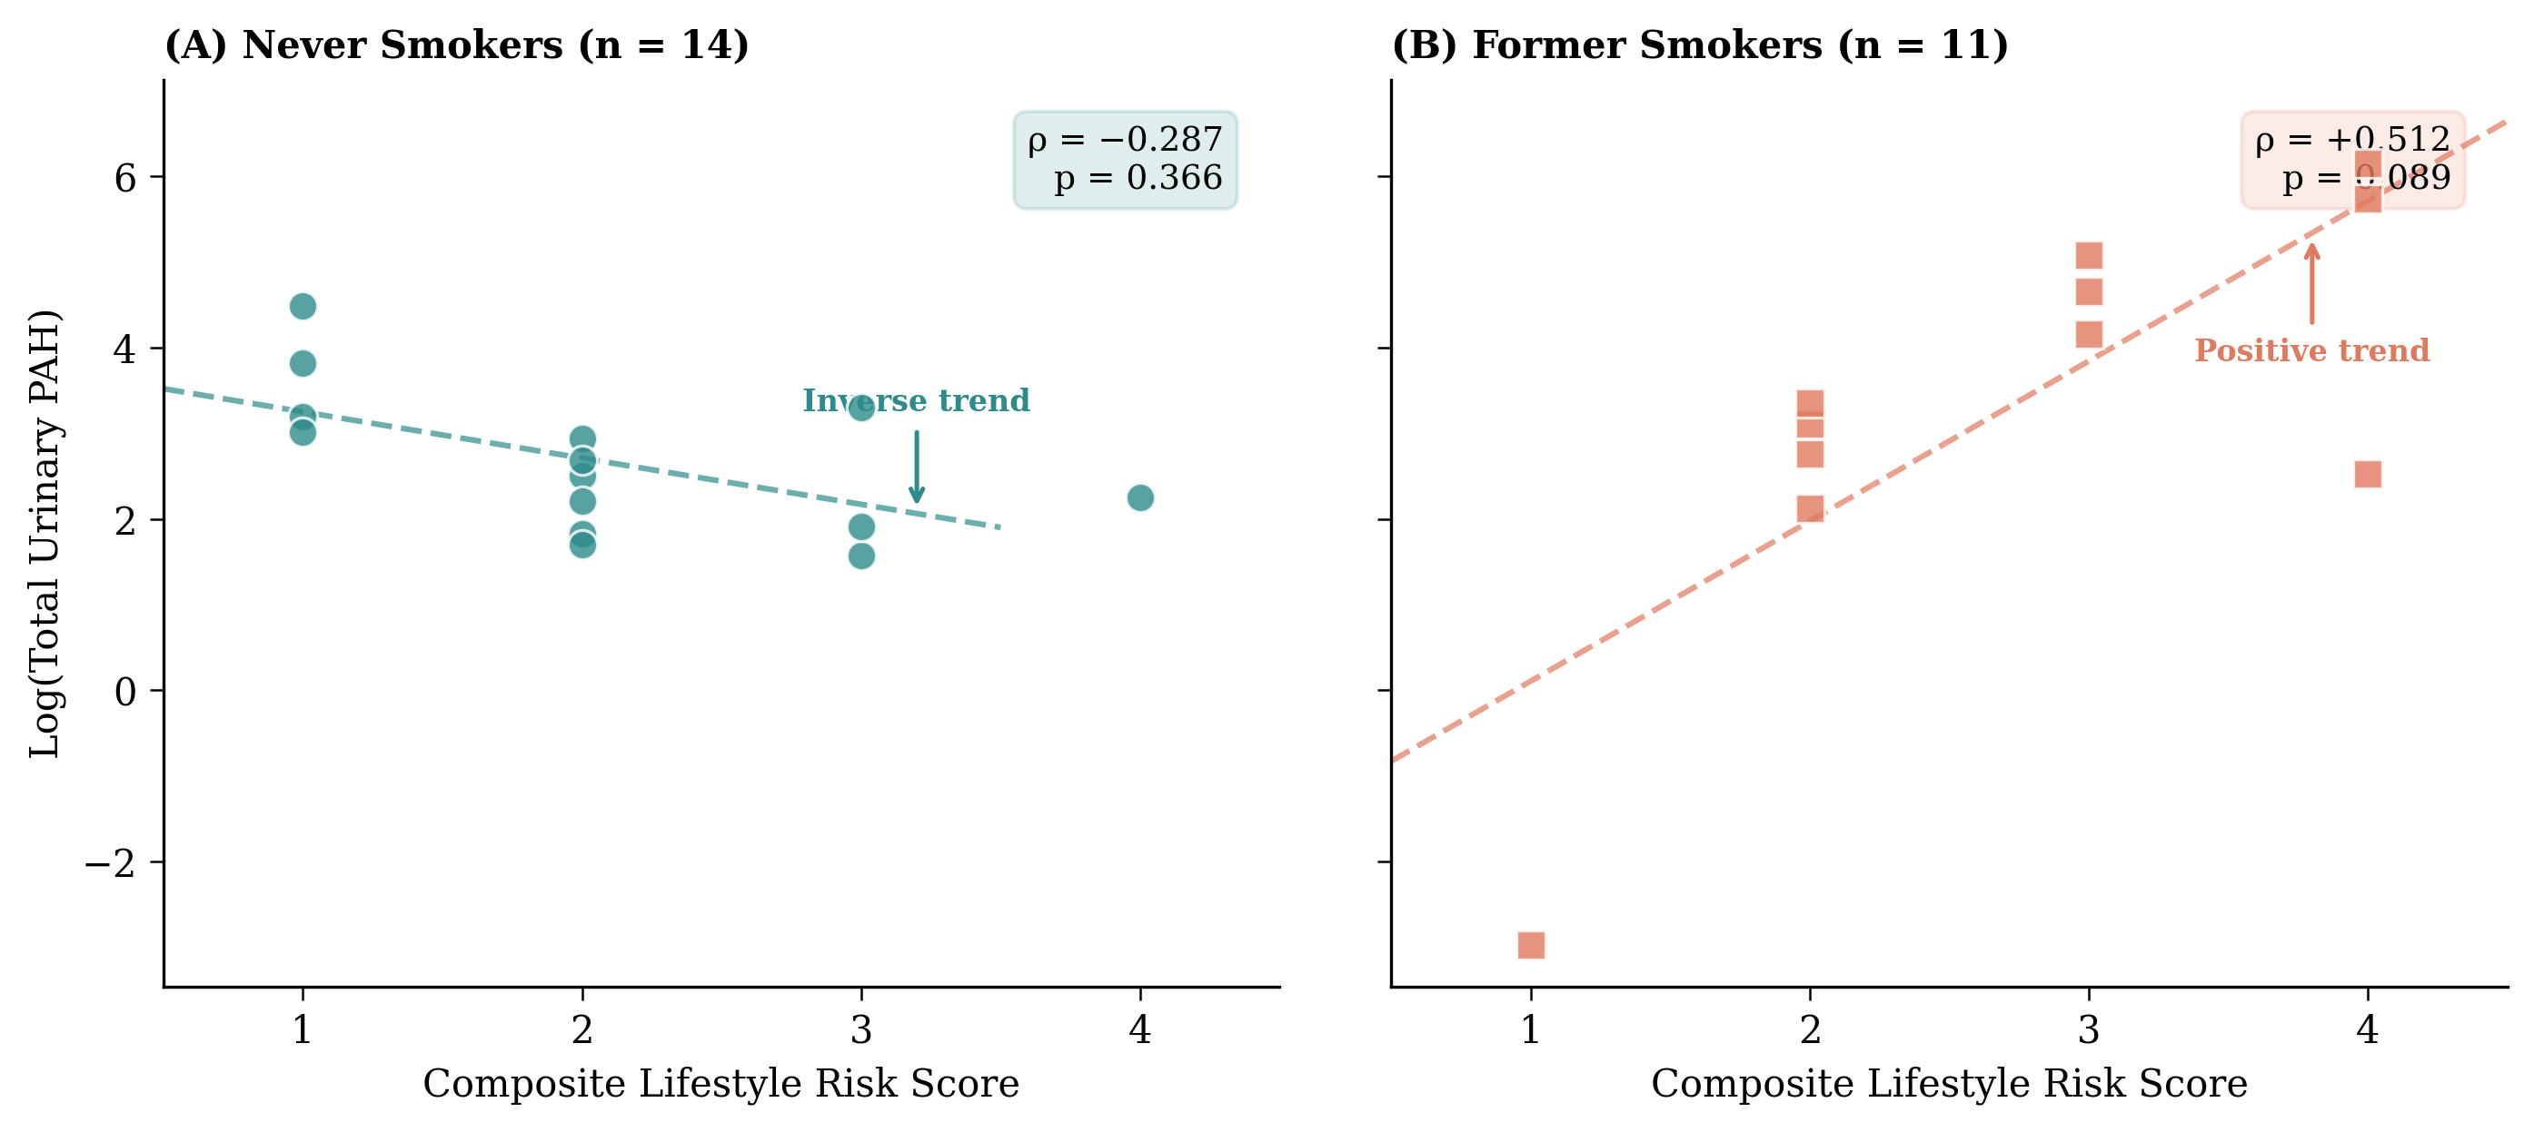
Figure 3. Smoking-stratified scatter plots of composite lifestyle risk score versus log-transformed total urinary PAH. (A) Never smokers (n = 14) show an inverse trend (ρ = −0.287, p = 0.366). (B) Former smokers (n = 11) show a positive trend (ρ = +0.512, p = 0.089). Dashed lines represent log-linear trend lines. The opposing directional trends explain the null pooled association.
3.5 Regression modelling
Linear regression results are presented in Table 3. In the unadjusted model (Model 1, n = 21), the lifestyle risk score was not a significant predictor of log-PAH (β = −0.35, 95% CI −1.55 to 0.85, p = 0.55; R² = 0.019). After adjustment for age and BMI (Model 2, n = 13), the coefficient reversed direction but remained non-significant (β = +0.28, 95% CI −1.42 to 1.98, p = 0.71; R² = 0.12). The extremely wide confidence intervals in both models reflect the imprecision inherent to this pilot sample size.

Table 3. Linear regression models predicting log-transformed total urinary PAH.
Variable | Model 1 (Unadjusted) β (95% CI) | p | Model 2 (Adjusted) β (95% CI) | p
Intercept | 3.09 (1.05, 5.13) | 0.005 | 1.86 (−6.92, 10.64) | 0.64
Lifestyle risk score | −0.35 (−1.55, 0.85) | 0.55 | 0.28 (−1.42, 1.98) | 0.71
Age (years) | — | — | 0.02 (−0.10, 0.14) | 0.72
BMI (kg/m²) | — | — | −0.04 (−0.36, 0.28) | 0.78
Model 1: n = 21, R² = 0.019. Model 2: n = 13, R² = 0.12. The substantial reduction in sample size from 21 to 13, driven by missing BMI data, severely limits interpretability of adjusted estimates. CI, confidence interval.

4. DISCUSSION
This multicenter pilot study is, to our knowledge, the first to evaluate the association between a composite lifestyle PAH risk score and urinary PAH biomarker concentrations in a sub-Saharan African male cohort. Three principal findings emerged. First, in this pilot study, we did not find evidence of a linear association between the composite lifestyle score and urinary PAH levels, although the wide confidence intervals preclude definitive conclusions. Second, individual dietary components showed statistically significant inverse correlations with urinary PAH, a counterintuitive pattern whose mechanistic underpinnings are explored in preliminary analyses of this cohort (Teme RE et al., manuscript in preparation). Third—and most importantly—smoking-stratified analysis revealed opposing directional associations, identifying smoking history as a qualitative effect modifier and generating a hypothesis that warrants testing in adequately powered studies.
4.1 Smoking as a qualitative effect modifier: the central finding
The opposing directional associations in former smokers (ρ = +0.512) versus never smokers (ρ = −0.287) represent the most novel and methodologically important finding of this pilot study. Tobacco smoking is the most potent known inducer of CYP1A1 and CYP1B1 via aryl hydrocarbon receptor (AhR) activation [27,28]. Even after cessation, persistent epigenetic modifications—particularly DNA methylation changes at the AhR repressor (AHRR) gene and CYP1A1 promoter regions—may maintain altered enzyme expression trajectories for years [29,30]. In our cohort, where median cessation interval was approximately 8 years, former smokers may have retained sufficient metabolic priming to generate detectable parent PAH in proportion to cumulative lifestyle exposure.
Among never smokers lacking this enzymatic priming, the dominant signal was the adaptive enzyme induction from chronic dietary PAH exposure, producing the inverse association. The two highest urinary PAH values in the cohort (471.0 and 310.2 mg/L) were recorded in former smokers with concurrent occupational exposure as auto mechanics, supporting the hypothesis that smoking-primed metabolic capacity amplifies the urinary PAH response to concurrent exposures.
These findings carry direct methodological implications: pooling former and never smokers introduces effect modification bias, cancelling signals in both strata and producing a spurious null result. Power calculations indicate n > 60 per smoking stratum would be required to detect ρ = ±0.50 with 80% power at α = 0.05, establishing a clear sample size target for confirmatory studies. A more detailed analysis of smoking-specific metabolic effects in this cohort is reported separately (Teme RE et al., manuscript in preparation).
4.2 The failure of composite scoring in a high-exposure setting
Composite lifestyle risk scores have proven informative in populations with relatively low baseline PAH exposure. Data from the US National Health and Nutrition Examination Survey (NHANES) 2001–2016 demonstrated that urinary hydroxylated PAH metabolites serve as stable biomarkers of multi-pathway exposure, with smoking, dietary habits, and residential factors contributing independently [7]. A global review of monohydroxylated PAH metabolites in 36 countries confirmed that dietary patterns, cooking practices, and tobacco use are significant determinants of urinary OH-PAH levels in diverse populations [8]. A recent European biomonitoring initiative (HBM4EU) identified smoking status, diet, and environmental factors as key determinants of PAH exposure across multiple countries [24,31]. Our findings suggest that in settings where a single dominant source—dietary PAH—already saturates the exposure distribution, additional lifestyle components fail to provide meaningful incremental discrimination.
The Nigerian dietary PAH landscape provides context. Charcoal-grilled suya from Nnewi and Port Harcourt markets contains benzo[a]pyrene at 8–25 µg/100 g, far exceeding European Union limits [14,18]. A recent Nigerian study demonstrated significant associations between occupational PAH exposure and inflammation, oxidative DNA damage, and organ dysfunction among barbecue makers in Southern Nigeria [15]. When dietary exposure of this magnitude represents the universal baseline, the incremental variance contributed by occupational exposure, smoking history, or physical inactivity is proportionally negligible.
4.3 The dietary PAH paradox in context
The significant inverse correlations between dietary PAH predictors and urinary PAH (ρ ranging from −0.445 to −0.515) are directionally opposite to expectation. In preliminary analyses of this cohort, we have proposed that chronic high-dose dietary PAH exposure induces adaptive upregulation of xenobiotic-metabolising enzymes via AhR signalling (Teme RE et al., manuscript in preparation). This enhanced metabolic clearance would shift excretion toward conjugated metabolites not captured by our GC-FID protocol, which measured parent PAH without enzymatic hydrolysis. The inverse associations extended across multiple individual PAH congeners, arguing against a chance finding.
This methodological distinction is crucial. Most human biomonitoring studies measure hydroxylated PAH metabolites (OH-PAHs) after enzymatic hydrolysis of glucuronide and sulphate conjugates [7,8,26]. Our measurement of unconjugated parent PAH is methodologically distinct and limits comparability. A positive dietary–PAH association reported in Chinese elderly populations [32] and European adults [31] may reflect this methodological difference, as those studies employed hydrolysis-inclusive protocols measuring total (free + conjugated) metabolites.
4.4 Comparison with the existing literature
Environmental and behavioural determinants of PAH exposure have been characterised in various populations but rarely in African cohorts. A recent Nigerian exposome study demonstrated that environmental and behavioural factors contribute significantly to PAH burden, underscoring the need for population-specific exposure assessment frameworks in Africa [22]. The HBM4EU initiative identified smoking, diet, and proximity to pollution sources as the primary determinants of PAH exposure among European adults and children [24,31]. A multimodal approach to prostate cancer early detection and risk assessment has been proposed for sub-Saharan African populations, integrating environmental exposure biomarkers with traditional clinical markers [25]. Our study contributes to this emerging framework by demonstrating that composite exposure indices require population-specific calibration before they can serve as useful epidemiological tools in high-exposure settings.
4.5 Strengths and limitations
Strengths include the multicenter design capturing geographic and occupational diversity; comprehensive assessment of 16 EPA-priority PAH congeners; evaluation of both individual and composite predictors; the novel application of composite exposure scoring in a West African context; and the critical smoking-stratified analysis revealing a qualitative effect modifier.
Limitations must be considered when interpreting these pilot findings. The sample size (n = 25) constrains statistical power, particularly for the adjusted regression and subgroup analyses; the wide confidence intervals in Table 3 underscore this imprecision. Cross-sectional design precludes causal inference. The GC-FID method measured unconjugated parent PAH without enzymatic hydrolysis—a key limitation that affects both the magnitude and directionality of associations relative to studies employing hydrolysis-inclusive protocols. Urinary PAH was not creatinine-corrected. Spot urine captures only a narrow 24–48-hour exposure window. Self-reported dietary data are subject to recall bias. The composite score assigned equal weight to components, which may not reflect their true relative contributions. Genetic polymorphisms in PAH-metabolising enzymes (CYP1A1, GSTM1, GSTT1) were not assessed, precluding gene–environment interaction analysis. Three participants’ diagnoses were confirmed through a machine learning consensus approach subsequently validated by histopathology; while the agreement strengthens confidence, the reliance on ML prediction for initial classification is a non-standard approach that readers should consider.

5. CONCLUSIONS
In this multicenter pilot study of 25 Nigerian men with prostate diseases, a four-component composite lifestyle PAH risk score did not significantly predict urinary PAH concentrations. The null result concealed clinically meaningful heterogeneity: smoking history functioned as a qualitative effect modifier, producing opposing positive and inverse trends in former versus never smokers, respectively. This hypothesis-generating finding warrants confirmation in adequately powered studies with n > 60 per smoking stratum. Future investigations should employ smoking-stratified designs, hydrolysis-inclusive analytical protocols, creatinine correction, and CYP1A1/GSTM1 genotyping to dissect the complex interplay between lifestyle exposures and PAH metabolism in West African populations at elevated prostate cancer risk.

REFERENCES
1. Abdel-Shafy HI, Mansour MSM. A review on polycyclic aromatic hydrocarbons: source, environmental impact, effect on human health and remediation. Egypt J Pet. 2016;25(1):107–23. doi:10.1016/j.ejpe.2015.03.011
2. Montano L, Mauceri C, Cibelli V, et al. Polycyclic aromatic hydrocarbons (PAHs) in the environment: occupational exposure, health risks, and fertility implications. Toxics. 2025;13(3):151. doi:10.3390/toxics13030151
3. Kim KH, Jahan SA, Kabir E, Brown RJC. A review of airborne polycyclic aromatic hydrocarbons (PAHs) and their human health effects. Environ Int. 2013;60:71–80. doi:10.1016/j.envint.2013.07.019
4. Louro H, Gomes BC, Saber AT, et al. The use of human biomonitoring to assess occupational exposure to PAHs in Europe: a comprehensive review. Toxics. 2022;10(8):480. doi:10.3390/toxics10080480
5. Nebert DW, Dalton TP. The role of cytochrome P450 enzymes in endogenous signalling pathways and environmental carcinogenesis. Nat Rev Cancer. 2006;6(12):947–60. doi:10.1038/nrc2015
6. Styszko K, Pamuła J, Pac A, Sochacka-Tatara E. Biomarkers for polycyclic aromatic hydrocarbons in human excreta: recent advances in analytical techniques—a review. Environ Geochem Health. 2023;45(10):7099–113. doi:10.1007/s10653-023-01699-1
7. Han L, Wang Q, Sun Y, et al. Urinary polycyclic aromatic hydrocarbon metabolites as stable biomarkers for multi-pathway exposure to PAHs: NHANES 2001–2016. Front Public Health. 2023;11:1190948. doi:10.3389/fpubh.2023.1190948
8. Huang S, Fang L, Yu S, Long C, Yu Y. Human internal exposure to polycyclic aromatic hydrocarbon: a global review of monohydroxylated metabolites and associated health risks. Hyg Environ Health Adv. 2026;17:100165. doi:10.1016/j.heha.2025.100165
9. IARC Working Group on the Evaluation of Carcinogenic Risks to Humans. Some non-heterocyclic polycyclic aromatic hydrocarbons and some related exposures. IARC Monographs on the evaluation of carcinogenic risks to humans. 2010;92:1.
10. Pratt MM, John K, MacLean AB, Afework S, Phillips DH, Poirier MC. Polycyclic aromatic hydrocarbon (PAH) exposure and DNA adduct semi-quantitation in archived human tissues. Int J Environ Res Public Health. 2011;8(7):2675–91. doi:10.3390/ijerph8072675
11. Ding Q, Hao T, Gao Y, Jiang S, Zhu Y, Huang YE, Liang Y. Associations of co-exposure to polycyclic aromatic hydrocarbons and heavy metals with sex steroid hormones among children aged 6–19 years. Hormone Research in Paediatrics. 2026 Jan 12;99(1):70-80. doi.org/10.1159/000541875
12. Cross AJ, Peters U, Kirsh VA, et al. A prospective study of meat and meat mutagens and prostate cancer risk. Cancer Res. 2005;65(24):11779–84. doi:10.1158/0008-5472.CAN-05-2191
13. Yu K-E, Mitra J, Starling AP, et al. Diet, polycyclic aromatic hydrocarbons, and oxidative stress biomarkers in pregnancy: a cohort study. Environ Res. 2025;275:121399. doi:10.1016/j.envres.2025.121399
14. Nsonwu-Anyanwu AC, Onyenweaku FC, Ojiako BO, et al. Association of exposure to polycyclic aromatic hydrocarbons with inflammation, oxidative DNA damage and renal–pulmonary dysfunctions in barbecue makers in Southern Nigeria. Rep Biochem Mol Biol. 2022;11(1):74–82. doi:10.52547/rbmb.11.1.74
15. Tongo I, Ogbeide O, Ezemonye L. Human health risk assessment of polycyclic aromatic hydrocarbons (PAHs) in smoked fish species from markets in Southern Nigeria. Toxicol Rep. 2017;4:55–61. doi:10.1016/j.toxrep.2016.12.006
16. Bray F, Laversanne M, Sung H, et al. Global cancer statistics 2022: GLOBOCAN estimates of incidence and mortality worldwide for 36 cancers in 185 countries. CA Cancer J Clin. 2024;74(3):229–63. doi:10.3322/caac.21834
17. Schafer EJ, Laversanne M, Sung H, Soerjomataram I, Briganti A, Dahut W, Bray F, Jemal A. Recent patterns and trends in global prostate cancer incidence and mortality: an update. European Urology. 2025 Mar 1;87(3):302-13. doi.org/10.1016/j.eururo.2024.11.013
18. Ekhator OC, Udowelle NA, Igbiri S, Asomugha RN, Frazzoli C, Orisakwe OE. Street foods exacerbate effects of the environmental burden of polycyclic aromatic hydrocarbons (PAHs) in Nigeria. Environmental Science and Pollution Research. 2018 Feb;25(6):5529-38. doi.org/10.1007/s11356-017-0894-1
19. Peluso A, Rastogi D, Klasky HB, Logan J, Maguire D, Grant J, Christian B, Hanson HA. Environmental determinants of health: Measuring multiple physical environmental exposures at the United States census tract level. Health & place. 2024 Sep 1;89:103303. doi.org/10.1016/j.healthplace.2024.103303
20. Bennitt FB, Wozniak S, Causey K, Spearman S, Okereke C, Garcia V, Hashmeh N, Ashbaugh C, Abdelkader A, Abdoun M, Abdurebi MJ. Global, regional, and national burden of household air pollution, 1990–2021: a systematic analysis for the Global Burden of Disease Study 2021. The Lancet. 2025 Apr 5;405(10485):1167-81. DOI: 10.1016/S0140-6736(24)02840-X
21. Ding E, Wang Y, Liu J, Tang S, Shi X. A review on the application of the exposome paradigm to unveil the environmental determinants of age-related diseases. Hum Genomics. 2022;16(1):54. doi:10.1186/s40246-022-00428-6
22. Dlamini Z, Alaouna M, Marutha T, Mkhize-Kwitshana Z, Mbodi L, Chauke-Malinga N, Luvhengo TE, Marima R, Hull R, Skepu A, Ntwasa M. The exposome perspective: environmental and infectious agents as drivers of cancer disparities in low-and middle-income countries. Cancers. 2025 Jul 31;17(15):2537. doi.org/10.3390/cancers17152537
23. Karakoltzidis A, Sarigiannis D, Løseth ME, et al. Polycyclic aromatic hydrocarbon (PAH) exposure among European adults: evidence from the HBM4EU aligned studies. Environ Int. 2025;198:109383. doi:10.1016/j.envint.2025.109383
24. F. Fernández S, Poteser M, Govarts E, Pardo O, Coscolla C, Schettgen T, Vogel N, Weber T, Murawski A, Kolossa-Gehring M, Ruether M. Determinants of exposure to acrylamide in European children and adults based on urinary biomarkers: results from the “European Human Biomonitoring Initiative” HBM4EU participating studies. Scientific Reports. 2023 Dec 2;13(1):21291. doi.org/10.1038/s41598-023-48738-6
25. Teme R, Ogenyi S, Asomugha A. A multimodal approach to prostate cancer early detection, risk assessment and biomarker-guided therapy: considerations for sub-Saharan Africa populations. In Press: Tumor Discov. 2025. doi:10.36922/td.025010134
26. Hua L, Gao Y, Guo S, Zhu H, Yao Y, Wang B, Fang J, Sun H, Xu F, Zhao H. Urinary metabolites of polycyclic aromatic hydrocarbons of rural population in Northwestern china: oxidative stress and health risk assessment. Environmental Science & Technology. 2024 Apr 26;58(18):7758-69. doi.org/10.1021/acs.est.4c00122
27. Rothhammer V, Quintana FJ. The aryl hydrocarbon receptor: an environmental sensor integrating immune responses in health and disease. Nat Rev Immunol. 2019;19(3):184–97. doi:10.1038/s41577-019-0125-8
28. Opitz CA, Holfelder P, Prentzell MT, Trump S. The complex biology of aryl hydrocarbon receptor activation in cancer and beyond. Biochemical Pharmacology. 2023 Oct 1;216:115798. doi.org/10.1016/j.bcp.2023.115798
29. Onuzulu CD, Lee S, Basu S, et al. Novel DNA methylation changes in mouse lungs associated with chronic smoking. Epigenetics. 2024;19(1):2322386. doi:10.1080/15592294.2024.2322386
30. Breitling LP, Yang R, Korn B, Burwinkel B, Brenner H. Tobacco-smoking-related differential DNA methylation: 27K discovery and replication. Am J Hum Genet. 2011;88(4):450–57. doi:10.1016/j.ajhg.2011.03.003
31. Skov-Jeppesen SM, Kobylecki CJ, Jacobsen KK, Bojesen SE. Aryl hydrocarbon receptor repressor (AHRR) methylation predicts risk of vascular disease: a cohort study of the general population. Int J Surg. 2024;110(11):6953–61. doi:10.1097/JS9.0000000000001922
32. Gao YF, Wang BW, Hua LT, et al. Risk assessment and exposure patterns of hydroxypolycyclic aromatic hydrocarbons in elderly population: insights from urinary metabolite levels and dietary habits. J Environ Sci. 2026;163:37–47. doi:10.1016/j.jes.2025.10.018
33. Patel AP, Mehta SS, White AJ, et al. Urinary polycyclic aromatic hydrocarbon metabolites and mortality in the United States: a prospective analysis. PLoS One. 2021;16(5):e0252719. doi:10.1371/journal.pone.0252719
34. Yuan Q, Jin K, Zhou X, et al. Urinary polycyclic aromatic hydrocarbon metabolites are positively related to serum testosterone levels of males and serum estradiol levels of females among US adults. Front Endocrinol. 2022;13:1037098. doi:10.3389/fendo.2022.1037098
35. Murray IA, Patterson AD, Perdew GH. Aryl hydrocarbon receptor ligands in cancer: friend and foe. Nat Rev Cancer. 2014;14(12):801–14. doi:10.1038/nrc3846

