HISTOPATHOLOGICAL AND ENDOSCOPIC FEATURES OF GASTRIC POLYPS

ABSTRACT
Aims: To describe some general characteristics, macroscopic features, and histopathological features of various types of gastric polyps.
Study design: A retrospective cross-sectional descriptive study
Place and Duration of Study: Department of Pathology, University Medical Center, Ho Chi Minh City from January to December 2023.
Methodology: A total of 545 patients who underwent gastric polypectomy were included based on predefined inclusion criteria. Clinical information, endoscopic findings, and histopathological characteristics of 568 gastric polyp specimens were collected and analyzed descriptively.
Results: Gastric polyps were predominantly found in females, mostly in the 50-69 age group, and located in the gastric body and antrum. The majority of cases presented with >1 polyp, size < 10 mm, and were sessile (non-pedunculated). Non-inflammatory polyps were predominant. The rates of H.pylori infection and dysplasia were low; dysplasia observed was low-grade and of intestinal type.
Conclusion: Gastric polyps are predominantly benign, with fundic gland polyps being the most common, mainly found in females and in the 50-69 age group. Polyps are typically small, sessile, and located in the gastric body and antrum. The rates of H. pylori infection and dysplasia are low, and when dysplasia is present, it is low-grade. These findings highlight the importance of combining endoscopy and histopathological evaluation for accurate classification, supporting timely diagnosis and management, and reducing the risk of malignant transformation.
Keywords: gastric polyp, fundic gland polyp, hyperplastic polyp, histopathology, prevalence.

INTRODUCTION
Gastric polyps are lesions protruding from the gastric mucosa and can originate from various histological sources, including the mucosa and underlying histological structures [1]. The detection rate of gastric polyps is increasing due to the widespread use of gastroscopy [2]. Gastric polyps have become a major clinical issue due to their high prevalence and the malignant potential of some types if not detected early [3].
Currently, the primary method for detecting gastric polyps is gastroscopy, which allows direct observation of the polyps location, shape, size, and number. However, determining the exact type of polyp is difficult and requires histopathological diagnosis to guide appropriate treatment.
The prevalence of different types of gastric polyps varies by geographical location and predisposing factors, such as Helicobacter pylori (H.pylori) infection and autoimmune gastritis [1]. The incidence of fundic gland polyps has significantly increased with the widespread use of proton pump inhibitors (PPIs) and the increasing use of endoscopy [2]. Conversely, following a decline in H.pylori infection rates, hyperplastic polyps have become less common.
According to some studies in the adult population, over 90% of all gastric polyps are non-neoplastic, including fundic gland polyps and hyperplastic polyps; neoplastic polyps are less common [3,4]. If left untreated, neoplastic gastric polyps can recur and eventually become cancerous. Neoplastic gastric polyps have a 10-20% rate of malignant transformation and are considered precancerous lesions. The risk of malignant transformation increases with polyp size, and the number of polyps also influences this risk.
Currently, gastric cancer is the fifth most common cancer and the third leading cause of cancer death worldwide, with high mortality often due to late-stage detection [5]. Therefore, accurate histopathological diagnosis of gastric polyps is crucial to prevent the risk of malignant transformation.
Based on the issues outlined above, this study was conducted to evaluate the general characteristics, macroscopic features, and histopathological findings of various types of gastric polyps.

MATERIAL AND METHODS
Study Subjects 545 patients (102 men, 443 women) with gastric polyps who underwent polypectomy, with specimens sent to the Department of Pathology, University Medical Center Ho Chi Minh City, from January 2023 to December 2023.
2.1 Study Methods
A retrospective cross-sectional descriptive study.
2.2 Sampling
Convenience sampling of 568 gastric polyp samples collected from 545 patients (102 men, 443 women) meeting the inclusion criteria.
2.2.1 Inclusion Criteria:
All cases diagnosed with gastric polyps via gastroscopy who underwent polypectomy and histopathological examination.
Complete information available: name, age, sex, and esophagogastroduodenoscopy (EGD) results.
2.2.2 Exclusion Criteria:
Specimens unsuitable for histological evaluation.
Specimens histologically diagnosed as metastatic cancer.
Data Analysis: Data collected were synthesized, analyzed, and processed using StataMP 17.0 software.

RESULTS AND DISCUSSION
  - Fundic Gland Polyps (FGPs)
    - Age and Sex Characteristics:
Table 1. Age and sex characteristics of patients with fundic gland polyps.
Characteristics |  | Number (n) | Percentage (%) | Total (n)
Sex | Male | 81 | 18.2 | 444
Sex | Female | 363 | 81.8 | 444
Age groups (years) | 20 – 29 | 10 | 2.3 | 444
Age groups (years) | 30 – 39 | 31 | 7 | 444
Age groups (years) | 40 – 49 | 67 | 15.1 | 444
Age groups (years) | 50 – 59 | 158 | 35.5 | 444
Age groups (years) | 60 – 69 | 119 | 26.8 | 444
Age groups (years) | 70 – 79 | 53 | 11.9 | 444
Age groups (years) | ≥80 | 6 | 1.4 | 444

The youngest patient was 22 years old and the oldest was 83 years old. The mean age was 56.4 ± 11.8 years. The disease was most frequently observed in the 50–69 age group, accounting for 62.3% of cases. Compared with international studies, the age distribution in our study was relatively comparable. According to the study by Elhanafi S et al [2] , the mean age was 54.7 ± 13 years. Sonnenberg A et al [6] reported a mean age of 59.5 ± 13.1 years, while Argüello Viúdez L et al [7] found a mean age of 67.6 ± 13.9 years.
Most of the aforementioned studies [2,10] reported a mean age ranging from 54 to 67 years, which is consistent with the findings of our study.
Sex: In our study, the disease was more common in females than in males, with proportions of 81.8% and 18.2%, respectively (female-to-male ratio = 4.5:1). When compared with international studies, the female-to-male ratio observed in our study was relatively consistent. Elhanafi S et al [2] reported a female-to-male ratio of 4.7:1, while Sonnenberg A et al [6] reported a ratio of 1.3:1. Similarly, Argüello Viúdez L [7] et al found a female-to-male ratio of 2.2:1. Overall, the female-to-male ratio across studies ranged from 1.3:1 to 4.7:1. Based on our findings and comparison with previous international studies, there appears to be no substantial variation in sex distribution among patients diagnosed with this disease.
3.2.2 Macroscopic Features:
Table 2. Macroscopic features of fundic gland polyps
Characteristics |  | Number (n) | Percentage (%) | Total (n)
Location | Cardia | 3 | 0.7 | 459
Location | Fundus | 38 | 8.3 | 459
Location | Body | 409 | 89 | 459
Location | Antrum | 9 | 2 | 459
Number of polyps | 1 polyp | 188 | 41 | 459
Number of polyps | >1 polyp | 271 | 59 | 459
Size (mm) | <10 | 418 | 91.1 | 459
Size (mm) | 10 – 19 | 38 | 8.3 | 459
Size (mm) | 20 – 29 | 3 | 0.6 | 459
Pedunculation status | Pedunculated | 6 | 1.3 | 459
Pedunculation status | Sessile | 453 | 98.7 | 459

Location: In our study, polyps were most frequently located in the gastric body, accounting for 89.0% of cases, followed by the gastric fundus (8.3%), while other locations were less commonly observed. These findings are consistent with those reported by Gao W et al [8], who found that fundic gland polyps were most commonly located in the gastric body and fundus. Similarly, Carmack SW et al [9] reported the gastric body as the most frequent site, and Le Dinh Quang et al [10] also observed the highest proportion of polyps in the gastric body (48.9%).
Number of polyps: In our study, single polyps were less common than multiple polyps, accounting for 41% and 59%, respectively (Table 2). These results are comparable to those reported by Argüello Viúdez L et al [7], with rates of 17.5% for single polyps and 82.5% for multiple polyps.
In contrast, Kővári B et al [11] reported a higher prevalence of single polyps in sporadic FGP and a higher prevalence of multiple polyps in syndromic FGP. The discrepancy may be explained by limitations in our study, particularly the incomplete assessment of patient history, which precluded differentiation between sporadic and syndromic FGP.
Polyp size: In our study, polyps smaller than 10 mm accounted for the majority of cases (91.1%), while larger polyps were uncommon (8.9%). These findings are consistent with those of Kővári B et al [11] , who reported that most FGPs measured 1–7 mm, and with the study by Carmack SW et al [9], in which polyps <10 mm predominated.
Pedunculation status: In our study, sessile polyps predominated (98.7%), while pedunculated polyps were rare (1.3%). This distribution is consistent with the findings of Le Dinh Quang et al [10], who reported a non-pedunculated rate of 98.5%.
3.1.3 Histopathological features:
Table 3. Histopathological features of fundic gland polyps
Characteristics |  | Number (n) | Percentage (%) | Total (n)
Inflammation | No inflammation | 402 | 87.6 | 459
Inflammation | Inflamed | 57 | 12.4 | 459
H. pylori infection | Negative | 458 | 99.7 | 459
H. pylori infection | Positive | 1 | 0.2 | 459
Dysplasia status | Absent | 455 | 99.8 | 459
Dysplasia status | Present | 4 | 0.9 | 459
Dysplasia grade | Low-grade | 4 | 100 | 4
Dysplasia grade | High-grade | 0 | 0 | 4
Type of dysplasia | Gastric type | 4 | 100 | 4
Type of dysplasia | Intestinal type | 0 | 0 | 4
Type of dysplasia | Gastric foveolar type | 0 | 0 | 4
Type of dysplasia | Serrated | 0 | 0 | 4

Inflammation: Polyps without inflammation predominated (87.6%, 402 samples), while 12.4% (57 samples) had inflammation.
H.pylori Infection: In our study, the prevalence of H. pylori infection was very low (0.2%), while 99.8% of patients were H. pylori – negative. These results are consistent with previous studies reporting low infection rates, including Sonnenberg A et al [6] (0.22%) and Elhanafi S et al [2] (9.76%).
Dysplasia: We observed a very low prevalence of dysplasia (0.9%), with 99.1% of cases showing no dysplasia. This finding is consistent with the study by Kővári B et al [11], which also reported a dysplasia rate of 0.9%, and with the study by Le Dinh Quang et al [10], in which no cases of dysplasia were identified. All dysplastic cases were low-grade and of the intestinal type. These results suggest that, although fundic gland polyps may be associated with dysplasia, their prognosis remains favorable when dysplasia is low grade.
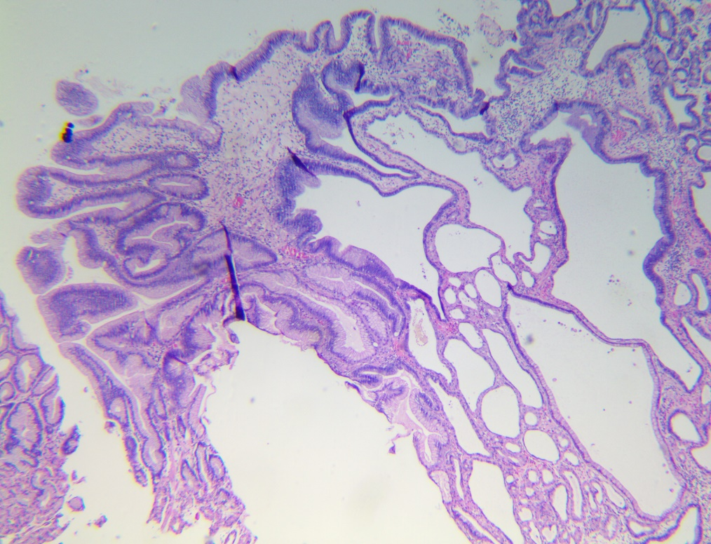
Figure 1: Fundic gland polyps with low-grade dysplasia at the surface
3.3. Hyperplastic Polyps
3.3.1 Age and Sex Characteristics:
Table 4. Age and sex characteristics of patients with hyperplastic polyps.
Characteristics |  | Number (n) | Percentage (%) | Total (n)
Sex | Male | 12 | 24.5 | 49
Sex | Female | 37 | 75.5 | 49
Age group (years) | 20 – 29 | 0 | 0 | 49
Age group (years) | 30 – 39 | 3 | 6.1 | 49
Age group (years) | 40 – 49 | 7 | 14.3 | 49
Age group (years) | 50 – 59 | 12 | 24.5 | 49
Age group (years) | 60 – 69 | 15 | 30.6 | 49
Age group (years) | 70 – 79 | 11 | 22.5 | 49
Age group (years) | ≥80 | 1 | 2 | 49

Age: The youngest patient was 35 years old and the oldest was 80 years old, with a mean age of 59.4 ± 11.7 years. The disease was most common in patients aged 50 – 69 years, accounting for 55.1% of cases. Compared with published studies worldwide, the mean age in our study is comparable, as most studies report a mean age ranging from 58 to 68 years [2,6,7].
Sex: The disease was more common in females than in males, with proportions of 75.5% and 24.5%, respectively (female-to-male ratio: 3.1:1). This ratio is comparable to those reported in previous studies, including Elhanafi S et al [2] (2.8:1) and Argüello Viúdez L et al [7] (1.6:1).
However, our findings differ from some studies, such as those by Sonnenberg A et al [6] (1:1) and Ahn JY et al [12] (1:1.5). These discrepancies may be attributed to differences in geographic distribution, the prevalence of gastritis, and H. pylori infection status.
3.3.2 Macroscopic Features:
Table 5. Macroscopic features of hyperplastic polyps
Characteristics |  | Number (n) | Percentage (%) | Total (n)
Location | Cardia | 0 | 0 | 49
Location | Fundus | 1 | 2 | 49
Location | Body | 33 | 67.4 | 49
Location | Antrum | 15 | 30.6 | 49
Number of polyps | 1 polyp | 30 | 61.2 | 49
Number of polyps | >1 polyp | 19 | 38.8 | 49
Size (mm) | <10 | 31 | 63.3 | 49
Size (mm) | 10 – 19 | 16 | 32.6 | 49
Size (mm) | 20 – 29 | 2 | 4.1 | 49
Pedunculation status | Sessile | 3 | 6.1 | 49
Pedunculation status | Pedunculated | 46 | 93.9 | 49

Location: In our study, polyps were most frequently located in the gastric body (67.4%), followed by the antrum (30.6%), while other locations were rare. This distribution differs from previous studies, including those by Kővári B et al [11] (2021), Vos S et al [13], Abraham SC et al [14] and Le Dinh Quang et al [10], which reported the antrum as the most common site. These differences may be related to geographic and ethnic variations.
Number of polyps: In our study, single polyps were significantly more common than multiple polyps, accounting for 61.2% and 38.8% of cases, respectively. These findings are consistent with those reported by Argüello Viúdez L et al [7], who observed proportions of 60% for single polyps and 40% for multiple polyps.
Size: In our study, polyps <10 mm were most common (63.3%), followed by those measuring 10 – 19 mm (32.6%) and 20–29 mm (4.1%). These findings are consistent with studies by Kővári B et al [11] (2021) and Vos S et al [13] (2020), which reported that most hyperplastic polyps measured <20 mm, as well as with the study by Carmack SW et al [9], in which polyps <10 mm predominated.
Pedunculation status: In our study, sessile polyps predominated (93.9%) compared with pedunculated polyps (6.1%) (Table 6). These findings are consistent with those reported by Ahn JY et al [12], who observed rates of 96.4% for sessile and 3.6% for pedunculated polyps, and by Le Dinh Quang et al [10], with corresponding rates of 95.6% and 4.4%.
3.3.3 Histopathological Features:
Table 6. Histopathological features of hyperplastic polyps
Characteristics |  | Number (n) | Percentage (%) | Total (n)
Inflammation | No inflammation | 31 | 63.3 | 49
Inflammation | Inflammation | 18 | 36.7 | 49
H. pylori infection | Negative | 48 | 98 | 49
H. pylori infection | Positive | 1 | 2 | 49
Dysplasia status | Absent | 48 | 98 | 49
Dysplasia status | Present | 1 | 2 | 49
Dysplasia grade | Low-grade | 1 | 100 | 1
Dysplasia grade | High-grade | 0 | 0 | 1
Type of dysplasia | Intestinal type | 1 | 100 | 1
Type of dysplasia | Gastric type | 0 | 0 | 1
Type of dysplasia | Gastric foveolar type | 0 | 0 | 1
Type of dysplasia | Serrated type | 0 | 0 | 1

Inflammation: Polyps without inflammation (63.3%, 31 samples) were more common than those with inflammation (36.7%, 18 samples).
H.pylori Infection: In our study, H. pylori – positive polyps accounted for 2% of cases, which is comparable to the rate reported by Sonnenberg A et al [6] (1.02%) but differs from that reported by Elhanafi S et al [2] (31.03%). These differences may be attributable to geographic variation and differences in H. pylori treatment practices across countries. A limitation of our study is that specific diagnostic methods for H. pylori infection were not applied to the study samples..
Dysplasia status: In our study, dysplasia was identified in 2% of cases, all of which were low-grade and of the intestinal type. These findings are consistent with those reported by Kővári B et al [11], who noted a low prevalence of dysplasia (approximately 4%), predominantly of the intestinal and gastric foveolar types. Similar low rates were also reported by Le Dinh Quang et al [10] (0.3% low-grade dysplasia) and Carmack et al [9] (<3%).
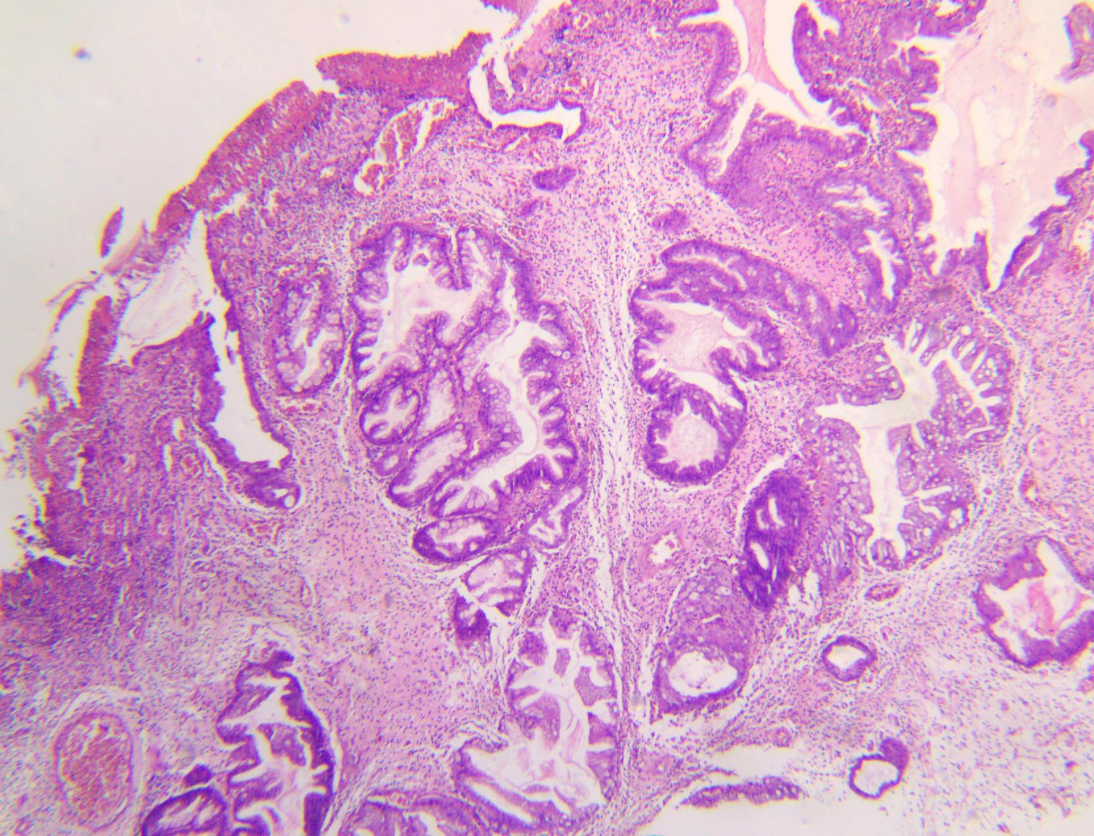
Figure 2: Hyperplastic polyp with low-grade dysplasia
3.4. Oxyntic Gland Adenoma
3.4.1 Age and Sex Characteristics:
Our study identified one case of Oxyntic gland adenoma. The mean age of patients with this tumor in our study was comparable to that reported in the literature, most commonly occurring in the sixth to seventh decades of life. Most studies have reported a male predominance, with male proportions ranging from 54.5% to 75%. In contrast, our study and that of Elhanafi S et al [2] reported exclusively female cases, while Singhi AD et al [15] observed a female predominance (60%).
3.4.2 Histopathological features
Our study is similar to that of Bertz S et al [16], as acid-secreting adenomas predominated over other types of adenomas.The case presented with multiple polyps, whereas Argüello Viúdez L et al [7] reported a markedly higher proportion of solitary polyps compared with multiple polyps (86.4% vs. 13.6%). In addition, the polyp in our study measured 15 mm, was located in the gastric body, and was sessile. In contrast, Le Dinh Quang et al [10] reported that adenomas were most frequently located in the antrum (46.7%), with 33.3% being pedunculated and 86.6% showing dysplasia, including 6.7% low-grade dysplasia. The discrepancies between our findings and those of previous studies may be explained by the very small sample size of our study, which included only one case of oxyntic gland adenoma among 568 cases. Larger multicenter studies are therefore needed to obtain more representative data
3.5. Dysplasia on Inflammatory Pseudo-polyp
In our study, one case of dysplasia arising in an inflammatory pseudopolyp was identified (0.2%). The patient was a 63-year-old female with a solitary polyp located in the gastric antrum, measuring 10 mm in size, sessile in morphology, and associated with inflammation and H.pylori infection.
3.6. Intramucosal Adenocarcinoma
3.6.1 Age and Sex Characteristics:
Our study identified one case of intramucosal adenocarcinoma (0.2%) in an 81-year-old male. This finding is comparable to that reported by Zea-Iriarte WL et al [17], who observed an adenocarcinoma rate of 1.8% with a typical age range of 72–86 years. However, their study reported cases in female patients, whereas our case occurred in a male patient.
3.6.2 Macroscopic Features:
The intramucosal adenocarcinoma in our study presented as a solitary, sessile polyp located in the gastric body, measuring 15 mm in size. In contrast, Zea-Iriarte WL et al [17] reported tumor sizes ranging from 10 to 20 mm, with the antrum being the predominant location rather than the gastric body. These differences may be attributable to the very small number of adenocarcinoma cases in our study, highlighting the need for larger sample sizes in future studies.
3.6.3 Histopathological Features:
The intramucosal adenocarcinoma was not associated with inflammation or H.pylori infection.
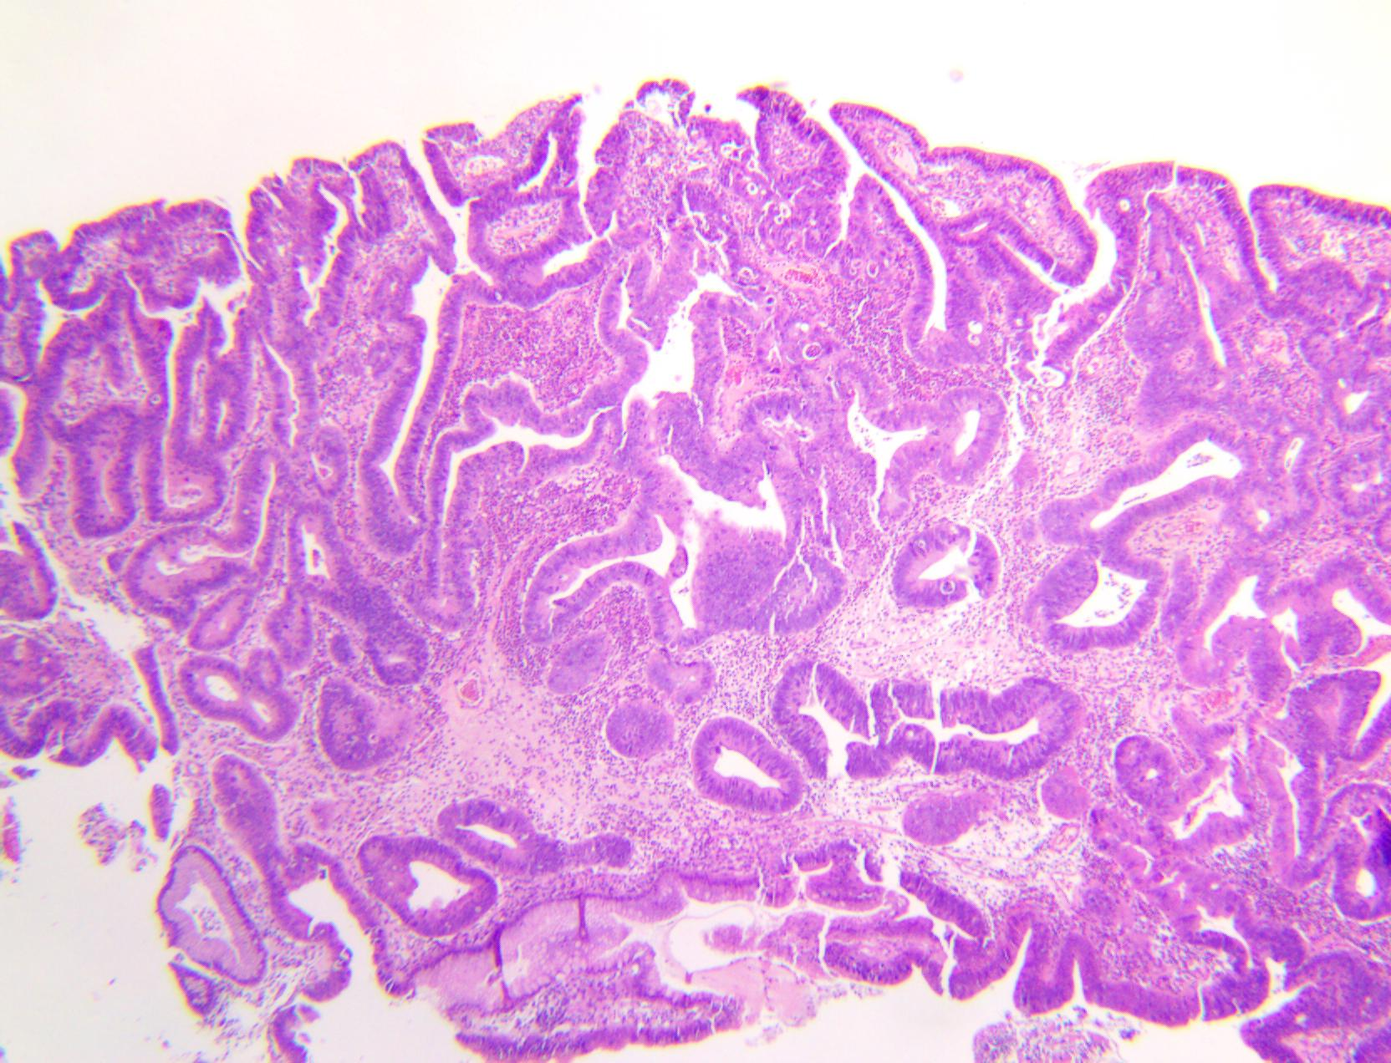
Figure 3: Adenocarcinoma in the mucosa

CONCLUSION
This study demonstrates that gastric polyps are predominantly benign, with non-neoplastic polyps accounting for the majority of cases. Fundic gland polyps were the most prevalent subtype, occurring mainly in females and in patients aged 50–69 years. Most polyps were small, sessile, and located in the gastric body. The prevalence of H.pylori infection and dysplasia was low, and when present, dysplasia was exclusively low-grade. These findings highlight the important role of combined endoscopic and histopathological evaluation in accurately classifying gastric polyps, facilitating appropriate management, and enabling early detection of lesions with malignant potential.
Consent

All authors declare that ‘written informed consent was obtained from the patient (or other approved parties) for publication of this case report and accompanying images. A copy of the written consent is available for review by the Editorial office/Chief Editor/Editorial Board members of this journal.

Ethical approval

All authors hereby declare that all experiments have been examined and approved by the appropriate ethics committee and have therefore been performed in accordance with the ethical standards laid down in the 1964 Declaration of Helsinki.

References

- Arteaga CD WR. Gastric Polyp. 2023 Jul 10.
- Elhanafi S, Saadi M, Lou W, et al. Gastric polyps: Association with Helicobacter pylori status and the pathology of the surrounding mucosa, a cross sectional study. World journal of gastrointestinal endoscopy. Aug 10 2015;7(10):995-1002. doi:10.4253/wjge.v7.i10.995
- Markowski AR, Markowska A, Guzinska-Ustymowicz K. Pathophysiological and clinical aspects of gastric hyperplastic polyps. World journal of gastroenterology. Oct 28 2016;22(40):8883-8891. doi:10.3748/wjg.v22.i40.8883
- Waldum H, Fossmark RJIJoMS. Gastritis, gastric polyps and gastric cancer. 2021;22(12):6548
- Ajani JA, D'Amico TA, Bentrem DJ, et al. Gastric Cancer, Version 2.2022, NCCN Clinical Practice Guidelines in Oncology. Journal of the National Comprehensive Cancer Network : JNCCN. Feb 2022;20(2):167-192. doi:10.6004/jnccn.2022.0008
- Sonnenberg A, Genta RM. Prevalence of benign gastric polyps in a large pathology database. Digestive and liver disease : official journal of the Italian Society of Gastroenterology and the Italian Association for the Study of the Liver. Feb 2015;47(2):164-9. doi:10.1016/j.dld.2014.10.004
- Argüello Viúdez L, Córdova H, Uchima H, et al. Gastric polyps: Retrospective analysis of 41,253 upper endoscopies. Gastroenterologia y hepatologia. Oct 2017;40(8):507-514. Pólipos gástricos: análisis retrospectivo de 41.253 endoscopias digestivas altas. doi:10.1016/j.gastrohep.2017.01.003
- Gao W, Huang Y, Lu S, Li C. The clinicopathological characteristics of gastric polyps and the relationship between fundic gland polyps, Helicobacter pylori infection, and proton pump inhibitors. Annals of palliative medicine. Feb 2021;10(2):2108-2114. doi:10.21037/apm-21-39
- Carmack SW, Genta RM, Schuler CM, Saboorian MH. The current spectrum of gastric polyps: a 1-year national study of over 120,000 patients. The American journal of gastroenterology. Jun 2009;104(6):1524-32. doi:10.1038/ajg.2009.139
- Le Dinh Quang, Quach Trong Duc. A study on the characteristics of gastric polyps. Ho Chi Minh City Journal of Medicine. 2017;21.
- Kővári B, Kim BH, Lauwers GY. The pathology of gastric and duodenal polyps: current concepts. Histopathology. Jan 2021;78(1):106-124. doi:10.1111/his.14275
- Ahn JY, Son DH, Choi KD, et al. Neoplasms arising in large gastric hyperplastic polyps: endoscopic and pathologic features. Gastrointestinal Endoscopy. 2014/12/01/ 2014;80(6):1005-1013.e2. doi:https://doi.org/10.1016/j.gie.2014.04.020
- Vos S, van der Post RS, Brosens LAA. Gastric Epithelial Polyps: When to Ponder, When to Panic. Surgical Pathology Clinics. 2020;13(3):431-452. doi:10.1016/j.path.2020.05.004
- Abraham SC, Montgomery EA, Singh VK, Yardley JH, Wu TT. Gastric adenomas: intestinal-type and gastric-type adenomas differ in the risk of adenocarcinoma and presence of background mucosal pathology. The American journal of surgical pathology. Oct 2002;26(10):1276-85. doi:10.1097/00000478-200210000-00004
- Singhi AD, Lazenby AJ, Montgomery EA. Gastric adenocarcinoma with chief cell differentiation: a proposal for reclassification as oxyntic gland polyp/adenoma. The American journal of surgical pathology. Jul 2012;36(7):1030-5. doi:10.1097/PAS.0b013e31825033e7
- Bertz S, Angeloni M, Drgac J, et al. Helicobacter Infection and Gastric Adenoma. Microorganisms. Jan 5 2021;9(1)doi:10.3390/microorganisms9010108
- Zea-Iriarte WL, Sekine I, Itsuno M, et al. Carcinoma in gastric hyperplastic polyps. A phenotypic study. Digestive diseases and sciences. Feb 1996;41(2):377-86. doi:10.1007/bf02093832

