Original Research Article

In Silico Multi-Epitope Vaccine Design Targeting Key Immunogenic Properties of Cryptococcus neoformans for the Prevention of Cryptococcal Meningitis

ABSTRACT

Aims: To develop a multi-epitope vaccine against Cryptococcus neoformans using computational immunoinformatics approaches for the prevention of cryptococcal meningitis.
Study design: Computational in silico vaccine design study.
Place and Duration of Study: The study was performed using publicly available protein sequence databases and bioinformatics tools during the project period.
Methodology: Four immunogenic proteins—Mp88, Hsp70, Chitin Deacetylase 2, and a GPI-anchored cell wall protein—were selected as vaccine targets. Cytotoxic T-cell, Helper T-cell, and B-cell epitopes were predicted and screened for antigenicity, immunogenicity, allergenicity, and toxicity. Selected epitopes were linked with suitable linkers and adjuvants to design a multi-epitope vaccine construct. Physicochemical properties, structural modelling, molecular docking with immune receptors, molecular dynamics simulations, codon optimization, and in silico cloning were performed.
Results: The final vaccine construct showed favorable physicochemical properties, structural stability, and strong interaction with immune receptor targets. Molecular dynamics simulations confirmed stability of the vaccine–receptor complex. Codon optimization and in silico cloning indicated efficient expression potential in a suitable host system.
Conclusion: The proposed multi-epitope vaccine construct is predicted to be stable, immunogenic, and suitable for further experimental validation as a preventive strategy against cryptococcal meningitis.

Keywords: Cryptococcal meningitis; multi-epitope vaccine; immunoinformatics; Cryptococcus neoformans

INTRODUCTION

Cryptococcus neoformans is the primary cause of cryptococcal meningitis, a potentially lethal infection that primarily affects immunocompromised individuals, particularly those living with HIV/AIDS [1, 2, 3]. Approximately 180,000 people worldwide succumb to cryptococcal meningitis annually, with a disproportionate burden in low- and middle-income countries where diagnostic and treatment resources are limited [4, 5]. Despite advancements in antifungal therapy, current treatment approaches remain largely reactive, relying on prolonged courses of medications that are often toxic, expensive, and difficult to access [6, 7]. Furthermore, the emergence of antifungal resistance and the risk of immune reconstitution inflammatory syndrome (IRIS) remain significant clinical concerns [8, 9]. Currently, there is no approved vaccine for cryptococcal disease, leaving a critical gap in preventive measures against this fatal infection [2, 10].
Recent progress in genomics and computational biology has facilitated the rise of reverse vaccinology. This approach utilizes immunoinformatics tools and genome-derived protein sequences to identify potential vaccine candidates without the requirement for pathogen cultivation [11, 12]. Reverse vaccinology represents a logical and cost-effective strategy for vaccine design, especially for complex fungal pathogens where traditional methods may fail.
To minimize safety risks while eliciting robust humoral and cellular immune responses, multi-epitope vaccine design has emerged as an advanced subunit strategy. This method involves predicting and combining specific B-cell and T-cell epitopes into a single synthetic construct [10, 9].
Recent silico studies have demonstrated the potential of these immunoinformatics-driven constructs as viable defensive prospects against various pathogens, including C. neoformans [11, 9]. In this study, four proteins were selected based on their immunogenic potential: Mp88, Hsp70, Chitin Deacetylase 2 (Cda2), and GPI-anchored cell wall protein. The FASTA sequences for these targets were retrieved from the UniProtKB database for further analysis
Provide a factual background, clearly defined problem, proposed solution, a brief literature survey and the scope and justification of the work done.]

- material and methods

  - Target protein selection
To identify the most effective vaccine candidates, four specific proteins were selected based on their high immunogenic potential and their critical roles in the pathogen's lifecycle. These included MP88 [17], HSP70 [16], chitin deacetylase 2 (CDA2) [15], and a GPI-anchored cell wall protein [14]. These targets were chosen because of their known ability to trigger a robust immune response and their accessibility on the fungal cell surface.
The primary amino acid sequences for each of these targets were retrieved in FASTA format from the UniProtKB database [13]. This ensured that the most accurate, manually curated, and up-to-date sequences were used as the foundation for all subsequent computational modeling and epitope mapping.

  - Epitope prediction and screening
Using IEDB [18] and NetMHCpan [19] the Cytotoxic T lymphocyte (MHC-I), Helper t lymphocyte (MHC-II), and B-cell epitopes were predicted. ·VaxiJen [20], AllerTOP [21], ToxinPred [22], and IFNepitope [23] screened for antigenicity, allergenicity, toxicity, and
IFN-γ induction respectively. The Population coverage analysis [24] ensured global applicability.

  - Vaccine construct design
The assembly of the multi-epitope vaccine was strategically engineered to ensure both structural stability and high processing efficiency. To prevent the formation of "junctional epitopes" and to facilitate proper proteasomal cleavage, the selected epitopes were merged using specialized AAY, GPGPG, and KK linkers [20]. These linkers act as physical spacers that allow each epitope to be presented effectively to the immune system without structural interference.
To further boost the vaccine's potency, alpha-defensin adjuvant was incorporated at the N-terminus, alongside a PADRE sequence, both of which serve to significantly enhance the overall immunogenicity of the construct [21]. These elements are vital for stimulating both innate and adaptive immune pathways. The final vaccine sequence, which attained a total length of 360 amino acids, was also appended with a 6xHis tag at the C-terminus to facilitate future downstream protein purification and detection. Throughout the design process, careful consideration was given to the role of post-translational modifications, as these factors are often decisive in determining the ultimate stability and biological efficacy of the vaccine within a host system [22].

  - Physicochemical analysis
ProtParam is an ExPASy tool that computes crucial physicochemical parameters—such as molecular weight, theoretical pI, amino acid composition, instability index, and hydropathicity (GRAVY)—from a protein's primary sequence to predict its stability and behavior. ProtParam analysis confirmed the vaccine to be [25]Stable (Instability Index: 25.81), Hydrophilic (GRAVY: -0.138), Thermostable (Aliphatic Index: 73.11).

  - Structure modeling and validation
The tertiary structure of the protein was predicted via AlphaFold which gives high-accuracy structural predictions. [26] To optimize local geometry and eliminate potential steric clashes, the raw model generated by AlphaFold was processed through GalaxyRefine server. [27] Post refining it was assessed through the validation tools PROCHECK [28], ERRAT [29], and ProSA-web [30] to ensure residues were within the favorable regions of the Ramachandran plot.

  - Molecular docking & dynamics
Docking with TLR4 via HADDOCK [31] yielded a strong binding score (-89.8). The interaction maps confirmed receptor engagement via PDBsum [32].
Molecular dynamics (MD) simulation in GROMACS, being a standard protocol for studying protein-ligand complexes, it provides enough time to observe protein stability, binding site dynamics, and conformational changes over the time of 100ns. GROMACS simulation (100 ns) [33] showed structural stability (RMSD ~1.0 nm, stable Rg and SASA).

  - Expression analysis
Codon optimization via Java Codon Adaptation Tool (JCat) [34]: This process yielded a Codon Adaptation Index (CAI) of 1.0, GC content of 51.67% indicating an ideal match with the host’s tRNA availability and stable mRNA formation.
Following the optimization, the sequence was computationally inserted into the pET28a(+) expression vector. The successful orientation of the construct was then verified and visualized using SnapGene [35].

- results

  - Sequence retrieval from NCBI:
The primary amino acid sequence of the target protein was successfully retrieved in FASTA format from the UniProtKB database [13]. This step was essential to ensure the use of a high-quality, manually curated sequence that is cross-referenced with existing experimental data. By sourcing the sequence from this comprehensive repository, a reliable foundation was established for all subsequent computational modeling and structural analysis.

  - Screening of epitopes:
Candidate epitopes were rigorously screened based on their antigenicity, allergenicity, and toxicity profiles to ensure the selection of only the most potent and safe peptides for the final vaccine construct

    - Screening of CTL and HTL epitopes:
Using the IEDB server, both CTL (MHCI) and HTL (MHC-II) epitopes were predicted from selected Cryptococcus neoformans proteins. These epitopes were screened for antigenicity, non-toxicity, non-allergenicity, and IFN-γ induction potential using tools like VaxiJen, ToxinPred, AllerTOP, and IFNepitope. Based on this analysis, 6 CTL and 7 HTL epitopes were shortlisted for the final vaccine construct due to their strong immunogenic profiles and safety characteristics (Table 1a and Table 1b)
Table 1a. Screened MHC-I epitopes.
Protein | Peptide | Allele | Toxicity | Allergenicity | Antigenicity | Immunogenicity
Mp88 | AMAGVISVV | HLA-A*02:03 | Non-Toxin | Non-Allergen | Antigen | Positive
 | STSTFQQRY | HLA-A*30:02 | Non-Toxin | Non-Allergen | Antigen | Positive
 | SAYPPGWYI | HLA-A*68:02 | Non-Toxin | Non-Allergen | Antigen | Positive
 | TAMAGVISV | HLA-A*68:02 | Non-Toxin | Non-Allergen | Antigen | Positive
 | TAMAGVISV | HLA-A*02:06 | Non-Toxin | Non-Allergen | Antigen | Positive
CDA 2 | VTEQDVTDNY | HLA-B*44:02 | Non-Toxin | Non-Allergen | Antigen | Positive
 | TEIASSFPTI | HLA-B*40:01 | Non-Toxin | Non-Allergen | Antigen | Positive
 | EIASSFPTI | HLA-A*26:01 | Non-Toxin | Non-Allergen | Antigen | Positive
 | YTMSVMTMF | HLA-B*58:01 | Non-Toxin | Non-Allergen | Antigen | Positive
HSP70 | EAAAATVQAK | HLA-A*68:01 | Non-Toxin | Non-Allergen | Antigen | Positive
 | VANPIMTKF | HLA-B*35:01 | Non-Toxin | Non-Allergen | Antigen | Positive
 | EAVANPIMTK | HLA-A*11:01 | Non-Toxin | Non-Allergen | Antigen | Positive
 | EEISSMVLI | HLA-B*40:01 | Non-Toxin | Non-Allergen | Antigen | Positive
 | KAVVTVPAY | HLA-B*58:01 | Non-Toxin | Non-Allergen | Antigen | Positive
 | KAVVTVPAY | HLA-B*57:01 | Non-Toxin | Non-Allergen | Antigen | Positive
GPI | APGTGAYTL | HLA-B*07:02 | Non-Toxin | Non-Allergen | Antigen | Positive
 | YTLSLSSLRR | HLA-A*68:01 | Non-Toxin | Non-Allergen | Antigen | Positive
 | KHTQVQDFDW | HLA-B*57:01 | Non-Toxin | Non-Allergen | Antigen | Positive
 | LAFGAYPSF | HLA-B*57:01 | Non-Toxin | Non-Allergen | Antigen | Positive
 | ELAPGTGAY | HLA-B*35:01 | Non-Toxin | Non-Allergen | Antigen | Positive

Table 1b: Screened MHC-II epitopes.
Protein | Peptide | Allele | Toxicity | Allergenicity | Antigeicity | Immunogenicity
Mp88 | GSGSAAAGSTAAASS | HLA-DQA105:01/DQB102:01 | Non-Toxin | Non-Allergen | Antigen | Positive
 | GSGSAAAGSTAAASS | HLA-DQA101:02/DQB106:02 | Non-Toxin | Non-Allergen | Antigen | Positive
 | NQTSYARLLSLNAID | HLA-DRB1*01:01 | Non-Toxin | Non-Allergen | Antigen | Positive
 | GNPVGGNVTTNATGS | HLA-DQA105:01/DQB103:01 | Non-Toxin | Non-Allergen | Antigen | Positive
 | ARVIPDGVLTAVHFV | HLA-DRB1*03:01 | Non-Toxin | Non-Allergen | Antigen | Positive
CDA 2 | TDEASAAASTDVNTE | HLA-DQA103:01/DQB103:02 | Non-Toxin | Non-Allergen | Antigen | Positive
 | GQQLFATINSTLNTK | HLA-DRB1*04:05 | Non-Toxin | Non-Allergen | Antigen | Positive
 | SSGSGSAAGSASTS | HLA-DQA105:01/DQB102:01 | Non-Toxin | Non-Allergen | Antigen | Positive
 | AALLTLTAGVALAHP | HLA-DRB1*07:01 | Non-Toxin | Non-Allergen | Antigen | Positive
 | AGYAPVTEIASSFP | HLA-DRB1*08:02 | Non-Toxin | Non-Allergen | Antigen | Positive
HSP 70 | GRKFEDAAVQADMKM | HLA-DQA103:01/DQB103:02 | Non-Toxin | Non-Allergen | Antigen | Positive
 | PDEAVAYGAAVQAAI | HLA-DQA105:01/DQB103:01 | Non-Toxin | Non-Allergen | Antigen | Positive
 | PLIKRNITVPTKKSE | HLA-DRB3*02:02 | Non-Toxin | Non-Allergen | Antigen | Positive
 | AVAYGAAVQAAILT G | HLA-DRB1*09:01 | Non-Toxin | Non-Allergen | Antigen | Positive
 | AEAYLGGTVSKAVVT | HLA-DQA105:01/DQB103:01 | Non-Toxin | Non-Allergen | Antigen | Positive
GPI | RGRYASQITELESKV | HLA-DRB1*04:05 | Non-Toxin | Non-Allergen | Antigen | Positive
 | RGRYASQITELESKV | HLA-DQA105:01/DQB102:01 | Non-Toxin | Non-Allergen | Antigen | Positive
 | RGRYASQITELESKV | HLA-DQA103:01/DQB103:02 | Non-Toxin | Non-Allergen | Antigen | Positive
 | TQEMASRLYQYNSPR | HLA-DPA101:03/DPB104:01 | Non-Toxin | Non-Allergen | Antigen | Positive
 | FTQEMASRLYQYNSP | HLA-DPA101:03/DPB102:01 | Non-Toxin | Non-Allergen | Antigen | Positive
 | RGRYASQITELESKV | HLA-DPA102:01/DPB101:01 | Non-Toxin | Non-Allergen | Antigen | Positive
 | HATPNISSITASSSS | HLA-DQA101:02/DQB106:02 | Non-Toxin | Non-Allergen | Antigen | Positive
 | QQFRIHSSTNTKVLL | HLA-DRB1*07:01 | Non-Toxin | Non-Allergen | Antigen | Positive
 | PKSRFAFTKPKSSPL | HLA-DPA102:01/DPB101:01 | Non-Toxin | Non-Allergen | Antigen | Positive

    - Screening of b Epitopes:
Linear B-cell epitopes were identified using the BepiPred 2.0 tool to ensure their ability to elicit a humoral immune response. Predicted epitopes were further assessed for their immunological suitability based on key criteria including antigenicity (VaxiJen v2.0), allergenicity (AllerTOP v2.0), and toxicity (ToxinPred). Following this screening, four non-toxic, non-allergenic, and antigenic B-cell epitopes were selected for integration into the final vaccine construct, supporting its potential to stimulate effective antibody-mediated immunity. (Table 2). The list of epitopes selected for final vaccine construct is listed (Table 3).

Table 2: Screened B Cell epitopes.

Protein | Peptide | Toxicity | Allergenicity | Antigenicity
Mp88 | GSDVSYEEWMNYMAYD | Non-Toxin | Non-Allergen | Antigen
CDA 2 | TPTGDWTGVNYNSSDP | Non-Toxin | Non-Allergen | Antigen
HSP70 | AVGIDLGTTYSVAVW | Non-Toxin | Non-Allergen | Antigen
GPI | TSTSTHTHV SCLADTL | Non-Toxin | Non-Allergen | Antigen

Table 3: Final Epitopes selected for Vaccine Construct.

Category | Epitope Sequence
CTL Epitope | TAMAGVISVAAY
CTL Epitope | VANPIMTKFAAY
CTL Epitope | APGTGAYTLAAY
HTL Epitope | NQTSYARLLSLNAIDGPGPG
HTL Epitope | AALLTLTAGVALAHPGPGPG
HTL Epitope | AEAYLGGTVSKAVVTGPGPG
HTL Epitope | TQEMASRLYQYNSPR
B Cell Epitope | TSTSTHTVSCLADTLKK
B Cell Epitope | AVGIDLGTTYSVAVW

    - Population coverage by CTL and HTL epitopes:

The population coverage by CTL and HTL epitopes as measured by IEDB (Figure1)

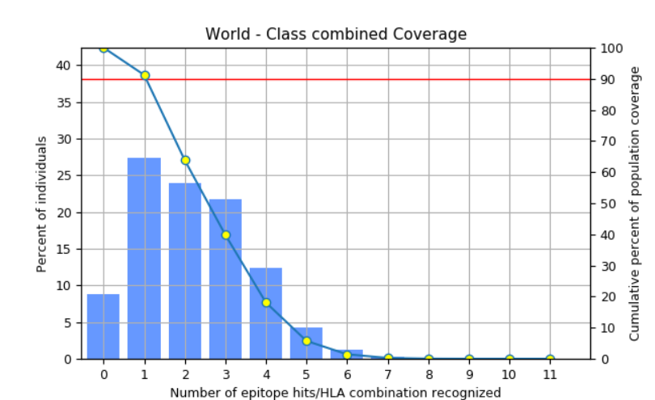

Figure 1: MHC 1 and MHC 2 combined population coverage

  - Vaccine construct design:
The final multi-epitope vaccine construct was designed by integrating selected CTL HTL, and B-cell epitopes, linked with immune-enhancing components to ensure optimal processing and presentation. (Figure 2)

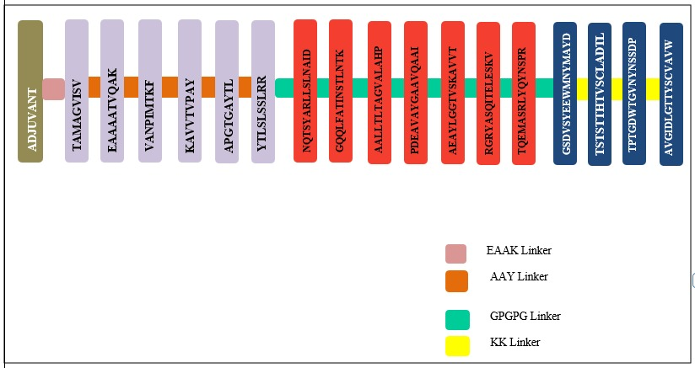

Figure 2: Vaccine construct Design

    - Immunological and physicochemical properties:
ProtParam analysis revealed that the vaccine construct contains 360 amino acids with a molecular weight of 37.39 kDa and a pI of 9.25. It is predicted to be stable (instability index: 25.81), thermostable (aliphatic index: 73.11), and hydrophilic (GRAVY: –0.138). The construct shows high solubility and favorable half-life predictions across mammalian, yeast, and E. coli systems, supporting its potential for expression and stability. (Table 4).

Table 4: Physiochemical properties of Vaccine Construct

Property | Value
Number of amino acids | 360
Molecular weight | 37,398.42 Da
Theoretical pI (Isoelectric Point) | 9.25
Total number of atoms | 5237
Molecular formula | C₁₆₅₄H₂₆₀₈N₄₅₄O₅₀₈S₁₃
Negatively charged residues (Asp + Glu) | 23
Positively charged residues (Arg + Lys) | 36
Instability index (II) | 25.81 (Stable)
Aliphatic index | 73.11
GRAVY (Hydropathicity index) | –0.138 (Hydrophilic)
Extinction coefficient (Cys oxidized) | 58260 M⁻¹cm⁻¹
Extinction coefficient (Cys reduced) | 57760 M⁻¹cm⁻¹
Abs 0.1% (Cys oxidized) | 1.558
Abs 0.1% (Cys reduced) | 1.544
Estimated half-life in mammalian cells | 30 hours (in vitro)
Estimated half-life in yeast | >20 hours (in vivo)
Estimated half-life in E. coli | >10 hours (in vivo)

    - Solubility of vaccine construct:
Solubility of the vaccine construct in E. coli was 0.856 as measured by SOLUprot. (Figure 3)
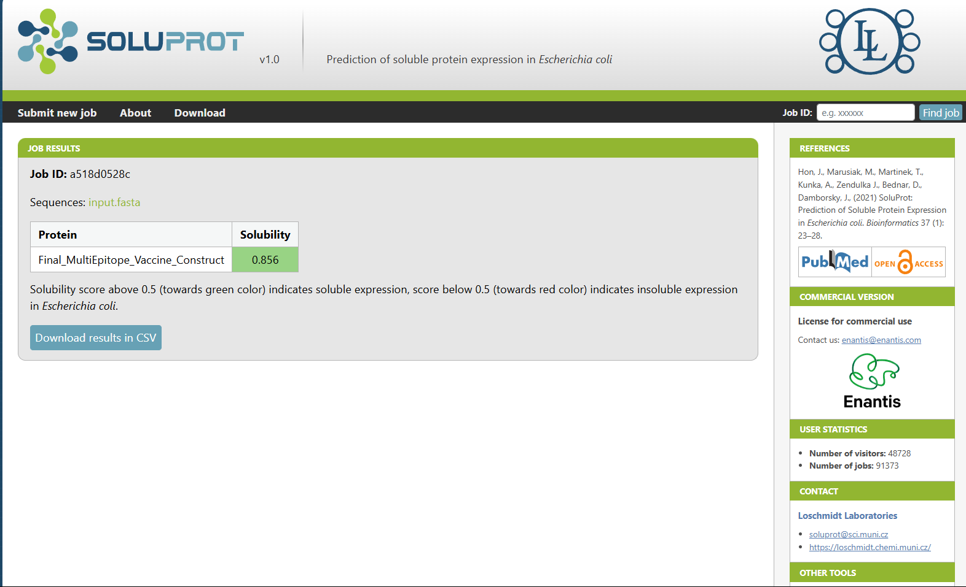

Figure 3: Solubility score of vaccine construct in E. coli by SOLUprot

  - Secondary Structure Prediction
The secondary structure of the final vaccine construct was analysed using the PSIPRED server. The prediction revealed a well-balanced composition of α-helices, β-strands, and random coils, indicating a stable and properly folded protein (Figure 4a, Figure 4b).

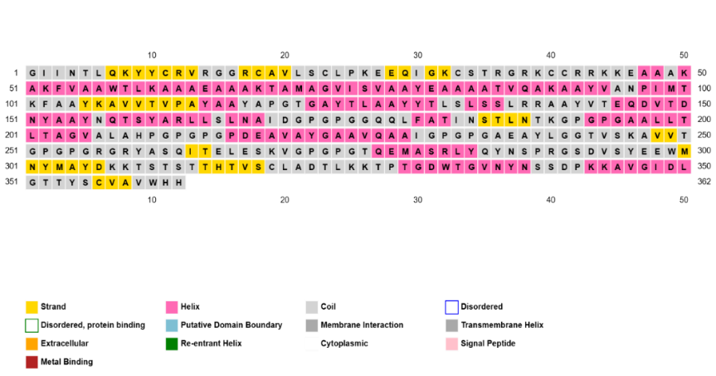
Figure 4a: Secondary Structure Prediction of Vaccine Construct by PSI-PRED

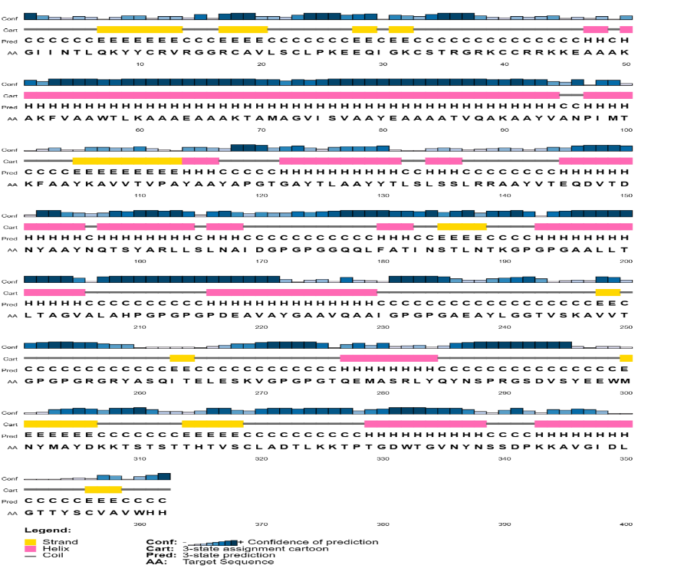
Figure4b: Secondary Structure Prediction Cartoonic Representation by PSI-PRED
  - 3D Structure Modelling and Validation:

    - 3DStructre Modelling.
The three-dimensional structure of the final multi-epitope vaccine construct was initially predicted using AlphaFold, which provided a high-confidence structural model. To enhance the quality of the predicted structure, it was refined using the GalaxyRefine server, which improves side-chain conformations and overall structural packing. (Figure 5a, Figure 5b)
.
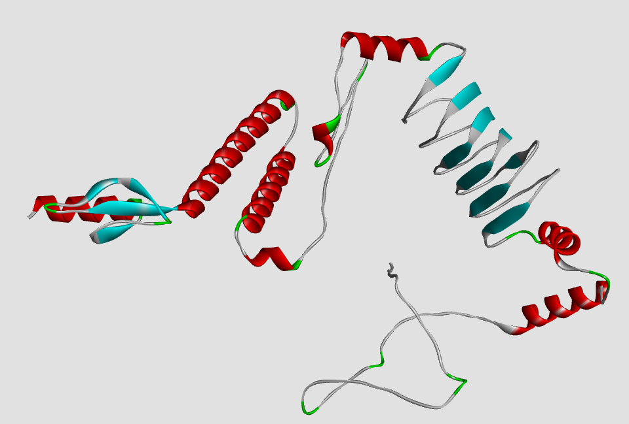
Figure 5a:3D Structure of Vaccine Construct Predicted by AlphaFold

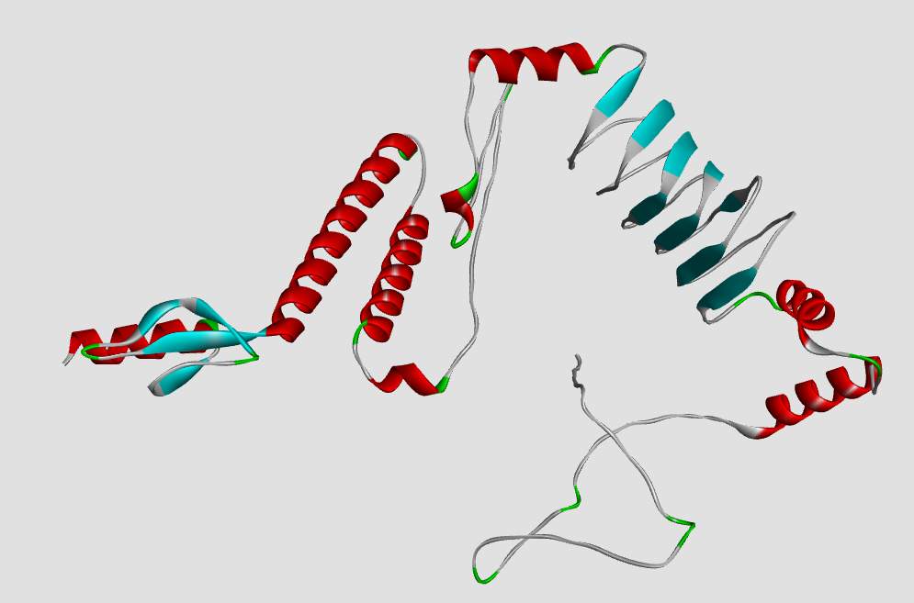
Figure 5b: Refined Structure of Vaccine Construct by Galaxy Refine
    - 3D Structure Validation:
The refined model was evaluated using multiple structural validation tools:

PROCHECK (Ramachandran Plot):
87.7% of residues were located in the most favored regions, with only 0.3% in disallowed regions, indicating good stereochemical quality. (Figure 5c)

ProSA-web:
The model achieved a Z-score of –3.54, which falls within the acceptable range for native protein structures, confirming the overall correctness of the model. (Figure 5c)

ERRAT:
The model scored an overall quality factor of 86.76, suggesting reliable non-bonded atomic interactions and a well-resolved structure. (Figure 5d)

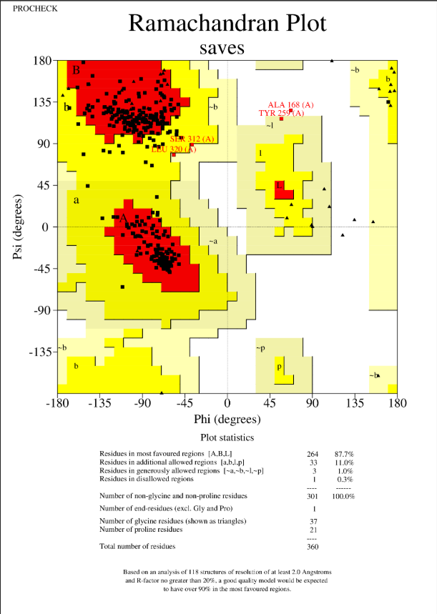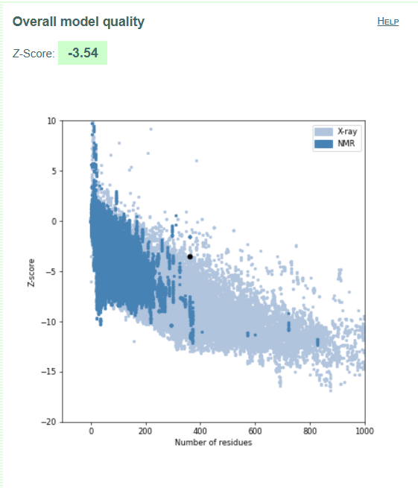
Figure 5c: Structure Validation by Procheck and ProSA

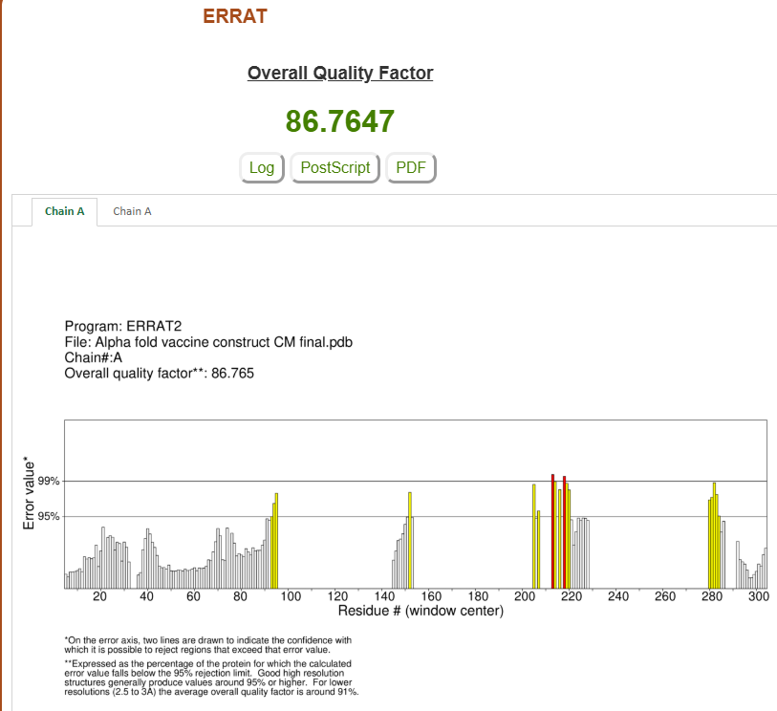
Figure 5d: Structure Validation by ERRAT

  - Molecular Docking:
Molecular docking of the refined vaccine construct with the TLR4 immune receptor was performed using the HADDOCK 2.4 server (Figure 6). Among the generated clusters, the best docking solution was selected based on key interaction parameters.
The selected cluster exhibited a HADDOCK score of –89.8 ± 2.9, indicating a strong and stable interaction (well below the –60 threshold). The interaction was supported by a high electrostatic energy (–375.4 ± 55.8) and favorable van der Waals energy (–32.9 ± 6.1), reflecting good shape complementarity and polar interactions. (Table 5)
The buried surface area of 1789.9 Å² further supported strong complex formation. Although the restraints violation was relatively high (191.9 ± 30.8), the overall Z-score of –1.4 confirmed the reliability of the docking pose.

Table 5: Best Cluster Properties of Docked Proteins by HADDOCK

Metric | Value | Interpretation
HADDOCK Score | –89.8 ± 2.9 | Very good. Well below the –60 threshold typically considered strong binding.
Electrostatic Energy | –375.4 ± 55.8 | Strong electrostatic interactions (critical for immunogenic proteins).
van der Waals Energy | –32.9 ± 6.1 | Acceptable; good shape complementarity.
Desolvation Energy | –1.1 ± 4.3 | Slightly low; acceptable but might reflect limited hydrophobic burial.
Restraints Violation | 191.9 ± 30.8 | On the higher side — could mean moderate violation of distance restraints.
Buried Surface Area | 1789.9 Å² ± 94.9 | Very good — above 1400 Å² is typically favourable for protein–protein docking.
Z-Score | –1.4 | Solid — the more negative, the better (Z < –1 is considered meaningful).

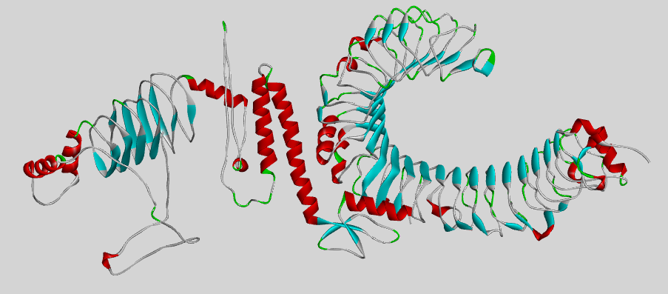
Figure 6: Visualized Structure of docked MEV and tlr-4 by Discovery Studio

  - Protein- Protein Interactions:
To gain deeper insight into the molecular interactions between the multi-epitope vaccine (MEV) and TLR4, the PDBsum server was used to analyze the docked complex.
The interaction interface revealed several hydrogen bonds, salt bridges, and non-bonded contacts between the MEV and TLR4, suggesting strong molecular recognition and stability of the complex. The PDBsum interaction map provided a detailed schematic of contacting residues, highlighting the binding hotspots essential for receptor engagement. (Figure 7). This interaction analysis supports the docking results and confirms that the MEV construct has a strong binding affinity for the TLR4 immune receptor, which is critical for initiating an effective innate immune response.
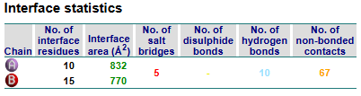
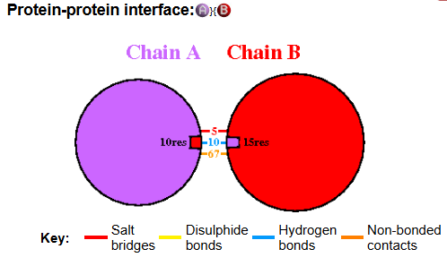
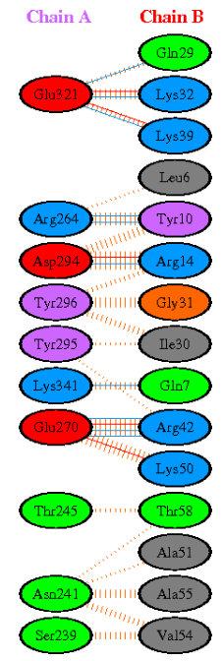
Figure 7: Protein-protein interaction between MEV and Tlr 4 from PDBsum

  - MD Simulations Analysis:

A 100 ns molecular dynamics simulation was performed to evaluate the stability, flexibility, and compactness of the MEV–TLR4 complex.
- RMSD analysis showed initial adjustment followed by stabilization around 1.0 nm, indicating conformational stability. (Figure 8a).
- RMSF revealed moderate fluctuations across residues, with minor peaks above 1.5 nm, typically at loop or terminal regions — suggesting localized flexibility. (Figure 8b)
- The Radius of Gyration (Rg) remained consistent between 4.2–4.4 nm, confirming structural compactness throughout the simulation. (Figure 8c)
- Solvent Accessible Surface Area values gradually decreased from ~550 nm² to ~470 nm², indicating reduced solvent exposure and tighter molecular packing. (Figure 8d).
These findings demonstrate that the vaccine construct maintains a stable and compact conformation, with sufficient flexibility in accessible regions — favorable for immune recognition and receptor binding.
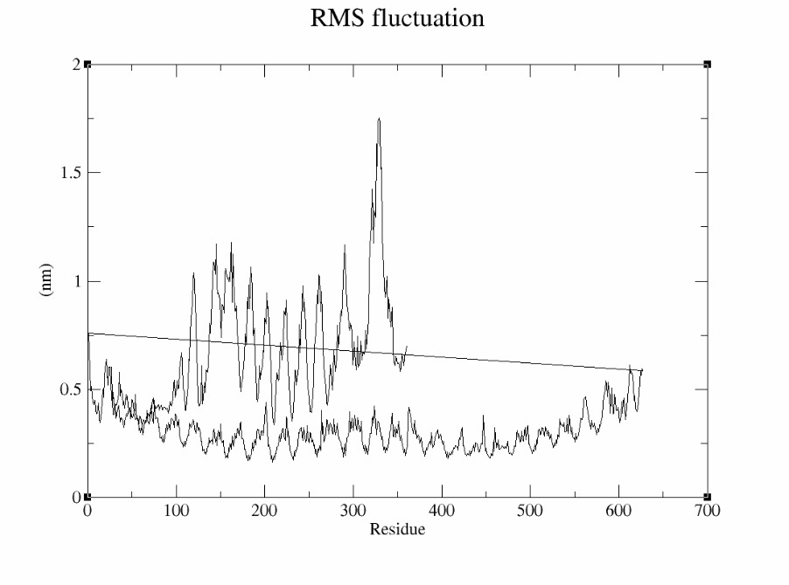
Figure 8a: Root Mean Square Fluctuation (RMSF) of Residue Flexibility in Vaccine Construct

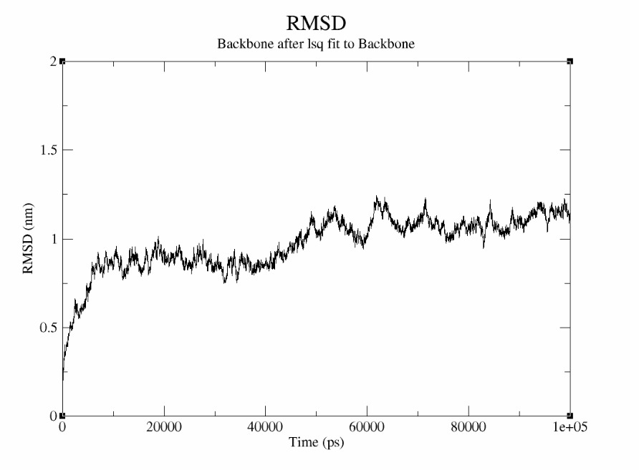
Figure 8b: Backbone RMSD Profile Showing Structural Stability Over 100 ns Simulation

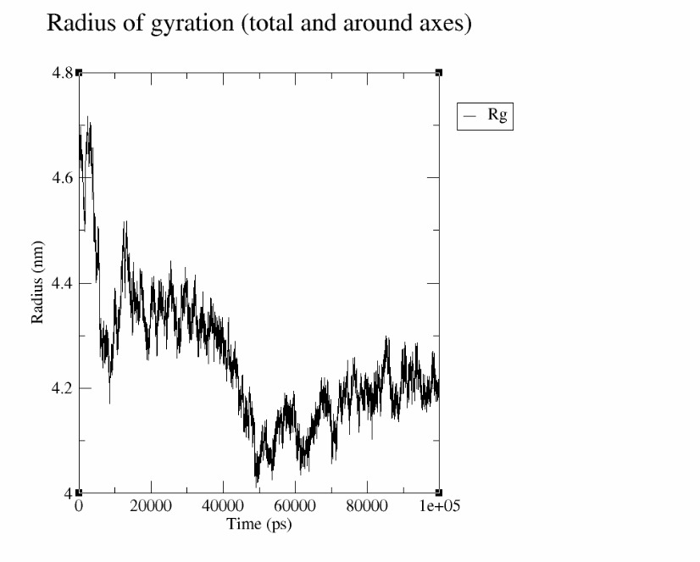
Figure 8c: Radius of Gyration Depicting Compactness of Vaccine Construct Over Time

  - Codon Optimization and In Silico Cloning:
To enhance expression efficiency in Escherichia coli (strain K12), the codon sequence of the final vaccine construct was optimized using the JCAT server. The optimized sequence achieved a Codon Adaptation Index (CAI) of 1.0 and a GC content of 51.67%, both of which fall within the ideal range for efficient transcription and translation in E. coli. The relative adaptiveness plot confirmed uniform codon usage, indicating successful adaptation (Figure 9a).
The optimized nucleotide sequence was then cloned in silico into the pET28a (+) expression vector using Snap Gene software (Figure 9b), positioned between NdeI and XhoI restriction sites. This construct is suitable for high-level recombinant expression and purification in bacterial systems.
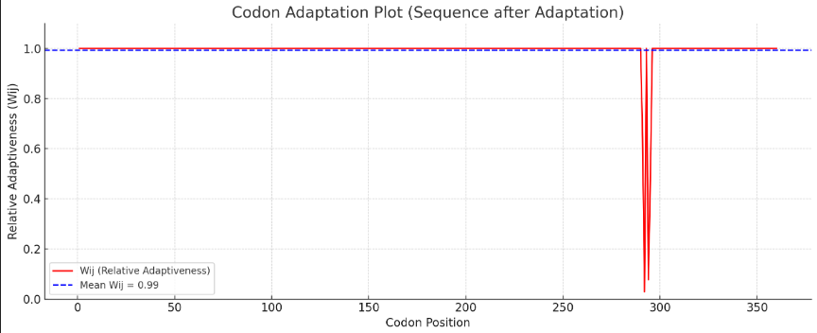
Figure 9a: Optimization of MEV codons according to E. coli (strain K12) by JCAT sever.

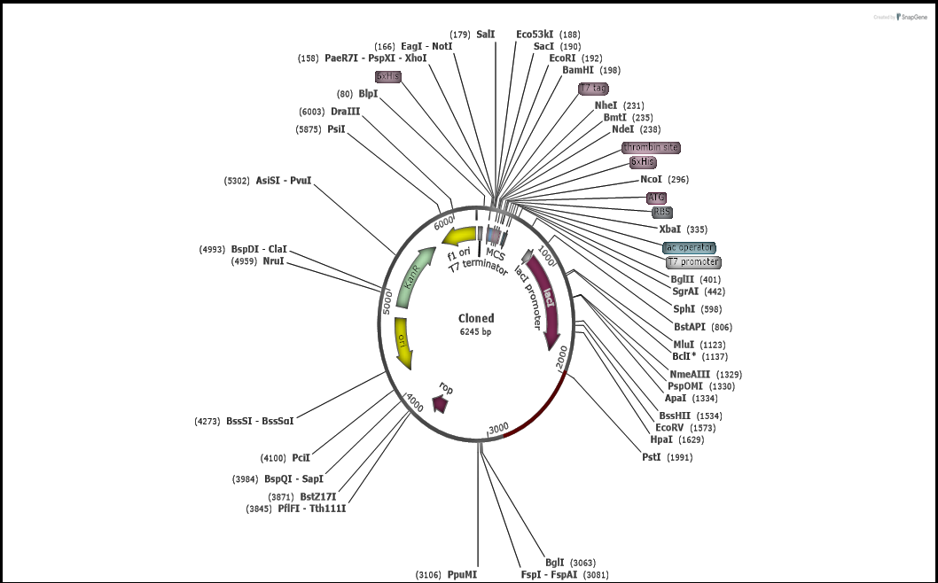
Figure 9b: Vaccine Cloned into the vector (Pet 28a+ and MEV).

- discussion
Cryptococcal meningitis is primarily caused by Cryptococcus neoformans. It is a life-threatening opportunistic fungal infection, particularly among immunocompromised populations found worldwide [36, 38, 39]. Despite the available antifungal therapies, treatment is frequently complicated due to drug toxicity, pharmacokinetic interactions, prolonged treatment duration, and high mortality rates, proving the need for improved preventive strategies [40, 41, 42]. Vaccine development against C. neoformans has therefore been proposed as a promising approach, and recent advances in reverse vaccinology and immunoinformatics provide powerful tools for identifying vaccine antigens [43, 44, 45, 46].
In this study, a multi-epitope subunit vaccine candidate was designed using different proteins. Immunodominant proteins of C. neoformans that include mannoprotein MP88 and other cell-wall-associated proteins known to stimulate host immune responses were selected based on literature and their antigenic properties [48, 49, 50]. Epitope prediction for B-cells, CTLs, and HTLs was performed using tools such as IEDB, which are widely used in standard epitope-based vaccine design [52, 53, 54]. The epitopes were further screened for immunogenicity, allergenicity, toxicity, and cytokine-induction potential to improve vaccine safety and efficacy profiles.
A total of 6 CTL, 7 HTL, and 4 B-cell epitopes were shortlisted and finally assembled into a 687-amino-acid construct using suitable linkers (AAY, GPGPG, KK) and an immunostimulatory β-defensin adjuvant. PADRE was included to overcome HLA-DR polymorphism limitations; it is a strategy commonly applied in multi-epitope vaccine design [56, 57]. Physicochemical analysis indicated that the construct is stable, soluble, hydrophilic, and suitable for bacterial expression.
Structural modelling was done using AlphaFold [26], refinement with GalaxyRefine [27], and validation was done through PROCHECK [28], ERRAT [29], and ProSA [30] which indicated a good stereochemical quality and favorable folding characteristics. Molecular docking with TLR4 using HADDOCK [31] suggested strong binding affinity supported by favorable electrostatic and van der Waals energy scores and substantial buried surface area. MD simulations with GROMACS [33] further demonstrated dynamic stability of the MEV–TLR4 complex, with RMSD, RMSF, radius of gyration, and SASA analyses indicating structural stability and flexibility. Codon optimization using JCAT [34] gave a CAI value of 1.0 and 51.67% GC content, which suggests an efficient expression in E. coli, and in silico cloning into the pET28a(+) vector confirmed via SnapGene [35] completed the construct design.
Overall, this study demonstrates an immunoinformatics-based pipeline for designing a potentially safe, stable, and immunogenic vaccine construct against cryptococcal meningitis, targeting fatal proteins from the cryptococcal species supporting the feasibility of computational vaccine discovery strategies for fungal pathogens.
- Conclusion

This project highlights the effective application of immunoinformatics in designing a safe and immunogenic multi-epitope vaccine candidate against Cryptococcus neoformans. The construct integrates epitopes capable of stimulating both cellular and humoral immunity, supported by favorable docking and simulation results.
The designed construct not only satisfies all key physicochemical and immunological parameters but also demonstrates robust receptor binding and stability under dynamic conditions. The inclusion of a β-defensin adjuvant, PADRE sequence, and epitope linkers improves immune accessibility and presentation. Structural validations confirm that the model is suitable for downstream experimental and clinical testing.
Furthermore, codon optimization and in silico cloning show that the construct is well-suited for bacterial expression systems such as E. coli, enhancing its viability for production and testing. Overall, this study delivers a computationally validated vaccine prototype with the potential to significantly advance the field of antifungal vaccine development. While in silico findings are highly promising, further in vitro and in vivo validation is essential to determine its protective efficacy and safety profile in real-world biological systems.

DATA AVAILABILITY STATEMENT
The datasets used and analyzed during the current study are available from the corresponding author on reasonable request.
- References

[1]. Rodrigues, M. L., Alviano, C. S., & Travassos, L. R.—1999—Pathogenicity of: virulence factors and immunological mechanisms—https://doi.org/10.1016/s1286-4579(99)80025-2
[2]. Rathore, S. S., Sathiyamoorthy, J., Lalitha, C., & Ramakrishnan, J.—2022—A holistic review on Cryptococcus neoformans 2https://doi.org/10.1016/j.micpath.2022.105521
[3]. Sen, M., Chatterji, T., Singh, V., Yadav, P., Das, A., & Mittal, V.—2017—Cryptococcal meningitis in HIV (AIDS) patients: A Mini Review https://doi.org/10.21276/aabs.2017.1344
[4]. Sen, M., Yadav, P., Das, A., & Chaterji, T.—2019—Cryptococcal meningitis in India https://doi.org/10.4103/mgmj.mgmj_14_20
[5]. Abassi, M., Boulware, D. R., & Rhein, J.—2015—Cryptococcal Meningitis: Diagnosis and Management Update—https://doi.org/10.1007/s40475-015-0046-y
[6]. Sugar, A. M., Stem, J. J., & Dupont, B.—1990—Overview: Treatment of Cryptococcal Meningitis—https://doi.org/10.1093/clinids/12.supplement_3.s338
[7]. Badali, H., Alian, S., Fakhim, H., Falahatinejad, M., Moradi, A., Mohammad Davoudi, M., Hagen, F., & Meis, J. F.—2015—Cryptococcal meningitis due to Cryptococcus neoformans genotype AFLP1/VNI in Iran: a review of the literature—https://doi.org/10.1111/myc.1241
[8]. Jhamb, R., Kashyap, B., Das, S., Berry, N., & Garg, A.—2013—Symptomatic relapse of HIV-associated cryptococcal meningitis: recurrent cryptococcal meningitis or Cryptococcus-related immune reconstitution inflammatory syndrome? —https://journals.sagepub.com/doi/10.1177/0956462413506889
[9]. Kumar Pandey, R., Ojha, R., Mishra, A., & Kumar Prajapati, V.—2018—Designing B- and T-cell multi-epitope-based subunit vaccine using immunoinformatics approach to control Zika virus infection—https://doi.org/10.1002/jcb.27110
[10]. Yurina, V., & Adianingsih, O. R.—2022—Predicting epitopes for vaccine development using bioinformaticstools—https://doi.org/10.1177/25151355221100218
[11]. Zhu, F., Qin, R., Ma, S., Zhou, Z., Tan, C., Tree, H., Zhang, P., Xu, Y., Luo, Y., Chen, J., & Pan, P.—2025—Designing a multi-epitope vaccine against Pseudomonas aeruginosa via integrating reverse vaccinology with immunoinformatics approaches—https://doi.org/10.1038/s41598-025-90226-6
[12]. Mugunthan, S. P., & Mani Chandra, H.—2021—A Computational Reverse Vaccinology Approach for the Design and Development of Multi-Epitopic Vaccine Against Avian Pathogen Mycoplasma gallisepticum—https://doi.org/10.3389/fvets.2021.721061
[13]. The UniProt Consortium – 2023 – UniProt: the Universal Protein Knowledgebase in 2023 – https://academic.oup.com/nar/article/51/D1/D523/6835119
[14]. Metzner, C., et al. – 2016 – Biomedical applications of glycosylphosphatidylinositol-anchored proteins – https://www.jlr.org/article/S0022-2275(20)32371-3/fulltext
[15]. Biondo, C., et al. – 2002 – Identification and cloning of a cryptococcal deacetylase that produces protective immune responses – https://journals.asm.org/doi/10.1128/iai.70.5.2383-2391.2002
[16]. Borges, T. J., et al. – 2012 – The anti-inflammatory mechanisms of Hsp70 – https://www.frontiersin.org/journals/immunology/articles/10.3389/fimmu.2012.00095/full
[17]. Huang, C., et al. – 2002 – Purification and characterization of a second immunoreactive mannoprotein from Cryptococcus neoformans that stimulates T-Cell responses – https://journals.asm.org/doi/10.1128/iai.70.10.5485-5493.2002
[18]. Vita, R., et al. – 2019 – The Immune Epitope Database (IEDB): 2018 update – https://academic.oup.com/nar/article/47/D1/D339/5144151
[19]. Reynisson, B., et al. – 2020 – NetMHCpan-4.1 and NetMHCIIpan-4.0: improved predictions of MHC antigen presentation by deep learning – https://pubmed.ncbi.nlm.nih.gov/32406916/
[20]. Doytchinova, I. A., et al. – 2007 – VaxiJen: a server for prediction of protective antigens, tumour antigens and subunit vaccines – https://bmcbioinformatics.biomedcentral.com/articles/10.1186/1471-2105-8-4
[21]. Dimitrov, I., et al. – 2014 – AllerTOP v.2 — a server for in silico prediction of allergens – https://pubmed.ncbi.nlm.nih.gov/24878803/
[22]. Gupta, S., et al. – 2013 – In Silico Approach for Predicting Toxicity of Peptides and Proteins – https://journals.plos.org/plosone/article?id=10.1371/journal.pone.0073957
[23]. Dhanda, S. K., et al. – 2013 – Designing of interferon-gamma inducing MHC class-II binders – https://pmc.ncbi.nlm.nih.gov/articles/PMC4235049/
[24]. Bui, H. H., et al. – 2006 – Predicting population coverage of T-cell epitope-based diagnostics and vaccines – https://pmc.ncbi.nlm.nih.gov/articles/PMC1513259/
[25]. Gasteiger, E., et al. – 2005 – Protein Identification and Analysis Tools on the ExPASy Server – https://link.springer.com/protocol/10.1385/1-59259-890-0:571
[26]. Jumper, J., et al. – 2021 – Highly accurate protein structure prediction with AlphaFold – https://www.nature.com/articles/s41586-021-03819-2
[27]. Heo, L., et al. – 2013 – GalaxyRefine: Protein structure refinement driven by side-chain repacking – https://academic.oup.com/nar/article/41/W1/W384/1108398
[28]. Laskowski, R. A., et al. – 1993 – PROCHECK: a program to check the stereochemical quality of protein structures – http://onlinelibrary.wiley.com/doi/abs/10.1107/s0021889892009944
[29]. Colovos, C. & Yeates, T. O. – 1993 – Verification of protein structures: patterns of nonbonded atomic interactions – https://pubmed.ncbi.nlm.nih.gov/8401235/
[30]. Wiederstein, M. & Sippl, M. J. – 2007 – ProSA-web: interactive web service for the recognition of errors in three-dimensional structures of proteins – https://academic.oup.com/nar/article/35/suppl_2/W407/2920938
[31]. van Zundert, G. C. P., et al. – 2016 – The HADDOCK2.2 Web Server: User-Friendly Integrative Modeling of Biomolecular Complexes – https://pubmed.ncbi.nlm.nih.gov/26410586/
[32]. Laskowski, R. A., et al. – 2018 – PDBsum: Structural summaries of PDB entries – https://onlinelibrary.wiley.com/doi/full/10.1002/pro.3289
[33]. Abraham, M. J., et al. – 2015 – GROMACS: High performance molecular simulations through multi-level parallelism from laptops to supercomputers – https://www.sciencedirect.com/science/article/pii/S2352711015000059
[34]. Grote, A., et al. – 2005 – JCat: a novel tool for codon adaptation of genes – https://pubmed.ncbi.nlm.nih.gov/15980527/
[35]. SnapGene Software – 2026 – SnapGene: Molecular Biology Software for Cloning and Sequence Visualization – https://www.snapgene.com/
[36]. Maziarz, E. K. & Perfect, J. R. – 2016 – Cryptococcosis – https://pubmed.ncbi.nlm.nih.gov/26897061/
[37]. May, R. C., et al. – 2016 – Cryptococcus: from environmental saprophyte to global pathogen – https://www.nature.com/articles/nrmicro.2015.6
[38]. Molloy, S. F., et al. – 2017 – Cryptococcal meningitis: A neglected NTD? – https://journals.plos.org/plosntds/article?id=10.1371/journal.pntd.0005575
[39]. Sloan, D. J. & Parris, V. – 2014 – Cryptococcal meningitis: epidemiology and therapeutic options – https://www.ncbi.nlm.nih.gov/pmc/articles/PMC4026566/
[40]. Brüggemann, R. J., et al. – 2009 – Clinical relevance of pharmacokinetic interactions of azole antifungal drugs – https://academic.oup.com/cid/article/48/10/1441/334338
[41]. Spernovasilis, N. & Kofteridis, D. P. – 2018 – Pre-existing liver disease and toxicity of antifungals – https://www.mdpi.com/2309-608X/4/4/133
[42]. Nandy, A. & Basak, S. C. – 2016 – A brief review of computer-assisted approaches to rational design of peptide vaccines – https://www.mdpi.com/1422-0067/17/5/666
[43]. Alsowayeh, N., et al. – 2022 – Reverse vaccinology and immunoinformatic assisted designing of a multi-epitopes-based vaccine against nosocomial Burkholderia cepacia – https://www.frontiersin.org/articles/10.3389/fmicb.2022.929400/full
[44]. Jalal, K., et al. – 2022 – Reverse vaccinology approach for multi-epitope centered vaccine design against delta variant of SARS-CoV-2 – https://link.springer.com/article/10.1007/s11356-021-17793-z
[45]. Poland, G. A., et al. – 2013 – Vaccinomics, adversomics, and the immune response network theory – https://www.sciencedirect.com/science/article/pii/S104453231300010X
[46]. Leopold Wager, C. M. & Wormley, F. L. Jr. – 2015 – Is development of a vaccine against Cryptococcus neoformans feasible? – https://journals.plos.org/plospathogens/article?id=10.1371/journal.ppat.1004843
[47]. Casadevall, A., et al. – 2019 – The capsule of Cryptococcus neoformans – https://www.tandfonline.com/doi/full/10.1080/21505594.2019.1627318
[48]. Pietrella, D., et al. – 2001 – Role of mannoprotein in induction and regulation of immunity to Cryptococcus neoformans – https://journals.asm.org/doi/10.1128/IAI.69.5.2808-2814.2001
[49]. Levitz, S. M. & Specht, C. A. – 2006 – The molecular basis for the immunogenicity of Cryptococcus neoformans mannoproteins – https://academic.oup.com/femsyr/article/6/4-5/513/576019
[50]. Rizzo, J., et al. – 2021 – Cryptococcus extracellular vesicles properties and their use as vaccine platforms – https://www.tandfonline.com/doi/full/10.1080/20013078.2021.1973335
[51]. Bui, H. H., et al. – 2007 – Development of an epitope conservancy analysis tool to facilitate the design of epitope-based diagnostics and vaccines – https://bmcbioinformatics.biomedcentral.com/articles/10.1186/1471-2105-8-361
[52]. Larsen, J. E. P., et al. – 2006 – Improved method for predicting linear B-cell epitopes – https://www.ncbi.nlm.nih.gov/pmc/articles/PMC1464391/
[53]. Lundegaard, C., et al. – 2008 – NetMHC-3.0: accurate web accessible predictions of MHC class I affinities – https://academic.oup.com/nar/article/36/suppl_2/W509/2505678
[54]. Fleri, W., et al. – 2017 – The immune epitope database and analysis resource in epitope discovery – https://www.frontiersin.org/articles/10.3389/fimmu.2017.00278/full
55.Patronov, A. & Doytchinova, I. – 2013 – T-cell epitope vaccine design by immunoinformatics – https://royalsocietypublishing.org/doi/10.1098/rsob.120139
[56]. Li, W., et al. – 2014 – Peptide vaccine: progress and challenges – https://www.mdpi.com/2076-393X/2/3/515
[57]. Ojha, R. & Prajapati, V. K. – 2021 – Cognizance of posttranslational modifications in vaccines – https://onlinelibrary.wiley.com/doi/10.1002/jcp.30453

