GIS-Based Land-Use Compatibility and Urban Safety Assessment of Fuel Stations in Residential Areas of Port Harcourt Municipality, Nigeria

Abstract
Rapid urbanization in developing countries has increased pressure on urban land resources, often resulting in incompatible land-use patterns and heightened environmental safety risks. One manifestation of this challenge is the proliferation of fuel stations within residential neighbourhoods. Although fuel stations are essential for urban transportation and economic activity, their close proximity to homes, schools, and markets raises concerns about environmental safety, planning compliance, and public health. This study evaluates the spatial compatibility and urban safety implications of fuel station locations within residential areas of Port Harcourt Municipality using Geographic Information Systems (GIS). Spatial mapping, nearest neighbour analysis, buffer analysis, and proximity modelling were applied to examine the distribution of fuel stations and their relationship with nearby residential buildings and other sensitive land uses. The results reveal a clustered spatial pattern, with fuel stations concentrated along major transportation corridors and mixed residential-commercial zones. Buffer analysis shows that 357 residential buildings are located within 50 m of fuel stations, 1,043 within 100 m, and 3,068 within 200 m, exposing a significant number of residents to hazards such as fire outbreaks, explosions, air pollution, and traffic accidents. Nearest neighbour analysis produced an index of 0.47 and a statistically significant Z-score of –8.89, confirming strong spatial clustering. Proximity analysis further identified several stations located within unsafe distances of schools and markets, indicating planning violations and land-use incompatibility. The findings suggest weak enforcement of development control regulations and highlight the need for risk-sensitive land-use planning. The study recommends GIS-based monitoring systems, stricter enforcement of planning standards, and the establishment of safety buffer zones to improve urban safety in Port Harcourt Municipality.

Keywords: Land-use compatibility, urban safety, GIS, fuel stations, facility location planning, Port Harcourt Municipality

1. Introduction
Urban planning is fundamentally concerned with organizing the spatial structure of cities in ways that promote environmental sustainability, economic efficiency, and public safety. Central to this objective is the principle of land-use compatibility, which requires that neighbouring land uses coexist without generating unacceptable environmental hazards, nuisance effects, or social conflicts. Planning systems typically operationalize this principle through zoning regulations, development control procedures, and spatial planning frameworks that separate hazardous activities from sensitive land uses such as residential neighbourhoods, schools, and healthcare facilities (Caves & Cullingworth, 2023; Hall & Tewdwr-Jones, 2019). Through these regulatory mechanisms, planners aim to ensure orderly urban growth while safeguarding environmental quality and public health.
However, in rapidly urbanizing regions—particularly in developing countries—the effectiveness of these regulatory mechanisms is often constrained by unplanned urban expansion, limited institutional capacity, speculative land development pressures, and inadequate enforcement of development control regulations. Rapid urbanization across many cities in Africa and other parts of the Global South has significantly intensified pressure on urban land resources, resulting in increasingly fragmented spatial structures and the intermixing of residential, commercial, and industrial land uses (Seto et al., 2012; UN-Habitat, 2020). Although mixed land use can enhance accessibility and urban vibrancy in certain contexts, uncontrolled proximity between hazardous facilities and residential environments may generate significant environmental and safety risks.
One urban facility that exemplifies this challenge is the petrol filling station. Fuel stations constitute an essential component of urban transportation infrastructure, providing petroleum products required for mobility and economic activity. Nevertheless, they also involve the storage, handling, and distribution of highly flammable fuels and the emission of volatile organic compounds (VOCs) such as benzene, toluene, ethylbenzene, and xylene (BTEX), which have been widely associated with environmental pollution and adverse health outcomes (World Health Organization, 2010; Anigilaje et al., 2024). Exposure to these compounds may contribute to respiratory illnesses and long-term health risks, while underground storage systems and fuel handling processes may lead to soil and groundwater contamination if not properly regulated.
Beyond chemical exposure risks, the spatial clustering of petrol stations within residential environments can generate additional environmental and safety concerns. These include increased fire hazards, explosion risks, localized air pollution, and traffic congestion associated with fuel delivery and vehicle queuing. Empirical studies have demonstrated that petrol station clusters may significantly increase benzene concentrations in surrounding neighbourhoods, thereby elevating lifetime cancer risks for nearby residents (Hsieh et al., 2021). Epidemiological research has also reported associations between residential proximity to petrol stations and elevated risks of certain health outcomes, including childhood leukemia (Malavolti et al., 2023). These findings highlight the importance of regulating the spatial location of fuel stations relative to sensitive land uses such as residential areas, schools, and markets.
Consequently, planning authorities in many countries impose minimum setback distances and location criteria for fuel stations as part of broader urban safety and environmental protection policies. Determining appropriate locations for such facilities therefore requires careful spatial assessment and compliance monitoring. Advances in Geographic Information Systems (GIS) have significantly improved the ability of planners and researchers to evaluate spatial relationships between urban land uses and identify potential areas of land-use conflict. GIS provides powerful analytical tools for spatial modelling, proximity analysis, and suitability assessment, enabling planners to visualize spatial patterns and evaluate compliance with regulatory standards (Longley et al., 2015). For example, GIS-based land suitability analysis has been widely applied to determine appropriate locations for petrol filling stations while minimizing environmental and safety risks (Khahro et al., 2014).
In Nigeria, concerns regarding the proliferation and siting of petrol filling stations have intensified in recent decades due to rapid urbanization, growing energy demand, and increasing levels of motorization. While petrol stations remain essential for supporting urban transportation systems, their rapid expansion in Nigerian cities has frequently outpaced the capacity of planning authorities to enforce development control regulations effectively. Nigeria’s planning framework, particularly the Nigerian Urban and Regional Planning Act of 1992, provides legal provisions for regulating land development and ensuring orderly spatial growth (Nigeria, 1992). However, practical implementation of these regulations is often weakened by institutional constraints, governance challenges, and strong pressures within urban land markets. As a result, petrol filling stations are frequently located within densely populated residential neighbourhoods, potentially increasing environmental risks and urban vulnerability.
Recent studies have begun to apply spatial analytical approaches to evaluate the siting of petrol stations in Nigerian cities. For instance, GIS-based analysis conducted in Umuahia revealed significant planning compliance challenges and spatial risks associated with the location of filling stations relative to residential environments (Ukanwa et al., 2024). Despite these emerging studies, systematic spatial assessments of fuel station distribution and residential proximity remain limited in many Nigerian cities, particularly in rapidly growing metropolitan areas such as Port Harcourt. Given the city's role as a major petroleum-related economic hub in the Niger Delta region, understanding the spatial relationship between fuel station locations and surrounding land uses is critical for improving urban safety and planning regulation.
Port Harcourt Municipality, the administrative and commercial centre of Rivers State, has experienced rapid urban expansion driven by population growth, industrial activities associated with the petroleum sector, and increasing demand for transportation infrastructure. As a major regional economic hub, the city contains numerous petrol filling stations distributed along major transportation corridors and within mixed residential-commercial neighbourhoods. While such locations may improve accessibility for motorists, they may also generate spatial conflicts between fuel station operations and surrounding residential land uses, raising concerns regarding environmental safety, public health, and planning compliance.
Despite the growing number of fuel stations in the city, limited empirical research has systematically examined their spatial distribution and their proximity to residential areas using geospatial analytical techniques. Addressing this gap is essential for informing evidence-based planning policies and strengthening development control practices. Spatial analysis using GIS offers an effective approach for evaluating whether existing fuel station locations conform to established planning principles and safety considerations.
Against this background, this study employs a GIS-based spatial analytical framework to examine the distribution of petrol filling stations and evaluate their compatibility with surrounding residential land uses in Port Harcourt Municipality. Specifically, the study seeks to:
- Map the spatial distribution of petrol filling stations within Port Harcourt Municipality.
- Analyse the proximity between fuel stations and residential buildings using GIS-based spatial techniques.
- Assess the degree of land-use compatibility and potential spatial conflicts between fuel station locations and residential environments.
By providing empirical evidence on the spatial relationship between fuel stations and residential land uses, the study contributes to the broader discourse on risk-sensitive urban planning, environmental health protection, and spatial planning governance in rapidly urbanizing cities.

2. Literature Review

2.1 Land-Use Compatibility and Hazardous Facilities
Land-use compatibility is a central principle in urban planning that seeks to minimize conflicts between neighbouring land uses and ensure that different urban activities coexist without creating environmental, social, or safety problems. Compatible land uses typically reinforce one another and enhance the functional efficiency of cities, whereas incompatible uses may generate noise, pollution, traffic congestion, visual intrusion, and public safety risks (Caves & Cullingworth, 2023; Hall & Tewdwr-Jones, 2019). Urban planning systems therefore employ zoning regulations, development control procedures, and land-use planning frameworks to organize urban activities in ways that protect residential environments and maintain urban liveability.
Within this planning framework, certain facilities are classified as hazardous or potentially hazardous land uses because they involve processes or materials capable of causing environmental contamination, fire outbreaks, explosions, or toxic exposure. Examples include petrol filling stations, chemical storage facilities, refineries, and industrial plants that store or process flammable or hazardous substances. The presence of such facilities in close proximity to residential areas or other sensitive land uses may expose surrounding populations to significant environmental and safety risks (Burby & Dalton, 1994; Cutter et al., 2008).
To mitigate these risks, planning authorities commonly prescribe minimum setback distances, zoning restrictions, and location criteria that regulate where hazardous facilities may be located within urban areas. These regulatory instruments aim to protect public health, reduce accident risks, and prevent land-use conflicts (Caves & Cullingworth, 2023). However, in rapidly growing cities, particularly in developing countries, these regulatory mechanisms are often weakened by rapid urban expansion, informal development, inadequate planning enforcement, and strong commercial pressures associated with urban land markets (UN-Habitat, 2020). As a result, hazardous facilities may emerge within densely populated neighbourhoods, increasing urban vulnerability to environmental hazards.

2.2 Fuel Stations and Urban Safety
Fuel stations represent a particularly important category of urban service infrastructure because they support mobility, transportation systems, and economic activity. Their spatial distribution is typically influenced by factors such as accessibility, traffic flow, population density, and commercial profitability (Khahro et al., 2014). Consequently, petrol filling stations are commonly located along major roads, transportation corridors, and commercial zones where vehicle traffic is highest.
While such locations improve convenience for motorists and transport operators, they may also expose nearby residents to environmental and safety hazards. Fuel stations involve the storage and dispensing of highly flammable petroleum products, including petrol and diesel, which present potential risks of fire outbreaks and explosions if safety standards are not strictly maintained (Anigilaje et al., 2024). In addition to accident risks, fuel stations are also known sources of volatile organic compounds (VOCs), including benzene, toluene, ethylbenzene, and xylene (BTEX), which are associated with air pollution and adverse health effects (World Health Organization, 2010).
Research has linked the proximity of petrol stations to residential areas with several environmental and health concerns. For instance, elevated benzene emissions have been recorded around clusters of petrol stations, increasing estimated lifetime cancer risks for nearby populations (Hsieh et al., 2021). Epidemiological studies have also found associations between residential proximity to fuel stations and certain health outcomes, including childhood leukemia (Malavolti et al., 2023). Beyond health concerns, poorly sited fuel stations may contribute to traffic congestion, soil contamination from fuel leakage, and urban fire hazards, particularly in densely built environments where evacuation and emergency response may be constrained.
These risks become particularly significant when fuel stations are located close to sensitive land uses such as schools, markets, hospitals, and residential buildings. In such contexts, even localized accidents may have severe consequences due to the concentration of people within the surrounding area. Consequently, many planning systems emphasize the need for risk-sensitive siting of petrol stations and strict adherence to safety regulations.

2.3 GIS Applications in Urban Safety and Planning
Advances in Geographic Information Systems (GIS) have significantly improved the ability of planners and researchers to analyse spatial relationships in urban environments and identify potential land-use conflicts. GIS provides a powerful framework for integrating spatial data, visualizing urban patterns, and conducting spatial analysis to support evidence-based planning decisions (Longley et al., 2015).
Several spatial analytical techniques supported by GIS are particularly useful for evaluating urban safety and land-use compatibility. Buffer analysis, for example, enables planners to establish safety zones around hazardous facilities and determine whether sensitive land uses fall within risk distances. Proximity analysis and distance matrix modelling allow researchers to measure the distance between facilities and surrounding receptors such as residential buildings or schools. Spatial overlay analysis can further integrate multiple datasets to assess land-use relationships and identify areas of potential conflict.
GIS-based methods have therefore become widely used tools for evaluating the suitability of locations for petrol filling stations and other potentially hazardous facilities. For example, GIS-based land suitability analysis has been used to determine appropriate locations for fuel stations based on environmental, accessibility, and safety criteria (Khahro et al., 2014). By enabling planners to visualize spatial patterns and quantify exposure risks, GIS provides a valuable decision-support system for development control, zoning enforcement, and urban risk management.
In rapidly urbanizing cities, where informal development and weak enforcement may complicate planning processes, GIS analysis can also help authorities identify non-compliant facilities and prioritize areas for regulatory intervention. As such, GIS plays an increasingly important role in risk-informed urban planning and environmental hazard assessment.

2.4 Theoretical Framework
This study is anchored in two complementary theoretical perspectives: Central Place Theory and Obnoxious Facility Location Theory.
Central Place Theory, originally developed by Christaller (1933), explains the spatial distribution of service facilities within urban and regional systems. According to the theory, service facilities locate in ways that maximize accessibility to consumers while ensuring economic viability. In urban environments, this often leads to the concentration of services along major transportation corridors and areas with high population demand. Fuel stations, as service facilities, tend to follow this pattern by locating in areas with high traffic flow and accessibility (Parr, 2025).
However, when market forces dominate without adequate regulatory oversight, such facilities may cluster excessively or locate within areas where they generate environmental or safety risks. In such situations, planning intervention becomes necessary to regulate facility location and ensure balanced spatial distribution.
Complementing this perspective is Obnoxious Facility Location Theory, which addresses the spatial placement of facilities that generate environmental hazards, nuisance effects, or public opposition. Such facilities, often referred to as “locally undesirable land uses” (LULUs) include landfills, waste treatment plants, refineries, and fuel storage facilities (Dear, 1992). The theory emphasizes that hazardous facilities should be located at safe distances from residential areas and other sensitive land uses in order to minimize environmental and social risks.
Fuel stations fall within this category because of the hazardous materials they store and the environmental risks associated with fuel leakage, vapour emissions, and fire hazards. The theoretical framework therefore supports the need for minimum safety buffers, risk-sensitive zoning policies, and careful spatial planning to reduce exposure to such hazards.

2.5 Conceptual Framework
The conceptual framework for this study links urban growth, fuel station location dynamics, spatial interaction, and urban safety outcomes. Rapid urban development and increasing motorization create growing demand for transportation infrastructure, including petrol filling stations. These facilities tend to locate according to accessibility, traffic flow, and commercial profitability, often concentrating along major transportation corridors and mixed-use areas.
However, the spatial interaction between fuel stations and surrounding land uses, particularly residential buildings, schools, and markets, may generate land-use conflicts and safety risks. When fuel stations are located too close to sensitive receptors, the likelihood of environmental hazards, accident exposure, and public health risks increases.
GIS-based spatial analysis provides an effective method for identifying and evaluating these interactions. Techniques such as buffer analysis, proximity modelling, distance matrix analysis, and nearest-neighbour analysis enable researchers to quantify spatial relationships between facilities and surrounding land uses. By identifying buildings or sensitive facilities located within risk zones, GIS can reveal patterns of potential land-use incompatibility.
The results of such spatial analysis provide valuable evidence for development control enforcement, zoning policy review, and broader urban safety planning, thereby supporting more sustainable and risk-sensitive urban development.

3. Methodology

3.1 Study Area
Port Harcourt Municipality is located in Rivers State in the southern region of Nigeria within the Niger Delta. The municipality forms the historic core of Port Harcourt city and serves as the administrative, commercial, and economic centre of the state. Geographically, the area lies within the coastal lowland of the Niger Delta and is characterized by a network of tidal creeks, rivers, and mangrove swamps that influence the pattern of settlement and urban development in the city. The municipality lies approximately between Latitude 4°45′N and 4°55′N and Longitude 6°55′E and 7°05′E, and the spatial data used in this study are referenced in the WGS 84 / UTM Zone 32N coordinate system (EPSG:32632).
Port Harcourt Municipality is bounded by Obio–Akpor Local Government Area to the north and east, while its southern and western margins are defined by extensive tidal waterways connected to the Bonny River system. These water bodies form a distinctive environmental setting that shapes land-use distribution, transportation routes, and urban expansion.
The municipality is highly urbanized and contains a dense network of roads, residential neighbourhoods, commercial districts, and institutional land uses concentrated within a relatively compact administrative boundary. As illustrated in Figure 1, the central and northern parts of the municipality exhibit a high concentration of road infrastructure and built-up areas, reflecting intense urban development.
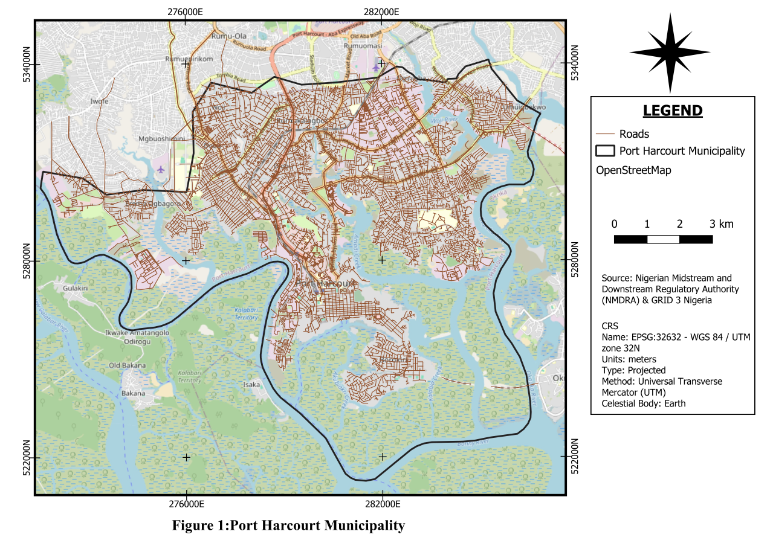
Port Harcourt’s strategic importance as a major centre of Nigeria’s petroleum industry has contributed significantly to its rapid urban growth and increasing transportation demand. Consequently, the municipality contains numerous petrol filling stations distributed along major transportation corridors and within mixed residential-commercial neighbourhoods. This pattern of development makes Port Harcourt Municipality an appropriate location for examining the spatial relationship between fuel station locations and surrounding residential land uses using GIS-based analytical techniques.
Source: OSM 2026

3.2 Data Sources
The study adopted a GIS-based spatial analytical approach using both primary and secondary data.
Primary data include:
- GPS coordinates of fuel stations
- field observation and verification
Secondary data include:
- Open Street Map
- land-use maps
- building footprints
- school and market locations
- planning regulations
- road network data sourced from OpenStreetMap and verified through GIS editing
All datasets were georeferenced and processed in QGIS using the WGS 84 / UTM Zone 32N coordinate system to ensure positional accuracy.

3.3 GIS Workflow
The GIS analytical workflow followed four stages.
Step 1: Data Collection
Spatial data were assembled for fuel station locations, building footprints, schools, markets, and roads through GPS survey, field validation, and secondary map sources.
Step 2: Data Preparation
Datasets were cleaned, georeferenced, checked for attribute consistency, and validated spatially before analysis.
Step 3: Spatial Analysis
Three major analytical techniques were applied:
- buffer analysis
- proximity analysis using distance matrix
- nearest neighbour analysis
Step 4: Visualization and Mapping
Outputs were presented as hazard buffer maps, spatial distribution maps, and proximity maps to reveal areas of incompatibility and exposure.

3.4 GIS Analytical Techniques

3.4.1 Buffer Analysis
Buffer analysis was conducted to evaluate the spatial relationship between fuel stations and surrounding residential buildings. Buffer zones of 50 m, 100 m, and 200 m were generated around each fuel station to represent different levels of hazard exposure.
These zones were interpreted as follows:
- 0–50 m: Critical hazard zone
- 50–100 m: High-risk zone
- 100–200 m: Moderate risk zone
The number of buildings falling within each buffer was derived through spatial overlay analysis.

3.4.2 Proximity Analysis
Proximity analysis was used to determine the shortest distances between fuel stations and nearby schools and markets. The QGIS Distance Matrix tool was used for this purpose. Distances were classified into three risk categories:
Distance Range | Risk Category
0–100 m | Non-compliant / High Risk
100–200 m | Caution Zone
>200 m | Safer Zone
This classification enabled the identification of fuel stations that may violate recommended safety standards.

3.4.3 Nearest Neighbour Analysis
Nearest Neighbour Analysis was used to evaluate the spatial distribution pattern of fuel stations within Port Harcourt Municipality. The Nearest Neighbour Index was computed as:
NNI = Observed Mean Distance
Expected Mean Distance

NNI < 1 indicates clustering
NNI = 1 indicates randomness
NNI > 1 indicates dispersion
The significance of the pattern was assessed using the Z-score.

4. Results

4.1 Spatial Distribution of Fuel Stations
Nearest Neighbour Analysis shows that fuel stations in Port Harcourt Municipality are spatially clustered rather than randomly or evenly distributed. The analysis produced an observed mean distance of 246.36 m, an expected mean distance of 519.99 m, a nearest neighbour index of 0.47, and a Z-score of –8.89, indicating a statistically significant clustered pattern.
This suggests that fuel stations are concentrated along major transportation routes and commercial corridors, especially:
- Trans Amadi Industrial Area
- Aba Road corridor
- Eastern Bypass
- Aggrey Road
- Diobu commercial axis

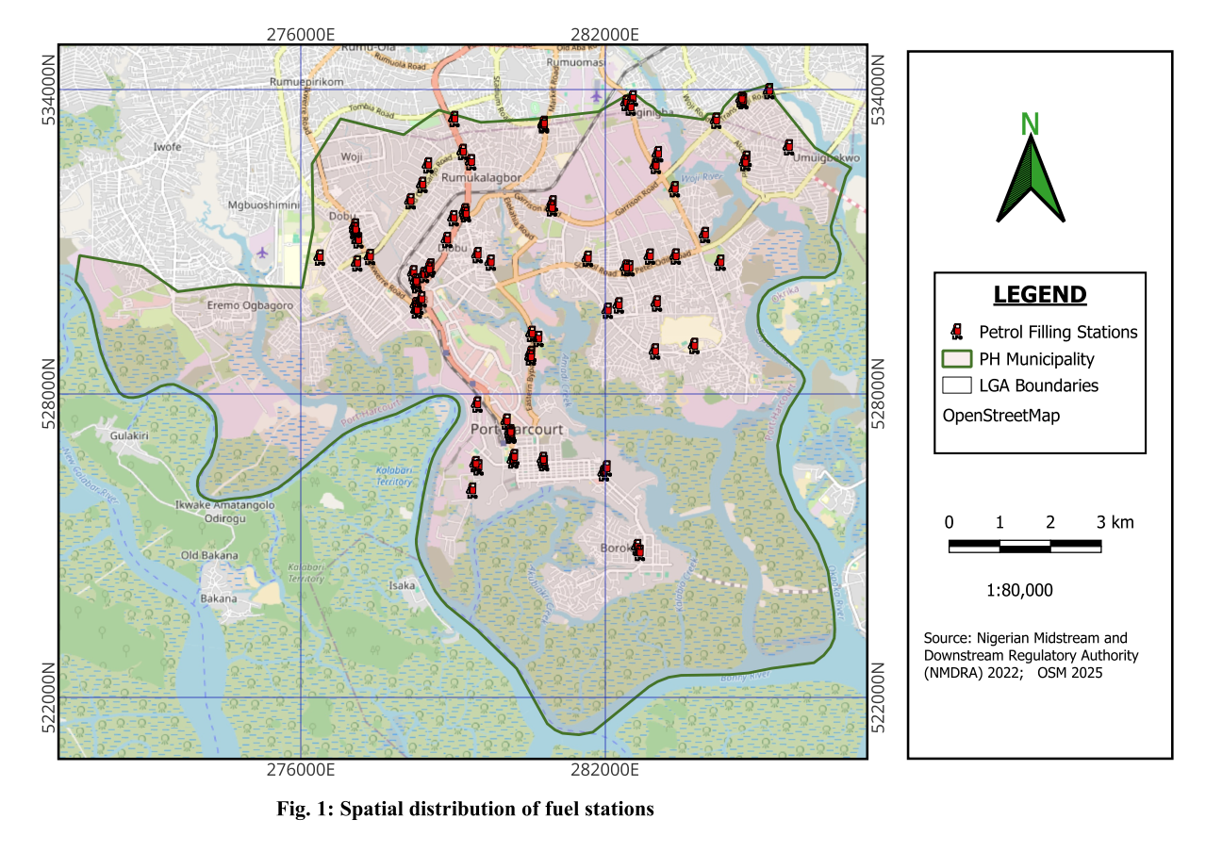

Figure 2: Spatial Distribution of Fuel Stations

Table 1: Result of Nearest Neighbour Analysis
Parameter | Value
Number of fuel stations | 78
Observed mean distance | 246.36 m
Expected mean distance | 519.99 m
Nearest neighbour index | 0.47
Z-score | −8.89
Distribution pattern | Clustered

4.2 Residential Exposure to Fuel Station Hazard Zones
Buffer analysis revealed substantial residential exposure to fuel station hazard zones. A total of 357 buildings were located within 50 m, 1,043 buildings within 100 m, and 3,068 buildings within 200 m of fuel stations.

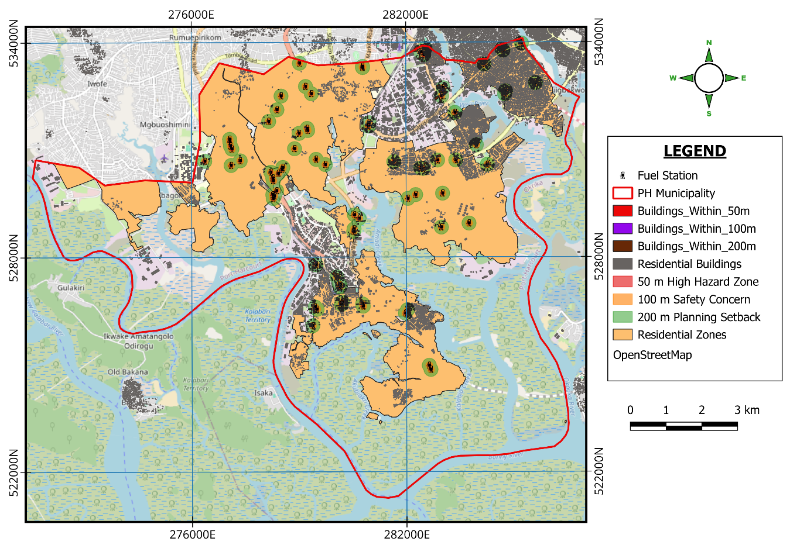

Fig. 3: Fuel Station Buffer Zones

Table 2: Residential Buildings within Fuel Station Hazard Zones
Buffer Distance | Number of Buildings | Risk Level
0–50 m | 357 | Critical hazard
50–100 m | 1,043 | High risk
100–200 m | 3,068 | Moderate risk
Source: GIS Buffer Analysis 2026
These results indicate that many residential structures are located within distances commonly regarded as unsafe for hazardous facilities.

4.3 Proximity of Fuel Stations to Schools
The proximity analysis between fuel stations and schools showed that while many stations are located in safer zones, a number of them fall within non-compliant or cautionary distances (See Fig. 4).
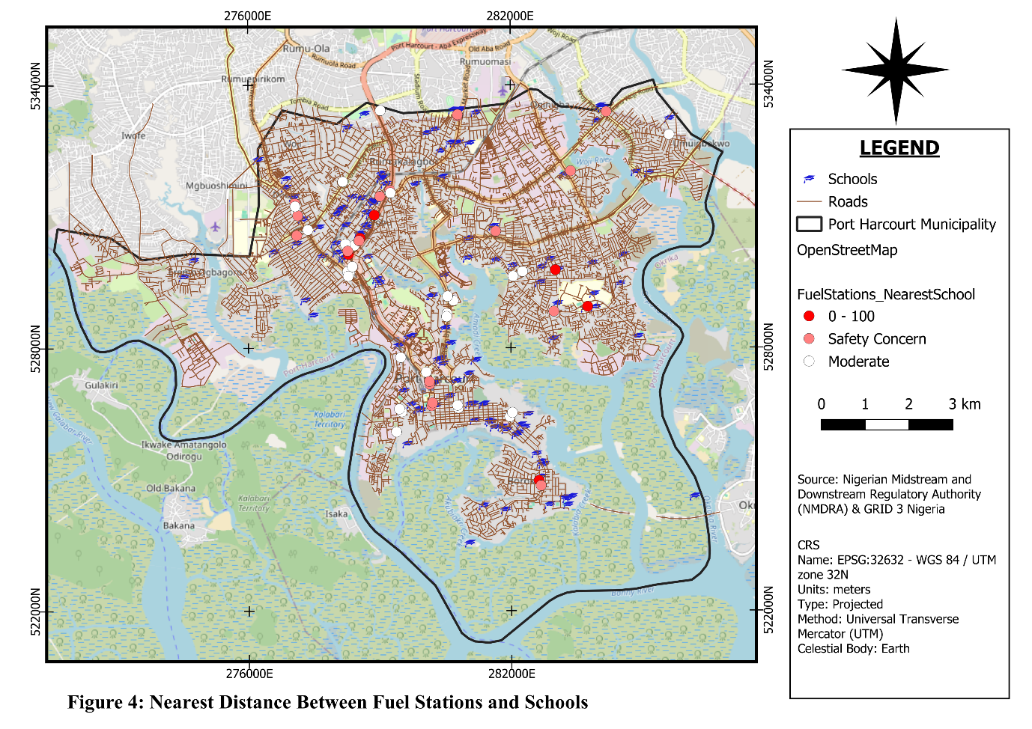
Examples of high-risk locations (0–100 m) include:
- Conoil, Ogbunabali – 91 m
- Conoil, Abuloma – 98 m
- Oando, Abuloma – 71 m
- Oando, Nkpogu – 93 m
- Forte Oil, Azikiwe Road – 98 m
- Techno, Abuloma – 57 m
- Stage Oil, D-Line – 77 m
Several other stations fell within the 100–200 m caution zone, including locations in Borokiri, Orogbum, Mile 3, Ogbunabali, and Aggrey Road. These findings indicate notable planning inconsistencies in the siting of fuel stations relative to educational facilities.

4.4 Proximity of Fuel Stations to Markets
Most fuel stations were found to be located at relatively safer distances from markets, but a few critical exceptions were identified. Notable high-risk cases include:
- Eastern Bypass station near roadside markets – 85 m
- Energy Matics near Nkpolu Mile 3 Market – 109 m
A station on Eastern Bypass located 124 m from roadside markets was classified in the caution zone. Although most stations were outside the most critical range, these cases reveal pockets of significant risk in densely active commercial areas (Fig. 5).
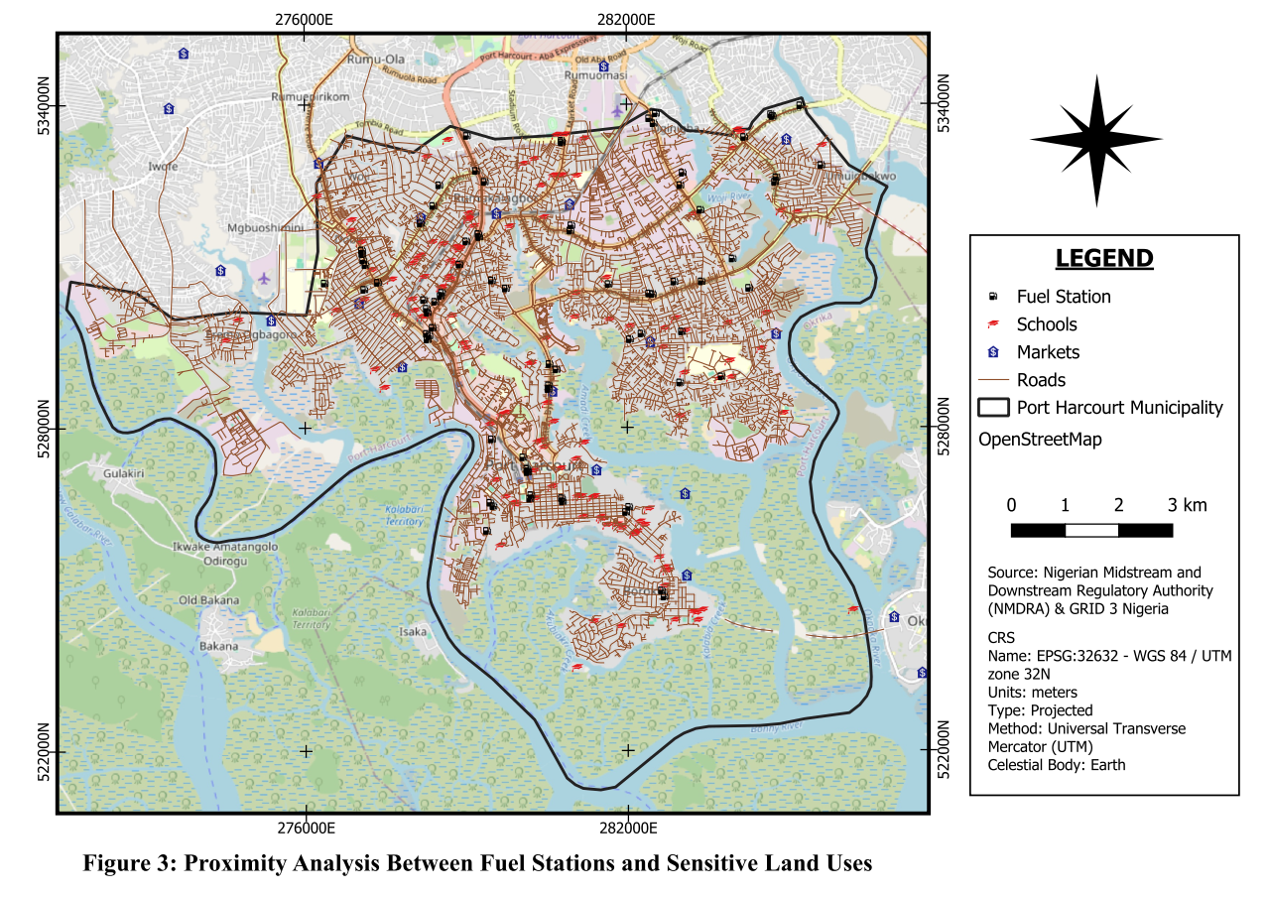
Fig. 5: Proximity of Fuel Stations to Sensitive Land Uses

4.5 Land-Use Compatibility Implications from Results
The results collectively point to significant land-use compatibility challenges in the municipality. The concentration of fuel stations along major road corridors, combined with the high number of buildings within short buffer distances, indicates an urban environment where hazardous land uses and sensitive receptors frequently coexist in close proximity.

5. Discussion
The spatial analysis undertaken in this study demonstrates that petrol filling stations in Port Harcourt Municipality are not randomly distributed, but instead exhibit a pronounced clustered spatial configuration, particularly along major road corridors and high-access urban locations. This pattern indicates that the siting of filling stations is strongly influenced by market-driven location factors, including traffic flow, visibility, and commercial accessibility. In urban economic geography and planning theory, such clustering is often interpreted through the lens of Central Place Theory, which posits that service facilities tend to concentrate in locations where accessibility to consumers is maximized (Christaller, 1933; Parr, 2025). Fuel stations, as retail infrastructure supporting transportation systems, therefore tend to locate along major transport routes and commercial corridors where vehicle flows are highest.
While such spatial clustering may enhance service efficiency and accessibility for motorists, it can also create significant environmental and safety externalities, particularly in densely populated urban areas. Planning scholarship has long highlighted the tension between market-based location efficiency and the regulatory responsibility of planning systems to manage externalities and protect public safety (Caves & Cullingworth, 2023; Hall & Tewdwr-Jones, 2019). When land markets operate in environments where planning institutions have limited enforcement capacity, economically attractive land uses frequently concentrate in high-demand locations even when this creates risks for neighbouring land uses (Burby & Dalton, 1994; Dear, 1992). Similar dynamics have been documented in rapidly urbanizing cities in Africa, where weak institutional coordination and rapid urban expansion often result in fragmented development patterns and the proliferation of incompatible land uses (Cobbinah et al., 2015). Within this broader context, the clustering observed in Port Harcourt Municipality should therefore not be viewed as an isolated phenomenon but as part of a wider pattern of market-led urban development occurring within constrained regulatory environments.
The implications of such clustering are particularly significant in the case of hazardous or potentially hazardous facilities. Unlike many commercial land uses, fuel stations involve the storage and distribution of highly flammable petroleum products and the emission of volatile organic compounds, which may present environmental and public health risks (Anigilaje et al., 2024; Malavolti et al., 2023). Planning research on hazardous land uses emphasizes that the risks associated with such facilities extend beyond individual sites; when hazardous facilities cluster within densely built environments, they may produce cumulative exposure landscapes that intensify vulnerability for nearby populations (Dear, 1992; Anguelovski et al., 2018). In Port Harcourt Municipality, the concentration of multiple fuel stations within built-up neighbourhoods suggests that hazard exposure is being layered onto already complex urban environments characterized by high residential density, mixed land uses, and intense vehicular activity.
The results of the buffer analysis provide particularly compelling evidence of land-use incompatibility between fuel stations and residential areas. The identification of 357 residential buildings within the 50 m hazard buffer indicates a substantial deviation from commonly recommended planning setback standards for hazardous facilities. When the analysis is extended to the 100 m and 200 m zones, the number of affected buildings increases significantly, indicating that a large residential population is located within distances where environmental hazards such as fire outbreaks, vapour emissions, fuel leakage, and traffic congestion may pose elevated risks. In land-use planning practice, setback distances are not merely technical guidelines but spatial instruments intended to reduce environmental externalities and ensure safe separation between incompatible land uses. Burby and Dalton (1994) demonstrated that hazard-sensitive land-use planning is only effective when regulatory frameworks are supported by strong institutional enforcement and monitoring mechanisms. Similarly, Dalton and Burby (1994) emphasize that development control systems must be supported by institutional coordination and effective governance structures in order to translate planning policies into enforceable spatial outcomes.
The spatial pattern observed within the 100 m and 200 m buffer zones further highlights the importance of conceptualizing urban risk as a continuum rather than a binary condition. Traditional planning approaches often rely on minimum separation distances as regulatory thresholds; however, contemporary urban risk research increasingly emphasizes that vulnerability should be understood in terms of exposure gradients, population density, and spatial concentration of hazards (Fekete et al., 2014; Meerow et al., 2016). In this perspective, the presence of large numbers of residential buildings within extended proximity zones suggests that hazard exposure may affect entire neighbourhoods rather than isolated properties. Studies examining proximity to hazardous infrastructure similarly highlight that risk should be interpreted as a function of cumulative exposure and urban spatial structure rather than solely as a matter of regulatory compliance (Osland, 2008). Consequently, the findings from Port Harcourt suggest that planning responses should not be limited to identifying violations within the most critical hazard buffer but should also consider the broader spatial field of exposure surrounding hazardous facilities.
The proximity of some filling stations to schools raises particularly important concerns from both planning and public health perspectives. Schools are widely recognized in planning practice as sensitive land uses, as they accommodate large concentrations of children who may be more vulnerable to environmental pollutants and accident risks. Environmental health research has demonstrated that exposure to petroleum-related pollutants, including benzene and other volatile organic compounds, may have adverse health implications for nearby populations (Anigilaje et al., 2024; Malavolti et al., 2023). Beyond air quality concerns, the presence of fuel stations near schools may also increase the risk of traffic-related hazards due to increased vehicle movements, tanker deliveries, and roadside congestion associated with fuel station operations. Planning scholarship on environmental justice further suggests that the location of hazardous facilities near socially vulnerable populations often reflects broader governance failures in urban land-use management (Anguelovski et al., 2018). In this sense, the proximity of fuel stations to schools in Port Harcourt Municipality highlights a multi-dimensional planning challenge involving environmental safety, public health protection, and equitable risk distribution.
The spatial relationship between fuel stations and markets presents a somewhat different pattern. In several cases, markets appear to be located at greater distances from fuel stations compared with residential areas and schools. This may reflect certain functional and operational considerations, such as the congestion associated with market environments, the need for pedestrian circulation space, and the logistical requirements of tanker access for fuel stations. Highly congested market areas may present operational constraints that discourage fuel station operators from locating directly within such nodes. Nevertheless, the presence of some markets within hazardous proximity to filling stations remains significant because markets represent high-density public spaces where accidents or fire incidents could have substantial consequences. Research on undesirable land uses has shown that spatial conflicts between hazardous facilities and surrounding activities are often highly localized, meaning that even a small number of high-risk cases may warrant targeted planning intervention (Dear, 1992; Owusu, 2008).
More broadly, the spatial patterns identified in this study reflect a wider issue of implementation deficit in urban planning governance. Across many rapidly growing cities, planning scholars have observed that statutory land-use plans and development standards frequently coexist with weak implementation capacity, fragmented institutional authority, and inconsistent enforcement practices (Hall & Tewdwr-Jones, 2019). In such contexts, land markets often exert stronger influence over development patterns than formal planning policies. This dynamic is particularly evident in rapidly urbanizing regions of the Global South, where population growth, infrastructure demand, and economic pressures frequently outpace the regulatory capacity of planning institutions (Cobbinah et al., 2015). As a result, hazardous facilities such as fuel stations may become embedded within mixed-use neighbourhoods where planning controls are insufficiently enforced.
The findings from Port Harcourt Municipality therefore illustrate a broader governance challenge in which development control systems struggle to balance economic development pressures with environmental safety considerations. From a policy perspective, strengthening development control mechanisms and improving interagency coordination between planning authorities and petroleum regulatory agencies may be essential for improving compliance with safety standards.
Finally, the study highlights the significant value of Geographic Information Systems (GIS) as a tool for urban safety analysis and development control monitoring. GIS-based spatial analysis enables planners to visualize hazard exposure zones, quantify affected populations, and identify spatial conflicts between hazardous facilities and surrounding land uses. Previous studies have demonstrated the usefulness of GIS techniques in evaluating the suitability of facility locations and assessing compliance with planning regulations (Khahro et al., 2014; Mohammed et al., 2014; Wahba et al., 2024). By integrating spatial data on infrastructure, buildings, and land uses, GIS provides a powerful evidence-based framework for identifying risk zones and informing planning decisions.
In the case of Port Harcourt Municipality, the GIS-based analysis presented in this study reveals patterns of spatial exposure that may not be readily apparent through conventional planning assessments. By quantifying the number of buildings located within hazard buffers and identifying proximity relationships between fuel stations and sensitive land uses, GIS analysis provides planners with actionable information that can support improved development control and risk-sensitive urban planning. This suggests that geospatial analysis tools can play an important role in strengthening urban governance by bridging the gap between planning regulations and their practical implementation.
Taken together, the findings indicate that fuel station development in Port Harcourt Municipality is largely shaped by commercial accessibility and market demand, rather than by precautionary land-use planning principles. While this spatial configuration enhances convenience and service coverage for motorists, it also increases the cumulative exposure of nearby residential populations and sensitive facilities to environmental hazards. The significance of this finding lies not only in identifying unsafe proximities but also in demonstrating how urban hazard exposure may emerge through incremental development decisions within weakly enforced planning systems. In this sense, the Port Harcourt case contributes to a broader body of planning literature emphasizing that urban safety outcomes are fundamentally shaped by governance capacity, regulatory enforcement, and the effective integration of spatial analysis into planning decision-making.

6. Policy Implications
The findings of this study carry significant policy implications for urban planning and development control in Port Harcourt Municipality.
First, there is an urgent need to strengthen enforcement of development control regulations governing the location of fuel stations. Facilities located within 100 m of residential buildings, schools, or other sensitive land uses should be reviewed through safety audits and regulatory compliance checks.
Second, planning authorities should establish or enforce mandatory safety buffer zones for fuel stations. A practical regulatory benchmark may include:
- Residential buildings: 100–150 m
- Schools: 150–200 m
- Markets: 150–200 m
Third, GIS-based monitoring systems should be integrated into planning approval and development control processes. A municipal geospatial database containing the locations of fuel stations, residential areas, schools, and markets would enable planners to detect potential zoning violations before approvals are granted.
Fourth, urban zoning policies should be reviewed to ensure a clearer separation between hazardous commercial activities and residential land uses. Mixed-use development areas should include strict safety provisions where fuel stations are permitted.
Fifth, existing fuel stations located within dense residential neighbourhoods should be subjected to routine public safety inspections. In high-risk cases, relocation, redesign, or additional mitigation measures may be necessary.
Finally, public awareness campaigns should be introduced to educate residents, developers, and operators on the environmental and safety implications of incompatible land-use patterns.

7. Conclusion
This study applied GIS techniques to evaluate land-use compatibility and urban safety implications of fuel station locations within Port Harcourt Municipality. The results reveal a strong clustering of fuel stations along major transportation corridors and mixed-use urban zones. Buffer analysis further shows that a substantial number of residential buildings are located within critical hazard zones surrounding fuel stations, indicating widespread land-use incompatibility.
Proximity analysis identified several fuel stations located within unsafe distances of schools and, in a few cases, markets, raising significant public safety concerns. These findings suggest that current development control mechanisms are insufficient to prevent potentially hazardous land-use conflicts in the municipality.
The study demonstrates the effectiveness of GIS-based spatial analysis in identifying planning violations, quantifying hazard exposure, and supporting risk-sensitive urban planning. Integrating geospatial tools into planning practice can improve monitoring, zoning enforcement, and urban safety management.
Achieving safer and more sustainable development in Port Harcourt Municipality will require coordinated action among urban planners, environmental regulators, development control agencies, and local government authorities. Stronger enforcement, GIS-based planning systems, and risk-informed land-use regulation are essential to reducing hazard exposure and protecting urban residents.

References
Anigilaje, E. A., Akinosun, O. M., Ohaka, N. C., et al. (2024). Exposure to benzene, toluene, ethylbenzene and xylene (BTEX) at Nigeria’s petrol stations: Current status, challenges and future directions. Frontiers in Public Health, 12, 1295758. https://doi.org/10.3389/fpubh.2024.1295758
Anguelovski, I., Connolly, J., & Brand, A. L. (2018). From landscapes of utopia to the margins of the green urban life: For whom is the new green city? City, 22(3), 417–436.
Apparicio, P., Cloutier, M.-S., & Shearmur, R. (2007). The case of Montréal’s missing food deserts: Evaluation of accessibility to food supermarkets. International Journal of Health Geographics, 6(4). https://doi.org/10.1186/1476-072X-6-4
Brunner, J., & Glasson, J. (2015). Contemporary issues in Australian urban and regional planning. Routledge.
Burby, R. J., & Dalton, L. C. (1994). Plans can matter! The role of land use plans and state planning mandates in limiting development in hazardous areas. Public Administration Review, 54(3), 229–238.
Caves, R. W., & Cullingworth, J. B. (2023). Planning in the USA: Policies, issues, and processes (5th ed.). Routledge.
Christaller, W. (1933). Central places in southern Germany. Prentice-Hall.
Cobbinah, P. B., Erdiaw-Kwasie, M. O., & Amoateng, P. (2015). Africa’s urbanisation: Implications for sustainable development. Cities, 47, 62–72. https://doi.org/10.1016/j.cities.2015.03.013
Cullingworth, B. (2004). Planning in the USA: Policies, issues and processes. Routledge.
Dalton, L. C., & Burby, R. J. (1994). Mandates, plans, and planners: Building local commitment to development management. Journal of the American Planning Association, 60(4), 444–461.
Dear, M. (1992). Understanding and overcoming the NIMBY syndrome. Journal of the American Planning Association, 58(3), 288–300.
Fekete, A., Hufschmidt, G., & Kruse, S. (2014). Benefits and challenges of resilience and vulnerability for disaster risk management. International Journal of Disaster Risk Science, 5(1), 3–20.
Hall, P., & Tewdwr-Jones, M. (2019). Urban and regional planning. Routledge.
Hsieh, P. Y., Shearston, J. A., & Hilpert, M. (2021). Benzene emissions from gas station clusters: A new framework for estimating lifetime cancer risk. Journal of Environmental Health Science and Engineering, 19(1), 273–283.
Khahro, S. H., Matori, A. N., Chandio, I. A., & Talpur, M. A. H. (2014). Land suitability analysis for installing new petrol filling stations using GIS. Procedia Engineering, 77, 28–36. https://doi.org/10.1016/j.proeng.2014.07.024
Longley, P. A., Goodchild, M. F., Maguire, D. J., & Rhind, D. W. (2015). Geographic information science and systems (4th ed.). Wiley.
Malavolti, M., Malagoli, C., Filippini, T., Wise, L. A., Bellelli, A., Palazzi, G., & Vinceti, M. (2023). Residential proximity to petrol stations and risk of childhood leukemia. European Journal of Epidemiology, 38(7), 771–782.
Meerow, S., Newell, J. P., & Stults, M. (2016). Defining urban resilience: A review. Landscape and Urban Planning, 147, 38–49. https://doi.org/10.1016/j.landurbplan.2015.11.011
Mohammed, M. U., Musa, I. J., & Jeb, D. N. (2014). GIS-based analysis of the location of filling stations in metropolitan Kano against the physical planning standards. American Journal of Engineering Research, 3(9), 147–158. https://www.academia.edu/11529536/GIS_Based_Analysis_of_the_Location_of_Filling_Stations_in_Metropolitan_Kano_against_the_Physical_Planning_Standards
Nigeria. (1992). Nigerian Urban and Regional Planning Act, No. 88 of 1992 (Cap N138 Laws of the Federation of Nigeria 2004). Government of Nigeria. https://faolex.fao.org/docs/pdf/nig120669.pdf
Osland, L., & Thorsen, I. (2008). Effects on housing prices of urban attraction and labour-market accessibility. Environment and Planning A, 40(10), 2490-2509.
Owusu, G. (2008). Indigenes' and migrants' access to land in peri-urban areas of Accra, Ghana. International Development Planning Review, 30(2), 177–198.
Parr, J. B. (2025). Walter Christaller (1893–1969): Originator of Central Place Theory. In Great Minds in Regional Science (Vol. 3, pp. 17–34). Springer Nature Switzerland.
Seto, K. C., Güneralp, B., & Hutyra, L. R. (2012). Global forecasts of urban expansion to 2030 and direct impacts on biodiversity and carbon pools. Proceedings of the National Academy of Sciences, 109(40), 16083–16088. https://doi.org/10.1073/pnas.1211658109
Ukanwa, S. O., Ejikeme, J. O., Chigbu, N., Okezie, M. D., & Gabriel, C. C. (2024). Site suitability analysis and risk assessment of petroleum filling stations in Umuahia metropolis using GIS techniques. FIG Working Week Proceedings.
UN-Habitat. (2020). World Cities Report 2020: The value of sustainable urbanization. United Nations.
Wahba, D., Omran, A. A., Adly, A., Gad, A., Arman, H., & El-Bagoury, H. (2024). Optimizing site selection for construction: Integrating GIS modeling, geophysical, geotechnical, and geomorphological data using the analytic hierarchy process. ISPRS International Journal of Geo-Information, 14(1), 3.
World Health Organization. (2010). WHO guidelines for indoor air quality: Selected pollutants. WHO Press.

