Original Research Article
Mapping Disaster Risk Perception Among College Students in Kerala: A Spatial Analysis.

Abstract
Kerala, India, faces increasing hazards and recurring disasters, necessitating greater community awareness to anticipate and respond to these dangers. This study developed a scale to evaluate college students' perception of disaster risk across Kerala. The State Action Plan on Climate Change (SAPCC) identifies Alappuzha, Palakkad, Wayanad, and Idukki as climate change hotspots, highly vulnerable to natural hazards like floods and droughts. Disaster risk perception among college students in Kerala was investigated through a spatial analysis. A structured questionnaire was administered to 420 randomly selected students from 14 districts. The study assessed disaster awareness, knowledge, experiences, perceptions of responsibility, human impact, preparedness, preventability, recovery, and post-disaster needs. Descriptive statistics revealed high awareness of disasters and related institutions, but gaps in formal disaster education and local hazard knowledge. Students recognized the health and educational impacts of disasters, but perceptions of financial damage were split. Responsibility was attributed to governments and individuals, but confidence in businesses and engagement in preventive activities were low. Many doubted disaster preventability but expressed confidence in post-disaster facilities and reconstruction, prioritizing safety over prevention. Factor analysis identified seven clusters shaping disaster risk management perspectives, including awareness, misconceptions, trust, and socio-demographic influences. District-level disparities highlighted the need for targeted interventions, with some districts showing stronger preparedness while others lagged. Recommendations include integrating disaster education into curriculam, conducting regular training programs, promoting community-based initiatives, leveraging technology for real-time alerts, and advocating for policy support to build a resilient student community. The findings emphasize the importance of comprehensive disaster risk reduction education and tailored strategies to enhance preparedness and resilience among college students in Kerala.
Keywords Kerala, Disaster Risk Perception, Climate Change Hotspots, College Students, Disaster Awareness
1 INTRODUCTION

The number of recorded disasters has increased fivefold over the past 50 years, driven in part by human-induced climate change (WMO, 2023). This trend is accelerating the prevalence of people affected by disasters and the countries that currently have operational early warning systems (EWS). Sixty-two million people directly affected by disasters in the last two decades live in countries without operational EWS. This means that without increased investment in resilience-building through extending early warning system coverage, developing countries are projected to have higher numbers of people affected by hazards as population growth continues (GAR2022). A disaster is an event that poses a danger to a society or community, causing human, material, environmental, and economic losses (United Nations Office for Disaster Risk Reduction, 2021). The four phases of disaster management are mitigation, preparedness, response, and recovery (Nipa, 2023; Behmam, 2017). Studies on risk perception in disaster management enable managers to predict public response, improve understanding of risk attitudes, prevent conflicts during emergencies, and establish effective risk communication (Johannesdóttir & Gísladóttir, 2010). "It is critical to study and understand the real perceptions and concerns of the population in order to design plans, programs, and policies that enable the development of better prepared and more resilient communities in the face of disasters" (Bronfman et al., 2016). Whereas risk perception studies can greatly benefit the efficiency of educating individuals and families and the actions of society for mitigation (Kung & Chen, 2012).
Risk perception is influenced by a combination of social and psychological processes that cause certain hazards to be more concerning to society while others become less concerning (Etkin, 2016). Livelihood opportunities (Chambers & Conway, 1992) can lead people to take more risks. The characteristics and consequences of a potential threat, as well as its proximity, also play a role in how it is perceived by society. In today's age of social media, the media plays a crucial role in ensuring that disaster news is covered objectively. The perceptions of university students are crucial in the study of disaster risk. (Simms, Kusenbach, and Tobin 2013) highlight the importance of studying students as they are both more vulnerable and more resilient to disasters compared to local community members. (Wu et al. 2017) also emphasize the significance of investigating students' thoughts on risk, disaster preparedness, and mitigation measures due to their vulnerability. Students contribute to reducing disaster risk in schools and communities by collaborating with teachers and other adults. For instance, a student in England saved many lives during the Indian Ocean Tsunami thanks to the tsunami education she received in her geography class (United Nations Office for Disaster Risk Reduction, 2016).
"Contrary to popular belief, students' understanding and attitudes towards disasters can actually help universities to enhance their current disaster management practices (Chen & Adefila, 2020; Tkachuck et al., 2018). For example, in a study on the disaster preparedness of university students, they provided valuable suggestions on university emergency preparedness, campus policies, training programs, and how to encourage students to be prepared for emergencies (Davis et al., 2019). Despite the fact that students have a high level of education, good health, and are often renters, which makes them more resilient to disasters, their lack of experience and their financial and emotional reliance on their families can also make them more vulnerable (Simms et al., 2013).
Even though students are among the most vulnerable groups in the community to natural disasters, they are often overlooked (Edwards, F, 2013) (Amri, A, 2017). University students are a rare set of individuals with a versatile worldview and exceptional adaptability (Khorram-Manesh, A, 2018). They can learn emergency skills more rapidly and efficiently than the general population since they possess these characteristics. As training sessions might greatly lower the costs of damages and students can be valuable resources for disaster response, prevention, and mitigation in general, it is strongly suggested to equip students with the right training and education (Pamidimukkala, 2020) (Tkachuck, M.A, 2018).
Kerala is often battered by a plethora of hazards, making it highly susceptible to multiple disasters. These hazards, inherent in the earth's natural evolution, transitioned into perilous events when human activities began to intersect with the environment. Human society has undergone significant transformations throughout history, intricately linked with the natural system. The changes mentioned in the passage have helped us understand how natural disasters occur. At the same time, because of the increasing population along the coast, some people who were not previously part of the main community had to move from the coast to the less welcoming terrain of the Western Ghats (George & Chattopadhyay, 2001). The elevated population density, with approximately 860 people per square Kilometer according to the 2011 Census, along with narrow roads, a dense road network, and concentrated coastal settlements, coupled with the generally higher standard of living compared to the national average, collectively contribute to heightened vulnerability to disasters among the populace.
Numerous studies have provided insights into the perceptions and readiness levels of different demographic groups regarding various natural disasters. (Foster 2002, MuralidasS 2007, Nair 2014), Investigated disaster of Kerala context. (Scalion,2008) investigated the volcanic perception and preparedness of urban youth near Vesuvius, highlighting the necessity for improved communication strategies. (Lovekamp,2008) explored college students' perceptions of tornadoes and earthquakes, revealing gaps in preparedness actions despite an understanding of potential risks. (Finnis,2010) examined hazard perception and preparedness among Taranaki youth, emphasizing the role of hazard education programs in enhancing resilience. (Yang,2010) focused on public earthquake risk perception, stressing the importance of tailored risk communication strategies. (Tuladhar,2013) studied disaster risk reduction education programs in Nepal.(Usuzawa,2014) emphasized the need for disaster medicine education among healthcare students in the Philippines and Indonesia. (Tuladhar,2015) revealed gaps in teachers' awareness of disaster risk reduction in Nepal. (Oztekin,2015) compared disaster preparedness perceptions among nursing students in earthquake-prone cities. (Cvetkoric,2015) investigated earthquake perceptions among secondary school students in Belgrade, highlighting the impact of information sources. (Reyes,2016) identified deficiencies in earthquake preparedness discussions among high school students in Mexico City. (Goddard,2018) emphasized the role of health education programs in improving college students' disaster preparedness. (Bandecchi,2019) underscored the importance of school-based emergency management efforts in increasing community resilience. (Buylova,2020) identified factors influencing public risk perceptions of a Cascadia subduction zone earthquake. (Kara,2020) revealed gaps in hazard awareness among secondary school students in Turkey.(Mizrak,2020) unveiled factors predicting anxiety in university students' disaster risk perception in Turkey. (Planic,2021) highlighted gender and education level influences on earthquake risk perception among Belgrade citizens. (Zhong,2021) investigated the impact of a disaster education program on flood risk perception among children in China. Lapada,(2022) emphasized the need for enhanced disaster risk reduction education among senior high school students in the Philippines. Huang (2022) analysed the role of trust in disaster risk perception among high school students in Ningbo, China. The study emphasized the moderating effect of government ability. These findings contribute to our understanding of disaster perceptions and preparedness, informing targeted interventions to enhance resilience and mitigation efforts.
1.2.STUDY AREA
Kerala State extends from 8⁰ 18^{I}North to 12⁰ 48^{I} North latitude and 74º 52^{I} East to 77º22^{I} East longitude along the coast in the south western part of India. Karnataka bounds the State in the north, Tamilnadu in the east and south, and Lakshadweep Sea in the west, with an area of 38863 sq Km, which is 1.27 percent of the total area of India, and the population share is about 2.7% in 2011 census. (Fig 1) Transportation is an integral part of all commercial and social development processes in Kerala State. (Jayarajan K 2014).Similarly, air and water routes play major roles in Kerala's development. Kerala, located on the Southwestern coast of India, spans approximately 560 kilometers along the Arabian Sea. It is divided into three main regions: the Highland, Midland, and Lowland. The Highland, covering nearly half of the State, consists of the Western Ghats with peaks like Anamudi. The Midland, occupying about 42% of Kerala, supports most of its population and is characterized by valleys and hills suitable for agriculture. The Lowland, forming a narrow strip along the coast, accommodates a quarter of the population despite its small size. Kerala's rivers and backwaters, including 44 perennial rivers and interconnected water bodies, contribute to its rich natural beauty and cultural heritage.
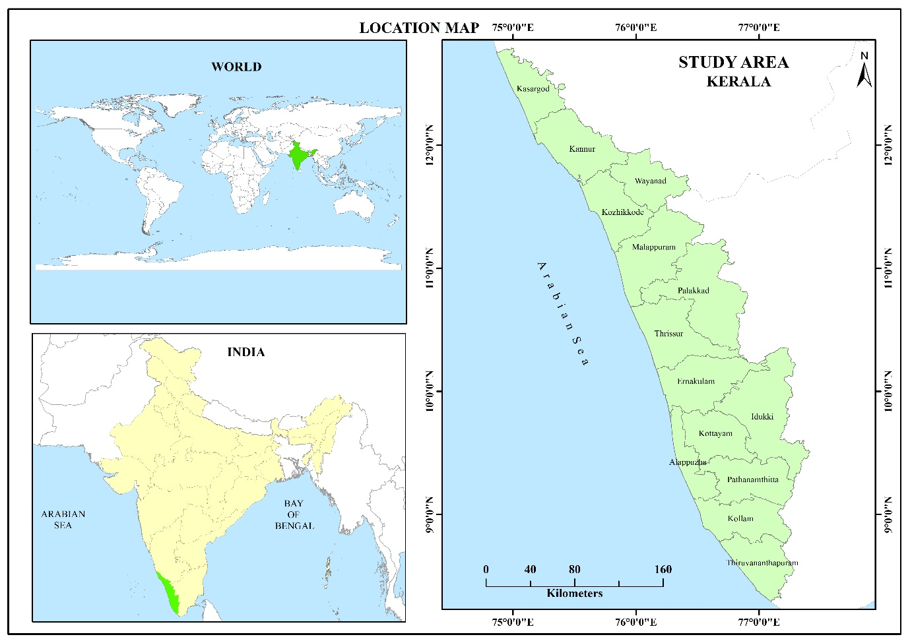
Fig 1 Location map of Kerala
1.3 UNDERSTANDING KERALA’S DISASTER PROFILE
Kerala, often referred to as "God's own country" and the "Gateway of monsoon in India," is characterized by its humid tropical climate, rich biodiversity, and high levels of human development(JayarajanK 2014) . However, the state is increasingly susceptible to a range of disasters due to environmental, demographic, and anthropogenic factors. Over the past century, Kerala has transitioned from an agrarian society to an urbanized one, with migration patterns significantly altering its demographic composition. Its dense population, with 860 persons per square kilometres, distributed across diverse terrains—highlands, midlands, and lowlands—renders it highly vulnerable to floods, landslides, earthquakes, droughts, lightning, tsunamis, and cyclones (Bhatt & Bhargava, 2006; Kerala State Disaster Management Authority, 2016). The Kerala State Disaster Management Plan (KSDMP) identifies 39 hazards, both natural and anthropogenic in origin, although not all exceed the local capacities for coping. Floods are the most recurrent disasters in Kerala due to its dense river networks and monsoon climate. Historically, the Great Flood of 1924 devastated the Periyar basin. More recently, between 2000–2018, Kerala experienced 14 floods (CRED, 2018). The 2018 floods, the most severe in a century, resulted in over 480 fatalities, displaced more than a million individuals, and necessitated the opening of major dams like Idukki for the first time. It was declared the largest humanitarian flood crisis globally in 2018 (CRED, 2018). Subsequent floods in 2019, 2020, and 2021 further underscored the intensifying role of climate change in exacerbating Kerala’s flood vulnerability.
Intense monsoons have precipitated fatal landslides, notably in Kavalappara (2019) and Pettimudi (2020) (Achu, 2021; Aju, 2020). From 2015 to 2020, Kerala experienced over 2,200 landslides, surpassing other Indian states significantly (Hussin, 2024). Recent incidents, such as the 2024 Mundakkai–Chooralmala disaster, highlight the urgent need for comprehensive risk assessment and mitigation strategies (Das, 2024; Kolathayar, 2024). Although Kerala is classified within seismic Zone III, indicating a moderate risk level, its midland region exhibits increased vulnerability due to tectonic shifts and historical events (Rajendran, John, Sreekumari, & Rajendran, 2009). While seismic risks are less frequent than floods or landslides, they remain a significant concern.
The state has experienced significant droughts in the years 1983, 1985, 1986, 1987, and most notably in 2016. The reduction in rainfall and unpredictable monsoon patterns have rendered over 50% of its territory susceptible to moderate to severe drought conditions, posing a threat to agricultural activities and water resources (Nathan, 2000; Kerala State Disaster Management Authority, 2016). Lightning, associated with Kerala's monsoon climate, frequently results in casualties and damage to infrastructure, remaining one of the most persistent natural hazards (Illiyas, Mohan, Mani, & Pradeepkumar, 2014). The 2004 Indian Ocean tsunami had a devastating impact on Kerala's coastline, particularly in Azheekkal, Kollam, resulting in the loss of over 172 lives (Suresh, 2005). This event led to reforms in disaster preparedness, coastal resilience, and community awareness. In 2017, Cyclone Ockhi impacted southern Kerala, bringing heavy rainfall and storm surges up to 0.5 meters, resulting in 12 fatalities and considerable property damage (Ravindran et al., 2018), highlighting the state's vulnerability to cyclonic events.
The geographic and demographic characteristics of Kerala, in conjunction with the impacts of climate change, have heightened the region's vulnerability to disasters. The frequent occurrence of floods, landslides, droughts, and other hazards underscores the critical necessity for proactive resilience-building, comprehensive disaster preparedness, and adaptive management strategies to protect its population and ecosystems.
This study aims to assess college students' understanding of disaster risk and to help higher education stakeholders identify important disaster preparedness indicators (DPIs) for students. It will enable them to enhance their programs and develop effective disaster risk reduction (DRR) courses. Additionally, it will assist policymakers in restructuring emergency preparedness policies and procedures. Knowledge regarding disaster risk helps young people to understand and reduce the consequences of disaster. The disaster risk perception among college students examines the association among perceptions regarding disaster risk. The quantitative study was designed to acquire a narrative from students to attain an in-depth understanding of how they perceive issues around disaster risk reduction and sustainable planning.

2 METHODS
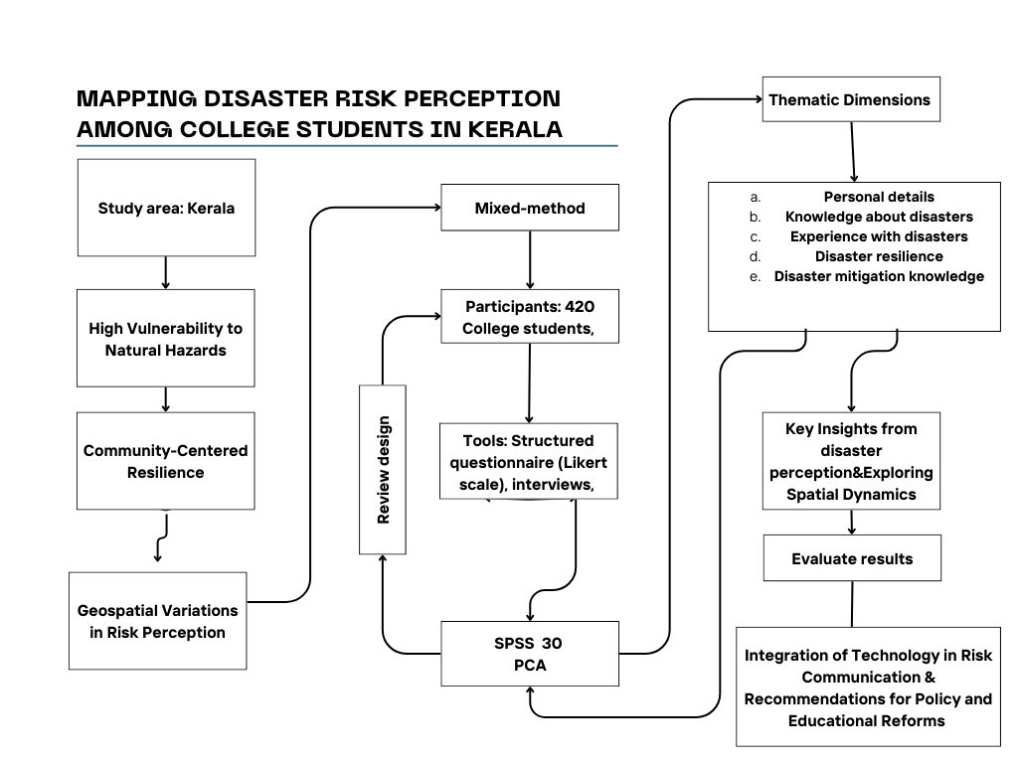

Fig 2 Methodology of Disaster Risk Perception among College students in Kerala
The present study employed a structured methodology to examine the disaster risk perception of college students in Kerala. (Fig 2) The research targeted students residing in disaster-prone communities, with a total of 420 respondents selected through random sampling, comprising 30 students from each of the 14 districts.(Table1) Primary data was collected using a structured questionnaire administered via an e-survey. The instrument was designed to capture multiple dimensions of students’ disaster risk perception, enabling a comprehensive and multi-faceted analysis. Five major categories of variables were included: (1) Personal information about students, (2) Disaster awareness and knowledge assessment, (3) Perceptions and experiences of disaster impacts, (4) Perceptions of responsibility, human impact, and preparedness for disasters, and (5) Perceptions of disaster preventability, recovery, and post-disaster needs.
The first category recorded demographic characteristics such as age, gender, residence, and education level. The second assessed students’ knowledge of disaster-related terms, awareness of organizations like KSDMA and NDMA, familiarity with disaster education, and recognition of the role of climate change in exacerbating disasters. The third category focused on students’ personal experiences with disasters, including financial losses, health issues, and disruptions to education, thereby capturing the influence of direct exposure on preparedness and risk perception. The fourth category examined views on the responsibilities of government, local bodies, businesses, and individuals in managing disasters, while also evaluating students’ own participation in resilience-building measures. Finally, the fifth category measured students’ awareness of risk reduction strategies and their confidence in science, technology, and sustainable practices for disaster prevention, recovery, and post-disaster management.
Table 1 District-Wise Colleges in Kerala with Selected Study Samples
Sl No. | District | Government | Private | Total | Rank | Samples from College
Sl No. | District | Government | Aided | Total | Rank | Samples from College
1 | Thiruvananthapuram | 10 (15.15) | 16(9.8) | 26(11.3) | 1 | 30
2 | Kollam | 2(3.03) | 13(7.9) | 15(6.5) | 6 | 30
3 | Pathanamthitta | 1(1.5) | 9(5.5) | 10(4.3) | 8 | 30
4 | Alappuzha | 1(1.5) | 12(7.3) | 13(5.6) | 7 | 30
5 | Kottayam | 1(1.5) | 23(14.1) | 24(10.4) | 2 | 30
6 | Idukki | 3(4.5) | 7(4.2) | 10(4.3) | 8 | 30
7 | Ernakulam | 5(7.5) | 21(12.8) | 26(11.3) | 1 | 30
8 | Thrissur | 5(7.5) | 17(10.4) | 22(9.6) | 3 | 30
9 | Palakkad | 8(12.12) | 8(4.9) | 16(6.9) | 5 | 30
10 | Malappuram | 9(13.6) | 13(7.9) | 22(9.6) | 3 | 30
11 | Kozhikode | 10(15.15) | 8(4.9) | 18(7.8) | 4 | 30
12 | Wayanad | 2(3.03) | 4(2.4) | 6(2.6) | 10 | 30
13 | Kannur | 4(6.06) | 9(5.5) | 13(5.6) | 7 | 30
14 | Kasargod | 5(7.5) | 3(1.8) | 8(3.4) | 9 | 30
 | Total | 66(100) | 163(100) | 229(100) |  | 420
Source: Directorate of Collegiate Education (Economic Review, 2019)
The table 1 delineates the distribution of government and private-aided arts and science colleges across the 14 districts of Kerala, alongside their respective rankings and sample sizes. Thiruvananthapuram and Ernakulam emerge as the leading districts, each accommodating 26 colleges (11.3%). Kottayam follows with 24 colleges (10.4%), while Thrissur and Malappuram jointly occupy the third position with 22 colleges each (9.6%). Kozhikode ranks fourth with 18 colleges (7.8%), succeeded by Palakkad with 16 colleges (6.9%). Kollam records 15 colleges (6.5%), whereas Alappuzha and Kannur each host 13 colleges (5.6%). Pathanamthitta and Idukki each contain 10 colleges (4.3%). Kasaragod accounts for 8 colleges (3.4%), and Wayanad has the fewest, with only 6 colleges (2.6%). In total, Kerala comprises 229 arts and science colleges, including 66 government (28.8%) and 163 private-aided (71.2%) institutions. Each district contributed 30 samples, culminating in a total of 420 samples for the study, thereby ensuring comprehensive coverage across the state.
For data analysis, both descriptive and inferential techniques were applied. Percentage analysis was used to examine the distribution of responses, providing a clear picture of while patterns across the sample. Additionally, factorial analysis was employed to identify relationships among variables and uncover the underlying factors shaping disaster risk perception and preparedness using SPSS 30. This comprehensive methodological approach enabled the study to integrate individual, institutional, and societal perspectives, offering a holistic understanding of disaster preparedness among college students in Kerala.
3 RESULTS
The results of the study present the findings derived from the primary survey conducted among 420 college students across Kerala. The data has been analysed to capture key aspects of disaster risk perception and preparedness, structured under five major dimensions: personal information, disaster awareness and knowledge, perceptions and experiences of disaster impacts, perceptions of responsibility and preparedness, and perceptions of disaster preventability and recovery. These results provide a clear understanding of how demographic factors, awareness levels, and personal experiences collectively influence students’ attitudes toward disaster management.
Table 2 Personal information of the students
Sl no | Variables | Mean | Std. Deviation
V1 | Male | 20.86 | 16.295
V2 | Female | 79.14 | 16.295
V3 | BA | 26.86 | 27.064
V4 | BSc | 73.14 | 27.064

Table 2 shows the descriptive statistics of the personal details indicate that the majority of respondents in the sample are female (Mean = 79.14, SD = 16.295), while the proportion of male respondents is considerably lower (Mean = 20.86, SD = 16.295). In terms of educational background, a larger share of participants are pursuing or have completed B.Sc. (Mean = 73.14, SD = 27.064), whereas fewer belong to the B.A. category (Mean = 26.86, SD = 27.064). The relatively higher means for females and B.Sc. students suggest that the sample is skewed toward these groups, reflecting stronger representation of women and science-background students in the study population. The standard deviation values indicate moderate variability within both gender and educational distributions, with education showing slightly higher dispersion compared to gender.
Table3 Disaster Awareness and Knowledge Assessment
Sl no | Disaster Awareness and Knowledge Assessment | Mean | Std. Deviation
V5 | Heard about the term disaster | 99.14 | 2.316
V6 | Not heard about the term disaster | 0.86 | 2.316
V7 | Aware about types of disaster | 97.57 | 5.229
V8 | Not aware about types of disaster | 2.43 | 5.229
V9 | Heard about KSDMA | 92.21 | 8.693
V10 | Not heard about KSDMA | 7.86 | 8.672
V11 | Knowledge about NDMA | 88.93 | 13.898
V12 | No knowledge about NDMA | 11.07 | 13.898
V13 | Receive disaster education | 73.29 | 27.099
V14 | Not receive disaster education | 26.71 | 27.099
V15 | Disaster knowledge is important | 97.21 | 6.886
V16 | Disaster knowledge is not important | 2.79 | 6.886
V17 | Knowledge of disaster-prone area | 69.43 | 24.679
V18 | No knowledge about disaster-prone area | 30.50 | 24.688
V19 | Climate change is the major cause of disaster | 88.36 | 15.535
V20 | Climate change is not a major cause of disaster | 11.64 | 15.535

Table 3 shows the Disaster Awareness and Knowledge Assessment reveal a generally high level of awareness among respondents. Almost all participants had heard about the term disaster (Mean = 99.14, SD = 2.316) and were aware of different types of disasters (Mean = 97.57, SD = 5.229). Similarly, awareness of institutions such as the Kerala State Disaster Management Authority (KSDMA) was high (Mean = 92.21, SD = 8.693), while knowledge about the National Disaster Management Authority (NDMA) was also substantial (Mean = 88.93, SD = 13.898). A majority of respondents had received disaster education (Mean = 73.29, SD = 27.099), though a notable proportion (26.71%) reported not receiving such education, indicating some gaps in formal awareness-building efforts. Importantly, respondents overwhelmingly agreed that disaster knowledge is important (Mean = 97.21, SD = 6.886). Knowledge of disaster-prone areas was moderate (Mean = 69.43, SD = 24.679), suggesting uneven geographical awareness among participants. Furthermore, most respondents acknowledged climate change as the major cause of disasters (Mean = 88.36, SD = 15.535). These findings highlight strong disaster awareness and recognition of institutional roles, though gaps remain in disaster education coverage and specific knowledge of disaster-prone areas.
Table 4 Perceptions and Experiences of Disaster Impacts
Sl no | Perceptions and Experiences of Disaster Impacts | Mean | Std. Deviation
V21 | Have disaster experience | 37.86 | 25.283
V22 | No disaster experience | 62.29 | 25.275
V23 | Disaster causes chronic diseases | 73.36 | 20.144
V24 | Disaster not causes chronic diseases | 9.93 | 15.745
V25 | Don’t know disaster causes diseases | 20.36 | 18.075
V26 | Disaster causes financial damage in family | 49.00 | 22.084
V27 | Disaster not causes financial damage in family | 47.43 | 25.961
V28 | College stops long time, when disaster occur | 63.07 | 17.804
V29 | College not stops long time, when disaster occurs | 37.07 | 17.873
V30 | Aware of effects of disaster apart from health | 79.71 | 18.248
V31 | Not aware of effects of disaster apart from health | 11.00 | 14.910
V32 | Don’t know effects of disaster apart from health | 9.21 | 11.879

Table4 shows the Perceptions and Experiences of Disaster Impacts indicate that a larger proportion of respondents reported no disaster experience (Mean = 62.29, SD = 25.275), while a smaller proportion had direct disaster experience (Mean = 37.86, SD = 25.283). A strong majority believed that disasters cause chronic diseases (Mean = 73.36, SD = 20.144), while very few disagreed (Mean = 9.93, SD = 15.745) or were uncertain (Mean = 20.36, SD = 18.075). Financial impacts appeared divided, with nearly equal proportions believing that disasters cause financial damage in families (Mean = 49.00, SD = 22.084) and those perceiving no such impact (Mean = 47.43, SD = 25.961), suggesting mixed experiences or perceptions in this domain. Educational disruption was recognized strongly, with most respondents agreeing that colleges stop for long durations during disasters (Mean = 63.07, SD = 17.804). Moreover, awareness of disaster effects beyond health was high (Mean = 79.71, SD = 18.248), while only a small share of respondents expressed unawareness (Mean = 11.00, SD = 14.910) or uncertainty (Mean = 9.21, SD = 11.879). The results highlight that while direct disaster experiences may not be widespread, awareness of health, education, and broader social impacts is relatively strong, though financial impacts remain perceived inconsistently.
Table 5 Perceptions of Responsibility, Human Impact, and Preparedness for Disasters

Sl no | Perceptions of Responsibility, Human Impact, and Preparedness for Disasters | Mean | Std. Deviation
V33 | International organisation has the responsible to tackle the disaster | 6.43 | 13.932
V34 | National government has the responsible to tackle disaster | 30.50 | 20.248
V35 | Local Govt has the responsible to tackle disaster | 22.71 | 22.602
V36 | Business & industries are responsible to tackle disaster | 4.29 | 13.327
V37 | Individuals has responsible to tackle disaster | 23.93 | 23.539
V38 | Others has responsible to tackle disaster | 8.00 | 14.534
V39 | Take action to reduce disaster risk | 57.36 | 23.802
V40 | Not take action to reduce disaster risk | 42.64 | 23.802
V41 | Get guidelines from NGO | 34.07 | 14.371
V42 | Not get guidelines from NGO | 65.29 | 14.663
V43 | Participating environmental activities | 39.14 | 16.076
V44 | Not participating environmental activities | 43.50 | 10.390
V45 | Maybe participating environmental activities | 17.29 | 13.459
V46 | Human activities bring impacts on disaster | 84.00 | 16.530
V47 | Human activities not bring impacts on disaster | 0.71 | 1.978
V48 | Human activities maybe bring impacts on disaster | 15.36 | 16.593
V49 | Our area is safe from disaster | 32.50 | 32.091
V50 | Our area is not safe from disaster | 66.07 | 33.808
V51 | Buildings are withstood from disaster | 28.64 | 19.860
V52 | Buildings are not withstood from disaster | 26.57 | 21.785
V53 | Buildings are maybe withstood from disaster | 44.86 | 25.013
V54 | Large scale disaster will occur in next 10 years | 54.71 | 27.852
V55 | Large scale disaster is not occurred in next 10 years | 4.43 | 7.293
V56 | Large scale disaster is maybe occurred in next 10 years | 44.43 | 22.111

Table5 shows the Perceptions of Responsibility, Human Impact, and Preparedness for Disasters show that respondents assign varying levels of responsibility and preparedness across institutions, individuals, and communities. Very few considered international organizations (Mean = 6.43, SD = 13.932) or businesses and industries (Mean = 4.29, SD = 13.327) as primarily responsible, while a slightly larger proportion placed responsibility on national governments (Mean = 30.50, SD = 20.248), local governments (Mean = 22.71, SD = 22.602), or individuals (Mean = 23.93, SD = 23.539). A higher proportion believed in the need to take action to reduce disaster risks (Mean = 57.36, SD = 23.802), although a significant portion also admitted to inaction (Mean = 42.64, SD = 23.802). Regarding guidance, most respondents reported not receiving guidelines from NGOs (Mean = 65.29, SD = 14.663), highlighting gaps in community outreach. Participation in environmental activities was moderate (Mean = 39.14, SD = 16.076), with slightly more respondents indicating non-participation (Mean = 43.50, SD = 10.390). Perceptions of human activities were strong, with a large majority recognizing them as major contributors to disasters (Mean = 84.00, SD = 16.530). Safety perceptions were divided, with more respondents feeling their area is not safe from disasters (Mean = 66.07, SD = 33.808) compared to those who felt safe (Mean = 32.50, SD = 32.091). Views on building resilience were mixed, as respondents were split between believing buildings could withstand disasters (Mean = 28.64) or not (Mean = 26.57), with many uncertain (Mean = 44.86). Finally, expectations of future disasters showed that more than half believed large-scale disasters will occur within the next 10 years (Mean = 54.71, SD = 27.852), while uncertainty also remained high (Mean = 44.43, SD = 22.111). The findings highlight a strong recognition of human-induced disaster risks and future vulnerabilities, coupled with moderate preparedness and significant gaps in institutional trust and community-level engagement.
Table6 Perceptions of Disaster Preventability, Recovery, and Post-Disaster Needs
Sl no | Perceptions of Disaster Preventability, Recovery, and Post-Disaster Needs | Mean | Std. Deviation
V57 | Disaster can be prevented | 24.86 | 25.109
V58 | Disaster cannot prevent | 40.64 | 22.714
V59 | Disaster maybe prevent | 34.71 | 20.764
V60 | Govt provided enough facility after disaster | 64.00 | 28.969
V61 | Govt not provided enough facility after disaster | 36.00 | 28.969
V62 | Confident in reconstruction activities after disaster | 66.00 | 22.972
V63 | Not confident in reconstruction activities after disaster | 33.79 | 22.570
V64 | Housing is the most important need after disaster | 4.21 | 7.866
V65 | Health is the important need after disaster | 23.71 | 14.757
V66 | Food is the important need after disaster | 7.86 | 14.858
V67 | Safety & security is the important need after disaster | 53.71 | 27.365
V68 | Access to safe drinking water is important need after disaster | 10.36 | 11.446
V69 | Disaster creates economic loss in Kerala | 91.86 | 17.879
V70 | Disaster cannot create economic loss in Kerala | 8.14 | 17.879
V71 | International organisation actions are useful to mitigate disaster risk | 86.00 | 17.554
V72 | International organisation actions no useful to mitigate disaster risk | 14.00 | 17.554
V73 | Adapting sustainable diet help to mitigate disaster risk impact | 31.71 | 27.432
V74 | Adapting sustainable diet not help to mitigate disaster risk impact | 89.64 | 14.830
V75 | Science and technology help to mitigate disaster risk | 10.36 | 14.830
V76 | Science and technology not help to mitigate disaster risk | 68.29 | 27.432

The analysis of Perceptions of Disaster Preventability, Recovery, and Post-Disaster Needs reveals a mixed outlook among respondents Table 6. A larger proportion believed disasters cannot be prevented (Mean = 40.64, SD = 22.714) or may only be partially prevented (Mean = 34.71, SD = 20.764), while fewer expressed confidence that disasters can indeed be prevented (Mean = 24.86, SD = 25.109). With respect to post-disaster governance, most respondents felt that the government provided adequate facilities after disasters (Mean = 64.00, SD = 28.969), and confidence in reconstruction activities was relatively high (Mean = 66.00, SD = 22.972), though a notable portion expressed scepticism (Mean = 33.79, SD = 22.570).
When considering essential post-disaster needs, respondents prioritized safety and security (Mean = 53.71, SD = 27.365) far more than housing (Mean = 4.21), health (Mean = 23.71), food (Mean = 7.86), or safe drinking water (Mean = 10.36), suggesting a focus on immediate protection and stability. Economic consequences were strongly recognized, with overwhelming agreement that disasters create significant economic losses in Kerala (Mean = 91.86, SD = 17.879). Respondents also placed strong trust in international organizations’ role in mitigating disaster risks (Mean = 86.00, SD = 17.554).However, sustainability and technology-related strategies were viewed with scepticism. A vast majority rejected the idea that adopting a sustainable diet could mitigate disaster risks (Mean = 89.64, SD = 14.830), and most respondents did not believe science and technology significantly reduce disaster impacts (Mean = 68.29, SD = 27.432). The findings highlight a practical orientation among respondents, where disasters are largely seen as unavoidable but manageable through government facilities, reconstruction confidence, institutional support, and focus on safety. At the same time, there is limited belief in preventive or innovative measures, such as sustainability and technological interventions, pointing to a need for stronger awareness campaigns in these domains.
3.1 FACTOR ANALYSIS FOR UNDERSTANDING VARIABLE CLUSTERING:
To further understand the interrelationships among the variables and to identify underlying patterns within the data, factor analysis was employed. This statistical technique is particularly useful in reducing a large set of observed variables into smaller, coherent clusters, or factors, that represent common dimensions of disaster risk perception. By applying this method, variables related to personal experiences, awareness, preparedness, and perceptions of responsibility were grouped into meaningful clusters, thereby highlighting the latent constructs influencing students’ attitudes toward disaster management. The clustering of variables not only simplifies the complexity of the dataset but also reveals how different dimensions—such as knowledge, exposure, and confidence in preventive measures—interact to shape overall preparedness. This approach enhances the interpretive power of the study by uncovering hidden structures within the data, offering deeper insights into the key factors that drive disaster perception and resilience among college students.
Table 7 Total Variance explained
Total Variance Explained
Component | Initial Eigenvalues |  |  | Extraction Sums of Squared Loadings |  |  | Rotation Sums of Squared Loadings
Component | Total | % of Variance | Cumulative % | Total | % of Variance | Cumulative % | Total | % of Variance | Cumulative %
1 | 14.508 | 19.089 | 19.089 | 14.508 | 19.089 | 19.089 | 11.351 | 14.935 | 14.935
2 | 12.103 | 15.925 | 35.014 | 12.103 | 15.925 | 35.014 | 10.898 | 14.340 | 29.275
3 | 9.798 | 12.893 | 47.907 | 9.798 | 12.893 | 47.907 | 8.028 | 10.563 | 39.839
4 | 7.967 | 10.483 | 58.390 | 7.967 | 10.483 | 58.390 | 7.754 | 10.203 | 50.042
5 | 6.708 | 8.826 | 67.217 | 6.708 | 8.826 | 67.217 | 6.953 | 9.149 | 59.191
6 | 5.885 | 7.743 | 74.959 | 5.885 | 7.743 | 74.959 | 6.313 | 8.307 | 67.498
7 | 5.439 | 7.157 | 82.116 | 5.439 | 7.157 | 82.116 | 5.260 | 6.921 | 74.419
8 | 3.491 | 4.594 | 86.710 | 3.491 | 4.594 | 86.710 | 4.531 | 5.962 | 80.381
9 | 3.154 | 4.151 | 90.861 | 3.154 | 4.151 | 90.861 | 3.862 | 5.082 | 85.463
10 | 2.540 | 3.342 | 94.203 | 2.540 | 3.342 | 94.203 | 3.612 | 4.752 | 90.215
11 | 1.867 | 2.457 | 96.660 | 1.867 | 2.457 | 96.660 | 3.543 | 4.661 | 94.877
12 | 1.447 | 1.904 | 98.564 | 1.447 | 1.904 | 98.564 | 2.034 | 2.676 | 97.553
13 | 1.091 | 1.436 | 100.000 | 1.091 | 1.436 | 100.000 | 1.860 | 2.447 | 100.000

Source: Extraction Method: Principal Component Analysis.

Table 7 and Fig 3 shows the distribution of variance among extracted components in the factor analysis. The initial eigenvalues show that the first component accounts for the largest share of variance (19.09%), followed by the second (15.93%), third (12.89%), and fourth (10.48%), with the first four factors together explaining 58.39% of the total variance. Adding the fifth (8.83%), sixth (7.74%), and seventh (7.16%) components increases the cumulative explained variance to 82.12%. By the tenth component, the cumulative variance explained reaches 94.20%, and all thirteen components collectively account for 100% of the variance. After rotation, the variance is more evenly distributed across the components, with the first component explaining 14.94%, the second 14.34%, the third 10.56%, and the fourth 10.20%. Importantly, rotation balances the explanatory power of the extracted factors, with seven components cumulatively explaining about 74.42% of the variance. This suggests that multiple factors significantly contribute to the dataset structure, and a rotated solution provides a clearer, more interpretable factor distribution compared to the unrotated extraction.

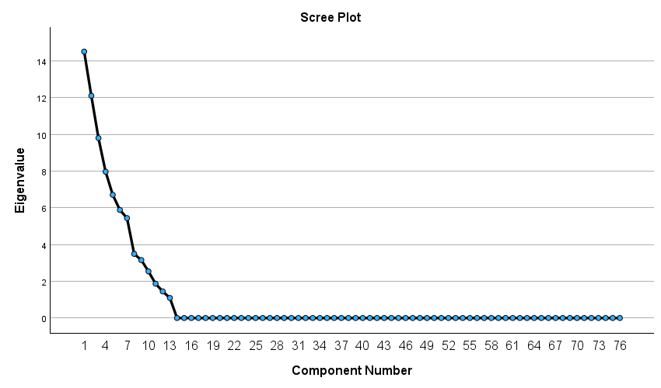
Fig 3 Scree Plot
After analysing the Total Variance Explained and the Scree Plot, it is evident that the extracted factors effectively capture the dataset’s underlying structure. The clustering of variables within a single dimension reflects shared variance, suggesting they are conceptually or functionally related. This latent construct reduces redundancy while enhancing interpretability. Variables with high loadings on the first factor converge around a central theme, confirming coherence and reinforcing the factor’s role as a meaningful representation of the construct. For factor extraction, the researchers applied Principal Component Analysis (PCA) with Varimax rotation to ensure scale consistency. Only factors with eigenvalues greater than 1 and loadings above 0.5 were retained, while items with communalities below 0.5 were excluded from the analysis.

Table 8 Perceptions and Preparedness toward Disaster Risk Management
Sl No | Variable No | Name of the Variable | Eigen Value
1 | V23 | No disaster experience | 0.895
2 | V20 | Climate change is the major cause of disaster | 0.874
3 | V14 | Receive disaster education | 0.820
4 | V42 | Got guidelines from NGO | 0.779
5 | V59 | Disaster cannot prevent | 0.620
6 | V66 | Health care is the important need after disaster | 0.609
7 | V35 | National Government are responsible for tackle disaster | 0.587
8 | V52 | Buildings are withstood from disaster | 0.504
9 | V68 | Safety & security is the important need after disaster | -0.543
10 | V43 | Not got guidelines from NGO | -0.747
11 | V54 | Buildings are maybe withstand from disaster | -0.774
12 | V39 | Others are responsible to tackle disaster | -0.795
13 | V15 | Not received disaster education | -0.820
14 | V58 | Disaster can be prevented | -0.825
15 | V21 | Climate change is not a major cause of disaster | -0.874
16 | V22 | Have disaster experience | -0.894

Source: Extraction Method: Principal Component Analysis. Rotation Method: Varimax with Kaiser normalization
This cluster of variables represents student’s perceptions, awareness, and preparedness regarding disasters, especially with respect to climate change, disaster education, and institutional responsibility. (Table 8 and Fig 4) On the positive side, individuals acknowledge climate change as a key cause of disasters (V20), recognize the importance of disaster education (V14), and highlight the role of NGOs (V42) and government (V35) in tackling disasters. They also stress that health care (V66) and structural resilience (V52) are vital in disaster management. Importantly, those with no direct disaster experience (V23) tend to hold stronger positive views. On the negative side, contrasting beliefs appear: some feel disasters can indeed be prevented (V58), climate change is not the main cause (V21), or that responsibility lies with others (V39). Lack of disaster experience (V22) and not receiving education (V15) weaken preparedness. Similarly, doubts about building resilience (V54), lack of NGO support (V43), and neglect of safety/security (V68) reduce confidence. This cluster reflects a dual perception—one of confidence in structured education, guidelines, and institutional responsibility, and another of scepticism and dependency on external factors and this cluster termed as “Perceptions and Preparedness toward Disaster Risk Management”.
Table 9 Disaster Awareness, Risk Perception, and Preparedness Behaviour
Sl No | Variable No | Name of the Variable | Eigen Value
1 | V50 | Our area is safe from disaster | 0.902
2 | V13 | Not knowledge about NDMA | 0.890
3 | V17 | Disaster knowledge is not important | 0.839
4 | V11 | Not heard about KSDMA | 0.807
5 | V56 | Large scale disaster is not occurred in next 10 years | 0.788
6 | V41 | Not taken action to reduce disaster risk | 0.599
7 | V46 | Not participated environmental activities | 0.538
8 | V40 | Taken action to reduce disaster risk | -0.599
9 | V55 | Large scale disaster will occur in next 10 years | -0.697
10 | V10 | Heard about KSDMA | -0.796
11 | V16 | Disaster knowledge is important | -0.839
12 | V51 | Our area is not safe from disaster | -0.878
13 | V12 | Knowledge about NDMA | -0.890

Source: Extraction Method: Principal Component Analysis. Rotation Method: Varimax with Kaiser normalization
This cluster of variables represents community perceptions of safety, knowledge, and proactive behaviour toward disaster risk management. (Table 9 Fig 5) On the positive eigenvalue side, people perceive their area as safe from disasters (V50), believe large-scale disasters are unlikely in the near future (V56), and display limited awareness of disaster institutions like NDMA (V13) and KSDMA (V11). They also undervalue disaster knowledge (V17) and show less engagement in preventive or environmental activities (V41, V46). Together, this reflects a sense of complacency and low awareness. On the negative eigenvalue side, contrasting perceptions appear. Some respondents acknowledge the importance of disaster knowledge (V16), have awareness of institutions like KSDMA (V10) and NDMA (V12), and recognize that their area may not be safe (V51). They are also more likely to anticipate large-scale disasters (V55) and report taking actions to reduce disaster risks (V40). This side reflects awareness and proactive preparedness. The interpretation suggests a polarized cluster: one group shows overconfidence and lack of knowledge, while another emphasizes awareness, institutional familiarity, and active disaster preparedness. This dimension is called “Disaster Awareness, Risk Perception, and Preparedness Behaviour”.

Table 10 Institutional Support, Technology, and Resource Priorities in Disaster Management
Sl No | Variable No | Name of the Variable | Eigen Value
1 | V77 | Science and technology help to mitigate disaster risk | 0.900
2 | V62 | Govt not provided enough facility after disaster | 0.864
3 | V71 | Disaster cannot create economic loss in Kerala | 0.788
4 | V37 | Businesses and industries are responsible for tackling disasters | 0.507
5 | V67 | Food is the important need after disaster | -0.527
6 | V70 | Disaster creates economic loss in Kerala | -0.788
7 | V61 | Govt provided enough facility after disaster | -0.864
8 | V76 | Adapting sustainable diet not help to mitigate disaster risk impact | -0.900

Source: Extraction Method: Principal Component Analysis. Rotation Method: Varimax with Kaiser normalization
This cluster of variables highlights the perceived role of institutions, technology, and resources in disaster risk management and recovery.(Table 10 Fig 6) On the positive eigenvalue side, respondents strongly believe that science and technology are crucial in mitigating disaster risk (V77), feel that the government has not provided adequate post-disaster facilities (V62), and perceive disasters as having limited economic impact in Kerala (V71). They also assign responsibility for disaster management to businesses and industries (V37). This reflects a view that emphasizes technological reliance and institutional accountability, but sometimes with underestimation of disaster’s economic severity. On the negative eigenvalue side, contrasting perceptions emerge: food is considered the most important immediate need after a disaster (V67), disasters are recognized as creating significant economic loss in Kerala (V70), and the government is viewed as having provided sufficient facilities in some cases (V61). Additionally, there is scepticism toward the idea that adopting sustainable diets contributes to disaster risk mitigation (V76). This side reflects a practical and resource-oriented perspective, focusing on tangible needs and economic realities. Taken together, this factor captures a duality—some stakeholders highlight science, institutions, and industries, while others stress basic needs, economic consequences, and scepticism toward unconventional mitigation measures. While this dimension is termed as“ Institutional Support, Technology, and Resource Priorities in Disaster Management”

Table 11 Awareness and Misconceptions of Health and Financial Impacts of Disasters
Sl No | Variable No | Name of the Variable | Eigen Value
1 | V26 | Don’t know disaster causes diseases | 0.851
2 | V32 | Not aware of effects of disaster apart from health | 0.844
3 | V27 | Disaster causes financial damage in family | 0.836
4 | V37 | Businesses and industries are responsible for tackling disasters | 0.544
5 | V31 | Aware of effects of disaster apart from health | -0.716
6 | V24 | Disaster causes chronic diseases | -0.721
7 | V28 | Disaster not causes financial damage in family | -0.944

Source: Extraction Method: Principal Component Analysis. Rotation Method: Varimax with Kaiser normalization
This cluster of variables captures people’s awareness, misconceptions, and recognition of disaster impacts on health and family finances.(Table 11 Fig 7) On the positive eigenvalue side, respondents show limited awareness: many do not know that disasters can cause diseases (V26) or affect areas beyond health (V32). At the same time, they acknowledge that disasters cause financial damage in families (V27) and assign responsibility for disaster management to businesses and industries (V37). This reflects a pattern of partial awareness combined with misconceptions—where financial losses are recognized, but health-related consequences are underestimated. On the negative eigenvalue side, others demonstrate stronger awareness: they recognize that disasters cause chronic diseases (V24), are aware of effects beyond health (V31), and reject the notion that disasters do not cause financial damage in families (V28). This reflects a more accurate and comprehensive understanding of disaster impacts. Taken together, this factor represents a contrast between misconception and awareness: one group underestimates health risks but sees financial damage, while another group clearly acknowledges both health and financial consequences of disasters. Apparently this dimension name is suggested is “Awareness and Misconceptions of Health and Financial Impacts of Disasters”.
Table 12 Awareness, Governance, and Confidence in Disaster Reconstruction
Sl No | Variable No | Name of the Variable | Eigen Value
1 | V49 | Human activities maybe bring impacts on disaster | 0.897
2 | V18 | Knowledge of disaster-prone area | 0.750
3 | V36 | Local governments are responsible for tackling disasters | 0.713
4 | V64 | Not confident in reconstruction activities after disaster | 0.707
5 | V63 | Confident in reconstruction activities after disaster | -0.705
6 | V19 | No knowledge about disaster-prone area | -0.751
7 | V47 | Human activities bring impacts on disaster | -0.892

Source: Extraction Method: Principal Component Analysis. Rotation Method: Varimax with Kaiser normalization
This cluster of variables reflects perceptions of human impact, local government responsibility, and confidence in disaster preparedness and recovery. (Table 12 Fig 8). On the positive eigenvalue side, respondents believe human activities may contribute to disasters (V49), possess knowledge of disaster-prone areas (V18), and acknowledge the responsibility of local governments in disaster management (V36). At the same time, some express a lack of confidence in reconstruction activities after a disaster (V64). This combination suggests awareness of risks and governance roles, but scepticism about post-disaster recovery efforts. On the negative eigenvalue side, a contrasting perception appears. Respondents show confidence in reconstruction activities (V63), admit to having no knowledge of disaster-prone areas (V19), and strongly acknowledge that human activities directly bring impacts on disasters (V47). This reflects a group that places greater trust in recovery systems while holding mixed levels of awareness about disaster-prone zones. This factor shows a dual dimension of awareness and trust: one group emphasizes human impact, local governance, and doubts in reconstruction, while another group displays higher confidence in recovery but lower situational knowledge. Cluster of the dimension title is “Awareness, Governance, and Confidence in Disaster Reconstruction”.

Table 13 Gender, Education, and Perceptions of Disaster Preventability
Sl No | Variable No | Name of the Variable | Eigen Value
1 | V3 | Female | 0.862
2 | V59 | Disaster cannot prevent | 0.670
3 | V5 | BSc | 0.531
4 | V57 | Large scale disaster is maybe occurred in next 10 years | 0.511
5 | V60 | Disaster maybe prevent | -0.497
6 | V4 | BA | -0.531
7 | V2 | Male | -0.862

Source: Extraction Method: Principal Component Analysis. Rotation Method: Varimax with Kaiser normalization
This cluster of variables highlights the relationship between gender, education, and perceptions of disaster preventability.(Table 13 Fig 9) On the positive eigenvalue side, female respondents (V3) are more likely to believe that disasters cannot be prevented (V59), with some also associating this view with higher education levels such as B.Sc. (V5). Additionally, they tend to consider that large-scale disasters may occur in the next 10 years (V57). This side reflects a more cautious and risk-aware outlook, showing higher concern about inevitability and recurrence of disasters. On the negative eigenvalue side, male respondents (V2) are more likely to hold the belief that disasters can be prevented (V60). Interestingly, this perspective also aligns with respondents having a B.A. qualification (V4). This side represents a more optimistic and preventive outlook, emphasizing human capability to reduce or stop disasters. The factor illustrates a contrast between gendered and educational perceptions: females and science-educated individuals lean toward inevitability and risk, while males and arts-educated individuals express greater faith in disaster prevention. While this cluster name is suggested as Gender, Education, and Perceptions of Disaster Preventability.
Table 14 Perceived Role and Effectiveness of International Organizations in Disaster Risk Reduction
Sl No | Variable No | Name of the Variable | Eigen Value
1 | V73 | International organisation actions no useful to mitigate disaster risk | 0.982
2 | V34 | International organisations are responsible for tackling disasters | 0.687
3 | V46 | Not participated environmental activities | 0.507
4 | V72 | International organisation actions are useful to mitigate disaster risk | -0.982

Source: Extraction Method: Principal Component Analysis. Rotation Method: Varimax with Kaiser normalization
This cluster of variables reflects perceptions of the role of international organizations and individual participation in disaster risk reduction.(Table 14 Fig 10) On the positive eigenvalue side, respondents express scepticism about the usefulness of international organizations in mitigating disaster risks (V73), while at the same time acknowledging that such organizations are responsible for tackling disasters (V34). Additionally, some report not participating in environmental activities (V46). This reflects a critical yet passive stance, where responsibility is shifted to external actors, but their effectiveness is doubted, coupled with low individual engagement. On the negative eigenvalue side, respondents strongly believe that international organizations’ actions are useful in mitigating disaster risks (V72). This represents a group with greater trust in international collaboration and external support in disaster management. This factor reveals a contrast between trust and scepticism: one group doubts the practical effectiveness of international organizations and lacks personal engagement, while another group values and supports the role of international interventions. Even though suggested dimension title is “Perceived Role and Effectiveness of International Organizations in Disaster Risk Reduction”.
The factor analysis reveals that perceptions of disaster risk management are shaped by a mix of awareness, trust, institutional responsibility, and socio-demographic influences. On one hand, some respondents show high awareness of disaster causes, health impacts, and financial losses, stressing the importance of disaster education, guidelines, and government or NGO involvement. On the other hand, a section of respondents underestimates risks, doubt preventability, or remain passive in preparedness efforts. Institutional roles emerge strongly, with governments, NGOs, businesses, and international organizations being seen as central actors, though their effectiveness is often questioned, reflecting a trust–distrust divide. Human activities are widely acknowledged as contributors to disasters, yet confidence in reconstruction varies, while participation in preventive environmental actions remains inconsistent. Gender and education also influence perceptions, with females and science graduates leaning toward risk inevitability, while males and arts graduates express more optimism about prevention. Similarly, views on international organizations diverge, with some valuing their support and others doubting their usefulness. These clusters suggest that disaster risk management is perceived through polarized lenses of awareness versus misconception, trust versus scepticism, and optimism versus inevitability, underscoring the urgent need for targeted disaster education, stronger community participation, and trust-building measures to ensure comprehensive preparedness.
Table 15 Composite index Mapping Disaster Risk Perception Among College Students in Kerala

 | Perceptions and Preparedness toward Disaster Risk Management | Disaster Awareness, Risk Perception, and Preparedness Behaviour | Institutional Support, Technology, and Resource Priorities in Disaster Management | Awareness and Misconceptions of Health and Financial Impacts of Disasters | Awareness, Governance, and Confidence in Disaster Reconstruction | Gender, Education, and Perceptions of Disaster Preventability | Perceived Role and Effectiveness of International Organizations in Disaster Risk Reduction | Composite Index
Thiruvananthapuram | 0.20 | -0.22 | -0.03 | 0.17 | -0.27 | 0.63 | 0.06 | 0.55
Kollam | 0.73 | 0.19 | -0.82 | 1.57 | -0.41 | 1.98 | -0.91 | 2.35
Pathanamthitta | -0.32 | 2.52 | 0.83 | -0.98 | 0.49 | 0.15 | -0.63 | 2.05
Alappuzha | -0.05 | -0.77 | 1.93 | -0.21 | 1.05 | 1.68 | 1.60 | 5.23
Kottayam | -0.03 | -0.76 | 1.80 | 1.87 | -0.35 | -1.69 | -0.69 | 0.15
Idukki | -0.78 | -0.74 | -0.47 | -0.67 | 1.51 | -0.82 | 0.72 | -1.25
Ernakulam | 1.10 | -0.77 | 0.85 | -1.72 | -1.58 | -0.30 | -0.93 | -3.35
Thrissur | 0.39 | 0.19 | -1.14 | 0.41 | -1.38 | -0.67 | 2.37 | 0.17
Palakkad | -0.30 | 0.71 | -0.05 | 0.25 | 0.04 | -0.71 | 0.20 | 0.15
Malappuram | 0.21 | -0.42 | -0.40 | 0.16 | -0.01 | 0.64 | -0.27 | -0.10
Kozhikode | 0.73 | 0.48 | -0.29 | -1.04 | -0.61 | -0.19 | 0.27 | -0.64
Wayanad | -0.35 | 1.33 | -0.22 | 0.97 | 0.51 | -0.49 | -0.06 | 1.68
Kannur | 1.28 | -0.89 | -1.27 | -0.32 | 1.83 | -0.61 | -0.94 | -0.93
Kasaragod | -2.81 | -0.86 | -0.71 | -0.46 | -0.82 | 0.41 | -0.81 | -6.05

The factor analysis across districts highlights variations in seven dimensions of disaster risk perception and preparedness. The factor analysis reveals significant district-wise variations in disaster risk perception and preparedness.(Table 15 Fig 11) Alappuzha records the highest composite score (5.23) due to strong institutional support, governance, and international trust, while Pathanamthitta (2.05), Kollam (2.35), and Wayanad (1.68) also perform well. Thiruvananthapuram shows balanced but modest results (0.55). In contrast, Kottayam, Palakkad, Thrissur, and Malappuram remain neutral to low, reflecting mixed strengths and weaknesses. Idukki (–1.25), Kozhikode (–0.64), and Kannur (–0.93) demonstrate negative indices despite some strengths. Ernakulam (–3.35) and Kasaragod (–6.05) emerge as the weakest, with Kasaragod showing the poorest perceptions across nearly all dimensions. Alappuzha, Kollam, Pathanamthitta, and Wayanad demonstrate stronger disaster awareness and preparedness, while Ernakulam, Kannur, and Kasaragod lag behind with weaker composite resilience. District-level variation reflects differences in institutional support, governance confidence, and perceptions of international organizations, highlighting the need for targeted interventions.

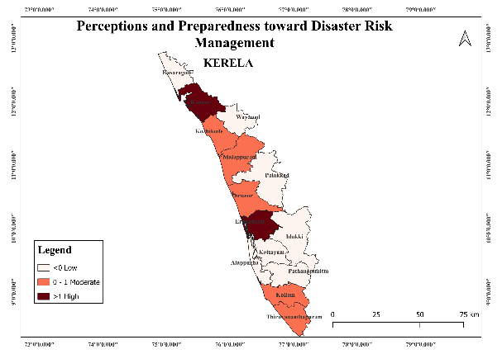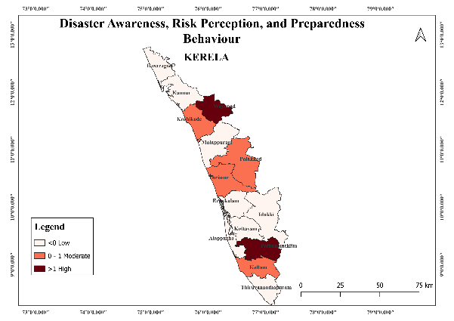

Figure 4 Figure5

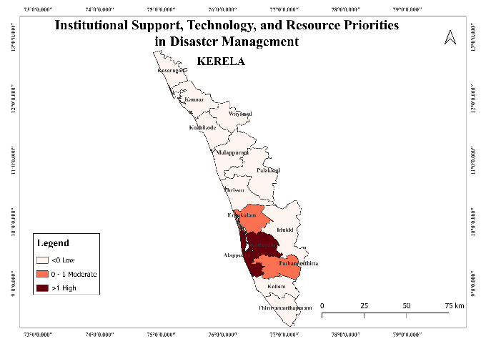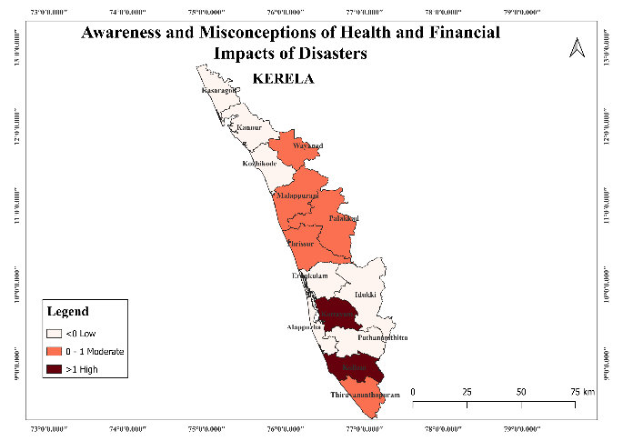
Figure 6 Figure7

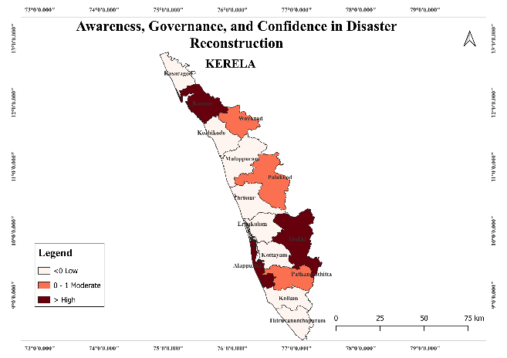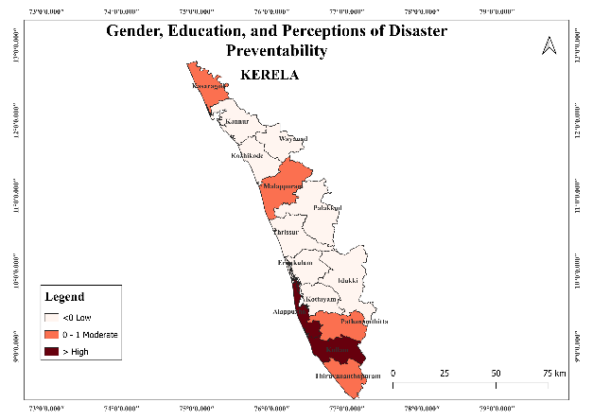
Figure 8 Figure 9

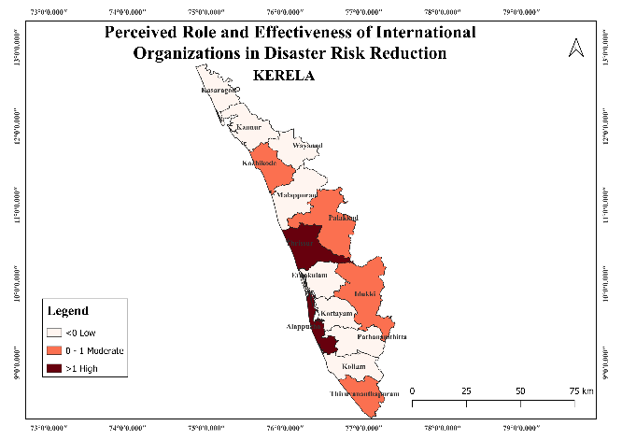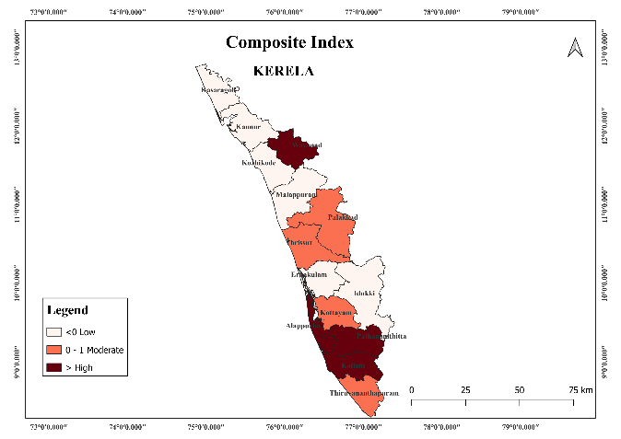

Figure 10 Figure 11

4 DISCUSSION
This study examined disaster risk perception and preparedness among 420 college students across 14 districts of Kerala and organized the findings into five core dimensions, complemented by factor-analytic insights and a district-level composite index. The results portray a student population that is highly aware of disasters and related institutions, yet unevenly equipped with formal disaster education, variably engaged in preparedness behaviours, and polarized in beliefs about preventability and responsibility.
The sample is skewed toward female respondents and students from science backgrounds (B.Sc.). This composition likely shapes the attitudes observed, especially around perceived inevitability of disasters and emphasis on technical/knowledge aspects of risk. The gendered and disciplinary profile should be kept in mind when interpreting aggregate attitudes—both as a potential strength (greater engagement of groups often active in community health and environmental issues) and a limitation (possible under-representation of other perspectives).In the context of the provided scenario, where the sample includes more female respondents and students from science backgrounds, this could indeed shape the attitudes regarding technical aspects of risk and perceptions of inevitability about disasters. This is consistent with findings that show gender-specific effects in academic fields, where female scholars often face distinct challenges and opportunities, affecting their contribution and impact (Griffith & Dasgupta, 2018).
Descriptive results show near-universal familiarity with the term “disaster,” high recognition of disaster types, and strong awareness of institutional actors such as KSDMA and NDMA. Yet roughly a quarter of students report not receiving disaster education, and knowledge of local disaster-prone areas is only moderate. This “broad but shallow” pattern suggests that awareness campaigns may be reaching students, but formalized, context-specific training (e.g., local hazard mapping, drills, role clarity during emergencies) is inconsistent. Strengthening curricular integration and experiential learning could convert general awareness into actionable, place-based knowledge. The awareness of institutional actors like the KSDMA and NDMA among students, despite the lack of consistent disaster education, highlights a need for more targeted and context-specific educational strategies. Current patterns suggest that although generalized awareness campaigns may have reached students, they often lack the depth needed for practical disaster preparedness (Patel et al., 2023).
Strengthening curricular integration and experiential learning could significantly improve this situation. Research shows that embedding disaster preparedness and awareness within the educational curriculum can enhance students’ disaster management skills. For instance, incorporating simulation-based training and experiential learning approaches have proven to increase competencies in disaster response among nursing students (Hamdi & Al Thobaity, 2023). Such training helps convert general awareness into actionable knowledge, making students better equipped for emergencies.
Studies emphasize the importance of integrating local knowledge and contextual factors into disaster education to improve effectiveness. Programs that involve student-led hazard mapping and collaborations with local government and NGOs have been shown to build resilience and preparedness in schools (J Arcegono et al., 2024). This approach ensures that disaster education is not only theoretical but also applies to local contexts, helping students understand specific risks and preparedness mechanisms relevant to their environment.
Moreover, enhancing experiential learning through simulations, drills, and service-learning can significantly advance disaster readiness. These methods allow students to practice and refine their skills in real-world scenarios, improving their confidence and competence in managing potential disasters. Involving students actively in disaster preparedness activities and aligning these experiences with academic knowledge ensures they are better prepared for real-world situations (Calaguas, 2025).To ensure that general awareness translates into practical preparedness, it is imperative for educational institutions to adopt a more comprehensive approach. This includes systematic disaster courses and regular drills, alongside fostering partnerships with experienced emergency responders. By doing so, universities can enhance their disaster education systems, making preparedness a core component of the academic experience (Tan et al., 2016).Implementing these strategies can turn broad awareness into in-depth understanding and preparedness, making students more adept at handling disaster situations. This way, we can ensure that they possess not only the knowledge of potential risks but also the ability to respond effectively when disasters strike.
Most students connect disasters with chronic health consequences and prolonged disruption to college operations, indicating strong salience of human and educational impacts. However, perceptions of household financial damage are split. This may reflect heterogeneity in prior exposure, socioeconomic buffering, or variability in compensation/relief experiences. Understanding youth perceptions of disaster impacts, particularly financial ones, involves recognizing how various factors influence their experiences and interpretations. Studies reveal that young people, often perceived as passive in disaster contexts, actually hold significant potential to contribute to risk communication and disaster management when equipped with appropriate platforms and support (Mitchell et al., 2008). They are keenly aware of the human and educational impacts of disasters, such as health consequences and disruptions to education, which suggests a strong salience of these issues among youth populations.
The split perception of household financial damage among students might reflect differences in prior exposure to disasters, socioeconomic conditions, and the variability in how compensation or relief efforts are experienced by different families. This suggests that youth’s understanding of economic impacts is nuanced and influenced by personal and community experiences. For example, in Fiji, youth perceived increased risks in accessing resources post-disasters due to socioeconomic insecurities, which affected their overall disaster experience (Murphy et al., 2023).
Effective financial risk communication requires that youth understand and trust the mechanisms in place. Studies underline the importance of involving youth actively in communication strategies, enabling them to act as both receivers and transmitters of information, thereby enhancing their role in disaster risk reduction (Midtbust et al., 2018). Furthermore, it is crucial for policy discussions to address how youth perceive the fairness and predictability of financial risk communication and relief measures to ensure that these mechanisms are transparent and accessible to young people.
Integrating youth voices in the development and communication of disaster risk policies can lead to perceptions that are more aligned with their realities and needs. This approach acknowledges that youth are not only affected by disasters but can also significantly influence their communities' preparedness and response strategies. Thus, fostering an environment where youth can engage in discussions about financial risks and relief mechanisms can enhance disaster resilience and preparedness at the societal level (Cox et al., 2018).
Students attribute meaningful responsibility to national and local governments and to individuals, but express low confidence in businesses/industries and only modest engagement in environmental or preventive activities. Many endorse the need to act, yet a sizable share also reports inaction. This intention–action gap points to practical barriers (time, resources, know-how), limited access to NGO guidance, and potentially low self-efficacy. Interventions should therefore move beyond awareness to scaffolding: simple preparedness checklists, peer-led campaigns, campus-based drills, and partnerships with local disaster management authorities and NGOs to translate intention into routine behaviour.
To increase student engagement in disaster preparedness, it is crucial to move beyond raising awareness to actively involving students in community-based initiatives and partnerships. This can be achieved through several strategies:
- Simple Preparedness Checklists: Providing straightforward and easily accessible checklists can guide students in taking concrete actions to prepare for disasters. These checklists can be distributed through academic channels, ensuring that students have the necessary steps to enhance their readiness (Ma et al., 2021).
- Peer-Led Campaigns: Empowering students to lead disaster preparedness campaigns can enhance peer influence and increase participation levels. Peer-led initiatives often resonate more with students and can effectively spread critical information (Corbin et al., 2021).
- Campus-Based Drills: Organizing regular disaster drills on campus can help students practice and internalize appropriate responses during emergencies. This experiential learning is crucial in translating theoretical knowledge into practical skills (Dunlop et al., 2016).
- Partnerships with Local Authorities and NGOs: Establishing collaborations with local disaster management authorities and NGOs can provide students with practical insights and opportunities to contribute to community resilience efforts. This collaboration can help bridge the gap between theoretical knowledge and practical application, fostering a more comprehensive understanding of disaster preparedness (Chandra et al., 2013).
- Service-Learning and Multiagency Collaboration: Incorporating service-learning into academic programs, particularly in disaster-related fields, can enhance student competencies and provide real-world disaster response experience through partnerships with multiple agencies (Calaguas, 2025).
By engaging students in these activities, institutions can foster a culture of preparedness, leading to improved disaster response capabilities. These initiatives not only enhance student readiness but also contribute to building resilient communities. A plurality of students doubt that disasters can be prevented, but they express relatively high confidence in post-disaster facilities and reconstruction. Prioritization of safety and security as post-disaster needs underscores a pragmatic focus on immediate protection over upstream prevention. At the same time, many students are sceptical about sustainability-oriented strategies (e.g., diet) and the role of science/technology in mitigation. This ambivalence suggests the need to differentiate hazard prevention (often impossible) from risk reduction (highly feasible), and to communicate concrete, locally relevant examples of how technology (early warning, resilient infrastructure) and sustainability (land-use planning, ecosystem services) measurably reduce impacts.
There is often a distinction between hazard prevention and risk reduction in disaster management, a misunderstanding that may contribute to the ambivalence among students. While preventing natural disasters entirely is generally not feasible, risk reduction efforts are crucial and highly effective in mitigating the impact of such events. Risk reduction can be achieved through measures like enhanced building codes, community education, and preparedness planning, which increase resilience and reduce vulnerabilities (Fallara, 2004).
The role of technology in disaster management is significant, offering tools for both risk reduction and post-disaster recovery. For instance, technological advancements such as the Internet of Emergency Services (IoES) provide real-time data collection and analysis, improving emergency coordination and response efficiency (Damasevicius et al., 2023). Geographic Information Systems (GIS) are employed to understand hazards and vulnerabilities, thus facilitating risk assessments and resource allocations, vital in planning and executing mitigative measures (Shafapourtehrany et al., 2023).Decision support systems also play a pivotal role, using predictive and prescriptive models to guide preparedness and response decisions. These systems help in allocating resources more efficiently and ensuring that response strategies are well-informed and effective (Suarez et al., 2024).Furthermore, social and community engagements enhanced by information technology can fortify disaster resilience by leveraging community-driven response frameworks (Tasic & Amir, 2016). Information systems are indispensable across all stages of disaster management, ensuring that both strategic and operational decisions are robust and aligned with real-time data (Van De Walle et al., 2014).
To address students' scepticism about sustainability strategies and technology, it is essential to educate on the difference between prevention and risk reduction, emphasizing the feasibility and tangible benefits of reduction strategies. Moreover, demonstrating the integration of technology in effective risk reduction and management practices could enhance student engagement and confidence in these measures as part of comprehensive disaster management strategies.
The factor analysis revealed seven clusters shaping disaster risk management perspectives. Confidence improves with education, NGO guidance, and visible measures but declines with limited experience. A gap exists between complacent and proactive groups, while priorities split between technology and basic needs. Misconceptions on health, governance transparency, gender, and disciplinary differences all influence preparedness. Trust and international support strengthen when contributions are practical and visible. The factor analysis identifying seven clusters influencing disaster risk management perspectives highlights the complexities in enhancing preparedness across varying groups. Confidence in disaster management improves with education, NGO guidance, and visible preparedness measures, suggesting the importance of informed engagement and transparency in strengthening community resilience (Gausche-Hill, 2009).
A crucial gap is evident between complacent individuals, who may lack direct experience, and proactive ones, who actively engage in preparedness. Bridging this gap involves targeted educational initiatives and real-world exercises to illustrate the practical benefits of preparedness measures (Dunlop et al., 2016). Misconceptions around health, governance transparency, gender roles, and disciplinary differences can affect how communities prepare for disasters, necessitating tailored communication strategies that address these misconceptions (Gowan et al., 2015).
Trust and international support are pivotal and are greatly strengthened when contributions are practical and visible, such as through volunteerism, which enhances community resilience and accelerates recovery (Ganoe et al., 2023). Priorities in disaster risk management often split between technology-driven solutions and meeting basic needs, requiring balanced approaches that integrate both modern technology and fundamental support systems (Kapucu & Hu, 2014).Enhanced collaboration between academic institutions, government agencies, and communities can leverage diverse expertise and resources to improve readiness and response strategies (Dunlop et al., 2016). This aligns with the perspective that fostering partnerships and active community involvement are essential for effective disaster preparedness, response, and recovery (Farhat et al., 2024).Integrating these insights into policy and practice will help address gaps in preparedness and support the development of a resilient disaster management framework.
District-level disparities highlight the need for targeted interventions. Alappuzha, Kollam, Pathanamthitta, and Wayanad show stronger preparedness, while Ernakulam, Kannur, and Kasaragod lag, with Thiruvananthapuram slightly above neutral. Differences stem from hazard histories, institutions, communication, and social capital. Weaker districts need trust-building and NGO support, while stronger ones should advance through drills, micro-credentials, and responder networks.Addressing district-level disparities in disaster preparedness requires tailoring interventions to the specific needs and strengths of each region. In districts like Alappuzha, Kollam, Pathanamthitta, and Wayanad, where preparedness is stronger, a focus should be on advancing current measures through the implementation of drills, providing micro-credentials, and developing robust responder networks. High levels of community resilience and resource endowment in these areas can be leveraged to enhance overall preparedness through innovative training and development initiatives (Ma et al., 2021).
For weaker districts such as Ernakulam, Kannur, and Kasaragod, interventions should focus on building trust and increasing support from NGOs. The inclusion of self-efficacy and community resilience strategies can significantly improve disaster preparedness. Ensuring efficient communication and enhancing social capital can lead to positive influences on knowledge and skills preparation in these communities (Hamann et al., 2016; Lai et al., 2018).
Tailored approaches cater to the different hazard histories and institutional capacities, where a higher emphasis on health disparities and governance transparency is essential. Strengthening NGO collaboration in these regions and fostering a participatory approach to preparedness can mitigate vulnerabilities arising from limited experiences and resources (Shukla et al., 2024).Ultimately, interventions should be strategic and customized according to the unique challenges and assets of each district, promoting a balanced focus on practical readiness, social support structures, and inclusive policy-making to bridge the preparedness gap (Kano et al., 2007; Najafi et al., 2015).
4.1 ENHANCING DISASTER RISK REDUCTION EDUCATION IN HIGHER EDUCATION INSTITUTIONS
To strengthen disaster preparedness and resilience in higher education, it is essential to integrate disaster education into the curriculum, making topics such as climate change, resilience, and disaster risk reduction mandatory across disciplines. Regular workshops, mock drills, and simulation exercises should be conducted to equip students with practical skills in disaster preparedness. Moreover, aligning educational initiatives with Kerala’s State Action Plan on Climate Change (SAPCC) will help address region-specific needs, especially in areas with low awareness. Leveraging technology, such as mobile apps, GIS tools, and VR simulations, can enhance real-time alerts and experiential learning. Promoting community-based initiatives, like student involvement in local disaster risk mapping and resilience-building activities, will strengthen the connection between campuses and local communities. Finally, adopting gender-sensitive and research-oriented policies is vital, as female students often perceive disaster risks more intensely. Encouraging gender-responsive strategies and conducting district-wise research will help improve the effectiveness of disaster risk education. 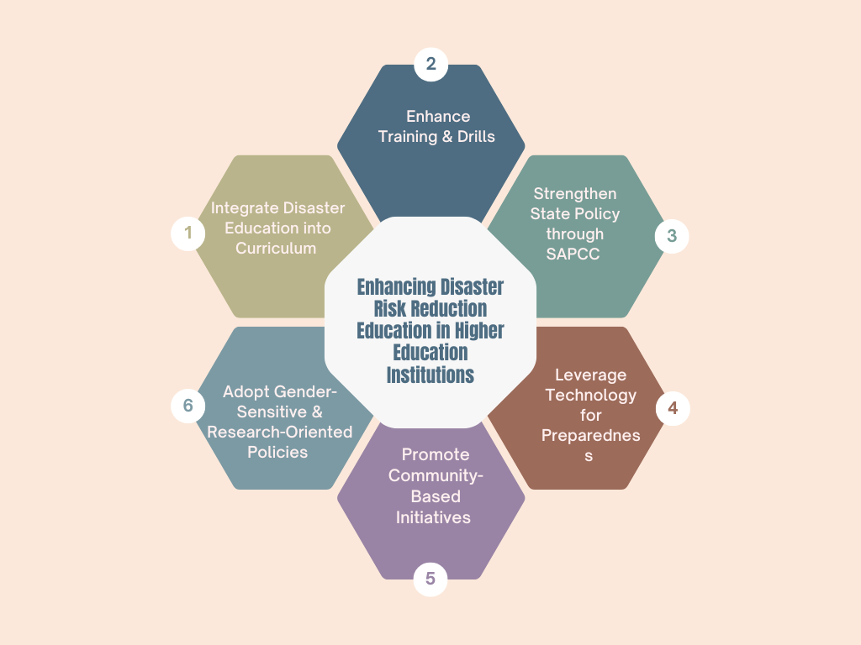
Figure 12 Enhancing disaster Risk reduction Education in Higher Education Institutions.
To enhance disaster risk perception and preparedness among college students in Kerala, several policy and educational reforms are essential. First, Curriculum Integration should be prioritized, incorporating disaster risk reduction topics across various academic disciplines to ensure students gain a well-rounded understanding of the issues. Regular Training Programs on disaster preparedness and response should be implemented, providing students with hands-on knowledge and practical skills to react effectively in emergencies. Additionally, Community-Based Initiatives should encourage students to participate in local disaster risk mapping and mitigation activities, fostering a sense of responsibility and proactive involvement. The Use of Technology is another key reform, with the development and promotion of mobile applications that offer real-time disaster alerts and preparedness resources, ensuring that students stay informed and responsive. Lastly, Policy Support should advocate for the integration of disaster education into higher education curricula, making it a mandatory component to build a resilient student community. Combining these measures will significantly improve Kerala's disaster resilience, ensuring that students are well-prepared and equipped to handle future disasters.
5 CONCLUSION
This study examines disaster risk perception and preparedness among 420 college students across 14 districts in Kerala, revealing a profile characterized by widespread awareness of disasters and institutions, yet marked by inconsistencies in formal education, practical readiness, and beliefs regarding preventability and responsibility. Spatial analysis indicates distinct district-level disparities: Alappuzha, Kollam, Pathanamthitta, and Wayanad exhibit stronger awareness and preparedness, whereas Ernakulam, Kannur, and Kasaragod are less prepared, with Thiruvananthapuram slightly above neutral. These differences likely reflect local hazard histories, institutional presence, communication efficacy, and social capital. Factor analysis identified seven clusters influencing risk management perspectives, ranging from education-driven confidence and institutional trust to complacency, misconceptions about health impacts, and divergent views on technology and international actors. Notably, an intention–action gap persists: many endorse preparedness but report limited action, indicating barriers such as time constraints, lack of know-how, limited access to guidance, and self-efficacy. Gender and disciplinary patterns are also significant, with science students and females tending toward risk realism, while males and arts students exhibit greater prevention optimism. Policy and practice should therefore be targeted and layered. Weaker districts require trust-building with local governments, sustained NGO guidance, and low-friction pathways to action (e.g., checklists, peer campaigns, campus drills). Stronger districts should enhance capabilities through advanced exercises, micro-credentialing, and student responder networks. Statewide, integrating disaster risk reduction into curricula, embedding experiential learning (e.g., drills, simulations, service-learning), and demonstrating the practical value of technology (e.g., early warning systems, resilient infrastructure) can transform broad awareness into routine preparedness. Clear, localized communication on health and financial risks is essential to correct misconceptions and motivate action.
Declarations
Conflict of interest
On behalf of all authors, the corresponding author states that there is no conflict of interest.
Ethical approval
Ethical approval not required.
Human or Animal rights
This article does not contain any studies with human participants or animals performed by any of the authors

Reference
Achu, A. L., Joseph, S., Aju, C. D., & Mathai, J. (2021). Preliminary analysis of a catastrophic landslide event on 6 August 2020 at Pettimudi, Kerala State, India. Landslides, 18(5), 1459–1463. https://doi.org/10.1007/s10346-020-01598-x
Amri, A., Bird, D. K., Ronan, K., Haynes, K., & Towers, B. (2017). Disaster risk reduction education in Indonesia: Challenges and recommendations for scaling up. Natural Hazards and Earth System Sciences, 17, 595–612. https://doi.org/10.5194/nhess-17-595-2017
Behnam, B. (2017). Post-earthquake fire analysis in urban structures: Risk management strategies. CRC Press.
Bentler, P. M. (1995). EQS structural equations program manual. Multivariate Software.
Bronfman, N. C., Cisternas, P. C., López‐Vázquez, E., & Cifuentes, L. A. (2016). Trust and risk perception of natural hazards: Implications for risk preparedness in Chile. Natural Hazards, 81(1), 307–327. https://doi.org/10.1007/s11069-015-2080-4
Calaguas, N. P. (2025). Strengthening disaster nursing competencies through service-learning and multiagency partnerships. The Journal of Nursing Education, 64(4), 259–263. https://doi.org/10.3928/01484834-20241122-02
Carlino, R., Somma, R., & Mayberry, G. C. (2007). Volcanic risk perception of young people in the urban areas of Vesuvius: Comparisons with other volcanic areas and implications for emergency management. Journal of Volcanology and Geothermal Research, 162(3–4), 229–240. https://doi.org/10.1016/j.jvolgeores.2007.12.010
Centre for Research on the Epidemiology of Disasters (CRED). (2018). EM-DAT: The international disaster database. Université catholique de Louvain. https://www.emdat.be
Chambers, R., & Conway, G. (1992). Sustainable rural livelihoods: Practical concepts for the 21st century (IDS Discussion Paper No. 296). Institute of Development Studies, University of Sussex.
Chandra, A., Stayton, A., Williams, M., Horta, M., Wells, K. B., Plough, A., & Tang, J. (2013). Getting actionable about community resilience: The Los Angeles County Community Disaster Resilience project. American Journal of Public Health, 103(7), 1181–1189. https://doi.org/10.2105/ajph.2013.301270
Chen, Y. F., & Adefila, A. (2020). Enhancing school safety through university engagement in DRR education. International Journal of Disaster Risk Reduction, 44, 101386. https://doi.org/10.1016/j.ijdrr.2019.101386
Corbin, J. H., Munodawafa, D., Barry, M. M., Sørensen, K., Omoleke, S. A., Manoncourt, E., Oyene, U. E., Huda, Q., Moran, T., Bayugo, Y. V., Amuyunzu-Nyamongo, M., Onya, H., Kwamboka, M., Spencer-Walters, D., Van Den Broucke, S., & Mweemba, O. (2021). A health promotion approach to emergency management: Effective community engagement strategies from five cases. Health Promotion International, 36(Suppl. 1), i24–i38. https://doi.org/10.1093/heapro/daab152
Cox, R. S., Plush, T., Tremblay, C., Hill, T. T., & Heykoop, C. (2018). More than a checkbox: Engaging youth in disaster risk reduction and resilience in Canada. Natural Hazards, 98(1), 213–227. https://doi.org/10.1007/s11069-018-3509-3
Cvetković, V., & Planić, J. (2022). Earthquake risk perception in Belgrade: Implications for disaster risk management. International Journal of Disaster Risk Management, 4(1), 69–88. https://doi.org/10.18485/ijdrm.2022.4.1.5
Damaševičius, R., Misra, S., & Bacanin, N. (2023). From sensors to safety: Internet of emergency services (IoES) for emergency response and disaster management. Journal of Sensor and Actuator Networks, 12(3), 41. https://doi.org/10.3390/jsan12030041
Das, R. (2024). Catastrophic landslide in Wayanad district of Kerala, India on July 30, 2024: A complex interplay between geology, geomorphology, and climate. Landslides. https://doi.org/10.1007/s10346-024-02385-8
Davis, C. N., Weber, M. C., Schulenberg, S. E., & Green, J. J. (2019). University students’ disaster preparedness: A focus group study. Best Practices in Mental Health, 15(2), 29–47.
DoECC. (2022). Kerala State Action Plan on Climate Change 2.0 (2023–2030). Directorate of Environment and Climate Change, Government of Kerala.
Dunlop, A. L., Isakov, A. P., Vaidyanathan, L., & Logue, K. M. (2016). Facilitators and barriers for effective academic-community collaboration for disaster preparedness and response. Journal of Public Health Management and Practice, 22(3), E20–E28. https://doi.org/10.1097/PHH.0b013e3182205087
Edwards, F. (2013). Campus roles in emergency management. In Disaster resistant university workshop: Linking mitigation and resilience (Paper 6). University of New Orleans. https://scholarworks.uno.edu/dru2013/6
Economic Review. (2021). State Planning Board, Kerala. Thiruvananthapuram: Government of Kerala.
Etkin, D. (2016). Disaster theory: An interdisciplinary approach to concepts and causes. Butterworth-Heinemann.
Farhat, H., Alinier, G., Laughton, J., Abougalala, W., Ben Dhiab, M., Chaabna, K., & El Aifa, K. (2024). Preparedness and emergency response strategies for chemical, biological, radiological and nuclear emergencies in disaster management: A qualitative systematic review. Journal of Contingencies and Crisis Management, 32(3). https://doi.org/10.1111/1468-5973.12592
Fallara, P. (2004). Disaster recovery planning. IEEE Potentials, 23(5), 42–44. https://doi.org/10.1109/mp.2004.1301248
Forster, L., Forster, P., Lutz-Bonengel, S., Willkomm, H., & Brinkmann, B. (2002). Natural radioactivity and human mitochondrial DNA mutations. Proceedings of the National Academy of Sciences of the United States of America, 99(21), 13950–13954. https://doi.org/10.1073/pnas.212516199
Gangalal Tuladhar, R., Yatabe, R., Dahal, R. K., & Bhandary, N. P. (2014). Knowledge of disaster risk reduction among school students in Nepal. Geomatics, Natural Hazards and Risk, 5(3), 190–207. https://doi.org/10.1080/19475705.2013.809556
Ganoe, M., Sihotang, T., & Roslida, J. (2023). The impact of volunteerism on community resilience in disaster management. Jurnal Ilmu Pendidikan dan Humaniora, 12(3), 199–213. https://doi.org/10.35335/jiph.v12i3.11
GAR Special Report. (2023). Mapping resilience for the sustainable development goals. UNDRR. https://www.undrr.org/gar/gar2023-special-report
Gausche-Hill, M. (2009). Pediatric disaster preparedness: Are we really prepared? Journal of Trauma: Injury, Infection & Critical Care, 67(2), S73–S76. https://doi.org/10.1097/TA.0b013e3181af2fff
George, P. S., & Chattopadhyay, S. (2001). Population and land use in Kerala. In M. G. Wolman (Ed.), Growing populations, changing landscapes: Studies from India, China, and the United States (pp. 79–106). National Academy Press.
Gowan, M. E., Sloan, J. A., & Kirk, R. C. (2015). Prepared for what? Addressing the disaster readiness gap beyond preparedness for survival. BMC Public Health, 15, 1139. https://doi.org/10.1186/s12889-015-2440-8
Griffith, E. E., & Dasgupta, N. (2018). How the demographic composition of academic science and engineering departments influences workplace culture, faculty experience, and retention risk. Social Sciences, 7(5), 71. https://doi.org/10.3390/socsci7050071
Hamann, C. J., Mello, E., Ramirez, M., Wu, H., Waldron, D., & Yang, J. (2016). Disaster preparedness in rural families of children with special health care needs. Disaster Medicine and Public Health Preparedness, 10(2), 225–232. https://doi.org/10.1017/dmp.2015.159
Hamdi, A., & Al Thobaity, A. (2023). Enhancing disaster triage competencies through simulation-based training: An interventional study among undergraduate nursing students. Sustainability, 15(21), 15513. https://doi.org/10.3390/su152115513
Hladnik, A. (2013). Image compression and face recognition: Two image processing applications of principal component analysis. International Circular of Graphic Education Research, 6, 56–61.
Hussin, H., Fauzi, A., Ghani, M. F. A., & Jaya, A. (2022). An approach to find the potential landslide source based on intersection of lineament using SRTM DEM. AIP Conference Proceedings, 2454, 050023. https://doi.org/10.1063/5.0078941
Illiyas, M. R., Mohan, R., Mani, M., & Pradeepkumar, K. (2014). Study on lightning casualties in Kerala. Journal of Natural Hazards, 5(2), 145–150.
Jayarajan, K. (2014). A medico-geographic study of HIV AIDS in Kerala state: GIS approach to public health planning (Unpublished doctoral dissertation). Madurai Kamaraj University. http://hdl.handle.net/10603/133267
Jóhannesdóttir, G., & Gísladóttir, G. (2010). People living under threat of volcanic hazard in southern Iceland: Vulnerability and risk perception. Natural Hazards and Earth System Sciences, 10(2), 407–420. https://doi.org/10.5194/nhess-10-407-2010
Joreskog, K. G. (1969). A general approach to confirmatory maximum likelihood factor analysis. Psychometrika, 34(2), 183–202. https://doi.org/10.1007/BF02289343
Kano, M., Ybarra, W. J., Bourque, L. B., Frias, G., & Ramirez, M. (2007). Are schools prepared for emergencies? A baseline assessment of emergency preparedness at school sites in three Los Angeles County school districts. Education and Urban Society, 39(3), 399–422. https://doi.org/10.1177/0013124506298130
Kapucu, N., & Hu, Q. (2014). Understanding multiplexity of collaborative emergency management networks. The American Review of Public Administration, 46(4), 399–417. https://doi.org/10.1177/0275074014555645
Kerala State Disaster Management Authority. (2016). Kerala State Disaster Management Plan. Government of Kerala. https://sdma.kerala.gov.in/wp-content/uploads/2018/11/Kerala-State-Disaster-Management-Plan-2016.pdf
Kerala State Disaster Management Authority. (2018). Annual report 2016–17. Government of Kerala. https://sdma.kerala.gov.in/annual-reports
Kerala State Disaster Management Authority. (n.d.). Kerala disaster management plan profile. Government of Kerala. http://www.kerenvis.nic.in/WriteReadData/UserFiles/file/Kerala-Disaster-Management-Plan-Profile-India.pdf
Khorram-Manesh, A., Berlin, J., Roseke, L. L., Aremyr, J., Sörensson, J., & Carlström, E. (2018). Emergency management and preparedness training for youth (EMPTY): The results of the first Swedish pilot study. Disaster Medicine and Public Health Preparedness, 12(5), 685–688. https://doi.org/10.1017/dmp.2017.135
Kolathayar, S., Menon, V., & Kundu, P. (2025). Landslides and debris flow triggered by the July 2024 extreme rainstorm in the Chooralmala watershed in Wayanad, India. Landslides, 22, 967–974. https://doi.org/10.1007/s10346-024-02443-1
KSCSTE. (2007). State of environment report, Kerala – Volume II: Natural hazards. Kerala State Council for Science, Technology and Environment.
Kung, Y. W., & Chen, S. H. (2012). Perception of earthquake risk in Taiwan: Effects of gender and past earthquake experience. Risk Analysis, 32(9), 1535–1546. https://doi.org/10.1111/j.1539-6924.2011.01760.x
Lapada, A. (2022). Disaster risk reduction knowledge among Filipino senior high school students. Journal of Social Sciences Review, 2(1), 56–73. https://doi.org/10.54183/jssr.v2i1.27
Li, H., Zhang, F., Wu, X., Peng, H., Bao, H., & Zhang, Y. (2022). High school students’ trust and risk perception of typhoon disaster: The moderating role of government ability in disaster management. International Journal of Disaster Risk Reduction, 71, 102816. https://doi.org/10.1016/j.ijdrr.2021.102816
Lovekamp, W. E., & Tate, M. L. (2023). College student disaster risk, fear, and preparedness. International Journal of Mass Emergencies & Disasters, 26(2), 70–90. https://doi.org/10.1177/028072700802600201
Ma, Z., Deng, X., Xu, D., & Guo, S. (2021). Community resilience and residents’ disaster preparedness: Evidence from China’s earthquake-stricken areas. Natural Hazards, 108(1), 567–591. https://doi.org/10.1007/s11069-021-04695-9
Midtbust, L. G. H., Dyregrov, A., & Djup, H. W. (2018). Communicating with children and adolescents about the risk of natural disasters. European Journal of Psychotraumatology, 9(sup2), 1429771. https://doi.org/10.1080/20008198.2018.1429771
Mishra, V., et al. (2018). The Kerala flood of 2018: Combined impact of extreme rainfall and reservoir storage. Hydrology and Earth System Sciences Discussions. https://doi.org/10.5194/hess-2018-000 (if available)
Mitchell, T., Choong, W., Haynes, K., Oven, K., & Hall, N. (2008). The roles of children and youth in communicating disaster risk. Children, Youth and Environments, 18(1), 254–279. https://doi.org/10.1353/cye.2008.0036
Mizrak, S., & Aslan, R. (2020). Disaster risk perception of university students. Risk, Hazard & Crisis in Public Policy, 11(4), 411–433. https://doi.org/10.1002/rhc3.12193
Murali Das, S. (2007). Lightning. In E. P. Yesodharan, K. Kokkal, & P. Harinarayanan (Eds.), State of the environment report of Kerala, 2007 – Volume II: Natural hazards (pp. 164). Kerala State Council for Science, Technology and Environment.
Murphy, N., Rarama, T., Atama, A., Kauyaca, I., Batibasaga, K., Azzopardi, P., Bowen, K. J., & Bohren, M. A. (2023). Changing climates, compounding challenges: A participatory study on how disasters affect the sexual and reproductive health and rights of young people in Fiji. BMJ Global Health, 8(Suppl. 3), e013299. https://doi.org/10.1136/bmjgh-2023-013299
Nair, A., Joseph, K. A., & Nair, K. S. (2014). Spatio-temporal analysis of rainfall trends over a maritime state (Kerala) of India during the last 100 years. Atmospheric Environment, 88, 123–132. https://doi.org/10.1016/j.atmosenv.2014.01.014
Najafi, M., Ardalan, A., Akbarisari, A., Noorbala, A. A., & Jabbari, H. (2015). Demographic determinants of disaster preparedness behaviors amongst Tehran inhabitants, Iran. PLoS Currents, 7. https://doi.org/10.1371/currents.dis.976b0ab9c9d9941cbbae3775a6c5fbe6
Nathan, S. (2000). Drought and water scarcity in Kerala: Issues and challenges. Indian Journal of Environmental Protection, 20(6), 441–446.
Nipa, T. J., Kermanshachi, S., & Pamidimukkala, A. (2023). Evaluation of resilience dimensions on the reconstruction of highway infrastructure projects. Journal of Legal Affairs and Dispute Resolution in Engineering and Construction, 15(2), 04522057. https://doi.org/10.1061/(ASCE)LA.1943-4170.0000452
Pamidimukkala, A., Kermanshachi, S., & Karthick, S. (2020). Impact of natural disasters on construction projects: Strategies to prevent cost and schedule overruns in reconstruction projects. In Creative Construction e-Conference 2020 (pp. 49–57). Budapest University of Technology and Economics.
Paritala, V., & Thummala, H. (2021). Factorial analysis and visualization of COVID-19 clinical data utilizing R. Clinical & Experimental Cardiology. https://www.longdom.org/open-access/factorial-analysis-and-visualization-of-covid19-clinical-data-utilizing-of-r.pdf
Patel, R. K., Kermanshachi, S., Etminani-Ghasrodashti, R., & Pamidimukkala, A. (2023). Disaster preparedness and awareness among university students: A structural equation analysis. International Journal of Environmental Research and Public Health, 20(5), 4447. https://doi.org/10.3390/ijerph20054447
Rajendran, K. N., John, B., Sreekumari, S., & Rajendran, C. P. (2009). Seismic hazard assessment of Kerala, India. Journal of the Geological Society of India, 73(4), 519–529. https://doi.org/10.1007/s12594-009-0042-2
Ravindran, K., Kumar, P. R., & Das, A. (2018). Cyclone Ockhi: Impact and response in Kerala. Journal of Coastal Management, 40(2), 109–114. https://doi.org/10.1080/08920753.2018.1426370
Reyes, T. G., Gouzeva, G., Santos-Reyes, G., & Padilla-Perez, D. (2016). Seismic risk perception of high school students in Mexico City. In Natural disasters: Risk assessment, management strategies and challenges (pp. 47–66). Nova Science Publishers.
Sefa Mizrak, & Aslan, R. (2020). Disaster risk perception of university students. Risk, Hazard & Crisis in Public Policy, 11(4), 411–433. https://doi.org/10.1002/rhc3.12193
Shafapourtehrany, M., Batur, M., Pradhan, B., Özener, H., Kalantar, B., & Shabani, F. (2023). A comprehensive review of geospatial technology applications in earthquake preparedness, emergency management, and damage assessment. Remote Sensing, 15(7), 1939. https://doi.org/10.3390/rs15071939
Shukla, M., Amberson, T., Heagele, T., McNeill, C., Adams, L., Ndayishimiye, K., & Castner, J. (2024). Tailoring household disaster preparedness interventions to reduce health disparities: Nursing implications from machine learning importance features from the 2018–2020 FEMA National Household Survey. International Journal of Environmental Research and Public Health, 21(5), 521. https://doi.org/10.3390/ijerph21050521
Simms, J. L., Kusenbach, M., & Tobin, G. A. (2013). Equally unprepared: Assessing the hurricane vulnerability of undergraduate students. Weather, Climate, and Society, 5(3), 233–243. https://doi.org/10.1175/WCAS-D-12-00037.1
Siquan, Y., Goa, H., Liu, L., He, L., Fan, C., & Tang, W. (2010). Analysis of public earthquake risk perception: Based on a questionnaire. In 3rd International Conference on Cartography and GIS, June 15–20, 2010 (pp. 1–9).
Suresh, V. (2005). Disaster mitigation: Bold new initiatives. Kerala Calling. https://www.kerala.gov.in/documents/10180/5543b281-dff6-4423-b741-6e33667b6599
Suarez, D., Gomez, C., Medaglia, A. L., Akhavan-Tabatabaei, R., & Grajales, S. (2024). Integrated decision support for disaster risk management: Aiding preparedness and response decisions in wildfire management. Information Systems Research, 35(2), 609–628. https://doi.org/10.1287/isre.2022.0118
Tan, Y., Li, C., Dong, Z., Liao, X., Xiang, J., & Su, H. (2016). Disaster preparedness among university students in Guangzhou, China: Assessment of status and demand for disaster education. Disaster Medicine and Public Health Preparedness, 11(3), 310–317. https://doi.org/10.1017/dmp.2016.124
Tasic, J., & Amir, S. (2016). Informational capital and disaster resilience: The case of Jalin Merapi. Disaster Prevention and Management, 25(3), 395–411. https://doi.org/10.1108/DPM-07-2015-0163
Tkachuck, M. A., Schulenberg, S. E., & Lair, E. C. (2018). Natural disaster preparedness in college students: Implications for institutions of higher learning. Journal of American College Health, 66(4), 269–279. https://doi.org/10.1080/07448481.2018.1431897
United Nations Office for Disaster Risk Reduction (UNDRR). (2015). Sendai framework for disaster risk reduction 2015–2030. https://www.unisdr.org/files/43291_sendaiframeworkfordrren.pdf
United Nations Office for Disaster Risk Reduction (UNDRR). (2016). Education reduces disaster risk. https://www.undrr.org/news/educationreduces-disaster-risk
United Nations Office for Disaster Risk Reduction (UNDRR). (2021). Disaster. https://www.undrr.org/terminology/disaster
Van De Walle, B., Hiltz, S. R., & Turoff, M. (2014). Information systems for emergency management. Routledge. https://doi.org/10.4324/9781315703473
WMO. (2023). Early warnings for all initiatives scaled up into action on the ground. https://public.wmo.int/en/media/press-release/early-warningsall-initiative-scaled-action-ground#:~:text=The%20Early%20Warnings%20For%20All%20Initiative%20(EW4All)%20was%20formally%20launched,by%20the%20end%20of%202027
Wu, H. C., Greer, A., Murphy, H. C., & Chang, R. (2017). Preparing for the new normal: Students and earthquake hazard adjustments in Oklahoma. International Journal of Disaster Risk Reduction, 25, 312–323. https://doi.org/10.1016/j.ijdrr.2017.09.033

