Original Research Article
Prevalence and Determinants of Dietary Supplement Use Among
Physically Active Young Adults

Abstract:
The growing emphasis on fitness and body consciousness has contributed to increased dietary supplement use among physically active young adults. This cross-sectional analytical study aimed to assess the prevalence of dietary supplement consumption and examine demographic and exercise related determinants among physically active individuals aged 18–35 years in Lucknow, Uttar Pradesh. A total of 100 participants engaged in structured exercise at least three times per week for a minimum of three months were selected using convenience sampling. Data were collected through a structured self-administered questionnaire covering sociodemographic characteristics, anthropometric profile, exercise patterns, supplement use, motivations and risk perception. Body Mass Index was calculated using standard criteria and data were analyzed using SPSS. Findings revealed that 32% of participants reported regular supplement use and 9% reported occasional use, while 59% did not consume supplements. Whey protein was the most commonly consumed supplement. The primary motivations for use were muscle recovery and muscle growth. Supplement consumption was more prevalent among individuals engaged in strength training and those exercising more than five times per week. A statistically significant association was observed between gender and supplement use, with males demonstrating higher consumption compared to females (χ² = 11.677, p = 0.003). Furthermore, the findings highlight that supplementation practices are shaped not only by physiological demands of exercise but also by behavioral and sociocultural influences within fitness environments. Although supplementation was common among certain groups, a considerable proportion of participants relied solely on their regular diet, indicating variability in perceptions regarding the necessity of supplements. These results emphasize the importance of targeted awareness programs and professional nutritional guidance to ensure rational, evidence based and safe supplement use among physically active young adults.
Keywords: dietary supplement, athletes, muscle recovery, exercise behavior, nutrition practices, exercise.

Introduction:
In recent years, the increasing emphasis on health, fitness and body consciousness has markedly influenced the lifestyle choices of young adults, particularly those who engage in regular physical activity. Participation in gym activities, recreational sports and structured workout routines has become increasingly prevalent. Simultaneously, the use of dietary supplements has become almost routine within many fitness communities (Knapik et al., 2016; Garthe & Maughan, 2018). For numerous physically active young adults, supplements are no longer perceived as optional additions but as essential components for achieving fitness, aesthetic or performance-related objectives (Backhouse et al., 2013; Aljaloud et al., 2013). Dietary supplements encompassing vitamins and minerals, protein powders, amino acids, ergogenic aids and herbal preparations are widely accessible in convenient forms such as tablets, capsules and powders. While their original purpose was to address nutrient deficiencies or support specific health needs, they are now frequently marketed as tools for muscle gain, fat loss, enhanced endurance and expedited recovery (Maughan et al., 2018; Verma et al., 2024). What was once predominantly associated with elite athletes has now become deeply integrated into the everyday routines of recreationally active individuals (Bianco et al., 2011; Froiland et al., 2004).
Research conducted across various countries consistently indicates that individuals who engage in physical activity are more likely to utilize supplements compared to the general population (Burnett et al., 2017; Knapik et al., 2016), although the extent and patterns of usage differ across contexts (Baltazar-Martins et al., 2019; Huang et al., 2006). Young adults involved in resistance training and high-intensity workouts frequently report elevated consumption of protein-based and performance-enhancing products (Bianco et al., 2011; Giannopoulou et al., 2013).
However, quantifying the number of individuals using supplements only partially addresses the issue. It is equally crucial to investigate the underlying reasons for their use and the factors influencing these decisions. Supplement consumption is influenced by a combination of demographic characteristics, lifestyle behaviors and psychosocial factors (Backhouse et al., 2013; Wiens et al., 2014). Gender differences are commonly observed, with men showing a greater propensity for muscle-building or ergogenic products, while women are more inclined towards micronutrients or weight management supplements (Giannopoulou et al., 2013; Darvishi et al., 2013). Factors such as educational attainment, type and intensity of exercise, health awareness and exposure to fitness-related content also play significant roles (Froiland et al., 2004; Wiens et al., 2014). Motivations often extend beyond medical necessity, encompassing aspirations for improved physique, enhanced performance, expedited recovery and overall well-being (Baltazar-Martins et al., 2019; Joseph et al., 2018). Peer influence, guidance from trainers and exposure to social media platforms further contribute to shaping beliefs regarding the necessity and efficacy of these products (Backhouse et al., 2013; Sankar & Khan, 2024).
Although certain dietary supplements, when consumed judiciously and supported by robust scientific evidence, may confer physiological benefits (Maughan et al., 2018), their unsupervised or excessive use presents significant public health concerns. Potential risks include micronutrient overconsumption, product adulteration or contamination, adverse metabolic or gastrointestinal effects and the inadvertent substitution of supplements for nutritionally adequate diets (Knapik et al., 2016; Sobal & Marquart, 1994). The rapid commercialization and aggressive marketing of these products often surpass the dissemination of evidence-based guidance, thereby influencing young adults to rely on non-professional sources of information (Froiland et al., 2004; Joseph et al., 2018).
Despite growing scholarly attention, existing research has predominantly centered on elite athletic populations (Maughan et al., 2018; Baltazar-Martins et al., 2019), resulting in comparatively limited evidence regarding recreationally active young adults. Furthermore, much of the literature remains descriptive, focusing primarily on prevalence estimates without sufficiently examining the sociocultural, behavioral and demographic determinants that shape supplement use practices (Garthe & Maughan, 2018; Chandana et al., 2023). This gap restricts a comprehensive understanding of the contextual drivers influencing consumption patterns. Accordingly, there is a need for analytically comprehensive investigations that move beyond prevalence to explore the multifactorial determinants of supplement use within this population. Generating such evidence is critical to informing targeted educational strategies, strengthening risk communication frameworks and guiding policy initiatives aimed at promoting safe, evidence-based and rational supplement practices among physically active young adults.

Materials and Methods
Study Design
A cross-sectional analytical study was conducted among physically active young adults in BBAU Lucknow, Uttar Pradesh. The study aimed to estimate the prevalence of dietary supplement use and identify demographic, anthropometric and exercise-related determinants associated with supplementation behavior. Data were collected from fitness centers and recreational exercise facilities over a defined study period.
Study Population
The study population comprised men and women aged 18–35 years who were engaged in structured physical activity at least three times per week for the preceding three months. Physically active individuals were targeted to ensure relevance to supplement consumption practices commonly associated with exercise participation.

.

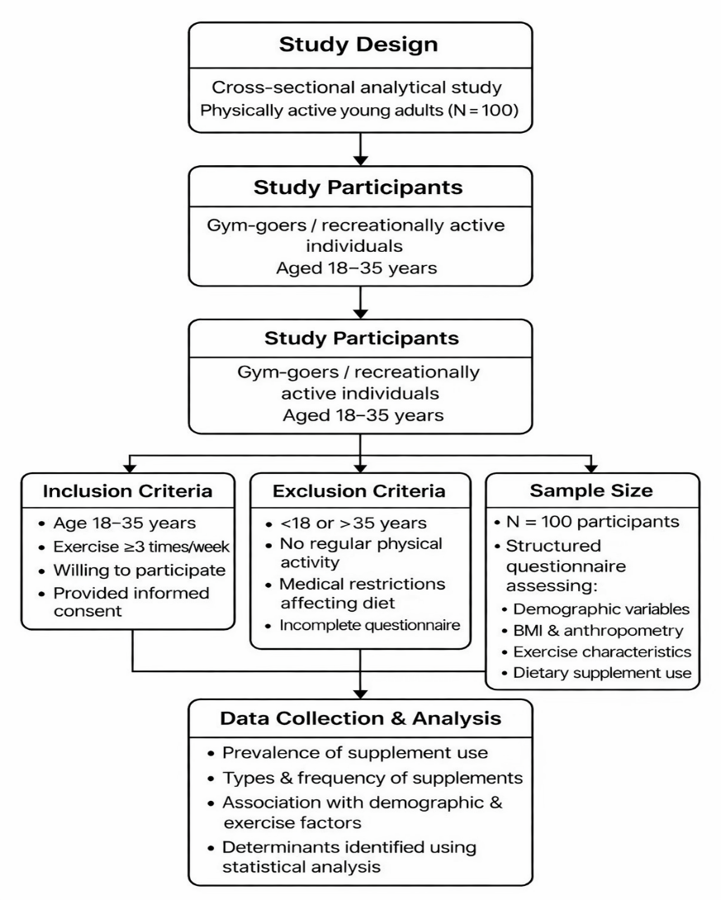
.
Sample Size and Sampling
A total of 100 participants were included in the analysis. Participants were recruited using a non-probability convenience sampling approach from gymnasiums and exercise settings. The sample size was considered adequate to estimate supplement use prevalence and explore associated factors within the study population.
Inclusion Criteria
Participants were eligible if they:
- Were aged 18–35 years.
- Engaged in regular structured exercise (≥3 sessions per week).
- Had maintained physical activity for at least three months.
- Completed the questionnaire in full.
Exclusion Criteria
Participants were excluded if they:
- Were <18 or >35 years.
- Did not participate in regular physical activity.
- Had medical conditions limiting diet or exercise.
- Submitted incomplete questionnaires.
Data Collection Instrument
Data were collected using a structured, self-administered questionnaire developed following a review of literature on dietary supplement use among physically active populations. The instrument consisted of five domains:
1. Sociodemographic and Socioeconomic Characteristics
Information on age, gender, educational attainment, residential status and socioeconomic category (lower, middle, upper) was obtained.
2. Anthropometric Assessment
Participants self-reported height and weight. Body Mass Index (BMI) was calculated using the Quetelet formula (kg/m²) and categorized according to World Health Organization criteria as underweight (<18.5), normal weight (18.5–24.9), overweight (25.0–29.9), and obese (≥30.0).
3. Physical Activity Profile
Data regarding exercise frequency, duration per session, type of training (e.g., resistance, aerobic, mixed) and primary fitness goals were recorded.
4. Dietary Supplement Use
Participants were asked about:
- Current or recent supplement use.
- Types of supplements consumed.
- Frequency and duration of use.
- Motivations for supplementation
Dietary supplement use was operationally defined as the consumption of any product intended to enhance performance, recovery or general health beyond habitual dietary intake.
5. Knowledge and Risk Perception
Selected items assessed awareness regarding appropriate use, potential benefits and possible risks associated with supplementation.
Data Collection Procedure
Eligible participants were informed about the study objectives and procedures. After obtaining written informed consent, questionnaires were administered in person. Participation was voluntary and confidentiality of responses was maintained throughout the study.
Statistical Analysis
Data were entered into Microsoft Excel and analyzed using SPSS.
Results and Discussion:
The following section presents the distribution and patterns of dietary supplement use among physically active young adults. It outlines the overall prevalence, commonly consumed supplement types and key motivations for use. Additionally, associations between supplement consumption and variables such as type of exercise, gender, and training frequency are examined to understand behavioral trends within the study population.
Prevalence of Dietary Supplement Use
This shows that (Fig.1) most participants (59%) reported that they do not consume dietary supplements, while 32% indicated regular use and 9% reported occasional use. This suggests that although supplementation is present among a considerable portion of the sample, it is not a universal practice. The findings reflect a mixed behavioral pattern, where a significant group integrates supplements into their routine, while the majority rely primarily on their regular diet and training practices without consistent supplementation.

Figure 1. Prevalence of Dietary Supplement Use
Types of Supplements Consumed
This (Fig.2) illustrates the distribution of supplement types among participants. The majority reported not using any supplement, while whey protein emerged as the most commonly consumed supplement among users. Creatine and combination use (protein with creatine) were reported by a smaller proportion, whereas casein protein and other supplements were least preferred. This pattern suggests that protein based supplementation, particularly whey protein, dominates supplement choices among active individuals, while specialized or alternative supplements are comparatively less utilized.

Figure 2. Types of Supplements Consumed
Motivations for Supplement Use
This illustrates (Fig.3) that muscle recovery is the most commonly reported benefit (highest frequency, around 35 respondents), followed by muscle growth (around 20 respondents). Other benefits such as both muscle recovery & muscle growth, weight loss/fat burning and refueling glycogen stores were reported by a moderate number of participants. Very few respondents selected hydration, any other or gave no response.

Figure 3. Motivations for Supplement Use
Supplement Use Across Type of Exercise
The findings (Table 1) indicate that strength training participants reported the highest consumption of supplements, particularly protein powders, compared to other exercise groups. A considerable number of individuals engaged in cardio activities also reported supplement use, though to a lesser extent. Participants involved in sports, yoga/pilates, and mixed exercise types showed comparatively lower and more varied supplement consumption patterns. A small proportion of respondents did not specify their exercise type. Overall, the data suggest that supplement consumption is more common among individuals engaged in strength-based training, possibly reflecting their focus on muscle recovery and growth.
Table 1 Supplement Use Across Type of Exercise
 |  | Consumption of Supplement (e.g. protein powder)
 |  | Yes | No | Sometimes
Type of exercise primarily engaged in. | Not Specified | 0 | 1 | 0
Type of exercise primarily engaged in. | Cardio (running, cycling etc.) | 6 | 10 | 1
Type of exercise primarily engaged in. | Strength training | 14 | 26 | 6
Type of exercise primarily engaged in. | Sports | 4 | 8 | 0
Type of exercise primarily engaged in. | Yoga/Pilates | 1 | 4 | 1
Type of exercise primarily engaged in. | Any Other | 1 | 6 | 1
Type of exercise primarily engaged in. | Both 1 & 3 | 1 | 1 | 0
Type of exercise primarily engaged in. | Both 2 & 4 | 1 | 1 | 0
Type of exercise primarily engaged in. | Both 2 & 3 | 1 | 1 | 0
Type of exercise primarily engaged in. | Both 1& 2 | 3 | 1 | 0
Supplement Use Across Gender
A Chi-square test of independence (Table 2) was conducted to examine the association between gender and supplement consumption. The results revealed a statistically significant association between the two variables (χ² = 11.677, df = 2, p = .003). Male participants were more likely to report consuming supplements compared to female participants. While a considerable proportion of males reported regular or occasional use, the majority of females indicated that they did not consume supplements. These findings suggest that gender plays a significant role in influencing supplementation behavior among physically active young adults.

Table 2 Supplement Use Across Gender
 |  | Supplement Consumption |  |  | Total
 |  | Yes | No | Sometimes | Total
Gender | Male | 30 | 37 | 8 | 75
Gender | Female | 2 | 22 | 1 | 25
Total |  | 32 | 59 | 9 | 100

Supplement Use Across Training Frequency
This indicates (Table 3) most participants (59%) did not consume supplements, while 32% reported use and 9% used them occasionally. Supplement use was relatively higher among those training more than five times per week (16 out of 46) and 3-4 times per week (9 out of 28). In contrast, fewer participants who exercised less frequently or never exercised reported lesser supplement use. Overall, non-consumption was common across all training frequencies.
Table 3 Supplement Use Across Training Frequency
 |  | Supplement Consumption |  |  | Total
 |  | Yes | No | Sometimes | Total
Frequency of Training Per Week | 1-2 times | 4 | 5 | 1 | 10
Frequency of Training Per Week | 3-4 times | 9 | 16 | 3 | 28
Frequency of Training Per Week | More than 5 times | 16 | 27 | 3 | 46
Frequency of Training Per Week | I do exercise regularly | 2 | 9 | 2 | 13
Frequency of Training Per Week | Never | 1 | 2 | 0 | 3
Total |  | 32 | 59 | 9 | 100

Discussion
The present study examined dietary supplement use among physically active young adults and found that while supplementation is common, it is not universally practiced. Nearly one-third of participants reported regular use and a smaller proportion used supplements occasionally, whereas the majority did not consume supplements. This suggests that although supplements are integrated into fitness culture, many individuals still rely primarily on regular dietary intake to support their exercise routines. Protein based supplements, particularly whey protein, emerged as the most preferred products. This reflects the strong focus on muscle recovery and growth within gym environments. The predominance of recovery and muscle related motivations indicates that supplementation is largely driven by performance and physique enhancement goals rather than general health needs. Creatine and combination supplementation were less frequently reported, suggesting selective adoption of performance enhancing products. Exercise patterns appeared to influence supplement behavior. Participants engaged in strength training demonstrated higher supplement consumption compared to those involved in cardio, sports or yoga-based activities. Similarly, individuals exercising more than five times per week reported greater supplement use compared to those training less frequently. This descriptive trend suggests that increased training frequency may elevate perceived nutritional demands, thereby encouraging supplementation. However, supplementation was not exclusive to highly active individuals, indicating that personal beliefs and external influences may also shape consumption behavior.
A statistically significant association between gender and supplement use was observed, with males more likely to consume supplements than females. This difference may reflect sociocultural norms, marketing influences and differing fitness objectives. Supplements aimed at muscle gain and performance are often promoted toward men, potentially contributing to higher usage rates among male participants.
Overall, the findings suggest that dietary supplement use among young adults is influenced by a combination of training intensity, gender and performance-oriented motivations. The variability across groups highlights the complex and multifactorial nature of supplementation behavior within fitness settings.
Conclusion
In conclusion, the study demonstrates that dietary supplement use among physically active young adults is prevalent but not universal. Protein supplements, particularly whey protein, are the most commonly consumed products, primarily motivated by muscle recovery and growth objectives. Gender emerged as a significant determinant, with males showing higher supplement use than females. Descriptive trends also indicate that individuals engaged in strength training and those exercising more frequently are more likely to consume supplements.
These findings suggest that supplementation practices are shaped not only by exercise demands but also by sociocultural and behavioral influences. Given the growing popularity of dietary supplements within fitness communities, there is a clear need for evidence-based nutrition education that promotes safe, informed and rational use. Encouraging balanced dietary practices alongside professional guidance can help ensure that supplementation complements, rather than replaces, sound nutritional habits among physically active young adults.
Competing Interests: None
Reference
Aljaloud, S. O., & Ibrahim, S. A. (2013). Use of dietary supplements among professional athletes in Saudi Arabia. Journal of nutrition and metabolism, 2013(1), 245349.
Backhouse, S. H., Whitaker, L., & Petróczi, A. (2013). Gateway to doping? Supplement use in the context of preferred competitive situations, doping attitude, beliefs, and norms. Scandinavian journal of medicine & science in sports, 23(2), 244-252.
Baltazar-Martins, G., Brito de Souza, D., Aguilar-Navarro, M., Muñoz-Guerra, J., Plata, M. D. M., & Del Coso, J. (2019). Prevalence and patterns of dietary supplement use in elite Spanish athletes. Journal of the International Society of Sports Nutrition, 16(1), 30.
Bianco, A., Mammina, C., Paoli, A., Bellafiore, M., Battaglia, G., Caramazza, G., ... & Jemni, M. (2011). Protein supplementation in strength and conditioning adepts: knowledge, dietary behavior and practice in Palermo, Italy. Journal of the International Society of Sports Nutrition, 8(1), 25.
Burnett, A. J., Livingstone, K. M., Woods, J. L., & McNaughton, S. A. (2017). Dietary supplement use among Australian adults: Findings from the 2011–2012 national nutrition and physical activity survey. Nutrients, 9(11), 1248.
Chandana, K. N., Syeda, F. S., Pallavi, R., & Veena, B. M. (2023). Comparative study on nutrition knowledge and consumption of dietary supplements among athletes and fitness practitioners. International Journal of Health & Allied Sciences, 12(1), 16-21.
Darvishi, L., Askari, G., Hariri, M., Bahreynian, M., Ghiasvand, R., Ehsani, S., ... & Khorvash, F. (2013). The use of nutritional supplements among male collegiate athletes. International journal of preventive medicine, 4(Suppl 1), S68.
Froiland, K., Koszewski, W., Hingst, J., & Kopecky, L. (2004). Nutritional supplement use among college athletes and their sources of information. International journal of sport nutrition and exercise metabolism, 14(1), 104-120.
Garthe, I., & Maughan, R. J. (2018). Athletes and supplements: prevalence and perspectives. International journal of sport nutrition and exercise metabolism, 28(2), 126-138.
Giannopoulou, I., Noutsos, K., Apostolidis, N., Bayios, I., & Nassis, G. P. (2013). Performance level affects the dietary supplement intake of both individual and team sports athletes. Journal of sports science & medicine, 12(1), 190.
Huang, S. H. S., Johnson, K., & Pipe, A. L. (2006). The use of dietary supplements and medications by Canadian athletes at the Atlanta and Sydney Olympic Games. Clinical Journal of Sport Medicine, 16(1), 27-33.
Joseph, N., Kumar, A., Singh, H., Shaheen, M., Das, K., & Shrivastava, A. (2018). Nutritional supplement and functional food use among medical students in India. Journal of Dietary Supplements, 15(6), 951-964.
Knapik, J. J., Steelman, R. A., Hoedebecke, S. S., Austin, K. G., Farina, E. K., & Lieberman, H. R. (2016). Prevalence of dietary supplement use by athletes: systematic review and meta-analysis. Sports Medicine, 46(1), 103-123.
Maughan, R. J., Burke, L. M., Dvorak, J., Larson-Meyer, D. E., Peeling, P., Phillips, S. M., ... & Engebretsen, L. (2018). IOC consensus statement: dietary supplements and the high-performance athlete. International journal of sport nutrition and exercise metabolism, 28(2), 104-125.
Sankar, K. K., & Khan, M. A. (2024). IJCM_166A: A cross sectional study to assess knowledge, attitude and practices about dietary supplements among gym going medical students. Indian Journal of Community Medicine, 49(Suppl 1), S48-S49.
SHARMA, D. (2020). STUDIES ON QUALITY ASSESSMENT OF SPORTS NUTRITION FORMULARY (Doctoral dissertation, CHAUDHARY SARWAN KUMAR HIMACHAL PRADESH KRISHI VISHVAVIDYALAYA).
Sobal, J., & Marquart, L. F. (1994). Vitamin/mineral supplement use among athletes: a review of the literature. International Journal of Sport Nutrition and Exercise Metabolism, 4(4), 320-334.
Verma, N. K., Singh, A. K., Rao, P. K., Singh, S., Mishra, S., & Singh, J. (2024). Dietary Supplements and Its Health Benefits: An Overview. Sch Acad J Pharm, 5, 181-188.
Wiens, K., Erdman, K. A., Stadnyk, M., & Parnell, J. A. (2014). Dietary supplement usage, motivation, and education in young Canadian athletes. International journal of sport nutrition and exercise metabolism, 24(6), 613-622.

