CONTRIBUTION OF AVOCADOS FRUIT TO THE NUTRITION OF RURAL HOUSEHOLDS IN BURUNDI: THE CASE OF TANGARA COMMUNE IN BUTANYERERA PROVINCE

ABSTRACT

The purpose of this study is to analyze the contribution of avocados to improving the nutrition of rural households in the Tangara commune by providing them protein, iron and zinc. This research was carried out in the Tangara commune, located in the Butanyerera province in northern Burundi, over a three-month period from August to October 2024. The nutrient analysis of the composition of these nutrients was conducted by Laboratory for the Analysis of Soils and Agri-Food Products of the Burundi Institute of Agricultural Sciences (ISABU).
This research involved a survey of households selected using a multi-stage sampling method, alongside a nutritional analysis of avocados harvested from their fields. The fruits samples analyzed were collected from four varieties: Persea americana var hass, fuerte, Persea americana var choquet and a local variety. Analysis were conducted exclusively on the flesh pulp of these avocados, the portion considered edible for human consumption. Protein content was determined using the Kjeldhal method, while iron and zinc concentration were measured by atomic absorption spectrometry.
These activities yielded significant results. The survey findings indicated that 86.9% of households owned avocado trees, and 99.48% reported consuming avocados. Among the varieties studied, nutritional analysis revealed that the fresh pulp of the local variety exhibited the highest protein and iron concentrations, with values of 2.09% for protein and 13.0mg/kg for iron. In comparison, the highest zinc content was observed in the Fuerte variety, at 8.04mg kg⁻¹.
All avocado pulp analyzed in this study, irrespective of variety, can be considered a good sources of protein and a moderate sources of micronutrients such as iron and zinc for human nutrition. Their consumption whithin in the study area contributes to household dietary intake by suppling essential nutrients, including those examined herein. This research underscores the nutritional significance of avocado consumption in local households.
Keywords: Avocado fruit, protein, iron, zinc and rural household nutrition.
1. INTRODUCTION
Despite considerable progress in agricultural production since the 1950s, the number of individuals suffering from undernutrition has tended to increase in absolute terms(Ramade, 2014). The contribution of agriculture to food security is well established, while renewed attention has been directed towards its role in household nutrition(Niragira et al., 2015). One of the key functions of agriculture is to provide nutritious food to the households that produce it(Haddad, 2013). Agricultural growth should therefore contribute to food security, both directly for example, through self-consumption and indirectly, such as through income generation(Haddad, 2013).
Households in the municipality of Tangara, Burundi, cultivate a variety of crops, including food crops, industrial crops, vegetables, and fruits, such as avocados. The avocado is a plant that thrives in all tropical and subtropical regions, and its production and consumption are steadily increasing worldwide. In Burundi, this crop is commonly grown for local consumption, with an average household producing 50 kg of avocados per year(Ndayisenga, 2010). Its thick, creamy texture and high nutrient content render it a popular fruit widely consumed in households(Dreher & Davenport, 2013).
Nevertheless, the food situation in Burundi remains unsatisfactory. The divergent trends in agricultural production, coupled with demographic pressure and climate change, have exposed numerous households to food insecurity(Niragira et al., 2011). Indeed, the Comprehensive Analysis of Vulnerability, Food Security, and Nutrition (AGVSAN) in Burundi indicated that 41.2% of households were food insecure, with a higher prevalence in rural areas (44%) compared to urban areas (17.8%)( Analyse Globale de la Vulnérabilité, de la Sécurité Alimentaire et de la Nutrition au Burundi, 2023). The consumption of protein- and iron-rich foods is particularly concerning, given that 15.2% of households had not consumed any protein-rich foods and 50.2% had not consumed any iron-rich foods(Mugisha & Nguendo Yongsi, 2023) and considering that 75.5% of the Burundian population resides in rural areas( Bureau Central Recensement, 2024), and considering that 75.5% of the Burundian population resides in rural areas (Bureau Central Recensement, 2024). In rural areas, daily protein consumption is less frequent than in urban areas( Analyse Globale de la Vulnérabilité, de la Sécurité Alimentaire et de la Nutrition au Burundi, 2023).
A diet deficient in protein and iron constitutes a major contributing factor to food insecurity, alongside inadequate intake of zinc-rich foods(Brown et al., 2002). The consequences of such deficiencies on individual health and societal development are manifold, including increased mortality and morbidity, impaired physical and intellectual development, reduced learning capacity and social skills, and intergenerational effects(Devautour et al., 2003). Irregularities in infant weight curves have been attributed to dietary factors, particularly insufficient protein intake(Holemans, 1954). Iron deficiency, which in its most severe form manifests as anaemia, leads to diminished physical capacity(Gardner et al., 1977) and reduced productivity in adults(Basta et al., 1979). Among pregnant women, severe anaemia accounts for 20% of maternal deaths(Howson et al., 1998). It also increases the risk of foetal and neonatal morbidity and mortality, as well as the likelihood of prematurity and low birth weight(Allen, 1997). Zinc deficiency impairs immune function and growth and is associated with elevated morbidity, particularly from diarrhoeal diseases(Brown et al., 2002).
Although individuals of all ages are affected to varying degrees by nutrient deficiencies(Le Bihan et al., 2002), the commune of Tangara possesses foods within its local environment such as avocados that are rich in these essential nutrients. Enhancing agricultural production and the consumption of nutritionally valuable foods, such as avocados, could assist households in this locality in addressing nutritional deficiencies related to these nutrients.

The objective of this study was to conduct a comprehensive investigation into the consumption and nutritional composition specifically protein, iron, and zinc of the different avocado varieties cultivated by households in the Tangara commune.

2. material and methods
2.1. Study area

The municipality of Tangara is one of eight municipalities constituting the province of Butanyerera in northern Burundi (Organic Law No. 1 of 16 March 2023 on the Determination and Delimitation of Provinces, Communes, Zones, Collines and/or Districts of the Republic of Burundi). It is bordered by the municipality of Kiremba to the north, Butihinda to the northeast, Muyinga to the east, Karusi to the southeast, Shombo and Bugendana to the southwest, Muhanga to the southwest, and Ngozi to the northwest. According to the draft organic law on the delimitation of provinces, municipalities, and zones/districts of the Republic of Burundi published in 2023, this municipality covers an area of 484.936 square kilometres.

2.1.1. Subdivision of the Tangara Municipality

The municipality of Tangara is subdivided into 13 zones, comprising 91 collines (Organic Law No. 1 of 16 March 2023 on the Determination and Delimitation of Provinces, Communes, Zones, Collines and/or Districts of the Republic of Burundi, 2023). These zones are Gasezerwa, Gashikanwa, Gatobo, Kabuye, Kananira, Mubanga, Musenyi, Ngoma, Nyagatovu, Remera, Ruhororo, Taba and Tangara.
The collines within the Tangara municipality are as follows: Cumba, Gitaramuka I, Mwika, Nkanda, Nyagatovu, Nyarugati, Cihonda, Gashikanwa, Kivumu, Maruri, Nini, Rwizingwe, Buhoro, Butaganda, Gitanga, Musumba, Ruhengeri, Sigi, Buganuka, Kabuye, Mubira, Mukoni, Mutobo, Nyakibingo, Nyamugari, Rimiro, Ruyaga I, Kamira, Kananira, Muramba, Rugabo, Runini, Ruyogoro, Gitwenzi, Kimerejana, Mihigo, Mubanga, Muhama, Ntiba, Bomba, Gitwa, Mafu, Mirango, Mugirampeke, Musakazi, Musenyi, Nyagasebeyi, Rushoka, Ruyaga II, Butaha, Gatukuza, Kabamba, Ngoma, Rutanga, Butezi, Gikingo, Kibande, Mashitsi, Nyagatovu, Rukongwa, Gatare, Mafuro, Remera, Rusengo, Rutambwe, Sabunda, Bucamihigo, Buniha, Cagura, Gitamo, Gitanga, Gitaramuka II, Kagoma, Kinyami, Rwamiko, Banda, Giturwe, Kobero, Nkoto, Nyarunazi, Nyinya, Ryarunyinya, Bwitoyi, Gasekanya, Gisura, Kigomero, Kiruhura, Mbasi, Myando, Ngendo and Nyakabanda.
The municipality contains collines sharing identical names but located in different zones. To address this, the present study assigned Roman numeral suffixes to these collines based on the phonetic alphabetical order of their respective administrative zones. Accordingly, the Gitaramuka colline situated in the Gasezerwa zone is designated "Gitaramuka I," while the one in the Ruhororo zone is designated "Gitaramuka II." Similarly, the Ruyaga colline located in the Kabuye zone is referred to as "Ruyaga I," and the one in the Musenyi zone as "Ruyaga II."
2.1.2. Population

According to administrative authorities, the population of the Tangara municipality resides in 59,967 households. The municipality has 263,764 inhabitants, representing 2.1% of Burundi's national population, with 75.5% residing in rural areas(Bureau Central Recensement, 2024). Of this population, 96.2% live in rural areas (Bureau Central Recensement, 2024), where agriculture constitutes their primary source of food. Households cultivate a variety of crops, including fruit crops(Manirakiza, 2021). The latter, however, are not as systematically structured as other crop types. The most prevalent fruit crops are avocados, which are partly consumed domestically and partly sold at low prices in local markets to generate income for purchasing other products(Manirakiza, 2021).

2.2. Sample size

The sample is one or more sampling units taken from a population and intended to provide information about that population(Gerville-réache & Couallier, 2011). For this study, our sample size was calculated using the following formula:

$$n=\frac{t_{p}^{2}*p\left(1-p\right)*N}{t_{P}^{2}*p\left(1-p\right)+\left(N-1\right)*y^{2}}ADDIN CSL_CITATION \{"citationItems":[\{"id":"ITEM-1","itemData":\{"ISBN":"9782759227365","author":[\{"dropping-particle":"","family":"Gabert","given":"Julien","non-dropping-particle":"","parse-names":false,"suffix":""\}],"editor":[\{"dropping-particle":"","family":"Quæ","given":"","non-dropping-particle":"","parse-names":false,"suffix":""\},\{"dropping-particle":"","family":"Gret","given":"","non-dropping-particle":"","parse-names":false,"suffix":""\}],"id":"ITEM-1","issued":\{"date-parts":[["2018"]]\},"publisher-place":"France","title":"Mémento de l’assainissement: Mettre en œuvre un service d’assainissement complet, durable adapté","type":"book"\},"uris":["http://www.mendeley.com/documents/?uuid=3aad37bf-27ff-411a-86eb-ccce72191e3b"]\}],"mendeley":\{"formattedCitation":"(Gabert, 2018)","plainTextFormattedCitation":"(Gabert, 2018)","previouslyFormattedCitation":"(Gabert, 2018)"\},"properties":\{"noteIndex":0\},"schema":"https://github.com/citation-style-language/schema/raw/master/csl-citation.json"\}(Gabert, 2018)$$

With:
- n: sample size;
- N: reference population;
- p: proportion of responses from the population, estimated at 50% for this study;
- t_{p}: sampling confidence interval set at 95% (t_{p}=1.96);
- y: sampling error margin set at 5% for our case study.
From this formula, we obtained a sample of:
$n=\frac{{1,96}^{2}*0,5\left(1-0,5\right)*59967}{{1,96}^{2}*0,5\left(1-0,5\right)+\left(59967-1\right)*{0,05}^{2}}=381,7209≃382$ households.

Their identification was applied once to the parent population.

2.3. Sampling method
To identify the n statistical units of our sample, we have used the multi-stage sampling method (Anderson et al., 2007). Thus, administrative areas were used as selection criteria in the first stage, followed by hills in the second stage and finally households in the third stage.

2.3. Data collection

Data were collected using a questionnaire that was prepared in advance and digitised using KoboToolbox software (Romarick & Mbourou, 2023). The questions were addressed to the head of the household, who was assumed to be automatically the manager of the family farm; where this was not the case, the questions were answered by his or her spouse.
For this study, laboratory samples of avocados were also collected from the surveyed households in order to analyze their content of the nutrients targeted by this research. These avocados were harvested from three cultivars Hass, Fuerte, and Choquet and one local variety. The fruit were ripe and free from disease. They were stored at ambient temperature until ripe. Following ripening, the samples were transported to the laboratory for analysis of their protein, iron, and zinc content.
2.4. Analysis of the protein, iron and zinc composition of our samples
2.4.1. Preparation of laboratory samples
The samples were prepared for analysis in accordance with AOAC International Official Method 950.02(AOAC, 2019). The pulp of the avocado fruits (a 0.5 kg sample was taken for each variety) was dried in the laboratory using a ventilated oven. Once dried, the pulp was weighed, ground into a fine powder using a blender, then sieved and stored in a refrigerator at -4°C until analysis. All reagents and solvents used were of analytical grade.
2.4.2. Determination of protein content
The protein content of the samples was determined from total nitrogen measured using the Kjeldahl method, as described in method 984.13A of AOAC International(AOAC, 2019). The samples were mineralized with sulphuric acid in the presence of a catalyst. The resulting acid solution was then rendered alkaline with a sodium hydroxide solution. The ammonia thus released was distilled into an excess of boric acid solution, after which the ammonia combined with the boric acid was titrated with a standard solution of hydrochloric or sulphuric acid. The nitrogen content obtained was subsequently converted to total protein content by multiplying by a conversion factor of 6.25(Greenfield & Southgate, 2003).
2.4.3. Micronutrient Dosage: Iron and Zinc
The iron and zinc content of the samples was determined using atomic absorption spectrometry, in accordance with method 975.03 of AOAC International(AOAC, 2019). An atomic absorption spectrophotometer (Perkin-Elmer model 2380, manufactured in the United States) was employed to quantify the iron (Fe) and zinc (Zn) concentrations in an acid-digested ash solution.
In this procedure, the sample is dissolved in hydrochloric acid solution following the destruction of any organic matter. The elements (iron and zinc) are then quantified, after appropriate dilution, by atomic absorption spectrometry. Atomic absorption measurements of the reference standard solutions and the sample solution were performed in quadruplicate using an air-acetylene oxidizing flame at the following wavelengths: Fe = 248.3 nm and Zn = 213.8 nm(Laporte et al., 1971). The results are expressed in milligrams of trace element per kilogram of sample (mg/kg).

2.5. Data cleaning and analysis

Regardless of the robustness of the methods employed, the quality of any analysis depends solely on the quality of the underlying data(Kristi et al., 2023). Data cleansing is therefore essential to ensure the validity of subsequent analyses. The principle of "garbage in, garbage out"(Lidwell et al., 2010) serves as a reminder that computer systems merely process the input they receive, irrespective of whether that input is accurate or erroneous. The data collected during this research were cleaned using Microsoft Excel; spelling errors were corrected and duplicate entries were removed. Statistical analyses were conducted using IBM SPSS software, version 21.

3. resultATs and discussion

During this research, interviews were conducted with 382 households in the municipality of Tangara between August and October 2024. Of these households, 86.95% cultivated avocados (Figure 1). However, avocado trees were planted in fields with other crops; consequently, no orchards with areas dedicated exclusively to avocado cultivation were observed.

This finding corroborates previous research suggesting that, in many countries, commercial avocado orchards are absent, with production instead originating from smallholder farmers cultivating a limited number of trees(Naamani, 2007). Addressing population pressure and facilitating adaptation to climate change through the cultivation of this crop could enhance the avocado sector within local households.

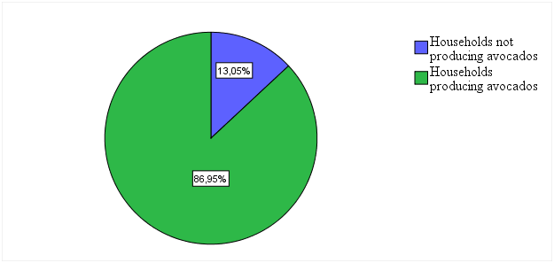

Figure 1: Households producing avocados in the municipality of Tangara

The households of the study area cultivate several varieties of avocado. Unfortunately, they only know the scientific names of three varieties (Table 1).

Table 1: Varieties of Avocados Cultivated in the Study Area

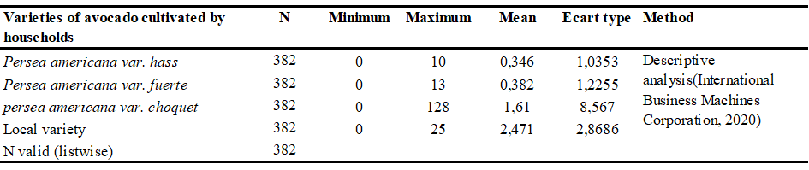
The results revealed the presence of several distinct, previously undocumented avocado varieties, collectively categorized under the denomination "local variety." This finding corroborates previous authors who indicated that numerous avocado varieties exist globally, varying according to the climatic conditions in which they are cultivated(Araújo et al., 2018) and differing by country of origin(Lahav & Kalmar, 1977). These local varieties warrant identification, protection and valorization, both for the conservation of avocado species and for their contribution to human nutrition.

Furthermore, households in the study area highly value avocado fruit. The results obtained indicate that nearly all households (99.48%) interviewed during this research consumed avocados (Figure 2). Even households without avocado trees benefited from their nutritional value.

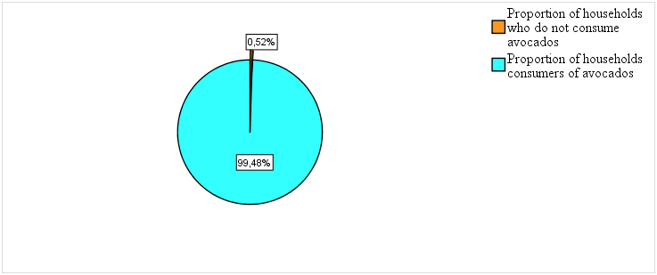

Figure 2: Proportion of Avocado-Consuming Households in the Study Area

The results suggest that households within the study area derive nutritional advantages from the cultivation of Persea americana Mill., specifically via its contribution of key micronutrients to the human diet.
In this context, analysis of the protein, iron, and zinc content of avocados harvested from the households' fields revealed that these nutrients were present in varying concentrations depending on the variety (Table 2). The results obtained for the Hass variety are simlar with those reported in previous studies(Dreher et al., 2013). Other researchers have reported iron levels for the Fuerte variety that align with our findings (Wills et al., 1986) ), as well as protein content for the Choquette variety comparable to that observed in the present study(Mardigan et al., 2019). No previous research on the local variety analyzed in this study could be located, owing to the absence of documented scientific nomenclature for this variety. This underscores the importance of identifying and characterizing local varieties.

Table 2: Nutritional composition of fresh avocado pulp: protein, Iron, and Zinc Levels
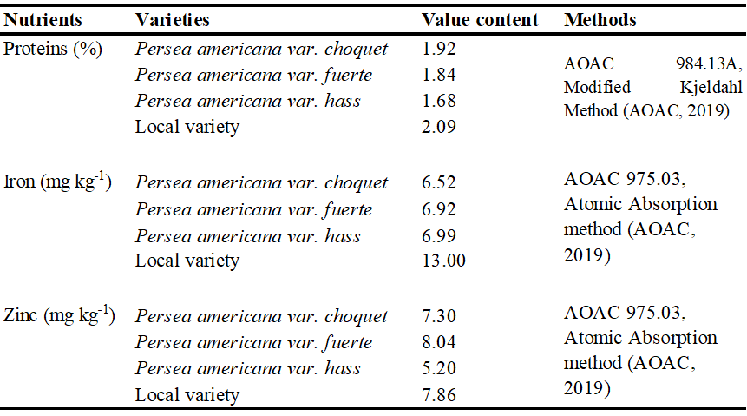
The results revealed statistically significant differences in protein content among the four cultivars analyzed (P < 0.05). The highest value was observed in the local variety. Comparable findings have been reported by other authors for the Fuerte variety(Rozan et al., 2021) and for the Choquet variety(Mardigan et al., 2019). Daily consumption of 1kg of fresh pulp from the avocados examined in this study would provide an adult household member with twice the recommended daily protein intake per kilogram of body weight (0.8 g kg⁻¹ day⁻¹) (World Health Organization, 2007). Household consumption of these avocados represents a key source of this macronutrient for the regional population.

Locally cultivated avocados may also be considered as source of iron and zinc for households. The iron concentrations observed in the Hass and Fuerte varieties (Table 2) are higher than those documented in previous studies(Rozan et al., 2021). Regarding zinc content, the results obtained (Table 2) are similar to those reported for the Hass variety(Nasri et al., 2023). The latter study, however, found approximately half the zinc content in the Fuerte variety compared to the present findings. Several other authors have reported values for the Fuerte and Hass varieties that are consistent with our results(Cowan & Wolstenholme, 2016). Furthermore, the zinc content observed for the Choquet variety is twice that reported by other researchers(Nasri et al., 2023). A daily intake of 1 kg of pulp from the avocados studied would meet the recommended iron requirement for a child (7 mg day⁻¹) (Martin, 2001), while providing nearly half the requirement for an adult woman (16 mg day⁻¹). The local landrace variety is particularly notable, as its higher iron content per kilogram could supply twice the child's requirement Iron and fully meet that of an adult man (8 mg day⁻¹) (Martin, 2001). With respect to zinc contribution, the daily consumption of 1 kg of pulp from any of the avocado varieties examined would supply approximately half the recommended dietary allowance of 15 mg day⁻¹ for an adult (Latham, 1997).

The consumption of avocados, particularly the varieties examined in this study, provides households in the study area with access to protein, iron, and zinc, thereby contributing to their nutritional well-being. This aligns with the assertion by authors who have suggested that the nutritional properties of avocados are frequently associated with health benefits, conferring upon them the status of a "superfood"(Bhuyan et al., 2019).

Furthermore, avocado farming provides local households with an income source that enables dietary diversification (Table 3).
Table 3: income earned from avocado farming by households in the study area
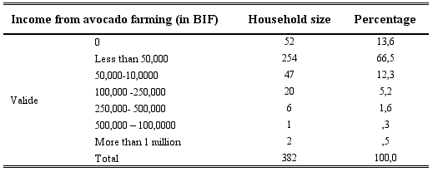
These findings indicate that avocado cultivation constitutes a widespread subsistence activity with limited profitability; 254 households (66.5% of producer families) derive an income of less than 50,000 BIF from it. This suggests that, for these families, avocado functions as a supplementary crop cultivated on a small scale, rather than a primary source of revenue.

Only 2.4% of households (9 families) generate income exceeding 250,000 BIF, a segment likely corresponding to producers with extensive planted areas. For the vast majority of the population, avocado cultivation constitutes an economic safety net by providing a modest additional income. This income enables households to access other sources of nutrients not produced within the family. This aligns with the view of other authors, who suggest that the production and consumption of avocados can provide both income and nutritious food for vulnerable households (Umaharan, 2018), and that avocado is a crop to be promoted in efforts to combat malnutrition and food insecurity (Bossou et al., 2024).

To maximize the nutritional benefits derived from these avocados in the study area, it is essential to strengthen farmers' capacities through training in avocado cultivation and preservation techniques, as well as in commercial management. Furthermore, the establishment of a collection and storage system, or the creation of agricultural cooperatives, could help stabilized fruit supply on the market and reduce post-harvest losses.
4. Conclusion

Avocado is the most commonly produced fruit among households in the commune of Tangara, Burundi. Its production is primarily intended for family consumption, despite its increasing role in export markets. The high rate of household consumption (99.48%) indicates that avocado is regularly incorporated into the local diet, enabling households to benefit from the nutrients contained in the fruit. The local variety analyzed was found to provide high levels of protein and iron for human consumption, while all varieties studied exhibited near zinc content values. Avocados thus play an important role in the nutrition of household members by supplying those essential nutrients. Their cultivation and consumption by households in the study area represent one of the strategies for improving household nutrition.

COMPETING INTERESTS DISCLAIMER:
Authors have declared that they have no known competing financial interests OR non-financial interests OR personal relationships that could have appeared to influence the work reported in this paper.

References

- Ramade, F. (2014). A world without famine? Towards sustainable agriculture. Paris: Dunod.
- Niragira, S., D’Haese, M., D’Haese, L., Ndimubandi, J., Desiere, S. and Buysse, J. (2015). Food for survival: Diagnosing crop patterns to secure lower threshold food security levels in farm households of Burundi. Food and Nutrition Bulletin, 36(2), 196–210. https://doi.org/10.1177/0379572115587491
- Haddad, L. (2013). From nutrition plus to nutrition driven: How to realize the elusive potential of agriculture for nutrition? Food and Nutrition Bulletin, 34(1), 39–44. https://doi.org/10.1177/156482651303400105
- Ndayisenga, A. (2010). The reproduction of a peasant system through off-farm income: The case of the Bututsi region in Burundi. University of Toulouse II-Le Mirail.

- Dreher, M. L., & Davenport, A. J. (2013). Hass Avocado Composition and Potential Health Effects. Critical Reviews in Food Science and Nutrition, 53(7), 738–750. https://doi.org/10.1080/10408398.2011.556759
- Niragira, S., Buysse, J., & D’Haese, L. (2011). Optimizing land use among small-scale farms through agricultural specialization in northern Burundi. Ghent University.

- Comprehensive Vulnerability, Food Security, and Nutrition Analysis of Burundi. (2023). State of food security in Burundi.

- Mugisha, A. D., & Nguendo Yongsi, H. B. (2023). Causes and consequences of household food and nutrition insecurity in Burundi: A qualitative approach. International Journal of Science Academic Research, 04(10), 6375–6381.

- Central Census Bureau. (2024). Report of preliminary results of the General Population and Housing Census (RGPHAE) in Burundi.

- Brown, K. H., Peerson, J. M., Rivera, J., & Allen, L. H. (2002). Effect of supplemental zinc on the growth and serum zinc concentrations of prepubertal children: A meta-analysis of randomized controlled trials. The American Journal of Clinical Nutrition, 75(6), 1062–1071. https://doi.org/10.1093/ajcn/75.6.1062
- Devautour, H., Moity-Maïzi, P., & Muchnik, J. (2003). Technical systems, know-how and agri-food innovations: Approaches and methods. In Food, know-how and innovations in agri-food in West Africa. CIRAD, CNEARC. http://repo.iain-tulungagung.ac.id/5510/5/BAB2.pdf
- Holemans, K. (1954). Nutritional deficiencies in Kwango. Brussels: I. Duculot, S.A. Gembloux.

- Gardner, G.W., Edgerton, V.R., Senewiratne, B., Barnard, R.J., & Ohira, Y. (1977). Physical work capacity and metabolic stress in subjects with iron deficiency anemia. American Journal of Clinical Nutrition, 30(6), 910–917. https://doi.org/10.1093/ajcn/30.6.910
- Basta, S., Soekirman, M., Karryadi, K. and Scrimshaw, N. (1979). Iron deficiency anemia and the productivity of adult males in Indonesia. American Journal Clinic Nutrition, 32(4), 916–925. https://doi.org/10.1093/ajcn/32.4.916
- Howson, C. P., Kennedy, E. T., & Horwitz, A. (1998). Prevention of Micronutrient Deficiencies: Tools for policy markers and public Health Workers (ed.)). Washington, D.C. http://www.nap.edu/catalog/5962.html
- Allen, L. H. (1997). Pregnancy and iron deficiency: unresolved issues. Nutrition Reviews, 55(4), 91–101. https://doi.org/10.1111/j.1753-4887.1997.tb06460.x
- Le Bihan, G., Delpeuch, F., & Maire, B. (2002). Nutrition and public policy. Charles Léopold Mayer.

- Manirakiza, D. (2021). Impact of food crop agricultural cooperatives on the living conditions of rural households in Burundi: The case of cooperatives in Ngozi province. University of Liège.

- Gerville-Réache, L., & Couallier, V. (2011). Representative sample (of a finite population): statistical definition and properties. https://hal.science/hal-00655566

- Gabert, J. (2018). Sanitation Handbook: Implementing a comprehensive, sustainable, and appropriate sanitation service (Quæ & Gret (eds.)). http://memento-assainissement.gret.org
- Anderson, D. R., Sweeney, D. J., & Williams, T. A. (2007). Statistics for Economics and Management (2nd ed.). Paris: De Boeck Supérieur.

- Romarick, D., & Mbourou, R. (2023). Field data collection within an NGO: Use of KoBoToolbox software. https://doi.org/hal-04085784
- AOAC. (2019). Official Methods of Analysis of AOAC International (21st ed.). Washington, DC.

- Greenfield, H., & Southgate, D. (2003). Food composition data—Production, management and use (2nd ed.). Rome: FAO Publishing Management Service.
- Laporte, J., Kovacsik, G., & Bellanger, J. (1971). Plant environments. In M. Pinta, G. Barroin, G. Baudin, J. Bellanger, H. Boiteux, M. Boucetta, et al. (Eds.). Atomic absorption spectrometry - Applications to chemical analysis (Volume 2, 446-519). Paris: Masson et Cie.

- Kristi, T., Elizabeth, H., Emilie, C.-J., Dennie, D., & Fortin, E. (2023). Research data management in the Canadian context. Pressbooks. https://doi.org/10.5206/TTIG7365
- Lidwell, W., Holden, K., & Butler, J. (2010). Universal Principles of Design. Singapore: Rockport Publishers.
- Naamani, G. (2007). Developments in the Avocado World. California Avocado Society Yearbook, 90, 71–76.

- Araújo, R. G., Rodriguez-Jasso, R. M., Ruiz, H. A., Pintado, M. M. E., and Aguilar, C. N. (2018). Avocado by-products: Nutritional and functional properties. Trends in Food Science & Technology, 80, 51–60. https://doi.org/10.1016/j.tifs.2018.07.027
- Lahav, E. and Kalmar, D. (1977). Water requirements of avocado in Israel. II*Influence on yield, fruit growth and oil content*. Australian Journal of Agricultural Research, 28(5), 869–877. https://doi.org/10.1071/AR9770869
- Wills, R.B.H., Lim, J.S.K., & Greenfield, H. (1986). Composition of Australian foods. 31. Tropical and sub-tropical fruit. Food Technology in Australia, 38(3), 118–123. https://doi.org/19861489315
- Mardigan, L. P., Santos, J. V. dos, Silva, T. P., Visentainer, J. V., Gomes, S. T. M., and Matsushita, M. (2019). Investigation of bioactive compounds from various avocado varieties (Persea americana Miller). Food Science and Technology, 39(1), 15–21. https://doi.org/https://doi.org/10.1590/fst.34817
- Rozan, M. A. A. G., Boriy, E. G., and Bayomy, H. M. (2021). Chemical composition, bioactive compounds and antioxidant activity of six avocado cultivars Persea americana Mill. (Lauraceae) grown in Egypt. Emirates Journal of Food and Agriculture, 33(10), 815–826. https://doi.org/10.9755/ejfa.2021.v33.i10.2772
- World Health Organization. 2007. Protein and amino acid requirements in human nutrition. Geneva: FAO, WHO, UNU Expert
- Nasri, C., Halabi, Y., Hajib, A., Choukri, H., Harhar, H., Lee, L. H., Mani, V., Ming, L. C., Goh, K. W., Bouyahya, A. and Tabyaoui, M. (2023). Proximate composition, lipid and elemental profiling of eight varieties of avocado (Persea americana). Scientific Reports, 13(22767), 1–14. https://doi.org/10.1038/s41598-023-50119-y
- Cowan, A. K., & Wolstenholme, B. N. (2016). Avocado. Encycl. In The Encyclopedia of Food and Health (1st ed.). https://doi.org/:10.1016/B978-0-12-384947-2.00049-0
- Martin, A. (2001). The recommended nutritional intakes (ANC) for the French population. Reproductive Nutrition Development, 41(2), 119–128. https://hal.science/hal-00900366v1
- Latham, M.C. (1997). Human nutrition in the developing world (Issue 29). Rome: FAO.
- Bhuyan, D. J., Alsherbiny, M. A., Perera, S., Low, M., Basu, A., Devi, O. A., Barooah, M. S., Li, C. G., and Papoutsis, K. (2019). The odyssey of bioactive compounds in Avocado (Persea Americana) and their health benefits. Antioxidants, 8(426), 1–53. https://doi.org/10.3390/antiox8100426
- Umaharan, P. (2018). Achieving sustainable cultivation of cocoa (1st ed.). Burleigh Dodds Science Publishing. https://doi.org/10.1201/9781351114547
- Bossou, A. F. A. D., Adoko, S. D., Avlessi, F., & Sohounhloue, K. C. D. (2024). Botanical Aspects, Nutritional and Chemical Profiles, Biological Properties and Cosmetic Uses of Persea Americana Mill. International Journal of Advanced Research, 12(02), 134–143. https://doi.org/10.21474/ijar01/18275

