Original Research article

NEW DISTIBUTIONAL RECORD OF THE PHYLACTOLAEMATE BRYOZOAN RUMARCANELLA HIMALAYANA ANNANDALE, 1911 FROM SATHYAMANGALAM TIGER RESERVE, ERODE DISTRICT, TAMIL NADU, INDIA

.
ABSTRACT
.
A new distributional record of the of Phylactolaemate Bryozoan Rumarcanella himalayana Annandale, 1911is described from the Sathyamangalam Tiger Reserve of Western Ghats of Tamil Nadu, India. The zooplankton samples were collected by extensive survey undertaken by the scientific team of Zoological Survey of India, Southern Regional Centre, Chennai, Tamil Nadu from the various waterbodies of Sathyamangalam Tiger Reserve, Erode district, Tamil Nadu during the year 2023 as a part of the Annual Programme of Research Work. The geographical distribution of this species is also discussed. Rumarcanella minuta (Toriumi, 1941) is a junior synonym of Stolella himalayana Annandale, 1911 which now becomes Rumarcanella himalayana based on the hypertubercles on statoblast. The family Plumatellidae Allman, 1856 is poorly studied in India and is represented by four genera viz. Plumatella Lamarck, 1816, Hyalinella Jullien, 1885, Rumarcanella Hirose and Mawatari, 2011 and Swarupella Shrivastava, 1981. The genus Rumarcanella Hirose and Mawatari, 2011 is represented by five species from India viz. Rumarcanella vorstmani (Toriumi, 1952) Rumarcanella indica Annandale, 1909 which were later synonimysed as Rumarcanella himalayana (Annandale, 1911), Rumarcanella gusuku Hirose & Mawatari, 2011 and Rumarcanella yanbaruensis Hirose & Mawatari, 2011. There are few studies on the freshwater bryozoans from the state of Tamil Nadu. The present study reports for the first time one species of bryozoan from the Western Ghats of Tamil Nadu.

Keywords: Bryozoa, Rumarcanella, Sathyamangalam Tiger Reserve, Western Ghats of Tamil Nadu, India.

- INTRODUCTION

The systematic studies of freshwater Bryozoa from India have been studied in detail only from few areas. The freshwater Bryozoans are common in India which occurs among the aquatic vegetation and algal mats and few are planktonic. Despite many limnological investigations in India, the freshwater. The present work was carried out during 2023.
Bryozoa are sessile although young colonies have a capacity for a slight movement over the substratum. The growth habit distinguishes most of the freshwater genera. Bryozoan colonies consist of more or less elongate induviduals called zooids which are small and numerous. Statoblasts are of much more regular shape and are produced by phylactolameta. Their shape may vary from a circular to an elliptical disc. Conspicuous spine are present on statoblasts of Pectinetella, Crystaella, Lophopodella, and Lophopus but in some forms the spines are absent. Sessoblasts are often called resting or attached statoblasts because they remain cemented to the zooecial tube or to the substratum. They are thick and elliptical and some are provided on the free face with a thin chitinous rim, the vestigial annules. Floatoblasts are generally called floating or free because they are produced on the funiculus in great numbers and are first released to float freely in the zooids body and then released from the zooid tubes to the surrounding water. A disc shaped, dark reddish-brown chitin covered central capsule containing germinal tissue from which new zooids will develop is the characteristic of both sessoblasts and floatoblasts. A light amber coloured gas filled float or annulus or ‘air cell’ is characteristics of floatoblasts. Sometimes it is possible to identify a species from only a single floatoblast. The statoblast may tide the species over periods of draught or winter long after the parent colonies have disintegrated or disappeared.
Bryozoan dispersal from one place to another may be by various means such as water animals (Birds & Mammals) and wind (Brown, 1933). Ducks, some amphibians, and some reptiles feeding on the water surface are known to ingest floatoblasts, which can remain viable and germinate after passing through the digestive tract (Brown 1933; Charalambi-dou et al. 2003; Figuerola et. al., 2005; Green et.al., 2008).
They are of not much economic importance. They live in freshwaters of varying PH range 5.3 to 8.0 and upto elevations of 3950 meters and occur at various depths of shoreline level to 214 m. They grow on submerged materials of many kinds such as plant leaves and stem, mussel, snail shells, rocks etc. and are also in close association with sponges. They feed on microscopic organisms both plant & animal and are being eaten by fishes, snails and possibly by other animals (Rogick, 1956). They are used as indicators in bioassay studies, water quality monitoring, paleolimnological research, for controlling their fouling growth and to identify their changes in community composition over time (Swami et.al., 2014).
For the present study the zooplankton samples from the Sathyamangalam Tiger Reserve, Erode district were used and some interesting flatboats of bryozoans were observed and were subjected for detailed taxonomic studies and it revealed a new distributional record of freshwater Bryozoan Rumarcanella himalayana Annandale, 1911 belonging to the genus Rumarcanella Hirose & Mawatari, 2011.

- material and methods

The Sathyamangalam Tiger Reserve is situated in Erode District of Sathyamangalam Taluk and parts of Erode Forest Circle. Fig. 1 shows the location map of Sathyamangalam Tiger Reserve. Photographs 1&2 shows a view of the collection locality (Gunderipallam dam)
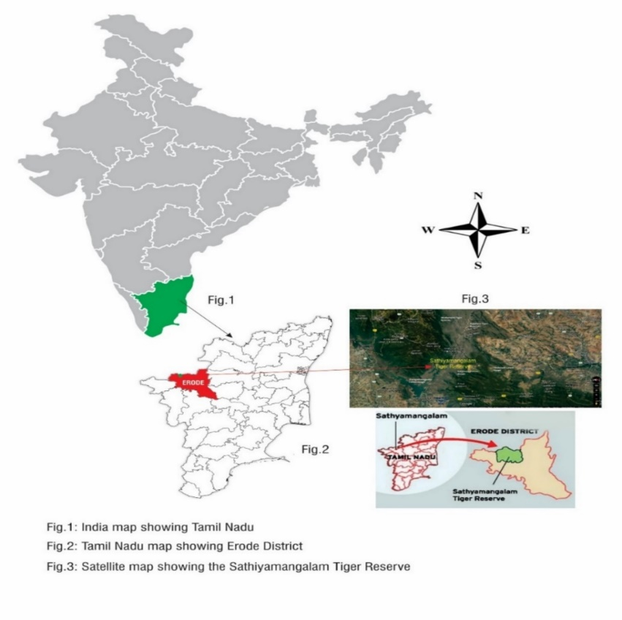
Fig. 1 Showing the location map of Sathyamangalam Tiger Reserve.
Table-1 DETAILS OF SAMPLE COLLECTION LOCALITY

Locality | District | Date | St. No | Lot No. | Latitude  (N) | Longitude  (E) | Altitude  (M) | No of zooplankton lots  collected | Collected by
Gunderipallam Dam, TN Palayam Range, Kongarpalayam beat, Sathyamangalam, Tamil Nadu. | Erode | 28.07.2023 | 1 | 5 | N  11. 56358° | E 077.36888° | 381.9M | 1 | Dr. J.Thilak & Party

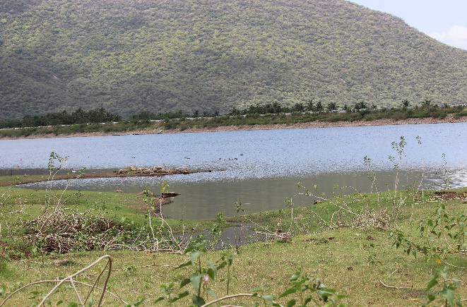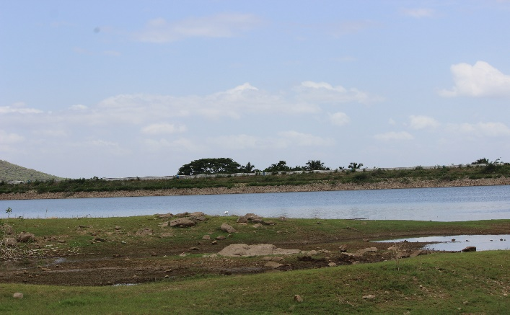
Photograph- 1 Photograph - 2

Photographs 1 & 2 Shows the photos of collection locality of Sathyamangalam Tiger Reserve view of Gunderipallam dam.

2.1 DETAILED METHODOLOGY

The plankton samples were collected by sweeping the plankton net made of bolting silk of mesh size 63µm through water among weeds and also by filtering 50 liters of water through the plankton net. The samples were preserved in 5% neutral formaldehyde, labeled and subjected for identification later. All the samples were deposited in National Zoological Collections of SRC/ZSI/Chennai. Temporary mounts of samples were prepared in the laboratory and the photographs of specimens were taken with Nikon 80i sterio zoom microscope with different magnifications such as 10x, 20x, 40x and 100x and the photographs of Bryozoan statoblasts were confirmed with experts in the relevant field.

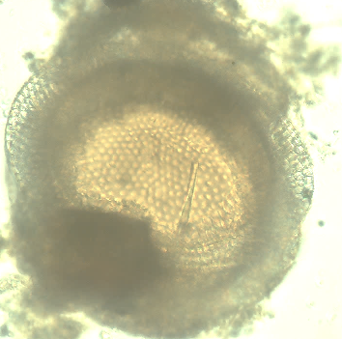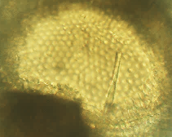
Fig-1 Fig-2

Fig.1: Photograph of the floatoblast of Rumarcanella himalayana Annandale, 1911.
Fig-2: Photograph of the floatoblasts ventral valve with inset showing tubercles on the annulus.
Fig-3: Photograph of sessoblast with inset showing tubercles on annulus.

Fig-3

2.1.1 ORIGINAL DESCRIPTIONS

Stolella himalayana Annandale, 1911: p. 246, fig. 49; Annandale & Kemp 1912: p. 143. Type material. No. ZEV 4813/7 (holotype), collected May, 1911 at Malwa Tal, Kumaun, W. Himalayas (3,600 feet) by S.W. Kemp.

2.1.1.1 CLASSIFICATION
Family Plumatellidae Allman 1856
Genus Rumarcanella Hirose & Mawatari, 2011
Rumarcanella himalayana Annandale, 1911

3. RESULTS AND DISCUSSION

While working among the Zooplankton samples from Sathyamangalam Tiger Reserve the first author come across the flotoblasts of Bryozoans and were photographed with higher magnification of 80i Nikon microscope.
3.1 DIAGNOSIS: Floatoblast ventral fenestra relatively large, its length more than half overall floatoblast length. Floatoblast dorsal fenestra length more than half the length of floatoblast. Floatoblasts length less than 350 µm; outline broadly oval to nearly circular, fenestra tubercles showing with hypertubercles.
Among phylactolaemate bryozoans floatoblasts have been found to carry the most reliable characters for species identification. In this species, the floatoblast features are quite distinctive: small size, fenestrae similar in size and shape, roughened suture, and hypertubercles. It is generally understood that among plumatellid bryozoans the sessoblast annulus is homologous to the gas-filled annulus of floatoblasts (Mukai 1982). The small floatoblast size is another distinguishing feature of Rumarcanella himalayana Annandale, 1911. Hypertubercles appear mostly on the ventral valve and are not expressed on every tubercle. The specimen consists of about numerous floatoblasts.
The genus Rumarcanella is the first ever to be based primarily on a single feature of the statoblast: the presence of hypertubercles. A hypertubercle may be defined as a small tubercle that sits atop a larger tubercle, generally seen on the floatoblast fenestra, but occasionally also found on the sessoblast frontal valve. Hypertubercles were first noticed in Rumarcanella vorstmani (Toriumi, 1952) and Rumarcanella minuta (Toriumi, 1941) which are now synonymized under Rumarcanella himalayana. The list was later expanded to include two new species, Rumarcanella gusuku Hirose & Mawatari, 2011b and Rumarcanella yanbaruensis Hirose & Mawatari, 2011b. This genus is considered problematic due to the likelihood that hypertubercles may not be a reliable unifying feature. For example, the floatoblasts of Plumatella raoi also have hypertubercles, but the colony features free branches, not the “entirely adherent branches specified in the genus description. Therefore, we must either broaden the genus definition, or else recognize that hypertubercles do not occur exclusively in this genus. In fact, they may commonly occur in any species where the statoblast tubercles are especially prominent. Hirose & Mawatari (2011b) provided genetic evidence that four Rumarcanella species with hypertubercles can be grouped in a single clade within a field that includes common Plumatellids and Fredericellids. However, it is possible that other species, with similar features but lacking statoblast hypertubercles, may also fall within the clade. In time the definition of genus Rumarcanella may be modified in ways that place less reliance on hypertubercles. Until then it should remain as an interesting concept, but one that allows certain species with hypertubercles not to be included.

3.1.1 DISTRIBUTION. India: India the species was first collected at Malwa Tal, a small village near Nainital in the foothills of the Himalaya Range, State of Uttarakhand, about 230 km northeast of New Delhi. Other sites include Kolkata (ZSI No. P1388/1) and the State of Maharashtra (Swami et al. 2016). Elsewhere: Beyond India the species has been reported from Australia (Mitra et al. 2013), Japan (Hirose & Mawatari 2011), Korea (Toriumi 1941), Thailand (Wood et al. 2006), and Taiwan (Toriumi 1942). ZSI No. P1388/1 collected 25 December 1958 at Dhakuria Lake, Kolkata by K.S. Rao and S.N. Paul.

4. CONCLUSION
Study on diversity of fresh water bryozoans may help to understand its role in food chain of freshwater ecosystem. Bryozoans are important in water quality monitoring and paleolimnological research and for controlling their growth as fowlers. More detailed surveys will reveal a greater number of species.

References

Annandale, N. (1915b) The Polyzoa of the lake and of brackish water in the Gangetic delta. Fauna of the Chilka Lake. Memoires of the Indian Museum, 5: 122–133.
Annandale, N. & Kemp, S. (1912) Observations on the invertebrate fauna of the Kumaon Lakes, with special reference to the sponges and Polyzoa. Records of the Indian Museum, 7: 129–45. https://doi.org/10.5962/bhl.part.28229
Brown, C.J.D. (1933) A limnological study of certain fresh-water Polyzoa with special reference to their statoblasts. Transactions of the American Microscopical Society, 52: 271–314.
Bushnell, J.H. (1965) On the taxonomy and distribution of freshwater Ectoprocta inMichigan. Part I. Transaction of the American Microscopical Society, 84 (2): 231–244. https://doi.org/10.2307/3224290
Bushnell JH, Rao KS. 1974. Dormant and quiescent stages and structure among the Ectoprocta: Physical and chemical factors affecting viability and germination of statoblast. American Microscopy Society; 93(4): 524-543.
Charalambidou, I., Santamaria, L. & Figuerola, J. (2003) How far can the freshwater bryozoan Cristatella mucedo disperse in duck guts? Archiv fur Hydrobiologie, 157: 547–554.
Figuerola, J., Green, A.J. & Michot, T.C. (2005) Invertebrate eggs can fly: Evidence of waterfowl mediated gene flow in aquatic invertebrates. American Naturalist, 165: 274–280.
Green, A.J., Jenkins, K.M., Bell, D., Morris, P.J. & Kingsford, R.T. (2008) The potential role of water birds in dispersing invertebrates and plants in arid Australia. Freshwater Biology, 53: 380–392.
Hirose, M. & Mawatari, S.F. (2007) Freshwater Bryozoa of Tonle Sap, Cambodia. Zoological Science, 24, 6, 630–641. https://doi.org/10.2108/zsj.24.630
Hirose, M. & Mawatari, S.F. (2011b) Freshwater Bryozoa of Okinawa, Japan, with descriptions of Rumarcanella gen. nov. INDIAN PHYLACTOLAEMATA (Phylactolaemata: Plumatellidae and two new species. Zootaxa, 2732(1): 1–19. https://doi.org/10.11646/zootaxa.2732.1.1
Kalita, G. & Goswami, M.M. (2006) Ectoproctan fauna of Deepar Wetland of Assam, India. Zoos Print Journal, 21: 2123 2125. https://doi.org/10.11609/JoTT.ZPJ.1321.2123-5
Massard, J.A. and G. Geimer (2008). Global diversity of bryozoans (Bryozoa or Ectoprocta) in freshwater. Hydrobiologia: 93–99. 5.
Mokashe, S.S. and. Harkal, A.D (2013). Occurrence of freshwater Bryozoa (Ectoprocta) from Ghanewadi water project, Ghanewadi, Jalna, Maharashtra, India. Flora and Fauna. 19 (special issue): 202–203.
Mukai, H. (1984) Additions to the freshwater Bryozoa in Gunma Prefecture. Science Reports of the Faculty of Education,Gunma University, 33: 49–60. [In Japanese with English abstract].
Rao, K.S. (1973) Studies on freshwater Bryozoa III. The Bryozoa of the Namada River System. In: Larwood, G.P. (Ed.), Recent Advances in Research. Proceedings of the International Bryozoology Association Conference. Academic Press, London, pp. 529–537.
Rao, K.S. (1992) Fresh-water Ecology (Bryozoa). Anmol Publications, New Dehli, 308 pp.
Rao, K.S., Agrawal, V., Diwan, A.P. & Shrivastava, P. (1985) Studies on freshwater Bryozoa V. Observations on central Indian materials. In: Nielsen, C. & Larwood, G.P. (Eds.), Bryozoa: Ordovician to Recent. Olsen & Olsen, Fredensbork, pp. 257 264.
Rogick M. (1959) Bryozoa. In Edmondson W. T. Editor. Freshwater Biology. Wiley, New York, 495-507.
Swami, P.S., Mokashe, S.S. & Harkal, A.D. (2014). Records of freshwater Bryozoa in Mula Dam of Ahmednagar District, Maharashtra, India. Journal of Entomology and Zoology Studies. 2 (6): 99-101.
Toriumi, M. (1942) Studies on freshwater Bryozoa of Japan 4. Freshwater Bryozoa of Taiwan (Formosa). The Science Reports of the Tohoku Imperial University, ser. 4, 17: 207–214.
Valarmathi K. and Santanu Mitra, (2017). Bryozoa In: Current Status of Freshwater Faunal Diversity in India: 1-624. (Published by the Director, Zoological Survey of India, Kolkata) 163-170. Editors: Kailash Chandra, Gopi, K.C., Rao, D.V., Valarmathi, K. and Alfred, J.R.B.
Wood, T.S., Anurakpongsatorn, P. & Mahujchariyawong, J. (2006) Freshwater bryozoans of Thailand (Ectoprocta and Ento-procta). The Natural History Journal of Chulalongkorn University, 6: 81–117.
***********************************

