Original Research Article

Characteristics of Size and Growth Patterns of Octopus cyanea in the Waters around Seruni Mumbul Village, East Lombok Regency, Indonesia

.
ABSTRACT

The waters around Seruni Mumbul Village, East Lombok Regency, are recognized as a potential habitat for the reef octopus (Octopus cyanea). This study aimed to examine the distribution of dorsal mantle length (DML), body weight, and growth patterns of Octopus cyanea in the area. Field sampling was conducted from April to August 2025 at two main landing sites: the Segare Harapan Jaya Cooperative and collectors in Dusun Kampung Mandar, Seruni Mumbul Village, Pringgabaya Subdistrict, East Lombok Regency, West Nusa Tenggara Province. Daily in situ measurements were performed on all landed individuals to obtain accurate morphometric data, including DML, body weight, and sex determination, with species identification following FAO guidelines. Data analyses included DML distribution, body weight distribution, and the length–weight relationship (W = aLᵇ), analyzed separately by sex. A total of 467 individuals were recorded, comprising 190 males and 277 females. DML ranged from 6 cm in both sexes, with maximum values of 20 cm for males and 22 cm for females. The mean DML of males was 11.36 ± 2.55 cm, dominated by the 8–10 cm size class, while females averaged 11.62 ± 2.45 cm, dominated by the 10–12 cm class. Body weight ranged from 60 g in both sexes, with maxima of 3,876 g for males and 3,600 g for females. The mean body weight of males was 1,140.6 ± 669.9 g (dominant weight class 823–1,077 g), while females averaged 1,102.38 ± 622.35 g (dominant class 568–823 g). The length–weight relationship indicated negative allometric growth (b < 3) for both sexes, suggesting that increases in length exceed gains in body weight. The Octopus cyanea population in the study area was dominated by individuals in the active somatic growth phase. These findings provide a scientific basis for sustainable octopus fishery management, particularly regarding catch size regulation, stock management, and local conservation strategies.

Keywords: Octopus cyanea; growth pattern; dorsal mantle length; length–weight relationship; East Lombok; reef octopus

1. INTRODUCTION

West Nusa Tenggara (WNT) Province has a marine area of 29,159.04 km² with high habitat complexity, including 76,420 ha of coral reef ecosystems that support marine biodiversity (FIP2B, 2022). These ecosystems provide critical ecological niches for various benthic organisms, including Octopus cyanea (Taqwa, 2024). Ecologically, octopuses are semelparous organisms with short life cycles that occupy an important position in the food web, functioning both as top predators in coral communities and as prey for larger organisms (Toha et al., 2015 in Linung et al., 2024). They utilize coral crevices and hard substrates as dens for shelter and reproduction (Taqwa, 2024). However, as intertidal to subtidal species, Octopus cyanea populations are vulnerable to anthropogenic pressures. Intensive resource extraction not only reduces abundance but may also alter size structure and trophic balance within marine ecosystems (Tarigan & Simbolon, 2020 in Lamelelang et al., 2024).

Understanding biological aspects, particularly growth patterns, is fundamental in marine science to explain how organisms respond to environmental conditions. The growth patterns of Octopus cyanea are highly plastic and strongly influenced by oceanographic variables and food availability in their habitat (Indrayani et al., 2023). Analyzing the length–weight relationship is an effective biometric approach to predict the physiological condition or “health” of individuals within a population (Andy Omar et al., 2020 Kartini et al., 2023). Ahmed et al. (2021) emphasized that growth parameters reflect habitat suitability and the species’ adaptive capacity to environmental variability. Differences in physicochemical characteristics of the water can trigger morphometric variation as a form of phenotypic adaptation (Semmens et al., 2004; Diniariwisan et al., 2023). Therefore, morphometric analysis serves not only as statistical data but also as an ecological indicator reflecting the quality of the habitat in which the organisms live (Tahir et al., 2024).

The waters surrounding Seruni Mumbul Village, East Lombok Regency, represent a specific habitat for Octopus cyanea in WNT Province. Although Mulyani et al. (2024) reported the dominance of this species in the Alas Strait, detailed information on the local population growth dynamics in the waters near Seruni Mumbul remains limited. This represents a crucial research gap, considering that Octopus cyanea exhibits rapid growth and a very short lifespan of less than one year (Linung et al., 2024), with male and female reproductive phases occurring within a brief period (Rufiati et al., 2024). The lack of baseline data on local biological characteristics can hinder conservation efforts and understanding of environmental carrying capacity. Given that octopus distribution is influenced by local factors, this study is essential to analyze the growth patterns of Octopus cyanea as biological baseline data to understand population dynamics in the waters around Seruni Mumbul Village.

2. material and methods

2.1 Study Area

The study was conducted over a five-month period, from April to August 2025. Data collection focused on the catch of local fishers operating in the waters surrounding Seruni Mumbul Village, East Lombok Regency, geographically located along the coast of the Alas Strait (Figure 1). This marine area is characterized by coral reef and seagrass habitats, which serve as the primary fishing grounds for local fishers.

In situ data collection was carried out at two main landing sites representing the catches from the area: the Segare Harapan Jaya Cooperative and collectors in Dusun Kampung Mandar. All Octopus cyanea individuals were measured immediately after landing to ensure the accuracy of morphometric measurements.
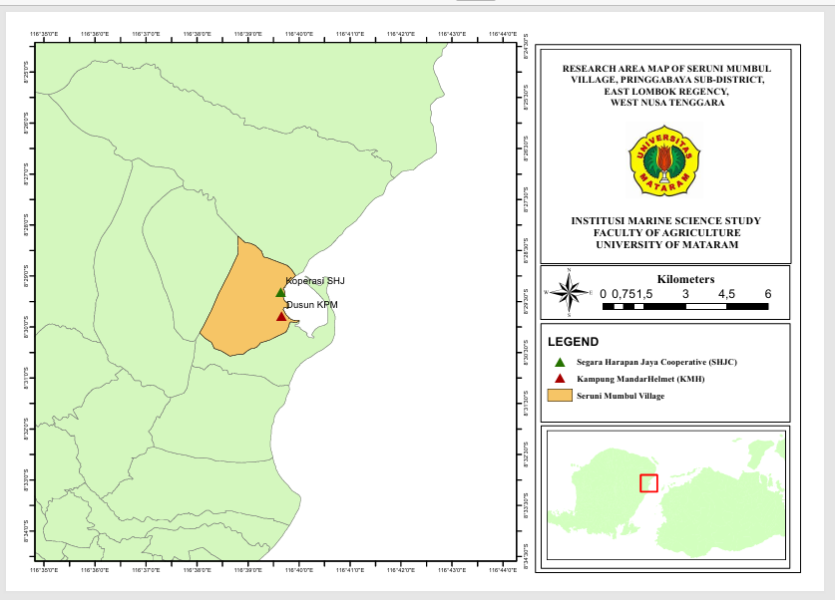
Figure 1. Study Area Map
2.2 Data Collection

The study utilized both primary and secondary data. Primary data were obtained through direct measurements of all Octopus cyanea individuals landed at the two sites, namely the Segare Harapan Jaya Cooperative and collectors in Dusun Kampung Mandar. Measured parameters included dorsal mantle length (DML), body weight, and sex, with species identification following FAO identification guides.

Dorsal mantle length (DML) was measured from the posterior end of the mantle to the center of the eye. During measurement, individuals were placed on a flat measuring board to maintain accuracy, considering the flexible body of octopuses. DML was measured using a measuring board and tape measure, while body weight was recorded using a digital scale.

Sex was determined by observing the reproductive organs, specifically by identifying the presence of a hectocotylus on the third arm, following FAO identification guidelines. Each measured individual was documented with photographs and recorded on a data collection form. Data collection was conducted daily throughout the study period from April to August 2025. Secondary data were obtained from books, scientific journals, and other supporting documents related to octopus biology.

2.3 Data Analysis

2.3.1 Dorsal Mantle Length and Body Weight Distribution

The distribution of dorsal mantle length (DML) and body weight of Octopus cyanea was analyzed using histograms. Analyses were conducted separately by sex (male and female) to identify differences in the size distribution of DML and body weight between sexes. The number of classes and class width for the histograms were determined using Sturges’ formula, allowing the size distribution to proportionally represent the population structure of Octopus cyanea at the study sites. The resulting DML and body weight distributions were then compared with gonadal maturity sizes based on sex from previous studies, in order to estimate the proportion of individuals that had reached maturity and were considered harvestable. Sturges’ formula used was as follows (Yunita et al., 2016):
$$K=1+\left(3,32×\log{(n}\right)$$
$$i=\frac{X_{\text{max}}-X_{\text{min}}}{K}$$
Where:
K | = Number of classes
n | = Sample size
i | = Class width
$$X_{\text{max}}$$ | = Maximum value
$$X_{\text{min}}$$ | = Minimum value

2.3.2 Growth Pattern Analysis

Dorsal mantle length and body weight data of Octopus cyanea were used to assess the morphometric condition of individuals (Effendie, 1997). These data were analyzed using the length–weight relationship. The following equation was applied (Le Cren, 1951 in Lempoy et al., 2020):
$$W=aL^{b}$$
Where:
W | = Total body weight (g)
L | = Dorsal mantle length (cm)
a & b | = Constants of the length–weight relationship

The exponent b was used to determine the growth pattern:
- If, b = 3, isometric growth, indicating proportional increases in length and weight.
- If b < 3 negative allometric growth, indicating that length increases more than weight
- If b > positive allometric growth, indicating that weight increases more than length

3. results and discussion

3.1 Dorsal Mantle Length Distribution of Octopus cyanea

A total of 467 Octopus cyanea individuals were measured during the study, with a sex ratio dominated by females (277 individuals, 59.3%) and males numbering 190 individuals (40.7%). morphometric analysis indicated a relatively wide size variation within the population. The minimum dorsal mantle length (DML) recorded was identical for both sexes at 6 cm; however, the maximum DML of females reached 22 cm, exceeding that of males (20 cm). The mean DML of males was 11.36 ± 2.55 cm, while females averaged slightly larger at 11.62 ± 2.45 cm. Population structure based on size classes exhibited a unimodal distribution for both sexes (Figure 2 & Figure 3), with the mode for males in the 8–10 cm class (54 individuals) and for females in the 10–12 cm class (84 individuals).

The larger maximum size of females indicates sexual dimorphism in Octopus cyanea captured in the waters surrounding Seruni Mumbul village. Biologically, this reflects energy allocation strategies, where females require greater mantle cavity space and body mass to support ovarian development and maximize fecundity (number of eggs) (Semmens et al., 2004). The shift of the modal size toward larger classes in females also suggests that somatic growth in females is relatively faster, or that they have a slightly longer lifespan than males prior to post-reproductive senescence, consistent with findings on other cephalopod species (Mangold, 1987 in Smith et al., 2005).

Based on gonadal maturity size (Lm) estimates from Omar et al. (2020), ≥12.9 cm for males and ≥15.5 cm for females, the captured population was predominantly composed of individuals that had not yet reached gonadal maturity. Only 74 individuals (15.8%) were estimated to have attained gonadal maturity, including 62 males and 12 females. This indicates that approximately 84% of the catch consisted of juveniles to sub-adults. The high proportion of individuals below Lm highlights the potential for growth overfishing, whereby most individuals are captured before reproduction, potentially compromising natural recruitment (Effendie, 1997 in Wulandari, 2022).

Data also showed that males reach maturity at smaller sizes than females. This aligns with the general life history strategy of cephalopods, in which males allocate energy to early sexual maturity to ensure reproductive success, while females delay maturity to attain optimal body size for energy reserves (yolk) and support the brooding period, during which they undergo total fasting until death (Mangold et al., 1987; Avila-Poveda et al., 2009; Smith et al., 2005).

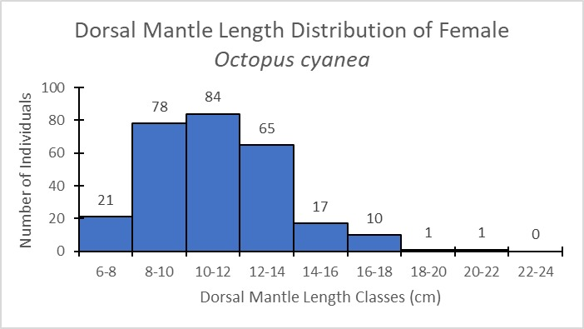 | 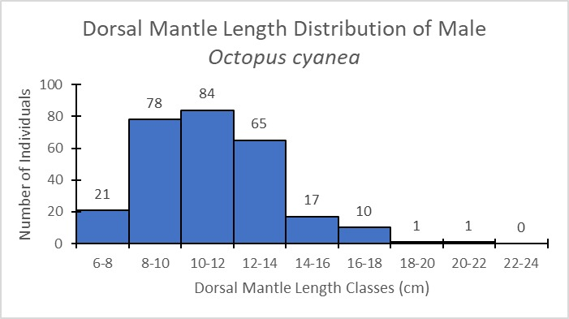
Figure 2. Dorsal Mantle Length Distribution of Female Octopus cyanea | Figure 3. Dorsal Mantle Length Distribution of Male Octopus cyanea

3.2 Body Weight Distribution of Male and Female Octopus cyanea

The body weight distribution of Octopus cyanea in the waters surrounding Seruni Mumbul exhibited relatively uniform patterns between sexes, although extreme values varied. Minimum body weight was identical for males and females at 60 g. Maximum body weight reached 3,876 g for males and 3,600 g for females. On average, males weighed 1,140.6 ± 669.9 g (Figure 4), while females averaged 1,102.38 ± 622.35 g (Figure 5). The population was dominated by medium-sized individuals, with the mode for males in the 823–1,077 g class (40 individuals) and for females in the 568–823 g class (56 individuals).

Although females exhibited larger maximum DML, the higher maximum weight in males indicates differences in condition factor between sexes. This is likely associated with energy allocation, as females invest substantial energy in egg production and brooding, often followed by a significant reduction in body mass post-reproduction (Smith et al., 2005; Semmens et al., 2004).

Using gonadal weight thresholds from Omar et al. (2020) (750 g for males and 900 g for females), 241 individuals (51.6% of the population) were estimated to have reached biological adulthood. This percentage is substantially higher than the maturity estimate based on DML (15.8%), suggesting that Octopus cyanea in this area exhibits faster body mass growth relative to length, likely supported by abundant prey availability, enabling individuals to reach critical reproductive weight more rapidly (Indrayani et al., 2023). This phenomenon is influenced by local prey abundance and oceanographic parameters, as reflected in geographic variation in gonadal maturity size of Octopus cyanea (Guard & Mgaya, 2002; Raberinary & Benbawa, 2012; Courage, 2013). For comparison, male Octopus cyanea in Tanzania mature at 320 g and females at 600 g (Guard & Mgaya, 2002), whereas in Madagascar, gonadal maturity occurs at 643 g for males and 2,246 g for females (Raberinary & Benbawa, 2012). Geographic differences are largely driven by local oceanographic conditions such as temperature and prey availability (Courage, 2013; Semmens et al., 2004). Optimal water temperatures in the coral reef ecosystem of Seruni Mumbul likely enhance metabolism, influencing energy allocation for somatic growth and reproductive organ development.

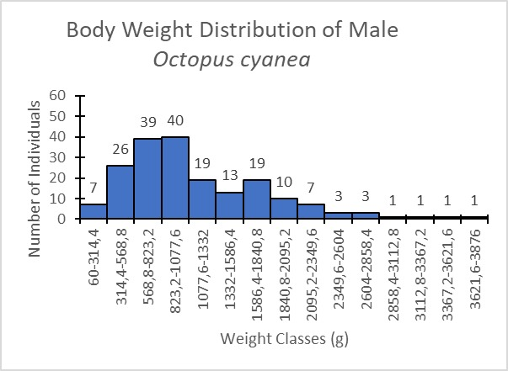 | 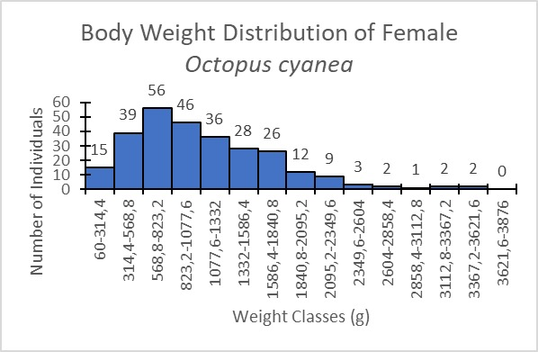
Figure 4. Body Weight Distribution of Male Octopus cyanea | Figure 5. Body Weight Distribution of Female Octopus cyanea

3.3 Growth Patterns of Male and Female Octopus cyanea

Regression analysis indicated similar growth patterns between sexes (Figure 4). For males, the DML–body weight relationship was expressed as W = 6,6401 L²·⁰⁶⁷⁶ with R² = 0,6177 (Figure 6), while females followed W = 2,8043 L²·³⁸⁷⁵ with R² = 0,6742 (Figure 7). The coefficients of determination (R²) of 0.6177 for males and 0.6742 for females indicate that approximately 61–67% of the variation in body weight can be explained by increases in mantle length. The remaining variation is likely influenced by other biological factors, such as gut fullness and arm condition. The correlation coefficients (r), calculated as the square root of (R²), demonstrate a moderately strong positive relationship between dorsal mantle length and total body weight in both sexes.

Allometric coefficients (b) were 2,06 for males and 2,38 for females, both significantly below 3 (b < 3), indicating negative allometric growth. This pattern suggests that the population is dominated by individuals in the active somatic growth phase, allocating more energy to mantle elongation than muscle mass accumulation. These findings are consistent with Marzuki et al. (2023) and Diniariwisan et al. (2023), who also reported negative allometric growth in octopuses from Ketapang Beach, East Lombok. The consistency across nearby waters indicates similar habitat characteristics in coastal East Lombok.

Low values of the allometric coefficient b may be influenced by both environmental (external) and biological (internal) factors. According to Amir et al. (2021), variations in b are largely determined by prey availability and water conditions. From an ecophysiological perspective, Semmens et al. (2004) explained that warm water temperatures, such as those characteristic of tropical waters in WNT, can stimulate octopus metabolism, causing energy obtained from food to be rapidly allocated to activity and mantle elongation, leaving limited energy for body mass deposition. Additionally, intensive fishing pressure in the study area (Omar et al., 2020) may result in growth overfishing, whereby octopuses are captured during their rapid growth phase before achieving optimal (isometric) body proportions.

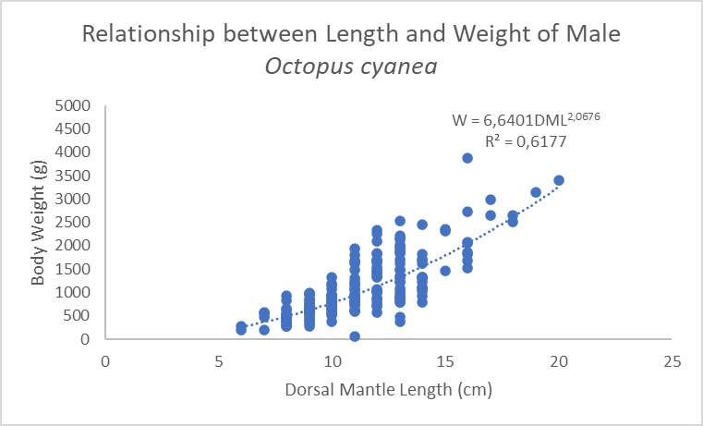 | 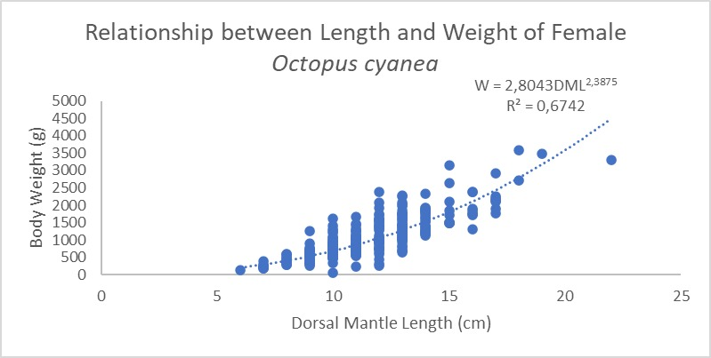
Figure 6. Relationship between Length and Weight of Male Octopus cyanea | Figure 7. Relationship between Length and Weight of Male Octopus cyanea

4. Conclusion

The biological characteristics of the Octopus cyanea population in the waters surrounding Seruni Mumbul Village are dominated by medium-sized individuals with a unimodal size distribution and exhibit sexual dimorphism. Females tend to reach larger maximum dorsal mantle lengths as an adaptation to enhance fecundity, whereas males achieve higher maximum body weights. The analysis of the length–weight relationship for both sexes confirmed a negative allometric growth pattern (b<3), indicating that the population is dominated by individuals in the active somatic growth phase, with mantle elongation prevailing over body mass accumulation. Furthermore, the disparity between the low proportion of gonadally mature individuals based on mantle length (15.8%) and the higher proportion estimated from body weight (51.6%) not only reflects the phenotypic plasticity of octopuses in response to local environmental conditions but also indicates intense exploitation pressure on juvenile individuals. These findings highlight the population’s vulnerability to growth overfishing, which could disrupt natural stock recruitment if appropriate size-based catch regulations are not implemented.

References

Ahmed, A. S., El-Ganainy, A. A., Osman, M. F., & Khalil, M. T. (2021). Observations on some morphometric characters of the webfoot octopus, Amphioctopus membranaceus (Quoy and Gaimard, 1832) from the Gulf of Suez, Red Sea, Egypt. Egyptian Journal of Aquatic Biology and Fisheries, 25(2), 103 - 115. https://doi.org/10.21608/Ejabf.2021.158705.
Amir, F., Mallawa, A., & Umar, M. T. (2021). Growth pattern and sex ratio of octopus (Octopus vulgaris) in Bone Bay. Jurnal Ilmiah Agribisnis dan Perikanan, 14(2), 527-532. [In Bahasa Indonesia]. https://doi.org/10.52046/agrikan.v14i2.873.
Omar, S. B. A., Safitri, A. R. D., Rahmadhani, A., Tresnati, J., Suwarni, S., Umar, M. T., & Kaseng, E. S. (2020). Relative growth of octopus, Octopus cyanea Gray, 1849, in the Makassar Strait and Bone Bay waters. Proceedings of the National Symposium on Marine and Fisheries, 7. [In Bahasa Indonesia].
Avila-Poveda, O. H., Colin-Flores, R. F., & Rosas, C. (2009). Gonad development during the early life of Octopus maya (Mollusca: Cephalopoda). The Biological Bulletin, 216(1), 94-102. https://doi.org/10.1086/BBLv216n1p94.
Balansada, A. R., Ompi, M., & Lumoindong, F. (2019). Identification and habitat of octopus (Cephalopoda) from Salibabu waters, Talaud Islands Regency. Jurnal Pesisir dan Laut Tropis, 7(3), 247–255. [In Bahasa Indonesia]. https://doi.org/10.35800/Jplt.7.3.2019.24742.
Diniariwisan, D., Marzuki, M., & Lestariningsih, W. A. (2023). Identification of biological dimensions of octopus in Ketapang Beach, East Lombok, for sustainable fisheries management. Jurnal Ganec Swara, 17(4), 1308-1312. [In Bahasa Indonesia]. https://pdfs.semanticscholar.org/03af/93821928d801023a794c1fb224ac44a4c142.pdf.
Effendie, M. I. (1997). Fisheries biology. Yogyakarta: Yayasan Pustaka Nusantara.
Forum Ilmiah Pengelolaan Perikanan Berkelanjutan Provinsi Nusa Tenggara Barat (FIP2B-NTB). (2022). Ecological database of West Nusa Tenggara Province. FIP2B-NTB.
Guard, M., & Mgaya, Y. D. (2002). The artisanal fishery for Octopus cyanea Gray in Tanzania. AMBIO: Journal of the Human Environment, 31(7), 528-536. https://doi.org/10.1579/0044-7447-31.7.528.
Indrayani, E., Hamuna, B., & Agamawan, L. P. I. (2023). Length-weight relationship and condition factors of some commercial fish from Youtefa Bay, Jayapura City, Indonesia. Journal of Fisheries, 67(1), 30-35. Https://Doi.Org/10.22146/Jfs.79653
Kalih, L. A. T. T. W. S. (2024). Population condition analysis and sustainability of lemuru (Sardinella lemuru) fishery in Awang Bay, Central Lombok Regency. Jurnal Teknologi Perikanan dan Kelautan, 15(1), 1-10. [In Bahasa Indonesia]. https://doi.org/10.24319/jtpk.15.1-10.
Kartini, S. (2023). Population dynamics of octopus (Octopus cyanea) on Darawa Island, Wakatobi Regency, Southeast Sulawesi (Doctoral dissertation, Universitas Hasanuddin).
Lamalelang, M. S., Soewarlan, L. C., & Toruan, L. N. L. (2024). Morphometric characteristics of reef octopus (Octopus cyanea) from northern and southern waters of Sikka Regency, East Nusa Tenggara. Techno-Fish, 8(1), 53-69. [In Bahasa Indonesia]. https://doi.org/10.25139/tf.vi.7781.
Le Cren, E. D. (1951). The length–weight relationship and seasonal cycle in gonad weight and condition in the perch (Perca fluviatilis). Journal of Animal Ecology, 20(2), 201–219. Https://doi.org/10.2307/1540.
Lempoy, R., Rondonuwu, A. B., & Bataragoa, N. E. (2020). Size, length–weight relationship, and condition factor of Banggai cardinalfish (Pterapogon kauderni Koumans, 1933) in Lembeh Strait, North Sulawesi. Jurnal Ilmiah Platax, 8(1), 30–36. [In Bahasa Indonesia]. https://doi.org/10.35800/jip.8.1.2020.27599.
Linung, M. K., Soewarlan, L. C., & Boikh, L. I. (2024). Size, length–weight relationship, and condition factor of Banggai cardinalfish (Pterapogon kauderni Koumans, 1933) in Lembeh Strait, North Sulawesi. Jurnal Bahari Papadak, 5(1), 122-131. [In Bahasa Indonesia]. https://ejurnal.undana.ac.id/index.php/JBP/article/view/16059.
Marzuki, M., Diniariwisan, D., & Lestariningsih, W. A. (2023). Identification of octopus biology and index values for fisheries management in the Alas Strait, West Nusa Tenggara. Jurnal Penelitian Pendidikan IPA, 9(12), 12149-12154. https://doi.org/10.29303/jppipa.v9i12.5956.
Mulyani, L. F., Arfiati, D., Widodo, M. S., & Yamindago, A. (2024). Molecular identification of the octopus (Octopus cyanea, Gray 1849) using Mt-DNA COI from Alas Strait Waters, Indonesia. Egyptian Journal of Aquatic Biology & Fisheries, 28(6), 603–615. https://doi.org/10.21608/ejabf.2024.392406.
Mangold K., 1987, eproduction. In P. R. Boyle (Ed.), Cephalopod life cycles: Comparative reviews (Vol. II, pp. 157–200). London: Academic Press.
Raberinary, D., & Benbow, S. (2012). The reproductive cycle of Octopus cyanea in southwest Madagascar and implications for fisheries management. Fisheries Research, 125, 190-197. https://doi.org/10.1016/j.fishres.2012.02.025.
Rufiati, I., Mahardika, I., & Wijana, M. (2024). Age estimation of octopus (Octopus cyanea) in Pringgabaya and Poto Tano districts using the stylet increment analysis (SIA) method. Ecotrophic 18(2), 144-160. [In Bahasa Indonesia]. https://doi.org/10.24843/EJES.2024.v18.i02.p01.
Semmens, J. M., Pecl, G. T., Villanueva, R., Jouffre, D., Sobrino, I., Wood, J. B., & Rigby, P. R. (2004). Understanding octopus growth: patterns, variability and physiology. Marine and Freshwater Research, 55(4), 367-377. https://doi.org/10.1071/MF03155.
Smith, J. M., Pierce, G. J., Zuur, A. F., & Boyle, P. R. (2005). Seasonal patterns of investment in reproductive and somatic tissues in the squid Loligo forbesi. Aquatic Living Resources, 18(4), 341-351. https://doi.org/10.1051/alr:2005038.
Sugiyono. (2017). Quantitative, qualitative, and R&D research methods. Bandung: Alfabeta, CV.
Sugiyono. (2022). Statistics for research. Bandung: Alfabeta.
Tahir, S., Utina, R., Baderan, D. W. K., & Zakaria, Z. (2024). Spatial distribution patterns of octopus (Octopus sp.) in fishing grounds of Torosiaje waters. J-CEKI: Jurnal Cendekia Ilmiah, 3(6), 6521-6540. [In Bahasa Indonesia]. https://doi.org/10.56799/jceki.v3i6.5257.
Tarigan, D.J, & Simbolon D. (2020). Social and economic characteristics of octopus fishers based on EAFM indicators in Banggai Laut Regency. Indonesian Journal of Maritime, 1(1), 1–10. [In Bahasa Indonesia]. https://doi.org/10.17509/ijom.v1i1.24620
Taqwa, M. (2024). Mapping of octopus (Octopus cyanea) fishing grounds in the Maros–Pangkep Geopark area, South Sulawesi (Doctoral dissertation, Universitas Hasanuddin).
Toha, A. H. A., Widodo, N., Hakim, L., & Sumirto, S. B. (2015). Octopus (Octopus cyanea) of Raja Ampat. Raja Ampat Biodiversity Conservation, 4(8), 4–8. [In Bahasa Indonesia]. https://ibcraja4.org/assets/file/2015/Bulletin8August2015.pdf.
Walpole, R. E. (1992). Introduction to statistics (3rd ed.). Jakarta: PT Gramedia Pustaka Utama.
Yunita, L. H., Ramdhani, F., Wulanda, Y., Magwa, R. J., Gelis, E. R. E., & Heltria, S. (2023). Gonad maturity stages of snappers (Lutjanus vitta) landed at TPI Tanjung Pasir, Tangerang Regency. Jurnal Teknologi Perikanan Dan Kelautan, 14(2), 213–219. [In Bahasa Indonesia]. https://doi.org/10.24319/jtpk.14.213-219.

