Original Research Article

A Path Model on Conflict Management Skills Beliefs among Public School Teachers as Influence by Organizational Politics, Transformational Leadership of School Heads, and Emotional Intelligence

ABSTRACT
This study sought to determine the best-fit path model on conflict management skills beliefs among public school teachers as influenced by organizational politics, transformational leadership, and emotional intelligence, utilizing a descriptive-correlational approach through Path Model Analysis among 400 public school teachers who were selected using a proportionate stratified random sampling technique in Region XI, Philippines. Findings showed very high levels of all exogenous variables: organizational politics, transformational leadership, and emotional intelligence, with likewise high levels of endogenous variable conflict management skills beliefs. Significant relationships were found between organizational politics and conflict management skills beliefs, transformational leadership and conflict management skills beliefs, and emotional intelligence and conflict management skills beliefs. Among the models tested, Model 3 emerged as the best-fit path model, demonstrating that organizational politics and emotional intelligence significantly influenced conflict management skills beliefs, except for transformational leadership. However, transformational leadership was being influenced significantly by organizational politics and emotional intelligence. This study provided a clearer understanding of how public school teachers developed confidence in managing conflict within their schools. The combined roles of organizational politics, transformational leadership, and emotional intelligence shed light on the real-world conditions that shaped teachers’ beliefs about how to handle conflicts effectively. The findings offered a grounded perspective that connected leadership practices, workplace dynamics, and personal emotional capacities, thereby helping bridge theory and practice in educational management research.
Keywords: organizational politics, transformational leadership, emotional intelligence,
conflict management skills beliefs, path model, Region XI, Philippines.

INTRODUCTION

Given that conflicts may arise among students, teachers, parents, and administrators, effective conflict management skills beliefs are vital in public schools. However, there are still gaps in our understanding of how to manage conflicts in this context efficiently. Unresolved conflicts diminished productivity and undermined organizational coherence, as established by Dewi and Susanti (2021). Further, Poynton, Poynton, & Bonneau (2016) found that public school educators and administrators were inadequately trained in conflict management. Employees sometimes avoid direct confrontations, leading to unsolved issues and hindered effective management (Maryani & Gazali, 2024).
To make schools more supportive and help students do better in school, it is important to have good conflict management skills beliefs. The objective of conflict management is to optimize beneficial results and mitigate adverse consequences (Emynorane, Ratna, Citriadin & Larissa, 2024). Task-related conflicts can foster alternative thinking; however, relationship conflicts frequently impede team performance, necessitating robust conflict management skills (Winardi, Prentice, & Weaven, 2022). These talents can lead to new ideas, stronger relationships, and higher levels of dedication, morale, and overall performance (McKibben, 2017; Rahim, 2023). They also require cultural awareness, active listening, and the ability to respond constructively to changing situations (Liu, Cui, Feng, Perera, & Han, 2020). Thus, cultivating conflict management skill beliefs in public secondary schools is crucial for building supportive learning environments and improving student outcomes.
Studies have examined the relationship between conflict management and various factors. In the study by Adu, Muah, Sanda, and Sarfo (2015), a significant positive relationship was found between conflict management, communication, and relationships at the workplace as indicators of organizational politics. This supported the idea that relationships at work and conflict management were influenced by communication. The results demonstrated that there were positive, significant relationships between two conflict management skills and all interpersonal communication skills as indicators of organizational politics (Sabanci, Sahin, and Özdemir, 2018). Snipes, Pitts, Bryant, Huning, and Snipes (2024) noted that employees' perceptions of organizational politics varied in their impact on job satisfaction across gender and age groups. Rasyid & Marta (2020) found that organizational politics negatively affected the proactive behavior of government employees.
2
A strong positive correlation between conflict management and transformational leadership was identified, as leaders who employed transformational leadership were associated with better leadership outcomes, as stated by Garcia (2004). An integrated style of conflict management skills was identified to have a positive correlation with individualized consideration and intellectual stimulation, which were indicators of transformational leadership according to Hunitie (2016). To improve the handling of organizational conflicts, frontline managers were educated about, trained in, and motivated to embrace transformational leadership methods. Studies demonstrated that transformational leadership was positively associated with employees' readiness to change (Adiwijaya, Ribhan, & Hayati , 2023). In fact, Millado, Guhao, & Rodriguez (2021) found that transformational leadership had a significant impact on organizational effectiveness.
3
Studies showed a positive and significant correlation between emotional intelligence and conflict management among physical education experts of Tehran University, as stressed by Heris and Heris (2011). Also, Valente and Lourenço (2020) distinct studies a positive relationship between emotional intelligence and conflict management. Łowicki and Zajenkowski (2017) found that emotional intelligence was positively associated with the general level of religious belief as part of normative beliefs, as one of the indicators of conflict management skills beliefs. Alutaya and Guhao (2023) stressed the role of emotional intelligence in increasing teachers' work engagement. Fteiha and Awwad (2020) demonstrated that students were effective in using stress-coping strategies, and that teachers should provide guidance on emotional intelligence and stress-coping styles. Cejas and Guhao (2023) demonstrated that emotional intelligence partially mediated the relationship between technology leadership and teaching effectiveness, enhancing the favorable influence of technological leadership on teacher performance.
This research was grounded in the Theory of Planned Behavior (TPB), which provided the basis for the current test development initiative. Social psychologists and other social scientists contended that the Theory of Planned Behavior (TPB) effectively encapsulated behavior across diverse contexts, rendering it one of the most esteemed frameworks for comprehending and predicting behavior (Murphy, Askew, and Sumner, 2017). The Theory of Planned Behavior (TPB), an extension of the Theories of Reasoned Action (TRA; Fishbein and Ajzen, 1980), integrates evaluations of attitudinal beliefs, normative beliefs, and control beliefs (Armitage & Conner, 2001; Ajzen, 2002).
4
This research was backed by Goleman’s (1995) Psychological Theory of Emotional Intelligence. The idea is that someone with emotional intelligence (EQ) can achieve objectivity through self-awareness, which in turn encourages productivity, motivation, and engagement at work and even changes the institution to fit the needs of the current situation. It claims that understanding the institution’s personnel will help foresee any potential changes. It could be in their ability to change management or in themselves.
In this study, the conceptual framework or hypothesized models, as shown in Figure 1, were evaluated for optimal fit to assist public school teachers in the Davao Region in becoming more adept at conflict management skills beliefs. As supported by theories and studies, the first conceptual paradigm demonstrated the direct influence of exogenous variables, such as organizational politics, transformational leadership, and emotional intelligence, on the endogenous variable, conflict management skills beliefs.
Latent variables cannot be measured easily because they are not immediately apparent. This connects numerous measurements or observable variables to each latent construct. Consequently, the amplitude of the regression routes between the unobserved and observed variables is one of the most important aspects of this study. In addition, Path Analysis is crucial for determining the best-fit model. The following is illustrated by the proposed model: The rectangular figures connected from the oval shapes are the measured variables of a latent construct. The single-headed arrow depicts the direct relationship between two variables, whereas the double-headed arrow denotes correlation.
5
EXOGENOUS ENDOGENOUS

Organizational Politics
Transformational Leadership
Conflict Management Skills Beliefs
Emotional Intelligence

Figure 1. The study’s conceptual framework shows the direct relationship of Organizational Politics, Transformational Leadership, Emotional Intelligence towards conflict management skills beliefs.

The association between the three exogenous variables and their direct causal relationship to the endogenous variable is depicted. This is demonstrated by the double-headed arrow connecting three exogenous variables: organizational politics and transformational leadership, transformational leadership and emotional intelligence, and organizational politics and emotional intelligence. The single-headed arrow emanating from the three exogenous factors is directly related to proficiency in conflict management skills beliefs. A single-headed indicator linked from the exogenous variables to the endogenous variable serves as an example of this. Additionally, the rectangular forms correspond to the measured variables for the respective exogenous and endogenous variables.
6
The first exogenous variable is organizational politics, measured by relationships, reputation, decisions, resources, and communication (Kacmar & Ferris, 1991; Drory, 1993; Kacmar & Carlson, 1997; Fedor & Maslyn, 2002; Hochwarter, 2003; Vigoda-Gadot, 2003).
The second exogenous variable, transformational leadership, has four observed indicators: vision building, innovative climate, intellectual stimulation, and individualized consideration (Moolenaar, Daly, & Sleegers, 2010). According to the study, transformational leadership encourages staff members to overcome their own obstacles and work toward achieving company goals, resulting in organizational change and innovation (Espita & Guhao, 2022).
The third exogenous variable, emotional intelligence, has five observed indicators: recognizing your own emotions, managing emotions, motivating yourself, recognizing other people's emotions, and building relationships (Fenanlampir & Mutohir, 2021). Research has shown that emotional intelligence increases job satisfaction and reduces burnout while improving employee engagement and performance (D’Amico, Geraci and Tarantino,2020; Alutaya and Guhao, 2024).
The endogenous variable conflict management skills beliefs had three observed indicators: attitudinal beliefs, control beliefs, and normative beliefs (Bancroft, 2020). Lundula (2024) stressed the importance of managers being able to adapt their conflict management approaches, demonstrating cultural intelligence, communicating effectively, and being open to adaptive leadership. Poor conflict management skills in the school community made even small arguments have bigger effects (Dawo, & Wagah, 2011).
7
This study was prompted by the rising prevalence of unresolved conflicts in public schools, which have been demonstrated to diminish productivity, undermine organizational cohesion, and negatively impact teachers' well-being and professional effectiveness (Dewi & Susanti, 2021). Poor conflict management negatively affected morale, strained relationships, and reduced the organization's overall effectiveness, making it a recurring problem in schools (Rahim, 2023). Given these circumstances, it was essential to investigate the factors influencing teachers' beliefs about conflict management, specifically organizational politics, transformational leadership, and emotional intelligence, to produce evidence-based insights that could enhance school environments and elevate educational outcomes.
A study using path analysis to look at the connections between organizational politics, transformational leadership, emotional intelligence, and conflict management skills beliefs in public secondary schools has not been conducted in the local area. Most research on conflict management skills beliefs examines only two to three variables. The researcher chose to carry out this multivariate study using the three variables as a construct of work involvement in this situation. The results of this study will provide new ideas for education and may be applied to the creation of a plan for raising conflict management skills beliefs awareness in public schools, which may improve the effectiveness of the educational system as a whole as well as student outcomes.
8
The purpose of this study was to identify the path model that best fits public schools' beliefs about conflict management skills. This study's specific goal was to quantify the extent of organizational politics across relationships, reputation, decisions, resources, and communication. To evaluate the amount of transformational leadership in terms of vision building, innovative climate, intellectual stimulation, and individualized consideration. To assess the emotional intelligence of public school teachers in terms of recognizing their own emotions, managing emotions, motivating themselves, recognizing other people's emotions, and building relationships. Additionally, to gauge the degree of conflict management skills beliefs in terms of attitudinal beliefs, control beliefs, and normative beliefs.
Furthermore, this study intended to determine the significant relationship between organizational politics and conflict management skills beliefs among public schools, transformational leadership and conflict management skills beliefs among public schools, and emotional intelligence and conflict management skills beliefs among public schools. Finally, to determine the best-fit path model that predicts conflict management skills beliefs among public schools. At the same time, the following null hypotheses were tested at a 0.05 level of significance. First, there is no significant relationship between organizational politics and conflict management skills beliefs. Second, transformational leadership and conflict management skills beliefs. Third, emotional intelligence and conflict management skills beliefs. Lastly, no path model best fits conflict management skills beliefs among public schools.
9
This also supports the Sustainable Development Goal 2015 Agenda 4 quality education that ensures that every student gains the information and abilities necessary to advance sustainable development, such as those related to conflict resolution and cultivating global citizenship, and No. 8 through fostering productive employment and sustainable, inclusive economic growth via enhanced working conditions and teacher engagement.
Additionally, this study sought to ascertain the significance of the relationships between organizational politics, transformational leadership, emotional intelligence, and conflict management skills beliefs in public secondary schools, as well as the connections between teacher stress and these beliefs. Lastly, to identify the model that best predicts conflict management skills beliefs in public secondary schools. The following null hypotheses were also evaluated concurrently at a 0.05 level of significance. First, there is no significant relationship between organizational politics and conflict management skills beliefs. Second, transformational leadership and conflict management skills beliefs. Third, emotional intelligence and conflict management skills beliefs. Lastly, no model best fits conflict management skills beliefs in public secondary schools.
This research is essential for global education as it will establish the groundwork for system implementation and advancement. By promoting a greater understanding of how conflict management skills beliefs are influenced by their surroundings and by external and personal qualities, this will aid in the development of stronger concepts in this area. As a result, it could clarify or possibly address the widespread issue of poor conflict management skills beliefs, which has negatively impacted student performance outcomes in schools, and is crucial to understanding the basic dynamics of education management.
10
The study's conclusions could serve as a useful foundation for management and system-improvement programs in schools and other educational establishments. Additionally, this may offer pertinent information to Department of Education officials planning programs and activities to enhance recognized domains in organizational politics, transformational leadership, and emotional intelligence that may affect the ability to manage conflict in public schools. This study might also serve as a useful starting point for formulating policy. This would also help the school administrator direct, manage, and promote conflict management skills beliefs.
The findings of this study can be applied to other research or to assess the efficacy of organizational politics, transformational leadership, and emotional intelligence in predicting conflict management skills beliefs. This analysis may provide them with a basis, a synopsis, or a cross-reference.
METHODOLOGY
This section offered a thorough explanation of the study's methodology, encompassing details on its implementation, participant demographics, the materials and instruments used, and, if relevant, the design and procedures employed.
Respondent
The research was conducted in public secondary schools located in Region XI. The chosen setting for this study was public secondary schools, where the researcher aimed to investigate the impact of organizational politics, transformational leadership, and emotional intelligence on conflict management skills beliefs. The study included 400 educators selected from a range of publicly funded secondary schools in the Davao Region. It used a heuristic to select 400 participants as an appropriate sample size for conducting path analysis.
11
The quantity of study participants was selected and established using Raosoft software. To reflect the 18,432 active teachers currently employed in the region, about 400 public secondary school teachers from different DepEd Region XI schools were surveyed for this study. A stratified random sampling technique was used to determine the number of respondents per division. In accordance with the essential criterion for establishing an adequate sample size for path analysis as delineated by Savalei (2021), the researcher complied with the foundational recommendations for ascertaining the optimal number of participants, which spanned from 200 to 400, as indicated by Smith and Dawber (2019).
This study offered all educators in the public schools of Region XI the opportunity to participate. Educators not employed in public secondary schools were excluded from the study group. As a result, educators working in private secondary institutions were deemed ineligible to participate. Participation in the study was entirely voluntary, and none of the subjects were coerced into taking part. Participants were notified of their right to withdraw from the research at any time if they felt discomfort.
Region XI has five provinces: Davao de Oro, Davao del Norte, Davao del Sur, Davao Oriental, and Davao Occidental. In these provinces, eleven divisions were established: the Davao de Oro Division, the Davao del Norte Division, the Davao del Sur Division, the Davao Oriental Division, the Davao Occidental Division, the Mati City Division, the Davao City Division, the Panabo City Division, the Tagum City Division, and the Island Garden City of Samal Division. The inquiry was conducted in public secondary schools situated in Region XI. Specifically, the distribution was as follows: Davao City (111 teachers, 28%), Tagum City (18 teachers, 5%), Davao del Norte (41 teachers, 10%), Davao Oriental (44 teachers, 11%), Island Garden City of Samal (9 teachers, 2%), Davao Occidental (33 teachers, 8%), Panabo City (14 teachers, 4%), Davao de Oro (63 teachers, 16%), Davao del Sur (41 teachers, 10%), Digos City (13 teachers, 3%), and Mati City (13 teachers, 3%).
12
In terms of professional rank, the largest group of respondents consists of Teacher II, with 152 participants (38.00%). This is followed by Teacher I, with 140 respondents (35.00%), and Teacher III, with 98 respondents (24.50%). A small portion belongs to the Master Teacher group, which includes 8 Master Teacher I respondents (2.00%) and 2 Master Teacher II respondents (0.50%).
In terms of years in service, the highest frequency falls within the 4–6 years bracket, with 99 respondents (24.75%). This is followed by 94 respondents with 7–10 years of service (23.50%), 70 respondents with 1–3 years (17.50%), 48 respondents with 11–15 years (12.00%), and 26 respondents with 16–20 years (6.50%). Those with longer service durations include 16 respondents with 21–25 years (4.00%), 24 respondents with 26–29 years (6.00%), and 23 respondents with 30 years and above (5.75%).
13
Materials and Instruments
The research utilized a questionnaire derived from online sources. The questionnaire included relevant items related to the study. The preliminary draft was initially presented to the researcher's advisor for feedback, after which specialists were solicited to evaluate the questionnaire. Following expert validation, the questionnaire's reliability was assessed by pilot testing.
Gliem and Gliem (2003) stated that Cronbach’s alpha reliability coefficient typically ranges from 0 to 1. However, there is actually no lower limit to the coefficient. The closer Cronbach’s alpha coefficient is to 1.0, the greater the internal consistency of the items in the scale. On the other hand, George and Mallery (2003) provided the following rules of thumb: Cronbach’s Alpha > .9 – Excellent; Cronbach’s Alpha > .8 – Good; Cronbach’s Alpha > .7 – Acceptable; Cronbach’s Alpha > .6 – Questionable; Cronbach’s Alpha > .5 – Poor; and Cronbach’s Alpha < .5 – Unacceptable. Although augmenting the value of alpha is somewhat contingent upon the quantity of items in the scale, it is important to recognize that this yields decreasing results. An alpha of .8 is likely a feasible objective. It is essential to compute and report Cronbach’s alpha coefficient to assess internal consistency reliability for any Likert-type scales or subscales utilized. The data analysis must utilize these aggregated scales or subscales rather than individual items. Cronbach's alpha does not yield reliability assessments for individual items.
In the study, five sets of questionnaires, modified from various authors and approved by experts, were employed. After careful evaluation, the experts' comments and recommendations were integrated into the final research instruments. The first part of the questionnaire addresses organizational politics, including indicators such as relationships, communication, reputation, decision-making, and resources, as outlined by Landells and Albrecht (2019). The second part deals with transformational leadership with indicators such as vision building, innovative climate, intellectual stimulation, and individual consideration, as mentioned by Garcia (2004). On the other hand, emotional Intelligence has five indicators, namely: recognizing your own emotions, managing yourself, recognizing other people’s emotions, and building relationships as stated by Fenanlampir and Mutohir. (2021). Lastly, attitudinal beliefs, control beliefs, and normative beliefs are indicators of conflict management skills beliefs according to Bancroft (2020).
14
The scale employed for interpreting the means of conflict management skills beliefs in public schools, organizational politics, transformational leadership, emotional intelligence, and teacher stress are the following ranges: 4.20 - 5.00 described as very high and interpreted as always evident; 3.40 - 4.19 labelled as high and interpreted as oftentimes evident; 2.60 - 3.39 defined as moderate and taken as occasionally evident; 1.80 - 2.59 labeled as low and interpreted rarely; and lastly, 1.00 - 1.79 described as very low and defined as never evident in public secondary schools.
According to George and Mallery (2003), a score of 0.9 or above is deemed extraordinary, 0.8 or higher is classified as good, 0.7 or higher is considered acceptable, 0.6 or higher is viewed as doubtful, 0.5 or higher is labeled poor, and any score below 0.5 is regarded as unacceptable. The Cronbach's alpha values for the survey instrument were 0.926 for the endogenous variable and 0.947 for the three exogenous variables, demonstrating that the research tools were both valid and reliable. The panel of examiners authenticated the four sets of questionnaires for endorsement. The instruments' construct validity received an aggregate rating of 0.942, signifying an excellent assessment of the tools. The final version was revised to incorporate the experts' modifications, remarks, and recommendations before execution.
15
Research Design and Procedure
The study utilized the path modeling technique. Bhandari (2021) stated that quantitative research emphasizes the collection, analysis, and interpretation of data through numerical measurements. A descriptive-correlational design was used to determine the levels of the variables and their inherent correlations, as indicated by Stangor and Walinga (2014).
Furthermore, it provided a multivariate statistical framework employed for modeling intricate interactions among variables observed both directly and indirectly across time. A multitude of concerns in causal analysis were evaluated using path analysis, a form of multiple regression. Path analysis is a method for investigating causal relationships among a set of variables, originally established in the 1920s. Path analysis is predominantly employed by scholars to assess evidence in accordance with a predetermined causal hypothesis. In route analysis, researchers investigated the impacts on dependent variables by performing a sequence of regressions within the designated model.
16
The study illustrated a graphical path diagram depicting the interrelations of organizational politics and conflict management skills beliefs, transformational leadership and conflict management skills beliefs, and emotional intelligence and conflict management skills beliefs in public secondary schools in Region XI. The path diagram was constructed using software that defined a model through matrices generated from the outcomes of survey questions, which served as the principal data collection instrument. The primary objective of the study was to identify the model that most effectively aligns with conflict management skills beliefs in public secondary schools within Region XI.
The subsequent indices and their associated criteria were employed to ascertain the best-fit model (Hair, Black, Babin & Anderson, 2020): all indices must remain within their allowable ranges when identifying the best-fit model.
CHART 1. Indices and their associated criteria
INDEX | CRITERION
Chi-Square / Degrees of Freedom  P-value | 0 < value < 2  > .05
Normed Fit Index (NFI) | > .95
Tucker-Lewis Index (TLI) | > .95
Comparative Fit Index (CFI) | > .95
Goodness of Fit Index (GFI) | > .95
Root Mean Square of Error Approximation (RMSEA)  P of Close Fit (Pclose) | < .05  > .05

The related p-value should be greater than 0.05 (Joreskog & Surbom, 1996), and the Chi-Square Value divided by the Degrees of Freedom should be between 0 and 2 (Kline, 1998; Marsh & Hocevar, 1985). According to MacCallum, Browne, & Sugawara (1996), the Root Mean Square Error Approximation value should be less than 0.05, and the corresponding P-close value should be more than 0.05. The Normed Fit Index, Tucker-Lewis Index, Goodness of Fit Index (Tabachnick & Fidell, 2007), Comparative Fit Index (West, Taylor, & Wu, 2012; Fan, Thompson, & Wang, 1999), and all other indices must be greater than 0.95.
17
The necessary data were gathered through a systematic face-to-face procedure. Initially, the researcher dispatched a formal letter requesting authorization to conduct the study to the Regional Director of the Department of Education in Region XI. Furthermore, the researcher composed an additional letter addressed to the eleven division superintendents of the various divisions included in the study. This was done to secure authorization from the superintendents for the researcher to conduct the study with teachers in their respective divisions. Following permission, survey questionnaires were distributed to public secondary school teachers in Region XI from February 2025 to April 2025. The researcher personally administered the questionnaires through direct interactions with teachers in the participating public secondary schools in Region XI.
The significance of the relationships between exogenous and endogenous variables was evaluated using the Pearson correlation coefficient. Additionally, linear regression was employed to ascertain the factors affecting the dependent variable in relation to the specified independent variables. The mean was employed to evaluate levels of organizational politics, transformational leadership, emotional intelligence, and conflict management skills beliefs. The research identified which exogenous variables best fit conflict management skills beliefs.
18
In addition, the researcher maintained adherence to ethical standards during the study by following procedural evaluations and established criteria provided by the University of Mindanao Ethics and Review Committee (UMERC). Participants in the study were granted the autonomy to engage voluntarily without any financial commitment. Additionally, in accordance with the Data Privacy Act of 2012, the researcher implemented measures to safeguard respondents' private information. All information sources utilized in the study were properly acknowledged. Overall, the researcher adhered to all UMERC ethical guidelines throughout the investigation. The emphasis on ethical conduct had grown as a result of society’s call for greater accountability. The ethical issues surrounding the research process, as stated in UMERC Form 2.2, were considered equally important as the critical task of selecting appropriate research techniques and procedures. Therefore, prior to its implementation, the study was approved by the University of Mindanao Ethics Review Committee (UMERC) under Protocol No. UMERC-2025-040. The panel of experts was determined in order to comply with the basic requirements of research ethics stipulated by the university.
RESULTS AND DISCUSSION
The statistics and results are presented here based on respondents' responses regarding organizational politics, transformational leadership, emotional intelligence, and beliefs about conflict management skills. The discussions are organized based on the subsequent subheadings: level of organizational politics, level of transformational leadership, level of emotional intelligence, and level of conflict management skills beliefs in public schools; the relationship between organizational politics and conflict management skills beliefs, transformational leadership and conflict management skills beliefs, emotional intelligence and conflict management skills beliefs, together with the best-fit model.
19
Level of Organizational Politics
Table 1 illustrates the level of organizational politics exhibited by teachers in Region XI. The mean score gained was 4.37, with a standard deviation of 0.568, signifying a very high level. Consequently, the indicator of organizational politics was always evident. Explicitly, the mean score of the domains of organizational politics are unveiled as follows: resources attained a mean score of 4.46 or very high; relationships had a mean score of 4.43 or very high; decisions obtained a mean score of 4.35 or very high; communications had a mean score of 4.34 or very high; and reputation reaped a mean score of 4.25 or very high.
Table 1.
Level of Organizational Politics

Indicator | SD | Mean | D.E.
Relationships | 0.596 | 4.43 | Very High
Communications | 0.603 | 4.34 | Very High
Reputation | 0.737 | 4.25 | Very High
Decisions | 0.732 | 4.35 | Very High
Resources | 0.613 | 4.46 | Very High
Overall | 0.568 | 4.37 | Very High

To promote a healthy and efficient organization, it is essential to cultivate relationships to achieve common goals, as robust interpersonal connections can enhance collaboration and collective success. Equally essential is the necessity to share information through proper channels, ensuring transparency and efficient communication throughout all organizational levels. A leader tries to make themselves look good, not by making others look incompetent. Leaders must be attentive and never abuse their authority by making decisions that benefit themselves, hence maintaining trust and fairness within the organizational framework. Allocate resources and responsibilities fairly, guided by organizational interests rather than personal influence.
20
This outcome corresponds with the research conducted by Schlag and Melé (2020), which underscores that for institutions to authentically foster human flourishing, they must be rooted in effective governance and ongoing care within their communities. Likewise, Mosquera, Tigre, and Alegre (2024) discovered that ethical leadership promotes equitable and altruistic decision-making, hence diminishing the impact of organizational politics. Supporting these findings, Mohamad, Mohamad, Alias, Hassan, and Fahme (2025) established that efficient organizational communication, enabled by various communication channels, is crucial for fostering information exchange and ensuring openness inside institutions.
Level of Transformational Leadership of School Heads
A summary of the level of transformational leadership of school heads in public schools is presented in Table 2. The overall mean rating is 4.48, which is described as very high, with a standard deviation of 0.524, which means that the transformational leadership of school heads is always evident. The mean ratings of the indicators of transformational leadership are unveiled as follows: individualized consideration landed a mean rating of 4.51 or very high; innovative climate acquired a mean rating of 4.49 or very high; vision building acquired a mean rating of 4.48 or very high; and intellectual stimulation had a mean rating of 4.45 or very high.
21
Table 2
Level of Transformational Leadership

Indicators | SD | Mean | D.E.
Vision Building | 0.546 | 4.48 | Very High
Innovative Climate | 0.582 | 4.49 | Very High
Intellectual Stimulation | 0.593 | 4.45 | Very High
Individualized Consideration | 0.570 | 4.51 | Very High
Overall | 0.524 | 4.48 | Very High

An effective leader consistently uses every opportunity to communicate the school’s vision, inspiring clarity and unity among the team, students, parents, and the wider community. A leader possesses a positive attitude that fosters assurance and energy within the team. They motivate us to look at and discuss new information, fostering perpetual learning and innovation. Furthermore, they are willing to take chances to improve our institution, reflecting a dedication to development and significant transformation.
This finding aligns with the study of Alfalih & Ragmoun (2025), which demonstrates that transformational leadership cultivates a positive organizational environment by promoting a culture of inclusion and support. Likewise, Mohammad, Vasudevan, Barhoom, Almajali, Al-Ayed, Al-Momani, and Mohammad (2024) assert that this kind of leadership fosters conditions that promote the acquisition of new knowledge and the readiness to embrace risks. Simultaneously, Shahid (2024) investigates leaders' preparedness to adapt, take risks, and confront obstacles, emphasizing these characteristics as essential for fostering institutional advancement.
22
Level of Emotional Intelligence
Table 3 shows the level of emotional intelligence in public schools. The overall mean score is 4.46 with a standard deviation of 0.512, which is very high, indicating that emotional intelligence is consistently apparent in schools. The mean scores of the domains of emotional intelligence are shown as follows: motivating yourself obtained a mean score of 4.51 or very high; recognizing your own emotions, recognizing other people’s emotions, and building relationships attained a mean score of 4.49 or very high; and managing emotions obtained a mean score of 4.32 or very high.
Table 3
Level of Emotional Intelligence

Indicators | SD | Mean | D.E.
Recognizing your Own Emotions | 0.590 | 4.49 | Very High
Managing Emotions | 0.580 | 4.32 | Very High
Motivating Yourself | 0.550 | 4.51 | Very High
Recognizing other People’s Emotions | 0.597 | 4.49 | Very High
Building Relationships | 0.612 | 4.49 | Very High
Overall | 0.512 | 4.46 | Very High

In terms of emotional intelligence, it encompasses various essential qualities that facilitate individuals in managing their own emotions and engaging effectively with others. It begins with recognizing your own emotions and understanding the underlying causes of those sensations. A person who can cope with stress exhibits resilience, adaptability, and the capacity to sustain attention in difficult circumstances. Individuals can listen to others demonstrating empathy and attentiveness in their interpersonal relationships. Moreover, they are positive in coping with problems, enabling them to maintain resilience and a constructive perspective under challenging circumstances. Moreover, they can communicate effectively with others, fostering comprehension and cooperation in both personal and professional contexts.
23
This result is consistent with the findings of Glassie & Schutte (2024), implying that those with emotional intelligence are more optimistic about positive outcomes when faced with obstacles. Also, in consonance with the study of Xiao, Double, Walker, Kunst & MacCann (2022), that in multiple regression, only emotion management and comprehension predicted expressive suppression, receptive listening, and valuing, and downward comparison, when all four EI branches predicted each regulating activity. The findings align with Kakarla (2025): emotional intelligence is a crucial ability in a world that is becoming more interconnected, as it improves communication effectiveness and promotes collaborative settings.
Level of Conflict Management Skills Beliefs
Table 4 shows the level of conflict management skills beliefs in public schools within Region XI. The overall mean score is 4.21 with a standard deviation of 0.494, labelled as very high, which implies that conflict management skills beliefs are always evident in public schools. The mean score for conflict management skills beliefs is carried by its indicators: normative beliefs (4.45, very high), control beliefs (4.15, high), and attitudinal beliefs (4.04, high).
24
Table 4
Level of Conflict Management Skills Beliefs

Indicators | SD | Mean | D.E.
Attitudinal Beliefs | 0.587 | 4.04 | High
Control Beliefs | 0.583 | 4.15 | High
Normative Beliefs | 0.581 | 4.45 | Very High
Overall | 0.494 | 4.21 | Very High

Regarding conflict management, individuals apologize for what they said, demonstrating accountability and a desire to restore the relationship. Furthermore, they listen when the other person is speaking, which displays respect and openness to understanding diverse ideas. Additionally, they acknowledge how the other person feels, validating emotions and cultivating empathy, all of which are necessary for constructive conflict resolution.
This finding aligns with Robbennolt (2024). Apologies can be used to encourage or prevent legal action, influence civil case settlements, affect criminal case punishment, offer alternative or supplemental forms of accountability, and shape relationships between conflicting parties at both interpersonal and geopolitical levels. Likewise, it supports the findings of Adham (2023) that empathy, active listening, and other abilities were found to be crucial for resolving conflicts within the team. Furthermore, Yu, Berg, & Zlatev (2021) mentioned that people frequently use verbal acknowledgement to address the feelings of others.
25
Correlation between Organizational Politics and Conflict Management Skills Beliefs

Table 5 presents the findings regarding the correlations between the organizational politics and conflict management skills beliefs of public schools in Davao Region. As indicated hypothesis, the relationship was tested at a .05 level of significance. The overall r-value of .450 with a p<.05. This result suggests a significant relationship between organizational politics and conflict management skills of public schools; therefore, the null hypothesis was rejected. The correlation coefficient of .450 further suggests a moderate relationship between the two variables.
The findings shown that all indicators of organizational politics namely: decisions with r-value of .420, reputations with r-value of .398, relationship with r-value of .390, communications with r-value of .386, and resources with r-value of .345 manifested significant relationship with the conflict management skills beliefs with its domains, attitudinal beliefs with overall r-value of .315, p-value less than .05 at 0.000: control beliefs with overall r-value of .335, p-value less than .05 at 0.000: and normative beliefs with overall r-value of .315, p-value less than .05 at 0.000. Therefore significant.
Table 5
26
Significance of the Relationship between Levels of Organizational Politics and Conflict Management Skills Beliefs

Organizational Politics | Conflict Management Skills Beliefs
Organizational Politics | Attitudinal Beliefs | Control Beliefs | Normative Beliefs | Overall
Relationships | .255*  (0.000) | .286*  (0.000) | .448*  (0.000) | .390*  (0.000)
Communications | .295*  (0.000) | .277*  (0.000) | .408*  (0.000) | .386*  (0.000)
Reputations | .303*  (0.000) | .304*  (0.000) | .405*  (0.000) | .398*  (0.000)
Decisions | .305*  (0.000) | .321*  (0.000) | .440*  (0.000) | .420*  (0.000)
Resources | .188*  (0.000) | .253*  (0.000) | .437*  (0.000) | .345*  (0.000)
Overall | .315*  (0.000) | .335*  (0.000) | .494*  (0.000) | .450*  (0.000)
*Significant at 0.05 significance level.
The findings shown that all indicators of organizational politics namely: decisions with r-value of .420, reputations with r-value of .398, relationship with r-value of .390, communications with r-value of .386, and resources with r-value of .345 manifested significant relationship with the conflict management skills beliefs with its domains, attitudinal beliefs with overall r-value of .315, p-value less than .05 at 0.000: control beliefs with overall r-value of .335, p-value less than .05 at 0.000: and normative beliefs with overall r-value of .315, p-value less than .05 at 0.000. Therefore significant.
This study supports the findings of Adu, Muah, Sanda, and Sarfo (2015), a significant positive relationship between conflict management and communication and relationship at the workplace as indicators of Organizational Politics. The results demonstrate that there were positive and significant relationships between two conflict management skills and all interpersonal communication skills as an indicator of Organizational Politics (Sabanci, Sahin, and Özdemir, 2018).
27
Correlation between Transformational Leadership and Conflict Management Skills Beliefs

As shown in Table 6, the data present the results of the correlation between transformational leadership and conflict management skills beliefs in public schools. The overall r-value is 0.406, with a p-value < 0.05, indicating that the result is statistically significant. Therefore, the null hypothesis of no significant relationship was rejected. It further suggests a strong relationship between transformational leadership and conflict management skills beliefs.
Table 6
Significance of the Relationship between Levels of Transformational Leadership and Conflict Management Skills Beliefs
Transformational Leadership | Conflict Management Skills Beliefs
Transformational Leadership | Attitudinal Beliefs | Control Beliefs | Normative Beliefs | Overall
Vision Building | .245*  (0.000) | .241*  (0.000) | .379*  (0.000) | .341*  (0.000)
Innovative Climate | .287*  (0.000) | .271*  (0.000) | .448*  (0.000) | .396*  (0.000)
Intellectual Stimulation | .279*  (0.000) | .295*  (0.000) | .440*  (0.000) | .399*  (0.000)
Individual Consideration | .243*  (0.000) | .242*  (0.000) | .395*  (0.000) | .346*  (0.000)
Overall | .289*  (0.000) | .287*  (0.000) | .455*  (0.000) | .406*  (0.000)
*Significant at 0.05 significance level.
However, when examining specific indicators of transformational leadership, individual consideration showed an r-value of 0.346, vision building showed an r-value of 0.341, intellectual stimulation showed an r-value of 0.399 and innovative climate showed an r-value of 0.396 manifested significant relationship with the conflict management skills beliefs with its indicators, attitudinal beliefs with overall r-value of .289, p-value less than .05 at 0.000: control beliefs with overall r-value of .287, p-value less than .05 at 0.000: and normative beliefs with overall r-value of .455, p-value less than .05 at 0.000. Therefore significant.
28
This finding aligns with Garcia (2004) strong positive correlation between conflict management and transformational leadership. Indicates the integrated style of conflict management skills has a positive correlation with individualized consideration, intellectual stimulation as indicators of transformational leadership (Hunitie, 2016).
Correlation between Emotional Intelligence and Conflict Management Skills Beliefs

Table 7 displays the findings on the correlations between emotional intelligence and beliefs about conflict management skills. The overall measures yielded an r-value of 0.510, which is statistically significant (p < 0.05). As a result, the null hypothesis, which suggests no significant relationship, was rejected.
The findings shown that all indicators of emotional intelligence namely: managing emotions with r-value of .538, building relationships with r-value of .473, recognizing other people’s emotions with r-value of .447, motivating yourself with r-value of .414, and recognizing your own emotions with r-value of .356 manifested significant relationship with the conflict management skills beliefs with its domains, attitudinal beliefs with overall r-value of .330, p-value less than .05 at 0.000: control beliefs with overall r-value of .357, p-value less than .05 at 0.000: and normative beliefs with overall r-value of .609, p-value less than .05 at 0.000. Therefore significant.
29
Table 7
Significance of the Relationship between Levels of Emotional Intelligence and Conflict Management Skills Beliefs

Emotional Intelligence | Conflict Management Skills Beliefs
Emotional Intelligence | Attitudinal Beliefs | Control Beliefs | Normative Beliefs | Overall
Recognizing your Own Emotions | .222*  (0.000) | .268*  (0.000) | .416*  (0.000) | .356*  (0.000)
Managing Emotions | .425*  (0.000) | .361*  (0.000) | .580*  (0.000) | .538*  (0.000)
Motivating Yourself | .268*  (0.000) | .283*  (0.000) | .501*  (0.000) | .414*  (0.000)
Recognizing other People’s Emotions | .258*  (0.000) | .305*  (0.000) | .575*  (0.000) | .447*  (0.000)
Building Relationships | .271*  (0.000) | .342*  (0.000) | .589*  (0.000) | .473*  (0.000)
Overall | .330*  (0.000) | .357*  (0.000) | .609*  (0.000) | .510*  (0.000)
*Significant at 0.05 significance level.
This is similar to the findings of Heris and Heris (2011) that show a significant correlation between emotional intelligence and conflict management in the Physical Education Experts of Tehran University. Valente & Lourenço (2020) found that a positive relationship exists between emotional intelligence and conflict management. Łowicki & Zajenkowski (2017) found that emotional intelligence is positively associated with the general level of religious belief as part of normative beliefs, as one of the indicators of conflict management skills beliefs.
30
Best Path Model on Conflict Management Skills Beliefs
To match the data with the initial suggested model shown, adjustments are required in Figure 1. Three produced path models were provided by the study. All contained indices must fall within their permitted ranges in order to identify the best model. The acceptable p-value should be greater than 0.05, and the Chi-Square Value divided by the Degrees of Freedom should fall between 0 and 2. The associated P-close value should be greater than 0.05, but the Root Mean Square Error Approximation value should be less than 0.05. Every other index, such as the Tucker Lewis Index, the Goodness of Fit Index, the Comparative Fit Index, and the Normed Fit Index, must be greater than 0.95.
Generated Model 1. Figure 2 shows the generated path model 1. It demonstrates how organizational politics and emotional intelligence, two exogenous variables, relate to one another and how they influence transformational leadership. Conflict management skills beliefs were directly influenced by transformational leadership and organizational politics.

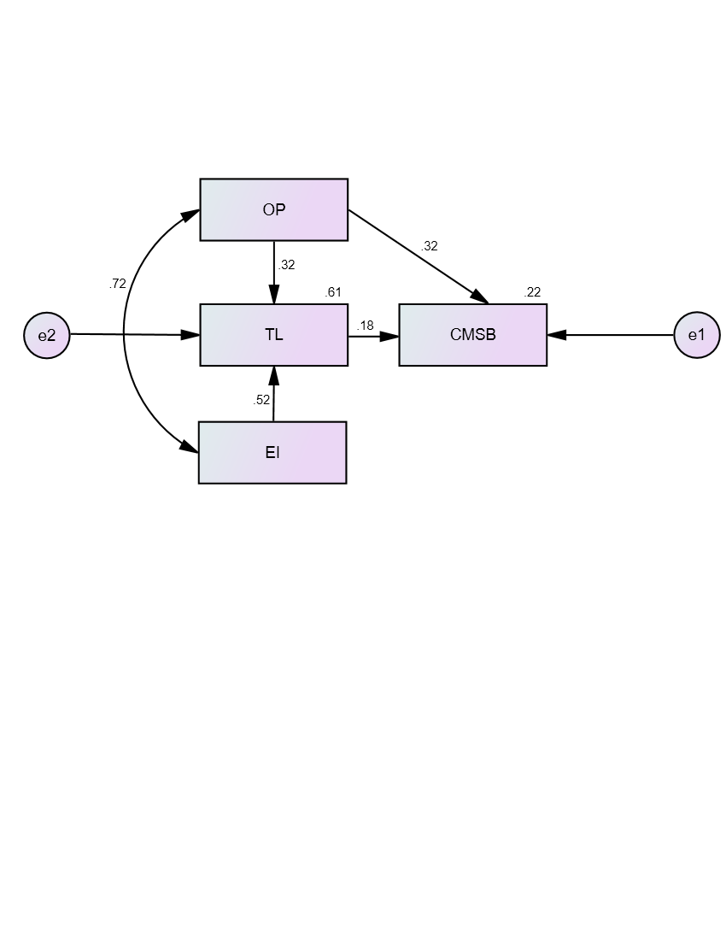
31

Figure 2: Path Analysis Model 1 in Standardized Solution
Legend: OP – Organizational Politics
TL – Transformational Leadership
EI – Emotional Intelligence
CMSB – Conflict Management Skills Beliefs.

Furthermore, the first generated model garnered a P-close of .000; the Chi-Square Value divided by the Degrees of Freedom was 29.683; the corresponding p-value was equal to .000; the Goodness of Fit Index was .966; the Comparative Fit Index was .964; the Normed Fit Index shown .963; Tucker-Lewis Index was .786; and the Root Mean Square Error Approximation value was .265. However, none of the indices met the allowable criteria, as indicated in Table 8. As a result, it does not fit well.
Table 8
32
Goodness of Fit Measures of Path Analysis Model 1

INDEX | CRITERION | MODEL FIT VALUE
P-Close | > 0.05 | .000
CMIN/DF | 0 < value < 2 | 29.683
P-value | > 0.05 | .000
GFI | > 0.95 | .966
CFI | > 0.95 | .964
NFI | > 0.95 | .963
TLI | > 0.95 | .786
RMSEA | < 0.05 | .265
Legend:
CMIN/DF - Chi-Square/Degrees of Freedom
NFI - Normed Fit Index
TLI - Tucker-Lewis Index
CFI - Comparative Fit Index
GFI - Goodness of Fit Index
RMSEA - Root Means Square of Error Approximation
Pclose - P of Close Fit
P-value - Probability Level
Generated Model 2. As shown in Figure 3, is the generated path model 2. It shows the relationship between organizational politics and emotional intelligence. On the contrary, they demonstrated an influence on transformational leadership. Subsequently, organizational politics did not directly influence beliefs about conflict management skills.

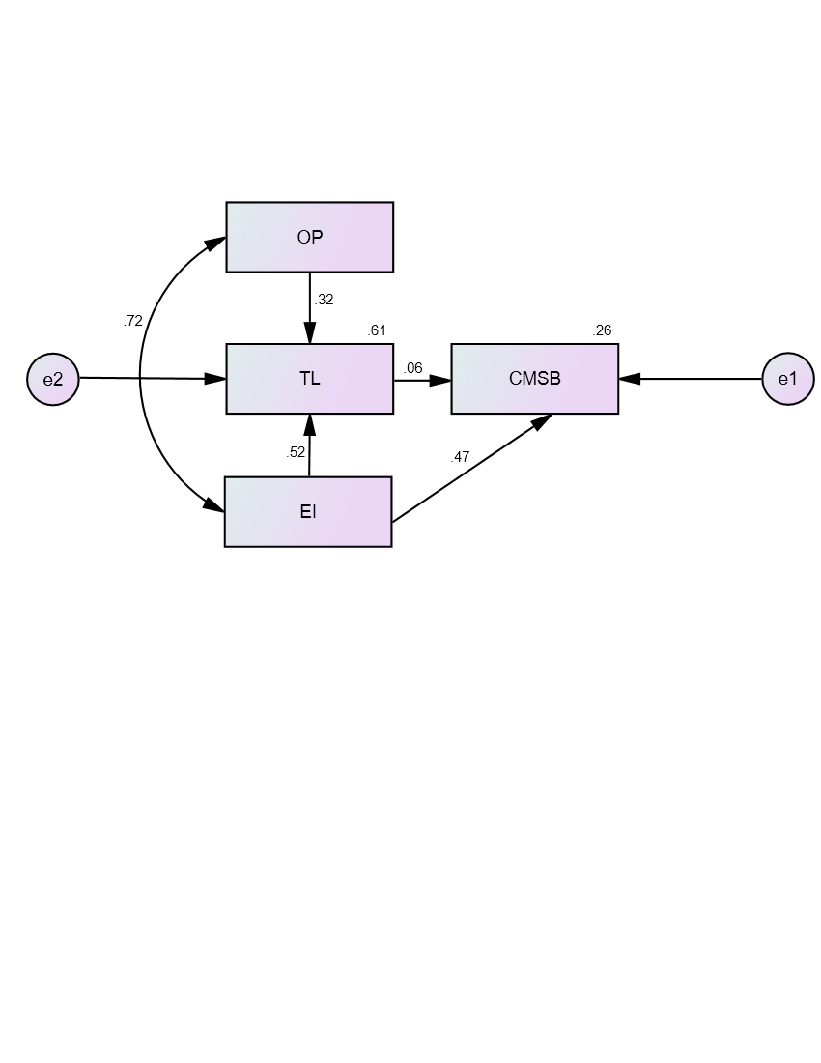
33

Figure 3: Path Analysis Model 2 in Standardized Solution
Legend: OP – Organizational Politics
TL – Transformational Leadership
EI – Emotional Intelligence
CMSB – Conflict Management Skills Beliefs.

Furthermore, a significant improvement was observed across the majority of the criteria provided when compared to model 1. The P-close from .000 to .046; the Chi-Square Value divided by the Degrees of Freedom from 29.683 to 7.250; the corresponding p-value from .000 to .007; the Goodness of Fit Index from .996 to .991; the Comparative Fit Index from .964 to .992; the Normed Fit Index shown from .963 to .991; Tucker Lewis Index from .786 to .953; and the Root Mean Square Error Approximation value from .265. to .124. However, the model was deemed unfit despite certain characteristics falling within acceptable ranges, while others did not match the requisite values, as illustrated in Table 9. As a result, path model 2 exhibited poor fit.
Table 9
34
Goodness of Fit Measures of Path Analysis Model 2
INDEX | CRITERION | MODEL FIT VALUE
P-Close | > 0.05 | .046
CMIN/DF | 0 < value < 2 | 7.250
P-value | > 0.05 | .007
GFI | > 0.95 | .991
CFI | > 0.95 | .992
NFI | > 0.95 | .991
TLI | > 0.95 | .953
RMSEA | < 0.05 | .124
Legend:
CMIN/DF - Chi-Square/Degrees of Freedom
NFI - Normed Fit Index
TLI - Tucker-Lewis Index
CFI - Comparative Fit Index
GFI - Goodness of Fit Index
RMSEA - Root Means Square of Error Approximation
Pclose - P of Close Fit
P-value - Probability Level

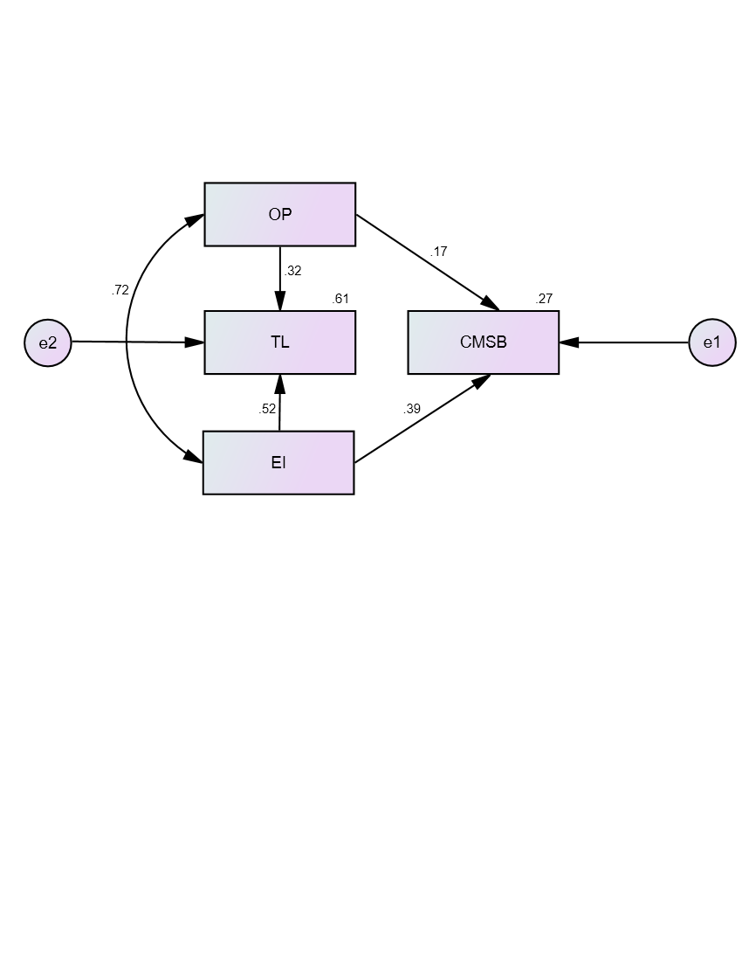
Generated Model 3. Finally, Figure 4 depicts the relationships among exogenous variables, organizational politics, and emotional intelligence (r = .72), as well as their direct influences on conflict management skill beliefs (Beta = .17 and .39, respectively). In contrast, they had an impact on transformational leadership, with Beta values of.32 and.52, respectively. However, transformational leadership did not have a direct influence on conflict management skills beliefs. Furthermore, organizational politics and emotional intelligence appeared as predictors of conflict management skills beliefs, accounting for 17 and 39 percent of the variance in conflict management skills beliefs, respectively. As a result, organizational politics and emotional intelligence were found to influence conflict management skills beliefs in public schools.
35

Figure 4: Path Analysis Model 3 in Standardized Solution
Legend: OP – Organizational Politics
TL – Transformational Leadership
EI – Emotional Intelligence
CMSB – Conflict Management Skills Beliefs.

Finally, Model 3 matched all of the criteria set forth. The P-close from .046 to. .969; the ChiSquare Value divided by the Degrees of Freedom from 7.250 to .004; the corresponding p-value from .007 to .948; the Goodness of Fit Index from .991 to 1.000; Comparative Fit Index from .992 to 1.000; the Normed Fit Index shown from .991 to 1.000; Tucker-Lewis Index from .953 to 1.007; and the Root Mean Square Error Approximation value from .124 to .000. As a result, all model fit values fell within the limits specified in Table 10. Therefore, Model 3 emerged as the best-fit path model.
36
Table 10
Goodness of Fit Measures of Path Analysis Model 3
INDEX | CRITERION | MODEL FIT VALUE
P-Close | > 0.05 | .969
CMIN/DF | 0 < value < 2 | .004
P-value | > 0.05 | .948
GFI | > 0.95 | 1.000
CFI | > 0.95 | 1.000
NFI | > 0.95 | 1.000
TLI | > 0.95 | 1.007
RMSEA | < 0.05 | .000
Legend:
CMIN/DF - Chi-Square/Degrees of Freedom
NFI - Normed Fit Index
TLI - Tucker-Lewis Index
CFI - Comparative Fit Index
GFI - Goodness of Fit Index
RMSEA - Root Means Square of Error Approximation
Pclose - P of Close Fit
P-value - Probability Level

This study also supported the findings of Adu, Muah, Sanda, and Sarfo (2015), who found a strong positive correlation between conflict management and relationships and communication at work as indicators of organizational politics. supports the notion that communication will affect working relationships and dispute resolution.
37
This study supported the findings of Adu, Muah, Sanda, and Sarfo (2015), who found a strong positive correlation between conflict management and relationships and communication at work as indicators of organizational politics. supports the notion that communication will affect workplace relationships and conflict resolution. According to Sabanci, Sahin, and Özdemir (2018), the results indicate that there were positive and significant relationships between two conflict management skills and all interpersonal communication skills, serving as an indicator of organizational politics. This aligns with the views of supervisors and leaders. Different investigations by Valente and Lourenço (2020) demonstrated a favorable correlation between conflict management and emotional intelligence. Łowicki and Zajenkowski (2017) found a favorable correlation between emotional intelligence and the overall degree of religious belief as part of normative views, one of the indicators of conflict management skills beliefs.
CONCLUSION AND RECOMMENDATION
The findings revealed that organizational politics among public school teachers in Region XI is significantly elevated. As a result, the behavioral attributes of organizational politics are consistently apparent. The level of transformational leadership among school heads in public schools is notably high, indicating that their transformational leadership traits are consistently evident. The emotional intelligence of public school teachers is notably high, suggesting that it is consistently present in educational institutions. Lastly, attitudes toward conflict management among public school teachers are notably strong, indicating that these beliefs are consistently present in this demographic.
38
Furthermore, the findings indicated a correlation between transformational leadership and beliefs about conflict management skills, and an association between organizational politics and those beliefs. Also, beliefs about emotional intelligence and conflict management skills were found to be correlated. Moreover, the most parsimonious model (Model 3) demonstrated a novel finding: the endogenous variable, the conflict management skills beliefs of public school teachers, was significantly predicted by organizational politics and emotional intelligence. However, transformational leadership showed no direct impact on beliefs about conflict management skills. Model 3 was the best-fit path model for beliefs about conflict management skills among public schools.
The study's findings corroborated Ajzen's (1991) Theory of Planned Behavior, demonstrating that educational and organizational settings help explain how training and social environments can strengthen individuals’ belief in their conflict management skills, ultimately leading to more positive interpersonal outcomes. Additionally, it also supported Goleman’s (1995) Psychological Theory of Emotional Intelligence, that that individuals who are emotionally intelligent are more likely to believe in their capacity to handle interpersonal disputes constructively. When individuals possess or are trained in these emotional competencies, they tend to develop stronger beliefs in their conflict management skills, leading to more intentional and effective behavior in challenging interpersonal situations.
39
Based on the results of the study, the researcher recommends that the Department of Education do the following. In terms of organizational politics, by fostering a positive organizational climate by supporting openness, justice, and transparency, and promoting participatory decision-making and setting clear policies, school administrators can eliminate damaging organizational politics and enhance teachers' self-confidence in their competence to handle conflict.
Moreover, to enhance Transformational Leadership, school heads can empower teachers and set an example of constructive conflict management skills beliefs by receiving professional development in transformational leadership techniques, such as promoting intellectual stimulation, offering individualized support, and inspiring a shared vision. This will enhance teachers' confidence in their conflict management skills beliefs.
Moreover, by integrating emotional intelligence training into ongoing professional development programs, educators can cultivate their self-awareness, self-regulation, empathy, and social skills, thereby enabling them to navigate conflicts with greater confidence and efficacy.
Consequently, to foster Conflict Management Skills Beliefs, schools should provide frequent training and support to teachers, enabling them to cultivate robust conflict management perspectives that emphasize the importance of emotional intelligence and effective organizational strategies. Educators can enhance their ability to settle conflicts calmly and constructively by fostering open communication and reflective practices.
40
Lastly, future studies should corroborate these findings by involving a wider, more diverse respondent pool or by conducting research across various contexts and environments. These efforts may also investigate supplementary variables, methodologies, and analytical tools to enhance understanding of the fundamental dynamics and mechanisms shaping beliefs about conflict management skills, thereby providing a robust basis for the formulation of educational policies and initiatives that yield more effective and inclusive conflict management practices.

COMPETING INTERESTS DISCLAIMER:
Authors have declared that they have no known competing financial interests OR non-financial interests OR personal relationships that could have appeared to influence the work reported in this paper.

REFERENCES
41
Adham, T. K. I. (2023). Conflict resolution in team: Analyzing the of conflicts and best skills for resolution. Scholars Journal of Engineering and Technology, 11(08), 152-162.
Adiwijaya, S., Ribhan, M., & Hayati, K. (2023). The effect of transformational leadership on readiness for change mediated by organizational commitment. Asian Journal of Economics, Business and Accounting, 23(15), 69-80. https://doi.org/10.9734/ajeba/2023/v23i151017
Adu, I. N., Muah, P., Sanda, M. A., & Sarfo, F. (2015). The role of conflict management in improving relationships at work: The moderating effect of communication. Journal of Emerging Trends in Economics and Management Sciences (JETEMS), 6(6), 367-376.
Ajzen, I. (1991). The theory of planned behavior. Organizational behavior and human decision processes, 50(2), 179-211.
Ajzen, I. (2002). Perceived behavioral control, self‐efficacy, locus of control, and the theory of planned behavior 1. Journal of applied social psychology, 32(4), 665-683.
Alfalih, A., & Ragmoun, W. (2025). The impact of transformational leadership on the workplace well-being of employees with disabilities: series mediation and moderation process. Frontiers in Public Health, 13, 1506257.
Alutaya, N. B., & Guhao Jr, E. S. (2023). Psychological capital, academic job satisfaction and emotional intelligence: a structural equation model on work engagement among public school teachers. European Journal of Education Studies, 11(1).
Armitage, C. J., & Conner, M. (2001). Efficacy of the theory of planned behaviour: A meta‐analytic review. British journal of social psychology, 40(4), 471-499.
Bancroft, C. A. (2020). Development of the Conflict Management Skills Beliefs Scale. The University of North Dakota.
Bhandari, P. (2021). Correlational research| When & how to use. Retrieved from Scribbr: https://www. scribbr. com/methodology/correlational-research.
Cejas, A.S. & Guhao, Jr., E.S. (2023). The mediating roles of emotional intelligence and school climate on the relationship between technological leadership of school heads and teaching effectiveness of teachers: Path Analysis. International Journal of Research Studies in Education. 12(6), 79-93
D’Amico, A., Geraci, A., & Tarantino, C. (2020). The relationship between perceived emotional intelligence, work engagement, job satisfaction, and burnout in Italian school teachers: An exploratory study. Psihologijske teme, 29(1), 63-84.
42
Dawo, J. I. A., & Wagah, M. O. (2011). Teaching Conflict Management Skills in Schools: Prerequisite for Peace and Achievement of Millennium Development Goals in Kenya. Educational Research and Reviews, 6(17), 902-905.
Dewi, S. P., & Susanti, M. (2021). Effect of work overload on job satisfaction through burnout. Jurnal Manajemen, 25(1), 56-75.
Drory, A. (1993). Perceived political climate and job attitudes. Organization studies, 14(1), 59-71.
Emynorane, R. H., Ratna, H. E., Citriadin, Y., Jean, A. T., & Larissa, R. (2024). Conflict management between teachers and students: case of Esperanto Private High School in Madagascar. JP (Jurnal Pendidikan): Teori Dan Praktik, 9(2), 165-174.
Espita, K. O., & Guhao Jr, E. S. (2022). A structural equation model on knowledge management performance in higher education institutions in Region VIII. Review of Integrative Business and Economics Research, 11(2), 95-114.
Fan, X., Thompson, B., & Wang, L. (1999). Effects of sample size, estimation methods, and model specification on structural equation modeling fit indexes. Structural equation modeling: a multidisciplinary journal, 6(1), 56-83.
Fedor, D. B., & Maslyn, J. M. (2002). Politics and political behavior: Where else do we go from here?.
Fenanlampir, A., & Mutohir, T. C. (2021). Emotional intelligence and learning outcomes: Study in physical education. Journal Sport Area, 6(3), 304-314.
Fishbein, M., & Ajzen, I. (1980). Theory of reasoned action/Theory of planned behavior. Belief, Attitude, Intention, and Behavior, An Introduction to Theory and Research.
Fteiha, M., & Awwad, N. (2020). Emotional intelligence and its relationship with stress coping style. Health psychology open, 7(2), 2055102920970416.
Garcia Sr, A. R. (2004). A study of the relationship among the constructs of transformational and transactional leadership and conflict management style. Our Lady of the Lake University.
George, D., & Mallery, P. (2003). SPSS for Windows step by step: answers to selected exercises. A simple guide and reference, 63(1), 1461-1470.
44
Glassie, S. L., & Schutte, N. S. (2024). The relationship between emotional intelligence and optimism: A meta‐analysis. International Journal of Psychology, 59(3), 353-367.
Gliem, J. A., & Gliem, R. R. (2003). Calculating, interpreting, and reporting Cronbach’s alpha reliability coefficient for Likert-type scales. Midwest research-to-Practice Conference in Adult, Continuing, and community education.
Goleman, D. (2005). Emotional intelligence: Why it can matter more than IQ. Bantam.
Hair, J. F., Black, W. C., Babin, B. J., Anderson, R. E., & Tatham, R. L. (2009). Análise multivariada de dados. Bookman editora.
Heris, S. P., & Heris, M. B. (2011). Relationship between emotional intelligence and conflict management strategies in physical education experts of Tehran University. World Applied Sciences Journal, 15(11), 1619-1622.
Hochwarter, W. A., Kacmar, C., Perrewe, P. L., & Johnson, D. (2003). Perceived organizational support as a mediator of the relationship between politics perceptions and work outcomes. Journal of Vocational behavior, 63(3), 438-456.
Hunitie, M. (2016). A cross-sectional study of the impact of transformational leadership on integrative conflict management. Asian Social Science, 12(5), 1-47.
Jöreskog, K. G., & Sörbom, D. (1996). LISREL 8: User's reference guide. Scientific Software International.
Kacmar, K. M., & Carlson, D. S. (1997). Further validation of the perceptions of politics scale (POPS): A multiple sample investigation. Journal of management, 23(5), 627-658.
Kacmar, K. M., & Ferris, G. R. (1991). Perceptions of organizational politics scale (POPS): Development and construct validation. Educational and Psychological measurement, 51(1), 193-205.
Kakarla, U. (2025). Emotional Intelligence in Interpersonal Communication. International Journal of Innovative Scientific Research, 3(1), 111-121.
Kline, R. B. (2023). Principles and practice of structural equation modeling. Guilford publications.
Landells, E. M., & Albrecht, S. L. (2019). Perceived organizational politics, engagement, and stress: The mediating influence of meaningful work. Frontiers in psychology, 10, 1612.
45
Liu, J., Cui, Z., Feng, Y., Perera, S., & Han, J. (2020). Impact of culture differences on performance of international construction joint ventures: the moderating role of conflict management. Engineering, Construction and Architectural Management, 27(9), 2353-2377.
Łowicki, P., & Zajenkowski, M. (2017). Divine emotions: On the link between emotional intelligence and religious belief. Journal of Religion and Health, 56(6), 1998-2009.
Lundula, N. (2024). Influence of leaders’ conflict management skills on multicultural team management. Walden University.
MacCallum, R. C., Browne, M. W., & Sugawara, H. M. (1996). Power analysis and determination of sample size for covariance structure modeling. Psychological methods, 1(2), 130.
Marsh, H. W., & Hocevar, D. (1985). Application of confirmatory factor analysis to the study of self-concept: First-and higher order factor models and their invariance across groups. Psychological bulletin, 97(3), 562.
Maryani, M., & Gazali, A. U. (2024). The effect of work conflict on job stress and employee performance. Golden Ratio of Human Resource Management, 4(2), 158-171.
McKibben, L. (2017). Conflict management: importance and implications. British Journal of Nursing, 26(2), 100-103.
Millado, K. F. M. R., Guhao Jr, E. S., & Rodriguez, G. D. (2021). Path model on organizational effectiveness of higher education institutions of Region XII. International Journal of Scientific & Technology Research, 10(05).
Mohamad, H., Mohamad, F., Alias, N. A., Hassan, N. I., & Fahme, N. M. (2025). The Role of Communication Channels and Communication Strategies in Malaysian Organizations. International Journal of Research and Innovation in Social Science, 9(6), 2020-2038.
Mohammad, S. I., Vasudevan, A., Barhoom, F. N. I., Almajali, R. M. I., Al-Ayed, S. I., Al-Momani, A. A. M., ... & Mohammad, A. A. S. (2024). Key Themes and Future Directions in Transformational Leadership: A Bibliometric Study. In Frontiers of Human Centricity in the Artificial Intelligence-Driven Society 5.0 (pp. 401-411). Cham: Springer Nature Switzerland.
Moolenaar, N. M., Daly, A. J., & Sleegers, P. J. (2010). Occupying the principal position: Examining relationships between transformational leadership, social network position, and schools’ innovative climate. Educational administration quarterly, 46(5), 623-670.
46
Mosquera, P., Tigre, F. B., & Alegre, M. (2024). Overcoming organizational politics and unlocking meaningful work through ethical leadership. International Journal of Ethics and Systems.
Murphy, A. M., Askew, K. L., & Sumner, K. E. (2017). Parents’ intentions to allow youth football participation: Perceived concussion risk and the theory of planned behavior. Sport, Exercise, and Performance Psychology, 6(3), 230.
Poynton, T. A., Poynton, S. L., & Bonneau, A. M. (2016). A Review of Conflict Management in Schools: A Call for Training. Journal of Educational Research and Practice, 6(2), 58-66.
Rahim, M. A. (2023). Managing conflict in organizations. Routledge.
Rasyid, F. A., & Marta, M. S. (2020). Impact of organizational politics on proactive behavior of government employees: the moderating role of self-efficacy. Available at SSRN 3568285.
Robbennolt, J. K. (2024). Apologies, Remorse, and Amends: Empirical Legal Studies Across Domains and Disciplines. European Journal of Empirical Legal Studies, 1(1), 3-18.
Sabanci, A., Sahin, A., & Özdemir, I. (2018). The Correlation between Interpersonal Communication Skills of Inspection Groups and Their Conflict Management Strategies. Online Submission, 4(4), 176-196.
Savalei, V. (2021). Improving fit indices in structural equation modeling with categorical data. Multivariate behavioral research, 56(3), 390-407.
Schlag, M., & Melé, D. (2020). Building institutions for the common good. The practice and purpose of business in an inclusive economy. Humanistic Management Journal, 5(1), 1-6.
Shahid, A. (2024). Transformational leadership: Are leaders open to a new “CALL”? Challenges, adaptation, leadership and learning. Open Journal of Business and Management, 12(6), 3806-3822.
Smith, P. A., & Dawber, J. (2019). Random probability vs quota sampling.
Snipes, R. L., Pitts, J. P., Bryant, P. C., Huning, T. M., & Snipes, A. (2024). Job satisfaction and politics in the modern workplace: an empirical examination of the moderating effects of gender and age on the perception of organizational politics-job satisfaction relationship. Employee Responsibilities and Rights Journal, 36(3), 337-365.
Stangor, C., & Walinga, J. (2014). 3.5 Psychologists Use Descriptive, Correlational, and Experimental Research Designs to Understand Behaviour–Introduction to Psychology (2026).
47
Tabachnick, B. G., & Fidell, L. S. (2007). Using Multivariate Statistics. Pearson Allyn & Bacon. Upper Saddle River, NJ.
Valente, S., & Lourenço, A. A. (2020, February). Conflict in the classroom: How teachers’ emotional intelligence influences conflict management. In Frontiers in education (Vol. 5, p. 5). Frontiers Media SA.
Vigoda-Gadot, E. (2003). Developments in organizational politics: How political dynamics affect employee performance in modern work sites. In Developments in Organizational Politics. Edward Elgar Publishing.
Winardi, M. A., Prentice, C., & Weaven, S. (2022). Systematic literature review on emotional intelligence and conflict management. Journal of global scholars of marketing science, 32(3), 372-397.
Xiao, H., Double, K. S., Walker, S. A., Kunst, H., & MacCann, C. (2022). Emotionally intelligent people use more high-engagement and less low-engagement processes to regulate others’ emotions. Journal of Intelligence, 10(4), 76.
Yu, A., Berg, J. M., & Zlatev, J. J. (2021). Emotional acknowledgment: How verbalizing others’ emotions fosters interpersonal trust. Organizational Behavior and Human Decision Processes, 164, 116-135.

