AN EMPIRICAL STUDY ON AWARENESS OF CIVIC RESPONSIBILITIES: A CASE STUDY OF LAW STUDENTS AT NUALS

Abstract
Youth are a valuable resource for any country, and among them, lawyers are a very important class of people who play a crucial role in protecting the rights of citizens. However, legal education has been criticised for being too technical and less focused on the needs of society. In this background, the current study focuses on civic education, awareness, and participation among law students. The study was conducted on students at the National University of Advanced Legal Studies (NUALS), Kerala. The results show that law students are adequately participating in and engaged with society through their activities. They are also well-informed about the rights, duties, and provisions of the Indian Constitution. Additionally, most of the respondents feel that their legal education has enabled them to be civically engaged and participate in society. However, some changes in the education process can help law students make a greater impact on society.
Keywords- Civic awareness, civic participation, civic engagement, law students, lawyers, social participation.

INTRODUCTION
Youth is the nation’s greatest asset and is expected to continuously lead the country to future success. Being a member of a community, college students take an active role in their community and their society. They are identifying social problems and coming up with solutions for these problems. Technology provides college students with more opportunities to learn about civic affairs and political issues. They can use this tool to interact with others, engage in civic society, and improve their political efficacy.
Over the last two to three decades, in democratic societies, concerns have been rising about strengthening democratic values and systems, including an emphasis on human rights. Civic responsibility through civic education influences students’ civic engagement. It also helps them to understand the role of the citizens, democratic values, and political views. Civic learning is a factor that affects students’ civic cognition and social participation concerning unfair social problems in societies. Civic expression is another factor that affects their perceptions about political discussions and social engagement in civic issues. Students use the internet and technology to communicate their political perceptions and their works to engage in their civic affairs. With a better understanding of students’ civic knowledge, civic value beliefs, and actions, we should be able to work more constructively in promoting their civic awareness and engagement.2
Background- Civic education and responsibilities
The youth population constitutes 65% of the country’s total population. Hence, through education, our youths can develop their competencies, skills, assets, and responsibilities as good citizens, which are vital for nation-building. The responsibility of higher education is to develop responsible citizens and encourage their engagement in the community. Consequently, the relationship between the community and universities is developed.2
A sense of civic responsibility refers to a personal belief and feeling that individuals have about their responsibility and duty to their societies. Therefore, if a person actively participates in solving community issues and problems, such as attending a community meeting, volunteering, raising money for charity, protesting against unfair practices, etc, they are declared good citizens of society. Civic responsibility consists of actions and attitudes associated with democratic governance and social participation. By advocating for social issues or environmental concerns, people strengthen their commitment to their community as well as their citizenship responsibilities, as explained by Weeks (1998). A 2016 survey by the Annenberg Public Policy Centre revealed that “only a quarter of Americans can name all three branches of government”. Kathleen Hall Jamieson, director of the Annenberg Public Policy Centre, commented that “Lack of basic civics knowledge is worrisome and argued for an increased focus on civics education in the schools”.3 This highlights the necessity of civic education at the basic level for all students.
A sense of civic responsibility could also be perceived as a personal investment in the well-being of others and society. In other words, citizens who have attained a sense of civic responsibility would be more responsive and supportive of developmental efforts at all levels (i.e., social and political). A sense of civic responsibility is well recognised as an important developmental factor towards becoming a productive citizen in the future. The lawyers play an important role in raising issues in society and safeguarding the rights of citizens. Productive citizens are the outcome of these efforts by lawyers and other stakeholders, who successfully embrace a sense of civic responsibility and a feeling of belongingness to the community in which they live. The changes in social, economic and technological patterns in society have produced a shift in young lawyers’ mentality, who are less inclined to feel a sense of duty to participate in society in the conventional ways. Past studies found that higher education not only produces students with a positive educational outcome but also develops students with positive self-concept, problem-solving skills, growth in leadership and cultural awareness, as well as a high level of civic outcome. But this has been declining quite rapidly in the past few years.3

Civic Education in Higher Education Institutions
The Evolution of Civic Education in Higher Education by Komives, Lucas, & McMahon (1998) states that civic education in higher education has transformed over the decades to adapt to the current trends and issues in the nation. Definitions of civic responsibility are vast and complicated, with several parts and contradictions. Enrlich (1997) explained the fact that higher education institutions will continue to have a difficult time developing civic education because the aspects of civic responsibility keep changing. It is the responsibility of the judiciary to make proper interpretations of the constitution and related aspects based on the changing environment. A group of researchers advocates for civic engagement to be incorporated into college curricula, making citizenship preparation a priority in teaching.
Bole and Gordon (2009) and Malin (2011) have specifically called for educational reform to cultivate and instil citizenship with meaningful opportunities for public engagement by law students. They specifically stated that civic education must be re-examined for how it is being effectively connected to today’s classroom and students. With all these changes and examinations to the higher education curriculum, teachers are the key to understanding how civic education can transition into the online and technology-driven learning environment. As one of the greatest predictors of civic and political engagement, service learning and civic engagement are two of the most successful ways to increase the social responsibility of law graduates.
Service learning has been used predominantly in civic education because of its direct correlation to civic responsibility. It can be described as one of the most well-known teaching methods associated with civic education.7 Service learning emerged in the 1960s to create a teaching method of using civic engagement to thoroughly teach for real-world problems. It is a form of experiential education that “promotes students’ critical thinking and interpersonal skills”. Therefore, it develops the soft skills for the real world. Through service learning, students are said to gain social and personal responsibility that positively affects their academic and personal lives.8 Civic education, when examined for its characteristics, provides a picture of collaboration, motivation, and engagement.
In Major’s (2014) book, Teaching Online: A Research-based Guide to Instructional Change, she examined student engagement to increase retention rates. Major has incorporated concepts of motivation, participation, attention, involvement, and intellectual effort to paint a picture of what student engagement needs to be in the 21st-century educational process. All these concepts can be transitioned into civic education and civic engagement among law students. Guthrie and McCracken (2010) described online education as providing students with the opportunity to compare a range of civic experiences both locally and over great distances. This unique experience could provide interest and motivation that were previously lacking in some web-based courses. The necessary changes in the curriculum of law students are to be made through a comparison with other countries’ law education to make lawyers in India as active as they are in other countries.
“Today's children must become tomorrow's responsible citizens. The attitudes they develop will shape the quality of life for all of us”. Their responsibilities are not confined to their duties alone but also to their rights. All citizens enjoy basic human rights and other constitutional rights guaranteed by the Indian Constitution. The lawyers and other stakeholders in the judiciary help to secure the rights of each citizen.
In the book “The Global Clinical Movement”, Frank Bloch and his co-authors proposed a movement to "transform legal education into justice education". They focus on empowering law students to create a just society through their efforts of active civic participation. If this does not happen, then society might crumble with lots of social issues in the coming years. The five writs in the Indian Constitution help to secure the rights of each citizen. This helps to achieve a welfare society.

Research problem

Although young people are a vital human resource for democratic governance and social change, their involvement in addressing social issues has been steadily declining in recent years. Despite formal education in civic responsibilities, young people, particularly law students, often remain indifferent to social problems affecting large sections of society. This gap is mostly caused by teaching-learning strategies that prioritises rote memorisation and cognitive learning over experiential and application-oriented learning, rather than shortcomings in the curriculum. As a result, students are unable to convert their theoretical understanding into social action.
Although legal education in India has been updated to comply with the Bar Council of India's standards, it still employs traditional teaching methods and places limited emphasis on social justice, community involvement, and political engagement. As a result, law professionals and students are less engaged in civic life, which diminishes their contributions to the country's development. Additionally, judicial activism has declined, and lawyers have become less involved in matters of public importance due to a lack of practical exposure to public interest law and social issues. The role of instructional methods and experiential learning in legal education, as well as their impact on young people's civic engagement and social responsibility, warrants for critical examination in this context.

Research questions
- What is the level of civic awareness among law students in India?
- What helps them the most in acquiring and promoting civic awareness?
- How much is the law student’s participation in fulfilling their civic responsibilities?
- What are the attitudes of the law students towards the community and community services?

Objectives of the study
To date, little is known about the extent of the sense of civic responsibility among law students in India. Therefore, it is in the interest of the present study to determine the level of sense of civic responsibility among law students and to identify specific factors that contribute to a sense of civic responsibility, such as curriculum, extracurricular activities, campus climate perception, etc. Based on this general objective above, the study addressed two specific objectives:
1) To identify the level of awareness of civic responsibility among law students.
2) To determine the level of participation among law students in fulfilling their civic responsibilities.

Significance of the Study
The current study is significant for legal education as well as for present and future educational practices. It looks at youth development with a focus on law students' civic duty in society. Lawyers are essential in fostering civic awareness, defending rights, and bolstering the rule of law. Civic education is essential to both national development and democratic processes.
By examining how law educators create, implement, and evaluate civic-oriented teaching practices, this study adds to a critical evaluation of how civic education is taught in modern classrooms. The study offers empirical insights into the effectiveness of contemporary pedagogical approaches by examining the connection between teaching strategies and law students' civic attitudes. The results could help academic institutions and law instructors assess how much their methods encourage civic engagement among their students.
Research Methodology
With an emphasis on the qualitative components of civic education among law students, particularly their degrees of civic awareness and civic participation, the current study uses a descriptive research design. Kerala, India, was the location of the study. Kerala was chosen because of its high literacy rate and advanced educational metrics, which offer a suitable setting for analysing civic engagement and awareness among educated youth. The participants were undergraduate law students enrolled in the National University for Advanced Legal Studies' (NUALS) five-year integrated LL.B. program. The respondents demonstrated that they had gained the academic and practical exposure required to interact with societal issues and legal procedures by completing all required internships and practical training components of the program. A convenience sampling method was employed for participant selection. From each batch of the five-year LL.B. program, five students were chosen, creating a sample that represented various phases of the institution's legal education. A structured questionnaire intended to gauge civic engagement and awareness was used to gather data. The chosen participants received the questionnaire electronically via email. Descriptive statistical methods, such as measures of central tendency, were used to analyse the gathered data. The results were presented and explained using visual aids like pie charts.
Analysis, Interpretations & Discussion

Students and community volunteering
Law students felt that they actively participated in community volunteering, as more than two-thirds of the respondents reported working with a group of people to solve various social problems (see figure 1). This shows their readiness and active participation in the community. Only about 33 per cent of the respondents never participated in community volunteering.
Figure 1: Participation in civic or legal activities
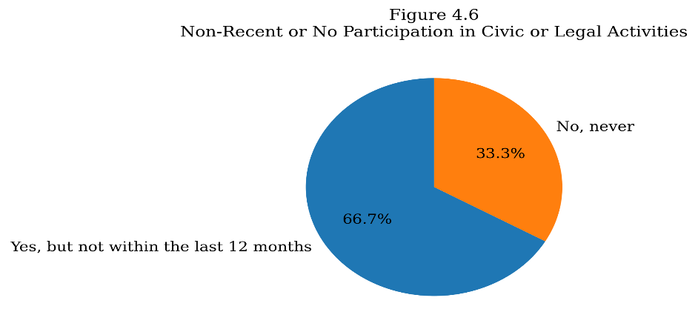
Source: Primary Data, 2025
Similarly, when asked about their volunteering without pay, more than three-fifths of the respondents volunteered in the community without pay. This shows their willingness to support their community without any remuneration. Only about two-fifths of the respondents had never volunteered without remuneration.
However, this is limited to very few activities, as they had never contacted or visited a public official at any level of government, a newspaper, or any form of mass media to express their opinions. This indicates their limited role in societal roles in solving social issues. They had never participated in protests, marches, or demonstrations in the public sphere, which tells us that they are not violent citizens of the society. They are not very keen to express their views explicitly at the public level, which indicates their hesitation and concern about how other people would perceive them. This is well indicated when they were asked whether they had worked as a canvasser- going door to door for a political or social group or candidate; none had done that in their entire life, nor during their education.
When asked about their signing of petitions to solve any social problems, about 33 per cent of the respondents said that they had signed one in the last 12 months to solve social issues. But the rest had never signed any petitions to solve any social problems in society. Similarly, none of the respondents had ever walked, run or bicycled for a charitable cause. This is different from simply giving money to a charitable society. They do not support many charitable activities by various organisations in society.
The condition of donating money to any group, either locally or nationally, a political or social group, a labour union, or any other kind of group, to support any social cause is only done by about 33 per cent. Around two-thirds of the respondents did not donate any money to social causes. This indicates the reluctance of law students to support social needs by donating money. However, this reluctance is limited to donating, not helping others and raising money to solve social issues. All the respondents had helped others raise funds for social causes at some point. Among them, around 33 per cent of the respondents had done it in the last 12-month period, and the rest had done it but not in the last 12 months (see figure 2). This shows their active support for social causes and their fundraising through various programmes.
Figure 2: Fundraising participation
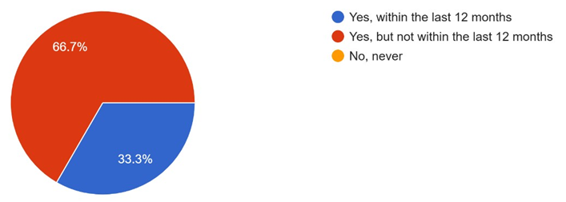
Source: Primary Data, 2025
When asked whether they regularly vote in the local elections, more than two-thirds of the respondents regularly vote in the local elections to elect the appropriate candidates for their constituency. However, the remaining 33 per cent do not vote regularly in the local elections, which is a fair indicator of their low participation in solving social issues.
Regarding their participation in the election process, 67 per cent of the respondents had contested in some elections in their lives. This is an indicator of their effort to support their community through their active participation and representing the community for the common good. But the rest never contested in any election and do not feel like doing so.
When the respondents were asked about their civic participation and volunteering in the community, only one-third had volunteered for civic or community organisations, health or social services, a religious group, or an organisation for children or education (see figure 3). This shows the readiness of the ones who volunteer there to participate in community activities. The rest of the respondents, about 66 per cent, had never volunteered in any community activities. The toll on the ones who do not volunteer is large, indicating their reluctance to do community service.
Figure 3: Civic participation and volunteering
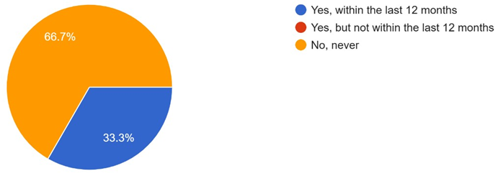
Source: Primary Data, 2025

Civic awareness among the Law students
When asked about their knowledge of fundamental rights and duties and related articles, all the respondents knew it, and two-thirds of the respondents knew it very well. This indicates that they know about their rights and duties and can exercise them when required. Similarly, they all know very well who to approach when these rights are violated. This would help them to seek appropriate remedies in case of its infringement.
Regarding the understanding of the Indian constitution, all the respondents have fairly good knowledge of the constitution, and among them, 67 per cent have very good knowledge of it. This shows their good levels of knowledge about the laws and principles of the nation. Similarly, in the case of the knowledge about the emergency numbers, 67 per cent of the respondents know it very well, and the rest know it. This shows their preparedness and alertness towards a possible mishap.

The education system and civic awareness
When the respondents were asked about the current condition of the education system in incorporating civic awareness among the students, 66 per cent of the respondents agreed that the current curriculum and educational systems are sufficient for the younger generations (see figure 4). Among them, 33.33 per cent strongly agree with it. The remaining 34 per cent remained neutral to it. This is a good indicator of the quality of the current educational system in incorporating civic responsibilities among the younger generation.
Figure 4: Current curriculum and civic education
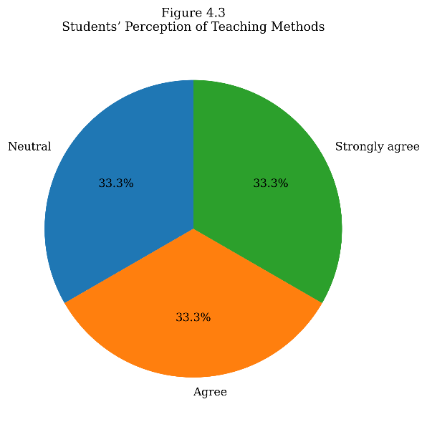
Source: Primary Data, 2025
When it comes to the current educational system, its curriculum and related activities, an essential step for the students to get acquainted with the rights and duties of each student in their respective societies, 67 per cent of the respondents agree that the current curriculum is sufficient in imparting the rights and duties among the law students, indicating a better civic education system in India. However, 33 per cent of the respondents disagree and feel that it is not sufficient in the current challenging times.
When the respondents were asked about the level of political participation in our society, only one-third of the respondents felt that it is fairly good. However, the remaining two-thirds of the respondents felt that it is neither good nor bad. This might be due to the lack of effectiveness of political participation in society.

Civic attitude among the students
The respondents have mixed responses to various situations presented to them. In certain circumstances, such as helping a person who had met with an accident and was bleeding on the road, all the respondents agreed; however, in other circumstances, such as dealing with a faulty street light or picking up garbage left on the road, it was not preferred by the respondents. They don’t feel the necessity to deal with it. Therefore, their practical application of civic knowledge is limited to their situations and not to the level of civic knowledge they possess.
Therefore, from the responses, it is very clear that law students have a very high civic awareness of their duties and responsibilities, and they feel that the current curriculum for school students is fairly sufficient to impart to them. Similarly, the number of community volunteers among the students is very low, and the current curriculum does not promote it as much. This might hinder their ability to connect with social issues. This adversely affects their community participation in society. This is well reflected through their inconsistencies in responses towards community participation. The attitude of the respondents is poor and varies based on situations. This creates difficulty for the respondents to actively participate in the community to solve social issues.

Conclusion
The results of this study show that law students have a comparatively high degree of civic awareness, especially when it comes to constitutional principles, legal rights and obligations, and public redress mechanisms. This fundamental understanding is consistent with the idea that young people, particularly those with legal training, are an essential resource for tackling societal issues. The study also shows that although civic awareness is highly developed, there is still little evidence of consistent and long-term civic engagement. This disconnect between information and action is indicative of a larger problem in Kerala, where civic engagement is relatively low but civic education is adequate.
The findings also show that students with greater civic awareness are more likely to participate in social activism and address social issues when necessary. However, rather than being institutionalised or ongoing, such engagement is typically situational. This inconsistency highlights the limitations of a curriculum that prioritises theoretical instruction over experiential learning. Due to the judiciary's crucial role in resolving social issues through procedures like public interest litigation and constitutional remedies, law students' limited practical experience limits their capacity to apply legal tools for the benefit of society.
These results highlight the necessity of curriculum changes that emphasise the real-world implementation of civic obligations and responsibilities through clinical legal education, community involvement, and participatory learning techniques. Enhancing these elements in legal education can help bridge the gap between civic awareness and civic action, empowering future judges and attorneys to engage more effectively with issues that affect significant portions of society. Ultimately, the study concludes that incorporating civic engagement into legal education is essential for achieving the broader social objectives of legal education and translating civic knowledge into effective public service.

References
- Aðalbjarnardóttir, S. (2008). Young people’s civic awareness and engagement: Listening to their voices using thematic and developmental analysis. Í A. Ross (ritstjóri), Reflecting on identities: Research, practice and innovation, 717-727.
- Beaumont, E., & Battistoni, R. M. (2006). Introductory essay: Beyond civics 101: Rethinking what we mean by civic education. Journal of Political Science Education, 2(3), 241-247.
- Bloch, F. (2011). A Global Perspective on Clinical Legal Education. Revista de educación y derecho, (4).
- Colby, A., Ehrlich, T., Beaumont, E., & Stephens, J. (2003). Educating citizens: Preparing America's undergraduates for lives of moral and civic responsibility. John Wiley & Sons.
- Degelman, C. (2000). Fostering Civic Responsibility through Service Learning. Service-Learning Network, 8(1), n1.
- Guthrie, K. L., & McCracken, H. (2010). Teaching and learning social justice through online service-learning courses. The International Review of Research in Open and Distributed Learning, 11(3), 78-94.
- Hillygus, D. S., Nie, N. H., Prewitt, K., & Pals, H. (2006). The hard count: The political and social challenges of census mobilisation. Russell Sage Foundation.
- Kelso, K. C., & Kelso, J. C. (2021). Civic Education and Civil Discourse: A Role for Courts, Judges, and Lawyers. J. App. Prac. & Process, 21, 473.
- Komives, S. R., Lucas, N., & McMahon, T. R. (2009). Exploring leadership: For college students who want to make a difference. John Wiley & Sons.
- Malin, H. (2011). American identity development and citizenship education: A summary of perspectives and call for new research. Applied Developmental Science, 15(2), 111-116.
- Morimoto, S. A., & Friedland, L. A. (2011). The lifeworld of youth in the information society. Youth & Society, 43(2), 549-567.
- Reamey, R. A. A. (2011). Engaged citizenship: The effect of Blackburn Institute participation on post-graduate behaviours and beliefs. The University of Alabama.
- Strait, J., & Sauer, T. (2004). Constructing experiential learning for online courses: The birth of e-service. Educause Quarterly, 27(1), 62-65.
- Thompson, D. F. (2008). Deliberative democratic theory and empirical political science. Annu. Rev. Polit. Sci., 11(1), 497-520.
- Weiss, M. L. (2006). Protest and possibilities: Civil society and coalitions for political change in Malaysia. Stanford University Press.

Thompson, D. F, Deliberative democratic theory and empirical political science, 11(1), Annu. Rev. Polit. Sci., 497-520, (2008).
Aðalbjarnardóttir, S, Young people’s civic awareness and engagement: Listening to their voices using thematic and developmental analysis, Í A. Ross (ritstjóri), Reflecting on identities: Research, practice and innovation, 717-727, (2008).
Kelso, K. C., & Kelso, J. C, Civic Education and Civil Discourse: A Role for Courts, Judges, and Lawyers, 21, J. App. Prac. & Process, 473-74, (2021).
Morimoto, S. A., & Friedland, L. A, The lifeworld of youth in the information society, 43(2), Youth & Society, 549-567, (2011).
Weiss, M. L. Protest and possibilities: Civil society and coalitions for political change in Malaysia. Stanford University Press, (2006).
Hillygus, D. S., Nie, N. H., Prewitt, K., & Pals, H. The hard count: The political and social challenges of census mobilisation. Russell Sage Foundation, (2006).
Reamey, R. A. A, Engaged citizenship: The effect of Blackburn Institute participation on post-graduate behaviours and beliefs. The University of Alabama, 7, (2011).
Battistoni, Rick, and Rick Battistoni. "Approaching democratic engagement." Advancing knowledge in service-learning, Research to transform the field (2006).
Guthrie, K. L., & McCracken, H, Teaching and learning social justice through online service-learning courses. 11(3), The International Review of Research in Open and Distributed Learning, 78-94, (2010).
Strait, J., & Sauer, T, Constructing experiential learning for online courses: The birth of e-service. 27(1), Educause Quarterly, 62-65, (2004).
Degelman, C, Fostering Civic Responsibility through Service Learning. 8(1), Service-Learning Network, 1-11, (2000).
Bloch, Frank S., ed, The global clinical movement: Educating lawyers for social justice. Oxford University Press, (2010).

