Review Article

Nature-Based Solutions vs Conventional Infrastructure: Cost-Benefit and Sustainability Evaluations in Built Environments

Abstract: Urban areas face increasing pressure from climate change, ecological degradation, and rising infrastructure costs, prompting renewed interest in Nature-Based Solutions (NBS) as alternatives to conventional grey infrastructure. This study systematically reviews 87 peer-reviewed articles (2013–2025) to compare NBS and conventional infrastructure across economic, environmental, social, and resilience dimensions. Using a mixed-methods approach that integrates PRISMA-guided systematic review with bibliometric network analysis (VOSviewer), the study synthesizes lifecycle cost patterns, sustainability outcomes, and methodological trends. The results indicate that while NBS often involve higher initial capital investment, lifecycle cost analyses frequently report long-term savings, with median lifecycle cost differentials favoring NBS when maintenance regimes and co-benefits are included. Hydrological outcomes show consistent directional improvements, including reductions in peak discharge and runoff volume, although effect magnitudes vary significantly across climatic and design contexts. Ecological benefits are more consistently quantified than socio-cultural outcomes, revealing an imbalance in sustainability assessment frameworks. Bibliometric analysis demonstrates strong geographic concentration in high-income regions and increasing attention to governance and equity-related themes in recent years. The review identifies substantial methodological heterogeneity in cost accounting boundaries, discount-rate assumptions, monitoring duration, and indicator selection, limiting the feasibility of formal meta-analysis and constraining cross-context comparability. By integrating economic and sustainability dimensions within a single analytical structure, this study clarifies where comparative evidence converges, where it remains uncertain, and which standardization priorities are necessary to strengthen future infrastructure evaluation.
Keywords: Lifecycle Costing; Ecosystem Services Valuation; Urban Resilience; Infrastructure Adaptation; Sustainability Assessment; Multi-Criteria Evaluation.
- Introduction AND BACKGROUND
  - Context and Key Concepts
Urban environments worldwide are confronting escalating pressures from climate change, rapid urbanization, and the decline of ecosystem health (Almulhim, 2023; Zhang J. et al., 2020). Conventional or “grey” infrastructure solutions such as concrete channels, underground pipes, and engineered stormwater systems have historically dominated the urban built environment (Bertrand-Krajewski, 2021; Chen et al., 2021; Finewood et al., 2019). These systems are designed to control water flows, manage drainage, and support urban services in a deterministic, engineered way (Dhakal & Chevalier, 2017). However, several studies report limitations including high capital and maintenance costs, limited adaptability to extreme events, ecological degradation, and loss of co-benefits linked to natural systems (Alves et al., 2020; O’Donnell et al., 2017).
As an alternative, Nature Based Solutions (NBS) are gaining recognition in urban planning and infrastructure (Gorm Dige, 2015). NBS broadly refer to interventions that harness natural processes such as green roofs, rain gardens, permeable pavements, bioswales, constructed wetlands, and urban forests to provide services traditionally achieved via grey infrastructure, while also restoring ecological functions (Alzahrani et al., 2025; Xing et al., 2017). Green Infrastructure (GI) and Blue Infrastructure (BI) are closely associated terms, emphasizing the integration of vegetation and water elements respectively into the urban fabric (Azmeer et al., 2024; Halder, Kumar, Deepak, Mandal, et al., 2025).
The concept of sustainability underpins the shift toward NBS (Hartmann et al., 2019). In our context, sustainability encompasses multiple dimensions: environmental impacts, including carbon sequestration, temperature regulation, habitat provision, and water quality improvement; social and cultural dimensions, such as enhancements in human well-being, recreational spaces, aesthetics, and social equity; and resilience and adaptability, referring to the capacity of infrastructure to respond, recover, and evolve under stressors like floods, droughts, climate change, or urban growth (Khan et al., 2025; Mir et al., 2024; Schellenberg et al., 2020; Sweta Rupapara et al., 2025). Equally critical is the economic perspective, often operationalized via cost benefit analysis (CBA), lifecycle costing, or economic evaluation, which compares the capital, operational, and maintenance costs of infrastructure solutions against direct and indirect benefits such as health improvements, energy savings, ecosystem services, and enhanced real estate values (Mahdiyar et al., 2016; Wouterszoon Jansen et al., 2020; Yao et al., 2020).
  - Previous Research and Global Trends
Globally, the academic and practitioner communities have increasingly assessed NBS versus grey infrastructure across sectors like stormwater management, urban cooling, flood mitigation, water purification, and biodiversity corridors (Donatti et al., 2022; Palomo et al., 2021). Many studies highlight that NBS can deliver comparable engineering performance at lower lifecycle cost while offering additional ecosystem and social benefits (Kumar, Maurya, Mandal, Mir, et al., 2025; Wei et al., 2016). For instance, urban green roofs and bioswales are often credited for reducing peak runoff, improving infiltration, cooling microclimates, and increasing urban biodiversity (Blackhurst et al., 2010; Cubi et al., 2016; Pearlmutter et al., 2021).
This suggests an opportunity for integrative reviews that bridge disciplinary divides and synthesize both economic and sustainability assessments holistically. Despite the increasing momentum behind NBS, urban decision makers and planners remain constrained by significant knowledge gaps when considering their implementation over conventional grey infrastructure (Aguilera-Rodríguez et al., 2025; Haque et al., 2022). Also, the diversity of evaluation methods, performance indicators, spatial and temporal scales, and valuation approaches across the literature complicates meaningful comparisons (Balzan, 2025; Fedele et al., 2019; Halder, Kumar, Deepak, Kumar, et al., 2025; Kumar & Shukla, 2022).
The concept of sustainability forms the cornerstone of the contemporary shift from conventional grey infrastructure toward NBS (Khoshhalshaghaji et al., 2025). Within the context of urban built environments, sustainability transcends a single dimension and instead embodies a holistic integration of environmental, social, cultural, and resilience related aspects (Barker et al., 2024; González-García et al., 2025). On the environmental front, NBS contribute to reducing the ecological footprint of cities by enhancing carbon sequestration, regulating urban microclimates, mitigating the urban heat island effect, improving water quality, and restoring natural habitats that are often lost to impervious grey structures (Lallemant et al., 2021; Ncube & Arthur, 2021; Wang et al., 2023). Beyond these biophysical benefits, NBS also offer significant social and cultural advantages by improving the quality of life and well-being of urban residents (Rathod, 2025). Features such as urban parks, vegetated roofs, wetlands, and green corridors create opportunities for recreation, aesthetic enjoyment, and cultural expression, while fostering a sense of community and social equity by providing accessible green spaces across diverse neighborhoods (Hartig et al., 2014; Kabisch & Haase, 2014; Pelorosso et al., 2017). Equally important is the dimension of resilience and adaptability (Saqib et al., 2024). NBS are described in the literature as dynamic systems capable of responding to stressors such as floods, droughts, climate variability, and rapid urban growth (Chausson et al., 2020; Kristi Miley, 2020). This broader framing highlights the relevance of evaluating infrastructure choices not solely on immediate engineering function or capital cost, but on their capacity to generate sustained ecological and societal benefits under changing conditions (Depietri & McPhearson, 2017; Frantzeskaki, 2019).
Several studies examine specific performance indicators such as runoff reduction, temperature regulation, or individual ecosystem service valuation (e.g., carbon sequestration), without always extending the analysis to cross-scale comparisons between NBS and conventional infrastructure (Coutts & Hahn, 2015; Das et al., 2022; Jiangyi, 2020; Lundholm, 2015; Sultana et al., 2017). In addition, a substantial portion of the literature originates from Europe and North America, which may influence the geographic distribution of case evidence (Baycan-Levent & Nijkamp, n.d.; Cotlier & Jimenez, 2022; Gies, 2006; Q. Li et al., 2023; Rojas et al., 2019; Sánchez Jiménez & de Adana, 2024). Bibliometric studies have documented rapid growth in NBS-related publications; however, comparatively fewer reviews integrate economic and sustainability dimensions within a single analytical structure (Herrera-Franco, 2021; Huesca-Domínguez et al., 2023). Comparative cost-benefit assessments that directly contrast NBS with conventional infrastructure using standardized criteria remain relatively limited in number (Alshehri et al., 2023; Halder & Kumar, 2025). Existing studies frequently examine environmental, economic, or social dimensions separately rather than within fully integrated assessment frameworks (Kabisch et al., 2016; Raymond et al., 2017).
In light of the patterns identified in the literature, this study systematically compares NBS and conventional infrastructure in urban built environments. The review examines economic dimensions, including capital, operational, and maintenance costs, alongside environmental and socio-cultural performance indicators. It also identifies the evaluation methods and metrics used in comparative assessments. The study is guided by the following research questions:
- How do NBS and grey infrastructure compare in terms of capital, operational, and maintenance costs across urban applications?
- What indirect economic and social outcomes are assessed in comparative studies?
- How are environmental sustainability, resilience, and adaptability measured?
- What tools and frameworks are employed in evaluations, and where do methodological differences occur?
By addressing these questions, the review aims to synthesize existing evidence and clarify areas of convergence and divergence within the literature. To guide the synthesis, key concepts used throughout this review were analytically clarified prior to coding. NBS are understood here as infrastructure-related interventions that intentionally employ ecological processes to deliver services within urban environments and that are evaluated in direct comparison with conventional grey infrastructure alternatives. This comparative framing is central to the scope of the review. Economic performance is examined primarily through lifecycle costing (LCC), cost–benefit analysis (CBA), and related valuation approaches that consider capital, operational, and maintenance expenditures over time. A lifecycle perspective is particularly important in comparative infrastructure assessment, as short-term capital comparisons alone may obscure longer-term maintenance dynamics and ecosystem-service flows.
Sustainability is treated as a multidimensional construct encompassing environmental performance (e.g., hydrological regulation, biodiversity, temperature moderation), socio-cultural outcomes (e.g., wellbeing, accessibility, equity), and resilience or adaptability under climatic and urban stressors. Resilience is considered analytically distinct from static environmental indicators, as it refers to the capacity of infrastructure systems to absorb disturbance, recover, and adapt over time. Finally, co-benefits are defined as indirect or secondary effects not captured in conventional engineering metrics, including public health improvements, property-value changes, and social cohesion impacts. These conceptual distinctions structured the thematic coding process and enabled consistent comparison across heterogeneous study designs.
While prior reviews have examined environmental benefits of NBS or discussed economic valuation frameworks independently, fewer studies have systematically analyzed how lifecycle cost assumptions, sustainability metrics, and methodological heterogeneity jointly shape comparative conclusions between NBS and conventional infrastructure. This review advances existing knowledge in three ways. First, it identifies lifecycle framing and discount-rate sensitivity as central determinants of reported economic advantage. Second, it documents a structural imbalance in the evidence base, where ecological metrics are consistently quantified while socio-cultural and equity dimensions remain less standardized. Third, it demonstrates that heterogeneity in cost boundaries, monitoring duration, and outcome indicators precludes formal meta-analysis, thereby clarifying the conditions necessary for future quantitative synthesis. By explicitly linking methodological design choices to comparative conclusions, the review moves beyond thematic aggregation toward structural evaluation of the evidence base itself.

2. Materials and Methods
In this research, a mixed-methods approach was adopted by combining a systematic review using the PRISMA (Preferred Reporting Items for Systematic Reviews and Meta-Analyses) framework with bibliometric analysis facilitated by VOS viewer (Arruda, 2022; Kirby, 2023; Page et al., 2021a; van Eck, 2010). PRISMA process leading to the selection of the papers used for both qualitative synthesis and bibliometric analysis. The mixed-methods approach has been instrumental in achieving the objectives of this study (J. Li et al., 2022). Expanding upon previous discussions, this study integrates the structured qualitative depth of a systematic review with the quantitative insights of bibliometric analysis to explore the integration of both economic and sustainability dimensions in a single analytical framework that systematically compares NBS and conventional infrastructure across urban environments. The research protocol for the study is shown in figure 1 on how the study is progressing. Study follows PRISMA guidelines and checklist (Page et al., 2021b).
  - The PRISMA Framework
The PRISMA framework was employed to systematically collect, screen, and analyse articles from the Web of Science (WOS) database. This method ensures transparency and reproducibility, which are vital for academic rigor (Chaudhuri & Kumar, 2022; Fu et al., 2022). A web search was done on September 24, 2025, as the initial step. Boolean operators (AND, OR) were applied to refine the results and ensure the selection of pertinent studies. "NBS” is first introduced in this paper and is not yet widely adopted. Furthermore, comprehensive relevant literature retrieval is built on NBS in green infrastructure and conventional infrastructure. Criteria for eligible literature through WOS are further classified in Table 1. The specific search query used in basic search mode, the search term was - (“Nature-Based Solutions” OR “Green Infrastructure” OR “Blue-Green Infrastructure” OR “Grey Infrastructure” OR “Conventional Infrastructure” OR “Built Infrastructure”) AND (“Sustainability Assessment” OR “Environmental Impact” OR “Carbon Footprint” OR “Biodiversity” OR “Resilience” OR “Adaptability” OR “Social Sustainability” OR “Ecosystem Services” OR “Cost-Benefit Analysis” OR “Life Cycle Costing” OR “Economic Evaluation” OR “Capital Cost” OR “Operational Cost” OR “Maintenance Cost” OR “Indirect Benefits”) AND (“Urban Environment” OR “Built Environment” OR “Urban Planning” OR “Urban Infrastructure”) and then search method topic was selected.
Table 1. Criteria for eligible literature through WOS (excluded if not meeting these criteria).
No. | Criteria
1 | Search Terms (Topic/Title/Abstract) | (“Nature-Based Solutions” OR “Green Infrastructure” OR “Blue-Green Infrastructure” OR “Grey Infrastructure” OR “Conventional Infrastructure” OR “Built Infrastructure”)  AND (“Sustainability Assessment” OR “Environmental Impact” OR “Carbon Footprint” OR “Biodiversity” OR “Resilience” OR “Adaptability” OR “Social Sustainability” OR “Ecosystem Services” OR “Cost-Benefit Analysis” OR “Life Cycle Costing” OR “Economic Evaluation” OR “Capital Cost” OR “Operational Cost” OR “Maintenance Cost” OR “Indirect Benefits”)  AND (“Urban Environment” OR “Built Environment” OR “Urban Planning” OR “Urban Infrastructure”)
2 | Document Type | Article
3 | Language | English
4 | Database | Web of Science (WOS) database
5 | Irrelevant Disciplines | Subject categories retrieved excluding:
5 | Irrelevant Disciplines | Physics and Astronomy;
5 | Irrelevant Disciplines | Chemical Engineering;
5 | Irrelevant Disciplines | Computer Sciences;
5 | Irrelevant Disciplines | Biochemistry, Genetics and Molecular Biology;
5 | Irrelevant Disciplines | Decision Sciences
5 | Irrelevant Disciplines | Pharmacology, Toxicology, and Pharmaceutics;
The selection of search terms was guided by the primary objective of the study, which focuses on comparative economic and sustainability evaluations of NBS and conventional infrastructure. Therefore, terms such as “carbon footprint,” “cost-benefit analysis,” “life cycle costing,” and “indirect benefits” were included to capture studies that quantitatively assess environmental and economic performance. Broader terms such as “climate change” or “urban ecology” were not used as standalone search keywords because they retrieve a substantially wider body of literature not necessarily focused on infrastructure comparison or cost-based evaluation. Instead, these themes are implicitly captured within sustainability-related terms (e.g., environmental impact, resilience, biodiversity). This approach ensured that the search remained targeted toward studies directly relevant to comparative infrastructure assessment while minimizing retrieval of conceptually adjacent but methodologically unrelated literature. The systematic review followed the PRISMA framework shown in Figure 1, encompassing four key phases (identification, screening, eligibility, and inclusion) to ensure a transparent and rigorous methodology.
No explicit publication year restriction was applied in the search strategy. The database search was conducted without temporal limits to capture the full evolution of comparative studies between NBS and conventional infrastructure. Following screening based on relevance and eligibility criteria, the earliest study meeting the inclusion criteria was published in 2013. Therefore, the final dataset spans the period from 2013 to 2025. The year 2013 does not represent a predefined starting point but reflects the emergence of eligible comparative research within the selected database and thematic scope. The emergence of studies from 2013 onward is consistent with the growing formalization of the NBS concept in academic and policy discourse during the early 2010s.

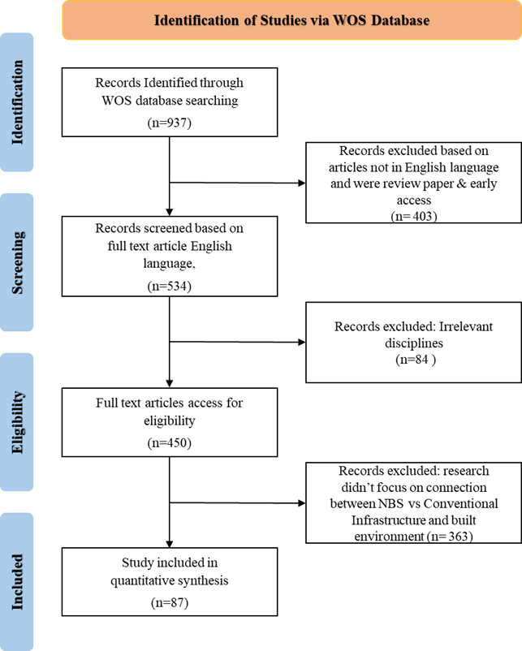
Figure 1. PRISMA framework of the study, Source: PRISMA 2020 (Page et al., 2021)
  - Bibliometric Analysis
For the bibliometric analysis, VOSviewer (version 1.6.19) was used to construct and visualize bibliometric networks based on the 87 studies included in the final dataset. VOSviewer is a software tool designed to build and analyze networks of co-occurring terms, citations, authors, and countries (Arruda, 2022; van Eck, 2010). It generates maps in which nodes represent items (e.g., keywords), and links represent co-occurrence relationships. The size of a node reflects the frequency of occurrence, while the proximity and thickness of links indicate the strength of association between terms. The bibliometric dataset was exported directly from the WOS Core Collection in plain text format and imported into VOSviewer. Keyword co-occurrence analysis was conducted using author-provided keywords and Keywords Plus (index keywords) supplied by WOS. No external or manually generated keywords were introduced. A minimum occurrence threshold of 3 was applied to filter infrequent terms and improve interpretability of the network visualization.
Emerging research trends were identified based on (1) frequency growth over time, (2) clustering of newly appearing or rapidly increasing keywords, and (3) temporal overlay visualization in VOSviewer, which assigns average publication year to keywords. Keywords with higher average publication years were interpreted as representing more recent thematic developments within the field. These analyses allowed identification of dominant themes, evolving conceptual clusters, and areas of increasing scholarly attention.
Overlay visualization was applied to assess temporal evolution of keywords, where node color represents the average publication year of documents in which a term appears. Terms with higher average publication years were interpreted as relatively more recent within the dataset.
  - Study quality appraisal and scoring framework
All included studies (n = 87) were assessed using a two-stage quality appraisal procedure consisting of (1) title-and-abstract screening and (2) full-text scoring. The final scoring rubric contained seven criteria:
- clarity and replicability of the methodology;
- appropriateness and resolution of outcome metrics;
- monitoring duration (empirical) or calibration/validation adequacy (modelling);
- transparency of assumptions, parameterization and data sources;
- reporting of uncertainty or sensitivity analyses;
- strength of causal inference; and
- external validity and contextual detail.
Each criterion was scored 0–2 (maximum 14). Quality tiers were defined as: High (≥10), Moderate (6–9), Low (≤5). During full-text review, several studies initially classified as Moderate were upgraded to High because the full texts revealed methodological rigor not evident in the abstracts, including multi-year monitoring, calibrated model verification, explicit uncertainty analysis, transparent cost accounting, or multi-method triangulation. In total, 11 studies were upgraded. Low-tier studies remained few (n = 6), typically due to insufficient methodological detail for reproducibility. Final tier distribution: High = 30 studies (34%), Moderate = 51 studies (59%), Low = 6 studies (7%).
A detailed record of individual-study scoring is provided in Supplementary Table S2, and harmonized metadata for all 87 studies is provided in Supplementary Table S3.
  - Sensitivity analysis and risk-of-bias procedures
To evaluate whether results were sensitive to the quality of included studies, descriptive statistics were recomputed under three scenarios:
- full set of studies;
- excluding all Low-tier studies; and
- retaining only High-tier studies.
Excluding Low-tier studies did not materially alter directional conclusions. Restricting analyses to High-tier studies reduced the numerical sample but preserved the dominant patterns in hydrological, economic and social outcomes. Because modelling and empirical designs were unevenly distributed across quality tiers, we did not apply numerical weighting by quality; instead, all quality scores are reported transparently to enable reader-driven weighting. This procedure aligns with PRISMA recommendations for transparent reporting of risk-of-bias handling in heterogeneous bodies of evidence.
- Results AND ANALYSIS
The initial database search yielded 937 records from the Web of Science Core Collection. After excluding non-English publications, review articles, and early access records (n = 403), 534 records proceeded to screening. A further 84 records were excluded based on disciplinary irrelevance. Title and abstract screening resulted in the exclusion of 363 articles that did not directly compare NBS and conventional infrastructure in built environments. Following full-text assessment of 87 eligible studies, all were retained for final inclusion in the synthesis.
Finally, 87 studies met the predefined eligibility criteria and were included in the final synthesis. A complete list of the included studies is provided in the Supplementary Materials, including authors, year of publication, title, and citation details to ensure transparency of the review corpus.
  - Publication trends
Figure 2 illustrates the temporal distribution of publications related to Nature Based Solutions (NBS) and conventional infrastructure in urban environments from 2013 to 2025. The data reveals a clear exponential growth in scholarly interest, as evidenced by the fitted exponential trend line (R² = 0.89), which indicates a strong correlation between publication year and the number of articles published. Initial research activity remained minimal between 2013 and 2017, with only one publication per year. However, a noticeable uptick began in 2018, followed by a marked increase after 2020. The number of publications rose from just 2 in 2020 to 10 in 2021, and continued to accelerate significantly, reaching 16 in 2023, 21 in 2024, and peaking at 24 in 2025.
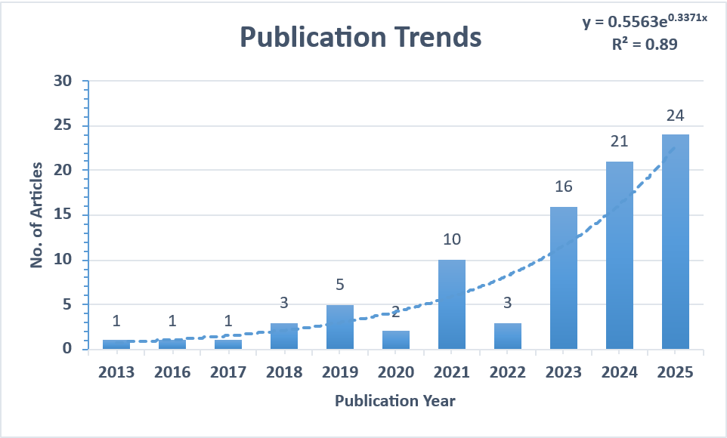
Figure 2. Exponential growth trend of “NBS”- related research and year wise data.
  - Analysis of co-occurring keywords
The keyword co-occurrence network (Figure 3), generated using VOSviewer, illustrates the conceptual structure of the research field by mapping the frequency and strength of relationships between terms. At the core of the network, the dominant terms include “ecosystem services,” “biodiversity,” “infrastructure,” “urban,” and “urban green infrastructure,” indicating their centrality to discussions surrounding Nature Based Solutions (NBS) in urban contexts. These core clusters suggest that much of the existing research revolves around the ecological benefits and service delivery potential of NBS when implemented as part of urban planning and infrastructure strategies. Closely connected terms such as “resilience,” “urban ecology,” “restoration,” and “sustainable cities” reflect the growing emphasis on adapting urban systems to environmental and social challenges through integrated, nature-driven approaches.
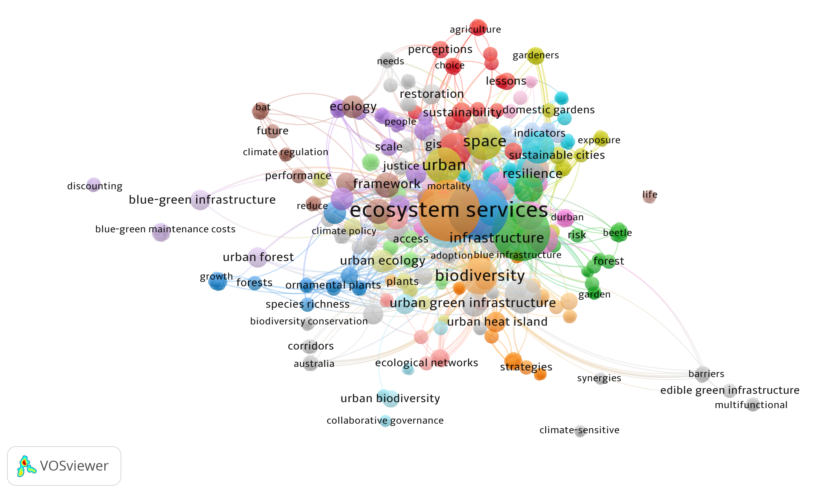
Figure 3. Co-occurring keyword map visualization using VOSviewer.

Overlay visualization based on average publication year indicates that terms such as “justice,” “access,” and “collaborative governance” are associated with more recent publications within the dataset. As shown in the overlay map (Figure 4), these keywords appear in comparatively later average publication years, suggesting increasing scholarly attention to social equity, governance structures, and participatory dimensions of NBS.
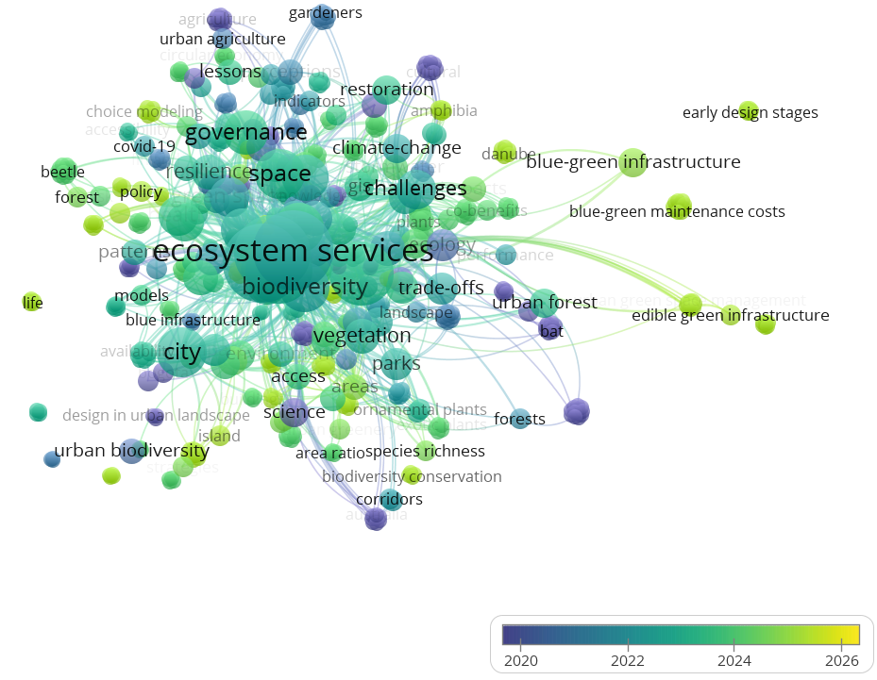
Figure 4. Keyword co-occurrence network with overlay visualization (average publication year).
  - Analysis of country distribution
The country-wise distribution of publications indicates a geographic concentration of research on Nature-Based Solutions and conventional infrastructure within urban environments. As shown in Figure 5, Germany leads with 14 publications, followed by England and Australia, each contributing 13 studies to the dataset. Austria and Finland follow with 8 and 7 publications, respectively. Other countries such as Denmark (4), Colombia (3), and Canada, France, and the Czech Republic (each with 2) are also represented. Overall, the dataset is predominantly composed of studies originating from European countries and Commonwealth nations, with comparatively fewer contributions from other regions. Contributions from countries in the Global South are comparatively limited within the current dataset.
Analysis of the geographic spread of the 87 studies revealed pronounced regional clustering. Europe accounted for 46 % of publications, Australia 13 %, North America 12 %, Asia 15 %, Latin America 8 %, and Africa 6 %. When grouped by World Bank income classification, 78 % originated from high-income countries, 18 % from upper-middle, and only 4 % from lower-middle or low-income regions. This bias toward temperate, high-income contexts limits the generalizability of observed economic and environmental outcomes. Urban form, labor costs, and governance capacity differ markedly in developing regions, potentially altering both the cost-effectiveness and performance of NBS. Future research should prioritize under-represented tropical and low-income cities to enhance external validity and policy transferability.
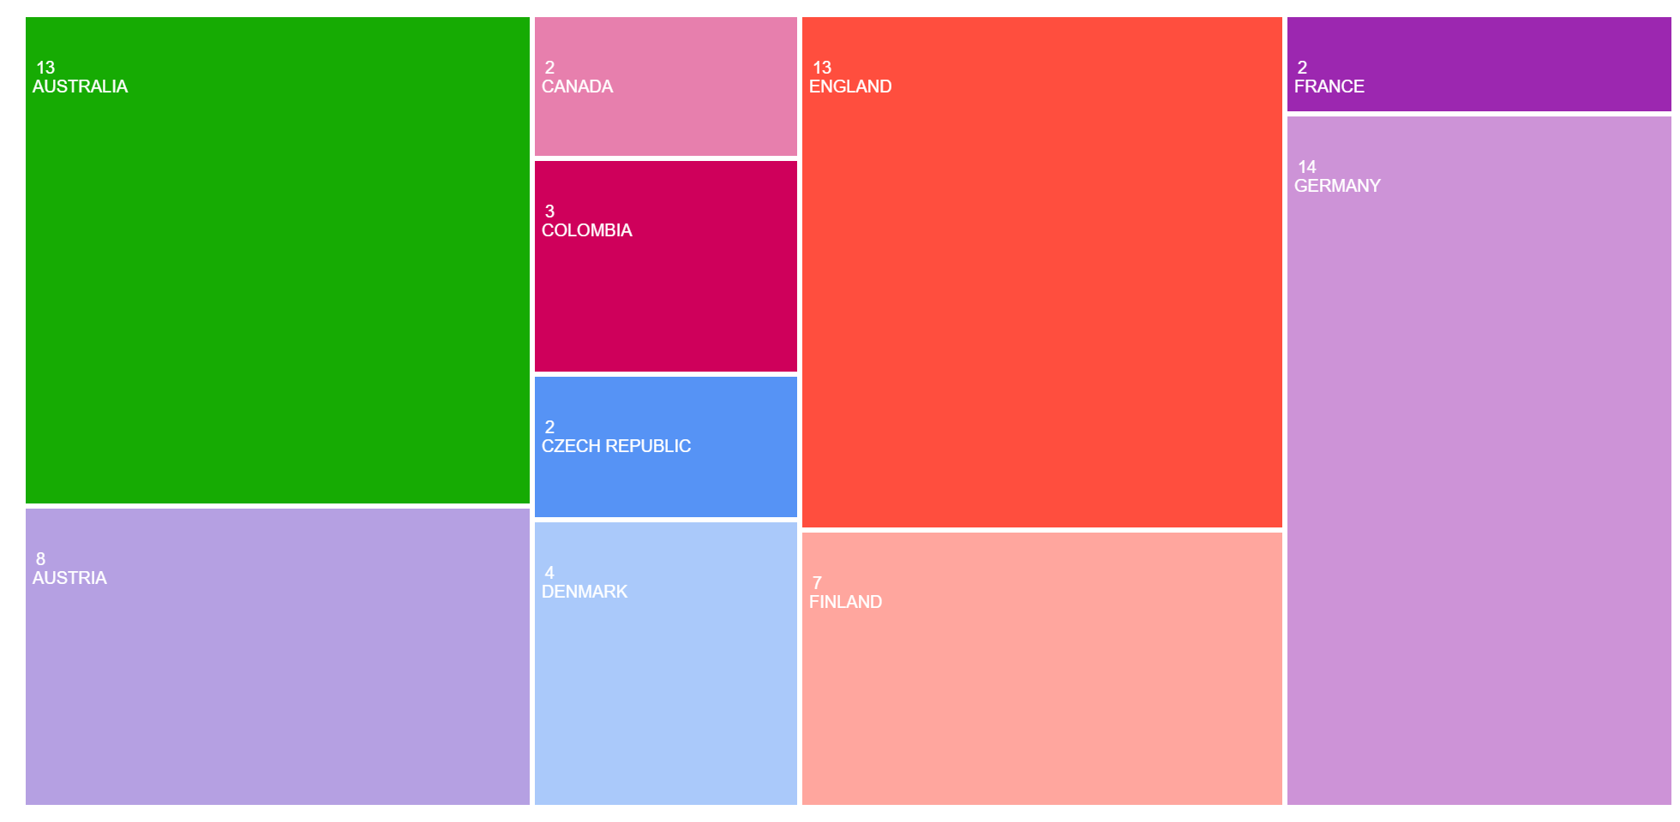
Figure 5. Geographical distribution of publications. Source: WOS
  - Quantitative synthesis
Although there is directional consensus that Nature-Based Solutions (NBS) frequently outperform or match grey infrastructure across hydrological, ecological and socio-economic dimensions, we did not conduct a meta-analysis. A formal pooled effect-size calculation is precluded by three persistent features of the literature:
1. Inconsistent cost definitions and accounting boundaries
Economic studies use non-comparable cost scopes (capital, O&M, or full lifecycle cost), differing time horizons (10–50 years) and discount rates (0–10%). Even among high-quality studies, monetary outcomes are not standardized sufficiently to compute comparable effect sizes without reconstructing harmonized LCC baselines or re-contacting authors for raw cost inputs.
2. Heterogeneous outcome metrics and units
Hydrological performance is reported variously as peak discharge reduction, runoff coefficient change, volume retention, or pollutant load removal. Thermal, biodiversity and social metrics also vary widely. These incompatibilities violate the assumptions needed for a meaningful meta-analysis.
3. Mixed study designs and variable methodological transparency
The corpus spans field experiments, observational designs, calibrated models, uncalibrated spatial models, hedonic pricing analyses, choice experiments, surveys and conceptual frameworks. After full-text scoring, many upgraded High-tier studies remained methodologically incompatible with empirical field studies due to different assumptions, boundary conditions and measurement scales.
Instead, we adopted a transparent descriptive synthesis approach. All studies reporting comparable numerical values are summarized in standardized tables in Supplementary Table S3, including units, base values, design type and quality tier.
The evidence base reveals several consistent patterns across the included studies. Hydrological findings (n = 41) show a clear directional trend toward reduced peak flows, lower runoff volumes and improved pollutant attenuation across diverse NBS. Descriptive pooled estimates indicate an average peak-flow reduction of approximately 34% (SD ± 17%) and a mean volume reduction of roughly 29% (SD ± 13%), although variability remains substantial due to differences in site conditions, design specifications and monitoring methods. Economic outcomes (n = 36 reporting monetary values) similarly suggest favourable performance, with LCC differentials between NBS and grey alternatives ranging from −65% to +20% and a median saving of −28%, while sensitivity analyses highlight persistent dependence on discount rates, maintenance regimes and assumed service lives. Ecological and social outcomes are also broadly positive: most ecological studies report enhancements in species richness, functional connectivity or habitat quality, whereas social outcomes commonly document improved wellbeing, environmental perceptions and in several cases measurable uplift in property values. However, despite these consistent directional effects, the heterogeneity of metrics, methods and reporting conventions prevents the calculation of statistically defensible pooled effect sizes.
  - Content Analysis and Thematic Synthesis
This section presents the results of the content analysis and thematic synthesis of the 87 included studies. Based on systematic coding and classification, five dominant thematic categories were identified: (1) economic cost and benefit dimensions, (2) environmental sustainability contributions, (3) socio-cultural impacts and urban livability, (4) infrastructure resilience and adaptability, and (5) evaluation tools and methodological frameworks. These themes structure the comparative analysis of NBS and conventional infrastructure across the reviewed literature.
    - Economic Cost and Benefit Dimensions
A prominent theme across the selected studies is the economic evaluation of NBS versus conventional infrastructure. Several studies emphasize that while NBS often entail higher upfront capital costs, they tend to deliver long-term economic advantages due to lower operational and maintenance costs, as well as indirect societal and environmental benefits. For example, green roofs and urban forests were shown to reduce energy consumption in adjacent buildings, lowering utility costs over time (Pradilla & Hack, 2024; Proebstl-Haider et al., 2025; van Oorschot et al., 2021). In a comparative assessment, NBS demonstrated higher cost-effectiveness for stormwater management than piped systems, especially when accounting for avoided flood damage and improved groundwater recharge (Fagerholm et al., 2025; He et al., 2023).
Despite these advantages, cost assessments vary considerably among studies. Some employ life cycle costing (LCC) and cost-benefit analysis (CBA), while others adopt less structured economic models (Andrade et al., 2013; Kato-Huerta & Geneletti, 2023). Studies that included indirect benefits—such as improved mental health, increased property values, or avoided healthcare costs—tended to favor NBS more strongly (Haghani et al., 2023; Silveira et al., 2025). However, a recurring limitation lies in the fragmented valuation of non-market benefits, often excluded or inconsistently calculated across case studies. This highlights a opportunity for standardized, integrative economic assessment frameworks that consider both direct and indirect returns on investment in urban NBS.

    - Environmental Sustainability Contributions
Environmental performance was the most frequently addressed theme among the reviewed studies. A substantial proportion of the literature reported positive outcomes associated with ecosystem service provisioning and urban sustainability indicators in NBS-focused case studies. Green infrastructure elements such as bioswales, permeable pavements, and green corridors were widely recognized for their contributions to urban biodiversity, air quality improvement, and temperature regulation (Brunbjerg et al., 2018; Hansen et al., 2023; Perrotti & Stremke, 2020). For instance, vegetated systems were more effective than concrete channels in reducing surface runoff and pollutant loadings in stormwater, especially in dense urban cores (Ring et al., 2021; Vallejo et al., 2024).
In terms of biodiversity support, studies reported that urban parks, wetlands, and green roofs provide critical habitats for native species and pollinators that are otherwise displaced by grey infrastructure (Grilo et al., 2025; Thorsson et al., 2025; B. Zhang, 2025). Additionally, the carbon sequestration potential of tree-based interventions and soil systems within NBS designs was acknowledged as a viable climate mitigation strategy, contributing to carbon neutrality goals in cities (Dondina et al., 2025; Hoover et al., 2023; Lonsdorf V et al., 2021). However, challenges remain in measuring and comparing these benefits consistently across geographical and climatic contexts. Only a limited number of studies utilized spatial modeling tools or long-term ecological monitoring to validate environmental gains (Miller et al., 2023; Zenglein et al., 2025). This gap underscores the importance of integrating geospatial and temporal metrics into sustainability evaluations of NBS, particularly for cities in the Global South where empirical data is often scarce.
    - Socio-Cultural Impacts and Urban Livability
Socio-cultural dimensions were addressed in a subset of the reviewed studies, with emphasis on indicators related to human well-being, public perception, accessibility, and urban livability. Several studies highlight how NBS contribute to urban livability by enhancing aesthetic values, providing recreational spaces, and promoting community engagement (Longato et al., 2023; van Oorschot et al., 2024; Wilczynska et al., 2021). Urban parks, greenways, and vegetated public spaces have been linked to improved mental and physical health outcomes, particularly in high-density neighborhoods where access to nature is limited (Dorst et al., 2021; du Toit et al., 2018). These benefits are not typically provided by conventional infrastructure, which often lacks multifunctional or interactive design components.
A recurring theme in the reviewed literature is the role of NBS in promoting environmental justice and equitable access to green spaces. Studies reported disparities in the distribution of NBS across socioeconomic groups, with wealthier communities more likely to benefit from investments in green infrastructure (Hoover et al., 2020; C. Li et al., 2024). As a result, recent research calls for participatory planning and inclusive design processes to ensure that NBS contribute to social cohesion and do not exacerbate urban inequalities (Battisti et al., 2024; Fagerholm et al., 2021; Kosma et al., 2023). Cultural identity and heritage were also occasionally considered, especially in the context of community-managed green spaces and indigenous landscape practices (Shu et al., 2022; Suarez et al., 2025). However, such cultural aspects remain underexplored in the literature, pointing to a research gap in understanding the socio-spatial dynamics and long-term social impacts of NBS in diverse urban settings.
    - Infrastructure Resilience and Adaptability
Infrastructure resilience and adaptability represent a critical lens through which the performance of NBS is increasingly evaluated, particularly in the context of climate change and urban risk. A growing body of research suggests that NBS can enhance the capacity of urban systems to absorb, recover from, and adapt to shocks such as flooding, heatwaves, and extreme precipitation events—challenges that are expected to intensify in the coming decades (Davey et al., 2024; Longato et al., 2024; Uribe-Aguado et al., 2025). Unlike conventional grey infrastructure, which is often rigid, centralized, and expensive to retrofit, NBS are described as flexible, modular, and capable of co-evolving with dynamic environmental and social conditions (Badura et al., 2021; Derkzen et al., 2017; Grabowski et al., 2023).
Several studies highlighted the role of specific NBS types, such as retention ponds, green roofs, permeable pavements, and riparian buffers—in mitigating the impacts of urban flooding by slowing surface runoff, enhancing infiltration, and storing excess water (Clauzel et al., 2025; M. Li et al., 2025; Morgenroth et al., 2025). These functions contribute not only to disaster risk reduction but also to longer-term urban adaptation. Additionally, the adaptive value of NBS was linked to their multifunctionality and capacity to deliver benefits across scales and time horizons. For example, urban forests were found to support both immediate microclimate regulation and long-term carbon storage (de Oliveira, 2025; Mahmoud et al., 2025; Wanner et al., 2025). However, empirical evidence of resilience performance remains fragmented, with few studies conducting longitudinal assessments or testing NBS under extreme climate scenarios. This gap indicates the opportunity for future research to incorporate resilience metrics, performance thresholds, and failure analysis into comparative evaluations of NBS and grey infrastructure systems.
    - Tools, Indicators, and Evaluation Frameworks
A key limitation identified across the reviewed studies is the lack of standardized tools and indicators for assessing and comparing the performance of NBS with conventional infrastructure. Although multiple methodologies have been proposed—ranging from cost-benefit analysis (CBA) and LCC to ecosystem service valuation and multi-criteria decision analysis, there is little consensus on which frameworks best capture the multi-dimensional nature of NBS benefits (Adams et al., 2024; Cook et al., 2024; Nygaard, 2024). As a result, many assessments rely on context-specific metrics that hinder cross-study comparability and transferability of findings.
Several studies emphasized the opportunity for integrative evaluation frameworks that account for environmental, social, and economic indicators simultaneously (Bechtel et al., 2025; Kumar, Maurya, Mandal, Halder, et al., 2025; Mell et al., 2016; Thorn et al., 2025). Efforts to operationalize the concept of co-benefits were evident in studies employing ecosystem service typologies or resilience-based indices (Kirk et al., 2021; Maurer et al., 2023; Megyesi et al., 2024). Tools such as GIS, hydrological modeling, and participatory mapping were occasionally used to enhance the spatial and stakeholder dimensions of evaluation (Hautamaki et al., 2024; Jerome et al., 2019; Morpurgo et al., 2024). However, these methods were applied inconsistently and often lacked clear guidelines for quantifying outcomes.
Additionally, few studies addressed the uncertainty and trade-offs involved in NBS implementation. Only a limited number employed sensitivity analyses or scenario modeling to explore how NBS might perform under different climatic or urban development conditions (Lu et al., 2023; Rahaman et al., 2024; Vasco et al., 2024). This methodological fragmentation underscores the urgent opportunity for harmonized, interdisciplinary tools that can inform evidence-based decision-making and policy development. Establishing robust, adaptable evaluation frameworks will be critical for scaling up NBS and ensuring their integration into mainstream urban infrastructure planning.
To further elucidate the methodological diversity within the reviewed literature, a synthesis of tools and software used across the 87 studies is presented in Table 2. This table groups studies according to the primary analytical instruments they employed, highlighting five dominant categories: Geographic Information Systems (GIS), simulation or modelling tools, evaluation frameworks, indicator indices, and general analytical tools.
Table 2. Tools and Software Used in NBS Evaluation.
Tool/Software | Primary Analytical Purpose | Application Context | References
Evaluation Frameworks | Structured qualitative or semi-quantitative assessment of sustainability and co-benefits | Assessment of ecological performance, biodiversity enhancement, ecosystem services, and multi-criteria sustainability evaluation | (Adams et al., 2024; Bush & Doyon, 2019; Di Marino et al., 2024; Dorst et al., 2021; Hansen et al., 2023; Jerome et al., 2019; Mahmoud et al., 2025; Uribe-Aguado et al., 2025)
GIS-Based Spatial Analysis | Spatial mapping and geographic assessment | Spatial distribution of NBS, ecosystem service mapping, microclimate regulation, and urban heat island mitigation | (Alves et al., 2024; Andrade et al., 2013; Battisti et al., 2024; Dawson et al., 2023; de Oliveira, 2025; Derkzen et al., 2017; Fagerholm et al., 2021, 2025; Kindvall et al., 2025; Maurer et al., 2023; Thorn et al., 2025; van Oorschot et al., 2021; B. Zhang, 2025)
Environmental Simulation / Modelling Tools | Predictive modelling and scenario-based simulation | Hydrological modelling, microclimate simulation, ecosystem service forecasting, and performance evaluation under alternative scenarios | (Dushkova et al., 2024; Focacci et al., 2025; Haghani et al., 2023; Hautamaki et al., 2024; Kato-Huerta & Geneletti, 2023; Kirk et al., 2021; M. Li et al., 2025; Llodra-Llabres & Carinanos, 2022; Megyesi et al., 2024; Nygaard, 2024; Proebstl-Haider et al., 2025; Raum et al., 2024; Vallejo et al., 2024; Wilczynska et al., 2021; Zenglein et al., 2025)
Economic & Indicator-Based Assessment Tools | Life-cycle costing, cost-benefit analysis, composite indices | Economic comparison of NBS and conventional infrastructure; long-term financial and ecological trade-offs | (Bechtel et al., 2025; Hysa et al., 2025; Ring et al., 2021)
Socio-Institutional & Governance Analysis | Qualitative or mixed-method institutional and governance analysis | Land-use planning, stakeholder engagement, governance structures, ecosystem service valuation (e.g., pollination), and institutional resilience | (Clauzel et al., 2025; Dondina et al., 2025; Grilo et al., 2025; Haghani et al., 2023; He et al., 2023; Hoover et al., 2020; Kilbane et al., 2019; Kosma et al., 2023; Leppanen et al., 2024; C. Li et al., 2024; Lonsdorf V et al., 2021; Machac et al., 2022; Miller et al., 2023; Parsa et al., 2019; Perrotti & Stremke, 2020; Rahaman et al., 2024; Shaamala et al., 2025; Silveira et al., 2025; Thorsson et al., 2025; van Oorschot et al., 2024; Wanner et al., 2025)

Several studies address multiple thematic dimensions; classification reflects the primary analytical method employed in each study. GIS-based approaches were primarily used for spatial mapping, suitability analysis, and ecosystem service assessment. Simulation and modelling tools were applied to examine hydrological performance, urban climate dynamics, and scenario-based infrastructure evaluation. Evaluation frameworks and indicator-based tools were employed to assess sustainability dimensions, co-benefits, and economic performance. Socio-institutional analyses addressed governance structures, land-use considerations, and stakeholder engagement processes. The visual classification in Figure 6 further illustrates how each evaluation framework integrates one or more analytical dimensions—environmental, social, economic, or cultural—demonstrating the interdisciplinary nature of NBS performance assessments. Together, the table and figure highlight not only the diversity of tools in use but also the fragmentation in methodological approaches, reinforcing the opportunity for more integrative, standardized frameworks in future comparative evaluations.
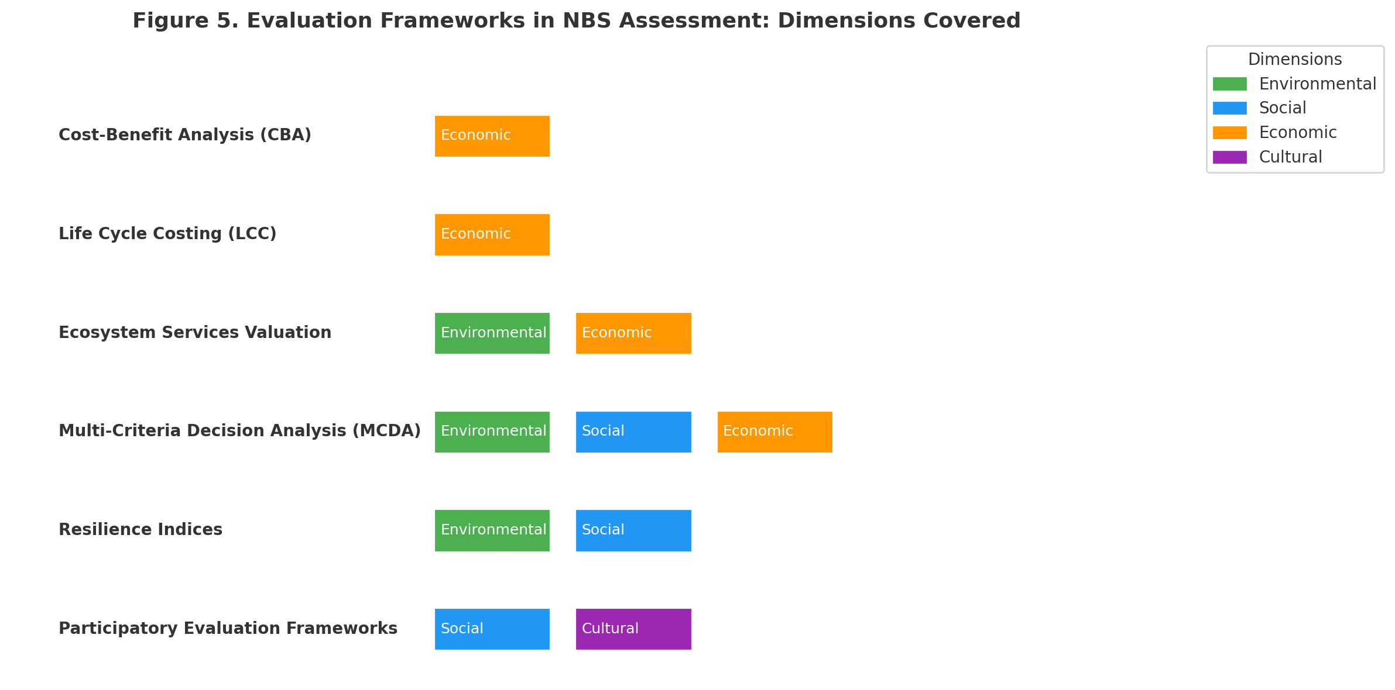
Figure 6. Evaluation Frameworks in NBS Assessment. Source: Author
The methodological heterogeneity identified in the Results section highlights the need for greater standardization in comparative assessments. Based on recurring measurement patterns and identified inconsistencies, a harmonized set of indicators may improve comparability in future research. Economic indicators could include 30-year life-cycle cost (LCC) reported as net present value (NPV) using a 3% real discount rate with sensitivity analysis at 1% and 5%, along with maintenance-cost ratios separated into establishment (0–5 years) and steady-state (6–30 years) phases. Hydrological indicators may include runoff coefficient and peak discharge reduction measured via continuous monitoring or calibrated models, supported by pollutant removal metrics (TSS, TN, TP). Ecological indicators could incorporate habitat area, species richness with standardized field effort, and functional connectivity indices where spatial modelling is applied. Social indicators may include green-space accessibility (m² per person within 300 m), using standardized well-being assessment instruments such as the WHO-5 (World Health Organization Five Well-Being Index) and SF-12 (12-item Short Form Health Survey), which measure psychological and health-related quality of life outcomes. Detailed definitions and metadata requirements are provided in the Supplementary Materials.
To holistically capture these interconnected dimensions, we developed a conceptual framework (Figure 7) that reflects the logic of comparison used in this study. The framework is organized into three layers: (i) infrastructure types (NBS and conventional infrastructure), (ii) evaluation dimensions—including cost-benefit analysis, sustainability outcomes (environmental and social), and resilience and adaptability—and (iii) assessment methods and tools, which include both quantitative and qualitative approaches such as GIS, hydrological models, MCDA, participatory mapping, and ecosystem service valuation. This visual model not only summarizes the analytical trajectory of the study but also provides a transferable structure for future comparative research.
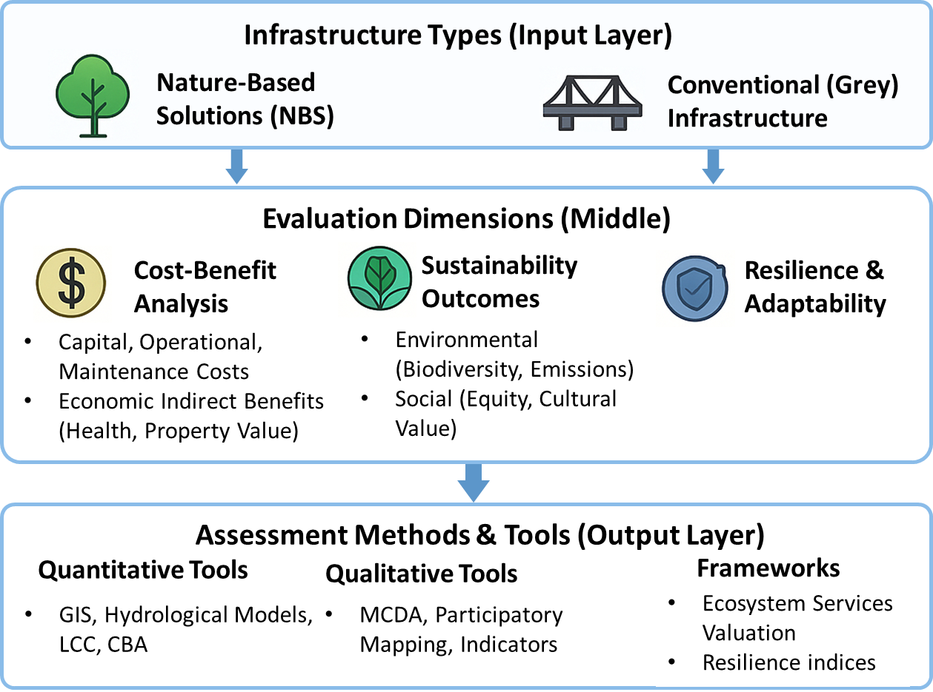
Figure 7. Conceptual Framework for Evaluating NBS vs Conventional Infrastructure
To further understand how NBS and conventional infrastructure are deployed in urban contexts, Table 3 presents a typology of application contexts derived from the classification of the reviewed studies. The table categorizes Nature-Based Solutions (NBS) practices and their conventional infrastructure counterparts into functional themes such as biodiversity support, ecosystem services, urban planning and policy, urban heat mitigation, economic valuation, flood control, stormwater management, and general environmental management. Biodiversity support was the most frequently represented category, accounting for 28 studies (32.18%), followed by ecosystem services (19.54%) and urban planning/policy (13.78%). Other categories, including urban heat mitigation, economic valuation, flood control, and stormwater management, were represented with smaller shares. The distribution of study counts and percentages across categories is detailed in Table 3.
Table 3. Typology of NBS and Conventional Infrastructure Applications Across Reviewed Studies, with Study Counts and Percentage Distribution.
Application Type | NBS Example | Grey Equivalent | Study Count | Percentage (%)
Biodiversity Support | Wetlands, green corridors | Fenced parks, single-species lawns | 28 | 32.18
Ecosystem Services | Blue-green infrastructure | Engineered systems | 17 | 19.54
Urban Planning/Policy | GIS, participatory tools | Zoning plans, masterplans | 12 | 13.78
Urban Heat Mitigation | Urban forests, green roofs | Air conditioning, reflective surfaces | 8 | 9.2
Economic Valuation | LCC, co-benefit models | Cost-based decision tools | 7 | 8.05
Flood Control | Retention ponds, wetlands | Dykes, levees | 6 | 6.9
Stormwater Management | Green roofs, swales | Concrete channels, drainage systems | 6 | 6.9
General Environmental Management | NBS combinations | General grey infrastructure | 3 | 3.45

To understand the systemic factors affecting NBS implementation, we classified and quantified the most cited enablers and barriers into five core thematic categories: policy/institutional, technical/knowledge, financial, social/cultural, and ecological/environmental (Figure 8). Financial barriers were the most frequently reported challenge, cited in 29% of studies, often linked to the lack of long-term funding and valuation metrics for ecosystem services. Technical and knowledge-related barriers were also prevalent (25%), including fragmented data, absence of unified standards, and complexity in modeling multifunctional outcomes. Policy and institutional structures, while often rigid, also acted as enablers in cases where governance frameworks integrated NBS into urban planning (22%). Social and cultural dynamics showed a mixed role—serving as barriers where public resistance or awareness gaps existed, yet also functioning as key enablers through community engagement and co-design processes. The ecological and environmental category was least cited as a direct barrier, although it remains relevant in relation to site-specific limitations and monitoring challenges. This distribution suggests that barriers to NBS implementation extend beyond environmental considerations and involve institutional, financial, and societal dimensions.
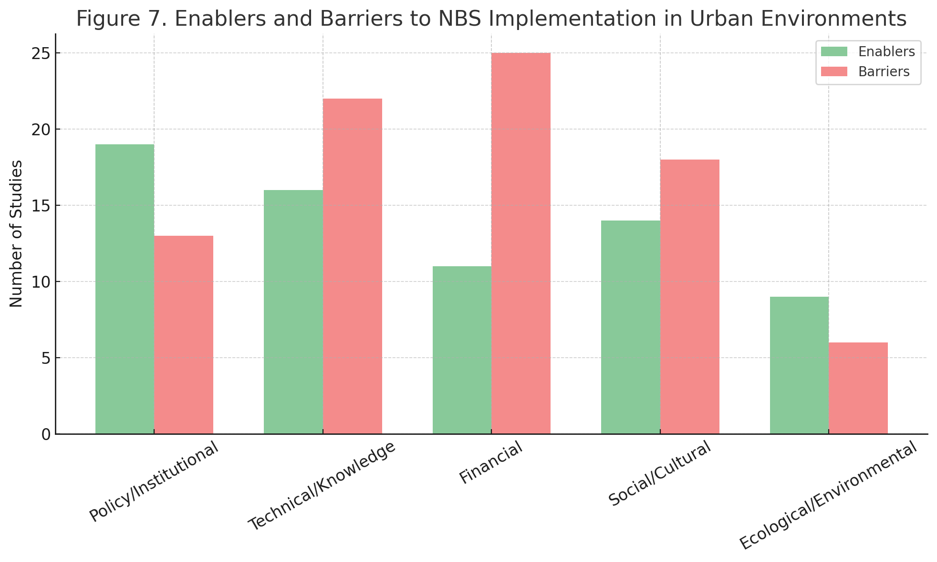
Figure 8. Enablers and Barriers to NBS Implementation in Urban Environments.
- Discussion
This review systematically addressed the core research questions guiding the study through a structured analysis of 87 peer-reviewed studies comparing NBS and conventional grey infrastructure in urban built environments. The key findings are synthesized across three major dimensions: economic performance, sustainability outcomes, and evaluation methodologies. The methodological heterogeneity observed across studies suggests that future meta-analyses would require either restricting inclusion to studies using comparable measurement frameworks (e.g., multi-year empirical monitoring with standardized hydrological metrics) or reconstructing harmonized cost and hydrological effect sizes from primary data. The harmonized indicator framework proposed in this Section may provide a structured basis for improving comparability in subsequent research.
  - Empirical research agenda
The synthesis of the reviewed literature reveals persistent evidence gaps that constrain robust cross-context comparison and long-term inference. Addressing these gaps requires greater methodological convergence and improved empirical design consistency.
First, comparative field-based studies employing paired-catchment or matched-site designs across climatic zones would strengthen hydrological inference. Continuous monitoring over multiple storm events and standardized reporting of runoff coefficients, peak discharge reduction, and pollutant removal would enhance cross-case comparability and enable more reliable performance benchmarking.
Second, controlled experimental or quasi-experimental designs examining microclimate regulation and building-energy interactions—particularly for green roofs and urban tree canopies—would improve understanding of thermal and energy-related co-benefits. Replicated measurements under varying seasonal and urban-density conditions are necessary to isolate intervention effects from background climatic variability.
Third, socio-economic evaluations would benefit from longitudinal and quasi-experimental approaches, such as before–after–control–impact (BACI) frameworks, combined with property transaction datasets and validated wellbeing instruments. Such designs would allow clearer causal inference regarding distributive impacts, equity outcomes, and long-term community benefits.
Fourth, pollutant-removal performance and ecological functionality require more standardized monitoring protocols. Mesocosm experiments and multi-site field trials could clarify the influence of substrate composition, vegetation selection, and maintenance regimes on hydraulic and ecological performance.
Fifth, integrated LCA and life-cycle costing (LCC) models incorporating probabilistic sensitivity analysis would strengthen economic robustness. Transparent reporting of discount rates, service-life assumptions, and uncertainty distributions would enable more defensible cross-study comparison and facilitate future meta-analytic synthesis.
Across all domains, harmonized indicator reporting and open-data practices remain critical for advancing cumulative knowledge. Without improved standardization of cost boundaries, temporal horizons, and sustainability metrics, the evidence base will remain directionally consistent but quantitatively fragmented. Strengthening empirical rigor, geographic diversity, and longitudinal depth will be essential for enhancing external validity and informing policy translation in varied socio-ecological contexts.
  - Synthesis of main findings
The synthesis of the reviewed literature reveals several structural patterns that shape the comparative evaluation of NBS and conventional grey infrastructure in urban environments. Rather than indicating uniform superiority of one approach over the other, the evidence demonstrates that comparative outcomes are highly sensitive to methodological framing, temporal scope, and indicator selection.
From an economic perspective, lifecycle framing emerges as the most decisive variable influencing conclusions. Although NBS frequently require higher upfront investment and greater design coordination, long-term operational savings, avoided damage costs, and ecosystem-service flows often offset initial expenditures (Battisti et al., 2024; Bush & Doyon, 2019; Dawson et al., 2023; de Oliveira, 2025; Derkzen et al., 2017; Kirk et al., 2021; Morgenroth et al., 2025; Proebstl-Haider et al., 2025; Vallejo et al., 2024; B. Zhang, 2025). However, the magnitude and even direction of this advantage depend strongly on discount-rate assumptions, cost-boundary definitions, and the inclusion or exclusion of indirect benefits. Studies applying lower real discount rates tend to favor NBS due to the extended horizon over which ecological and social returns accrue, whereas higher discount rates compress long-term benefits and reduce apparent cost competitiveness (Dondina et al., 2025; Hautamaki et al., 2024; Mahmoud et al., 2025; Thorsson et al., 2025; Uribe-Aguado et al., 2025). This sensitivity suggests that economic comparisons are not purely technical calculations but reflect normative assumptions regarding intergenerational valuation and long-term urban investment priorities (Clauzel et al., 2025; Kilbane et al., 2019; Morgenroth et al., 2025; Parsa et al., 2019; Wanner et al., 2025).
Across sustainability dimensions, ecological outcomes are the most consistently quantified and reported. Hydrological regulation, peak-flow attenuation, temperature moderation, and biodiversity enhancement appear as recurrent strengths of NBS (Battisti et al., 2024; Dorst et al., 2021; Dushkova et al., 2024; Hysa et al., 2025; Llodra-Llabres & Carinanos, 2022; Nygaard, 2024; Ring et al., 2021; Shaamala et al., 2025; Suarez et al., 2025). Socially, they support physical and mental health, recreational use, community engagement, and cultural values (Chalmin-Pui et al., 2021; Grilo et al., 2025; Hansen et al., 2023; Leppanen et al., 2024; M. Li et al., 2025; Rahaman et al., 2024; Zenglein et al., 2025). However, a clear imbalance exists between ecological and socio-cultural metrics. Environmental indicators are typically supported by measurable biophysical data and modelling tools, whereas social outcomes—such as wellbeing, equity, and cultural value—are more frequently assessed through qualitative or perception-based approaches (Fagerholm et al., 2021; Hautamaki et al., 2024; Horvat et al., 2024; Kosma et al., 2023; van Oorschot et al., 2024), indicating a critical gap that must be addressed to ensure inclusive sustainability transitions. This asymmetry may reflect both data availability and disciplinary bias, potentially shaping policy narratives toward measurable ecological gains while underrepresenting distributive justice and long-term social inclusion. The limited integration of equity metrics further constrains understanding of who benefits from NBS investments and under what governance conditions (Focacci et al., 2025; Koranyi et al., 2021; Parsa et al., 2019).
Methodological heterogeneity represents another defining characteristic of the evidence base. The reviewed studies span engineering experiments, ecological field assessments, economic valuations, spatial modelling, and participatory governance analyses (Bush & Doyon, 2019; Di Marino et al., 2024; He et al., 2023; C. Li et al., 2024; Lonsdorf V et al., 2021; Lubaina et al., 2025; Silveira et al., 2025; van Oorschot et al., 2021). While this interdisciplinarity enriches conceptual understanding, it also restricts cumulative comparability (Dorst et al., 2021; Ge et al., 2019; Hoover et al., 2020; Kilbane et al., 2019; Rahaman et al., 2024). Divergent cost scopes, inconsistent service-life assumptions, variable monitoring durations, and heterogeneous outcome metrics limit the feasibility of formal meta-analysis and complicate policy benchmarking. The absence of harmonized reporting standards remains a structural barrier to synthesizing quantitative effect sizes across contexts. The visualization of tools and frameworks in Table 3 and Figure 6 further demonstrated the variation in dimensions (economic, environmental, social, cultural) considered in performance assessments (Adams et al., 2024; Breed et al., 2023; Leppanen et al., 2024; Llodra-Llabres & Carinanos, 2022; Scott et al., 2018; B. Zhang, 2025).
Geographic concentration further influences interpretive validity. A substantial proportion of studies originate from high-income, temperate regions with established governance capacity and formalized planning systems. Urban morphology, labor costs, institutional capacity, and climatic conditions differ significantly in rapidly urbanizing tropical and lower-income contexts (Brandner et al., 2025; Kilbane et al., 2019; Norton et al., 2023). Consequently, cost structures, maintenance feasibility, and performance outcomes documented in the existing literature may not transfer directly to cities with different socio-ecological configurations (Derkzen et al., 2017; Fagerholm et al., 2025; Machac et al., 2022; Mahmoud et al., 2025; Rahaman et al., 2024; Wu et al., 2023). This concentration suggests that the current evidence base provides stronger internal consistency than global generalizability.
Across dimensions, the durability of observed benefits appears closely linked to governance structures and maintenance regimes. Financial and institutional barriers are cited more frequently than ecological limitations, indicating that implementation challenges are often systemic rather than technical. Where policy integration, long-term funding, and community engagement mechanisms are present, NBS outcomes tend to be more stable and scalable. Conversely, fragmented governance and uncertain maintenance responsibilities weaken lifecycle performance claims, regardless of biophysical effectiveness.
  - Theoretical and Methodological Progress in Comparative NBS Research
Despite rapid growth in publication volume, theoretical development within comparative NBS research appears incremental rather than transformative. Early studies primarily framed NBS as environmentally beneficial alternatives to grey infrastructure, often emphasizing ecosystem-service provision without explicit economic integration. More recent contributions increasingly adopt lifecycle and co-benefit perspectives, suggesting gradual convergence toward multi-dimensional evaluation frameworks. However, a unified theoretical model linking economic valuation, governance dynamics, and resilience theory remains underdeveloped. As a result, comparative assessments are often pragmatic and case-specific rather than grounded in a coherent conceptual paradigm.
Methodologically, the field demonstrates both diversification and fragmentation. Advances are visible in the increasing use of lifecycle costing, spatial modelling, and probabilistic sensitivity analysis. However, progress toward harmonized reporting standards remains limited. Discount-rate assumptions, service-life parameters, and ecosystem-service valuation boundaries vary substantially across studies, impeding cumulative synthesis. While technical sophistication has increased, comparability has not improved proportionally, indicating that methodological expansion has outpaced standardization.
The comparative evidence is not uniformly convergent. While many studies report lifecycle cost competitiveness of NBS, others identify higher maintenance burdens or site-specific underperformance, particularly in high-density urban contexts with limited space. Similarly, hydrological benefits are directionally consistent, yet effect magnitudes vary widely depending on soil conditions, vegetation maturity, and maintenance regimes. These inconsistencies suggest that performance claims are context-dependent rather than universally generalizable.
Three structural gaps persist in the literature. First, long-term empirical monitoring beyond 10–15 years remains scarce, limiting confidence in lifecycle durability claims. Second, distributive equity outcomes are rarely quantified using standardized indicators, constraining understanding of who benefits from NBS investments. Third, cross-climatic comparative field studies are limited, restricting generalizability across socio-ecological contexts.
Taken together, the findings indicate that NBS cannot be evaluated solely through short-term engineering efficiency metrics. Their comparative performance depends on temporal scale, accounting assumptions, governance capacity, and the integration of ecological and social valuation frameworks. The current body of evidence supports the potential of NBS to deliver multi-functional benefits; however, methodological fragmentation and geographic bias limit definitive cross-context generalization. Strengthening standardization, expanding longitudinal empirical studies, and improving equity-oriented assessment remain essential for advancing evidence-based comparative infrastructure planning.
Several limitations of this review should be acknowledged. First, the analysis is restricted to peer-reviewed English-language publications indexed in the Web of Science Core Collection. While this ensures academic rigor and methodological transparency, it may exclude relevant case studies, policy reports, and regionally published research, particularly from non-English-speaking and lower-income contexts. Second, despite applying structured inclusion criteria and quality screening, variability in study design, monitoring duration, cost-accounting boundaries, and indicator selection introduces heterogeneity that constrains direct quantitative comparability. The absence of standardized reporting frameworks prevented formal meta-analysis and limits the ability to derive pooled effect estimates. Third, lifecycle economic assessments are sensitive to discount-rate assumptions, service-life parameters, and the monetization of indirect benefits. As these assumptions vary across studies, synthesized cost comparisons should be interpreted as context-dependent rather than universally generalizable. Fourth, bibliometric analysis reflects publication trends rather than implementation intensity and may overrepresent regions with stronger research infrastructure. Finally, although thematic coding was conducted systematically, interpretive synthesis inherently involves researcher judgment. While transparency measures were applied, some degree of analytical subjectivity cannot be fully eliminated.
These limitations suggest that the conclusions of this review should be interpreted as structured synthesis of available evidence rather than definitive performance rankings across all urban contexts.

- CONCLUSION
This review synthesizes comparative evidence on Nature-Based Solutions (NBS) and conventional infrastructure across economic, environmental, socio-cultural, and resilience dimensions. The findings indicate that lifecycle framing is central to cost comparisons: while NBS frequently involve higher upfront investment, long-term cost trajectories often converge or favor NBS when maintenance regimes and ecosystem-service flows are incorporated. Hydrological and ecological outcomes demonstrate consistent directional benefits, yet effect magnitudes vary substantially across climatic, spatial, and governance contexts. A defining characteristic of the evidence base is methodological heterogeneity. Variability in discount-rate assumptions, cost boundaries, monitoring duration, and sustainability indicators limits cross-study comparability and precludes formal meta-analytic synthesis. Moreover, the literature remains geographically concentrated and disproportionately focused on ecological metrics relative to social and equity-oriented outcomes.
Rather than establishing universal superiority of one infrastructure paradigm, the review clarifies the conditions under which comparative advantages are most likely to emerge and identifies structural barriers to cumulative knowledge production. By linking lifecycle economic assumptions, sustainability metrics, and governance capacity to reported performance outcomes, the study advances understanding of how comparative conclusions are constructed and where evidence remains uncertain.
Strengthening standardization, expanding long-term empirical monitoring, and improving geographic and socio-cultural representation will be essential for enhancing the robustness and transferability of comparative infrastructure evaluation in future research.
Data availability statement
All data that support the findings of this study are included within the article (and any supplementary files).
.

References
Adams, C., Moglia, M., & Frantzeskaki, N. (2024). Realising transformative agendas in cities through mainstreaming urban nature-based solutions. URBAN FORESTRY & URBAN GREENING, 91. https://doi.org/10.1016/j.ufug.2023.128160
Aguilera-Rodríguez, J. J., Scolobig, A., Martin, J. G. C., & Linnerooth-Bayer, J. (2025). Implementing nature-based solutions: insights from private contractors and consultants. Nature-Based Solutions, 100278. https://doi.org/10.1016/j.nbsj.2025.100278
Almulhim, A. I. (2023). Urbanization-environment conundrum: an invitation to sustainable development in Saudi Arabian cities. International Journal of Sustainable Development and World Ecology, 30(4), 359–373. https://doi.org/10.1080/13504509.2022.2152199
Alshehri, K., Gao, Z., Harbottle, M., Sapsford, D., & Cleall, P. (2023). Life cycle assessment and cost-benefit analysis of nature-based solutions for contaminated land remediation: A mini-review. Heliyon, 9(10). https://doi.org/10.1016/j.heliyon.2023.e20632
Alves, A., van Opstal, C., Keijzer, N., & Sutton Nora and Chen, W.-S. (2024). Planning the multifunctionality of nature-based solutions in urban spaces. CITIES, 146. https://doi.org/10.1016/j.cities.2023.104751
Alves, A., Vojinovic, Z., Kapelan, Z., Sanchez, A., & Gersonius, B. (2020). Exploring trade-offs among the multiple benefits of green-blue-grey infrastructure for urban flood mitigation. Science of The Total Environment, 703, 134980. https://doi.org/10.1016/j.scitotenv.2019.134980
Alzahrani, S., Ullah, S., & Al-Ghamdi, S. G. (2025). How Can We Cool Warming Cities Using Nature-Based Solutions? Frontiers for Young Minds, 13. https://doi.org/10.3389/frym.2025.1395250
Andrade, G. I., Remolina, F., & Wiesner, D. (2013). Assembling the pieces: a framework for the integration of multi-functional ecological main structure in the emerging urban region of Bogota, Colombia. URBAN ECOSYSTEMS, 16(4, SI), 723–739. https://doi.org/10.1007/s11252-013-0292-5
Arruda, H. (2022). VOSviewer and Bibliometrix. Journal of the Medical Library Association : JMLA, 110(3), 392–395. https://doi.org/10.5195/jmla.2022.1434
Azmeer, A., Tahir, F., & Al-Ghamdi, S. G. (2024). Progress on green infrastructure for urban cooling: Evaluating techniques, design strategies, and benefits. Urban Climate, 56. https://doi.org/10.1016/j.uclim.2024.102077
Badura, T., Lorencova, E. K., Ferrini, S., & Vackarova, D. (2021). Public support for urban climate adaptation policy through nature-based solutions in Prague. LANDSCAPE AND URBAN PLANNING, 215. https://doi.org/10.1016/j.landurbplan.2021.104215
Balzan, M. V. (2025). Scaling nature-based solutions to address the twin crises of biodiversity loss and climate change. Cell Reports Sustainability, 2(4). https://doi.org/10.1016/j.crsus.2025.100387
Barker, A., Garcia-Blanco, G., Garcia, I., & Aguirre-Such, A. (2024). The role of strategic planning in Nature- based Solutions (NBS) transformation: An evaluation of the Green Cities Framework in mainstreaming NBS in 6 European countries. Nature-Based Solutions, 6, 100157. https://doi.org/10.1016/j.nbsj.2024.100157
Battisti, L., Giacco, G., Moraca, M., Pettenati, G., Dansero, E., & Larcher, F. (2024). Spatializing Urban Forests as Nature-based Solutions: a methodological proposal. CITIES, 144. https://doi.org/10.1016/j.cities.2023.104629
Baycan-Levent, T., & Nijkamp, P. (n.d.). Planning and Management of Urban Green Spaces in Europe: Comparative Analysis. https://doi.org/10.1061/ASCE0733-94882009135:11
Bechtel, D., Amberger, R., Helmreich, B., Bienert, S., & Lang, W. (2025). Life cycle cost analysis of urban trees: a case study of five cities in Germany. URBAN FORESTRY & URBAN GREENING, 112. https://doi.org/10.1016/j.ufug.2025.128952
Bertrand-Krajewski, J.-L. (2021). Integrated urban stormwater management: Evolution and multidisciplinary perspective. Journal of Hydro-Environment Research, 38, 72–83. https://doi.org/10.1016/j.jher.2020.11.003
Blackhurst, M., Hendrickson, C., & Matthews, H. S. (2010). Cost-effectiveness of green roofs. Journal of Architectural Engineering, 16(4), 136–143. https://doi.org/10.1061/(ASCE)AE.1943-5568.0000022
Brandner, A., Taczanowska, K., & Zoderer Brenda Maria and Schunko, C. (2025). Mapping wild food foraging locations reveals urban green space preferences and avenues for edible city solutions. URBAN FORESTRY & URBAN GREENING, 104. https://doi.org/10.1016/j.ufug.2024.128602
Breed, C. A., Du Plessis, T., Engemann, K., Pauleit, S., & Pasgaard, M. (2023). Moving green infrastructure planning from theory to practice in sub-Saharan African cities requires collaborative operationalization. URBAN FORESTRY & URBAN GREENING, 89. https://doi.org/10.1016/j.ufug.2023.128085
Brunbjerg, A. K., Hale, J. D., Bates, A. J., Fowler, R. E., Rosenfeld, E. J., & Sadler, J. P. (2018). Can patterns of urban biodiversity be predicted using simple measures of green infrastructure? URBAN FORESTRY & URBAN GREENING, 32, 143–153. https://doi.org/10.1016/j.ufug.2018.03.015
Bush, J., & Doyon, A. (2019). Building urban resilience with nature-based solutions: How can urban planning contribute? CITIES, 95. https://doi.org/10.1016/j.cities.2019.102483
Chalmin-Pui, L. S., Griffiths, A., Roe, J., Heaton, T., & Cameron, R. (2021). Why garden? - Attitudes and the perceived health benefits of home gardening. CITIES, 112. https://doi.org/10.1016/j.cities.2021.103118
Chaudhuri, S., & Kumar, A. (2022). Urban greenery for air pollution control: a meta-analysis of current practice, progress, and challenges. Environmental Monitoring and Assessment. https://doi.org/10.1007/s10661-022-09808-w
Chausson, A., Turner, B., Seddon, D., Chabaneix, N., Girardin, C. A. J., Kapos, V., Key, I., Roe, D., Smith, A., Woroniecki, S., & Seddon, N. (2020). Mapping the effectiveness of nature‐based solutions for climate change adaptation. Global Change Biology, 26(11), 6134–6155. https://doi.org/10.1111/gcb.15310
Chen, W., Wang, W., Huang, G., Wang, Z., Lai, C., & Yang, Z. (2021). The capacity of grey infrastructure in urban flood management: A comprehensive analysis of grey infrastructure and the green-grey approach. International Journal of Disaster Risk Reduction, 54, 102045.
Clauzel, C., Louis-Lucas, T., Bortolamiol, S., Blanc, N., Gresillon, E., Bouteau, F., Laurenti, P., & Clavel, J. (2025). Schoolyard greening to improve functional connectivity in the city and support biodiversity. URBAN FORESTRY & URBAN GREENING, 112. https://doi.org/10.1016/j.ufug.2025.128937
Cook, L. M., Good, K. D., Moretti, M., Kremer Peleg and Wadzuk, B., Traver, R., & Smith, V. (2024). Towards the intentional multifunctionality of urban green infrastructure: a paradox of choice? NPJ URBAN SUSTAINABILITY, 4(1). https://doi.org/10.1038/s42949-024-00145-0
Cotlier, G. I., & Jimenez, J. C. (2022). The Extreme Heat Wave over Western North America in 2021: An Assessment by Means of Land Surface Temperature. Remote Sensing, 14(3). https://doi.org/10.3390/rs14030561
Coutts, C., & Hahn, M. (2015). Green Infrastructure, Ecosystem Services, and Human Health. International Journal of Environmental Research and Public Health, 12(8), 9768–9798. https://doi.org/10.3390/ijerph120809768
Cubi, E., Zibin, N. F., Thompson, S. J., & Bergerson, J. (2016). Sustainability of Rooftop Technologies in Cold Climates: Comparative Life Cycle Assessment of White Roofs, Green Roofs, and Photovoltaic Panels. Journal of Industrial Ecology, 20(2), 249–262. https://doi.org/10.1111/jiec.12269
Das, M., Das, A., & Pandey, R. (2022). Exploring nexus between ecosystem services and livelihood dependency for sustainable ecosystem management in lower Gangetic plains, Eastern India. Environmental Science and Pollution Research. https://doi.org/10.1007/s11356-022-20057-9
Davey, M. L., Blaalid, R., Dahle, S., Stange Erik E. and Barton, D. N., & Rusch, G. M. (2024). Seasonal variation in urban pollen resource use by north temperate European honeybees. URBAN ECOSYSTEMS, 27(2), 515–529. https://doi.org/10.1007/s11252-023-01458-1
Dawson, L., Elbakidze, M., van Ermel, L. E. K., Olsson, U., Ongena, Y. P., Schaffer, C., & Johansson, K.-E. (2023). Why don’t we go outside?-Perceived constraints for users of urban greenspace in Sweden. URBAN FORESTRY & URBAN GREENING, 82. https://doi.org/10.1016/j.ufug.2023.127865
de Oliveira, F. L. (2025). Nature in nature-based solutions in urban planning. LANDSCAPE AND URBAN PLANNING, 256. https://doi.org/10.1016/j.landurbplan.2024.105282
Depietri, Y., & McPhearson, T. (2017). Integrating the Grey, Green, and Blue in Cities: Nature-Based Solutions for Climate Change Adaptation and Risk Reduction. In In Nature-Based Solutions to Climate Change Adaptation in Urban Areas (pp. 91–109). Springer. https://doi.org/10.1007/978-3-319-56091-5_6
Derkzen, M. L., van Teeffelen, A. J. A., & Verburg, P. H. (2017). Green infrastructure for urban climate adaptation: How do residents’ views on climate impacts and green infrastructure shape adaptation preferences? LANDSCAPE AND URBAN PLANNING, 157, 106–130. https://doi.org/10.1016/j.landurbplan.2016.05.027
Dhakal, K. P., & Chevalier, L. R. (2017). Managing urban stormwater for urban sustainability: Barriers and policy solutions for green infrastructure application. Journal of Environmental Management, 203, 171–181. https://doi.org/10.1016/j.jenvman.2017.07.065
Di Marino, M., Tiitu, M., Saglie, I.-L., & Lapintie, K. (2024). Conceptualizing `green’ in urban and regional planning - the cases of Oslo and Helsinki. EUROPEAN PLANNING STUDIES, 32(6), 1187–1209. https://doi.org/10.1080/09654313.2023.2285811
Donatti, C. I., Andrade, A., Cohen-Shacham, E., Fedele, G., Hou-Jones, X., & Robyn, B. (2022). Ensuring that nature-based solutions for climate mitigation address multiple global challenges. One Earth, 5(5), 493–504. https://doi.org/10.1016/j.oneear.2022.04.010
Dondina, O., Tirozzi, P., Viviano, A., Mori, E., Orioli, V., Tommasi, N., Tanzi Alessandro and Bazzoli, L., Caprio, E., Patetta, C., Pastore, M. C., Bani, L., & Ancillotto, L. (2025). Spatial and habitat determinants of small-mammal biodiversity in urban green areas: Lessons for nature-based solutions. URBAN FORESTRY & URBAN GREENING, 104. https://doi.org/10.1016/j.ufug.2024.128641
Dorst, H., van der Jagt, A., Runhaar, H., & Raven, R. (2021). Structural conditions for the wider uptake of urban nature-based solutions-A conceptual framework. CITIES, 116. https://doi.org/10.1016/j.cities.2021.103283
du Toit, M. J., Cilliers, S. S., Dallimer, M., Goddard, M., Guenat, S., & Cornelius, S. F. (2018). Urban green infrastructure and ecosystem services in sub-Saharan Africa. LANDSCAPE AND URBAN PLANNING, 180, 249–261. https://doi.org/10.1016/j.landurbplan.2018.06.001
Dushkova, D., Ignatieva, M., Konstantinova, A., Nilon, C., & Mueller, N. (2024). Urban biodiversity and design in time of (post)pandemics: research perspectives from URBIO international network. URBAN ECOSYSTEMS, 27(5), 1767–1779. https://doi.org/10.1007/s11252-024-01547-9
Fagerholm, N., Eilola, S., & Arki, V. (2021). Outdoor recreation and nature’s contribution to well-being in a pandemic situation-Case Turku, Finland. URBAN FORESTRY & URBAN GREENING, 64. https://doi.org/10.1016/j.ufug.2021.127257
Fagerholm, N., Tanhuanpaa, T., Hasanzadeh, K., Kajosaari, A., Rinne, T., Holpainen, M., & Kytta, M. (2025). Urban green infrastructure and recreational patterns: A 3D geospatial data analysis. URBAN FORESTRY & URBAN GREENING, 112. https://doi.org/10.1016/j.ufug.2025.128892
Fedele, G., Donatti, C. I., Harvey, C. A., Hannah, L., & Hole, D. G. (2019). Transformative adaptation to climate change for sustainable social-ecological systems. Environmental Science & Policy, 101, 116–125. https://doi.org/10.1016/j.envsci.2019.07.001
Finewood, M. H., Matsler, A. M., & Zivkovich, J. (2019). Green Infrastructure and the Hidden Politics of Urban Stormwater Governance in a Postindustrial City. Annals of the American Association of Geographers, 109(3), 909–925. https://doi.org/10.1080/24694452.2018.1507813
Focacci, M., Schaffer, C., de Meo, I., Paletto, A., & Salbitano, F. (2025). Exploration of the functions and potentials of urban forest gardens in Sweden. URBAN FORESTRY & URBAN GREENING, 112. https://doi.org/10.1016/j.ufug.2025.128990
Frantzeskaki, N. (2019). Seven lessons for planning nature-based solutions in cities. Environmental Science & Policy, 93, 101–111. https://doi.org/10.1016/j.envsci.2018.12.033
Fu, J., Dupre, K., Tavares, S., King, D., & ... (2022). Optimized greenery configuration to mitigate urban heat: A decade systematic review. Frontiers of Architectural …. https://www.sciencedirect.com/science/article/pii/S209526352100100X
Ge, B., Mehring, A. S., & Levin, L. A. (2019). Urbanization alters belowground invertebrate community structure in semi-arid regions: A comparison of lawns, biofilters and sage scrub. LANDSCAPE AND URBAN PLANNING, 192. https://doi.org/10.1016/j.landurbplan.2019.103664
Gies, E. (2006). The Health Benefits of Parks How Parks Help Keep Americans and Their Communities Fit and Healthy. www.tpl.org
González-García, A., Palomo, I., Codemo, A., Rodeghiero, M., Dubo, T., Vallet, A., & Lavorel, S. (2025). Co-benefits of nature-based solutions exceed the costs of implementation. Cell Reports Sustainability, 2(3). https://doi.org/10.1016/j.crsus.2025.100336
Gorm Dige. (2015). Green infrastructure: better living through nature-based solutions. https://www.eea.europa.eu/articles/green-infrastructure-better-living-through
Grabowski, Z. J., McPhearson, T., & Pickett, S. T. A. (2023). Transforming US urban green infrastructure planning to address equity. LANDSCAPE AND URBAN PLANNING, 229. https://doi.org/10.1016/j.landurbplan.2022.104591
Grilo, F., Mcphearson, T., Aleixo, C., Santos-Reis, M., & Branquinho, C. (2025). Urban trees through a functional traits’ lens: Exploring the interplay between tree functional groups and social-ecological factors. URBAN FORESTRY & URBAN GREENING, 107. https://doi.org/10.1016/j.ufug.2025.128749
Haghani, M., Sabri, S., De Gruyter, C., Ardeshiri, A., Shahhoseini, Z., Sanchez, T. W., & Acuto, M. (2023). The landscape and evolution of urban planning science. CITIES, 136. https://doi.org/10.1016/j.cities.2023.104261
Halder, N., & Kumar, D. (2025). Towards Reviving Vernacular Architecture in India: Insights into the Indigenous Building Traditions. Journal of the International Society for the Study of Vernacular Settlements (ISVS e-Journal), 12(5), 40–54. https://doi.org/10.61275/ISVSej-2025-12-05-03
Halder, N., Kumar, M., Deepak, A., Kumar, D., Yasmin, N., Ullah, S., & Al-Ghamdi, S. G. (2025). Spatiotemporal Assessment of Urban Thermal Discomfort in Kolkata, India: Insights from Cloud-Based Remote Sensing. IEEE Journal of Selected Topics in Applied Earth Observations and Remote Sensing, 1–17. https://doi.org/10.1109/JSTARS.2025.3607940
Halder, N., Kumar, M., Deepak, A., Mandal, S. K., Azmeer, A., Mir, B. A., Nurdiawati, A., & Al-Ghamdi, S. G. (2025). The Role of Urban Greenery in Enhancing Thermal Comfort: Systematic Review Insights. Sustainability, 17(6), 2545. https://doi.org/10.3390/su17062545
Hansen, R., Mattes, A., Meier, M., & Kurths, A. (2023). Reorienting urban green infrastructure planning towards biodiversity - Perspectives and ongoing debates from Germany. URBAN FORESTRY & URBAN GREENING, 90. https://doi.org/10.1016/j.ufug.2023.128155
Haque, Md. N., Saroar, M., Fattah, Md. A., & Morshed, S. R. (2022). Environmental benefits of blue ecosystem services and resident’s willingness to pay in Khulna city, Bangladesh. Heliyon, 8(5). https://doi.org/10.1016/j.heliyon.2022.e09535
Hartig, T., Mitchell, R., de Vries, S., & Frumkin, H. (2014). Nature and Health. Annual Review of Public Health, 35(1), 207–228. https://doi.org/10.1146/annurev-publhealth-032013-182443
Hartmann, T., Slavíková, L., & Mccarthy, S. (2019). Nature-Based Flood Risk Management on Private Land Disciplinary Perspectives on a Multidisciplinary Challenge.
Hautamaki, R., Puustinen, T., Merikoski, T., & Staffans, A. (2024). Greening the compact city: Unarticulated tensions and incremental advances in municipal climate action plans. CITIES, 152. https://doi.org/10.1016/j.cities.2024.105251
He, M., Ge, D., Jiang, J., Wang, P., & Yao, C. (2023). How do urban function and development level effect construction level of green infrastructure? A case study of 110 built-up areas of cities in the Yangtze River Economic Zone. CITIES, 143. https://doi.org/10.1016/j.cities.2023.104620
Herrera-Franco, G. (2021). Worldwide research on geoparks through bibliometric analysis. Sustainability (Switzerland), 13(3), 1–32. https://doi.org/10.3390/su13031175
Hoover, F.-A., Meerow, S., Coleman, E., Grabowski, Z., & McPhearson, T. (2023). Why go green? Comparing rationales and planning criteria for green infrastructure in US city plans. LANDSCAPE AND URBAN PLANNING, 237. https://doi.org/10.1016/j.landurbplan.2023.104781
Hoover, F.-A., Price I, J., & Hopton, M. E. (2020). Examining the effects of green infrastructure on residential sales prices in Omaha, Nebraska. URBAN FORESTRY & URBAN GREENING, 54. https://doi.org/10.1016/j.ufug.2020.126778
Horvat, E., Sipek, M., & Sajna, N. (2024). Urban hedges facilitate spontaneous woody plants. URBAN FORESTRY & URBAN GREENING, 96. https://doi.org/10.1016/j.ufug.2024.128336
Huesca-Domínguez, I., Morteo, E., & ... (2023). Two decades of the Latin American Journal of Aquatic Mammals (LAJAM): A bibliometric review for the period 2002–2022. … American Journal of …. https://www.lajamjournal.org/index.php/lajam/article/view/1549
Hysa, A., Lowe, R., & Geist, J. (2025). Waterfront usage trends across German metropolitan areas: A social-ecological perspective to urban blue-green infrastructure connectivity. LANDSCAPE AND URBAN PLANNING, 260. https://doi.org/10.1016/j.landurbplan.2025.105369
Jerome, G., Sinnett, D., Burgess, S., Calvert, T., & Mortlock, R. (2019). A framework for assessing the quality of green infrastructure in the built environment in the UK. URBAN FORESTRY & URBAN GREENING, 40(SI), 174–182. https://doi.org/10.1016/j.ufug.2019.04.001
Jiangyi, L. (2020). Cost-effectiveness analysis of different types of payments for ecosystem services: A case in the urban wetland ecosystem. Journal of Cleaner Production, 249. https://doi.org/10.1016/j.jclepro.2019.119325
Kabisch, N., Frantzeskaki, N., Pauleit, S., Naumann, S., Davis, M., Artmann, M., Haase, D., Knapp, S., Korn, H., Stadler, J., Zaunberger, K., & Bonn, A. (2016). Nature-based solutions to climate change mitigation and adaptation in urban areas: perspectives on indicators, knowledge gaps, barriers, and opportunities for action. Ecology and Society, 21(2), art39. https://doi.org/10.5751/ES-08373-210239
Kabisch, N., & Haase, D. (2014). Green justice or just green? Provision of urban green spaces in Berlin, Germany. Landscape and Urban Planning, 122, 129–139. https://doi.org/10.1016/j.landurbplan.2013.11.016
Kato-Huerta, J., & Geneletti, D. (2023). Analysing the treatment of environmental justice and nature-based solutions in the Urban Climate Action Plans of Latin American metropolitan areas. LOCAL ENVIRONMENT, 28(11), 1388–1409. https://doi.org/10.1080/13549839.2023.2221431
Khan, M. I., Yasmeen, T., Khan, M., Hadi, N. U., Asif, M., Farooq, M., & Al-Ghamdi, S. G. (2025). Integrating industry 4.0 for enhanced sustainability: Pathways and prospects. Sustainable Production and Consumption, 54, 149–189. https://doi.org/10.1016/j.spc.2024.12.012
Khoshhalshaghaji, F., Chin, R. J., & Lim, P. I. (2025). Application of the SWOT-IE to improve stormwater management via a nature-based solution in Kuala Lumpur, Malaysia. Heliyon, 11(4). https://doi.org/10.1016/j.heliyon.2025.e42700
Kilbane, S., Weller, R., & Hobbs, R. (2019). Beyond ecological modelling: ground-truthing connectivity conservation networks through a design charrette in Western Australia. LANDSCAPE AND URBAN PLANNING, 191. https://doi.org/10.1016/j.landurbplan.2017.05.001
Kindvall, O., Pont, M. B., Stavroulaki, I., Lanemo, E., Wigren, L., & Levan, M. (2025). Predicting habitat functionality using habitat network models in urban planning. ENVIRONMENT AND PLANNING B-URBAN ANALYTICS AND CITY SCIENCE, 52(6), 1482–1497. https://doi.org/10.1177/23998083241299165
Kirby, A. (2023). Exploratory Bibliometrics: Using VOSviewer as a Preliminary Research Tool. Publications, 11(1). https://doi.org/10.3390/publications11010010
Kirk, H., Garrard, G. E., Croeser, T., Backstrom, A., Berthon, K., Furlong, C., Hurley, J., Thomas, F., Webb, A., & Bekessy, S. A. (2021). Building biodiversity into the urban fabric: A case study in applying Biodiversity Sensitive Urban Design (BSUD). URBAN FORESTRY & URBAN GREENING, 62. https://doi.org/10.1016/j.ufug.2021.127176
Koranyi, D., Galle, R., Donko, B., Chamberlain, D. E., & Batary, P. (2021). Urbanization does not affect green space bird species richness in a mid-sized city. URBAN ECOSYSTEMS, 24(4), 789–800. https://doi.org/10.1007/s11252-020-01083-2
Kosma, M., Laita, A., & Duflot, R. (2023). No net loss of connectivity: Conserving habitat networks in the context of urban expansion. LANDSCAPE AND URBAN PLANNING, 239. https://doi.org/10.1016/j.landurbplan.2023.104847
Kristi Miley. (2020). Global Health Security - Recognizing Vulnerabilities, Creating Opportunities (A. J. Masys, R. Izurieta, & M. Reina Ortiz, Eds.; 1st ed.). Springer International Publishing. https://doi.org/10.1007/978-3-030-23491-1
Kumar, D., Maurya, K. K., Mandal, S. K., Halder, N., Mir, B. A., Nurdiawati, A., & Al-Ghamdi, S. G. (2025). A Whole-Life Carbon Assessment of a Single-Family House in North India Using BIM-LCA Integration. Buildings, 15(13), 2195. https://doi.org/10.3390/buildings15132195
Kumar, D., Maurya, K. K., Mandal, S. K., Mir, B. A., Nurdiawati, A., & Al-Ghamdi, S. G. (2025). Life Cycle Assessment in the Early Design Phase of Buildings: Strategies, Tools, and Future Directions. Buildings, 15(10), 1612. https://doi.org/10.3390/buildings15101612
Kumar, D., & Shukla, B. (2022). Urban Green Spaces For Promoting Healthy Living And Wellbeing: Prospects For Housing. ECS Transactions, 107(1), 18835–18857. https://doi.org/10.1149/10701.18835ecst
Lallemant, D., Hamel, P., Balbi, M., Lim, T. N., Schmitt, R., & Win, S. (2021). Nature-based solutions for flood risk reduction: A probabilistic modeling framework. One Earth, 4(9), 1310–1321. https://doi.org/10.1016/j.oneear.2021.08.010
Leppanen, P.-K., Kinnunen, A., Hautamaki, R., Jarvi, L., Havu, M., Junnila, S., & Tahvonen, O. (2024). Impact of changing urban typologies on residential vegetation and its climate-effects - A case study from Helsinki, Finland. URBAN FORESTRY & URBAN GREENING, 96. https://doi.org/10.1016/j.ufug.2024.128343
Li, C., Xue, Y., & Fu, X. (2024). Urban Built Environment and Flood Ramifications: Evidence from Insurance Claims Data in Miami, Florida. JOURNAL OF PLANNING EDUCATION AND RESEARCH. https://doi.org/10.1177/0739456X241276854
Li, J., Mao, Y., Ouyang, J., & Zheng, S. (2022). A review of urban microclimate research based on CiteSpace and VOSviewer analysis. International Journal of Environmental …. https://www.mdpi.com/1660-4601/19/8/4741
Li, M., Remme, R. P., van Bodegom, P. M., & van Oudenhoven, A. P. E. (2025). Solution to what? Global assessment of nature-based solutions, urban challenges, and outcomes. LANDSCAPE AND URBAN PLANNING, 256. https://doi.org/10.1016/j.landurbplan.2025.105294
Li, Q., Monticelli, C., Kutlu, A., & Zanelli, A. (2023). Feasibility of textile envelope integrated flexible photovoltaic in Europe: Carbon footprint assessment and life cycle cost analysis. Journal of Cleaner Production, 430. https://doi.org/10.1016/j.jclepro.2023.139716
Llodra-Llabres, J., & Carinanos, P. (2022). Enhancing pollination ecosystem service in urban green areas: An opportunity for the conservation of pollinators. URBAN FORESTRY & URBAN GREENING, 74. https://doi.org/10.1016/j.ufug.2022.127621
Longato, D., Cortinovis, C., Balzan, M., & Geneletti, D. (2023). A method to prioritize and allocate nature-based solutions in urban areas based on ecosystem service demand. LANDSCAPE AND URBAN PLANNING, 235. https://doi.org/10.1016/j.landurbplan.2023.104743
Longato, D., Cortinovis, C., Balzan, M., & Geneletti, D. (2024). Identifying suitable policy instruments to promote nature-based solutions in urban plans. CITIES, 154. https://doi.org/10.1016/j.cities.2024.105348
Lonsdorf V, E., Nootenboom, C., Janke, B., & Horgan, B. P. (2021). Assessing urban ecosystem services provided by green infrastructure: Golf courses in the Minneapolis-St. Paul metro area. LANDSCAPE AND URBAN PLANNING, 208. https://doi.org/10.1016/j.landurbplan.2020.104022
Lu, J., Xu, Y., Zhu, J., & Hernando, A. (2023). Assessing Environmental Attitudes under China’s Accelerating Ecological Civilization: A Case of the Urban Green Infrastructure Project in Zhangjiagang Bay. JOURNAL OF URBAN PLANNING AND DEVELOPMENT, 149(4). https://doi.org/10.1061/JUPDDM.UPENG-4277
Lubaina, S., Asifa, I., & Agha, S. A. (2025). The concept of sponge city as a nature-based solution for urban resilience: Insights from stakeholders in Karachi, Pakistan. HABITAT INTERNATIONAL, 165. https://doi.org/10.1016/j.habitatint.2025.103564
Lundholm, J. T. (2015). The ecology and evolution of constructed ecosystems as green infrastructure. Frontiers in Ecology and Evolution. https://doi.org/10.3389/fevo.2015.00106
Machac, J., Brabec, J., & Arnberger, A. (2022). Exploring public preferences and preference heterogeneity for green and blue infrastructure in urban green spaces. URBAN FORESTRY & URBAN GREENING, 75. https://doi.org/10.1016/j.ufug.2022.127695
Mahdiyar, A., Tabatabaee, S., Sadeghifam, A. N., & ... (2016). Probabilistic private cost-benefit analysis for green roof installation: A Monte Carlo simulation approach. Urban Forestry &urban …. https://www.sciencedirect.com/science/article/pii/S1618866716302709
Mahmoud, I., Dubois, G., Liquete, C., & Robuchon, M. (2025). Understanding collaborative governance of biodiversity-inclusive urban planning: Methodological approach and benchmarking results for urban nature plans in 10 European cities. URBAN ECOSYSTEMS, 28(2). https://doi.org/10.1007/s11252-024-01656-5
Maurer, M., Chang, P., Olafsson, A. S., Moller, M. S., & Gulsrud, N. M. (2023). A social-ecological-technological system approach to just nature-based solutions: A case of digital participatory mapping of meaningful places in a marginalized neighborhood in Copenhagen, Denmark. URBAN FORESTRY & URBAN GREENING, 89. https://doi.org/10.1016/j.ufug.2023.128120
Megyesi, B., Gholipour, A., Cuomo, F., Canga, E., Tsatsou, A., Zihlmann, V., Junge, R., Milosevic, D., & Pineda-Martos, R. (2024). Perceptions of stakeholders on nature-based solutions in urban planning: A thematic analysis in six European cities. URBAN FORESTRY & URBAN GREENING, 96. https://doi.org/10.1016/j.ufug.2024.128344
Mell, I. C., Henneberry, J., Hehl-Lange, S., & Keskin, B. (2016). To green or not to green: Establishing the economic value of green infrastructure investments in The Wicker, Sheffield. URBAN FORESTRY & URBAN GREENING, 18, 257–267. https://doi.org/10.1016/j.ufug.2016.06.015
Miller, J. D., Vesuviano, G., Wallbank, J. R., Fletcher, D. H., & Jones, L. (2023). Hydrological assessment of urban Nature-Based Solutions for urban planning using Ecosystem Service toolkit applications. LANDSCAPE AND URBAN PLANNING, 234. https://doi.org/10.1016/j.landurbplan.2023.104737
Mir, B. A., Nurdiawati, A., & Al-Ghamdi, S. G. (2024). Assessing the environmental impact of freshwater use in LCA: established practices and current methods. In Environmental Science: Water Research and Technology. Royal Society of Chemistry. https://doi.org/10.1039/d4ew00641k
Morgenroth, J., Doick, K., Hauer, R., Locke, D. H., Barora, C. O., Roman, L. A., Conway, T. M., Dobbs, C., Duinker, P., Gulsrud Natalie M. and Jim, C. Y., Koeser, A. K., Landry, S., Livesley, S., Nesbitt, L., Shackleton, C. M., & Tan P. Y. and Yang, J. (2025). Urban tree cover targets: The good, the bad and the SMART. URBAN FORESTRY & URBAN GREENING, 112. https://doi.org/10.1016/j.ufug.2025.128979
Morpurgo, J., Huurdeman, M. A., & Oostermeijer J. Gerard B. and Remme, R. P. (2024). Vegetation density is the main driver of insect species richness and diversity in small private urban front gardens. URBAN FORESTRY & URBAN GREENING, 101. https://doi.org/10.1016/j.ufug.2024.128531
Ncube, S., & Arthur, S. (2021). Influence of Blue-Green and Grey Infrastructure Combinations on Natural and Human-Derived Capital in Urban Drainage Planning. Sustainability, 13(5), 2571. https://doi.org/10.3390/su13052571
Norton, B. A., Mears, M., Warren, P. H., Siriwardena, G. M., Plummer, K. E., Turner, T., Hancock, S., Grafius, D. R., & Evans, K. L. (2023). Biodiversity and environmental stressors along urban walking routes. URBAN FORESTRY & URBAN GREENING, 85. https://doi.org/10.1016/j.ufug.2023.127951
Nygaard, C. A. (2024). Green infrastructure and socioeconomic dynamics in London low-income neighbourhoods: A 120-year perspective. CITIES, 144. https://doi.org/10.1016/j.cities.2023.104616
O’Donnell, E. C., Lamond, J. E., & Thorne, C. R. (2017). Recognising barriers to implementation of Blue-Green Infrastructure: a Newcastle case study. Urban Water Journal, 14(9), 964–971. https://doi.org/10.1080/1573062X.2017.1279190
Page, M. J., McKenzie, J. E., Bossuyt, P. M., Boutron, I., Hoffmann, T. C., Mulrow, C. D., Shamseer, L., Tetzlaff, J. M., Akl, E. A., Brennan, S. E., Chou, R., Glanville, J., Grimshaw, J. M., Hróbjartsson, A., Lalu, M. M., Li, T., Loder, E. W., Mayo-Wilson, E., McDonald, S., … Moher, D. (2021a). The PRISMA 2020 statement: An updated guideline for reporting systematic reviews. In The BMJ (Vol. 372). BMJ Publishing Group. https://doi.org/10.1136/bmj.n71
Page, M. J., McKenzie, J. E., Bossuyt, P. M., Boutron, I., Hoffmann, T. C., Mulrow, C. D., Shamseer, L., Tetzlaff, J. M., Akl, E. A., Brennan, S. E., Chou, R., Glanville, J., Grimshaw, J. M., Hróbjartsson, A., Lalu, M. M., Li, T., Loder, E. W., Mayo-Wilson, E., McDonald, S., … Moher, D. (2021b). The PRISMA 2020 statement: an updated guideline for reporting systematic reviews. BMJ, 372. https://doi.org/10.1136/bmj.n71
Palomo, I., Locatelli, B., Otero, I., Colloff, M., Crouzat, E., Cuni-Sanchez, A., Gómez-Baggethun, E., González-García, A., Grêt-Regamey, A., Jiménez-Aceituno, A., Martín-López, B., Pascual, U., Zafra-Calvo, N., Bruley, E., Fischborn, M., Metz, R., & Lavorel, S. (2021). Assessing nature-based solutions for transformative change. One Earth, 4(5), 730–741. https://doi.org/10.1016/j.oneear.2021.04.013
Parsa, V. A., Salehi, E., Yavari, A. R., & van Bodegom, P. M. (2019). Evaluating the potential contribution of urban ecosystem service to climate change mitigation. URBAN ECOSYSTEMS, 22(5), 989–1006. https://doi.org/10.1007/s11252-019-00870-w
Pearlmutter, D., Pucher, B., Calheiros, C. S. C., Hoffmann, K. A., Aicher, A., Pinho, P., Stracqualursi, A., Korolova, A., Pobric, A., Galvão, A., Pitha, U., & Nehls, T. (2021). Closing water cycles in the built environment through nature‐based solutions: The contribution of vertical greening systems and green roofs. Water (Switzerland), 13(16). https://doi.org/10.3390/w13162165
Pelorosso, R., Gobattoni, F., & Leone, A. (2017). Green Courtyards as Urban Cool Islands: towards Nature-based climate adaptation plans of compact cities. CSE-City Safety Energy. https://journals.lepenseur.it/index.php/cse/article/view/86
Perrotti, D., & Stremke, S. (2020). Can urban metabolism models advance green infrastructure planning? Insights from ecosystem services research. ENVIRONMENT AND PLANNING B-URBAN ANALYTICS AND CITY SCIENCE, 47(4), 678–694. https://doi.org/10.1177/2399808318797131
Pradilla, G., & Hack, J. (2024). An urban rivers renaissance? Stream restoration and green-blue infrastructure in Latin America - Insights from urban planning in Colombia. URBAN ECOSYSTEMS, 27(6), 2245–2265. https://doi.org/10.1007/s11252-024-01571-9
Proebstl-Haider, U., Feilhammer, M., & Wanner, A. (2025). The influence of payments and time payments: Preconditions to implement nature-based solutions in Austrian cities. CITIES, 162. https://doi.org/10.1016/j.cities.2025.105990
Rahaman, G. M. A., Langkvist, M., & Loutfi, A. (2024). Deep learning based automated estimation of urban green space index from satellite image: A case study. URBAN FORESTRY & URBAN GREENING, 97. https://doi.org/10.1016/j.ufug.2024.128373
Rathod, V. (2025). DESIGNING TOMORROW: RETHINKING URBAN PLANNING FOR RESILIENT CITIES. INTERNATIONAL JOURNAL OF URBAN AND REGIONAL PLANNING RESEARCH AND DEVELOPMENT, 3(2), 1–19. https://doi.org/10.34218/IJURPRD_03_02_001
Raum, S., Hossu, C.-A., Lupp, G., Pauleit, S., & Egerer, M. (2024). Stakeholder exposure to and knowledge of tree pests and diseases and their management in urban areas. URBAN FORESTRY & URBAN GREENING, 100. https://doi.org/10.1016/j.ufug.2024.128456
Raymond, C. M., Frantzeskaki, N., Kabisch, N., Berry, P., Breil, M., Nita, M. R., Geneletti, D., & Calfapietra, C. (2017). A framework for assessing and implementing the co-benefits of nature-based solutions in urban areas. Environmental Science & Policy, 77, 15–24. https://doi.org/10.1016/j.envsci.2017.07.008
Ring, Z., Damyanovic, D., & Reinwald, F. (2021). Green and open space factor Vienna: A steering and evaluation tool for urban green infrastructure. URBAN FORESTRY & URBAN GREENING, 62. https://doi.org/10.1016/j.ufug.2021.127131
Rojas, C., Munizaga, J., Rojas, O., Martínez, C., & Pino, J. (2019). Urban development versus wetland loss in a coastal Latin American city: Lessons for sustainable land use planning. Land Use Policy, 80, 47–56. https://doi.org/10.1016/j.landusepol.2018.09.036
Sánchez Jiménez, J. L., & de Adana, M. (2024). Assessment of Outdoor Thermal Comfort in a Hot Summer Region of Europe. Atmosphere, 15(2). https://doi.org/10.3390/atmos15020214
Saqib, A., Khan, M. S. U., & Rana, I. A. (2024). Bridging Nature and Urbanity Through Green Roof Resilience Framework (GRF): A Thematic Review. Nature-Based Solutions. https://www.sciencedirect.com/science/article/pii/S2772411524000739
Schellenberg, T., Subramanian, V., & ... (2020). Wastewater discharge standards in the evolving context of urban sustainability–The case of India. Frontiers in …. https://doi.org/10.3389/fenvs.2020.00030
Scott, A., Dean, A., Barry, V., & Kotter, R. (2018). Places of urban disorder? Exposing the hidden nature and values of an English private urban allotment landscape. LANDSCAPE AND URBAN PLANNING, 169, 185–198. https://doi.org/10.1016/j.landurbplan.2017.09.004
Shaamala, A., Tilly, N., & Yigitcanlar, T. (2025). Leveraging urban AI for high-resolution urban heat mapping: Towards climate resilient cities. ENVIRONMENT AND PLANNING B-URBAN ANALYTICS AND CITY SCIENCE. https://doi.org/10.1177/23998083251337864
Shu, X., Mesimaki, M., Kotze, D. J., Wales, M., Xie, L., Benicke, R., & Lehvavirta, S. (2022). Needs and expectations of German and Chinese children for livable urban green spaces revealed by the method of empathy-based stories. URBAN FORESTRY & URBAN GREENING, 68. https://doi.org/10.1016/j.ufug.2022.127476
Silveira, C., Piston, N., Martinez-Lopez, J., Alcaraz-Segura, D., Postma, T., & Lopez-Torralbo Juan M. and Zamora, R. (2025). Identifying priority heat-risk areas in Granada, Spain, using InVEST and landscape metrics. URBAN FORESTRY & URBAN GREENING, 107. https://doi.org/10.1016/j.ufug.2025.128794
Suarez, M. J. A., Garcia, M. D., & Leiras, A. (2025). Sociological perspectives on urban green infrastructure: Identifying research gaps and advancing future directions. URBAN FORESTRY & URBAN GREENING, 111. https://doi.org/10.1016/j.ufug.2025.128873
Sultana, M. N., Akib, S., & Ashraf, M. A. (2017). Thermal comfort and runoff water quality performance on green roofs in tropical conditions. Geology, Ecology, and …. https://doi.org/10.1080/24749508.2017.1301058
Sweta Rupapara, Vishva Rathod, Harsh Rupapara, Nandini Halder, & Deepak Kumar. (2025). Evaluating the benefits of urban greenery in Urban Heat Island mitigation: Methods, indicators and gaps. Nature Environment and Pollution Technology, 24(4). https://doi.org/https://doi.org/10.46488/NEPT.2025.v24i04.D1812
Thorn, J. P. R., Maruza, T. C. G., & Stoffberg, M. (2025). Climate justice and informal trader’s access to urban green spaces. CITIES, 159. https://doi.org/10.1016/j.cities.2025.105725
Thorsson, S., Backlin, O., Friberg, J., Eriksson, S. F., Haghighatafshar, S., Konarska, J., Kotze, S., Lindberg, F., Malmberg, C.-A., Rayner, D., Schade, J., Strom, L., Sunden, B., Sundstrom, B., Wallenberg, N., & Ylmen, P. (2025). A framework for integrated assessment of blue-green infrastructure: A decision support tool for evaluating climate adaptation and social benefits in relation to construction and maintenance costs. CITIES, 166. https://doi.org/10.1016/j.cities.2025.106239
Uribe-Aguado, J., Patino, J. N., Wild, T., Kozak, D., & Sanchez, J. P. R. (2025). A decision support tool for the selection of biophysical methodologies to assess urban nature-based solutions using regulating ecosystem services. URBAN FORESTRY & URBAN GREENING, 112. https://doi.org/10.1016/j.ufug.2025.128842
Vallejo, A. N., Schwarz-v.Raumer, H.-G., & Eisenberg, B. (2024). The interplay of land-use and land-ownership as a key for urban greening management. URBAN FORESTRY & URBAN GREENING, 99. https://doi.org/10.1016/j.ufug.2024.128442
van Eck, N. J. (2010). Software survey: VOSviewer, a computer program for bibliometric mapping. Scientometrics, 84(2), 523–538. https://doi.org/10.1007/s11192-009-0146-3
van Oorschot, J., Slootweg, M., Remme, R. P., Sprecher, B., & van der Voet, E. (2024). Optimizing green and gray infrastructure planning for sustainable urban development. NPJ URBAN SUSTAINABILITY, 4(1). https://doi.org/10.1038/s42949-024-00178-5
van Oorschot, J., Sprecher, B., van `t Zelfde Maarten and van Bodegom, P. M., & van Oudenhoven, A. P. E. (2021). Assessing urban ecosystem services in support of spatial planning in the Hague, the Netherlands. LANDSCAPE AND URBAN PLANNING, 214. https://doi.org/10.1016/j.landurbplan.2021.104195
Vasco, F., Perrin, J.-A., & Oertli, B. (2024). Urban pondscape connecting people with nature and biodiversity in a medium-sized European city (Geneva, Switzerland). URBAN ECOSYSTEMS, 27(4), 1117–1137. https://doi.org/10.1007/s11252-023-01493-y
Wang, F., Liu, J., Qin, G., Zhang, J., Zhou, J., Wu, J., Zhang, L., Thapa, P., Sanders, C. J., Santos, I. R., Li, X., Lin, G., Weng, Q., Tang, J., Jiao, N., & Ren, H. (2023). Coastal blue carbon in China as a nature-based solution toward carbon neutrality. The Innovation, 4(5). https://doi.org/10.1016/j.xinn.2023.100481
Wanner, A., Proebstl-Haider, U., & Jungnickel, M. (2025). Leveraging nature for just cities: Planning nature-based solutions in Greece. URBAN FORESTRY & URBAN GREENING, 106. https://doi.org/10.1016/j.ufug.2025.128731
Wei, H.-H., Shohet, I. M., Skibniewski, M. J., Shapira, S., & Yao, X. (2016). Assessing the Lifecycle Sustainability Costs and Benefits of Seismic Mitigation Designs for Buildings. Journal of Architectural Engineering, 22(1). https://doi.org/10.1061/(ASCE)AE.1943-5568.0000188
Wilczynska, A., Myszka, I., Bell, S., Slapinska, M., Janatian, N., & Schwerk, A. (2021). Exploring the spatial potential of neglected or unmanaged blue spaces in the city of Warsaw, Poland. URBAN FORESTRY & URBAN GREENING, 64. https://doi.org/10.1016/j.ufug.2021.127252
Wouterszoon Jansen, B., van Stijn, A., Gruis, V., & van Bortel, G. (2020). A circular economy life cycle costing model (CE-LCC) for building components. Resources, Conservation and Recycling, 161. https://doi.org/10.1016/j.resconrec.2020.104857
Wu, Y., Wei, Y. D., Liu, M., & Garcia, I. (2023). Green infrastructure inequality in the context of COVID-19: Taking parks and trails as examples. URBAN FORESTRY & URBAN GREENING, 86. https://doi.org/10.1016/j.ufug.2023.128027
Xing, Y., Jones, P., & Donnison, I. (2017). Characterisation of nature-based solutions for the built environment. Sustainability. https://www.mdpi.com/2071-1050/9/1/149
Yao, L., Chini, A., & Zeng, R. (2020). Integrating cost-benefits analysis and life cycle assessment of green roofs: a case study in Florida. Human and Ecological Risk Assessment, 26(2), 443–458. https://doi.org/10.1080/10807039.2018.1514251
Zenglein, F., Berger, J. L., & Hartlieb, M. (2025). Urban biodiversity and green space maintenance: limitations and chances in German cities. URBAN RESEARCH & PRACTICE. https://doi.org/10.1080/17535069.2025.2561703
Zhang, B. (2025). Perceptions of trade-offs between urban forest ecosystem services and disservices: A case study of Canberra, Australia. URBAN FORESTRY & URBAN GREENING, 105. https://doi.org/10.1016/j.ufug.2025.128711
Zhang, J., Yu, Z., Cheng, Y., Chen, C., Wan, Y., Zhao, B., & ... (2020). Evaluating the disparities in urban green space provision in communities with diverse built environments: The case of a rapidly urbanizing Chinese city. Building and …. https://www.sciencedirect.com/science/article/pii/S0360132320305436

