Comparative Assessment of Odonata Diversity and Population Dynamics in Rural versus Urban Agricultural Landscapes of the Eastern Gangetic Plains

ABSTRACT
Background: Odonata are widely recognized as sensitive indicators of freshwater and agro-ecosystem quality because their life cycle depends on the integrity of both aquatic and terrestrial habitats. Aim: This study assessed odonate diversity, distribution and seasonal population dynamics across rural and urban agricultural landscapes of the Eastern Gangetic Plains. Methodology: Field surveys were conducted from March 2021 to February 2024 in Manpur (rural) and Gaya city (urban) using weekly point-count observations in food-grain, vegetable, pulse and oilseed habitats. Species abundance was summarized using relative abundance and community metrics, and landscape-level patterns were examined with analysis of variance and principal component analysis. Results: Rural Manpur supported greater diversity (24 species) than urban Gaya (17 species), while Sørensen's similarity index indicated only moderate overlap between the two assemblages (0.571). Crop composition emerged as a major driver of community structure, with food-grain systems showing the highest richness (S = 21), abundance (N = 2239) and Shannon diversity (H' = 2.734). Seasonal variation was significant in both landscapes, and abundance peaked during the monsoon; the urban assemblage showed slightly higher seasonal sensitivity (ICC = 0.426) than the rural assemblage (ICC = 0.368). Conclusion: Habitat heterogeneity, crop diversification and monsoon-linked aquatic microhabitats play central roles in sustaining odonate communities in human-modified agricultural landscapes.
Keywords: Odonata diversity, agro-ecosystems, habitat heterogeneity, Eastern Gangetic Plains, bioindicators, urbanization
1. INTRODUCTION
India's agricultural landscapes function not only as production systems but also as ecological matrices that support diverse flora and fauna. Traditional mixed farming practices, seasonal crop mosaics and irrigation-linked wetlands can create microhabitats that contribute to biodiversity conservation within working landscapes. However, land-use intensification, urban expansion and habitat fragmentation increasingly threaten the ecological integrity of these agro-ecosystems.
Within such systems, members of the insect order Odonata (dragonflies and damselflies) are particularly important because of their amphibious life cycle and their ecological role as predators in both aquatic and terrestrial environments. Their occurrence is strongly linked to water quality, vegetation structure, hydroperiod and habitat continuity, making them useful bioindicators of environmental change. In addition, odonates contribute to natural regulation of mosquitoes and several crop-associated insects.
Although India supports a rich odonate fauna, most published work has focused on major biodiversity hotspots such as the Western Ghats and Himalayan foothills. In contrast, the Eastern Gangetic Plains remain comparatively less explored despite their extensive floodplains, irrigation channels and mixed rural-urban agricultural mosaics. The Gaya region of Bihar therefore provides an important setting for examining how landscape context and crop composition influence odonate assemblages.
The present study compares odonate diversity and population dynamics in two contrasting agricultural landscapes of the Gaya region: a predominantly rural landscape at Manpur and an urban agricultural matrix within Gaya city. The study further evaluates how crop type, habitat heterogeneity and seasonal change shape community structure in these working agro-ecosystems.
2. METHODOLOGY
2.1 Study area
The study was conducted in Gaya district, Bihar, India, covering approximately 4,976 km2 between 24°30' N and 25°06' N latitude and 84°24' E and 85°30' E longitude. The district lies within the Punpun sub-basin of the Ganga river system and is traversed by the Morhar, Phalgu, Paimar and Dhadhar rivers.
Two agricultural landscapes were selected for comparison: Manpur, representing a rural agrarian landscape with relatively continuous habitat structure, and Gaya city, representing fragmented agricultural patches embedded within an urban matrix. The regional cropping system includes rain-fed Kharif crops such as rice and maize and irrigated Rabi crops such as wheat, legumes and mustard. Surveys were stratified across food grains, vegetables, oilseeds and pulses.
2.2 Sampling design and data collection
A systematic field survey was conducted from March 2022 to February 2024 using a point-count approach to monitor adult odonate abundance and composition. At each landscape, adult free-flying odonates were recorded at twenty fixed locations within each microhabitat, with a minimum spacing of 10 m between points to reduce pseudo-replication.
Observations were restricted to a radius of approximately 3 m around each point and were conducted weekly during peak activity periods between 09:00 and 12:00 h and again between 15:00 and 16:00 h. Species were identified in the field using high-resolution photography and standard taxonomic references.
2.3 Data analysis
Preliminary summaries were prepared in Microsoft Excel and statistical analyses were conducted in R. Relative abundance (RA%) was calculated for each species. Community structure was assessed using the Shannon-Wiener diversity index (H'), Menhinick's richness index (d), Pielou's evenness index (J') and the Berger-Parker dominance index (D). Beta diversity between rural and urban landscapes was estimated using Sørensen's similarity index, Cs = 2C/(A + B), where C is the number of shared species and A and B are the total species recorded at each site.
Differences in richness and diversity metrics between the two landscapes were examined using one-way analysis of variance (ANOVA), with significance considered at P < .05. Principal component analysis (PCA) was applied to log-transformed abundance data [log(x + 1)] to identify relationships between species assemblages and environmental variables, including vegetation cover, crop type and disturbance intensity. Biplots and scree plots were used to interpret species-habitat associations and the variance explained by major principal components.
3. RESULTS AND DISCUSSION
3.1 General diversity and distribution
The rural landscape of Manpur supported greater odonate diversity than the urban agricultural landscape of Gaya. A total of 24 species were recorded in Manpur, whereas 17 species were documented in Gaya. Sørensen's similarity index between the two sites was 0.571, indicating only moderate overlap and suggesting that the two landscapes supported partially distinct assemblages.
Taxonomic composition also differed between the two settings. In Manpur, Anisoptera constituted 77% of the recorded odonate population, whereas the urban landscape showed stronger representation of Zygoptera. Manpur hosted 13 species not observed at the urban site, including Anaciaeschna jaspidea and Acisoma panorpoides, while the urban landscape included six exclusive species such as Anax guttatus and Agriocnemis kalinga.
These patterns support the habitat heterogeneity hypothesis, according to which structurally diverse rural agro-ecosystems provide a greater range of breeding sites, foraging opportunities and refuge habitats than fragmented urban systems. Irrigation channels, temporary wetlands, varied crop architecture and lower overall disturbance in Manpur probably contributed to this higher richness, whereas the urban matrix appears to filter out more sensitive taxa and favour relatively tolerant species.
Table 1. Comparative summary of rural and urban landscapes
Metric | Rural (Manpur) | Urban (Gaya)
Species richness (S) | 24 | 17
Exclusive species | 13 | 6
Dominant suborder | Anisoptera (77%) | Zygoptera (75%)
Seasonal ANOVA | F = 14.41, P < .001 | F = 12.88, P < .001
Seasonal ICC | 0.368 | 0.426
Shared community statistic: Sørensen's Similarity Index (SSI) = 0.571.
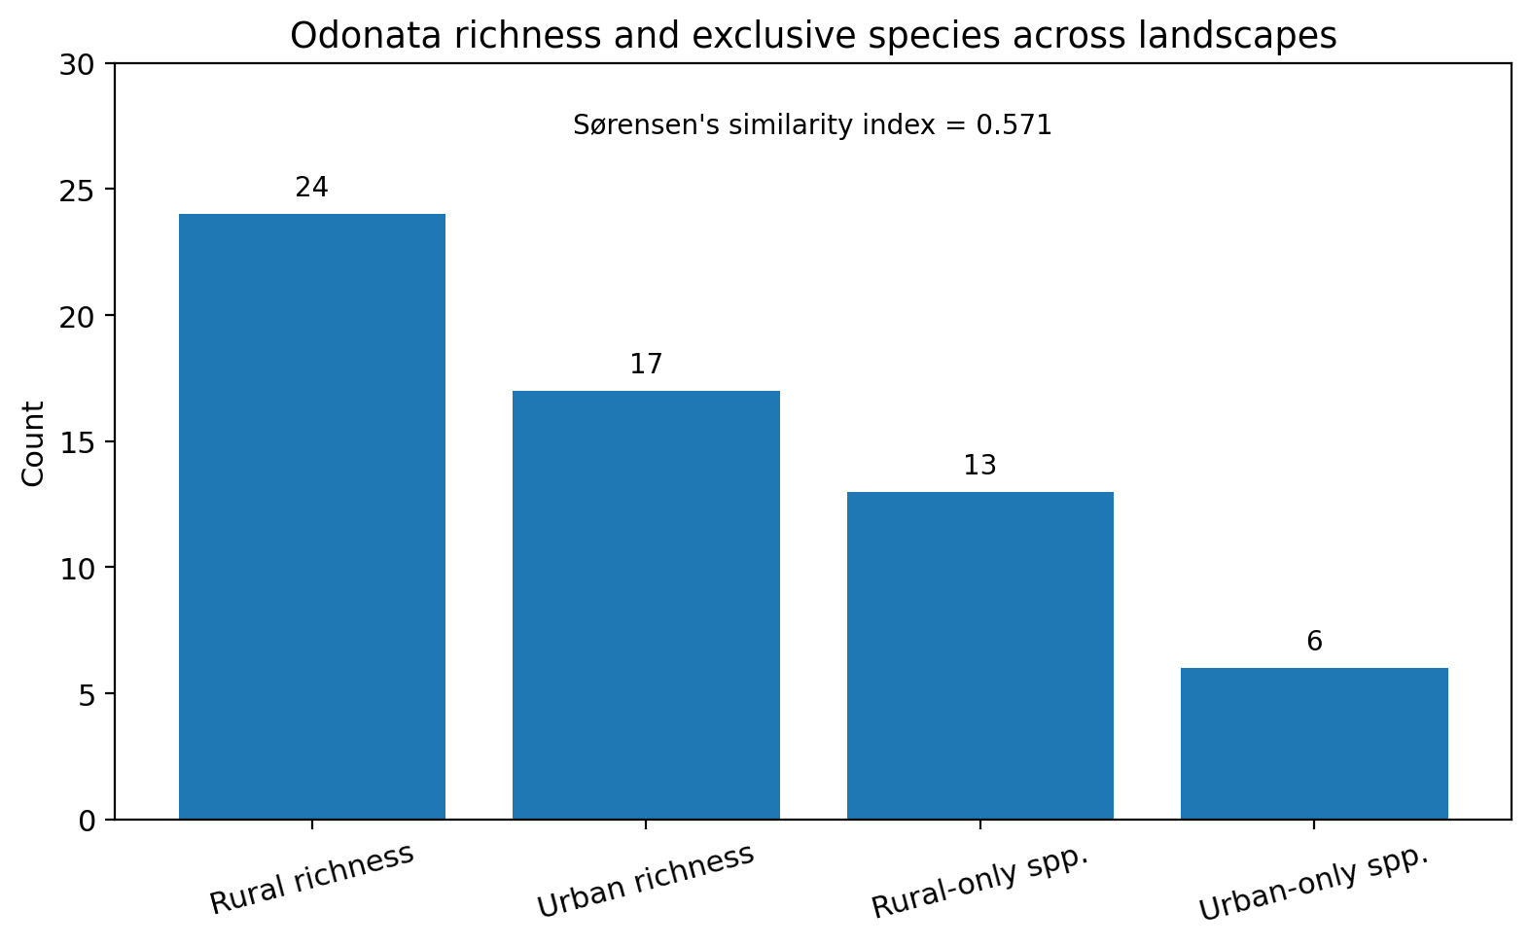
Figure 1. Species richness and exclusive species counts across rural and urban landscapes.
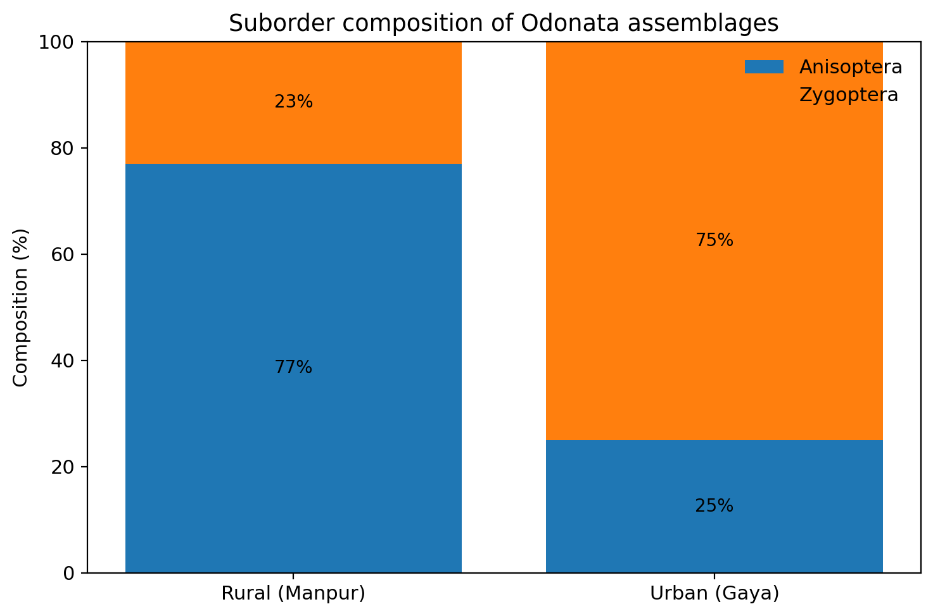
Figure 2. Suborder composition of Odonata assemblages in rural and urban agricultural landscapes.
3.2 Influence of crop composition
Principal component analysis showed that crop composition was a major determinant of community structure. PC1 explained 75.25% of the total variance, while PC2 explained an additional 16.15%. PC1 was strongly and positively associated with food grains (0.757) and vegetables (0.519), indicating that these crop types were the strongest predictors of species distribution.
Food-grain habitats supported the highest richness (S = 21) and the highest Shannon diversity value (H' = 2.734), indicating a comparatively complex and stable assemblage. Species such as Neurothemis fulvia, Orthetrum sabina and Pantala flavescens were strongly associated with food-grain systems. Vegetable crops formed a second important cluster, with species such as Diplacodes trivialis and Ceriagrion coromandelianum showing close affinity to vegetable habitats.
Pulse fields supported the lowest richness (S = 9) and the lowest abundance (N = 677). Oilseed habitats, although lower in richness than food grains, showed comparatively high evenness (J' = 0.91), indicating a more balanced distribution of individuals among the species present. Overall, food-grain ecosystems, especially those linked with rice-based seasonal hydrology, appeared to offer habitat conditions resembling shallow temporary wetlands and therefore supported the highest abundance and richness.
Table 2. Crop-associated community metrics and PCA interpretation
Crop / metric | Reported value | Interpretation for Odonata community | Source in manuscript
Food grains: PC1 loading | 0.757 | Strong positive association with the major axis of community differentiation | Results 3.2
Vegetables: PC1 loading | 0.519 | Secondary positive association with PC1 | Results 3.2
Food grains: PC2 loading | -0.649 | Negative separation along PC2 | Results 3.2
Vegetables: PC2 loading | 0.576 | Positive separation along PC2 | Results 3.2
Food grains: abundance | N = 2239 | Highest abundance among reported crop categories | Discussion 3.2
Food grains: richness | S = 21 | Highest richness among crop categories | Results 3.2 / Discussion 3.2
Food grains: Shannon diversity | H' = 2.734 | Indicates a complex and stable community | Results 3.2
Pulses: abundance | N = 677 | Lowest reported abundance | Results 3.2 / Discussion 3.2
Pulses: richness | S = 9 | Lowest reported richness | Results 3.2 / Discussion 3.2
Oilseeds: evenness | J' = 0.91 | Highest evenness among reported crop groups | Discussion 3.2
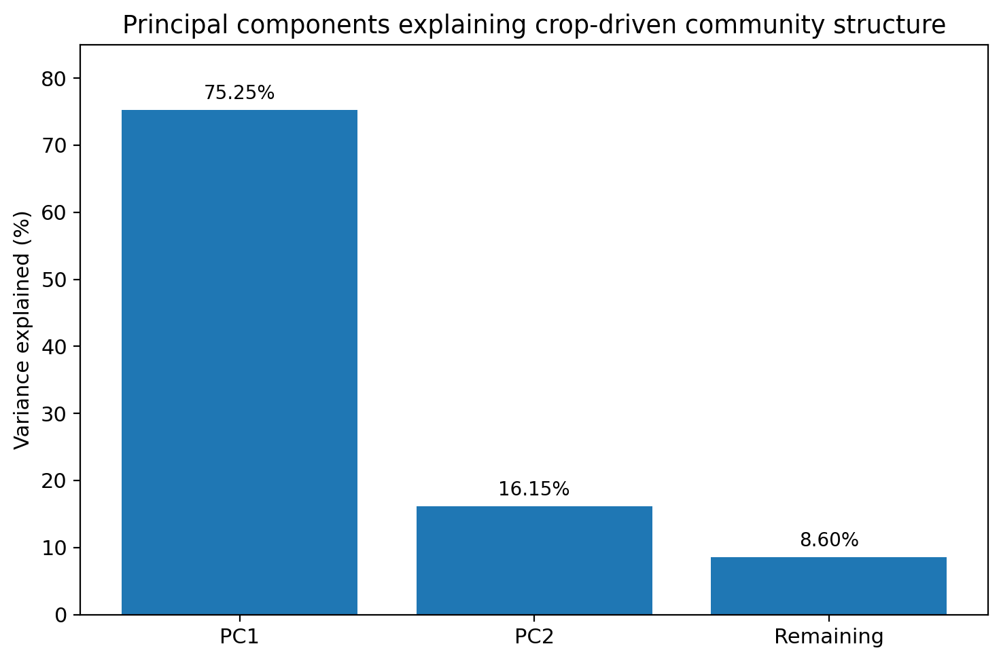
Figure 3. Percentage of variance explained by principal components of crop-driven community structure.
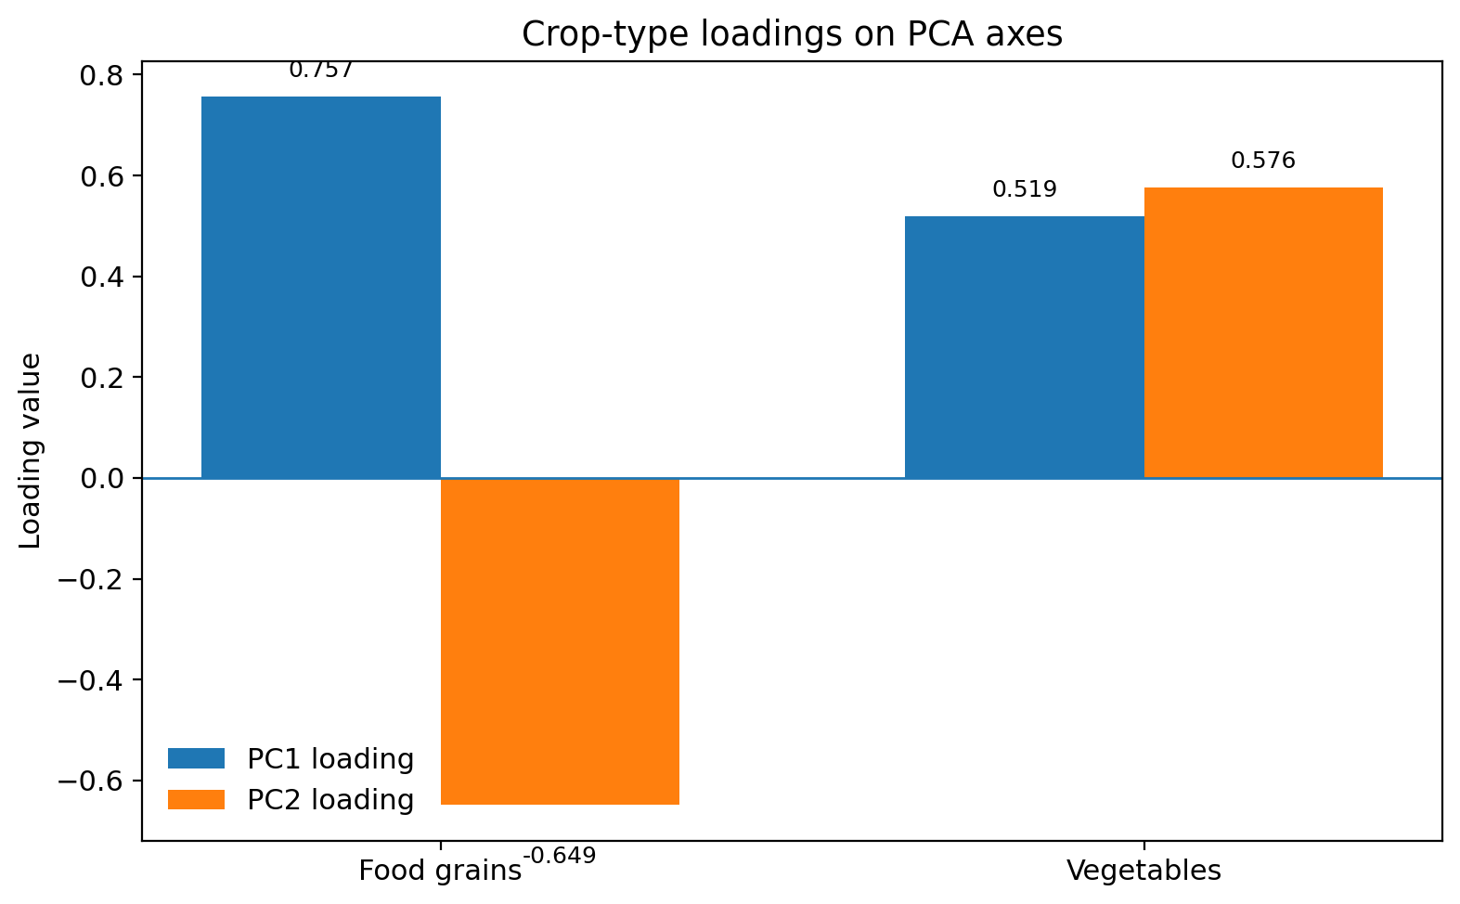
Figure 4. PCA loadings showing the relative influence of food grains and vegetables on PC1 and PC2.
3.3 Seasonal abundance and population dynamics
Seasonality had a significant effect on odonate abundance in both landscapes. One-way ANOVA showed highly significant differences among pre-monsoon, monsoon and post-monsoon periods for both the rural and urban sites (P < .001). In both landscapes, abundance peaked during the monsoon and declined thereafter in the post-monsoon and pre-monsoon periods.
In the rural landscape of Manpur, seasonal variation explained approximately 36.8% of the total abundance variance (ICC = 0.368). Species such as Pantala flavescens and Orthetrum sabina showed pronounced monsoonal increases. The urban landscape exhibited slightly stronger seasonal dependence, with an ICC of 0.426, indicating that 42.6% of the variance in abundance was attributable to seasonal changes.
Urban-tolerant species such as Brachythemis contaminata reached marked peaks during the monsoon, emphasizing the importance of temporary rain-fed water bodies in the urban agricultural matrix. The stronger monsoonal response in the urban landscape suggests that urban populations rely more heavily on short-lived seasonal habitat windows, whereas rural communities benefit from more persistent habitat continuity.
Table 3. Reported seasonal peaks of representative species
Species | Landscape | Reported monsoon mean count | Reported dispersion
Pantala flavescens | Rural (Manpur) | 80.5 | ± 7.29
Orthetrum sabina | Rural (Manpur) | 49.25 | ± 7.11
Brachythemis contaminata | Urban (Gaya) | 51.75 | ± 1.08
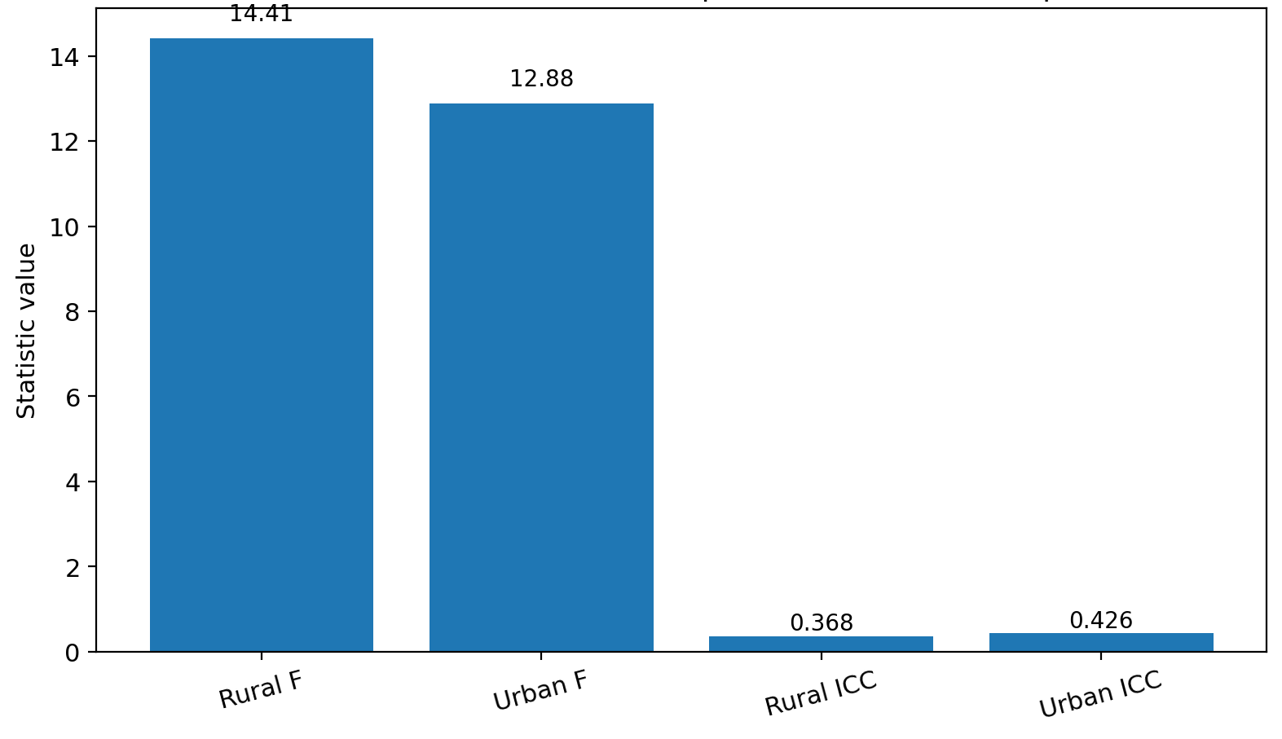
Figure 5. Comparison of seasonal effect statistics reported for rural and urban landscapes.
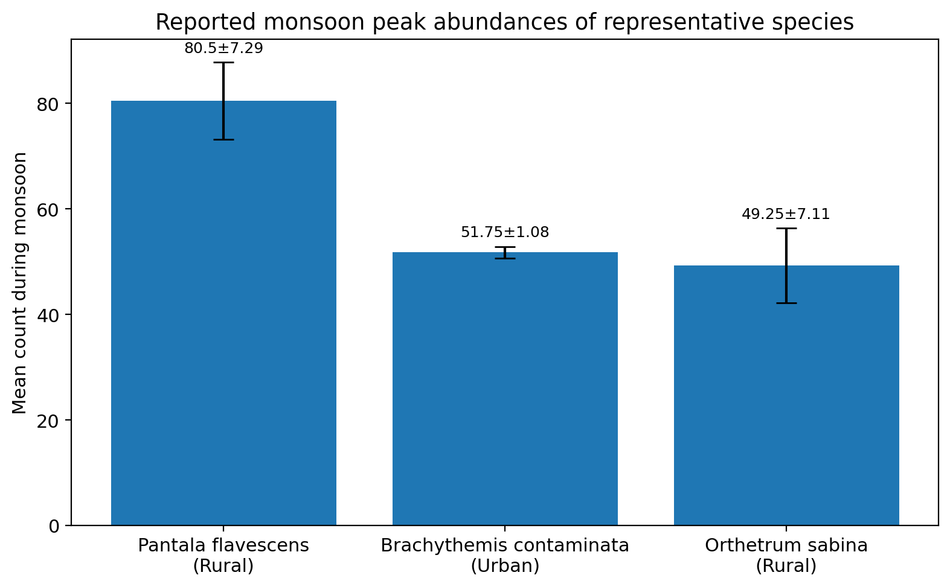
Figure 6. Monsoon peak abundance of representative Odonata species recorded in the study.
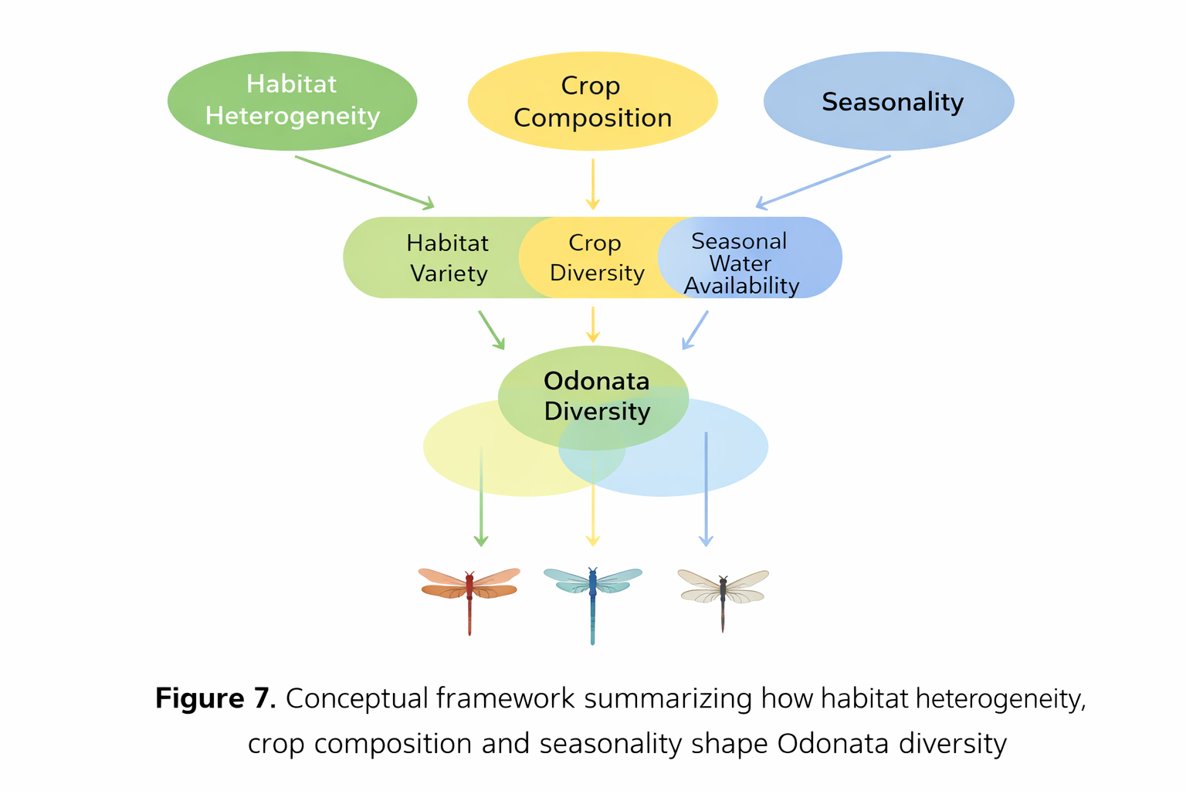
Figure 7. Conceptual framework summarizing how habitat heterogeneity, crop composition and seasonality shape Odonata diversity.
4. CONCLUSION
This study demonstrates that crop composition, habitat heterogeneity and seasonality jointly influence odonate diversity in the agricultural landscapes of the Eastern Gangetic Plains. Rural agro-ecosystems supported higher richness than urban agricultural patches, and food-grain habitats contributed disproportionately to overall abundance and diversity. Monsoon-linked aquatic microhabitats were especially important in both settings, with urban assemblages showing greater seasonal sensitivity.
From a management perspective, the findings support biodiversity-friendly agricultural planning based on crop diversification and landscape mosaics rather than extensive monocultures. Maintaining food grains and vegetables alongside other crop types, conserving small water bodies and vegetated field margins and protecting seasonal aquatic habitats in urbanizing areas may help sustain odonate populations and the ecological services they provide, including natural pest regulation.

CONSENT
Not applicable.
ETHICAL APPROVAL
This study was based on field observation of free-flying insects in agricultural habitats and did not involve human participants or experimental manipulation of vertebrate animals. Formal ethical approval was therefore not required.
REFERENCES
Adu, B., Dada, O., & Tunwase, V. (2022). An ecological study of freshwater ecosystem and its colligation to Odonates assemblages in Ipogun, Southwest Nigeria. Bulletin of the National Research Centre, 46, 86.
Beketov, M. A., Kefford, B. J., Schafer, R. B., & Liess, M. (2013). Pesticides reduce regional biodiversity of stream invertebrates. Proceedings of the National Academy of Sciences, 110(27), 11039-11043.
Benton, T. G., Vickery, J. A., & Wilson, J. D. (2003). Farmland biodiversity: Is habitat heterogeneity the key? Trends in Ecology & Evolution, 18(4), 182-188.
Chapin, F. S., III, Zavaleta, E. S., Eviner, V. T., Naylor, R. L., Vitousek, P. M., Reynolds, H. L., et al. (2000). Consequences of changing biodiversity. Nature, 405(6783), 234-242.
Clausnitzer, V., Kalkman, V. J., Ram, M., Collen, B., Baillie, J. E., Bedjanic, M., et al. (2009). Odonata enter the biodiversity crisis debate: The first global assessment of an insect group. Biological Conservation, 142(8), 1864-1869.
FAO. (2020). India at a glance: FAO in India. Food and Agriculture Organization of the United Nations.
Kalkman, V. J., Clausnitzer, V., Dijkstra, K. D. B., Orr, A. G., Paulson, D. R., & van Tol, J. (2008). Global diversity of dragonflies (Odonata) in freshwater. Hydrobiologia, 595(1), 351-363.
Kumar, A., & Tyagi, S. (2021). Conservation of Odonata in agricultural landscapes: A sustainable approach. Environmental Sustainability, 4(3), 165-173.
Kumar, A., Singh, R., & Mishra, R. (2023). Odonata diversity in rural and urban agricultural landscapes of Gaya, Bihar. Biodiversity Research Journal, 15(1), 101-115.
Lal, R. (2019). Soil carbon sequestration in India. Agriculture, Ecosystems & Environment, 274, 21-29.
McCauley, S. J., Hammond, J. I., & Mabry, K. E. (2015). Simulated climate change increases larval mortality, alters phenology, and affects flight morphology of a dragonfly. Ecosphere, 6(10), 1-12.
McKinney, M. L. (2008). Effects of urbanization on species richness: A review of plants and animals. Urban Ecosystems, 11, 161-176.
Reddy, S. (2018). Biodiversity and agriculture: An essential partnership. Journal of Sustainable Agriculture, 42(3), 235-249.
Sharma, R., & Yadav, S. (2019). Odonata as biological pest control agents: An overview. Agricultural Reviews, 40(2), 123-129.
Simaika, J. P., & Samways, M. J. (2010). Comparative assessment of indices of freshwater habitat conditions using different bioindicator groups. Ecological Indicators, 10(2), 456-465.
Singh, R., & Singh, M. (2022). Crop diversity and soil fertility in Bihar: A case study of Gaya district. Journal of Agricultural Science and Technology, 14(2), 99-108.
Sinha, R. (2017). The Ahar-Pyne system: A traditional water management system in Bihar. International Journal of Water Resources Development, 33(4), 715-727.
Subramanian, K. A., Babu, R., & Tiple, A. D. (2018). The status and distribution of dragonflies and damselflies (Odonata) of India. Journal of Threatened Taxa, 10(3), 11503-11518.
Tscharntke, T., Clough, Y., Wanger, T. C., Jackson, L., Motzke, I., Perfecto, I., et al. (2012). Global food security, biodiversity conservation and the future of agricultural intensification. Biological Conservation, 151(1), 53-59.

