Original research paper

Household Carbon Footprints and Climate Change Vulnerability in Maharashtra

.
ABSTRACT

This study presents a comprehensive analysis of the relationship between household carbon emissions and economic vulnerability to climate change across Maharashtra, India. Using a stratified survey of 1000 households across 123 villages and cities in Maharashtra between August 2022 and March 2023 from tribal, rural, urban, and metropolitan regions. We quantified households' Carbon Footprint and assessed economic losses due to climate related extremes, including floods, droughts, cyclones, and erratic rainfall. Carbon footprints were estimated using activity based emission factors, while economic vulnerability was assessed through a household loss index and comparative statistical analysis across regions. The results reveal a notable disparity: metropolitan households exhibit the highest emissions, primarily from electricity (42%) and transport (37%), followed by urban households with significant contributions from transport (40%) and electricity (30%). In contrast, rural (biomass 38%) and tribal biomass (57%) households, while having lower overall emissions, are more economically vulnerable. Tribal communities also show increasing emissions due to the continued reliance on biomass for cooking and household activities. This inverse relationship between emissions and vulnerability highlights a pressing climate justice issue. Rural and tribal communities, dependent on climate sensitive livelihoods, are disproportionately affected, whereas high emission urban centers benefit from diversified economies and resilient infrastructure. These findings underscore the urgent need for region specific climate policies that not only mitigate emissions but also enhance the adaptive capacity of the most vulnerable. By presenting strong empirical evidence of unequal climate impacts, this research calls for a just, inclusive, and context responsive approach to sustainable development in Maharashtra.

Keywords: Climate Change, Household Carbon Footprin, Climate Justice, Climate Vulnerability, Maharashtra
1. INTRODUCTION

Climate change refers to long term shifts in temperature and weather patterns across the globe, largely triggered by anthropogenic activities (Shivanna, 2022). Uncontrolled sources like transportation, fossil fuel combustion, industrial emissions, and deforestation are major contributors, releasing greenhouse gases (GHGs) that drive climate change (Kumar et al., 2021). These GHGs can be tracked through carbon footprint, which (Engström et al., 2024) defined as “A measure of the total emission of carbon dioxide (and other greenhouse gases such as nitrous oxide and methane) caused by a particular product throughout its life cycle.” Measuring carbon footprint helps identify how GHGs are produced through human activities (Fitzpatrick et al., 2015). Global studies have examined how climate change affects social, economic, and environmental systems (Clemens et al., 2022). Events like droughts, floods, and rising sea levels have led to crop failures, inflation, and disruptions in livelihoods (Kabir et al., 2023). Individual lifestyle choices also contribute significantly. (Koide, et al., 2021) found that household consumption patterns are linked to unsustainable living and high GHG emissions. In India, (Ahmad et al., 2015) household GHG emissions are influenced by income, family size, and consumption of services like water, electricity, and LPG. Many rural families, however, still rely on solid fuels such as wood and coal due to income disparities (Sharma & Dash, 2022). States with high urbanization and economic activity contribute more to India’s carbon footprint, prompting the question who is more responsible and vulnerable? (Halder et al., 2012) highlighted that underdeveloped region, where people depend on agriculture and forests, are highly exposed. Urban centers like Mumbai and Chennai also face severe effects, including intense monsoons and rising sea levels (Yenneti et al., 2016). Central Indian cities report increased heatwaves and shifting rainfall patterns (Subramanian et al., 2023). Maharashtra, India’s richest state and home to Mumbai, spans 720 km of coastline and features diverse topographies across regions like Western Maharashtra, Konkan, Khandesh, Vidarbha, and Marathwada (Kelkar et al., 2020). According to the India GHG Platform, Uttar Pradesh leads in total emissions, followed by Maharashtra and Gujarat. Odisha tops energy sector emissions, while Gujarat leads in industrial emissions. Uttar Pradesh ranks highest in agriculture and forestry emissions, with Maharashtra sixth. In the waste sector, Maharashtra holds the second position.

This study focuses on understanding the impact of climate change across tribal, rural, urban, and metropolitan areas of Maharashtra by analysing major sources of household carbon emissions, estimating and comparing carbon footprints based on lifestyle differences, and assessing the economic impacts on livelihoods. By calculating family level GHG emissions, the research aims to raise awareness and encourage sustainable practices that can help mitigate climate change. Awareness of carbon footprints enables people to understand how their choices affect the environment and promotes a shift toward sustainability (Ramachandra et al., 2014).

2. methodology

Maharashtra (Fig. 1), located between 15.59°N to 22.05°N latitude and 72.68°E to 80.88°E longitude, exhibits diverse geographical and climatic conditions influencing household consumption patterns and their contribution to greenhouse gas (GHG) emissions. This study employed a randomized survey approach, conducting door-to-door interviews using a structured questionnaire to assess these patterns (Bhoyar et al., 2014). Data were collected from 1000 households across 123 villages and cities in Maharashtra between August 2022 and March 2023 (Fig. 2). The survey was stratified by settlement type, with 200 responses per region and 50 per category - tribal, rural, urban, and metropolitan areas. To strengthen the analysis, secondary data from government sources, academic journals, and relevant articles were also incorporated. The methodological framework of this study strategically categorized the diverse human settlements of Maharashtra into four distinct types: Tribal areas, encompassing nomadic and scheduled tribe populations; Rural areas, defined as villages exclusive of the aforementioned tribal groups; Urban areas, including towns and cities with populations under one million, represented by Nagar Panchayats, Nagar Parishads, and smaller Mahanagar Palikas, and Metropolitan cities, characterized by populations ranging from one to five million. To ensure comprehensive geographical representation, data collection was conducted across the five principal geographical divisions of Maharashtra: Konkan, Western Maharashtra, Khandesh, Marathwada, and Vidarbha, thereby capturing the socio economic and ecological variations inherent within the state. This stratified site selection aimed to provide a nuanced understanding of carbon footprints and climate change impacts across a spectrum of settlement characteristics and 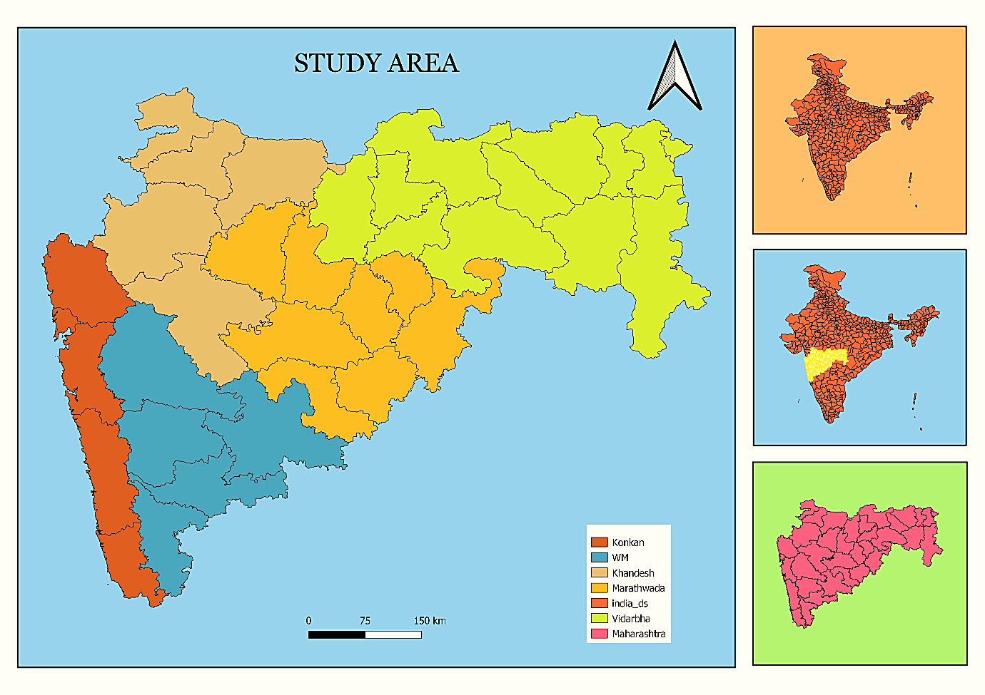regional contexts.
Fig. 1. Map Showing the Study Area of Maharashtra
Fig. 2. Map Showing the Study Sites of Maharashtra
2.1 Carbon Footprint Calculation

The household carbon footprint was determined using:
$GHG emission= Activity data × Emission factor$
where activity data includes fuel use, transport, electricity, and food consumption. Emissions were standardized in CO₂e, following Fong (2014) and India GHG Program.

2.2 CO₂ Equivalent Emission Factors

Greenhouse gas (GHG) emissions were converted to CO₂-equivalent (CO₂e) using Global Warming Potential (GWP). Emission factors were sourced from peer reviewed literature and government database (Table 1).
Source Type | Source | CO₂e Emission Factor | Unit | Reference
Liquid Fuels | Petrol | 2.27193 | kg CO₂e/L | India GHG Program
 | Diesel | 2.6444 | kg CO₂e/L | India GHG Program
Other Fuels | LPG | 2.985 | kg CO₂e/kg | Bhoyar et al.,
 | Biomass Burning | 1.597 | kg CO₂e/kg | Bhattacharya et al.,
Travel | Air travel | 0.121 | kg CO₂e/passenger-km | India GHG Program
 | Bus travel | 0.0151 | kg CO₂e/passenger-km | India GHG Program
Energy | Grid electricity | 0.91 | kg CO₂e/kWh | GHG Inventory Report
Food | Rice | 1.220 | kg CO₂e/kg | Bhoyar et al.,
 | Wheat | 0.12 | kg CO₂e/kg | Bhoyar et al.,
 | Non-vegetarian food | 0.78 | kg CO₂e/kg | Bhoyar et al.,

Table 1. CO₂ Equivalent Emission Factors for Various Sources

2.3 Monetary Impact Calculation

This study evaluates the monetary impact of extreme climatic events cyclones, floods, droughts, erratic rainfall, unseasonal rainfall, and hailstorms on agriculture, livelihoods, businesses, and household income in Maharashtra (2018-2023). Using primary survey data, economic losses are quantified using normalized units of 0.5/10,000. Adapting the framework of Singh et al., (2012), the study examines both direct and indirect economic effects. Normalized losses are compared with carbon footprint metrics, highlighting regional disparities in climate vulnerability and the link between emissions and economic impacts.

2.4 Limitations of Study

This study is primarily based on primary data collected through household interviews, which introduces certain limitations due to incomplete or inconsistent information provided by respondents. Emissions related to workplaces or occupational activities were not considered, as assessing them involves complex variations across different work environments and job profiles. Additionally, lifecycle emissions from housing infrastructure, household waste generation, and household appliances were excluded from the scope of this study.

3. results and discussion

3.1 Metro Cities: High Carbon Footprint, Low Economic Vulnerability.

Metropolitan households exhibited the highest carbon footprint, primarily driven by electricity consumption (42%), transportation (37%), LPG usage (13%), and food consumption (8%) (Figure 4 (A)). The extensive dependence on electrical appliances, air-conditioning systems, and private vehicles substantially elevates household emissions. This pattern mirrors global findings that associate urban affluence with higher per capita energy demand and increased greenhouse gas (GHG) emissions (IEA, 2023). Maharashtra’s metropolitan centers, notably Mumbai and Pune, function as major economic and industrial hubs characterized by dense populations, high mobility, and continuous energy requirements for commercial and residential operations. Similar studies across Indian districts confirm that per capita emissions are markedly higher in metropolitan areas than in semi-urban or rural districts, highlighting how economic growth and consumption intensity directly translate into elevated emission levels (Lee et al., 2021). The concentration of commercial activities, digital infrastructure, and transport networks in metropolitan regions amplifies the energy intensity of daily life. High-rise housing complexes, widespread use of personal vehicles, and the growing demand for consumer electronics create a consistent upward trend in household energy use (Kaul et al., 2020). Additionally, the proliferation of lifestyle-related energy consumption such as home entertainment systems, refrigerated storage, and online delivery logistics further compounds the carbon burden of metropolitan living. Urban expansion and the increase in built-up areas also result in reduced carbon sequestration capacity due to the loss of vegetation and permeable land surfaces, exacerbating the urban heat island effect (Rizwan et al., 2008). Despite their high emissions, metropolitan households reported relatively low economic losses from climate-induced events (Figure 3 (A)). This apparent resilience can be attributed to strong economic diversification, robust infrastructure, and limited dependence on climate-sensitive sectors such as agriculture. The availability of insurance systems, early warning mechanisms, and rapid emergency responses in these regions further mitigates direct economic impacts. However, localized vulnerabilities persist particularly in flood-prone urban zones and informal settlements where inadequate drainage and unplanned construction intensify the impact of extreme rainfall events. Field data revealed that households in Mumbai and Pune reported recurrent losses from urban flooding, including damage to electrical equipment, temporary displacement, and income disruption. This duality high emissions but relatively low vulnerability illustrates a broader climate inequality embedded in urban systems. Wealthier urban populations not only contribute disproportionately to GHG emissions but also possess greater adaptive capacity to shield themselves from the resulting climate risks (Hallegatte et al., 2013).

3.2 Urban Areas: High Carbon Footprint, Moderate Economic Vulnerability

Urban households exhibited a high carbon footprint, with transportation (40%) and electricity (30%) as the major contributors, followed by LPG (12%), biomass (10%), and food (8%) (Figure 4 (B)). The increased dependence on private vehicles, exacerbated by inadequate public transportation, is a key factor driving emissions. This aligns with literature identifying private vehicle expansion as a major contributor to urban carbon emissions (Sims et al., 2014). Specifically focusing on urban flooding in Maharashtra, reports following the severe floods of 2019 and 2021 in regions like Sangli and Kolhapur have documented substantial economic losses (Figure 3 (B)). These losses include damage to infrastructure (e.g., roads and power supply), forced business closures due to inundation, and significant damage to residential properties (Economic Survey of Maharashtra, 2021–2022; Down To Earth, 2019). The disruption to transportation and communication networks further exacerbates these economic impacts. Furthermore, studies on disaster risk reduction and climate change adaptation in urban areas of Maharashtra emphasize the increasing frequency and intensity of extreme weather events, including floods, and their disproportionate impact on urban economies (TERI, 2014).

3.3 Rural Areas: Low Carbon Footprint, High Economic Vulnerability

Rural households had the lowest carbon footprint, largely due to lower electricity consumption. Biomass fuel usage for cooking (38%) was the dominant contributor, followed by transportation (21%), electricity (18%), food (12%), and LPG (11%) (Figure 4 (C)). The persistent reliance on traditional biomass aligns with previous findings that rural energy consumption patterns remain a significant yet often overlooked contributor to emissions (Smith et al., 2014). Rural areas exhibited the highest economic vulnerability, given their dependence on agriculture, which is highly sensitive to climate variability. Climate related events Including cyclones, floods, droughts, and unseasonal rainfall have led to significant crop failures, soil degradation, and damage to agricultural infrastructure (Figure 3 (C)). Furthermore, the prevalence of monocropping exacerbates financial risks by limiting adaptability to extreme weather fluctuations (Altieri, 1999). The economic implications of these events reinforce the need for climate resilient agricultural practices (Porter et al., 2014). The vulnerability of rural farmers in Maharashtra to climate change driven by their reliance on monocropping and exposure to extreme events such as cyclones, floods, hailstorms, unseasonal rainfall, and drought aligns with findings from earlier studies. Monocropping amplifies climate-related agricultural risks by diminishing biodiversity, exhausting soil nutrients, and heightening susceptibility to pests and diseases, thereby reducing the overall resilience of farming systems to climatic variability (Bera et al., 2022). The lack of crop diversity diminishes the system's resilience to extreme weather events like droughts and floods, as different crops have varying tolerances to such stresses (Food Tank, 2021). The impact of cyclones in the Konkan region, which cause long-term economic displacement due to the destruction of mature orchards and structural damage, underscores the vulnerability of coastal agricultural communities to increasingly intense extreme weather events (Hindustan Times, 2023). Climate change is projected to increase the intensity of cyclones in the Arabian Sea, further threatening these regions (IPCC, 2021). Similarly, the findings of floods, hailstorms, and unseasonal rainfall causing crop failures and soil loss in Western Maharashtra and Khandesh align with research indicating increased erratic rainfall patterns and extreme precipitation events due to climate change, which are detrimental to agricultural productivity. The drought conditions in Marathwada and Vidarbha, exacerbated by erratic monsoons and declining groundwater levels, are well documented consequences of climate change in semi-arid regions of India (Kuchimanchi et al., 2019). The dependence on rain fed agriculture and the intensification of water stress due to changing climate patterns make these regions particularly vulnerable (Bhagawat et al., 2021).

3.4 Tribal Areas: Moderate Carbon Footprint, High Economic Vulnerability

Tribal households exhibited the second highest carbon footprint, primarily due to biomass burning (57%), followed by electricity and food consumption (13% each), transportation (11%), and LPG use (6%) (Figure 4 (D)). The continued reliance on biomass for energy needs contributes significantly to emissions, consistent with previous findings on traditional energy usage in marginalized communities (IEA, 2022). Tribal regions, while exhibiting diversified livelihood strategies including non-timber forest product (NTFP) collection, handicrafts, and subsistence farming remain highly vulnerable to climate induced economic losses. Poor healthcare access, weak infrastructure, and frequent losses of homes and livestock due to extreme weather events contribute to persistent economic instability (Figure 3 (D)). While diversification enhances resilience, the lack of basic services and disaster preparedness leaves tribal communities highly susceptible to climate induced hardships (Ellis, 2000). During the survey, tribal households reported that although they had received LPG connections under the PM Ujjwala Scheme, the lack of nearby refilling stations, often located 30 to 40 km away and forced them to continue relying on biomass as their primary cooking fuel. This logistical barrier contributes to rising carbon emissions in these areas despite access to clean energy infrastructure.
Fig. 3. (B) Urban Area
Fig. 3. (C) Rural Area
Fig. 3. (A) Metropolitan Area
Fig. 3. Breakdown of Average Household Carbon Footprints Source
Fig. 3. (D) Tribal Area
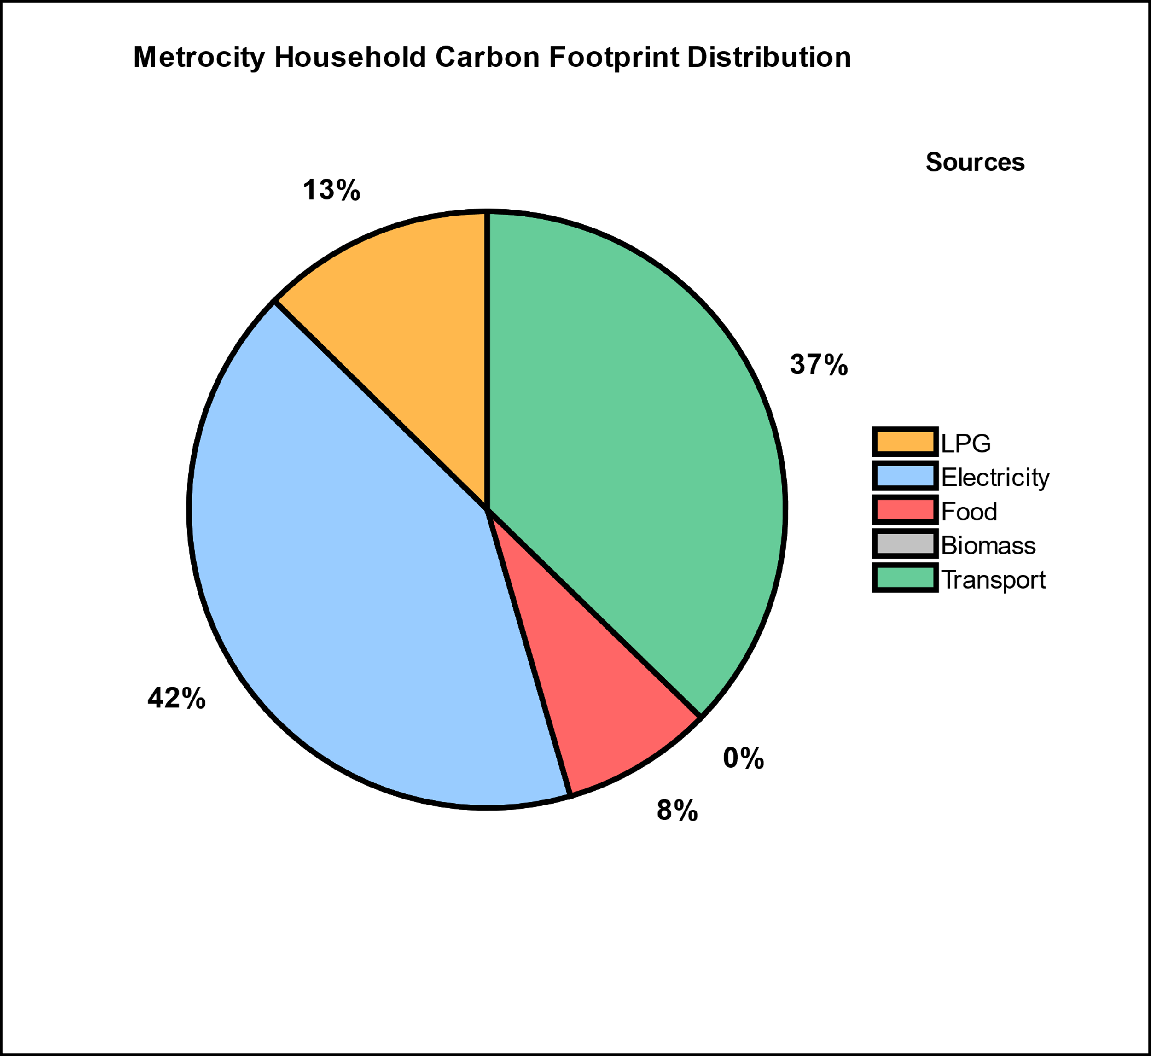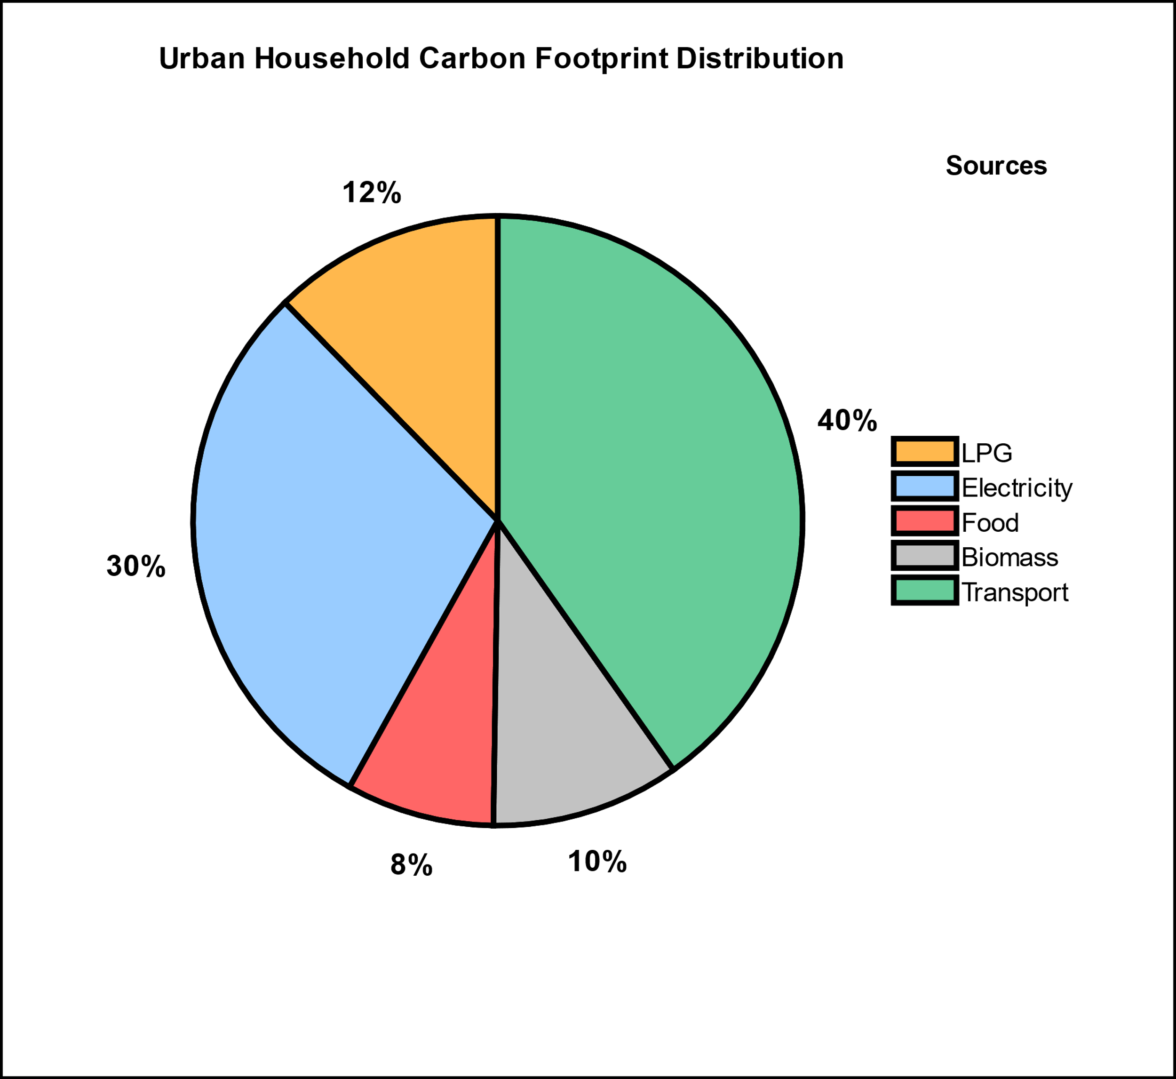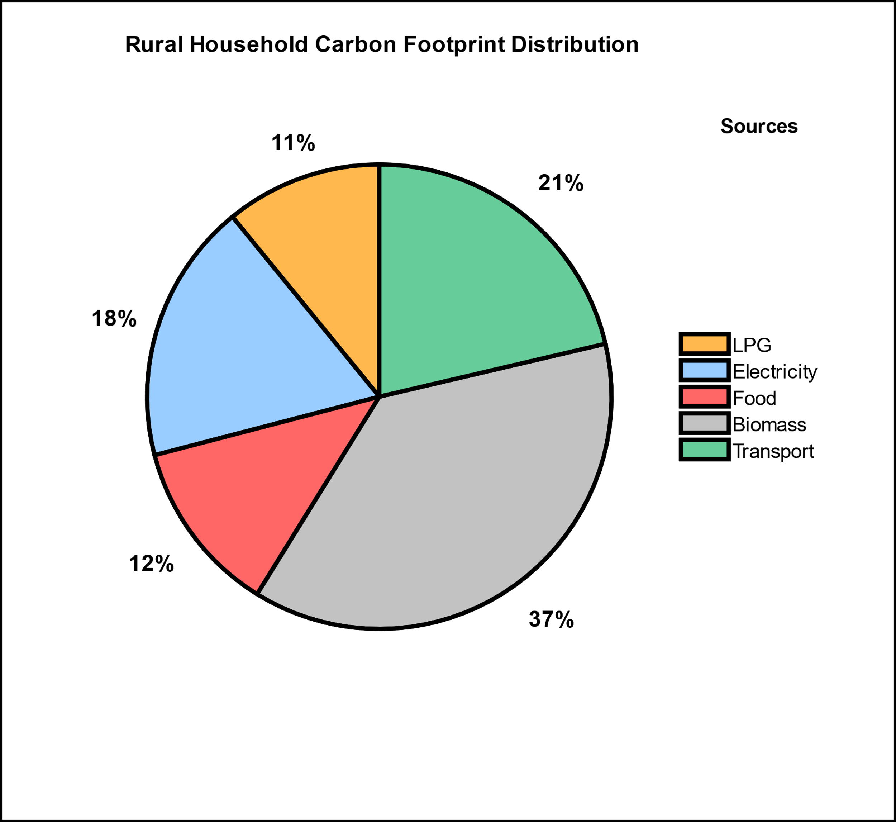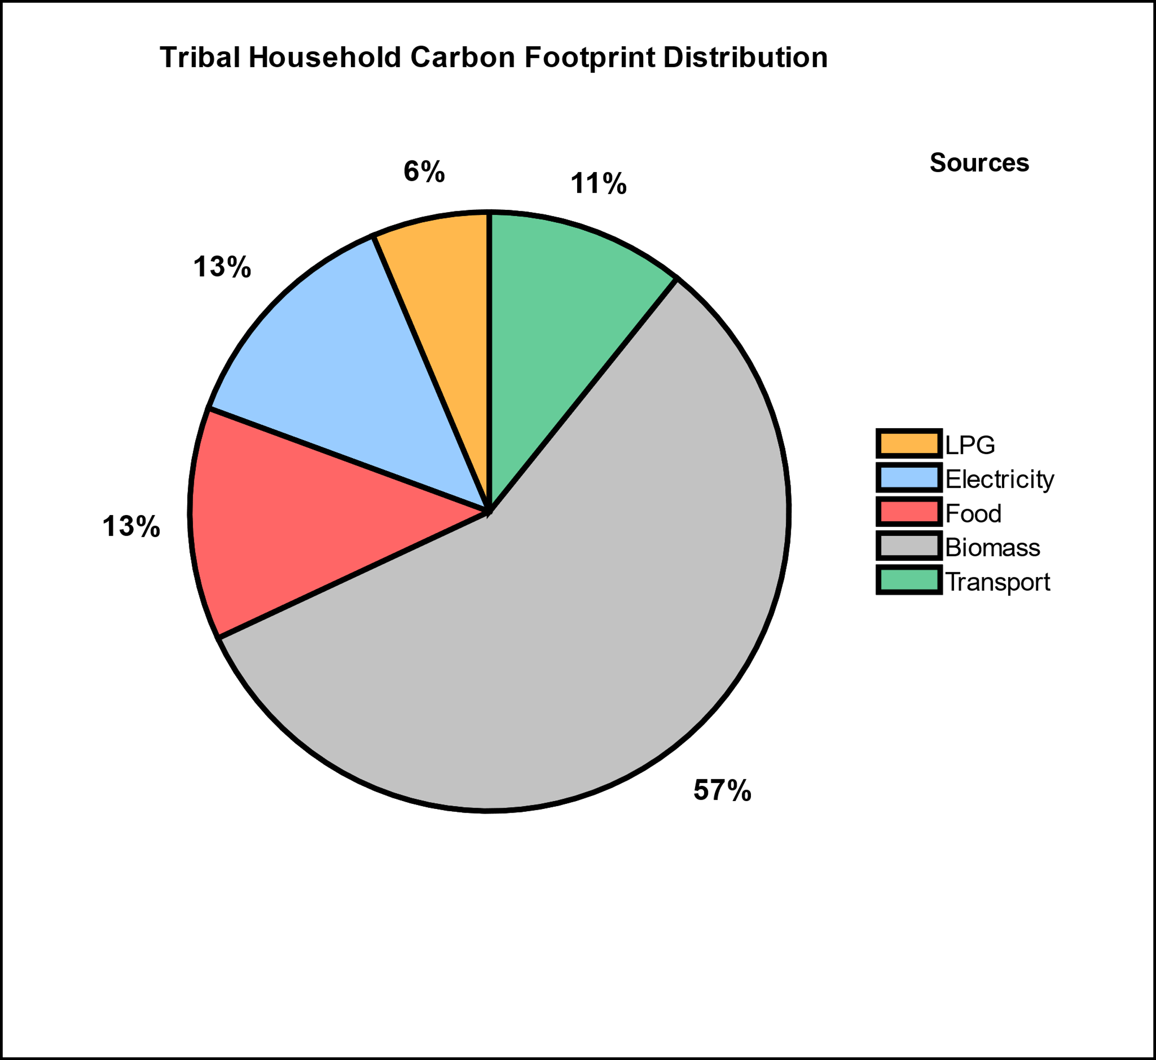
Fig. 4. (A) Metropolitan Area
Fig. 4. (B) Urban Area
Fig. 4. (C) Rural Area
Fig. 4. (D) Tribal Area
Fig. 4. Co2e emission of different factor across different Human Settlement

4. Conclusion

This study highlights the unequal distribution of household carbon footprints and climate induced economic vulnerabilities across Maharashtra’s tribal, rural, urban, and metropolitan settlements. Metropolitan and urban households exhibit the highest carbon footprints, driven primarily by electricity consumption, transportation, and modern lifestyles. However, these regions display relatively low economic vulnerability owing to diversified income sources, stronger infrastructure, and improved adaptive capacity. In contrast, rural and tribal households, despite their low emissions rooted in traditional biomass use and subsistence economies, face the greatest exposure to climate-induced economic losses. This paradox underscores a clear climate injustice: communities contributing least to greenhouse gas emissions bear the heaviest burdens of climate impacts. Agricultural dependence, inadequate infrastructure, and limited access to adaptive resources exacerbate their vulnerability. The persistence of biomass reliance in tribal and rural areas despite initiatives such as the Ujjwala Scheme highlights gaps in clean energy accessibility and infrastructure planning. Meanwhile, urban centers continue to face localized risks, particularly from flooding and extreme rainfall, which disrupt economic activity and strain urban resilience systems.
Overall, the findings demonstrate that carbon responsibility and climate vulnerability are inversely related across Maharashtra’s settlement gradient. Addressing this imbalance demands context-specific interventions that integrate emission mitigation with adaptive capacity building. Policies should prioritize equitable energy access, sustainable transportation, and climate-resilient agriculture while embedding principles of climate justice into regional planning. Without such targeted and inclusive approaches, climate change will continue to deepen existing socioeconomic inequities across Maharashtra’s diverse landscapes.

COMPLIANCE WITH ETHICAL STANDARDS CONFLICTS OF INTEREST
The authors have no competing interests to declare that are relevant to the content of this article.
HUMAN AND ANIMAL RIGHTS AND INFORMED CONSENT
This article contains no studies on animal subjects conducted by any of the authors. Before beginning the experiments described in this article, the authors obtained informed consent from all human participants.

DECLARATIONS
All authors confirm that they have read and understood the statement on the **Ethical Responsibilities of Authors** as outlined in the Instructions for Authors and have complied with these requirements where applicable. The authors further declare that no generative artificial intelligence tools, including Large Language Models such as ChatGPT, Copilot, or similar systems, and no text-to-image generation technologies were used in the writing, preparation, or editing of this manuscript.

Definitions, Acronyms, Abbreviations
CO₂: Carbon Dioxide
CO₂e: Carbon Dioxide Equivalent
GHG: Greenhouse Gases
GWP: Global Warming Potential
LPG: Liquefied Petroleum Gas
NTFP: Non-Timber Forest Products

References

- Ahmad, S., Baiocchi, G., & Creutzig, F. (2015). CO₂ emissions from direct energy use of urban households in India. Environmental Science & Technology, 49(19), 11312–11320.
- Altieri, M. A. (1995). Agroecology: The science of sustainable agriculture. Boulder, CO: Westview Press.
- Bera, M., Bose, P., & Nag, P. K. (2022). Household carbon footprint: Rural and urban community. Journal of Ecology and Natural Resources, 6(2).
- Bhagawat, C. (2021). Climate change impacts on Maharashtra agriculture. Institute for Sustainable Communities.
- Bhattacharya, S. C., Albina, D. O., & Salam, P. A. (2002). Emission factors of wood and charcoal-fired cookstoves. Biomass and Bioenergy, 23(6), 453–469.
- Bhoyar, S. P., Dusad, S., Shrivastava, R., Mishra, S., Gupta, N., & Rao, A. B. (2014). Understanding the impact of lifestyle on individual carbon footprint. Procedia – Social and Behavioral Sciences, 133, 47–60.
- Clemens, V., von Hirschhausen, E., & Fegert, J. M. (2022). Report of the Intergovernmental Panel on Climate Change: Implications for the mental health policy of children and adolescents in Europe. European Child & Adolescent Psychiatry, 31(5), 701–713.
- Ellis, F. (2000). Rural livelihoods and diversity in developing countries. Oxford: Oxford University Press.
- Engström, E., Lewis, A. N., Moberg, Å., Vanhuyse, F., Dawkins, E., Lambe, F., Sendlhofer, T., & Ran, Y. (2024). Using labels to support climate-friendly lunch purchases: An in-store study. Cleaner and Responsible Consumption, 15, 100239.
- Fitzpatrick, J.J., McCarthy, S. and Byrne, E.P., 2015. Sustainability insights and reflections from a personal carbon footprint study: the need for quantitative and qualitative change. Sustainable Production and Consumption, 1, pp.34–46.
- Fong, W.K., Kuramochi, T., Roelfsema, M., et al., 2014. Global protocol for community-scale greenhouse gas emission inventories (GPC). World Resources Institute, C40 Cities Climate Leadership Group and ICLEI.
- Halder, P., Sharma, R. and Alam, A., 2012. Local perceptions of and responses to climate change: experiences from natural resource-dependent communities in India. Regional Environmental Change, 12, pp.665–673.
- Hallegatte, S., 2016. Shock Waves: Managing the Impacts of Climate Change on Poverty. Washington, DC: World Bank Publications.
- International Energy Agency (IEA), 2022. World Energy Outlook 2022. Paris: IEA.
- Kabir, M., Habiba, U.E., Khan, W., Shah, A., Rahim, S., De los Rios-Escalante, P.R., Farooqi, Z.U.R., Ali, L. and Shafiq, M., 2023. Climate change due to increasing concentration of carbon dioxide and its impacts on environment in the 21st century: a mini review. Journal of King Saud University – Science, 35(5), 102693.
- Kaul, M., Kulkarni, S. and Chunekar, A., 2020. Energy Consumption Patterns in Indian Households. New Delhi: Prayas Energy Group.
- Kelkar, S.M., Kulkarni, A. and Rao, K.K., 2020. Impact of climate variability and change on crop production in Maharashtra, India. Current Science, 118(8), pp.1235–1245.
- Koide, R., Lettenmeier, M., Akenji, L., Toivio, V., Amellina, A., Khodke, A., Watabe, A. and Kojima, S., 2021. Lifestyle carbon footprints and changes in lifestyles to limit global warming to 1.5 °C and ways forward for related research. Sustainability Science, 16(6), pp.2087–2099.
- Kuchimanchi, B.R., Nazareth, D., Bendapudi, R., Awasthi, S. and D’Souza, M., 2019. Assessing differential vulnerability of communities in the agrarian context in two districts of Maharashtra, India. Climate and Development, 11(10), pp.918–929.
- Kumar, V., Ranjan, D. and Verma, K., 2021. Global climate change: the loop between cause and impact. In: Kumar, V. (ed.), Global Climate Change. Elsevier, pp.187–211.
- Lee, J., Taherzadeh, O. and Kanemoto, K., 2021. The scale and drivers of carbon footprints in households, cities and regions across India. Global Environmental Change, 66, 102205.
- Porter, J., Xie, L., Challinor, A.J., Howden, M., Iqbal, M.M., Lobell, D.B. and Travasso, M.I., 2014. Food security and food production systems. In: Field, C.B. et al. (eds.), Climate Change 2014: Impacts, Adaptation, and Vulnerability. Part A: Global and Sectoral Aspects. Cambridge: Cambridge University Press, pp.485–533.
- Ramachandra, T.V., 2012. Decentralised carbon footprint analysis for opting climate change mitigation strategies in India. Renewable and Sustainable Energy Reviews, 16(8), pp.5820–5833.
- Ramachandra, T.V., Sreejith, K. and Bharath, H.A., 2014. Sector-wise assessment of carbon footprint across major cities in India. In: Muthu, S.S. (ed.), Assessment of Carbon Footprint in Different Industrial Sectors, Volume 2. Singapore: Springer, pp.207–267.
- Sharma, V. and Dash, M., 2022. Household energy use pattern in rural India: a path towards sustainable development. Environmental Challenges, 6, 100404.
- Shivanna, K.R., 2022. Climate change and its impact on biodiversity and human welfare. Proceedings of the Indian National Science Academy, 88(2), pp.160–171.
- Singh, A., Patwardhan, A., Abhyankar, A. and Sarda, N.L., 2011. Extreme Weather Events in India: A Preliminary Analysis of Impacts. Mumbai: Indian Institute of Technology Bombay.
- Smith, P., Bustamante, M., Ahammad, H., Clark, H., Dong, H., Elsiddig, E.A., Haberl, H., Harper, R., House, J., Jafari, M. and Masera, O., 2014. Agriculture, forestry and other land use (AFOLU). In: Edenhofer, O. et al. (eds.), Climate Change 2014: Mitigation of Climate Change. Cambridge: Cambridge University Press, pp.811–922.
- Subramanian, A., Nagarajan, A.M., Vinod, S., Chakraborty, S., Sivagami, K., Theodore, T., Sathyanarayanan, S.S., Tamizhdurai, P. and Mangesh, V.L., 2023. Long-term impacts of climate change on coastal and transitional ecosystems in India: an overview of its current status, future projections, solutions and policies. RSC Advances, 13(18), pp.12204–12228.
- TERI, 2014. Assessing Climate Change Vulnerability and Adaptation Strategies for Maharashtra. Maharashtra State Adaptation Action Plan on Climate Change (MSAAPCC). New Delhi: The Energy and Resources Institute.
- Yenneti, K., Tripathi, S., Wei, Y.D., Chen, W. and Joshi, G., 2016. The truly disadvantaged? Assessing social vulnerability to climate change in urban India. Habitat International, 56, pp.124–135.

