Original Research Article

Biosynthesis of silver nanoparticles using indicator microorganisms

.
ABSTRACT

Nanotechnology has recently become increasingly widespread in various areas of human activity. Various methods for producing nanoparticles of metals and other substances are used worldwide. Microbial synthesis is the most environmentally friendly method. Soil is the richest source of microorganisms, and anthropogenic impacts on soil promote the development of resistance mechanisms in the microorganisms living there. In this study, we examined the ability of indicator bacteria newly isolated from contaminated urban soils to synthesize silver nanoparticles. Two isolates were identified as the most active silver nanoparticle producers. Molecular genetic identification revealed that these isolates belong to Bacillus halotolerans and Pseudarthrobacter oxydans.

Keywords: Bacillus halotolerans, silver nanoparticles, UV spectrum, microorganisms, soil, urbanization.

1. INTRODUCTION

The priority of sustainable and environmentally friendly nanotechnology has led to the development of microbial synthesis methods for silver nanoparticles (Huq et al., 2022). Traditional chemical synthesis methods in most cases require the use of various toxic reagents and specific reaction conditions. Green synthesis using microorganisms, on the other hand, offers a more environmentally friendly alternative, emphasizing the natural metabolites and enzymes of bacteria and microscopic fungi (Fahim et al., 2024; Akdasci et al., 2025).
Numerous scientific studies conducted worldwide have shown that representatives of various genera and species of bacteria are capable of biosynthesizing silver nanoparticles. These include Bacillus, Pseudomonas, Streptomyces, Lactobacillus, Arthrobacter, and many others (Saba et al., 2025; Plokhovska et al., 2025; Alam et al., 2021; Solís-Sandí et al., 2023; Huq & Akter, 2021).
Microorganisms utilize various metabolites during the biosynthesis of silver nanoparticles, but one of the most well-known and studied mechanisms is the reductase mechanism, which involves specific enzymes and proteins. Nitrate reductase can participate in the microbial synthesis of silver nanoparticles both intracellularly and extracellularly. In the intracellular pathway, synthesized particles accumulate in the peri- and cytoplasmic space, as well as in the cell-wall complex. In the extracellular pathway, nitrate reductase is secreted into the outer space, where it promotes the reduction of silver ions to a metallic state and subsequently forms nanoparticles. The intracellular mechanism poses difficulties in isolating synthesized nanoparticles from bacterial cells. Various methods are used for this purpose, ranging from lysis to ultrasonic treatment. The extracellular pathway is much simpler in this regard and allows for easier separation of nanoparticles from bacterial cells (Singh et al., 2015; Garg et al., 2020).
Microbial synthesis of metal nanoparticles is sensitive to process conditions, which are influenced by factors such as the composition of the nutrient medium, pH, temperature, stirring speed, and the concentration of the added metal solution (Zayinitdinova et al., 2023; Ibrahim et al., 2021; Rose et al., 2019).
To identify potential microorganisms that synthesize metal nanoparticles, including silver, attention should be paid to econiches exposed to anthropogenic impact, since long-term interaction of microbiocenoses with pollutants, especially heavy metals, can contribute to the emergence of properties such as the formation of nanoparticles (Guerrero et al., 2022; Esmail et al., 2022; Kazemi et al., 2017; Das et al., 2014).
Pollution of any type impacts microbial diversity in many ecosystems, and soil microorganisms are effective indicators of soil health and quality. Exposure to heavy metals causes a shift in the ratio of fast-growing to slow-growing species in favor of the former. However, changes in species composition can also occur. For example, when soil was contaminated with cadmium, nickel and cobalt, Arthrobacter, Phycicoccus, Bacillus, Paenibacillus and Deinococcus predominated among gram-positive bacteria, and Devosia, Kaistobacter, Rhodoplanes, Thermomonas, Mesorhizobium, Lysobacter, Rhodobacter and Sphingomonas predominated among gram-negative bacteria (Zayinitdinova et al., 2022; Sazykina et al., 2022; Boros-Lajszner et al., 2021; Jiao et al., 2019; Kazemi et al., 2017).
The current level of urbanization and industrial development inevitably lead to the contamination of urban and man-made soils with various chemicals, both inorganic and organic. The accumulation of pollutants in the soil, in turn, causes changes in the physicochemical and biological properties of the soil. Microorganisms, as the most numerous inhabitants of the soil, respond to these changes in various ways – by increasing or decreasing enzymatic activity, decreasing biodiversity and heterogeneity of the microbiome, increasing the proportion of fast-growing and pigmented microbiome members, and strengthening defense mechanisms to resist external influences.
Such conditions make it possible to identify microorganisms with beneficial properties and biotechnological potential for further application in various areas of human life.
During their life cycle, bacteria produce a large number of diverse intra- and extracellular biochemical substances, such as enzymes, peptides, and polysaccharides, which act as reducing and stabilizing agents in the biosynthesis of nanoparticles, and a relatively wide selection of synthetic strains ensures the production of silver nanoparticles with a wide range of physicochemical properties, including size and shape (Singh et al., 2015; Akhil et al., 2023)..

2. material and methods

2.1 Sampling
To identify indicator microorganisms, soil samples were collected in the center of Tashkent, which is experiencing anthropogenic pressure. Samples were collected using the "envelope" method from 25 points at a depth of 0-15 cm and then averaged (Soil Microbial Sampling Protocol). pH and temperature measurements were taken in the field. Soil samples were pre-sifted through a 2 mm stainless steel sieve, and their moisture content was determined in the laboratory (Table 1).

Table 1. Physicochemical characteristics of soil (mg/kg)

Humus | NO₃⁻N | NH₄⁺-N | P₂O₅ | K₂O | Cl⁻ | SO₄²⁻ | pH | Humidity | Т, ⁰С
0.9 | 12.3 | 2.4 | 24.1 | 192.1 | 120.8 | 199.2 | 7.02 | 13.6 | +24.0

2.2 Microorganisms
The obtained soil samples were suspended in sterile water. Dilutions were then prepared from this suspension. Aliquots of these dilutions were plated on Petri dishes using various elective nutrient media (HiMedia) and incubated at 30°C in a stationary mode. The following media were used: Nutrient agar, Nutrient broth, Ashby agar, Sabouraud Dextrose Agar, Giltay, Starch-ammonia agar, and Endo agar.
After 24-48 hours of incubation, CFU were visually analyzed and counted.
Among the identified isolates, dominant forms were selected, purified, and the growth rate was determined (Netrusov et al., 2005).
2.3 Silver Nanoparticle Synthesis
The resulting pure isolates were tested for their ability to synthesize silver nanoparticles. A fresh AgNO₃ solution was prepared with a final silver ion concentration of 100 mg/ml.
The isolated indicator isolates were subcultured in Nutrient Broth liquid medium in 100 ml flasks, and then 1 ml of the working silver nitrate solution was added to the 24-hour culture. The cultures and reaction mixtures were incubated in a shaker-incubator at 30°C and 120 rpm. Silver nanoparticle synthesis was assessed visually by color change in the solution (Al-asbahi et al., 2024).
2.4 Microorganism Identification
The selected strains were identified using MALDI-TOF mass spectrometry. Subsequently, the nucleotide sequence of the 16S rRNA gene was determined (Altschul et al., 1990). Phylogenetic analysis was performed using MEGA 6.06 software using the maximum likelihood method based on the Tamura-Nei model (Tamura et al., 2013).
3. results and discussion

3.1 Sampling

To identify indicator soil microorganisms, soil samples were collected in the center of Tashkent, a city exposed to anthropogenic load. A total of 25 point samples were collected using the "envelope" method, which were then mixed to prepare a single sample for subsequent microbiological analysis.
Soil sampling was conducted in the spring. pH and temperature measurements were taken in the field, and moisture content was determined in the laboratory.
Before preparing the soil suspension, the soil was sieved through a 2 mm stainless steel sieve.
For microbiological examination of the collected samples, the soil was weighed to account for moisture content, and limiting dilutions were prepared in sterile water. Aliquots of the resulting suspension were placed in sterile Petri dishes and covered with molten agar media. All cultures were incubated in a thermostatted oven at 30°C for 24-48 hours. After 48 hours of incubation, CFU were counted and the dominant forms of microorganisms were identified (Table 2).

Table 2. Microbiological analysis of the average sample of selected sites

# | Sample name | Name of the nutrient medium
# | Sample name | Nutrient agar | Nutrient broth | Sabouraud Dextrose Agar | Giltay | Starch-ammonia agar | Ashby agar | Endo agar
1 | Sample 1 | 6,25х10⁶ | 2,5х10⁵ | 2,0х10³ | 2,0х10² | 7,8х10⁵ | 5,4х10⁵ | -

3.2 Microorganisms

The highest number of microorganisms was detected on Nutrient agar, where their concentration reached 6.25 x 106 cells/ml. Figure 1 shows the microbial landscape of the microbial colonies detected on Nutrient agar. The presence of pigmented forms is noted, indicating anthropogenic loading of the collected samples (Lazutin et al., 2025). It can also be seen that certain microbial colonies are particularly abundant (Fig. 1).

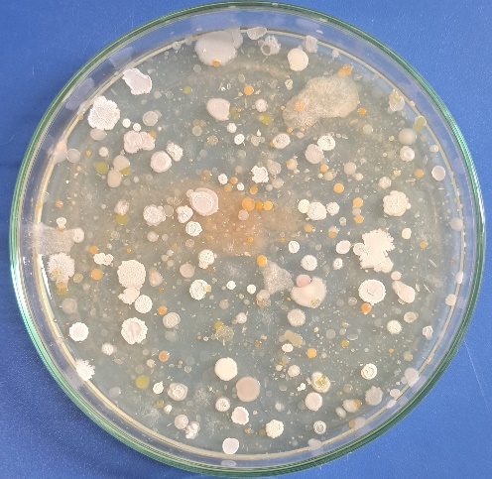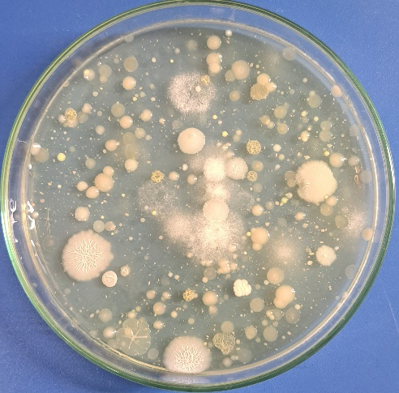

Fig. 1. Microbial landscape of a soil sample (Nutrient agar).
Following microbiological examination, nine isolates were selected for further study.
First, pure cultures of the isolated isolates were tested for growth rate under normal conditions. For this purpose, 5% of the inoculum relative to the volume of the medium was added to flasks containing Nutrient Broth. All cultures were incubated at 30°C and 120 rpm. The optical density of the culture fluids was measured every 24 hours for three days at a wavelength of 540 nm. Maximum optical density values were determined after 48 hours of incubation for seven and four isolates (Fig. 2).

Fig. 2. Growth rate of isolated isolates under normal conditions.
3.3 Silver Nanoparticle Synthesis

Next, all nine isolates were tested for their ability to synthesize silver nanoparticles. A silver nitrate solution with a silver ion concentration of 100 mg/ml was prepared. The test microorganisms were grown for 24 hours in flasks containing 100 ml of Nutrient Broth medium at 30°C and 120 rpm in a shaker incubator. Then, 1 ml of the prepared silver nitrate solution was added to the culture fluids, resulting in a final concentration of 100 mg of silver ions per 100 ml of reaction mixture. Further incubation was carried out under the same conditions as for culturing the isolates (Table 3).

Table 3. Screening of cultures for the synthetic capacity of silver nanoparticles
(pH = 7, T = 30°C, 120 rpm)

# | Name of the isolate | 1 h | 24 h | 48 h | 72 h
1 | Isolate 1 + Ag | - | + | + | +
2 | Isolate 2 + Ag | - | + | + | +
3 | Isolate 3 + Ag | - | + | ++ | ++
4 | Isolate 4 + Ag | - | ++ | +++ | ++++
5 | Isolate 5 + Ag | - | + | + | ++
6 | Isolate 6 + Ag | - | + | ++ | ++
7 | Isolate 7 + Ag | - | ++ | ++ | +++
8 | Isolate 8 + Ag | - | + | + | +
9 | Isolate 9 + Ag | - | + | + | ++

At the initial stage, the ability of microorganisms to synthesize silver nanoparticles was determined visually by the change in color of the reaction mixture (Fig. 3).

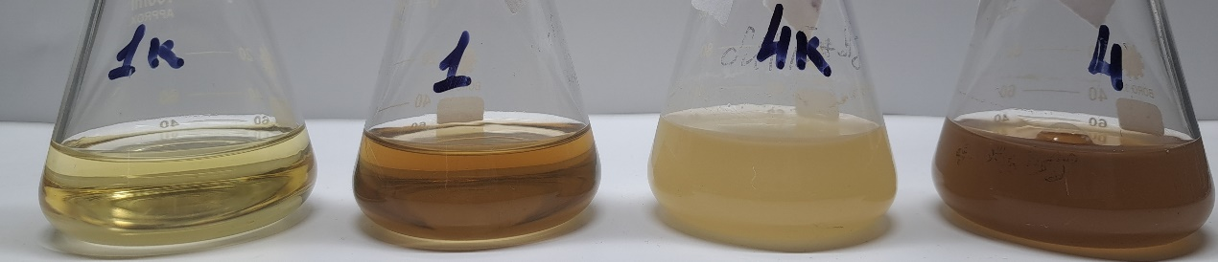
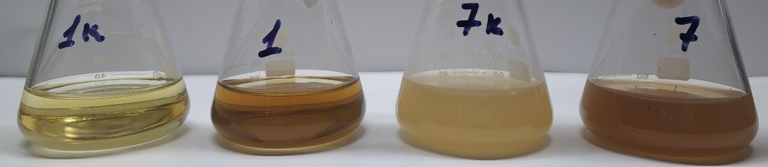

Fig. 3. Color change in the reaction mixture due to silver nanoparticle biosynthesis (1 k – Nutrient broth; 1 – Nutrient broth+Ag⁺; 4 k – culture fluid of isolate 4; 4 – culture fluid of isolate 4+Ag⁺; 7 k – culture fluid of isolate 7; 7 – culture fluid of isolate 7+Ag⁺).
After completing the silver nanoparticle biosynthesis experiment, samples of solutions 4 and 7 were subjected to UV spectroscopy to confirm the presence of silver nanoparticles in these samples. Isolate 4 showed the most pronounced spectrum (Figure 4).

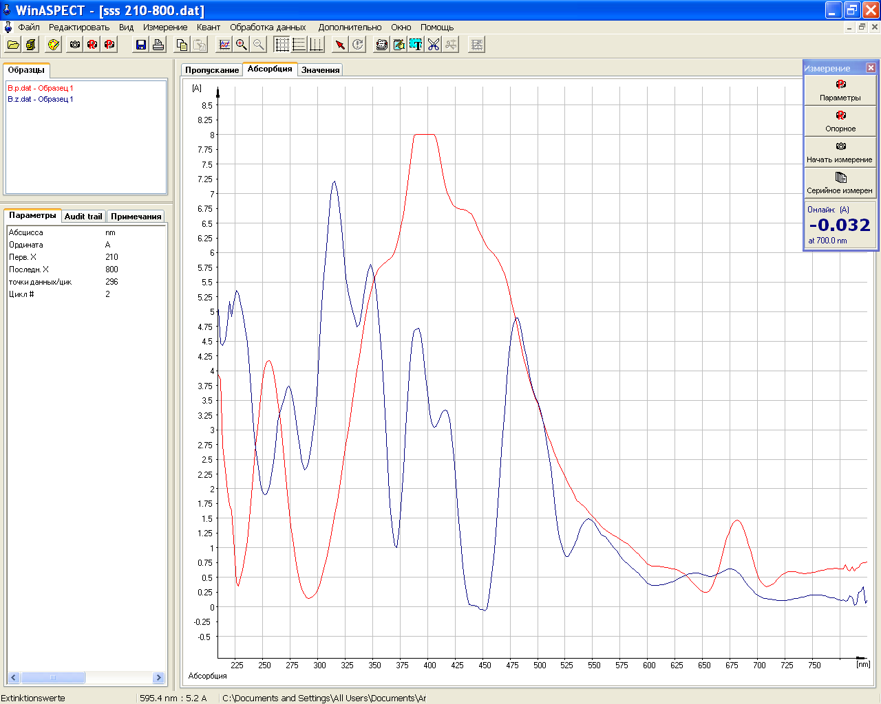
Fig. 4. UV spectra of solutions containing: control – peptone medium + AgNO₃ (blue). 1. culture liquid + AgNO₃ (red).
The spectrum of the sample in the presence of isolate 4 (red spectrum) is characterized by a pronounced maximum at approximately 400 nm, which is a typical LSPR peak of spherical Ag nanoparticles with sizes of approximately 10–40 nm. The presence of shoulders at 360, 430, and 460 nm indicates moderate polydispersity of the particles, as well as the presence of aggregated or anisotropic nanostructures. The width of the plasmonic peak indicates size heterogeneity and possible partial aggregation, which is expected for biological synthesis without strict stabilization control.
3.4 Microorganism Identification

After confirming the presence of silver nanoparticles in the culture fluids of the indicator microorganisms using UV spectroscopy, a preliminary identification of these isolates was performed using the MaldiTof analyzer. This revealed that isolate 4 is Bacillus subtilis, and isolate 7 is Pseudarthrobacter oxydans. However, to obtain more reliable information, the more active isolate 4 was further identified using the 16S rRNA method. Universal 16S rRNA gene primers were used for molecular genetic identification of the strain. The 16S rRNA gene was sequenced. A phylogenetic analysis of this strain was then performed. The results showed that isolate 4 belongs to the species Bacillus halotolerans (Fig. 5).

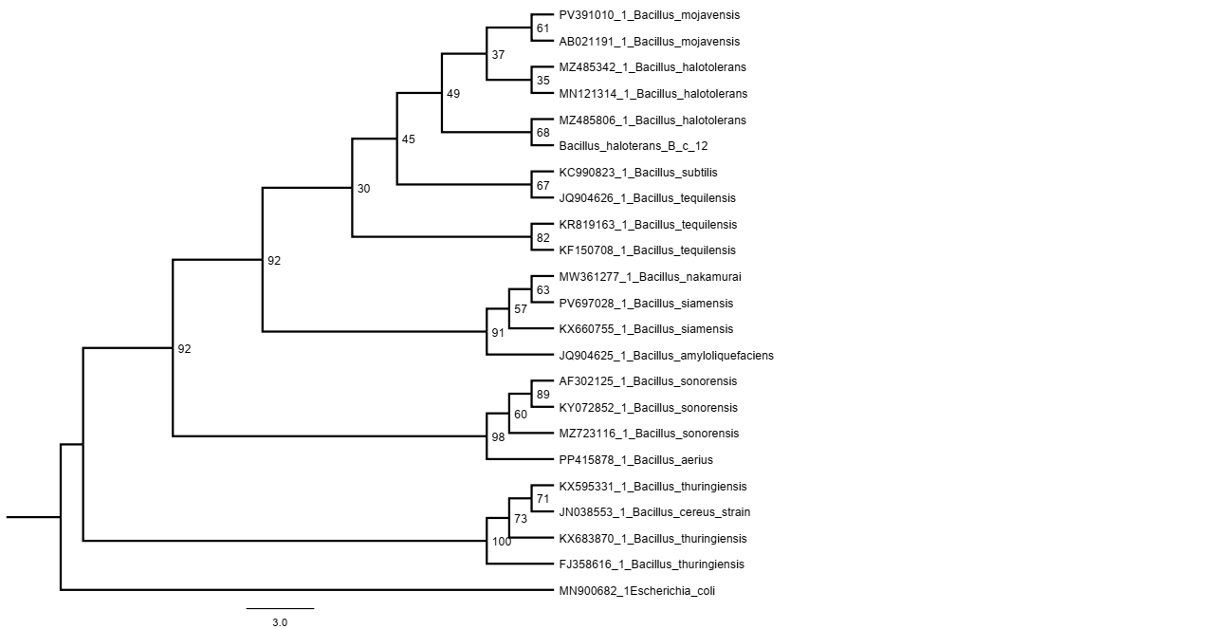

Fig. 5. Phylogenetic tree of the Bacillus halotolerans strain.
Comparative analysis of the sequenced nucleotide sequence of the 16S rRNA gene of strain 4 with reference nucleotide sequences of type strains from the EzBioCloud database revealed its highest similarity to the nucleotide sequence of the 16S rRNA gene of representatives of the genus Bacillus, species Bacillus halotolerans (99.76%).
4. Conclusion

As a result of the conducted research, nine of the most representative indicator isolates were identified, recovered during a microbiological survey of soil exposed to anthropogenic pressure in the central part of Tashkent. Isolates 4 and 7 demonstrated the highest specific growth rate under optimal conditions. The next step was to determine the ability of the isolated isolates to synthesize silver nanoparticles when a silver nitrate solution was added to the culture fluid at a final silver ion concentration of 100 mg per 100 ml of the reaction mixture. This study demonstrated the ability of isolates 4 and 7 to synthesize silver nanoparticles. To confirm this, UV spectroscopy of the culture fluid samples from these isolates was conducted. The resulting spectra revealed the presence of silver nanoparticles. Preliminary identification by MaldiTof revealed that isolate 4 belonged to Bacillus subtilis, and isolate 7 to Pseudarthrobacter oxydans. Further molecular genetic identification of 16S rRNA confirmed that isolate 7 belonged to Pseudarthrobacter oxydans, but isolate 4 was classified as Bacillus halotolerans.
The study revealed that the Bacillus halotolerans strain isolated from anthropogenically contaminated soil in central Tashkent was the most active and effective producer of silver nanoparticles among the other indicator microorganisms isolated.

References

Akdasci, E., Eker, F., Duman, H., Bechelany, M. & Karav, S. (2025). Microbial-based green synthesis of silver nanoparticles: A comparative review of bacteria- and fungi-mediated approaches. International Journal of Molecular Sciences, 26(20), 10163. https://doi.org/10.3390/ijms262010163
Akhil, T., Bhavana, V., Ann Maria, C.G. & Nidhin, M. (2023). Role of biosynthesized silver nanoparticles in environmental remediation: A review. Nanotechnology for Environmental Engineering, 8, 829–843. https://doi.org/10.1007/s41204-023-00324-x
Alam, A., Tanveer, F., Khalil, A.T., Zohra, T., Khamlich, S., Alam, M.M. et al. (2021). Silver nanoparticles biosynthesized from secondary metabolite producing marine Actinobacteria and evaluation of their biomedical potential. Antonie Leeuwenhoek, 114, 1497–1516. https://doi.org/10.1007/s10482-021-01616-5
Al-asbahi, M.G.S.S., Al-Ofiry, B.A., Saad, F.A.A., Alnehia, A. & Al-Gunaid, M.Q.A. (2024). Silver nanoparticles biosynthesis using mixture of Lactobacillus sp. and Bacillus sp. growth and their antibacterial activity. Scientific Reports, 14, 10224. https://doi.org/10.1038/s41598-024-59936-1
Altschul, S.F., Gish, W., Miller, W., Myers, E.W. & Lipman, D.J. (1990). Basic local alignment search tool. Journal of Molecular Biology, 215(3), 403–410. https://doi.org/10.1016/S0022-2836(05)80360-2
Boros-Lajszner, E., Wyszkowska, J., Borowik, A. & Kucharski, J. (2021). The Response of the soil microbiome to contamination with cadmium, cobalt and nickel in soil sown with Brassica napus. Minerals, 11(5), 498. https://doi.org/10.3390/min11050498
Das, V.L., Thomas, R., Varghese, R.T., Soniya, E.V., Mathew, J. & Radhakrishnan, E.K. (2014). Extracellular synthesis of silver nanoparticles by the Bacillus strain CS 11 isolated from industrialized area. 3 Biotech, 4(2), 121-126. https://doi.org/10.1007/s13205-013-0130-8
Esmail, R., Afshar, A., Morteza, M., Abolfazl, A. & Akhondi, E. (2022). Synthesis of silver nanoparticles with high efficiency and stability by culture supernatant of Bacillus ROM6 isolated from Zarshouran gold mine and evaluating its antibacterial effects. BMC Microbiology, 22, 97. https://doi.org/10.1186/s12866-022-02490-5
Fahim, M., Shahzaib, A., Nishat, N., Jahan, A., Bhat, T.A. & Inam, A. (2024). Green synthesis of silver nanoparticles: A comprehensive review of methods, influencing factors, and applications. JCIS Open, 16, 100125. https://doi.org/10.1016/j.jciso.2024.100125
Garg, D., Sarkar, A., Chand, P., Bansal, P., Gola, D., Sharma, S., et al. (2020). Synthesis of silver nanoparticles utilizing various biological systems: mechanisms and applications—a review. Progress in Biomaterials, 9, 81–95. https://doi.org/10.1007/s40204-020-00135-2
Guerrero, D.S., Bertani, R.P., Ledesma, A., de los Angeles Frías, M., Romero, C.M. & Dávila Costa, J.S. (2022). Silver nanoparticles synthesized by the heavy metal resistant strain Amycolatopsis tucumanensis and its application in controlling red strip disease in sugarcane. Heliyon, 8(5), e09472. https://doi.org/10.1016/j.heliyon.2022.e09472
Huq, M.A. & Akter, S. (2021). Characterization and genome analysis of Arthrobacter bangladeshi sp. nov., applied for the green synthesis of silver nanoparticles and their antibacterial efficacy against drug-resistant human pathogens. Pharmaceutics, 13(10), 1691. https://doi.org/10.3390/pharmaceutics13101691
Huq, M.A., Ashrafudoulla, M., Rahman, M.M., Balusamy, S.R. & Akter, S. (2022). Green synthesis and potential antibacterial applications of bioactive silver nanoparticles: A review. Polymers, 14, 742. https://doi.org/10.3390/polym14040742
Ibrahim, S., Ahmad, Z., Manzoor, M.Z., Mujahid, M., Faheem, Z. & Adnan, A. (2021). Optimization for biogenic microbial synthesis of silver nanoparticles through response surface methodology, characterization, their antimicrobial, antioxidant, and catalytic potential. Scientific Reports, 11, 770. https://doi.org/10.1038/s41598-020-80805-0
Jiao, S., Chen, W. & Wei, G. (2019). Resilience and assemblage of soil microbiome in response to chemical contamination combined with plant growth. Applied and Environmental Microbiology, 85, e02523-18. https://doi.org/10.1128/AEM.02523-18
Kazemi, S., Doudi, M. & Amiri, G.R. (2017). Biosynthesis of silver nanoparticles using bacteria isolates from wastewater. Medical Laboratory Journal, 11(6), 42-47. https://doi.org/10.29252/mlj.11.6.42
Lazutin, N., Zaynitdinova, L., Juraeva, R. & Ergashev, R. (2025). Microbial diversity of soils under anthropogenic load. Asian Journal of Environment & Ecology, 24(5), 349-55. https://doi.org/10.9734/ajee/2025/v24i5716
Netrusov, A.I., Egorova, M.A., Zakharchuk, L.M. & Kolotilova, N.N. (2005). Microbiology Workshop: Textbook for students of higher educational institutions. Academy, Moscow. (in Russian)

Plokhovska, S., García-Villaraco, A., Lucas, J.A., Gutierrez-Mañero, F.J. & Ramos-Solano, B. (2025). Silver nanoparticles coated with metabolites of Pseudomonas sp. N5.12 inhibit bacterial pathogens and fungal phytopathogens. Scientific Reports, 15, 1522. https://doi.org/10.1038/s41598-024-84503-z
Rose, G.K., Soni, R., Rishi, P. & Soni, S.K. (2019). Optimization of the biological synthesis of silver nanoparticles using Penicillium oxalicum GRS-1 and their antimicrobial effects against common food-borne pathogens. Green Processing and Synthesis, 8(1), 144-156. https://doi.org/10.1515/gps-2018-0042
Saba, M., Farooq, S., Alessa, A.H., Bektas, K.I., Belduz, A.O., Khan, A.Z. et al. (2025). Green synthesis of silver nanoparticles using keratinase from Pseudomonas aeruginosa-C1M, characterization and applications as novel multifunctional biocatalyst. BMC Biotechnology, 25, 27. https://doi.org/10.1186/s12896-025-00959-5
Sazykina, M.A., Minkina, T.M., Konstantinova, E.Y., Khmelevtsova, L.E., Azhogina, T.N., Antonenko, E.M. et al. (2022). Pollution impact on microbial communities composition in natural and anthropogenically modified soils of Southern Russia. Microbiological Research, 254, 126913. https://doi.org/10.1016/j.micres.2021.126913
Singh, R., Shedbalkar, U.U., Wadhwani, S.A. & Chopade, B.A. (2015). Bacteriagenic silver nanoparticles: synthesis, mechanism, and applications. Applied Microbiology and Biotechnology, 99(11), 4579–4593. https://doi.org/10.1007/s00253-015-6622-1
Soil Microbial Sampling Protocol – CD Genomics. https://www.cd-genomics.com/microbioseq/soil-microbial-sampling-protocol.html
Solís-Sandí, I., Cordero-Fuentes, S., Pereira-Reyes, R., Vega-Baudrit, J.R., Batista-Menezes, D. & De Oca-Vásquez, G.M. (2023). Optimization of the biosynthesis of silver nanoparticles using bacterial extracts and their antimicrobial potential. Biotechnology Reports, 40, e00816. https://doi.org/10.1016/j.btre.2023.e00816
Tamura, K., Stecher, G., Peterson, D., Filipski, A. & Kumar, S. (2013). MEGA 6: Molecular Evolutionary Genetics Analysis version 6.0. Molecular Biology and Evolution, 30(12), 2725–2729. https://doi.org/10.1093/molbev/mst197
Zayinitdinova, L.I., Juraeva, R.N., Lazutin, N.A., Mavjudova, A.M., Bekmukhamedova, N.K. & Ergashev, R.B. (2022). Microbiocenosis of anthropogenically transformed soils. Proceedings of the Pakistan Academy of Sciences: B Pakistan Academy of Sciences Life and Environmental Sciences, 59(4), 15-23. https://doi.org/10.53560/PPASB(59-4)722
Zaynitdinova, L.I., Juraeva, R.N., Tashpulatov, J.J., Lazutin, N.A., Mavjudova, A.M. & Khegay, T.B. (2023). Microbial synthesis of silver nanoparticles and their effect of wheat seeds’ germination. Asia-Pacific Journal of Molecular Biology and Biotechnology, 31(3), 1-9. https://doi.org/10.35118/apjmbb.2023.031.3.01

