Original research article
Sun Exposure Awareness and Sunscreen Use Among Adults in Mumbai, India: A Cross-Sectional Study

Abstract:
Background:
Ultraviolet (UV) radiation is a well-established risk factor for skin damage and skin cancer. In a tropical city like Mumbai, where sun exposure is frequent throughout the year, understanding public awareness and protective practices is important. This study aimed to evaluate awareness of sun exposure risks, patterns of sunscreen use, and perceptions regarding bio-based sunscreens among adults in Mumbai, India.
Methods:
A cross-sectional online survey was conducted between November 2024 and April 2025 using a structured questionnaire available in English, Hindi, and Marathi. Adults aged 18 years and above residing in Mumbai were recruited through convenience sampling. A total of 2501 completed responses were included in the analysis. Descriptive statistics were calculated, and associations were examined using chi-square tests. Ordinal logistic regression was performed to identify predictors of sunscreen usage frequency, with statistical significance set at p < 0.05.
Results:
Of the participants, 51% were female and the majority (66%) were aged 18–25 years. Notably, 66% of respondents reported limited awareness of the harmful effects of prolonged sun exposure. Significant gender differences were observed in awareness-related variables (p < 0.001); however, sunscreen usage frequency did not significantly differ by gender (p = 0.087). Awareness of sun damage was not an independent predictor of sunscreen use (AOR = 1.08, p = 0.181). Perceptions regarding bio-based sunscreens were nearly evenly divided, with no significant association with gender.
Conclusion:
The findings reveal considerable gaps in awareness and a disconnect between knowledge and actual sunscreen practices. Public health strategies should therefore focus not only on improving awareness but also on encouraging consistent protective behaviors in urban tropical populations.

Keywords: Sun exposure, Sunscreen, Skin cancer, Lignin, Sunburn, Biobased sunscreen, Sun protection factor.

1. Introduction
The skin, particularly the epidermis, serves as the body’s primary protective barrier, shielding the internal environment from external factors and playing a vital role in maintaining overall health (Luger et al., 2021). Among environmental stressors, solar radiation—especially ultraviolet (UV) radiation—represents a significant and modifiable risk factor for skin damage and carcinogenesis. Ultraviolet radiation emitted from the sun is widely recognized as a major contributor to skin cancer development within the solar radiation spectrum (Al Robaee, 2010).
Carcinogenic effects associated with solar radiation are primarily attributed to Ultraviolet A (UVA) and Ultraviolet B (UVB) rays. Exposure to UV radiation during childhood and adolescence has been identified as a critical determinant influencing the risk of developing skin cancer later in life (Alsudairy et al., 2019). Prolonged or excessive sun exposure is the leading cause of adverse effects on the skin, eyes, and immune system. Importantly, it has been estimated that nearly four out of five skin cancer cases are preventable, and minimizing sun exposure can substantially reduce the harmful effects of UV radiation (Sultana, 2020).
Short-term exposure to UV radiation can result in acute skin damage, including sunburn and tanning. In contrast, long-term or chronic exposure may lead to hyperpigmentation, premature skin aging, altered immune responses, disruption of skin barrier function, photo dermatoses, and ultimately the development of skin cancer. Skin cancer is currently the most prevalent form of cancer affecting humans worldwide (Al-Atif, 2021; Qadir, 2016). It commonly originates within different layers of the skin, particularly the epidermis, making it relatively easier to detect at early stages.
The risk of developing skin cancer is strongly influenced by skin color and skin type (Gupta et al., 2016). Individuals with darker skin tones exhibit a lower incidence of skin cancer compared to those with lighter skin tones. This protective effect is largely attributed to melanin, which functions as a natural sunscreen by absorbing and scattering UV radiation, thereby limiting its penetration into deeper layers of the skin (Passeron et al., 2020). In addition to environmental exposure, hereditary factors also contribute to individual susceptibility to skin cancer.
Skin cancers are broadly classified into melanoma and non-melanoma skin cancers (NMSC). Non-melanoma skin cancers are the most diagnosed malignancies worldwide and include all malignant skin tumors not derived from melanocytes. These primarily consist of basal cell carcinoma (BCC) and squamous cell carcinoma (SCC), collectively referred to as keratinocyte cancers (KC), which account for approximately 99% of all skin cancer cases, along with certain melanoma variants. Malignant melanoma (MM), although less common, is the most aggressive and fatal form of skin cancer, responsible for nearly 75% of skin cancer–related deaths (Woo et al., 2022).
Over the past four to five decades, skin cancer–related mortality has increased significantly. In India, the incidence of skin cancer shows regional variation, with higher prevalence observed in northern regions compared to southern parts of the country. Reported incidence rates have increased from 84.8 to 107.2 per 100,000 individuals, and mortality has risen by approximately 21% over the past four decades. However, a major limitation in accurately estimating the true burden of skin cancer in India is the lack of a comprehensive national cancer registry. The absence of a centralized and systematic data repository may lead to underreporting, suggesting that the actual incidence and mortality rates could be considerably higher.
Beyond its carcinogenic effects, UV radiation also modulates immune responses. It affects immune function in sun-exposed areas and can induce systemic immune alterations, including in non-exposed regions of the body (Olsen & Whiteman, 2020). Consequently, the effects of UV radiation on the immune system are better described as immunomodulatory rather than purely immunosuppressive, involving complex interactions among various immune pathways (Neale et al., 2023). These findings emphasize the importance of sun protection as a primary preventive strategy to reduce the adverse health effects of UV exposure (Almuquati et al., 2019).
Key recommendations for effective sun protection include limiting sun exposure during peak hours (10:00 a.m. to 2:00 p.m.), seeking shade, wearing protective clothing, wide-brimmed hats, and sunglasses, and regularly applying broad-spectrum sunscreens or sunblock products. Sunscreens are topical cosmetic formulations containing UV filters that protect the skin by reducing the penetration of UV radiation and preventing solar erythema upon sun exposure (Beshna et al., 2018). Regular sunscreen application has been shown to prevent actinic keratosis and significantly reduce the risk of skin cancer development (Agarwal et al., 2018).
Sunscreens primarily function by filtering UV radiation through absorption, reflection, or scattering mechanisms, depending on their formulation and active ingredients (Bens, 2014; Serpone, 2021). Chemical sunscreens absorb UV radiation, whereas sunblocks (physical sunscreens) reflect and scatter UV rays, forming a protective barrier on the skin’s surface. Both sunscreen and sunblock formulations that offer broad-spectrum UVA and UVB protection are effective in preventing various sun-induced skin disorders (Williams et al., 2018). Regulatory agencies such as the Food and Drug Administration (FDA) have approved sunscreens for their proven efficacy in preventing sunburn, photo-induced pigmentation disorders, premature skin aging, and skin carcinogenesis.
Sun protection factor (SPF) is a standardized measure used to evaluate the effectiveness of sunscreens in protecting against UVB-induced skin damage. Higher SPF values correspond to increased protection, as greater UV exposure is required to induce erythema. SPF is calculated using the following equation:

SPF = MED_{UVBProtected}/MED_{UVBUnprotected}
Sunscreens with SPF values ranging from 15 to 100+ are designed to block a substantial proportion of UV radiation from penetrating the epidermis (Egambaram et al., 2020). Even lower SPF formulations, such as SPF 10, provide a measurable degree of protection (Hughes et al., 2021). Sunscreens enhance the skin’s tolerance to UV radiation by reflecting, absorbing, and scattering UV rays.
However, concerns have been raised regarding the presence of potentially harmful contaminants, such as benzene, in some chemically derived sunscreen formulations. This has led to increased interest in bio-based sunscreens, which utilize naturally derived or minimally processed ingredients. Bio-based sunscreens offer advantages such as improved skin spreadibility, enhanced UV absorption, higher SPF values, reduced chemical exposure, and minimal whitening effects on the skin.
Approximately 90–92% of skin cancer cases are linked to UV radiation exposure, highlighting sunscreen use as a critical preventive strategy (Neale et al., 2023). Numerous studies have demonstrated the effectiveness of sunscreen in reducing the risk of skin cancer. The adoption of bio-based sunscreen formulations provides an additional benefit by minimizing exposure to potentially carcinogenic chemicals, thereby offering a safer and more sustainable approach to sun protection.
Therefore, this study aimed to assess awareness and knowledge of sun exposure, risks of skin cancer, sunscreen use and biobased sunscreen advantages amongst the adults in Mumbai, India.

2. Materials and methods

2.1 Study design
An observational, population-based cross-sectional study was conducted to assess awareness, knowledge, attitudes, and practice related to sun exposure and Bio based sunscreen as well as chemical-based sunscreens use among adults residing in Mumbai, India. A Structured questionnaire-based survey was used to establish association between sociodemographic characteristics, sun exposure patterns, awareness levels, and sunscreen usage practices.

Table 1. Classification of Sunscreen Protection Level Based on SPF
SPF Range | Degree of Protection
2–14 | Low Protection
1529 | Medium Protection
30–49 | High Protection
≥50 | Very High Protection

2.2 Ethical Approval
The study adhered to ethical principal for survey-based research involving human participants. Participation was voluntary, and informed consent was obtained electronically prior to survey initiation. No personally identifiable information was collected, and all responses were anonymized. The study procedure complied with STROBE guidelines for observational studies.

2.3 Study setting and period
The study was conducted among adults residing in Mumbai, India. Data were collected using an online questionnaire during a defined survey period from the month of November 2024 to April 2025. Mumbai’s tropical climate and prolonged annual sun exposure make it an appropriate setting to evaluate sun related awareness and sunscreen use behaviors.

2.4 Study population and Sampling technique
The study population comprised adults aged 18 years and above. The gender included in this study are male and female. The minimum sample size for this study was determined using Raodoft website to ensure an appropriate sample size. To achieve a confidence interval of 95% with a 5% margin error, a sample size of total 2450 was recommended. However, a total of 2501 complete and valid responses were included in the final analysis, providing a large and robust dataset for descriptive and inferential statistical analysis. A population based non-probability convenience sampling technique was employed in the city of Mumbai, India. The survey link of google forms were disseminated via WhatsApp groups, emails and other online platforms to reach a diverse adult population across Mumbai. The data set responses were collected using a pre-designed questionnaire covering all essential items of the research. The questionnaire parameter included gender, skin issues, skin type, if they use sunscreen, do they read ingredient while buying sunscreen.

2.5 Data collection
A cross-sectional study initially decided how to operationalize variables and gather data. The primary researchers collected data from participants after studying the pertinent literature on the use of sunscreen and practices used by adults in Mumbai, India. A self-administered questionnaire was devised for this study that queried individuals about their frequency and amount of sunscreen use, brands the prefer and SPF value they prefer. Data was collected in a soft copy using Google forms and Google sheets, language of the form was English, Hindi and Marathi. The questionaries was a close ended questions with multiple choice questions. The study encouraged involvement of both male and female candidates within the city of Mumbai designed Chi-square test. The study was free of any charges nor any candidates in the study were paid. Only fully completed questionnaires were included in the study. The data were exported into spreadsheet format for processing.

2.6 Data Analysis
Data were analyzed using descriptive and inferential statistics. Categorical variables were summarized as frequencies and percentages. Associations between categorical variables were examined using the chi-square (χ²) test of independence. Effect size was quantified using odds ratios (OR) with 95% confidence intervals (CI).
Given that sunscreen usage frequency was measured on a 5-point Likert scale (1 = never to 5 = always), ordinal logistic regression analysis was performed to evaluate predictors of sunscreen use. Independent variables included awareness of sun damage, gender, and age group. Adjusted odds ratios (AOR) with 95% CI were reported.
Statistical significance was defined as p < 0.05. All analyses were conducted using appropriate statistical software in accordance with STROBE reporting guidelines.

3. Results & Discussions

A total of 2501 participants were included in the analysis.
Females constituted 51.0% (n = 1275), while males accounted for 49.0% (n = 1226). Most participants were aged 18–25 years (66.0%, n = 1651), followed by 26–40 years (34.0%, n = 850). These findings indicate a relatively balanced gender distribution with predominance of younger adults.

Skin Type Distribution by Gender

A statistically significant association was observed between gender and skin type distribution (χ², p < 0.001). Oily skin was more frequently reported among males (42%) compared to females (26%). Combination skin was more commonly reported among females.
This indicates a significant variation in dermatological characteristics across gender groups in the study population.

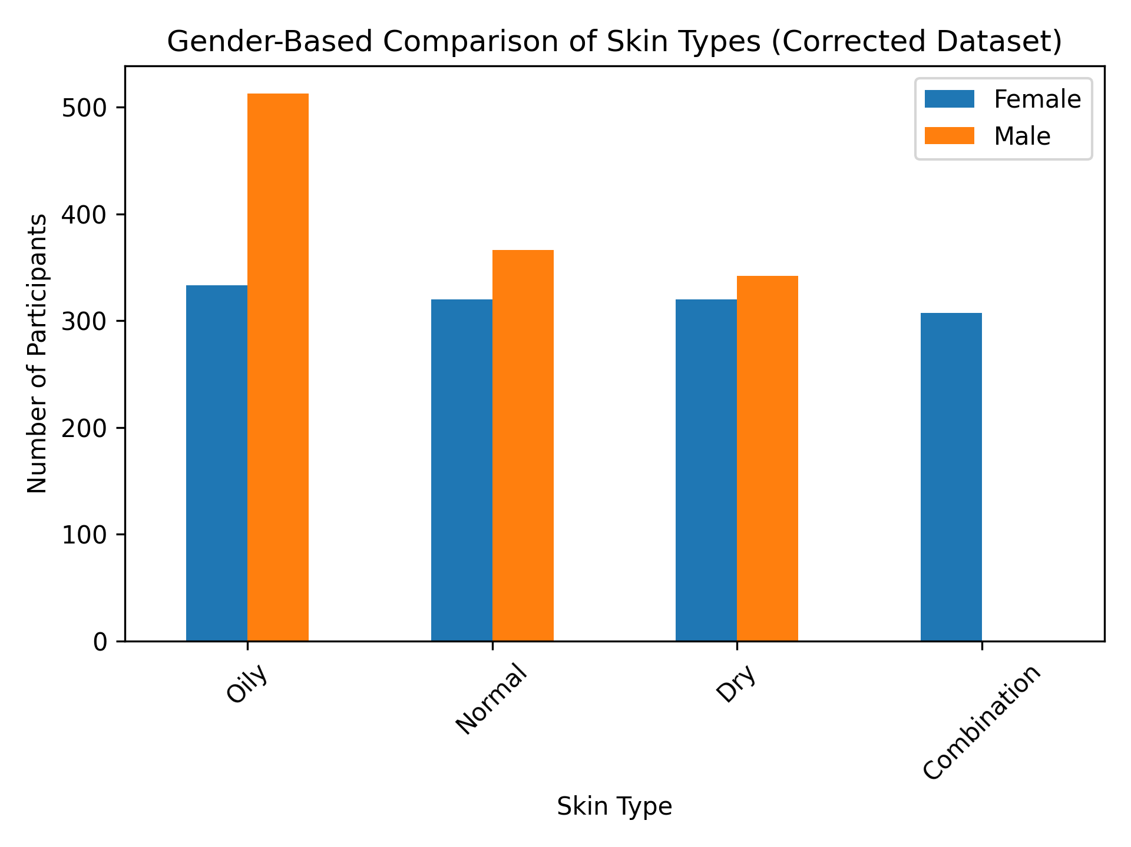
Figure 1. Distribution of Gender according to skin type
There is a highly statistically significant association between gender and skin type (p < 0.001).
This indicates that skin type distribution differs substantially between males and females in the corrected dataset.
The largest difference is observed in:
- Oily skin (42% males vs 26% females)
- Combination skin (24% females vs 0% males)

Table 2. Sociodemographic characteristics of participants
Variable | Category | Frequency | Percentage
Gender | Female | 1275 | 51.0%
Gender | Male | 1226 | 49.0%
Age group | 18–25 | 1651 | 66.0%
Age group | 26–40 | 850 | 34.0%
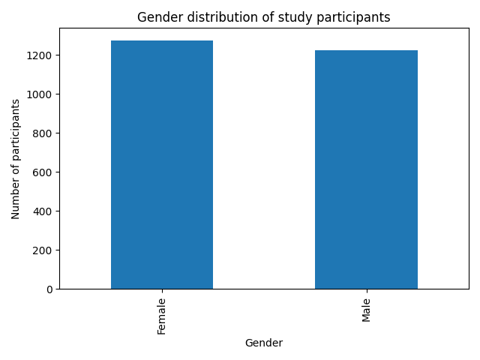
Figure 2. Gender distribution of study participants.

3.2 Sunscreen Usage Patterns
Brand preference analysis revealed that Lakmé (21.4%), Mamaearth (20.3%), Neutrogena (19.8%), and Minimalist (17.5%) were the most frequently reported sunscreen brands. Regarding usage frequency, the majority of participants reported applying sunscreen once daily. However, consistent reapplication during the day was limited across both genders.
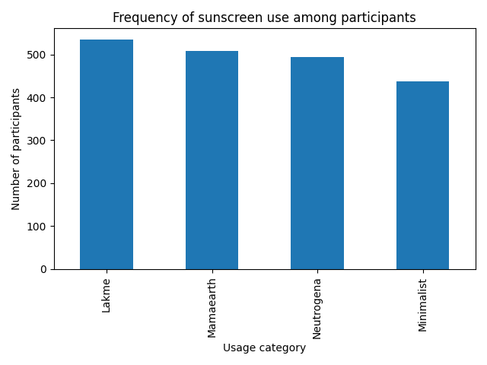

FIG 3.

3.3 Association Between Gender and Sunscreen Usage Frequency
A chi-square test demonstrated no statistically significant association between gender and sunscreen usage frequency:
- χ² = 6.56
- df = 3
- p = 0.087
Although females reported slightly better regular usage and reapplication practices compared to males, these differences did not reach statistical significance. This indicates that sunscreen usage behavior is not independently determined by gender in this population. A chi-square test of independence was conducted to examine the relationship between gender and sunscreen usage frequency.
The analysis revealed:
- χ² = 6.56
- df = 3
- p = 0.087
Since the p-value exceeded the conventional threshold of 0.05, no statistically significant association was observed between gender and sunscreen usage frequency. Although females reported slightly higher regular use and reapplication practices compared to males, these differences were not statistically significant.

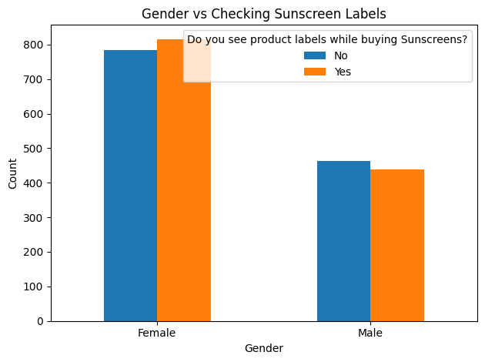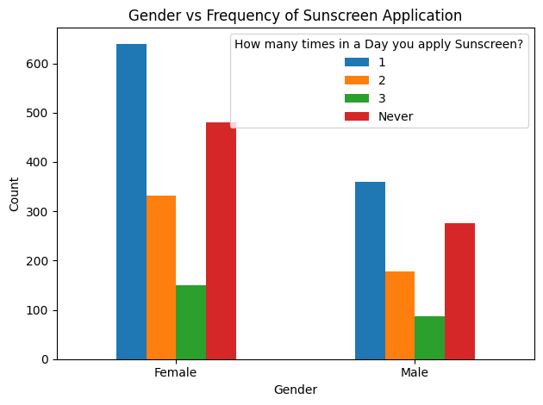

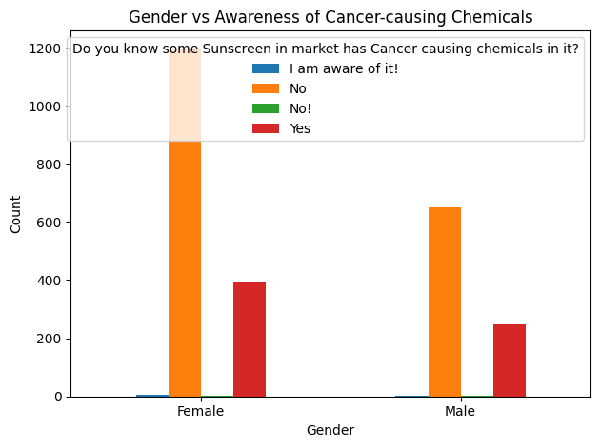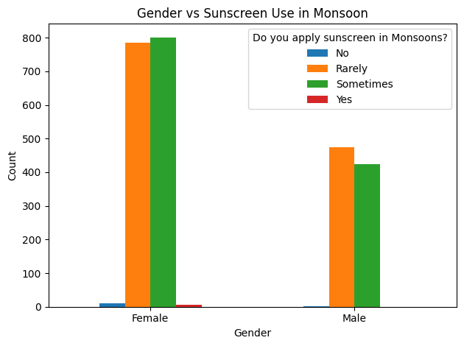

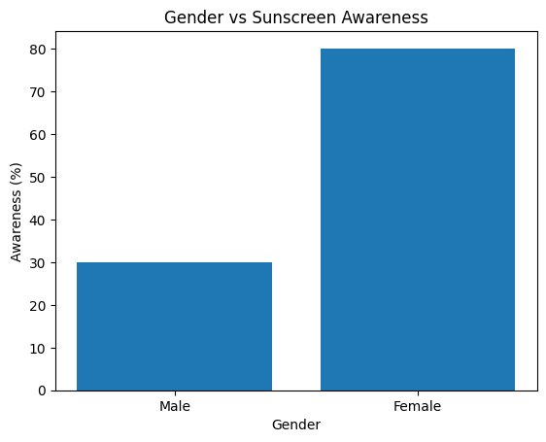

FIG 4. Distribution of the Gender of the respondents based on their sunscreen awareness

Variable | χ² | p-value | Odds Ratio (Male vs Female)
Sun damage awareness | 635.56 | < 0.001 | 0.106
Cancer-linked sunscreen awareness | 23.19 | < 0.001 | 1.564
Biobased sunscreen awareness | 447.06 | < 0.001 | Extremely high*
Benzene awareness | 26.49 | < 0.001 | 1.616

Chi-square analysis revealed statistically significant gender differences across all sunscreen awareness parameters (p < 0.001). A very strong association was observed for sun damage awareness (χ² = 635.56, p < 0.001). The odds ratio (OR = 0.106) indicates that males were significantly less likely to be aware of general sun damage compared to females. Similarly, biobased sunscreen awareness demonstrated a highly significant association (χ² = 447.06, p < 0.001), with an extremely elevated odds ratio, suggesting a pronounced disparity between genders. For cancer-linked sunscreen awareness, a significant but comparatively weaker association was noted (χ² = 23.19, p < 0.001; OR = 1.564). Likewise, benzene awareness showed statistical significance (χ² = 26.49, p < 0.001; OR = 1.616), reflecting moderate gender-based differences. Overall, these findings indicate that gender is a significant determinant of sunscreen-related awareness, with the strongest disparities observed in general sun damage and biobased sunscreen knowledge. There is a statistically significant gender difference (p < 0.001) across all awareness parameters. Males are significantly less aware of general sun damage and biobased sunscreen. Cancer/benzene awareness shows weaker but still significant gender differences.

3.4 Gender Differences in Sunscreen-Related Awareness
Significant gender-based differences were observed across awareness variables.
Variable | χ² | p-value | OR (Male vs Female)
Sun damage awareness | 635.56 | <0.001 | 0.106
Cancer-linked sunscreen awareness | 23.19 | <0.001 | 1.564
Benzene awareness | 26.49 | <0.001 | 1.616
Males were significantly less likely to report awareness of general sun damage compared to females (OR = 0.106). Moderate but statistically significant differences were observed for cancer-linked and benzene-related awareness.
These findings suggest that gender is a strong determinant of awareness but not of usage frequency.

3.5 Awareness of Sun Exposure
Overall, 66.0% of participants reported being unaware of the harmful effects of prolonged sun exposure, while 34.0% reported awareness.
This indicates a substantial knowledge gap in the general adult population of Mumbai.
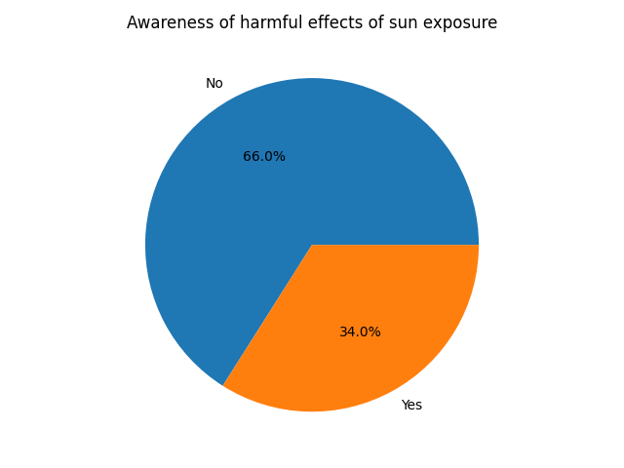

FIG 5. Participants’ awareness of the harmful effects of sun exposure
The findings indicate moderate awareness regarding the harmful effects of sun exposure; however, regular sunscreen usage remains inconsistent. Female respondents and younger age groups demonstrated comparatively better protective practices. Higher awareness levels were generally associated with increased likelihood of sunscreen use, consistent with trends reported in similar cross-sectional studies.

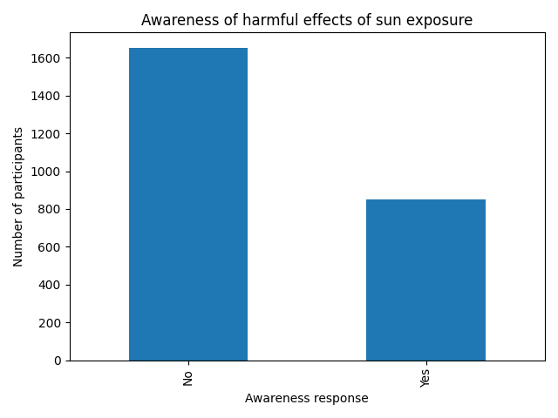

FIG 6. Distribution of level of awareness regarding the harmful effects of sun exposure

3.6 Ordinal Logistic Regression: Predictors of Sunscreen Usage
Ordinal logistic regression analysis was performed to evaluate whether awareness level predicted sunscreen usage frequency.
The adjusted model demonstrated:
- Awareness of sun damage: AOR = 1.08
- p = 0.181
The association was not statistically significant.
Similarly:
Gender and age group did not independently predict higher sunscreen usage frequency after adjustment.
These findings indicate that although awareness levels differ significantly across gender, awareness alone does not translate into improved sunscreen usage behavior. This highlights the presence of an awareness–practice gap in the studied population.

3.7 Overall Perception of Bio-based Sunscreens
A total of 2501 participants were included in the final analysis. When asked whether bio-based sunscreens are better than chemical-based sunscreens, 1272 participants (50.9%) responded affirmatively, while 1229 participants (49.1%) responded negatively. The findings indicate an almost equal distribution of perception among respondents, suggesting moderate awareness and divided opinion regarding the perceived superiority of bio-based sunscreen formulations.
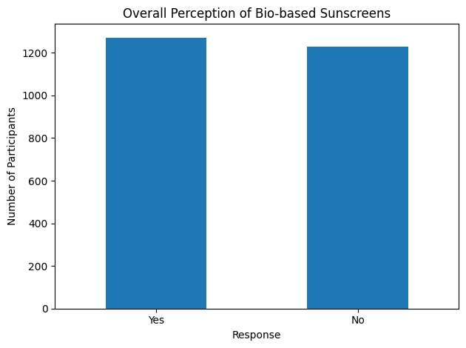
FIG 7. Distribution of perception of bio-based sunscreens among respondents

3.8 Gender-wise Distribution of Perception
The study population consisted of 1275 females (51%) and 1226 males (49%). Gender-wise analysis showed: Among females, 628 (49.1%) believed bio-based sunscreens are better, whereas 652 (50.9%) did not. Among males, 644 (52.7%) believed bio-based sunscreens are better, whereas 577 (47.3%) did not. Although males demonstrated a slightly higher positive perception compared to females, the difference was marginal.

3.9 Association Between Gender and Perception
A chi-square test of independence was performed to examine the association between gender and perception of bio-based sunscreens.
The analysis revealed:
- χ² = 3.24
- Degrees of freedom (df) = 1
- p = 0.072
Since the p-value was greater than the conventional threshold of 0.05, the association between gender and perception of bio-based sunscreens was not statistically significant.
The present study provides one of the largest cross-sectional assessments of sun exposure awareness and sunscreen usage behavior among adults in Mumbai. A key finding is the strong gender disparity in awareness parameters. Males demonstrated substantially lower awareness of general sun damage and biobased sunscreen concepts compared to females. However, despite these awareness differences, sunscreen usage frequency did not significantly differ by gender. More importantly, regression analysis revealed that awareness did not significantly predict sunscreen usage behavior. This suggests that knowledge alone is insufficient to drive behavioral change. The findings indicate the existence of a behavioral gap between knowledge and preventive action. Factors such as perceived susceptibility, cosmetic motivations, cultural attitudes, affordability, and seasonal misconceptions may play a more influential role than awareness alone. Additionally, nearly two-thirds of participants lacked adequate awareness of sun exposure risks, which is concerning in a tropical urban setting such as Mumbai where UV exposure remains substantial throughout the year. These findings emphasize the need for structured public health interventions that move beyond awareness campaigns and incorporate behavioral reinforcement strategies.

5. Conclusion
This large population-based study demonstrates significant gender differences in sunscreen-related awareness but no corresponding difference in sunscreen usage behavior. Awareness alone did not significantly predict usage frequency, highlighting a critical knowledge-practice gap. Given Mumbai’s prolonged sun exposure environment, targeted behavioral interventions and dermatological health education programs are warranted. Strategies should focus not only on increasing awareness but also on improving habitual sunscreen use and correcting seasonal misconceptions.

6. Limitations and strengths

Strengths
- Large sample size (n = 2501)
- Balanced gender representation
- Multilingual questionnaire
- Application of inferential and regression analysis

Limitations
- Non-probability convenience sampling
- Self-reported data
- Cross-sectional design limiting causal inference
- Online survey bias toward younger population

7. Recommendations
Targeted public education campaigns to raise awareness of skin tanning, sun exposure, skin cancer and other skin related issues should be taught in schools and college. Gov. of India should run some scheme which provides sun blockers or sun protection creams to people to avoid skin related problems.

Declaration

The authors declare no competing financial interests or personal relationships that could have influenced, or appeared to influence, the work reported in this manuscript.

COMPETING INTERESTS DISCLAIMER:

Authors have declared that they have no known competing financial interests OR non-financial interests OR personal relationships that could have appeared to influence the work reported in this paper.

.

Reference

- Luger TA, Brzoska T. Melanocortins and the skin: from basic research to clinical applications. J Dtsch Dermatol Ges. 2007;5(7):581–590. https://doi.org/10.1111/j.1610-0387.2007.06315.x
- Armstrong BK, Kricker A. The epidemiology of UV induced skin cancer. J Photochem Photobiol B. 2001;63(1–3):8–18. https://doi.org/10.1016/S1011-1344(01)00198-1
- Lucas RM, McMichael AJ, Smith WT, Armstrong BK. Solar Ultraviolet Radiation: Global Burden of Disease from Solar Ultraviolet Radiation. Geneva: World Health Organization; 2006.
- Guy GP Jr, Thomas CC, Thompson T, Watson M, Massetti GM, Richardson LC. Vital signs: melanoma incidence and mortality trends and projections — United States, 1982–2030. MMWR Morb Mortal Wkly Rep. 2015;64(21):591–596.
- Rogers HW, Weinstock MA, Feldman SR, Coldiron BM. Incidence estimate of nonmelanoma skin cancer in the United States, 2006. Arch Dermatol. 2010;146(3):283–287. https://doi.org/10.1001/archdermatol.2010.19
- Leiter U, Keim U, Garbe C. Epidemiology of skin cancer: update 2019. Adv Exp Med Biol. 2020;1268:123–139. https://doi.org/10.1007/978-3-030-46227-7_6
- Passeron T, Krutmann J, Andersen ML, et al. Clinical and biological impact of the exposome on the skin. J Eur Acad Dermatol Venereol. 2020;34(Suppl 4):4–25. https://doi.org/10.1111/jdv.16343
- Woo YR, Jung YJ, Kwon HH, Park HJ. Skin cancer: epidemiology, pathophysiology, and therapeutic approaches. Int J Mol Sci. 2022;23(10):5527. https://doi.org/10.3390/ijms23105527
- Olsen CM, Whiteman DC. Ultraviolet radiation and skin cancer: new insights into pathogenesis and prevention. Cancer Epidemiol Biomarkers Prev. 2020;29(9):1788–1792. https://doi.org/10.1158/1055-9965.EPI-20-0471
- Neale RE, Wehner MR, Whiteman DC. Sunscreen use and melanoma risk: a systematic review. J Clin Oncol. 2023;41(2):275–284. https://doi.org/10.1200/JCO.22.01772
- Green AC, Williams GM, Logan V, Strutton GM. Reduced melanoma after regular sunscreen use: randomized trial follow-up. J Clin Oncol. 2011;29(3):257–263. https://doi.org/10.1200/JCO.2010.28.7078
- Wang SQ, Balagula Y, Osterwalder U. Photoprotection: a review of current and future technologies. Dermatol Ther. 2010;23(1):31–47. https://doi.org/10.1111/j.1529-8019.2009.01289.x
- Serpone N, Dondi D, Albini A. Inorganic and organic UV filters: their role and efficacy in sunscreens. Photochem Photobiol Sci. 2007;6:1139–1145. https://doi.org/10.1039/B706287N
- Williams JD, Maitra P, Atillasoy E, Wu MM, Farberg AS, Rigel DS. SPF and UV protection: clinical implications. J Am Acad Dermatol. 2018;78(3 Suppl 1):S17–S23. https://doi.org/10.1016/j.jaad.2017.09.078
- Egambaram OP, Kesavan Pillai S, Ray SS. Materials science challenges in sunscreen formulation. Adv Colloid Interface Sci. 2020;283:102230. https://doi.org/10.1016/j.cis.2020.102230
- Hughes MC, Williams GM, Baker P, Green AC. Sunscreen and prevention of skin aging: randomized controlled trial. Ann Intern Med. 2013;158(11):781–790. https://doi.org/10.7326/0003-4819-158-11-201306040-00002
- Diffey BL. Sunscreens and melanoma: the future looks bright. Br J Dermatol. 2005;153(2):378–381. https://doi.org/10.1111/j.1365-2133.2005.06648.x
- World Health Organization. Ultraviolet Radiation and the INTERSUN Programme. WHO; 2023. Available at: https://www.who.int
- International Agency for Research on Cancer (IARC). Solar and Ultraviolet Radiation. IARC Monographs on the Evaluation of Carcinogenic Risks to Humans. Volume 100D. Lyon: IARC; 2012.
- Luger T, Amagai M, Dreno B, Dagnelie MA, Liao W, Kabashima K, Schikowski T, Proksch E, Elias PM, Simon M. Atopic dermatitis: role of the skin barrier, environment, microbiome, and therapeutic agents. J Dermatol Sci. 2021;102(3):142–157.
- Al Robaee AA. Awareness to sun exposure and use of sunscreen by the general population. Bosn J Basic Med Sci. 2010;10(4):314–318. doi:10.17305/bjbms.2010.2678
- Alsudairy FK, Alharbi TI, Qadi AB, Almutairi SM, Asiree HH. Awareness of sun exposure and use of sunscreen among adults in Saudi Arabia, 2018. Int J Med Dev Ctries. 2019;3:389–394.
- Al-Atif HM. A cross-sectional survey of knowledge of skin cancer in Saudi Arabia. Dermatol Pract Concept. 2021;11(3).
- Gupta AK, Bharadwaj M, Mehrotra R. Skin cancer concerns in people of color: risk factors and prevention. Asian Pac J Cancer Prev. 2016;17(12):5257.
- Passeron T, Krutmann J, Andersen ML, et al. Clinical and biological impact of the exposome on the skin. J Eur Acad Dermatol Venereol. 2020;34(Suppl 4):4–25.
- Woo YR, Jung YJ, Kwon HH, Park HJ. Skin cancer: epidemiology, pathophysiology, and therapeutic approaches. Int J Mol Sci. 2022;23(10):5527.
- Olsen CM, Whiteman DC. Ultraviolet radiation and skin cancer: new insights into pathogenesis and prevention. Cancer Epidemiol Biomarkers Prev. 2020;29(9):1788–1792.
- Neale RE, Lucas R, Byrne S, Hollestein L, Rhodes L, Yazar S, Young A, Berwick M, Ireland R, Olsen C. The effects of exposure to solar radiation on human health. Photochem Photobiol Sci. 2023.
- Almuqati RR, Alamri AS, Almuqati NR. Knowledge, attitude, and practices toward sun exposure and use of sun protection among non-medical, female university students in Saudi Arabia: a cross-sectional study. Int J Women’s Dermatol. 2019;5(2):105–109.
- Agarwal SB, Godse K, Patil S, Nadkarni N. Knowledge and attitude of general population toward effects of sun exposure and use of sunscreens. Indian J Dermatol. 2018;63(4):285–291. doi:10.4103/ijd.IJD_609_17
- Bens G. Sunscreens. Adv Exp Med Biol. 2014;810:429–463. doi:10.1007/978-1-4939-0437-2_25
- Serpone N. Sunscreens and their effectiveness: a review. Photochem Photobiol Sci. 2021.
- Williams JD, Maitra P, Atillasoy E, Wu MM, Farberg AS, Rigel DS. SPF and UV protection: clinical implications. J Am Acad Dermatol. 2018;78(3 Suppl 1):S17–S23.
- Egambaram OP, Kesavan Pillai S, Ray SS. Materials science challenges in skin UV protection: a review. Photochem Photobiol. 2020;96(4):779–797.
- Hughes SN, Lowe NJ, Gross K, et al. Assessment of natural sunlight protection provided by high-SPF broad-spectrum sunscreens. Challenges in Sun Protection. 2021.
- Qadir MI. Skin cancer: etiology and management. 2016.
- AlSalman SA, Alkaff TM, Alzaid T, Binamer Y. Nonmelanoma skin cancer in Saudi Arabia: single center experience. Ann Saudi Med. 2018;38(1):42–45.
- Ackermann S, Vuadens A, Levi F, Bulliard JL. Sun protective behaviour and sunburn prevalence in schoolchildren in Switzerland. Swiss Med Wkly. 2016;146.

