Original Research Paper

DETERMINANTS OF FACTORS THAT INFLUENCE TAXPAYERS TO AVOID TAX EVASION

.
ABSTRACT

Aims: This study aims to test and obtain empirical evidence related to the influence of tax justice, taxation system, level of understanding, tax sanctions, tax discrimination and developments in tax technology and information on the occurrence of tax fraud by taxpayers in East Java
Study design: This type of research is quantitative
Place and Duration of Study: The research population uses all MSMEs that are Corporate Taxpayers and registered at the East Java Pratama Tax Service Office (KPP), namely KPP Malang, South Malang, North Malang, Kediri, Pasuruan, Probolinggo, Jember, Banyuwangi, Batu, Tulungagung, Blitar, and Surabaya City in 2023 with sample criteria, namely Corporate Taxpayers and registered at the East Java Pratama Tax Service Office for at least 5 years since 2019, in the form of a PT have a minimum of 50 permanent employees, have a business in the manufacturing sector and Corporate Taxpayers who are not hereditary family businesses
Methodology: The data collection technique for this research uses literature studies and field research. The analysis technique used in this study uses Structural Equation Modeling (SEM) analysis.
Results: The conclusion of this study is that tax justice, taxation system, and tax discrimination have a significant influence on the occurrence of tax evasion or fraud. The level of tax understanding, tax sanctions, and the development of tax technology and information do not have a significant effect on tax evasion or fraud.

Keywords: [Tax Justice; Taxation System; Level Of Understanding; Tax Sanctions; Tax Discrimination]

1. INTRODUCTION

Tax law enforcement is very necessary to support the task of the Directorate General of Taxes in collecting tax revenues stipulated in the State Budget. ( Hafidzullah et al., 2024) Enforcement of tax laws is one of the important pillars of an effective and fair tax system. To achieve effective tax law enforcement, several strategic steps are needed, including Strengthening Regulations and Policies; Capacity Building and Integrity of Tax Officers; Use of Technology and Data Analytics; and Inter-Agency Cooperation. Collaboration with these law enforcement agencies, such as the police and prosecutor's office, as well as international institutions to handle cross-border taxation cases. Thus, tax law enforcement not only supports the DGT's task in collecting tax revenues in accordance with the State Budget, but also plays a crucial role in creating a fair, transparent, and effective tax system. ( Asnawi & Mukhlishin , 2017) (JAYA & Narsa, 2022) ( Riskiyadi et al., 2020)
In a country, the principles of efficiency, equality, fairness and neutrality must be applied in its tax system. However, it is difficult to apply all these principles. So, to achieve the principle of justice, a principle of neutrality is also needed. However, when implementing the principle of neutrality, sometimes taxpayers feel unfair, therefore taxpayers think to avoid and reduce (Enofe et al., 2019) their obligations in paying taxes that are carried out in violation of existing laws and regulations. This is what causes tax fraud attempts when reporting taxes. Fraud committed by taxpayers is usually in the mode of tax evasion. Because, they consider taxes to be a burden that will reduce their income. In fact, the money paid for taxes is very useful for the progress of a country. (Mehrara & Farahani, 2016)
In general, there are three basic views on the ethics of tax evasion, namely tax evasion is sometimes seen as ethical, never ethical and always seen as ethical. The many cases of tax evasion that have occurred, causing people to lose trust in tax officials and the government because they feel unfair and are worried that the taxes they deposit will be misused by irresponsible parties. ( Ritsatos , 2014)
Fairness is one of the key non-economic variables of tax compliance behavior. Tax fairness for taxpayers is a person's behavior to pay and report taxes in accordance with the provisions of applicable tax regulations. The results of the study show that fairness has a negative effect on the ethical perception of tax evasion, which is measured by two indicators, namely benefits and the ability to pay taxes. So, the fairer the existing tax, tax fraud committed by tax ( São Paulo & Stuttgart , 2019) (Camila et al., 2021) evasion will be seen as unethical behavior. Taxes are considered fair by the Taxpayer, if the tax charged is proportional to the ability to pay and the benefits received, so that the Taxpayer feels the benefit of the tax burden that has been incurred.
All taxpayers must know about taxation in Indonesia, so that they do not pay and report their taxes wrongly. Understanding taxation is very important in order to understand and know the generally applicable tax regulations. But. There are still many taxpayers who do not understand tax regulations, so they neglect their obligations and commit tax fraud. Thus, the level of tax understanding has a negative effect on tax embezzlement/fraud. This means that with the provisions of the tax rate implementation regulations, taxpayers will not dare to commit acts of tax embezzlement/fraud. However, according to research, it is said that tax sanctions also have a positive effect on taxpayers' perceptions of tax embezzlement/fraud. Thus, the greater the level of (Jaya, 2019) ( Surahman & Putra, 2018) (Kurnia, 2023) sanctions given to tax fraudsters, the more dare taxpayers will not dare to commit tax evasion/fraud.
A well-structured tax system will make it easier for taxpayers to calculate, pay, and report their tax owed. Research has found that the tax system has a negative effect on taxpayers' perceptions of ethics of tax evasion. The research is similar to a study conducted by the one that found that the tax system has a negative effect on taxpayers' perception of tax evasion ethics. Based on the description above, this study was carried out with the aim of replicating several previous variables, namely tax fairness, tax system, level of tax understanding, tax sanctions, tax discrimination, and the development of tax technology and information on the occurrence of tax embezzlement/fraud by taxpayers in the East Java region. The research is different from the previous one, because it uses Corporate Taxpayers and is registered at the Tax Service Office (KPP) of the Pratama East Java Region, namely KPP Malang, KPP Malang south, KPP Malang north, KPP Kediri, KPP Pasuruan, KPP Probolinggo, KPP Jember, KPP Banyuwangi, KPP Batu, KPP Tulungagung, KPP Blitar, and KPP Surabaya City. (Palil, 2004; São Paulo & Stuttgart , 2019) (Camila et al., 2021)

2. LITERATURE REVIEW AND HYPOTHESIS DEVELOPMENT

2.1 Attribution Theory
Successful social human interaction requires each individual to have a theory of mind. However, these interactions require more than a few related abilities which are the main variables of thought, namely the ability to relate theories of thought with others. Attribution theory studies an individual's explanations and abilities for their own or others' behavior. Attribution theory is a theory first proposed by Fritz (1958) is a theory that explains how people draw conclusions about the causes of behavior carried out both from themselves and others. Attribution theory explains that when individuals observe someone's behavior and try to determine whether or not their behavior arises naturally. The main concept of attribution theory is that individuals are always trying to infer and explain what they see in the behavior of others. Attribution refers to the explanations and clauseal conclusions made by individuals in determining their steps and being able to control and evaluate their own and external environmental behavior. (Heider, 1958)

2.2 Tax Justice
Tax fairness is justice in implementing the existing tax system. Every existing citizen is obliged to participate in government financing in accordance with the provisions of applicable laws. The participation referred to in this provision is to provide a portion of the income obtained from residents who work individually or in groups. In this case, the public considers that the obligation to pay taxes is called a burden, so the community needs certainty from the State that what they have spent in paying taxes is used transparently and gets fair treatment. ( Hafidzullah et al., 2024)
2.3 Taxation system
To increase the awareness of taxpayers, in 1983 tax reform was carried out from an official assessment system to a self-assessment system ( Friskianti et al., 2014) One of the core differences between these two tax collection systems is the authority to determine the amount of tax owed. In the official assessment, the authority to determine the amount of tax is with the government, while in self-assessment the authority is with the taxpayer. The tax system can be interpreted as a unit consisting of elements of tax policy, tax law, and tax administration that are interconnected with each other, synergized, and harmoniously working together to achieve the State's goals in the target of obtaining tax revenue optimally (Mirah et al., 2016)

2.4 Tax sanctions
Tax sanctions are a guarantee that the provisions of laws and regulations related to taxation will be complied with in accordance with applicable laws. The sanctions are the government's efforts to control and supervise in ensuring citizens who obey laws and regulations. It can be stated that tax sanctions are a form of government control over citizens so that citizens comply with applicable taxpayers
2.5 Tax discrimination
Discrimination is a form of restriction, harassment or direct exclusion of individuals based on Law No. 30 of 1999 article 1 paragraph (3) related to Human Rights. In this case, it can be concluded that discrimination is treatment that is not in accordance with norms and is unfair that can cause harm to certain individuals or groups such as race and gender.
2.6 Previous research
Some previous studies related to this research topic include the following:
- Prielly Natasya Kartini Widjaja, Linda Lambey, Stanley Kho Walandouw. The purpose of his research is to find out the effect of tax discrimination and tax auditing on tax evasion. Data was collected using questionnaires. The questionnaire was filled out by 100 taxpayers at the Bitung Pratama KPP. The sampling technique is non-probability sampling with convenience sampling or accidental sampling methods. The research used multiple linear regression methods and used SPSS software version 21.0. The results of his research show that tax discrimination has no effect on tax evasion and tax auditing has an effect on tax evasion. (Widjaja et al., 2017)
- Tien-Shih Hsieh, Zhihong Wang, and Sebahattin Demirkanc. His research aims to investigate how interactions between CEOs and CFOs who (Hsieh et al., 2018) overconfidently affect a company's tax avoidance strategy. Using equity-based measures to identify overconfident CEOs and CFOs as well as multiple measures of tax avoidance, the study found that companies were more likely to engage in tax avoidance activities when both CEOs and CFOs exhibited overconfidence traits. These results support the False Consensus Effect theory, which states that individuals with overconfidence are more likely to seek out and work with individuals who have similar characteristics, thus reinforcing decisions that may be more aggressive or risky, including in taxation strategies. The study provides insights for investors, regulators, and policymakers in understanding how top management decisions affect corporate tax avoidance behavior as well as its impact on overall tax revenue.
- Dodik Ariyanto, Gusti Ayu Putu Weni Andayani and I Gusti Ayu Made Asri Dwija Putri ( Ariyanto , 2020) . The aim of his research was to evaluate the influence of justice, culture and love of money on ethical perceptions of tax evasion. And gender will strengthen the influence of justice, culture and on ethical perceptions of tax evasion. The results of the research and statistical analysis show that the gender coefficient (moderation variable) and the interaction between gender and exogenous variables are not significant. Such a moderation variable is called a moderation homologizer.
- Theresa Valentina and Meinie Susanty . His research aims to obtain empirical evidence of the influence of the tax system, tax rates, tax sanctions, justice, discrimination, tax audits, and tax understanding on taxpayers' perceptions of tax evasion. The object of his research is a personal obligation registered at the tax service office in the DKI Jakarta area. The method used is a quantitative method using the gform online questionnaire and analyzed using multiple regression analysis techniques. The results of his research show that the tax system, discrimination, and tax audit have an effect on tax evasion, and tax rates, tax sanctions, fairness, and understanding of taxation have no effect on tax evasion. (Valentia & Susanty, 2021)
- Elia Rossa. The study aims to examine the role of audit quality moderation on the influence (Rossa, 2022) of managers' overconfidence and capital intensity on tax avoidance. The results of his research show that managers' overconfidence has a negative and significant effect on tax avoidance, capital intensity has a positive and significant effect on tax avoidance. Audit quality does not moderate the influence of manager overconfidence and capital intensity on tax avoidance. The study emphasizes that overconfident managers reduce tax avoidance practices.

2.7 Hypothesis development
2.7.1 Tax Fairness to Tax Avoidance
A number of empirical studies have shown a negative relationship between tax fairness and tax avoidance. A study conducted by , as well as Fatimah and Wardani (2017) found that the higher the level of tax fairness perceived by taxpayers, the lower their likelihood of engaging in tax evasion. This indicates that a fair and transparent tax policy can be an effective instrument in preventing tax evasion. Based on this explanation, the first hypothesis in this study can be formulated as follows: (Fadwa et al., 2022) ( Justice Pajak et al., 2019)
H1: Tax Justice Negatively Affects the Occurrence of Tax Evasion Actions

2.7.2 Tax System on Tax Avoidance
Some studies have shown that self-assessment systems can help reduce tax avoidance practices. Research reveals that a better implementation of this system will reduce tax evasion practices, because taxpayers are more aware of their tax responsibilities and there are increasingly strict supervision mechanisms. In addition, the results of the study conducted by showed that (Syamsiah et al., 2024) (Pratama et al., 2020) the self-assessment system has a negative influence on tax avoidance. In other words, the more effective the implementation of this system, the lower the tendency of taxpayers to avoid taxes. This is due to a combination of system transparency, stricter sanctions, and ease of tax reporting that reduces the gap for taxpayers to practice tax avoidance.
In the context of tax compliance, the self-assessment system also plays a role in increasing taxpayers' awareness of the importance of their contribution to the country's development. When taxpayers have a better understanding of their tax obligations as well as the benefits that can be obtained from the taxes paid, they will be more likely to comply. On the other hand, tax authorities must also ensure that this system is not abused by improving the supervisory system, more effective tax audits, and strengthening the incentive and sanction system for compliant and non-compliant taxpayers.
Based on the above explanation, it can be concluded that the self-assessment system has an important role in reducing tax evasion. With effective implementation, this system is able to create a more transparent tax environment, increase taxpayer compliance, and narrow the space for tax avoidance practices. Therefore, the second hypothesis in this study is formulated as follows:
H2: The Tax System Negatively Affects the Occurrence of Tax Evasion Actions

2.7.3 Taxation Understanding Level of Tax Avoidance
The results of the research conducted by show that tax understanding has a negative effect on tax evasion. This means that the higher the taxpayer's understanding of taxation, the less likely they are to commit tax avoidance actions. This is due to increased awareness of the risks and legal consequences of tax non-compliance, as well as a better understanding of the benefits of tax compliance for countries and society. In addition, a good understanding can also increase taxpayers' trust in the tax system, thereby reducing their tendency to look for ways to avoid tax obligations. Thus, based on the literature review and previous research findings, the third hypothesis in this study can be formulated as follows: (Fadwa et al., 2022)
H3: The Level of Tax Understanding Negatively Affects the Occurrence of Tax Avoidance Actions

2.7.4 Tax Sanctions for Tax Evasion
The existence of tax sanctions aims to suppress tax avoidance and tax evasion. If tax sanctions are applied strictly and consistently, taxpayers will think twice before trying to avoid their obligations because the risks faced are greater than the benefits obtained from the action. On the other hand, if sanctions are ineffective or rarely applied, taxpayers tend to see loopholes in the tax system that can be used to avoid taxes. Previous research has shown that stricter and optimally implemented tax sanctions can contribute to reducing tax avoidance practices. When taxpayers realize that the risk of being sanctioned is significant enough, they will be more likely to comply with tax rules and carry out their obligations correctly and on time. Based on the description above, the fourth hypothesis in this study can be formulated as follows:
H4: Tax Sanctions Have a Negative Effect on the Occurrence of Tax Avoidance Actions
2.7.5 Tax Discrimination Against Tax Avoidance
Research conducted by Indriyani et al. (2016) shows that the more frequent tax discrimination occurs, the more likely taxpayers are to commit tax evasion. On the other hand, if discrimination in the tax system can be reduced or eliminated, taxpayers will feel that the system implemented is fairer and more transparent, thereby increasing awareness and compliance in carrying out their tax obligations. Therefore, a fair, transparent, and supported tax system by professional and impartial officials is an important factor in creating a healthier and less violating tax environment. Based on the description above, the fifth hypothesis in this study can be formulated as follows:
H5: Tax Discrimination Has a Positive Effect on the Occurrence of Tax Avoidance Actions

2.7.6 Developments in Tax Technology and Information on Tax Avoidance
The results of research conducted by Lenggono (2019) and Fitriyanti et al. (2017) show that the application of tax technology actually has a positive and significant effect on tax evasion. This can happen because while tax technology aims to increase transparency and compliance, there are loopholes that taxpayers can exploit to manipulate data, avoid tax liability, or find ways to reduce the tax burden illegally. In addition, the implementation of suboptimal technology or lack of supervision in the digital tax system can open up opportunities for certain parties to exploit the system to avoid paying taxes that they should be paying. Thus, based on the literature review and previous research findings, the sixth hypothesis in this study can be formulated as follows:
H6: The Development of Tax Technology and Information Negatively Affects the Occurrence of Tax Avoidance Actions

3. METHODOLOGY
This study uses a quantitative method with the structural equation modelling method for the method. The research tests several relevant variables and these variables must be optimally tested to see their influence and impact statistically. The population in this study is all MSMEs that are corporate taxpayers and registered at the Tax Service Office (KPP) Pratama in the East Java region, namely KPP Malang, KPP South Malang, KPP North Malang, KPP Kediri, KPP Pasuruan, KPP Probolinggo, KPP Jember, KPP Banyuwangi, KPP Batu, KPP Tulungagung, KPP Blitar, and KPP Surabaya City in 2023.
The data collection technique of this research uses literature studies, and field research. Literature studies are obtained through books, articles, journals, the internet, and literature (Jaya, 2020) . This study sampled the data obtained with the following research criteria:
1) Corporate taxpayers and registered with the Tax Service Office (KPP) Pratama East Java region for at least 5 years since 2019, 2) Corporate taxpayers in the form of PTs (limited liability companies), 3) Corporate taxpayers who have at least 50 permanent employees, 4) Corporate taxpayers who have businesses in the manufacturing sector, 5) Corporate taxpayers who are not hereditary family businesses.
The data used in this study is classified as secondary data which is a number of data obtained from the online data of KPP Pratama in the East Java region. In addition, the secondary data used in this study is also in the form of research journals, data and other scientific references that come from the internet.

4. results and discussion

After the questionnaire was distributed, sample data was obtained from 150 respondents. This data is based on the response rate and return of the questionnaire that has been distributed previously, and the filling is complete without any blanks in the survey fill. A total of 150 respondents who are Corporate Taxpayers and registered at the Tax Service Office (KPP) Pratama for the East Java Region are further divided into several regions, namely KPP Malang, KPP south Malang, KPP north Malang, KPP Kediri, KPP Pasuruan, KPP Probolinggo, KPP Jember, KPP Banyuwangi, KPP Batu, KPP Batu, KPP Tulungagung, KPP Blitar, and KPP Surabaya City in 2023.
The survey data that has been obtained is then tested for validity and reliability to determine the accuracy of the tabulated data. The results of the test are explained in table 1 below.

Table 1. Validity and Reliability Test Results
Variable | Item | Correlation (r) |  | Coefficients
Variable | Item | R | Status | Alpha | Status
Tax Justice | KP01 | 0,492 | Valid | 0,820 | Strong reliability
Tax Justice | KP02 | 0,942 | Valid | 0,820 | Strong reliability
Tax Justice | KP03 | 0,942 | Valid | 0,820 | Strong reliability
Tax Justice | KP04 | 0,938 | Valid | 0,820 | Strong reliability
Taxation system | SP01 | 0,582 | Valid | 0,804 | Strong reliability
Taxation system | SP02 | 0,594 | Valid | 0,804 | Strong reliability
Taxation system | SP03 | 0,618 | Valid | 0,804 | Strong reliability
Taxation system | SP04 | 0,618 | Valid | 0,804 | Strong reliability
Level of understanding of taxation | TPP01 | 0,431 | Valid | 0,760 | Sufficient reliability
Level of understanding of taxation | TPP02 | 0,803 | Valid | 0,760 | Sufficient reliability
Level of understanding of taxation | TPP03 | 0,803 | Valid | 0,760 | Sufficient reliability
Level of understanding of taxation | TPP04 | 0,561 | Valid | 0,760 | Sufficient reliability
Level of understanding of taxation | TPP05 | 0,661 | Valid | 0,760 | Sufficient reliability
Tax sanctions | SPK01 | 0,741 | Valid | 0,776 | Sufficient reliability
Tax sanctions | SPK02 | 0,796 | Valid | 0,776 | Sufficient reliability
Tax sanctions | SPK03 | 0,618 | Valid | 0,776 | Sufficient reliability
Tax sanctions | SPK04 | 0,632 | Valid | 0,776 | Sufficient reliability
Tax discrimination | DP01 | 0,846 | Valid | 0,791 | Sufficient reliability
Tax discrimination | DP02 | 0,846 | Valid | 0,791 | Sufficient reliability
Tax discrimination | DP03 | 0,595 | Valid | 0,791 | Sufficient reliability
Tax discrimination | DP04 | 0,655 | Valid | 0,791 | Sufficient reliability
Developments in tax technology and information | PTP01 | 0,995 | Valid | 0,857 | Strong reliability
Developments in tax technology and information | PTP02 | 0,987 | Valid | 0,857 | Strong reliability
Developments in tax technology and information | PTP03 | 0,991 | Valid | 0,857 | Strong reliability
Developments in tax technology and information | PTP04 | 0,977 | Valid | 0,857 | Strong reliability
The occurrence of tax embezzlement/fraud | PKP01 | 0,990 | Valid | 0,837 | Strong reliability
The occurrence of tax embezzlement/fraud | PKP02 | 0,955 | Valid | 0,837 | Strong reliability
The occurrence of tax embezzlement/fraud | PKP03 | 0,958 | Valid | 0,837 | Strong reliability
The occurrence of tax embezzlement/fraud | PKP04 | 0,990 | Valid | 0,837 | Strong reliability
The occurrence of tax embezzlement/fraud | PKP05 | 0,979 | Valid | 0,837 | Strong reliability

Based on table 1, it shows that all question items from the variable have been in accordance with the conditions that have been set, namely the r value of the > r of the table, so that with questionnaire data of 150, then using the equation degree of freedom (DF = N-2) or DF = 150-2 = 148, the r table value of 148 is obtained as 0.161. This result means that all of the statement items are entirely valid and can be used in the study. Meanwhile, based on the results of the reliability test, it is known that the Cronbach's alpha value of all variables is greater than the standard reliability test stipulation, which is 0.70 (Hair et al., 2014)

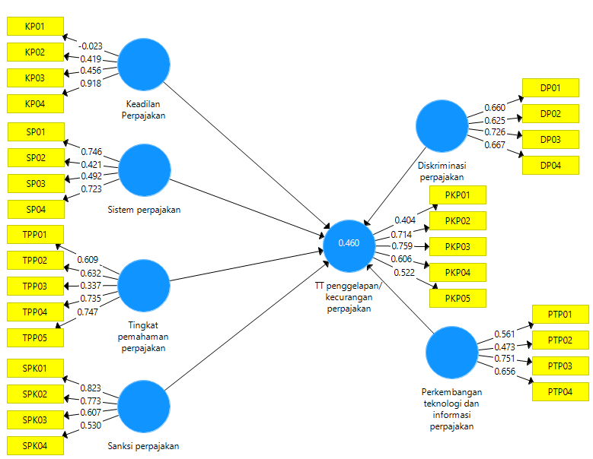
Figure 1 Inner model test results (R-square)

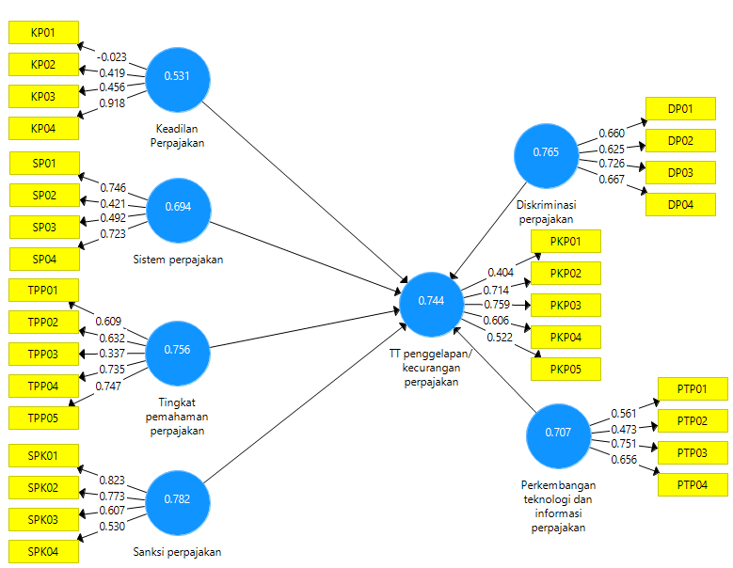
Figure 2 Outer model test results (composite reliability)

From figures 1 and 2 and table 1, it is shown that the composite reliability value for the variables of tax understanding level, tax sanctions, tax discrimination, tax technology and information developments, and the occurrence of tax embezzlement/fraud is more than 0.70. This means that all construct variables have a good level of reliability, and are in accordance with the required drinking value limit. Meanwhile, the variables of Tax Justice and the tax system are less than 0.70. This means that these two construct variables have a poor level of reliability, and are not in accordance with the required drinking value limit. Next, the results of the calculation that have been carried out also found that the R-Square value of the research model shows a value of 0.460. This result means that all variations in the variables in explaining the variability of the constraints of embezzlement or tax fraud are still small, namely 46.0%.
Next, hypothesis testing is carried out by comparing the calculated t value with the value of the table, When the higher the calculated t value than the t table, it is concluded that there has been a significant relationship between variables, but conversely if the calculated t value is less than t table, then there is no significant relationship between variables. The number of data tested was 150, so that the value of the t table (5%) was obtained based on the Rules of thumb, which was 1.975. The results of this research hypothesis test can be shown in figure 3, figure 4.

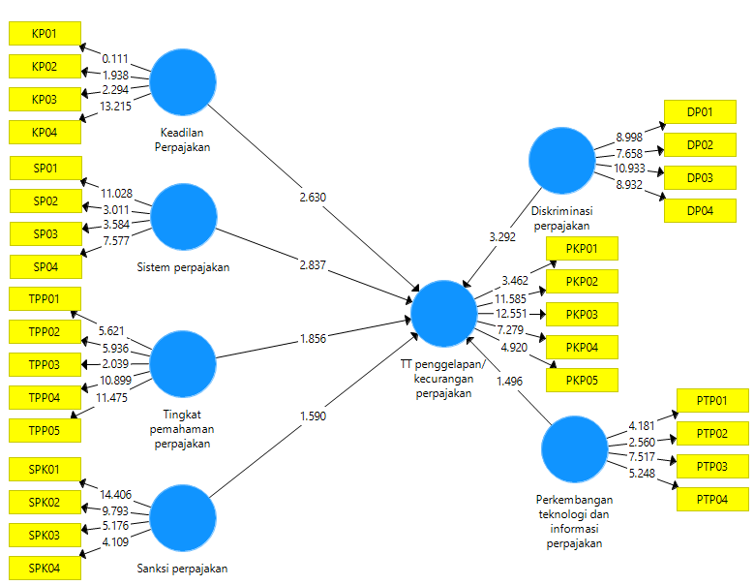
Figure 3 Hypothesis Test Results (t-count)

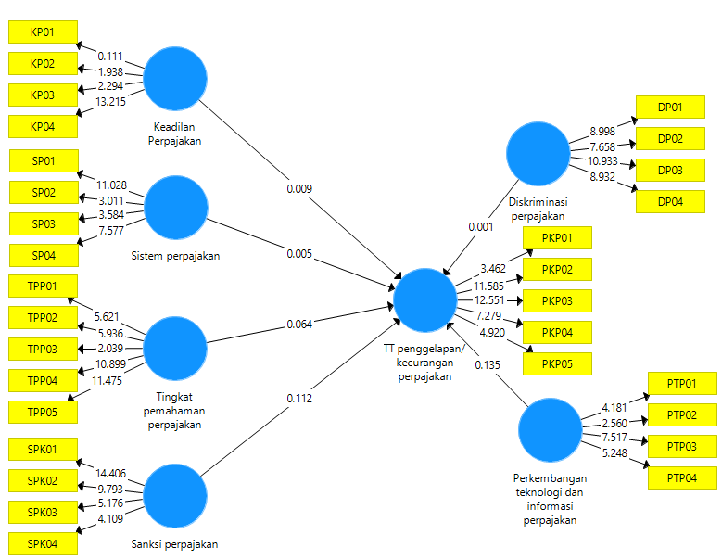

Figure 4 Hypothesis Test Results (p-value)

Table 2. Data Tabulation of Research Hypothesis Test Results

Hypothesis |  |  |  | t count | P value | Ket.
H1 | Tax Justice |  | The occurrence of tax embezzlement/fraud | 2,630 | 0,009 | Sig.
H2 | Taxation system |  | The occurrence of tax embezzlement/fraud | 2,837 | 0,005 | Sig.
H3 | Level of understanding of taxation |  | The occurrence of tax embezzlement/fraud | 1,856 | 0,064 | Not Sig.
H4 | Tax sanctions |  | The occurrence of tax embezzlement/fraud | 1,590 | 0,112 | Not Sig.
H5 | Tax discrimination |  | The occurrence of tax embezzlement/fraud | 3,292 | 0,001 | Sig.
H6 | Developments in tax technology and information |  | The occurrence of tax embezzlement/fraud | 1,496 | 0,135 | Not Sig.

The first test showed that tax fairness had a significant positive effect on the occurrence of tax embezzlement/fraud, this finding was supported by the value of t calculated > t table (2.630>1.975) and a path coefficient of 0.009. These findings indicate that the first hypothesis is not accepted. These findings support previous research. The second test results show that the tax system has a significant positive effect on the occurrence of tax embezzlement/fraud, this finding is supported by the value of t calculated > t table (2.837>1.975) and a path coefficient of 0.005. These findings indicate that the second hypothesis is not accepted. These findings support previous research (Hafidzullah et al., 2024). The third test results are that the level of tax understanding does not have a significant effect on the occurrence of tax embezzlement/fraud, this finding is supported by the value of t-calculated > t table (1.856<1.975) and a path coefficient of 0.064. These findings indicate that the third hypothesis is not accepted. The results of the fourth test found that tax sanctions did not have a significant effect on the occurrence of tax embezzlement/fraud, this finding was supported by a t-value calculated > t table (1.590<1.975) and a path coefficient of 0.112. These findings indicate that the fourth hypothesis is not accepted.
The fifth test results that tax discrimination has a significant positive effect on the occurrence of tax embezzlement/fraud, this finding is supported by the t>t value of the table (3.292>1.975) and a path coefficient of 0.001. These findings indicate that the fifth hypothesis is accepted. These findings support previous research (Camila et al., 2021; Sitanggang & Pramesthi, 2019). The sixth test results, the development of tax technology and information did not have a significant effect on the occurrence of tax embezzlement/fraud, this finding was supported by the t-value of the < t table (1.496<1.975) and the path coefficient of 0.135. These findings indicate that the sixth hypothesis is not accepted. These findings support previous research ( True et al., 2020)

4.1 DISCUSSION
The first finding is that tax justice has a significant positive effect on the occurrence of tax embezzlement/fraud. These findings show that the higher the perception of tax fairness, the greater the likelihood of tax embezzlement or fraud. This may happen because taxpayers who feel unfair may respond by embezzling as a form of protest or dissatisfaction. Second, the tax system has a significant positive effect on the occurrence of tax embezzlement/fraud. A complex or unfair tax system is perceived by taxpayers, and can encourage them to look for loopholes and commit embezzlement. These findings show that weaknesses or injustices in the tax system can increase the chances of fraud. Third, the level of tax understanding does not have a significant effect on the occurrence of tax embezzlement/fraud. These results show that the level of taxpayer understanding of taxation does not directly influence the decision to commit embezzlement. In other words, neither good nor bad understanding of taxation has a significant effect on the tendency to cheat. A third hypothesis is not accepted, indicating that other factors may be more dominant in influencing the act of embezzlement.
The fourth finding is that tax sanctions do not have a significant effect on the occurrence of tax embezzlement/fraud. These findings indicate that the existence of tax sanctions, while important, does not significantly reduce acts of embezzlement or fraud. It is possible that the existing sanctions are considered not severe enough or ineffective in preventing such actions. This also suggests that the effectiveness of sanctions may need to be reviewed or balanced with other measures that are more effective in reducing tax fraud. Fifth, tax discrimination has a significant positive effect on the occurrence of tax embezzlement/fraud. Discrimination in taxation, where some groups feel they are being treated unfairly, can trigger embezzlement as a form of resistance or dissatisfaction. The fifth hypothesis is accepted, suggesting that discrimination in the tax system can increase the tendency of taxpayers to commit fraud. Sixth, the development of tax technology and information does not have a significant effect on the occurrence of tax embezzlement/fraud. These findings show that although technology and information in taxation continue to evolve, it has not been able to significantly reduce tax evasion or fraud. The sixth hypothesis is not accepted, which may suggest that technology and information alone are not enough without being accompanied by other efforts such as education or stronger law enforcement.
Thus, the results of these six tests provide a comprehensive overview of the factors that influence tax embezzlement/fraud, and emphasize the importance of considering fairness, system, and treatment in tax policy.

4. Conclusion

This study reveals that tax fairness, tax system, and tax discrimination have a significant influence on the occurrence of tax embezzlement or fraud. On the other hand, the level of tax understanding, tax sanctions, and the development of tax technology and information do not have a significant effect on these actions. This shows that injustice and weakness in the tax system can trigger tax evasion by taxpayers. The results of this study have important implications for governments and policymakers. Justice in the tax system and the elimination of discrimination in the treatment of taxpayers need to be top priorities to reduce tax evasion. In addition, it is necessary to evaluate and improve the tax system to be more transparent and fair, so that taxpayers feel more responsible in fulfilling their tax obligations.

References

Ariyanto, D. (2020). Influence of justice, culture and love of money towards ethical perception on tax evasion with gender as moderating variable. Journal of Money Laundering Control, 23(1), 245–266. https://doi.org/10.1108/JMLC-06-2019-0047
Asnawi, H. S., & Mukhlishin, A. (2017). TAX SANCTIONS AND TAX COURTS IN INDONESIA: Efforts to Optimize Tax Revenue Related to National Development. Journal of Sharia Law and Economics, 5(2), 355–376.
Camila, E. M., Azifah, M. R., & Merlinda, S. (2021). Wpop's Perception of Tax Evasion Ethics Individual Taxpayer Perception of Tax Evasion Ethics. Attitude, 6(1), 11–27.
Enofe, A., Embele, K., & Obazee, E. P. (2019). Tax Audit, Investigation, and Tax Evasion. Journal of Accounting and Financial Management, 5(4), 47–66.
Fadwa, F., Sir, Z. M. E., & Limbong, C. H. (2022). The Effect of Service Quality and Product Quality on Loyalty Mediated by Customer Satisfaction. Indonesian Interdisciplinary Journal of Sharia Economics (IIJSE), 5(2), 852–873. https://doi.org/10.31538/iijse.v5i2.2511
Friskianti, Y., Dwi Handayani Department of Accounting, B., Economics, F., & State of Semarang, U. (2014). THE INFLUENCE OF THE SELF-ASSESSMENT SYSTEM, JUSTICE, TAX TECHNOLOGY, AND DISTRUST OF THE FISCAL AUTHORITIES ON TAX EVASION ACTIONS. Accounting Analysis Journal, 3(4), 543–552. https://doi.org/10.15294/aaj.v3i4.4216
Hafidzullah, A. Y., Hendrawarman, & Awangga, R. A. (2024). The Role of Justice and the Tax System in Overcoming the Challenges of Tax Malfeit in Indonesia. Humaniorum, 2(1), 53–59. https://doi.org/10.37010/hmr.v2i1.41
Hair, J. F., Sarstedt, M., Hopkins, L., & Kuppelwieser, V. G. (2014). Partial least squares structural equation modeling (PLS-SEM): An emerging tool in business research. European Business Review, 26(2), 106–121. https://doi.org/10.1108/EBR-10-2013-0128
Heider, F. (1958). The Psychology of Interpersonal Relations. Wiley.
Hsieh, T. S., Wang, Z., & Demirkan, S. (2018). Overconfidence and tax avoidance: The role of CEO and CFO interaction. Journal of Accounting and Public Policy, 37(3), 241–253. https://doi.org/10.1016/j.jaccpubpol.2018.04.004
Jaya, I. M. L. M. (2019). The Reality of Tax Awareness Among the Young Generation (Students) of Yogyakarta and Surabaya I Made Laut Mertha Jaya. Scientific Journal of Accounting, 4(2), 161–183.
Jaya, I. M. L. M. (2020). Quantitative and Qualitative Research Methods: Theory, Application, and Real Research (V. Wiratna Sujarweni, ed.; 1st ed.). http://www.anakhebatindonesia.com/author-i-made-laut-mertha-jaya-606.html.
JAYA, I. M. L. M., & Narsa, I. M. (2022). The Nexus Between Forensic Tax and Accounting Knowledge After Pandemic COVID-19 in Indonesia. In A. Pego (Ed.), Handbook of Research on Global Networking Post COVID-19 (pp. 480–494). IGI Global Publishing. https://doi.org/10.4018/978-1-7998-8856-7.ch026
Tax Justice, P., Tax Collection, S., Tax Delay, S., Tax Discrimination Against Tax Embezzlement Kusnadi, D., & Rinika, D. (2019). The Influence of Tax Justice, Tax Collection System, Tax Delay Sanctions, and Tax Discrimination on Tax Evasion. Journal of Accounting and Management Research (JRAMM), 8(2), 85–93. https://doi.org/10.33024/JUR.JERAM.V8I2.2614
Kurnia, S. (2023). The Effect of Tax Understanding Levels, Tax Services and Tax Sanctions on Individual Income Tax Compliance (PPh). Accounting Global Journal, 7(1), 50–62. https://doi.org/10.24176/agj.v7i1.8799
Mehrara, M., & Farahani, Y. G. (2016). The study of the effects of tax evasion and tax revenues on economic stabilities in oecd countries. World Scientific News, 33, 43–55.
Mirah, A. A., Paramita, P., Ayu, G., & Budiasih, N. (2016). THE INFLUENCE OF THE TAX SYSTEM, JUSTICE, AND TAX TECHNOLOGY ON TAXPAYERS' PERCEPTIONS OF TAX EVASION. E-Journal of Accounting, 17(2), 1030–1056. https://ojs.unud.ac.id/index.php/akuntansi/article/view/19884
Palil, M. R. (2004). The Effect of E-Commerce on Malaysian Tax System: an Empirical Evidence From Academicians and Malaysian Tax Practitioners. Journal of Accounting and Finance, 6(1), 1–9. https://doi.org/10.9744/jak.6.1.pp.1-9
Pratama, T. G., Business, F., & Accounting, P. (2020). What affects tax evasion?: A Study on the Bantul Regency Regional Apparatus Organization. Journal of Business and Information Systems (e-ISSN: 2685-2543), 2(2), 95–105. https://doi.org/10.36067/jbis.v2i2.64
Riskiyadi, M., Tarjo, & Anggono, A. (2020). Dilemma between Fraud and Tax Compliance at Government Agencies. International Colloquium Forensics Accounting and Governance (ICFAG), 1(1), 13–20.
Ritsatos, T. (2014). Tax evasion and compliance; From the neoclassical paradigm to behavioural economics, a review. Journal of Accounting and Organizational Change, 10(2), 244–262. https://doi.org/10.1108/JAOC-07-2012-0059
Rossa, E. (2022). The influence of manager overconfidence and capital intensity on tax avoidance moderated by audit quality. JABI (Indonesian Journal of Sustainable Accounting), 5(1), 1–19. https://doi.org/10.32493/jabi.v1i1.y2022.p1-19
Sejati, F. R., Ponto, S., Prasetianingrum, S., Sumartono, S., & Sumbari, N. N. (2020). Factors that affect dividend policy. Indonesian Accounting and Finance Periodical, 5(2), 110. https://doi.org/10.20473/baki.v5i2.21480
Sitanggang, T., & Pramesthi, S. (2019). Perception of the Tax System, Tax Justice, and Discrimination against Tax Evasion Behavior. Jraa, VI(1), 1–19.
Surahman, W., & Putra, U. Y. (2018). Factors of Taxpayers' Perception of Tax Evasion Ethics. REKSA Journal: Financial Engineering, Sharia and Audit, 5(1), 1. https://doi.org/10.12928/j.reksa.v5i1.140
Syamsiah, S. S., Lukita, C., & Sujaya, F. A. (2024). THE INFLUENCE OF THE TAX SYSTEM, TAX JUSTICE, TAX RELIGIOSITY AND TAX SANCTIONS ON THE PERCEPTION OF TAX EVASION IN KARAWANG REGENCY. SCIENTIFIC JOURNAL OF REFLECTION: Economics, Accounting, Management and Business, 7(3), 802–815. https://doi.org/10.37481/sjr.v7i3.905
Valentia, T., & Susanty, M. (2021). Factors That Affect Taxpayer Behavior Towards Compliance of Micro and Medium Business Taxpayers. E-Journal of TSM Accounting, 1(4), 335–348.
Widjaja, P. N. K., Lambey, L., & Walandouw, S. K. (2017). THE EFFECT OF DISCRIMINATION AND TAX AUDIT ON THE PERCEPTION OF INDIVIDUAL TAXPAYERS REGARDING TAX EVASION IN BITUNG CITY (Case Study on WPOP encountered at KPP Pratama Bitung). Going Concern: Journal of Accounting Research, 12(2), 541–552. https://doi.org/10.32400/gc.12.2.17961.2017

