Original Research Article

The Impact of Foreign Direct Investment on Dongguan's Export Structure: Evidence from a VECM Model

Abstract
Amid shifting global value chains and deepening regional integration in Southern China, Dongguan has remained a key destination for export-oriented foreign direct investment (FDI). Using annual data from 1995 to 2024, this paper estimates a Vector Error Correction Model (VECM) to analyze how FDI influences both the commodity composition and trade mode structure of the city’s exports. The findings reveal that although FDI maintains a long-run equilibrium relationship with export structure, its direct role in upgrading the shares of high-tech or general-trade exports remains limited. Instead, FDI primarily amplifies short-term fluctuations rather than driving sustained structural improvement. This suggests that Dongguan’s entrenched “FDI + processing trade” model has created a low-end lock-in, where the structural benefits of FDI remain underutilized. The paper concludes with policy recommendations aimed at unlocking FDI’s potential for value-chain upgrading in the Pearl River Delta.

Keywords: Foreign Direct Investment; Export Structure; VECM; Dongguan

- Introduction
Dongguan is one of the earliest cities in China to receive industrial transfers from Hong Kong, Macao, and international markets. By the end of 2022, the city had cumulatively utilized over USD 110 billion in FDI, with foreign-invested industrial enterprises accounting for nearly 60% of the city’s total industrial output. Meanwhile, Dongguan’s total exports grew from USD 530 million in 1990 to USD 139.6 billion in 2024, with the export structure shifting from labor-intensive products such as toys and garments to high-tech goods like electronic information and smart equipment.
However, despite this expansion and structural upgrading, Dongguan’s exports still face a “three lows and one high” dilemma: low value-added products, a persistent dominance of processing trade, and overreliance on the U.S. market, which increases exposure to external shocks.
Among the various factors influencing export structure evolution, the spillover effects of FDI are particularly critical. On the one hand, FDI fills funding gaps in high-end equipment, core components, and frontier technologies； on the other, multinational corporations (MNCs) accelerate local firms’ technological absorption and re-innovation through demonstration, industrial linkages, and competition effects. Theoretically, FDI can promote export structure upgrading, yet the dynamic mechanisms at the city level remain underexplored. This paper uses a VECM model based on 1995–2024 data to empirically examine the dynamic impact of FDI on Dongguan’s export structure.
- Literature Review
Foreign Direct Investment (FDI) is a core driver of economic globalization, exerting profound effects on the export structure of host economies—an indicator reflecting export composition, quality, and sophistication. Extensive empirical research has explored the FDI-export structure nexus across countries and sectors. This review synthesizes key findings on the impact directions and underlying mechanisms of FDI, laying the groundwork for investigating Dongguan City’s case using the VECM model.

2.1 Positive Impacts
Numerous empirical studies confirm FDI’s role in upgrading export structures. Mabeta et al. (2025) analyzed 6 selected Southern African Development Community (SADC) countries over 2001–2021 and found FDI directly boosts agricultural production and export capacity, with a more pronounced effect on export performance. Islam (2022) used VECM to study Bangladesh (1995–2020) and identified a significant long-run positive relationship between FDI and export receipts, as FDI provides capital and operational capabilities for export-oriented industries like ready-made garments (RMG).
In China, Liang et al. (2024) noted that post-WTO FDI liberalization induced foreign entry in high-tech sectors, explaining 8.7% of foreign-invested enterprises (FIEs)’ export growth (1998-2007). Xin et al. (2023) verified that service sector FDI significantly promotes service exports in SAARC countries (2000-2020), diversifying export structures. Shi et al. (2025) found Chinese outward FDI (OFDI) enhances export sophistication in Belt and Road Initiative (BRI) countries (2010-2015), especially in poorer nations, while Abdi & Mohamed (2025) identified FDI as a key driver of Somalia’s agricultural exports by improving market access. Singaram et al. (2025) used ARDL bounds testing to confirm a long-term positive relationship between FDI and exports in India, emphasizing FDI’s role in driving export growth.

2.2 Negative Impacts
Contradictory evidence highlights FDI’s potential drawbacks. Liu et al. (2024) used China’s 2002 FDI regulation changes as an instrumental variable and found horizontal FDI reduces domestic firms’ export quality via intensified domestic competition, lowering incentives for quality investment. Amoah et al. (2025) applied VECM to Ghana’s data (1990-2021) and reported a significant negative long-term and short-term FDI-export relationship, attributed to foreign investors crowding out domestic competitors or pursuing tariff-avoidance rather than export promotion. The study also identified a U-shaped threshold effect, with FDI above 0.53% harmful to export businesses.

2.3 Mixed or Conditional Impacts
The FDI-export structure relationship is often conditional on specific factors. Sun et al. (2024) studied China’s OFDI and BRI countries (2003-2018) and found it positively affects primary product export similarity but negatively impacts resource-based, low-tech, and medium/high-skill intensive manufactures—aligning with comparative advantages. Sheng & Yang (2016) noted FDI’s promotion of export variety in China varies by region and sector, thriving in provinces with improved court efficiency and special economic zones. Eppinger & Ma (2021) added that FDI ownership restructuring boosts FIE output and productivity but may reduce technology spillovers compared to joint ventures (JVs), leading to mixed export structure effects. Yasin & Esquivias (2023) studied Indonesia’s manufacturing sector and found FDI spillover effects support exports but lower import propensity and intensity, with absorptive capacity (human capital) and complementary sector FDI inflows moderating the relationship.

2.4 Mechanisms Underlying the Impact of FDI on Export Structure
2.4.1 Technology Spillover and Knowledge Transfer
Technology spillover is a core mechanism linking FDI to export structure. Jiang et al. (2018) found international joint ventures generate larger technology spillovers than wholly foreign-owned enterprises (WFOEs) due to direct knowledge sharing with local partners. Mabeta et al. (2025) emphasized FDI in SADC countries transfers advanced agricultural technologies, irrigation facilities, and high-yield seeds, enhancing export competitiveness. Liang et al. (2024) highlighted that post-WTO FDI liberalization in China brought advanced production methods to high-tech sectors, shifting exports from labor- to technology-intensive. Shi et al. (2025) identified host country productivity as a crucial mediating factor in China’s OFDI impact on BRI countries’ export sophistication, with indirect technology spillover effects accounting for approximately 39% of the total impact.
2.4.2 Market Access and Global Value Chain Integration
FDI facilitates host countries’ integration into global value chains (GVCs) and expands market access. Mabeta et al. (2025) noted export-oriented FDI in African agriculture helps local products enter international markets and strengthen value chain positions. Islam (2022) found FDI in Bangladesh’s RMG sector leverages multinational corporations (MNCs)’ global networks to boost exports. Zhang et al. (2024) used a two-tier stochastic frontier gravity model and confirmed Chinese OFDI promotes exports by integrating host countries into China-centered GVCs, with stronger effects in high OFDI stock nations. Xin et al. (2023) added that trade openness in SAARC countries promotes the integration of FDI and domestic industries, enhancing FDI’s positive impact on service exports through GVC participation.
2.4.3 Competition Effect and Resource Reallocation
FDI influences export structure through domestic market competition. Liu et al. (2024) showed horizontal FDI intensifies competition, prompting domestic firms to adjust product mixes but reducing new product quality investment. (2025) found FDI in SADC agriculture stimulates domestic firms to improve productivity through competition, upgrading agricultural export structures. Amoah et al. (2025) added that excessive FDI competition can lead to market monopolization by foreign firms, reducing domestic firms’ export capacity—explaining the negative FDI-export relationship in Ghana. Krishna et al. (2021) argued FDI-induced competition encourages innovation and quality improvement, shifting exports toward high-value-added products.

2.5 Literature Commentary
Existing empirical research has identified FDI’s positive, negative, and mixed impacts on export structure, clarifying core mechanisms (technology spillover, market access, competition effects) across diverse economies. However, critical gaps remain: most studies focus on national or regional levels with limited attention to city-specific analyses (e.g., Dongguan, a major manufacturing and export hub with intensive FDI), lack detailed analysis of manufacturing sub-sectors central to Dongguan’s export structure, rarely apply VECM to capture dynamic adjustments of city-level export structures to FDI shocks. These gaps underscore the necessity of this study—by focusing on Dongguan, applying VECM,, it will fill empirical voids in city-level FDI-export structure research, provide targeted insights for optimizing Dongguan’s export structure.
- Current Situation of FDI and Export Trade Development in Dongguan

3.1 Current Situation of FDI Development in Dongguan
In 2024, Dongguan established 1,446 new foreign-invested enterprises, a year-on-year increase of 5.6%, with actually utilized foreign capital reaching 5.34 billion RMB, mainly concentrated in advanced manufacturing fields such as electronic information, equipment manufacturing, and new materials. In the early stage (e.g., 2005), Dongguan’s FDI scale expanded rapidly: the actually utilized foreign capital reached 1.468 billion US dollars that year, a year-on-year increase of 51.7%, and the contractual foreign capital in the manufacturing sector accounted for as high as 95.6%, with Hong Kong and Taiwan as the main sources of capital.
In recent years, affected by factors such as weakened global demand, the actually utilized foreign capital decreased to 75.232 million US dollars in 2024, a drop of 26%, but the manufacturing sector still accounted for 35.1%, indicating that the foreign capital structure is highly consistent with Dongguan’s strategy of "establishing the city through manufacturing." At the government level, platforms such as Humen Port Comprehensive Bonded Zone and Qingxi Bonded Logistics Center continue to enhance the investment attraction effect, with the goal of exceeding 125 billion RMB in import and export volume in relevant regions by 2025. Supplementary measures such as one-time rewards and tax incentives are also implemented to strengthen the attractiveness to foreign capital.

3.2 Current Situation of Export Trade Development in Dongguan
In 2024, Dongguan’s goods exports achieved positive growth in key markets such as Asia, Europe, and countries along the "Belt and Road": exports to Asia reached 485.43 billion RMB, an increase of 7.1%； exports to Europe reached 167.29 billion RMB, an increase of 8.9%； exports to countries co-building the "Belt and Road" reached 255.13 billion RMB, an increase of 2.0%. Mechanical and electrical products remain the main export driver: in 2022, exports of mechanical and electrical products reached 626.967 billion RMB, accounting for 67.9% of the total export volume, but decreased by 7.5% year-on-year due to weak external demand.
In terms of trade mode, new formats such as general trade, cross-border e-commerce, and market procurement have grown rapidly: in 2022, the import and export volume of cross-border e-commerce reached 81.86 billion RMB, an increase of 11.3%, and bonded logistics exports increased by 33.6%, becoming an important force to offset the decline in traditional processing trade. The government is helping enterprises diversify market development and stabilize orders by strengthening the layout of overseas warehouses, holding 1,000 e-commerce live streaming and product promotion activities every year, and promoting the RCEP rules of origin.
- Results and Discussion

4.1 Data and Variable Definition
This study involves four variables:
LFDI: The actually utilized foreign direct investment in Dongguan；
LEXS1: The proportion of mechanical and electrical products exports in the city’s total exports (reflecting the export commodity structure)；
LEXS2: The proportion of general trade exports in the city’s total exports (reflecting the trade mode structure)；
LGDP: Dongguan’s gross regional product.
The original data of all variables are derived from the annual statistical yearbooks and statistical bulletins on national economic and social development released by the Dongguan Municipal Bureau of Statistics. All variables are logarithmically processed (denoted by adding "L" before the variable name) to reduce the impact of heteroscedasticity and non-linearity, ensuring the robustness and interpretability of the model estimation.

Table 1. Variable Selection and Data Sources
Variable Name | Symbol | Definition | Data Source
Proportion of Mechanical and Electrical Products Exports | LEXS1 | Exports of Mechanical and Electrical Products / Total Exports | Dongguan Municipal Bureau of Statistics
Proportion of General Trade Exports | LEXS2 | General Trade Exports / Total Exports | Dongguan Municipal Bureau of Statistics
Foreign Direct Investment | LFDI | Actually Utilized Foreign Capital | Dongguan Municipal Bureau of Statistics
Gross Regional Product | LGDP | Gross Regional Product | Dongguan Municipal Bureau of Statistics
Source: Author’s compilation (2025)

4.2 Stationarity and Cointegration Tests

Table 2. Stationarity Test Results
Variable | ADF(p) | Result | PP(p) | Result
LEXS1 | -2.37(0.38) | Non-stationary | -4.41(0.00) | Non-stationary
LEXS2 | -2.89(0.18) | Non-stationary | -2.93(0.16) | Non-stationary
LFDI | -1.28(0.87) | Non-stationary | -0.41(0.98) | Non-stationary
LGDP | -0.47(0.98) | Non-stationary | -0.03(0.99) | Non-stationary
D(EXS1) | -4.31(0.01) | Stationary | -4.26(0.01) | Stationary
D(LEXS2) | -2.34(0.39) | Non-stationary | -3.89(0.02) | Stationary
D(FDI) | --4.06(0.02) | Stationary | -4.98(0.01) | Stationary
D(GDP) | -5.76(0.00) | Stationary | -6.59(0.00) | Stationary
Source: Author’s compilation (2025)

ADF and PP tests are conducted on the four original sequences. The results show that for the proportion of mechanical and electrical products exports (LEXS1), the proportion of general trade exports (LEXS2), actually utilized FDI (LFDI), and gross regional product (LGDP), the two test statistics of their level values are not significant (the corresponding p-values are much higher than 0.05), indicating that all four sequences are non-stationary processes.
After first-differencing, all series except D(LEXS2 (ADF p = 0.39)) reject the unit-root null at the 5% level in either the ADF or PP test, indicating stationarity. Overall, the four variables are at least integrated of order one, meeting the prerequisite for further cointegration tests.

Table 3. Cointegration Test Results
Hypothesized No. of CE(s) | Eigenvalue | Trace Statistic | 0.05 Critical Value | Prob.** Critical Value
None * | 0.913354 | 126.4879 | 47.85613 | 0.0000
At most 1 * | 0.842240 | 65.33988 | 29.79707 | 0.0000
At most 2 * | 0.522748 | 19.17282 | 15.49471 | 0.0133
At most 3 | 0.026835 | 0.680046 | 3.841465 | 0.4096
Source: Author’s compilation (2025)

At the 5% significance level, there are 3 stable long-term equilibrium relationships among Dongguan’s actually utilized FDI (LFDI), export commodity structure (proportion of mechanical and electrical products, LEXS1), export trade mode structure (proportion of general trade, LEXS2), and gross regional product (LGDP). This means that FDI is not only in long-term linkage with Dongguan’s overall economic scale but also maintains long-term cointegration with the technological content of export products (proportion of mechanical and electrical products) and the transformation and upgrading of trade modes (proportion of general trade)； any deviation will return to equilibrium through adjustments of other variables in the long run. Thus, we can establish a VECM model.

4.3 Model Specification
4.3.1 Long-term Cointegration Equations
$$LEXS1-0.0775LGDP-0.00LFDI-0.00LEXS2=3.7391$$
$$LEXS2-1.9624LGDP-0.00LFDI-0.00LEXS1=-10.1632$$
$$LFDI+0.9450LGDP-0.00LEXS1-0.00LEXS2=18.4184$$
FDI has a long-term equilibrium with export structure variables. Since the coefficients of FDI in the cointegration vectors for LEXS1 and LEXS2 are 0, its long-term structural effect is not significant. The "FDI contribution" discussed below refers to the results of short-term dynamic adjustments and variance decomposition, not long-term elasticity. The cointegration relationship confirms that FDI is linked to the export structure but lacks direct optimization channels； FDI indirectly affects the export structure mainly by expanding LGDP, and its long-term elasticity for general trade is much higher than that for mechanical and electrical products.
4.3.2 Short-term Error Correction Equations
$${∆LEXS1}_{1,t}=-1.37{ECT}_{1,t-1}-0.005{∆LFDI}_{t-1}$$
The coefficient of the error correction term (ECT₁) is -1.37, indicating that once the proportion of mechanical and electrical exports deviates from the long-term equilibrium, the system will quickly correct it with a force of 137% in the next period； while the coefficient of the short-term change of FDI (ΔLFDI) is close to zero, indicating that foreign capital fluctuations have almost no direct impact on the export structure of mechanical and electrical products.
$${∆LEXS2}_{1,t}=-0.86{ECT}_{2,t-1}+0.05{∆LFDI}_{t-2}$$ The coefficient of the error correction term (ECT₂) is -0.86, showing that after deviating from the long-term equilibrium, about 86% of the deviation will be adjusted back within one year； the coefficient of the lagged term of FDI (ΔLFDI) is only 0.05, meaning that the short-term inflow of foreign capital has a weak and temporary boosting effect on the proportion of general trade, and the lock-in effect of processing trade still dominates.

4.4 VECM Stability Test

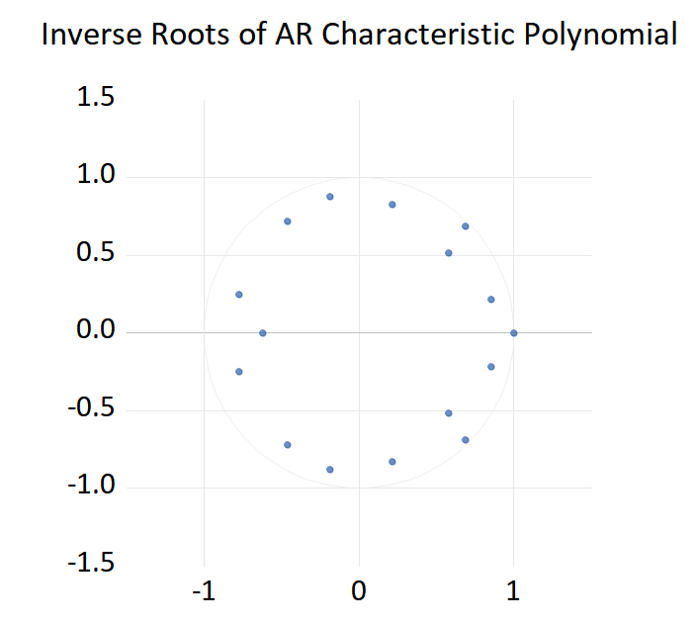

Fig. 1. VECM Model Stability Test

All inverse roots of the AR characteristic polynomial lie strictly inside the unit circle,without exceeding the circumference.The VECM model established based on the four variables (LFDI, LEXS1, LEXS2, LGDP) is stable. The dynamic system composed of Dongguan’s actually utilized foreign capital scale, export commodity structure, trade mode structure, and gross regional product has been in a long-term stable equilibrium track； any short-term shocks (such as a sudden increase in foreign capital or a sharp drop in the proportion of mechanical and electrical exports) will be gradually absorbed by the system over time without causing permanent deviations.

4.5 Impulse Response Analysis
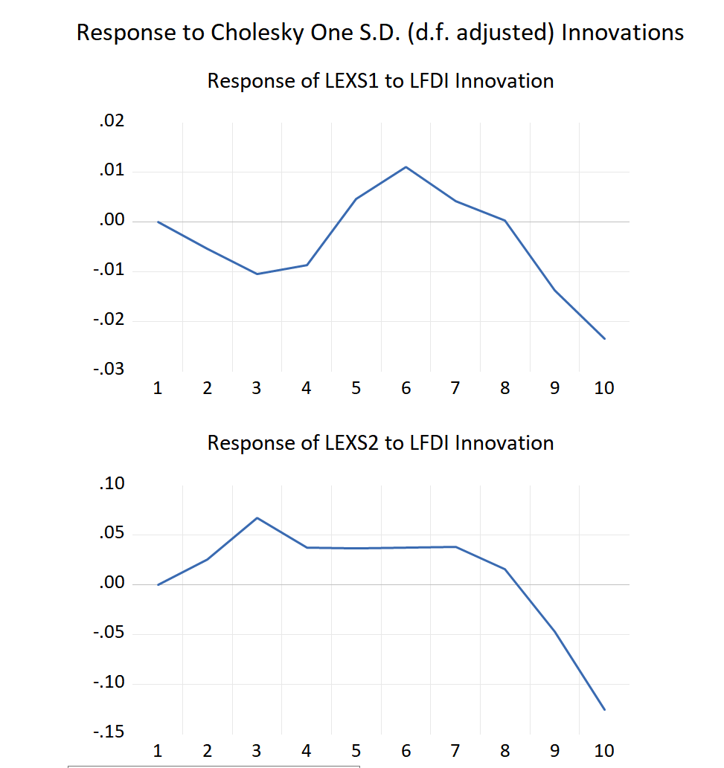

Fig. 2. Impulse Response Functions

The impact of FDI inflow on Dongguan’s export structure has a typical characteristic of "time lag—reversal—convergence." In the short term, an increase in foreign capital will temporarily reduce the proportion of mechanical and electrical exports but increase the proportion of general trade； in the medium and long term, the impulse response converges to 0 after the 6th period, indicating that FDI shocks do not change the long-term equilibrium level of the export structure but only cause short-term pseudo-upgrading. This shows that foreign capital ultimately returns the export structure to the equilibrium path through capacity upgrading and industrial chain supporting, without causing permanent distortions.

4.6 Variance Decomposition

Table 4. Variance Decomposition Results
Period | S.E. | LEXS1 | LEXS2 | LFDI | LGDP
1 | 0.025301 | 57.73289 | 0.000000 | 18.18735 | 24.07976
2 | 0.030861 | 52.45486 | 1.718084 | 26.24559 | 19.58146
3 | 0.035614 | 40.10693 | 4.334202 | 34.25036 | 21.30851
4 | 0.038272 | 34.78743 | 5.150040 | 38.66066 | 21.40187
5 | 0.039300 | 34.08846 | 5.905843 | 39.03657 | 20.96913
6 | 0.043252 | 30.35124 | 6.407208 | 45.59887 | 17.64179
7 | 0.044430 | 30.81311 | 6.199444 | 46.14544 | 16.84190
8 | 0.044486 | 30.79965 | 6.332637 | 46.03346 | 16.83425
9 | 0.048492 | 28.24263 | 5.335295 | 52.24052 | 14.18155
10 | 0.057606 | 21.63110 | 3.798747 | 64.06913 | 10.50102
Source: Author’s compilation (2025)

From the variance decomposition results, it can be seen that the fluctuations of both the proportion of mechanical and electrical products exports and the proportion of general trade exports are not dominated by their own inertia in the long run, but quickly give way to the external force of actually utilized foreign capital over time.
For the proportion of mechanical and electrical products exports, nearly 60% of the fluctuations in the first period after the shock can be explained by itself—foreign trade inertia and the stickiness of the existing industrial chain make short-term adjustments relatively slow； however, after the fourth period, the contribution of foreign capital surpasses its own inertia, accounting for more than 60% of all fluctuations by the tenth period, while the explanatory power of gross regional product gradually decreases from a quarter in the early stage to about 10%. This means that in the medium and long term, whether Dongguan can maintain a high proportion of mechanical and electrical exports depends crucially on whether foreign capital can continuously bring technology, equipment, and high-end capacity； once the inflow of foreign capital slows down, the steady-state level of the proportion of mechanical and electrical products will drop significantly.

Table 5 Variance Decomposition Results
Period | S.E. | LEXS1 | LEXS2 | LFDI | LGDP
1 | 0.066178 | 7.345409 | 83.60809 | 0.370931 | 8.675569
2 | 0.099481 | 21.18299 | 48.06054 | 0.415132 | 30.34134
3 | 0.128638 | 28.38783 | 28.80661 | 11.33589 | 31.46967
4 | 0.139378 | 24.31907 | 24.54543 | 13.18454 | 37.95095
5 | 0.157007 | 22.60412 | 20.08542 | 15.44530 | 41.86517
6 | 0.165732 | 21.23845 | 18.10921 | 19.08358 | 41.56877
7 | 0.171071 | 20.53824 | 17.03427 | 21.10955 | 41.31793
8 | 0.175732 | 20.18313 | 16.58268 | 20.02799 | 43.20620
9 | 0.197213 | 16.69052 | 13.23157 | 29.36070 | 40.71721
10 | 0.258858 | 10.37622 | 7.719288 | 55.36847 | 26.53603
Source: Author’s compilation (2025)

The inertia of the proportion of general trade exports decays faster and more thoroughly. In the first period, more than 80% of the fluctuations are explained by its own factors, showing a strong path dependence of trade mode； however, only three periods later, this self-circulation is broken, and foreign capital, gross regional product, and the proportion of mechanical and electrical products almost split the explanatory power equally； by the tenth period, foreign capital alone contributes more than half of the fluctuations, while the explanatory power of the trade mode itself drops to less than 8%. It is evident that Dongguan’s general trade is highly sensitive to the flow of foreign capital: when foreign capital enters in the form of new factories or independent brand exports, the share of general trade rises rapidly； once foreign capital shifts to processing trade or moves orders overseas, the share will fall back quickly.
- Conclusions and Policy Recommendations

5.1 Research Conclusions
Based on the empirical analysis of Dongguan’s data from 1995 to 2024 using the VECM model, this paper draws the following core conclusions:
5.1.1 Long-term equilibrium linkage exists, but the direct optimization effect is weak
Dongguan’s FDI has three stable long-term cointegration relationships with the export structure and economic scale, indicating that FDI is in long-term linkage with the export structure and economic development. However, the direct optimization effect of FDI on the export structure is not significant, mainly transmitted indirectly through LGDP (e.g., the long-term indirect impact coefficient of FDI lagged by one period on LEXS1 is only -0.0820), and its long-term negative impact on the proportion of general trade (LEXS2) is stronger, reflecting that foreign capital has not effectively promoted structural upgrading.
5.1.2 Short-term dynamic characteristics
Impulse response analysis shows that the short-term inflow of FDI will temporarily reduce the proportion of mechanical and electrical products and increase the proportion of general trade, but the medium and long-term effects gradually converge to neutrality. This indicates that the impact of FDI on the export structure is mainly "short-term fluctuations," lacking the motivation to promote continuous structural upgrading, and the export structure ultimately returns to the original equilibrium path.
Variance decomposition shows that
For LEXS1: The contribution rate of foreign capital rises from 18.2% in the first period to 64.1% in the tenth period, replacing its own inertia (57.7%→21.6%) as the main factor dominating fluctuations.
For LEXS2: The contribution rate of foreign capital soars from 0.4% in the first period to 55.4% in the tenth period, and its own path dependence (83.6%→7.7%) is completely broken, highlighting the sensitivity to foreign capital flows.
Over time, the contribution of FDI to the fluctuations of the export structure has increased significantly (accounting for 64.07% of LEXS1 and over 55% of LEXS2 in the tenth period), indicating that the export structure is highly dependent on foreign capital. However, this dependence has not brought about value chain upgrading: although mechanical and electrical products account for more than 50% of exports, they rely on foreign capital’s technology and equipment； the proportion of general trade is sensitive to foreign capital flows but is locked in by the "both ends outside" processing trade mode, presenting the contradiction of "scale expansion vs. quality lag." The proportion of general trade is initially dominated by its own inertia (its own contribution is 83.61% in the first period), but the contribution of foreign capital rises rapidly in the later period, indicating that its transformation is highly dependent on foreign capital forms (such as foreign capital with independent brand exports). However, the lock-in effect of processing trade has not been resolved； once foreign capital shifts to low-end processing or relocates overseas, the proportion of general trade will directly decline, with weak sustainability.
Dongguan’s "foreign investment + processing trade" model has formed a low-end lock-in: although FDI has promoted the export scale of mechanical and electrical products, the technology spillover is limited, and high-value-added links are still dominated by foreign capital； the proportion of general trade is driven by short-term foreign capital behaviors, lacking independent upgrading motivation. Although the proportion of high-tech products has gradually increased, the core links are controlled by foreign capital； the proportion of general trade is sensitive to foreign capital flows but lacks rootedness. Future policies need to shift from "stabilizing foreign capital" to "utilizing foreign capital," and restructure trade modes through technology absorption rules.

5.2 Policy Recommendations
Combined with the core empirical findings that "FDI has a long-term linkage with Dongguan’s export structure but lacks direct optimization effects, with large short-term fluctuations and long-term low-end lock-in," the following policy recommendations are proposed:
First, strengthen the screening of foreign capital quality and the supervision of rootedness. Dongguan should establish a "foreign capital quality access list," taking R&D investment intensity, local procurement rate, and local patent conversion rate as core evaluation indicators, and focus on introducing "chain-supplementing" foreign capital such as semiconductor packaging and testing and core components of intelligent equipment. At the same time, implement a "technological gradient reward" system, providing phased financial rebates to foreign capital that establishes regional headquarters or R&D centers based on the degree of technology spillover, and gradually cancel land and electricity price subsidies for pure assembly and processing projects to break the low-end lock-in of the "foreign investment + processing trade" model.
Second, promote the transformation of processing trade to "independent brands + general trade." Relying on the cross-border e-commerce comprehensive pilot zone policy, pilot the "localized procurement of foreign capital orders" plan, encouraging leading enterprises in the electronic information industry chain (such as Samsung and Flex) to open non-core links to local supporting manufacturers. Co-build the "Dongguan International Technology Transfer Center" with the Hong Kong Productivity Council to provide one-stop support such as overseas warehouses and compliance certification for small and medium-sized foreign-funded enterprises, accelerating the adoption of general trade by processing trade enterprises for exports.
Third, build a collaborative innovation network between "foreign-funded enterprises and local enterprises." Implement the "chain leader enterprise technology diffusion plan," releasing a list of core technology needs every year to match local small and medium-sized enterprises to participate in supporting R&D of foreign-funded enterprises. Launch the "domestic-funded enterprises' export leapfrogging plan," selecting 100 high-growth domestic-funded enterprises to provide market development and digital marketing opportunities, sharing foreign-funded logistics and distribution networks, reducing the cost of independent brand overseas expansion, and hedging the risk of short-term foreign capital fluctuations.
Disclaimer (Artificial Intelligence)
Artificial intelligence tools (ChatGPT & Deepseek) were used exclusively for language editing and stylistic improvement. No AI system contributed to the study design, data analysis, interpretation, or conclusions. Responsibility for the content of this manuscript rests entirely with the authors.

References
Abdikafi Hassan Abdi & Amir Mohamud Mohamed.(2025).Determinants of agricultural exports in Somalia: the impacts of exchange rates, foreign direct investment, and institutional quality.Cogent Economics & Finance,13(1), https://doi.org/10.1080/23322039.2024.2445755.
Stein Masunda,Amanda Rudo Chiweshe & Gabriel Mhonyera.(2025).Impact of foreign direct investment on export sophistication in Sub-Saharan Africa: the moderating role of human capital and institutional quality.International Trade, Politics and Development,9(3),180-190. https://doi.org/10.1108/ITPD-05-2025-0017.
Safet Kurtovic,Nehat Maxhuni,Blerim Halili & Arta Maxhuni.(2025).Is There an Asymmetric Effect Due to Foreign Direct Investment on the Exports of the Manufacturing and Service Sectors of Central, Eastern, and South-Eastern European Countries?.Eastern European Economics,63(6),875-924. https://doi.org/10.1080/00128775.2024.2368683.
Shah Alam Mukul & Wahid Soruar.(2025).Foreign Direct Investment and Export Growth: Time-series Evidence from Bangladesh's Garment Sector.Asian Journal of Economics, Business and Accounting,25(8),1-12. https://doi.org/10.9734/AJEBA/2025/V25I81911.
Jinhai Shi,Lili Kang,Fei Peng & Sajid Anwar.(2025).Belt and road initiative and export sophistication: The role of China’s outward foreign direct investment.The Journal of International Trade & Economic Development,34(5),1094-1113. https://doi.org/10.1080/09638199.2024.2369757.
Joseph Owusu Amoah,Imhotep Paul Alagidede & Yakubu Awudu Sare.(2025).Dynamic Effect of Foreign Direct Investment on Export Growth in Ghana: Does Financial Development Matter?.Transnational Corporations Review,17(2),200129-200129. https://doi.org/10.1016/J.TNCR.2025.200129.
Parveen Kumar,Ali Moridian,Magdalena Radulescu & Ilinca Margarita.(2025).The Impact of Foreign Direct Investment on Exports: A Study of Selected Countries in the CESEE Region.Economies,13(6),150-150. https://doi.org/10.3390/ECONOMIES13060150.
Vidyasagar Selvaraj Singaram,Waseem Ahmad,Mohammad Shareef,Shakeel Akther & Nargis Akhter Wani.(2025).Impact of Foreign Direct Investment, Export, Import and Inflation on Economics Growth in India: An Empirical Analysis.South Asian Journal of Social Studies and Economics,22(3),13-21. https://doi.org/10.9734/SAJSSE/2025/V22I3965.
Muhammad Ikram & Rabie Nahdi.(2025).Toward sustainable development: Unfolding the nexus among exports, foreign direct investment, capital formation, natural resource rent, unemployment, and low-carbon transition in Morocco.Resources Policy,102,105490-105490. https://doi.org/10.1016/J.RESOURPOL.2025.105490.
Yang Yi,Zhao Jing & Yang Young Soo.(2025).Foreign direct investment and export expansion: political connection and innovative performance.Management Decision,63(1),368-386. https://doi.org/10.1108/MD-02-2024-0238.
Joshua Mabeta,Luboš Smutka & Tomáš Mrkvička.(2025).Impact of foreign direct investment on agricultural production and exports of SADC countries.Social Sciences & Humanities Open,11,101499-101499. https://doi.org/10.1016/J.SSAHO.2025.101499.
NavruzKhotamov.(2024).Exports and foreign direct investment in the presence of downside risk.The World Economy,48(3),500-534. https://doi.org/10.1111/TWEC.13651.
Qing Liu,Larry D. Qiu & Chaoqun Zhan.(2024).FDI inflows and export quality: Domestic competition and within-firm adjustment.Journal of Development Economics,170,103293-. https://doi.org/10.1016/J.JDEVECO.2024.103293.
He Yugang.(2024).E-commerce and foreign direct investment: pioneering a new era of trade strategies.Humanities and Social Sciences Communications,11(1), https://doi.org/10.1057/S41599-024-03062-W.
Xianke Li & Chongyan Li.(2024).Interaction Effect of Export Trade, Foreign Direct Investment and Technological Independent Innovation in China.Sustainability,16(8), https://doi.org/10.3390/SU16083211.
Zhang Song,Kalirajan Kaliappa & Chen Chunlai.(2024).The impact of outward foreign direct investment on China’s export: an analysis using two-tier stochastic frontier gravity model.Journal of the Asia Pacific Economy,29(2),545-565. https://doi.org/10.1080/13547860.2022.2029048.
YangLiang,Mary E.Lovely & HongshengZhang.(2024).Targeted Liberalization: China's foreign investment regulation reform and its post‐WTO‐accession export surge.Review of International Economics,33(1),166-206. https://doi.org/10.1111/ROIE.12737.
]Kastratović Radovan.(2024).The impact of foreign direct investment on agricultural exports: The evidence from developing countries.The Journal of International Trade & Economic Development,33(2),276-293. https://doi.org/10.1080/09638199.2023.2175306.
Sun Yanyan,Zhang Song & Zhang Kunling.(2024).The impact of China’s outward foreign direct investment on its export similarity with belt and road countries.The Journal of International Trade & Economic Development,33(1),76-117. https://doi.org/10.1080/09638199.2022.2159057.
Yongrong Xin,Aftab Hussain Tabasam,Zhenling Chen,Aysha Zamir & Carlos Samuel Ramos Meza.(2023).Correction: Analyzing the Impact of Foreign Direct Investment, Energy Consumption on Services Exports, and Growth of the Services Sector: Evidence from SAARC Countries.Journal of the Knowledge Economy,15(3),15450-15451. https://doi.org/10.1007/S13132-023-01488-2.
Yasin Mohammad Zeqi & Esquivias Miguel Angel.(2023).Spillover effects of foreign direct investment on manufacturing exports and imports in Indonesia.Studies in Economics and Finance,40(4),625-646. https://doi.org/10.1108/SEF-12-2022-0551.
Mohammad Mohidul Islam.(2022).The Role of Foreign Direct Investment (FDI) Inflows on Export Performancein Developing Economies:Evidence from Bangladesh.South Asian Journal of Social Studies and Economics,49-57. https://doi.org/10.9734/SAJSSE/2022/V16I3615.
Ren Jiazhen,Sarkar Apurbo,Li Hong & Li Xiaojing.(2022).Does the Host Country’s Foreign Direct Investment (FDI) Restrictiveness Inhibit the Export Sophistication of the Home Country? Evidence from China’s Manufacturing Data.Sustainability,14(22),15218-15218. https://doi.org/10.3390/SU142215218.
Liu Haiyun & Wang Xuefeng.(2022).Spillover Effects of Foreign Direct Investment on Export Sophistication: Evidence from Chinese Domestic Manufacturing Firms.The Journal of Development Studies,58(11),2393-2408. https://doi.org/10.1080/00220388.2022.2094254.
Xiong Tingting & Sun Hao.(2019).Structure and dynamics of global capital and international trade: Analysis of the relationship between exports and foreign direct investment (FDI) from 2001 to 2006.International Journal of Finance & Economics,26(1),542-559. https://doi.org/10.1002/ijfe.1803.

