Prevalence of mandibular lingual frenum attachment in 3 - 6 years old children: a pilot cross-sectional study

Abstract:
Background: An essential anatomical component that may affect gingival health, dental hygiene, and the development of dentition is the mandibular labial frenum. Gingival recession and plaque retention may be predisposed by differences in frenal attachment. The incidence of mandibular frenal attachment types in preschoolers, however, has not been well documented.
Goal: Using the Coryllos classification, ascertain the prevalence of mandibular frenal attachment types in children under the age of six and assess how they relate to age and gender.
Materials and Methods: One hundred children with complete primary teeth, ages three to six, participated in a cross-sectional study. Clinical evaluation and Coryllos classification (Types 1–4) were used to classify mandibular frenal attachment. In order to analyze the data, descriptive statistics were used. The Chi-square test was used to evaluate the relationship between demographic type, gender, and age group. P-values less than 0.05 were regarded as statistically significant.
Results: Of the 100 children who were assessed, 60% were females, while 40% were males. The commonest type of frenal attachment was Coryllos Type 3, accounting for 75%, while Type 2 was 14%, Type 4 was 10%, and Type 1 was 1%. There was no statistically significant relationship between gender (p = 0.54) and age (p = 0.12) groups and the type of frenal attachment.
Conclusion: The commonest type of mandibular frenum was Coryllos Type 3. There was no relationship with age and gender. Early detection of variations is important for preventive pediatric dental care.
Keywords: Mandibular frenum, Coryllos classification, prevalence, primary dentition, pediatric dentistry.
INTRODUCTION:
The labial frenum is a dynamic fold of mucous membrane made up of dense connective tissue fibers and elastic fibers, and sometimes muscle fibers, extending from the inner surface of the lips to the alveolar mucosa and the underlying periosteum. The frenum is an important part of the lips and plays an important role in the stabilization and functioning of the lips. The variations in the shape and position of the frenum may affect the periodontal health, maintenance of oral hygiene, and dentofacial development¹,².
The frenum develops from the tectolabial bands during the development of the embryo, which are the bands that connect the upper and lower lips to the developing alveolar ridges³. As the growth of the craniofacial region continues, the vertical growth of the alveolar process and the eruption of the teeth result in the apparent apical movement of the frenum attachment site⁴. As the child develops, especially during the primary dentition stage, the alveolar process is relatively underdeveloped, and the frenum attachment may appear to be high, which should not be confused with pathological high frenum attachment sites⁵.
Abnormal or high frenum attachments have been linked with plaque retention, localized gingival inflammation, gingival recession, midline diastema, and poor periodontal health⁶,⁷. The mechanical stress of high frenum attachments, which occur with movement of lips, may result in marginal tissue stress, thus causing recession defects in susceptible individuals. However, frenum morphology alone is not indicative of pathology unless other clinical features such as blanching, inflammation, or loss of attachment are present⁹.
Several classification systems have been advocated for the classification of labial frenum attachments. The widely accepted classification system by Placek M et al. classified frenum attachments as mucosal, gingival, papillary, and papilla penetrating types based on anatomical insertion¹⁰. The Coryllos classification system, which was originally used for lingual frenulum, used an anatomical grading system (Types 1-4) based on the level of frenum insertion and has been used in clinical practice because of its simplicity and reproducibility¹¹,¹².
Most literature has been published on the maxillary labial frenum and its relationship with midline diastema occurrence. There is a lack of epidemiological studies on the frenal attachment relationship in the mandible, especially among preschool children younger than 6 years old. This is an important period in the development of good hygiene habits and the assessment of soft tissue growth. Knowledge of the normal occurrence of types of mandibular frenal attachment is important in avoiding unnecessary surgical intervention and promoting preventive care from an early age¹³,¹⁴.
The current study aimed to investigate the prevalence of types of mandibular frenal attachment among children younger than 6 years old using the Coryllos classification system and its relationship with age and gender.

Materials and Methods

Study Design
This study was conducted as a pilot cross-sectional observational investigation to evaluate the prevalence and distribution of mandibular labial frenal attachment types among preschool children. Cross-sectional design was chosen as it is appropriate for prevalence estimation and association analysis in a defined population at a single point in time. The study was designed and reported in accordance with the Strengthening the Reporting of Observational Studies in Epidemiology (STROBE) guidelines for cross-sectional studies.

2. Setting
The study was conducted at the Department of Pediatric and Preventive Dentistry. Participants were recruited from children who attended the department during the study period. The study was approved by the Institutional Ethics Committee prior to commencement (IEC No: ECR/1742/APDCH/PEDO/UG 07/TN OCT 2025) and was conducted in accordance with the ethical principles of the Declaration of Helsinki.

3. Participants
Children aged 3–6 years with complete primary dentition who visited the department during the study period were considered for inclusion. Eligibility was assessed using pre-specified inclusion and exclusion criteria.
Inclusion criteria:
- Age between 3 and 6 years
- Presence of complete primary dentition
- Cooperative behavior during clinical examination
Exclusion criteria:
- Presence of craniofacial abnormalities (e.g., cleft palate)
- History of frenectomy or prior soft tissue surgery in the region
- Systemic conditions known to affect oral soft tissues
- Incomplete primary dentition

4. Sample Size

A total of 100 children who fulfilled the eligibility criteria were enrolled consecutively during the study period. As this was a pilot study, the sample size was determined based on feasibility considerations rather than a formal sample size calculation.

5. Variables
The primary outcome variable was the type of mandibular labial frenal attachment, classified according to the Coryllos classification system into four types:
- Type 1: Mucosal attachment
- Type 2: Gingival attachment
- Type 3: Papillary attachment
- Type 4: Posterior (submucosal) attachment
Covariates assessed included age (categorized as 3–4 years and 5–6 years) and sex (male or female). These variables were recorded at the time of clinical examination.

6. Data Sources and Measurement
Clinical examination was performed with the child seated upright on a dental chair under adequate illumination provided by a dental light source. A mouth mirror and explorer were used as standard diagnostic instruments. The mandibular labial frenum was examined by gently retracting the lower lip outward and upward to expose the area of insertion. Care was taken to avoid overstretching the frenum, which may cause discomfort. The level of frenal insertion was assessed by direct visual inspection; a blanch test was performed where clinically indicated to confirm the attachment level. All data were recorded on a predesigned, standardized data collection form and subsequently transferred to Microsoft Excel for data entry and management.

7. Efforts to Address Sources of Bias
To minimize measurement bias, all clinical examinations were performed by a single calibrated examiner, thereby eliminating inter-examiner variability. Intra-examiner reliability was assessed by re-examining a randomly selected subset of 10 children after an interval of one week. The use of a standardized examination protocol and a uniform classification system (Coryllos) further reduced the potential for misclassification. Participants were recruited consecutively among attendees meeting the eligibility criteria, reducing selection bias. However, as this was a convenience sample from a single departmental setting, selection bias inherent to clinic-based sampling cannot be excluded.

8. Statistical Methods
Data were analyzed using descriptive and inferential statistical methods. The distribution of mandibular frenal attachment types was summarized as frequencies and proportions. To facilitate comparison and ensure adequate expected cell frequencies for statistical testing, Coryllos Types 1 and 2 were combined into a single category prior to inferential analysis.
The association between frenal attachment type and sex, and between frenal attachment type and age group, was evaluated using the Pearson Chi-square test. Expected cell frequencies were verified to be adequate before applying the test. A two-tailed p-value of less than 0.05 was set as the threshold for statistical significance.
Results
Participants
A total of 100 children aged 3 to 6 years with complete primary dentition were included. Of these, 60 (60%) were females, and 40 (40%) were males. The distribution of participants by age was as follows: 10 (10%) of the children were aged 3 to 4 years, while 90 (90%) of the children were aged 5 to 6 years. (Figure 1, 2)
Descriptive Data
All of the participants who took part in this study were assessed for mandibular frenal attachment. There was no participant dropout, and data were obtained for all participants.
Outcome data (Prevalence of Frenal Types)
The most prevalent mandibular frenal attachment was Coryllos Type 3, which was found in 75 (75%) of the participants. The other prevalent types of mandibular frenal attachments were Type 2, which was found in 14 (14%) of the participants, Type 4, which was found in 10 (10%) of the participants, and Type 1, which was found in 1 (1%) of the participants.
Association with gender
The frequency distribution of frenal attachment types with respect to gender indicated that the highest frequency of frenal attachment type 3 was observed in both females (46/60, 76.7%) and males (29/40, 72.5%). The Chi-square test results showed that there was no statistically significant association between frenal attachment types and gender, as the p-value was 0.54. (Table 1)
Association with age group
In the 3- to 4-year age group, frenal attachment type 3 was observed in 6 (60%) children, and in the 5- to 6-year age group, frenal attachment type 3 was observed in 69 (76.7%) children. The Chi-square test results showed that there was no statistically significant association between frenal attachment types and the age group, as the p-value was 0.12. (Table 2)

Figure 1: Distribution of Coryllos Frenum Types

Row labels | Female | Male | Grand total | Chi-square | p-value
Type 1 & 2 | 8 | 7 | 15
Type 3 | 46 | 29 | 75
Type 4 | 6 | 4 | 10
Grand total | 60 | 40 | 100 | 2.18 | 0.54
Table 1: Association between frenal type and gender

Row Labels | 3–4 years | 5–6 years | Grand Total | Chi-square | p-value
type 1 & 2 | 1 | 14 | 15
type 3 | 6 | 69 | 75
type 4 | 3 | 7 | 10
Grand Total | 10 | 90 | 100 | 5.83 | 0.12
Table 2: Association between frenal type and age group

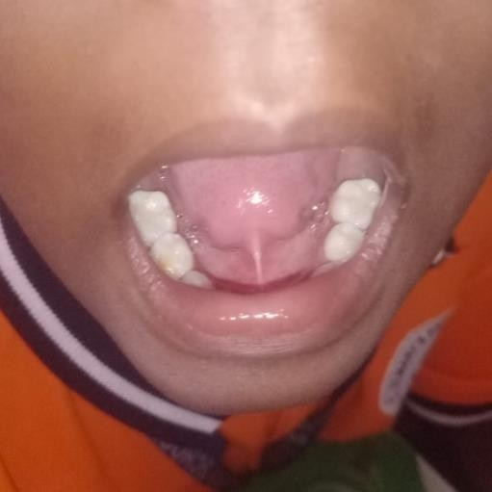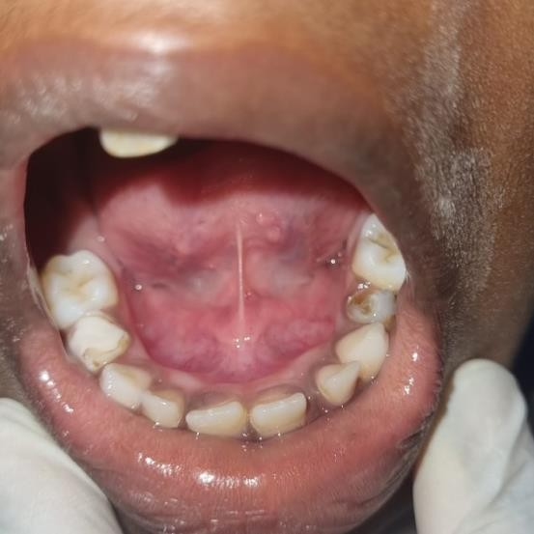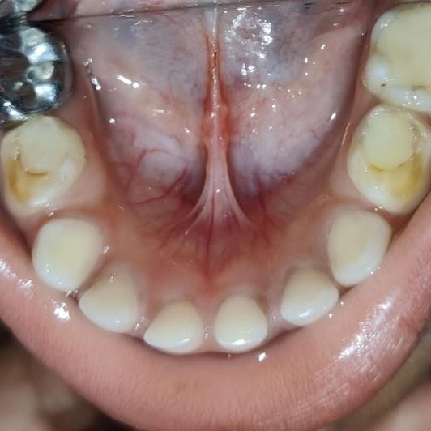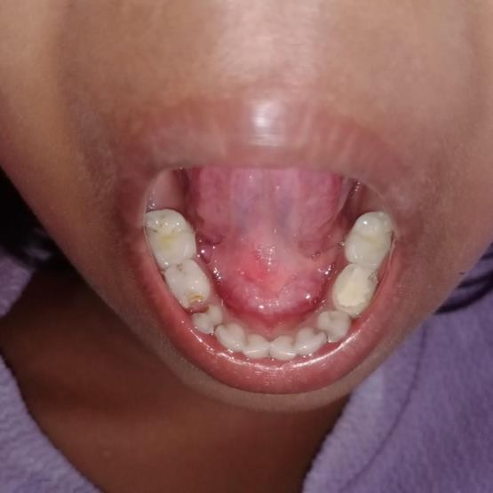
Type 1
Type 3
Type 2
Type 4
Figure 2: Mandibular frenal attachment (Coryllos classification system)
Discussion
This study aimed to assess the prevalence of the types of mandibular frenal attachment in children younger than 6 years old using the classification system described by Coryllos and found that the highest prevalence was recorded in children with type 3 frenal attachment or the papillary type, followed by type 2, type 4, and type 1 frenal attachment. No statistical association with the age and gender of the children was noted.
Developmental Considerations:
Frenal attachment is also known to exhibit positional changes during the growth and development of the craniofacial structures. The labial frenum is formed from the tectolabial bands during embryonic development and is affected by the growth of the alveolar process and the eruption of the teeth¹,². In children younger than 6 years old, the height of the alveolar bone is relatively reduced, and the frenal attachment may appear to be positioned coronally³. As the vertical growth of the alveolar bone continues during the mixed dentition stage, the frenal attachment appears to be apically displaced from its original position.^{4,5}
The high incidence of Coryllos Type 3 that was found in this present study may therefore be a physiological state of development rather than a pathological state. The above pattern of development was noted by Sewerin⁴ and Popovich et al.⁶, who emphasized that many high frenal attachments occurring during early childhood tend to resolve spontaneously with growth.
Periodontal Implications
The clinical significance of high frenal attachments has been discussed for many decades. Placek M et al. proposed a classification of frenal attachments and suggested that papillary and papilla penetrating types of high frenal attachments may be associated with periodontal compromises⁷. The tension that is exerted on the marginal gingival tissue as a result of lip movements may cause a pull on the marginal gingival tissue, thereby contributing to gingival recession.
However, recent evidence indicates that frenal morphology does not lead to periodontal destruction unless associated with poor oral hygiene, inflammation, or traumatic occlusion⁹,¹⁰. Devishree et al.¹¹ emphasized that surgical interventions should be based on functional and periodontal indications rather than on anatomical appearance. The absence of gingival recession assessment in this study does not permit a direct correlation with periodontal status, although it appears that papillary attachment may be common in preschool children and may be considered a normal anatomical finding.
Comparison with Previous Studies
Most epidemiological studies available in the literature have reported on maxillary labial frenum rather than mandibular frenum. Studies by Sewerin⁴ and Mirko et al.¹² mainly evaluated the frenal attachment in the upper jaw and its periodontal implications. There is limited literature available on the prevalence of the mandibular frenum in primary dentition.
In studies examining pediatric subjects, increased levels of frenal attachments have been documented to occur more frequently in the early stages of dentition development¹³,¹⁴. Segal et al.¹⁵ have emphasized that different classification systems exist in the literature. The application of the Coryllos classification system in the present study was utilized as a simplified form of anatomical classification, despite being specifically designed to evaluate lingual frenulum anatomy¹⁶. The presence of a majority of Type 3 frenums in the present study supports the premise that papillary attachment represents a transient form of development. Longitudinal studies have demonstrated that there is a gradual repositioning of the apex with increasing age.^{4,5,17}
Gender and Age Association
No statistically significant association was detected between gender distribution and frenulum type in the present study (p = 0.54), supporting previous studies that have demonstrated that frenulum anatomy is influenced more significantly by embryological development rather than gender-related biological influences.
Likewise, no correlation was found between the type of frenum and age group in the narrow range of 3 to 6 years. The narrow age range of the children in the study might have affected the findings because the children were predominantly in the age range of 5 to 6 years. Rakosi et al.¹⁷ indicated that more pronounced positional changes in the frenum occur during the transition to mixed dentition, which was not included in the study.
Clinical Significance in Pediatric Dentistry
The clinical significance of frenum in pediatric dentistry is of preventive concern rather than therapeutic. High mandibular frenum can contribute to the retention of dental plaque because of the difficulty in effectively brushing the lower anterior teeth. However, frenectomy or frenotomy is indicated in cases of recurring gingival inflammation, persisting gingival recession, difficulty in oral hygiene and functional impairment
Laser-assisted frenectomy/frenotomy has been advocated as a less invasive procedure with less discomfort to the patient.^{19,20} However, indiscriminate surgical procedures in preschool children are not advocated unless clinical indications are evident.^{11,21}
Methodological Strengths and Limitations
The primary strength of this research is that it deals with mandibular frenal attachment in a particular preschool population, which is an area of concern that has not yet been addressed by pediatric epidemiological studies. The standardized classification system is also a strength of this research.
However, certain limitations of this research must be kept in mind:
1. The cross-sectional design of this research has restricted us from studying the longitudinal migration of this particular population.
2. The unequal distribution of age has restricted us from studying this population further from a developmental point of view.
3. This research was conducted in a single institution and sample population from neighboring areas around the institution.
Implications for Future Research
Longitudinal studies on frenal attachment from primary to mixed dentition would provide valuable information regarding the permanency or transience of the papillary attachment in the preschool child. Inclusion of digital photographic analysis and periodontal assessment may also improve the diagnostic accuracy²². Assessment of the relationship between frenal morphology and hygiene habits in preschool children may provide valuable information regarding prevention. Inclusion of soft tissue examination in the pediatric examination protocol is recommended.
Conclusion
Within the limitations of the study, the Coryllos type 3 frenal attachment was the most commonly observed in children younger than 6 years. No association between frenal attachment and age or gender was noted. Normal variations should be recognized to prevent surgical interventions in pediatric patients. Early detection of variations is important for preventive pediatric dental care.
References
- Sicher H, Bhaskar SN. Orban’s Oral Histology and Embryology. 9th ed. St Louis: Mosby; 1980.
- Moore KL, Persaud TVN. The Developing Human: Clinically Oriented Embryology. 8th ed. Saunders; 2008.
- Townsend GC, Brown T. The development of the dentition. Aust Dent J. 1981;26(3):153–9.
- Sewerin I. Prevalence of variations and anomalies of the upper labial frenum. Acta Odontol Scand. 1971;29(4):487–96.
- Bergström K, Jensen R, Mårtensson B. The effect of superior labial frenectomy. Am J Orthod. 1973;63(6):633–8.
- Popovich F, Thompson GW, Main PA. The maxillary labial frenum and its relationship to diastema. Am J Orthod. 1977;72(4):399–408.
- Placek M, Skach M, Mrklas L. Significance of the labial frenum attachment in periodontal disease in man. Part 1. J Periodontol. 1974;45(12):891–4.
- Mirko P, Miroslav S, Lubor M. Significance of the labial frenum attachment in periodontal disease in man. Part 2. J Periodontol. 1974;45(12):895–7.
- Ainamo J, Löe H. Anatomical characteristics of gingiva. J Periodontol. 1966;37(1):5–13.
- Maynard JG, Wilson RD. Physiologic dimensions of the periodontium. J Periodontol. 1979;50(4):170–4.
- Devishree, Gujjari SK, Shubhashini PV. Frenectomy: a review with reports of surgical techniques. J Clin Diagn Res. 2012;6(9):1587–92.
- Olivi G, Chaumanet G, Genovese MD, Beneduce C, Andreana S. Er,Cr:YSGG laser labial frenectomy. Gen Dent. 2010;58(3):e126–33.
- Huang WJ, Creath CJ. The midline diastema: a review. Pediatr Dent. 1995;17(3):171–9.
- Kotlow LA. Oral diagnosis of abnormal frenum attachments. J Pediatr Dent Care. 2004;10(3):11–4.
- Segal LM, Stephenson R, Dawes M, Feldman P. Prevalence and treatment of ankyloglossia. Can Fam Physician. 2007;53(6):1027–33.
- Coryllos E, Genna CW, Salloum AC. Congenital tongue-tie and breastfeeding. AAP Newsletter. 2004.
- Rakosi T, Jonas I, Graber TM. Orthodontic Diagnosis. Thieme; 1993.
- Newman MG, Takei HH, Klokkevold PR, Carranza FA. Carranza’s Clinical Periodontology. 12th ed. Elsevier; 2015.
- Chaubal TV, Dixit MB. Ankyloglossia and its management. J Indian Soc Periodontol. 2011;15(3):270–2.
- Romeo U, Palaia G, Del Vecchio A, Tenore G, Visca P, Maggiore C. Excision of lingual frenulum with diode laser. Photomed Laser Surg. 2008;26(6):543–6.
- American Academy of Pediatric Dentistry. Management of the frenulum in pediatric patients. Pediatr Dent. 2022;44(6):412–9.
- Tugnait A, Clerehugh V. Gingival recession—its significance and management. J Dent. 2001;29(6):381–94.

