Clinical Evaluation of Oral Mucosal Alterations in Tobacco Users

ABSTRACT:
INTRODUCTION : Tobacco consumption, whether in smoked or smokeless forms, is a well-established risk factor for oral mucosal and periodontal disorders. Continuous exposure to tobacco products can result in inflammatory changes, keratotic lesions, and potentially malignant alterations within the oral cavity.
Aim: The present study aimed to evaluate the spectrum of oral mucosal and periodontal changes among tobacco users and to analyse their association with different types of tobacco habits.
Methods: A cross-sectional observational study was carried out among 150 individuals with a documented history of tobacco use attending a dental outpatient department. Participants were classified into three groups: smoking, smokeless tobacco use, and combined habits. Demographic details and habit characteristics were recorded. Comprehensive intraoral and periodontal examinations were performed. The collected data were analysed using descriptive statistics and the chi-square test to assess associations between age and tobacco habits.
Results: Of the total participants, 85.3% were males and 14.7% were females, with smoking identified as the most common habit. Frequently observed findings included chronic gingivitis, chronic periodontitis, leukoplakia, oral sub mucous fibrosis, tobacco pouch keratosis, leukoedema, smoker’s melanosis, and dental caries with periapical involvement. Smoker’s melanosis and smoker’s palate were predominantly associated with smoking, whereas leukoplakia and oral sub mucous fibrosis were more frequent among smokeless tobacco users. Individuals practicing combined habits demonstrated more extensive mucosal involvement and advanced periodontal destruction. A statistically significant association was observed between age and smoking (p = 0.000) as well as smokeless tobacco use (p = 0.009), while no significant association was noted for combined habits (p = 0.495).
Conclusion: The study highlights a strong relationship between tobacco use and a wide range of oral mucosal and periodontal alterations, with greater severity seen in individuals with dual habits. Early clinical screening and structured tobacco cessation interventions are essential to limit disease progression and reduce the risk of malignant transformation.
Keywords:
Tobacco, Oral mucosal lesions, Leukoplakia, Oral sub mucous fibrosis, Periodontitis, Smoker’s melanosis
INTRODUCTION:
The oral cavity is lined by a dynamic mucosal epithelium that performs protective, sensory, and functional roles. This mucosa is structurally specialized to withstand varying mechanical demands within the oral environment. Regions subjected to greater friction, such as the gingiva and hard palate, are covered by keratinized epithelium, whereas areas requiring flexibility, including the buccal mucosa and floor of the mouth, are lined by non-keratinized epithelium. Collectively, these tissues preserve oral integrity and facilitate mastication, speech, swallowing, and taste (2,3).
Habitual exposure to irritants, particularly tobacco, can disrupt the normal architecture and physiology of this mucosal barrier. Tobacco is consumed in smoked forms such as cigarettes and bidis, as well as in smokeless preparations including betel quid, gutkha, pan masala, and areca nut–containing products (6,7). Persistent exposure of oral tissues to these substances results in chronic irritation and chemical injury. The epithelium may initially respond with adaptive changes such as hyperkeratosis and epithelial thickening; however, prolonged exposure can lead to pathological alterations (1,13).
The extent and pattern of tissue damage are influenced by several factors, including the type of tobacco product, frequency and duration of use, and the specific site of placement within the oral cavity. Chronic irritation may induce cellular atypia and epithelial dysplasia, which are recognized as precursor changes for potentially malignant disorders such as leukoplakia and oral sub mucous fibrosis (9,13). If left undetected or untreated, these lesions may progress toward malignant transformation and culminate in oral carcinoma.
Oral cancer remains a significant public health challenge worldwide. Reports from the World Health Organization consistently identify tobacco use as one of the leading preventable causes of global morbidity and mortality (8). In India, the burden of tobacco-associated oral disease is particularly high due to the widespread availability and social acceptance of both smoked and smokeless forms (6,7). Lesions such as leukoplakia, oral sub mucous fibrosis, erythroplakia, tobacco pouch keratosis, and smoker’s melanosis are frequently observed among habitual users (9,10,13). Several of these conditions carry a documented risk of malignant transformation, especially when associated with prolonged exposure.
Beyond tobacco-specific carcinogens, additional modifying factors including nutritional deficiencies, socioeconomic limitations, limited awareness, delayed access to care, and viral infections such as human papillomavirus may further influence disease progression. A Major challenge in oral cancer management is that early lesions are often asymptomatic, resulting in delayed clinical presentation and advanced-stage diagnosis (8).

Considering these factors, early detection of mucosal alterations in tobacco users is critical. Dental professionals play an essential role in routine screening, patient counselling, and implementation of tobacco cessation strategies (5). Assessing the clinical spectrum of oral mucosal and periodontal changes among individuals with varying tobacco habits can enhance understanding of disease patterns and risk distribution.
Therefore, the present study was undertaken to evaluate the range of oral mucosal and periodontal alterations in individuals using different forms of tobacco and to analyse the relationship between habit characteristics and clinical presentation.

MATERIALS AND METHODS :
This study was designed as a cross-sectional observational study conducted in the outpatient department of a dental institution. A total of 150 patients with a documented history of tobacco consumption were included in the study. Demographic details, including age and gender, were recorded. A detailed habit history was obtained from each participant, documenting the type of tobacco usage—smoking (cigarette or beedi), smokeless forms (betel nut, areca nut preparations, pan masala, haans), or combined use—along with the duration and frequency of the habit (1,13).
A comprehensive Intraoral examination was performed under adequate illumination using standard diagnostic instruments, including mouth mirrors and explorers. The oral mucosa was systematically evaluated for the presence of potentially malignant disorders and other mucosal alterations such as leukoplakia, oral sub mucous fibrosis, keratotic lesions, smoker’s melanosis, leukoedema, and ulcerative lesions (1,9,13). Periodontal assessment was carried out to identify gingival inflammation and features of chronic periodontitis. Dental examination included evaluation for dental caries, apical periodontitis, retained root stumps, and occlusal attrition. Soft tissue abnormalities, including mucoceles, glossitis, and granulomatous lesions, were also documented (1).
Participants were categorized into three groups based on the type of tobacco habit: smoking, smokeless tobacco use, or combined use. The recorded clinical findings were classified according to lesion type and analysed using descriptive statistical methods to determine the distribution and association of oral lesions with different forms of tobacco use, following methodologies similar to previously published cross-sectional studies (1,13).

INCLUSION CRITERIA :
- Males and females aged 18 years and above
- Individuals willing to disclose tobacco and alcohol habits and undergo oral examination
- Individuals practicing the habit for at least one year and still actively continuing it
- Individuals willing to undergo biopsy procedures if required

EXCLUSION CRITERIA :
- Individuals below 18 years of age
- Those unwilling to disclose habits or undergo examination
- Patients with systemic illnesses and on medication
- Individuals who had completely stopped the habit within the past year
- Patients unwilling to undergo biopsy if indicated

For each patient, a structured case sheet was used to document all relevant details, including personal oral habits. Information regarding tobacco smoking, tobacco chewing, and alcohol consumption was specifically recorded (1). Every patient underwent a thorough oral examination under adequate lighting while seated in a dental chair. Particular attention was given to identifying and evaluating oral lesions. When a lesion was detected, it was examined in detail and photographed after obtaining informed consent. In cases where a definitive diagnosis was required, a biopsy was performed with patient consent. All collected data were compiled and subjected to statistical analysis to derive meaningful results, in accordance with previously reported clinical study protocols (1,13).

RESULTS :
In the present study, 150 individuals with tobacco-related habits were divided into three groups: smoking (Group A), chewing (Group B), and combined smoking and chewing (Group C). Among the study population, 128 (85.3%) were males and 22 (14.7%) were females. Groups A and C comprised only male participants. The age of participants ranged from 18 to 85 years, with a mean age of 36 years. Individuals in the fourth, fifth, and sixth decades demonstrated a higher incidence of tobacco usage, consistent with previously reported epidemiological trends (6,7).
Among the 150 participants, various oral mucosal and periodontal lesions were observed. Patients in the smoking group exhibited a greater number of lesions compared to the other two groups. Group A consisted of 82 male patients. Of these, 20 individuals belonged to the 21–30 year age group, 19 to 31–40 years, 15 to 41–50 years, 10 to 51–60 years, 9 to 61–70 years, 5 to 71–80 years, and 1 to 81–90 years.
Smoker’s palate and smoker’s melanosis were more frequently observed in this group, findings that are in agreement with earlier clinical studies (10,11). Seven patients presented with smoker’s melanosis and four with smoker’s palate. Other common findings included chronic gingivitis, chronic periodontitis, dental caries with apical involvement, and generalized mucosal pigmentation. Occasional cases of median rhomboid glossitis were also noted, similar to findings reported in previous literature (12).
In the chewing group (Group B), oral sub mucous fibrosis (OSMF) (3 cases) and leukoplakia (10 cases) were the most predominant lesions. These findings correspond with earlier cross-sectional studies conducted among chewing tobacco users (9,13). Additional lesions observed included tobacco pouch keratosis, occlusal attrition, lichenoid reactions, and chronic periodontitis.
Among the mixed habit group (Group C), leukoedema and leukoplakia showed higher incidence rates, along with more advanced periodontal destruction and a greater likelihood of lesions with malignant potential. Significant lesions identified in this group included malignant ulcers, oral sub mucous fibrosis, lichenoid lesions, and early pre-leukoplakic changes, consistent with patterns reported in tobacco-associated mucosal studies (1,13).
Across all three groups, the most predominant lesions observed were smoker’s palate (4 cases), smoker’s melanosis (7 cases), leukoplakia (10 cases), oral sub mucous fibrosis (3 cases), and leukoedema (6 cases). The most commonly affected age groups were 21–30 years and 51–60 years, reflecting age-related distribution patterns documented in previous Indian population studies (6,7).
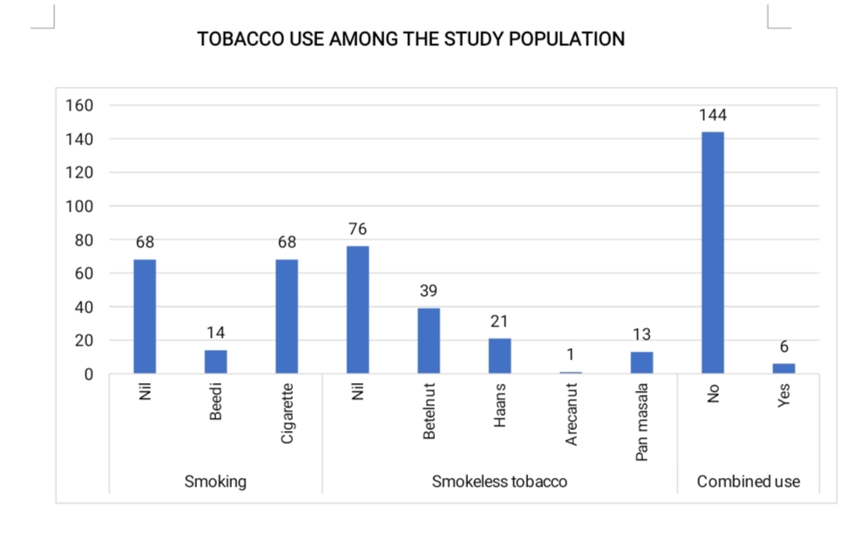

Fig 1 : TOBACCO USE AMONG THE STUDY POPULATION
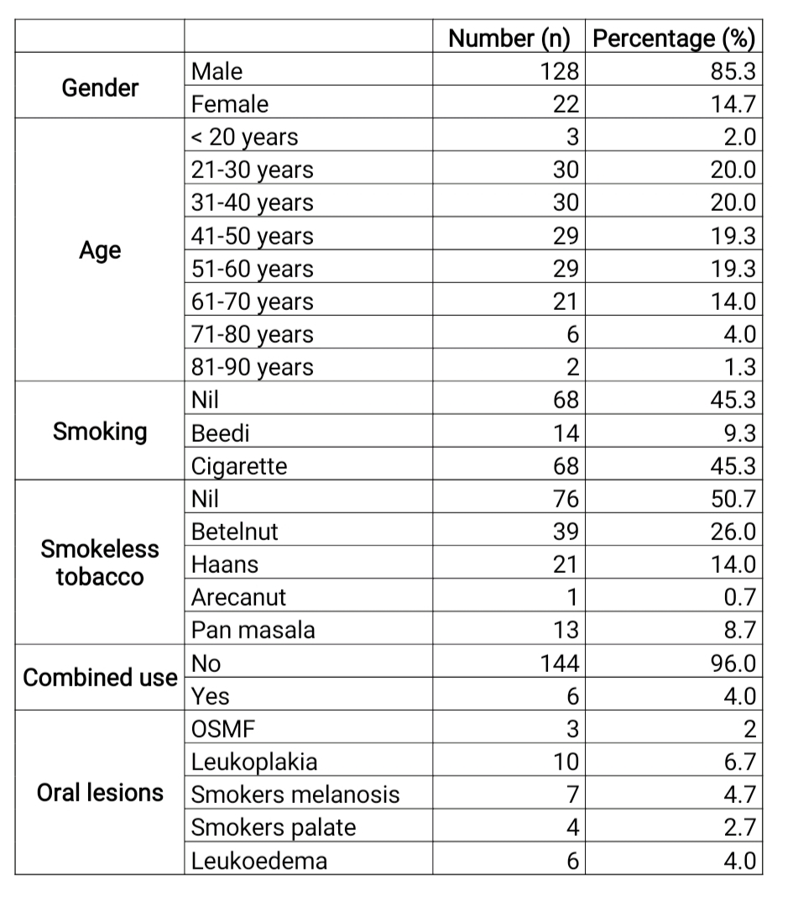
table 1: Tobacco consumption across different Age groups and Gender

DISCUSSION:
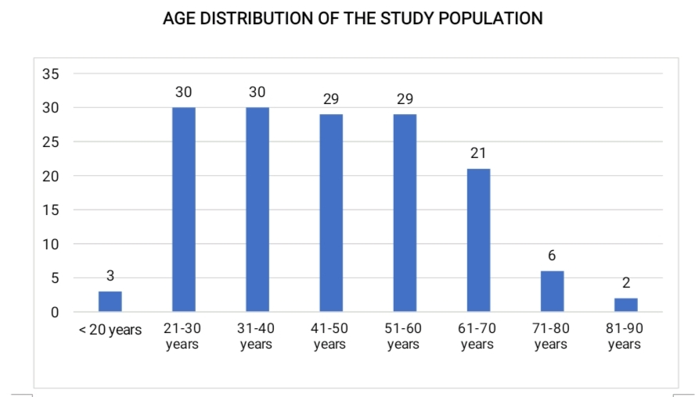
Tobacco consumption continues to be a major contributor to preventable illness and mortality worldwide. Global health reports indicate that millions of deaths each year are directly attributable to tobacco-related diseases, and projections suggest that this burden may increase further if effective preventive strategies are not strengthened [8]. In India, both smoking and smokeless forms of tobacco are widely used across different age groups and socioeconomic strata, contributing significantly to the overall public health burden [6,7]. The easy accessibility of tobacco products, along with their social and cultural acceptance, plays a crucial role in sustaining high prevalence rates. As a result, tobacco-associated oral diseases are frequently encountered in clinical practice, as demonstrated in epidemiological studies evaluating oral mucosal lesions among tobacco users [1,13]
.In the present study, the frequency, duration, and type of tobacco habit were carefully documented and analysed in relation to the clinical findings. A clear association was observed between long-standing tobacco use and the occurrence of oral mucosal alterations. Similar associations between chronic
Fig 2 : AGE DISTRIBUTION OF THE STUDY POPULATION

tobacco exposure and mucosal lesions have been reported in previous studies [1,4,13]. Lesions were more commonly identified in individuals belonging to the third to sixth decades of life, which is consistent with epidemiological observations showing increased prevalence of tobacco-related lesions in middle-aged adults [6,7,9].
This pattern may be attributed to prolonged exposure over time, as cumulative tissue damage increases with continued use. Chronic irritation from tobacco leads to epithelial and connective tissue changes, as described in standard oral histology texts [2,3]. The findings of the present study therefore suggest that both the intensity and duration of the habit play a significant role in determining the severity and distribution of oral lesions. Comparable findings highlighting the dose–response relationship between tobacco use and lesion development have also been documented in earlier research [1,13].
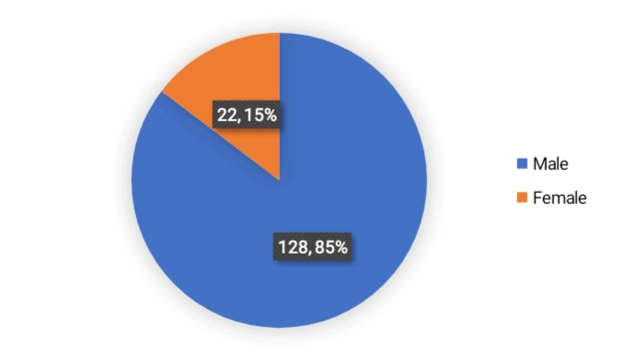

Fig 3 : GENDER OF THE STUDY POPULATION
Various oral lesions were found more frequently among male tobacco users compared to female users, which may be attributed to the higher prevalence of tobacco consumption among males and the greater proportion of male participants in the study group. Similar findings showing higher tobacco usage among males in India have been reported in national surveys and epidemiological studies [6,7,8]. In the present study, Groups A and C had no female patients, as none of the female participants revealed a positive history of smoking.
Although smoking is prevalent among women in certain parts of India, including Chennai, across both affluent and lower socioeconomic strata [7,8], no female smokers were reported in this study. A possible explanation for this observation may be underreporting of personal habits such as smoking and alcohol consumption among women due to social and cultural stigma. Previous studies have emphasized the influence of sociocultural factors on tobacco reporting patterns and prevalence [5,6].
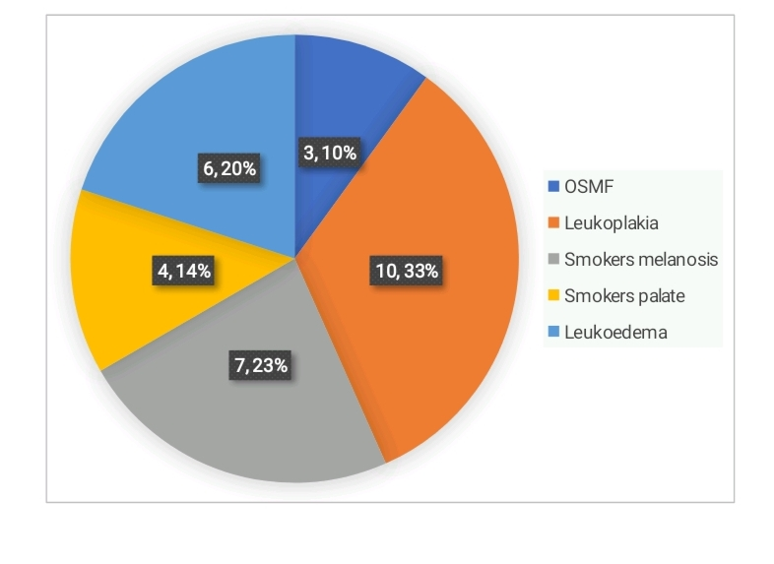
The higher prevalence of oral lesions among male tobacco users observed in this study is consistent with earlier reports that demonstrate a strong association between tobacco use and oral mucosal alterations [1,4,9,13]. Tobacco-related lesions such as smoker’s melanosis and other pigmentation changes have also been well documented in habitual smokers [10,11], while smoking has been implicated as an etiological factor in certain mucosal conditions such as median rhomboid glossitis [12]. The pathogenesis of these lesions can be explained by histological changes induced by chronic tobacco exposure, including epithelial alterations and connective tissue changes [2,3].

Fig 4 : ORAL LESIONS

Comparison of individuals with lesions among the three groups showed that lesions were more common in Group A and Group C (48 cases each), followed closely by Group B (46 cases). The higher occurrence of lesions in Groups A and C may be attributed to the deleterious effects of smoking alone and its combined use with smokeless tobacco. Previous studies have demonstrated that both smoked and smokeless forms of tobacco are independently associated with oral mucosal alterations, and the risk increases with combined exposure (1,9,13).
Among male participants with lesions, Group C (combined smoking and chewing habit) exhibited relatively more lesions compared to the other groups. This finding may be explained by the cumulative and synergistic effects of dual habits, where the frequency and duration of tobacco use play a critical role in lesion development and severity (1,8).
In males, the most frequently observed lesions included oral sub mucous fibrosis (OSMF), smoker’s melanosis, smoker’s palate, leukoplakia, and leukoedema. The association of OSMF and leukoplakia with chewing habits has been well documented (9,13). Smoker’s melanosis and its dose-dependent relationship with smoking have also been widely reported (10,11), while smoker’s palate has been strongly linked to chronic heat and tobacco exposure (12). These findings are consistent with earlier clinical studies evaluating oral mucosal changes among tobacco users (1,4).
Among female tobacco users, leukoplakia, leukoedema, multiple mucosal lesions, malignant ulcers, and OSMF were observed more frequently compared to males. This may be attributed to the prevalent habit of chewing tobacco along with betel quid among females. The strong association between betel quid/arecanut chewing and OSMF and leukoplakia has been clearly established in previous epidemiological studies (9,13).
Overall, the findings reinforce existing evidence that both individual and combined tobacco habits significantly contribute to the development of oral mucosal lesions, with severity influenced by type, duration, and frequency of exposure (1,8,13).
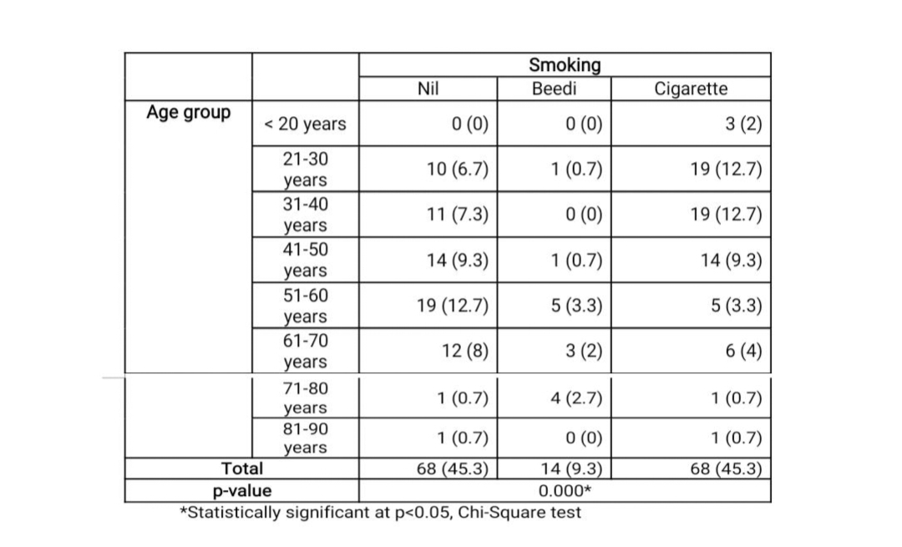
Table 2: The association between age and type of smoking habit

A statistically significant association was observed between age and type of smoking habit (Chi-square test, p = 0.000), indicating that smoking patterns varied across different age groups. Similar age-wise variations in smoking prevalence have been reported in national epidemiological surveys in India (6,7).
Overall, 45.3% of participants (68 individuals) reported no smoking habit, while an equal proportion (45.3%) were cigarette smokers. Beedi smoking was less common (9.3%). The predominance of cigarette smoking over beedi use in certain age groups is consistent with findings from population-based studies assessing tobacco consumption patterns in India (6,7).
Cigarette smoking was more prevalent among individuals in the 21–30 and 31–40 year age groups. In the 41–50 year category, smokers and non-smokers were nearly equal in number. Among participants aged 51–60 years, the proportion of non-smokers increased, although both cigarette and beedi use were still present. Earlier studies have similarly documented higher smoking rates among young and middle-aged adults compared to older age groups (6,7).
In older age groups (61–80 years), cigarette use declined, while beedi smoking was relatively more noticeable in the 71–80 year group. Very few participants were observed in the 81–90 year category. The variation in smoking patterns across age groups may reflect generational preferences, accessibility, and long-term habit persistence as described in prior tobacco epidemiology reports (6,8).
Overall, cigarette smoking predominated in younger and middle-aged adults, reinforcing the need for targeted preventive and cessation strategies in these age groups, particularly given the established association between smoking and oral mucosal lesions (1,10–12).

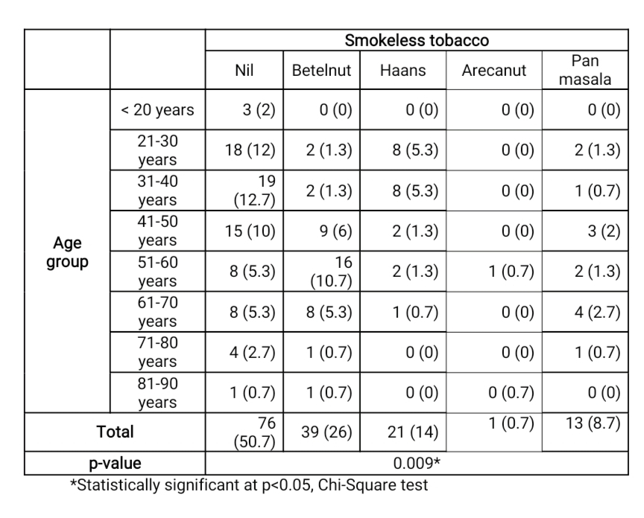
table 3: The association between age and type of smokeless tobacco

The association between age and type of smokeless tobacco habit was found to be statistically significant (p = 0.009, Chi-square test), indicating that tobacco habits vary meaningfully with age. Similar age-related variations in chewing habits have been reported in national surveys conducted in India (6,7).
Overall, 50.7% of the participants (76 individuals) reported no smokeless tobacco use, making it the most common category. Among users, betelnut consumption (26%) was the most prevalent habit, followed by haans (14%), pan masala (8.7%), and arecanut (0.7%), which was the least common. Previous epidemiological studies have documented a high prevalence of chewing tobacco and arecanut products in the Indian population (6,7,13).
In younger age groups (<20 years), almost all individuals reported no habit. Usage begins to appear more prominently in the 21–30 and 31–40 year groups, especially with haans and betelnut. A noticeable increase in betelnut consumption is seen in the 41–60 year age groups, with the highest frequency observed in individuals aged 51–60 years. Similar findings have been reported in cross-sectional studies where middle-aged individuals showed higher prevalence of chewing habits and related oral lesions (1,13).

Pan masala use was distributed across middle and older age groups, while arecanut use was reported in only one individual. The association between arecanut and the development of oral sub mucous fibrosis and leukoplakia has been well established in previous literature (9,13).In older age groups (61–90 years), the number of participants decreases, but betelnut and pan masala habits continue to be present, reflecting long-term persistence of chewing habits as reported in earlier studies (6,7).
In summary, smokeless tobacco habits were more common in middle-aged and older individuals, particularly betelnut use, and the pattern of consumption showed a statistically significant association with age. Given the well-documented link between chewing habits and oral mucosal pathology (1,9,13), these findings highlight the importance of early screening and habit cessation counselling.

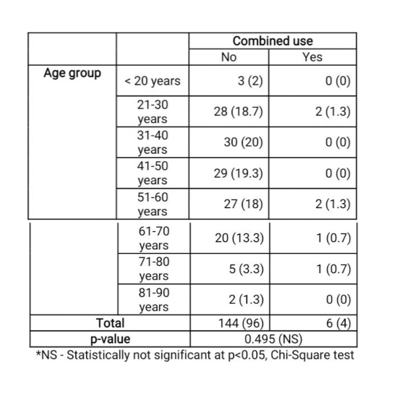
Table 4: The distribution of combined use of habits across different age groups

This table shows the distribution of combined use of habits (both smoking and smokeless tobacco) across different age groups. Overall, the majority of participants did not report combined use. Out of the total sample, 96% (144 individuals) had no combined habit, while only 4% (6 individuals) reported combined use.
In the younger age group (<20 years), none of the participants reported combined use. A small number of combined users were observed in the 21–30 years (1.3%) and 51–60 years (1.3%) age groups. Similarly, very few cases were seen in the 61–70 years and 71–80 years categories. No combined use was reported in the 31–40, 41–50, and 81–90 year groups. Similar age-related variations in tobacco consumption patterns have been reported in national and epidemiological surveys conducted in India (6,7).
The statistical analysis showed that the association between age and combined habit was not statistically significant (p = 0.495, Chi-square test). This indicates that combined use does not vary significantly across different age groups in this study population. Although dual habits were relatively uncommon in the present study, previous literature suggests that combined exposure to smoking and smokeless tobacco may increase the risk and severity of oral mucosal lesions due to cumulative carcinogenic effects (1,9,13).
In summary, combined use of smoking and smokeless tobacco was relatively rare in this cohort, and no meaningful age-related pattern was observed. However, given the well-documented association between tobacco habits and oral mucosal pathology (1,8,13), even a small proportion of dual users warrants clinical attention and preventive counselling.
REFERENCES
1. Ramasamy J, Sivapathasundharam B. A study
on oral mucosal changes among tobacco users. J Oral Maxillofac Pathol
2021;25:470-7
2.Nanci A. Tencate’s, Text book of Oral Histology. 7th ed. India: Elsevier;
2012. p. 319-324.
3. Kumar GS, Orban’s Text Book of Oral Histology and Embryology.
12th ed. India: Elsevier; 2010. p. 210-20.
4.Cadugo MA, Chua MG, Feliciano MA, Jimenez FC, Uy HG. Preliminary
clinical study on the oral lesions among the Dumagats. J Philipp Dent
Assoc (PHILIPPINES) 1998;50:36‑42.
5. Crews KM, Gordy FM, Penton‑Eklund N, Curran AE, Clay JR.
Tobacco cessation: A practical dental service. Gen Dent
1999;47:476‑83.
6. Preeti S, Raut DK. Prevalence and Pattern of Tobacco Consumption
in India. Int Res J Soc Sci 2012;1-8.
7. Rani M, Bonu S, Jha P, Nguyen SN, Jamjoum L. Tobacco use in India:
Prevalence and predictors of smoking and chewing in a national cross
sectional household survey. Tob Control 2003;12:e4.
8.World Health Organization (2008) WHO Report on the Global
Tobacco Epidemic. The MPOWER Package. Geneva: World Health
Organization; 2008.
9. Yu‑Lee YH, Lee HY, Tung S, Shieh TY. Epidemiological survey of oral
sub mucous fibrosis and leukoplakia in aborigines of Taiwan. J Oral
Pathol Med 2001;30:213‑19.
10. Hedin CA, Axell T. Oral melanin pigmentation in 467 Thai and Malaysian
people with special emphasis on smokers melanosis. J Oral Pathol Med
1991;20:8‑12.
11.Hedin CA, Pindborg JJ, Axell T. Disappearance of smokers melanosis
after reducing smoking. J Oral Pathol Med 1993;22:228‑30.
12.Arendorf TM, Walker DM. Tobacco smoking and denture wearing as
local etiological factors in median rhomboid glossitis. Int J Oral Surg
1984;13:411‑5.
13.Reddy SS, Prashanth R, Devi BK, Chugh N, Kaur A, Thomas N.
Prevalence of oral mucosal lesions among chewing tobacco users:
A cross-sectional study. Indian J Dent Res 2015;26:537-41.

