KNOWLEDGE AND ATTITUDE TOWARD THE USE OF CONE BEAM COMPUTED TOMOGRAPHY AMONG DENTAL STUDENTS – A CROSS SECTIONAL QUESTIONNAIRE BASED STUDY

ABSTRACT:
Background: Cone Beam Computed Tomography (CBCT) has transformed dental imaging by providing three-dimensional visualization with increased accuracy and CBCT provides three-dimensional visualization with lower radiation doses than conventional medical CT. Adequate awareness and a good attitude toward CBCT are necessary for its effective and responsible application in a clinical setting. This study sought to evaluate dental students' knowledge and attitudes about using CBCT.
Methods: A cross-sectional descriptive study was conducted with undergraduate dental students, using a structured self-administered questionnaire. The survey consisted of questions about demographic data, indications for CBCT, awareness of radiation safety, and attitudes toward CBCT in the clinical setting. Descriptive statistics were used to summarize the data and chi-square tests were conducted to identify associations between academic level, knowledge, or attitude scores.
Results :The majority of students (94%) indicated they were familiar with CBCT, and this was especially true for senior students (97%). Notably, 66% of respondents recognized dental and maxillofacial imaging as the primary reason for obtaining a CBCT scan. More than half (53%) incorrectly recognized higher radiation dose as advantages of CBCT, and almost all the participants (93%) agreed that CBCT is a valuable resource in contemporary dental practice. However, there were gaps regarding safety; only about 69% were aware of radiation safety practices. There were statistically significant differences for several questions across years of study related to having knowledge of CBCT advantages, knowledge of safety practices, and having exposure to training.Only 43% reported having attended a presentation or formal training on CBCT.

Conclusion : The research shows that despite positive general awareness and attitudes regarding CBCT among dental undergraduate students, there are still significant gaps identified in terms of formal training and radiation safety knowledge, as well as actual hands-on exposure to practice. It is clear that structured CBCT education, with theoretical, technical, and clinical components, must be included in undergraduate education to ensure competency and preparedness for contemporary practice.
keywords : Cone Beam Computed Tomography (CBCT) , Dental Students , Dental radiology, 3D imaging, Dental education.

INTRODUCTION :
Cone Beam Computed Tomography (CBCT) is one of the most significant advances in dental imaging technology over the past twenty years. Cone Beam Computed Tomography (CBCT) is a modern 3D imaging tool that has changed the landscape of dental radiology due to its capacity for detailed visualization of the maxillofacial anatomy with relatively lower radiation doses than traditional conventional tomography (1).

Since CBCT was adopted in dentistry in the late 1990s, it has become widely used in multiple dental disciplines, such as oral surgery, implantology, orthodontics, endodontics, and maxillofacial diagnosis (2). CBCT provides clinicians the ability to visualize anatomical detail in multiple planes, supporting diagnostic accuracy, treatment planning precision, and improved patient outcomes (3).

Although it offers several advantages , CBCT should be used wisely, as it has a higher radiation dose than normal 2D radiographs, such as periapical or panoramic radiographs (4). It is, therefore, important for dental health professionals to have adequate knowledge of its indications, limitations, and radiation-protective concepts. As future professionals, dental students need to develop adequate knowledge about and positive attitudes towards CBCT, to apply it safely and effectively in a clinical setting (5).

Attitude is an equally important factor in determining the likelihood that students will adopt and implement CBCT in their future practice. Most studies survey students and find a generally positive attitude about CBCT, viewing it as a necessary form of modern dental diagnostic radiography (6).

However, attitude, even positive attitude, cannot substitute for adequate knowledge; without the proper discipline and training, both over-exposure and improper use of CBCT may increase unnecessary radiation exposure risk while compromising the efficiency of obtaining the diagnostics (7). Incorporating CBCT education into dental education, with a focus on both a theoretical and a practical aspect, can fill existing gaps in knowledge. Workshops, CDE programs, and simulation-based learning can improve students' competence and confidence (8).

The present study aimed to assess the dental students' knowledge and attitude regarding cone beam computed tomography in Adhiparasakthi dental college and hospital.Ethical approval was obtained from the Institutional Ethical Committee of Adhiparasakthi Dental College .

MATERIALS AND METHODS :
This study was carried out as a cross-sectional, questionnaire-based survey to assess undergraduate dental students' knowledge and attitudes toward Cone Beam Computed Tomography (CBCT) in dental practice. The study was undertaken at Adhiparasakthi Dental College, and Hospital in Melmaruvathur, Tamil Nadu, India. The participants included third-year, final-year undergraduate dental students and interns (CRRI).The questionnaire was validated by experts and pilot tested on 230 students. Data were analyzed using SPSS.Reliability was assessed using Cronbach’s alpha.
The inclusion criteria consisted of all the undergraduate dental students attending their undergraduate third year, final year, and CRRI level, who were enrolled at Adhiparasakthi Dental College, and Hospital, who agreed to participate in the study. Students who did not consent to participate were excluded from the survey.
A convenience sampling method was employed, wherein students were contacted through established communication channels rather than through a randomized selection process.The questionnaire was distributed electronically.There were a total of 230 responses.
ATTITUDE AND KNOWLEDGE OF USE OF CBCT IN DENTISTRY AMONG DENTAL STUDENTS
NAME :
AGE :
YEAR OF STUDY :
● 3 rd year
● 4 th year
● Internship
● Other
1. What is CBCT ?
● Cone beam computed tomography
● Computed bone cone tomography
● Cone beam cranial tomography
● None of the above
2. CBCT primarily used in ?
● General radiology
● Dental and maxillofacial imaging
● Orthopedics
● Implantology
3. Which of the following is an advantage of CBCT over conventional CT ? ● Lower cost and radiation dose
● Higher radiation dose
● Better soft tissue resolution
● Slower image acquisition
4. CBCT be integrated into undergraduate dental training?
● strongly agree
● Agree
● Disagree
● Strongly disagree
5. What do you think is the main barrier to CBCT use ?
● Cost
● lack of knowledge /training
● Radiation exposure
● lack of equipment
6. Do you feel that CBCT is a valuable addition to modern dental care?
● Yes
● No
● Not sure
7. CBCT is most appropriate for which of the following situations ?
● Implant planning
● Orthodontic evaluation
● TMJ assessment
● Pathology evaluation
● Endodontic evaluation
8. Do you know the radiation safety protocols for CBCT use?
● Yes
● No
9. Have you attended any formal training or lectures on CBCT ?
● Yes
● No
10. Do you have any additional comments or suggestions regarding CBCT use in dental education and practice ?

RESULT :
A total of 230 undergraduate dental students and interns participated in this study. When participants were asked to identify the correct definition of CBCT (Q1), 94.3% of them accurately indicated that CBCT stands for "Cone Beam Computed Tomography". Also, a statistically significant association was found between year of study and accuracy of response (χ² = 30.050, p < 0.001), with senior students showing higher knowledge. Similar findings have been reported in the literature regarding the knowledge of radiology education (9).

In the next question regarding primary use of CBCT (Q2), 66% of participants indicated that dental and maxillofacial imaging is the most common indication, but no statistically significant association was observed. (p = 0.082). For Q3,53% of participants incorrectly considered higher radiation dose as an advantage of CBCT.More than half of participants showed misconception regarding radiation dose.Interns correctly identified lower radiation dose as advantage of CBCT.while 37.8% of them incorrectly indicated that it was better for soft tissue resolution. There was a significant association with years of study and knowledge of benefits or advantages (p = 0.019).

For Q4 regarding curriculum integration, 51.7% of participants agreed or strongly agreed that CBCT should be incorporated into undergraduate training, and no significant association was found with year of study and educational philosophy (p = 0.402). Cost was reported as the most frequently cited barrier (50.4%) followed by a lack of training and knowledge (28.7%)(Q5). A statistically significant difference across academic levels was noted (p=0.004).These barriers are consistent with previously reported findings CBCT implementation in dental colleges (10).

The majority of respondents believed CBCT would enhance dental care (Q6) (93% indicated they "strongly agree"). There were no statistically significant differences between years (p = 0.142).In terms of clinical indications (Q7), implant planning (31.3%) and orthodontic evaluation (25.2%) were selected most often. A strong statistical association was reported (p < 0.001).

Only 68.6% indicated an awareness of the appropriate radiation safety guidelines for CBCT (Q8), with interns exhibiting a more favorable response (p = 0.001). Only 43.4% reported attending any formal training or lectures on CBCT (Q9) and this was significantly associated with academic level (p < 0.001) as described in the previous section.From the provided open-ended responses (Q10), it was evident that participants felt strongly about the need for better training, affordability, and hands-on opportunities to gain more experience.

Figure : 1 (Q1) Figure : 2 (Q3)
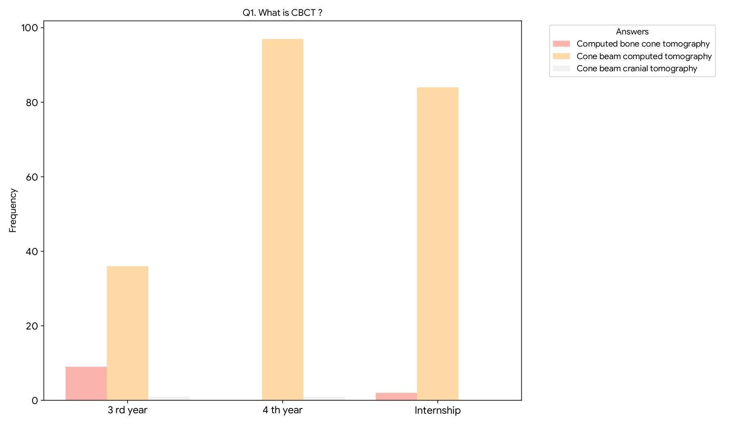
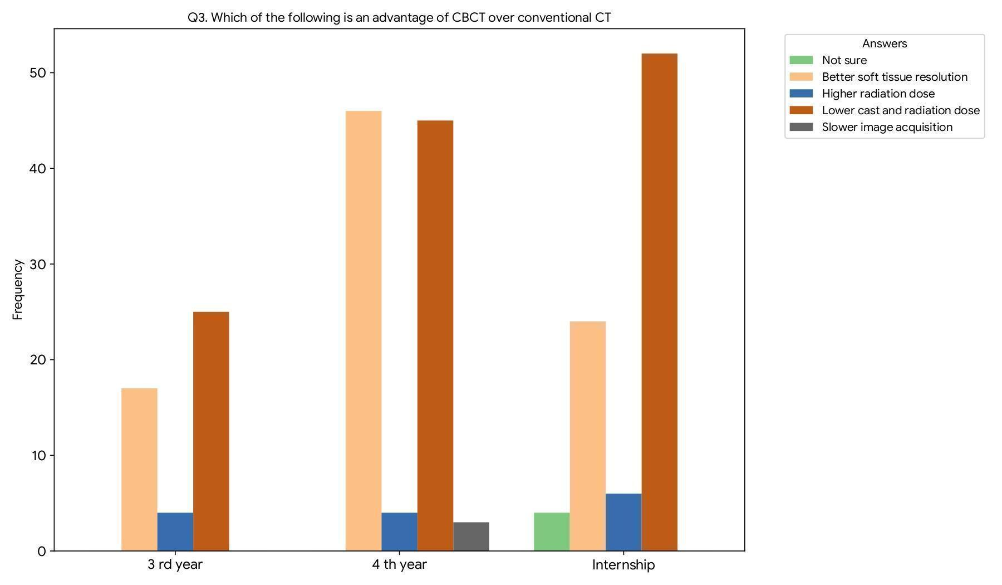
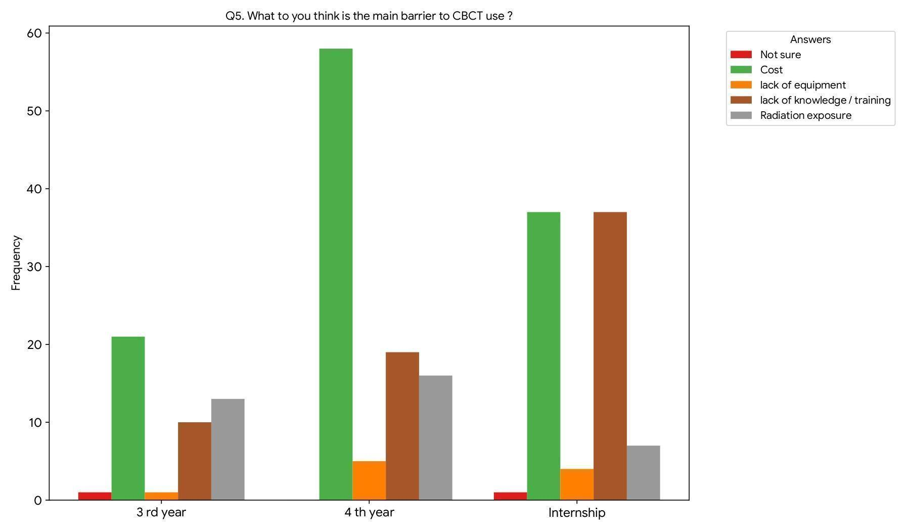
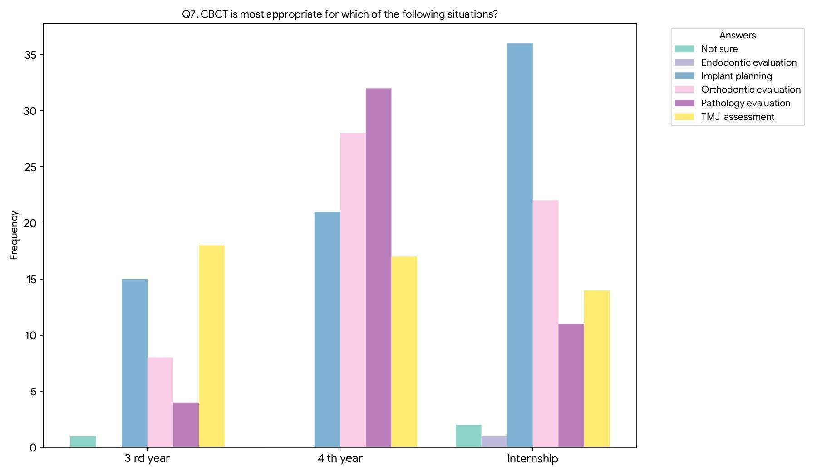
Figure : 3 (Q5) Figure : 4 (Q7)
Figure : 5 (Q9) Figure : 6(Q9)
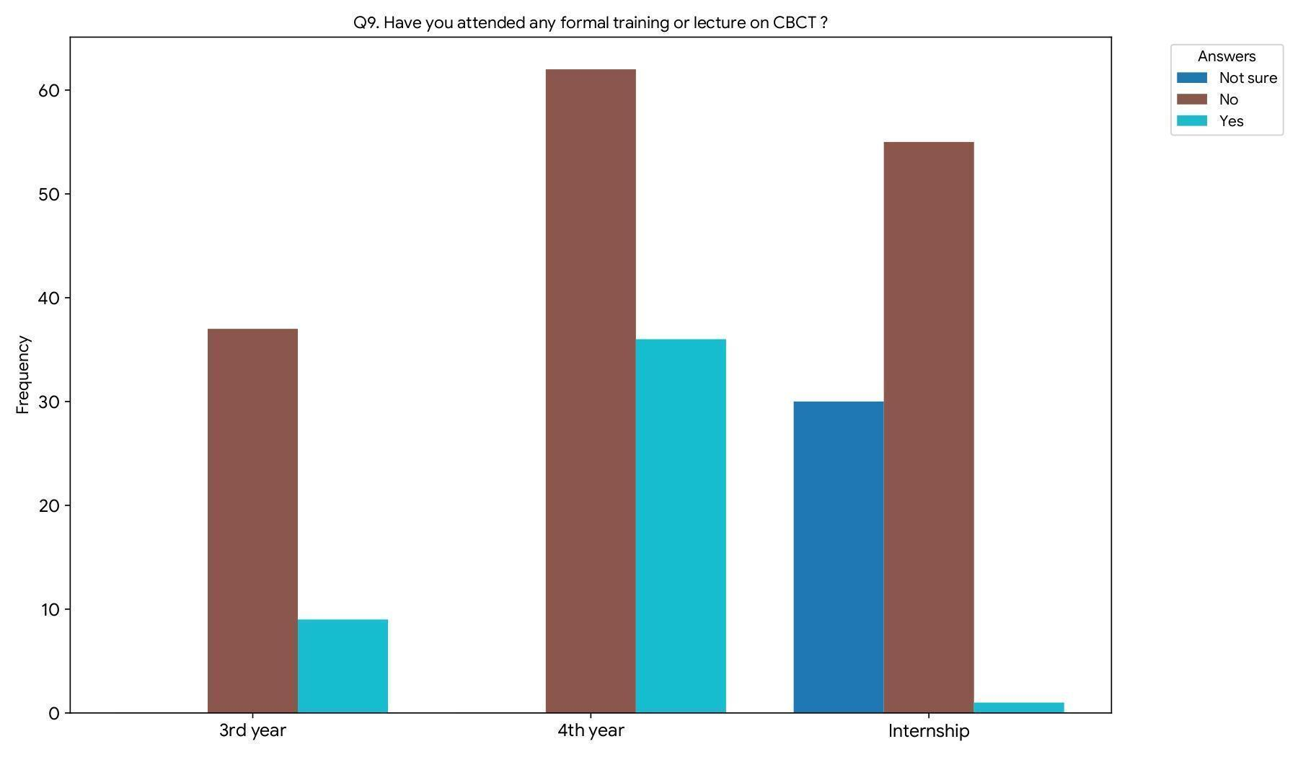
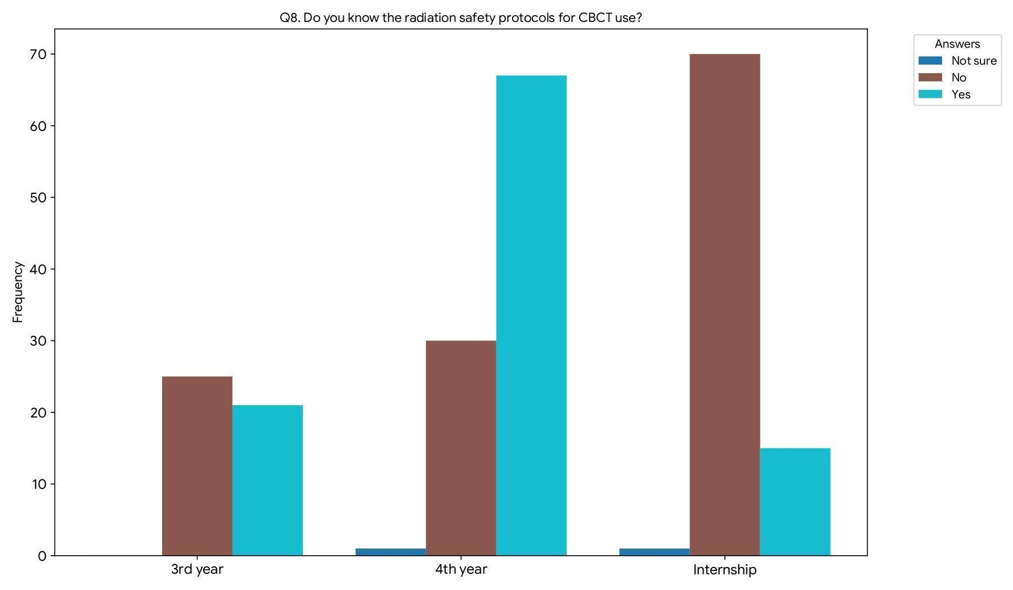

Table : 1 ( knowledge and attitude of use of CBCT among dental students )

Questions | Options | 3rd year |  | 4th year |  | Intern |  | Total |  | P- value
Questions | Options | N | % | N | % | N | % | N | % | P- value
Q1.what is  CBCT? | Computed bone cone tomography | 9(3.9) |  | 0 |  | 2(0.86) |  | 11(4.78) |  | 0.05*
Q1.what is  CBCT? | Conebeam computed tomography | 36(15.6) |  | 97(42.1) |  | 84(36.5) |  | 217(94.3) |  | 0.05*
Q1.what is  CBCT? | Conebeam cranial tomography | 1(2.3) |  | 1(2.3) |  | 0 |  | 2(0.86) |  | 0.05*
Q2.CBCT is primarily used in ? | Dental and maxillo facial imaging | 24(10.4) |  | 72(31.3) |  | 56(24.3) |  | 152(66) |  | 0.082
Q2.CBCT is primarily used in ? | General radiology | 17(7.39) |  | 22(9.56) |  | 22(9.56) |  | 61(26.5) |  | 0.082
Q2.CBCT is primarily used in ? | Implantology | 3(1.30) |  | 1(2.3) |  | 7(3.04) |  | 11(4.78) |  | 0.082
Q2.CBCT is primarily used in ? | Orthopedics | 2(0.86) |  | 3(1.30) |  | 1(2.3) |  | 6(2.60) |  | 0.082
Q3.which of the following  is an advantage  of CBCT over  conventional CT? | Not sure | 0 |  | 0 |  | 4(1.73) |  | 87(37.8) |  | 0.019*
 | Better soft tissue  resolution | 17(7.39) |  | 46(20) |  | 24(10.4) |  | 14(6.08) |  | 0.019*
 | Higher radiation dose | 4(1.73) |  | 4(1.73) |  | 6(2.60) |  | 122(53.04) |  | 0.019*
 | Lower cost and radiation dose | 25(10.8) |  | 45(19.5) |  | 52(22.6) |  | 3(1.30) |  | 0.019*
 | Slower image acquisition | 0 |  | 3(1.30) |  | 0 |  | 3(1.30) |  | 0.019*
Q4.CBCT should be integrated into undergraduate  dental  training ? | Not sure | 0 |  | 0 |  | 2(0.86) |  | 2(0.86) |  | 0.402
 | Agree | 24(10.4) |  | 49(21.30) |  | 46(20) |  | 119(51.73) |  | 0.402
 | Disagree | 1(2.3) |  | 4(1.73) |  | 0 |  | 5(2.17) |  | 0.402
 | Strongly agree | 21(9.13) |  | 44(19.1) |  | 38(16.52) |  | 103(44.7) |  | 0.402
 | Strongly disagree | 0 |  | 1(2.3) |  | 0 |  | 1(2.3) |  | 0.402
Q5.what do you think  Is the main barrier to CBCT use ? | Not sure | 1(2.3) |  | 0 |  | 1(2.3) |  | 2(0.86) |  | 0.004*
Q5.what do you think  Is the main barrier to CBCT use ? | cost | 21(9.13) |  | 58(25.2) |  | 37(16) |  | 116(50.4) |  | 0.004*
Q5.what do you think  Is the main barrier to CBCT use ? | Lack of equipment | 1(2.3) |  | 5(2.17) |  | 4(1.73) |  | 10(4.34) |  | 0.004*
Q5.what do you think  Is the main barrier to CBCT use ? | Lack of knowledge/  training | 10(4.34) |  | 19(8.26) |  | 37(16) |  | 66(28.6) |  | 0.004*
Q5.what do you think  Is the main barrier to CBCT use ? | Radiation exposure | 13(5.65) |  | 16(6.95) |  | 7(3.04) |  | 36(15.6) |  | 0.004*
Q6.Do you feel that CBCT is a valuable Addition to  Modern dental care? | No | 4(1.73) |  | 1(2.3) |  | 6(2.60) |  | 11(4.7) |  | 0.142
 | Not sure | 1(2.3) |  | 3(1.30) |  | 1(2.3) |  | 5(2.17) |  | 0.142
 | yes | 41(17.8) |  | 94(40.8) |  | 79(34.3) |  | 214(93) |  | 0.142
Q7.CBCT is most appropriate for which of the following situations? | Not sure | 1(2.3) |  | 0 |  | 2(0.86) |  | 3(1.30) |  | 0.001*
 | Endodontic evaluation | 0 |  | 0 |  | 1(2.3) |  | 1(2.3) |  | 0.001*
 | Implant planning | 15(6.52) |  | 21(9.13) |  | 36(15.6) |  | 72(31.3) |  | 0.001*
 | Orthodontic evaluation | 8(3.47) |  | 28(12.17) |  | 22(9.56) |  | 58(25.2) |  | 0.001*
 | Pathology evaluation | 4(1.73) |  | 32(13.9) |  | 11(4.78) |  | 47(20.4) |  | 0.001*
 | TMJ assessment | 18(7.82) |  | 17(7.39) |  | 14(6.08) |  | 49(21.3) |  | 0.001*
Q8.Do you know the Radiation safety protocols for CBCT use? | Not sure | 0 |  | 1(2.3) |  | 1(2.3) |  | 2(0.86) |  | 0.001*
Q8.Do you know the Radiation safety protocols for CBCT use? | No | 25(10.86) |  | 30(13) |  | 15(6.52) |  | 70(30.4) |  | 0.001*
Q8.Do you know the Radiation safety protocols for CBCT use? | Yes | 21(9.13) |  | 67(29.1) |  | 70(30.4) |  | 158(68.6) |  | 0.001*
Q9.Have you  Attended any formal training or lecture on  CBCT? | Not sure | 0 |  | 0 |  | 1(2.3) |  | 1(2.3) |  | 0.001*
 | No | 37(16.08) |  | 62(26.95) |  | 30(13.04) |  | 129(56.08) |  | 0.001*
 | Yes | 9(3.9) |  | 36(15.6) |  | 55(23.9) |  | 100(43.4) |  | 0.001*
*Statistically significant at p<0.05
DISCUSSION :
The current study evaluated the knowledge and attitude of cone-beam computed tomography (CBCT) among undergraduate dental students consisting of third-year, fourth-year, and interns. Overall, the data suggest that there is a generally positive attitude toward the use of CBCT, however some substantial gaps still exist in basic knowledge, training, and awareness of radiation safety. Multiple studies from varying countries indicate that knowledge of CBCT is relatively limited for dental students and is dependent on training level and practice (11,12).
In similar findings, although undergraduate students in India had heard of CBCT, their knowledge of radiation safety concepts and interpretation were inadequate (12). This suggests that theoretical knowledge cannot stand alone, and must be supplemented with hands-on training and practical experiences (13)
The majority of participants in this study correctly identified CBCT as Cone Beam Computed Tomography, and there was a statistically significant correlation (p < 0.001) between correct responses and the study year. Third-year students showed less knowledge than interns and fourth-year students. This pattern suggests that as academic level and clinical exposure rise, so does knowledge of advanced imaging modalities.In Turkey, Similar findings were reported that senior dental students were considerably more aware of CBCT concepts than junior students.only 63.3% of dental students reported having heard of CBCT, and most students reported not having been adequately instructed in the curriculum (11).
Most participants correctly identified CBCT as cone-beam computed tomography and correctly associated the primary use of CBCT to imaging in dentistry and maxillofacial studies. This correlates with previous reports which have shown that CBCT is increasingly used in dental diagnostic and treatment planning (1,14). Nevertheless, statistical significant differences were seen in each academic year, especially regarding basic knowledge, advantages of using CBCT, and awareness of radiation safety protocols, which reflects differences in schools and exposure to training during undergrad education. A study conducted in Malaysia, over 80% of respondents believed CBCT should be included in the graduate curriculum (15).

Most often, lack of equipment, expense, and insufficient training were frequently mentioned as limitations to using CBCT. This observation is consistent with the literature highlighting the need for structured education, including the need for hands-on training, to ensure competent and safe practice in the clinical use of CBCT (16,17.).

Despite the agreement from a majority of students that it would be a valuable addition to today's dental practice, a large number indicated limited, if any, formal training (or workshops), which suggests a potential curricular change may be useful. Prior research also encourages modules on CBCT to be incorporated early on into the undergraduate curriculum on radiation protection and diagnostic interpretation (18,19).

Additionally, the majority of participants expressed enthusiasm for integrating CBCT training for undergraduate students, which aligns with the anticipated increased expectations for advanced imaging skills among future dental professionals. With an expanding dependence on three-dimensional imaging modalities for endodontics, implantology, orthodontics, and maxillofacial pathology, an established CBCT education is essential for enhancing diagnosis and patient safety (20,21).
Knowledge of the benefits of CBCT over traditional CT was found to be significantly correlated with the year of study (p = 0.019). A greater percentage of interns accurately identified cost savings and lower radiation exposure as the main benefits. Senior students' increased clinical exposure and engagement with radiology departments may be responsible for their improved comprehension. CBCT is more appropriate for dental applications because the study delivers significantly lower radiation doses than medical CT, particularly when limited fields of view are used (22).
More than 90% of the participants believed that CBCT was a useful addition to modern dental care, even though there were some problems. This finding showsCBCT is increasingly recognized as an important diagnostic tool. Also, there was a statistically significant link between the year of study and knowing when it is appropriate to use CBCT (p <
0.001). Implant planning, orthodontic evaluation, temporomandibular joint assessment, and pathology evaluation were commonly identified indications. These results are in agreement with guidelines published by the European Commission, which recommend CBCT for complex diagnostic tasks where conventional two-dimensional imaging is insufficient (23).
As academic level increased, there was a statistically significant improvement in knowledge of radiation safety procedures related to CBCT use (p = 0.001). When compared to third- and fourth-year students, interns showed greater awareness. This result emphasizes how crucial it is to emphasize radiation safety concepts early in dental education, such as the ALARA (As Low As Reasonably Achievable) principle. Junior students' inadequate understanding of radiation safety has been documented in earlier research and is still a cause for concern (24).
Attendance at formal training programs or lectures on CBCT was reported by less than half of the participants, with a statistically significant difference among academic levels (p < 0.001). Interns were more likely to have attended CBCT-related training, indicating that exposure is largely dependent on clinical postings rather than structured curricular teaching. This highlights the need for systematic inclusion of CBCT education within undergraduate programs rather than reliance on incidental learning (25).
Qualitative feedback from participants further supported these findings, with many students emphasizing the need for curriculum integration, hands-on training, demonstrations, and reduced cost of CBCT imaging. These perceptions align with global recommendations advocating competency-based CBCT education to ensure safe and effective clinical application (26).
Recent international evidence indicates that greater clinical exposure and structured educational environments improve awareness of CBCT among senior students and practicing dentists(27).Also noted that senior undergraduate students showed considerably greater conceptual understanding and confidence in CBCT interpretation compared to preclinical students,indicating similar improvements across academic progression(28).
Even though the majority of participants thought CBCT was a useful addition to contemporary dental practice, there were notable gaps in formal training attendance and radiation safety knowledge, especially among junior students. This emphasizes how undergraduate curricula must methodically incorporate radiation biology,CBCT education,and practical training(29).

Conclusion
Although dental students demonstrate positive attitudes and general awareness regarding CBCT, notable deficiencies persist in their depth of knowledge, radiation safety understanding, and practical experience.These findings highlight the need for dental institutions to strengthen undergraduate curricula through structured CBCT education and radiation safety training.

Enhancing clinical exposure and integrating comprehensive imaging training will better prepare future dental professionals to use CBCT responsibly and effectively. As dental imaging technology continues to evolve, equipping students with both technical competence and safety awareness is essential to ensure high-quality, evidence-based patient care.
LIMITATIONS
This study has several limitations that should be considered when interpreting the findings. First, the study was conducted in a single dental institution using a convenience sampling method, which may limit the generalizability of the results to all dental students in other colleges or regions. The sample may not fully represent the diversity of undergraduate dental students in terms of curriculum exposure, clinical experience, and access to CBCT facilities. In addition, the study relied on a self-administered questionnaire, which may introduce response bias, recall bias, and the possibility of socially desirable answers. As a result, the reported knowledge and attitudes may not completely reflect the actual level of competence or clinical behavior of the participants.
Another limitation is that the study assessed knowledge and attitude using self-reported responses rather than objective evaluation or practical assessment of CBCT interpretation skills. The cross-sectional design captures data at a single point in time and does not allow assessment of changes in knowledge or attitude as students progress through their training. Furthermore, the questionnaire did not explore detailed curriculum content or the quality and duration of CBCT training received by students.

REFERENCES :
1. Scarfe WC, Farman AG. What is cone-beam CT and how does it work? Dent Clin North Am. 2008;52(4):707–30.
2. P, Procacci C, Tacconi A, et al. A new volumetric CT machine for dental imaging based on cone-beam technique. Eur Radiol. 1998;8(9):1558–64.

3. Patel S. New dimensions in endodontic imaging: Part 2. Cone beam computed tomography. Int Endod J. 2009;42(6):463–75.

4. Pauwels R, et al. Effective dose range for dental CBCT scanners. Eur J Radiol. 2012;81(2):267–71.

5. Arnheiter C, et al. Undergraduate radiology education: A survey of dental schools. J Dent Educ. 2006;70(10):1108–14.

6. Ekambaram M, et al. Knowledge, attitude and awareness of CBCT among dental students. J Contemp Dent Pract. 2017;18(3):208–12.
7. Horner K, et al. Basic principles for use of dental cone beam CT: consensus guidelines. Br J Radiol. 2015;88(1055):20150726.
8. Mupparapu M, et al. Educational needs in 3D imaging among dental students and practitioners. J Dent Educ. 2018;82(5):481–90.
9. Pauwels R, et al. Education in dental radiology. Dentomaxillofac Radiol.2015.
10. Jacobs R, et al. Undergraduate CBCT training needs. Clin Oral Investig. 2018.
11. Kamburoğlu K, et al. Knowledge and attitudes of dental students towards digital radiography and CBCT. Dentomaxillofac Radiol. 2011;40(6):439–43.
12. Gupta J, et al. Knowledge and attitude toward CBCT among dental students in India. J Oral Biol Craniofac Res. 2015;5(1):59–63.
13. Aps JK. Cone beam CT in paediatric dentistry: Overview and clinical applications. Eur Arch Paediatr Dent. 2013;14(3):139–46.
14. Pauwels R. Cone beam CT for dental and maxillofacial imaging: dose matters. Radiat Prot Dosimetry. 2015;165(1-4):156-61.
15. Nurul H, et al. Knowledge and attitude toward CBCT among Malaysian dental students. Malays J med Res. 2020;4(3):12–8
16. Loubele M, Guerrero ME, et al. Image quality vs radiation dose in CBCT. Eur J
Radiol. 2008;75(2):265-72.
17. Horner K, Islam M, et al. Basic principles for use of dental CBCT: review. Br Dent J. 2009;206(3):159-62.
18. Brown J, Jacobs R. Training in CBCT interpretation for dental students. J Dent Educ. 2018;82(6):612-20.
19. Parsa A, Ibrahim N, et al. Undergraduate readiness for CBCT use. Imaging Sci Dent. 2015;45(2):73-9.
20. Patel S. CBCT in endodontics. Int Endod J. 2009;42(9):755-76.
21. Bornstein MM. CBCT in implant dentistry. Clin Oral Implants Res. 2014;25(11):1301-9.
22. Ludlow JB, Ivanovic M. Comparative dosimetry of dental CBCT devices and 64-slice CT for oral and maxillofacial radiology. Oral Surg Oral Med Oral Pathol Oral Radiol Endod. 2008;106(1):106–114.
23. European Commission. Radiation Protection No. 172: Cone beam CT for dental and maxillofacial radiology. Luxembourg: EC; 2012.
24. Al-Okshi A, Lindh C, Salé H, Petersson A. Awareness of radiation protection and dose levels of CBCT among dental students. Dentomaxillofac Radiol. 2017;46(8):20170007.
25. Sezgin OS, et al. Knowledge and attitudes of dental students towards CBCT. Eur J Dent Educ. 2019;23(3):341–347
26. White SC, Pharoah MJ. Oral Radiology: Principles and Interpretation. 7th ed. St. Louis: Mosby; 2014.
27. Uvarichev M, Sherstneva V, Mikheikina A, et al. CBCT: knowledge, attitude, and practice among dentists. BMC Oral Health. 2025;25:1540. doi:10.1186/s12903-025-06870-x. Published 06 Oct 2025.
28. binti Mohd Nasir HH, bin Khalid HN, Chaurasia B, Sanwatsarkar G. Knowledge and Attitude Towards Cone Beam Computed Tomography (CBCT) Among Undergraduate Dental Students in Malaysia – A Questionnaire Survey. Malaysian Journal of Medical Research. 2025;9(3):55-68.
29. Coşkun Albayrak S, Özdemir ÖS. Awareness of Cone Beam Computed Tomography (CBCT) use and radiation safety among dentists and specialists. BMC Oral Health. 2025;25:1436.

