Original Research Article
Oral manifestations associated with hypertensive patients: A clinical observational study

ABSTRACT:

Background: Hypertension is a major chronic systemic disease affecting a large population worldwide. It has numerous oral implications either due to the disease process itself or as adverse effects of antihypertensive medications.Early identification of oral manifestations can improve diagnosis, quality of life, and comprehensive management.

Aim: To evaluate the prevalence and types of oral manifestations in hypertensive patients.

Materials and Methods: A clinical observational study was conducted on 100 hypertensive patients visiting the outpatient department of Oral Medicine and Radiology in a private dental institute located in Melmaruvathur over a period of six months. Detailed case histories were recorded, including demographic data, duration and hypertension, and antihypertensive medications. Comprehensive intraoral examinations were performed to assess oral soft tissue and hard tissue changes. The collected data were analyzed statistically to determine the frequency of various oral findings.

Result: Periodontal disease was the most frequently observed oral condition, with periodontitis affecting 70% of the study population. Gingivitis was identified in 29% of patients, while acute necrotizing ulcerative gingivitis was noted in 1%. The highest prevalence of periodontal disease was observed in individuals aged between 60 and 79 years. Various oral mucosal lesions, including gingival hyperplasia, leukoplakia, lichen planus, and hyposalivation, were also documented.

Conclusion:

Oral manifestations were commonly observed among hypertensive patients, with periodontal disease being the predominant finding.Regular oral screening and interdisciplinary collaboration are essential for optimal management of hypertensive individuals.
INTRODUCTION:

Hypertension is one of the most common chronic cardiovascular disorders and a major global health burden.Hypertension is the most prevalent non communicable disease and remains the leading cause of morbidity and mortality.It affects approximately 30–40% of the adult population and is a leading risk factor for stroke, myocardial infarction, renal failure, and premature death[1].While the systemic consequences of hypertension are well recognised,its impact on oral health has gained attention only in recent years. Persistent elevation of systemic arterial pressure can lead to progressive damage to multiple systems of the body, including the oral cavity.

The oral cavity frequently reflects systemic conditions and may exhibit changes due to underlying disease or pharmacological therapy[2].Changes in oral tissue may occur due to altered blood flow,immune dysfunction,metabolic disturbances or pharmacological therapy.Hypertensive patients frequently present with findings affecting both hard and soft tissues.In hypertensive patients, oral alterations such as xerostomia, gingival enlargement, mucosal petechiae, lichenoid reactions, burning sensation, impaired wound healing, and altered taste perception are frequently reported[3]. Many antihypertensive medications, particularly calcium channel blockers, diuretics, and beta blockers, can induce oral side effects including gingival hyperplasia, dryness, or oral
ulcerations[4]

Hypertension is often described as a “silent killer” because it remains asymptomatic in many individuals until significant target organ damage has occurred. From a pathophysiological perspective, hypertension leads to endothelial dysfunction, vascular remodeling, and increased arterial stiffness[5]. These vascular changes extend to the microcirculation of the oral cavity,
particularly affecting the periodontium, which is highly vascularized[6]

Recent research has emphasized the bidirectional relationship between periodontal disease and systemic conditions such as cardiovascular disease and hypertension[7]. Hypertension shares inflammatory pathways with periodontal disease, including elevated C-reactive protein, interleukin-6, and tumor necrosis factor-alpha levels[8]. These mediators contribute to endothelial
dysfunction and periodontal breakdown[9].

Calcium channel blockers are known to induce gingival overgrowth[10], while antihypertensive therapy has also been associated with xerostomia and reduced salivary flow[11]. Therefore, oral health assessment may provide additional insight into systemic inflammatory burden and disease progression.
Despite numerous studies linking hypertension and oral health changes, literature demonstrating the prevalence and pattern of oral manifestations specifically among hypertensive patients remains limited. Therefore, understanding these associations is crucial for early detection and improved patient management. The present study was undertaken to evaluate and analyze the oral manifestations observed in hypertensive patients.

MATERIALS AND METHODS:

The study sample consisted of 100 known hypertensive patients visiting the outpatient department of oral medicine and radiology in private dental institute located at melmaruvathur.The study consist of patient between the age group of 20-80 years of which 42 patients were males and 58 were females, all patients were from different socio-economic status. Patients were examined clinically using a mouth mirror, probe, Williams’s periodontal probe to check the periodontal pockets, Russell’s periodontal index was used to estimate the gingival and periodontal health and further histopathological examination for mucosal changes was also carried out. All the Patients included in the study were known hypertensive patients and who were under the medication of the antihypertensive drugs.Gingivitis and periodontitis were confirmed from patients Russell’s periodontal index, and hypo salivation was noted by asking questions to the patients regarding symptoms.All the data were collected and analysed statistically.

Questions asked to the patients to evaluate hypo salivation:

An affirmative response to at least two of these questions were considered as hypo salivation;

1) Does your mouth usually feel dry?

2) Does your mouth feel dry while eating a meal?

3) Do you have difficulty swallowing dry food?

4) Do you often sip water while swallowing dry foods?

5) Is the amount of saliva in your mouth too little, or don’t you notice it?[1]

ETHICAL CLEARANCE:

Ethical approval for this study was obtained from the appropriate ethics committee, and all procedures complied with ethical research standards.
RESULT:

A total of 100 patients were included in the study. The age of the study population ranged from
25 to 87 years, with a predominance of middle-aged and elderly individuals.Female patients constituted the majority of the study population (58%), while males accounted for 42% of the cases.[Fig 1]
Among the study participants, periodontitis was the most prevalent periodontal condition, observed in 70% of patients[Fig 2].Gingivitis was diagnosed in 29% of cases[Fig 3] and acute necrotizing ulcerative gingivitis (ANUG) was observed in 1% of the study population.
The highest prevalence of periodontal disease was seen in patients aged 60–79

years (46%), followed by those aged 40–59 years (34%). Patients aged 20–39 years and those

80 years and above constituted 10% each of the study population.

Associated oral mucosal lesions include gingival hyperplasia(6%)[Fig 4,Fig 8],lichen planus

(3%)[Fig 9],lichenoid reactions (1%)[Fig 5], leukoplakia (4%), leukoedema (2%)[Fig

6],ulcerations (3%), and hyposalivation(7%)[Fig 7]. The remaining 74% of patients did not exhibit any associated oral lesions.The study showed a significant prevalence of oral manifestations among hypertensive subjects, the most common findings being xerostomia, gingival enlargement. Medication-related effects were also observed in patients taking calcium channel blockers and beta blockers.

DISCUSSION:

Hypertension is a chronic systemic condition with well-documented multisystem involvement, including effects on the oral cavity. The present study was conducted to evaluate the prevalence and pattern of oral manifestations in hypertensive patients and to correlate these findings with disease history.

In the present study, a predominance of middle-aged and elderly individuals was observed, with the highest prevalence of periodontal disease noted in patients aged 60–79 years. This finding is consistent with previous studies reporting an increased prevalence and severity of periodontal disease with advancing age, possibly due to prolonged exposure to systemic risk factors, compromised immune response, and cumulative plaque accumulation[12]. Female patients constituted a larger proportion of the study population, which may reflect increased health-seeking behavior among women, a trend observed in earlier epidemiological studies.

The high prevalence of periodontal disease among hypertensive patients supports evidence suggesting a bidirectional association between hypertension and
periodontal inflammation[6][7]. Long-standing periodontal infections may release inflammatory mediators into the systemic circulation, potentially contributing to endothelial dysfunction and increasing the risk of vascular complications. Chronic periodontal infection may contribute to systemic inflammation and endothelial dysfunction[8][9]. Endothelial dysfunction results in impaired nitric oxide bioavailability, increased oxidative stress, and heightened expression of adhesion molecules, all of which promote vascular inflammation and remodeling [5]. These vascular alterations may compromise gingival microcirculation, reducing oxygen and nutrient delivery to periodontal tissues [6]. Conversely, hypertension may impair microcirculation within periodontal tissues, increasing susceptibility to periodontal breakdown.The finding that 70% of hypertensive patients exhibit periodontitis suggests that high blood pressure is a significant systemic modifier of periodontal health. Hypertension induces a state of chronic systemic oxidative stress, which leads to micro-angiopathy—a thickening of the basement membrane in small capillaries. In the oral cavity, the gingiva relies on a dense network of micro-vessels for immune surveillance and nutrient delivery. When these vessels are compromised, the tissue experiences localized hypoxia.Hypoxia induces the expression of Hypoxia-Inducible Factor 1-alpha which promotes the release of pro- inflammatory cytokines such as IL-1β and TNF-α. This localized inflammatory environment accelerates the breakdown of the periodontal ligament and alveolar bone. Furthermore, reduced blood flow limits the delivery of systemic immune cells to the periodontal pocket, allowing anaerobic bacteria to proliferate
unchecked[6].

The present study also demonstrated a notable prevalence of oral mucosal lesions among hypertensive patients. Gingival hyperplasia was the most frequently observed lesion, particularly among patients receiving calcium channel blockers. This finding is in agreement with earlier reports that attribute drug-induced gingival enlargement to altered fibroblast activity and increased extracellular matrix production caused by calcium channel blockade[10][13].This condition creates challenge in maintaining oral hygiene and may lead to functional and esthetic concern.

Lichen planus and lichenoid reactions were also observed, which may be attributed to immunologically mediated mechanisms or drug-induced hypersensitivity reactions associated
with antihypertensive therapy.Lichen planus and lichenoid reactions were observed in a combined

4% of our cohort. While idiopathic lichen planus is an autoimmune condition, lichenoid drug reactions are a delayed hypersensitivity response to medications like ACE inhibitors and ARBs. These lesions often manifest as bilateral white striae on the buccal mucosa [14][15].Such lesions are clinically important because they may resemble idiopathic lichen planus and, in rare instances, carry a risk of malignant transformation. Accurate diagnosis, careful evaluation of medication history, and periodic follow-up are therefore essential components of patient management.

Leukoplakia and leukoedema were observed in a subset of patients, particularly among elderly individuals. These lesions may be influenced by long-standing systemic disease, compromised oral hygiene, and associated risk factors such as tobacco use. Ulcerations and angular cheilitis, though less frequent, were observed and may be related to xerostomia, nutritional deficiencies, or
impaired wound healing commonly seen in hypertensive patients.[16]

In the study conducted by Lucia Ramirez et al[17], xerostomia was one of the most common reported symptoms .Xerostomia was one of the most commonly reported symptoms in the present study. This finding is consistent with previous studies that have identified diuretics and beta blockers as major contributors to reduced salivary flow. Salivary hypofunction not only compromises oral comfort but also increases the risk of dental caries, mucosal infections, and periodontal disease.The 7% prevalence of hyposalivation recorded in our study is a critical clinical finding. Saliva provides buffering capacity and antimicrobial proteins like IgA. Antihypertensive drugs, particularly diuretics, cause a reduction in intravascular volume, which leads to secondary dehydration of the salivary acinar cells. Beta-blockers further complicate this by interfering with the sympathetic nervous system's control over salivary protein secretion, resulting in thick,
viscous saliva that provides less protection[11][18].

The results of the present investigation emphasize that hypertension should be regarded as a systemic disorder with implications extending beyond the cardiovascular system, including notable effects on oral health. The substantial occurrence of periodontal disease among hypertensive participants in this study is consistent with existing evidence suggesting a relationship between elevated blood pressure and periodontal inflammation[19]. Chronic inflammatory processes appear to serve as a biological bridge connecting these conditions. Long-standing periodontal infections may release inflammatory mediators into the systemic
circulation, potentially contributing to endothelial dysfunction and increasing the risk of vascular complications.

The greater prevalence of periodontal disease among older participants in this study corresponds with widely recognized evidence that advancing age functions as a cumulative risk factor. Elderly hypertensive patients often present with longer disease duration, extended exposure to pharmacological therapy, and concurrent systemic conditions such as diabetes mellitus, all of which may collectively aggravate periodontal deterioration. Additionally, age-related alterations in immune function may reduce the efficiency of inflammatory regulation, thereby increasing susceptibility to chronic periodontal damage.

It is also important to acknowledge that behavioral and lifestyle factors—including tobacco use, alcohol consumption, dietary patterns, and psychological stress—may influence both blood pressure control and oral health status. Although the current study primarily assessed clinical parameters, future investigations incorporating lifestyle assessments and inflammatory biomarkers may provide deeper insight into the mechanisms underlying this association.

The role of dental professionals in the comprehensive care of hypertensive patients is particularly significant. Routine dental consultations offer opportunities for early detection of oral changes, monitoring of medication-related side effects, and even preliminary blood pressure screening. Close collaboration between dentists and physicians can facilitate timely adjustments in therapy
when adverse oral reactions are identified, ultimately enhancing patient out comes[7][19].

Patient education is equally essential. Hypertensive individuals should be counseled regarding meticulous oral hygiene practices and the need for regular dental visits to detect medication- related side effects at an early stage. Preventive strategies such as professional scaling, plaque control measures, and management of xerostomia can significantly enhance oral co mfort and
quality of life [11][18]

Oral manifestations may serve as early indicators of systemic disease progression or adverse drug reactions. Regular dental screening, patient education, and close collaboration between dental professionals and physicians are essential for early detection and comprehensive management of hypertensive patients.

The findings further support the growing recognition of the interrelationship between oral and systemic health. Early identification of oral manifestations in individuals with hypertension may
contribute to improved clinical monitoring, enhanced quality of life, and more integrated approaches to healthcare delivery.

CONCLUSION:

Oral manifestations are common among hypertensive individuals and can serve as an important diagnostic indicator. Regular oral screening and interdisciplinary management are essential for improved patient care.The present study revealed a high prevalence of oral manifestations among hypertensive patients, demonstrating a strong association between hypertension, its pharmacological management, and oral health.

REFERENCE:

1. Kumar P, Mastan KMK, Chowdhary R, Shanmugam K. Oral manifestations in hypertensive patients: a clinical study. J Oral Maxillofac Pathol. 2012;16(2):215-221.

2. Urse GN. Systemic disease manifestations in the oral cavity. Osteopathic Family

Physician. 2014;6(3):16–21.

3. Elmi Rankohi Z, Shabanian M, Maleki D. Oral manifestations of patients taking anti- hypertensive medications. J Islam Dent Assoc Iran. 2020;32(3-4):83-88.

4. Langari SF, Hosseini SR, Bijani A, et al. Association between antihypertensive drugs and elderly's oral health-related quality of life. Caspian J Intern Med. 2022;13(3):582-
588.

5. Shearer BG, Haddad EH, Ferrucci LM, et al. Systemic inflammation linking periodontal disease and hypertension. Cardiovasc Res. 2021;117(2):378–388.

6. Monteiro Junior S, Pereira Júnior NL, de Oliveira TM, et al. Association between hypertension and periodontal disease: A systematic review. J Periodontal Res.
2020;55(1):1–12.
7. Sanz M, Herrera D, Kebschull M, et al. Scientific evidence on the links between periodontal diseases and systemic diseases. J Clin Periodontol. 2020;47(3):268–288.

8. Liu X, Lin J, Liu Z, et al. Prevalence and risk factors for periodontal disease in patients with hypertension. Med Sci Monit. 2022;28:e936432.

9. Tonetti MS, Jepsen S, Jin L, Otomo-Corgel J. Impact of periodontal diseases on overall health. J Periodontol. 2017;88(10):S144–S149.

10. Ellis JS, Seymour RA, Steele JG, et al. Gingival hyperplasia caused by calcium channel blockers. J Clin Periodontol. 1999;26(4):220–224.

11. Chaudhary PP, Singh AK. Xerostomia and salivary dysfunction associated with antihypertensive therapy. Oral Health Prev Dent. 2019;17(5):423–431.

12. Huang Q, Dong X. Prevalence of periodontal disease in middle-aged and elderly patients. Am J Transl Res. 2022;14(8):5677–5684.

13. Ferreira S, Ribeiro LG, Casati MZ, et al. Gingival overgrowth induced by antihypertensive drugs. J Periodontol. 2018;89(6):701–710.

14. Kaomongkolgit R. Oral lichenoid drug reaction associated with antihypertensive drugs. J Drugs Dermatol. 2010;9(1):73-75.

15. Sarafan N, Alipour A, Shariati A. Drug-induced oral lichenoid reactions in patients consuming antihypertensive drugs. Cardiovasc Biomed J. 2022;2(2):3-10.

16. López-Jornet P, Camacho-Alonso F. Oral manifestations and complications of antihypertensive medications. Oral Dis. 2019;25(3):672-680.

17. Ramírez L, Sánchez I, Muñoz M, et al. Risk factors associated with xerostomia in hypertensive patients. Oral Dis. 2023;29(3):1299-1311.

18. Villa A, Connell CL, Abati S. Disorders of salivation: Xerostomia—diagnosis and
treatment. J Clin Med. 2021;10(1):80.

19. Bahekar AA, Singh S, Saha S, et al. Effect of periodontal therapy on inflammatory markers in hypertension. Hypertens Res. 24021;44(4):395-404.

FIGURE 1-SHOWING GENDER DISTRIBUTION

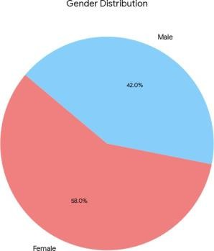

FIGURE 2-SHOWING PERCENTAGE OF PERIODONTITIS

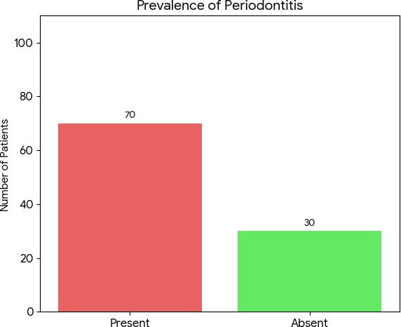

FIGURE 3-SHOWING PERCENTAGE OF GINGIVITIS 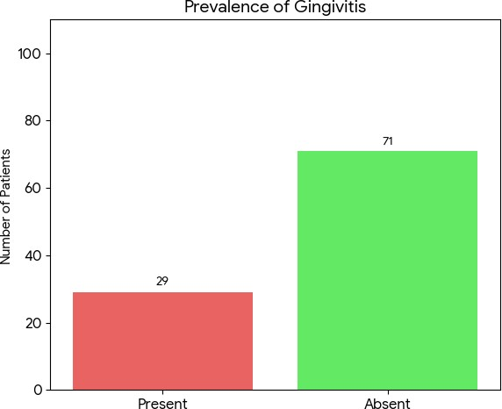

FIGURE 4-SHOWING PERCENTAGE OF GINGIVAL HYPERPLASIA

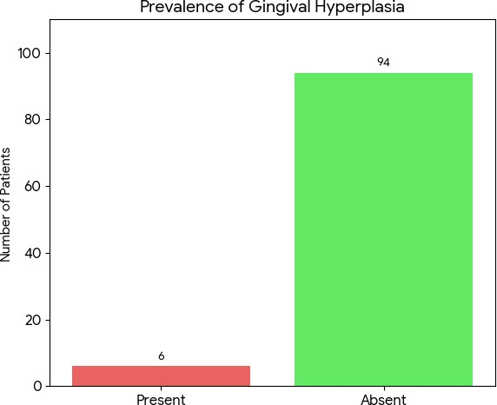

FIGURE5-SHOWING OVERALL CLINICAL FINDINGS

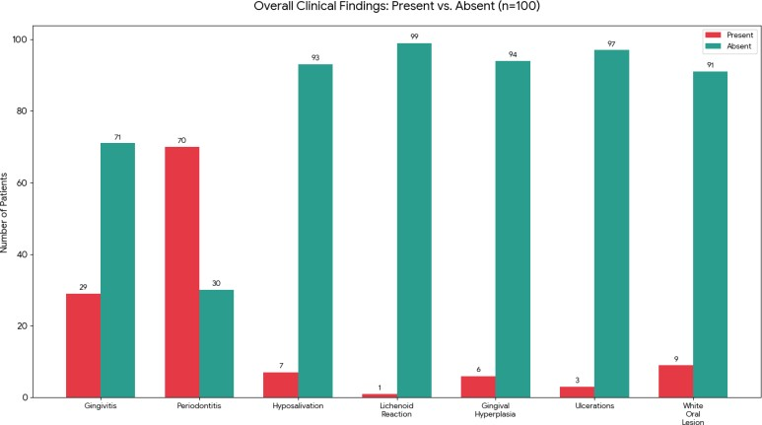

FIGURE 6-SHOWING PERCENTAGE OF WHITE ORAL LESION
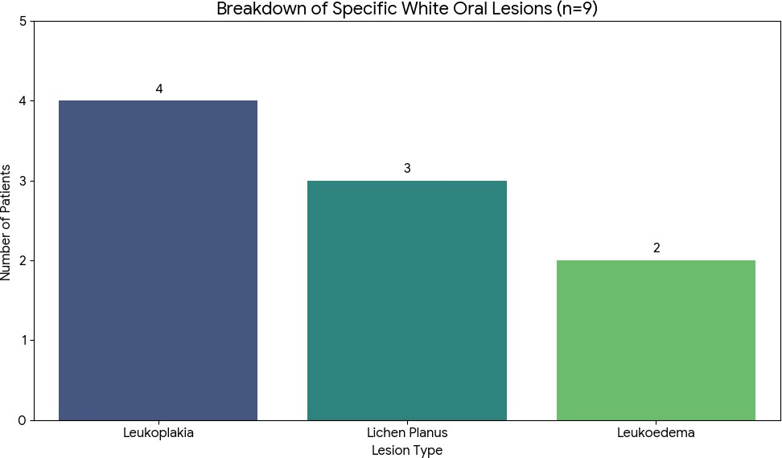

FIGURE 7-SHOWING PERCENTAGE OF HYPOSALIVATION

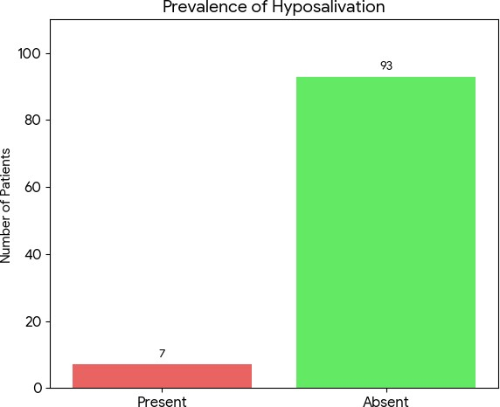

FIGURE 8 -SHOWING GINGIVAL HYPERPLASIA

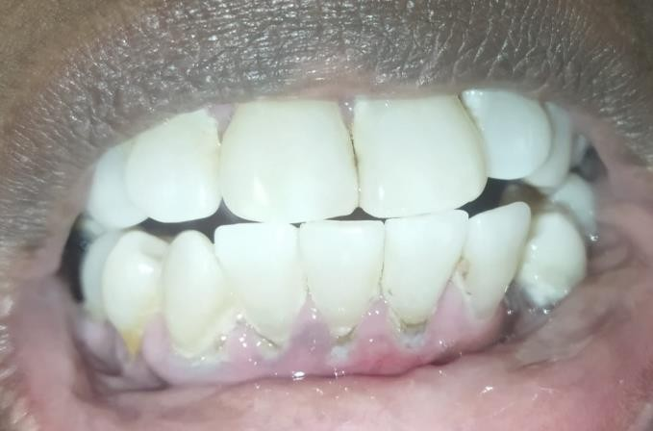

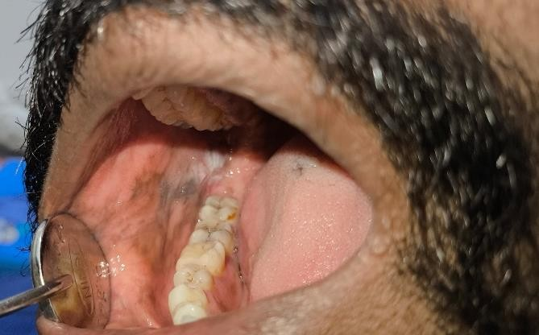

FIGURE 9-SHOWING LICHEN PLANUS

