Original Research Article
A Comparative Evaluation of flexural strength, hardness and fracture toughness of a polymer-infiltrated ceramic and a lithium disilicate glass matrix ceramic – An in vitro study

.
ABSTRACT

Introduction: The study aims to compare the flexural strength, hardness, and fracture toughness of polymer-infiltrated ceramics to lithium disilicate to assess clinical suitability.
The past two decades have witnessed an evolution in the use of all ceramic restorations, opted for by both clinicians as well as patients. The increasing use of dental CAD/CAM systems has ushered in the development of novel CAD/CAM machinable ceramics with superior physical properties needed for permanent dental restorations.
Material and Methods: 20 specimens each of polymer-infiltrated ceramic and lithium disilicate glass matrix ceramic were prepared per ISO standards, on which mechanical and thermal tests were conducted in metallurgical labs.
Result: On testing the specimen, it was observed that IPS e.max CAD had statistically highly significant (p<0.001) greater flexural strength, microhardness and fracture strength as compared to VITA Enamic.
Conclusion: The presence of weaker polymer infiltration in VITA Enamic attributes towards its lower microhardness and flexural strength. It can also be deduced that the infiltration of a polymer phase into the ceramic structure does not improve its mechanical properties when compared to glass-matrix ceramics.

Keywords: Flexural strength, Hardness test, Ceramics

1. INTRODUCTION

The past two decades have witnessed an evolution in the use of all ceramic restorations, opted for by both clinicians as well as patients.¹ High demands for aesthetic dentistry and biocompatible materials have paved the way for the development of newer ceramic materials. Some of the major goals of modern ceramic systems are an improvement of the mechanical properties as well as the manufacturing quality of the ceramic, and one of the ways of making that happen is the use of new technologies such as CAD/CAM (computer-aided design/computer-aided manufacturing).²
Ceramic restorative materials are currently classified into three main groups: glass matrix ceramics, polycrystalline ceramics and resin-matrix ceramics. The glass matrix family is further subdivided into three subgroups: naturally occurring feldspathic ceramics, synthetics ceramics and glass-infiltrated ceramics. Polycrystalline ceramics are subdivided into four subgroups: alumina, stabilized zirconia, zirconia-toughened alumina and alumina-toughened zirconia (currently in development). The third group, resin-matrix ceramics, is divided into several subgroups according to their composition.³
In 1988, lithium disilicate dental ceramics were introduced for use as a heat-pressed core material. The unique microstructure of many minuscule interlocking, randomly oriented plate-like crystals creates a remarkably homogenous material that immensely improves the mechanical properties of this material when compared to feldspathic and leucite reinforced glass matrix ceramics.⁴
A new interpenetrating network material in which a porous ceramic is infiltrated by a polymer was developed in 2013 as VITA Enamic.⁵ Manufactured with a dual network structure, it is composed of a dominant porous ceramic network that is reinforced, via capillary action, with a polymer matrix.⁶
Technique sensitivity, economical aspects and aesthetic appearance are usually the factors taken into account by the dentist for selection of ceramic material. However, these are hardly the factors that have weight in determining the success rate of a ceramic material. Any dental ceramic should be able to withstand the biomechanical forces placed upon them during function or parafunction in the oral environment. A critical evaluation of mechanical properties like flexural strength, hardness and fracture toughness is essential to understand the intraoral performance of the ceramic material. In vitro evaluation of newly introduced resin matrix ceramics and their comparison with glass matrix ceramics, which are already established as having superior mechanical properties, is of utmost importance.

2. material and methods
The study was conducted by preparing the specimens according to the ISO standardization for the study of ceramic materials. The study was carried out in metallurgical laboratories where the mechanical and thermal testing of the materials was done.⁷

Sample Size and Source-
20 specimens of each material were utilized for the study. So, the total sample size required for this study was
20*2=40
List 1 : The distribution of the sample size was as follows

 | VITA Enamic | IPS e.max CAD
12 x 14 x 2 mm | 10 | 10
2 x 4 x 18 mm | 10 | 10
Total | 20 | 20

Materials-
- VITA Enamic multiColor blocks for CEREC/inLab (VITA Zahnfabrik, Bad Säckingen, Germany) (Fig.1)
- IPS e.max CAD blocks for inLab (Ivoclar Vivadent, Schaan, Liechtenstein) (Fig.2)
- Wet Mouth Liquid (ICPA Health Products Ltd.) (Fig.3)

Armamentarium- (Fig.4)
- Steel file
- Diamond file
- Digital Vernier Caliper (Baker ED20)

Equipment-
- OMAX 80X JetMachine (OMAX, Washington, USA) (Fig.5)
- Temperature cycling chamber (Comet Environs) (Fig.6)
- UNITEST-10 Universal Testing Machine (ACME Engineers, India) (Fig.7)
- Vickers Microhardness Tester, Reichert Austria Make, Sr. No. 363798 (Fig.8)
- Vision Inspection System Model No. AVI-IMG-3D (Sipcon Measuring Systems, India) (Fig.9)
Plan of Study-
The VITA Enamic and IPS e.max CAD blocks of size 12 mm x 14 mm x 18 mm were obtained from their respective manufacturers. The ceramic specimens, batch numbers and manufacturers are listed in Table 1. The ceramic materials were used as supplied.
10 samples of each ceramic material were obtained in two different measurement specifications as follows:
- 10 samples of VITA Enamic (2 mm x 4 mm x 18 mm) for flexural strength testing
- 10 samples of IPS e.max CAD (2 mm x 4 mm x 18 mm) for flexural strength testing
- 10 samples of VITA Enamic (2 mm x 12 mm x 14 mm) for hardness and fracture toughness testing
- 10 samples of IPS e.max CAD (2 mm x 12 mm x 14 mm) for hardness and fracture toughness testing
Sample Preparation (Fig. 10):
Ceramic samples measuring 2 mm × 4 mm × 18 mm and 2 mm × 12 mm × 14 mm were sectioned from larger blocks using a waterjet machine (OMAX 80X, USA) at 4572 mm/min. The blocks were secured on a wooden platform in the machine’s catch tank using nails. Required dimensions were programmed into the machine controller, and high-speed water mixed with abrasives cut the ceramics without thermal damage, preserving structural integrity.⁸ Samples were filed with diamond and steel files for uniformity. Dimensions were verified using a digital vernier caliper (Baker E20, min reading 0.01 mm). Samples outside ±0.2 mm tolerance or with chipping were discarded. All samples met ISO standards for material testing.⁷
Thermocycling:
Specimens underwent 500 thermal cycles in a 5°C/55°C bath using Comet Environs chambers. Each cycle involved 30 sec at 5°C, a 5-sec transfer, 10 sec at 55°C, and a 5-sec return. This regimen, based on Gale MS et al., was performed in artificial saliva (Wet Mouth Liquid, ICPA Health Products Ltd.).⁹
Three-Point Bend Test (Fig. 11):
Conducted with a UNITEST-10 universal testing machine (Acme Engineers, India) per ISO 6872:2015, samples (2 mm × 4 mm × 18 mm) were placed on a metal jig with 15 mm support spans.⁷ Dimensions were input into the software, and a central force was applied at 0.5 mm/min until failure. Fracture stress (σf) was calculated using:
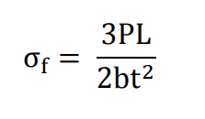
Where P = fracture load (N), L = support span (mm), b = width (mm), and d = thickness (mm).
Hardness Test (Fig. 12)
Microhardness was measured on samples (2 mm × 12 mm × 14 mm) using a Vickers Microhardness Tester (Reichert, Austria) with a 50 g load as per ISO 6507. Diagonals of the indentations were measured under a microscope (AVI-IMG-3D, Sipcon Measuring Systems, India). Microhardness was calculated with:
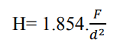
where F = load (g) and d = diagonal length of the indentation.
Fracture Toughness (Fig. 13)
Samples used for hardness testing were also tested for fracture toughness. They were loaded in tension at 0.5 mm/min until crack propagation or failure, with load and displacement monitored. Crack lengths were observed under an optical microscope. Fracture toughness (K_{IC}) was calculated using:
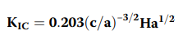
where c = half diagonal of the indentation, a = crack length, and H = Vickers hardness number.
Data Management & Analysis
Test results were classified and coded for analysis. Statistical analysis was performed using SPSS v21. Descriptive statistics (mean, SD) were used for quantitative data. A significance level of α = 0.05 was set, with p ≤ 0.05 considered significant. Data normality was assessed via the Shapiro-Wilk test, and unpaired t-tests compared Groups A and B across study parameters.

3. results and discussion

The data obtained was compiled and subjected to statistical analysis.
The arithmetic mean, standard deviation and standard error were calculated for each group.
On further conducting an unpaired t test for each group, it was observed that IPS e.max CAD had statistically highly significant (p<0.001) greater flexural strength, microhardness and fracture toughness as compared to VITA Enamic.

Table 1: Descriptive statistics like mean, standard deviation and standard error of flexural strength for VITA Enamic and IPS e.max CAD.
(in Mpa) | Mean | SD | SE | Minimum | Maximum
VITA Enamic | 145.91 | 32.3 | 10.21 | 107.13 | 186.49
IPS e.max CAD | 343.78 | 30.96 | 9.79 | 256.75 | 359.87

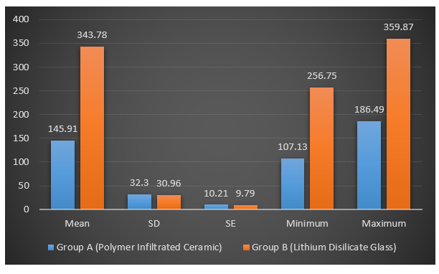

Graph 1: Mean, standard deviation and standard error of flexural strength for VITA Enamic and IPS e.max CAD

In Mpa | Mean | SD | Mean Difference ± SE | Unpaired t test | p value, Significance
Vita Enamic | 145.91 | 32.3 | 197.86 ± 14.15 | t = -13.982 | p<0.001**
IPS e.max CAD | 343.78 | 30.96 | 197.86 ± 14.15 | t = -13.982 | p<0.001**
Table 2: Comparative statistics of flexural strength of VITA Enamic and IPS e.max CAD after unpaired t test

Table 3: Descriptive statistics like mean, standard deviation and standard error of microhardness for VITA Enamic and IPS e.max CAD
In HV | Mean | SD | SE | Minimum | Maximum
VITA Enamic | 7.7 | 1.05 | 0.33 | 6.0 | 9.0
IPS e.max CAD | 22.0 | 5.96 | 1.88 | 15.0 | 32.0

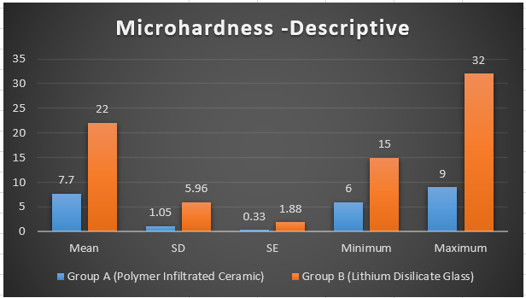

Graph 2: Mean, standard deviation and standard error of microhardness for VITA Enamic and IPS e.max CAD

Table 4: Comparative statistics of microhardness of VITA Enamic and IPS e.max CAD after unpaired t test
 | Mean | SD | Mean Difference ± SE | Unpaired t test | p value, Significance
VITA Enamic | 7.7 | 1.05 | 14.3 ± 1.91 | t =7.467 | p<0.001**
IPS e.max CAD | 22.0 | 5.96 | 14.3 ± 1.91 | t =7.467 | p<0.001**

Table 5: Descriptive statistics like mean, standard deviation and standard error of fracture toughness for VITA Enamic and IPS e.max CAD

 | Mean | SD | SE | Minimum | Maximum
VITA Enamic | 1.34 | 0.37 | 0.11 | 1.01 | 1.89
IPS e.max CAD | 2.32 | 0.03 | 0.01 | 2.27 | 2.37

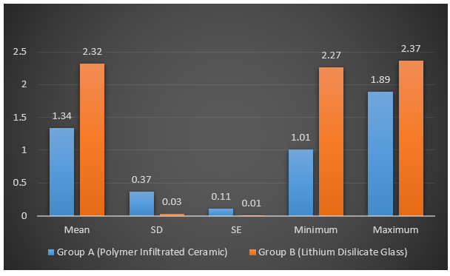

Graph 3: Mean, standard deviation and standard error of fracture toughness for VITA Enamic and IPS e.max CAD

Table 6: Comparative statistics of fracture toughness of VITA Enamic and IPS e.max CAD after unpaired t test
 | Mean | SD | Mean Difference ± SE | Unpaired t test | p value, Significance
VITA Enamic | 1.34 | 0.37 | 0.97 ± 0.11 | t = -8.269 | p<0.001**
IPS e.max CAD | 2.32 | 0.03 | 0.97 ± 0.11 | t = -8.269 | p<0.001**

Discussion:
The rise of in-office milling machines and in-lab digital design has accelerated the development of new dental materials. CAD/CAM technology has improved the fit and precision of crowns and fixed dental prostheses, with newer materials enhancing both efficiency and predictability.¹⁰ As minimally invasive dentistry advances, the mechanical properties of restorative materials are continually tested, expanding options for aesthetic restorations.¹¹ CAD/CAM resin composite blocks have introduced new applications for ceramics, broadening material choices.
CAD/CAM materials are broadly classified into two categories: glass ceramics and resin composites. Glass ceramics consist of a glassy matrix reinforced with ceramic fillers, offering superior mechanical properties due to their crystalline structure. Resin composites, on the other hand, feature a polymeric matrix with ceramic fillers, offering advantages in machinability and mechanical properties akin to enamel and dentin.¹² Their standardized industrial production results in dense, reliable structures.¹³
To verify manufacturers' claims, mechanical testing of dental materials is essential. Tests predict how materials respond intraorally, focusing on their ability to withstand biomechanical forces during function and parafunction.^{14, 15} Mechanical properties are evaluated through in vitro tests, standardized by organizations like the ADA and ISO 6872:2015 for ceramic materials.
Types of In Vitro Tests
In vitro tests fall into two categories:
- Physical Property Measurements: Include flexural strength, microhardness, and fracture toughness tests.
- Simulations of Clinical Behavior: Replicate intraoral conditions, such as thermocycling, to assess material durability under temperature changes.¹⁵
Dental materials face various stresses: tensile (elongation), compressive (shortening), and shear (twisting). Flexural stress, a combination of these forces, is critical in prosthetic applications.¹⁶ The three-point bend test is the ISO standard for measuring flexural strength, involving a supported specimen subjected to a central load.⁷
Hardness indicates resistance to surface indentation and affects finishing, polishing, and wear resistance. The Vickers hardness test, using a diamond indenter, measures surface indentation diagonals to calculate hardness values. High hardness can improve wear resistance but may increase enamel wear in opposing teeth.¹⁷
Fracture toughness measures a material’s ability to resist crack propagation. The indentation fracture technique, using a Vickers indenter, introduces microcracks to assess toughness.¹⁸ This property is crucial for materials exposed to mechanical stresses in the oral environment.
In vitro tests often overlook fatigue effects, which are critical for predicting clinical performance. Thermocycling simulates the temperature fluctuations in the mouth, creating stress at the material interfaces.^{19, 20} Testing in artificial saliva enhances the replication of intraoral conditions.
Study Findings and Material Comparison
In this study, IPS e.max CAD and VITA Enamic were compared:
- Flexural Strength: IPS e.max CAD exhibited a mean strength of 343.78 MPa, significantly higher than VITA Enamic’s 145.91 MPa. This suggests IPS e.max CAD can withstand greater loads before failure.
- Hardness: IPS e.max CAD had a mean Vickers hardness of 22.0 VHN, compared to 7.7 VHN for VITA Enamic. The lower hardness of VITA Enamic may reduce opposing enamel wear.
- Fracture Toughness: IPS e.max CAD showed higher toughness (2.32 MPa√m) than VITA Enamic (1.34 MPa√m), indicating better resistance to crack propagation.
The structural differences explain these results: IPS e.max CAD has interlocked lithium disilicate crystals, providing strength and toughness. VITA Enamic’s dual-network structure, with a porous ceramic framework filled with polymer, enhances flexibility but reduces hardness and toughness.⁴
IPS e.max CAD has a high crystalline content of up to 70 vol% of glassy matrix. Crystallization of the material occurs after heating under a vacuum that results in the development of a highly interlocked microstructure of lithium disilicate crystals.²¹ Tangential compressive stresses develop around the crystals due to thermal expansion mismatch between the crystals and the glass matrix. These stresses are theoretically responsible for the increased fracture toughness due to bridging and crack deflection.²² As opposed to the composition of IPS e.max CAD, VITA Enamic is formed of a dual network structure with a porous sintered ceramic framework; the pores of which are filled with a polymer material via capillary action after application of a coupling agent under high pressure. This high-pressure infiltration generally leads to improved fracture toughness as compared to other ceramic resin composite materials.^{23, 24}
Clinical Implications
While IPS e.max CAD offers superior mechanical properties, VITA Enamic’s lower hardness may protect opposing teeth from wear. Its easier milling and less abrasive nature are advantageous for certain clinical scenarios. However, VITA Enamic is more prone to edge chipping due to its microstructure, while IPS e.max CAD’s higher hardness makes it more susceptible to chipping at stress points.
It can be deduced that in a direct comparison between properties, glass ceramics are superior as compared to ceramic-polymer composite materials. Ease of fabrication and the possibility of an easier and less visible intra-oral repair of minor defects induced by function are the advantages of ceramic-polymer materials.
Limitations of the Study
- Specimen Size: The small size of ceramic blocks limited specimen dimensions, slightly deviating from ISO 6872 standards.
- In Vitro vs. Clinical Conditions: In vitro tests cannot fully replicate the oral environment. Factors like saliva composition, occlusion, and operator technique affect clinical outcomes.
- Lack of Long-Term Clinical Data: Future clinical trials are needed to confirm these findings over extended periods.
Future Directions
Further research should include additional properties like wear resistance, biocompatibility, fatigue testing, and color stability. Long-term clinical studies will help establish the real-world performance of these materials. Combining the strengths of glass ceramics and ceramic-polymer composites could lead to advanced materials with high mechanical tolerance and reduced enamel wear.

4. Conclusion

IPS e.max CAD demonstrated superior flexural strength, hardness, and fracture toughness compared to VITA Enamic. However, VITA Enamic’s lower hardness may benefit opposing enamel, and its easier milling offers practical advantages. Clinicians should consider these properties alongside individual patient needs and clinical situations when selecting materials. Ultimately, in vitro studies, supplemented by clinical trials, are essential for guiding the future of CAD/CAM dental materials.

COMPETING INTERESTS DISCLAIMER:
Authors have declared that they have no known competing financial interests OR non-financial interests OR personal relationships that could have appeared to influence the work reported in this paper.

References

1. Chai J, Takahashi Y, Sulaiman F, Chong K, Lautenschlager EP. Probability of fracture of all-ceramic crowns. Int J Prosthodont. 2000 Sep-Oct;13(5):420-4.
2. Lohbauer U, Petschelt A, Greil P. Lifetime prediction of CAD/CAM dental ceramics. J Biomed Mater Res. 2002;63(6):780-5.
3. Gracis S, Thompson VP, Ferencz JL, Silva NR, Bonfante EA. A new classification system for all-ceramic and ceramic-like restorative materials. Int J Prosthodont. 2015 May-Jun;28(3):227-35.
4. Willard A, Gabriel Chu TM. The science and application of IPS e.max dental ceramic. Kaohsiung J Med Sci. 2018 Apr;34(4):238-242.
5. He LH, Swain M. A novel polymer infiltrated ceramic dental material. Dent Mater. 2011 Jun;27(6):527-34.
6. VITA North America [Internet]. www.vitanorthamerica.com. [cited 2023 Feb 18]. Available from: https://www.vitanorthamerica.com/en-US/Download-centre-275
7. International Organization for Standardization. ISO 6872:2015(E). _ Dentistry — Ceramic materials_. Geneva: ISO; 2015.
8. Belli R, Geinzer E, Muschweck A, Petschelt A, Lohbauer U. Mechanical fatigue degradation of ceramics versus resin composites for dental restorations. Dent Mater. 2014 Apr;30(4):424-32.
9. Gale MS, Darvell BW. Thermal cycling procedures for laboratory testing of dental restorations. J Dent. 1999 Feb;27(2):89-99.
10. Miyazaki T, Hotta Y, Kunii J, Kuriyama S, Tamaki Y. A review of dental CAD/CAM: current status and future perspectives from 20 years of experience. Dent Mater J. 2009 Jan;28(1):44-56.
11. Conrad HJ, Seong WJ, Pesun IJ. Current ceramic materials and systems with clinical recommendations: a systematic review. J Prosthet Dent. 2007 Nov;98(5):389-404.
12. Ruse ND, Sadoun MJ. Resin-composite blocks for dental CAD/CAM applications. J Dent Res. 2014 Dec;93(12):1232-4.
13. Giordano R. Materials for chairside CAD/CAM-produced restorations. J Am Dent Assoc. 2006 Sep;137 Suppl:14S-21S.
14. Guazzato M, Albakry M, Ringer SP, Swain MV. Strength, fracture toughness and microstructure of a selection of all-ceramic materials. Part I. Pressable and alumina glass-infiltrated ceramics. Dent Mater. 2004 Jun;20(5):441-8.
15. Kelly JR, Benetti P, Rungruanganunt P, Bona AD. The slippery slope: critical perspectives on in vitro research methodologies. Dent Mater. 2012 Jan;28(1):41-51.
16. Anusavice KJ, Shen C, Rawls HR. Phillip's science of Dental materials Kenneth. 12th ed. St. Louis, MO: Elsevier; 2012.
17. Sakaguchi RL, Powers JM. Craig's restorative dental materials. 13th ed. St. Louis, MO: Elsevier; 2012.
18. Scherrer SS, Denry IL, Wiskott HW. Comparison of three fracture toughness testing techniques using a dental glass and a dental ceramic. Dent Mater. 1998 Jul;14(4):246-55.
19. Vásquez V, Ozcan M, Nishioka R, Souza R, Mesquita A, Pavanelli C. Mechanical and thermal cycling effects on the flexural strength of glass ceramics fused to titanium. Dent Mater J. 2008 Jan;27(1):7-15.
20. Egilmez F, Ergun G, Cekic-Nagas I, Vallittu PK, Lassila LVJ. Does artificial aging affect mechanical properties of CAD/CAM composite materials. J Prosthodont Res. 2018 Jan;62(1):65-74.
21. Höland W, Apel E, van ‘t Hoen C, Rheinberger V. Studies of crystal phase formations in high-strength lithium disilicate glass–Ceramics. J Non Cryst Solids. 2006 Sep14;352(38-39):4041–50.
22. Guess PC, Schultheis S, Bonfante EA, Coelho PG, Ferencz JL, Silva NR. All-ceramic systems: laboratory and clinical performance. Dent Clin North Am. 2011 Apr;55(2):333-52, ix.
23. Heintze SD, Zimmerli B. Relevance of in vitro tests of adhesive and composite dental materials, a review in 3 parts. Part 1: Approval requirements and standardized testing of composite materials according to ISO specifications. Schweiz Monatsschr Zahnmed. 2011;121(9):804-16. Dutch, English.
24. Della Bona A, Corazza PH, Zhang Y. Characterization of a polymer-infiltrated ceramic-network material. Dent Mater. 2014 May;30(5):564-9.

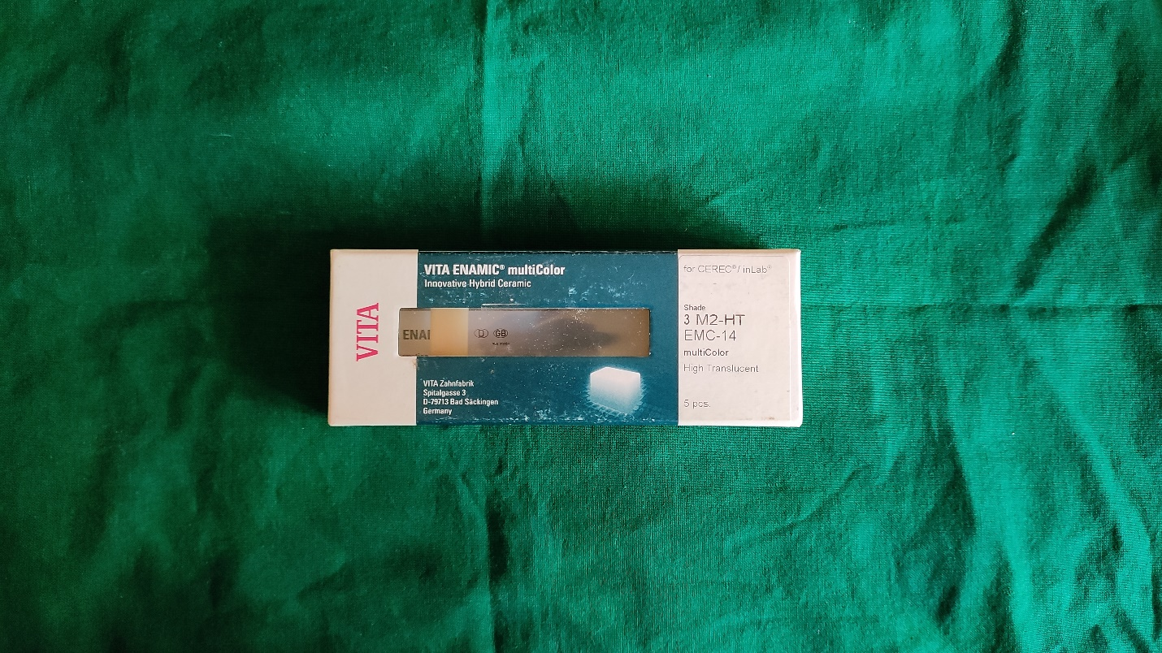

(a)

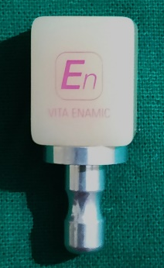

(b)

Fig. 1: VITA Enamic multiColor blocks for CEREC/inLab (VITA Zahnfabrik, Bad Säckingen, Germany)

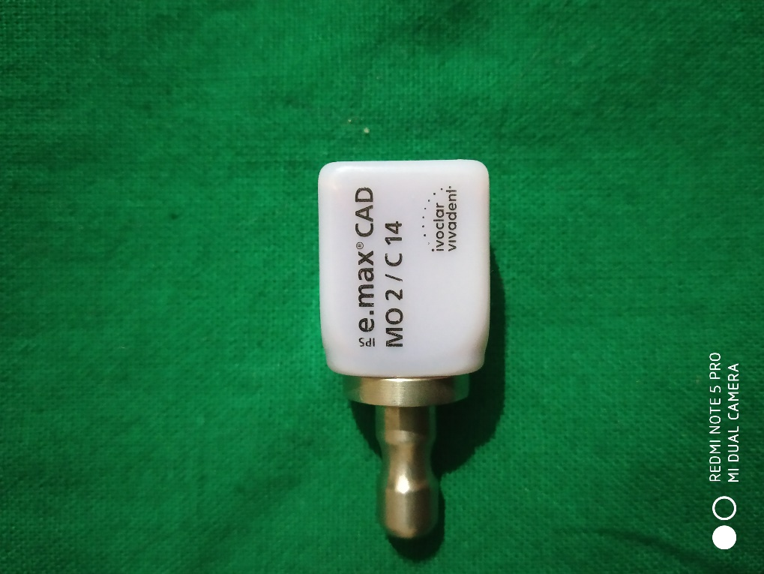
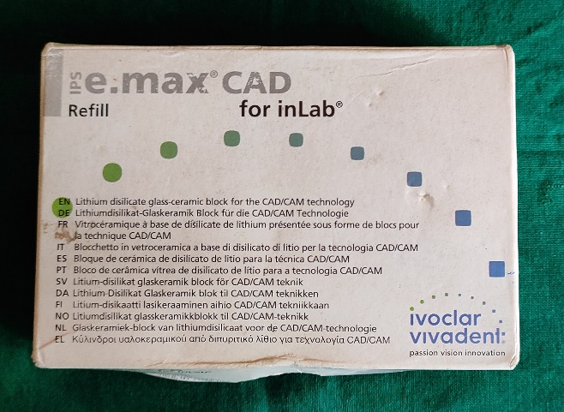

Fig. 2: IPS e.max CAD blocks for inLab (Ivoclar Vivadent, Schaan, Liechtenstein)

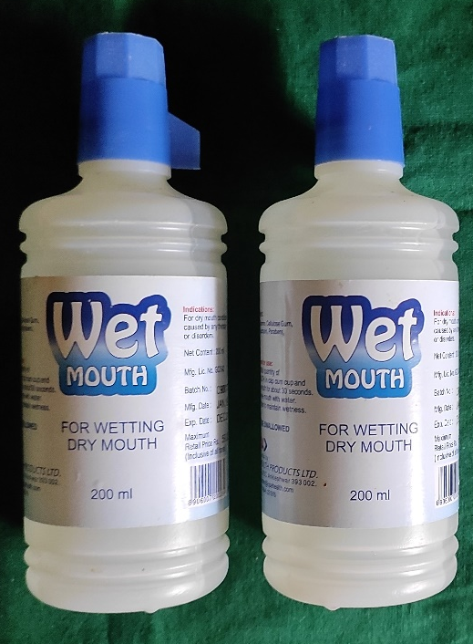

Fig. 3: Wet Mouth Liquid (ICPA Health Products Ltd.)
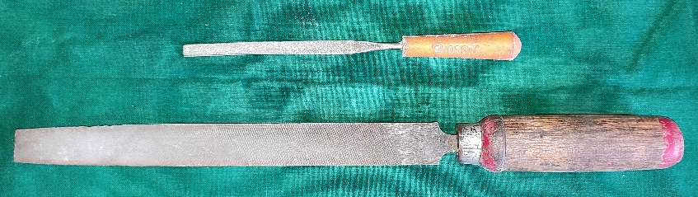

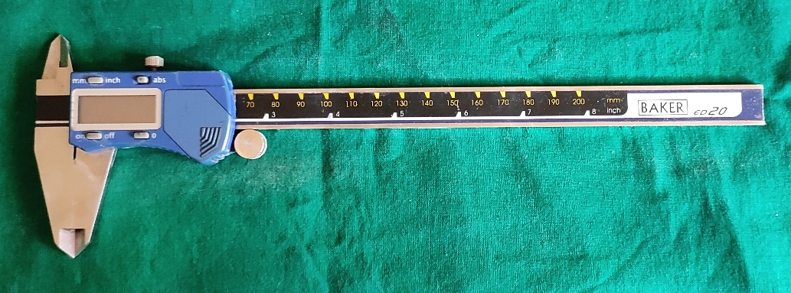

Fig. 4: Armamentarium

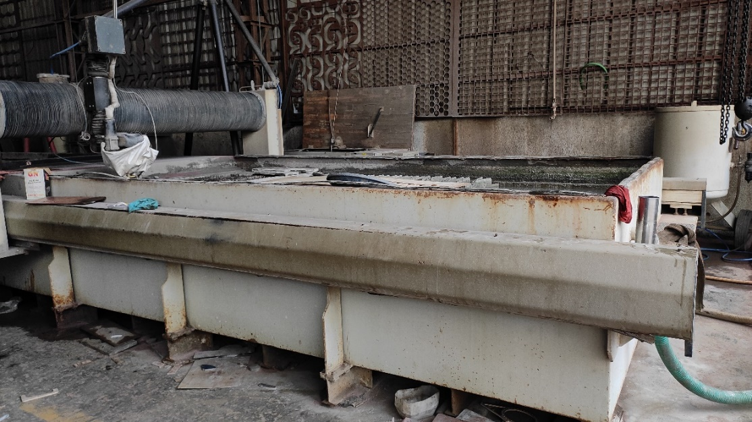

Fig. 5: OMAX 80X JetMachine (OMAX, Washington, USA)

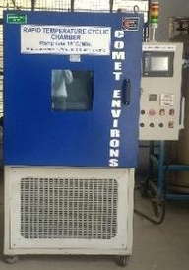

Fig. 6: Temperature cycling chamber (Comet Environs)

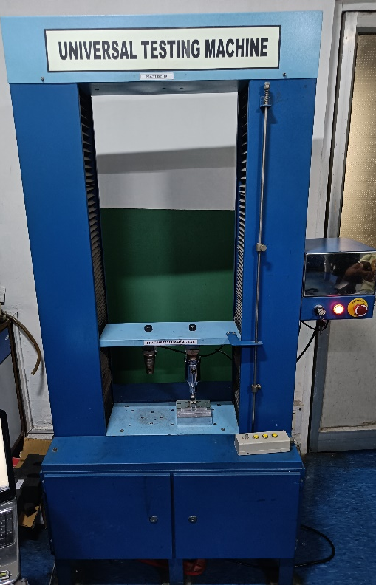

Fig. 7: UNITEST-10 Universal Testing Machine (ACME Engineers, India)

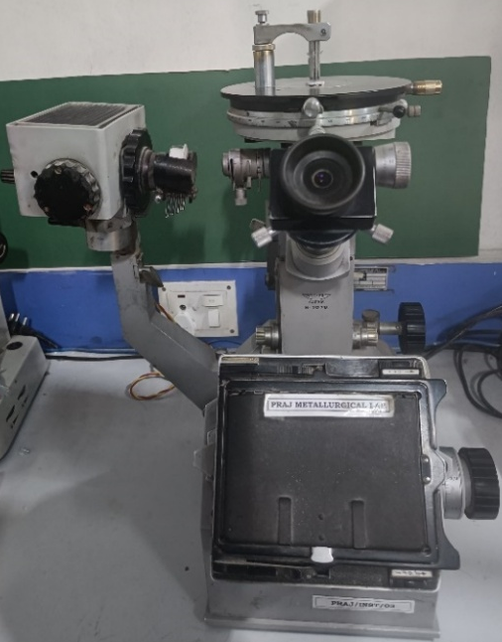

Fig. 8: Vickers Microhardness Tester, Reichert Austria Make, Sr. No. 363798

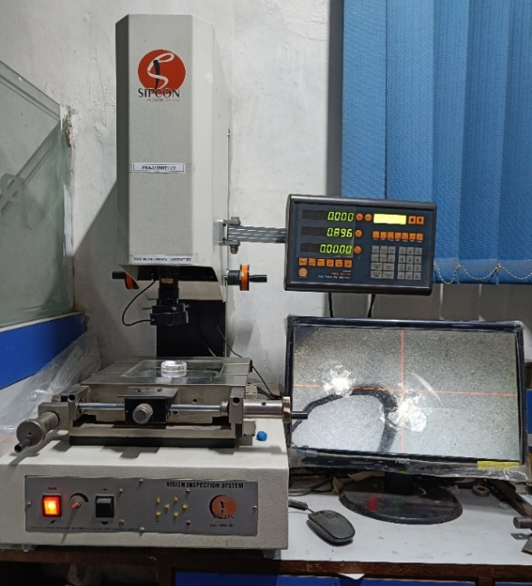

Fig. 9: Vision Inspection System Model No. AVI-IMG-3D (Sipcon Measuring Systems, India)

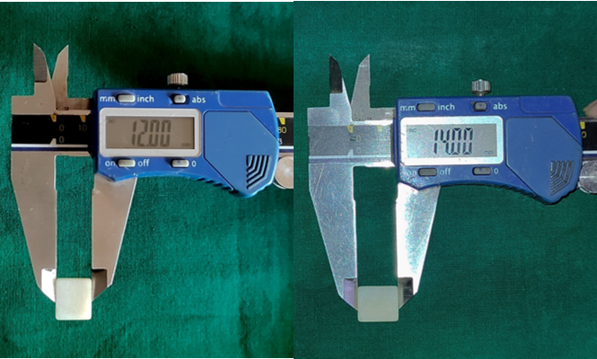
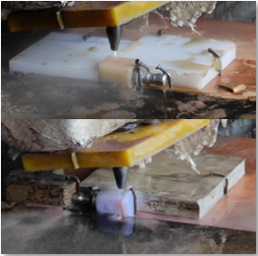

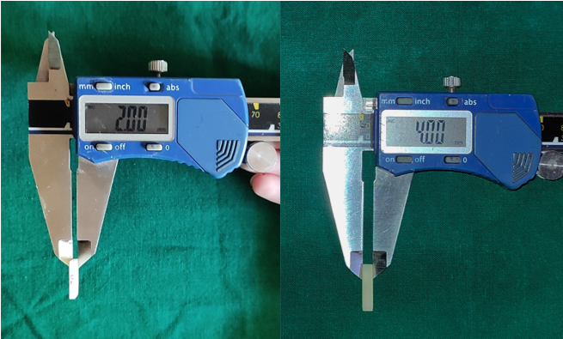

Fig. 10: Sample preparation
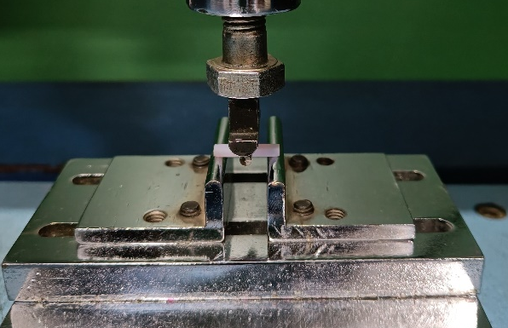

Fig. 11 Three-point bend test on Universal Testing Machine

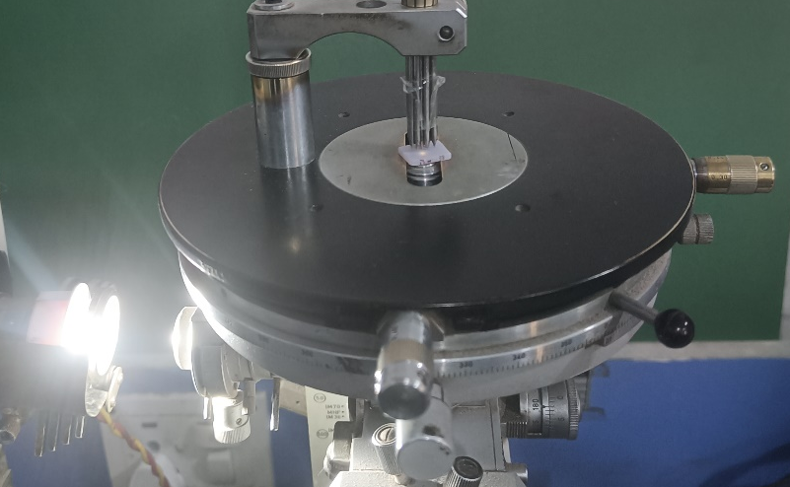

Fig. 12: Hardness test on Vickers Microhardness Tester

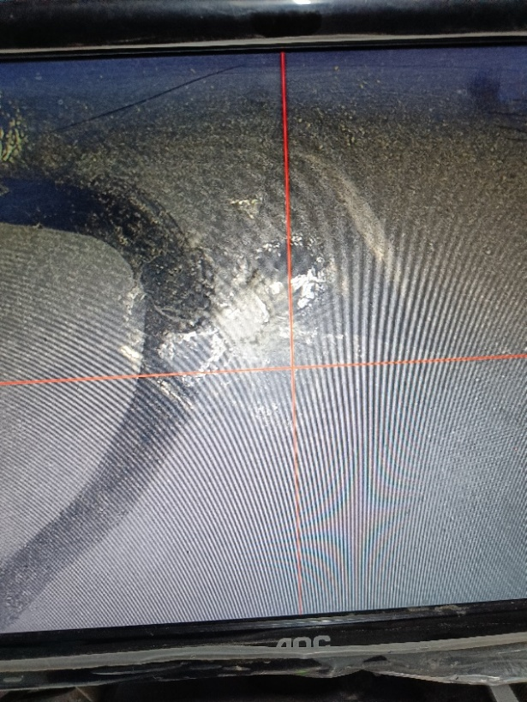

Fig. 13: Crack length evaluation using the Vision Inspection System

