Case report
An Ischemic Stroke Revealing an Aneurysmal Dilation of the Ascending Aorta and Atheromatous Ectasia of the Descending Thoracic Aorta

Abstract
We report the case of an acute embolic-appearing ischemic stroke that led to the diagnosis of a complex aortic pathology combining an ascending aortic aneurysm, defined as a permanent pathological dilation of the proximal aorta conferring a major risk of dissection or rupture, and an atheromatous ectasia of the descending thoracic aorta, characterized by the accumulation of fibrolipidic deposits within the aortic wall and constituting a potential embolic source, as illustrated in the present case. Identification of this atypical emboligenic substrate prompted a multidisciplinary management strategy.
Key words : ischemic stroke, aortic aneurysm, atherosclerosis .

1 — Introduction
Abdominal aortic aneurysm (AAA) is a frequent clinical entity, with an estimated prevalence of 4–7% in men over 65 years of age. Its predominant predisposing factors : smoking, hypertension, male sex, and aging, substantially overlap with those of atherosclerosis (1).
In contrast, aneurysms of the ascending thoracic aorta (ATAA) and descending thoracic aorta (DTAA) constitute distinct pathophysiological entities, differing in their genetic, embryologic, anatomic, histologic, and biochemical characteristics, both in physiological and pathological states.
We herein describe the case of a patient admitted for an acute neurovascular syndrome, in whom further evaluation uncovered an ascending aortic aneurysm associated with an atheromatous plaque within an ectatic descending thoracic aorta.

2 — Case Presentation
A 60-year-old woman without any cardiovascular risk factor, followed for urothelial carcinoma surgically treated four years earlier, was admitted for acute confusion. On examination, consciousness was scored at 14/15, and both hemodynamic and respiratory parameters were stable. Blood pressure was 137/78 mmHg and heart rate 80 beats per minute.
Brain MRI revealed bilateral occipital and left insular cortical signal abnormalities demonstrating diffusion restriction and FLAIR hyperintensity, compatible with acute ischemic infarctions within the superficial territories of the left middle cerebral artery and both posterior cerebral arteries, suggesting a probable embolic origin (Figure 1).
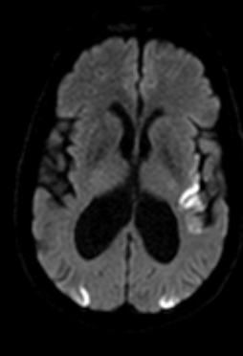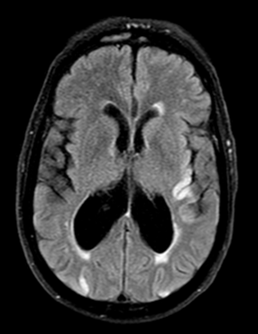
Figure 1 : Axial brain MRI in Diffusion (a) and FLAIR (b) sequences demonstrates bilateral occipital and left insular cortical signal abnormalities with diffusion restriction and corresponding FLAIR hyperintensity, consistent with acute ischemic infarctions involving the superficial territory of the left middle cerebral artery and the posterior cerebral arteries, in keeping with a probable embolic origin.

The electrocardiogram showed left ventricular hypertrophy without repolarization abnormalities. Transthoracic echocardiography demonstrated an aneurysmal dilation of the ascending aorta measuring 51 mm (Figure 2), tricuspid and mild degenerative aortic valve changes resulting in moderate aortic regurgitation, and preserved biventricular function without additional abnormalities.

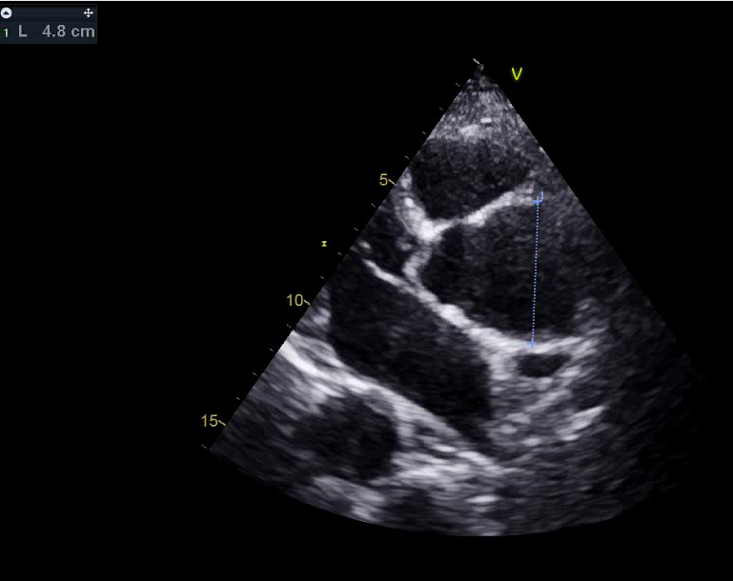
Figure 2 : Transthoracic echocardiography in a parasternal long-axis view demonstrates aneurysmal dilation of the ascending aorta measuring 48 mm.
Contrast-enhanced thoracic CT confirmed a 48 mm ascending aortic aneurysm extending to a 42 mm ectatic descending aorta. The latter harbored a large, irregular-surfaced, hemicircumferential mural thrombus considered potentially emboligenic (Figure 3). Laboratory investigations were unremarkable. Ultrasound of the supra-aortic trunks revealed atherosclerotic changes without significant stenosing plaques.
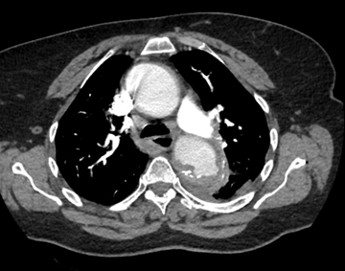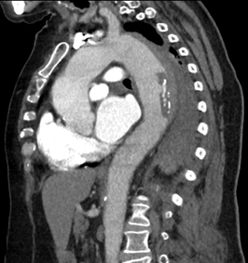
Figure 3 : Contrast-enhanced thoracic CT in axial (a) and sagittal (b) views demonstrates an ascending thoracic aortic aneurysm measuring 48 mm at its maximal diameter, extending into a 42 mm ectatic descending aorta, which harbors a hemicircumferential mural thrombus with an irregular surface, consistent with a potentially emboligenic component.
The patient underwent thrombolysis and was stabilized with beta-blockers and an angiotensin-converting enzyme inhibitor to prevent progression toward aortic dissection. Aspirin, statin therapy, and prophylactic low-molecular-weight heparin were initiated 24 hours after a follow-up CT scan confirmed the absence of hemorrhagic transformation. Close neurological monitoring was maintained, with prevention of aspiration pneumonia and a swallowing assessment prior to initiating oral feeding, alongside strict surveillance of arterial pressure, glycemia, and temperature.
The follow up ulteriorly didn’t show any progression of the aneursmal dilatation of the aorta and conservative approach was choosen.

3 — Discussion
The pathophysiology of AAA is closely linked to atherosclerotic risk factors and plaque development (2,3). In contrast, numerous studies suggest that ascending aortic aneurysms are predominantly of genetic or familial origin (4,5). In patients without identifiable genetic mutations, inflammation or infection constitutes a recognized non-atherosclerotic trigger (6,7).
Emerging evidence supports the concept of the aorta as two distinct functional entities:
(A) the ascending aorta, and
(B) the thoraco-abdominal aorta (descending thoracic and abdominal segments),
separated by the ligamentum arteriosum (8,9).
These differences stem from divergent embryologic origins (10). ATAA displays a pro-aneurysmal yet paradoxically anti-atherosclerotic phenotype, whereas the thoraco-abdominal aorta is particularly susceptible to atherosclerotic aneurysm formation. Vascular smooth muscle cells (VSMCs), the primary cellular component of the aortic media, differ in embryologic origin and migratory pathways depending on the aortic segment (11). In the ascending aorta, they arise from neural crest cells, whereas in the descending thoracic and abdominal aorta they derive from paraxial mesoderm (10).
These distinctions determine divergent molecular and mechanical responses, including impaired cellular differentiation, aberrant extracellular matrix remodeling, and variable susceptibility to inflammatory or mechanical stimuli (12). Thus, the biological mechanisms underlying aneurysm development depend fundamentally on anatomical location, supporting the notion of genetically and physiologically distinct aortic territories.
The present case illustrates the unusual coexistence of an ascending aortic aneurysm and an atheromatous dilation of the descending thoracic aorta, revealed by an acute embolic ischemic stroke.

4 — Conclusion
A refined understanding of the physiopathological disparities between the ascending aorta—relatively protected from atherosclerosis—and the thoraco-abdominal aorta—particularly vulnerable to atheromatous degeneration—is essential for the development of targeted therapeutic strategies.
A deeper comprehension of the segment-specific biological mechanisms governing aortic disease represents a major challenge, with the potential to enable earlier intervention and prevent life-threatening complications.
ETHICAL APPROVAL : As per international standards or university standards written ethical approval has been collected and preserved by the author(s).
CONSENT : As per international standards or university standards, patient(s) written consent has been collected and preserved by the author(s).
COMPETING INTERESTS : Authors have declared that no competing interests exist.

5 — References
- Cornuz J, Sidoti Pinto C, Tevaearai H, Egger M. Risk factors for asymptomatic abdominal aortic aneurysm: systematic review and meta-analysis of population-based screening studies. Eur J Public Health 2004;14(04):343–349
- Zarins, C.K.; Xu, C.; Glagov, S. Atherosclerotic enlargement of the human abdominal aorta. Atherosclerosis 2001, 155, 157–164. [CrossRef]
- Kuhlencordt, P.J.; Gyurko, R.; Han, F.; Scherrer-Crosbie, M.; Aretz, T.H.; Hajjar, R.; Picard, M.H.; Huang, P.L. Accelerated atherosclerosis, aortic aneurysm formation, and ischemic heart disease in apolipoprotein E/endothelial nitric oxide synthase double-knockout mice. Circulation 2001, 104, 448–454. [CrossRef] [PubMed]
- Biddinger, A.; Rocklin, M.; Coselli, J.; Milewicz, D.M. Familial thoracic aortic dilatations and dissections: A case control study. J. Vasc. Surg. 1997, 25, 506–511. [CrossRef]
- Ostberg, N.P.; Zafar, M.A.; Ziganshin, B.A.; Elefteriades, J.A. The Genetics of Thoracic Aortic Aneurysms and Dissection: A Clinical Perspective. Biomolecules 2020, 10, 182. [CrossRef]
- Schmidt, J.; Sunesen, K.; Kornum, J.B.; Duhaut, P.; Thomsen, R.W. Predictors for pathologically confirmed aortitis after resection of the ascending aorta: A 12-year Danish nationwide population-based cross-sectional study. Arthritis Res. Ther. 2011, 13, R87. [CrossRef]
- Elefteriades, J.A.; Ziganshin, B.A.; Halperin, J.L. Diseases of the Aorta. In Fuster and Hurst’s the Heart, 15e; Fuster, V., Narula, J., Vaishnava, P., Leon, M.B., Callans, D.J., Rumsfeld, J., Poppas, A., Eds.; McGraw-Hill Education: New York, NY, USA, 2022.
- Ruddy, J.M.; Jones, J.A.; Spinale, F.G.; Ikonomidis, J.S. Regional heterogeneity within the aorta: Relevance to aneurysm disease. J. Thorac. Cardiovasc. Surg. 2008, 136, 1123–1130. [CrossRef]
- Elefteriades, J.A.; Farkas, E.A. Thoracic aortic aneurysm clinically pertinent controversies and uncertainties. J. Am. Coll. Cardiol. 2010, 55, 841–857. [CrossRef] [PubMed]
- Ruddy, J.M.; Jones, J.A.; Ikonomidis, J.S. Pathophysiology of thoracic aortic aneurysm (TAA): Is it not one uniform aorta? Role of embryologic origin. Prog. Cardiovasc. Dis. 2013, 56, 68–73. [CrossRef] [PubMed]
- Grewal, N.; Gittenberger-de Groot, A.C.; Lindeman, J.H.; Klautz, A.; Driessen, A.; Klautz, R.J.M.; Poelmann, R.E. Normal and abnormal development of the aortic valve and ascending aortic wall: A comprehensive overview of the embryology and pathology of the bicuspid aortic valve. Ann. Cardiothorac. Surg. 2022, 11, 380–388. [CrossRef] [PubMed]
- Halloran, B.G.; Davis, V.A.; McManus, B.M.; Lynch, T.G.; Baxter, B.T. Localization of aortic disease is associated with intrinsic differences in aortic structure. J. Surg. Res. 1995, 59, 17–22. [CrossRef]

