Case report
A STEMI Revealing Aortic Endocarditis Complicated by a Mitro-Aortic Trigone Abscess in a 44-Year-Old Patient

Abstract
We report the case of a 44-year-old man, a chronic smoker with a 28 pack-year history, regular consumer of alcohol, cannabis, and hashish, followed for coronary artery disease with two previous angioplasties, admitted for typical chest pain with ST-segment elevation consistent with an ST-segment elevation myocardial infarction (STEMI). Coronary angiography performed during hospitalization revealed a critical stenosis of the ostium of the proximal left anterior descending artery and of the first marginal artery, severe stenosis of the mid-LAD and distal right coronary artery, and a proximal occlusion of the circumflex artery.
Given the atypical clinical course—persistent inflammatory syndrome, fever, and development of a new murmur—transthoracic and subsequent transesophageal echocardiography were performed. These examinations revealed a heterogeneous, hypoechoic thickening localized at the mitro-aortic trigone consistent with a partially debrided abscess, as well as a mobile structure on the aortic annulus. The findings indicated aortic infective endocarditis complicated by a partially debrided mitro-aortic trigone abscess, occurring in the setting of underlying rheumatic mitral and aortic valve disease, initially unnoticed and revealed through a STEMI presentation.
The patient received full therapy for ischemic heart disease, including dual antiplatelet therapy, anticoagulation, statins, an ACE inhibitor, and a beta-blocker. Surgical revascularization was planned; however, the prognosis suddenly worsened as septic shock and hemodynamic failure developed, leading to the patient’s death.
This case highlights the importance of considering infectious or structural causes in young patients presenting with STEMI and unobstructed coronary arteries, and underscores the critical diagnostic value of transesophageal echocardiography for detecting perivalvular complications.

1. Introduction
Three generations ago, the diagnosis of endocarditis was almost synonymous with fatal prognosis. Over decades of clinical observation, evolving hypotheses—regardless of their initial validity—and numerous studies have progressively refined the definition of infective endocarditis (IE). Reliable therapeutic strategies emerged relatively late with the advent of antibiotics, transforming a nearly always lethal disease into a treatable condition. In parallel, advances in modern cardiac surgery have dramatically improved management and survival prospects (1).
Cardiac abscesses represent a severe complication of infective endocarditis, often indicating delayed diagnosis and significant bacterial virulence, thereby reducing the chances of cure with antibiotics alone. Fortunately, early detection is now facilitated by transesophageal echocardiography (TEE).
Acute ST-segment elevation myocardial infarction (STEMI) and cardiogenic shock are major cardiovascular emergencies associated with high mortality (2). While common causes of STEMI—plaque rupture or erosion, thrombosis—are well established (3), rare cases occur where embolization of valvular vegetations originating from IE precipitates coronary occlusion. IE affects the endocardial surface, predominantly the valves, leading to vegetations that may embolize to the coronary arteries and induce STEMI (4).
We describe here a recent case of STEMI secondary to infective endocarditis, characterized by a mitro-aortic trigone abscess diagnosed in our institution.

2. Case Presentation
A 44-year-old man, chronic smoker (28 pack-years) and regular consumer of alcohol, cannabis, and hashish, with a history of coronary artery disease treated by two angioplasties, presented with sharp chest pain, exertional dyspnea progressing to orthopnea, persistent fever unresponsive to prior antibiotics, and systemic symptoms including asthenia, anorexia, and weight loss. Initial vital signs were stable: blood pressure 110/80 mmHg, heart rate 83 bpm. Cardiac auscultation revealed a loud “rumbling” diastolic murmur at the mitral area (grade 4/6). Abdominal examination was unremarkable. Cutaneous signs included petechiae and an Osler node. The ECG showed circumferential ST-segment elevation without reciprocal changes.
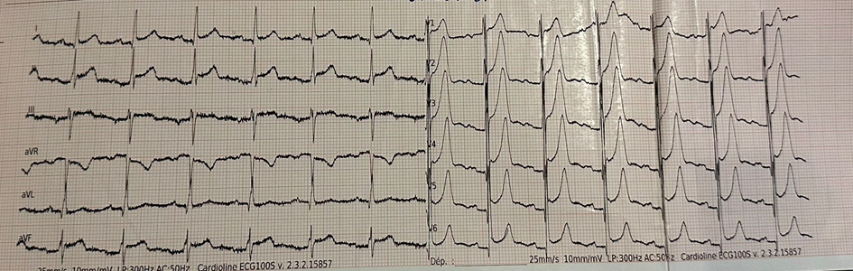
Figure 1: ECG showing circumferential ST-segment elevation corresponding to the ischemic event
Transthoracic Echocardiography
TTE revealed:
- thickened, rigid mitral valve
- severe mitral stenosis (mean gradient 10 mmHg, valve area 1.1 cm², inter-leaflet separation 6 mm)
- calcified and remodeled aortic valve with moderate stenosis (valve area 1.6 cm², mean gradient 17 mmHg, Vmax 2.7 m/s)
- a hyper-echogenic cavity between the aortic annulus and the roof of the left atrium, suggestive of a mitro-aortic trigone abscess
- LV not dilated, moderate concentric LVH, preserved global and segmental kinetics, ejection fraction ≈50%
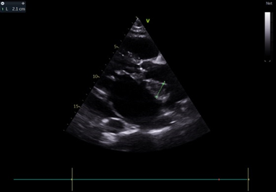
Figure 2: Long-axis view showing mitro-aortic trigone abscess, 21 mm thick
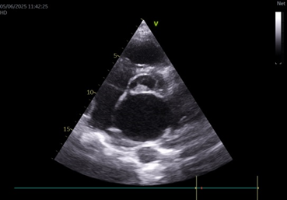
Figure 3: Short-axis view confirming mitro-aortic trigone abscess
Coronary Angiography
Coronary angiography revealed:
- critical stenosis of the ostium of the proximal LAD and first marginal artery
- severe stenosis of the mid-LAD and distal RCA
- proximal occlusion of the circumflex artery
Transesophageal Echocardiography
TEE demonstrated:
- thickened, remodeled mitral valve with severe stenosis, without superimposed vegetation
- thickened tricuspid aortic valve with calcified moderate stenosis
- heterogeneous, hypoechoic thickening at the mitro-aortic trigone consistent with a partially debrided abscess
- a vibratile mass on the aortic annulus
These findings supported a diagnosis of aortic infective endocarditis complicated by a partially debrided mitro-aortic trigone abscess, in the setting of underlying rheumatic mitral and aortic valve disease.
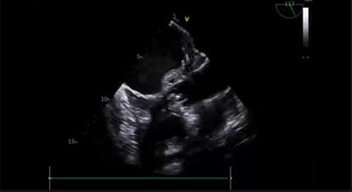
Figure 4: Long-axis mitral–aortic view showing the trigone abscess
Additional Work-up
- Supra-aortic trunk ultrasound: normal
- Brain CT & thoracic angio-CT: no abnormalities
- Thoraco-abdominopelvic CT: no pulmonary septic emboli
Laboratory Findings
- Elevated troponin Ic: 0.38 ng/mL (normal <0.031)
- Normochromic, normocytic, aregenerative anemia (Hb 9 g/dL; reticulocytes 47,400/mm³)
- Marked inflammatory syndrome: leukocytosis 223,150/mm³ (neutrophils 19,400/mm³); CRP 315 mg/L; PCT 2.99 ng/mL
- Blood cultures: Campylobacter fetus ssp. fetus
Clinical Course
The patient received dual antiplatelet therapy, anticoagulation, statins, an ACE inhibitor, and a beta-blocker. Coronary bypass surgery was planned. However, the clinical status deteriorated abruptly, with the onset of septic shock and hemodynamic collapse, leading to death.

3. Discussion
The reported frequency of abscess formation in infective endocarditis ranges from 20–30%, rising to 60% in prosthetic valve endocarditis according to pathological studies (5,6). A male predominance has been documented in large series of abscess-complicated IE (7,8). Clinically, these patients frequently present with advanced heart failure (NYHA III–IV). Abscesses are associated with heart failure in more than 60% of cases, particularly in aortic native valve IE, where diagnosis and surgical intervention are often delayed [5,8,9]. In contrast, abscesses on prosthetic valves—if not accompanied by prosthetic dehiscence—tend to produce less heart failure at diagnosis, which is usually earlier.
Embolic complications occur in nearly one-third of patients, mainly in native valve IE. Larger series confirm this frequency, with neurologic and peripheral emboli occurring in prosthetic valve abscesses as well (7,10). Staphylococci and streptococci are the most commonly isolated pathogens; however, 20–30% of cases yield negative cultures (5,6,11).
TEE remains the gold standard for diagnosing abscesses, with sensitivity >80% and diagnostic accuracy approaching 100%. Limitations arise when lesions are located on the anterior annulus or obscured by calcification or prosthetic materials. Aortic abscesses are typical, representing >80% of cases (12). Extension into the aortic root, fibrous trigone, interventricular septum, or formation of multiple fistulas reflects advanced disease (13).
Coronary embolism is a rare but severe complication of IE, and STEMI due to septic emboli is exceptional (14). When present, the valves most frequently involved are the tricuspid (50%), followed by aortic (20%) and mitral valves (20%) (15) . Embolization risk is influenced by vegetation size and the microbiological pathogen, with Staphylococcus aureus being highly emboligenic (16,17).
Reported cases show varied coronary territories affected (18,19): anterior (20,21), anterolateral (19,22), inferior (19,23,24), lateral (25), as well as multiterritorial infarctions. Currently, no validated therapeutic strategy exists for STEMI caused by IE, as guidelines address each condition separately. Therefore, management must be individualized.

4. Conclusion
Advances in the management of severe infective endocarditis complicated by coronary embolism highlight the cumulative progress of medical knowledge—no single breakthrough has transformed diagnosis or treatment. Despite significant developments in both medical and surgical management, IE remains associated with high morbidity and mortality.
This case underscores the necessity of early diagnosis and the importance of considering structural or infectious causes in young patients presenting with STEMI, as well as the pivotal role of TEE in identifying perivalvular complications
ETHICAL APPROVAL : As per international standards or university standards written ethical approval has been collected and preserved by the author(s).
CONSENT : As per international standards or university standards, patient(s) written consent has been collected and preserved by the author(s).
COMPETING INTERESTS : Authors have declared that no competing interests exist.

5. references
[1] Meine, T. J., Nettles, R. E., Anderson, D. J., Cabell, C. H., Corey, G. R., Sexton, D. J., & Wang, A. (2001). Cardiac conduction abnormalities in endocarditis defined by the Duke criteria. American Heart Journal, 142(2), 280–285. https://doi.org/10.1067/mhj.2001.116964
[2] Samsky, M. D., Morrow, D. A., Proudfoot, A. G., Hochman, J. S., Thiele, H., & Rao, S. V. (2021). Cardiogenic Shock After Acute Myocardial Infarction: A Review. JAMA, 326(18), 1840–1850. https://doi.org/10.1001/jama.2021.18323
[3] Baaten, C. C. F. M. J., Nagy, M., Bergmeier, W., Spronk, H. M. H., & van der Meijden, P. E. J. (2024). Platelet biology and function: plaque erosion vs. rupture. European Heart Journal, 45(1), 18–31. https://doi.org/10.1093/eurheartj/ehad720
[4] Fabri, J. Jr., Issa, V. S., Pomerantzeff, P. M. A., Grinberg, M., Barretto, A. C. P., & Mansur, A. J. (2006). Time-related distribution, risk factors and prognostic influence of embolism in patients with left-sided infective endocarditis. International Journal of Cardiology, 110(3), 334–339. https://doi.org/10.1016/j.ijcard.2005.07.016
[5] Rodrigues Borges, A. G., Suresh, K., Mirza, H., Katz, J. P., Simandl, S. L., Bilfinger, T., & Cohn, P. F. (2002). False aneurysm of the mitral-aortic intervalvular fibrosa after uncomplicated aortic valve replacement. Journal of the American Society of Echocardiography, 15(7), 743–745. https://doi.org/10.1067/mje.2002.118909
[6] Matthews, R. V., French, W. J., & Criley, J. M. (1989). Chest trauma and subvalvular left ventricular aneurysms. Chest, 95(2), 474–476. https://doi.org/10.1378/chest.95.2.474
[7] Economopoulos, G. (2007). Delayed pseudoaneurysm of the mitral-aortic intervalvular fibrosa. Annals of Thoracic Surgery, 83(6), 2233. https://doi.org/10.1016/j.athoracsur.2006.04.091
[8] Afridi, I., Apostolidou, M. A., Saad, R. M., & Zoghbi, W. A. (1995). Pseudoaneurysms of the mitral-aortic intervalvular fibrosa: dynamic characterization using transesophageal echocardiographic and Doppler techniques. Journal of the American College of Cardiology, 25(1), 137–145. https://doi.org/10.1016/0735-1097(94)00326-l
[9] Ghersin, E., Litmanovich, D., Agmon, Y., & Milo, S. (2005). Pseudoaneurysm of the mitral-aortic intervalvular fibrosa following aortic valve replacement – diagnosis and dynamic evaluation with multidetector CT and transesophageal echocardiography. Interactive CardioVascular and Thoracic Surgery, 4(6), 502–504. https://doi.org/10.1510/icvts.2005.112607
[10] Yokoyama, Y., Tamaki, S., Kato, N., Yokote, J., & Mutsuga, M. (2003). Pseudoaneurysm from the mitral-aortic intervalvular fibrosa following endocarditis. Jpn J Thorac Cardiovasc Surg, 51(8), 374–7. https://doi.org/10.1007/BF02719470
[11] Karalis, D. G., Bansal, R. C., Hauck, A. J., Ross, J. J., Applegate, P. M., Jutzy, K. R., Mintz, G. S., & Chandrasekaran, K. (1992). Transesophageal echocardiographic recognition of subaortic complications in aortic valve endocarditis: Clinical and surgical implications. Circulation, 86(2), 353–362. https://doi.org/10.1161/01.cir.86.2.353
[12] Bier, A. J., Lamphere, J. A., & Daily, P. O. (1995). Coronary artery compression caused by a large pseudoaneurysm of the mitral-aortic intervalvular fibrosa. Journal of the American Society of Echocardiography, 8(5 Pt 1), 753–756. https://doi.org/10.1016/s0894-7317(05)80394-3
[13] Koch, R., Kapoor, A., & Spencer, K. T. (2003). Stroke in patient with an intervalvular fibrosa pseudoaneurysm and aortic pseudoaneurysm. Journal of the American Society of Echocardiography, 16(8), 894–896. https://doi.org/10.1067/S0894-7317(03)00408-5
[14] Mylonakis, E., & Calderwood, S. B. (2001). Infective endocarditis in adults. New England Journal of Medicine, 345(18), 1318–1330. https://doi.org/10.1056/NEJMra010082
[15] Ashley, E. A., & Niebauer, J. (2004). Cardiology Explained. Remedica. https://www.ncbi.nlm.nih.gov/books/NBK2204/
[16] Hubert, S., Thuny, F., Resseguier, N., Giorgi, R., Tribouilloy, C., Le Dolley, Y., Casalta, J. P., Riberi, A., Chevalier, F., Rusinaru, D., Malaquin, D., Remadi, J. P., Ben Ammar, A., Avierinos, J. F., Collart, F., Raoult, D., & Habib, G. (2013). Prediction of symptomatic embolism in infective endocarditis: Construction and validation of a risk calculator in a multicenter cohort. Journal of the American College of Cardiology, 62(15), 1384–1392. https://doi.org/10.1016/j.jacc.2013.07.029
[17] Mohananey, D., Mohadjer, A., Pettersson, G., Navia, J., Gordon, S., Shrestha, N., Grimm, R. A., Rodriguez, L. L., Griffin, B. P., & Desai, M. Y. (2018). Association of vegetation size with embolic risk in patients with infective endocarditis: A systematic review and meta-analysis. JAMA Internal Medicine, 178(4), 502–510. https://doi.org/10.1001/jamainternmed.2017.8653
[18] Connolly, D. L., Dardas, P. S., Crowley, J. J., Kenny, A., & Petch, M. C. (1994). Acute coronary embolism complicating aortic valve endocarditis treated with streptokinase and aspirin. A case report. The Journal of Heart Valve Disease, 3(3), 245-246. https://pubmed.ncbi.nlm.nih.gov/8087259/
[19] F. Casazza, F. Faorista, F. Donatelli, and A. Grossi, “Acute myocardial infarction in bacterial endocarditis,” Giornale Ita liano di Cardiologia, vol. 26, no. 2, pp. 207–211, 1996.
[20] Ural, E., Bildirici, U., Kahraman, G., & Komsuoğlu, B. (2007). Coronary embolism complicating aortic valve endocarditis: treatment with successful coronary angioplasty. International Journal of Cardiology, 119(3), 377–379. https://doi.org/10.1016/j.ijcard.2006.07.180
[21] Hibbert, B., Kazmi, M., Veinot, J. P., O'Brien, E. R., & Glover, C. (2012). Infective endocarditis presenting as ST-elevation myocardial infarction: an angiographic diagnosis. Canadian Journal of Cardiology, 28(4), 515.e15–515.e17. https://doi.org/10.1016/j.cjca.2012.01.006
[22] Murtaza, G., Rahman, Z. U., Sitwala, P., Ladia, V., Barad, B., Albalbissi, K., Paul, T. K., & Ramu, V. (2017). Case of Acute ST Segment Elevation Myocardial Infarction in Infective Endocarditismanagement with Intra Coronary Stenting. Clinics and Practice, 7(3), 950. https://doi.org/10.4081/cp.2017.950
[23] Singh, M., Mishra, A., & Kaluski, E. (2015). Acute ST-elevation myocardial infarction due to septic embolism: a case report and review of management options. Catheterization and Cardiovascular Interventions, 85(6), E166–E171. https://doi.org/10.1002/ccd.25829
[24] Jose, J., Narayanan, K., Chacko, S. T., & George, O. K. (2011). Infective endocarditis presenting with ST segment elevation. Journal of Heart Valve Disease, 20(4), 468–470. https://pubmed.ncbi.nlm.nih.gov/21863663/
[25] Roxas, C. J., & Weekes, A. J. (2011). Acute myocardial infarction caused by coronary embolism from infective endocarditis. The Journal of Emergency Medicine, 40(5), 509–514. https://doi.org/10.1016/j.jemermed.2007.12.041

