Case report

BEYOND CHILDHOOD: ADULT ADENOID HYPERTROPHY PRESENTING AS A NASOPHARYNGEAL MASS

Abstract
Adenoid hypertrophy is often seen in children but rarely continues into adulthood due to natural shrinking of adenoid tissue after puberty. When it occurs in adults, it can resemble other issues in the nasopharynx, including cancer. We describe a case of a 51-year-old woman who complained of left-sided nasal obstruction for the past five to six years. Clinical examination showed a deviated nasal septum leaning to the left side and a suspected nasopharyngeal mass. Imaging revealed a soft-tissue lesion in the nasopharyngeal area. Given the potential for a tumor, a biopsy was done. Two small biopsy tissues were sent for further examination. The microscopic review showed respiratory epithelium over dense lymphoid tissue with well-formed lymphoid follicles and prominent germinal centers. No signs of abnormal cell growth, inflammation, or malignancy were found. These findings were consistent with adenoid hypertrophy. This condition in adults is rare and may result from chronic infection, allergies, pollution, or ongoing lymphoid overgrowth. Since nasopharyngeal masses in adults often raise concerns about malignancy, histopathological examination is crucial for diagnosis. This case emphasizes the need to consider adenoid hypertrophy when diagnosing nasopharyngeal masses in adults and highlights the role of histopathology in reaching a final diagnosis.

Introduction
Adenoids, also called nasopharyngeal tonsils, are lymphoid tissues found in the roof and back wall of the nasopharynx, part of Waldeyer's ring¹. They are most prominent during childhood and typically shrink after puberty ². Therefore, adenoid hypertrophy is frequently seen in children and rarely continues in adults.
When adult patients present with nasopharyngeal masses, there is often concern about malignant conditions, such as nasopharyngeal carcinoma or lymphoma³. Ongoing adenoid tissue in adults has been linked to chronic infections, allergies, environmental factors, and smoking⁴. Adenoidectomy with or without tonsillectomy and ventilation-tube insertion is one of the most frequently performed operations.⁵

Presentation of Case
A 51-year-old woman presented with left-sided nasal obstruction for five to six years. The obstruction developed gradually and was ongoing. There was no history of nosebleeds, weight loss, or other systemic symptoms.
Clinical examination revealed a deviated nasal septum toward the left side. Nasal endoscopy indicated a mass in the nasopharyngeal region. The initial clinical diagnosis was left-sided nasal septum deviation with a nasopharyngeal mass being considered.
Imaging showed a soft-tissue lesion in the nasopharynx.
A biopsy was carried out and sent for histopathological examination. The sample included two small biopsy pieces, one measuring 0.5 × 0.5 cm and other measuring 0.3x0.2cm.

Histopathological Findings - The microscopic examination from the biopsy tissue revealed Respiratory epithelium lining. The underlying stroma showed prominent lymphoid tissue with well formed lymphoid follicles and germinal centres which was consistent with lymphoid hyperplasia. There was also seen focal areas of squamous metaplasia.
No evidence of malignancy or granulomatous inflammation was identified. The final diagnosis was suggestive of adenoid hypertrophy.

Discussion
Since adenoid tissue typically experiences physiological involution after adolescence, adenoid hypertrophy is uncommon in adults but common in children². However, a number of studies have shown that adenoid tissue may continue to exist in adults and manifest as symptoms like nasal discharge, snoring, and obstruction⁶. Adenoid hypertrophy in adults is now more easily detected with increased use of nasal endoscopy and imaging methods⁷. The prevalence of adenoid hypertrophy in adults varies among studies. Khan et al. reported that adenoid hypertrophy accounted for approximately 4.31% of adult patients presenting with nasal obstruction, indicating that although uncommon, it remains a clinically significant cause of nasal obstruction¹⁰. Another study by Hamad et al. evaluated 140 adult patients presenting with nasal obstruction and found adenoid hypertrophy in 24 patients (17.14%), suggesting that persistent adenoid tissue can be a significant etiological factor for nasal obstruction in adults⁷. Al-Juboori et al. reported a much lower prevalence of 0.18% among adults with nasal obstruction, highlighting the rarity of this condition in older individuals⁴. The persistence of adenoid tissue in adulthood has been attributed to a number of etiological factors. Environmental pollution, smoking, allergic rhinitis, and chronic infections are all thought to be significant risk factors.⁴. Rout et al. observed that approximately 21% of adult nasal obstruction cases were associated with adenoid hypertrophy, with chronic infection and allergy being the most common contributing factors⁹. Similarly, other studies have suggested that persistent childhood adenoid hypertrophy or chronic inflammatory stimulation may contribute to the enlargement of adenoid tissue in adults².
Due to its potential to resemble malignant nasopharyngeal lesions, adult adenoid hypertrophy is also clinically significant. The differential diagnosis should always take into account conditions like nasopharyngeal carcinoma, lymphoma, or other nasopharyngeal tumors³. Radiological imaging can demonstrate the presence of a nasopharyngeal mass but cannot reliably distinguish between benign and malignant lesions⁸.
Hence, histopathological examination still remains the gold standard for diagnosing the condition. Histologically, adenoid hypertrophy presents as a layer of respiratory epithelium overlying lymphoid tissue with well-formed lymphoid follicles and prominent germinal centres, indicating reactive lymphoid hyperplasia⁹. Similar histopathological findings have been described in previous studies evaluating adult adenoid tissue⁵.
In the current case, the patient has been presenting with long-standing nasal obstruction, and the imaging studies showed evidence of a nasopharyngeal mass. Histopathology revealed evidence of reactive lymphoid hyperplasia, as seen in adenoid hypertrophy. This is in agreement with the findings of other studies that have emphasized the importance of biopsy in adult patients presenting with nasopharyngeal masses in order to exclude malignancy⁷.
Conclusion
While adenoid hypertrophy mainly affects children, it can rarely continue into adulthood and appear as a nasopharyngeal mass. Such instances may mimic malignant lesions both clinically and on imaging. Thus, histopathological examination is vital for accurate diagnosis and for ruling out cancer.

Figures
Figure 1- Nasopharyngeal growth seen on nasal endoscopy.
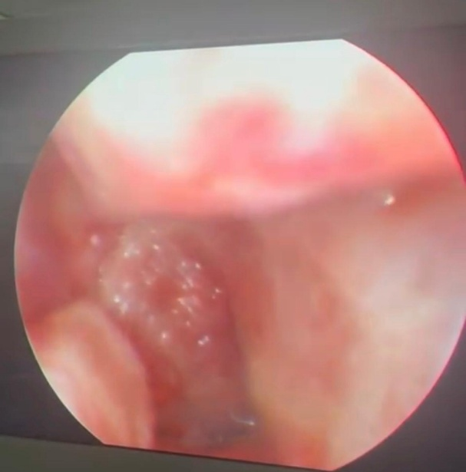

Figure 2: Gross photograph showing two tiny biopsy fragments one measuring approximately 0.5 × 0.5 cm and other measuring 0.2x0.2cm..

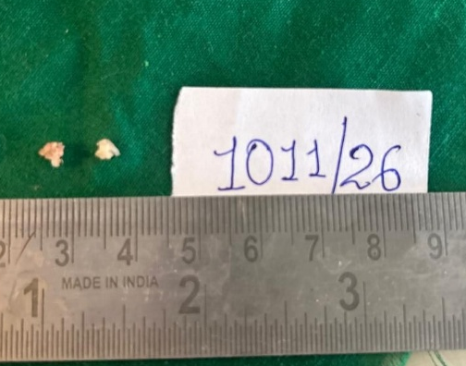

Figure 3: Photomicrograph showing respiratory epithelium over lymphoid tissue with lymphoid follicles (H&E stain, low power).
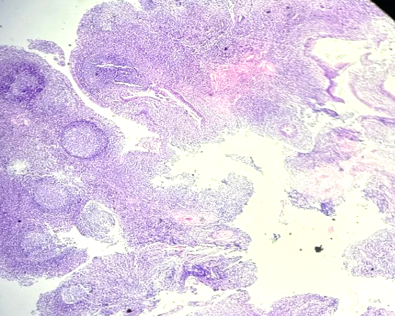

Figure 4: Photomicrograph showing prominent germinal centers consistent with adenoid hypertrophy (H&E stain, high power) and pseudostratified ciliated columnar lining epithelium.

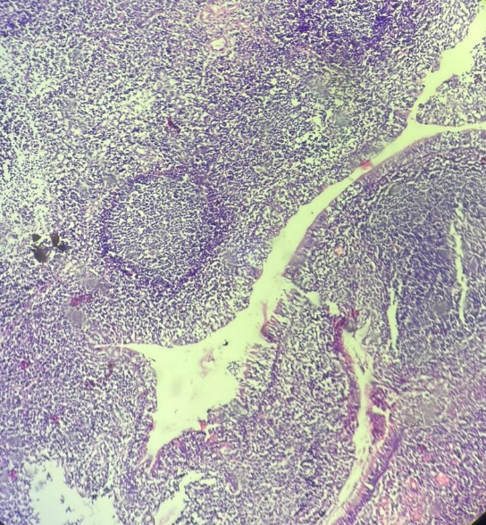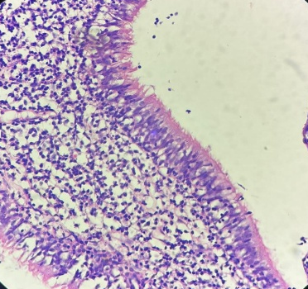

Fig 5- Epithelial lining showing squamous metaplasia at foci
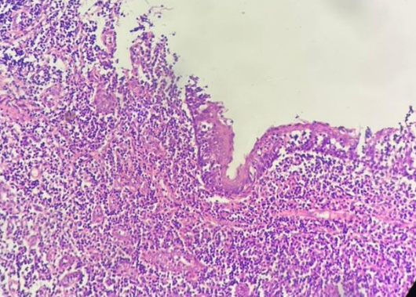

References
- Jeans WD, Fernando DC, Maw AR, Leighton BC. A longitudinal study of the growth of the nasopharynx and its contents in normal children. Br J Radiol. 1981;54:117-121.
- Thimmappa TD, Gangadhara KS. Adenoid hypertrophy in adults. Int J Otorhinolaryngol Head Neck Surg. 2019;5:1354-1357.
- Frenkiel S, Black MJ, Small P. Persistent adenoid presenting as a nasopharyngeal mass. J Otolaryngol. 1980;9(4):357-360.
- Al-Juboori AN, Fadhil A, Sahib N. Adenoid hypertrophy in adult patients and its relation with allergy. European Scientific Journal. 2014;10(12):1857-7881.
- Yildirim N, Şahan M, Karslioğlu Y. Adenoid hypertrophy in adults: clinical and morphological characteristics. Journal of International Medical Research. 2008 Jan;36(1):157-62.
- Avseren E, Bora F, Yucel Z, Oltulu E, Ceylan S. Adenoid hypertrophy in adults. Istanbul Med J. 2010;11(4):168-170.
- Alhamad RM, Jassim AA. Adenoid hypertrophy in adults and nasal obstruction. Al-Kindy College Medical Journal. 2014;10(1):8-10
- Tonpe S, Warbhe H, Banode P, Gandham S, Nagendra V. The diagnostic value of CT scan in identifying adenoid hypertrophy in adults: A case report. Cureus. 2024;16(6):e62793.
- Rout MR, Mohanty D, Vijaylaxmi Y, Bobba K, Metta C. Adenoid hypertrophy in adults: A case series. Indian J Otolaryngol Head Neck Surg. 2013;65(3):269-274.
- Haq AU, Khan NU, Asghar A, Manzoor F, Akhtar M, Pervez S. Adenoid hypertrophy: An unusual cause of nasal obstruction in adults. Pak Armed Forces Med J.

