Case report
Incidental Low-Grade Biliary Intraepithelial Neoplasia Following Laparoscopic Cholecystectomy: A Case Report
Abstract
Biliary intraepithelial neoplasia (BilIN) is a noninvasive precursor lesion which has the potential to progress to cholangiocarcinoma. A 70-year-old hypertensive female, presented with complaints of recurrent abdominal pain associated with flatulence. Abdominal ultrasonography revealed cholelithiasis with no evidence of biliary dilatation or mass lesion. Histopathological examination of the cholecystectomy specimen revealed features consistent with low-grade BilIN.
Keywords
Biliary intraepithelial neoplasia, cholangiocarcinoma, laparoscopic cholecystectomy, precancerous conditions.
Introduction
Biliary intraepithelial neoplasia (BilIN) is a precancerous lesion in the bile duct lining. [1] It represents an early stage in the multistep progression toward cholangiocarcinoma. It is usually an incidental microscopic finding in gallbladder specimens. The lesion is characterized by atypical epithelial cells with multi-layering of the cell nuclei and micropapillary projections as abnormal, non-invasive epithelial cells lining the intrahepatic or extrahepatic bile ducts or gallbladder, forming flat, micropapillary, or pseudopapillary structures. [2] These changes resemble pancreatic intraepithelial neoplasia (PanIN) and occur in conditions like choledochal cysts, primary sclerosing cholangitis, or chronic liver disease. Since the biliary tract and pancreas share a common developmental process as well as morphological characteristics as duct systems, it is plausible that some biliary and pancreatic diseases show similar pathological features and biological behaviors. [3] BilIN is often microscopic and found incidentally in resected specimens, such as during surgery for gallstones or choledochal cysts. Previously BilIN was classified into low (BilIN-1: mild atypia), moderate (BilIN-2), and high grades (BilIN-3: severe atypia, carcinoma in situ with loss of polarity and irregular nuclei). [4] Later world health organization histologically stratified BilIN using a two-tiered classification low-grade (combining former BilIN-1/2, mild-moderate atypia) and high-grade (former BilIN-3, severe atypia with loss of polarity). High-grade lesions carry a significant risk of progressing to invasive adenocarcinoma if untreated. [5] We present a case of BilIN diagnosed on histopathology after an uneventful laparoscopic cholecystectomy.
Case Presentation
A 70-year-old woman with hypertension on regular treatment, presented with complaints of recurrent abdominal pain associated with flatulence. There was no history of jaundice, fever, or weight loss. On evaluation, ultrasonography of the abdomen revealed cholelithiasis with no evidence of biliary dilatation or mass lesion (Figure 1).
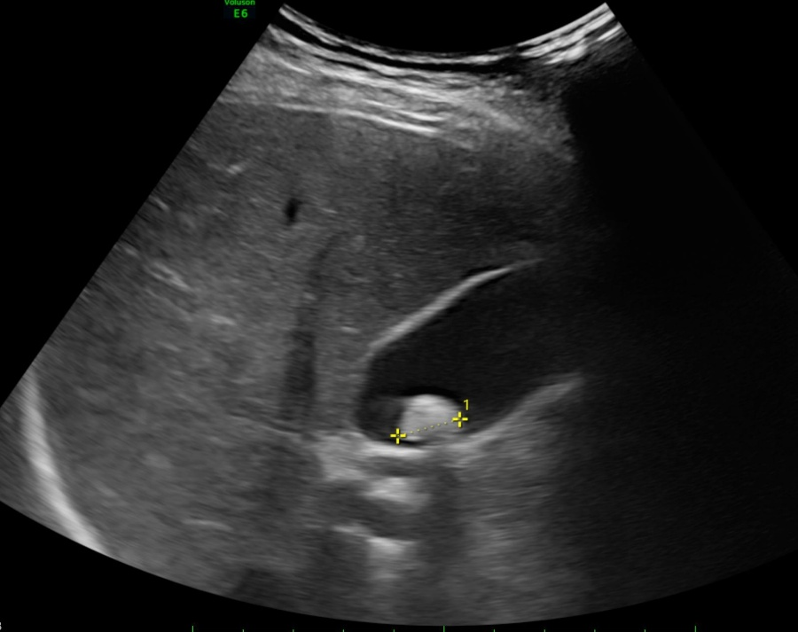
Figure 1: Abdominal ultrasonogram
After preanesthetic evaluation and optimization of comorbidities, she was planned for elective laparoscopic cholecystectomy. The patient underwent laparoscopic cholecystectomy uneventfully under general anesthesia. The intraoperative period was smooth, with no complications (Figure 2). Postoperatively, her recovery was satisfactory. She was discharged on postoperative day 2 in stable condition.
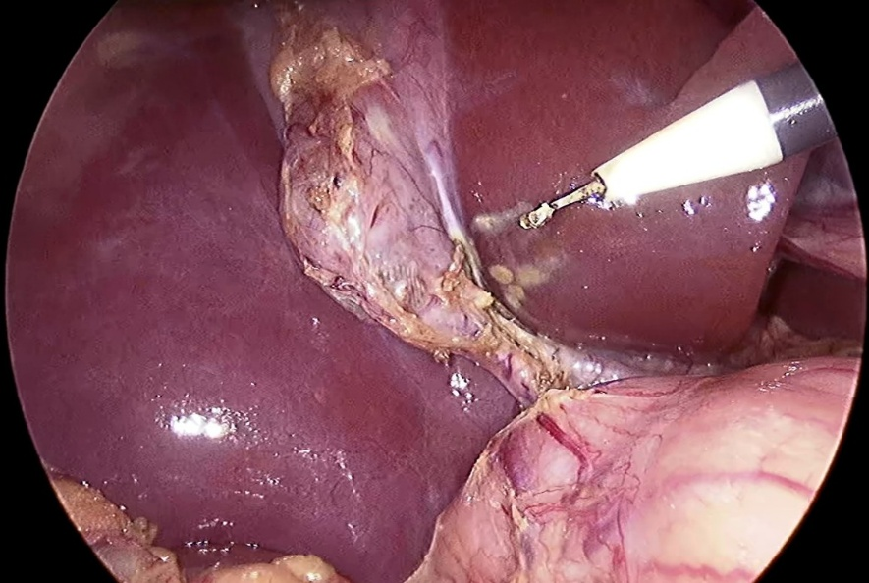
Figure 2: Intra operative findings
Histopathological examination of the gallbladder specimen revealed features consistent with low-grade biliary intraepithelial neoplasia, with no evidence of invasive malignancy (Figure 3). The cystic duct margin was free of dysplasia. No further surgical intervention was considered, as the lesion was confined to the gallbladder mucosa and margins were clear. The patient and attendants were informed about the finding and reassured that the premalignant lesion was already removed with the gallbladder. At 6-month follow-up, no evidence of progression was observed on ultrasonography and liver function tests. The patient gave the informed consent for the publication of the case for academic purposes, provided anonymity is maintained.
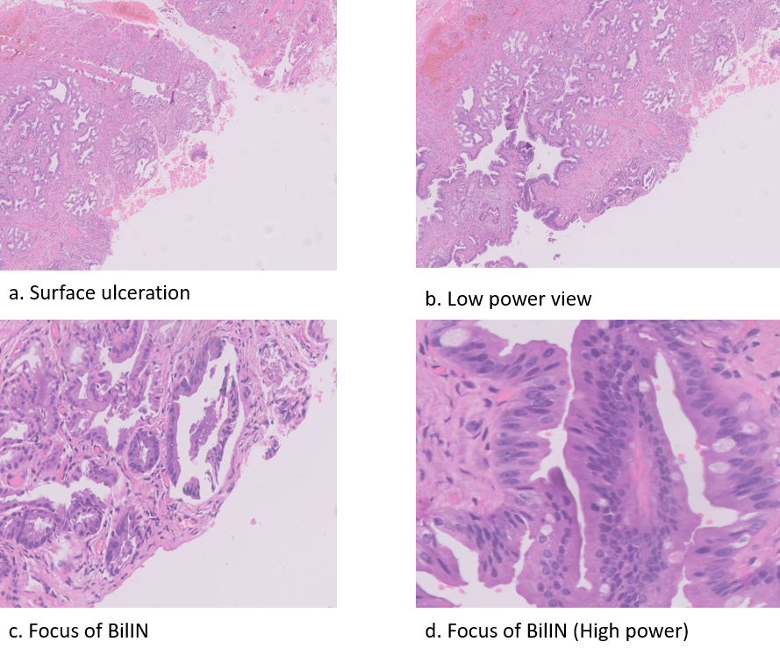
Figure 3: Histopathological findings of gall bladder specimen
Discussion
This case presents a low grade BilIN diagnosed on histopathology of a laparoscopic cholecystectomy specimen. BilIN is a microscopic disease and produces no symptoms in its initial stages, and cannot be detected using routine imaging methods. [6] Its prevalence is not clearly known but high cholelithiasis burden in India increases incidental detection value. [7] BilIN arises from chronic inflammation and genetic alterations in the biliary epithelium. It is commonly associated with conditions that promote ongoing bile duct injury. Chronic biliary diseases like primary sclerosing cholangitis (PSC), choledocholithiasis, and choledochal cysts drive BilIN development through repeated epithelial damage and repair. Other risks include abnormal pancreatobiliary junction, cirrhosis (from hepatitis C or alcohol), and potentially Epstein-Barr virus in some cases. [8]
BilIN reflects multistep cholangiocarcinogenesis, starting with metaplastic changes from inflammation, followed by dysplasia (low-grade to high-grade). Molecular shifts involve genes like KRAS, p53 upregulation in high-grade lesions, and markers such as S100P or MUC5AC, though inflammation may complicate pure genetic progression. [9] Factors beyond inflammation, like hematoma or fibrosis, can occasionally trigger atypical growth. [10] Using the BilIN classification, there is increasing evidence that molecular and genetic alterations accumulate during the progression of BilIN to cholangiocarcinoma.
BilIN is a noninvasive precursor to cholangiocarcinoma (CCA) with variable progression risk based on grade and location. High-grade BilIN (BilIN-3) carries higher malignant potential, while low-grade lesions progress more slowly. Exact progression rates remain unclear due to frequent incidental detection post-resection. [11] No routine oncological follow-up is necessary unless there are other risk factors (e.g., primary sclerosing cholangitis, choledochal cyst, hepatolithiasis). General hepatobiliary health monitoring (liver function tests, ultrasound if clinically indicated) can be advised. No routine CT/MRI or tumor markers are needed unless symptoms develop. [12] Since the present case didn’t show obstructive symptoms, no further investigations were carried out. Computerized tomography (CT) scan and ERCP may be considered when a patient presents with obstructive symptoms.
Conclusions
The case presented with recurrent abdominal pain and was found to be cholelithiasis on ultrasonography. BilIN was diagnosed only after histopathology examination. The cholecystectomy is typically curative for isolated BilIN, as the affected organ has been fully removed. Routine histopathological examination is recommended of cholecystectomy patients to catch precancerous lesions in early stages for better patient management with improved outcomes.

COMPETING INTERESTS DISCLAIMER:
Authors have declared that they have no known competing financial interests OR non-financial interests OR personal relationships that could have appeared to influence the work reported in this paper.

References
- Wang W, Chen W, Li K, Wang J. Successful treatment of biliary intraepithelial neoplasia in the common bile duct via local excision: A case report. Oncology Letters. 2016;11(5):3142-4.
- Zen Y, Adsay NV, Bardadin K, Colombari R, Ferrell L, Haga H, Hong SM, Hytiroglou P, Klöppel G, Lauwers GY, Van Leeuwen DJ. Biliary intraepithelial neoplasia: an international interobserver agreement study and proposal for diagnostic criteria. Modern pathology. 2007;20(6):701-9.
- Zaccari P, Cardinale V, Severi C, Pedica F, Carpino G, Gaudio E, Doglioni C, Petrone MC, Alvaro D, Arcidiacono PG, Capurso G. Common features between neoplastic and preneoplastic lesions of the biliary tract and the pancreas. World Journal of Gastroenterology. 2019;25(31):4343.
- Matthaei H, Lingohr P, Strässer A, Dietrich D, Rostamzadeh B, Glees S, Roering M, Möhring P, Scheerbaum M, Stoffels B, Kalff JC. Biliary intraepithelial neoplasia (BilIN) is frequently found in surgical margins of biliary tract cancer resection specimens but has no clinical implications. Virchows Archiv. 2015;466(2):133-41.
- Nakanuma Y, Sugino T, Okamura Y, Nomura Y, Watanabe H, Terada T, Sato Y. Characterization of high-grade biliary intraepithelial neoplasm of the gallbladder in comparison with intracholecystic papillary neoplasm. Human Pathology. 2021;116:22-30.
- Hucl T. Precursors to cholangiocarcinoma. Gastroenterology Research and Practice. 2019;2019(1):1389289.
- Chaturvedi A, Misra S, Chaudhary S, Gupta S, Prakash P, Kumar V, Akhtar N, Rajan S. Treatment Outcomes of Incidental Gallbladder Cancer–Results from a High-Volume Tertiary Care Centre in North India. Indian Journal of Surgical Oncology. 2024;15(Suppl 2):204-11.
- Bojan A, Pricop C, Ciocoiu M, Vladeanu MC, Bararu Bojan I, Badulescu OV, Badescu MC, Plesoianu CE, Halitchi DI, Foia LG. Environmental and metabolic risk factors linked to gallbladder dysplasia. Metabolites. 2024;14(5):273.
- Jin Y, He X, Wu Y. Gastrointestinal cancer: molecular pathogenesis and targeted therapy. Molecular Biomedicine. 2025;6(1):136.
- Tanabe H, Uehara T, Ota H. Cell lineage-specific immunohistochemical markers in biliary intraepithelial neoplasia: Implications for subclassification and grading. Pathology-Research and Practice. 2025;269:155896.
- Yu YD, Yoon KC, Kang WH, Jo HS, Kim DS, Kim JY. Prevalence and clinical significance of biliary intraepithelial neoplasia (BilIN) in cholangiocarcinoma. Indian Journal of Surgery. 2020;82(3):387-93.
- Yoshida N, Koikawa K, Aoyagi T, Ogata T, Taniguchi M. The existence of biliary intraepithelial neoplasia at resection margin is not a risk factor for recurrence of biliary tract cancer. Formosan Journal of Surgery. 2023;56(6):183-8.

