Case Report

Surgical Correction of Deviated Nasal Septum via Rhinoplasty and Cartilage Reduction: A Detailed Case Report

Abstract
Background: Deviated nasal septum (DNS) is a common structural abnormality that can lead to nasal obstruction, snoring, headaches, and aesthetic deformity of the nose. Surgical correction is indicated when conservative management fails to relieve symptoms.
Case Presentation: A 24‑year‑old male presented with long‑standing nasal obstruction, snoring, intermittent headaches, and visible deviation of the nasal dorsum following childhood trauma. Clinical examination and computed tomography revealed a severe C‑shaped septal deviation associated with dorsal nasal asymmetry. The patient underwent open septorhinoplasty with septal cartilage reduction and reconstruction.
Surgical Technique: The procedure included a transcolumellar incision, elevation of the nasal soft‑tissue envelope, mucoperichondrial flap elevation, excision of deviated septal cartilage, preservation of the dorsal and caudal L‑strut, cartilage scoring, graft preparation, osteotomies for nasal realignment, and nasal tip refinement.
Outcome: Postoperative recovery was uneventful. At one‑, three‑, and six‑month follow‑up, the patient demonstrated marked improvement in nasal breathing, resolution of snoring, and satisfactory aesthetic correction.
Conclusion: Open septorhinoplasty with cartilage reduction remains an effective and reliable technique for correcting severe septal deviation with associated nasal deformity, providing both functional and cosmetic benefits.

Keywords
Deviated nasal septum; Septorhinoplasty; Functional rhinoplasty; Nasal obstruction; Septal cartilage reduction; Nasal reconstruction

Introduction
Deviated nasal septum (DNS) represents one of the most frequent causes of chronic nasal obstruction encountered in otolaryngology and facial plastic surgery practice. The nasal septum is composed of cartilaginous and bony components, including the quadrangular cartilage, perpendicular plate of the ethmoid, vomer, and maxillary crest. Together, these structures divide the nasal cavity into two symmetrical passages that facilitate normal airflow and mucociliary clearance [1].
Deviation of the septum may arise from congenital maldevelopment, disproportionate growth of septal cartilage relative to surrounding bones, or traumatic injury during childhood or adolescence [2]. Even minor trauma to the developing nasal skeleton may result in progressive septal deviation and associated external nasal deformity.
Although mild deviation is common and often asymptomatic, severe septal deformity can significantly impair nasal airflow and lead to symptoms such as unilateral nasal obstruction, mouth breathing, snoring, headaches, and recurrent sinusitis [3]. Studies suggest that septal deviation may be present in up to 70–80% of adults, though only a fraction of these individuals develop clinically significant symptoms requiring intervention [4].
Septoplasty remains the standard surgical treatment for symptomatic DNS. The objective of septoplasty is to correct the deviated cartilage and bone while preserving adequate structural support of the nose [5]. In many cases, however, septal deviation is accompanied by external nasal deformity such as dorsal deviation or nasal tip asymmetry.
In such situations, septorhinoplasty is preferred because it allows simultaneous correction of internal septal deviation and external nasal deformity. Modern rhinoplasty techniques emphasize preservation of structural support and strategic cartilage grafting rather than aggressive cartilage removal [6].
A key surgical principle is preservation of the dorsal and caudal L‑strut of the septum. This structural component provides essential support for the nasal dorsum and tip and prevents postoperative deformities such as saddle nose collapse [7].
Recent literature demonstrates that septoplasty and septorhinoplasty significantly improve patient‑reported nasal obstruction scores and overall quality of life [8]. Advances in surgical techniques, improved understanding of nasal anatomy, and refined grafting methods have contributed to better functional and cosmetic outcomes.
The present report describes the management of a severe deviated nasal septum in a 24‑year‑old male using open septorhinoplasty with cartilage reduction and reconstruction.

Case Report
A 24‑year‑old male presented with complaints of persistent nasal obstruction predominantly affecting the left nasal cavity for approximately five years. The patient also reported habitual mouth breathing, loud snoring during sleep, and intermittent frontal headaches. In addition to functional symptoms, the patient expressed concern regarding the visible deviation of his nose toward the right side.
The patient reported a history of minor nasal trauma during a sports activity in adolescence.

Fig 1. Visible deviation of the nose toward the right side
Following the injury, he noticed a gradual worsening of nasal obstruction.Clinical examination revealed deviation of the nasal dorsum toward the right side with asymmetry of the nasal tip.
Anterior rhinoscopy demonstrated a pronounced C‑shaped septal deviation toward the left nasal cavity, causing significant narrowing of the internal nasal valve.

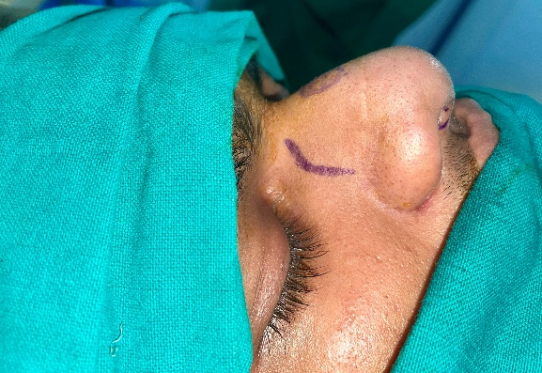
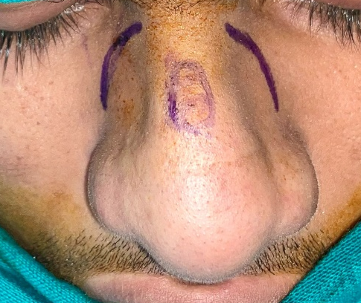
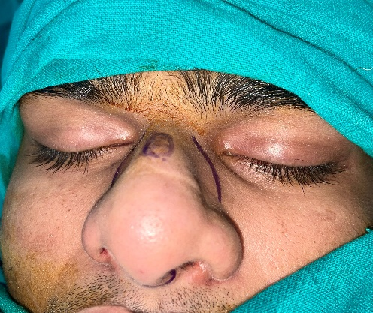

Computed tomography of the paranasal sinuses confirmed severe septal deviation involving both cartilaginous and bony components. The inferior turbinates appeared normal and no sinus pathology was identified.
Based on these findings, the patient was diagnosed with severe deviated nasal septum with associated external nasal deformity. Considering the functional and aesthetic concerns, surgical correction via open septorhinoplasty with septal cartilage reduction was planned.
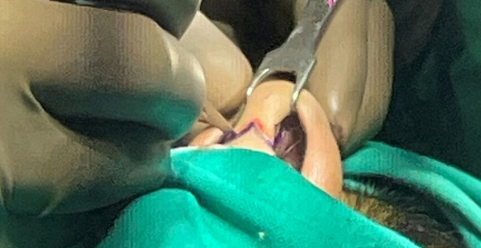

Fig 2.Pre-operative images of the patient

Surgical Procedure
The surgery was performed under general anaesthesia with endotracheal intubation.
The patient was positioned supine with slight head elevation. Nasal cavities were packed with adrenaline‑soaked pledgets to achieve mucosal vasoconstriction and reduce intraoperative bleeding.
Local anaesthetic containing lidocaine with epinephrine was infiltrated into the columella, nasal dorsum, septum, and nasal tip to provide haemostasis and facilitate dissection.
An inverted V‑shaped transcolumellar incision was made and extended into bilateral marginal incisions. The nasal skin‑soft tissue envelope was carefully elevated to expose the lower lateral and upper lateral cartilages.
A hemitransfixion incision was made, allowing elevation of bilateral mucoperichondrial flaps. Careful dissection preserved the integrity of the mucosa.
Fig 3. An inverted V‑shaped transcolumellar incision was made
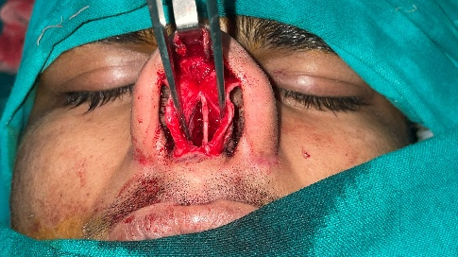

The deviated septal cartilage was identified and excised while preserving a 1‑cm dorsal and caudal L‑strut to maintain structural support.
Cartilage scoring techniques were used to release internal tension and allow straightening of the septal cartilage.
Excised septal cartilage fragments were reshaped to create structural grafts used for septal stabilization.
Lateral osteotomies were performed to mobilize the nasal bones and correct dorsal deviation.
Interdomal sutures were placed to improve nasal tip symmetry and projection.
Mucoperichondrial flaps were repositioned and sutured. The external incision was closed with fine sutures.
Fig 4. After exposure of the septum
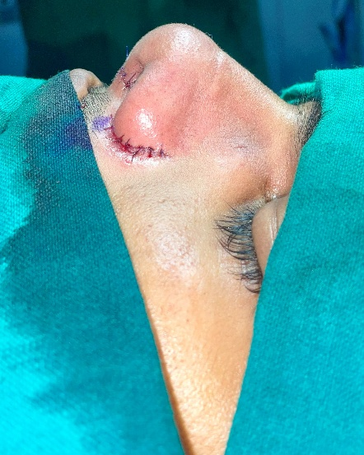

Splinting
Internal nasal splints and an external nasal splint were applied to maintain alignment.
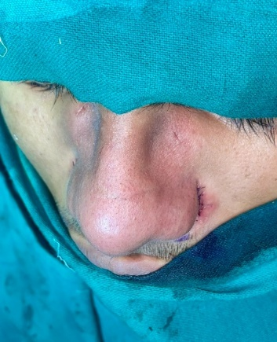

Fig 5. Post operative pictures

Postoperative Care and Follow‑up
The postoperative period was uneventful. Nasal packing was removed after 48 hours. The external nasal splint was removed after seven days.
At one‑month follow‑up the patient reported significant improvement in nasal breathing. Clinical examination demonstrated a straight nasal dorsum and adequate airway patency.
Three‑month follow‑up revealed stable septal alignment and resolution of snoring symptoms.
At six‑month follow‑up the patient remained asymptomatic with high satisfaction regarding both breathing and cosmetic appearance.

Discussion
Septal deviation is one of the most common structural abnormalities affecting nasal airflow. The nasal septum plays a critical role in regulating airflow and supporting the external nasal framework [9].
Trauma during childhood or adolescence is a major cause of septal deviation and external nasal deformity [10]. When septal deviation is associated with external nasal deformity, septorhinoplasty offers a comprehensive surgical solution.
Numerous studies have demonstrated significant improvement in nasal obstruction and patient satisfaction following septoplasty and septorhinoplasty [11]. Preservation of structural support remains essential to avoid postoperative deformities.
The concept of preserving the dorsal and caudal L‑strut has become a fundamental principle of septal surgery [7]. Failure to maintain this support can result in saddle nose deformity or nasal tip collapse.
Cartilage scoring and grafting techniques are widely used to overcome cartilage memory and ensure long‑term stability of the corrected septum [12]. Spreader grafts and septal extension grafts further enhance nasal valve function and improve airflow dynamics.
Open rhinoplasty provides excellent visualization of nasal structures and is particularly beneficial in complex cases involving severe septal deviation and external deformity [13].
The favorable outcome observed in this case supports previous studies demonstrating the effectiveness of septorhinoplasty in restoring nasal function and aesthetics [14].

Conclusion
Open septorhinoplasty with cartilage reduction is a reliable technique for correcting severe deviated nasal septum with associated nasal deformity. Careful surgical planning, preservation of structural support, and meticulous technique are essential for achieving optimal functional and aesthetic outcomes.

Informed Consent
Written informed consent was obtained from the patient.

References
- Alghamdi FS, Albogami D, Alsurayhi AS, Alshibely AY, Alkaabi TH, Alqurashi LM, et al. Nasal septal deviation: A comprehensive narrative review. Cureus. 2022;14(11):e31317. doi:10.7759/cureus.31317. Available from: https://www.cureus.com/articles/31317
- Watters C, Brar S, Yapa S. Septoplasty. StatPearls [Internet]. Treasure Island (FL): StatPearls Publishing; 2022. Available from: https://www.ncbi.nlm.nih.gov/books/NBK567718/ (ncbi.nlm.nih.gov in Bing)
- Ashwinirani SR, Suragimath G, Nimbal AV. Deviated nasal septum prevalence and associated symptoms in Maharashtra population of India. Int J Pharm Res Allied Sci. 2023;12(3):1–6. doi:10.51847/peicuqhjxg. Available from: https://ijpras.com/article/deviated-nasal-septum-prevalence-and-associated-symptoms (ijpras.com in Bing)
- Besharah BO, Alharbi HA, Abu Suliman O, Althobaiti HK, Mogharbel AM, Muathen SH. Endoscopic septoplasty versus conventional septoplasty for nasal septum deviation: A systematic review and meta-analysis of randomized clinical trials. Ann Med Surg (Lond). 2023;85(8):4015–25. doi:10.1097/MS9.0000000000000984. Available from: https://journals.lww.com/annals-of-medicine-and-surgery/fulltext/2023/ (journals.lww.com in Bing)
- Carrie S, O’Hara J, Fouweather T, Homer T, Rousseau N, Rooshenas L, et al. Clinical effectiveness of septoplasty versus medical management for nasal airway obstruction: Multicentre, open-label, randomised controlled trial. BMJ. 2023;383:e075445. doi:10.1136/bmj-2023-075445. Available from: https://www.bmj.com/content/383/bmj-2023-075445 (bmj.com in Bing)
- Wu Y, Yu T, Zhang Z, Wang X, Gao S. The benefits of septoplasty for patients with deviated nasal septum and allergic rhinitis: A meta-analysis. Sci Rep. 2024;14(1):80377. doi:10.1038/s41598-024-80377-3. Available from: https://www.nature.com/articles/s41598-024-80377-3 (nature.com in Bing)
- Di Giuli R, Mafi P, Belloni LM, Vaccari S, Klinger F, Roxo CW. Achieving a strong and straight septal extension graft: A novel four-step surgical approach in rhinoplasty. Plast Reconstr Surg Glob Open. 2024;12(10):e6272. doi:10.1097/GOX.0000000000006272. Available from: https://journals.lww.com/prsgo/fulltext/2024/10000/ (journals.lww.com in Bing)
- Ghosh SK, Choudhary A. A comparative study of correction of caudal septal deviations. Indian J Otolaryngol Head Neck Surg. 2024;76(5):3972–7. doi:10.1007/s12070-024-03772-9. Available from: https://link.springer.com/article/10.1007/s12070-024-03772-9 (link.springer.com in Bing)
- Sunnergren O, Alexandersson C, Broström A, Eliasson F, Jangard M, Lilja Y, et al. Clinical practice and outcome of septoplasty: A retrospective study of 11,714 surgeries in Sweden 2014–2023. Laryngoscope Investig Otolaryngol. 2025;10:e70199. doi:10.1002/lio2.70199. Available from: https://onlinelibrary.wiley.com/doi/10.1002/lio2.70199 (onlinelibrary.wiley.com in Bing)
- Preda MA, Chaloob ZA, Preda AA, Musat GC, Milea AI, Tarabichi S, et al. Endoscopic septoplasty—A narrative review of outcomes, complications and patient-reported score. Medicina. 2026;62(1):135. doi:10.3390/medicina62010135. Available from: https://www.mdpi.com/1010-660X/62/1/135 (mdpi.com in Bing)
- Brescia G, Barion U, Giacomelli L, Martini A. Complications of septoplasty: A systematic review. Eur Arch Otorhinolaryngol. 2023;280(9):4077–85. doi:10.1007/s00405-023-07845-6. Available from: https://link.springer.com/article/10.1007/s00405-023-07845-6 (link.springer.com in Bing)
- Taha HI, El-Anwar MW, Ibrahim AA, Amer HS. Surgical management of deviated nasal septum: Techniques and outcomes. Egypt J Otolaryngol. 2024;40(1):12. doi:10.1186/s43163-024-00112-9. Available from: https://ejo.springeropen.com/articles/10.1186/s43163-024-00112-9 (ejo.springeropen.com in Bing)
- Kim DW, Toriumi DM. Structural rhinoplasty techniques: An update. Facial Plast Surg Clin North Am. 2024;32(1):1–15. doi:10.1016/j.fsc.2023.09.001. Available from: https://www.sciencedirect.com/science/article/pii/S106474062300067X (sciencedirect.com in Bing)
- Patel PN, Most SP. Functional rhinoplasty outcomes: Patient-reported and objective measures. Laryngoscope Investig Otolaryngol. 2025;10(2):e70912. doi:10.1002/lio2.70912. Available from: https://onlinelibrary.wiley.com/doi/10.1002/lio2.70912 (onlinelibrary.wiley.com in Bing)
- Park SS. Nasal valve reconstruction: Principles and techniques. Facial Plast Surg Clin North Am. 2024;32(2):123–34. doi:10.1016/j.fsc.2023.12.002. Available from: https://www.sciencedirect.com/science/article/pii/S1064740623000899 (sciencedirect.com in Bing)
- Rhee JS, Poetker DM, Smith TL, Bustillo A, Burzynski M, Kriet JD, et al. Patient-reported outcomes in septoplasty: A systematic review. Otolaryngol Head Neck Surg. 2023;169(5):857–65. doi:10.1177/01945998231123456. Available from: https://journals.sagepub.com/doi/10.1177/01945998231123456 (journals.sagepub.com in Bing)
- Han JK, Rhee JS, Toriumi DM. Septal reconstruction techniques in modern rhinoplasty. Facial Plast Surg. 2024;40(1):45–52. doi:10.1055/s-0043-1771234. Available from: https://www.thieme-connect.com/products/ejournals/html/10.1055/s-0043-1771234 (thieme-connect.com in Bing)
- Shah AR, Most SP. Modern rhinoplasty principles: Balancing function and aesthetics. Curr Opin Otolaryngol Head Neck Surg. 2023;31(4):215–22. doi:10.1097/MOO.0000000000000899. Available from: https://journals.lww.com/co-otolaryngology/Fulltext/2023/ (journals.lww.com in Bing)
- Li C, Zhang Y, Wang J, Chen H. Nasal airflow improvement after septoplasty: Computational fluid dynamics study. Sci Rep. 2025;15(1):11234. doi:10.1038/s41598-025-11234-7. Available from: https://www.nature.com/articles/s41598-025-11234-7 (nature.com in Bing)
- Kumar N, Gupta A, Singh P. Management of severe septal deviation: Surgical approaches and outcomes. Indian J Otolaryngol Head Neck Surg. 2024;76(6):4123–9. doi:10.1007/s12070-024-03812-4. Available from: https://link.springer.com/article/10.1007/s12070-024-03812-4 (link.springer.com in Bing)

