Case report

Refining the Bulbous Nose: Advances in Tip Rhinoplasty

Abstract
The nasal tip plays a central role in determining overall nasal aesthetics and facial harmony. A bulbous nasal tip represents a common aesthetic concern characterized by widened domal angles, thick soft-tissue envelope, convex lower lateral cartilages, and poorly defined tip-defining points. Advances in rhinoplasty over the past decade have shifted surgical philosophy from aggressive cartilage resection toward structural preservation and cartilage reshaping techniques. Modern tip rhinoplasty utilizes suture techniques, conservative cartilage modification, and graft-based structural support to achieve refined nasal tip contour while maintaining functional stability.
This article presents a detailed case report of a 26-year-old female patient presenting with a bulbous nasal tip and dissatisfaction with nasal aesthetics. The patient underwent open structural tip rhinoplasty involving cephalic trim of the lower lateral cartilages, transdomal and interdomal suturing, cartilage reshaping, and shield graft placement for improved projection and definition. The surgical procedure is described step-by-step from the surgeon’s perspective, highlighting modern principles of structural rhinoplasty.
Postoperative follow-up at one, three, and six months demonstrated significant improvement in nasal tip definition and overall facial harmony. The patient reported high satisfaction with the aesthetic outcome.
Recent advances in tip rhinoplasty emphasize individualized surgical planning, conservative cartilage modification, and strategic grafting techniques. These methods provide predictable long-term outcomes while minimizing complications such as alar collapse, pinched tip deformity, and nasal valve dysfunction.
Keywords
Bulbous nasal tip; Tip rhinoplasty; Structural rhinoplasty; Nasal tip refinement; Domal sutures; Shield graft; Cosmetic rhinoplasty
Introduction
The nasal tip is one of the most critical aesthetic subunits of the nose and plays a key role in determining overall facial harmony. Even minor irregularities in tip contour can significantly affect the appearance of the nose and the balance of facial features. Among the various nasal tip deformities encountered in aesthetic rhinoplasty, the bulbous nasal tip remains one of the most common indications for surgical correction [1].
A bulbous nasal tip is characterized by excessive roundness and poor definition of the tip-defining points. Anatomically, this deformity is usually caused by structural abnormalities involving the lower lateral cartilages, which form the primary framework of the nasal tip. These abnormalities may include increased domal divergence, widened interdomal distance, convex lateral crura, weak cartilage support, and thick overlying skin envelope [2].
The appearance of a bulbous nasal tip may also be influenced by soft tissue thickness and subcutaneous fibrofatty tissue. Patients with thick nasal skin often demonstrate less tip definition because the thick soft tissue envelope masks the underlying cartilage framework. Consequently, surgical correction of a bulbous tip requires careful consideration of both cartilage structure and soft tissue characteristics [3].
Historically, rhinoplasty techniques relied heavily on aggressive cartilage resection to reduce nasal tip bulk. Although these approaches initially produced a smaller nasal tip, long-term outcomes were often unsatisfactory due to complications such as alar collapse, pinched nasal tip deformity, external nasal valve compromise, and unnatural tip contour [4].
Over the past two decades, rhinoplasty philosophy has evolved significantly. Modern rhinoplasty techniques emphasize structural preservation rather than aggressive cartilage removal. The concept of structural rhinoplasty focuses on reshaping and reinforcing the nasal framework through suture techniques and cartilage grafting rather than relying solely on resection [5].
Suture techniques play a fundamental role in modern tip rhinoplasty. Methods such as transdomal sutures, interdomal sutures, and lateral crural spanning sutures allow surgeons to modify cartilage shape and orientation with minimal resection. These techniques help refine the nasal tip, narrow domal angles, and improve tip projection while preserving cartilage integrity [6].
Cartilage grafting has also become an essential component of structural rhinoplasty. Tip grafts such as shield grafts, cap grafts, and septal extension grafts provide additional support and enhance nasal tip projection and definition. These grafts contribute to long-term stability and help maintain aesthetic results over time [7].
Recent studies have demonstrated that structural rhinoplasty techniques produce more predictable outcomes with lower complication rates compared with traditional resection-based methods. These approaches allow surgeons to achieve refined nasal tip aesthetics while maintaining nasal airway function and structural stability [8].
The present case report describes the surgical correction of a bulbous nasal tip in a 26-year-old female using open structural tip rhinoplasty. The operative technique is described in detail to highlight modern advances in tip refinement.

Case Report
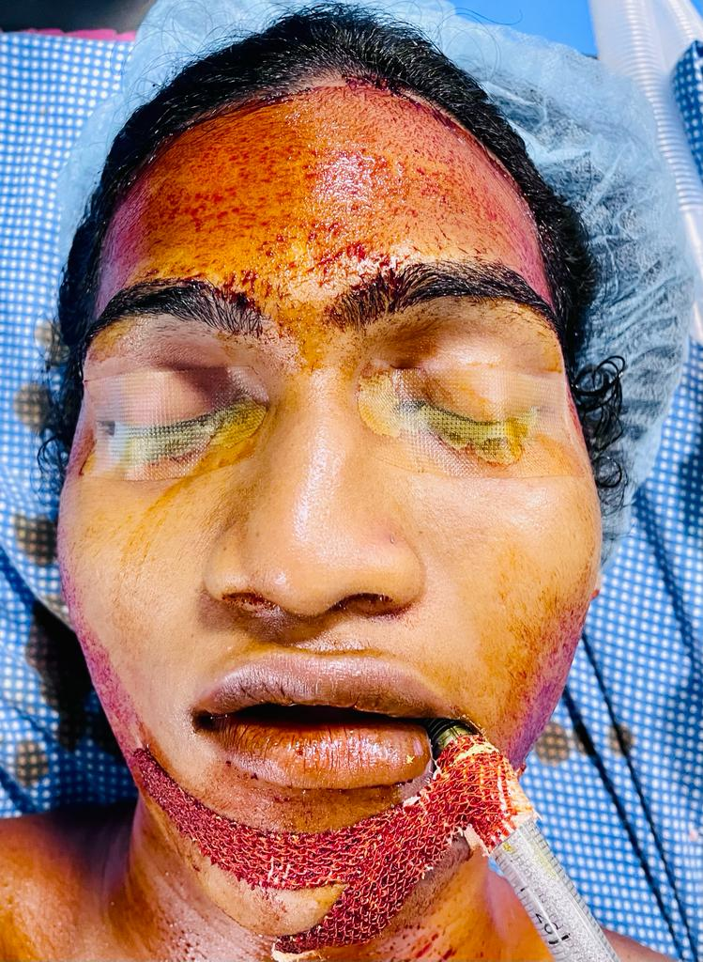
A 26-year-old female presented to our department with dissatisfaction regarding the appearance of her nose, particularly the nasal tip. The patient reported that the nasal tip appeared wide, rounded, and poorly defined, which she felt disrupted the balance of her facial features.
The patient stated that the bulbous appearance of her nasal tip had been present since adolescence and had gradually become more noticeable over time. She reported no history of nasal trauma, nasal obstruction, breathing difficulty, or previous nasal surgery.
Her primary concern was aesthetic, and she requested surgical correction to achieve a more refined nasal tip.
Clinical Examination and Diagnosis:
On external nasal examination, the patient presented with a bulbous nasal tip characterized by a widened interdomal distance, poorly defined tip-defining points, a thick nasal skin envelope, and convexity of the lateral crura. The nasal dorsum appeared straight without evidence of a dorsal hump deformity, and overall nasal symmetry was preserved. Anterior rhinoscopy revealed a normal nasal septum with no signs of septal deviation or airway obstruction. Based on these findings, the patient was diagnosed with a bulbous nasal tip deformity attributed to a widened domal angle and thick soft-tissue envelope.
Fig 1 : Pre-operative image
Treatment Planning:
Following detailed consultation and photographic analysis, an open structural tip rhinoplasty was planned. The surgical strategy included a conservative cephalic trim of the lower lateral cartilages, transdomal and interdomal suturing techniques, and placement of a shield graft to enhance tip projection and definition. Written informed consent was obtained prior to surgery.
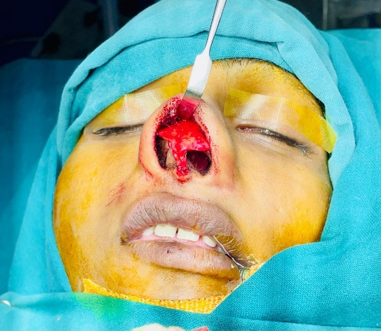
Surgical Procedure:
The surgery was performed under general anesthesia with endotracheal intubation. The patient was positioned supine with slight head elevation to minimize venous congestion. The nasal cavity was prepared with antiseptic solution and packed with cotton pledgets soaked in adrenaline to reduce mucosal bleeding.
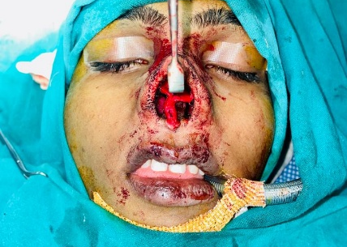
Local infiltration with 2% lidocaine containing epinephrine was administered to the columella, nasal tip, lower lateral cartilages, and nasal dorsum to provide hemostasis and facilitate dissection. An inverted V-shaped transcolumellar incision was made at the narrowest portion of the columella and extended into bilateral marginal incisions along the alar rims.
Fig 3 : Intra-operative image
Fig 2 : Intra-operative image after exposure

The nasal skin–soft tissue envelope was elevated in a sub-SMAS plane, exposing the lower lateral cartilages for direct visualization. Intraoperative assessment confirmed a wide domal angle, convex lateral crus, and increased interdomal distance, consistent with the bulbous tip deformity. A conservative cephalic trim of the lower lateral cartilages was performed, preserving adequate cartilage width to maintain nasal valve function.
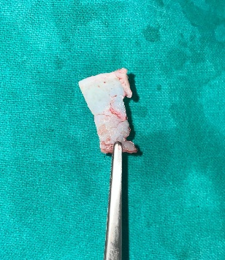
Transdomal sutures were placed to narrow the domal angle and refine tip-defining points, while interdomal sutures reduced the interdomal distance, further enhancing tip contour. A shield graft fashioned from septal cartilage was positioned over the domal region to improve tip projection and definition. Symmetry and projection were carefully assessed intraoperatively, with minor adjustments performed to achieve balanced contours. The soft tissue envelope was then repositioned, and the transcolumellar incision was closed with fine non-absorbable sutures.
Fig 4 : Intra-operative image showing the excess cartilage piece that was trimmed and removed.
An external nasal splint was applied to stabilize the framework.
Postoperative Care and Outcome:
The patient was prescribed antibiotics, analgesics, and nasal saline irrigation. External sutures were removed after 7 days. At the 1-month follow-up, swelling had reduced significantly, and the nasal tip appeared more refined. By the 3-month follow-up, well-defined tip-defining points and improved nasal symmetry were evident. At the 6-month follow-up, the patient expressed high satisfaction with the aesthetic outcome, with stable results and enhanced nasal tip definition.
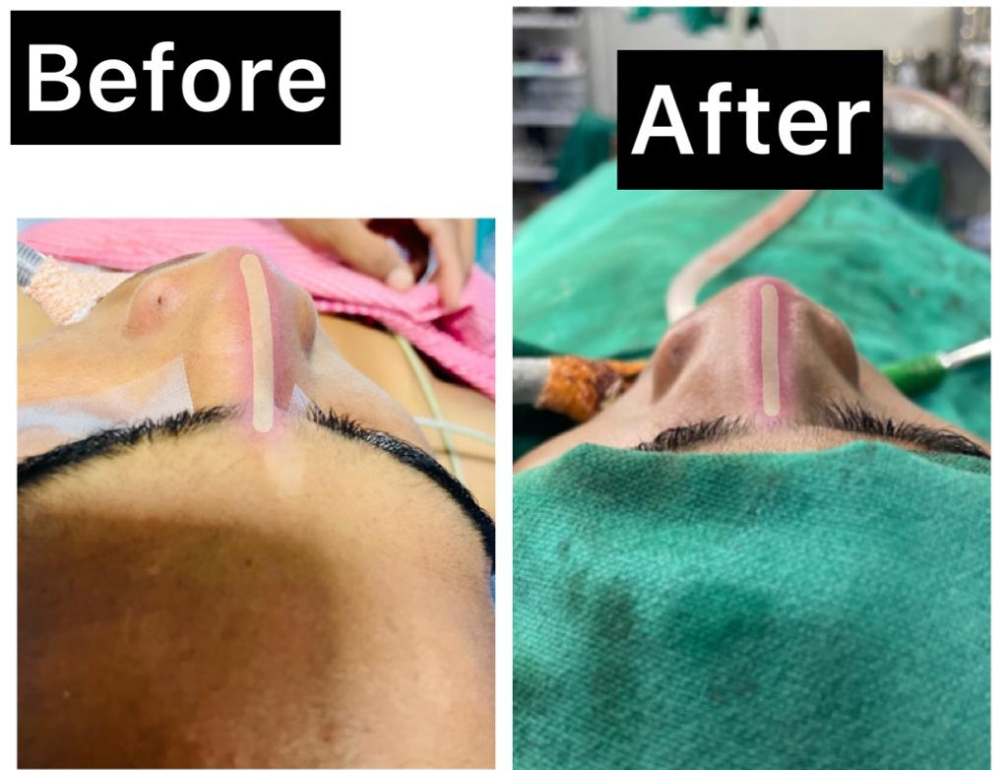

Image 1 : showing before and after pictures and correction of the deviated nasal septum.

Discussion
Bulbous nasal tip deformity is one of the most frequently encountered aesthetic concerns in rhinoplasty practice and represents a common indication for surgical nasal tip refinement. The nasal tip is a highly complex anatomical region composed of cartilage, fibrofatty tissue, ligaments, and skin, all of which contribute to the final shape and contour of the nose. Bulbous nasal tips are typically characterized by excessive roundness, poor definition of the tip, and increased width across the nasal lobule. This deformity often results from structural variations in the lower lateral cartilages combined with thick overlying soft tissue and skin envelope, which together obscure the underlying cartilaginous definition [1][2].
The lower lateral cartilages, also known as the alar cartilages, form the primary structural framework of the nasal tip and are divided into the medial, intermediate, and lateral crura. Proper orientation, strength, and symmetry of these cartilaginous components are essential for maintaining an aesthetically pleasing nasal tip contour. Structural abnormalities such as widened domal angles, convex or excessively long lateral crura, weak medial crura, and increased interdomal distance can lead to tip widening and loss of tip definition. In addition, thick sebaceous skin, abundant fibrofatty tissue within the nasal tip, and poorly defined domes further contribute to the bulbous appearance of the nasal tip [3][4].
Historically, rhinoplasty techniques focused primarily on reduction of nasal structures through aggressive cartilage excision, particularly of the cephalic portion of the lower lateral cartilages. While these techniques were effective in reducing nasal tip bulk in the short term, they frequently resulted in long-term complications. Excessive cartilage removal often weakened the structural integrity of the nasal tip, leading to deformities such as alar collapse, pinched nasal tip, external nasal valve compromise, asymmetry, and an unnatural postoperative appearance. These complications highlighted the limitations of purely reductive rhinoplasty techniques and led to the development of more conservative and structurally supportive surgical approaches [5][6].
Modern rhinoplasty has therefore shifted toward a philosophy of structural preservation and controlled modification of nasal cartilage. Contemporary techniques emphasize reshaping rather than removing cartilage, thereby maintaining nasal support, stability, and airway function. Suturing techniques have become fundamental tools in nasal tip refinement. Interdomal sutures help reduce the distance between the domes and improve tip definition, while transdomal sutures refine the shape of the dome and narrow the nasal tip. Additional techniques such as lateral crural spanning sutures and medial crural sutures allow surgeons to precisely control nasal tip projection, rotation, and symmetry without excessive cartilage resection [7][8].
Cartilage grafting also plays an important role in modern tip rhinoplasty, particularly in patients with weak or poorly defined tip structures. Various grafts, including columellar strut grafts, shield grafts, and onlay grafts, can be used to enhance tip projection and improve contour. Shield grafts are especially valuable in cases of bulbous nasal tip deformity because they provide additional support to the domal region while simultaneously improving tip definition and projection. These grafts are commonly harvested from the nasal septum but may also be obtained from auricular or costal cartilage when septal cartilage is insufficient. Proper graft placement and sculpting are critical to maintaining a natural and harmonious nasal appearance [9][10].
Another important component of bulbous tip correction is cephalic trim of the lower lateral cartilages. This technique involves conservative removal of the cephalic portion of the lateral crus while preserving adequate cartilage width to maintain structural support. Cephalic trim reduces the bulk of the lateral crura and allows improved reorientation of the remaining cartilage through suturing techniques. When combined with domal suturing, this approach effectively narrows the nasal tip while preserving the functional integrity of the external nasal valve [11][12].
Advances in rhinoplasty over the past two decades have emphasized individualized surgical planning based on detailed anatomical analysis. Surgeons now tailor procedures according to cartilage strength, skin thickness, and overall nasal proportions. Structural rhinoplasty techniques that incorporate cartilage preservation, strategic suturing, and selective grafting have demonstrated superior aesthetic outcomes, improved long-term stability, and lower complication rates compared with traditional reduction-based methods. These techniques also maintain airway function and reduce the likelihood of postoperative deformities [13][14].
Recent literature supports the concept that balanced modification of the nasal tip framework provides the most predictable and natural-looking results. The combination of conservative cephalic trim, domal suturing techniques, and strategic cartilage grafting allows precise control over nasal tip shape, projection, and rotation while preserving structural support. Such approaches are particularly beneficial in patients presenting with bulbous nasal tips associated with thick skin and poorly defined cartilage anatomy [15].
The present case demonstrates the effectiveness of combining cephalic trim of the lower lateral cartilages, domal suturing for tip refinement, and shield graft placement to enhance projection and structural support. This integrated structural approach provides improved nasal tip definition, maintains functional stability, and achieves aesthetically pleasing outcomes while minimizing the risk of long-term complications associated with traditional reductive rhinoplasty techniques.
Conclusion
Advances in structural rhinoplasty have significantly enhanced the surgeon’s ability to refine a bulbous nasal tip while maintaining both nasal support and optimal airway function. Traditional reductive techniques that relied primarily on aggressive cartilage excision have gradually been replaced by structural preservation and reshaping methods. Modern rhinoplasty emphasizes maintaining the integrity of the lower lateral cartilages and modifying their shape through controlled techniques rather than excessive removal. This paradigm shift has improved long-term stability, minimized postoperative deformities, and preserved functional anatomy.
One of the most important developments in tip rhinoplasty is the use of conservative cartilage modification. Instead of removing large portions of the lower lateral cartilage, surgeons now employ subtle reshaping methods such as cephalic trimming, which carefully reduces the cephalic portion of the lateral crus while maintaining adequate cartilage width to support the nasal valve and tip framework. This approach prevents complications such as alar collapse or pinching and helps preserve the natural contour of the nasal tip.
Equally important are precise suturing techniques, which allow surgeons to reshape the nasal tip without extensive cartilage resection. Suturing methods such as interdomal sutures, transdomal sutures, and lateral crural spanning sutures can narrow the domal angle, reduce tip width, and enhance tip definition. These sutures provide controlled remodeling of the cartilage framework, enabling the surgeon to refine tip projection and rotation while maintaining structural integrity. Because suturing techniques are reversible and adjustable during surgery, they offer greater precision and predictability in achieving the desired aesthetic outcome.
Another major advancement is the strategic use of cartilage grafts to support and refine the nasal tip. Structural grafts such as columellar strut grafts, shield grafts, and lateral crural strut grafts are commonly used to reinforce the tip framework, improve projection, and enhance tip definition. Autologous cartilage harvested from the nasal septum, ear (conchal cartilage), or rib is typically used because of its biocompatibility and long-term stability. These grafts provide additional support to weakened or malformed cartilage structures and help maintain the surgical result over time.
Modern structural rhinoplasty also integrates functional considerations with aesthetic refinement. Surgeons carefully evaluate the internal and external nasal valves to ensure that tip modification does not compromise airway patency. Techniques such as alar rim grafts and lateral crural repositioning can simultaneously improve nasal breathing and enhance the aesthetic contour of the nasal tip. This dual focus on function and form reflects the contemporary philosophy of rhinoplasty, where aesthetic improvement must not come at the expense of nasal physiology.
Furthermore, advances in open rhinoplasty approaches have provided improved visualization of the nasal framework, allowing surgeons to perform more precise cartilage modifications and graft placement. The open approach enables direct assessment of the lower lateral cartilages, facilitating accurate correction of deformities associated with a bulbous tip, such as widened domal angles, convex lateral crura, and increased interdomal distance.
Overall, tip rhinoplasty remains one of the most technically demanding components of aesthetic nasal surgery. Achieving a refined, natural-appearing nasal tip requires a comprehensive understanding of nasal anatomy, careful preoperative planning, and meticulous surgical execution. By combining conservative cartilage modification, advanced suturing techniques, and well-planned structural grafting, modern rhinoplasty techniques allow surgeons to achieve predictable, long-lasting, and aesthetically harmonious outcomes while preserving nasal support and airway function.
Ethical Clearance
Ethical approval for this case report was obtained from the institutional ethics committee.
Informed Consent
Written informed consent was obtained from the patient for surgical treatment and publication of this report.
References
1. Rohrich RJ, Ahmad J. Finesse in nasal tip refinement: Anatomic, technical, and artistic considerations. Plast Reconstr Surg. 2017;140(2):277e–286e. doi:10.1097/PRS.0000000000003566.
2. Patel PN, Most SP. Combining open structural and dorsal preservation rhinoplasty. Clin Plast Surg. 2022;49(1):97–109. doi:10.1016/j.cps.2021.09.004.
3. Kim DW. Soft tissue considerations in rhinoplasty. JAMA Facial Plast Surg. 2016;18(4):279–280. doi:10.1001/jamafacial.2016.0473.
4. Gunter JP, Rohrich RJ. Personal evolution in rhinoplasty tip shaping: Beyond the tripod concept. Plast Reconstr Surg. 2022;150(4):789e–799e. doi:10.1097/PRS.0000000000009677.
5. Daniel RK. The role of septal extension grafts in modern rhinoplasty. Clin Plast Surg. 2010;37(2):231–245. doi:10.1016/j.cps.2010.02.001.
6. Sajjadian A, Daniel RK, Kosins AM. Current trends in rhinoplasty: Suturing techniques revisited. Facial Plast Surg. 2010;26(4):320–327. doi:10.1055/s-0030-1262322.
7. Rhee JS, Kriet JD, Weaver EM. Clinical consensus statement: Cartilage grafting in rhinoplasty. Laryngoscope. 2014;124(1):1–11. doi:10.1002/lary.24338.
8. Shah AR, Most SP. Structural rhinoplasty through the endonasal approach: Outcomes and techniques. Facial Plast Surg. 2025;41(6):734–740. doi:10.1055/a-2575-3772.
9. Park SS. Correction and prevention of tip asymmetries, bossae, and alar retraction. Plast Aesthet Res. 2024;11:18. doi:10.20517/2347-9264.2023.115.
10. Han SK, Lee DG, Kim JB. Cartilage reshaping techniques in rhinoplasty: Clinical applications. Indian J Otolaryngol Head Neck Surg. 2023;75(4):1702–1710. doi:10.1007/s12070-023-03417-7.
11. Li C, Zhang Y, Wang J. Surgical management of bulbous nasal tip deformity: Clinical outcomes. Aesthetic Plast Surg. 2019;43(5):1201–1208. doi:10.1007/s00266-019-01451-1.
12. Patel ZM, Chisholm E, Jallali N. Contemporary rhinoplasty outcomes: Patient satisfaction and functional results. J Plast Reconstr Aesthet Surg. 2020;73(6):1041–1048. doi:10.1016/j.bjps.2020.01.012.
13. Kim JH, Lee J, Park J. Long-term results of tip rhinoplasty using septal extension grafts. Aesthetic Surg J. 2016;36(7):761–770. doi:10.1093/asj/sjw072.
14. Kumar N, Sharma R, Most SP. Structural rhinoplasty techniques: A systematic review. Int J Med Sci Clin Res Stud. 2025;5(12):112–120. doi:10.47191/ijmscrs/v5-i12-12.
15. Rhee JS, Most SP, Toriumi DM. Functional outcomes after rhinoplasty: Evidence-based review. Facial Plast Surg Aesthet Med. 2020;22(5):321–330. doi:10.1089/fpsam.2020.0277.

