Case report

Endoscopic Retrieval of Impacted Ingested Cow Skin “Kpomo” in an Adolescent Female: A Case Report

Abstract
Background: Esophageal food bolus impaction is a gastrointestinal emergency requiring prompt endoscopic intervention. While meat bolus impaction is well documented in Western literature, regional dietary practices, such as ingestion of cow skin (kpomo), may predispose to impaction in adolescents.
Case Presentation: A 16-year-old female presented with sudden retrosternal chest pain, vomiting, and dyspnoea after swallowing unchewed kpomo. Initial management included intravenous proton pump inhibitor therapy and failed nasogastric tube insertion. Upper gastrointestinal endoscopy revealed distal esophageal impaction. Initial retrieval with a basket was unsuccessful; successful extraction was achieved using a polypectomy snare following distal manipulation. Post-procedure recovery was uneventful.
Conclusion: This case highlights kpomo as a culturally specific risk factor for esophageal impaction and underscores the importance of timely endoscopic management to prevent complications.

Keywords
Cow skin (kpomo); Esophageal food bolus impaction; Adolescent; Endoscopy; West Africa; Foreign body removal

Introduction
Esophageal foreign body impaction is a common gastrointestinal emergency in adolescents and adults, most often due to food bolus obstruction (ASGE, 2011). While Western literature frequently reports meat impaction, dietary habits are regionally specific and influence the type of foreign body encountered (Pfau, 2014; Fung et al., 2019; Negoita et al., 2023).
Cow skin, locally called kpomo, is a widely consumed delicacy in West Africa. Despite prolonged cooking, kpomo retains a dense, elastic, rubbery texture due to its high collagen content. Swallowing kpomo without adequate mastication increases the risk of distal esophageal impaction, as was observed in this present case. The distal oesophagus is particularly vulnerable due to physiological narrowing at the lower esophageal sphincter (Aronberg et al., 2015; Zakko et al., 2024).
Delay in recognition and intervention may lead to mucosal injury, perforation, mediastinitis, aspiration, and sepsis. Despite the prevalence of kpomo consumption, there is limited documentation of its role in esophageal impaction, making this case a valuable contribution to region-specific clinical literature.

Case Presentation
Miss D.F., a 16-year-old female student, presented with a 1-day history of sudden-onset chest pain. The pain was sharp, constant, mid-sternal, worsened by swallowing and talking, and scored 8/10 in severity. She reported swallowing kpomo(cow skin) without adequate chewing.
Associated symptoms included vomiting and difficulty breathing. Initial management at the school clinic involved intravenous omeprazole and a failed nasogastric tube insertion. Persistent symptoms prompted referral to a tertiary facility.

Examination Findings: She was very conscious, in painful distress and restless, Not pale, anicteric, acyanosed, No pedal edema, PR 79 bpm, BP 103/60 mmHg, RR 24 cpm, chest clear, Soft, epigastric and umbilical tenderness, no organomegaly

Investigations: HIV: Seronegative, Hepatitis B & C: Non-reactive, VDRL: Non-reactive, haemoglobin level is 14g/dl.
Diagnosis: Suspected distal esophageal foreign body impaction.
Plan: commence resuscitation and then schedule patient for emergency endoscopic foreign body removal.

Methodology

Pre-Procedure Preparation: Patient assessed and declared fit by anesthesiologist, mild conscious sedation administered, Oxygen via nasal prongs, Continuous monitoring of vitals, Bite guard applied, 10% Topical lidocaine sprayed to posterior pharynx for mucosal anaesthesia.

Endoscopic Findings and Intervention
Flexible upper GI endoscopy revealed distal esophageal impaction, by a foreign body kpomo. Initial retrieval using an endoscopic retrieval basket failed, which was likely due to the slippery nature as it was coated with saliva and the size of the cow skin(kpomo). The foreign body was gently manipulated distally and successfully grasped with a polypectomy snare, then extracted orally without complications. There was an instant retrieve of distress by the patient. She was subsequently observed for full recovery and later transferred to the ward for further observation.
Post-Procedure Care: she was placed on nil per os, intravenous PPi, antibiotics, analgesics and fluid. Patient resumed oral intake after 48hours without complications and later discharged in stable clinical state after counselling on proper dietary habit and to chew well before attempting to swallow.

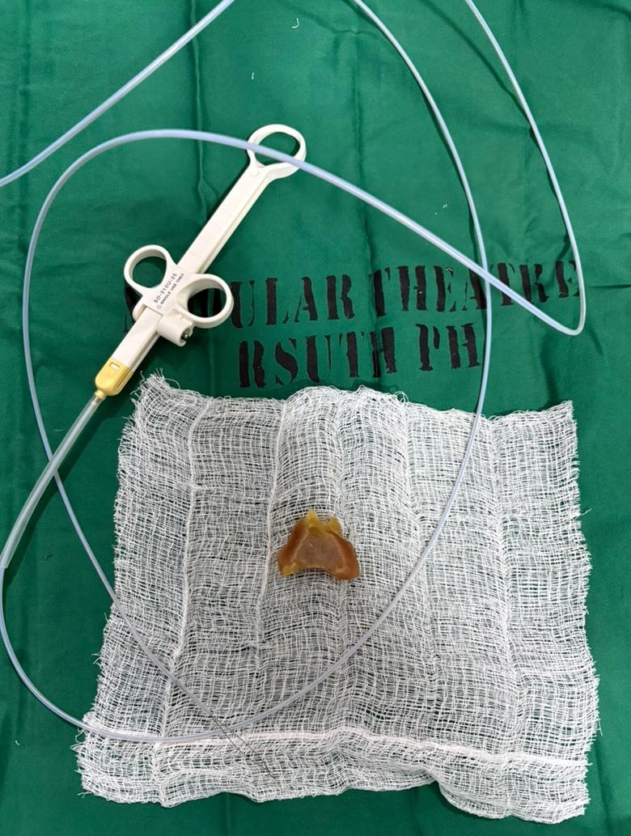
Fig 1. Retrieved Cow skin (Kpomo) and polypectomy snare.

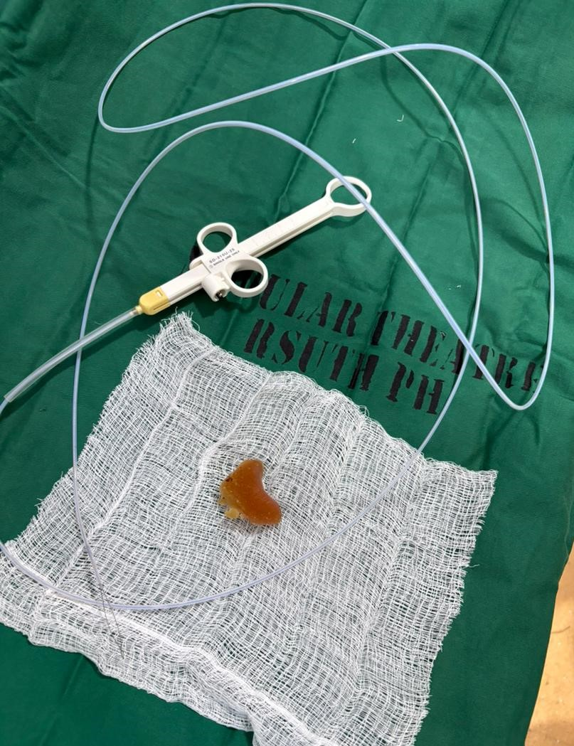
Fig 2. Retrieved Cow skin (Kpomo) and polypectomy snare.

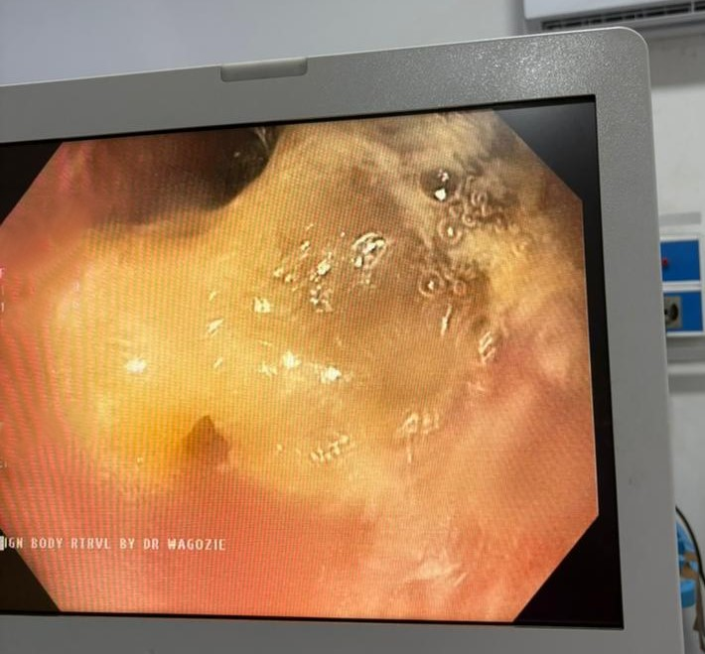
Fig 3. Impacted Cow skin(Kpomo) in the Lower Oesophagus
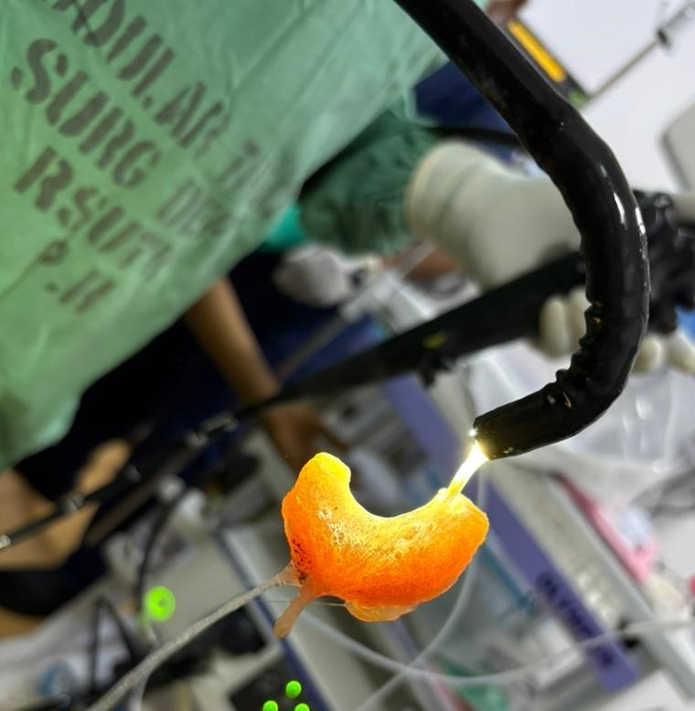
Fig 4. Retrieved Foreign body at the tip of the scope held with polypeptomy snare

Discussion
Esophageal foreign body impaction is a recognized gastrointestinal emergency requiring prompt evaluation and intervention (Eisen et al., 2002). Food bolus impaction accounts for the majority of esophageal foreign bodies in adolescents and adults, particularly following ingestion of poorly chewed meat products (ASGE, 2011; ESGE, 2016; Gurala et al., 2021).
A similar case reported by Longstreth and Longstreth (2009) described a 15-year-old female who presented with sudden retrosternal chest pain and vomiting following ingestion of inadequately chewed meat. Endoscopy revealed a food bolus impacted in the distal oesophagus, which required snare retrieval after failed basket extraction. The clinical pattern closely mirrors that of the present case.
Timing and Indications for Endoscopy: According to ASGE guidelines, esophageal food impaction without complete obstruction should undergo urgent endoscopic removal within 24 hours to reduce the risk of complications. In cases of complete obstruction or inability to handle secretions, emergent endoscopy is recommended (ASGE, 2011). Similarly, ESGE recommends endoscopic intervention within 24 hours for food bolus impaction and within 6 hours if there are signs of complete obstruction or respiratory compromise (ESGE, 2016). Early referral and timely intervention in this patient were in keeping with international best practice standards.
Technique of Retrieval: Evidence supports a stepwise approach to foreign body extraction. Retrieval baskets are often first-line instruments; however, when impaction is firm, alternative tools such as polypectomy snares or grasping forceps may be more effective (Birk et al., 2016). Distal manipulation before extraction, as performed in this case, is recommended in selected cases to reduce mucosal trauma and avoid perforation. Forceful proximal traction against a tightly embedded bolus increases the risk of esophageal tear.
Antibiotic Use and Post-Procedural Care: Routine antibiotic prophylaxis is not universally required for uncomplicated food bolus removal. However, antibiotics may be indicated where there is concern for mucosal injury, prolonged impaction, or high risk of perforation (ASGE, 2011). In this case, intravenous ceftriaxone was administered prophylactically due to the duration of impaction, failed prior manipulation attempt (NG tube insertion), and need for mechanical manipulation during retrieval. Proton pump inhibitors post-extraction were used to promote mucosal healing and reduce acid-mediated injury.
Cultural and Regional Considerations: While Western literature frequently reports steak and meat bolus impaction, this case highlights cow skin (kpomo) as a culturally relevant risk factor in West African settings. Its dense, elastic consistency increases the risk of distal esophageal lodging when swallowed without adequate mastication. This case therefore contributes region-specific insight into dietary risk factors for food bolus obstruction.
Complications and Prognosis: Untreated esophageal impaction may lead to esophageal perforation, mediastinitis, aspiration, sepsis, and stricture formation. The reported perforation rate for impacted esophageal foreign bodies ranges between 1–4%, increasing with delayed intervention (ESGE, 2016). Prompt endoscopic retrieval in this patient resulted in an uneventful recovery, consistent with favorable outcomes reported in early-managed cases and also in line with best global practices.

Conclusion
Severe retrosternal chest pain in adolescents following ingestion of poorly chewed food should raise suspicion for esophageal impaction with foreign body. Timely referral, adherence to guideline-based endoscopic management, and structured post-procedure care result in excellent outcomes. Public education on safe consumption of high-risk foods such as kpomo and proper chewing of food before swallowing may reduce incidence.

Clinical learning Points
- Cultural dietary practices matter – Foods like Cow skin (kpomo), with dense and elastic textures, can cause esophageal impaction if swallowed without adequate chewing.
2. High index of suspicion – Adolescents, children and adults, presenting with sudden retrosternal pain, vomiting, or dysphagia after recent ingestion of difficult-to-chew food should be evaluated promptly for esophageal obstruction following foreign body impaction, even if vital signs are stable.
3. Endoscopy is first-line management – Urgent upper GI endoscopy within 24 hours is recommended; initial basket retrieval may fail, and alternative tools like polypectomy snares should be considered.
4. Stepwise retrieval minimizes risk – Gentle distal manipulation prior to extraction reduces the risk of mucosal trauma and esophageal perforation.
5. Post-procedure care is essential – Nil per os, proton pump inhibitors, hydration, analgesia, and selective prophylactic antibiotics help optimize recovery and prevent complications.

References
1. ASGE Standards of Practice Committee. Management of ingested foreign bodies and food impactions. Gastrointest Endosc. 2011;73:1085–1091.
2. Birk M, Bauerfeind P, Deprez PH, et al. Removal of foreign bodies in the upper gastrointestinal tract. ESGE Guideline. Endoscopy. 2016;48:489–496.
3. Longstreth GF, Longstreth KJ. Esophageal food bolus impaction: epidemiology and management. Gastroenterology Review. 2009;5:12–18.
Pfau, P. R. (2014). Removal and management of esophageal foreign bodies. Techniques in Gastrointestinal Endoscopy, 16(1), 32-39.
Negoita, L. M., Ghenea, C. S., Constantinescu, G., Sandru, V., Stan-Ilie, M., Plotogea, O. M., ... & Mihaila, M. (2023). Esophageal food impaction and foreign object ingestion in gastrointestinal tract: A review of clinical and endoscopic management. Gastroenterology Insights, 14(1), 131-143.
Fung, B. M., Sweetser, S., Wong Kee Song, L. M., & Tabibian, J. H. (2019). Foreign object ingestion and esophageal food impaction: An update and review on endoscopic management. World journal of gastrointestinal endoscopy, 11(3), 174–192. https://doi.org/10.4253/wjge.v11.i3.174
Zakko, A., Spinelli, C. M., Coe, G., Weisberg, I., & Brown, N. G. (2024). S682 Esophageal Foreign Body Impaction Followed by Immediate Dilation Is Not Associated With an Increased Risk of Esophageal Perforation: A Systematic Review With Meta-Analysis. Official journal of the American College of Gastroenterology| ACG, 119(10S), S471.
Aronberg, R. M., Punekar, S. R., Adam, S. I., Judson, B. L., Mehra, S., & Yarbrough, W. G. (2015). Esophageal perforation caused by edible foreign bodies: a systematic review of the literature. The Laryngoscope, 125(2), 371-378.
Gurala, D., Polavarapu, A., Philipose, J., Amarnath, S., Avula, A., Idiculla, P. S., Demissie, S., & Gumaste, V. (2021). Esophageal Food Impaction: A Retrospective Chart Review. Gastroenterology research, 14(3), 173–178. https://doi.org/10.14740/gr1387
Eisen, G. M., Baron, T. H., Dominitz, J. A., Faigel, D. O., Goldstein, J. L., Johanson, J. F., ... & Wheeler-Harbough, J. (2002). Guideline for the management of ingested foreign bodies. Gastrointestinal endoscopy, 55(7), 802-806.

