Case report

Sjögren’s Syndrome Presenting With Multiple Cystic Lung Lesions: A Rare Pulmonary Manifestation

Abstract

Aims: This case report aims to describe a rare presentation of primary Sjögren’s syndrome (pSS) manifesting as diffuse thin-walled cystic lung disease, emphasizing the need for autoimmune evaluation in such cases to avoid misdiagnosis and enable multidisciplinary management.

Case Presentation: A 60-year-old female farmer presented with progressive dyspnoea, dry cough, fever, and longstanding sicca symptoms, along with a prior history of myocardial infarction. Examination revealed pallor, respiratory distress, and bilateral basal crackles. High-resolution computed tomography (HRCT) demonstrated diffuse thin-walled pulmonary cysts with associated interstitial changes and bronchiectasis. Laboratory evaluation showed normocytic anaemia with elevated ESR and CRP. Autoimmune testing revealed positive antinuclear antibodies (ANA) and anti-Ro/SSA antibodies, while Schirmer’s test confirmed ocular dryness, supporting the diagnosis of pSS with pulmonary involvement consistent with lymphocytic interstitial pneumonia.

Discussion: Cystic lung disease in pSS is thought to result from lymphocytic infiltration causing small airway obstruction and cyst formation. Radiologically, these thin-walled cysts associated with interstitial changes may mimic other cystic lung disorders such as pulmonary Langerhans cell histiocytosis and lymphangioleiomyomatosis, posing diagnostic challenges.

Conclusion: Diffuse thin-walled cystic lung disease may represent an uncommon but important pulmonary manifestation of primary Sjögren’s syndrome. Recognition of this pattern is essential to prompt autoimmune evaluation, avoid misdiagnosis and enable timely multidisciplinary management.

Keywords
Sjögren’s Syndrome; Cystic Lung Disease; Lymphocytic Interstitial Pneumonia; Autoimmune Disease; Interstitial Lung Disease

Introduction
Sjögren’s syndrome is a chronic autoimmune disorder primarily affecting exocrine glands, leading to xerostomia and keratoconjunctivitis sicca. Extraglandular manifestations, including pulmonary involvement, can significantly affect prognosis. Although interstitial lung disease (ILD) is a well-documented feature, cystic lung lesions are rarely observed.
This report presents a rare case of primary Sjögren’s syndrome presenting with multiple pulmonary cysts, expanding the clinical spectrum of lung involvement in this autoimmune disease.

Presentation of Case
A 60-year-old woman, a farmer by occupation, presented with a one-week history of progressive dyspnoea, persistent dry cough, and low-grade fever. Dyspnoea had worsened to the extent of limiting daily activities. She denied any history of tuberculosis, asthma, smoking, or previously diagnosed connective tissue disease.
She reported long-standing dryness of the mouth and eyes, increased thirst, and difficulty swallowing dry food for several years. Five years earlier, she had suffered a right ventricular myocardial infarction and had remained clinically stable thereafter. There was no significant family history of autoimmune disease.
On examination, the patient was pale, afebrile, and dyspnoeic at rest with an oxygen saturation of 88% on room air. There was no cyanosis or clubbing. Chest examination revealed bilateral coarse crackles in the infra-axillary and infrascapular regions with reduced chest expansion (2 cm).

Investigations: Laboratory evaluation revealed normocytic anaemia (MCV 82 fL), neutrophilic leucocytosis, ESR 36 mm/hr, and CRP 36 mg/L. Liver and renal function tests, calcium, and thyroid-stimulating hormone were within normal limits. Sputum for acid-fast bacilli was negative.
Chest radiography showed fibrotic changes with multiple cysts. High-resolution computed tomography (HRCT) demonstrated diffuse interstitial lung disease with multiple cystic and cavitary lesions and bronchiectasis in both lower lobes, consistent with lymphocytic interstitial pneumonia (LIP) as seen in Figure 1 and Figure 2.
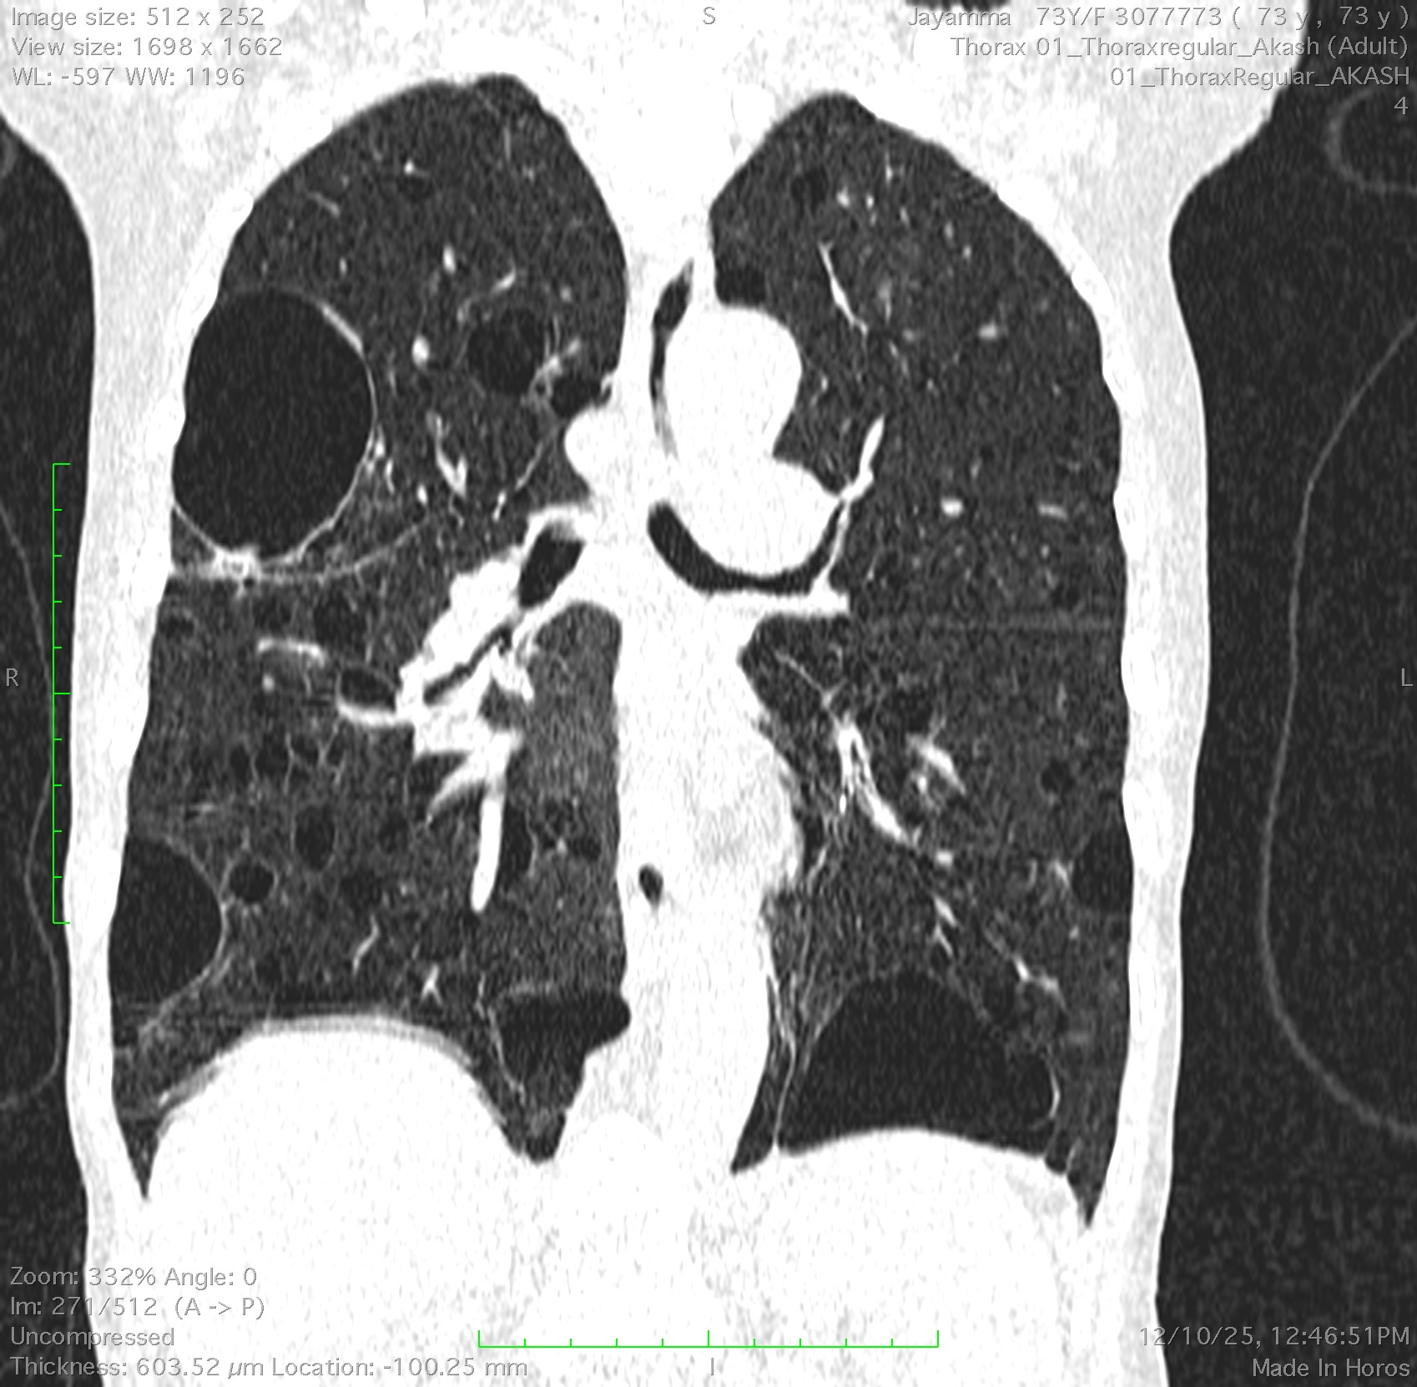  Figure 1 Coronal HRCT reconstruction demonstrating bilateral, diffuse thin-walled pulmonary cysts, predominantly in the mid and lower lung zones, consistent with cystic lung involvement in Sjögren’s syndrome. | 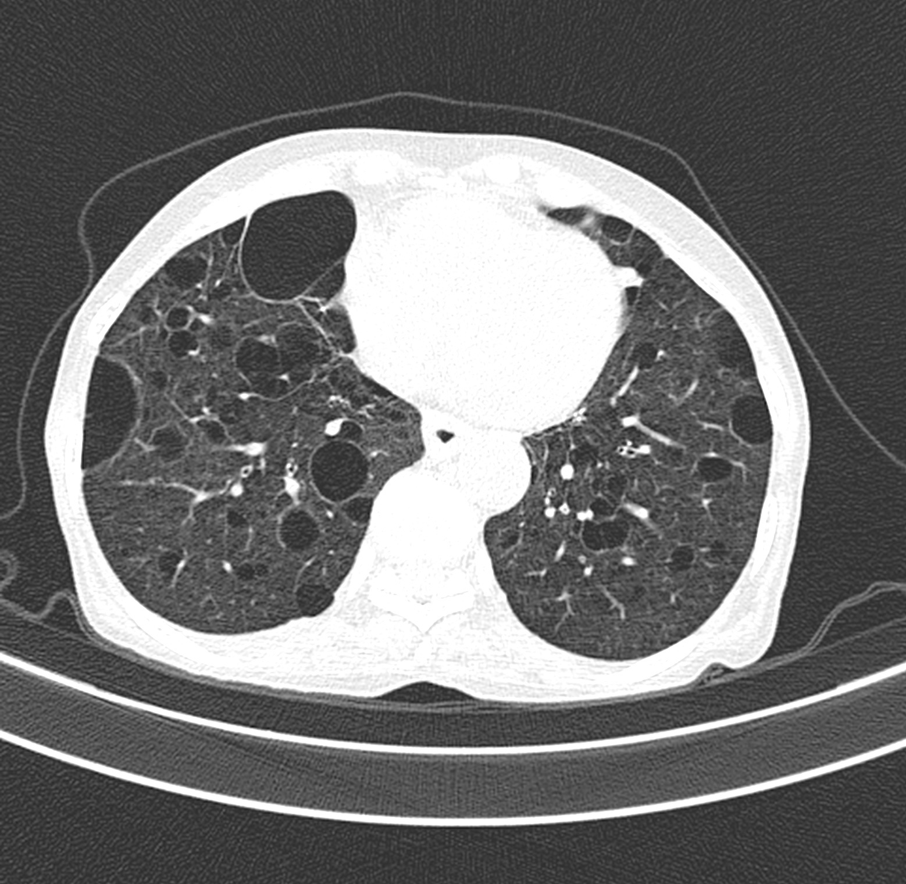  Figure 2 Axial HRCT of the thorax showing multiple, thin-walled cystic lesions of varying sizes diffusely involving both lungs.
Autoimmune screening revealed positive antinuclear antibodies and anti-Ro/SSA antibodies, confirming the diagnosis of primary Sjögren’s syndrome. Schirmer’s test was positive and salivary gland function was mildly reduced. The patient was managed with systemic corticosteroids, oxygen therapy and supportive care.
Differential diagnoses considered included pulmonary Langerhans cell histiocytosis, lymphangioleiomyomatosis, infectious cavitary lung disease and vasculitis-related pulmonary involvement. The presence of thin-walled cysts without necrosis, negative infectious workup, autoimmune seropositivity and sicca symptoms supported a diagnosis of pSS-associated LIP.

The patient was initiated on systemic corticosteroid therapy along with supplemental oxygen and supportive care. Symptomatic treatment for sicca symptoms was also provided.

Following initiation of corticosteroid therapy, the patient demonstrated symptomatic improvement with reduced dyspnoea and improved oxygen saturation. She was advised regular follow-up with pulmonary function testing and serial imaging to monitor disease progression and to detect complications such as pneumothorax or lymphomatous transformation.

Discussion
Pulmonary involvement in primary Sjögren’s syndrome (pSS) represents one of the most significant extra-glandular manifestations, contributing to morbidity and, in some cases, mortality. The spectrum of pulmonary disease in pSS encompasses airway abnormalities, interstitial lung disease (ILD), and cystic lung disease. (1) Among the ILD patterns, the most frequently reported are nonspecific interstitial pneumonia (NSIP), usual interstitial pneumonia (UIP), and lymphocytic interstitial pneumonia (LIP) (2,3).
In the present case, high-resolution computed tomography (HRCT) revealed multiple thin-walled cystic lesions distributed predominantly in the lower lobes, along with interstitial thickening and bronchiectasis. These findings were consistent with LIP-related cystic lung disease, a rare but recognized manifestation of Sjögren’s syndrome. Cyst formation in pSS is thought to result from peribronchiolar lymphocytic infiltration, leading to small airway obstruction, air trapping, and subsequent alveolar wall rupture. Another proposed mechanism involves the check-valve phenomenon, where inflammatory narrowing of bronchioles allows air inflow but restricts outflow, resulting in localized hyperinflation and cyst development.(4)
Radiologically, cystic lung disease associated with pSS typically presents with thin-walled cysts of variable size, often coexisting with ground-glass opacities, centrilobular nodules, or interlobular septal thickening. The absence of thick-walled cavitations, air-fluid levels, or necrosis helps differentiate cystic lesions from infectious or vasculitic cavities. (5) This distinction is clinically significant because cystic lesions in pSS reflect a non-destructive, inflammatory process, while cavitary lesions often imply infection or malignancy.(6)
Histopathological examination in such cases—if pursued—usually demonstrates diffuse lymphoplasmacytic infiltration of the interstitium with reactive lymphoid follicles, occasionally containing germinal centers, characteristic of LIP. The lymphoid proliferation can, however, evolve into mucosa-associated lymphoid tissue (MALT) lymphoma, emphasizing the importance of ongoing surveillance.(4,7)
Management of pSS-related cystic lung disease primarily involves systemic corticosteroid therapy, which can improve symptoms and stabilize lung function, though radiologic reversal is uncommon. In cases of progressive disease or poor response to steroids, immunosuppressants such as azathioprine, mycophenolate mofetil, or rituximab may be considered.(8,9) Regular HRCT and pulmonary function monitoring are essential for assessing disease progression and early detection of complications such as pneumothorax or lymphomatous transformation.
Recent literature emphasizes that cystic lung disease may represent an early or isolated pulmonary manifestation of Sjögren’s syndrome, sometimes preceding classical sicca symptoms or serological positivity. (6,10) Therefore, clinicians should maintain a high index of suspicion when evaluating patients with unexplained diffuse cystic lung disease.
This case contributes to the expanding recognition of cystic pulmonary manifestations in Sjögren’s syndrome, highlighting the necessity for multidisciplinary collaboration between pulmonologists, rheumatologists, and radiologists to achieve timely diagnosis and optimal management.

Conclusion
This case highlights the importance of recognizing cystic lung lesions as a possible pulmonary manifestation of primary Sjögren’s syndrome. Thin-walled cysts may be an early or dominant presentation of the disease and can occur even before classical sicca symptoms are clinically significant. Clinicians should consider Sjögren syndrome as a differential diagnosis for patients presenting with idiopathic cystic lung disease. A multidisciplinary approach involving pulmonologists, rheumatologists, and radiologists is crucial for timely diagnosis, appropriate management, and vigilant monitoring for potential complications such as pneumothorax or lymphomatous transformation. Further research is needed to clarify the pathophysiological mechanisms driving cyst formation and to optimize therapeutic strategies for patients with Sjögren’s-related cystic lung disease.

References
1. Flament T, Bigot A, Chaigne B, Henique H, Diot E, Marchand-Adam S. Pulmonary manifestations of Sjögren’s syndrome. Eur Respir Rev Off J Eur Respir Soc. 2016 June;25(140):110–23.
2. Lynch DA. Lung Disease Related to Collagen Vascular Disease. J Thorac Imaging. 2009 Nov;24(4):299–309.
3. Mormile I, Mormile M, Rossi FW, Williams M, Valente T, Candia C, et al. Radiological patterns and pulmonary function values of lung involvement in primary Sjögren’s syndrome: A pilot analysis. Front Med. 2022;9:998028.
4. Avelino EB de P, Verza L, Neves T, Chojniak R, Guimarães MD. Lymphocytic interstitial pneumonia and pulmonary amyloidosis in Sjögren’s syndrome. Radiol Bras. 2019;52(6):410–1.
5. Boddu P, Parimi V, Taddonio M, Kane JR, Yeldandi A. Pathologic and Radiologic Correlation of Adult Cystic Lung Disease: A Comprehensive Review. Pathol Res Int. 2017 Feb 8;2017:1–17.
6. Pan CH, Zhang XF, Chen C, An XB. Review of research on pulmonary cysts in sjögren’s syndrome. J Cardiothorac Surg. 2025 July 18;20(1):306.
7. Kim JY, Park SH, Kim SK, Hyun DS, Kum YS, Jung KJ, et al. Lymphocytic interstitial pneumonia in primary Sjögren’s syndrome: a case report. Korean J Intern Med. 2011 Mar;26(1):108–11.
8. Lee AS, Scofield RH, Hammitt KM, Gupta N, Thomas DE, Moua T, et al. Consensus Guidelines for Evaluation and Management of Pulmonary Disease in Sjögren’s. Chest. 2021 Feb;159(2):683–98.
9. Price EJ, Rauz S, Tappuni AR, Sutcliffe N, Hackett KL, Barone F, et al. The British Society for Rheumatology guideline for the management of adults with primary Sjögren’s Syndrome. Rheumatology [Internet]. 2017 June 28 [cited 2025 Dec 14]; Available from: https://academic.oup.com/rheumatology/article-lookup/doi/10.1093/rheumatology/kex163
10. Gupta N, Wikenheiser-Brokamp KA, Fischer A, McCormack FX. Diffuse Cystic Lung Disease as the Presenting Manifestation of Sjögren Syndrome. Ann Am Thorac Soc. 2016 Mar;13(3):371–5.

