Original Research Article
In Silico identification of BACE-1 inhibitory potential of Indicol from Mangifera Indica for targeting Alzheimer’s Disease

Abstract:
Background: Alzheimer’s disease (AD) is a neurodegenerative disorder characterized by the accumulation of amyloid-beta (Aβ) plaques, primarily formed through the enzymatic action of beta-site amyloid precursor protein cleaving enzyme 1 (BACE-1). The search for effective BACE-1 inhibitors has led to the exploration of phytocompounds, particularly those derived from traditional medicinal plants.
Aim and Objective: This study aims to identify and evaluate the potential BACE-1 inhibitory activity of phytocompounds extracted from Mangifera indica, specifically focusing on Indicol and Cyclocolorenone, through in silico methods namely molecular docking and molecular dynamics simulations.
Materials and Methods: The phytocompounds from Mangifera indica were screened using the Phytochemical and Drug Target Database (PDTDB) and IMPPAT 2.0, yielding 545 compounds, which were further narrowed down to 241 based on blood-brain barrier (BBB) permeability. The X-ray crystallography structure of BACE-1 (PDB ID: 1FKN) was prepared for docking using the Schrodinger Maestro suite. Molecular docking was performed using Glide and Prime suites; followed by molecular dynamics simulations to assess the stability and interaction of the top ligands with BACE-1.
Results: Molecular docking revealed that Indicol exhibited a binding affinity of -6.65 kcal/mol, forming significant hydrogen bonds with crucial BACE-1 residues (Gln73, Lys107, Gly230, Thr232). Cyclocolorenone, while showing a lower binding affinity of -5.37 kcal/mol in MM/GBSA analysis, demonstrated weaker interactions with BACE-1. Molecular dynamics simulations also indicated that, Indicol maintained stable interactions over a 100 ns simulation, whereas Cyclocolorenone showed less consistent binding.
Conclusion: The findings suggest that Indicol from Mangifera indica is a promising candidate for BACE-1 inhibition, demonstrating strong binding affinity and stability in silico. The results warrant further experimental validation to explore the therapeutic potential of Indicol in the treatment of Alzheimer’s disease.
Keywords: Alzheimer’s disease, BACE-1, molecular docking, MD simulation
Introduction:
AD is an age-related neurodegeneration disorder characterized by patients exhibiting dementia, impairment of thinking, reasoning and judgment, accompanied by a progressive loss of neocortex and hippocampal neurons in the brain [1] [2]. According to the World Health Organization (WHO), around 50 million people suffer from this disorder worldwide. In India, ⁓ 5.29 million people suffer from Alzheimer’s disease. This number is estimated to rise to ⁓ 82 million by 2030 worldwide [3, 4]. Therefore, an immediate measure is necessary to curb the development of AD in India and globally. Two hallmark pathologies characterize this disease; the extracellular accumulation of Aβ₄₂ peptides and intracellular cytoskeleton Tau protein aggregation in the cortical and hippocampal regions of the brain. The Aβ₄₂ accumulation results from the cleavage of Amyloid beta Precursor Protein (APP) by β-secretase and γ-secretase [5]. APP is a substrate of BACE-1 that results in the regulation of neurite growth, synapse formation, metal homeostasis, and synaptic plasticity. BACE-1 is also involved in processing neuregulin-1, which in turn regulates the development and signaling pathway of neuronal cells. In the case of AD brain, the levels of neuregilin-1 are found to be high, thereby affecting neuronal cell development. BACE1 also regulate the voltage-gated sodium channels in the presynaptic terminals, which increases the Aβ plaque formation between the synaptic junction of nerve cells of AD brain [6, 7]. These reports provide sufficient reason to speculate that, targeting BACE-1 using suitable compounds can yield promising therapeutic for the treatment of AD.
Studies relating to BACE-1 knockout mice have reported a decline in Aβ production associated with mild neurological defects, the involvement of BACE-1 knockout in synaptic defects, peripheral hypomethylation, and disturbance in substrate-specific BACE-1 activation [6, 7]. Additionally other BACE-1 knockout mice- showed high concentration of BACE-1 in the presynaptic neurons showed memory impairments, reduction in neuron myelination, neurochemical defects, reduced muscle spindles, neurogenesis and astrogenesis based alterations, reduction in spine density, retinal pathology, and other endophenotypes [8-15]. These reports have confirmed the limitations in the use of BACE-1 knockout in treatment of AD. Few chemically synthesized BACE-1 inhibitors such as Verubecestat, Lanabecestat, and Atabecestat have been previously assessed in animal models. These compounds however demonstrated side effects such as anxiety, rash development, minimal reduction in Aβ plaque, and reduced Blood-Brain Barrier (BBB) permeability [16]. Certain properties such as low molecular weight, more nitrogen, sulfur, and halogens and less oxygen in their structures, long chain lengths, high degree of saturation, a high number of rotatable bonds, and fewer chiral centers prevent synthetic compounds from effectively binding to the target proteins [17]. Furthermore, the issue of efficacy, safety, availability and cost raise concerns on using chemically synthesized drugs as therapeutics against BACE-1. Therefore, there is a dire need to look for phytocompounds that can be used as inhibitor to BACE-1 and developed as therapeutic drug.
The rationale behind using of phytocompounds as therapeutic are, diverse and favorable chemical scaffolds, beneficial ADME/Tox profiles; along with a high degree of binding affinity towards target proteins. Phytocompounds have proven their broad safety profiles and efficacy over synthetic compounds, as they are naturally optimized toward their cellular targets [18]. Phytochemicals/secondary metabolites obtained from Bacoside A, Bacoside B, Sulforaphane, Genistein, Resveratrol, Quercetin, Curcumin, Epigalocatechin-3-gallate, Withanamides A and B have been studied for their protection against diseases such as Arthritis, Diabetes, Alzheimer's, Leukemia, and Breast, Lung, Colorectal, Prostate Cancers [19-27]. The phytocompounds obtained from Mangifera indica have also been studied for their antidiabetic, anticancer, neuroprotective, anti-obesity, and anti-parasitic properties against liver injury [28-35]. However, the neuroprotective properties of Mangifera indica derived compounds with respect to their involvement in the AD treatment remain unexplored. In the present study, using in silico approach, we report existence of phytocompounds in the Mangifera indica, those demonstrate the interactions with the crucial BACE-1 residues. These interactions seem to possess BACE-1 inhibitory potential and thus can be of therapeutic significance in the treatment of Alzheimer disease.

Materials And Methods:
Phytocompound and ADME/Tox Screening:
Phytocompounds (Ligands) from Mangifera indica were screened using PDTDB (Phytochemical and Drug Target Database: https://pdt.biogem.org/search.php) and IMPPAT 2.0 (Indian Medicinal Plants, Phytochemistry And Therapeutics 2.0: https://cb.imsc.res.in/imppat/home) [36, 37]. These compounds were further screened for their physiochemical and drug-likeness properties using ‘SwissADME’ (http://www.swissadme.ch/) and admetSAR (http://lmmd.ecust.edu.cn/admetsar2/) [38].
Target protein selection and structure validation:
The X-ray crystallography structure of Human BACE-1 was obtained from the Research Collaboratory for Structural Bioinformatics Protein Data Bank (RCSB-PDB) (https://www.rcsb.org/). The PDB ID: 1FKN was selected as the structure had a resolution of 1.90Å, working and free R-value of 0.224 and 0.180 respectively [37].
Protein and Ligand preparation:
BACE-1 X-ray crystallography structure (1FKN) was prepared for docking using the ‘Protein Preparation Wizard’ module of Schrodinger Maestro suite version 2024-1. We set the default parameters for optimizing hydrogen bonds, assigning bond orders, adding missing heavy atoms, creating disulfide bonds, and assigning protonation states and tautomers. Similarly, the shortlisted ligands were optimized using the ‘LigPrep’ module [39]. The parameters such as structure optimization, and addition of any missing atoms or partial charges using the force field OPLS-2005 were set for the ligands.
Post preparation, the active site of BACE-1 was identified as Asp32 and Asp228 as per Kocak et.al. 2016 and UNIPROT database version 2024_02 (https://www.uniprot.org/help/uniprotkb) [40]. Before molecular docking, the ligands were positioned within the interaction box to ensure their proximity to the BACE-1 active site.
Molecular docking:
We employed two docking methods using the Glide and Prime suites of Schrodinger Maestro Suite version 2024-1. We used the Glide suite for conducting a High Throughput Virtual Screening (HTVS) to increase the hit rate and filter potential phytocompounds against BACE-1. Following this, the docking analysis was performed using the Glide SP (Standard Precision) and XP (Extra Precision) for accurately predicting the ligand poses in BACE-1 binding sites [41]. After filtering the binding affinities of each compound, we predicted the MM/GBSA scores of the top 10 docked compounds. The MM/GBSA analysis was done using the Prime suite of the same software; as this method is used to measure the binding affinities in the presence of a solvation layer [42]. Finally, the top docked interactions (one from Glide XP and one from Prime MM/GBSA) were compared with a negative and positive control.
Molecular Dynamic Simulation:
The compounds with the highest binding affinity (from Glide XP) and MM/GBSA (from Prime MM/GBSA) scores were subjected to Molecular Dynamic (MD) simulation using the ‘Desmond’ suite. The simulations were carried out using the isothermal-isobaric ensemble at 300 Kelvin and 1.013 bar pressure for 100 nanoseconds. The OPLS-2005 force field and the predefined TIP3P solvent model were utilized for running MD simulations of Indicol and Cyclocolorenone with BACE-1 [43]. The results of the MD simulation were analyzed using RMSD (Root Mean Square Deviation), RMSF (Root Mean Square Fluctuation), and ligand-receptor interaction-based plots (ligand-atom points of contact over time, ligand-receptor point of contact plot at atomic scale).
Results:
Phytochemicals screening from Mangifera indica:
In the present study we used IMPPAT and PDTDB databases that revealed the presence of 545 phytochemicals in Mangifera indica. These phytochemicals were further shortlisted to 241 compounds based on their BBB (blood-brain barrier) crossing capabilities. These potential 241 small molecule inhibitors compounds (shown in Table 1), were subjected to molecular docking analysis against BACE-1 (Table 1).
Protein model selection and verification:
The 3D model for BACE-1 was downloaded from PDB (PDB ID: 1FKN). It was found that several studies have used 1FKN as a template for analyzing the inhibitory potentials of numerous phytocompounds against BACE-1 [44-47]. The 3D structure of 1FKN was prepared for molecular docking using the ‘Protein preparation wizard’. While the structure post preparation was verified using ‘Ramachandran plot’ module of the same software (Ramachandran plot displayed in Figure 1) [48, 49]. In the present study we have utilized 1FKN/BACE-1 for assessing its interacting potentials with the phytocompounds found in Mangifera indica.
Molecular docking analysis of Indicol and Cyclocolorenone with BACE-1:
We subjected the 545 phytocompounds to HTVS analysis that filtered 241 compounds (listed in Table 2) that were lead optimized. The HTVS analysis shortlisted 155 phytocompounds, which showed benzoic acid to have a binding energy of −5.91 kcal/mol. Further these 155 compounds were subjected to Glide SP and then Glide XP molecular docking suites respectively; to refine lead optimization and identify top lead compounds against BACE-1 [50]. The Glide SP analysis filtered 60 compounds, among them Guaiol had the highest binding affinity of −6.71 kcal/mol (Table 3), whereas the Glide XP docking analysis filtered the top 12 (Table 4) phytocompounds having the higher binding affinities with BACE-1; as compared to 241 compounds (the top 10 compounds are shown in Table 1). Among these top 12 phytocompounds, only Indicol (Figure 2a) demonstrated the highest binding affinity of −6.65 kcal/mol. Subsequently, we subjected these top 12 phytocompounds to the Prime MM/GBSA suite to calculate their MM/GBSA ΔG binding scores (MM/GBSA scores shown in Table 5). Among those, Cyclocolorenone (Figure 2b) had the highest MM/GBSA ΔG binding score of −56.37kcal/mol with BACE-1. The Glide XP and Prime MM/GBSA suites filtered the most favorable chemical structures having the highest binding affinities. Hence, Indicol and Cyclocolorenone were selected for analyzing the 2D and 3D interactions with BACE-1 residues.
The 2D interaction diagram of Indicol (Figure 3a) showed three OH groups from Indicol those formed hydrogen bonds with four BACE-1 residues Gln73, Lys107, Gly230, and Thr232. This result indicated interaction between the ligand and protein. The hydrogen bond distance between Indicol and BACE-1 residues was measured using the ‘Measure’ tool of the Maestro suite. Using the measure tool, the 3D interaction diagrams displayed the bond distance between Indicol and Gln73, Lys107, Gly230, and Thr232 were 1.69Ǻ, 2.06Ǻ, 1.89Ǻ and 3.29Ǻ respectively (shown in Figure 3b & 3c). The ligand-protein hydrogen bond distances signify strong binding affinity with BACE-1. On the other hand, the carbonyl group of Cyclocolorenone formed a hydrogen bond with Thr232 (Figure 3d); with a bond distance of 4.31Ǻ (Figure 3e). Together these results suggested that Indicol and Cyclocolorenone can interact with BACE-1 in silico. Furthermore, such interactions between Indicol-BACE1 and Cyclocolorenone-BACE1 could be inhibitory to BACE-1 activity in situ. However, in order to rule out the artifactuality of these outcomes it was necessary to compare the interaction between BACE1 and these compounds against suitable controls.
The molecular docking results (including the bond distance and interactions) of Indicol and Cyclocolorenone with BACE-1 were compared to positive and negative control. We used Verubecestat as a positive control, which is a known synthetic inhibitor to BACE-1 [51]. Under similar conditions, using similar parameters It was found that Verubecestat show binding energy of −6.8kcal/mol and formed hydrogen bonds with Gly11, Gln73, Thr232, and Arg235 (Figure 3f). Additionally, the bond distances were 2.01Å, 2.03Å, 2.21Å and 2.17Å (Figure 3g). The results display Verubecestat binding with two crucial BACE-1 residues as compared to the four crucial residues by Indicol. These results suggested toward weaker binding affinity between Verubecestat and BACE-1 as compared to that between Indicol-BACE1. As a negative control, we docked Indicol with pepsin (stomach enzyme belonging to the aspartic protease family) [52]. The docking results showed a binding score of −7.7 kcal/mol. Indicol formed a hydrogen bond with pepsin residue Gln308. The bond distance was found to be 2.11Å (Figure 3h & 3i). Parallelly, in other negative control Cyclocolorenone was docked with pepsin (as shown in Figure 3j). Herein it was observed that hydrogen bond (with bond distance 2.12Ǻ) formation take place between the Cyclocolorenone OH group and Gly93 of pepsin (shown in Figure 3k). Clearly Cyclocolorenone was unable to interfere with pepsin functioning in silico (as Ile94 and Gln277 are the active sites of pepsin). Thus, both the negative controls eliminated the possibility of any artifact in the interaction between Indicol-BACE1 and Cyclocolorenone-BACE and simultaneously our results also ruled out possibility of Indicol and Cyclocolorenone interfering with other regulatory enzymes. Together these results establish the potential of Indicol to effectively and specifically target BACE-1 crucial residues without interfering with other metabolic enzymes.
MM/GBSA is a molecular docking method that combines molecular mechanics energies and implicit solvation models; to calculate conformational changes between ligand-protein interactions. Many studies have shown MM/GBSA scores to identify and rank the effective inhibitors against specific protein targets such as Acetylcholinesterase, BACE-1 and synapsin I, II and III with ursolic acid, rosmarinic acid, and carnosic acid; HMOX1,CNR1, STAT3, HDAC2, and MAOB with glycyrrhisoflavone, eugenol, ferulic acid, methyl jasmonate, geranyl formate, formononetin, and elemicin [42, 53-55]. Similarly, our MM/GBSA results revealed the docking score of 7.11 kcal/mol, between Indicol and crucial BACE-1 residues. Whereas Cyclocolorenone showed an MM/GBSA dock score of −56.37 kcal/mol. Between both these compounds, only Indicol displayed an efficient hydrogen binding affinity with crucial BACE-1 residues Gln73, Lys107, Gly230, and Thr232; in contrast to Cyclocolorenone which had hydrogen binding only with Thr232. Although the positive MM/GBSA docking score of Indicol and BACE-1 might suggest an endothermic reaction occurring in the cell, as compared to Cyclocolorenone and BACE -1. But these must be corelated using an in vitro study aimed to deduce the type of biochemical reaction taking place in the neuronal cells.
Molecular dynamic simulations of Indicol and Cyclocolorenone with BACE-1:
MD simulation provides a thorough visualization of the ligand-protein interactions on an atomic scale concerning time. This method also considers a few physiological parameters such as pH, temperature, pressure, water, ions, and other molecules in the system. These parameters are known to mimic the cellular environment by placing a solvation layer along with a force field around the target ligand–protein. Therefore, the MD simulation approach is used to assess the overall stability of ligand–protein complexes [56]. Based on this we conducted the MD simulation between Indicol and BACE-1 for 100ns. The acceptable RMSD values for ligand-protein are usually between 0-3.0Å in an MD simulation having stable and normal conditions [57]. Studies showcasing the in silico inhibitory potentials of Morus alba Linn derived phytocompounds and phytocompounds from traditional medicinal plants like glucoraphanin, vitexin, and niazinin have RMSD and RMSF values between the acceptable values. Along with this, these phytocompounds had efficient binding affinities with their respective target proteins Acetylcholinesterase and GSK-3β [58, 59]. Similarly, our simulation report generated the RMSD values between 1.50Å to 2.25Å for Indicol and BACE-1 (as shown in Figure 4a). While the RMSD graph between Cyclocolorenone and BACE-1 had a difference between 1.75Å to 2.25Å (Figure 4b). Together these graphs point that, Indicol, as compared to Cyclocolorenone, exhibited better interaction with BACE-1. The RMSF value denotes conformational changes in target protein chains during the simulation run. Our RMSF plots show a fluctuation of Indicol and BACE-1 (Figure 5a) between 0.5 to 2.0Å. While Figure 5b. shows the fluctuation between Cyclocolorenone and BACE-1 to be between 0.5 to <2.0Å. A relatively less fluctuation was observed between Indicol and Cyclocolorenone concerning BACE-1.
The interaction diagram of Indicol and BACE-1 (Figure 6a) shows the Indicol ‘OH’ groups interaction fractions of above 1.0 with Phe108 (a BACE-1 residue) during the 100ns simulation. Other than Phe108, Gln12, and Lys107 showed hydrogen bond formation with Indicol for the designated simulation time. Whereas, Figure 6b. showed Cyclocolorenone interacting with BACE-1 residues below the interaction fraction of 1.0. Further, the points of contact diagram between ligand and protein are split into two sections, the top panels of both diagrams represent the points of contact BACE-1 made with Indicol and Cyclocolorenone. The total points of contact fluctuate between 0 and 8 with an average of 4. In the case of Cyclocolorenone, the total points of contact fluctuated between 0 and 6, with an average of 3. Therefore, our results point towards the existence of a fluid nature between Indicol and BACE-1; as compared to Cyclocolorenone and BACE-1. The bottom panel shows residue interactions of BACE-1 with Indicol (Figure 6c). The BACE-1 residues Phe108 (dark orange), Gln12, Lys107 (Orange) and Thr72, Gln73, Gly74 and Gly230 (faint orange shade) interacted with Indicol during the 100ns MD simulation. Out of these Gln12, Gln73, Gly74, and Lys107 were found to interact for ~90ns of the simulation run. Similarly Figure 6d. showed Gln73 interacting with Cyclocolorenone for 20ns during the simulation run. Indicol was able to maintain hydrogen bond interaction for a longer time with BACE-1 residues as opposed to Cyclocolorenone. The detailed schematic diagram of ligand–protein atomic level interactions between Indicol and BACE-1 residues (Figure 6e) formed hydrogen bonds for 76% (Gln12), 68% (Lys107 and Phe108), and 32% (Gly230) with the three OH groups of Indicol during the 100ns simulation run. On the contrary, Figure 6f. showed Cyclocolorenone was unable to form any bonds with BACE-1 residues during the simulation run concerning time. These results point towards the efficacy of Indicol to have affinity and possibly inhibit BACE-1 crucial residues as opposed to Cyclocolorenone in silico. The MD simulation results of Indicol and BACE-1 suggest that strong hydrogen bond formation of Indicol with Gln73, Lys107, and Thr232 may lead to BACE-1 inhibition. To further validate these results an in vitro and in vivo investigation is necessary.
ADME/Tox analysis of Indicol and Cyclocolorenone:
Bioinformatics–based web services aid in the generation of drug-likeness, pharmacokinetics, Absorption, Distribution, Metabolism, Excretion, and Toxicity (ADME/Tox) capability/ profiles of any given compound. Such properties aid in drug discovery, and drug development and prevent drug rejection during in vivo studies [60] [38]. A few phytocompounds from previous studies were able to qualify the required ADME/Tox properties; prior concluding them as potential in silico inhibitors of target proteins such as BACE-1, acetylcholinesterase, and butyrylcholinesterase [61-63]. In the current study, we utilized SwissADME and admetSAR web services that provide drug-likeness, compound physicochemical, and medical chemistry properties of any given compound. Further, these web services were used to explore the above-mentioned drug properties of Indicol and Cyclocolorenone. Based on this new found that the structures Indicol had a molecular weight of 336.47 g/mol and Cyclocolorenone had 218.34 g/mol Cyclocolorenone. Both the phytocompounds demonstrated a bioavailability score of 0.55 and high permeability in the Gastrointestinal tract. Except for the Pfizer 3/75 rule, both phytocompounds qualified the drug-likeness criteria such as Lipinski’s rule of five Ghose, Veber, Egan, and GSK 4/400 rules. These structures had no PAINS and Brenk structural alerts (aforementioned properties mentioned in Table 2).
The BOILED EGG model graphically represents two drug-likeness properties. Firstly, the ability to cross the GI tract and BBB. The GI tract and BBB permeability are determined by TPSA and WLOGP (lipophilicity). Secondly, whether the compound is a possible P-glycoprotein (P-gp) substrate. The P-gp inhibition parameter is directly shown in the BOILED EGG model. The red color dot indicates whether the compound is a P-gp non-substrate; while the blue color dot indicates the compound is a P-gp substrate [38]. The combined BOILED EGG model (Figure 7a) shows that Indicol (blue dot) is a P-gp substrate; while Cyclocolorenone (red dot) is a P-gp non-substrate. Additionally, it was found that Indicol had a TPSA value of 69.92 Å² and WLOGP value of 2.30; whereas Cyclocolorenone had a TPSA value of 17.07 Å² and WLOGP value of 3.59. These TPSA and WLOGP values qualify both compounds to cross the BBB.
The bioavailability radar represents the physicochemical and oral bioavailability prediction of any compound. Properties such as flexibility, insaturation, insolubility lipophilicity, polarity, and size of compounds are described in the bioavailability radar [64]. Both Indicol and Cyclocolorenone (Figure 7b) were in the required parameters range. Indicol showed 2.34 (XLOGP3) lipophilicity, molecular weight 336.47g/mol, 69.92Å polarity, insolubility represented by LogS [ESOL] value of -3.33, insaturation described by Fraction Csp3 value of 1.00 01and 01 flexibility value (representing the number of rotatable bonds). But Cyclocolorenone had an XLOGP3 value of 3.18, 218.33 g/mol molecular weight, 17.07Å polarity, insolubility LogS [ESOL] value -3.20, Fraction Csp3 value of 0.80 and no flexibility (shown in Table 3).
The toxicity analysis of Indicol and Cyclocolorenone revealed that, both the compounds are non-carcinogenic and had a negative probability for the Ames mutagenesis test. Along with this Indicol was found to be non-hepatotoxic and non-nephrotoxic; while Cyclocolorenone was hepatotoxic and nephrotoxic. Based on the toxicity analysis (summarized in Table 4), Indicol can be considered a better option against BACE-1 therapeutic in AD. Both Indicol and Cyclocolorenone qualified for drug-likeness, physicochemical, and pharmacokinetic properties. Cyclocolorenone showed a low degree of interaction with BACE-1 residues, as compared to Indicol.
Discussion:
Phytochemicals screening from Mangifera indica:
A few studies have used online comprehensive databases that provide chemical structures, structural information, molecular scaffolds, physicochemical properties, and chemical identifiers of phytocompounds. These chemical structures (ligands) procured from these databases were used to find potential small molecule inhibitors previously against BACE-1, SAR-COV-19, Nipah Virus using computational analysis [65-69]. Similarly, our study found two phytocompounds named Indicol and Cyclocolorenone that showed potential in silico BACE-1 inhibiting potential. Moreover, these compounds demonstrated a similar molecular scaffold, physiochemical and druglike properties of a therapeutic drug against BACE-1.
Protein model selection and verification:
BACE-1 is a single pass (Type-I) trans-membrane aspartyl protease composed of 501 amino acids. This Type-I trans-membrane protein has an ectodomain (N-terminal) that controls substrate entry and protein conformation near the active site residues Asp32 and Asp228 (catalytic dyad). This catalytic dyad is covered by a flap region which is an anti-parallel hairpin loop located between N-terminal residues Val67 and Glu77 (shown in Figure 1). It is known that the open and closed conformation of this flap region regulates substrate binding at the active site. Moreover, BACE–1 residue Tyr71 plays a crucial role in substrate binding and conformation. On the other hand, three hydrogen bond formations between Tyr71-Gly74, Lys75-Glu77, and Tyr71-Lys107 are essential for stabilizing the open conformation in the unbound state [61]. The residues Lys107 and Phe108 are known conserved residues that are essential for substrate binding. Based on our findings, Indicol and Cyclocolorenone form hydrogen bonds with the essential BACE-1 residues. Therefore, these two phytocompounds are able to inhibit BACE-1 in silico. Further, an in vitro investigation of the BACE-1 inhibiting capacity of Indicol and Cyclocolorenone must be conducted in neuronal cells to affirm these reactions.
Molecular docking analysis of Indicol and Cyclocolorenone with BACE-1:
There are several studies that have used the Schrodinger ‘Glide’ and ‘Prime’ module for molecular docking and MM/GBSA analysis for analyzing protein-ligand interactions. These studies showed significant in silico inhibitory interactions occurring between SARS-Cov-2 Mpro and Flortaucipir, AurKB and Fostamatinib like compound, Human Polo-like Kinase 1 and 1,3,4-oxadiazole derivatives, and SARS-CoV-2 3CL hydrolase (Mpro) and dimethyl lithospermate [70-74]. The Schrodinger Glide module consists of three sub-modules viz HTVS, Glide SP, and Glide XP designed for refined lead optimization. The sub-module HTVS shortlists compounds based on their binding affinity with protein residues and drug-likeness properties, resulting in lead optimization [75].
Together these results infer the capability of Indicol to effectively target BACE-1 crucial residues and its inability to interfere with other metabolic enzymes. Earlier studies shown that BACE-1 residue such as Gln73 found in the flap region regulates the open and closed conformation. At the same time, Tyr71 located in the flap region forms a hydrogen bond with Lys107 during a closed conformation. But in an open conformation state, this bond is broken as Tyr71 interacts and forms a hydrogen bond with Trp76. On the other hand, Thr232 is a hydrophilic residue situated in the S2 binding pocket of the BACE-1 active site [76-78]. Based on these studies it is evident that a hydrogen bond or any interaction with these residues may lead to BACE-1 inhibition. Our results are in agreement with these reports and suggest that Indicol interacting with Gln73, Lys107, and Thr232 may lead to inhibition of the flap region open conformation in BACE-1— thus preventing APP binding with the BACE-1 active site and eventually downregulating Aβ peptide formation in the brain.
Studies pertaining to the importance of hydrogen bonds in ligand-protein interactions have established that an average bond distance of 2 to 4.5Å signifies a stronger hydrogen bond interaction between ligand-protein. Furthermore, when these hydrogen bonds are established with between ligand and crucial residues in the active site of enzymes, it may obstruct the open or closed conformation of that enzyme [79, 80]. Our results indicated that the Indicol can establish hydrogen bonds with crucial residues BACE1 (Gln73, Lys107, Gly230, and Thr232) and the bond distance in all the case was found below 4.5Å with four crucial BACE-1 residues. In contrast Cyclocolorenone had a bond distance of 4.31Ǻ with only Thr232 residue of BACE1. The positive control Verubecestat had hydrogen bond interaction with only two crucial BACE-1 residues namely Gln73 and Thr232. Together these results signify a strong interaction occurring between Indicol and BACE-1; as compared to Cyclocolorenone and Verubecestat with BACE1 in silico.
However, the assessment of ligand-protein interaction using molecular docking methods is limited by the absence of entropic and solvation effects occurring in the cellular milieu. This limitation was overcome by MD simulation methods that provide an atomic spectrum of dynamic interaction between target ligand and protein [81].
Molecular dynamic simulations of Indicol and Cyclocolorenone with BACE-1:
It is known that two conserved BACE-1 residues Lys107 and Phe108 are important for substrate binding in situ. Of these Lys107 is crucial for stabilizing BACE-1 open conformation in an unbound state. Moreover, Lys107 is known to interact with another conserved residue Tyr71 located in the flap region involved in substrate binding [61]. Briefly, any interaction with these residues can probably lead to BACE-1 inhibition in vivo. Our 100ns MD simulation results showed the OH group of Indicol interacted with BACE-1 residues Lys107 and Phe108. Additionally, our results display hydrogen bond formation for more than 70 ns between Indicol and BACE-1 residues (Lys107 and Phe108). On the contrary, Cyclocolorenone was unable to form any bond with BACE-1 residues. Overall, our MD simulation results predict Indicol to inhibit BACE-1 more efficiently as opposed to Cyclocolorenone. The combination of molecular docking and MD simulation results helps infer that, Indicol as compared to Cyclocolorenone demonstrates a strong binding affinity with BACE-1 in silico.
ADME/Tox analysis of Indicol and Cyclocolorenone:
According to previous ADME/Tox studies a suitable BACE-1 inhibitor must be small in size, to pass the BBB and also large enough to fit in the binding pockets of the active site [82]. Moreover, the number of rotatable bonds must be minimal and must possess drug-likeness properties [83] [84]. Our results demonstrate that Indicol instead of Cyclocolorenone, qualifies the drug-likeness, pharmacokinetics, and medical chemistry parameters to be a potential BACE-1 inhibitor in AD.
Conclusions:
The prevalence of AD among the elderly has risen for a few decades. This estimate is expected to rise in the coming few years. Although several studies have proved the role of few synthetic compounds to inhibit BACE-1 activity in situ. There have been toxic side effects manifested during clinical trials. Our study has revealed the potential BACE-1 inhibition of Indicol (a phytocompound predicted to be found in Mangifera indica); thus, highlighting its therapeutic potential. The virtual screening and molecular docking disclose the strong binding potential and inhibitory capability of Indicol with BACE-1, as compared to Cyclocolorenone. The hydrogen bond formation capacity of Indicol with BACE-1 residues Gly11, Gln73, Thr232, and Arg235 signify a much steadier association; as opposed to Cyclocolorenone. Further, our MD simulation run of 100ns displayed a strong binding affinity of Indicol with BACE-1 residues Gln12, Lys107, Phe108, and Gly230. The ADME/Tox profiles of Indicol predict a better binding affinity with BACE-1 as compared to other Mangifera indica phytocompounds. These findings provide a piece of compelling evidence that interaction between Indicol and BACE-1 could inhibit the enzymatic activity in situ. Additionally, a chemically synthesized structure of Indicol could be mimic a similar interaction observed in our in silico findings. Thus, the current study paves the way for harnessing the potential of the natural derivative Indicol for further experimental validation and exploration as a drug candidate for therapeutic intervention of AD.
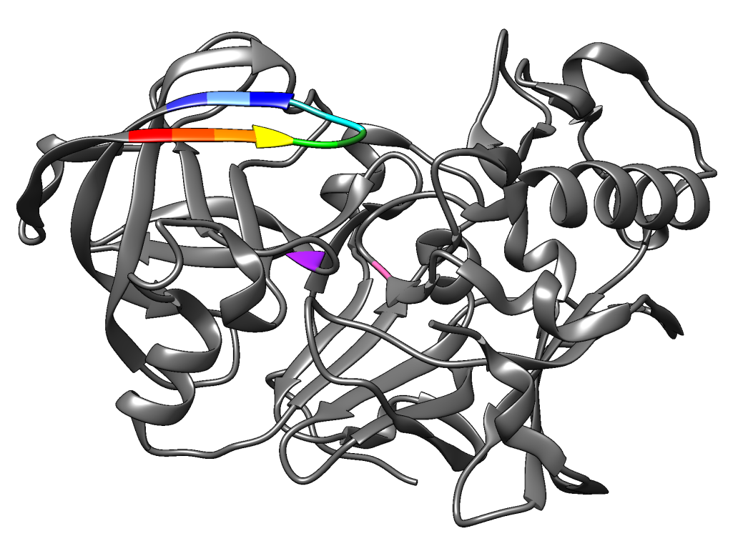
V Y V P Y T Q G K W E
VAL-TYR-VAL-PRO-TYR-THR-GLN-GLY-LYS-TRP-GLU
D32 D228
ASP ASP
FLAP region – Valine 67 to Glutamine 77
Active site residues
FLAP

Figure 1: A 3D ribbon model representation of BACE-1 displaying the ‘flap’ region. The flap region is comprising of a total 11 residues from Val67 to Glu78, that are coloured as red, red-orange, orange, yellow, electric green, forest green, aqua-light, sea green, blue, cornflower blue, Persian blue. The flap region is in the ‘open’ conformation. Moreover, the Asp-dyad residues Asp32 and Asp228 are displayed in color as hot pink and purple.

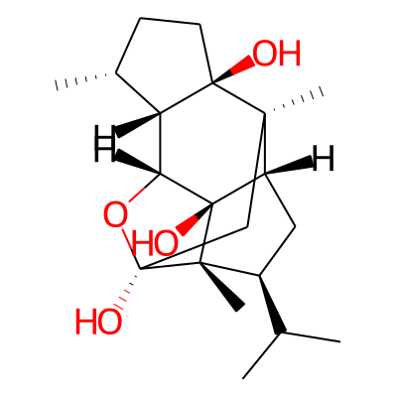
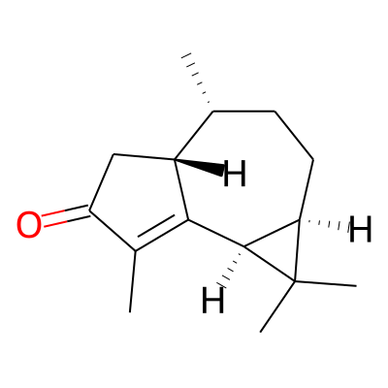
a.
b.

Figure 2: 2D chemical structures of phytocompounds A. Indicol, B. Cyclocolorenone.

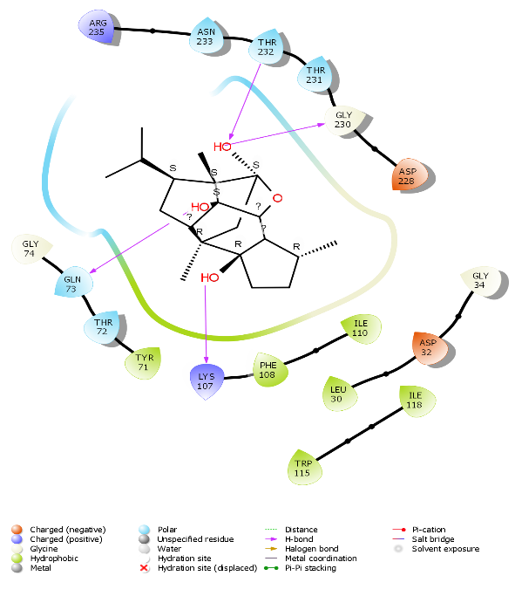
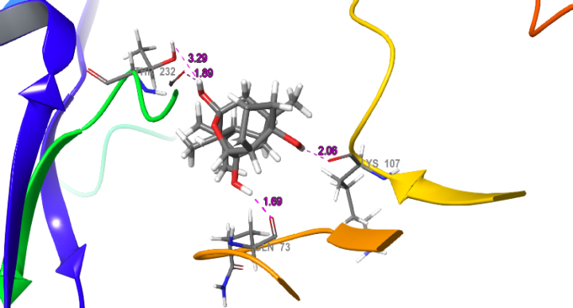
a.
b.

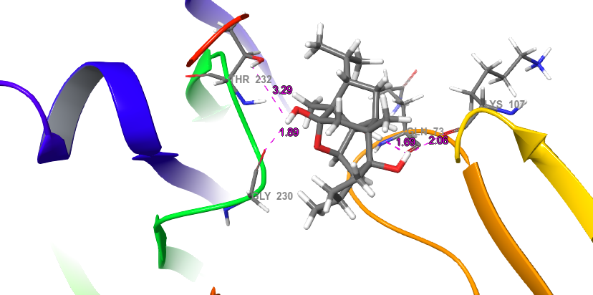
c.

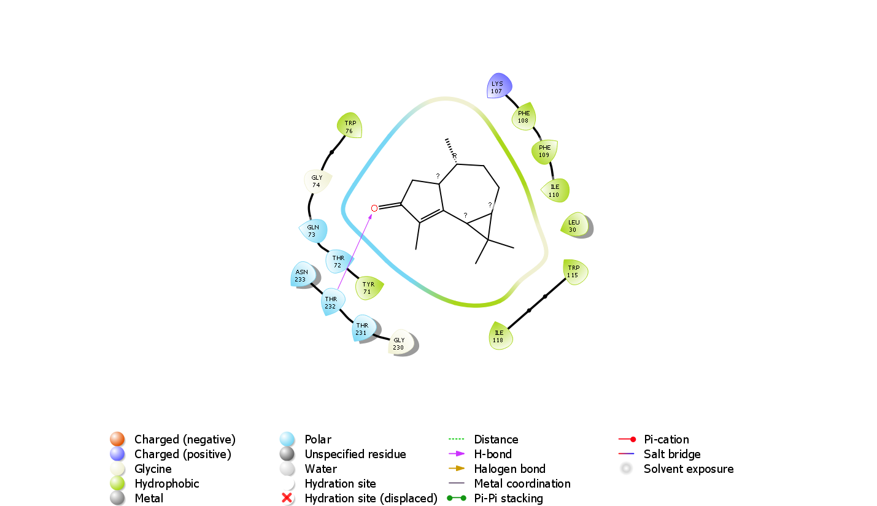
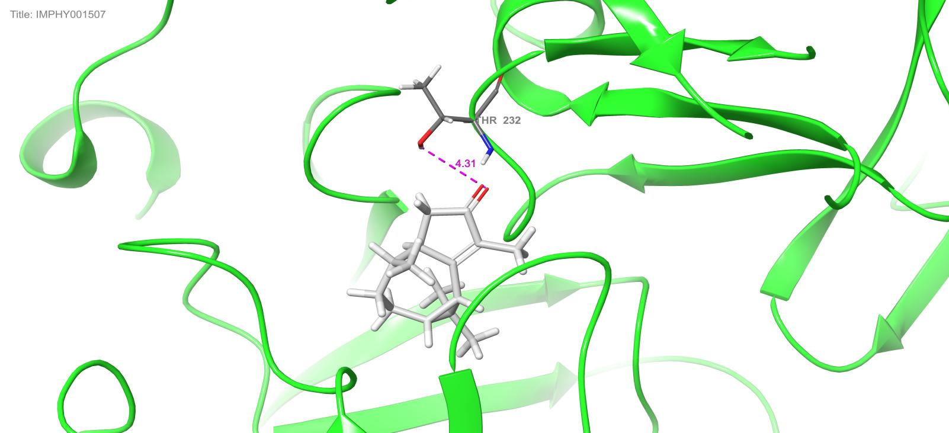
d.
e.

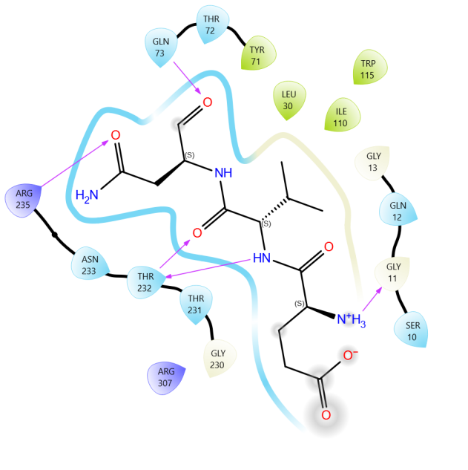
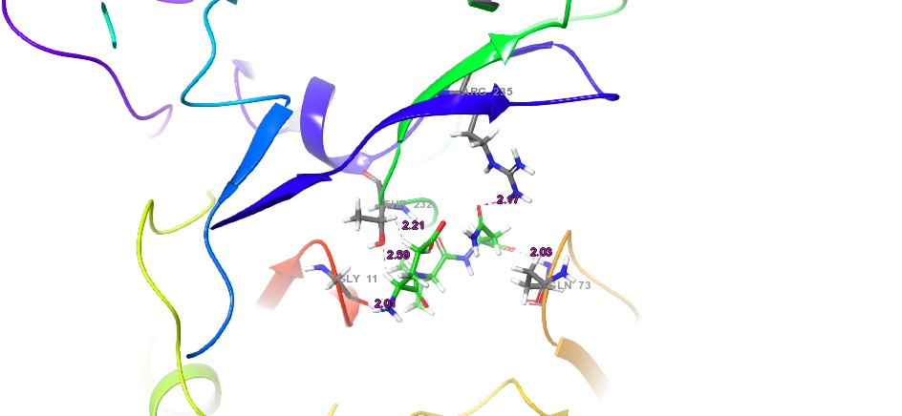
f.
g.

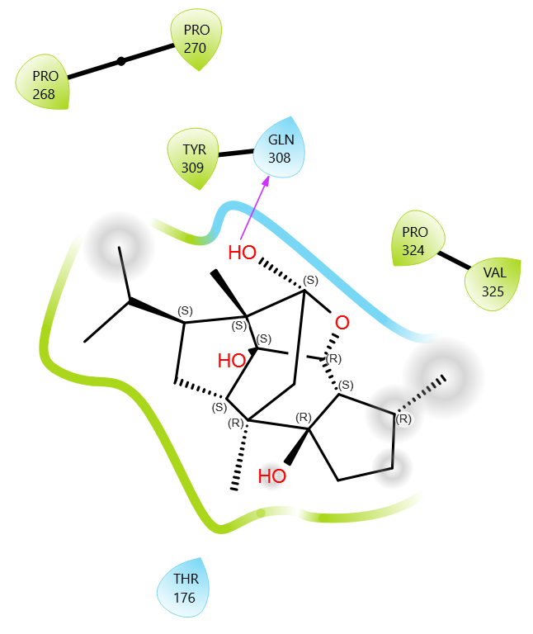
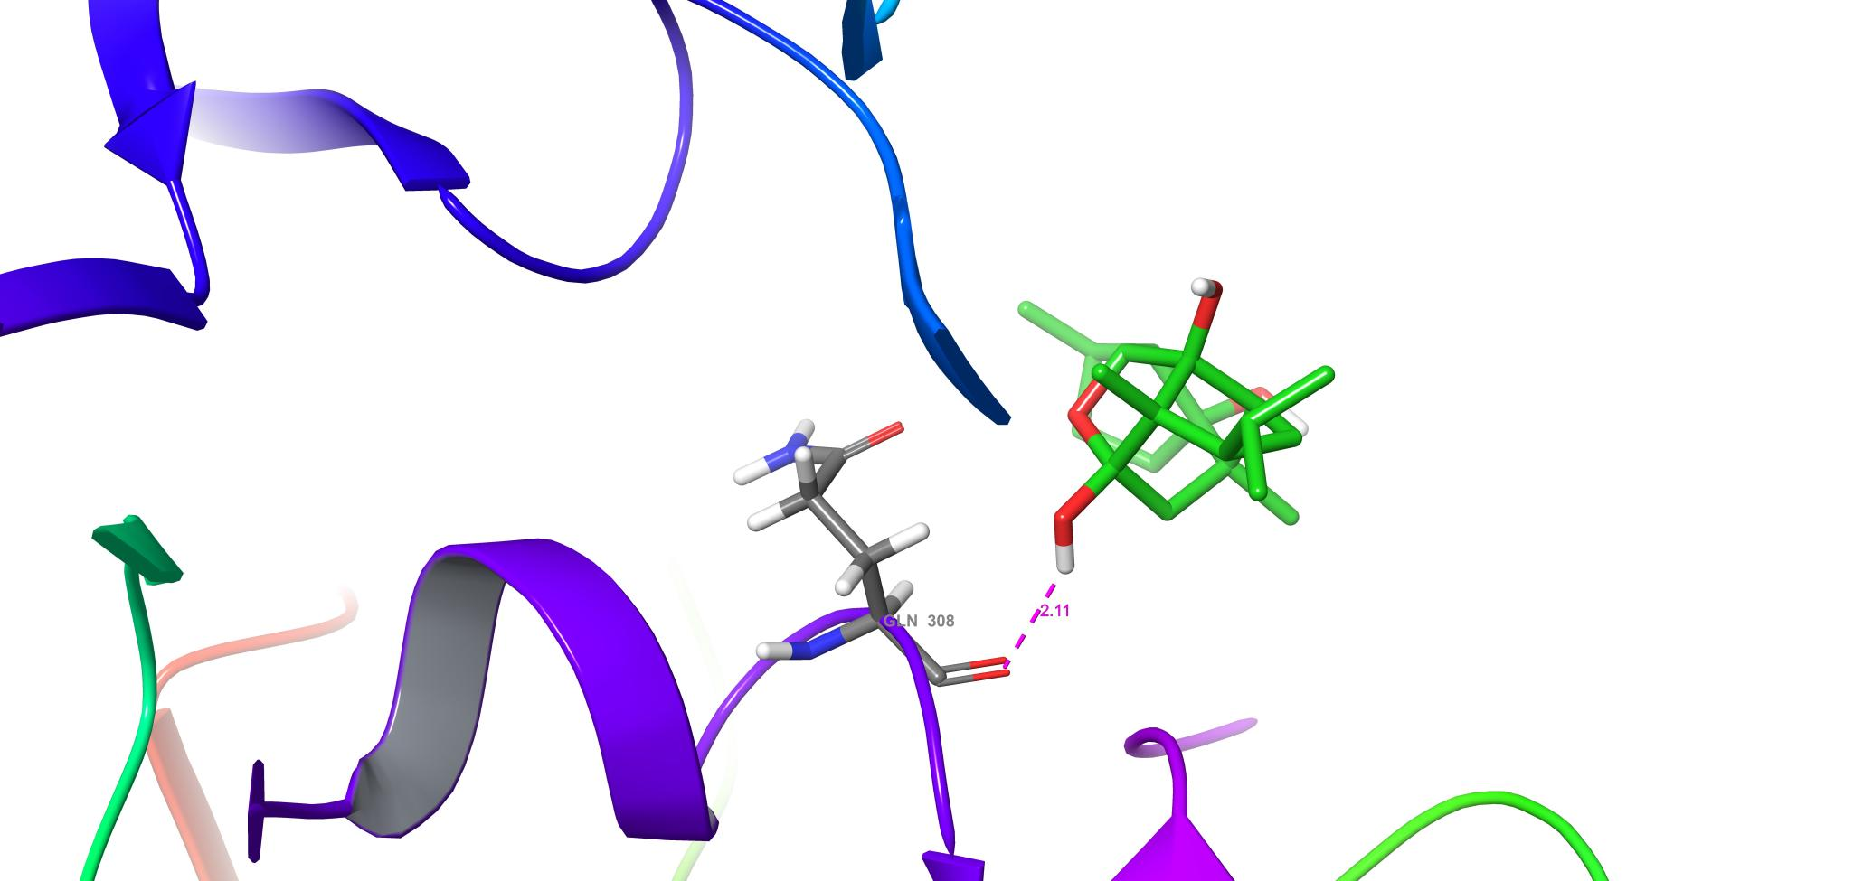
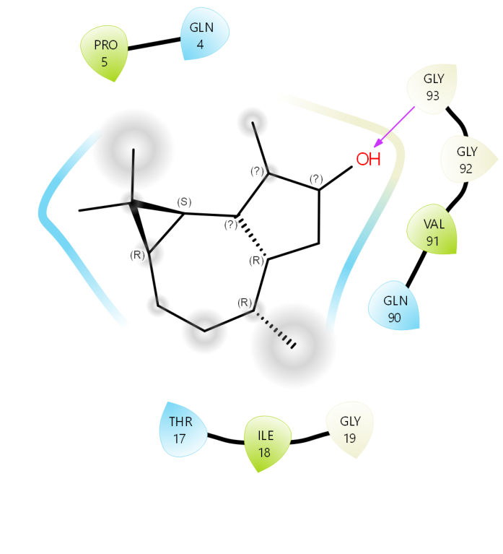
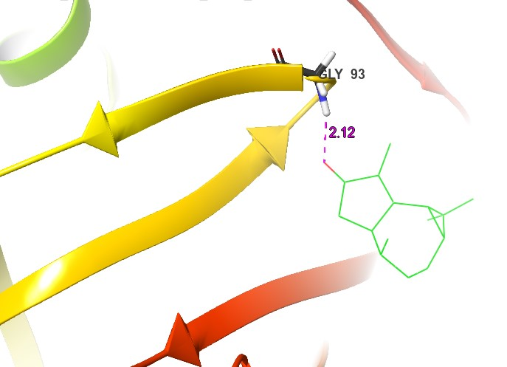
Figure 3: Comparative 2D and 3D Molecular docking results showing interaction along with the bond distances of Indicol and Cyclocolorenone with BACE-1; along with positive and negative controls: 3a. The 2D interaction diagram showing three hydroxyl (OH) groups of Indicol interacting with crucial BACE-1 residues Gln73, Lys107, Gly230 and Thr232. 3b. & 3c. The 3D interaction diagram clarifies the bond distances between Indicol and Gln73, Lys107, Gly230 and Thr232 to be 1.69Ǻ, 2.06Ǻ, 1.89Ǻ and 3.29Ǻ respectively. These bonds signify strong binding affinities of Indicol by binding with four crucial BACE-1 residues required for inhibition. On the other hand, 3d. displays the carbonyl group of Cyclocolorenone forming a hydrogen bond with Thr232. Whereas 3e. shows the bond distance between the carboxyl group and Thr232 to be 4.31Ǻ. Thus, suggesting a weak interaction between Cyclocolorenone and BACE-1. These results were compared against a known BACE-1 inhibitor Verubecestat (positive control) 3f. shows 2D interaction diagram of positive control Verubecestat forming hydrogen bonds with Gly11, Gln73, Thr232 and Arg235 of BACE-1 residues. Consequently 3g. exhibits the 3D interaction diagram of positive control Verubecestat bond distances of Gly11, Gln73, Thr232 and Arg235 to be 2.01Ǻ, 2.03Ǻ, 2.21Ǻ and 2.35Ǻ respectively. The results display Verubecestat binding with two crucial BACE-1 residues as compared to the four crucial residues by Indicol; thereby suggesting weak binding affinity of Verubecestat with BACE-1. 3h. The 2D interaction diagram of the negative control shows Indicol forming a hydrogen bond with pepsin’s non-crucial residue Gln308 and 3i. shows the bond distance of 2.11Ǻ between pepsin and Indicol. Thus, the negative control rules out the possibility of Indicol interfering with other regulating enzymes in the cell. Additionally, the other negative control Cyclocolorenone interaction with pepsin (as shown in Figure 3j) demonstrates hydrogen bond formation between the Cyclocolorenone OH group and Gly 93 of pepsin. The respective bond distance between Cyclocolorenone and Gly93 (shown in Figure 3k) was found to be 2.12Ǻ; thereby clearly stating the fact that Cyclocolorenone was unable to interfere with pepsin functioning in silico.
h.
i.
j.
k.
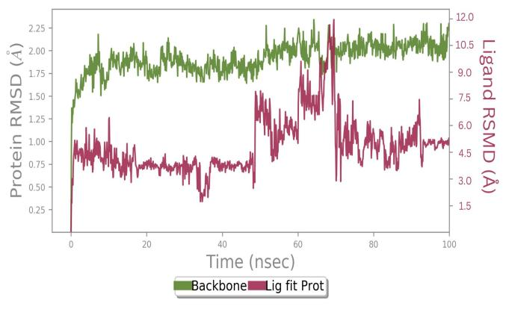
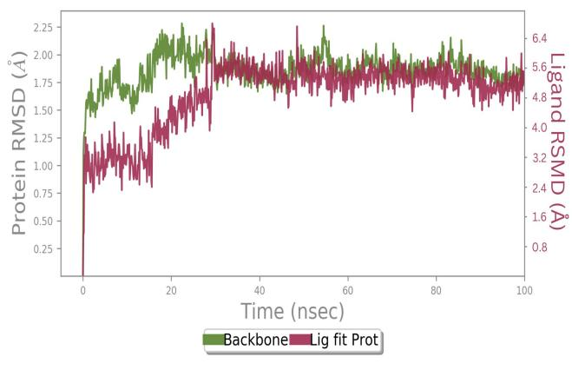
a.
b.
Figure 4: RMSD graph denoting the average displacement between Indicol and Cyclocolorenone with BACE-1 coordinates during MD simulation concerning time: 4a. The RMSD graph represents the quantitative measure of Indicol and BACE-1 for 100ns. This graph also demonstrates a difference of 1.50Å to 2.25Å between Indicol and BACE-1 4b. Show the RMSD graph between Cyclocolorenone and BACE-1 to have a difference between 1.75Å to 2.25Å. Together these graphs point that, Indicol has a better interaction with BACE-1 as compared to Cyclocolorenone.
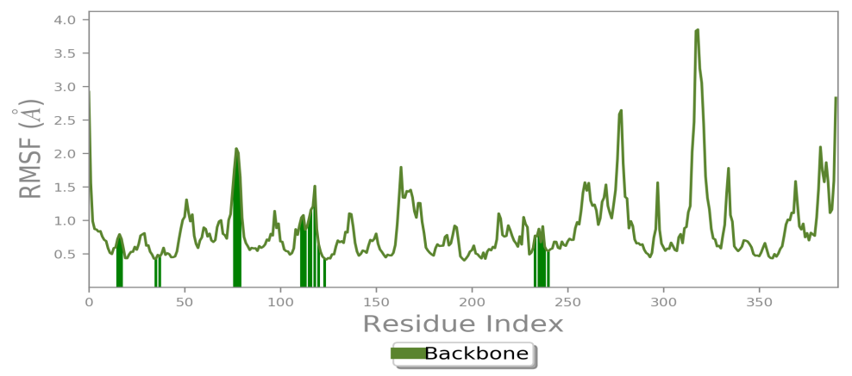
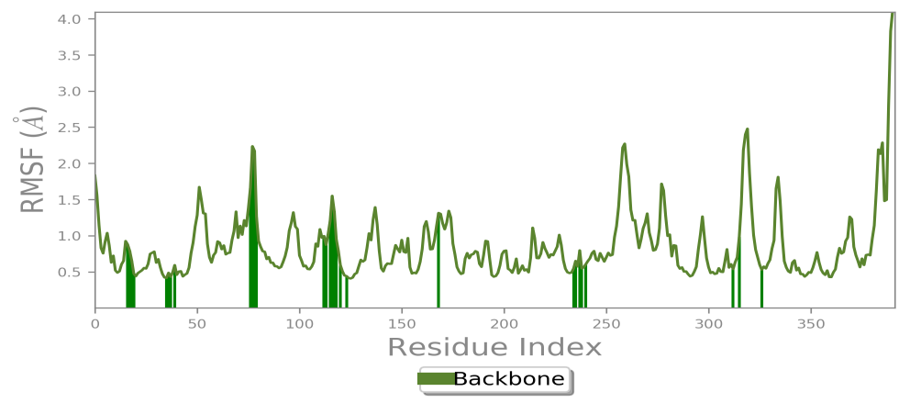
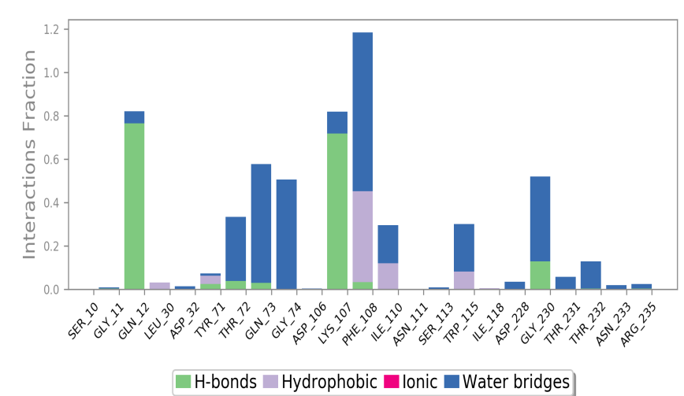
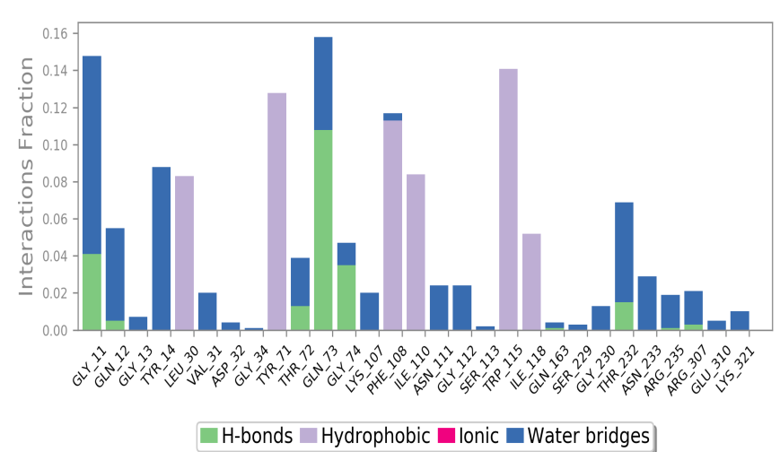
Figure 5: The RMSF plot characterizes the local changes or fluctuations between Indicol and Cyclocolorenone against BACE-1 in MD simulations: The RMSF plot represents the average deviation of Indicol and Cyclocolorenone with BACE-1 residues for 100ns. 5a. The plot shows a fluctuation between Indicol and BACE-1 between 0.5 to 2.0Å. While 5b. shows the fluctuation between Cyclocolorenone and BACE-1 to be between 0.5 to < 2.0Å. A relatively less fluctuation was observed between Indicol and Cyclocolorenone concerning BACE-1.
a.
b.
a.
b.

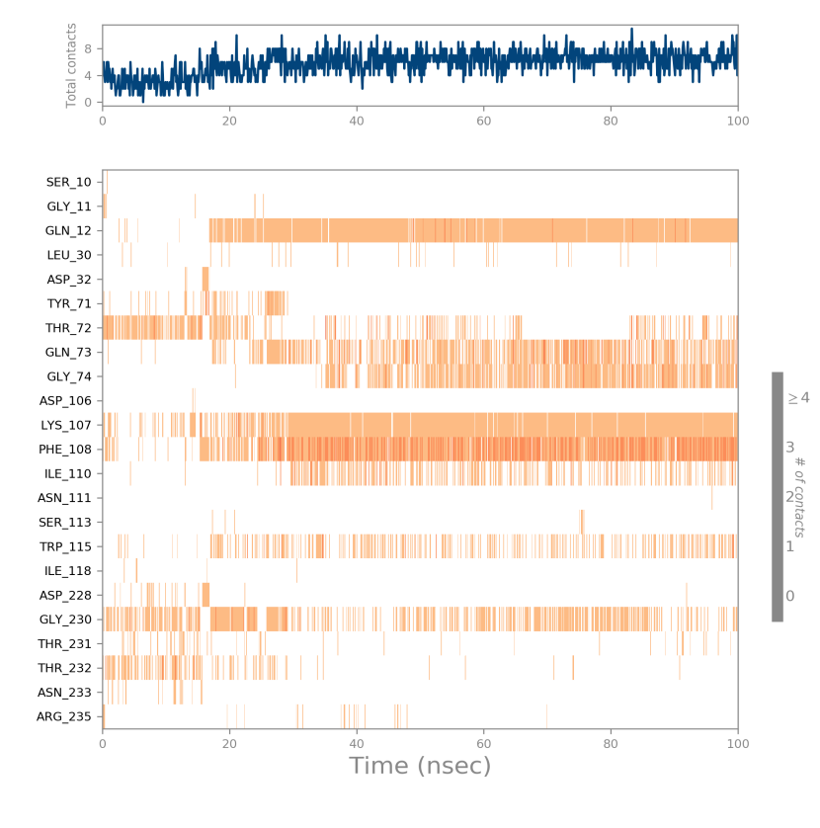
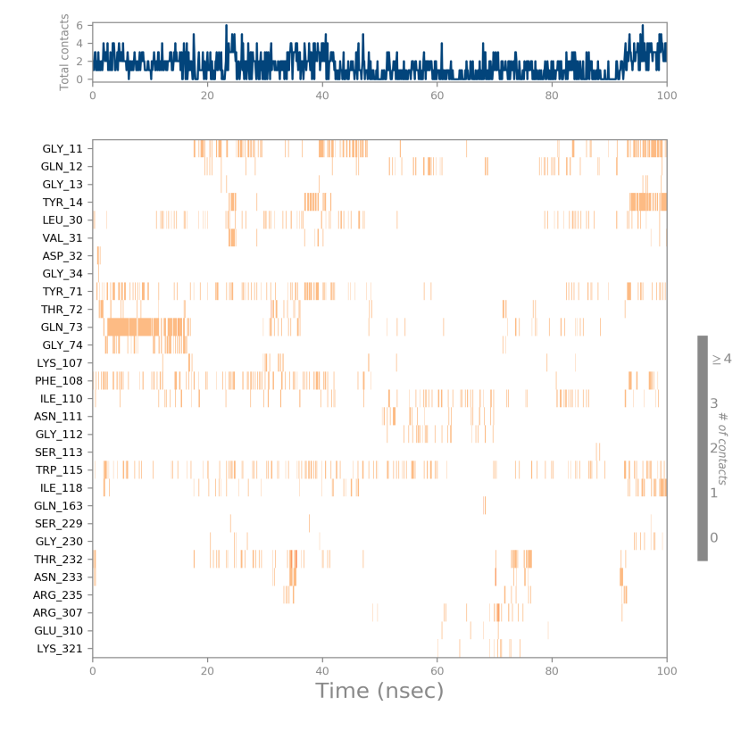
c.
d.
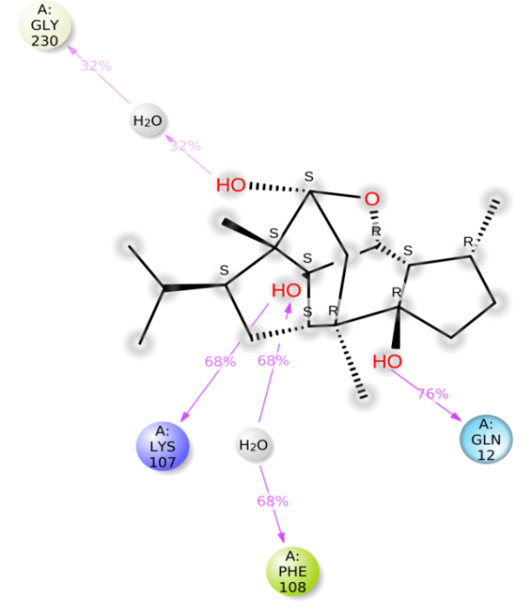
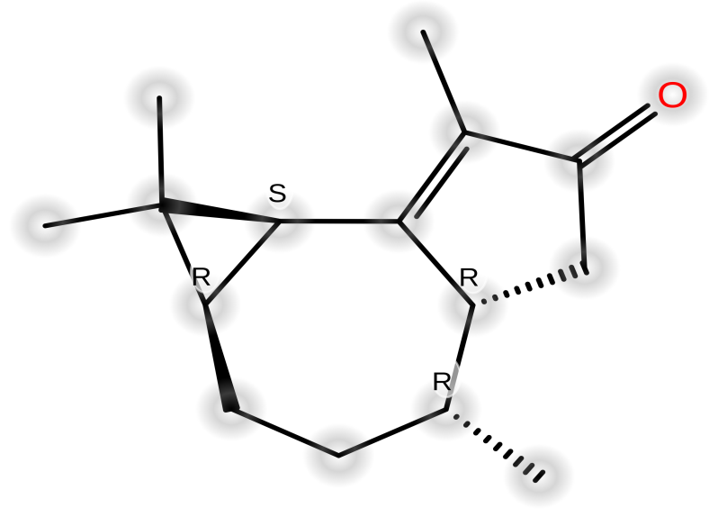
e.
f.

Figure 6: Detailed MD simulation representation of Indicol and Cyclocolorenone interactive groups with crucial BACE-1 residues: The interaction diagram, points of contact, and detailed ligand-protein atomic interaction diagrams further clarify the MD simulation results. 6a. The interaction diagrams show the Indicol ‘OH’ groups interaction fractions of above 1.0 with Phe108 (BACE-1 residue) during the 100ns simulation. Whereas, 6b. showed Cyclocolorenone interacting with BACE-1 residues below the interaction fraction of 1.0. 6c. The top panels of both diagrams represent the points of contact BACE-1 made with Indicol. The bottom panel shows residue interactions of BACE-1 with Indicol. The BACE-1 residues Phe108 (dark orange), Gln12, Lys107 (Orange colour) and Thr72, Gln73, Gly74 and Gly230 (faint orange shade) interacted with Indicol during the 100ns MD simulation. Out of these Gln12, Gln73, Gly74, and Lys107 were found to interact for ~90ns of the simulation run. Similarly 6d. shows Gln73 interacting with Cyclocolorenone for 20ns during the simulation run. 6e. A detailed schematic diagram of ligand–atom interactions with the BACE-1 residues formed hydrogen bonds for 76% (Gln12), 68% (Lys107 and Phe108), and 32% (Gly230) with three OH groups of Indicol during the 100 ns simulation run. On the contrary, 6f. Cyclocolorenone was unable to form any bonds with BACE-1 residues during the simulation run.
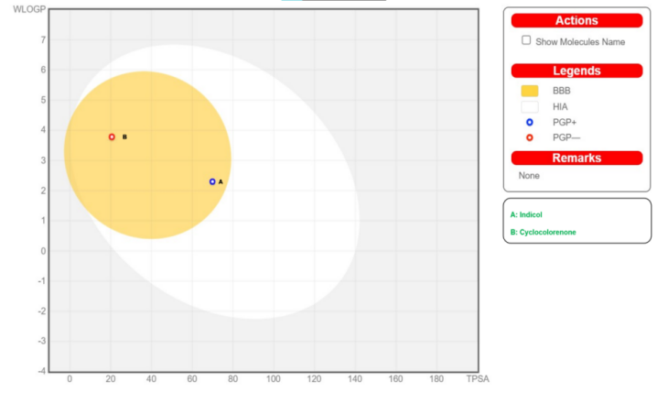
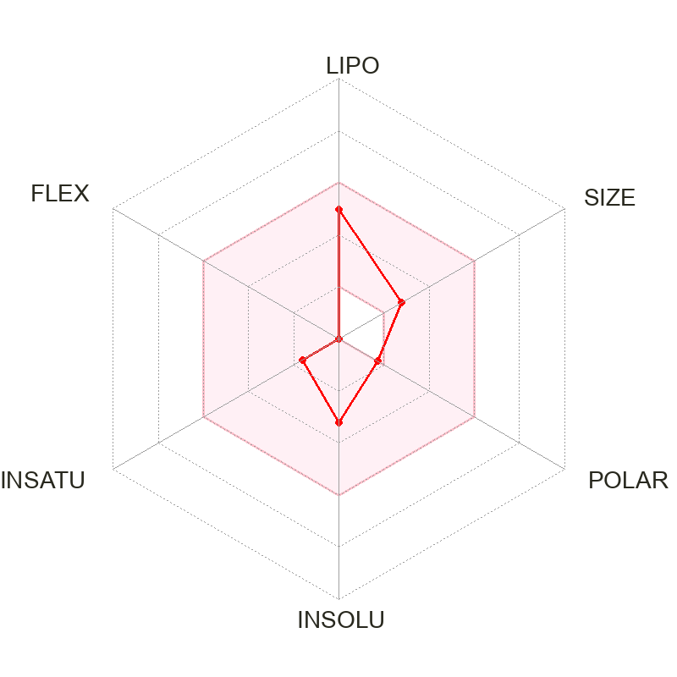
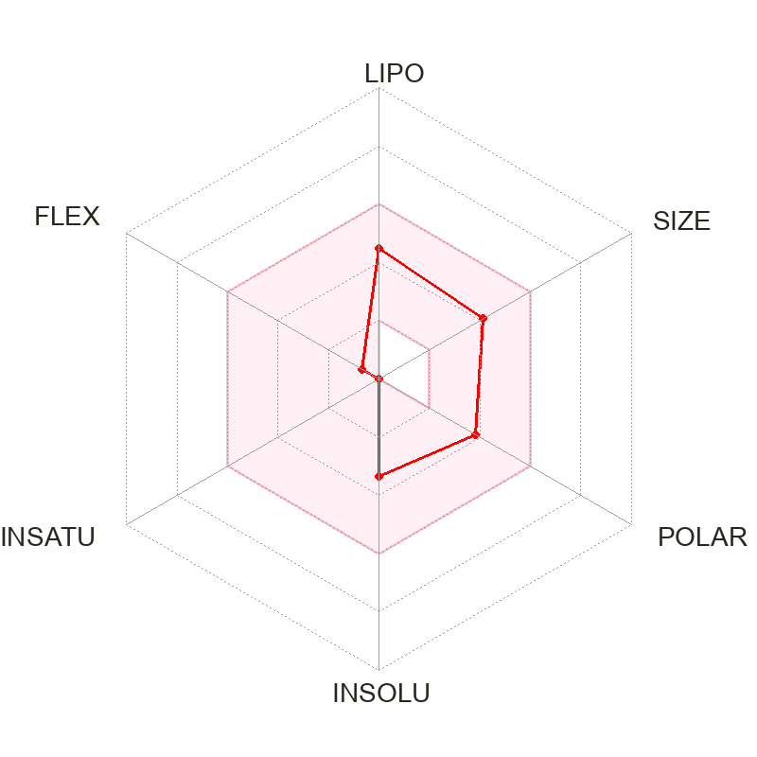
a.
b.
c.

Figure 7: Pharmacokinetic and Drug likeness profile of Indicol and Cyclocolorenone: The ADME/Tox properties, Drug-likeness, and medical chemistry of Indicol and Cyclocolorenone were checked using SwissADME and admeSAR webservices; before proceeding for molecular docking and MD simulation. a. The combined BOILED EGG model of Indicol (Blue dot) and Cyclocolorenone (Red dot) demonstrates that both Indicol and Cyclocolorenone can cross the Blood-brain barrier (Yellow area) while Indicol is potential P-GP substrate, while Cyclocolorenone is a probable non-P-GP substrate. Similarly, b. & c. display the Bio-availability radar plotting the drug-likeness properties of Indicol and Cyclocolorenone. The LIPO (lipophilicity), SIZE (molecular weight), POLAR (polarity), INSOLU (insolubility), INSATU (Instauration), and FLEX (flexibility) properties of both compounds were found in the permissive zones for qualifying them to be administered as therapeutic drugs. It was also observed that both these compounds abide by all the Bioavailability radar parameters. Overall, our ADME/Tox properties qualify Indicol as a possible BACE-1 inhibitor.

Table 1: The molecular docking results showing the top docking score along with the MM/GBSA ΔG binding score of Indicol (−6.65) and Cyclocolorenone (−56.37) respectively.

Phytocompounds | Docking score(kcal/mol) | MMGBSA ΔG(kcal/mol)
Indicol | −6.65 | 7.11
gamma-Eudesmol | −5.32 | −4.27
Guaiol | −4.85 | 12.68
Spathulenol | −4.71 | −53.34
Resorcinol | −4.52 | −25.75
Viridiflorol | −4.47 | −53.10
tau-Cadinol | −4.46 | −35.29
Pogostol | −4.42 | −50.29
Cyclocolorenone | −4.21 | −56.37

Table 2: (Left) Various ADME and (Right) Drug-likeness properties of Indicol and Cyclocolorenone.

Property | Indicol | Cyclocolorenone
Bioavailability score | 0.55 | 0.55
Solubility class [ESOL] | Soluble | Soluble
Solubility class [Silicos-IT] | Soluble | Soluble
Blood Blood-brain barrier permeation | Yes | Yes
Gastrointestinal absorption | High | High
Log Kp (Skin permeation, cm/s) | −6.69 | −5.37
Number of PAINS structural alerts | 0.0 | 0.0
Number of Brenk structural alerts | 0.0 | 0.0
CYP1A2 inhibitor | No | No
CYP2C19 inhibitor | No | Yes
CYP2C9 inhibitor | No | No
CYP2D6 inhibitor | No | No
CYP3A4 inhibitor | No | No
P-glycoprotein substrate | Yes | No
Number of Lipinski’s rule of 5 violations | 0 | 0
Lipinski’s rule of 5 | Passed | Passed
Number of Ghose rule violations | 0 | 0
Ghose rule | Passed | Passed
Veber rule | Good | Good
Egan rule | Good | Good
GSK 4/400 rule | Good | Good
Pfizer 3/75 rule | Bad | Bad
Weighted quantitative estimate of drug-likeness (QEDw) score | 0.69 | 0.61
Molecular weight (g/mol) | 336.47 | 218.34

Table 3: Bioavailability radar showing lipophilicity (XLOGP3), size (MW: molecular weight), polarity (TPSA), insolubility (LogS [ESOL]), Instauration (Fraction Csp3) and flexibility (Number of rotatable bonds) the respective value range and values occurring in Indicol and Cyclocolorenone.
Parameters | Value Range | Indicol | Cyclocolorenone
Lipophilicity | −0.7< XLOGP3< +5.0 | 2.34 | 3.18
Size | 150g/mol< MW< 500 g/mol | 336.47 g/mol | 218.33 g/mol
Polar | 20Å2< TPSA< 130Å2 | 69.92 Å2 | 17.07 Å2
Insolubility | -6< Log S[ESOL]< 0 | −3.33 | −3.20
Instauration | 0.25< Fraction Csp3< 1 | 1.0 | 0.80
Flexibility | 0< Number of rotatable bonds< 9 | 1 | 0

Table 4: A few Toxicity properties such as Ames mutagenesis, acute oral toxicity, biodegradation, carcinogenicity, hepatotoxicity, and nephrotoxicity of Indicol and Cyclocolorenone.
Property | Indicol | Cyclocolorenone
Ames mutagenesis | – | –
Acute oral toxicity | III | III
Biodegradation | – | –
Carcinogenicity | – | –
Hepatotoxicity | – | +
Nephrotoxicity | – | +

COMPETING INTERESTS DISCLAIMER:
Authors have declared that they have no known competing financial interests OR non-financial interests OR personal relationships that could have appeared to influence the work reported in this paper.

References
1. Ferreira, A., Calpain dysregulation in Alzheimer's disease. ISRN Biochem, 2012. 2012: p. 728571.
2. Ravindranath, V. and J.S. Sundarakumar, Changing demography and the challenge of dementia in India. Nat Rev Neurol, 2021. 17(12): p. 747-758.
3. Nandi, A., et al., Global and regional projections of the economic burden of Alzheimer's disease and related dementias from 2019 to 2050: A value of statistical life approach. 2022. 51.
4. Singh, G., et al., The burden of neurological disorders across the states of India: the Global Burden of Disease Study 1990–2019. 2021. 9(8): p. e1129-e1144.
5. Nasb, M., et al., Alzheimer's disease puzzle: delving into pathogenesis hypotheses. 2024. 15(1): p. 43.
6. Hampel, H., et al., The Amyloid-beta Pathway in Alzheimer's Disease. Mol Psychiatry, 2021. 26(10): p. 5481-5503.
7. Sayad, A., et al., The emerging roles of the β-secretase BACE1 and the long non-coding RNA BACE1-AS in human diseases: a focus on neurodegenerative diseases and cancer. 2022. 14: p. 853180.
8. Laird, F.M., et al., BACE1, a major determinant of selective vulnerability of the brain to amyloid-β amyloidogenesis, is essential for cognitive, emotional, and synaptic functions. 2005. 25(50): p. 11693-11709.
9. Ohno, M., et al., BACE1 deficiency rescues memory deficits and cholinergic dysfunction in a mouse model of Alzheimer's disease. 2004. 41(1): p. 27-33.
10. Cheret, C., et al., Bace1 and Neuregulin‐1 cooperate to control formation and maintenance of muscle spindles. 2013. 32(14): p. 2015-2028.
11. Hu, X., et al., BACE1 regulates hippocampal astrogenesis via the Jagged1-Notch pathway. 2013. 4(1): p. 40-49.
12. Savonenko, A., et al., Alteration of BACE1-dependent NRG1/ErbB4 signaling and schizophrenia-like phenotypes in BACE1-null mice. 2008. 105(14): p. 5585-5590.
13. Hitt, B.D., et al., BACE1-/-mice exhibit seizure activity that does not correlate with sodium channel level or axonal localization. 2010. 5: p. 1-14.
14. Cai, J., et al., β‐Secretase (BACE1) inhibition causes retinal pathology by vascular dysregulation and accumulation of age pigment. 2012. 4(9): p. 980-991.
15. Harrison, S.M., et al., BACE1 (β-secretase) transgenic and knockout mice: identification of neurochemical deficits and behavioral changes. 2003. 24(3): p. 646-655.
16. Das, B. and R. Yan, A Close Look at BACE1 Inhibitors for Alzheimer's Disease Treatment. CNS Drugs, 2019. 33(3): p. 251-263.
17. Atanasov, A.G., et al., Discovery and resupply of pharmacologically active plant-derived natural products: A review. Biotechnology advances, 2015. 33(8): p. 1582-1614.
18. Ayaz, M., et al., Natural products-based drugs: potential therapeutics against Alzheimer’s disease and other neurological disorders. 2019, Frontiers Media SA: Frontiers in Pharmacology. p. 1417.
19. Ramasamy, S., et al., In Silico and In Vitro Analysis of Bacoside A Aglycones and Its Derivatives as the Constituents Responsible for the Cognitive Effects of Bacopa monnieri. PLoS One, 2015. 10(5): p. e0126565.
20. Jose, S., et al., Surface modified PLGA nanoparticles for brain targeting of Bacoside-A. Eur J Pharm Sci, 2014. 63: p. 29-35.
21. Gianfredi, V., et al., Sulforaphane and Epigallocatechin Gallate Restore Estrogen Receptor Expression by Modulating Epigenetic Events in the Breast Cancer Cell Line MDA-MB-231: A Systematic Review and Meta-Analysis. J Nutrigenet Nutrigenomics, 2017. 10(3-4): p. 126-135.
22. Zhang, Y. and H. Chen, Genistein, an epigenome modifier during cancer prevention. Epigenetics, 2011. 6(7): p. 888-91.
23. Gao, Y. and T.O. Tollefsbol, Combinational Proanthocyanidins and Resveratrol Synergistically Inhibit Human Breast Cancer Cells and Impact Epigenetic(-)Mediating Machinery. Int J Mol Sci, 2018. 19(8).
24. Young-Ho Kim, D.-H.L., Jae-Hoon Jeong, Zong Sheng Guo, and Yong J. Lee, Quercetin augments TRAIL-induced apoptotic death involvement of the ERK signal transduction pathway. Biochem Pharmacol., 2008. 75(10): p. 1946–1958.
25. Vareed, S.K., et al., Blood–brain barrier permeability of bioactive withanamides present in Withania somnifera fruit extract. 2014. 28(8): p. 1260-1264.
26. Thakur, V.S., et al., Plant phytochemicals as epigenetic modulators: role in cancer chemoprevention. AAPS J, 2014. 16(1): p. 151-63.
27. Desai, A.G., et al., Medicinal plants and cancer chemoprevention. 2008. 9(7): p. 581-591.
28. Kumar, M., et al., Mango (Mangifera indica L.) leaves: Nutritional composition, phytochemical profile, and health-promoting bioactivities. Antioxidants, 2021. 10(2): p. 299.
29. El-Sayyad, S.M., et al., Mangiferin protects against intestinal ischemia/reperfusion-induced liver injury: ‬‬Involvement of PPAR-gamma, GSK-3beta and Wnt/beta-catenin pathway‬‬‬‬‬‬‬‬‬‬‬‬‬‬‬‬‬‬‬‬‬‬‬‬‬‬‬‬‬‬‬‬‬‬‬‬‬‬‬‬‬‬‬‬‬‬‬‬. Eur J Pharmacol, 2017. 809: p. 80-86.‬‬‬‬‬‬‬‬‬‬‬‬‬‬‬
30. Al Omairi, N.E., et al., Neuroprotective efficiency of Mangifera indica leaves extract on cadmium-induced cortical damage in rats. Metab Brain Dis, 2018. 33(4): p. 1121-1130.
31. Yap, K.M., et al., Mangifera indica (Mango): A Promising Medicinal Plant for Breast Cancer Therapy and Understanding Its Potential Mechanisms of Action. Breast Cancer (Dove Med Press), 2021. 13: p. 471-503.
32. Temviriyanukul, P., et al., Mangifera indica 'Namdokmai' Prevents Neuronal Cells from Amyloid Peptide Toxicity and Inhibits BACE-1 Activities in a Drosophila Model of Alzheimer's Amyloidosis. Pharmaceuticals (Basel), 2022. 15(5).
33. Fernández-Ponce, M.T., et al., Use of high pressure techniques to produce Mangifera indica L. leaf extracts enriched in potent antioxidant phenolic compounds. Innovative Food Science & Emerging Technologies, 2015. 29: p. 94-106.
34. Sangeetha, K.N., et al., 3beta-taraxerol of Mangifera indica, a PI3K dependent dual activator of glucose transport and glycogen synthesis in 3T3-L1 adipocytes. Biochim Biophys Acta, 2010. 1800(3): p. 359-66.
35. Sawale, S., et al., Ferulic Acid as a Potential Drug for Neurological Disorder: An In silico Approach. Asian Journal of Biochemistry, Genetics and Molecular Biology, 2025. 17(3): p. 52-67.
36. Vivek-Ananth, R., et al., IMPPAT 2.0: an enhanced and expanded phytochemical atlas of Indian medicinal plants. ACS omega, 2023. 8(9): p. 8827-8845.
37. Rose, P.W., et al., The RCSB Protein Data Bank: new resources for research and education. Nucleic Acids Res, 2013. 41(Database issue): p. D475-82.
38. Daina, A., O. Michielin, and V. Zoete, SwissADME: a free web tool to evaluate pharmacokinetics, drug-likeness and medicinal chemistry friendliness of small molecules. Sci Rep, 2017. 7: p. 42717.
39. Iwaloye, O., et al., In silico molecular studies of natural compounds as possible anti-Alzheimer’s agents: ligand-based design. Network Modeling Analysis in Health Informatics and Bioinformatics, 2020. 9: p. 1-14.
40. Consortium, U., UniProt: a hub for protein information. Nucleic acids research, 2015. 43(D1): p. D204-D212.
41. Chidambaram, K., Identification of BACE-1 Inhibitors against Alzheimer’s Disease through E-Pharmacophore-Based Virtual Screening and Molecular Dynamics Simulation Studies: An Insilco Approach. Life, 2023. 13(4): p. 952.
42. Pattar, S.V., et al., In silico molecular docking studies and MM/GBSA analysis of coumarin-carbonodithioate hybrid derivatives divulge the anticancer potential against breast cancer. Beni-Suef University Journal of Basic and Applied Sciences, 2020. 9(1).
43. Kumar, S., et al., Discovery of new hydroxyethylamine analogs against 3CLpro protein target of SARS-CoV-2: Molecular docking, molecular dynamics simulation, and structure–activity relationship studies. Journal of Chemical Information Modeling, 2020. 60(12): p. 5754-5770.
44. Contreras-Puentes, N., J. Mercado-Camargo, and A. Alvíz-Amador, In silico study of ginsenoside analogues as possible BACE1 inhibitors involved in Alzheimer's disease. F1000Research, 2019. 8.
45. Nagu, P., et al., Identification of Herbal Molecules for the Treatment of Alzheimer's Disease Through a Combination of Molecular Docking and In-Vitro Analysis. 2023. 82(05): p. 504-514.
46. Ion, G.N.D., et al., Application of molecular framework-based data-mining method in the search for beta-secretase 1 inhibitors through drug repurposing. 2019.
47. Sheokand, D., et al., Molecular docking analysis of marine phytochemicals with BACE-1. 2024. 20(2): p. 151.
48. Silva-Junior, E.F., et al., Dynamic Simulation, Docking and DFT Studies Applied to a Set of Anti-Acetylcholinesterase Inhibitors in the enzyme β-Secretase (BACE-1): An Important Therapeutic Target in Alzheimer's Disease. Current Computer-Aided Drug Design, 2017. 13(4): p. 1-1.
49. Goel, S. and Y. Kumar, Assessing Inhibitory potential of natural compounds against BACE1 in Alzheimer's disease: A molecular docking and molecular dynamics simulation approach. Indian Journal of Biochemistry Biophysics, 2024. 61(6): p. 345-353.
50. Mishra, V. and C.J.I.j.o.b.m. Pathak, Human Toll-Like Receptor 4 (hTLR4): Structural and functional dynamics in cancer. 2019. 122: p. 425-451.
51. Kennedy, M.E., et al., The BACE1 inhibitor verubecestat (MK-8931) reduces CNS β-amyloid in animal models and in Alzheimer’s disease patients. Science translational medicine, 2016. 8(363): p. 363ra150-363ra150.
52. Fu, Z., et al., Marked difference in efficiency of the digestive enzymes pepsin, trypsin, chymotrypsin, and pancreatic elastase to cleave tightly folded proteins. Biological Chemistry, 2021. 402(7): p. 861-867.
53. Zhang, X., H. Perez-Sanchez, and F. C. Lightstone, A comprehensive docking and MM/GBSA rescoring study of ligand recognition upon binding antithrombin. Current topics in medicinal chemistry, 2017. 17(14): p. 1631-1639.
54. Godschalk, F., et al., Comparison of MM/GBSA calculations based on explicit and implicit solvent simulations. Physical Chemistry Chemical Physics, 2013. 15(20): p. 7731-7739.
55. Khanna, S., et al., An integrated network pharmacology and molecular modelling study of phytoconstituents targeting Alzheimer's disease. Medicine in Omics, 2024. 12: p. 100031.
56. Singh, S. and V.K. Singh, Molecular dynamics simulation: methods and application. Frontiers in protein structure, function,, 2020: p. 213-238.
57. Sukanya, S., et al., Structure-based virtual screening, biological assessment, and MD simulation studies of novel CNS compatible GSK-3β inhibitors as potential Alzheimer’s disease therapeutics. 2022.
58. Paul, A., et al., Computational simulations reveal the synergistic action of phytochemicals of Morus alba to exert anti-Alzheimer activity via inhibition of acetylcholinesterase and glycogen synthase kinase-3β. Polycyclic Aromatic Compounds, 2024. 44(5): p. 3476-3500.
59. Naik, S.R., et al., Structure-based virtual screening, molecular dynamics and binding affinity calculations of some potential phytocompounds against SARS-CoV-2. Journal of Biomolecular Structure Dynamics, 2022. 40(15): p. 6921-6938.
60. van de Waterbeemd, H. and E. Gifford, ADMET in silico modelling: towards prediction paradise? Nat Rev Drug Discov, 2003. 2(3): p. 192-204.
61. Nadh, A.G., et al., Identification of potential lead compounds against BACE1 through in-silico screening of phytochemicals of Medhya rasayana plants for Alzheimer's disease management. Comput Biol Med, 2022. 145: p. 105422.
62. Raafat, K., Identification of phytochemicals from North African plants for treating Alzheimer’s diseases and of their molecular targets by in silico network pharmacology approach. Journal of traditional complementary medicine, 2021. 11(3): p. 268-278.
63. Jamal, Q.M.S., et al., Identification of natural compounds of the apple as inhibitors against cholinesterase for the treatment of Alzheimer’s disease: an in silico molecular docking simulation and ADMET study. Nutrients, 2023. 15(7): p. 1579.
64. Ritchie, T.J., P. Ertl, and R. Lewis, The graphical representation of ADME-related molecule properties for medicinal chemists. Drug Discov Today, 2011. 16(1-2): p. 65-72.
65. Alshehri, S.A., S. Wahab, and M.A.A. Almoyad, In silico identification of potential protein kinase C alpha inhibitors from phytochemicals from IMPPAT database for anticancer therapeutics: a virtual screening approach. Journal of Biomolecular Structure and Dynamics, 2023: p. 1-12.
66. Thakur, L., P. Vadhera, and N. Yadav, Combating SARS-COV-19 by phytochemicals: an in silico study. Innovare Journal of Life Sciences, 2020. 8(4): p. 1-4.
67. Randhawa, V., S. Pathania, and M. Kumar, Computational Identification of Potential Multitarget Inhibitors of Nipah Virus by Molecular Docking and Molecular Dynamics. Microorganisms, 2022. 10(6).
68. Alrouji, M., et al., Identifying β-secretase 1 (BACE1) inhibitors from plant-based compounds: an approach targeting Alzheimer’s therapeutics employing molecular docking and dynamics simulation. Molecular Diversity, 2023.
69. Mukerjee, N., et al., Repurposing food molecules as a potential BACE1 inhibitor for Alzheimer’s disease. Frontiers in Aging Neuroscience, 2022. 14.
70. Scotti, L., et al., Challenges and Discoveries in Polypharmacology of Neurodegenerative Diseases. Current Topics in Medicinal Chemistry, 2023. 23(5): p. 349-370.
71. Wei, C.R., et al., Repurposing Alzheimer’s Therapeutics: A Computational Approach To Identifying Potential SARS-Cov-2 Mpro Inhibitors. NeuroQuantology, 2023. 21(7): p. 816.
72. Eshak, D. and M. Arumugam, Unveiling Therapeutic Biomarkers and Druggable Targets in ALS: An Integrative Microarray Analysis, Molecular docking, and Structural Dynamics studies. Computational Biology and Chemistry, 2024: p. 108211.
73. Revanasiddappa, B., et al., An In-silico Approach: Design, Homology Modeling, Molecular Docking, MM/GBSA Simulations, and ADMET Screening of Novel 1,3,4-oxadiazoles as PLK1inhibitors. Current Drug Research Reviews, 2023. 15(1): p. 88-100.
74. Choudhary, M.I., et al., In silico identification of potential inhibitors of key SARS-CoV-2 3CL hydrolase (Mpro) via molecular docking, MMGBSA predictive binding energy calculations, and molecular dynamics simulation. Plos one, 2020. 15(7): p. e0235030.
75. Dhameliya, T.M., P.R. Nagar, and N.D.J.M.D. Gajjar, Systematic virtual screening in search of SARS CoV-2 inhibitors against spike glycoprotein: pharmacophore screening, molecular docking, ADMET analysis and MD simulations. Molecular Diversity, 2022. 26(5): p. 2775-2792.
76. Xu, Y., et al., Flexibility of the flap in the active site of BACE1 as revealed by crystal structures and molecular dynamics simulations. Acta Crystallogr D Biol Crystallogr, 2012. 68(Pt 1): p. 13-25.
77. Chakraborty, S., S. Kumar, and S. Basu, Conformational transition in the substrate binding domain of beta-secretase exploited by NMA and its implication in inhibitor recognition: BACE1-myricetin a case study. Neurochem Int, 2011. 58(8): p. 914-23.
78. Mouchlis, V.D., et al., Computer-Aided Drug Design of beta-Secretase, gamma-Secretase and Anti-Tau Inhibitors for the Discovery of Novel Alzheimer's Therapeutics. Int J Mol Sci, 2020. 21(3).
79. Huang, B.J.I.o.L.B.S. and P.-P.I. Area, Identification of pockets on protein surface to predict protein–ligand binding sites. 2013: p. 25-39.
80. Panigrahi, S.K. and G.R. Desiraju, Strong and weak hydrogen bonds in the protein-ligand interface. Proteins, 2007. 67(1): p. 128-141.
81. Gioia, D., et al., Dynamic docking: a paradigm shift in computational drug discovery. 2017. 22(11): p. 2029.
82. Moussa-Pacha, N.M., et al., BACE1 inhibitors: Current status and future directions in treating Alzheimer's disease. Med Res Rev, 2020. 40(1): p. 339-384.
83. Ahsan, M.J., et al., Molecular properties prediction and synthesis of novel 1,3,4-oxadiazole analogues as potent antimicrobial and antitubercular agents. Bioorg Med Chem Lett, 2011. 21(24): p. 7246-50.
84. Azam, F., et al., Ginger components as new leads for the design and development of novel multi-targeted anti-Alzheimer’s drugs: A computational investigation. Drug design, development therapy, 2014: p. 2045-2059.

