Postbiotics as Emerging Functional Biotics: Production Strategies, Mechanisms of Action, Characterization and Therapeutic Applications

ABSTRACT

Background

Functional biotics have gained increasing attention in biotechnology and health sciences due to their ability to modulate host physiology and microbial balance. Among these, postbiotics represent non-viable microbial products and metabolites generated during fermentation that offer enhanced stability and safety compared to live probiotic preparations. The growing interest in postbiotics highlights the need for a comprehensive understanding of their production strategies, characterization approaches, biological mechanisms, and potential applications.

Methods

This work presents an integrated overview of postbiotic production derived from microbial fermentation, followed by separation and inactivation processes to obtain bioactive preparations. Characterization techniques included physicochemical analysis, protein and peptide estimation, and structural profiling using spectroscopic methods. Bioactivity evaluation focused on antimicrobial, antioxidant, anti-inflammatory, metabolic, and immunomodulatory properties. The manuscript also summarizes sources, biochemical composition, molecular mechanisms, and technological advantages relevant to pharmaceutical, nutraceutical, and cosmetic applications.

Results

Postbiotics were found to contain diverse bioactive components such as organic acids, peptides, polysaccharides, enzymes, and cell wall fragments that contribute to multiple functional effects. Mechanistic insights revealed modulation of epithelial barrier integrity, immune signaling pathways, oxidative stress responses, and gut–brain and gut–liver axis communication. Compared with live probiotics, postbiotics demonstrated improved stability, longer shelf life, and reduced safety concerns, making them suitable for industrial formulation and clinical translation.

Conclusion

Postbiotics represent a promising next-generation functional biotic with broad applications across biotechnology and health sectors. Advances in fermentation technology, molecular characterization, and precision engineering are expected to accelerate the development of targeted postbiotic formulations for therapeutic and functional food applications.
Keywords:
Postbiotics; Functional biotics; Microbial metabolites; Fermentation biotechnology; Bioactive compounds; Therapeutic applications.

1. INTRODUCTION
Postbiotics—bioactive substances produced through probiotic metabolism—are emerging as a viable option for treating chronic conditions without relying on live microbes (Asefa, Z et al., 2025). They represent a key advancement in biotherapeutics, delivering both therapeutic and prophylactic benefits in contemporary medicine. The connection between diet and well-being dates to Hippocrates around 400 B.C., who wisely stated, “Let food be thy medicine and medicine be thy food” (Calvanese, C. M et al., 2025). Today, we are witnessing a renewed appreciation for nutrition's vital role in disease prevention and treatment.
Consumers today increasingly favour health-oriented foods, driven by heightened awareness of how diet influences well-being (Ge, S et al., 2024). This shift has boosted the market for functional foods like probiotics, prebiotics, and synbiotics—terms that lack a single standardized definition. Probiotics deliver live microbes that support intestinal health, while prebiotics serve as substrates fermented by gut bacteria to yield comparable advantages (Condurso, C et al., 2025; Chikindas, M. L et al., 2025b). Synbiotics pair probiotics with prebiotics to boost the viability and function of helpful microbes in the digestive system, thereby enhancing overall health.
Paraprobiotics involve inactivated bacterial cells that retain probiotic-like benefits despite lacking viability. Metabiotics, though less defined, typically denote valuable metabolites from probiotic fermentation. A rising focus is on postbiotics, which arise from non-viable microbial cells or their extracts and show promise in food and pharmaceutical applications.
Unlike probiotics, postbiotics eliminate the need for live cells in end products, despite stemming from microbial origins (Molina, D et al., 2025). They include diverse bioactive agents—such as short-chain fatty acids, exopolysaccharides, enzymes, peptides, teichoic acids, and cell-wall components—that trigger physiological, immune, neurohormonal, and metabolic responses (Chikindas, M. L et al., 2025b). These exhibit antimicrobial, antioxidant, and immune-regulating effects, positioning them as stable, secure substitutes for live probiotics (Meena, K. K et al 2025).
Postbiotics comprise non-living microbial cells, fragments, or fermentation-derived metabolites, presenting a strong alternative to conventional probiotics and prebiotics (Tong Y et al., 2025). While probiotics garner much attention, postbiotics receive less scrutiny for their clinical value and formulation benefits, including excellent shelf life (stable at ≤25°C for ≥12 months) and safety in vulnerable groups, supported by in vitro studies and Phase I trials (Mafe, A. N et al., 2025).
This review paper focuses on the emerging role of postbiotics as next-generation functional biotics, highlighting their sources, bioactive components, production strategies, characterization methods, mechanisms of action, and potential applications in pharmaceutical, nutraceutical, and cosmetic fields. It also discusses current advantages, limitations, and future perspectives to support the development of safe and effective postbiotic-based formulations.

2. PREBIOTICS, PROBIOTICS AND POSTBIOTICS
Postbiotics, prebiotics, and probiotics each offer unique benefits in functional foods and therapeutics, but they differ markedly in composition, stability, and application (Mafe, A. N et al., 2025). Table 1 below compares probiotics (live microbes), prebiotics (non-digestible substrates) and postbiotics (non-viable metabolites), highlighting their definitions, mechanisms, advantages, and limitations to underscore postbiotics' edge in safety and shelf life for managing chronic conditions like metabolic syndrome (Amobonye, A et al., 2025; Calvanese, C. M et al., 2025).

Table 1: Comparative Overview of Probiotics, Prebiotics and Postbiotics

Feature | Probiotics | Prebiotics | Postbiotics
Concept | Living microorganisms that support host health when consumed in adequate amounts | Non-digestible substrates that selectively stimulate beneficial microbiota | Bioactive microbial metabolites or non-viable cellular components produced during fermentation
Biological  Nature | Viable bacteria or yeasts | Dietary fibers and functional carbohydrates | Organic acids, SCFAs, peptides, enzymes, EPS, teichoic acids, vitamins
Viability Requirement | Essential | Not applicable | Not required
Primary  Functional Components | Whole microbial cells (Lactobacillus, Bifidobacterium, yeast) | Inulin, FOS, GOS, resistant starch, oligosaccharides | Butyrate, acetate, bacteriocins, phenylactic acid, cell wall fragments
Mode of Action | Colonization, competitive exclusion, metabolic activity | Selective fermentation promoting beneficial bacteria growth | Direct signaling via metabolites; immune and metabolic pathway modulation
Interaction with  Gut Microbiota | Direct microbial interaction and temporary colonization | Acts as nutrient source for microbiota | Alters microbial environment without colonization
Stability  During  Processing | Sensitive to heat, oxygen, and gastric acidity | Highly stable chemical compounds | Highly stable; resistant to temperature and pH variations
Shelf Life | Limited; requires controlled storage | Long shelf life | Extended shelf life due to non-viable nature
Safety Considerations | Generally safe but rare infection risk in vulnerable individuals | Very safe as dietary components | High safety margin; no risk of microbial translocation
Technological Advantages | Functional microbiome modulation | Easy incorporation into food matrices | Easier formulation, precise dosing, reproducible composition
Immuno-modulatory Role | Strain-specific immune modulation | Indirect immune support via microbiota | Direct cytokine regulation and anti-inflammatory signaling
Anti-Inflammatory Potential | Moderate to strong (strain dependent) | Indirect via fermentation products | Strong through SCFAs and signaling pathways (NF-κB, GPCRs)
Examples | L. rhamnosus GG, B. longum, S. boulardii | Inulin, fructooligosaccharides, galactooligosaccharides | Butyrate-rich extracts, heat-treated L. plantarum, EPS
Common Applications | IBS, diarrhea, immune health | Gut microbiome nourishment, metabolic health | Gut barrier protection, inflammation control, metabolic regulation
Regulatory Status | Well established globally | Classified as dietary fibers or functional ingredients | Emerging regulatory frameworks
Limitations | Loss of viability, storage challenges | Individual variability in fermentation response | Mechanistic pathways still under investigation

3. SOURCES AND COMPONENTS OF POSTBIOTICS
Postbiotics are generated from a broad range of microbial sources during fermentation or as structural derivatives of microbial cells. These bioactive preparations include metabolites, cell wall fragments, enzymes, peptides, and complex macromolecules released by bacteria, yeasts, and filamentous fungi. The biochemical composition of postbiotics depends strongly on microbial strain characteristics, fermentation substrates, and environmental conditions, resulting in diverse functional profiles. Unlike purified single compounds, postbiotics represent a composite matrix of microbial-derived molecules that collectively exert immunomodulatory, antimicrobial, metabolic, and antioxidant effects.
Microorganisms belonging to lactic acid bacteria, Bacillus species, Enterococcus, Streptococcus, and Bifidobacterium genera are among the most extensively studied producers of postbiotic metabolites (Yousefvand, A et al., 2024; Akman, P. K et al., 2023; Xu, P et al., 2025). For example, Bacillus amyloliquefaciens and Lactiplantibacillus plantarum (Condurso, C et al., 2025) generate organic acids such as phenylactic acid, acetic acid, and butyric acid, while Lacticaseibacillus helveticus produces a wide spectrum of amino acids and peptides with functional roles in host metabolism listed in table 2 (Amobonye, A et al., 2025). Similarly, Leuconostoc mesenteroides synthesizes dextran and oligosaccharides, whereas Streptococcus salivarius produces antimicrobial bacteriocins such as salivaricins. Yeast-derived postbiotics from Saccharomyces boulardii include aromatic metabolites, acetylated amino acids, and signaling molecules, while fungal species such as Cordyceps militaris, Penicillium flavigenum, and Phellinus linteus contribute polysaccharides and secondary metabolites with potential therapeutic value (Calvanese, C. M et al., 2025).

Table 2. Sources of Postbiotics and Major Bioactive Components

Source Type / Fermentation System | Dominant Microorganisms | Major Postbiotic Components | Health-Related Effects | Example Products / Matrices | Reference
Kimchi (Fermented vegetables) | Lactiplantibacillus plantarum, Leuconostoc mesenteroides, Pediococcus spp. | SCFAs, bacteriocins, exopolysaccharides (EPS) | Antimicrobial, antioxidant, immune modulation | Traditional fermented kimchi | Mafe, A. N et al., 2025; Pawar, S. V et al., 2026; Calvanese, C. M et al., 2025
Tempeh (Fermented soybeans) | Rhizopus spp., LAB | Organic acids, enzymes, polyamines | Gut health support, digestive benefits | Indonesian tempeh | Mafe, A. N et al., 2025; Pawar, S. V et al., 2026; Asefa, Z et al., 2025.
Yogurt (Fermented dairy) | Lactobacillus bulgaricus, Streptococcus thermophilus | Lactic acid, bioactive peptides, EPS | Microbiota modulation, immune support | Commercial yogurt | Mafe, A. N et al., 2025; Yousefvand, A et al., 2024; Pawar, S. V et al., 2026; Meena, K. K et al 2025.
Sauerkraut / Pickles | Lactobacillus spp., Leuconostoc spp. | Organic acids, bacteriocins | Antioxidant and antimicrobial activity | Fermented cabbage products | Mafe, A. N et al., 2025; Pawar, S. V et al., 2026; Asefa, Z et al., 2025.
LAB-Enriched Fermented Dairy | Lactobacillus casei and related LAB | SCFAs, antimicrobial peptides | Gut health improvement | Fermented milk products | Pawar, S. V et al., 2026
Tempeh Co-fermentation | Rhizopus spp. + LAB | Peptidoglycans, polyamines | Anti-inflammatory effects | Soy-based fermented foods | Pawar, S. V et al., 2026; Meena, K. K et al 2025.
Industrial Co-culture Fermentation | Bifidobacterium, Propionibacterium spp. | Propionic acid, peptides, vitamins (B12) | Metabolic regulation, anti-cancer potential | Probiotic dairy beverages | Mafe, A. N et al., 2025; Meena, K. K et al 2025; Calvanese, C. M et al., 2025;  Asefa, Z et al., 2025.
Bacillus Fermentation Systems | Bacillus subtilis, B. amyloliquefaciens | Phenolic acids, organic acids, enzymes | Antimicrobial and metabolic benefits | Functional beverages | Asefa, Z et al., 2025.
Yeast-Based Fermentation | Saccharomyces boulardii | Amino acid derivatives, aromatic metabolites | Gut health, antioxidant activity | Fermented supplements | Amobonye, A et al., 2025
Fungal Fermentation | Cordyceps militaris, Phellinus linteus, Penicillium flavigenum | β-glucans, uronic acids, secondary metabolites | Immune regulation, antioxidant effects | Medicinal fungi preparations | Amobonye, A et al., 2025
Industrial Functional Drinks | Mixed probiotic cultures | Exopolysaccharides, organic acids | Immune support and metabolic balance | Functional beverages | Meena, K. K et al 2025; Amobonye, A et al., 2025

Traditional fermented foods and industrial bioprocessing platforms further expand the diversity of postbiotic sources. Controlled fermentation allows the production of defined bioactive compounds, including short-chain fatty acids (SCFAs), vitamins, enzymes, and antimicrobial peptides illustrated in figure 1. The wide biochemical diversity observed across microbial producers underscores the evolving definition of postbiotics, which now extends beyond conventional lactic acid bacteria to include complex microbial ecosystems.

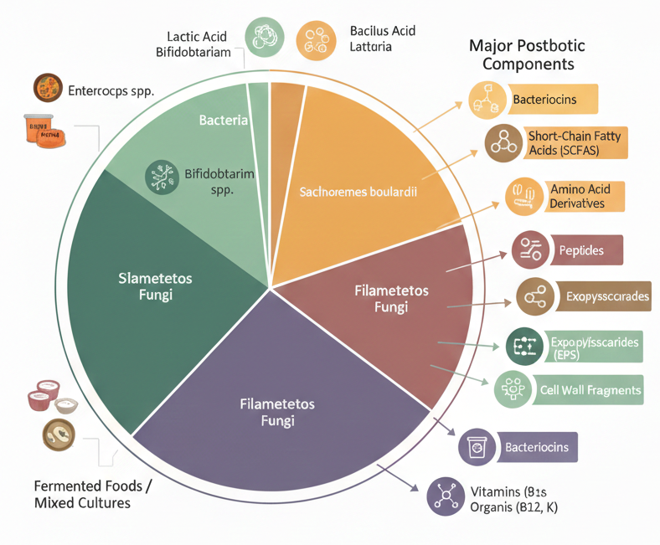
Figure 1. Sources and components of Postbiotics

3.1 Short-Chain Fatty Acids and Organic Acids
Short-chain fatty acids such as acetate, propionate, and butyrate represent major postbiotic metabolites formed during carbohydrate fermentation (Amobonye, A et al., 2025). These organic acids regulate intestinal pH, inhibit pathogenic bacteria, and influence host immune signaling pathways. Additional metabolites such as phenylactic acid, ferulic acid, and hydroxyphenyl derivatives produced by Bacillus and Lactiplantibacillus strains contribute antioxidant and antimicrobial functions (Asefa, Z et al., 2025). Through modulation of epithelial integrity and inflammatory responses, SCFAs play a central role in maintaining gut homeostasis and metabolic balance (Calvanese, C. M et al., 2025).

3.2 Polysaccharides, Exopolysaccharides and Cell Wall Structures
Polysaccharides and exopolysaccharides are major structural components detected in postbiotic preparations. Dextran, oligosaccharides, β-glucans, and uronic acid–rich polymers derived from Leuconostoc, Bifidobacterium, and fungal sources exhibit immunomodulatory and anti-inflammatory properties (Amobonye, A et al., 2025). Peptidoglycan fragments composed of N-acetylglucosamine and N-acetylmuramic acid residues further contribute to immune activation and barrier function. These structural molecules highlight how non-viable microbial components can elicit significant biological responses (Asefa, Z et al., 2025).

3.3 Enzymes, Bioactive Peptides and Bacteriocins
Postbiotic formulations frequently contain enzyme systems and peptide-based molecules that enhance antioxidant defense and antimicrobial activity. Enzymes such as superoxide dismutase, catalase, and glutathione peroxidase support oxidative stress regulation, whereas peptides derived from lactic acid bacteria demonstrate roles in immune modulation and metabolic regulation ((Amobonye, A et al., 2025; Asefa, Z et al., 2025; Mafe, A. N et al., 2025;). Antimicrobial peptides including enterocins and salivaricins exemplify bacteriocins capable of suppressing pathogenic microorganisms without disrupting beneficial microbiota (Calvanese, C. M et al., 2025).

3.4 Teichoic Acids, Vitamins and Cellular Metabolites
Teichoic acids and lipoteichoic acids, characteristic of Gram-positive bacterial cell walls, are increasingly recognized as functional postbiotic components. These anionic polymers interact with host immune receptors and regulate inflammatory signaling pathways (Amobonye, A et al., 2025). In addition, microbial fermentation produces vitamins such as riboflavin (B2), vitamin B12, folate, and vitamin K, contributing to nutritional and metabolic benefits. Aromatic metabolites, amino acid derivatives, and co-factor molecules produced by yeast and fungal sources further expand the biochemical diversity of postbiotics (Asefa, Z et al., 2025).

3.5 Functional Diversity Driven by Microbial Sources
The functional properties of postbiotics are closely linked to the metabolic capabilities of their microbial producers. Bacterial strains primarily generate organic acids, peptides, and bacteriocins, whereas yeast and fungal sources contribute complex polysaccharides and secondary metabolites. Variations in fermentation substrates, environmental conditions, and growth phase significantly influence metabolite composition and bioactivity. Understanding this microbial diversity is essential for designing targeted postbiotic formulations with specific therapeutic or industrial applications.

4. MECHANISMS OF ACTION AND BIOLOGICAL BASIS OF POSTBIOTICS
Postbiotics exert their health-promoting effects through a multifaceted network of biological pathways that operate either independently or synergistically. Unlike probiotics, which depend on microbial viability and colonization, postbiotics deliver pre-formed bioactive molecules generated during microbial fermentation. These inactive microbial preparations contain metabolites, peptides, and structural components capable of modulating host physiology. Although the precise mechanisms underlying postbiotic efficacy are still being elucidated, current evidence highlights several key processes, including epithelial barrier reinforcement, immune regulation, metabolic signaling, antimicrobial protection, and neuro–immune communication. Understanding these interconnected mechanisms is essential for optimizing therapeutic applications and ensuring consistent product efficacy.

4.1 Enhancement of Intestinal Barrier Function and Epithelial Integrity
One of the primary mechanisms attributed to postbiotics is the strengthening of intestinal barrier integrity (Chikindas, M. L et al., 2025b). Microbial metabolites activate intracellular pathways such as the PI3K/Akt signaling cascade, leading to increased expression of tight junction proteins, including occludin and claudins. Concurrently, activation of NF-κB–associated mucin pathways promotes mucin production and enhances the protective mucus layer. These effects collectively improve epithelial resilience, reduce intestinal permeability, and support gut homeostasis. By reinforcing structural defenses within the gastrointestinal tract, postbiotics contribute to protection against environmental stressors and pathogenic invasion (Meena, K. K et al 2025).

4.2 Gut Microbiota Modulation and Immune Regulation
Postbiotics influence host health by reshaping the gut microbial ecosystem and regulating immune responses through microbe-derived metabolites (Chikindas, M. L et al., 2025b). Short-chain fatty acids (SCFAs) such as acetate, propionate, and butyrate nourish colonocytes, maintain microbial balance, and suppress opportunistic pathogens (Mafe, A. N et al., 2025). Structural components and bioactive molecules interact with pattern recognition receptors, including Toll-like receptors and NOD-like receptors, modulating cytokine production and inflammatory signaling (Amobonye, A et al., 2025). These interactions help restore immune equilibrium by balancing pro- and anti-inflammatory responses, thereby reducing chronic inflammatory activity while promoting beneficial microbial diversity (Asefa, Z et al., 2025).

4.3 Antioxidant and Antimicrobial Defense Mechanisms
Postbiotics provide protective antioxidant and antimicrobial functions through bacteriocins, organic acids, and enzyme systems. Bacteriocins disrupt pathogenic microbial membranes, preventing colonization and supporting microbial stability within the gut (Amobonye, A et al., 2025). Organic acids reduce luminal pH, creating an environment unfavorable for harmful microorganisms. Additionally, enzymatic antioxidants such as superoxide dismutase and catalase neutralize reactive oxygen species, mitigating oxidative stress associated with inflammation and aging. These combined activities enhance host defense mechanisms and contribute to disease prevention (Mafe, A. N et al., 2025).
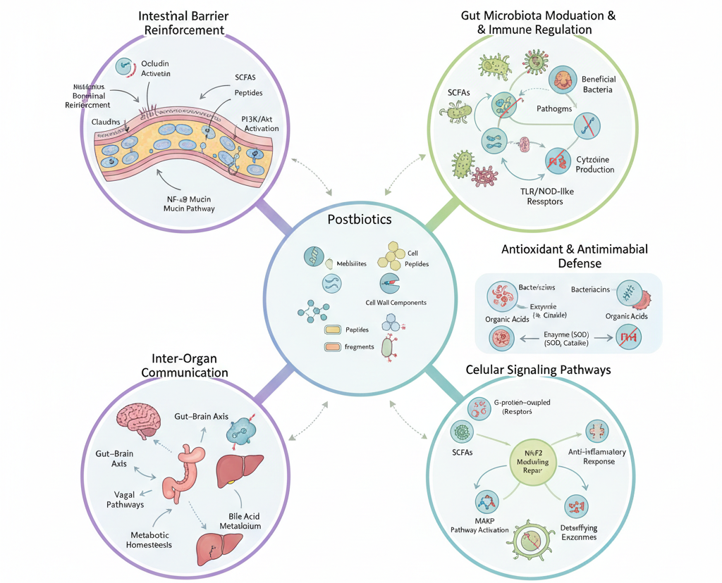
Figure 2. Mechanism of action and biological basis of postbiotics

4.4 Modulation of Cellular Signaling Pathways
Postbiotic components interact with multiple intracellular signaling networks that regulate inflammation, metabolism, and cellular survival. Activation of G-protein-coupled receptors (e.g., FFA2 and FFA3) by SCFAs induces anti-inflammatory responses, while inhibition of NF-κB signaling reduces transcription of inflammatory cytokines such as TNF-α and IL-6. Furthermore, modulation of MAPK pathways influences cellular differentiation and stress responses, promoting tissue repair and physiological balance. Activation of antioxidant regulatory systems, including the Nrf2 pathway, enhances expression of detoxifying enzymes and supports cellular resilience against oxidative damage (Mafe, A. N et al., 2025).

4.5 Gut–Brain and Gut–Liver Axis Communication
Beyond local gastrointestinal effects, postbiotics contribute to me physiological regulation through inter-organ signaling networks. SCFAs interact with enteric neurons and activate vagal pathways, influencing mood regulation, cognition, and neuroprotection within the gut–brain axis. Simultaneously, postbiotics modulate bile acid metabolism and immune signaling within the gut–liver axis, supporting metabolic homeostasis and hepatic detoxification processes. These interactions demonstrate the ability of postbiotic metabolites to act as signaling mediators linking microbial activity to systemic health outcomes (Mafe, A. N et al., 2025).

4.6 Variability, Host Factors and Precision Postbiotic Approaches
The biological effects of postbiotics vary depending on microbial strain origin, fermentation conditions, and host-specific factors such as genetics, diet, and health status. This variability highlights the importance of personalized approaches in postbiotic therapy. Emerging advances in synthetic biology and microbial engineering are enabling the development of precision postbiotics designed to target specific pathways, including bile acid signaling, Toll-like receptor modulation, and cytokine regulation. Engineered delivery systems and CRISPR-based microbial platforms offer promising strategies for producing tailored postbiotic formulations with enhanced therapeutic specificity (Mafe, A. N et al., 2025).

5. APPLICATIONS OF POSTBIOTICS

5.1 Immune Modulation and Allergy Management
Postbiotics play an important role in regulating immune responses by influencing cytokine signaling and maintaining the balance between Th1 and Th2 pathways. Their bioactive components may help reduce hypersensitivity reactions and support immune equilibrium in allergic and autoimmune conditions (Amobonye, A et al., 2025). Emerging evidence suggests their potential use as supportive agents in inflammatory bowel disorders and immune dysregulation (Mafe, A. N et al., 2025; Chikindas, M. L et al., 2025b).

5.2 Periodontal and Oral Health
In oral healthcare, postbiotic metabolites exhibit antimicrobial properties that inhibit pathogenic biofilm formation and strengthen mucosal barriers. These effects contribute to reduced plaque accumulation, improved periodontal stability, and decreased oral inflammation, highlighting their potential in preventive dental formulations (Meena, K. K et al 2025).

5.3 Gastrointestinal Health and Diarrhea Prevention
Postbiotics contribute to gut health by enhancing short-chain fatty acid production, reinforcing epithelial integrity, and restoring microbial balance. These mechanisms help stabilize intestinal function and may reduce the frequency and severity of diarrhea by maintaining a healthy gut environment (Meena, K. K et al 2025).

5.4 Anti-Inflammatory and Chronic Disease Management
Through the regulation of inflammatory mediators and cytokine networks, postbiotics help attenuate systemic inflammation (Amobonye, A et al., 2025; Chikindas, M. L et al., 2025b). Their modulatory effects on immune signaling pathways position them as promising adjuncts in managing chronic inflammatory conditions and metabolic disorders (Meena, K. K et al 2025).

5.5 Cosmetic and Dermatological Applications
Postbiotics are increasingly incorporated into cosmetic formulations due to their antioxidant capacity and ability to enhance skin barrier function. These properties support skin hydration, reduce oxidative stress, and contribute to anti-aging and protective skincare strategies (Meena, K. K et al 2025; Amobonye, A et al., 2025).

5.6 Liver and Metabolic Health
Postbiotic metabolites influence lipid metabolism, bile acid signaling, and insulin sensitivity. By modulating metabolic pathways and reducing inflammatory stress, they may contribute to improved liver function and better metabolic health outcomes (Meena, K. K et al 2025).

5.7 Anti-Tumor and Immunotherapeutic Potential
Preclinical studies suggest that postbiotics may regulate apoptosis pathways and immune checkpoints involved in tumor progression (Chikindas, M. L et al., 2025b). Although clinical evidence remains limited, these findings highlight their emerging role in cancer-related research (Mafe, A. N et al., 2025).

5.8 Microbiota Restoration and Gut Ecosystem Stability
Postbiotics support microbial diversity by suppressing pathogenic growth and promoting beneficial bacteria. This ecological balance enhances gut resilience and contributes to overall digestive health (Meena, K. K et al 2025)..

5.9 Mental Health and the Gut–Brain Axis
Through interactions with microbial metabolites and inflammatory signaling, postbiotics may influence neurotransmitter production and neural communication pathways (Mafe, A. N et al., 2025). These mechanisms suggest potential benefits in mood regulation and stress resilience (Meena, K. K et al 2025).

5.10 Dental Caries Prevention
Antimicrobial compounds derived from postbiotics can limit cariogenic bacterial growth and reduce biofilm formation, indicating their potential role in preventive oral care products (Meena, K. K et al 2025).

5.11 Agricultural and Poultry Applications
Beyond human health, postbiotics are being explored in livestock production to improve nutrient absorption, enhance gut microbiota balance, and increase resistance to infections, ultimately supporting sustainable agricultural practices (Meena, K. K et al 2025).

6. ADVANTAGES OF POSTBIOTICS
Postbiotics present several advantages compared with live probiotics and traditional microbiome-modulating approaches due to their non-viable yet functionally active nature. The absence of living microorganisms significantly enhances safety by eliminating risks associated with microbial translocation, opportunistic infection, or transfer of antibiotic resistance genes, making postbiotics particularly suitable for vulnerable populations. In addition, postbiotic preparations exhibit superior physicochemical stability, as they are less sensitive to temperature changes, oxygen exposure, and gastric conditions. This stability enables easier incorporation into functional foods, dietary supplements, and pharmaceutical dosage forms without compromising bioactivity (Mafe, A. N et al., 2025).
Another important benefit lies in their defined biochemical composition, which allows more predictable and mechanism-driven therapeutic outcomes. Bioactive molecules such as short-chain fatty acids, peptides, bacteriocins, and cell wall components interact with molecular pathways involved in immune regulation, inflammation control, and metabolic balance. Postbiotics have also been associated with improved intestinal barrier function through enhanced tight junction protein expression and mucin synthesis, contributing to gut health and systemic homeostasis. Furthermore, their ease of standardization and reproducible dosing simplifies quality control and supports regulatory acceptance, thereby facilitating large-scale industrial and clinical applications.

7. LIMITATIONS OF POSTBIOTICS
Despite increasing scientific interest, several challenges continue to limit the broader clinical and industrial adoption of postbiotics (Mafe, A. N et al., 2025). Current research remains fragmented, with considerable variability in study design, dosage regimens, and formulation strategies, making it difficult to establish unified conclusions regarding efficacy. The absence of universally accepted production standards and analytical protocols further complicates comparisons across studies and hinders regulatory harmonization. While most investigations focus on gastrointestinal and immune-related outcomes, comparatively fewer studies explore applications in metabolic disorders, neurological health, or oncology, indicating significant gaps in translational research. Addressing these limitations will require well-designed clinical trials, standardized characterization methods, and interdisciplinary collaboration to fully realize the therapeutic potential of postbiotics (Calvanese, C. M et al., 2025).

8. PRODUCTION AND SEPARATION OF POSTBIOTICS
8.1 Inactivation and Postbiotic Generation
After fermentation, microbial cultures are transformed into postbiotic preparations through carefully controlled inactivation steps that remove microbial viability while maintaining functional metabolites. Various physical and biochemical approaches, including heat exposure, ultraviolet irradiation, high-pressure processing, and enzymatic treatments, are commonly applied. These methods allow preservation of biologically active molecules such as organic acids, bioactive peptides, exopolysaccharides, and structural cell wall components like peptidoglycans and lipoteichoic acids (Akman, P. K et al., 2023). Selecting an appropriate inactivation strategy is essential, as overly harsh processing conditions may degrade sensitive compounds and reduce functional efficacy. Therefore, optimized protocols are required to achieve microbial safety while retaining the desired biological properties of the postbiotic preparation.

8.2 Bacterial Strains and Growth Conditions
Lactic acid bacteria frequently used for postbiotic production include Lactiplantibacillus plantarum, Lactococcus lactis, and Weissella cibaria (Akman et al., 2023). These strains were cultivated in de Man, Rogosa and Sharpe (MRS) medium at approximately 37 °C under controlled conditions to enhance metabolite synthesis (Condurso et al., 2025; Misra, S et al., 2023). Pathogenic indicator organisms such as Listeria monocytogenes, Staphylococcus aureus, Escherichia coli, and Salmonella typhimurium were grown in Tryptic Soy Broth, while mold strains Aspergillus niger and Aspergillus flavus were maintained on Potato Dextrose Agar (Khakpour M et al., 2024). Fermentation variables including incubation time, nutrient composition, and environmental conditions significantly influenced metabolite diversity and yield (Molina et al., 2025).

8.4 Extraction, Separation and Purification of Postbiotic Fractions
Recovery of postbiotic components from fermented cultures generally involves sequential downstream processing steps. Initially, microbial biomass is removed by centrifugation, followed by sterile membrane filtration through 0.22 µm filters to obtain clear cell-free supernatants enriched with soluble metabolites (Molina, D et al., 2025). Polysaccharide-rich fractions, particularly exopolysaccharides, may be recovered by ethanol precipitation and subsequent dialysis or purification procedures. Freeze-drying is often employed to improve product stability and facilitate handling during further characterization or formulation. These processes enable the isolation of metabolite-rich fractions suitable for functional and bioactivity studies.

8.3 Separation and Purification Techniques
Following inactivation, additional purification steps are applied to concentrate and refine postbiotic constituents. Techniques such as ultrafiltration and microfiltration are commonly used to separate molecules based on molecular size, allowing enrichment of peptides, organic acids, or polysaccharides. Advanced purification approaches, including ion-exchange chromatography, gel filtration, and high-performance liquid chromatography, can be utilized to obtain well-defined fractions for pharmaceutical or clinical applications (Amobonye, A et al., 2025). Stabilization strategies such as spray-drying or lyophilization are frequently adopted to produce stable powder formulations with extended shelf life and improved processing characteristics (Ramasamy, T et al., 2025).

8.3 Quality Control and Standardization
Standardized production requires comprehensive characterization of the final preparation, including metabolomic profiling, microbial safety verification, and batch-to-batch consistency analysis (Misra, S et al., 2023). Advanced analytical tools such as mass spectrometry, nuclear magnetic resonance spectroscopy, and proteomics platforms are increasingly integrated into postbiotic manufacturing pipelines to ensure reproducibility and regulatory compliance (Molina, D et al., 2025; Condurso, C et al., 2025).
.
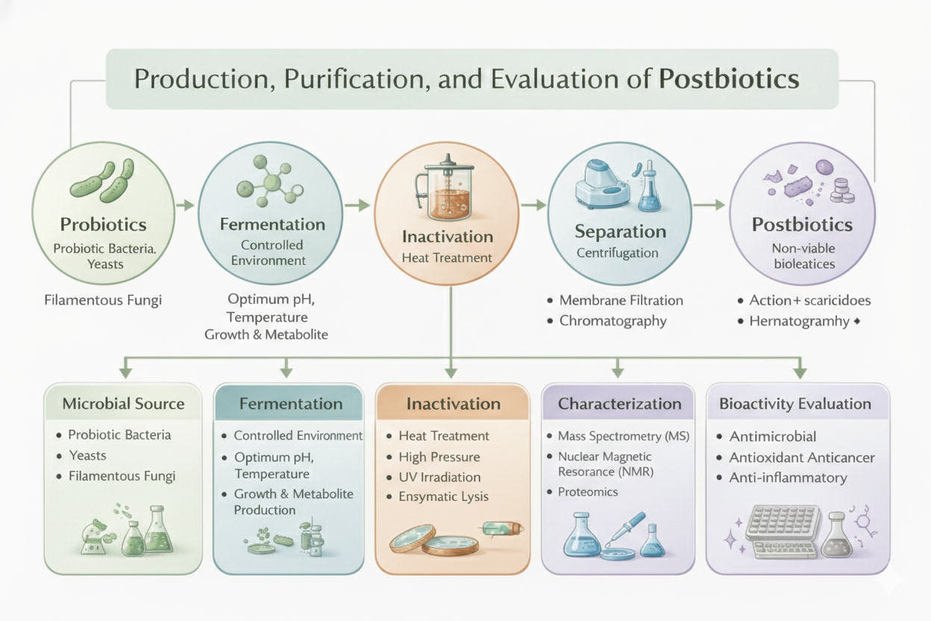
Figure 3- production, purification and evaluation of probiotics

9. TESTS FOR CHARACTERIZATION OF POSTBIOTICS
Characterization of postbiotic preparations is essential to evaluate their physicochemical properties, biochemical composition, and structural features. These parameters provide insights into metabolite stability, functional activity, and overall quality of the postbiotic extract (Ramasamy, T et al., 2025). The characterization workflow generally includes physicochemical analysis, compositional assessment, and molecular profiling (Ramasamy, T et al., 2025).
9.1 Physicochemical Characterization
9.1.1 pH Measurement
The pH of postbiotic extracts was determined using a calibrated benchtop digital pH meter equipped with a temperature probe and magnetic stirrer (Condurso, C et al., 2025; Mafe, A. N et al., 2025). Samples were allowed to equilibrate at room temperature prior to measurement, and the electrode was directly immersed into the extract to obtain stable readings (Meena, K. K. et al., 2025; Br, A. 2025c).
9.1.2 Total Titratable Acidity (TTA)
Titratable acidity was assessed by titration with 0.1 N NaOH using phenolphthalein as an indicator. A 10 mL aliquot of the extract was diluted with carbonate-free distilled water and titrated until the endpoint (pH ≈ 8.3) was reached. Results were expressed as grams of citric acid equivalent per 100 mL of sample, reflecting the total organic acid content (Condurso, C et al., 2025).
9.1.3 Colour Analysis
Colour characteristics of the postbiotic extracts were evaluated using an image-based visual analyzer equipped with controlled illumination and high-resolution imaging. Samples placed in Petri dishes were photographed against a white background to ensure uniformity. Image processing included background correction and colour threshold optimization to generate reliable RGB values (Condurso, C et al., 2025).
9.1.4 Moisture Content
Moisture levels were determined according to AOAC guidelines. Approximately 10 g of sample was dried at 105 °C for 180 min, and moisture percentage was calculated based on the difference between initial and final weights. This parameter helps assess sample stability and shelf-life (Meena, K. K. et al., 2025; Akman, P. K et al., 2023).
9.2 Biochemical Composition Analysis
9.2.1 Protein and Peptide Estimation
Total protein and peptide content in postbiotic preparations were quantified using the Lowry method. This analysis provides an estimation of bioactive peptides and proteinaceous compounds that may contribute to antimicrobial and antioxidant properties.
10. EVALUATION

10.1 Determination of Minimum Inhibitory Concentration (MIC) and Minimum Bactericidal Concentration (MBC)
The antimicrobial activity of postbiotics derived from Lactiplantibacillus plantarum was evaluated using a broth microdilution assay. The postbiotic extract was prepared in phosphate-buffered saline (PBS) and serially diluted to obtain concentrations ranging from 0.4 to 50 mg/mL. Exponentially growing bacterial cultures were adjusted to the required density and inoculated into sterile 96-well microplates containing the postbiotic dilutions. The plates were incubated at 37 °C overnight under appropriate conditions. The minimum inhibitory concentration (MIC) was defined as the lowest concentration of the postbiotic preparation that prevented visible microbial growth (Molina, D et al., 2025; Khakpour M et al., 2024).
To determine the minimum bactericidal concentration (MBC), aliquots (50 µL) from wells showing no visible growth were plated onto agar media and incubated at 37 °C for 24 h (Khakpour M et al., 2024). The MBC was recorded as the lowest concentration at which no bacterial colonies were detected on the agar surface, indicating complete bactericidal activity (Tong Y et al., 2025).

6. Evaluation of Biological Activities of Postbiotics
6.1 Antibacterial Activity
The antibacterial potential of postbiotics derived from Lactiplantibacillus plantarum can be assessed using the agar well-diffusion technique (Khakpour M et al., 2024). Pathogenic indicator strains are adjusted to approximately 6 log₁₀ CFU/mL and uniformly spread on Mueller–Hinton agar plates to form a lawn culture. Sterile wells are created using a micropipette tip, and defined volumes of postbiotic preparations are introduced into each well. Sterile MRS medium serves as the negative control to eliminate media-related effects. Following incubation at 37 °C for 24 h, antimicrobial efficacy is determined by measuring the diameter of inhibition zones surrounding the wells. All experiments are performed in triplicate to ensure reproducibility and statistical reliability (Akman, P. K et al., 2023; Chikindas, M. L et al., 2025b).

6.2 Antifungal Activity
Antifungal efficacy may be evaluated against molds such as Aspergillus niger and Aspergillus flavus using a modified agar well-diffusion assay (Khakpour M et al., 2024). Spore suspensions (~10⁶ spores/mL) are evenly distributed on potato dextrose agar (PDA) plates. Wells of approximately 6 mm diameter are filled with postbiotic preparations and incubated at 30 °C for 48 h. The presence and size of clear inhibition zones indicate antifungal activity, reflecting the ability of organic acids, bacteriocins, and secondary metabolites to suppress fungal growth.

6.3 Antioxidant Activity
Postbiotics possess strong antioxidant potential owing to metabolites such as short-chain fatty acids, peptides, and antioxidant enzymes including catalase and glutathione peroxidase (Amobonye, A et al., 2025). These compounds scavenge reactive oxygen species and reduce oxidative stress, which is associated with chronic disorders such as diabetes, cardiovascular diseases, and neurodegeneration (Chikindas, M. L et al., 2025b). Radical-scavenging assays such as DPPH and ABTS are commonly used to quantify antioxidant capacity (Molina, D et al., 2025). Studies have demonstrated that heat-treated postbiotic preparations can exhibit high free-radical scavenging activity, supporting their application in nutraceuticals and cosmetic formulations aimed at oxidative stress reduction ((Yousefvand, A et al., 2024).

6.4 Anticancer Activity
The antiproliferative effects of postbiotics can be investigated using cancer cell culture models (Xu, P et al., 2025). Cervical cancer cell lines such as HeLa, CaSki, and C-33A are maintained in appropriate culture media supplemented with fetal bovine serum and antibiotics under controlled CO₂ incubation. Cell viability is typically assessed using the MTT assay, where treated cells metabolize tetrazolium salts into formazan crystals measurable at 570 nm (Molina, D et al., 2025). Reduction in cell viability following exposure to postbiotic preparations indicates potential anticancer activity through mechanisms such as apoptosis induction and inhibition of cellular proliferation (Chikindas, M. L et al., 2025b).

6.5 Anti-Inflammatory Activity
Postbiotics exhibit immunomodulatory effects by regulating cytokine production and suppressing pro-inflammatory signaling pathways (Amobonye, A et al., 2025). Experimental studies report reductions in inflammatory markers alongside increased anti-inflammatory cytokines after treatment with postbiotic mixtures. These effects are attributed to microbial metabolites capable of modulating immune responses in intestinal and skin inflammation models, suggesting potential therapeutic roles in colitis and inflammatory skin disorders (Chikindas, M. L et al., 2025b).

6.6 Anti-Diabetic Potential
Bioactive components such as acetate, propionate, and butyrate influence glucose metabolism and gut–brain signaling pathways associated with diabetes management (Chikindas, M. L et al., 2025b). Postbiotic formulations have been shown to enhance insulin secretion, regulate GLP-1 production, and improve metabolic indices in experimental models. Gamma-aminobutyric acid (GABA)-rich postbiotics further contribute to glycemic control, highlighting their potential as supportive strategies in managing type-2 diabetes and prediabetic conditions (Amobonye, A et al., 2025).

6.7 Antimicrobial and Antiproliferative Properties
Postbiotics contain bacteriocins, organic acids, fatty acids, and hydrogen peroxide, which collectively inhibit bacterial and fungal pathogens (Amobonye, A et al., 2025). These antimicrobial properties vary depending on microbial strain and fermentation conditions (Chikindas, M. L et al., 2025b). Beyond antimicrobial activity, several postbiotic preparations exhibit antiproliferative effects against cancer cell lines by inducing apoptosis and inhibiting tumor cell migration, suggesting promising applications in future therapeutic development (Br, A. 2025c).

Table 3-Evaluation Methods Used for Assessing Postbiotic Bioactivities
Bioactivity / Evaluation | Method Used | Principle | Key Parameters Measured | Expected Outcome / Significance
Antibacterial Activity | Agar well diffusion / Disk diffusion | Diffusion of postbiotic compounds inhibits microbial growth | Zone of inhibition (mm) | Demonstrates antimicrobial potential against pathogenic bacteria
Antibacterial Potency | MIC and MBC (Broth microdilution) | Serial dilution determines inhibitory and bactericidal concentrations | MIC (mg/mL), MBC (mg/mL) | Determines minimum effective concentration of postbiotics
Antifungal Activity | Agar well diffusion on PDA | Inhibition of fungal spore germination and growth | Inhibition zone diameter | Indicates antifungal efficacy against molds and yeasts
Antioxidant Activity | DPPH Radical Scavenging Assay | Neutralization of free radicals by antioxidant metabolites | % Radical scavenging activity | Reflects antioxidant capacity of postbiotic compounds
Antioxidant Activity | ABTS Assay (optional) | Electron transfer-based antioxidant evaluation | % Inhibition / IC50 | Confirms oxidative stress mitigation potential
Protein / Peptide Characterization | Lowry or Bradford Assay | Colorimetric detection of protein concentration | Protein content (µg/mL) | Quantifies bioactive peptides present in postbiotics
Organic Acid Analysis | HPLC (optional) | Separation and quantification of SCFAs and organic acids | Acetate, propionate, butyrate levels | Identifies metabolic composition of postbiotics
Anticancer Activity | MTT Cell Viability Assay | Reduction of tetrazolium salt indicates living cells | % Cell viability / Growth inhibition | Evaluates cytotoxic and antiproliferative effects
Anti-inflammatory Activity | Cytokine profiling (ELISA / literature-based) | Measurement of inflammatory mediators | IL-6, TNF-α, IL-10 levels | Demonstrates immunomodulatory properties
Metabolic Activity (Anti-diabetic) | SCFA quantification / in vitro assays | Regulation of metabolic signaling pathways | GLP-1, insulin-related markers | Indicates metabolic health benefits
Stability Assessment | Temperature / Storage Stability Tests | Monitoring retention of functional activity over time | Activity retention %, pH change | Evaluates shelf-life and industrial feasibility

7. STABILITY AND STORAGE STUDIES OF POSTBIOTIC PREPARATIONS

7.1 Temperature Stability Studies
Temperature stability was evaluated to simulate real-world storage and distribution conditions. Samples were stored at 4 ± 1 °C, 25 ± 1 °C, and 37 ± 1 °C, representing refrigerated, ambient, and accelerated thermal conditions, respectively (Misra, S et al., 2023). Refrigeration conditions reflect recommended cold storage practices, while room temperature represents typical household or retail environments (Jannah, S. R et al., 2022). The elevated temperature condition was included to assess stability under stress conditions commonly encountered in tropical climates or during transportation. Postbiotic samples were periodically analyzed for physicochemical properties and biological activity to determine any temperature-induced changes (Mudgil, P et al., 2024).

7.2 Thermal Stability Assessment
Thermal stability of postbiotic preparations was assessed by exposing samples to controlled heat treatments. Suspensions of postbiotic material were prepared in sterile peptone water and subjected to heating at 50 °C and 80 °C for defined time intervals (5 and 10 min). Following treatment, samples were cooled and evaluated for retention of functional properties such as antimicrobial or antioxidant activity. Unlike live probiotics, postbiotics do not rely on cell viability; therefore, stability was determined based on preservation of bioactive compounds rather than microbial survival (Br, A. 2025c).

7.3 Storage Stability Under Different Conditions
Postbiotic formulations were stored in airtight polypropylene containers to minimize environmental exposure (Misra, S et al., 2023). Stability evaluation was conducted under refrigerated and room-temperature conditions for defined durations (Mudgil, P et al., 2024 and Meena, K. K. et al., 2025). Samples were analyzed at scheduled intervals (e.g., 1, 3, and 6 months) to assess changes in physicochemical parameters, bioactivity, and overall product integrity. Stability indicators included maintenance of antimicrobial activity, antioxidant capacity, and absence of degradation-related changes (Jannah, S. R et al., 2022)

7.4 Monitoring Stability During Storage
Short-term stability studies were conducted by storing postbiotic samples at 4 °C and 25 °C for several weeks (Ge, S et al., 2024). At weekly intervals, aliquots were analyzed to monitor variations in pH, bioactive compound levels, and functional activity. Stability was expressed as the percentage retention of activity compared with initial values:
$$\text{Stability Retention (\%)}=\frac{\text{Activity after storage}}{\text{Initial activity}}×100$$
This approach allows assessment of functional stability rather than microbial survival, which is more relevant for non-viable postbiotic preparations.

Conclusion
Postbiotics have emerged as a promising class of functional biotics with significant potential in biotechnology, healthcare, and industrial applications. Unlike live probiotics, postbiotics provide defined bioactive compounds with improved stability, safety, and ease of formulation, making them attractive for pharmaceutical, nutraceutical, and cosmetic developments. The present review highlights the diverse sources, biochemical composition, production strategies, and characterization approaches that underpin postbiotic functionality. Mechanistic insights demonstrate that postbiotics contribute to epithelial barrier reinforcement, immune modulation, metabolic regulation, antimicrobial defense, and systemic signaling through gut–organ axes. Despite these advantages, challenges such as standardization of production protocols, variability among microbial strains, and limited long-term clinical data remain. Future research integrating advanced fermentation technologies, molecular characterization, and precision engineering approaches will be essential to unlock the full therapeutic potential of postbiotics. Overall, postbiotics represent a safe, stable, and scientifically evolving platform for next-generation functional products aimed at improving human health and wellbeing.

DISCLAIMER (ARTIFICIAL INTELLIGENCE)
The authors declare that generative artificial intelligence tools, including ChatGPT (OpenAI), Perplexity AI, and Google Gemini, were used only for language editing, text refinement, and schematic image preparation. All scientific content, interpretation, and conclusions are the sole responsibility of the authors.

Abbreviations
SCFAs – Short-Chain Fatty Acids; EPS – Exopolysaccharides; BAPs – Bioactive Peptides; GABA – Gamma-Aminobutyric Acid; FTIR – Fourier Transform Infrared Spectroscopy; TTA – Total Titratable Acidity; NF-κB – Nuclear Factor Kappa B; MAPK – Mitogen-Activated Protein Kinase; TLRs – Toll-Like Receptors; GPCRs – G-Protein-Coupled Receptors; ROS – Reactive Oxygen Species; SOD – Superoxide Dismutase; CAT – Catalase; GPx – Glutathione Peroxidase; MRS – De Man, Rogosa and Sharpe Medium; PBS – Phosphate Buffered Saline; DPPH – 2,2-Diphenyl-1-picrylhydrazyl.

12. References

- Akman, P. K., Kutlu, G., & Tornuk, F. (2023). Development and characterization of a novel sodium alginate based active film supplemented with Lactiplantibacillus plantarum postbiotic. International Journal of Biological Macromolecules, 244, 125240. https://doi.org/10.1016/j.ijbiomac.2023.125240.
- Amobonye, A., Pillay, B., Hlope, F., Asong, S. T., & Pillai, S. (2025). Postbiotics: an insightful review of the latest category in functional biotics. World Journal of Microbiology and Biotechnology, 41(8), 293. https://doi.org/10.1007/s11274-025-04483-8.
- Asefa, Z., Belay, A., Welelaw, E., & Haile, M. (2025). Postbiotics and their biotherapeutic potential for chronic disease and their feature perspective: a review. Frontiers in Microbiomes, 4. https://doi.org/10.3389/frmbi.2025.1489339.
- Balakrishna, K., Naveena, G., & Kingston, J. J. (2026). Postbiotics at the interface of microbial biotechnology and therapeutics: industrial production, functional mechanisms, and clinical potentials. Archives of Microbiology, 208(2), 123. https://doi.org/10.1007/s00203-025-04701-9
- Br, A. (2025c). Assessment of the Stability and Viability of a Probiotic Formulation with Strains of Lactiplantibacillus LH05 and LH06 Isolated from Breast Milk. Food Science & Nutrition, 11(3), 1–9. https://doi.org/10.24966/fsn-1076/100222
- Calvanese, C. M., Villani, F., Ercolini, D., & De Filippis, F. (2025). Postbiotics versus probiotics: Possible new allies for human health. Food Research International, 217, 116869. https://doi.org/10.1016/j.foodres.2025.116869.
- Condurso, C., Merlino, M., Miller, A., Di Rosa, A. R., Accetta, F., Leonardi, M., Cicero, N., & Gervasi, T. (2025). Developing Novel Plant-Based Probiotic Beverages: A study on viability and physicochemical and sensory stability. Foods, 14(12), 2148. https://doi.org/10.3390/foods14122148
- Erdinc, A. N., & Cufaoglu, G. (2026). Postbiotics as natural antimicrobials: a novel biocontrol strategy for food safety. Frontiers in Bacteriology, 4. https://doi.org/10.3389/fbrio.2025.1712139.
- Jannah, S. R., Rahayu, E. S., Yanti, R., Suroto, D. A., & Wikandari, R. (2022). Study of Viability, Storage Stability, and Shelf Life of Probiotic Instant Coffee Lactiplantibacillus plantarum Subsp. plantarum Dad-13 in Vacuum and Nonvacuum Packaging at Different Storage Temperatures. International Journal of Food Science, 2022, 1–7. https://doi.org/10.1155/2022/1663772.
- Khakpour, M., Mohsenzadeh, M., & Salari, A. (2024). Feasibility of lactiplantibacillus plantarum postbiotics production in challenging media by different techniques. AMB Express, 14(1), 47. https://doi.org/10.1186/s13568-024-01704-5
- Khakpour, M., Mohsenzadeh, M., & Salari, A. (2024b). Feasibility of lactiplantibacillus plantarum postbiotics production in challenging media by different techniques. AMB Express, 14(1), 47. https://doi.org/10.1186/s13568-024-01704-5
- Mafe, A. N., Sharifi‐Rad, J., Calina, D., Ogunyemi, A. J., & Tubi, A. O. (2025). Postbiotics in Functional foods: Microbial derivatives shaping health, immunity and Next‐Generation nutrition. Food Frontiers, 7(1). https://doi.org/10.1002/fft2.70205.
- Meena, K. K., Joshi, M., Gupta, L., & Meena, S. (2025). Comprehensive insights into postbiotics: Bridging the gap to real-world application. Food Nutrition, 1(2), 100024. https://doi.org/10.1016/j.fnutr.2025.100024.
- Meena, K. K., Taneja, N. K., Ojha, A., & Mudgil, D. (2025). Physicochemical and microbial stability in probiotic Raabadi (a dairy‐plant‐based beverage) powder under varied storage temperatures. Food Biomacromolecules., 2(4), 488–502. https://doi.org/10.1002/fob2.70031.
- Molina, D., Marinas, I. C., Angamarca, E., Hanganu, A., Stan, M., Chifiriuc, M. C., & Tenea, G. N. (2025). Postbiotic-Based Extracts from Native Probiotic Strains: A Promising Strategy for Food Preservation and Antimicrobial Defense. Antibiotics, 14(3), 318. https://doi.org/10.3390/antibiotics14030318.
- Mudgil, P., Alkaabi, F., Khan, H., Javed, M., Hajamohideen, A. R., Hamed, F., & Maqsood, S. (2024). Enhanced viability and stability of the Lactobacillus reuteri DSM 17938 probiotic strain following microencapsulation in pea and rice protein-inulin conjugates. Frontiers in Sustainable Food Systems, 8. https://doi.org/10.3389/fsufs.2024.1284069.
- Pawar, S. V., Saldinger, S. S., & Shemesh, M. (2026). Postbiotics for improving food quality and safety: From mechanistic insights to industrial applications. LWT, 241, 119066. https://doi.org/10.1016/j.lwt.2026.119066.
- Ramasamy, T., Chellapandian, N., & Dharumadurai, D. (2025). Separation, characterization and identification of postbiotics from probiotic microbes. In Elsevier eBooks (pp. 119–129). https://doi.org/10.1016/b978-0-443-22188-0.00008-5.
- Tong, Y., Abbas, Z., Zhang, J., Wang, J., Zhou, Y., Si, D., Wei, X., & Zhang, R. (2025). Antimicrobial activity and mechanism of novel postbiotics against foodborne pathogens. LWT, 217, 117464. https://doi.org/10.1016/j.lwt.2025.117464
- Trymers, M., Wiśniewski, P., Tkacz, K., & Zakrzewski, A. (2026c). From production to application: postbiotics in meat, meat products, other food matrices, and bioactive packaging. Foods, 15(3), 501. https://doi.org/10.3390/foods15030501.
- Xu, P., Mageswary, M. U., Nisaa, A. A., Li, X., Tan, Y., Oon, C., Tan, C., Luo, W., & Liong, M. (2025). Antimicrobial and Anticancer Activities of Lactiplantibacillus plantarum Probio87 Isolated from Human Breast Milk. Nutrients, 17(15), 2554. https://doi.org/10.3390/nu17152554.
- Yousefvand, A., Pham, Q., Ho, T. M., Amiri, S., Mäkelä-Salmi, N., & Saris, P. E. J. (2024). Bifidobacterium animalis subsp. lactis BB12-Derived Postbiotic Powders Enhance Antioxidant and Physicochemical Properties of Low-Fat Yoghurt. Food and Bioprocess Technology, 17(11), 4354–4370. https://doi.org/10.1007/s11947-024-03405-0.
- Chikindas, M. L., Roopchand, D. E., Tiwari, S. K., Sichel, L. S., Karwe, M. V., Nitin, N., Fagundes, V. L., Popov, I. V., Tagg, J. R., Lu, X., & Todorov, S. D. (2025b). An integrated engineering approach to creating Health‐Modulating Postbiotics. Molecular Nutrition & Food Research, 70(1), e70326. https://doi.org/10.1002/mnfr.70326.
- Misra, S., Pandey, P., Panigrahi, C., & Mishra, H. N. (2023). A comparative approach on the spray and freeze drying of probiotic and Gamma-aminobutyric acid as a single entity: Characterization and evaluation of stability in simulated gastrointestinal conditions. Food Chemistry Advances, 3, 100385. https://doi.org/10.1016/j.focha.2023.100385.
- Ge, S., Han, J., Sun, Q., Ye, Z., Zhou, Q., Li, P., & Gu, Q. (2024). Optimization of cryoprotectants for improving the freeze-dried survival rate of potential probiotic Lactococcus lactis ZFM559 and evaluation of its storage stability. LWT, 198, 116052. https://doi.org/10.1016/j.lwt.2024.116052

