EFFECTS OF MOULD MATERIALS ON THE MECHANICAL PROPERTIES OF ALUMINIUM CASTING

ABSTRACT
Background: Casting has been widely adopted across industrial sectors due to its ability to produce complex geometries at relatively low cost. Critical factors influencing casting quality include heat transfer across the mould–metal interface, solidification rate, and mould material properties.
Aim: The study aims to evaluate the effects of mould materials on mechanical properties of aluminium were investigated.
Place and Duration of the Study: This research was carried out at the Department of Materials Science and Engineering, Obafemi Awolowo University, Ile-Ife, Nigeria between 2013-2015.
Methods: Mould materials were prepared from sand, metal, and plaster of paris (POP). A steel rod of about 25mm in diameter was used as pattern to cast aluminium in these three mould materials. Test pieces were machined from the casting produced by each of the three mould materials for tensile, hardness and impact tests, as well as microstructure.
Results: The result revealed that Sample A exhibited the highest hardness value of 38.00 BHN, followed by Sample C with 36.50 BHN. It was observed from the tests that aluminium cast by sand has the highest value of ductility at the expense of its hardness, while those castings by metal and POP moulds have appreciable increase in hardness values but lesser values of ductility.
Conclusion: The study concludes that sand mould would be preferred where ductility is the major requirement, while metal and POP moulds might be preferred when hardness is the priority.

Keywords: Casting, aluminium, mould, sand, plaster of paris, metal

1. Introduction
Casting is a fundamental metalworking process that involves pouring molten metal into a mould cavity, allowing it to solidify, and then removing the solidified casting. It has been widely adopted across industrial sectors due to its ability to produce complex geometries at relatively low cost [1]. Critical factors influencing casting quality include heat transfer across the mould–metal interface, solidification rate, and mould material properties [2]. In green sand moulds, parameters such as strength, permeability, and hardness play crucial roles in determining final casting properties [3].
Casting techniques are broadly categorized into expendable and non-expendable mould processes, as shown in Figure 1. Expendable mould casting employs temporary moulds, typically sand, shell, or plaster, which are destroyed after use. Sand casting is widely applied due to its flexibility, low cost, and suitability for a wide range of alloys [4][5]. Studies have shown that factors such as runner size, mould temperature, and pouring conditions directly influence the mechanical strength of aluminium alloys [6]. Plaster mould casting, though costlier, enables superior surface finish and dimensional accuracy, making it suitable for intricate geometries [7]. Shell moulding [8][9][10] casting further enhance precision and surface quality, often used in aerospace and artistic applications. Lost-wax (investment) moulds can be made in a single phase where a refractory clay material is laid directly over the wax model [11]. Lost-wax process is commonly used alongside vacuum casting [12]. Evaporative-pattern methods are essential for complex parts fabrication [13], examples of which are found in lost-foam [14] and full-mould casting [15], employ polystyrene patterns that vaporize during pouring, simplifying mould preparation.
Non-expendable mould casting methods utilize permanent metallic moulds, offering improved repeatability and dimensional accuracy. These include, die casting, semi-solid metal casting, centrifugal casting, and continuous casting. In die casting method, molten metal is forced into the cavity of a reusable steel mould (die) under high pressure. Die casting is a manufacturing process specially for a near-net shape with high dimensional accuracy and good surface finish objects [16]. Semi-solid techniques, in particular, reduce porosity and enable heat treatment, yielding castings with improved strength and ductility[17][18]. Centrifugal casting is a technique of producing castings by pouring molten metal into a rotating mould and allow it to solidify in the same mould [19]. Centrifugal casting is a manufacturing process used to form cylindrical components with a central axis of rotation [20]. In continuous casting process, molten metal flows into the continuous casting mould, cools by cold water, and pulls out after solidification [21]. Continuous casting is employed not only because of the increased quality of the final products but also for its relatively cost effectiveness associated with standard products, validating their continuous use in steel production [22].

Continuous
Expendable mould casting
Non-expendable mould casting
Full mould
Lost foam
Evaporative
Centrifugal
Lost wax
Shell
Semi-solid
Plaster
Die casting
Casting Techniques
Permanent
Sand
Fig. 1. Casting Techniques
Mechanical tests represent a critical aspect of casting process, serving as a reliable means of evaluating the performance and integrity of cast materials [23]. In the context of aluminium castings, tensile [24], hardness [25][26], and impact [27] tests are particularly indispensable for characterizing mechanical behavior under varying service conditions. These tests do not only provide fundamental data on strength, ductility, toughness, and resistance to deformation but also reveal the influence of intrinsic and process-related factors, such as casting defects, mould materials, and cooling rates [28], on final material properties. Mechanical tests generate valuable insights that guide the optimization of casting design and processing parameters. This, in turn, contributes to improved structural reliability, reduced defect rates, and enhanced material performance in diverse engineering applications.
Casting process simulation has become an indispensable tool across manufacturing industries, playing a crucial role in product design and process development to improve yield and casting quality. Successful implementation of simulation relies heavily on high-quality input data, particularly thermo-physical and physical properties during solidification [29]. By employing numerical methods, casting simulations enables precise calculation of component quality through detailed analyses of mould filling, solidification, and cooling - providing quantitative predictions of mechanical properties, thermal stresses, and distortions, offering valuable insight into cast performance before production begins [30]. Consequently, simulation facilitates the design of casting techniques tailored to specific applications, thereby enhancing reliability and efficiency. For example, Iqbal et al. [31] employed MAGMASOFT software to evaluate three modifications in mould design by analyzing the effects of riser and gate location and size on filling pattern, pressure, velocity, cooling rate, and solidification.
Despite its ancient origins, casting remains highly relevant in modern engineering. Parameters such as pouring temperature, gating design, and mould type influence microstructure formation and mechanical behaviour. Improper process control may result in defects such as porosity, shrinkage, and cavities, which compromise performance [32]. Previous studies have compared aluminium alloy castings from CO₂ process, metal mould, cement-bonded sand mould and naturally-bonded sand moulds [33]. However, limited research exists on the comparative performance of aluminium castings produced using sand, POP, and metal moulds. This gap motivates the present study, which seeks to examine variations in mechanical properties of aluminium castings across different mould types.

2. MATERIALS AND METHODS
2.1. Materials
Materials used for this reaserch work are; Aluminium scrap, Sand, Plaster of paris (POP), Splitable cast iron metal mould.
2.2. Preparation of POP Mould
Aluminium scrap was bought, POP powder was bought, Cylindrical hollow cast iron was fabricated, casting sand was made available at Materials Science and Engineering Department Laboratory, Obafemi Awolowo University, Ile-Ife, Nigeria.
Powder form of POP was mixed with adequate amount of water, the mixture was then mixed with talc and silica flour to control the setting time of the plaster as well as to improve its strength. The plaster was poured over the casting pattern (rod-like cast iron). The POP slurry was allowed to sit for 20 minutes before removing the pattern. The mould was baked for several hours in order to remove the moisture and make it hard enough to accommodate the molten metal.
2.3. Preparation of Metal Mould
Cylindrical hollow cast iron which could be split into two halves and clamped together was fabricated. This was meant to serve as the mould. The mould was preheated to about 150-200ºC in order to ease the flow of molten metal as well as reduce thermal damage to the casting. The mould cavity was coated with a refractory material in order to prevent the casting from sticking to the mould and to elongate the mould life.
2.4. Preparation of Sand Mould
Casting sand was put inside a system of frames or mould boxes known as a flask, pattern of desired shape (rod-like) was placed in sand to create the mould, Pattern and sand were incorporated in a gating system, pattern was removed in order to create a cavity.

2.5. Preparation of Aluminium Cast by Different Mould Techniques
Scrap aluminium was melted in the electric furnace. The molten metal was then poured into the respective mould materials prepared above. Each of them was allowed to cool for one hour. Aluminium casting was removed from sand and POP mould by breaking them, while it was removed from metal mould simply by splitting the cylindrical metal mould. Aluminium castings gotten from these three different mould materials were cleaned and machined for microstructure analysis and mechanical tests.
2.6. Characterizations
The microstructural characteristics of the three samples were examined using a metallographic microscope after a systematic preparation process involving grinding (from coarse to fine), polishing, and etching. Their tensile properties were evaluated with a tensometer, while resistance to indentation was assessed using a Brinell hardness testing machine. In addition, the impact strength of the samples, indicating their ability to withstand sudden applied loads, was determined through the Izod impact test.

3. RESULTS AND DISCUSSION
3.1 Microstructure Analysis
Figure 2 presents the microstructural analysis of Sample A (aluminium casting produced using a metal mould). The presence of very fine microstructures indicates rapid heat dissipation from the aluminium through the metal–mould interface, resulting in a high rate of solidification and cooling. Consequently, insufficient time was available for significant grain growth, leading to the formation of fine microstructures.
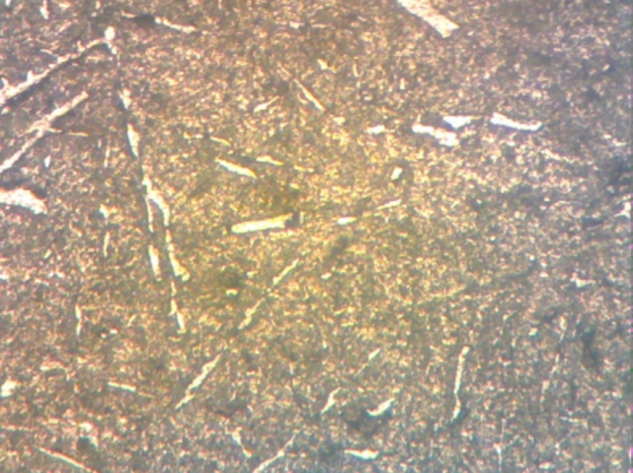
Fig. 2. Microstructure of sample ‘A’ X 200
Figure 3 shows the microstructure properties of sample ‘B’ (aluminium casting by using sand mould). Microstructures seen here were coarse, an indication that aluminium casting and sand mould interface allowed enough time for the growth of new free strain.
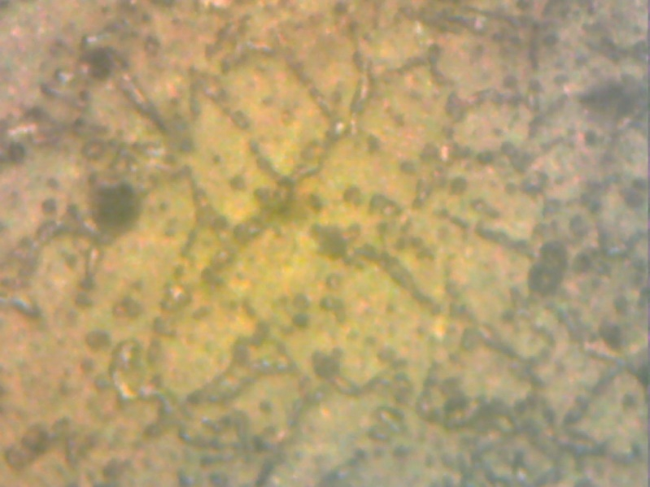
Fig. 3. Microstructure of sample ‘B’ X200
Figure 4 shows the microstructure properties of sample ‘C’ (aluminium casting by using POP). Fine microstructures were observed in this Figure. This is an indication that the aluminium casting and POP interface exchange heat to the surrounding quickly without allowing enough time for the growth of new free strains.
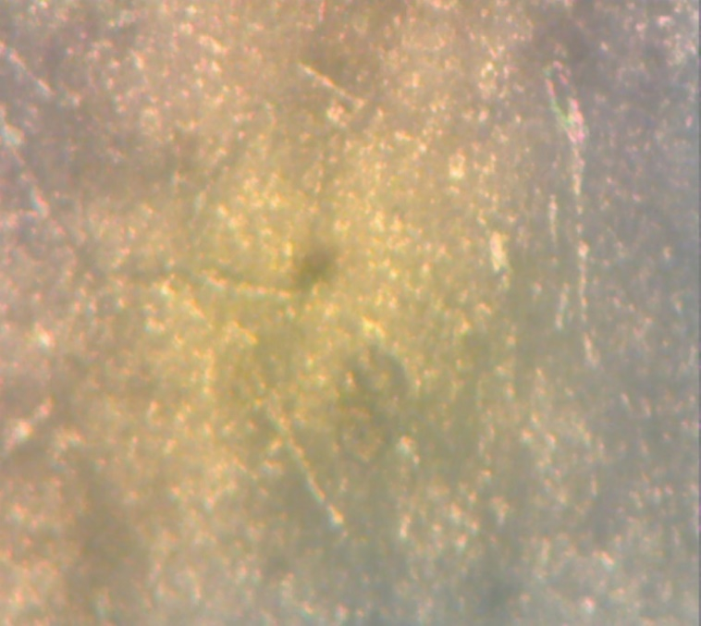
Fig. 4. Microstructure of sample ‘C’ X 200

  - Tensile Tests Results
Figure 5 shows that Sample A fractured under an applied load of 90 MPa, while Figure 6 indicates that Sample B fractured at 100 MPa. Whereas Figure 7 reveals that Sample C fractured at 72 MPa. These results suggest that Sample B exhibited the highest ductility, sustaining the maximum load before fracture, whereas Sample A demonstrated moderate ductility with a lower fracture load. Sample C, which fractured at the lowest load, displayed the least ductility and weakest mechanical performance among the three samples.

Fig. 5. Stress- strain curve of sample ‘A’

Figure 6. Stress-strain curve of sample ‘B’

Figure 7. Stress-strain curve of sample ‘C’

As shown in Figure 8, Sample B exhibits the highest tensile strain at fracture (0.025), whereas Samples A and C both fractured at a lower tensile strain of 0.0175. This indicates that Sample B possesses the greatest ductility among the three samples.

Figure 8. Bar chart showing the results of tensile strain at fracture
  - Hardness Tests Results
Figure 9 presents the hardness test results of the three samples. Sample A exhibited the highest hardness value of 38.00 BHN, followed by Sample C with 36.50 BHN, while Sample B recorded the lowest value of 32.80 BHN. The superior hardness of Sample A could be attributed to the chilling effect, resulting from rapid heat extraction at the metal–mould interface, which enhanced microstructural refinement. Similarly, the relatively high hardness of Sample C could be linked to the presence of additives (talc and silica) in the POP mould. These additives impeded dislocation motion, thereby promoting precipitation hardening. In contrast, the slower cooling rate experienced by Sample B led to a coarser microstructure, and consequently, lower hardness.

Figure 9. Bar chart showing hardness results
3.4 Impact Tests Results
Figure 10 presents the impact test results of the three samples. Sample B recorded the highest impact strength of 6.52, followed by Sample C with 6.25, while Sample A showed the lowest value of 5.98. These results indicate that Sample B exhibits the greatest ability to withstand sudden loading, with Sample C performing moderately well, and Sample A demonstrating the least resistance to impact.

Figure 10. Bar chart showing the results of impact test

4. CONCLUSIONS AND RECOMMENDATION
4.1. Conclusions
Sand moulds retard heat extraction, producing slower cooling and coarser-grained microstructures that promote plastic deformation and greater ductility. In contrast, the rapid heat removal associated with metal moulds (chilling effect) and the precipitation-hardening influence of additives in plaster-of-paris (POP) moulds yield finer, harder microstructures with elevated hardness but reduced ductility. Overall, these observations highlight the fundamental trade-off between hardness/strength and ductility driven by mould type and cooling rate.

COMPETING INTERESTS
The authors declare no conflicts of interest.

REFERENCES
[1] R. W. Lewis, R. S. Ransing, W. K. S. Pao, K. Kulasegaram, and J. Bonet, “Alternative techniques for casting process simulation,” Int. J. Numer. Methods Heat Fluid Flow, vol. 14, no. 2, pp. 145–166, 2004, doi: 10.1108/09615530410513782.
[2] M. łągiewka and Z. Konopka, “The Influence of Material of Mould and Modification on the Structure of Alsi11 Alloy,” Arch. Foundry Eng., vol. 12, no. 1, pp. 67–70, 2012, doi: 10.2478/v10266-012-0013-1.
[3] M. B. Parappagoudar, D. K. Pratihar, and G. L. Datta, “Forward and reverse mappings in green sand mould system using neural networks,” Appl. Soft Comput. J., vol. 8, no. 1, pp. 239–260, Jan. 2008, doi: 10.1016/j.asoc.2007.01.005.
[4] R. A. UPADHYE and I. KESWANI, “Optimization of Sand Casting Process Parameter Using Taguchi Method in Foundry Nagpur 440013 India castings manufactured in iron foundry by maximizing the signal to noise ratios and the effects of signal to noise ratio of the experiments depending upon th,” Int. J. Eng. Res. Technol., vol. 1, no. 7, pp. 1–11, 2012.
[5] C. Saikaew and S. Wiengwiset, “Optimization of molding sand composition for quality improvement of iron castings,” Appl. Clay Sci., vol. 67–68, pp. 26–31, 2012, doi: 10.1016/j.clay.2012.07.005.
[6] R. Ichakpa Ejilah, D. S. G, and E. I. Datau N, “THE EFFECT OF SAND CASTING PROCESS PARAMETERS ON MECHANICAL PROPERTIES OF ALUMINUM ALLOY CASTING.” [Online]. Available: https://www.researchgate.net/publication/232416969
[7] M. Pawlak and R. Władysiak, “Plaster mould casting process of AlSi11 alloy,” Arch. Foundry Eng., vol. 9, no. 4, pp. 225–232, 2009.
[8] W. Jiang, Z. Fan, D. Liao, X. Dong, and Z. Zhao, “A new shell casting process based on expendable pattern with vacuum and low-pressure casting for aluminum and magnesium alloys,” Int. J. Adv. Manuf. Technol., vol. 51, no. 1–4, pp. 25–34, 2010, doi: 10.1007/s00170-010-2596-4.
[9] . I. B. D., “Optimization of Ceramic Shell Mold Materials in Investment Casting,” Int. J. Res. Eng. Technol., vol. 03, no. 10, pp. 30–33, 2014, doi: 10.15623/ijret.2014.0310005.
[10] S. Jones and C. Yuan, “Advances in shell moulding for investment casting,” J. Mater. Process. Technol., vol. 135, no. 2-3 SPEC., pp. 258–265, 2003, doi: 10.1016/S0924-0136(02)00907-X.
[11] C. J. Davey, “The early history of lost-wax casting,” Metall. Civilis. Eurasia Beyond, pp. 147–154, 2009.
[12] B. Aremo and M. O. Adeoye, “A low-cost vacuum casting equipment for aluminium alloys,” Russ. J. Non-Ferrous Met., vol. 51, no. 2, pp. 124–130, 2010, doi: 10.3103/S1067821210020094.
[13] S. Kumar, P. Kumar, and H. S. Shan, “Optimization of tensile properties of evaporative pattern casting process through Taguchi’s method,” J. Mater. Process. Technol., vol. 204, no. 1–3, pp. 59–69, 2008, doi: 10.1016/j.jmatprotec.2007.10.075.
[14] X. J. Liu, S. H. Bhavnani, and R. A. Overfelt, “Simulation of EPS foam decomposition in the lost foam casting process,” J. Mater. Process. Technol., vol. 182, no. 1–3, pp. 333–342, 2007, doi: 10.1016/j.jmatprotec.2006.08.023.
[15] F. G. Martins and C. A. S. de Oliveira, “Study of full-mold casting process for Al-Si hipoeuthetic alloys,” J. Mater. Process. Technol., vol. 179, no. 1–3, pp. 196–201, 2006, doi: 10.1016/j.jmatprotec.2006.03.085.
[16] Z. Zhang, R. Tremblay, and D. Dubé, “Microstructure and mechanical properties of ZA104 (0.3-0.6Ca) die-casting magnesium alloys,” Mater. Sci. Eng. A, vol. 385, no. 1–2, pp. 286–291, 2004, doi: 10.1016/j.msea.2004.06.063.
[17] A. Info, “An Overview of Semi-Solid Metal Processing,” vol. 8, no. 19, pp. 369–373, 2014.
[18] J. Wannasin and S. Thanabumrungkul, “Development of a semi-solid metal processing technique for aluminium casting applications,” Songklanakarin J. Sci. Technol., vol. 30, no. 2, pp. 215–220, 2008.
[19] A. Oyewole and A. M. Sunday, “Design and Fabrication of a Centrifugal Casting Machine,” Int. J. Eng. Sci. Technol., vol. 3, no. 12, pp. 8204–8210, 2011.
[20] K. S. Keerthiprasad, M. S. Murali, P. G. Mukunda, and S. Majumdar, “Numerical simulation and cold modeling experiments on centrifugal casting,” Metall. Mater. Trans. B Process Metall. Mater. Process. Sci., vol. 42, no. 1, pp. 144–155, 2011, doi: 10.1007/s11663-010-9402-4.
[21] L. Sowa and A. Bokota, “Numerical model of thermal and flow phenomena the process growing of the CC slab,” Arch. Metall. Mater., vol. 56, no. 2, pp. 359–366, 2011, doi: 10.2478/v10172-011-0038-4.
[22] S. Bockus, “A study of the microstructure and mechanical properties of continuously cast iron products,” Metalurgija, vol. 45, no. 4, pp. 287–290, 2006.
[23] M. Neuser, O. Grydin, Y. Frolov, and M. Schaper, “Influence of solidification rates and heat treatment on the mechanical performance and joinability of the cast aluminium alloy AlSi10Mg,” Prod. Eng., vol. 16, no. 2–3, pp. 193–202, 2022, doi: 10.1007/s11740-022-01106-1.
[24] K. A. Gul, D. Dispinar, E. S. Kayali, and O. Aslan, “Assessment of Tensile Properties of Cast High Mg containing Al-Mg-Cu Aluminum Alloy with Correlation of Computed Tomography Scans and Optical Crack Surface Analysis,” Int. J. Met., vol. 17, no. 4, pp. 2622–2637, 2023, doi: 10.1007/s40962-023-01038-1.
[25] M. Thirumal Azhagan, B. Mohan, and A. Rajadurai, “Optimization of process parameters to enhance the hardness on squeeze cast aluminium alloy AA6061,” Int. J. Eng. Technol., vol. 6, no. 1, pp. 183–189, 2014.
[26] V. A. Babu, B, S.K. kathikeyan, “Experimental Investigation and Analysis of Corrosion and Hardness using Aluminium Composites,” Int. J. Latest Trends Eng. Technol., vol. 4, no. 4, pp. 37–46, 2014.
[27] N. D. Alexopoulos, “Impact properties of the aircraft cast aluminium alloy Al-7Si0.6Mg (A357),” EPJ Web Conf., vol. 6, 2010, doi: 10.1051/epjconf/20100602002.
[28] L. Tian, Y. Guo, J. Li, F. Xia, M. Liang, and Y. Bai, “Effects of solidification cooling rate on the microstructure and mechanical properties of a cast Al-Si-Cu-Mg-Ni piston alloy,” Materials (Basel)., vol. 11, no. 7, pp. 3–11, 2018, doi: 10.3390/ma11071230.
[29] Z. Guo, N. Saunders, A. P. Miodownik, and J. P. Schillé, “Modelling of materials properties and behaviour critical to casting simulation,” Mater. Sci. Eng. A, vol. 413–414, pp. 465–469, 2005, doi: 10.1016/j.msea.2005.09.036.
[30] S. Seifeddine and I. L. Svensson, “Prediction of mechanical properties of cast aluminium components at various iron contents,” Mater. Des., vol. 31, no. SUPPL. 1, pp. S6–S12, 2010, doi: 10.1016/j.matdes.2009.11.023.
[31] H. Iqbal, A. K. Sheikh, A. Al-Yousef, and M. Younas, “Mold design optimization for sand casting of complex geometries using advance simulation tools,” Mater. Manuf. Process., vol. 27, no. 7, pp. 775–785, 2012, doi: 10.1080/10426914.2011.648250.
[32] A. K. M. A. Ahamed and H. Kato, “Influence of casting defects on tensile properties of ADC12 aluminum alloy die-castings,” Mater. Trans., vol. 49, no. 7, pp. 1621–1628, 2008, doi: 10.2320/matertrans.F-MRA2008814.
[33] Wasiu Ajibola ayoola, “EFFECT OF CASTING MOULD ON MECHANICAL PROPERTIES OF 60633 ALUMINIUM ALLOY,” 2012.

