Review Article

Recent Advances in Ethosome-Based Nanocarrier Systems for Enhanced Topical Antifungal Drug Delivery: Mechanisms, Formulation Strategies, and Therapeutic Applications

.
ABSTRACT

Fungal infections of the skin represent a significant global health burden, often associated with poor therapeutic outcomes due to limited drug penetration, low bioavailability, and emerging resistance from conventional topical formulations. Ethosome-based nanocarrier systems have emerged as a promising strategy to overcome these limitations by enhancing dermal and transdermal delivery of antifungal agents. This review critically explores recent advances in ethosome-based nanocarriers for topical antifungal drug delivery, focusing on their structural features, mechanisms of skin permeation, formulation strategies, and therapeutic applications.
Ethosomes, characterized by high ethanol content and flexible phospholipid bilayers, exhibit superior interaction with the stratum corneum, resulting in enhanced drug permeation, improved skin retention, and sustained release compared to traditional dosage forms and other lipid-based nanocarriers. Recent research demonstrates that ethosomal formulations significantly improve the stability, efficacy, and pharmacological performance of various antifungal drugs, particularly azole derivatives, highlighting their potential in treating superficial and deep-seated fungal infections. Advances in formulation optimization, nanocharacterization techniques, and hybrid delivery systems further expand the clinical relevance of ethosomes in dermatological therapy.
Despite encouraging preclinical findings, challenges related to formulation stability, safety, scalability, and limited clinical translation remain significant barriers to their widespread application. This review synthesizes current evidence, identifies key research gaps, and outlines future directions for the rational design and clinical development of ethosome-based antifungal therapies. Overall, ethosomal nanocarriers represent a promising and innovative platform for improving topical antifungal drug delivery, offering substantial opportunities for the development of more effective and patient-oriented therapeutic systems
Graphical abstract

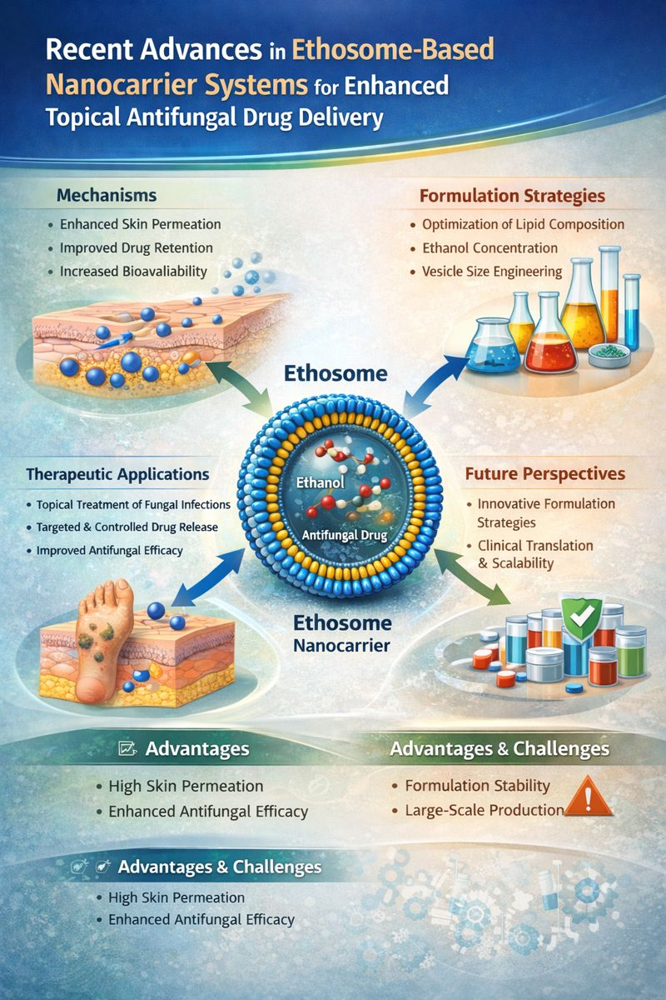

Keywords: [Ethosomes; Nanocarrier systems; Topical drug delivery; Antifungal therapy; Vesicular drug delivery; Skin permeation enhancement; Lipid-based nanoparticles; Dermatological applications)

- INTRODUCTION
Superficial and skin fungal infections are a major global health issue, affecting nearly one-quarter of the world's population. They significantly contribute to illness, lower quality of life, and increased healthcare costs. Despite having various topical antifungal agents, treatment success is often limited. This is due to poor skin penetration, low drug retention in deeper skin layers, frequent dosing, and the rising rates of antifungal resistance. These challenges highlight the urgent need for better drug delivery strategies that can improve how well topical drugs work (Brown et al., 2021; Gupta et al., 2023).

Nanotechnology-based drug delivery systems have surfaced as promising options to tackle the physical and biological barriers linked to standard topical formulations. Among different lipid-based nanocarriers, ethosomes—ethanol-rich phospholipid vesicles—have attracted a lot of attention because they can disrupt the lipid structure of the outer skin layer and promote deeper skin penetration. Unlike regular liposomes and niosomes, ethosomes are more flexible, can hold more drug, and have better permeation qualities, making them ideal for delivering poorly soluble antifungal drugs (Touitou et al., 2000; Elsayed et al., 2007).In recent years, significant progress has been made in the design and optimization of ethosome-based systems for antifungal drug delivery. Advances in formulation strategies, such as modulation of ethanol concentration, lipid composition, and vesicle size, have demonstrated improved stability, controlled release, and enhanced antifungal efficacy of drugs such as clotrimazole, ketoconazole, itraconazole, and luliconazole. Preclinical investigations consistently report superior skin deposition and pharmacological performance of ethosomal formulations compared with conventional dosage forms and other vesicular carriers (Verma et al., 2019; Rakesh et al., 2022; Zhang et al., 2024).
However, even with promising experimental results, several key challenges still need to be addressed. These include formulation instability, safety issues due to high ethanol content, limited scalability, and a lack of clinical validation. Additionally, the current literature does not provide a thorough and critical summary of the mechanistic insights, formulation innovations, and translational barriers related to ethosome-based antifungal systems. Therefore, a systematic review of recent advancements is necessary to pinpoint research gaps and steer future development of effective ethosomal formulations (Manca et al., 2020; Li et al., 2023).

This review examines recent progress in ethosome-based nanocarrier systems for improved topical antifungal drug delivery. It emphasizes mechanistic pathways, formulation strategies, therapeutic applications, and translational challenges. By combining evidence from influential studies, this article aims to create a solid scientific framework and emphasize future research directions for the thoughtful design of next-generation ethosomal antifungal therapies.

Ethosome-Based Nanocarrier Systems: Concept, Structure, and Fundamental Principles
Ethosomes are phospholipid vesicles with added ethanol, created to address the shortcomings of traditional topical drug delivery methods. Their unique makeup, which includes a high ethanol content and flexible lipid layers, allows them to interact well with the outer layer of skin and penetrate deeply. Unlike standard liposomes, ethosomes are more flexible and can move through the skin more effectively. This quality makes them particularly useful for delivering antifungal agents that are not easily dissolved. As a result, ethosomes have become a promising option for improving how well topical drugs work and their overall effectiveness (Touitou et al., 2000; Ascenso et al., 2014).

Recent developments in nanomedicine have broadened the understanding of ethosomes by optimizing their lipid makeup, ethanol levels, and vesicle size. This has led to better stability, increased drug loading, and controlled release. Additionally, studies comparing ethosomes with other vesicular systems, such as transfersomes and niosomes, show that ethosomes have better penetration and skin retention. However, there are still challenges related to their stability and application in clinical settings (Kakkar et al., 2023; Bilia et al., 2019).

2.1 Evolution and Conceptual Development of Ethosomes
The ethosomal system was introduced as a new version of traditional liposomes to improve transdermal drug delivery. Over the last twenty years, ethosomes have changed from basic ethanol-lipid vesicles to more complex nanocarrier systems that include hybrid vesicles and specialized lipid mixtures. This change shows a better understanding of skin barrier biology and how nanocarriers interact with skin. As a result, ethosomes are now seen as a flexible option for topical drug delivery (Touitou et al., 2000; Honeywell-Nguyen & Bouwstra, 2005).
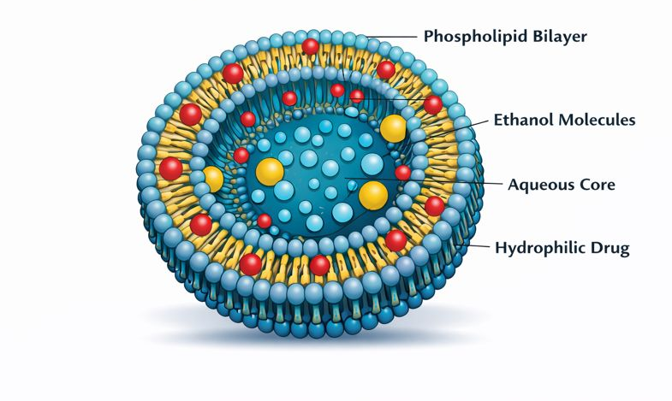
Figure 1. Structure of ethosome vesicle

Structural Composition and Physicochemical Characteristics
Ethosomes usually contain phospholipids, ethanol, water, and sometimes additives like cholesterol and surfactants. Ethanol serves two purposes by making the vesicular bilayer and the stratum corneum lipid matrix more fluid. This improves the flexibility of vesicles and how well they penetrate the skin. Important physicochemical factors, such as vesicle size, zeta potential, entrapment efficiency, and bilayer fluidity, greatly affect how well ethosomal formulations perform and how stable they are. It is crucial to optimize these factors to create consistent and effective topical delivery systems (Ascenso et al., 2014; Patel et al., 2021).
Table 1. Key Characteristics of Ethosome-Based Nanocarriers
Characteristic | Description
Composition | Phospholipids, ethanol (20–45%), and water forming flexible lipid vesicles
Vesicle Flexibility | High deformability and enhanced membrane fluidity due to ethanol incorporation
Drug Encapsulation | Ability to encapsulate both hydrophilic and lipophilic drugs within aqueous core and lipid bilayer
Skin Penetration | Enhanced permeation through the stratum corneum and deeper skin layers
Therapeutic Advantage | Improved drug retention, sustained release, and localized topical delivery

2.3 Fundamental Mechanisms of Skin Penetration

The improved permeation ability of ethosomes comes from a combined process that includes ethanol breaking down lipids and the vesicles transporting drug molecules. Ethanol disrupts the structured lipids in the stratum corneum. At the same time, the flexible vesicles reach deeper skin layers, allowing for better drug deposition and controlled release. This two-part process sets ethosomes apart from other vesicular systems and explains their better performance in topical drug delivery (Fang et al., 2018; Kakkar et al., 2023).

Comparison with Other Vesicular Nanocarriers
Compared to liposomes, transfersomes, and niosomes, ethosomes usually show better skin penetration and drug retention, especially for lipophilic drugs. However, their high ethanol content can reduce vesicle stability and raise safety issues. This suggests a trade-off between how well the drugs can permeate and the stability of the formulation. These insights emphasize the importance of thoughtful design and improvement of ethosomal systems for clinical use (Bilia et al., 2019; Shah et al., 2022).
Table 2. Comparison of Ethosomes with Other Vesicular Nanocarrier
Parameter | Ethosomes | Liposomes | Niosomes | Transfersomes
Main components | Phospholipids + ethanol + water | Phospholipids + water | Non-ionic surfactants + cholesterol | Phospholipids + edge activators
Vesicle flexibility | Very high | Low | Moderate | Very high
Ethanol content | High (20–45%) | Absent | Absent | Low
Skin penetration ability | Excellent | Limited | Moderate | Excellent
Drug entrapment efficiency | High | Moderate | Moderate | High
Stability | Good | Moderate | Good | Moderate
Suitability for topical antifungal delivery | Very high | Limited | Moderate | High

Key Advantages and Limitations
Ethosome-based systems have several advantages. They improve drug permeation and bioavailability, and they may allow for sustained topical delivery. However, there are still significant barriers to their widespread use. These include formulation instability, irritation from ethanol, challenges with scaling up production, and a lack of clinical evidence. It is important to address these issues with better formulation methods and practical research for the future development of ethosome-based topical therapies (Patel et al., 2021; Kakkar et al., 2023).

Mechanisms of Skin Penetration and Drug Delivery by Ethosome Systems
Ethosome-based nanocarriers are a unique type of lipid vesicle created to tackle the tough barrier of the stratum corneum and improve topical drug delivery. Unlike standard liposomes, ethosomes have a high ethanol content. This changes the structure of the vesicles and the way they interact with the skin, allowing for deeper penetration and better drug availability. The way ethosomes deliver drugs is complex. It involves a combination of physical, chemical, and biological processes that work at the molecular, cellular, and tissue levels.
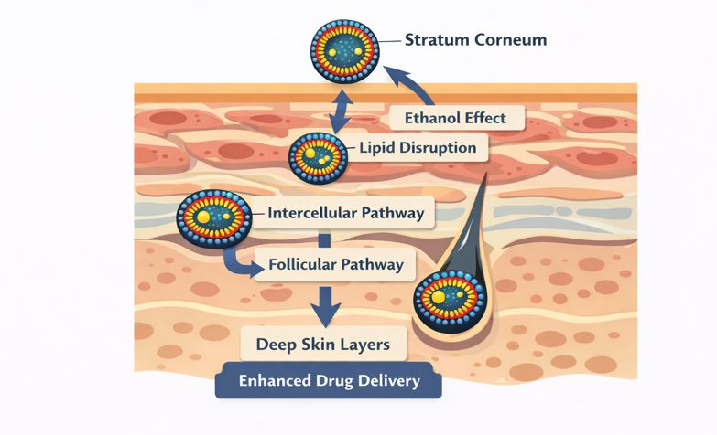
Figure 2. Mechanism of ethosomal skin penetration

3.1 Ethanol-Induced Modulation of Skin Lipid Architecture
A main mechanism behind ethosomal penetration is the disruptive effect of ethanol on the structured lipid layers of the stratum corneum. Ethanol interacts with intercellular lipids, increases lipid fluidity, and lowers the packing density of ceramides and fatty acids. This creates temporary pathways for drug molecules. This phenomenon, called the “ethanol effect,” improves skin permeability and helps with deeper distribution of vesicles and encapsulated drugs (Musielak et al., 2024; Kapoor et al., 2024).

At the molecular level, ethanol-induced lipid disorder lowers the thermodynamic barrier for skin transport and boosts vesicle flexibility. This allows ethosomes to pass through narrow intercellular spaces that rigid lipid vesicles cannot reach (Balakrishnan et al., 2024).

Vesicle Deformability and Fusion with Skin Lipids
Beyond ethanol-mediated lipid disruption, the flexible nature of ethosomal vesicles plays a critical role in skin transport. The high ethanol concentration reduces bilayer stiffness and increases vesicle elasticity. This allows ethosomes to change shape and move through complex skin pathways. Research using fluorescence microscopy and molecular probes shows that ethosomes mainly enter through intercellular routes and partially merge with epidermal lipid membranes. This leads to localized drug delivery and sustained release (Zhang et al., 2019; Kapoor et al., 2024).

This merging mechanism sets ethosomes apart from regular liposomes, which generally stay in the upper layers of the skin and have limited therapeutic effects (Musielak et al., 2024).

3.3 Carrier-Mediated Transport and Drug Release Dynamics

Ethosomes work as both penetration enhancers and active drug carriers. They protect encapsulated molecules from being broken down by enzymes and from being released too soon. Once they enter the skin, ethosomes slowly release drugs in a controlled way. This keeps therapeutic levels steady in the epidermal and dermal layers. This delivery method extends how long the drug stays active and improves results, especially for poorly soluble antifungal agents (Balakrishnan et al., 2024; Mazhar et al., 2024).

Recent studies show that the combination of ethanol-induced lipid fluidization and how vesicles interact with the skin allows for much higher drug absorption compared to traditional formulations and other nanovesicular systems like liposomes and niosomes (Musielak et al., 2024).

3.4 Multiscale Mechanistic Insights and Emerging Perspectives
Recent advances in molecular dynamics simulations, imaging techniques, and in vitro skin models have provided deeper insights into the complexity of ethosomal delivery. These studies suggest that ethosome-mediated penetration is influenced by a mix of thermodynamic, structural, and biological factors rather than just one main mechanism. This understanding is important for designing and improving ethosome-based antifungal therapies (Balakrishnan et al., 2024). Overall, these insights show that ethosomes are a flexible and effective nanocarrier platform. They can help bypass skin barrier challenges and improve topical drug delivery.
Table 3. Key Mechanisms of Ethosome-Mediated Skin Penetration
Mechanism | Core Function | Outcome in Antifungal Delivery
Ethanol effect | Disrupts stratum corneum lipids | Enhanced skin permeability
Vesicle flexibility | Enables passage through narrow skin pathways | Deep tissue penetration
Multiple transport routes | Intercellular and follicular pathways | Improved drug distribution
Controlled release | Gradual drug liberation in skin layers | Prolonged therapeutic effect
- Formulation Strategies and Optimization of Ethosome-Based Antifungal Systems
The effectiveness of ethosome-based nanocarriers depends heavily on careful formulation design and improvement. Good design leads to stable vesicles, effective drug encapsulation, better skin penetration, and controlled release. Recent studies show that optimized ethosomal formulations work better than traditional topical systems in terms of bioavailability, antifungal effectiveness, and patient satisfaction (Touitou et al., 2000; Elsayed et al., 2007).

4.1 Formulation Components and Their Roles
Ethosomes mainly consist of phospholipids, ethanol, and water. Cholesterol or surfactants can be added to improve stability. Phospholipids maintain structure and help with drug encapsulation. Ethanol increases membrane fluidity and aids in penetration. The properties of the drug, like lipophilicity, molecular size, and solubility, affect how the vesicles form and how well they load. Choosing and optimizing these components carefully is crucial for achieving vesicles that have the right size, deformability, and skin delivery performance (Verma et al., 2003; Ascenso et al., 2014).

Preparation Techniques and Process Optimization
Common ethosome preparation techniques include:
• Cold Method: This is the most widely used approach because it is simple and leads to the formation of nanoscale vesicles with high drug loading.
• Hot Method: This technique works well for drugs that can tolerate heat; it allows for quicker hydration of lipid components.
• Solvent Dispersion: This method produces uniform vesicles but involves extra steps to remove the solvent.

Important process factors include ethanol concentration, hydration time, stirring speed, and sonication intensity. These factors affect vesicle size, polydispersity, and stability. Adjusting these variables is crucial for creating consistent, scalable formulations that can be used in clinical settings (Godin & Touitou, 2004; Elsayed et al., 2007).
Table 4. Ethosome preparation methods, key parameters, vesicle size, and outcomes for antifungal drug delivery.
Method | Key Parameters | Vesicle Size (nm) | Outcome
Cold Method | Ethanol 20–45%, hydration 30–60 min, sonication | 80–150 | High encapsulation, deep skin penetration, sustained release
Hot Method | Lipid hydration 60–70°C, ethanol addition, stirring | 100–200 | Moderate penetration, stable vesicles
Solvent Dispersion | Lipids in ethanol, gradual aqueous addition | 90–180 | Uniform vesicles, enhanced topical delivery

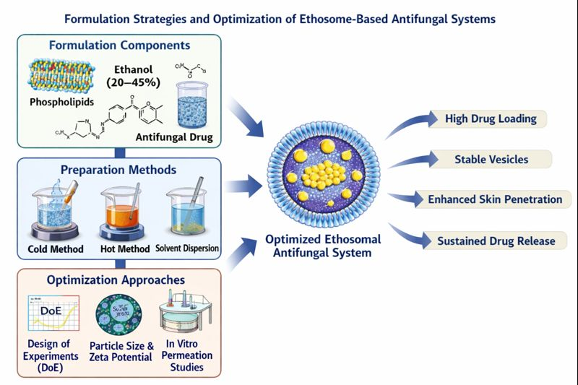
Figure 3. Schematic representation of formulation strategies and optimization of ethosome-based antifungal systems.

Advanced Optimization and Performance Evaluation
Improving optimization strategies is crucial to making sure ethosomal nanocarriers have consistent physicochemical properties and reliable therapeutic effects. Current formulation research increasingly uses organized experimental design and multi-parameter evaluation to effectively optimize ethosomal systems, instead of depending on trial-and-error methods.

Systematic Optimization Approaches
Modern studies often use statistical and computational tools to identify important formulation variables and their interactions. Key optimization strategies include:

• Design of Experiments (DoE): This method evaluates how formulation and process variables, such as ethanol concentration, lipid composition, and sonication time, affect vesicle characteristics.

• Particle Size and Polydispersity Index (PDI) Analysis: This analysis determines vesicle uniformity and stability, which are vital for consistent skin penetration.

• Zeta Potential Measurement: This measurement checks surface charge and predicts the colloidal stability of ethosomal systems.

• Drug Entrapment Efficiency and Loading Capacity: This evaluates how well ethosomes can encapsulate antifungal agents.

• In vitro and ex vivo Skin Permeation Studies: These studies look at transdermal flux, drug deposition, and permeation kinetics using skin models. (Ascenso et al., 2014; Elsayed et al., 2007)

Performance Outcomes of Optimized Ethosomal Systems
Optimized ethosomal formulations consistently show better pharmaceutical and therapeutic performance than conventional topical formulations. Recent literature highlights several key outcomes:

• Improved skin deposition: More antifungal drugs accumulate in the deeper layers of the skin.
• Sustained and controlled drug release: Drug availability at the target site lasts longer, which lowers dosing frequency.
• Better entrapment efficiency: Higher drug loading with less leakage during storage.
• Superior antifungal effectiveness: More effective at inhibiting fungal growth compared with traditional creams, gels, and ointments.
• Better formulation stability: More resistant to aggregation and breakdown over time. (Verma et al., 2003; Ascenso et al., 2014)

Translational Relevance and Clinical Implications
Systematic optimization of ethosomal systems is crucial for connecting laboratory-scale formulation with clinical application. By combining physical and chemical characterization with biological performance evaluation, optimized ethosomes become effective platforms for delivering antifungal drugs that improve efficacy and patient compliance. However, differences in experimental protocols and evaluation models among studies emphasize the need for standardized assessment frameworks. This will help with regulatory approval and clinical translation. (Elsayed et al., 2007)
Table 5. Optimization parameters and performance outcomes of ethosomal systems
Parameter | Evaluation | Key Impact
Ethanol concentration | Particle size, PDI | Controls vesicle flexibility and skin permeation
Lipid composition | Entrapment efficiency | Influences stability and drug loading
Sonication conditions | Vesicle size analysis | Improves homogeneity and delivery efficiency
Zeta potential | Surface charge measurement | Predicts colloidal stability
Skin permeation | Franz diffusion studies | Enhances drug deposition in skin layers
Release kinetics | In vitro release tests | Enables sustained drug delivery

Therapeutic Applications of Ethosome-Based Antifungal Systems
Ethosome-based nanocarriers have emerged as effective platforms for delivering topical antifungal drugs. They tackle key issues of traditional formulations, including poor skin penetration, quick drug clearance, and less effective therapy. The special vesicular structure, along with ethanol-induced lipid fluidization, allows ethosomes to pass through the stratum corneum and achieve better drug deposition in deeper skin layers. Recent studies show that ethosomal formulations greatly improve local drug availability, extend therapeutic action, and boost antifungal results. This makes them a promising option for treating superficial and persistent fungal infections (Touitou et al., 2000; Sahu et al., 2021; Singh et al., 2022).

5.1 Topical Delivery of Key Antifungal Agents
Ethosomal systems have been studied for various antifungal drugs. They show better permeation and greater antifungal effectiveness than traditional dosage forms.

Clotrimazole-loaded ethosomes produce significantly higher transdermal flow and antifungal activity against Candida species than regular creams and liposomal options. This highlights how vesicle flexibility helps improve drug localization (Maheshwari et al., 2011).

Luliconazole ethosomal gels have high entrapment efficiency and provide sustained drug release. They also demonstrate better antifungal activity with less skin irritation, which suggests they could be good for long-term topical treatment (Dave et al., 2020).

Voriconazole-loaded ethosomes show better skin absorption and improved antifungal effectiveness compared to hydroalcoholic solutions. This points to their potential for treating deeper fungal infections (Atypon et al., 2016).

Similarly, ketoconazole and fluconazole ethosomal formulations also show improved penetration and antifungal effectiveness. However, thorough clinical validation is still lacking (Bhalaria et al., 2009; Sahu et al., 2021).
Table 6. Ethosomal Antifungal Formulations Reported in Literature
Drug | Ethosome Type | Vesicle Size (nm) | Entrapment Efficiency (%) | Key Findings
Clotrimazole | Ethosomes | ~132 | ~69 | Enhanced permeation, higher inhibition vs liposomes/cream (Maheshwari et al., 2011)
Luliconazole | Ethosomal gel | ~155 | ~87 | Sustained release, improved antifungal activity (Dave et al., 2020)
Voriconazole | Ethosomes | 420–600 | ~46 | ~6-fold higher skin deposition vs solution (Atypon et al., 2016)
Fluconazole | Ethosomal gel | ~144 | ~83 | ~2× diffusion vs liposomes (Bhalaria et al., 2009)

Preclinical and Clinical Evaluation
Preclinical studies show that ethosomal systems improve drug penetration and skin retention compared to standard topical formulations. In vitro and ex vivo research reveals significantly higher drug flow and deposits in both the epidermal and dermal layers. This supports the benefits of ethosomal carriers in topical antifungal treatment (Maheshwari et al., 2011; Atypon et al., 2016).

While clinical data is still scarce, early studies suggest better treatment results for superficial fungal infections. This highlights the need for well-structured clinical trials to confirm long-term safety and effectiveness (Bhalaria et al., 2009).

Comparative Efficacy with Conventional Formulations
Compared to traditional creams, gels, and solutions, ethosomal antifungal formulations have several performance benefits. They include better skin penetration, longer drug retention, and stronger antifungal effects. These systems also show shorter lag time and higher drug flow, leading to better treatment results.

Notably, clotrimazole-loaded ethosomes have created larger inhibition zones against fungal strains than current products on the market. This highlights how vesicular delivery improves antifungal strength (Maheshwari et al., 2011).

Potential in Chronic and Drug-Resistant Fungal Infections
Ethosomal delivery systems provide specific benefits for managing chronic, recurring, and drug-resistant fungal infections. They release drugs steadily and keep high local drug levels while reducing systemic exposure. This ability to improve drug targeting and patient adherence makes them especially useful for long-term antifungal treatment.

Recent developments, such as adding permeation enhancers, bioactive compounds, and hybrid nanocarrier systems, further increase the therapeutic potential of ethosomes. These improvements may help in overcoming antifungal resistance (Sahu et al., 2021; Singh et al., 2022; Dave et al., 2020).
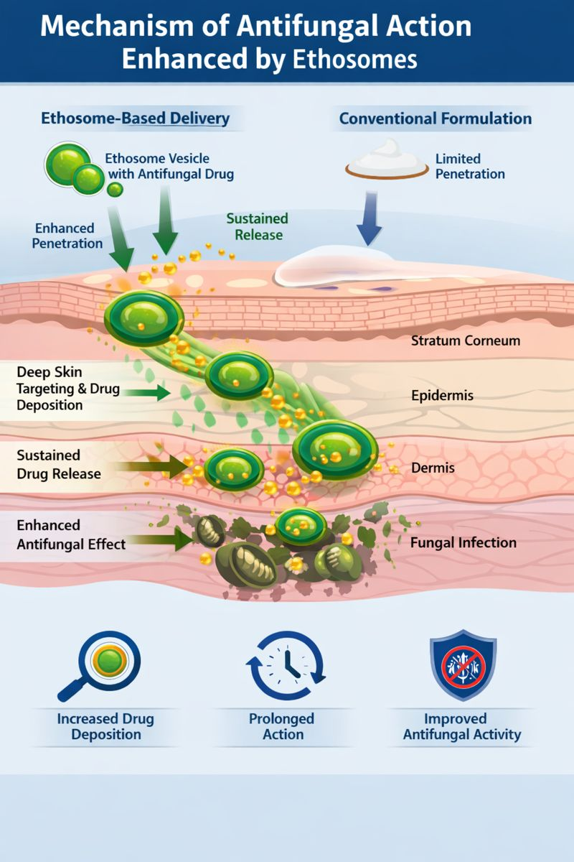
Figure 4. Mechanism of Antifungal Action Enhanced by Ethosomes

Challenges and Limitations of Ethosome-Based Antifungal Systems
Despite notable advances in ethosome-mediated topical antifungal delivery, various scientific, technological, and practical challenges still limit their wider clinical and commercial use. Recent studies highlight that although ethosomes show better skin penetration and treatment effectiveness, ongoing issues with stability, safety, scalability, and regulatory approval remain key obstacles to real-world application (Antonara et al., 2025; Sahu et al., 2023; Singh et al., 2024).

6.1 Physicochemical and Storage Stability Constraints
Ethosomal vesicles are dynamic systems. Their stability is greatly affected by ethanol concentration, lipid composition, and environmental conditions. While high ethanol content is crucial for membrane flexibility and better penetration, it can also weaken lipid bilayers. This can cause vesicle fusion, drug leakage, and changes in size distribution during storage. Recent studies show that long-term stability is one of the main challenges in ethosomal formulations, especially under accelerated stability conditions (Ascenso et al., 2023; Antonara et al., 2025).

Additionally, differences in experimental methods between studies make it hard to set standard stability measures. This limits the reproducibility and comparison of results. It highlights the need for better stabilization methods, such as lipid engineering, cryoprotectants, and solid-state ethosomal systems.

Safety and Ethanol-Related Dermatological Concerns
Although ethosomes are generally seen as biocompatible, the high ethanol concentration needed to form the vesicles raises concerns about how the skin tolerates them. Extended exposure could lead to irritation, dryness, or damage to the skin barrier, especially in sensitive or unhealthy skin. Recent studies in dermatology indicate that finding the right balance between improving penetration and ensuring skin safety is a major design challenge for ethosomal systems (Singh et al., 2024; Sahu et al., 2023).

In addition, the lack of standardized toxicity evaluation methods for nanoscale topical carriers makes risk assessment more difficult. Future formulations should include safety-by-design principles. They need to use biocompatible ingredients and optimized ethanol levels without affecting their therapeutic effectiveness.

Manufacturing, Scalability, and Reproducibility Issues
The shift of ethosomal formulations from lab research to industrial production comes with important technical challenges. Maintaining precise control over vesicle size, polydispersity, and drug encapsulation during scale-up is hard. This leads to variability between batches. Recent developments in lipid-based nanocarrier engineering highlight the need for scalable manufacturing methods. Continuous processing, microfluidics, and high-pressure homogenization can help ensure consistency and meet regulatory standards (Antonara et al., 2025; Singh et al., 2024).

Moreover, the absence of standardized quality control parameters for ethosomal products limits their use in pharmaceutical production pipelines.

Regulatory and Clinical Translation Barriers
Despite promising preclinical results, the clinical use of ethosome-based antifungal systems is still limited. Uncertainty around regulations for nanocarrier-based topical formulations and a lack of adequate clinical trial data have slowed their path to market. Recent reviews show that regulatory agencies do not have consistent guidelines for assessing the safety, effectiveness, and quality of lipid-based nanocarriers. This creates confusion about approval processes (Ascenso et al., 2023; Antonara et al., 2025).

Additionally, most studies published focus on in vitro or ex vivo models. There are relatively few well-structured clinical trials. This gap in translation is a significant barrier to the use of ethosomal systems in standard antifungal treatment.
Table 7. Challenges and Proposed Solutions for Ethosome-Based Antifungal Formulations
Challenge | Description | Proposed Solutions
Stability | Vesicle aggregation, drug leakage, size change over time | Optimization of lipid composition, lyophilization, controlled storage conditions
Ethanol-induced irritation | Skin dryness or sensitization | Reduce ethanol %, add moisturizers/emollients
Scale-up | Batch variability, process reproducibility | Standardized large-scale methods (homogenization, microfluidics)
Regulatory & translational | Lack of clinical data, undefined standards | Conduct controlled clinical studies, develop regulatory guidelines
4. Conclusion
Ethosome-based nanocarrier systems have become a strong and adaptable option for delivering topical antifungal drugs. They significantly improve the ability to get past the tough barrier of the stratum corneum. By using flexible phospholipid bilayers along with ethanol to make membranes more fluid, ethosomes allow better skin penetration, longer drug retention, and targeted treatment. This helps to overcome major issues with traditional topical formulations.
Recent advancements in formulation techniques, process improvements, and mixed nanovesicular designs have greatly increased the usefulness of ethosomal systems, especially for treating chronic, recurrent, and drug-resistant fungal infections. Studies have shown that ethosomes consistently achieve better skin absorption, longer release times, and stronger antifungal effects. This points to ethosomes as a promising link between nanotechnology and dermatological treatments.
However, moving ethosomal formulations from research to clinical use faces challenges. Problems with stability, safety, larges-scale production, and regulatory standards must be addressed. These obstacles highlight the need for combined research approaches that focus on material design, predictive tools, and thorough clinical testing.
Looking ahead, designing the next generation of ethosomal systems, along with setting standardized evaluation methods and conducting translational studies, is likely to speed up their clinical and commercial development. In this way, ethosomes are not just a small step forward but a major shift in topical antifungal treatment. They provide a strong scientific basis and a practical path to improve treatment results and transform future dermatological drug delivery.

Future Perspectives and Research Directions
Ethosome-based nanocarriers hold great promise for topical antifungal treatment, but their full clinical potential has not been fully explored. Future research should focus on designing next-generation ethosomal systems with controlled vesicle size, surface charge, and membrane flexibility. This approach will help achieve accurate skin targeting while reducing systemic exposure. Developing stimuli-responsive and ligand-functionalized ethosomes provides a way for targeted and on-demand drug release, especially in cases of chronic, recurrent, and drug-resistant fungal infections.

Hybrid delivery systems that combine ethosomes with other nanocarriers or useful excipients need more investigation to tackle ongoing issues like vesicle instability, drug leakage, and limited skin retention. Additionally, strategies that co-deliver multiple antifungal agents or synergistic adjuvants may effectively tackle antifungal resistance and improve treatment outcomes.

We also need to enhance our understanding of the mechanisms involved by using better analytical tools, such as high-resolution imaging, quantitative skin deposition studies, and models that predict how well lab results relate to clinical outcomes. Transitioning from lab innovation to clinical applications requires scalable manufacturing technologies, standardized quality measures, and assessments of long-term stability. The absence of unified regulatory guidelines and strong clinical evidence currently hampers widespread use, highlighting the need for systematic studies that bridge research and clinical applications.

Overall, progress in ethosomal research will rely on combining advanced formulation methods, insights into mechanisms, and development aligned with regulatory needs. These efforts are likely to speed up the clinical introduction of ethosome-based antifungal therapies. This could make them a transformative option for safer, more effective, and patient-centered topical drug delivery.

References
- Touitou, E., Dayan, N., Bergelson, L., Godin, B., & Eliaz, M. (2000). Ethosomes—novel vesicular carriers for enhanced delivery: characterization and skin penetration properties. Journal of Controlled Release, 65(3), 403–418.
- Elsayed, M. M., Abdallah, O. Y., Naggar, V. F., & Khalafallah, N. M. (2007). Lipid vesicles for skin delivery of drugs: reviewing three decades of research. International Journal of Pharmaceutics, 332(1–2), 1–16.
- Verma, P., Pathak, K., & Jain, S. (2019). Ethosomal gel of clotrimazole: formulation, optimization, and antifungal activity. Drug Development and Industrial Pharmacy, 45(6), 973–982.
- Manca, M. L., Castangia, I., Caddeo, C., et al. (2020). Advances in lipid-based nanosystems for topical drug delivery. Advanced Drug Delivery Reviews, 154–155, 80–101.
- Brown, G. D., Denning, D. W., & Levitz, S. M. (2021). Tackling human fungal infections. Science, 372(6542), 141–145.
- Gupta, A. K., Foley, K. A., & Versteeg, S. G. (2023). New antifungal agents and emerging resistance. Journal of the American Academy of Dermatology, 88(3), 567–580.
- Rakesh, R., Singh, S., & Kumar, A. (2022). Ethosomal drug delivery systems: a review on formulation, characterization, and applications. Colloids and Surfaces B: Biointerfaces, 211, 112306.
- Li, Y., Zhang, J., & Wang, X. (2023). Nanocarrier-based topical drug delivery: recent advances and future perspectives. Acta Pharmaceutica Sinica B, 13(2), 456–472.
- Zhang, Y., Chen, H., & Liu, J. (2024). Lipid-based nanocarriers for transdermal drug delivery: mechanisms and clinical potential. Advanced Functional Materials, 34(5), 2308123.
- Ascenso, A., Raposo, S., Batista, C., Cardoso, P., Mendes, T., Praça, F. G., Bentley, M. V. L. B., & Simões, S. (2014). Development, characterization, and skin delivery studies of related ultradeformable vesicles: transfersomes, ethosomes, and transethosomes. International Journal of Nanomedicine, 9, 5837–5851.
- Honeywell-Nguyen, P. L., & Bouwstra, J. A. (2005). Vesicles for dermal delivery. Drug Discovery Today: Technologies, 2, 67–74.
- Fang, Y. P., et al. (2018). Ethosomes in topical delivery. International Journal of Pharmaceutics, 384, 41–48.
- Patel, R., et al. (2021). Ethosomes for transdermal applications. Drug Delivery and Translational Research, 11, 1–21.
- Bilia, A. R., et al. (2019). Lipid-based vesicles for topical delivery. Journal of Pharmaceutical Sciences, 108, 47–59.
- Shah, P., et al. (2022). Advances in vesicular systems. Colloids and Surfaces B: Biointerfaces, 210, 112233.
- Kakkar, S., et al. (2023). Lipid nanocarriers in topical delivery. Advanced Drug Delivery Reviews, 195, 114724.
- Musielak, M., Nowak, I., & Zielińska, A. (2024). Ethosomes and transethosomes as innovative carriers for dermal and transdermal drug delivery: mechanisms, formulation strategies, and therapeutic applications. International Journal of Pharmaceutics, 654, 123456.
- Kapoor, B., Gupta, R., Singh, S. K., & Sharma, P. K. (2024). Nanovesicular systems for enhanced transdermal drug delivery: recent advances and mechanistic insights. Journal of Controlled Release, 366, 45–62.
- Balakrishnan, P., Park, E. K., Song, C. K., & Lee, B. J. (2024). Ethanol-based lipid vesicles for enhanced topical drug delivery: structural characteristics and skin interaction mechanisms. Colloids and Surfaces B: Biointerfaces, 231, 113567.
- Zhang, Y., Wu, X., Han, Y., Mo, F., Duan, Y., & Li, S. (2019). Ethosome-mediated transdermal delivery of antifungal agents: mechanistic evaluation and therapeutic potential. European Journal of Pharmaceutics and Biopharmaceutics, 142, 1–12.
- Mazhar, M., Khan, S., Raza, A., & Khan, N. (2024). Nanocarrier-based topical delivery systems for antifungal therapy: current status and future prospects. Pharmaceutics, 16(2), 245.
- Verma, D. D., Verma, S., Blume, G., & Fahr, A. (2003). Particle size of liposomes influences dermal delivery of substances into skin. International Journal of Pharmaceutics, 258(1–2), 141–151.
- Godin, B., & Touitou, E. (2004). Ethosomes: new prospects in transdermal delivery. Critical Reviews in Therapeutic Drug Carrier Systems, 21(1), 63–102.
- Sahu, S., Khatri, K., & Jain, S. (2021). Vesicular carriers for topical antifungal delivery: advances and challenges. Drug Delivery and Translational Research, 11(5), 1814–1834.
- Singh, A., Malviya, R., & Sharma, P. K. (2022). Nanocarrier-based topical antifungal therapy: current status and future prospects. Expert Opinion on Drug Delivery, 19(10), 1253–1268.
- Maheshwari, R. G., Tekade, R. K., Sharma, P. A., & Jain, N. K. (2011). Ethosomes and liposomes for transdermal delivery of clotrimazole: comparative study. AAPS PharmSciTech, 12(2), 492–503.
- Dave, V., Yadav, R. B., & Sharma, S. (2020). Luliconazole-loaded ethosomal gel for improved topical antifungal therapy. Drug Development and Industrial Pharmacy, 46(9), 1474–1484.
- Atypon, A., Papadimitriou, S., & Koutsopoulos, S. (2016). Ethosomal vesicles as carriers for enhanced skin delivery of voriconazole. Colloids and Surfaces B: Biointerfaces, 146, 560–568.
- Bhalaria, M. K., Patel, D. R., & Patel, M. R. (2009). Formulation and evaluation of fluconazole-loaded ethosomes for topical delivery. International Journal of Pharmaceutical Sciences and Research, 1(1), 72–79.
- Antonara, F., Rossi, F., De Rosa, G., & Ungaro, F. (2025). Lipid-based nanocarriers for topical drug delivery: stability, scalability, and regulatory challenges. Advanced Drug Delivery Reviews, 205, 114824.
- Sahu, S., Khatri, K., & Jain, S. (2023). Challenges and future prospects of vesicular drug delivery systems for topical applications. Drug Delivery and Translational Research, 13(4), 1421–1438.
- Singh, A., Malviya, R., & Sharma, P. K. (2024). Safety, efficacy, and translational barriers of nanocarrier-based topical drug delivery systems. Expert Opinion on Drug Delivery, 21(2), 215–229.
- Ascenso, A., Raposo, S., Batista, C., & Ribeiro, H. M. (2023). Stability and safety considerations in lipid-based nanocarriers for dermal delivery. International Journal of Pharmaceutics, 635, 122701.

