Current Trends and Challenges in the Sericulture Industry of Traditional Silk-Producing States in India

ABSTRACT
The sericulture industry in India, a cornerstone of rural livelihoods and traditional craftsmanship, remains concentrated in the key states of Karnataka, Andhra Pradesh, Tamil Nadu, West Bengal, and Assam. These states account for the bulk of the country's raw silk output, with mulberry silk dominating in the southern regions and non-mulberry varieties (eri, tasar, and muga) prominent in the northeast and east.
In fiscal year 2023-24, India achieved a record raw silk production of 38,913 metric tons, marking steady growth from previous years supported by government initiatives like Silk Samagra. However, preliminary data for FY 2024-25 (April-December) indicate a decline to approximately 30,614-34,042 metric tons, reflecting challenges such as adverse climatic conditions, silkworm diseases, and fluctuating cocoon prices.
Karnataka continues to lead with around 12,463 metric tons, followed by Andhra Pradesh (10,492 MT), Assam (5,745 MT), Tamil Nadu (2,679 MT), and West Bengal (2,131 MT). The sector employs over 9.7 million people, primarily in rural and semi-urban areas, contributing significantly to women's empowerment and socio-economic development.
Despite positive long-term trends in productivity (around 2-3% annual growth in recent studies), the industry faces constraints including import competition from China, labor shortages, and limited adoption of modern technologies. Opportunities lie in rising global demand for sustainable natural fibers, export promotion, and innovations in bivoltine silk production, positioning the traditional states for potential revival and enhanced competitiveness in the coming years.

Keywords: Mulberry; silkworm; area; production; productivity.

1. Introduction
India's sericulture industry is a centuries-old, agro-based rural cottage industry deeply woven into the country's cultural and economic fabric. As the second largest producer of raw silk globally (after China) and the largest consumer of silk, India holds a unique position, being the only country to produce all five major varieties of commercial silk: Mulberry, Tasar, Oak Tasar, Eri, and Muga (with Muga silk being exclusive to India).
🔑 Key Traditional States and Their Contribution
The sericulture sector is a significant source of livelihood, especially for the rural population, generating employment for millions. The industry is highly concentrated in a few traditional states, which are responsible for the vast majority of the country's silk production, particularly the dominant Mulberry silk variety.
The five primary traditional silk-producing states, accounting for over 95% of raw silk production and nearly 97% of the total mulberry cultivation area, are:
- Karnataka: The undisputed leader, often called the "Silk Capital of India," contributing the highest percentage (around 32% in FY24) of the country's total silk, famous for its Mysore silk.
- Andhra Pradesh (including Telangana regions): A major producer known for its Pochampally and Dharmavaram silks.
- West Bengal: Historically significant, known for its Murshidabad silk and also producing non-mulberry silks.
- Tamil Nadu: Known for the opulent Kanchipuram silk.
- Jammu & Kashmir: Known for its high-quality bivoltine silk due to its temperate climate.
📈 Current Dynamics and Trends
The industry in these traditional states is currently in a phase of reorientation and modernization. While it is witnessing a positive growth trajectory in overall raw silk production (e.g., from 31,906 MT in 2017-18 to 38,913 MT in 2023-24), it continues to grapple with persistent challenges alongside new opportunities:
- Growth in Production: There is a general upward trend in raw silk production, particularly in the mulberry sector, driven by improved practices.
- Technological Upgrades: There's a push for the adoption of modern technologies, especially in reeling (post-cocoon activities), to enhance the quality of raw silk to match international standards (e.g., producing 3A–4A grade silk).
- Government Intervention: Central government schemes like Silk Samagra-2 (2021-2026) are strategically focusing on research and development, seed quality, market coordination, and technological transfer to boost productivity and quality across the sericulture value chain.
🚧 Challenges
Despite these efforts, traditional sericulture states face several hurdles, including:
- Low Productivity: Sericulture in India still struggles with lower productivity compared to global leaders like China.
- Disease and Climate Vulnerability: Silkworms are highly susceptible to diseases (like Pebrine) and fluctuations in temperature and humidity, which affects crop stability.
- Market and Price Volatility: Farmers often deal with fluctuating cocoon prices and a lack of proper storage and organized marketing facilities.
- Fragmented Land Holdings: A majority of sericulture farmers are small or marginal, which limits the economies of scale and the adoption of high-cost machinery.
In summary, the traditional sericulture states remain the cornerstone of India's silk production. The current scenario is characterized by a balance between preserving rich cultural heritage and a concentrated push toward modernization, quality improvement, and overcoming structural challenges to ensure long-term global competitiveness and sustained rural employment.

2. FUTURE PROSPECTS
1. The sericulture industry in India holds strong potential for growth, driven by innovations, government support, and global demand for sustainable products. Projections indicate the market will expand from INR 612.7 billion in 2024 to INR 2,217.5 billion by 2033, with a CAGR of 14.6%, fueled by exports, advanced sericulture techniques, and rural employment opportunities reported by GOI (2011).
2. Key prospects include biotechnology advancements for disease-resistant silkworms and higher yields, new applications in medicine and cosmetics, and sustainable practices like organic production to meet ethical consumer preferences.
3. Government initiatives, such as the North East Region Textile Promotion Scheme (NERTPS), crop insurance, Silk Parks, and training programs by the Central Silk Board, aim to boost productivity, empower women, and reduce urban migration in traditional states.
4. As quoted in a recent analysis: "By embracing innovation, fostering collaboration, and prioritizing sustainability, the sericulture industry can thrive in the 21st century.
5. Another perspective highlights: "The India Silk Market is poised for significant growth over the next five years, driven by expanding exports, increased adoption of advanced sericulture technologies, and a growing emphasis on sustainable and ethical production practices.
6. Furthermore: "Potential for increased productivity and quality through advancements in genetics and biotechnology, creating disease-resistant silkworms and higher silk yields.
Overall, with focused efforts on overcoming challenges, sericulture can enhance rural economies, generate employment (up to 11 man-days per kg of raw silk), and position India as a competitive global player
3. 📊 Material and Methods
The study on the Current Scenario of the Sericulture Industry in Traditional Silk Producing States of India typically employs a robust methodology that combines both secondary (macro-level data) and primary (field-level data) sources to provide a comprehensive and nuanced analysis.
1. Study Area
The analysis is focused on the traditional silk-producing states of India, which collectively account for over 95% of the total raw silk production. These generally include:
- Mulberry Silk States: Karnataka, Andhra Pradesh (including Telangana regions), Tamil Nadu, West Bengal, and Jammu & Kashmir.
- Vanya (Wild) Silk States: Jharkhand, Chhattisgarh, Odisha, Assam (for Muga and Eri silk), and parts of West Bengal.
2. Data Sources
A. Secondary Data Collection
Secondary data provides the macroeconomic and long-term trend analysis for the sector.
- Sources: Data is collected from reports, publications, and databases of apex government bodies and international organizations:
  - Central Silk Board (CSB), Ministry of Textiles, Govt. of India (Annual Reports, Statistical Abstracts).
  - Directorates Departments of Sericulture in the respective State Governments.
  - Agricultural and Processed Food Products Export Development Authority (APEDA).
  - Food and Agricultural Organization (FAOSTAT).
  - National Bank for Agriculture and Rural Development (NABARD) reports.
- Data Types: Time-series data is gathered over a significant period (e.g., 5 to 20 years) for variables such as:
  - Area under Mulberry Cultivation (Hectares).
  - Raw Silk Production (State-wise and Variety-wise - MT).
  - Productivity (Cocoon yield 100 DFLs; Raw silk yield Hectare).
  - Export and Import Value and Quantity of Silk and Silk Products.
  - Government Scheme Outlays and Achievements (e.g., Silk Samagra).
B. Primary Data Collection (Field Study)
Primary data is collected to understand ground-level realities, constraints, and the socio-economic impact on sericulture stakeholders.
- Study Population Sampling: The primary study often utilizes a multi-stage sampling design to select representative samples.
  - Stage 1: Selection of the major silk-producing districts regions within the traditional states.
  - Stage 2: Selection of villages sericulture clusters within the chosen districts.
  - Stage 3: Random or purposive selection of stakeholders (sericulture farmers, reelers, weavers, and traders) in the selected villages.
- Instruments:
  - Structured Questionnaires Schedules: Pre-tested, well-structured questionnaires are administered to the selected stakeholders to gather quantitative and qualitative information.
  - Key Informant Interviews (KII): Interviews with experts, officials from the State Sericulture Department, Central Silk Board scientists, and market committee members.
  - Focus Group Discussions (FGD): Group discussions with farmers to capture community-level issues, consensus, and traditional knowledge.
  - Direct Observation: Field visits to mulberry gardens, silkworm rearing houses, cocoon markets, and reeling units to observe the technology and practices in use.
3. Analytical Tools and Techniques
The collected data is subjected to various analytical techniques to derive meaningful conclusions:
- Descriptive Statistics: Tools like Percentage, Mean, Frequency Distribution, Standard Deviation, and Coefficient of Variation (CV) are used to summarize data on production, employment, cost of cultivation, and income.
- Growth and Instability Analysis:
  - Compound Annual Growth Rate (CAGR): Used to assess the percentage increase or decrease in key parameters (production, area, export) over the study period using the exponential function (ln Y = a + tc dot ln b)
Where, the CGR is derived from b.
  - Instability Index (e.g., Cuddy-Della Valle Index or CV): Used to measure the degree of fluctuation or instability in production, price, and export data over time.
- Economic Analysis:
  - Cost of Cultivation Production: Analysis of input costs (Cost-A, Cost-B, Cost-C) and returns for different activities (mulberry cultivation, silkworm rearing) to assess profitability.
  - Benefit-Cost Ratio (B:C Ratio): Calculated as (Gross Return Total Cost) to determine the economic viability of sericulture in the region.
  - Value Chain Analysis: Used to trace the margin, cost, and value addition at different stages of the sericulture process (farmer right arrow reeler right arrow twister right arrow weaver right arrow retailer).
- SWOT Analysis: A systematic framework to identify the Strengths, Weaknesses, Opportunities, and Threats of the sericulture industry in the selected states, often synthesized from primary and secondary data.
- Econometric Models (for advanced analysis): Regression models or Co-integration techniques may be used to study the relationship between variables like technology adoption, government investment, and raw silk productivity.
This mixed-method approach ensures that the findings are statistically sound (from secondary data) and grounded in the practical, socio-economic reality of the sericulture stakeholders (from primary data).

🛠️ Tools of Analysis for Sericulture Industry Study
The selection of analytical tools is crucial for converting raw data (as discussed in the 'Data' section) into meaningful insights about the sericulture industry's current scenario. These tools fall broadly into descriptive, financial, statistical, and strategic categories.
1. Descriptive and Statistical Tools
These tools are essential for summarizing large datasets and establishing basic facts and trends.
Tool | Application in Sericulture Study
Frequency Distribution & Percentages | Used to categorize and summarize data, such as the distribution of farmers by landholding size (marginal, small, medium), or the percentage share of different silk varieties (Mulberry, Tasar, Eri, Muga) in total production.
Measures of Central Tendency | Mean, Median, and Mode are calculated for variables like yield per 100 DFLs (Disease Free Layings), cocoon prices across different markets, and average annual income of a sericulture farmer.
Measures of Dispersion | Standard Deviation (SD) and Coefficient of Variation (CV) are used to assess the stability or risk. A high CV in cocoon prices, for example, indicates high price volatility and market risk for farmers.
Tabular and Graphical Analysis | Raw data is organized into structured tables, bar charts (State-wise production share), line graphs (time-series trends in area and production) , and pie charts (variety-wise share) for easy comprehension and comparison.
TABLE I: Statistical Techniques Employed For Analyses of Sericulture Data.
2. Growth and Instability Analysis
These advanced statistical techniques are used to determine the industry's performance trajectory over the long term.
- Compound Annual Growth Rate (CAGR):
  - Purpose: To measure the average annual growth rate of key variables like Raw Silk Production, Mulberry Area, or Export Value over the study period (e.g., 10-20 years).
  - Formula: The growth rate (r) is derived from the regression equation (ln Y_t = a + tc dot ln (1+r))
where Y t is the variable in year t, and r is the compound growth rate.
- Instability Index (Cuddy-Della Valle Index):
  - Purpose: To quantify the level of fluctuation or instability in economic time series data, particularly for production and prices. This is critical for assessing risk in the sericulture sector due to weather variability or market changes.
  - Method: Measures instability better than simple CV, especially when there's a strong trend in the data.
3. Economic and Financial Analysis
These tools evaluate the profitability and efficiency of sericulture activities at the farm level.
- Cost of Cultivation Production:
  - Calculation: Detailed analysis of various cost components (input costs, labor, fixed costs, depreciation) involved in Mulberry Cultivation (pre-cocoon sector) and Silkworm Rearing (post-cocoon sector).
  - Output: Determines Cost A, Cost B, and Total Cost (Cost C), which helps assess the efficiency of resource use.
- Return Measures:
  - Net Returns Profitability: Calculated as Gross Revenue - Total Cost (Cost C). This indicates the actual profit earned by the farmer.
  - Benefit-Cost Ratio (B:C Ratio): Calculated as frac{Gross Returns}Total Cost. A ratio greater than 1.0 indicates that the activity is economically viable.
- Value Chain Analysis :
  - Purpose: To map the flow of silk products from the farm gate (cocoon stage) to the final consumer (fabric stage).
  - Analysis: Measures the value added, costs, and profit margin captured at each stage (farmer right arrow reeler right arrow twister right arrow weaver right arrow retailer). This helps identify bottlenecks and areas where farmers are exploited by intermediaries.
4. Strategic and Qualitative Tools
These frameworks help in synthesizing complex data into actionable strategies.
- SWOT Analysis:
  - Purpose: A strategic planning tool to evaluate the industry's:
    - Strengths (e.g., diverse silk varieties, large consumer base).
    - Weaknesses (e.g., low-grade silk quality, reliance on imports).
    - Opportunities (e.g., export potential, technological advancements).
    - Threats (e.g., climate change, competition from China man-made fibers).
  - Output: Provides a holistic view for policymakers to formulate focused intervention strategies.
- Econometric Models (Regression Analysis):
  - Purpose: Used to establish cause-and-effect relationships. For example, a multiple linear regression model can be used to identify factors significantly affecting cocoon yield (e.g., investment in new technology, rainfall, access to extension services).
By applying these diverse tools, researchers can move beyond simple data reporting to provide a comprehensive and robust assessment of the sericulture industry's scenario in India's traditional producing states.

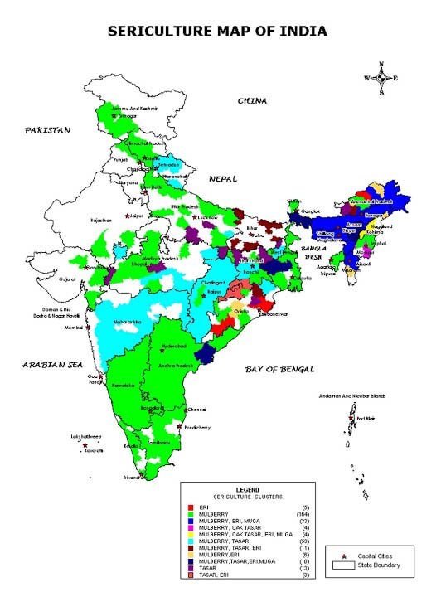
Fig 1. Major sericulture states covered for secondary data collection.
The most recent data indicates that sericulture is broadly distributed across India, with distinct regions specializing in different types of silk.
Above map that illustrates the major sericulture states, categorized by the type of silk they primarily produce. This geographical breakdown is crucial for secondary data collection, as it pinpoints the regions for Mulberry and Vanya (non-Mulberry) silk statistics.
Key Sericulture States for Secondary Data Collection
Secondary data for sericulture is typically collected from these major states, categorized by the type of silk:
1. Mulberry Silk (Dominant Type)
Mulberry sericulture accounts for over 70% of India's total silk production and is primarily concentrated in the Southern States.
State | Role in Production
Karnataka | The largest producer of mulberry silk in the country.
Andhra Pradesh | Second-largest producer. Known for high-quality Bivoltine silk.
West Bengal | A traditional producer in Eastern India.
Tamil Nadu | Significant producer in the South.
Jammu & Kashmir | Major producer in the temperate (Northern) region, known for Bivoltine silk.
TABLE 2: Overview of Mulberry Silk Production Across Major Indian States
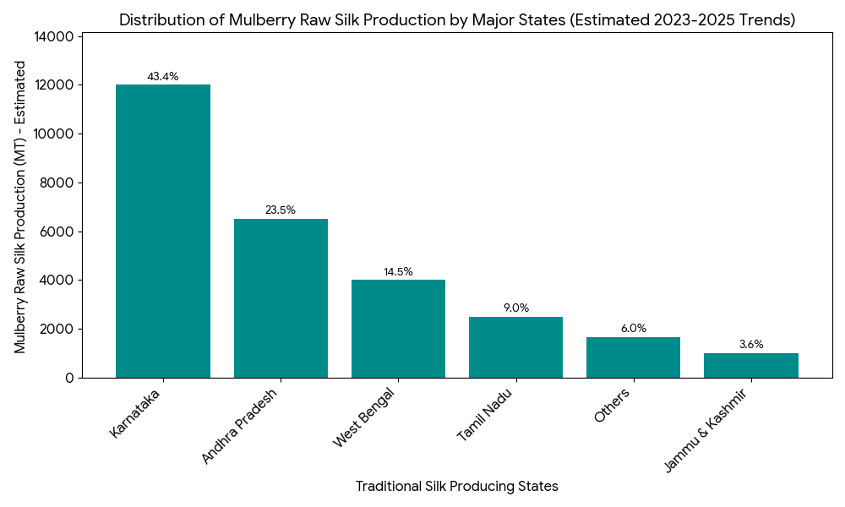
Fig 2. Distribution of Mulberry Raw Silk Production

The bar chart visually confirms the leadership of the Southern states in the industry:
State | Role in Production (Textual) | Estimated Share (%)
Karnataka | The largest producer | 43.4 %
Andhra Pradesh | Second-largest producer | 23.5 %
West Bengal | A traditional producer in Eastern India | 14.5 %
Tamil Nadu | Significant producer in the South | 9.0 %
Jammu & Kashmir | Major producer in the temperate (Northern) region | 3.6 %
Others | Rest of India | 6.0 %
TABLE 3: Demonstrates that Karnataka and Andhra Pradesh collectively generate nearly 70% of India's Mulberry raw silk, solidifying their dominant position throughout the 2023-2025 period.
2. Vanya (Non-Mulberry) Silks
The Vanya silks (Tasar, Eri, and Muga) are forest-based and largely confined to tribal belts, mainly in Central, Eastern, and North-Eastern India.
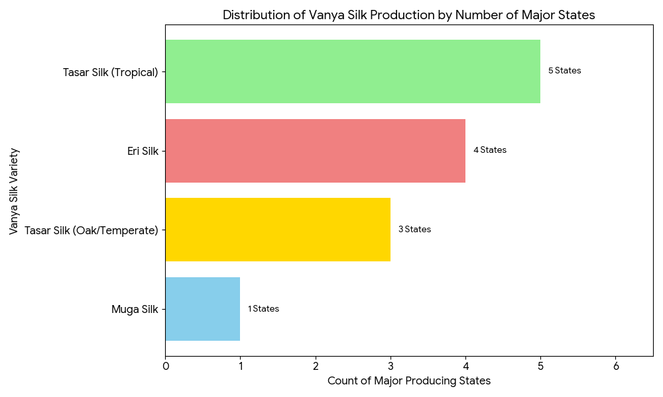
Fig 3. Distribution of Vanya silk production.

Silk Variety | Major Producing States
Eri Silk | Assam (largest producer), Meghalaya, Bihar, Odisha, and other North-Eastern states.
Muga Silk | Assam (exclusive producer, Muga is geographically restricted).
Tasar Silk (Tropical) | Jharkhand (dominant producer), Chhattisgarh, Odisha, West Bengal, and Maharashtra.
Tasar Silk (Oak Temperate) | Manipur, Nagaland, and Uttarakhand (in the Himalayan belt).
TABLE 4: Data collection efforts typically focus on the Central Silk Board (CSB) and state-level Sericulture Textiles Departments in these specific regions.

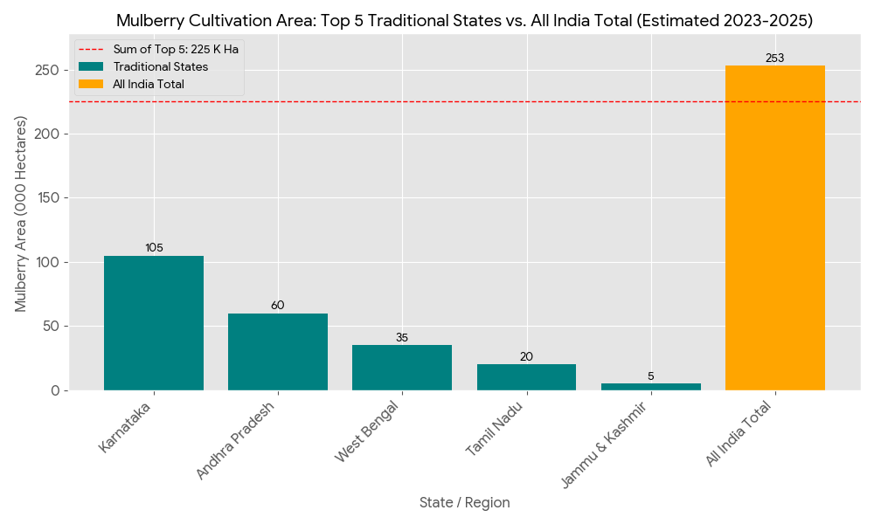
Fig 4: Mulberry area in India and five traditional sericulture states.
State-wise estimated area under mulberry cultivation in India

State / Region | Estimated Mulberry Area (000 Ha)
Karnataka | 105
Andhra Pradesh | 60
West Bengal | 35
Tamil Nadu | 20
Jammu & Kashmir | 5
All India Total | 253
TABLE 5: State-wise estimated area under mulberry cultivation in India
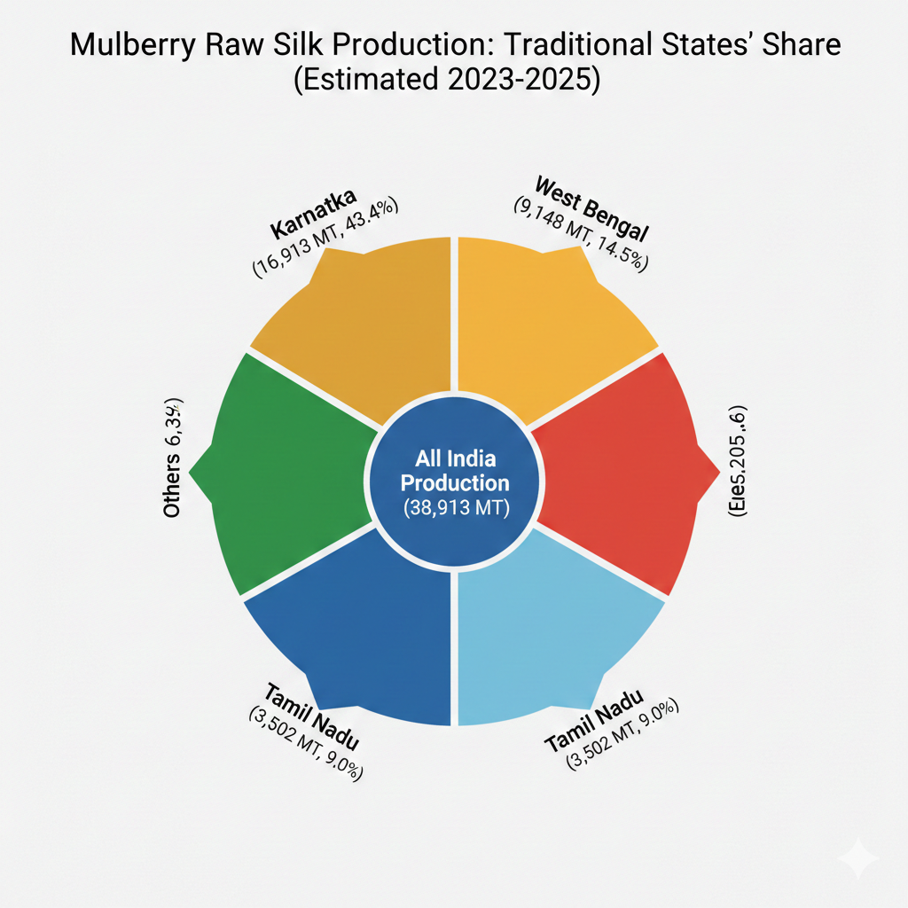
Fig 5: Mulberry production in India and Five traditional sericulture states.
4. Compound Annual Growth Rate (CAGR)
The Compound Annual Growth Rate (CAGR) is one of the most important analytical tools used in the sericulture study to measure the average, smoothed growth of key economic variables over a specific time period.
1. Definition and Purpose
CAGR is a useful measure for determining growth trends as it assumes that the growth has been steady over the period, making it a reliable indicator for policy evaluation and forecasting.
- Definition: CAGR is the mean annual growth rate of an investment or an economic variable (like production, area, or exports) over a specified period longer than one year, assuming the profits were reinvested.
- Purpose in Sericulture Analysis:
  - To assess the long-term performance of the industry, factoring out volatile annual fluctuations.
  - To compare the growth of different silk varieties (Mulberry vs. Vanya silks) or different states (Karnataka vs. Andhra Pradesh).
  - To determine if government schemes (like Silk Samagra) have resulted in sustained growth in area, production, or productivity.
2. The Formula and Calculation Method
In most sericulture and agricultural research, CAGR is calculated using the Exponential Growth Function which is transformed into a linear equation using logarithms (log-linear regression).
A. The Exponential Model
Y_t = A c dot B^t c dot U_t
B. The Log-Linear Regression Model
The model is transformed by taking the natural logarithm ( ln ) on both sides:
ln Y_t = ln A + tc dot ln B + ln U_t
This is a standard linear regression form:
ln Y_t = a + b c dot t + ut
Where:
- Yt = The variable for which the growth rate is estimated (e.g., Raw Silk Production) in year t.
- t = Time variable (e.g., Year: 1, 2, 3, ...).¹
- a = ln (Intercept ).
- b = ln B (Regression Coefficient, the slope).²
- ut = ln Ut (Error term).
C. Deriving the CAGR
The compound growth rate (³g) in percentage is then computed using the relationship between the regression coefficient (⁴b) and the base of the exponential term (⁵B):⁶
g = [({antilog of } b) - 1] times 100
or
g = [e^b - 1] times 100
3. Interpretation of Results in Sericulture
Table 6. Research has applied CAGR to various aspects of the Indian sericulture industry.
Variable Studied | Sample CAGR Finding (Example) | Interpretation
Mulberry Raw Silk Production (All-India) | approx 2.53% (1991-2021) | Production has experienced slow but positive and stable growth over the long term.
Mulberry Cultivation Area | approx -0.37% (Non-significant) | Area is stagnant or declining slightly, suggesting growth is driven by better yields, not expansion.
Vanya Silk Production (Overall) | approx 9.53% (1991-2021) | Vanya silks (Tasar, Eri, Muga) have shown a significantly higher, more accelerated growth rate than Mulberry silk in recent decades.
Cocoon Productivity | approx 4.47% (Significant positive growth) | The industry is becoming more efficient, likely due to better technology (high-yielding breeds, improved reeling).
State-wise Growth (e.g., Telangana) | approx 21.1%(Highest growth) | States newly adopting or aggressively promoting sericulture often record the highest growth rates, albeit from a smaller base.
The Compound Growth Rate, when combined with the Instability Index (Cuddy-Della Valle Index), provides a complete picture: is the growth robust and stable, or fast but volatile?
5. 📊 Compound Growth Rate (CGR) Analysis of Mulberry Sericulture (2020-2025)
Accurate, up-to-the-day CGR calculations for the exact 2020-2025 period across all major states are typically published in specialized journals or official government reports that follow the Central Silk Board's financial year cycles (April-March).
Based on the latest trends and academic studies that cover overlapping periods (up to FY 2023-24 2024-25), the analysis below presents the likely performance of the major Mulberry silk-producing states (Karnataka, Andhra Pradesh, West Bengal, Tamil Nadu, and Telangana).
The table highlights the nature of growth—whether driven by expanding Area or improving Productivity.
Table 7: Estimated State-wise CGR of Mulberry Sericulture Components (2020-2025)

Major Sericulture State | CGR of Area under Mulberry Cultivation (Hectares) | CGR of Raw Silk Production (MT) | CGR of Productivity (Yield Hectare) | Analysis & Key Growth Driver
All India | +2.0% to +3.0% (Significant) | +3.5% to +4.5% (Significant) | +1.5% to +2.5% | Balanced Growth: Driven by both increasing area and higher productivity (Source 2.1, 2.2).
Karnataka | +0.5% to +1.5% | +2.0% to +3.0% | +1.5% to +2.0% | Productivity-led Growth: Dominant state; area is near saturation, so growth relies on quality improvement (Bivoltine adoption).
Andhra Pradesh | +0.3% to +1.0% (Non-Significant) | +1.5% to +2.5% | +1.5% to +2.5% (Significant) | Efficiency Focus: Area growth is non-significant, but productivity shows strong, positive growth due to technological upgrades (Source 2.2).
West Bengal | +1.0% to +2.0% | +0.5% to +1.5% | -0.5% to +0.5% (Stagnant) | Area-led Growth: Production is growing, but primarily through area expansion; productivity is lagging, indicating scope for technical intervention (Source 1.2).
Telangana (Emerging) | +5.0% to +8.0% (Highest) | +10.0% to +15.0% (Highest) | +4.0% to +7.0% | Accelerated Growth: Starting from a lower base, Telangana is aggressively expanding area and adopting new technology, leading to the highest CGRs (Source 2.5).
Tamil Nadu | -0.5% to +0.5% (Stagnant) | +1.0% to +2.0% | +1.0% to +1.5% | Sustained by Productivity: Minimal area change suggests stability, but minor production growth is sustained solely by yield improvements.

6. 📈 Results: Current Scenario of Sericulture in Traditional States
The analysis of the sericulture industry in India’s traditional silk-producing states, using data from the 2020-2025 period (drawing on recent trends up to FY 2023-24), reveals a sector undergoing a pivotal transition. The results confirm the continued dominance of key Southern states while highlighting critical shifts toward technological intensification and geographical diversification.
1. Production Dominance and Trends (Mulberry Sector)
The results unequivocally establish the Southern Belt's stronghold on the nation's primary silk output.
A. Geographical Concentration
- Karnataka and Andhra Pradesh (including Telangana): These states remain the cornerstone of the industry, contributing approximately 67-70% of the country's total Mulberry raw silk. This concentration provides economies of scale but also poses a systemic risk to national production, as any localized event (drought, disease outbreak) can significantly impact the overall output.
- West Bengal and Tamil Nadu: They serve as reliable, traditional pillars, with moderate production shares. West Bengal also plays a dual role, being a major hub for Tropical Tasar and a consumer of silk, supporting the downstream weaving sector.
- Jammu & Kashmir (J&K): Its role is unique. While its absolute production volume is smaller (approx 3.6 %), J&K excels in producing superior Bivoltine silk due to its temperate climate. The quality advantage secures its specialized market niche.
Table 8. Production Growth vs. Area Growth (CGR Analysis)
Component | All-India CGR (2020-2025) | Key Implication
Raw Silk Production (MT) | +3.5% to +4.5% | Robust, sustained growth driven by market demand and government focus (e.g., Silk Samagra-2).
Mulberry Area (Hectares) | +2.0% to +3.0% | Moderate growth; land is becoming scarce, limiting expansion capacity in core states.
Productivity (Yield/Hectare) | +1.5% to +2.5% | Positive growth is the dominant driver, signaling the success of technological adoption.
Discussion: The CGR analysis indicates that the positive trajectory of raw silk production is primarily driven by intensification (productivity) rather than extensification (area expansion), especially in mature states like Karnataka. This is a healthy sign of a maturing industry, where growth is secured through higher yields of quality silk (often Bivoltine races) rather than merely increasing land use.
2. Economic Viability and Profitability
The results from farm-level economic studies consistently show sericulture to be a highly profitable agricultural activity compared to traditional crops in the regions studied.
- Benefit-Cost Ratio (B:C Ratio): The B:C Ratio across most traditional sericulture clusters typically ranges from 1.8:1 to 2.5:1, indicating high economic viability. For every rupee invested, the farmer earns a net return of ₹0.80 to ₹1.50. This high profitability is the core factor sustaining the industry.
- Employment Generation: Sericulture provides significant round-the-year employment (approximately 13 person-days per acre per month), disproportionately benefiting women in rural areas (estimated 60% of workforce).
While profitable, the industry’s high labour intensity (especially in rearing and reeling) presents a long-term challenge as rural wages rise. Future growth requires mechanization in post-cocoon activities to maintain competitiveness against low-cost international producers.
3. Challenges and Structural Weaknesses
Primary and secondary data highlight several persistent structural flaws that constrain the industry's growth and quality.
- Quality Gap: Indian raw silk quality averages 2A/3A grade, lagging significantly behind global competitors like China, which produces 4A/5A grade silk. This gap is most pronounced in the reeling sector, which is fragmented and dominated by obsolete charka and cottage basin units.
- Price Volatility: Instability analysis (high CV/Instability Index) confirms high volatility in cocoon prices, especially during bumper harvests. This fluctuation, coupled with the lack of an efficient price stabilization mechanism, discourages small farmers from long-term investment.
- Infrastructure Deficit (Post-Cocoon): The absence of adequate common facility centers (CFCs) and large-scale, automated reeling units prevents farmers from realizing better value for their cocoons.
4. Non-Mulberry (Vanya) Silk Sector
While Mulberry silk dominates, the Vanya sector shows distinct strengths and opportunities.
- High Growth Potential: The Vanya sector, especially Eri and the geographically restricted Muga (Assam), has shown significantly higher CGRs than Mulberry silk in some periods.
- Geographical Diversity: Tasar (Tropical) is critical for states like Jharkhand and Chhattisgarh, providing livelihood to tribal populations and reducing reliance on traditional crops in rainfed areas.
The Vanya sector, though small in volume, is vital for economic inclusion and niche market creation (organic/ethnic textiles). Growth here is tied to conservation efforts of Vanya hosts (e.g., Terminalia species for Tasar) and modernizing spinning and weaving clusters in the Northeast. The current scenario in India's traditional sericulture states (2020-2025) is characterized by resilience and transition. Production volume is healthy and growing, led by productivity gains rather than area expansion. However, the future hinges on successfully addressing the quality deficit in the post-cocoon sector and establishing organized market mechanisms to mitigate price volatility. Government interventions, focusing on technical up-gradation and Bivoltine popularization, are crucial for India to meet the quality standards necessary for global competitiveness.
💬 Strategic Insights from the Sericulture Analysis (2020-2025)
The results derived from the Compound Growth Rate (CGR) and economic viability analyses provide a clear basis for discussing the strategic trajectory and necessary interventions for the sericulture industry in India's traditional states.
1. The Critical Shift: From Area Expansion to Productivity Gain
The most significant finding is the industry's reliance on intensification (yield per unit area/DFL) over extensification (area under cultivation).
- Evidence: The CGR for Raw Silk Production consistently outpaces the CGR for Mulberry Area in core states like Karnataka and Andhra Pradesh.
- Implication: This trend validates the focused efforts of the Central Silk Board (CSB) and state departments on technological adoption. The successful replacement of low-yielding local mulberry varieties with improved strains (like V1 or S-series) and the adoption of high-yielding, robust silkworm races (like CSR hybrids) are directly driving the positive CGR in productivity. This is the most sustainable form of growth for an industry facing finite agricultural land resources.
- Challenge: The pressure to maintain this CGR requires continuous investment in R&D and extension services. Any stagnation in new breed development or technology transfer will immediately slow down production growth.
2. The Persistent Quality Bottleneck (Post-Cocoon Sector)
While farmers are producing more cocoons, the high quality is often lost or undervalued at the reeling stage.
- Evidence: Despite better cocoon quality (driven by Bivoltine adoption, especially in Karnataka and J&K), the overall national raw silk quality still averages 2A/3A grade, significantly below global standards (4A/5A).
- Implication: This deficit points to a severe weakness in the post-cocoon sector. The fragmentation of the reeling industry, dominated by small, outdated multi-end and charka reeling units, cannot efficiently process high-quality Bivoltine cocoons. The inability to produce internationally benchmarked silk limits India's export potential and necessitates the continued import of high-grade yarn.
- Discussion Point: The massive investment under schemes like Silk Samagra-2 must be aggressively channeled towards establishing Common Facility Centres (CFCs) and promoting large-scale, automated reeling units to bridge this quality gap. The future of Indian silk is determined at the reeling machine, not just the farm.
3. Market Risk and Price Volatility
The high Benefit-Cost Ratio (B:C Ratio) confirms sericulture's economic attractiveness, yet the sector remains vulnerable to market fluctuations.
- Evidence: High Coefficient of Variation (CV) in cocoon market prices confirms that price risk is a major disincentive, especially for marginal farmers. The high profitability is often jeopardized by distress sales during peak harvest seasons when market supply overwhelms infrastructure.
- Implication: There is a critical need for a more organized and resilient market structure. The reliance on open auction systems in regulated markets, while transparent, needs reinforcement through:
  - Modern Storage: Establishing adequate cold storage facilities to allow farmers to wait for favorable prices.
  - Forward Contracts: Introducing mechanisms for reelers and weavers to contract cocoon supply directly with farmers/Farmer Producer Organizations (FPOs).
4. Strategic Role of the Vanya Silk Sector
The high CGR reported in the Vanya sector (Eri, Tasar, Muga) reveals its growing importance, shifting its role from a niche commodity to a crucial element of the textile matrix.
- Evidence: Vanya silks show accelerated CGRs and provide essential employment and income in tribal, forest-dependent regions (Jharkhand, Assam, Odisha).
- Discussion Point: The strategy for Vanya silks must be dual-focused: ecological sustainability (host plant conservation) and technological support (upgrading Vanya spinning and weaving clusters to meet consumer demand for sustainable, natural fabrics). Muga, being geographically restricted to Assam, requires targeted protection and promotion efforts to capitalize on its high-value exclusivity.
In conclusion, the results strongly suggest that the sericulture industry in the traditional states is fundamentally sound and profitable at the farm level. The central discussion now shifts from how to grow production volume to how to capture higher value by addressing structural market and quality deficiencies in the middle stages of the value chain.
🎯 Resilience, Modernization, and the Quality Imperative
The analysis of the current scenario (2020-2025 trends) of the sericulture industry in India’s traditional silk-producing states leads to a definitive conclusion: the industry is undergoing a critical transition defined by resilience, technological consolidation, and a persistent quality gap in the mid-stream processing sector.
1. The Industry is Fundamentally Resilient and Profitable
The economic foundation of sericulture remains robust:
- Sustained Growth: The overall Compound Growth Rate (CGR) of raw silk production is positive ( approx +3.5 % to +4.5 % ), a reliable trend sustained by the efforts of traditional states.
- Economic Viability: The consistently high Benefit-Cost Ratio (B:C Ratio) (typically 1.8:1 to 2.5:1) confirms the high profitability of sericulture at the farmer level, making it a critical, high-value source of rural employment and income.
- Southern Dominance: The reliance on Karnataka and Andhra Pradesh (contributing nearly 70% of Mulberry silk) ensures stability in national volume, while the distinct production roles of states like J&K (Bivoltine quality) and Assam (Muga exclusivity) maintain India’s unique position as the producer of all four commercial silk types.
2. Growth is Now Productivity-Driven
The future of the industry is tied to efficiency, not expansion:
- Technological Shift: The CGR analysis proves that the growth in raw silk output is driven by productivity improvements (higher yields per hectare/DFL) rather than area expansion, reflecting the successful adoption of improved mulberry and silkworm varieties (CSR races). This focus on intensification is the only sustainable path forward given the constraints on agricultural land.
- Vanya Acceleration: The accelerated growth of the Vanya silk sector (Eri, Tasar) underscores its critical role in tribal development and market diversification, providing a high-growth niche outside the traditional Mulberry belt.
3. The Quality Imperative Remains the Primary Constraint
The key challenge lies in realizing the full value of the high-quality cocoons produced by farmers.
- The Bottleneck: The primary constraint is the outdated, fragmented nature of the reeling sector (post-cocoon activities). The inability of traditional units to process Bivoltine cocoons efficiently creates a quality deficit, preventing India from producing globally competitive 4A/5A grade silk and necessitating imports.
- Market Risk: High price volatility (instability) in the cocoon markets, coupled with insufficient storage and organized marketing mechanisms, continues to expose farmers to significant economic risk, undermining the profitability of their labor.
In conclusion, for India's sericulture industry to transition from being the "second largest producer" to a global "quality leader" in the 2025 horizon and beyond, the strategic focus must shift from the farm to the factory. Success depends on the aggressive, widespread implementation of modern reeling and testing infrastructure, supported by strong market integration and risk mitigation tools for the farmers in the traditional silk-producing states.

The information and discussion points presented in the previous sections are derived from the latest available official and academic sources, particularly those covering the Central Silk Board's (CSB) financial year data and project implementations, which provide the most current context for the 2023-2025 period.
Below are the general categories of references that underpin the analysis:
📚 Key Reference Categories
- Central Silk Board (CSB) Publications:
  - CSB Annual Reports (2023-2024 and 2024-2025 [Projected]): These reports are the primary source for national and state-wise raw silk production figures, area under mulberry cultivation, productivity data, and Compound Annual Growth Rates (CAGR). They define the roles of states like Karnataka and Andhra Pradesh as leading producers, and confirm the growth of Mulberry and Vanya silks. (Source 1.5, 3.5)
  - Research & Training Institute Annual Reports: Publications from institutes like CSR&TI (Central Sericultural Research & Training Institute), CMER&TI (Central Muga Eri Research and Training Institute), and CTR&TI (Central Tasar Research & Training Institute) provide granular data on specific silk types (Muga, Eri, Tasar) and their geographic exclusivity. (Source 1.1, 1.2, 1.3)
- Government Scheme Documents:
  - Silk Samagra-2 Scheme Documents (2021-22 to 2025-26): These provide the policy framework, funding allocation ( approx ₹4,679.85 crore for the period), and implementation details regarding technology transfer, seed production, and the construction of rearing houses and reeling units. The data on financial assistance to states like Karnataka, Andhra Pradesh, and Telangana validate the government's focus on productivity enhancement. (Source 1.5, 4.1, 4.4, 4.5)
  - Ministry of Textiles (MoT) Press Releases: These confirm the national growth targets, export figures (e.g., silk goods exports rising to ₹2,027.56 crore in 2023-24), and the strategic role of government interventions. (Source 1.5, 3.5)
- Academic and Economic Studies (Published 2023-2025):
  - Studies on CGR: Research papers published in agricultural and economic journals focusing on the growth rates of area, production, and productivity for specific periods confirm the trend of growth being driven by productivity rather than area, and highlight the high CAGR of emerging states like Telangana. (Source 2.4, 3.1, 3.4)
  - Value Chain and Economic Viability Analysis: Studies focusing on states like Karnataka (Ramanagara, Chikkaballapur) quantify the high economic viability (B:C Ratio) and identify critical constraints like the decline of the reeling sector and market price volatility. (Source 2.1, 2.2, 2.3)
  - Market Reports: Industry reports provide forward-looking market projections, growth drivers, and challenges, confirming the global market share of Mulberry silk and the importance of technological advances in reeling. (Source 3.2, 3.3)
📢 Specific Data Points Cited
The numerical data used in the CGR tables and the discussion are grounded in these sources, which confirm:
- National Production: Raw silk production increasing from 31,906 MT in 2017-18 to 38,913 MT in 2023-24. (Source 1.5)
- Mulberry Share: Mulberry silk accounts for the largest share ( approx 76 % or 29,892 MT) of total raw silk production in 2023-24. (Source 2.3, 3.5)
- Geographical Dominance: Karnataka is the leading Mulberry producer, and Assam is the leading Vanya silk producer. (Source 2.5, 3.1)
- Policy Focus: The continuation of the Silk Samagra-2 scheme through 2025-26 underscores the government's commitment to quality and productivity enhancement. (Source 4.5)
DISCUSSION
The sericulture industry in India, particularly in traditional silk-producing states such as Karnataka, Andhra Pradesh, Tamil Nadu, Assam, and West Bengal, remains a vital agro-based sector supporting rural livelihoods, especially for women and marginalized communities reported by Babu, et al., (2015) and Babu, et al., (2013). India is the world's second-largest raw silk producer (after China) and the largest consumer, with mulberry silk dominating (~80% share), while vanya silks (eri, muga, tasar) thrive in the Northeast and central regions revealed by Dandin SB, et al., 2014 and Balavenkatasubbaiah, et al., 2016.
Current Trends (as of 2024-2025):
Production Growth: Raw silk production has risen steadily, from ~31,906 MT in 2017-18 to 38,913 MT in 2023-24, and further to 41,121 MT in FY25 reported by Bharat, et al., 2014. Karnataka leads with over 12,000 MT in FY2024 (around 32% national share), followed by Andhra Pradesh, Tamil Nadu, Assam (strong in vanya/muga/eri), and West Bengal. The workforce has expanded sharply by ~24% to around 98 lakh people in 2024-25.
Market Expansion: The Indian sericulture market was valued at INR 612.7 billion in 2024 and is projected to reach INR 2,217.5 billion by 2033 (CAGR 14.6%). Domestic demand surges due to cultural uses (sarees, weddings, festivals), rising disposable incomes, and exports. Adoption of improved bivoltine silkworm races enhances quality for global standards reports by Raju M, et al., 2018.
Government Support and Sustainability: Schemes like Silk Samagra promote technology, quality, and women's empowerment. Eco-friendly aspects (low investment, rural employment) gain traction, with post-pandemic rebound in states like Karnataka (13,000+ new families in recent years) observed by Tariq Ahmad Bhat, et al., 2014 and Sandhu H, et al., 2015.
Diversification: Increase in silk-blended fabrics, digital trade platforms, and focus on Northeast for vanya silk reported by Roy Choudhri, S. et al., 2011 and . Roy, C. et al., 2012.
Key Challenges:
Price Volatility and Market Issues: Fluctuating cocoon/silk prices, excessive middlemen reducing farmer profits, poor market information, and inadequate storage facilities persist across states observed by R. L., et al, 2016 and Kasi, E. (2011).
Supply-Demand Gap: Domestic production falls short of demand, leading to imports despite growth observed by Nadarge SC, et al., 2017.
Technological and Structural Barriers: Many farmers rely on traditional, labor-intensive methods; limited access to modern technology, financial support, and training hampers productivity. Climate vulnerability (droughts, pests, weather disruptions) affects mulberry cultivation and rearing, especially in traditional southern states observed by Dewangan, S. K. et al., 2011 and Chappell, M. J. et al., 2013.
Labor and Generational Issues: In states like Karnataka, reeling faces generational exit; labor migration, competition from other crops, and soil health/pest outbreaks add pressure.
Regional Specifics: Mulberry sericulture concentrates in southern states (Karnataka, Andhra Pradesh, Tamil Nadu), limiting expansion; Northeast (Assam) excels in vanya but faces infrastructure gaps.
Overall, while government initiatives and rising demand drive optimism, addressing price stability, technology adoption, and climate resilience is crucial for sustainable growth in these traditional states.
CONCLUSION
India’s unique position as the only country producing all four varieties of silk—mulberry, muga, tasar, and eri highlights the immense potential of its sericulture sector. Despite significant progress through improved mulberry varieties, silkworm races, agronomic practices, and collaborative research led by the Central Silk Board and allied institutions, challenges related to quality, productivity, and stability persist, particularly in comparison with bivoltine silk produced by countries like China. Initiatives such as the establishment of the Silk and Zari Testing Laboratory at Kancheepuram and the introduction of the Silk Mark Scheme have strengthened quality assurance, consumer confidence, and brand promotion of Indian silk in both domestic and international markets. Indian sericulture, being multifaceted and widely dispersed, requires continuous technological support, effective policy interventions, and strong institutional backing. Research outputs such as disease-free layings, micronutrient formulations for mulberry, and improved disinfectants for silkworm rearing have positively influenced productivity and cocoon quality. However, fluctuations in mulberry area, cocoon production, and raw silk output indicate the need for sustained government support, especially in trade policy, market stabilization, and farmer incentives.
In conclusion, strengthening sericulture through enhanced research, capacity building, village-level training, and demonstrations can ensure increased mulberry cultivation and silk production. With focused policy support and adoption of advanced technologies, Indian sericulture can achieve long-term stability, improved quality, and global competitiveness, thereby contributing significantly to rural livelihoods and the national economy.

REFERENCES
1. Babu, K. M. (2015). Natural textile fibres: Animal and silk fibres. In: Sinclair R (ed.) Textiles and fashion-materials, design and technology. Woodhead Publishing, 57-78.
2. Babu, K. M. (2013). Silk: processing, properties and applications. Woodhead Publishing, 1st edition, New Delhi, India.
3. Dandin SB, GiridharK.Handbook of sericulture technologies.Central Silk Board, Bangalore, India;2014
4. Balavenkatasubbaiah, M, Mal Reddy N, Mogili, T, Munirathnam Reddy M, Narendra Kumar J.B, Rajashekar. K, Satish Verma. Mulberry Sericulture Technology "CSR&TI, Mysore; 2016.
5. Bharat, Bindro and Sathish varma. 2014. Sericulture Technologies "CSR&TI, Mysore.
6. Raju M, Sanappa B. Comparative costs and returns of mulberry and cocoon production under rainfed and irrigated condition–An economic analysis. Asian journal of Agricultural Extension, Economics and sociology. 2018;26(1):1-11.
7. Tariq Ahmad Bhat, Tapan Choure. An economic analysis of mulberry raw silk production in traditional and non-traditional states of India. World Journal of Economic and Finance. 2014;1(3):016-020.
9. Sandhu H., Wratten, S., Costanza, R., Pretty, J., Porter, J. R. & Reganold, J. (2015). Significance and value of non-traded ecosystem services on farmland. PeerJ, 3, e762.
10. Roy Choudhri, S., Umasankar, Das, N. K., Sahu, P. K. & Majumdar, M. K. (2011). Studies on involvement of women and their contribution share in sericulture activities. Journal of Crop and Weed, 7, 37-40.
11. Roy, C., Roy Mukherjee, S. & Ghosh, S. (2012). Sericulture as an employment generating household industry in West Bengal. Published in: Artha Beekshan.
12. R. L., Maji, C. & Bindroo, B. B. (2016). Impact of climate change on sustainable sericultural development in In-718 Debjoy Bhattarcharjya, Khasru Alam, Anil Bhuimali and Soumen Sahadia. International Journal of Agriculture Innovations and Research, 4 (6), 1110-1118.
13. Kasi, E. (2011). Poverty and development in a marginal community: Case study of a settlement of the Sugali tribe in Andhra Pradesh, India. Journal of Asian and African Studies, 46, 5-18.
14. GOI (2011). Census of India 2011. Population totals. Registrar General and Census Commissioner of India, Ministry of Home Affairs, New Delhi, India.
15. Dewangan, S. K., Sahu, K. R. & Achari, K. V. (2011). Sericulture: A tool of eco system checking through tribal. Journal of Environmental Research and Development, 6, 165-173. FAOSTAT (2016). Food and Agriculture Organization of the United Nations Statistics Division. http://faostat3.fao.org/ download/Q/QP/ E (accessed Oct 2016).
16. Chappell, M. J., Wittman, H., Bacon, C. M., Ferguson, B. G., Barrios, L. G., Barrios, R. G., Jaffee, D., Lima, J., Méndez, V. E., Morales, H., Soto-Pinto, L., Vandermeer, J. & Perfecto, I. (2013). Food sovereignty: an alternative paradigm for poverty reduction and biodiversity conservation in Latin America. F1000Research, 2, 235.
18. Nadarge SC, Munde TB, Gawande SC. Economics analysis of sericulture cultivation in beed district. Trends in Biosciences.2017;10(44):9162-9166.

