ANTIBACTERIAL PROPERTY AND BIODEGRADABILITY OF BIOPLASTIC PRODUCTS FROM Gracilaria salicornia AND Halimeda opuntia WITH ZINC OXIDE NANOPARTICLES

ABSTRACT
Marine algae have attracted a great deal of interest as an excellent source of bioplastic due to their hydrocolloid property and rich polysaccharide. This research focuses on the development of bioplastic products from Gracilaria salicornia and Halimeda opuntia with Zinc Oxide nanoparticles (ZnONps) found in the coastal water of Alma Beach, Catarman, Northern Samar. The seaweed bioplastic products were subjected to physicochemical and antibacterial property, employing FTIR spectroscopy, UV-Vis spectrophotometer and Scanning Electron Microscopy for analytical analysis after incorporation of biosynthesized Zinc Oxide nanoparticles. The agar was extracted from Gracilaria salicornia through drying, alkaline solution treatment and boiling and freezing method. Meanwhile, the crude extraction method was used for Halimeda opuntia. The resulting films exhibited favorable mechanical property including enhanced tensile strength, elongation at break, UV resistance, and antibacterial activity against Staphylococcus aureus. A micrometer caliper was used to measure the films thickness; tensile strength and elongation at break was determined using slander weights; solubility test was done using water, hexane and ethanol as a solvent; and soil degradation under controlled conditions. Bioplastic film thicknesses measured 0.41 mm and 0.43 mm for G. salicornia and H. opuntia, respectively. The solubility test shows that both samples are soluble in water but insoluble in ethanol and hexane. The bioplastics were slightly acidic at pH 6.89–6.9 and demonstrated complete biodegradation within three days in soil when exposed to water. UV-Vis, FTIR and SEM analyses confirmed successful incorporation of ZnONps. These properties underscore the potential of seaweed-based bioplastics with ZnONps for sustainable applications in packaging, agriculture, and biomedical fields.

Keywords: Antibacterial property, Bioplastic film, Gracilaria salicornia, Halimeda opuntia, Zinc Oxide nanoparticles

- INTRODUCTION
Plastic pollution has been a serious global issue, posing significant risks to ecosystems, public health, and economic stability. Toxic microplastics have been detected in marine life, which compromises aquatic food chains and exposes humans to immunotoxic and neurotoxic effects (Flores, 2024; Li et al., 2024). To address these concerns, seaweed-based bioplastics have been explored for their potential use to reduce marine pollution while offering viable alternatives for food packaging and disposable products (Janani et al., 2024).
Seaweed, or macroalgae, comprises brown, red, and green algae that play a vital role in promoting sustainable marine resources. The global seaweed industry continues to expand, with its market projected to grow from $20.02 billion in 2023 to $22.62 billion in 2024 at a 13% annual growth rate (Seaweed Cultivation Global Market Report 2024, 2024). Its cultivation offers a sustainable solution that requires no land, fertilizers, or freshwater, contributing to climate change mitigation and biodiversity conservation (Matos et al., 2024).
Among various species, Gracilaria salicornia is one of the most commercially valuable red algae due to its agar content and adaptability to diverse aquatic environments. Cultivated widely in the Philippines, it thrives in brackish and coastal waters and contains bioactive compounds with antioxidant and antibacterial properties, enhancing its value for food, pharmaceutical, and bioplastic applications (Bahrun et al., 2022; Ramezanpour et al., 2021).
Halimeda opuntia, a green macroalga, is also recognized for its biochemical potential. Rich in carotenoids, chlorophyll, and phenolic compounds, it exhibits strong antioxidant and antimicrobial properties (Yasin et al., 2022; Selim et al., 2012). These characteristics make it a promising material for sustainable packaging and bioplastic development.
Biodegradable plastics derived from seaweeds offer an eco-friendly alternative to petroleum-based polymers. The polysaccharides in G. salicornia and H. opuntia enhance film forming ability, biocompatibility, and biodegradability (Jabeen et al., 2023). Incorporating zinc oxide nanoparticles (ZnO NPs) and glycerol can further improve the films’ mechanical, antimicrobial, and thermal properties (Dagalea & Cui-Lim, 2021; Cai et al., 2023).
This study aims to develop and characterize biodegradable bioplastic films from Gracilaria salicornia and Halimeda opuntia. Through physicochemical and biodegradability analyses, the research seeks to evaluate their potential as sustainable materials for eco-friendly packaging and contribute to the advancement of marine-based bioplastics.
- METHODOLOGY
Sample Collection
The seaweed sample was collected from Alma Beach, Brgy. UEP III, Catarman, Northern Samar, Philippines. It was thoroughly washed to eliminate unwanted debris and air-dried for several days. Then, stored in polyethylene bags for further assay.

Alkali extraction of agar
The alkali treatment extraction method was carried out following the procedure described by Ling et al. (2016). Ten(10) grams of dried Gracilaria salicornia were treated with 500 mL of 5% w/v NaOH solution for 2 hours at 80 °C. After the treatment, the sample was thoroughly rinsed and immersed in deionized water at room temperature. The pH was adjusted to fall within the range of 6.5 to 7.5. The sample was then heated at 120 °C for 2 hours. The resulting filtrate was allowed to cool to room temperature and subsequently frozen overnight to concentrate the agar gel. The solidified agar was then thawed and dried at 50 °C for 24 hours.

Crude extraction of Halimeda opuntia
The extraction method was adapted from the study of Gadhi et al. (2018). Once dried, Halimeda opuntia was grounded into a fine powder using a grinder and was stored in polythene bags at 28 °C, away from direct light exposure. The dried macroalgal powder was then subjected to solvent extraction using ethanol for a duration of three days. The crude extract was collected through simple distillation at 60 °C. It was then stored in a refrigerator.

Preparation of biosynthesized Zinc Oxide nanoparticles
The preparation followed the procedure of Dagalea and Cui-Lim (2021), with minor modifications. Zinc oxide nanoparticles were synthesized using zinc nitrate and sodium hydroxide as precursors, with agar acting as the stabilizing agent. Initially, approximately 0.1 g of polysaccharide agar was dissolved in 500 mL of lukewarm distilled water. Zinc nitrate, weighing 14.874 grams (0.1 mol), was then added to the solution, followed by continuous stirring for one hour to ensure complete dissolution. Once the zinc nitrate was fully dissolved, a 0.2 M NaOH solution was slowly added drop by drop with constant stirring. The reaction was allowed to proceed for two hours. After completion, the solution was left undisturbed overnight, and the supernatant was carefully removed. The remaining mixture was centrifuged at 1,000 g for 10 minutes, and the supernatant was discarded. The nanoparticles were then collected and washed three times with distilled water to remove any by-products and excess starch. Finally, the washed nanoparticles were dried overnight at 80 °C.

Preparation of seaweed bioplastic films with ZnONps
This process was adapted from the study of Banda et al. (2024) with some modifications. To formulate the bioplastic film, 0.1 g of ZnONps powder was dissolved in 25 mL of PVA. The mixture was stirred using a magnetic stirrer for 1 hour. Subsequently, a 2:3 ratio of glycerol to sorbitol was added. The powdered sample was then incorporated into the solution, which was heated on a hot plate for 5 minutes at a temperature between 50°C and 60°C. After heating, the solution was removed from the hot plate and poured into petri dishes to a thickness of 1 cm. It was allowed to cool for 10 to 15 minutes until solidified. Finally, the samples were placed in an oven and heated at 85°C for 30 to 40 minutes with 5-minute intervals to eliminate excess moisture.

Physicochemical characterization of seaweed-based bioplastic films
Thickness
The thickness of the seaweed bioplastic was measured using a micrometer caliper at five different spots. The final thickness value was obtained by calculating the average of these five measurements.

Tensile strength and elongation at break
Tensile tests were conducted to determine the load required to break the plastic test sample and the extent of its stretch. The seaweed bioplastic film was attached to an improvised platform designed to hold weights. Weights were gradually added to the platform until the sample reached its breaking point. This procedure was adapted from the study of Caballa et al. (2019).

Color
In this parameter, the color of the bioplastic was evaluated through visual observation of 5 informed persons.

Solubility
Solubility tests were conducted to assess the ability of the compounds to dissolve in a solvent at a room temperature. A 0.1 g sample of Gracilaria salicornia and Halimeda opuntia with ZnONps was tested separately against water, ethanol and hexane.

Moisture content
Films were conditioned at 58% relative humidity (RH) in the desiccator at room temperature for seven (7) days. The eight difference as determined before and after drying of the films in the oven at 105°C for 24h.

Soil biodegradation test
The biodegradation of the films was determined using the soil burial test method. The test was conducted using cups/containers with a 10 cm diameter. Six containers were prepared to test two different film samples, with three cups allocated for each sample. Each cup was filled with clay soil, and drainage holes were made at the bottom of each cup. Film samples were cut into 3 × 3 cm squares and buried in the soil. The soil containing the film samples was watered with 20 mL of water. The weight of the films was measured daily over a period of three consecutive days ( Yusmaniar et al., 2019; Sari et al., 2024).

Transparency
The transparency of the biosynthesized ZnONps and bioplastic films was evaluated using a UV-Vis spectrophotometer (BSDBU-201-B, Biolab) at wavelengths ranging from 300 to 600 nm (Udayagiri et al., 2024). The transparency of the developed biodegradable plastics from Gracilaria salicornia and Halimeda opuntia with ZnONps was expressed as percent transmittance, measured specifically at 600 nm (Rhim et al., 2014).

Fourier Transform Infrared Spectroscopy
An FTIR spectrophotometer was used to identify the chemical functional groups in attenuated total reflectance (ATR) mode. The absorbance spectrum for each film was recorded within the range of 400 to 4000 cm⁻¹. Prior to FTIR analysis, the prepared films were cut into 2 × 2 cm pieces and oven-dried at 60 °C for 24 hours. Additionally, changes in the functional groups present in the biosynthesized ZnONps were identified.
Scanning Electron Microscopy
The morphology of the particles was examined using a scanning electron microscope (SEM), JEOL JSM-6310LV, operating at magnifications ranging from 500 to 4000 μm to study the surface structure of the synthesized ZnONps. Additionally, SEM analysis was performed to observe the morphological changes introduced by the biosynthesized ZnONps in the bioplastic films.

Antibacterial test
The Kirby-Bauer disk diffusion method was used to evaluate the antibacterial activity of the biofilms against Escherichia coli and Staphylococcus aureus. The procedure was adapted from the study of Banda et al., (2024). All equipment was sterilized using an autoclave prior to use. Subcultured pure isolates of the test organisms were aseptically transferred onto the surface of cultured plates using inoculation loops. Filter papers, serving as positive controls, were soaked in Clindamycin for gram-positive bacteria and Cefalexin for gram-negative bacteria, while negative controls were soaked in distilled water. Additional filter papers were soaked in the biofilm solutions. The soaked discs were aseptically placed onto the surface of nutrient agar plates using sterile tweezers, ensuring appropriate spacing between discs. The inoculated plates were then incubated at 37 °C for 18–24 hours. After incubation, the plates were examined for clear zones of inhibition around the discs, which were measured using a Vernier caliper.

- RESULTS AND DISCUSSION
Physicochemical characterization of seaweed-based bioplastic films
Table 1. Summary of the physicochemical properties of G. salicornia (s1) and H. opuntia (s2) with Zinc Oxide nanoparticles
Sample | Thickness  (mm) | Tensile strength | Color | pH | Moisture Content | Water (solvent) | Ethanol (solvent) | Hexane (solvent) | Biode-gradability
G. salicornia bioplastic film | 0.43 | 980 g | White | 6.92 | 27. 44% | soluble | Insoluble | Insoluble | 3 days
H. opuntia bioplastic film | 0.41 | 840 g | Green | 6.89 | 20.04% | soluble | insoluble | insoluble | 3 days

The bioplastic films derived from Gracilaria salicornia and Halimeda opuntia with ZnONps exhibited comparable physicochemical properties with slight variations in thickness, strength, and moisture content. The G. salicornia film was slightly thicker (0.43 mm) and showed higher tensile strength (980 g) than H. opuntia (0.41 mm, 840 g), likely due to the agar content that enhances film rigidity. The white color of G. salicornia and the green hue of H. opuntia reflect their respective pigment compositions. Both films displayed near-neutral pH values (6.9) and were soluble in water but insoluble in ethanol and hexane, indicating hydrophilic behavior typical of seaweed-based polymers. The G. salicornia film had a higher moisture content (27.44%) compared to H. opuntia (20.04%), suggesting greater water absorption capacity. Meanwhile, the biodegradability of the bioplastic films derived from G. salicornia and H. opuntia was assessed through soil burial observation over three days. Notably, visual inspection revealed that the films began to disintegrate by day 2, and by day 3, the films had completely degraded. This rapid breakdown is attributed to the water-soluble nature of the bioplastic materials. Overall, both films demonstrated good potential as biodegradable materials.

Analysis
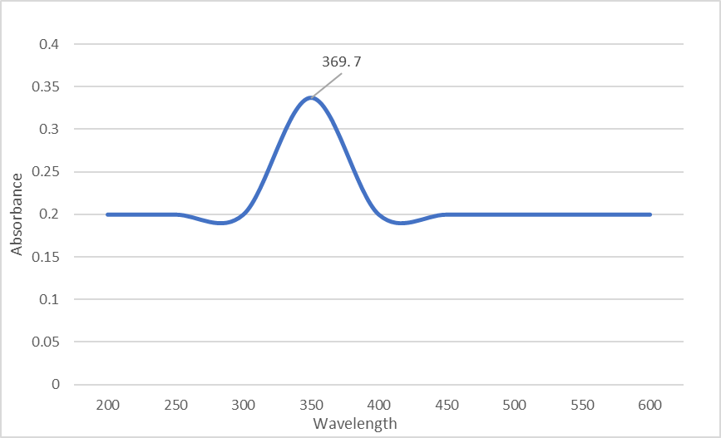
Figure 1. Transparency of bioplastic films from Gracilaria salicornia and Halimeda opuntia with ZnONps
The peak observed at 369.7 nm confirms the successful incorporation of ZnO nanoparticles synthesized using agar extracted from Gracilaria salicornia, which imparted notable properties. The addition of nanoparticles like ZnONps enhances resistance to UV radiation. According to a study by Al-Khaial et al., (2024), characteristic peaks in the 370–340 nm range are indicative of the presence of ZnO nanoparticles. When compared to other concentrations of 0.1 M, 0.07 M, and 0.04 M which showed peaks at 369 nm, 364 nm, and 361 nm respectively. Thus, the 0.1 M zinc nitrate concentration used during biosynthesis resulted in a distinct peak at 369.7 nm.
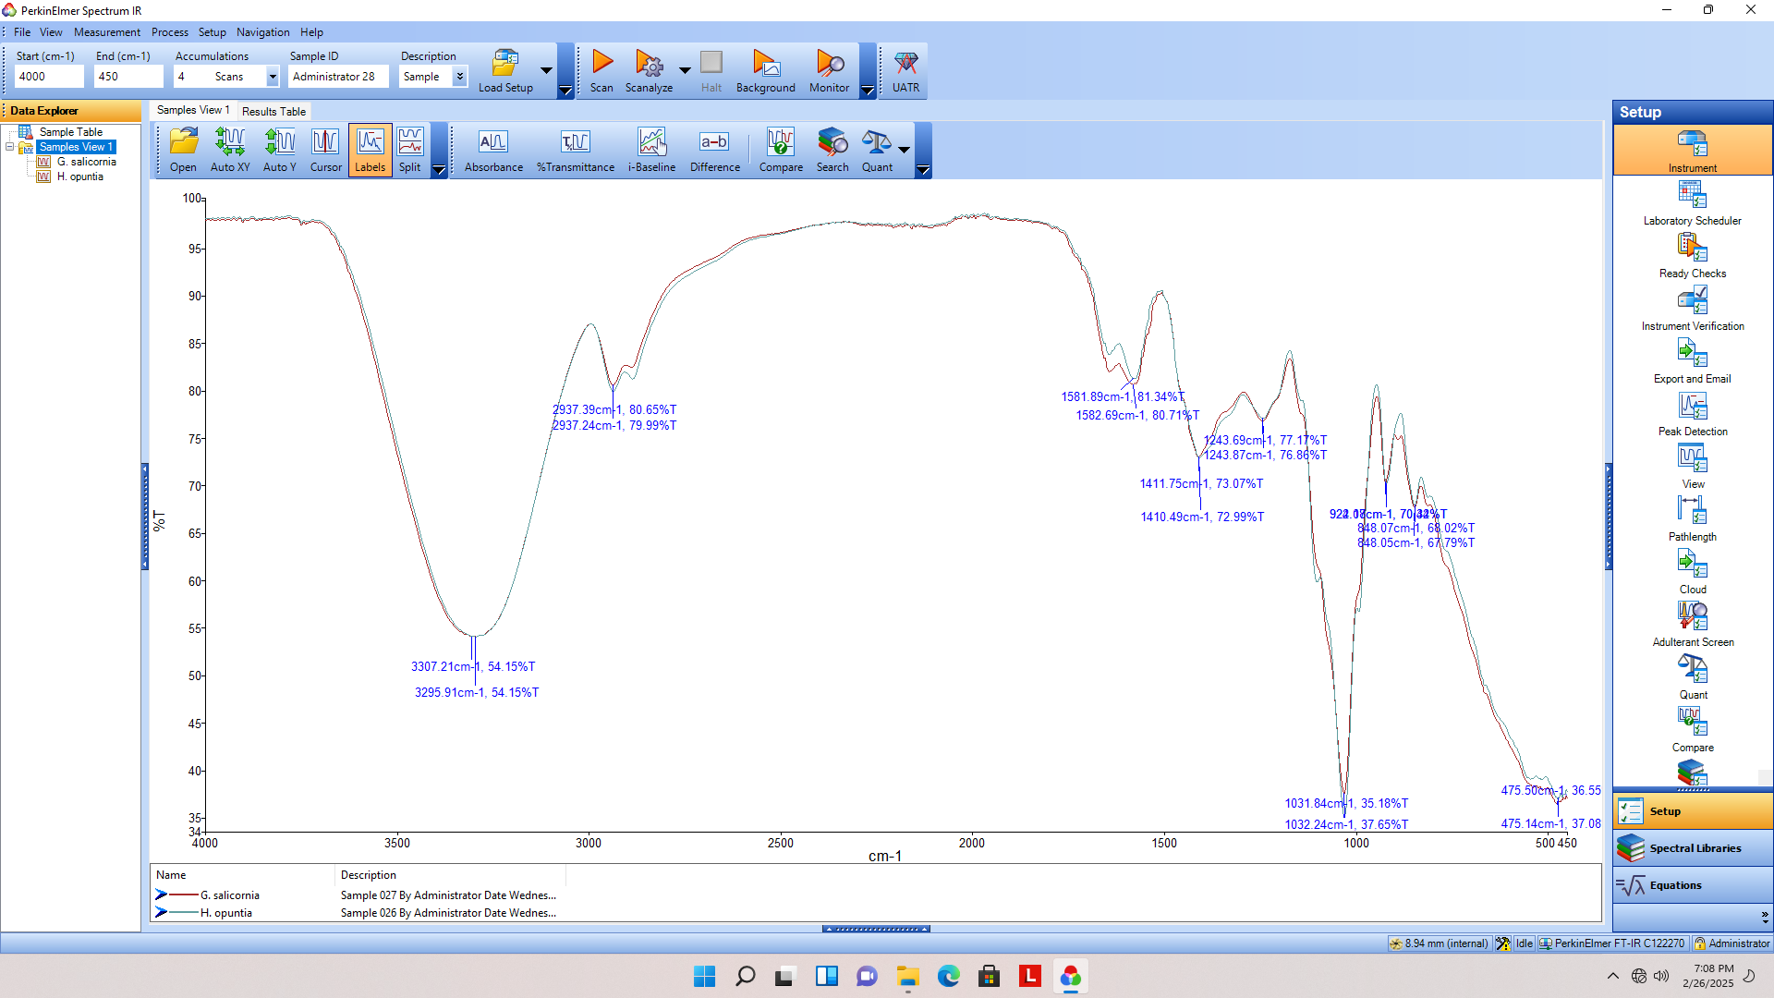
Figure 2. Structural formation of bioplastic films from Gracilaria salicornia and Halimeda opuntia with ZnONps
Figure 2 presents the FTIR spectrum of the bioplastic films, showing characteristic peaks of biopolymer-based materials. O–H stretching at 3296–3294 cm⁻¹ indicates hydroxyl groups from PVA or glycerol, while C–H stretching at 2936–2887 cm⁻¹ confirms aliphatic chains from seaweed. C=O stretching at 1644–1583 cm⁻¹ suggests esters or amides. Peaks at 1408–1410 cm⁻¹ and 1105–1033 cm⁻¹ correspond to O–H/C–H bending and C–O stretching from polysaccharides. Bands at 923–848 cm⁻¹ reflect C–H out-of-plane bending, and signals at 476–471 cm⁻¹ indicate ZnO presence (Zhuo et al., 2008). These features confirm successful integration of seaweed polymers, plasticizers, and ZnO nanoparticles.

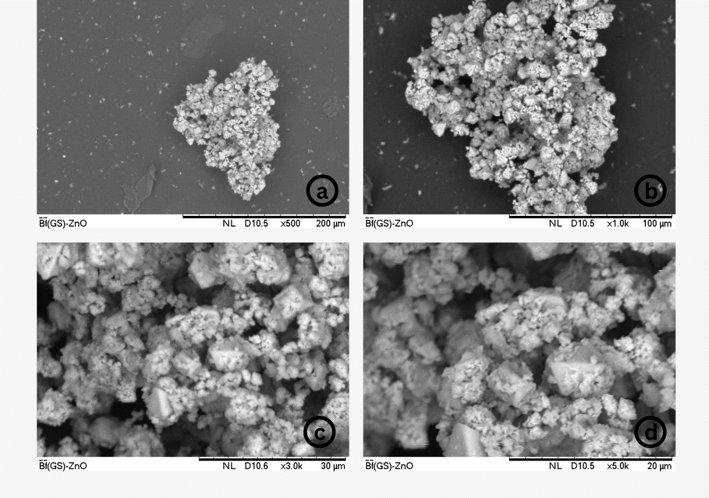
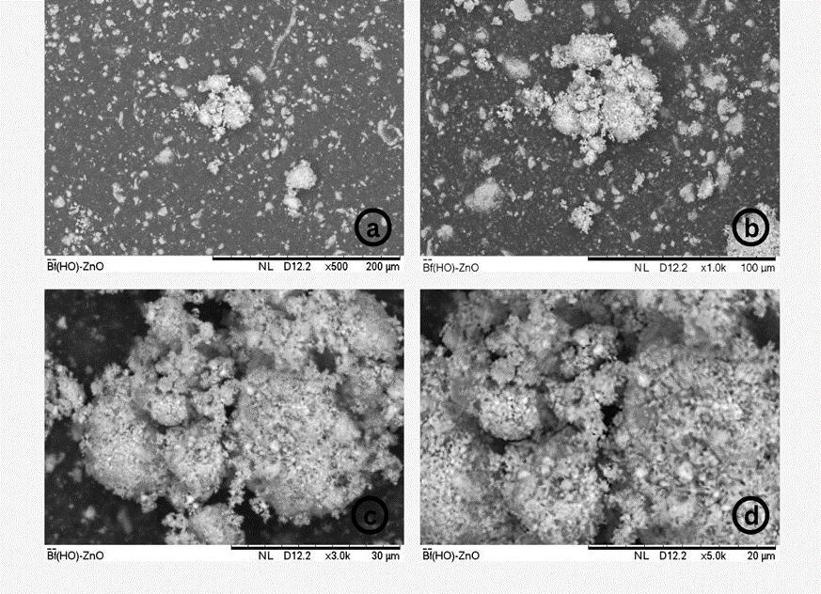
Figure 3. Surface micrographs of G. salicornia (left) and H. opuntia (right) Biofilm-ZnO NPs at (a) 200 mm, (b)100 mm, (c) 30 mm, (d) 20 mm, with magnification of x500, X1.0k, X3.0k and X5.0k respectively.
The morphology of the bioplastic films was analyzed using Scanning Electron Microscopy (SEM) to assess film quality and observe the effects of biosynthesized ZnO nanoparticles. In Figure 2, the ZnO nanoparticles appear to be embedded within the matrix, suggesting they were effectively dispersed and contributed to crystalline structure formation. At lower magnification (×500, 200 μm scale; Figure 3a), large aggregates of ZnONps can be observed within the bioplastic matrix, indicating non-uniform particle distribution at the macroscopic level. As the magnification increases to ×1,000 (100 μm scale; Figure 3b), the aggregates exhibit a more textured appearance, with smaller sub-clusters of nanoparticles becoming evident. At higher magnifications (×3,000, 30 μm scale; Figure 3c and ×5,000, 20 μm scale; Figure 3d), the images reveal the irregular morphology of the ZnO NPs, with the particles forming compact clusters and displaying a porous, rough surface structure. These nanoparticles can form shapes like rods, wires, tubes, spheres, needles, discs, rings, spirals, flowers, stars, and boxes.

Table 2. Zone of Inhibition of bioplastic films against Escherichia coli and Staphylooccus aureus
 | ZOI against Escherichia coli  (mm) | ZOI against Staphylooccus aureus (mm)
Gracilaria salicornia bioplastic film | 1.23 | 2.03
Cefalexin (+ control) |  | 34.7
Clindamycin (- control) | 45.8
Distilled water | 0 | 0
Halimeda opuntia bioplastic film | 0.53 | 2.06
Cefalexin (+ control) |  | 34.7
Clindamycin (- control) | 45.8
Distilled water | 0 | 0

The antibacterial test demonstrated that bioplastic films made from Gracilaria salicornia and Halimeda opuntia exhibited mild inhibitory activity against both Escherichia coli and Staphylococcus aureus. The G. salicornia film produced inhibition zones of 2.03 mm for S. aureus and 1.23 mm for E. coli, while H. opuntia showed similar inhibition against S. aureus (2.06 mm) but lower activity against E. coli (0.53 mm). Although these values were notably smaller than those of the positive antibiotic controls, they confirm that the seaweed-based bioplastics possess slight yet detectable antibacterial properties. The inhibition zones below 2 mm, suggest limited antimicrobial susceptibility. The findings also indicate that the antibacterial function of the incorporated ZnO nanoparticles was preserved within the bioplastic matrix, implying no interference from other film components. Moreover, the ZnO nanoparticles demonstrated a more pronounced inhibitory effect against S. aureus than E. coli, suggesting greater efficacy against Gram-positive bacteria. The effectiveness of ZnONps was influenced by particle size and exposure to visible light (Jones et al., 2008; Zhou et al., 2023). Mendes, et al., (2024) explained that the lower apparent antibacterial activity of against Escherichia coli could be associated with the flower-shaped of its nanoparticles in nm that had either cause the lack of defects on the particle core

- CONCLUSION
The findings highlight the potential use of seaweed-based bioplastics as sustainable alternatives. Their good mechanical strength, water solubility, near-neutral pH, and noticeable antibacterial activity, particularly against Staphylococcus aureus, indicate their suitability for eco-friendly packaging and related applications. Films made from Gracilaria salicornia demonstrated the best overall performance, although further refinement is needed to achieve uniform ZnO nanoparticle distribution and consistent film quality. This study highlights the promise of marine algae bioplastics as sustainable options for future packaging applications.

- REFERENCES
Al-Khaial, Mohammed & Chan, Siok-Yee & Abu-Zurayk, Rund & Alnairat, Nour. (2024). Biosynthesis and Characterization of Zinc Oxide Nanoparticles (ZnO-NPs) Utilizing Banana Peel Extract. Inorganics. 12. 121. 10.3390/inorganics12040121.
Asano, S. (2024, October 18). Polyvinyl Alcohol: A Comprehensive Overview. Advanced Materials Science Research, 7(5). doi:10.37532
Ayyakkalai, B., Nath, J., Rao, H. G., Venkata, V., Nori, S. S., & Suryanarayan, S. S. (2024). Chapter 17 - Seaweed derived sustainable packaging. Applications of Seaweeds in Food and Nutrition, 263-287. Retrieved from https://doi.org/10.1016/B978-0-323-91803-9.00006-8
Bahrun, Okino, T., Rasyid, H., & Soekamto, N. H. (2022). Biological evaluation and molecular docking of Indonesian. Journal of Research in Pharmacy. Retrieved from https://www.jrespharm.com/uploads/pdf/pdf_MPJ_1183.pdf
Banda, G. J., Dagalea, F. M., & Cui-Lim, K. M. (2024). Physicochemical Analysis of Biofilms from Cocos nucifera Linn. (Coconut) Flour and Manihot esculenta Crantz (Cassava) Starch with Polyvinyl Alcohol (PVA). Asian Journal of Applied Chemistry Research, 15(1), 21-27. doi:10.9734/AJACR/2024/v15i1279
Bordeos, M. R., Dagalea, F. S., & Vicencio, M. G. (2024). Characterization of a Bioplastic Product from the Ulva reticulata (Ribbon Sea Lettuce) Extract. Asian Journal of Chemical Sciences, 14(2), 161-168. doi:10.9734/AJOCS/2024/v14i2301
Caballa, F. J., & Getalado, M. (2019, April). Plastic Film from Dioscorea Hispida Dennst KOROT Tuber. International Journal of Trend in Scientific Research and Development, 3(3), 484-486. doi:10.31142/ijtsrd22936
Cai, Z., Li, M., Zhu, Z., Wang, X., Huang, Y., Li, T., . . . Yan, M. (2023). Biological Degradation of Plastics and Microplastics: A Recent Perspective on Associated Mechanisms and Influencing Factors. Microorganisms, 11, 1661. Retrieved from https://doi.org/10.3390%2Fmicroorganisms11071661
Cu, M. A., Gento, J. T., Lagrimas, J. L., Dagalea, F. M., & Lim, K. M. (2024). Biodegradable Nypa fruticans (Nipa) Starch P VA Biocomposite Films for Food Packaging. Asian Journal of Applied Chemistry Research, 26-33. Retrieved from https://doi.org/10.9734/ajacr/2024/v15i4294
Dagalea, F. M., & Cui – Lim, K. M. (2021). Analysis of Biofilms from Biosynthesized Zinc Oxide Nanoparticles. International Research Journal of Pure & Applied Chemistry, 22(1), 92-97. doi:10.9734/IRJPAC/2021/v22i130381
Flores, M. (2024, May 15). HUMANS OF THE OCEAN: Pinoy fisherman laments plastic crisis’ impact on livelihood. Retrieved from Greenpeace: https://www.greenpeace.org/philippines/story/63553/humans-of-the-ocean-pinoy-fisherman-laments-plastic-crisis-impact-on-livelihood/
Gracilaria salicornia. (n.d.). Retrieved from GLOBAL INVASIVE SPECIES DATABASE: https://www.iucngisd.org/gisd/species.php?sc=1026
Jabeen, N., & Atif, M. (2023). Polysaccharides based biopolymers for biomedical applications: A review. Polymers for Advanced Technologies, 35(1). Retrieved from https://doi.org/10.1002/pat.6203
Janani, S., Geetha, R., & Gopal, R. K. (2024). Production and Evaluation of a Seaweed-Based Bioplastic Sheet for Food Packaging. Uttar Pradesh Journal of Zoology, 45(14), 108-115. doi:https://doi.org/10.56557/upjoz/2024/v45i144184
Jones, N., Ray, B., Ranjit, K. T., & Manna, A. C. (2008). Antibacterial activity of ZnO nanoparticle suspensions on a broad spectrum of microorganisms. FEMS Microbiol Lett., 279(1), 71-6. doi:10.1111/j.1574-6968.2007.01012.x.
Li, H., Liu, H., Bi, L., Liu, Y., & Peng, R. (2024). Immunotoxicity of microplastics in fish. Fish & Shellfish Immunology, 150, 109619. Retrieved from https://doi.org/10.1016/j.fsi.2024.109619
Market Study for Philippines: Plastics Circularity Opportunities and Barriers. (2021, March 21). Retrieved from World Bank Group: https://www.worldbank.org/en/country/philippines/publication/market-study-for-philippines-plastics-circularity-opportunities-and-barriers-report-landing-page
Matos, J., Cardoso, C., Serralheiro, M., Bandarra, N., & Alfonso, C. (2024). Seaweed bioactives potential as nutraceuticals and functional ingredients: A review. Journal of Food Composition and Analysis, 133, 106453. Retrieved from https://doi.org/10.1016/j.jfca.2024.106453
Mendes, A., Granadeiro, C. M., Leite, A., Pereira, E., Teixeira, P., & Poças, F. (2024). Optimizing Antimicrobial Efficacy: Investigating the Impact of Zinc Oxide Nanoparticle Shape and Size. Nanomaterials, 14(7), 638. doi:10.3390/nano14070638
Ramezanpour, Z., p, Pirbasti, F. G., & Dogaheh, S. R. (2021). Bioactivity Potential of Gracilaria salicornia, Padina boergesenii, Polycladia myrica: Antibacterial, Antioxidant and Total Phenol Assays. Journal of Phycological Research, 5.
Rhim, J.-W., Wang, L.-F., Lee, Y., & Hong, S.-I. (2014, March 15). Preparation and characterization of bio-nanocomposite films of agar and silver nanoparticles: laser ablation method. Carbohydrate polymers, 103(1), 456-465. Retrieved from https://doi.org/10.1016/j.carbpol.2013.12.075
Santana, R. F., Bonomo, R. F., Gandolfi , O. R., Rodrigues, L. B., Santos, L. S., Pires, A. d., . . . Veloso, C. M. (2017, December 2). Characterization of starch-based bioplastics from jackfruit seed plasticized with glycerol. Journal of Food Science and Technology, 55(1), :278–286. doi:10.1007/s13197-017-2936-6
Sari, W. M., Supartono, W., & Suharno. (2024). Characterization of Biodegradable Films from Raw Seaweed (Kappaphycus Alvarezii) and Glycerol. IOP Conference Series Earth and Environmental Science, 1364(1), 012081. doi:10.1088/1755-1315/1364/1/012081
Seaweed Cultivation Global Market Report 2024. (2024, January). Retrieved from The Business Research Company: https://www.thebusinessresearchcompany.com/report/seaweed-cultivation-global-market-report
Selim, S. A. (2012, January 22). Antimicrobial, Antiplasmid and Cytotoxicity Potentials of Marine Algae Halimeda opuntia and Sarconema filiforme Collected from Red Sea Coast. International Journal of Marine and Environmental Sciences, 6. doi:10.5281/zenodo.1072926
Sun, J., Wang, L., & Yin, G. (2023). Preparation and Application of Edible Film Based on Sodium. Coatings, 13, 1716. Retrieved from https://doi.org/10.3390/coatings13101716
Udayagiri, H., Sana, S., Dogiparthi, L., Vadde, R., Varma, R. S., Koduru, J., . . . Karri, R. (2024). Phytochemical fabrication of ZnO nanoparticles and their antibacterial and anti-biofilm activity. Scientific Reports, 14. Retrieved from https://doi.org/10.1038/s41598-024-69044-9
Yasin, I., Nazarudin, M., Mazli, N., Saadi, A., Azizee, M., Nooraini, M., . . . Fakhrulddin, I. (2022, April). Preliminary screening of antioxidant and cytotoxic potential of green seaweed, Halimeda opuntia (Linnaeus) Lamouroux. Saudi Journal of Biological Sciences, 29, 2698-2705. Retrieved from https://doi.org/10.1016/j.sjbs.2021.12.066

Zhuo, Ren & Feng, H. & Liang, Q & Liu, Jinzhang & Chen, Jiangtao & Yan, De & Feng,
J. & li, Howard & Cheng, Shuang & Geng, Baisong & Xu, X & Wang, Jinwang & Wu, Z. G. & Yan, Peng & Yue, Guanghui. (2008). Morphology-controlled synthesis, growth mechanism, optical and microwave absorption properties of ZnO nanocombs. Journal of Physics D Applied Physics. 41. 185405-13. 10.1088/0022-3727/41/18/185405.

Zhou, X.-Q., Hayat , Z., Zhang, D.-D., Li , M.-Y., Hu, S., Wu, Q., . . . Yuan, Y. (2023). Zinc Oxide Nanoparticles: Synthesis, Characterization, Modification, and Applications in Food and Agriculture. Processes, 11(4). doi:10.3390/pr11041193

