Original Research Article

Evaluation of Anti-inflammatory and Anti-coagulant Activities of Tridax Procumbenes by Using Egg Albumin Denaturation and Blood Coagulation Assay

ABSTRACT
Tridax Procumbens, a medicinal plant traditionally used for various ailments, was evaluated for anti-inflammatory and anti-coagulant properties using in vitro models. Ethanolic extracts were tested for anti-inflammatory effects via protein denaturation and membrane stabilization assays, with diclofenac sodium as the standard, and for anti-coagulant activity by measuring clotting time in human blood, using heparin as reference. The extract exhibited potent, dose-dependent anti-inflammatory and anti-coagulant effects comparable to standards, indicating bioactive compounds that modulate inflammation and coagulation pathways. These results validate its ethnomedicinal use and suggest potential for treating thrombotic disorders and inflammation, warranting further studies on active constituents and mechanisms.
Aims: To evaluate the anti-inflammatory as well as anti-coagulant activities of Tridax Procumbens by using Egg Albumin Denaturation and Blood Coagulation Assay.
Study design: Experimental study.
Place and Duration of Study: Department of Pharmacology, Rani Chennamma College of Pharmacy, Karnataka, India, between June 2025 to October 2025.
Methodology: Using UV spectroscopic analysis at various doses, the anti-inflammatory properties of Tridax Procumbens ethanolic extract were assessed. Protein denaturation percentage inhibition was computed, and the outcomes were contrasted with Diclofenac sodium. The % inhibition and concentration for the extract and standard were shown on a graph. Heparin was used as the reference standard to measure prothrombin time in human blood in order to evaluate anti- coagulant activity.
Results: With a dose-dependent rise in percentage inhibition, the extract demonstrated strong anti-inflammatory efficacy that was comparable to Diclofenac. In a similar vein, the extract showed strong anti-coagulant activity, as shown by a prolonged prothrombin time that was on par with heparin. These results suggest the existence of bioactive substances that can alter coagulation pathways and inflammatory reactions.
Conclusion: In conclusion, the study offers scientific support for the traditional medical applications of Tridax Procumbens. Its promise as a natural medicinal agent for controlling inflammatory illnesses and averting thrombotic consequences is highlighted by the ethanolic extract's anti-inflammatory and anti-coagulant properties. These results prompt more research to identify the precise mechanisms of action of the active phytoconstituents, isolate and describe them, and investigate their possible clinical uses in contemporary medicine.
Keywords: Tridax Procumbens, Extract, Phytoconstituents, Anti-inflammatory activity, Anti-coagulant activity, In- vitro methodology.
1.INTRODUCTION
Since ancient times, medicinal plants have been used as primary therapeutic agents, and over 80% of the world's population still receives their medical care from herbal remedies¹. Since these plants provide bioactive chemicals that can be developed into standardized herbal formulations or used as leads for novel medications, scientific validation of these plants is crucial. Flavonoids, terpenoids, alkaloids, and other metabolites are abundant in pharmacologically active species found in the Asteraceae family, one of the biggest families of flowering plants².

Due to its several medicinal uses, Tridax Procumbens L., a common creeping herb in the Asteraceae family, has drawn a lot of attention. The plant, which is native to tropical America but is now widely distributed in Asia, Africa, and Europe, has long been used in traditional medicine to treat respiratory conditions, fever, diarrhea, wounds, and skin infections. Its anti-inflammatory, anticoagulant, antioxidant, wound-healing, antibacterial, antidiabetic, hepatoprotective, and immunomodulatory properties are supported by current research^{3,4,5}.

Coagulation and inflammation are closely related physiological processes that are implicated in a number of chronic illnesses, such as cancer, heart disease, and arthritis⁶. Particularly useful are natural substances that have both anticoagulant and anti-inflammatory properties. According to studies, T. procumbens acts on both intrinsic and extrinsic coagulation pathways by inhibiting the COX and LOX pathways, which suppresses the synthesis of prostaglandins and leukotrienes. It also prolongs PT and aPTT. Flavonoids (quercetin, luteolin), alkaloids, coumarins, tannins, and other phenolic chemicals are primarily responsible for these actions^{7,8,9}.

Tridax Procumbens has become a significant plant in phytopharmacological research due to its broad therapeutic potential and solid scientific data¹⁰. With a focus on its anti-inflammatory and anticoagulant qualities, this chapter offers a thorough summary of its phytochemistry, pharmacological activity, plant profile, and therapeutic uses.

Morphological Description
Tridax Procumbens is a creeping perennial herb with branched, hairy stems that root at the nodes and grow 30–50 cm tall. Its opposite, irregularly lobed leaves are rough due to trichomes. The plant bears small solitary flower heads with white ray florets and yellow tubular florets, typical of the Asteraceae family. Fruits are bristly achenes with a pappus for wind dispersal. It has a shallow fibrous root system aiding rapid spread, and its tissues contain secretory canals with resinous substances linked to medicinal properties.
The plant has a fibrous, shallow root system that lets it quickly spread and take over disturbed spots. Studies of its anatomy show lots of parenchymatous tissue and secretory canals filled with resinous stuff—these likely contribute to its medicinal properties.

Geographical Distribution
The plant is native to tropical America but has spread widely in tropical and subtropical regions of Asia, Africa, and Europe. In India, Tridax Procumbens is commonly found along roadsides, in agricultural fields, and wastelands. It thrives in poor soils, high temperatures, and areas of frequent disturbance, which makes it a highly invasive weed.

Botanical Description:
Kingdom: Plantae
Division: Magnoliophyta
Class: Magnoliopsida
Order: Asterales
Family: Asteraceae
Genus: Tridax
Species: Tridax Procumbens L.

Fig no. 1: Tridax procumbens
Traditional use
Traditionally, Tridax procumbens has been used for wound healing, treatment of ulcers, cough, insect repellant activity and infectious diseases. It is commonly applied as a poultice on cuts and wounds to stop bleeding and accelerate healing. Decoctions are used to treat diarrhea and fever.

Pharmacological Activities
- Anti-inflammatory activity
- Anti-bacterial activity
- Anti-coagulant activity
- Anti-oxidant activity
- Wound healing activity
- Anti-microbial activity
- Anti-Diabetic activity
- Anti-thrombotic activity
- Hepatoprotective activity
- Immunomodulatory activity

2. MATERIALS AND METHODS

Table 1: List of chemicals and reagents used in the study.

Sr.No | Chemical
 | Ethanol
 | Diclofenac Sodium
 | Phosphate Buffer Saline Solution
 | Ferric Chloride
 | Benedict’s reagent
 | Wagner’s reagent
 | Sodium Hydroxide solution
 | Concentrated HNO3
 | Acetic Anhydride
 | Lead Acetate solution
 | Sulfuric Acid
 | Ninhydrin reagent

- All the chemicals are collected from Rani Chennamma College of Pharmacy.

Table 2: List of Equipment

Sr.No | Equipment’s
 | Rota Evaporator
 | Soxhlet Apparatus
 | UV-Spectrophotometer
 | Centrifugation Apparatus
 | pH meter
 | Electric water bath
 | Magnetic stirrer

2.1 Collection and Authentication of Tridax Procumbens

The Tidax Procumbens were collected from different places such as Rani Chennamma College of Pharmacy, Belagavi, outside of college campus and from college neared places. After being verified by Dr. Harsha Hegde (ICMR-NITM). The plant Tridax Procumbens was washed and shade dried for 2 weeks. After drying, the whole plant was transformed into a fine powder by using electric mixer.

2.2 Collection of Blood Sample

The Dr. Prabhakar Kore KLE Hospital Blood Bank provided the blood samples.

2.3 Extraction Process:
2.3.1 Soxhlet Extraction Method: After powdering shade-dried Tridax Procumbens leaves, 50 g of the coarse material was extracted for 48 hours using 250 mL of 70% ethanol in a Soxhlet device. A rotary evaporator was used to concentrate the extract at 40–50°C, remove all of the solvent, and weigh the resulting extract residue^{11,12}.
2.3.2 Maceration Method: 70 g of powdered shade-dried Tridax Procumbens leaves were macerated with 700 mL of 70% ethanol at room temperature for 48 hours, stirring occasionally. After filtering the combination, the filtrate was concentrated on a water bath to produce a solid extract that was kept in a sealed container in a dry, cool environment The extract was placed in closed container in cool and dry place to prevent any microbial growth ¹³.

2.4 Phytochemical screening

To find carbohydrates, phenolics, saponins, alkaloids, proteins, flavonoids, tannins, amino acids, and steroids, phytochemical screening of Tridax Procumbens leaves was carried out using conventional techniques^{14,15,16}.
Alkaloids (Wagner's Test): When Wagner's reagent was added to the extract, a reddish-brown precipitate formed, indicating the presence of alkaloids.
Saponins (Foam Test): Saponins were detected by shaking the extract with water, which produced stable foam.

Steroids: The extract changed color from violet to blue when combined with sulfuric acid and acetic anhydride, indicating the presence of steroids.
Tannins (Lead Acetate Test): The addition of lead acetate produced a yellow precipitate, which is a sign of tannins.

Ferric chloride test: Alcoholic FeCl₃ produced a bluish-black coloring, confirming phenols (Ferric Chloride Test).

Benedict's Test for carbs: Heating the extract with Benedict's reagent produced a red precipitate, which is a sign of carbs.
Proteins (Xanthoproteic Test): Proteins were confirmed by the reaction with concentrated HNO₃, which created a yellow tint.
Flavonoids (NaOH Test): When treated with NaOH, a rich yellow color appeared, signifying the presence of flavonoids.
Ninhydrin Test for Amino Acids: Heating with the ninhydrin reagent produced a blue color, indicating the presence of amino acids.

2.5 Anti-Inflammatory Activity
The anti-inflammatory activity of Tridax Procumbens crude extracts can be determined in vitro for inhibition of the denaturation of egg albumin (protein). Egg albumin denaturation inhibition was used to gauge the crude extract's anti-inflammatory properties. 0.2 mL of 1-2% egg albumin, 2 mL of extract or standard (Diclofenac sodium), and 2.8 mL of phosphate buffer (pH 7.4) were combined to create a reaction mixture (5 mL). Instead of the sample, the control had two milliliters of distilled water. After 30 minutes of incubation at 37 ± 2°C, each combination was heated for 15 minutes at 70 ± 2°C. Using distilled water as a blank, absorbance at 280 nm was measured after chilling. The usual formula was used to determine the percentage inhibition of protein denaturation^{17,18}.
Percentage inhibition = Absorbance of control – Absorbance of test sample × 100
Absorbance of control
2.6 Anti-Coagulant Activity
This test measures the duration of thrombin-induced clotting to assess anticoagulant activity. To obtain platelet- poor plasma (PPP), healthy volunteers' blood was drawn into trisodium citrate tubes and centrifuged for 15 minutes at 3000 rpm. CaCl₂ (25 mM), 0.2 mL plasma, and 0.1 mL crude extract (different concentrations) were combined in fusion tubes and incubated at 37°C for the test. In the control, saline was used in place of the extract, while EDTA and sodium citrate were used as reference standards. The prothrombin time was calculated by tilting the tubes every five seconds to record the clotting time^{19,20}.

3. RESULT AND DISCUSSIONS

3.1 Percentage yield:

An ethanol solution was used to extract 50 grams of powdered dried Tridax Procumbens leaves. Following drying, the filtrate produced 6.2 grams of extract, or 12.4% of the original 50 grams of plant powder.

3.2 Preliminary phytochemical determination:

After the successful conventional extraction of the Tridax Procumbens leaves, the preliminary phytochemical study revealed. The ethanolic extract contained primary metabolites such as alkaloids, saponins, tannins, steroids, phenols, flavonoids, amino acids, and proteins, according to the preliminary phytochemical qualitative analysis. These phytochemicals were identified by characteristics color changes using standard procedures. The list is summarized in Table 3.

Table 3: Phytochemicals present and absent in various solvents of Tridax Procumbens

Sr. No | Phytochemicals | Ethanol
1 | Alkaloids | +
2 | Saponins | +
3 | Steroids | +
4 | Tannins | +
5 | Phenol | +
6 | carbohydrates | +
7 | Proteins | +
8 | Flavonoids | +
9 | Amino acids | +

Here + : Present - : Absent

3.3 Anti-inflammatory activity of Tridax Procumbens:
At a concentration of 250 mg/ml, the ethanolic leaf extract of Tridax Procumbens had notable anti-inflammatory effect that was equivalent to that of the standard medication Diclofenac at the same dose. The activity of the ethanolic extract was comparable to the standard drug Diclofenac at the same concentration. These findings position the ethanolic extract of Tridax Procumbens as a promising natural alternative to synthetic NSAIDs like diclofenac, particularly for managing acute inflammation with potentially fewer gastrointentional side effects.

Table: 4: Anti-inflammatory activity analysis of Tridax Procumbens

Concentration (ug/ml) | Absorbance (Control) | Absorbance (Extract) | % Inhibition (Extract) | Absorbance (Diclofenac Sodium) | %Inhibition (Diclofenac Sodium)
100 | 0.512 | 0.412 | 19.53% | 0.310 | 39.45%
200 | 0.512 | 0.354 | 30.85% | 0.251 | 50.97%
400 | 0.512 | 0.289 | 43.55% | 0.187 | 63.51%
800 | 0.512 | 0.221 | 56.83% | 0.124 | 75.78%

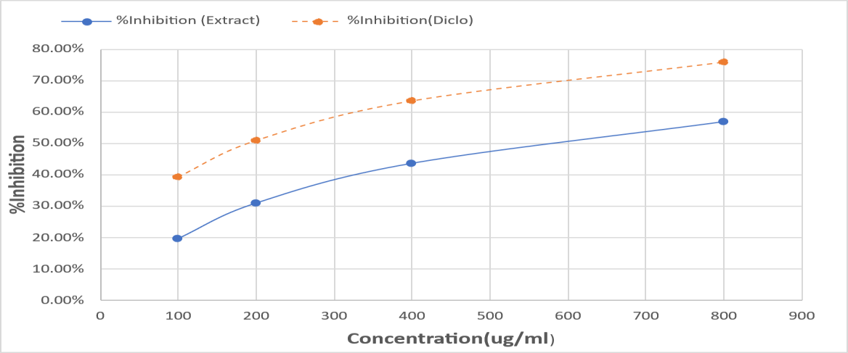
Fig no. 2 Graphical presentation of Egg Albumin Denaturation

3.4 Anti-Coagulant activity of Tridax Procumbens:

Longer clotting times in the current investigation show that Tridax Procumbens has strong anti-coagulant activity. In comparison to Heparin, the effect was less noticeable but still dose dependent. Flavonoids and phenolic substances that can disrupt the coagulation cascade are found in Tridax Procumbens. The anticoagulant effect is dose-dependent, increasing with higher concentrations. This anticoagulant potency can be attributed to the extract's rich profile of bioactive flavonoids and phenolic compounds, which interfere with key steps in the coagulation cascade.
Table: 5: Prothrombin time observed in Samples

Sample | Prothrombin time (min) | Observation
Control (Normal blood) | 4.47 mins | Normal clot formation
Standard (Heparin) | 27.37 mins | Strong anti-coagulant effect
Tridax Procumbens Extract | 7.08 mins | Moderate anti-coagulant activity
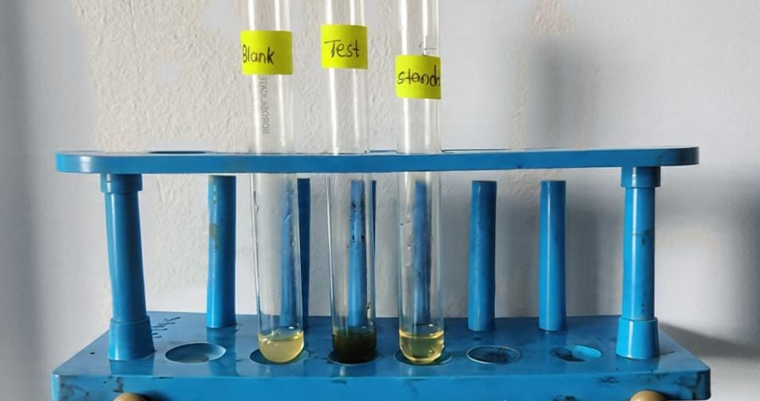

Fig no. 3 Plasma clotting test

Medicinal plants have always played a central role in human health care. From ancient times, they have been used as primary therapeutic agents, and even today, nearly 80% of the world’s population relies on traditional herbal medicines for treatment of various diseases. Inflammation and coagulation are two interlinked biological processes that play critical roles in maintaining homeostasis.
Tridax Procunbens is used as a phytomedicine by traditional healers and practitioners of Unani and Ayurvedic systems of medicine. Ethanol could have led to better extraction of these active principles with enhanced anti-inflammatory activity of Tridax Procumbens leaves in the in the present study. The ethanolic extract of Tridax Procumbens showed very good anti-inflammatory activity. The highlight of this study was that the ethanolic extract showed very good anti-inflammatory and anti-coagulant activity. Tridax procumbens has been extensively studied for its anti-inflammatory activity, which is attributed to its rich content of flavonoids, alkaloids, saponins, tannins, and sterols. Tridax procumbens also shows anticoagulant and antithrombotic properties due to its phytochemical composition of flavonoids, alkaloids, tannins and phenolic compounds. These effects highlight the potential role of Tridax procumbens as a natural therapeutic agent against cardiovascular and thrombotic disorders.
Tridax Procumbens ethanolic extract produced 6.2 g from 50 g of dried leaves (12.4%), demonstrating ethanol's efficacy as a solvent. Amino acids were not present, but phytochemical screening revealed the presence of alkaloids, flavonoids, phenols, tannins, saponins, steroids, carbohydrates, and proteins. These bioactive components include anticoagulant, anti-inflammatory, antioxidant, and antibacterial properties. The extract was less effective than diclofenac but showed dose-dependent anti-inflammatory effects (19.53%–56.83% inhibition at 100–800 µg/ml). Additionally, it demonstrated mild anticoagulant effect compared to heparin by extending the clotting time from 4.47 to 7.08 minutes, primarily due to flavonoids and phenols.
Overall, Tridax Procumbens has a great deal of pharmacological promise, which supports its traditional use. However, more research is required to identify active chemicals, evaluate safety, and improve extraction. Collectively, the results confirm that Tridax procumbens possesses meaningful pharmacological properties, particularly anti-inflammatory and anticoagulant effects, though less potent than synthetic drugs.

4.CONCLUSION

The current study validates the traditional usage of Tridax Procumbens in folk medicine by establishing its pharmacological relevance and demonstrating its strong anti-inflammatory and anti-coagulant properties in vitro. The plant extract successfully suppressed protein denaturation, suggesting a protective role against inflammation, when the anti-inflammatory potential was evaluated using the egg albumin denaturation assay. In a similar vein, the blood coagulation test demonstrated how well it delayed the formation of clots in comparison to the control, indicating potential anticoagulant qualities. These results highlight Tridax Procumbens' therapeutic value as a natural substitute for prescription medications. Tridax Procumbens may prove to be a viable option for the creation of secure and efficient herbal treatments for conditions involving inflammation and coagulation. Taken together, these dual anti-inflammatory and anticoagulant effects point towards a broad-spectrum pharmacological profile that may be particularly beneficial in clinical conditions where inflammation and hypercoagulability coexist, such as cardiovascular disease, autoimmune disorders, or post-surgical states.
Similarly, the significant prolongation of clotting time in the in vitro blood coagulation assay suggests that the extract interferes with key steps in the coagulation cascade, thereby reducing the risk of pathological thrombus formation.
Tridax procumbens could emerge as a promising candidate for the development of safe, cost-effective, and accessible phytopharmaceuticals aimed at managing inflammation and coagulation-related disorders, especially in resource-limited settings.

REFERENCES
- World Health Organization. Traditional Medicine Strategy 2014–2023. WHO; 2013.
- Kumar S, Pandey AK. Chemistry and biological activities of flavonoids: An overview. ScientificWorldJournal. 2013;2013: 162750.
- Olorunnisola OS, Bradley G, Afolayan AJ. Ethnobotanical survey of medicinal plants used for the management of diabetes mellitus in the Nkonkobe municipality of South Africa. J Med Plants Res. 2011;5(14):2925–33.
- Prabhu K, Karar PK, Hemalatha S. Biological and pharmacological properties of Tridax Procumbens L. Int J Pharm Sci Rev Res. 2011;8(2):57–62.
- Tiwari U, Rastogi B, Singh P, et al. Anti-inflammatory activity of Tridax Procumbens on experimental animals. J Ethnopharmacol. 2011;137(1):457–62.
- Libby P. Inflammatory mechanisms: The molecular basis of inflammation and disease. Nutr Rev. 2007;65(12):S140–6
- Esmon CT. The interactions between inflammation and coagulation. Br J Haematol. 2005;131(4):417–30.
- Oyedapo OO, Famurewa AJ. Antiinflammatory activity of extracts of Tridax Procumbens in rat models. Afr J Biomed Res. 2004;7(1):67–71.
- Pal S, Shukla YN, Maurya R. Bioactive compounds from Tridax Procumbens. Pharmazie. 1995;50(7):488–9.
- Chaturvedi A. Pharmacological and biochemical studies on Tridax Procumbens L. J Pharm Res. 2012;5(8):4090–5.
- Chaitra pai, Ujjwala Kulkarni. Antibacterial activity of Tridax Procumbens with special reference to nosocomial pathogens. 2011; 1(4); 164-173
- Nethravathi HR, Prashith KTR et.al. Studies on antioxidant and anthelmintic activity of Gnidia glausa (Fresen)
- Ravindra B, Mithun M et al. anthelmintic activity of leaves of Lantana camera L. IJPS.2012 July 28.1(6): 287-288
- Pankaj Kushwaha, Shiv Shankar Yadav. Phytochemical screening and GC-MS studies of the methanolic extract of Tridax Procumbens. IJPSR.2019 10(5); 2492-2496
- Rajaram Sawant, Ashvin Godghate. Preliminary phytochemical analysis of leaves of Tridax Procumbens L. IJSET, June 2013;2(3): 388-394
- Sowmya Jhample, Sanjivani Gajdhane. Phytochemical screening and in vitro antimicrobial activity of Tridax Procumbens L. RJLBPCS 2015, 1(1); 44-53
- Austin A et al. “In-vitro antioxidant and anti-inflammatory potential of methanolic extract of Tridax procumbens (Linn.) leaves.” Austin Journal of Clinical Trials. 2020;7(1):1042.
- R Nandita, M Jeevitha, Journal of Pharmacy and BioAllied Sciences, December 2024 27;16: S4081–S4084 Ameena M, Rajeshkumar S, Evaluation of the Anti-inflammatory, Antimicrobial, Antioxidant, and Cytotoxic Effects of Chitosan Thiocolchicoside-Lauric Acid Nanogel, 2023 Sep 26;15(9):e46003
- Arwa Alshargabi, Effect of Tridax procumbens extracts on coagulation time according to gender and blood groups A and O: in vitro study, Journal of Herbal Medicine, Volume 42, December 2023, 100806
- Bandla R, Krishn M, Reddy KS. Isolation, partial purification and assessment of anticoagulant properties of Tridax procumbens from leaf extracts. Oncol Radiother. 2025;19(3):45-52.

