Application of Carbon Nanotubes in Coating Corrosion Protection

Abstract: Corrosion refers to the gradual deterioration and degradation of materials (typically metals) under the combined effects of chemical, electrochemical, and physical factors in the surrounding environment. This phenomenon is widespread across various sectors of the national economy, causing substantial economic losses to national infrastructure development and the normal operation of enterprises. Carbon nanotubes (CNTs), owing to their unique one-dimensional nanostructure and outstanding physical and chemical properties, have demonstrated significant potential in the field of corrosion protection and control. This paper systematically reviews the applications of carbon nanotubes in corrosion protection from five perspectives: anticorrosion coatings, corrosion inhibitors, electrochemical corrosion protection, metal matrix composites, and bio-antimicrobial applications. Finally, the future prospects of carbon nanotubes in the field of corrosion protection and control are discussed.

Keywords: carbon nanotubes; anticorrosion coatings; corrosion inhibitors; electrochemical corrosion protection; biocorrosion protection

1 Introduction
With the rapid development of industrialization and technological advancement, the service environments of equipment and materials have become increasingly severe. The resulting corrosion problems not only shorten the service life of equipment and materials but also threaten public safety and property, and may even lead to sudden catastrophic accidents^{[1]}. It has been reported that the annual economic losses caused by corrosion account for more than 3% of the gross domestic product (GDP) of many countries worldwide^{[2]}. Therefore, corrosion protection and control have become essential and highly significant tasks in modern industry.
Conventional anticorrosion materials, such as epoxy resin coatings and perchloroethylene paints, exhibit excellent properties in many aspects, including good corrosion resistance, wear resistance, and strong adhesion. However, in specific application environments—such as aerospace, mechanical manufacturing, and marine conditions—these materials may encounter more severe challenges, particularly under extreme conditions of high temperature, high humidity, and high salinity^{[3]}. Consequently, the development of materials with superior wear resistance, high-temperature stability, and enhanced corrosion resistance has become crucial for addressing these challenges.
As an emerging nanomaterial, carbon nanotubes (CNTs) have attracted extensive attention from both the scientific community and industry since their discovery by the Japanese physicist Iijima in 1991^{[4]}. CNTs are nanoscale tubular structures composed of carbon atoms. Their unique one-dimensional nanostructure and sp² carbon–carbon bonding configuration endow them with exceptional mechanical strength, high electrical and thermal conductivity, and excellent chemical stability. These distinctive characteristics make CNTs highly promising for applications in corrosion protection. Therefore, this paper systematically reviews the preparation methods of carbon nanotubes for anticorrosion applications, their corrosion protection mechanisms, and their practical applications in the field. Furthermore, the challenges encountered in their application and future development prospects are discussed in depth.

2 Basic Characteristics of Carbon Nanotubes

2.1 Structure and Classification of Carbon Nanotubes
Carbon nanotubes (CNTs) are a unique class of one-dimensional nanomaterials composed of carbon atoms arranged in a hexagonal lattice and bonded through sp² hybridization to form coaxial cylindrical structures^{[5]}. CNTs are generally classified into single-walled carbon nanotubes (SWCNTs) and multi-walled carbon nanotubes (MWCNTs). Single-walled carbon nanotubes (SWCNTs) (Figure 1a) consist entirely of carbon atoms and can be structurally regarded as a single graphene sheet seamlessly rolled into a cylindrical tube, forming a hollow structure with a single graphitic layer wrapped around a common central axis. In contrast, multi-walled carbon nanotubes (MWCNTs) (Figure 1b) are composed of multiple concentric graphene layers rolled around the same central axis, with a defined interlayer spacing between adjacent layers. They can be considered as nested assemblies of several SWCNTs, where the spacing between neighboring layers is comparable to the interlayer distance in graphite.
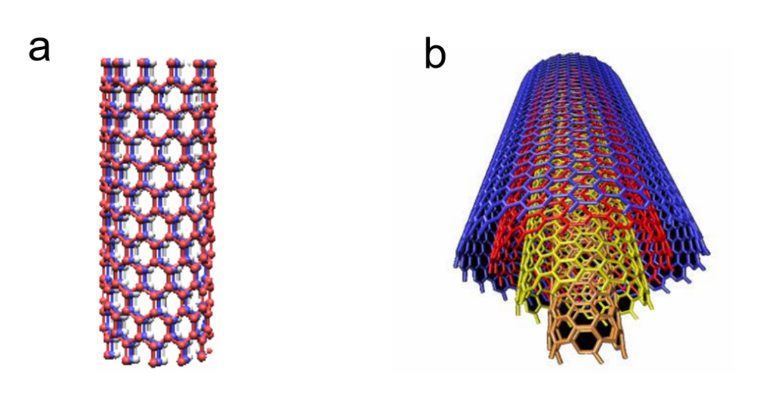
(a) Single-walled carbon nanotube (SWCNT) （b）Multi-walled carbon nanotube (MWCNT)
Figure 1 Schematic illustration of the structure of carbon nanotubes^{[3]}

2.2 Physical and Chemical Properties of Carbon Nanotubes
Carbon nanotubes (CNTs) exhibit exceptional stiffness and axial strength due to the sp² carbon-carbon bonds within their structure. These properties provide significant advantages in the field of corrosion protection. By incorporating CNTs as additives into corrosion-resistant coatings, the mechanical properties of the coatings can be significantly enhanced, improving their wear resistance and impact resistance^{[6]}. Moreover, the unique one-dimensional nanostructure of CNTs allows for efficient heat transfer along their length, making them widely regarded as excellent thermal conductors. Their outstanding thermal conductivity and thermal stability ensure that CNT-based corrosion protection materials can maintain stable performance even in high-temperature environments, demonstrating reliability and durability under extreme conditions. In addition to these advantages, CNTs also feature small diameters and large specific surface areas. Due to their smaller diameter, CNTs can densely pack on the material surface, forming a compact protective layer that effectively isolates the corrosion medium from direct contact with the substrate, thus preventing corrosion. Their large specific surface area also allows CNTs to adsorb microorganisms, impurities, and other harmful substances, further enhancing the corrosion resistance of the material^{[7]}. These properties make CNTs highly promising for applications in corrosion protection.

3 Current Status of Carbon Nanotubes in the Field of Corrosion Protection

3.1 Carbon Nanotubes as Additives in Corrosion-Resistant Coatings
Coating protection is a common method for preventing metal corrosion by applying a corrosion-resistant layer that isolates corrosive agents and slows down the corrosion process. Carbon nanotubes (CNTs), as additives in corrosion-resistant coatings, play a vital role due to their small size, excellent physicochemical properties, and high chemical stability. CNTs not only form a dense physical barrier that prevents corrosive media from reaching the substrate but also significantly enhance the coating's corrosion resistance through electrochemical protection and improved mechanical properties. Liu Henghao et al^{[8]}. successfully developed CNT-modified aqueous epoxy zinc-rich coatings by incorporating CNTs as an aqueous slurry into epoxy emulsions. The study showed that adding 0.2% CNTs to the zinc-based coating enhanced its impact resistance and corrosion protection significantly. This improvement is attributed to the unique nanostructure of CNTs, which increases the coating's density and corrosion resistance, effectively isolating corrosive agents from the substrate. Similarly, Alishahi M et al^{[9]}. prepared Ni-P-CNT coatings, demonstrating that CNT inclusion enhanced both the tribological properties and corrosion resistance of the coating. Electrochemical tests in 3.5 wt% NaCl solution revealed that the CNTs improved the coating's performance in preventing corrosion. Epoxy resin, a widely used organic coating, offers excellent thermosetting properties and strong adhesion to metal surfaces, along with good stability and flexibility. However, it suffers from inherent defects such as poor impact resistance and limited thermal stability. To address these issues, Qin Wenfeng et al^{[10]}.proposed incorporating CNTs into epoxy resin to prepare composite coatings. By controlling the CNT content, they successfully produced coatings with enhanced properties. Electrochemical testing showed that with 0.5% CNTs, the composite coating exhibited a significant increase in corrosion potential (-1.510V) and the lowest corrosion rate. Static immersion tests further confirmed its superior corrosion protection performance, highlighting the potential of CNTs in enhancing the protective capabilities of composite coatings.
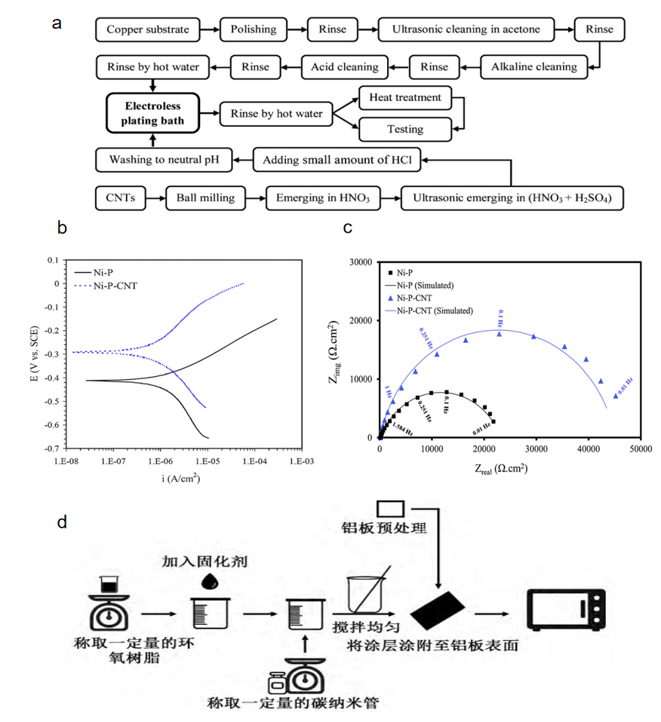
Figure 2 (a) Research on the preparation process of nickel-phosphorus-carbon nanotube chemical coatings^{[9]}.
(b) Polarization curves of the coating in 3.5% sodium chloride solution^{[9]}.
(c) Nyquist plot of the coating in 3.5% sodium chloride solution^{[9]}.
(d) Preparation flowchart of carbon nanotube/epoxy resin coatings^{[10]}.

3.2 Carbon Nanotubes as Carriers for Corrosion Inhibitors
A corrosion inhibitor is a compound or complex that, when present in an environment (medium) at an appropriate concentration and form, can prevent or slow down the corrosion of materials. The corrosion inhibitor technology is characterized by low cost, ease of operation, strong adaptability, and good performance, making it one of the most widely used methods in the field of corrosion protection^{[11]}. Carbon nanotubes (CNTs), as corrosion inhibitors (with the inhibition mechanism shown in Figure 3a), not only form a dense protective layer on the metal surface through their efficient adsorption properties, effectively isolating corrosive media, but also possess the characteristics of being environmentally friendly and sustainable, aligning with modern chemical industries' pursuit of sustainable development. Furthermore, the multifunctionality of CNTs allows for chemical modification to tailor different functional groups, adapting to the needs of various metals and corrosion environments, showcasing high flexibility and broad application potential. Therefore, CNTs play an extremely important role as corrosion inhibitors in the field of corrosion protection. Shirazi Z et al^{[12]}. synthesized a new carbon nanotube composite material (PAA/GO/f-MWCNT) as a corrosion inhibitor by in-situ polymerization of poly-aminobenzoic acid (PAA), graphene oxide (GO), and functionalized multi-walled carbon nanotubes (f-MWCNTs). The researchers tested the corrosion resistance of this inhibitor on stainless steel 316 (SS316) using electrochemical impedance spectroscopy (EIS). The experimental results showed that the corrosion resistance of SS316 was significantly improved by adding the PAA/GO/f-MWCNT nanocomposite material to the corrosive medium. This enhancement is mainly attributed to the high adsorption capacity of the nanocomposite material on the metal surface and the formation of a dense and uniform protective film, effectively isolating the corrosive media from the metal. Cen H et al^{[13]}.successfully synthesized functionalized carbon nanotubes (FCNTs) through an efficient hydrothermal method, as shown in Figure 3b. The researchers then used these FCNTs as corrosion inhibitors for carbon steel in saturated sodium chloride solution and studied the corrosion inhibition effect of FCNTs on carbon steel in a CO2-saturated 1% NaCl solution using various characterization and measurement methods. The results showed that FCNTs effectively inhibited the corrosion of carbon steel, with an inhibition efficiency of nearly 90% at a concentration of 100 mg/L. Zhang Y et al^{[14]}. prepared a titanium dioxide coating multi-walled carbon nanotube (MWCNTs)/bis(triethoxysilylpropyl) tetrasulfide (BTESPT) composite coating on AA 2024 using cathodic electrophoretic deposition. The researchers used scanning electron microscopy, Fourier-transform infrared spectroscopy, and surface coverage measurements to investigate the microscopic geometry of the composite coating. The results revealed that the modified multi-walled carbon nanotubes, due to their excellent dispersion properties, significantly improved the corrosion resistance of BTESPT and its combination with the titanium dioxide coating, providing long-term and stable corrosion protection.
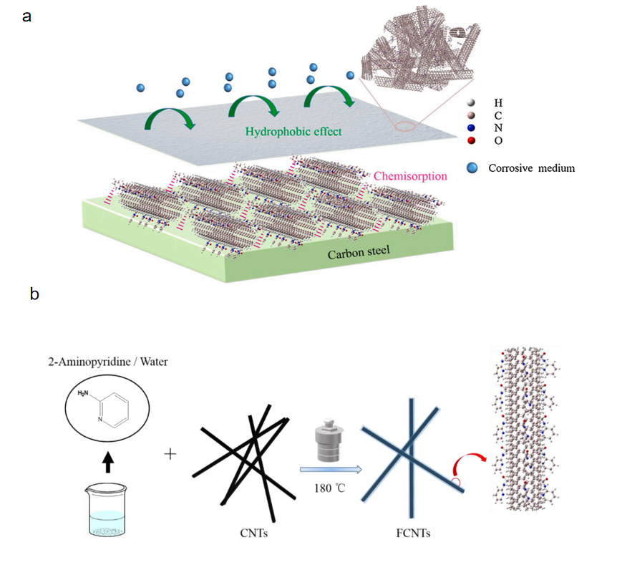 Figure 3 (a) Schematic diagram of the corrosion inhibition mechanism of CNTs on metal surfaces^{[13]}.
(b) Schematic diagram of the synthesis of FCNTs^{[13]}.

3.3 Carbon Nanotubes as Electrode Materials in Electrochemical Corrosion Protection Systems
Carbon nanotubes (CNTs) possess excellent electrical conductivity and chemical stability, making them suitable as electrode materials in electrochemical corrosion protection systems. When combined with metal substrates, CNTs can form a stable electrochemical protection system that effectively prevents metal corrosion, as shown in the electrochemical corrosion protection mechanism of CNTs in Figure 4a^{[15]}. Zhou Guohua^{[16]} successfully prepared CNT/AZ31 magnesium-based composites using CNT-incubated block casting technology. The researchers studied the effect of CNT content on the corrosion resistance of the composite material by measuring electrochemical polarization curves and using scanning electron microscopy (SEM) to observe the surface morphology before and after corrosion. The results, shown in Figure 4b, demonstrated that with the increase in CNT content, the corrosion current (Icorr) of the MWCNTs/AZ31 composite material decreased significantly, indicating that the composite material with CNTs exhibited better corrosion resistance in 3.5% NaCl solution than AZ31 alloy. Moreover, as the CNT content increased, the corrosion resistance of the composite material improved significantly. This indicates that the addition of CNTs significantly enhanced the corrosion resistance of the composite material. Bogdanovskaya V A et al^{[17]}. synthesized multi-walled carbon nanotubes (MWCNTs) through methane catalytic pyrolysis on iron-cobalt or cobalt-molybdenum catalysts, and studied their electrochemical performance before and after corrosion treatment, as shown in Figure 4c. The results indicated that, under the same conditions, CNTs exhibited better corrosion resistance compared to vortex carbon (carbon black). Ganash A A^{[18]} prepared MWCNT composite coatings on 304 stainless steel surfaces in sulfuric acid solution using the potentiodynamic method. The coating was characterized using cyclic voltammetry, Fourier transform infrared spectroscopy (FTIR), and scanning electron microscopy (SEM). The study demonstrated that MWCNT composite coatings effectively inhibited corrosion of stainless steel in chloride solutions. Li L et al^{[19]}. studied the operating conditions of polymer electrolyte membranes (PEM) for fuel cells at 80°C. As shown in Figure 4d, under the same conditions, the oxidation current of functionalized CNTs and catalytic CNTs was lower than that of carbon black (CB). This suggests that multi-walled CNTs exhibited better corrosion resistance than carbon black (CB) even at high temperatures.
 Figure 4 (a) Synergistic effect of CNT nanobarriers and cathodic inhibition^{[15].}
(b) Polarization curves of AZ31 alloy and composite material^{[16]}.
(c) Schematic diagram of electrochemical testing of composite coatings^{[20]}.
(d) Chronoamperometric curve of carbon after 8 hours of electrochemical oxidation at 1.2 V and 80°C^{[19]}.

3.4 Carbon Nanotubes as Reinforcing Phases in Metal Matrix Composites
Carbon nanotube (CNT) reinforced metal matrix composites (MMCs) are excellent nanocomposites and highly attractive advanced materials. These nanocomposites can be produced using various techniques, with common methods for preparing CNT-reinforced aluminum-based composites including casting, powder metallurgy, and stir friction methods^{[21]}. Rajesh et al^{[22]}. successfully fabricated Al7075 aluminum alloy composites using multi-walled carbon nanotubes (MWCNTs) as a reinforcing material and systematically tested the differences in corrosion resistance between the composite material and the unreinforced Al7075 alloy. The results showed that the unreinforced Al7075 alloy had a higher corrosion rate compared to the prepared nanocomposites. This is because the reinforcing material helps slow down corrosion loss by forming an oxide layer. Zhang Pengxiang^{[23]} used high-energy ultrasonic-assisted casting technology to successfully prepare CNTs@Ni reinforced 2024 aluminum-based composites (2024-CNTs@Ni). To assess the electrochemical corrosion resistance of the composite material, the researchers conducted electrochemical impedance spectroscopy (EIS) analysis and compared it with the electrochemical corrosion resistance of pure 2024 aluminum alloy. The results indicated that the 2024-CNTs@Ni aluminum-based composite exhibited stronger electrochemical corrosion resistance than the 2024 aluminum alloy. This finding provides new ideas and methods for improving the corrosion resistance of aluminum-based materials. Zhang Y et al^{[24]}. used chemical vapor deposition (CVD) to successfully prepare aluminum metal matrix composite (CNT-Al MMC) coatings containing CNTs on AZ91 Mg alloy substrates, with pure aluminum coatings without CNTs as a comparison. The researchers then used scanning electron microscopy (SEM) to observe the surface morphology changes of the AZ91 Mg alloy substrate, pure aluminum coatings, and CNT-Al MMC coatings in a corrosive environment. The experimental results, shown in Figure 5, demonstrated that both the AZ91 Mg alloy substrate and pure aluminum coatings exhibited significant cracks and holes on their surfaces after corrosion, indicating poor corrosion resistance. In contrast, the CNT-Al MMC coatings showed a significant reduction in the number and size of cracks and holes under the same corrosive conditions, exhibiting exceptional corrosion resistance. This important finding not only validated the effectiveness of the CVD process in preparing high-performance CNT-Al MMC coatings but also emphasized the critical role of CNTs in enhancing coating performance. Due to their high surface area and excellent mechanical properties, CNTs effectively suppress crack propagation and disperse the stress concentration generated during corrosion, significantly improving the mechanical strength and corrosion resistance of the coatings and enhancing the overall stability and durability of the coatings.
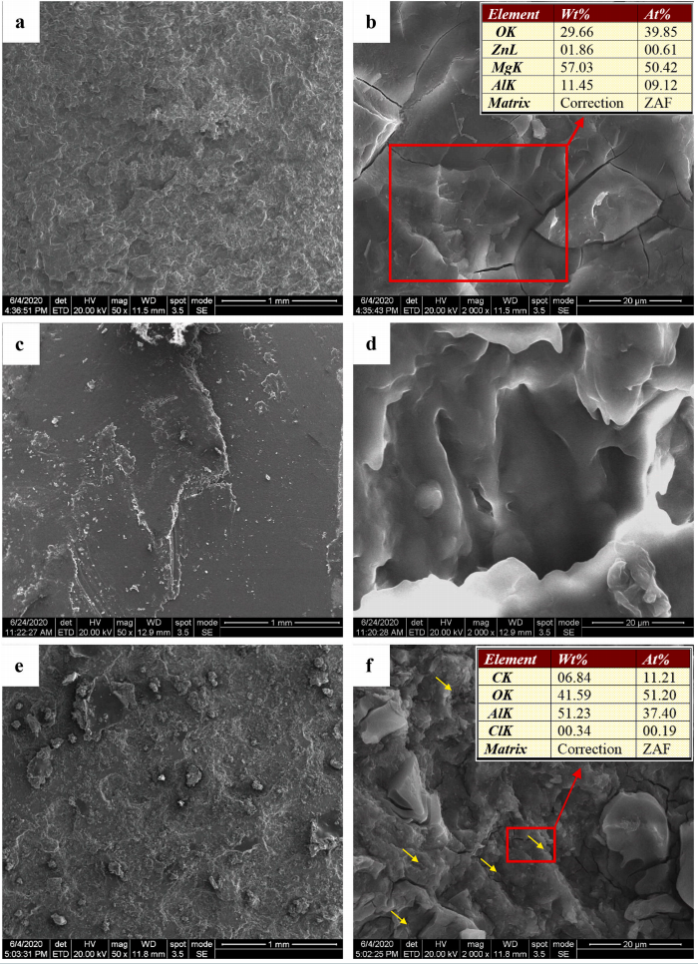
(a, b) AZ91 Mg alloy substrate,
(c, d) pure aluminum coating,
(e, f) CNT-Al MMC coating.
Figure 5 Scanning electron microscope (SEM) images at different magnifications after electrochemical corrosion showing:

3.5 Application of Carbon Nanotubes in Biocorrosion Control
Carbon nanotubes (CNTs) have excellent biocompatibility and antimicrobial properties, making them promising new materials for biocorrosion control. In applications such as medical devices and implants, the antimicrobial properties of CNTs can effectively inhibit the growth and reproduction of bacteria, thereby reducing the risk of biocorrosion. Abazari S et al^{[25]}. incorporated magnesium oxide (MgO) nanoparticles onto carbon nanotubes (CNTs) and used a semi-powder metallurgy method to reinforce Mg-3Zn-1Mn alloy (ZM31 alloy), followed by hot extrusion to prepare ZM31/MgO-CNT composites, as shown in Figure 6a. In the study, the researchers used potentiodynamic polarization to assess the corrosion resistance of the fabricated composites. The results indicated that the ZM31/MgO-CNT composite, which included CNTs and MgO, not only exhibited excellent corrosion resistance but also demonstrated superior cell compatibility due to its lower corrosion rate. This suggests that the composite material has great potential in biomedical applications, particularly for implants that require good biocompatibility. The lower corrosion rate helps reduce the release of harmful ions in the body, minimizing tissue irritation and inflammation, and promoting cell adhesion, growth, and differentiation on the material surface.Jian Y et al^{[26]}. prepared MWCNT/chitosan composite coatings using a one-step electrodeposition method (the preparation process is shown in Figure 6b). Through a series of electrochemical tests, the researchers found that the MWCNT/chitosan composite coating had significantly lower corrosion current density on titanium alloy and 316L stainless steel substrates compared to bare metal and pure chitosan coatings. Specifically, on titanium alloy, the corrosion current density of the composite coating was only 0.047 times that of bare titanium alloy; on 316L stainless steel, it was reduced to 1/56 of bare stainless steel. This indicates that the MWCNT/chitosan composite coating can significantly reduce the corrosion current density and corrosion rate of metal implants. Its hydrophobicity and dense structure provide excellent protective ability, ensuring that implants in complex biological environments can have a longer service life and higher safety.In the biomedical field, 316L stainless steel is widely used as an implant material due to its excellent mechanical properties and corrosion resistance. However, in complex biological environments, the surface of stainless steel may suffer from bacterial adhesion and corrosion, leading to infection and tissue damage. To address these issues, Sivaraj D et al^{[27]}. developed an innovative nanocomposite coating—silver-doped hydroxyapatite/functionalized multi-walled carbon nanotubes (Ag-HA/f-MWCNTs) coating, with the preparation process shown in Figure 6c. To evaluate the corrosion resistance of this coating on 316L stainless steel implants, the researchers conducted detailed electrochemical measurements in simulated body fluid (SBF) using potentiodynamic polarization. Figure 6d shows the potentiodynamic polarization curves of the 316L stainless steel implant surface with the Ag-HA/MWCNTs composite coating in SBF solution. The results clearly show that the introduction of CNTs in the Ag-HA nanocomposite significantly enhanced the corrosion resistance of the coating. This finding fully validates the effectiveness of the Ag-HA/f-MWCNTs nanocomposite coating in improving the durability and safety of the material.Despite significant progress in CNT research in recent years, its widespread application in clinical practice faces several obstacles. First, the toxicity of CNTs remains a major issue with practical significance. There are still many unknowns regarding the pharmacokinetics, internalization processes, and accumulation of CNTs in important human organs. Additionally, some literature reports suggest that CNTs may have potential genotoxicity[28,29,30]. However, due to the limited systematic research conducted on humans, this issue remains controversial in the academic community. It is important to note that most studies on CNT toxicity have been conducted in cell or animal models. Therefore, to fully and thoroughly evaluate the potential impact of CNTs on human health, including their possible genotoxicity and teratogenic effects, more human-specific studies are needed. 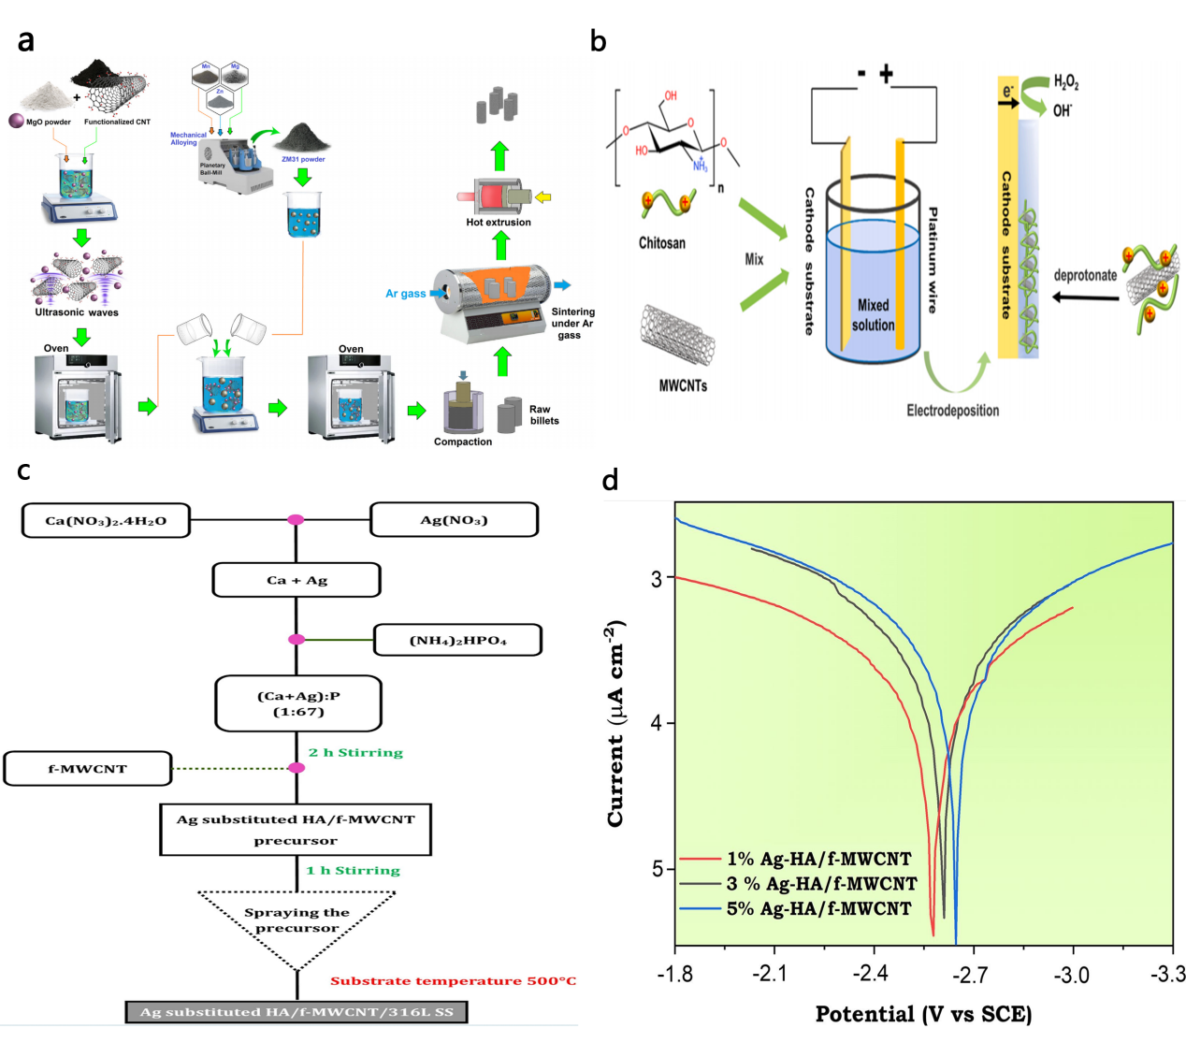
Figure 6 (a) Schematic diagram of the semi-powder metallurgy synthesis of MgO-CNTs/ZM31 composites^{[25]}.
(b) Schematic diagram of the electrodeposition of MWCNT/chitosan composite coatings^{[26]}.
(c) Experimental flowchart for the preparation of Ag-substituted HA/f-MWCNT nanocomposite coatings on 316L stainless steel implants^{[27]}.
(d) Polarization curves of Ag-substituted HA/f-MWCNT/316L stainless steel in SBF solution at 37°C^{[27]}.

4 Conclusion
Carbon nanotubes (CNTs), as a novel corrosion protection material, have attracted widespread attention in sectors crucial to national economy and public welfare, such as the military, telecommunications, transportation, construction, power, and petrochemical industries, due to their excellent physicochemical properties, good corrosion resistance, multifunctionality, and environmental sustainability^{[31]}. However, CNTs still face several challenges in the field of corrosion control that need to be addressed:
(1) High production cost: The production cost of CNTs is relatively high, which hinders their large-scale adoption in corrosion protection coatings. Efforts should continue to reduce production costs and explore more efficient fabrication methods.
(2) Aggregation and distribution: Due to their large specific surface area, CNTs are prone to aggregation in coatings, which affects their uniform distribution and performance. Therefore, surface modification of CNTs and the use of better dispersing agents and stabilizers are key solutions to these issues^{[32]}.
(3) Complex corrosion processes in multi-factor coupled environments: The corrosion process of CNTs in complex environments is highly intricate, involving the interaction of multiple factors such as chemical media, temperature, pressure, electric fields, and magnetic fields. To better understand and control the corrosion behavior of CNTs, it is necessary to consider the combined effects of various factors. Advanced experimental techniques and theoretical models are needed for in-depth exploration and research.
(4) Unclear corrosion mechanism: The corrosion mechanism of CNTs is still not fully understood. Although some studies have attempted to explore the corrosion mechanisms of CNTs, due to experimental conditions and characterization limitations, there is still a lack of a deep understanding of the corrosion mechanisms. Further research and exploration are needed. Future research should focus on deeply understanding the interactions between the chemical properties, physical structure, and environmental factors of CNTs to better control their corrosion behavior and improve their corrosion resistance. Additionally, more advanced characterization techniques need to be developed to better study and understand the corrosion mechanisms of CNTs.
Despite these challenges in the application of CNTs in corrosion protection, with the continuous advancement of technology and in-depth research, our understanding of CNTs will deepen, and their preparation techniques and application fields will continue to develop. In the future, CNTs are expected to play a more significant role in corrosion engineering, providing more durable and environmentally friendly protection for equipment and materials.

COMPETING INTERESTS DISCLAIMER:
Authors have declared that they have no known competing financial interests OR non-financial interests OR personal relationships that could have appeared to influence the work reported in this paper.

References
- Li Xuejin, Wang Juan, Wei Gang, et al. Application of carbon nanotubes in marine anti-corrosion coatings [J]. Chemical Engineering New Materials, 2023, 51(06): 241-244+249.
- Liu Henghao, Liu Lingli. Research progress on carbon nanotubes in anti-corrosion coatings [J]. Polymer Bulletin, 2018(08): 53-58.
- Xu Rongli. Performance and mechanism study of carbon nanotube reinforced ceramic composite coatings [D]. Jiangnan University, 2020.
- Iijima S. Helical microtubules of graphitic carbon [J]. Nature, 1991, 354(6348): 56-58.
- Li Sishi. Carbon nanocomposites and their applications in anti-corrosion coatings and flexible sensors [D]. Wuhan University, 2022.
- Xu J, Qi W, Deng W, et al. Tribo-induced evolution of nodular supporting structures providing high-performance solid lubricants in carbon nanotube coated films [J]. Carbon, 2024, 228: 119440-119440.
- Shi Xiaofan, Jia Xinlei. Research progress on the application of carbon nanotubes in anti-corrosion coatings [J]. Shandong Chemical Industry, 2021, 50(19): 111-112.
- Liu Henghao, Sun Jing, Jiang Yong. The effect of carbon nanotubes on the corrosion resistance of water-based epoxy zinc-rich coatings [J]. Coatings Industry, 2019, 49(08): 23-28+34.
- Alishahi M, Monirvaghefi S M, Saatchi A, et al. The effect of carbon nanotubes on the corrosion and tribological behavior of electroless Ni–P–CNT composite coating [J]. Applied Surface Science, 2012, 258(7): 2439-2446.
- Qin Wenfeng, Xue Yunsheng, Lin Chuanxi, et al. Preparation and corrosion resistance study of nanocarbon nanotube/epoxy resin composite coating for photothermal deicing [J]. Science and Technology and Engineering, 2023, 23(30): 12866-12873.
- Xing Xuteng. Preparation of micro-nano container-loaded corrosion inhibitors and their corrosion inhibition performance on carbon steel [D]. Tianjin University, 2021.
- Shirazi Z, Golikand A N, Keshavarz M H. A new nanocomposite based on poly(o-anthranilic acid), graphene oxide, and functionalized carbon nanotube as an efficient corrosion inhibitor for stainless steel in severe environmental corrosion [J]. Composites Communications, 2020, 22: 100467.
- Cen H, Cao J J, Chen Z. Functionalized carbon nanotubes as a novel inhibitor to enhance the anticorrosion performance of carbon steel in CO2-saturated NaCl solution [J]. Corrosion Science, 2020, 177: 109011.
- Zhang Y, Zhu H, Zhuang C, et al. TiO2 coated multi-wall carbon nanotube as a corrosion inhibitor for improving the corrosion resistance of BTESPT coatings [J]. Materials Chemistry and Physics, 2016, 179: 80-91.
- Zhang Jinge. Preparation and corrosion mechanism study of CNT-based/organic nanocomposite coatings [D]. Yangzhou University, 2022.
- Zhou Guohua. Electrochemical corrosion study of WMCNTs/AZ31 composites [J]. Journal of Corrosion and Protection, 2013, 33(05): 430-434.
- Bogdanovskaya V A, Koltsova E M, Zhutaeva G V, et al. Physico-chemical properties of carbon nanotubes as supports for cathode catalysts of fuel cells. Surface structure and corrosion resistance [J]. Protection of Metals and Physical Chemistry of Surfaces, 2016, 52: 45-54.
- Ganash A A. Electrochemical synthesis and corrosion behaviour of polypyrrole and polypyrrole/carbon nanotube nanocomposite films [J]. Journal of Composite Materials, 2014, 48(18): 2215-2225.
- Li L, Xing Y. Electrochemical durability of carbon nanotubes at 80°C [J]. Journal of Power Sources, 2008, 178(1): 75-79.
- Zhou Wen. Preparation and performance optimization of SiO2-MWCNTs enhanced organosilicon composite coatings [D]. Jiangnan University, 2023.
- Íris C, Sónia S. Strengthening mechanisms in carbon nanotubes reinforced metal matrix composites: A review [J]. Metals, 2021, 11(10): 1613-1613.
- Rajesh, M K, et al. Corrosion behavior studies of Al7075 reinforced with multiwalled carbon nanotubes metal matrix composites in acidic medium [J]. International Journal of Applied Engineering Research, 2018, 13(12 Pt.6): 10897-10904.
- Zhang Pengxiang. Preparation and performance study of CNTs@Ni enhanced 2024 aluminum matrix composites [D]. Nanchang University, 2022.
- Zhang Y, Wang Q, Chen G, et al. Mechanical, tribological and corrosion physiognomies of CNT-Al metal matrix composite (MMC) coatings deposited by cold gas dynamic spray (CGDS) process [J]. Surface and Coatings Technology, 2020, 403: 126380.
- Abazari S, Shamsipur A, Bakhsheshi-Rad H R, et al. MgO-incorporated carbon nanotubes-reinforced Mg-based composites to improve mechanical, corrosion, and biological properties targeting biomedical applications [J]. Journal of Materials Research and Technology, 2022, 20: 976-990.
- Jian Y, Zhang J, Yang C, et al. Biological MWCNT/chitosan composite coating with outstanding anti-corrosion property for implants [J]. Colloids and Surfaces B: Biointerfaces, 2023, 225: 113227.
- Sivaraj D, Vijayalakshmi K. Enhanced antibacterial and corrosion resistance properties of Ag substituted hydroxyapatite/functionalized multiwall carbon nanotube nanocomposite coating on 316L stainless steel for biomedical application [J]. Ultrasonics Sonochemistry, 2019, 59: 104730.
- Catalán J, Siivola K M, Nymark P, et al. In vitro and in vivo genotoxic effects of straight versus tangled multi-walled carbon nanotubes [J]. Nanotoxicology, 2016, 10(6): 794-806.
- Demirci O, Hasimi N, Kilinc E, Tolan V. Evaluation of genotoxic effects of C-60 fullerene-gamma-Fe2O3 and multi-wall carbon nanotubes-gamma-Fe2O3 nanoparticles [J]. Kafkas University Veterinary Faculty, 2018, 24: 799-805.
- Møller P, Jacobsen N R. Weight of evidence analysis for assessing the genotoxic potential of carbon nanotubes [J]. Critical Reviews in Toxicology, 2017, 47(10): 871-888.
- Lin Haidan, Lie Jianping, Sun Baomin. Research progress and outlook of carbon nanotube functional coatings [J]. Chemical Engineering New Materials, 2018, 46(05): 28-31.
- Shi Xiaofan, Jia Xinlei. Research progress on the application of carbon nanotubes in anti-corrosion coatings [J]. Shandong Chemical Industry, 2021, 50(19): 111-112.

