Original Research Article

SERUM P SELECTIN LEVELS AMONGST HYPERTENSIVE PATIENTS IN NORTH- CENTRAL NIGERIA: A COMPARATIVE STUDY

ABSTRACT

Background: Hypertension is a common and important major global health problem affecting more than 927 million people worldwide. Elevated levels of P selectin correlates with platelet activation. Platelet activation plays a key role in the complications of hypertension.
AIM: To determine the serum levels of P selectin in hypertensive patients and to compare the serum P selectin in control subjects in North central Nigeria.
Method: This was a cross-sectional comparative study conducted among 151 Hypertensives and 150 Normotensive controls in Federal Medical Centre Keffi Nasarawa State (North Central Nigeria). Soluble P-selectin levels were assessed using the enzyme-linked immunosorbent assay technique. Five millilitres (5mls) of venous blood were aseptically collected by venepuncture from each participant into plain tube and analysed using Elabsceince ELISA kits. Data obtained were analysed using SPSS version 27, and results considered to be significant at p<0.05.
Results: P-selectin values observed in hypertensive cases were higher (median 6.7ng/ml) than that in normotensive individuals (median 4.245ng/ml) mm statistically significant difference (p=0.0001, P<0.05). There was also a statistically significant difference in P-selectin values between poorly controlled hypertensives (median 7.028ng/ml), well controlled hypertensives (median 5.983ng/ml) and normotensive controls (median 4.245ng/ml) (p<0.05). A cut off point for P-selectin value showing increased platelet activation for this study was derived using area under curve (AUC) and receiver operating characteristic (ROC). A value of 4.7ng/ml with 82% sensitivity and 74% specificity with an AUC of 0.78 was obtained.
Conclusion: This study found significantly higher levels of soluble P-selectin in hypertensive cases compared to normotensive controls. Patients with poorly controlled hypertension also had significantly higher levels of soluble P-selectin compared with those with well controlled hypertension. The significantly higher values seen in hypertensives implies that platelet activation is increased with hypertension. P-selectin can therefore be used as a marker of platelet activation in hypertension.

Key Words: Serum P selectin Levels, hypertension and North central Nigeria

INTRODUCTION

Platelets are small, anucleated cytoplasmic bodies that circulate in the blood as guards of vascular integrity.¹ They do not interact with the inner surface of normal vessels, but adhere immediately to vessels where there is a breach in the endothelium.² Platelet activation is central in many biologic processes such as inflammation, atherosclerosis, as well as pathological conditions like hypertension and diabetes mellitus.^{3,4} The extent of platelet activation may differ depending on the underlying disorder, but invariably leads to the development of complications such as cerebrovascular ischemia and myocardial infarctions. Although the pathophysiology and treatment of hypertension and its complications are much better understood now, the exact mechanism by which hypertension acts as a cardiovascular risk factor is not fully understood. Increased circulating levels of markers of coagulation e.g. fibrinogen, VonWillibrand factor (VWF), antithrombin III, have been used previously as predictors of cardiovascular events and many of these abnormalities are present in individuals with hypertension corroborating that hypertension confers a prothrombotic state.^{5,6} These abnormalities appear to be related to the severity and duration of hypertension.⁶ Currently, attention has been directed at the role of platelets in the pathogenesis and complications of hypertension as a number of studies have shown increased platelet activation in hypertension.⁴⁻⁶
There is growing evidence to show that platelets and the endothelium get activated in hypertension and contribute to the thrombotic tendency seen in hypertension.⁴⁻⁶ Even though the blood vessels are exposed to high pressure, the main complications seen in hypertension are thrombotic rather than haemorrhagic in nature the so called “thrombotic paradox”.^{5,6} This strengthens the theory that hypertension confers a thrombotic state marked by abnormalities of endothelial dysfunction and platelet activation. This dysfunction is present with systolic hypertension or simultaneous systolic and diastolic hypertension, hence, the focus on platelet activation as an important mediator in hypertensive vascular injury.^{6,7}
Although hypertensive vascular injury has been well documented, the role of platelet activation in the complications of hypertension is a new area of research that needs to be further explored in Nigerian hypertensives with the hope of possible therapeutic intervention in future. Platelets are the major source of circulating P-selectin. Elevated levels of this protein may correlate platelet acitivation.⁸
We aimed to assess the serum P selectin levels in patients with hypertension and to compare the P selectin levels in a control group.

METHODOLOGY
This is a cross-sectional comparative study carried out among known hypertensives attending the medical & family practice outpatient clinics at Federal Medical Centre Keffi while healthy volunteers from the Keffi community and staff working at FMC Keffi were recruited to serve as controls. FMC Keffi is located in Nasarawa State of Nigeria. It is a 220 bedded hospital it serving individuals/patients from Benue, Plateau, Kaduna, Kogi and Niger states as well as the Federal Capital Territory. Ethical approval was obtained from the ethical committee of FMC Keffi.

Inclusion criteria
Consenting adults, age greater than 18 years. Known hypertensive patients attending the medical and family practice outpatient clinic at FMC Keffi. Normotensive healthy individuals with a mean diastolic blood pressure range of 57 – 89mmHg and a mean systolic blood pressure range of 97 – 139mmHg taken in the sitting position after a minimum of five minutes rest (who have never been diagnosed with hypertension, ) served as controls.

Exclusion criteria
Evidence of acute hypertension secondary to an identifiable cause such as drug ingestion, acute pain syndrome. Clinical findings of an acute clinical condition or ongoing acute target organ damage requiring treatment such as acute coronary syndrome, transient ischemic attack, atrial fibrillation, congestive cardiac failure. History of antiplatelet drug use in the last 7 days.

A hundred and fifty one (151) hypertensives and one hundred and fifty (150) normotensive controls who consented were enrolled for the study. Hypertension was defined as a systolic blood pressure equal to or greater than 140mmHg, and a diastolic blood pressure equal to or greater than 90mmHg and or individuals with prior diagnosis of hypertension taking anti-hypertensive medication. Blood pressure was measured with a standard sphygmomanometer at the arm in a sitting position two times after a minimum of 5 minutes rest and the average used for the analysis
A questionnaire was administered to enrolled participants: - the questionnaire highlighted the participants’ biodata, history of hypertension (time of diagnosis, medication patient is taking including antihypertensive and antiplatelet drugs, and any complications secondary to hypertension). Blood pressure measurements were taken twice in sitting relaxed position after a minimum of five minutes rest and a mean blood pressure obtained.
Soluble P-selectin concentration was measured in citrated plasma using the quantitative Human Soluble P-selectin ELISA kits (Elabscience biotechnology inc. Texas catlog No: E-EL-H0917). With a sensitivity of 0.1ng and detection range of 0.16 - 10ng/ml and coefficient of variation of <10%
The data are expressed as medians and range, unless otherwise indicated.
Statistical analysis was conducted using the statistical software package SPSS version 26. Statistical significance was set at p <0.05

RESULTS
Table 1: Socio-demographics of participants

Social-demographic parameters | Cases  n=151  n(%) | Controls  n=150  n(%) | X²Cal(p-value)
Gender
Male | 57(37.7) | 78(52.0)
Female | 94(62.3) | 72(48.0) | 1.08(0.29)
Age range (Years) | 26-83 | 18-80
Age group (Years)
<30 | 7(4.6) | 50(33.3)
31-40 | 35(23.2) | 63(41.4)
41-50 | 45(29.8) | 30(20.0)
>50 | 64(42.2) | 8(5.3) | 3.26(0.03)
Educational Status
None | 28(18.5) | 4(2.7)
Primary | 15(9.9) | 10(6.7)
Secondary | 37(24.5) | 54(36.0)
Tertiary | 71(47.1) | 82(54.7) | 4.87(0.02)
Occupation
Medical Professionals | 2(1.3) | 12(8.0)
Civil Servants | 66(43.7) | 98(65.3)
Business/Traders | 29(19.2) | 12(8.0)
Unemployed | 26(17.2) | 4(2.7)
Farmers | 6(4.0) | 4(2.7)
Students | 3(2.0) | 16(10.7)
Teaching | 13(8.6) | 2(1.3)
Retirees | 6(4.0) | 2(1.3) | 1.08(0.29)

Table 2: Clinical history and status of the patients (Hypertensives)
Clinical findings | Cases  n=151  n (%)
Hypertensive status
Controlled Hypertension | 49(32.4)
Poorly Controlled Hypertension | 102(67.6)
Duration since Hypertension diagnosis
<1 year | 35(23.2)
1-5 years | 52(34.4)
6-10 years | 29(19.2)
>10 years | 23(15.2)
Do not Known | 12(7.9)
On anti-hypertensive drugs
Yes | 131(86.8)
No | 20(13.2)
Duration on Anti-hypertensive drugs
<1 year | 31(20.6)
1-5 years | 50(33.1)
6-10 years | 26(17.2)
>10 years | 20(13.2)
Do not know | 24(15.9)
Any Complication secondary to hypertension
Yes | 23(15.2)
No | 128(84.8)
If Yes What Type?
Stoke | 2(1.3)
Cardiac Complication
Heart Failure | 15(9.9)
Myocardial Infarction | 2(1.3)
Arrhythmias | 1(0.7)
Renal disease or damage | 1(0.7)
Transient ischemic attacks | 2(1.3)

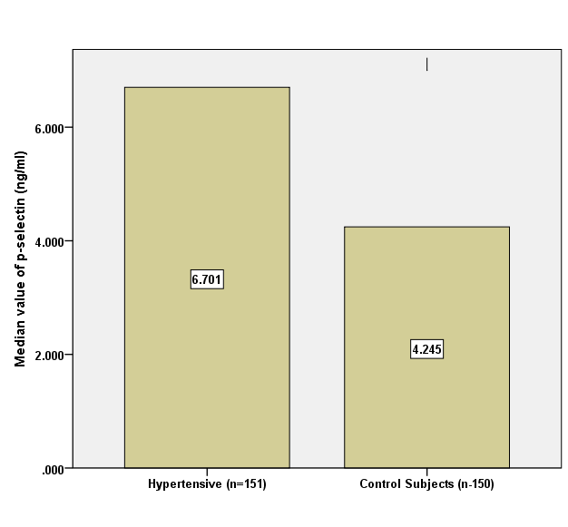
Figure 1: Soluble P-selectin values in patients (hypertensives) and controls (normotensives)

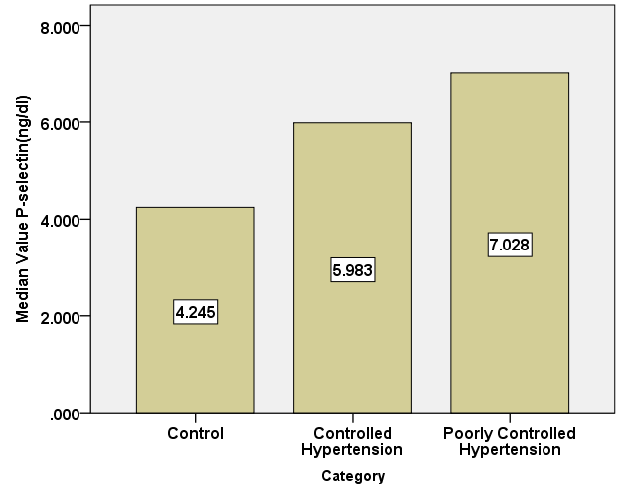
Figure 2: Souble P-selectin values in normotensive controls, well controlled hypertensives and poorly controlled hypertensives

Table 3: Association of Gender, Age and clinical characteristics of hypertensives with P-selectin values
Clinical characteristics | OR | 95%CI | p-value
Gender: Males*
Females | 0.903 | 0.822-0.992 | 0.03
Age Group: **
31-40 years | 1.097 | 0.944-1.275 | 0.23
41-50 years | 1.282 | 1.091-1.490 | 0.002
>50 years | 1.435 | 1.223-1.683 | 0.0001
Hypertensive status (Ref: Normotensive)**
Well Controlled Hypertension | 1.537 | 1.316-1.796 | 0.0001
Poorly Controlled Hypertension | 1.696 | 1.459-1.972 | 0.0001
Length of been Hypertensive**
<1 year | 1.345 | 1.132-1.599 | 0.001
1-5 years | 1.701 | 1.449-1.997 | 0.0001
6-10 years | 1.795 | 1.415-2.152 | 0.0001
>10 years | 1.815 | 1.475-2.185 | 0.0001
Do not Known | 1.387 | 1.066-1.804 | 0.0001
On anti-hypertensive drugs*
Yes | 1.280 | 1.018-1.608 | 0.03
Length on being on Anti-hypertensive drugs
Reference**
<1 year | 1.409 | 1.179-1.682 | 0.0001
1-5 years | 1.685 | 1.436-1.978 | 0.0001
6-10 years | 1.774 | 1.451-2.169 | 0.0001
>10 years | 1.651 | 1.332-2.045 | 0.0001
Do not know | 1.421 | 1.107-1.682 | 0.006
Any Complication secondary to hypertension*
No
Yes | 1.041 | 0.855-1.268 | 0.687
If Yes, What Type
Cerebrovascular accident | 1.567 | 0.733-3.352 | 0.247
Cardiac Complication | 1.096 | 0.864-1.390 | 0.449
Heart Failure | 1.086 | 0.854-1.380 | 0.409
Myocardial Infarction | 1.060 | 0.571-1.969 | 0.571
Arrhythmias | 1.929 | 0.540-6.893 | 0.312
Renal disease or damage | 0.051 | 0.001-5.005 | 0.204
Transient ischemic attacks | 0.753 | 0.375-1.509 | 0.753

Key: *=binary logistic regression, **=multinomial logistic regression, OR=odds ratio, 95%CI= 95% Confidence interval, p-value=Significant level, p<0.05=significant statistically, p>0.05=not significant statistically.

Cut-off value for P-selectin in hypertensive individuals
Figure 3 shows the area under curve (AUC) and receiver operating characteristic (ROC) for the derivation of the cut-off point for P-selectin values in Hypertensives using 2/3 of the data (i.e. 100 participants P-selectin values each taken from both hypertensive and normotensive groups). The AUC value as derived was 0.783±0.026, p=0.0001 which is acceptable been >0.7. The AUC was also statistically significant (p<0.05). A cut off point of 4.78ng/ml was obtained.

Table 4 shows the performance of the derived cut-off when 1/3 of the data (i.e.) 50 hypertensive and normotensive participants P-selectin values were subjected to the cut-off, a sensitivity of 0.82(82%) and specificity of 0.74(74%) was obtained.

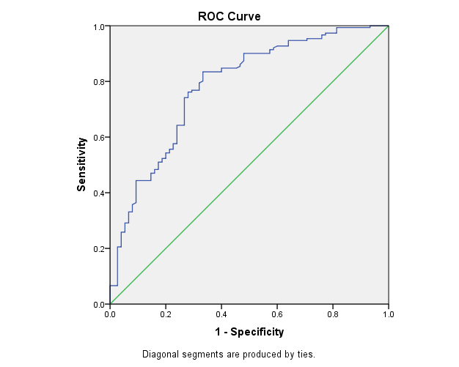
Parameter | AUC | SE | 95%CI | Significance
P-selectin(ng/ml) | 0.783 | 0.026 | 0.731-0.835 | <0.0001

Figure 3: Receiver Operating Characteristics of measured P-selectin for the study subjects

Key: ROC= Receiver operating characteristics, AUC=Area under curve, SE=standard error, CI=Confidence interval, p<0.05= statistically significant, p>0.05=Not statistically significant

Parameters | Cut-off | Sensitivity | Specificity
P-selectin | 4.78(ng/ml) | 0.82(82.0%) | 0.74(74.0%)
Table 4: The sensitivity and specificity outcome of the derived Cut-off value for P-selectin.

50 patients (Hypertensives) and 50 controls (Normotensives) were used to test run the derived cut –off values for P-selectin in hypertensive patients

DISCUSSION
This study assessed and compared the platelet activation levels in 151 hypertensives and 150 normotensive controls using soluble P- selectin in citrated plasma. The study found a positive correlation between P-selectin levels and hypertension. Hypertensive patients had significantly higher levels of soluble P- selectin compared to the normotensive controls. P-selectin was positively associated with an increase in systolic and/or diastolic blood pressure and levels of P- selectin in poorly controlled hypertensive patients were significantly higher than levels seen in patients with well controlled hypertension.
These findings are in keeping with various studies which have demonstrated higher levels of soluble P-selectin in hypertensive individuals compared to normotensive controls.⁹⁻¹¹
The Multi Ethnic Study of Atherosclerosis (MESA), found higher levels of plasma P-selectin in hypertensives compared to normotensive controls.⁹ They also observed a positive association between plasma P-selectin and increase in systolic and diastolic blood pressure. This pattern of increase was observed in all races and ethnic groups that were analyzed.
Preston et al ¹² in his study also found elevated P-selectin expression in high risk patients with uncontrolled severe hypertension, they also demonstrated a positive association between increased P-selectin levels with elevated systolic and diastolic blood pressure. Platelet activation and platelet P-selectin levels increased with higher blood pressure measurements suggesting that worsening or poorly controlled hypertension is associated with increased secretion of P-selectin.¹³ This is similar to the findings of this study with statistically significant higher levels of P-selectin seen in poorly controlled hypertensives when compared with well controlled hypertensive cases, and P-selectin levels was also statistically significantly higher in well controlled hypertensives when compared with normotensive subjects.
Lee et al ¹⁰ and Reiner et al ¹¹ reported significant correlations between soluble P-selectin and hypertension, Lee et al ¹⁰ concluded that P-selectin is a marker of cardiovascular disease, while Reiner et al ¹¹ related higher P- selectin levels in hypertensives to an increased risk of developing atherosclerosis. Varughese et al ¹⁴ concluded that increased P-selectin levels in hypertension reflected platelet activation and was predictive of coronary events (myocardial infarction).
Contrary to the above this study did not show a strong correlation between high P-selectin values and complications attributable to hypertension in our study population. This difference may be because hypertensive patients with acute conditions were excluded from this study. Secondly the number of hypertensives with complications secondary to hypertension formed a small cohort of the total number of hypertensives in this study, and comprehensive diagnostic screening /testing was not done on the hypertensive patients to determine presence of underlying complications that may have been present as this was beyond the scope of this study.
P-selectin levels increased significantly with age but there was no significant difference in levels with sex although males had marginally higher values than females in this study.
Lee et al, ¹⁰ and Reiner et al,¹¹ equally found higher levels of plasma P-selectin in males than females. They also found a positive correlation with P-selectin values and increasing age. The MESA study on the other hand found a positive association with P- selectin values and sex but no association with age while Shalia et al,¹³ found no association between P-selectin levels and increasing age in hypertensives, he rather suggested that both young and old hypertensives with raised P-selectin levels are equally at an increased risk of developing target organ damage.
Nadar SK. et al, 2004 ⁵ in his study of untreated newly diagnosed hypertensive patients found that when commenced on anti-hypertensives (amlodipine), levels of soluble P-selectin declined . Similar findings were also noted in a study conducted by Sanada et al, ¹⁵ where 21 hypertensive cases with high levels of soluble P-selectin were placed on calcium channel blockers and followed up for 55 weeks. This is similar to our findings which showed lower P-selectin levels in hypertensive individuals with well controlled blood pressures (therapeutically) as compared with hypertensive cases whose blood pressures were poorly controlled (inadequately treated). But although P-selectin levels were lower in the well-controlled individuals with hypertension, their P-selectin levels were still significantly higher than levels found in non-hypertensive controls.
Spencer et al, 2002 ¹⁵ found that following regular and consistent treatment with antihypertensives, levels of P-selectin in hypertensives declined, though it still remained significantly higher than levels found in the non-hypertensive control group. This suggests that though proper management of hypertension produces a significant reduction in P-selectin levels and improvement of platelet function there is a possibility that even with treatment cardiovascular risk may not fall back to levels seen in normotensive individuals. ¹⁵ This also supports the role of other factors being involved in complications seen in hypertension such as endothelial dysfunction demonstrated by raised levels of VonWillibrand factor, fibrinogen and increased plasma viscosity. ¹⁶
Unfortunately, majority of the hypertensive patients, had poorly controlled hypertension probably related to delayed and inconsistent therapy and a general level of poor illness behavior. A hypertensive patient who obtains one or two normal blood pressure readings is likely to set aside further medications against medical advice. Poverty and sociocultural and educational issues may also play a role. Akintunde AA ¹⁷ as well as Bioma V ¹⁸ in their work found a high medication non adherence among Nigerians and Ghanaians which they attributed to lack of formal education, low monthly income, concern about the side effects of the hypertensive medication and preference for herbal preparations.
A graphical presentation created by plotting sensitivity against (1- specificity) at various threshold settings showed that the cut off point for P-selectin value in hypertensive cases (i.e. showing platelet activation) was 4.78ng/ml with 82% sensitivity and 74% specificity for this study. This agrees with studies on the use of area under curve(AUC) and receiver operating characteristic curve (ROC) that proposes that a sensitivity and specificity of greater than 70% and AUC >0.6 is acceptable following testing.^{19,20} The ROC curve is a graphical presentation of screening characteristics, it is used to determine the connection between sensitivity and specificity of a test, the area under curve (AUC) is a measure of the overall quality of the test. It can be interpreted as the probability that a random person with the disease has a higher test measurement than a random person who is healthy. ^{19,20} This study using soluble P-selectin to assess platelet activation was able to predict 84% of the hypertensive test group as cases (i.e. had activated platelets) and 74% of the normotensive subjects as controls (no significant platelet activation) with an AUC of 0.78 . Thomas M. et al ²¹ in his study used ROC to determine the cut of range for high platelet reactivity (platelet activation) in patients with acute coronary syndrome who were on treatment with P2Y12 receptor antagonist and aspirin. An optimal cut off for high platelet reactivity was determined by ROC curve and AUC analysis, thereby detecting patients who still had high platelet reactivity despite being on antiplatelet medications. Fei et al ²² also used ROC curve and AUC analysis to determine the cut off values for P-selectin, D-dimers and platelet count in predicting patients at risk of developing portal vein thrombosis following devascularization in patients with cirrhotic portal hypertension while Wei et al ²³ also used ROC curve analysis and AUC to determine the value of using P-selectin, D-dimers and thrombus precursor protein (TpP) to predict risk of developing portal vein thrombosis following splenectomy. In both cases optimal values for AUC were obtained and P-selectin was found to have a significant and valuable value in predicting early thrombosis following surgery. From the foregoing, the derived cut off values obtained for soluble P-selectin from our study population at FMC Keffi may similarly be used in risk stratifying patients who may be at risk of developing complications secondary to hypertension

CONCLUSION
Soluble P- selectin was found to be significantly higher among the hypertensive patients compared to the normotensive group. Hypertensives with poorly controlled blood pressure had significantly higher levels of soluble P-selectin when compared to those with well controlled blood pressure. This significantly raised levels could have a predictive significance for increased risk of adverse conditions like cardiovascular events, thrombotic complications and end organ damage. Thus, soluble P-selectin used as a marker of platelet activation in hypertensives.

REFERENCES

1. Geddis, AE, Green JP, List AF, Rodgers GM, Arber DA, Means T, Glader B. Megakaryocytes wintrobes clinical haematology. Pp371-388,13th edition. KK&W
2. Choi J-L, Li S, Han J-Y. Platelet Function Tests: A Review of Progresses in Clinical Application. Biomed Res Int, vol. 2014, https:doi.org//10.1155/2014/456569
3. Ghoshal K, Bhattacharyya M. Overview of Platelet Physiology: Its Hemostatic and Nonhemostatic Role in Disease Pathogenesis. Sci World Journal,vol. 2014,781857 https://doi.org/10.1155/2014/781857
4. El Haouari M, Rosado JA. Platelet function in hypertension. Blood Cells, Mol Dis. 2009; 42(1):38-43.
5. Nadar SK, Blann AD, Kamath S, Beevers DG, Lip GYH. Platelet indexes in relation to target organ damage in high-risk hypertensive patients: A substudy of the Anglo-Scandinavian Cardiac Outcomes Trial (ASCOT). J Am Coll Cardiol. 2004;44(2):415-422
6. Gkaliagkousi E, Passacquale G, Douma S, Zamboulis C, Ferro A. Platelet Activation in Essential Hypertension: Implications for Antiplatelet Treatment. Am J Hypertens. 2010;23(3):229–236.
7. Lip GYH. Hypertension, platelets, and the endothelium: The “thrombotic paradox” of
hypertension (or “Birmingham paradox”) revisited. Hypertension. 2003;41(2):196-200
8. Ferroni P, Martini F, Riondino S, La Farina F, Magnapera A, Ciatti F, Guadagni F. Soluble P-selectin as a marker of in vivo platelet activation. Clin Chim Acta. 2009 Jan;399(1-2):88-91. doi: 10.1016/j.cca.2008.09.018. Epub 2008 Sep 21.

9. Italiano JE. 2008 The structure and production of blood platelets. In: Platelets in Hematologic and Cardiovascular Disorders: A Clinical Handbook. pp 1-20,Newyork,:cambridge university press.
10. Preston RA, Jy W, Jimenez JJ, Mauro LM, Horstman LL, Valle M, et al. Effects of severe hypertension on endothelial and platelet microparticles. Hypertension. 2003;41:211-217
11. Bielinskia SJ, Berardia C, Decker PA, Kirschc PS, Larsonc NB, Pankow JS, et al. P-selectin and subclinical and clinical atherosclerosis: The Multi-Ethnic study of Atherosclerosis. Atherosclerosis. 2015;240(1):3–9.
12 Preston RA, Coffey JO, Materson B, Ledford M, Alonso AB. Elevated platelet P-selectin expression and platelet activation in high risk patients with uncontrolled severe hypertension. Atherosclerosis. 2007;192(1):148–154.

13. Shalia KK, Mashru MR, Vasvani JB, Mokal RA, Mithbawkar SM, Thakur PK. Circulating levels of cell adhesion molecules in hypertension. Indian Journal of Clinical Biochemistry. 2009;24(4):388-397
14. Varughese GI, Patel J V, Tomson J, Blann AD, Hughes EA, Lip GYH, et al. Prognostic value of plasma soluble P-selectin and von Willebrand factor as indices of platelet activation and endothelial damage/dysfunction in high-risk patients with hypertension: a sub-study of the Anglo-Scandinavian Cardiac Outcomes Trial.Journal of Internal Medicine.2007;261(4):382-391
15. Sanada H, Midorikawa S, Yatabe J, Sasaki Yatabe M, Katoh T, Baba T, et al. Elevation of Serum Soluble E-and P-Selectin in Patients with Hypertension Is Reversed by Benidipine, a Long-Acting Calcium Channel Blocker.Hypertension Research.2005; 28:871-878,
16. Spencer CGC, Gurney D, Blann AD, Beevers DG, Lip GYH. Von Willebrand Factor, Soluble P-Selectin, and Target Organ Damage in Hypertension. Hypertension.2002 ;40: 61-66 Jul [cited 2019 Apr 23];40(1):61–66
17. Akintunde AA, Akintunde TS. Anti hypetensive medications Adherence Among Nigerian Hypertensive Subjects in a Specialist Clinic. Compare to a General outpatient Clinic. Annals of Medical and Health Science Research. 2015;5(3);173-178.
18. Bioma V, Ademola AD, Odusola AO, Agyekum F, Nwafor CE, Cole H, Salako B, et al. Factors associated with medication non adherence among hypertensives in Ghana and Nigeria. International Journal of Hypertension. 2015https://doi//org10.1155/2015/205716
19. Batista TR, Carvalho De Figueiredo R, Rios DR. Platelets volume indexes and cardiovascular risk factors. Rev Assoc Med Bras. 2018;64(6):554-559
20. Mandrekar JN. Receiver Operating Characteristics Curve in Diagnostic Test Assessment. Journal of Thoracic Oncology. 2010;5(9):1315-1316.
21. Thomas MR, Wijeyeratne TD, May JA, Johnson A, Heptinstall S, Fox S. A platelet P-selectin test predicts adverse cardiovascular events in patients with acute coronary syndromes treated with aspirin and clopidogrel. Platelets. 2014;25(8):612-618.
22. Fei Y, Zong GQ, Chen J, Liu MR. Evaluation of the Value of d-Dimer, P-selectin, and Platelet Count for Prediction of Portal Vein Thrombosis After Devascularization. Clin Appl Thromb / Haemostasis. 2016;22(5):471–475.
23. Wei Y, Xuedong C, Shen H, Wu W, Cao G, Chen W, et al. P-selectin level at First and Third Day After Portal Hypertensive Splenectomy For Early Prediction of Portal Vein Thrombosis in Patients With Cirrhosis. Clin Appl Thromb Haemost. 2018(9_suppl), 76S-83S.https//doi.org1177/1076029618788180.

