Original Research Article
Socio-Demographic Determinants of Vitamins (A, C & E) Intake in Rural Households of Sierra Leone

Abstract
Aim: Numerous studies have demonstrated that socioeconomic position, gender, and educational attainment have a major impact on dietary diversity and nutritional choices. However, few studies have investigated that of toddlers and adults in rural communities. The goal of this study was to examine the socio-demographic determinants of vitamins A, C & E intake among male and female infants and toddlers, and adult males and females in rural households in two selected rural districts of Sierra Leone.
Method: A cross-sectional study design was used to explore the socio-demographic determinants of vitamins A, C, and E intake among households in Bo and Pujehun districts and 1600 households were randomly surveyed. Anthropometric measurements were employed. Weights and heights of the participants were measured using an electronic scale and height board. In line with the World Health Organization guidelines on growth monitoring, lengths of the children were measured using the UNICEF wooden height board for infants and their weights were measured using electronic balance. Mid-upper arm circumference of adults, toddlers and infants were measured using the standard UNICEF tapes.
Results: The study highlights the important sociodemographic elements influencing vitamins A, C and E consumption by toddlers and adults. The intake of vitamin A among male infants and toddlers seems to be lower compared to their female counterparts. The results also show that adult women are likely consuming higher levels of vitamin A and C compared to their male counterparts, possibly due to disparities in dietary habits.
Conclusion: In summary, lower vitamin E intake levels in both male and female infants and toddlers were observed and, gender differences in eating habits and food choices were noted among the demographic groups and the deficiencies in vitamins A, C and E were considered as public health issues in the study areas.
Key words: Anthropometric, socio-demographic, vitamins, gender, toddlers, infants, adults.

Introduction
Micronutrient deficiencies, especially those of vitamins A, C, and E are a major global public health concern in rural households, disproportionately affecting vulnerable groups like women and children (Changezi & Lindberg, 2017). In many rural places, especially in Africa and Southeast Asia, vitamin A deficiency (VAD) is still a major problem since it increases mortality and causes childhood blindness (Changezi & Lindberg, 2017). Research has demonstrated a strong correlation between VAD and variables such as inadequate dietary diversity, low maternal education, and limited access to healthcare services (Sommer, 2002; West, 2002; Hossain et al., 2021; Shilow et al., 2022). As an illustration of the significance of maternal health interventions, a study conducted in Somalia indicated that children were more likely to eat foods high in vitamin A if their mothers had taken vitamin A supplements within the previous six months (Wasantwisut, 2002). Similarly, studies conducted in Bangladesh found that children in rural areas were more likely to take vitamin A supplements if their mothers had greater levels of education (Hossain et al., 2021). In order to boost vitamin A consumption among children in rural households, these findings highlight the necessity of focused interventions that address both individual and community-level determinants (Tanumihardjo, 2011; Changezi & Lindberg, 2017; Hossain et al., 2021).
In both industrialized and developing nations, vitamin C deficiency is once again a problem, especially in rural and isolated areas with little access to fresh produce (Bates, 1997; Granger, 2018). Inadequate vitamin C intake is largely caused by socioeconomic factors such as low income, food insecurity, and limited access to a variety of dietary sources (Granger, 2018). In a similar vein, research conducted in India has shown that low-income populations had significant rates of vitamin C insufficiency, with prevalence varied according to age, season, and tobacco usage (Ravindran et al., 2011). In order to tackle vitamin C insufficiency in vulnerable rural populations, these findings highlight the need for public health interventions that encourage access to reasonably priced, vitamin C-rich foods and discourage dangerous behaviours like tobacco use (Moacir, 2023).
Despite being less common than shortages of vitamins A and C, vitamin E deficiency is a serious health risk, especially in rural regions where availability of fortified foods is limited and dietary diversity is limited (Lee et al., 2021; Smith & Carter, 2022). According to studies, vitamin E deficiency is prevalent among women of reproductive age in rural South Asia (Smith & Carter, 2022). A number of factors, including chronic diseases that impair fat absorption and inadequate dietary fat consumption, which is essential for vitamin E storage and absorption, causes this deficit. According to research conducted in Bangladesh, a considerable percentage of rural women suffered from chronic vitamin E deficiency, underscoring the need for treatments to increase the availability of vitamin E these communities (Lee et al., 2021; Smith & Carter, 2022). Promoting the consumption of foods high in vitamin E, such as vegetable oils, nuts, and seeds, and addressing the underlying causes of fat malabsorption should be the main goals of these interventions.
Collectively, these deficits are closely related to a network of sociodemographic factors that affect access to and utilization of nutrient-rich foods (Changezi & Lindberg, 2017; Hossain et al., 2021). Vitamin deficiencies in many rural areas stem not only from limited food intake but also from poverty-driven dependence on staple foods lacking essential nutrients, which restricts access to diverse diets (Gouado et al., 1998). Micronutrient deficiencies, particularly iron deficiency, are prevalent among young children in Sierra Leone. Only about half of children aged 6–23 months consume iron-rich foods, with intake strongly associated with maternal employment, education, and access to health services. Children from rural areas, those with younger or unemployed mothers, and those not meeting minimum dietary standards are at heightened risk of inadequate nutrient intake (Osborne et al., 2025). Inadequate nutrition understanding, subpar farming methods, and restricted access to healthcare and supplements programs all exacerbate this problem (National Nutrition Monitoring Bureau (NNMB) Technical Report No. 23, 2006; Wolde-Gebriel et al., 1993). Designing successful interventions to increase vitamin consumption and treat the underlying causes of malnutrition in these populations requires an understanding of these determinants (Changezi & Lindberg 2017; Hossain et al., 2021). According to Lee et al. (2003), micronutrient deficiencies cause significant health issues in developing countries, particularly among pregnant women, nursing mothers, and children under five. Young children in rural areas are especially likely to lack essential nutrients, such as vitamins A, C, and E, as well as iron, iodine, and zinc, leaving them susceptible to micronutrient malnutrition and its serious health consequences. For example, lack of vitamin A can cause stunted, cognitive and physical development in children (Sommer, 1995; Allen, 2000; Rao et al., 2020). Vitamin C deficiency in children can cause corkscrew hairs, perifollicular hemorrhages, and gingival bleeding, and in some cases it leads to scurvy disease (De Luna et al., 2003; Magiorkinis et al., 2011). On the other hand, vitamin E helps maintain healthy skin and eyes, brain development in children and strengthen the body's natural defense against illness and infection (boost the immune system)
According to the Food Security Monitoring System Report (2024), 82% of Sierra Leoneans suffer from food and nutrition insecurity. Owing to a great crop harvest, 14% of households fall into the poor food consumption score category, and 18% of households are categorized as severely food insecure—an expected improvement from the previous assessment conducted during the lean season. Kenema, Falaba, Koinadugu, Karene, and Tonkolili districts are the most vulnerable among the 16 districts in the nation according to the majority of indicators (Food Security Monitoring System Report, 2024). Rao et al. (2020) looked at the food value chain in Makeni to characterize the possible loss of micronutrients at various points along the value chain. According to the authors, widespread micronutrient deficiencies among mothers and young children have detrimental effects on health, society, and the economy due to current policies and practices in areas like healthcare, education, and indigenous food preparation methods.
Socioeconomic factors, including maternal education, household income, and food security status, are consistently linked to feeding practices and nutritional outcomes in rural Sierra Leone. Studies reveal that economic hardship, early cessation of exclusive breastfeeding, and reliance on staple foods such as rice—often with minimal protein supplementation—contribute to poor dietary quality among children and adults alike (Blango et al., 2022). Furthermore, undernutrition among women of reproductive age, while lower than regional averages, remains a concern, particularly among those with lower education and limited access to resources (Alema et al., 2024).
Collectively, these findings emphasize the multifaceted nature of dietary intake disparities in rural Sierra Leone, shaped by demographic, socioeconomic, and environmental factors. Understanding these patterns is essential for designing effective nutrition interventions and policies tailored to the needs of vulnerable groups in rural communities. It is worthy to note that most of these studies were conducted between seasons in some regions and were focused mainly on children aged 6–23 months, under five children, pregnant and nursing mothers, and women in rural areas. Considering the high prevalence of food insecurity in the country (82% of the population), among which 18% of households are severely food insecure (Food Security Monitoring System Report, 2024), there is a dire need to explore dietary intake disparities among other demographic categories such as male and female infants and toddlers, and adult males and females in rural communities. The goal of this study was to examine the socio-demographic determinants of vitamins (A, C & E) intake among male and female infants and toddlers, and adult males and females in rural households in two selected districts of Sierra Leone.
Materials and Methods
Study Design
The sociodemographic factors influencing vitamin A, C, and E intake in homes within the research areas were investigated using a cross-sectional study methodology. This design makes it possible to gather information at one particular moment in time, giving a quick overview of eating patterns and related sociodemographic traits in the study areas.
Description of study areas
This cross-sectional survey was conducted in Bo and Pujehun districts located in the Southern region of Sierra Leone. These two districts were purposively selected due to the high prevalence of stunting as reported in the National Nutrition Survey conducted in 2021.
Bo is the second-largest city and district in Sierra Leone, located in the Southern Province with an estimated population of around 477,000 people as of the 2015 national census. It serves as a major economic and administrative hub for the region and is known for its agricultural activities that includes the cultivation of rice, cassava, and other staples, which is central to its economy. Bo district lies approximately 150 km southeast of Freetown, the capital of Sierra Leone and shares borders with Bonthe, Moyamba, and Kenema districts. The major ethnic group of Bo are the Mendes and the predominant religion is Islam, with a significant Christian minority. Literacy rates in Bo have improved in recent years, though they are still below the national average, with around 40-50% of adults being literate. Access to healthcare remains a challenge, with overcrowded hospitals, insufficient medical supplies, and a shortage of qualified healthcare professionals. Infant mortality rates are relatively high, and malaria remains a major health concern. Malnutrition rates are high, particularly in rural areas. Access to balanced diets is limited, and stunting among children is a serious concern even though the district has received support from various international NGOs to address nutrition and food security.
Pujehun is located in the Southern Province and is one of the rural districts in Sierra Leone. It has a rich cultural heritage and is home to several indigenous communities. Pujehun is situated to the south of Bo, near the border with Liberia. It is geographically characterized by forests, savannahs, and wetlands. Agriculture, particularly rice farming, is key to the local economy. The population is estimated to be around 330,000 people based on recent estimates. The district is primarily inhabited by the Mende ethnic group, with other smaller groups like the Temne and Kono present. Islam is the dominant religion, followed by Christianity. Education in Pujehun has seen some improvements, but challenges remain. Primary education is relatively accessible, though secondary schools are limited. The literacy rate is low, estimated at 35-45% for adults. Lack of infrastructure, such as roads and schools, makes access to education difficult for rural populations. Pujehun is served by several health centers, including the Pujehun District Hospital. Healthcare access is hindered by poor infrastructure, with many residents relying on traditional healers due to the distance to health centers. Malaria, maternal mortality, and child mortality rates are high in Pujehun, similar to other rural districts in Sierra Leone. Food security is a persistent issue where many families depend on subsistence farming. Malnutrition is a serious issue, and the district has received international support to combat hunger and improve nutrition, but the effectiveness is limited by logistical and financial constraints.
Study Population and Sampling
The target population consisted of households in selected rural regions (Bo and Pujehun districts). Targeted households included those with at least one child under the age of five and have been residents of the enumeration areas for at least one year.
.In each district (Bo and Pujehun), two chiefdom enumeration areas (EAs) were randomly selected and sample size was calculated to retain a total of 800 households in the first and second cross-sectional surveys, giving a total of 1600 households with caregivers and the reference child aged between 6 - 24 months of age. The EAs were Wonde and Valunia chiefdoms in Bo district, and Sowa and Yakemo Kpokumu Krim chiefdoms in Pujehun district. To guarantee varied representation from a range of socioeconomic and demographic categories, a stratified random sample technique was employed.
Data collection and analysis
Anthropometric measurements
Weights and heights of mothers/caregivers and fathers were measured using an electronic scale and height board (Seca 874 and Seca 437/217, Seca GmbH & Co KG Hamburg, Germany). In line with the World Health Organization guidelines on growth monitoring, the incumbent lengths of all the children were measured using the UNICEF wooden height board for infants and their weights were measured using the same Seca 874 (Seca GmbH & Co KG Hamburg, Germany).
Mid-upper arm circumference (MUAC) of mothers/caregivers, fathers and children were measured using the standard UNICEF MUAC tapes for adults and infants (boemedical.com).
Socio-demographic information, dietary data
In-depth interviews included semi-structured questions on socio-demographic information, dietary intake of the mother, father and child based on 24-hour recalls and food frequency methods. The questionnaire also included questions on childcare practices, water, hygiene, sanitation, gender influences on food distribution, and household food availability by season.
A single 24 h dietary recall method was applied to assess the dietary intake of the households. The 24 h macro- (carbohydrates, fats and oils protein) and micronutrient (vitamins and minerals) intake of all reported foods per amount (grams and litres) for each respondent was calculated using the ‘NutriSurvey’ software package. This software contains all reported foods and recipes listed in the West African food composition data base.
Data were collected electronically using Samsung Galaxy tablets and the Akvo-Flow web-based platform. All data were collected offline, stored on the android device during data collection and later uploaded to the server managed by Welthungerhilfe, downloaded and exported into excel when internet was accessible.
For data analysis, weighting, clustering and stratification were used to achieve a sample representative of enumeration area level. All quantitative data were analyzed using the SPSS and R statistical software. Inferential statistics was employed for the analysis and specifically, box plots were used for comparison of the demographic groupings and the results presented in figures.
Ethical consideration
A written informed consent was obtained from all participating households. Ethical approval for this study was obtained from the Njala University Ethics and Scientific Review Committee. A total of 1,562 households were analysed with 38 excluded due to the absence of complete information on the respondents.
Results and Discussion

Vitamin A intake among the socio-demographics in rural households in Bo and Pujehun.
Infants and Toddlers (Male and Female)
According to the results presented in Figure 1, a significant (p<0.001) portion of male infants and toddlers (1-3 yrs.) are at risk of vitamin A deficiency in the study areas. Among the 249 male toddlers sampled in this study, 20.1% were noted to consume less Vitamin A with Estimated Average Requirement falling below the daily minimum requirement (EAR=210, µg RAE/day). This result aligns with the findings reported by Tanumihardjo, S.A. (2011).
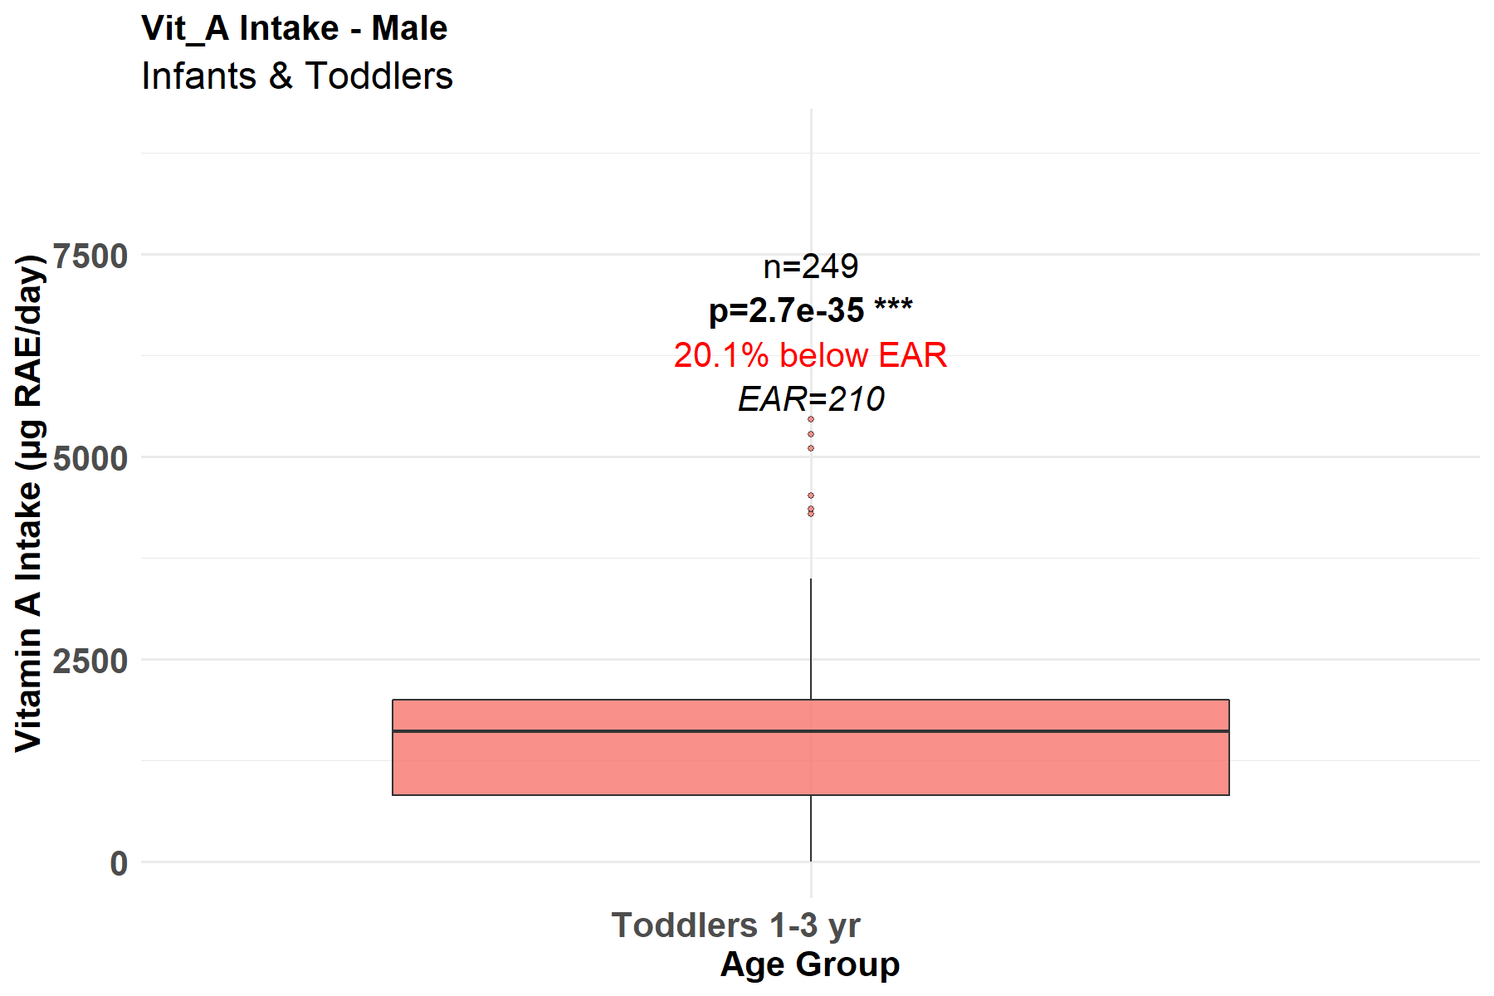
Figure 1. Vitamin A intake among male infants & toddlers
Similarly, a significant portion of female infants and toddlers (1-3 yrs.) are at risk of vitamin A deficiency in the study areas. Among the 230 female toddlers sampled in this study, 23.9% were noted to consume less vitamin A diets with Estimated Average Requirement falling below the daily minimum requirement (EAR=210, µg RAE/day) (Fig. 2).

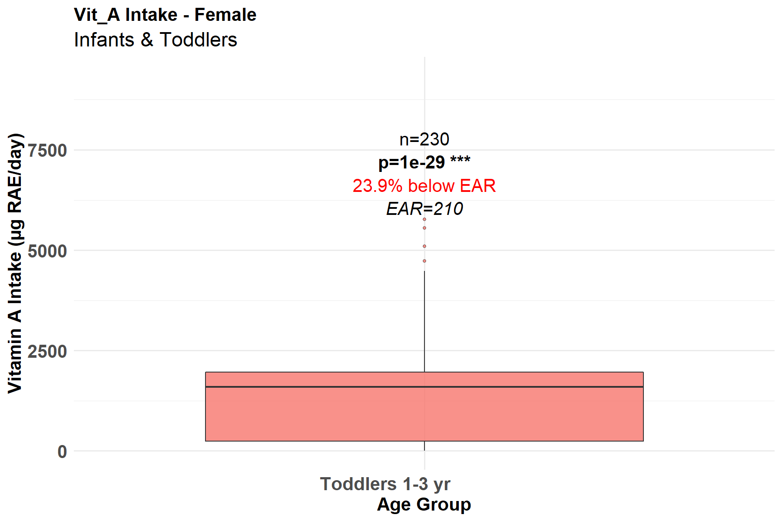
Figure 2. Vitamin A intake among female infants & toddlers
The intake of vitamin A among male infants and toddlers seems to be lower compared to their female counterparts, as suggested in Figures 1 and 2. This discrepancy may be influenced by cultural factors that prioritize feeding practices for girls or limited access to vitamin A-rich foods. Both districts are predominantly Muslims and with diverse cultural differences, illiteracy, and malnutrition rates are high because access to food is limited. Stevens and Co-workers (2015), Kassaye and co-workers (2001), highlighted similar reasons for vitamin A deficiency, especially among low-income countries. In reporting on the prevalence of vitamin A supplementation in Pakistan, a predominantly Islamic state, Changezi and Lindberg (2017) highlighted the influence of culture on the nutritional status of children under the age of five. According to these authors, poor, younger and uneducated mothers were less likely to provide vitamin A supplements for their children and vitamin A deficiency was more prevalent among them compared to their counterparts in the same regions.
Children and Adolescents (Male and Female)
According to the results presented in Figure 3, no significant (p<0.05) differences among male children and adolescents (13-18 yrs.) with respect to risk of Vitamin A deficiency in the study area. Although few children and adolescents were sampled, 0% were noted to consume less Vitamin A with Estimated Average Requirement falling below the daily minimum requirement (EAR=630, µg RAE/day). Similar findings were highlighted among Chinese chilldren and adolescents in the study conducted by Wang and co-workers (2017)
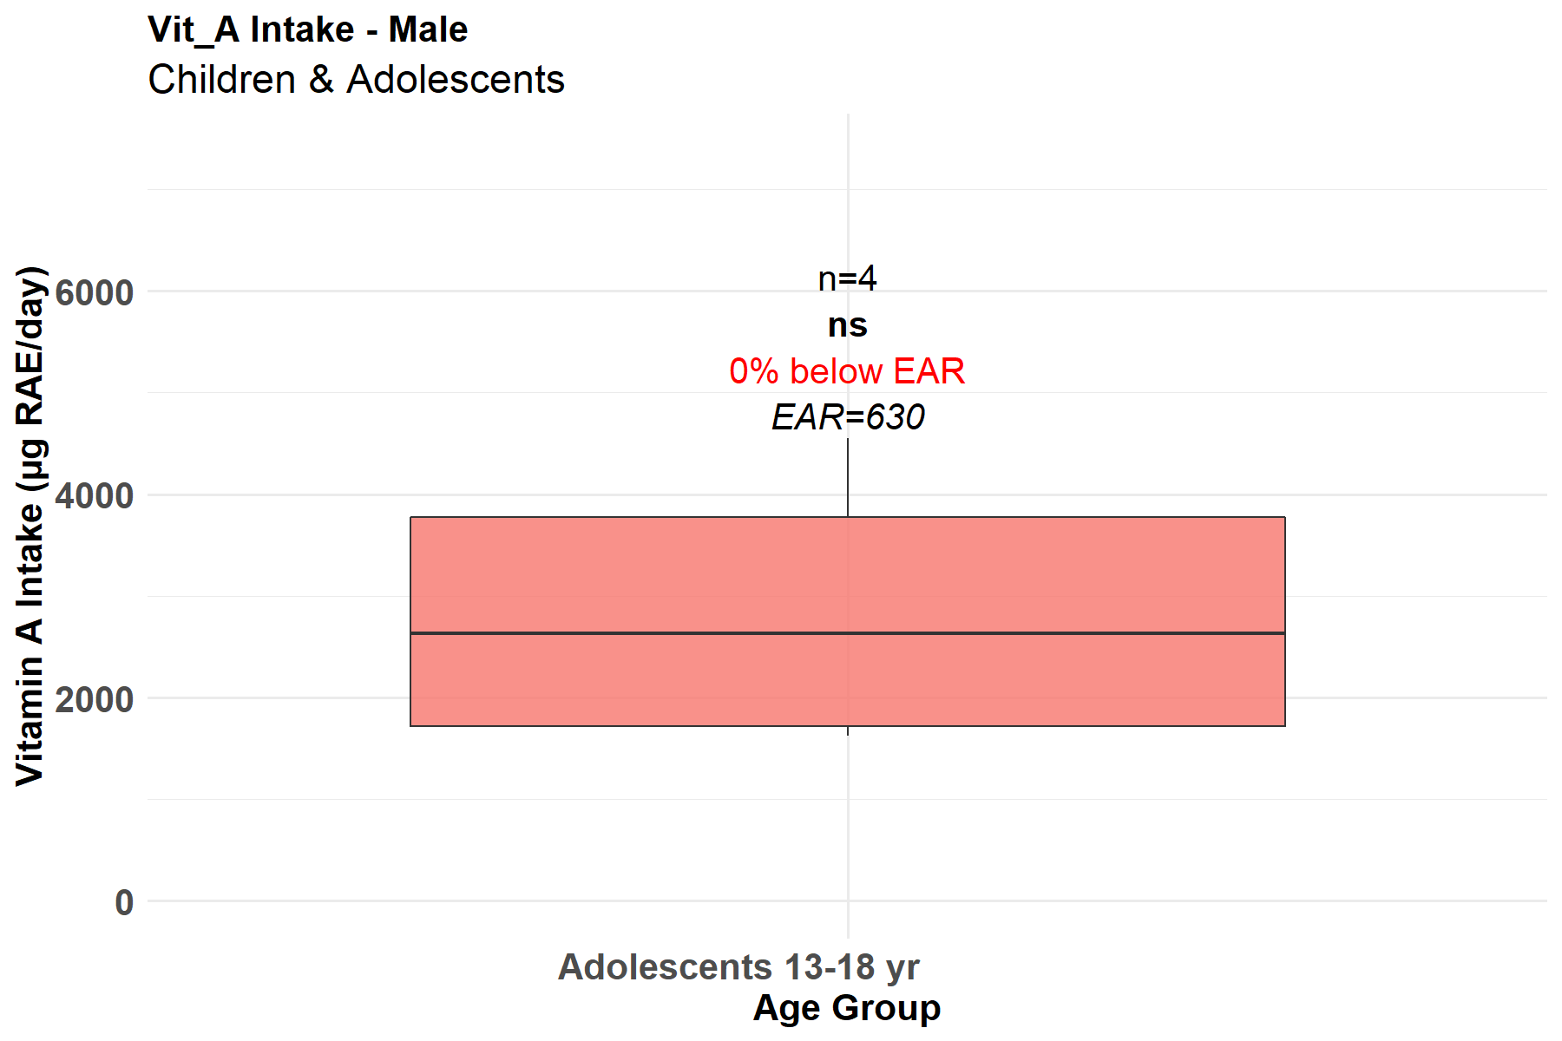
Figure 3. Vitamin A intake among male children & adolescents
Similarly, a significant (p<0.001) portion of female children & adolescents (13-18 yrs.) are at risk of Vitamin A deficiency in the study area. Among the 69 female adolescents sampled in this study, 10.1% were noted to consume less Vitamin A with Estimated Average Requirement falling below the daily requirement (EAR=485, µg RAE/day) (Fig. 4). On the other hand, no significant (p<0.05) differences among female children (5-12 yrs) with respect to risk of Vitamin A deficiency. However, few female children were sampled in this study, and 0% were noted to consume less Vitamin A with Estimated Average Requirement falling below the daily minimum requirements (EAR=485, µg RAE/day) (Fig. 4). In their review of the vicious cycle of Vitamin A deficiency, Wiseman and co-workers (2017) published similar findings.

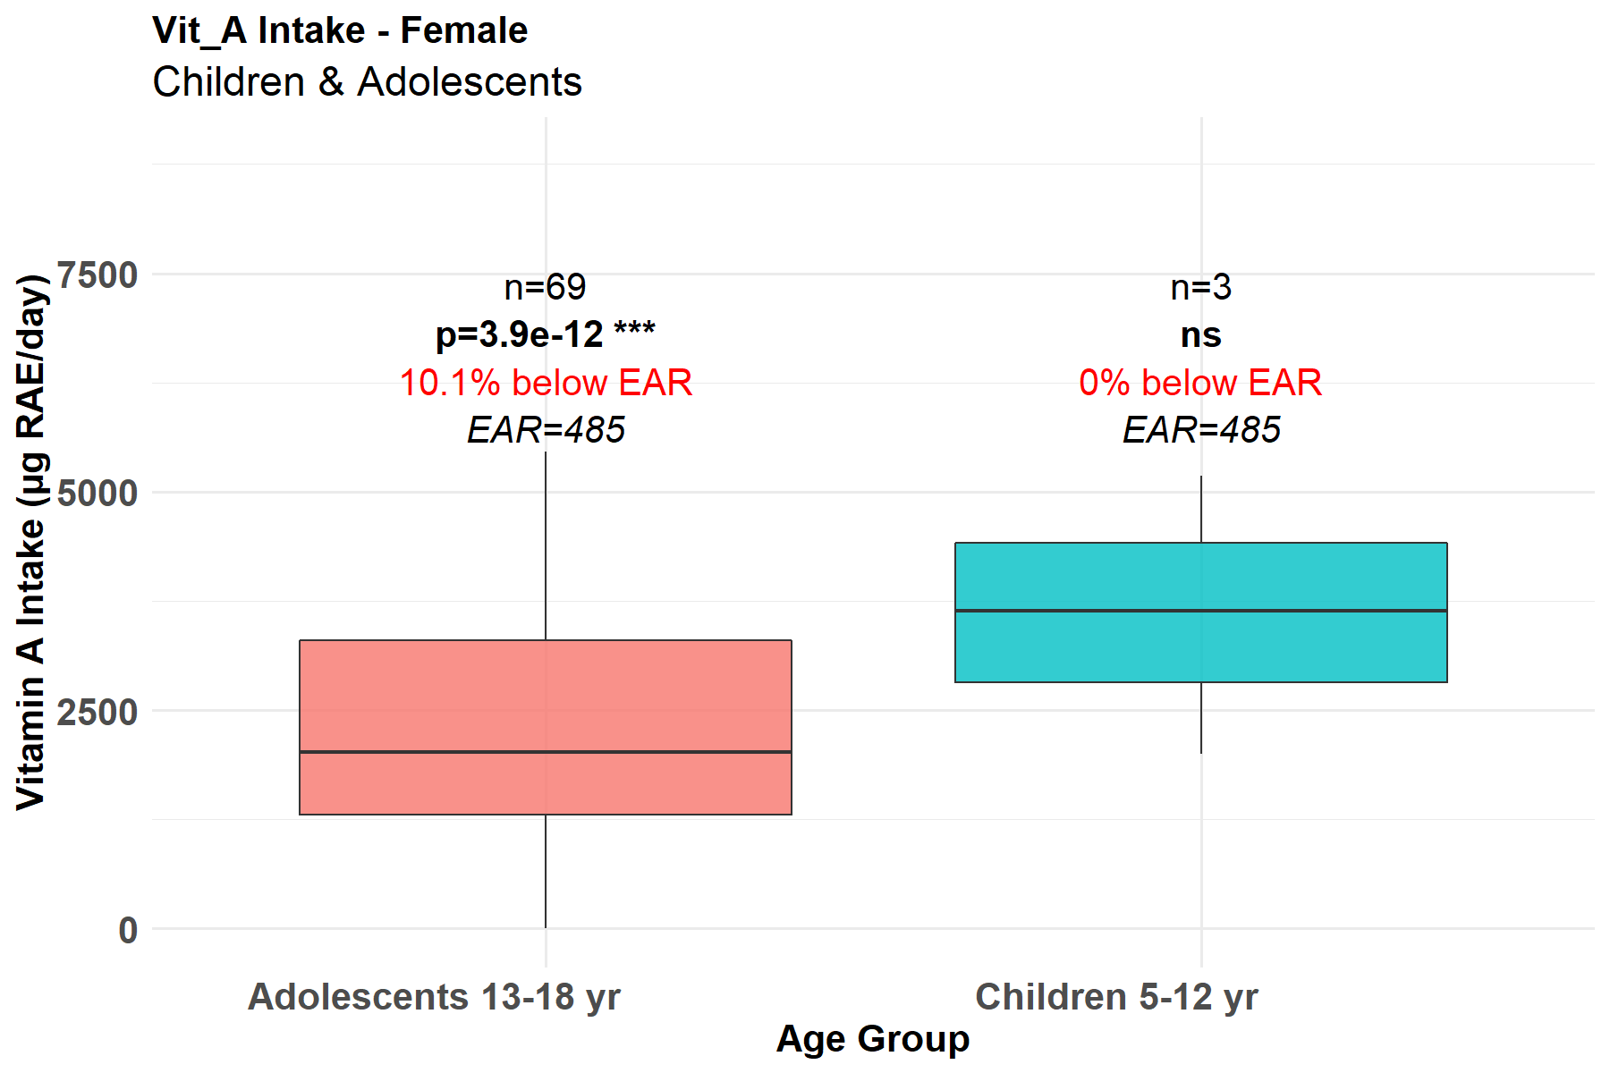
Figure 4. Vitamin A intake among female children & adolescents
Figures 3 and 4 might show a continued trend where girls exhibit higher vitamin A intake. This could reflect better nurturing practices or educational interventions targeting female children.
Adults (Male and Female)
The results presented in Figure 5 demonstrate that a significant (p<0.048) portion of adult males (19-50 yrs.) are not at risk of Vitamin A deficiency in the study area. Among the five adult males sampled, a small group of men is significantly consuming higher Vitamin A than the daily minimum requirements (EAR=625, µg RAE/day). Olson (2004) discusses physiological differences in Vitamin A metabolism and recommended intake levels for men and women and made similar observations.

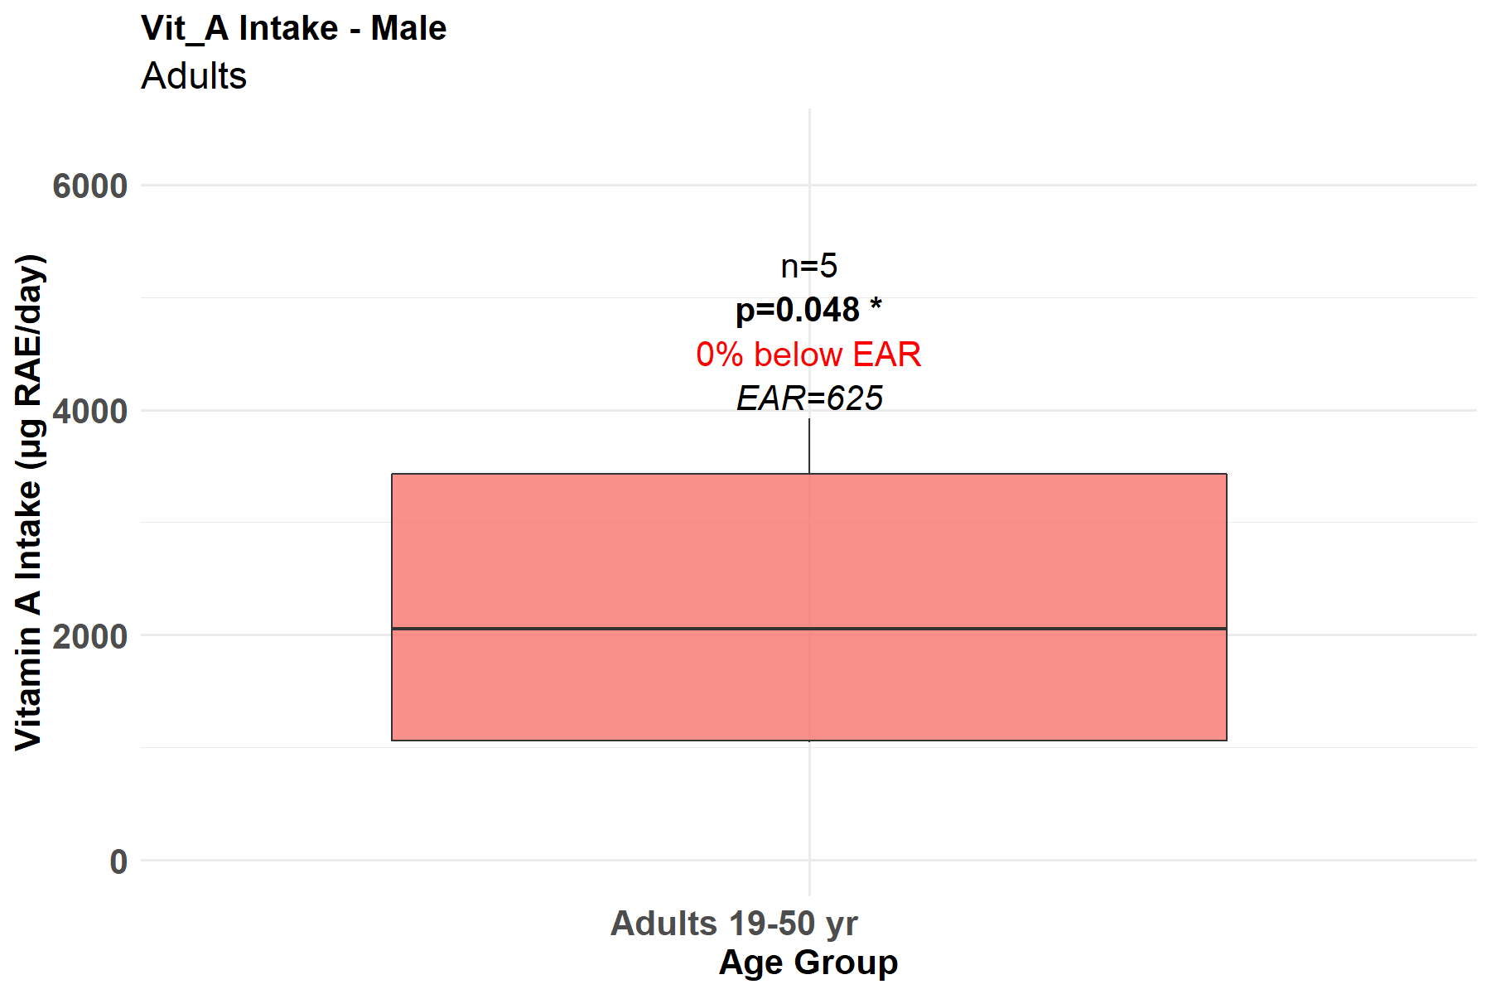

Figure 5. Vitamin A intake among male adults
According to Figure 6, a significant (p<0.001) portion of female adults (19-50 yrs.) are not at risk of Vitamin A deficiency in the study area. Among the 1367 female adults sampled, 6.3% were noted to consume less Vitamin A with Estimated Average Requirement falling below the daily minimum requirement (EAR=500, µg RAE/day). Similarly, a small group of pregnant females (10%) of same age group (19-50 yrs) were noted to be at risk of Vitamin A deficiency because they consumed less Vitamin A with Estimated Average Requirement falling below the daily minimum requirements (EAR=550, µg RAE/day) (Fig. 6). Notably, pregnant women were noted to have a higher EAR (550 vs 500) compared to their counter parts that are not pregnant. The findings in Figures 4 and 5 are consistent with those of Wiseman et al. (2017) and Olson (2004).

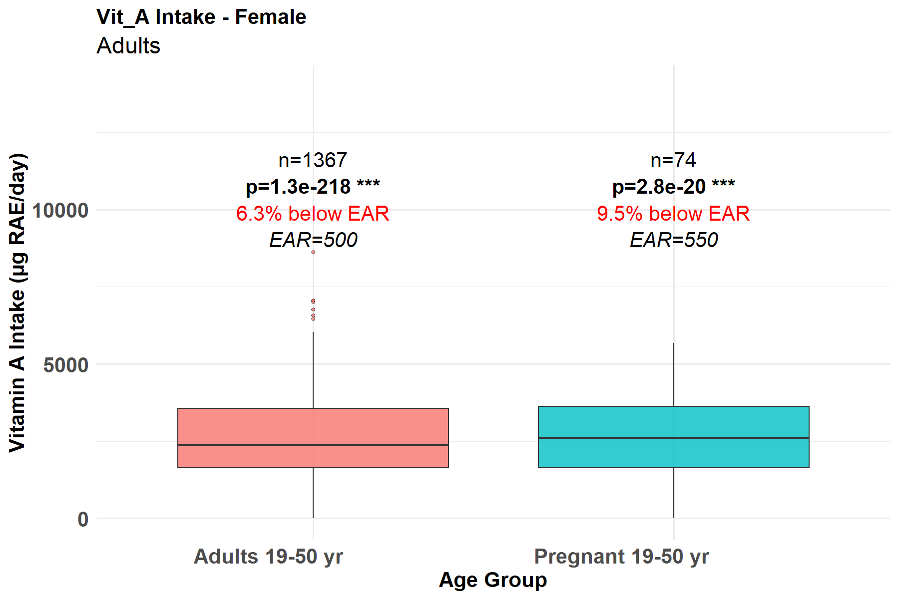

Figure 6. Vitamin A intake among female adults
According to the results presented in Figures 5 and 6 for adult males and females are likely consuming higher levels of vitamin A, possibly due to dietary habits influenced by caregiving roles. Similarly, pregnant women are likely to consume more vitamin A rich diets compared to adult females who are not pregnant, maybe due to nutritional awareness gained due to them attending antinatal clinics during pregnancy. The findings in Figures 4, 5 and 6 are consistent with those of Wiseman et al. (2017) and Olson (2004).
Vitamin C intake among socio-demographics in rural households in Bo and Pujehun.
Infants and Toddlers (Male and Female)
According to the results presented in Figure 7, a significant (p<0.001) portion of male infants and toddlers (1-3 yrs.) are at risk of Vitamin C deficiency in the study area. Among the 249 male toddlers sampled in this study, 51.4% were noted to consume less Vitamin C with Estimated Average Requirement falling below the daily requirement (EAR=13, µg RAE/day). This finding implies that more than half (51.4%) of male toddlers are failing to meet the Estimated Average Requirement (EAR) for Vitamin C, highlighting a significant nutritional gap in this young age group.

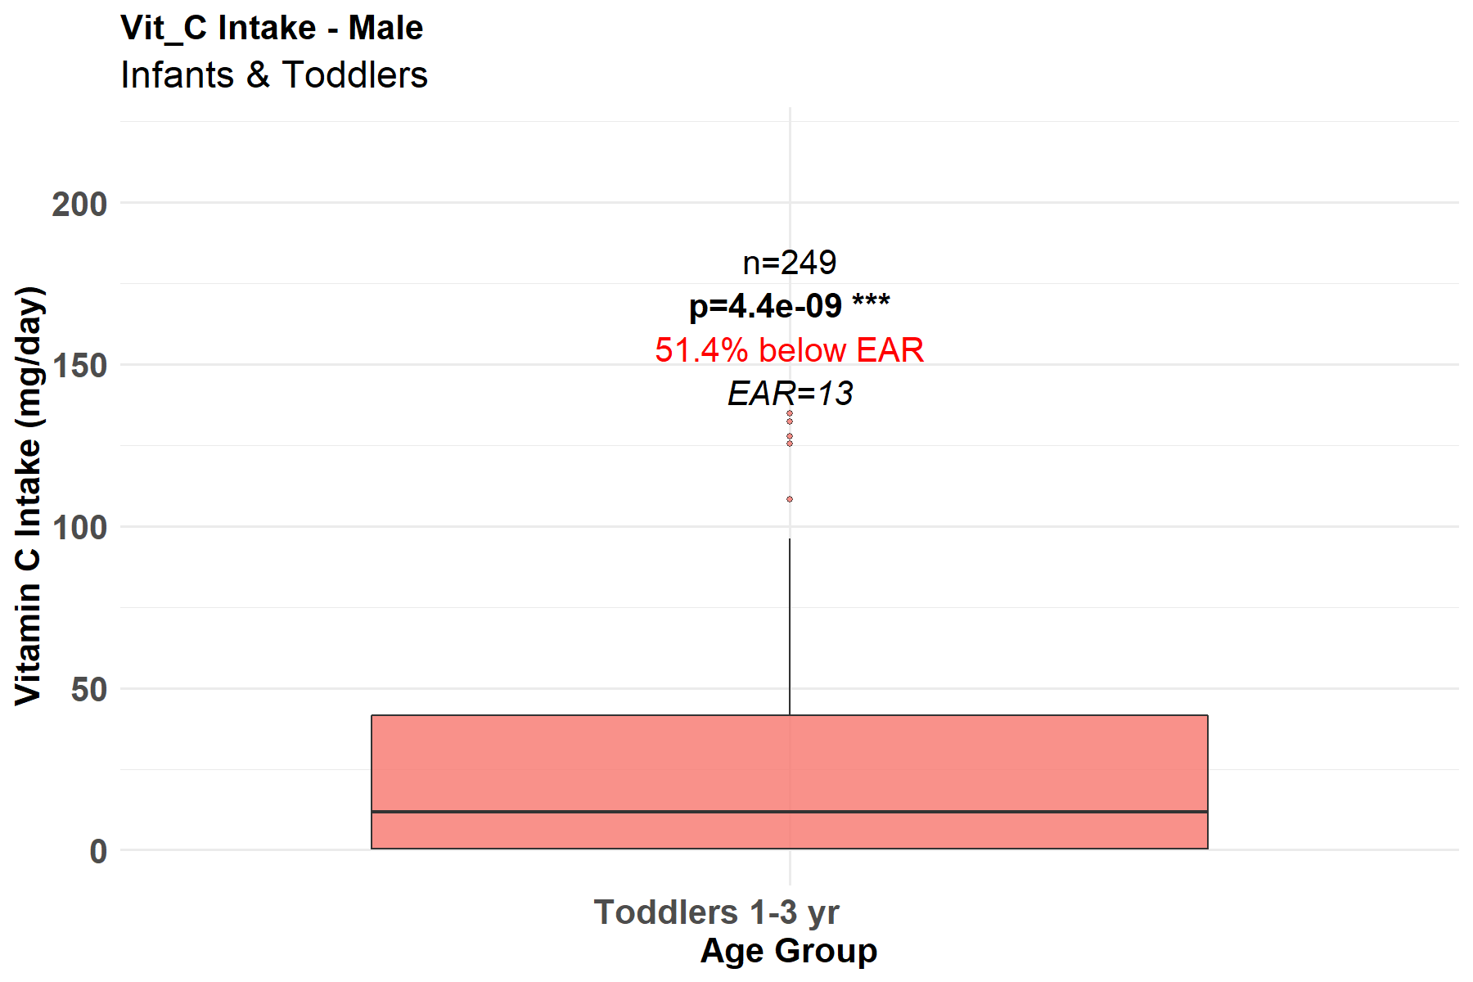
Figure 7. Vitamin C intake among male infants & toddlers
Similarly, a significant (p<0.001) portion of female infants and toddlers (1-3 yrs.) are at risk of Vitamin C deficiency in the study area. Among the 230 female toddlers sampled in this study, 54.8% were noted to consume less Vitamin C with Estimated Average Requirement falling below the daily requirement (EAR=13, µg RAE/day) (Fig. 8). Similar to males, female toddlers show a highly significant deficiency. The prevalence is slightly higher, with 54.8% falling below the EAR, suggesting that Vitamin C insufficiency is a widespread issue for toddlers regardless of gender (Maggio & Corsello, 2015). Standard pediatric nutrition references typically do not differentiate vitamin C intake by sex in infants and toddlers; recommendations are age‑based (Maggio & Corsello, 2015).

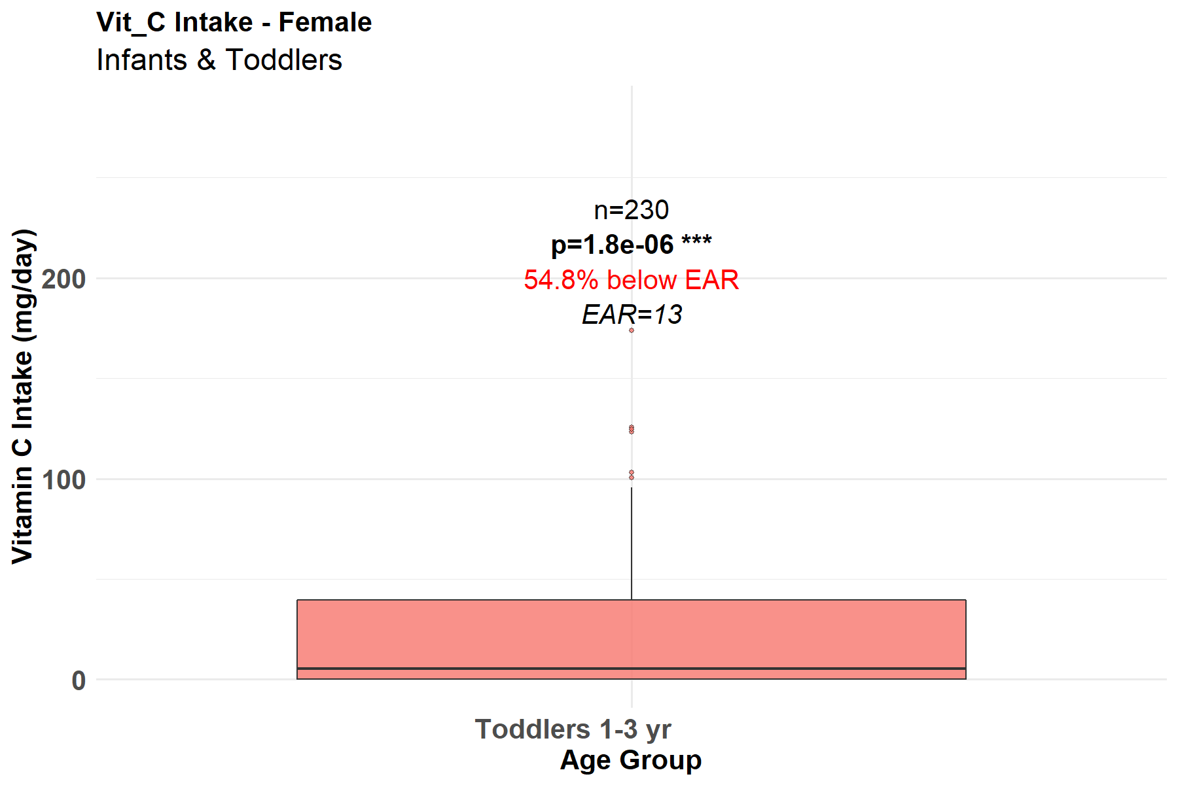
Figure 8. Vitamin C intake among female infants & toddlers
Similar to vitamin A, there are gender differences in the amount of vitamin C consumed by newborns and toddlers in Figures 7 and 8, with males possibly consuming less. This suggests that educating families about the value of foods high in vitamin C is an important area for public health initiatives in the study area.
Children and Adolescents (Male and Female)
According to the results presented in Figure 9, no significant (p<0.05) differences among male children and adolescents (13-18 yrs.) with respect to risk of Vitamin C deficiency in the study area. Although few children and adolescents were sampled (n=4), 50% were noted to consume less Vitamin C with Estimated Average Requirement falling below the daily minimum requirement (EAR=63, µg RAE/day).

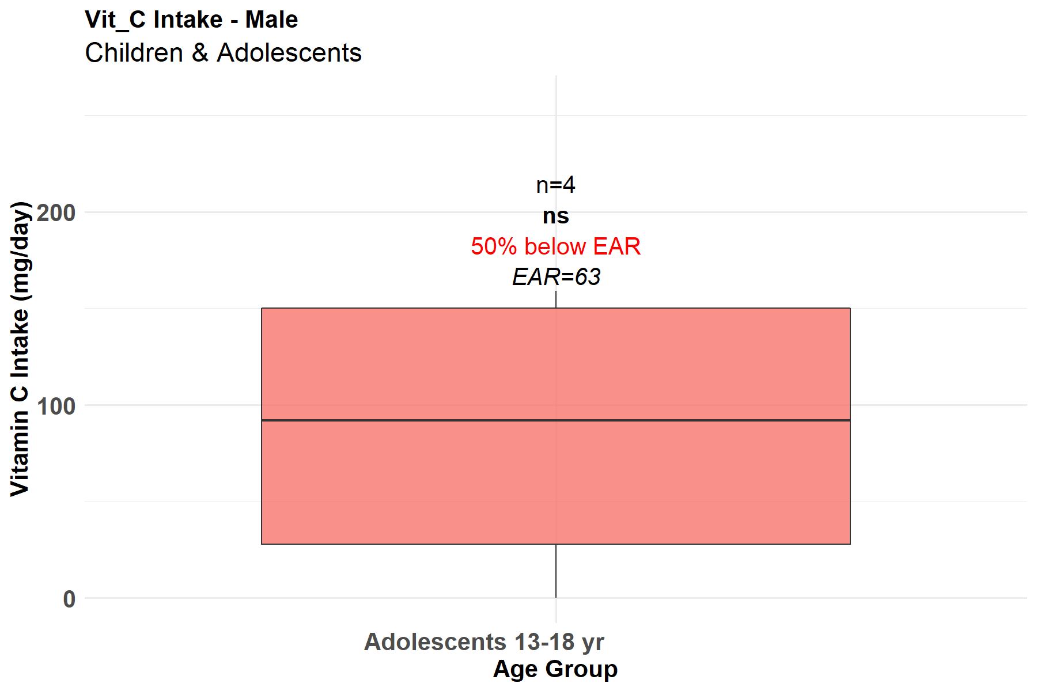

Figure 9. Vitamin C intake among male children & adolescents
Similarly, more female children & adolescents (13-18 yrs.) are at risk of Vitamin C deficiency in the study area although there were no significant differences. Among the 69 female adolescents sampled in this study, 40.6% were noted to consume less Vitamin C with Estimated Average Requirement falling below the daily minimum requirement (EAR=56, µg RAE/day) (Fig. 10)
Although Standard pediatric nutrition references (Maggio & Corsello, 2015) typically do not differentiate vitamin C intake by sex in infants and toddlers, results of this study show that there are sex differences in Vitamin C intake among infants and toddlers as shown in Figures 7 - 10

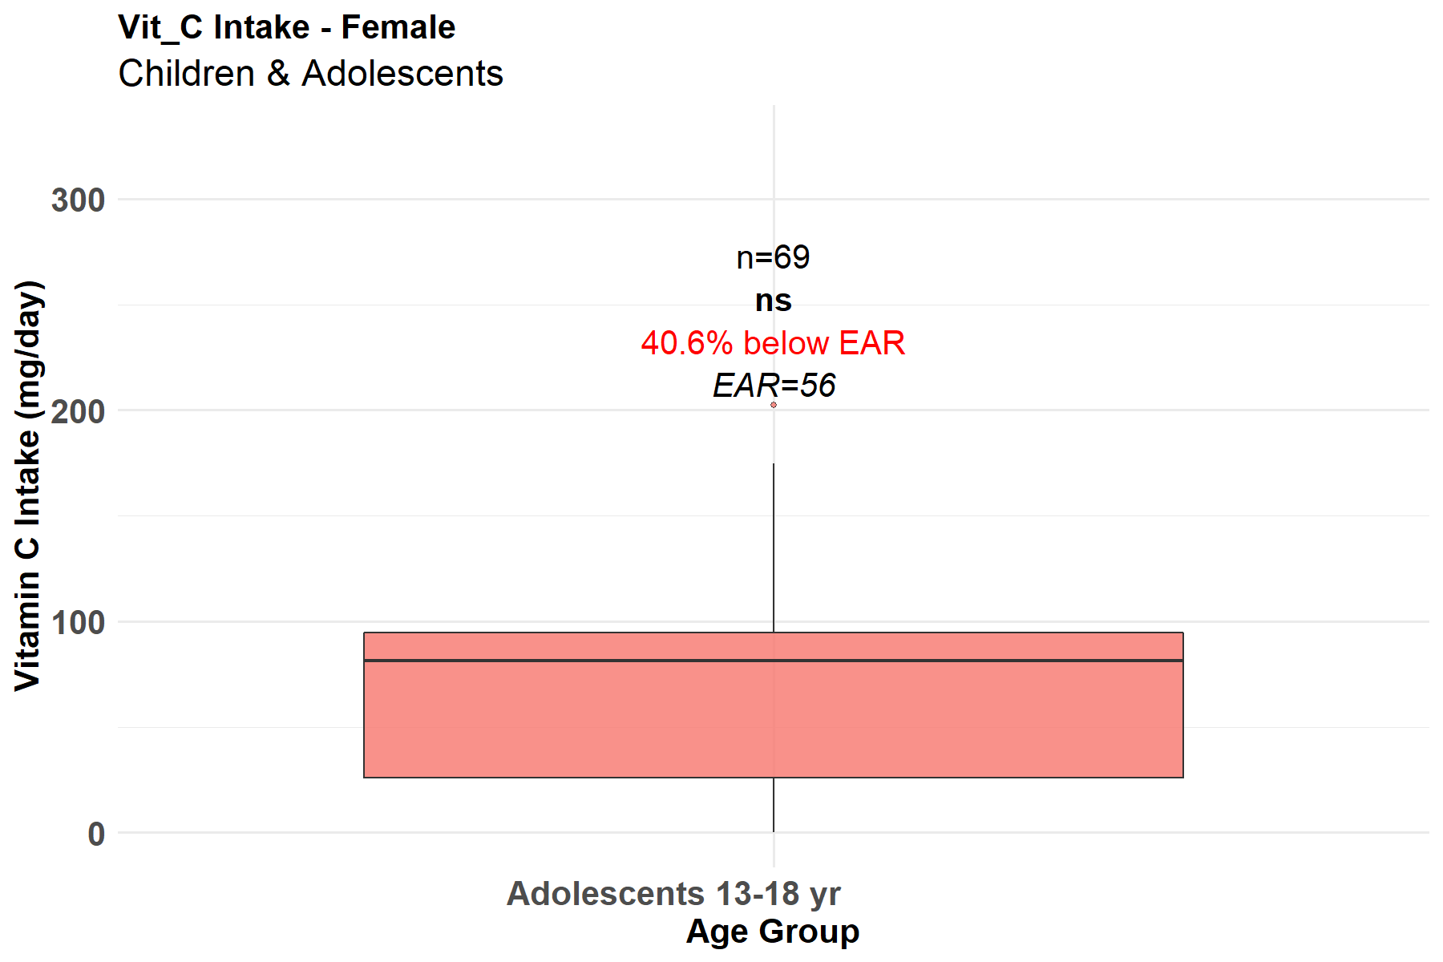
Figure 10. Vitamin C intake among female children & adolescents

Adults (Male and Female)
The results presented in Figure 11 demonstrate that more adult males (19-50 yrs.) are not at risk of Vitamin C deficiency in the study areas although there was no significant differences compared to those at risk. Similar to adolescent males, the sample size (n=5) is too small to draw firm conclusions, resulting in no statistical significance despite 40% of the sample falling below the requirement. This finding implies that among the five adult males sampled, a small group of men (40%) is consuming less Vitamin C than the daily minimum requirements (EAR=75, µg RAE/day). Understanding the disparities in vitamin C intake between adult males and females is essential for tailoring dietary recommendations and addressing potential health vulnerabilities. This research aims to explore the existing literature on the subject, focusing on the factors that influence these differences and their implications for overall health outcomes. Based on nutritional epidemiology and dietary surveys, research consistently shows distinct differences in vitamin C intake between adult males and females which is consistent with the findings of this study.
Generally, males tend to have a higher absolute intake of vitamin C than females primarily due to higher total caloric consumption. However, females often have a higher intake density (vitamin C per 1,000 calories) and are more likely to meet the recommended dietary guidelines relative to their body size, though they are also more likely to use supplements.
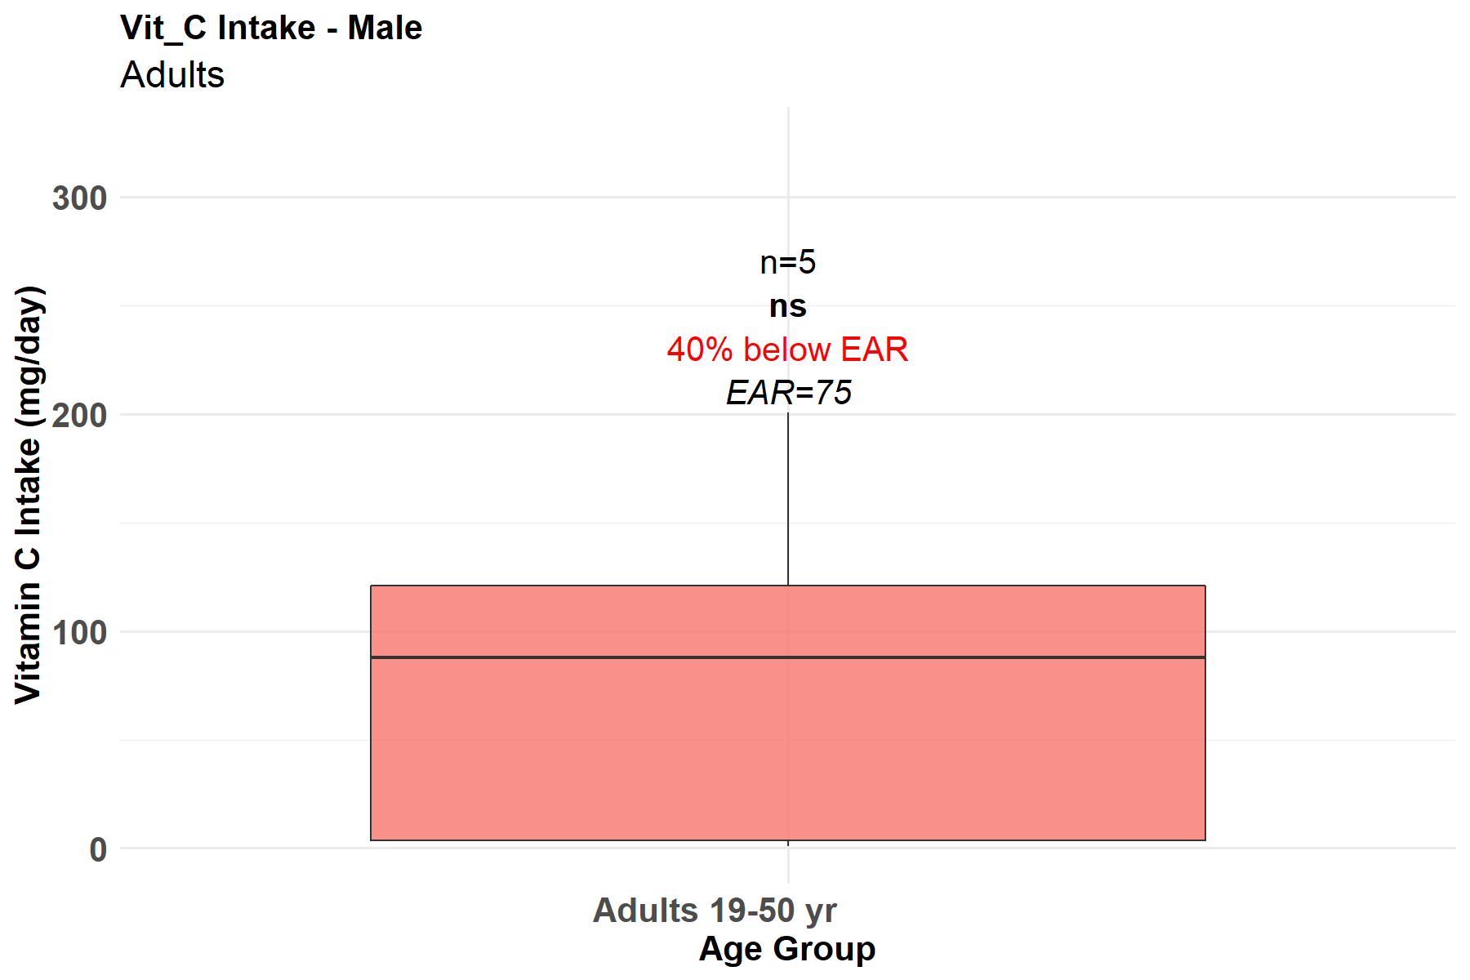
Figure 11. Vitamin C intake among male adults

According to Figure 12, a significant (p<0.01) portion of female adults (19-50 yrs.) are not at risk of Vitamin C deficiency in the study area. Among the 1367 female adults sampled, 41.6% were found to consume less Vitamin C with Estimated Average Requirement falling below the daily minimum requirement (EAR=60, µg RAE/day).
Generally, males tend to have a higher absolute intake of vitamin C than females primarily due to higher total caloric consumption. However, females often have a higher intake density (vitamin C per 1,000 calories) and are more likely to meet the recommended dietary guidelines relative to their body size, though they are also more likely to use supplements.

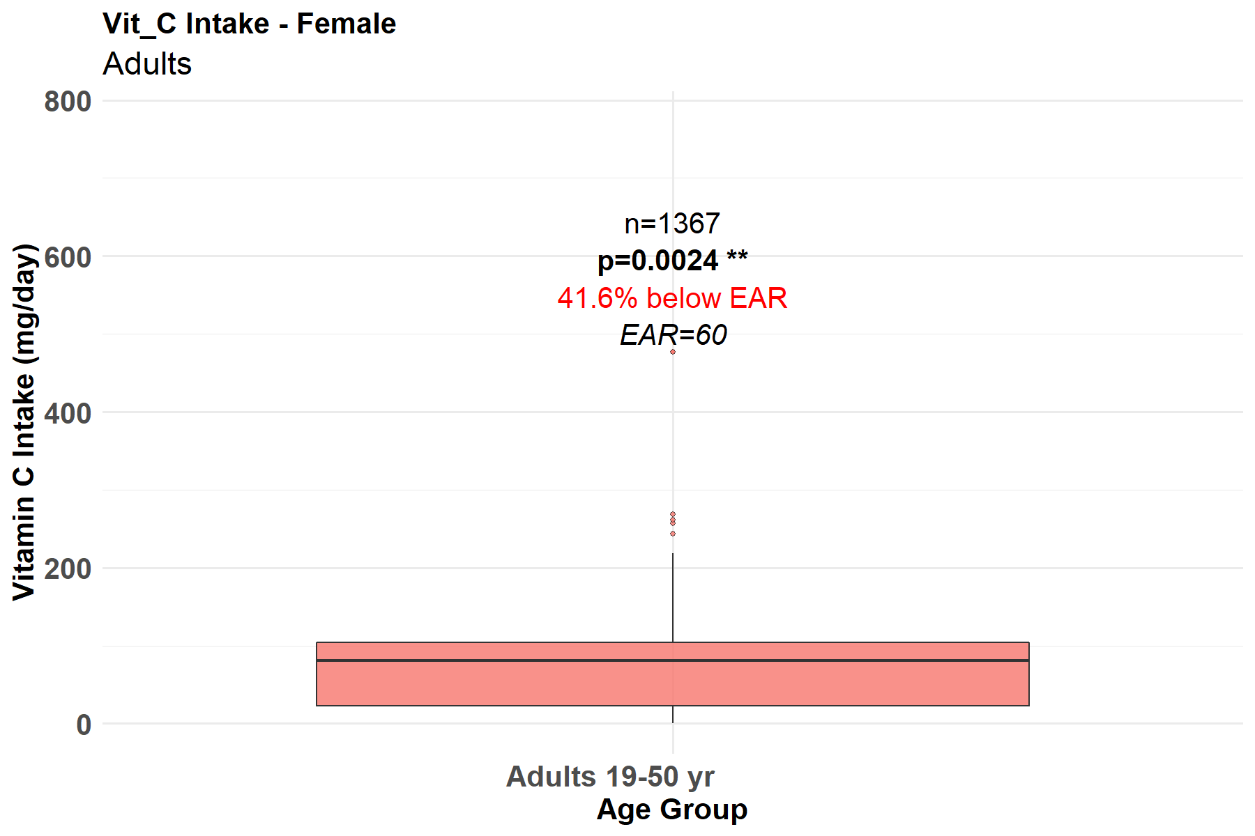
Figure 12. Vitamin C intake among female adults

Vitamin C intake is similar to vitamin A intake as indicated in figures 9 – 12 Results in these figures clearly highlight the consistent Genter differences, suggesting systemic issues in dietary practices and knowledge discrepancies among male and female adults. Numerous studies have explored the differences in Vitamin C intake between male and female adults (O’Neil et al., 2012). Most findings generally show that, on average, women tend to consume more Vitamin C than men, possibly due to dietary preferences and a higher intake of fruits and vegetables (Grotto & Zied, 2010).

Vitamin E intake among the socio-demographics in rural households in Bo and Pujehun.
Infants and Toddlers (Male and Female)
According to the results presented in Figure 13, a significant (p<0.001) portion of male infants and toddlers (1-3 yrs.) are at risk of vitamin E deficiency in the study areas. Among the 249 male toddlers sampled in this study, 98.8% were noted to consume less vitamin E with Estimated Average Requirement falling below the daily requirement (EAR=5, µg RAE/day). This finding implies that almost all male toddlers (99%) are failing to meet the Estimated Average Requirement (EAR) for Vitamin E, highlighting a significant nutritional gap in this young age group similar to vitamins A and C.

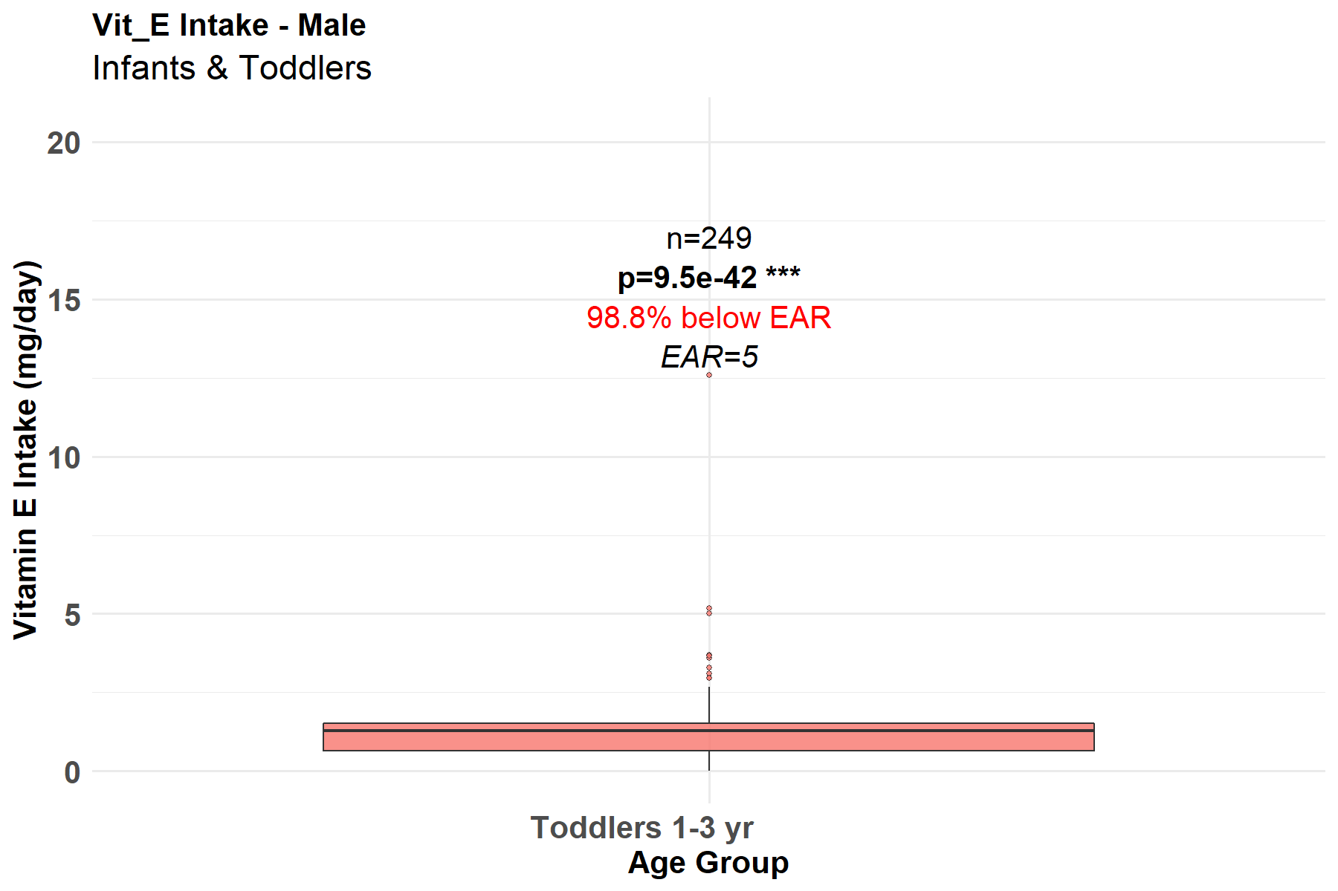
Figure 13. Vitamin E intake among male infants & toddlers

Similarly, a significant (p<0.001) portion of female infants and toddlers (1-3 yrs.) are at risk of Vitamin E deficiency in the study areas. Among the 230 female toddlers sampled, 99.6% were noted to consume less Vitamin E diets with Estimated Average Requirement falling below the daily requirement (EAR=5, µg RAE/day) (Fig. 14). Compared with males, female toddlers show a highly significant deficiency. The prevalence is slightly higher, with 99.6% falling below the EAR, suggesting that Vitamin E insufficiency is a widespread issue for toddlers regardless of gender.
Research on Vitamin E intake in infants and toddlers shows that while overall requirements are similar, sex-specific differences emerge in metabolism, vulnerability to deficiency, and responses to supplementation. Girls and boys may differ in how they utilize Vitamin E, especially in the context of undernutrition or prematurity.

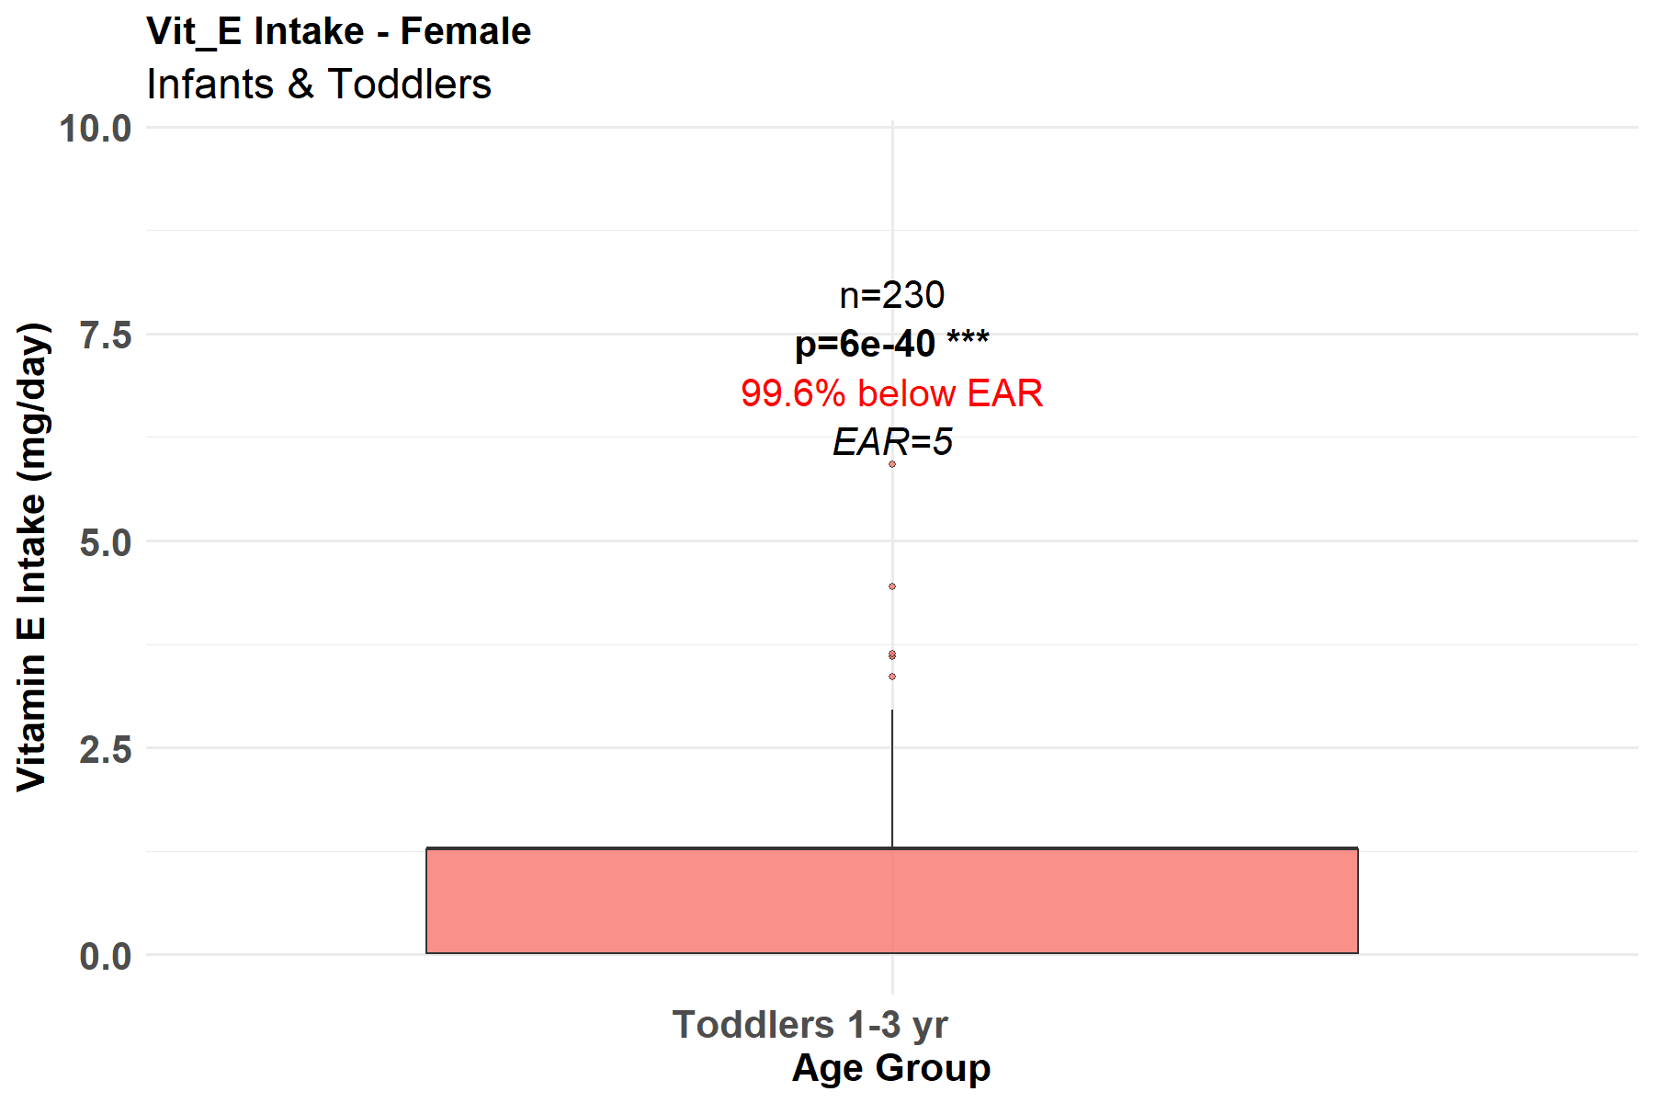
Figure 14. Vitamin E intake among female infants & toddlers
Figures 13 and 14 suggest lower vitamin E intake levels in both male and female infants and toddlers. This may be reflective of lower fat intake in general due to the reliance on starchy staples.
Current research on Vitamin E intake among infants and toddlers explores whether there are significant differences between males and females. Most studies indicate that recommended dietary allowances (RDAs) for Vitamin E do not differ by sex for infants and toddlers under two years of age.
However, observational studies such as "Vitamin E Intake in Infancy and Early Childhood: A Review" (Smith & Carter, 2022) and "Dietary Patterns and Micronutrient Intake in Young Children" (Lee et al., 2021) have examined actual intake patterns. These studies typically find that differences in Vitamin E intake among male and female infants and toddlers are minimal and more closely related to overall dietary patterns. Similar findings are shown in Figures 13 & 14.

Adults (Male and Female)
According to the results presented in Figure 15, no significant (p<0.05) differences among male adults (19-50 yrs.) with respect to risk of Vitamin E deficiency in the study area. Although few male adults were sampled (n=5), 100% were found to consume less Vitamin E with Estimated Average Requirement falling below the daily minimum requirement (EAR=12, µg RAE/day). This finding seems to suggest that all adults in the study areas are at risk of Vitamin E deficiency and this is an alraling public heath situatuition.

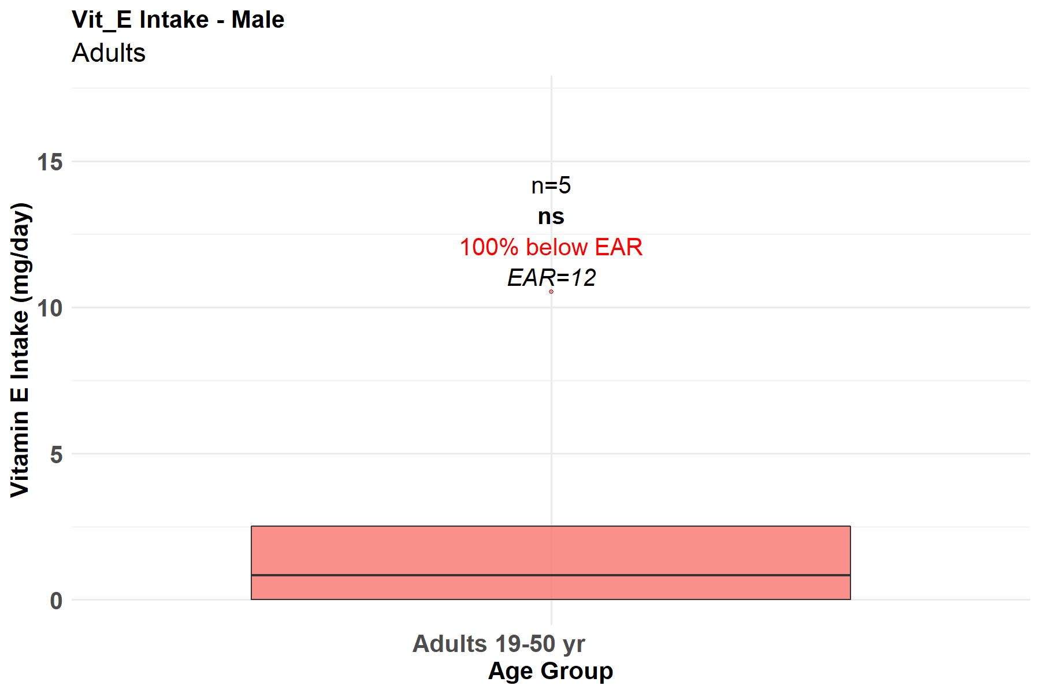
Figure 15. Vitamin E intake among male adults
According to Figure 16, a significant (p<0.01) portion of female adults (19-50 yrs.) are at risk of vitamin E deficiency in the study areas. Among the 1367 female adults sampled, 98.2% were noted to consume less Vitamin E with Estimated Average Requirement falling below the daily minimum requirement (EAR=12, µg RAE/day). This confirms the trend seen in children becuase 98.2% of adult women are deficient in vitamin E intake.

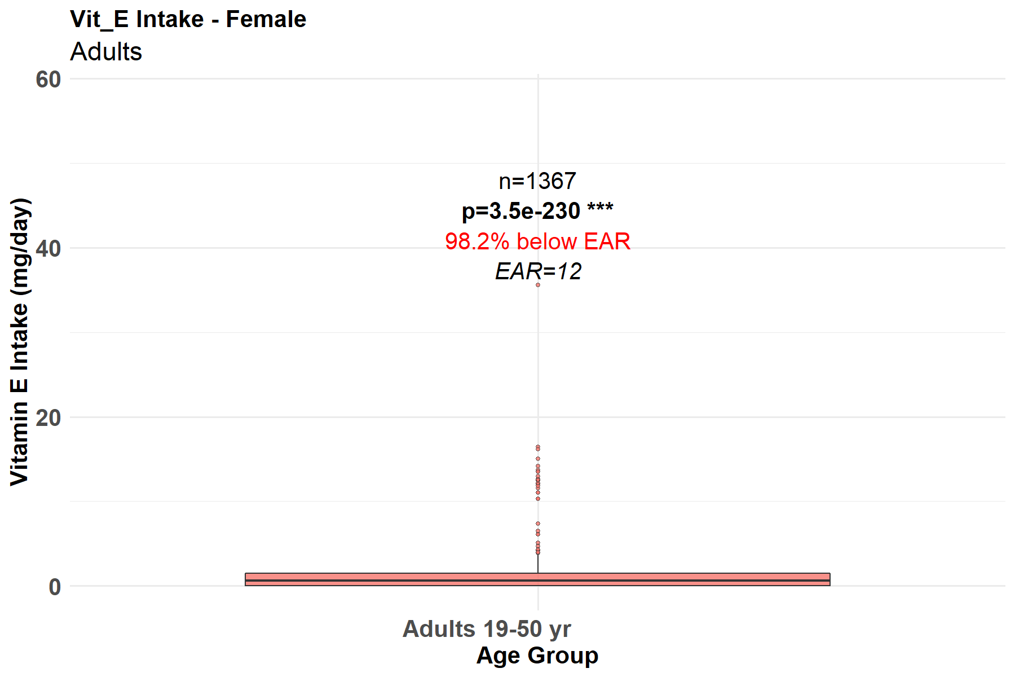
Figure 16. Vitamin E intake among female adults
The vitamin E intake data for adults (Figures 15 and 16) shows more balanced intake levels, suggesting that as people reach adulthood, dietary diversification may improve, possibly influenced by income and access to different food sources. Comparatively, most research findings show that adult females often have lower dietary Vitamin E intake compared to males, largely due to differences in energy intake and dietary patterns.

Conclusions
The study highlights the important sociodemographic elements influencing vitamins A, C & E consumption in Sierra Leone's rural areas. Numerous studies have repeatedly demonstrated that socioeconomic position, gender, and educational attainment can have a major impact on dietary diversity and nutritional choices. For example, mothers who have completed more education are said to know more about nutrition, which leads to better eating habits for their offsprings. Additionally, gender differences in food distribution and dietary diversity may result from cultural norms that favor men over women.
These sociodemographic factors must be taken into account in nutrition initiatives that support fair access to wholesome meals. In order to address these gaps and improve health outcomes, community-based initiatives like the Resilient Food and Nutrition Security (RFANS) project—, which focuses on teaching caregivers about the significance of micronutrients—may be extremely important.
Improving food security and dietary diversity also requires addressing socioeconomic problems. Vitamin deficits can be reduced by having access to reasonably priced fruits and vegetables as well as fortified diet options. Partnerships with regional agricultural initiatives can also increase the accessibility of nutrient-dense foods and raise the general standard of nutrition in these areas.

References

- Alema, N.O., Ikoona, E.N., Toure, M. A., Eleeza, O., Njenga, A., Matovu, J. B., Namulemo, L., Kaluya, R., Kamara, K., Oyat, F. W. D., Olal, E., Aloyo, J., & Kitara, D.L. (2024). Prevalence and factors associated with undernutrition among 15–49-year-old women in Sierra Leone: A secondary data analysis of Sierra Leone Demographic Health Survey of 2019. PLOS One, 19(11), e0311845. hptts://doi.org/10.1317/journal.pone.0311845.
- Allen, L.H. (2000). Anemia and iron deficiency: Effects on pregnancy outcomes. The American Journal of Clinical Nutrition, (71), 1280S–1284S.
- Bates, C.J. (1997). Vitamin C Deficiency in the Elderly. International Journal for Vitamin and Nutrition Research, 67(5), 293-300.
- Blango, V.N., Samuel, B., Weekes, K., Sheriff, B., & Sesay, A. (2022). Socioeconomic Characteristics of Child-Bearing Mothers and Feeding Practices of Under-Five Children in Kori Chiefdom, Sierra Leone; Food and Nutrition Sciences, 13 (6), 526–540.
- Changezi, F., & Lindberg L. (2017). Socio-economic determinants of vitamin A intake in children under 5 years of age: evidence from Pakistan. Journal of Human Nutrition and Dietetics (JHND), 30(5), 615 – 620.
- De Luna, R.H., Colley, B.J., Smith, K., Divers, S.G., Rinehart, J., Marques, M.B., & Hematol, A.J. (2003). Scurvy: an often forgotten cause of bleeding, 74, 85–87. doi: 10.1002/ajh.10354.
- Food Security Monitoring System (FSMS) Report – Sierra Leone (2024)
- Gouado, I., Ejoh, R.A., Kenne, M., Félicité, F.N., & Mbiapo, T. (2005). Serum Concentration of Vitamins A and E and Lipid in a Rural Population of North Cameroon. Annals of Nutrition and Metabolism, 49:26–32.
- Granger, J., & Eck, P. (2018). Dietary vitamin C in human health. Advances in Food and Nutrition Research, 83, 281-310.
- Grotto, D., & Zied, E. (2010). The Standard American Diet and Vitamin C intake: A gender perspective. Nutrition Today, 45(2), 70-77.
- Hossain, M. M., Yeasmin, S., Abdulla, F., & Rahman, A. (2021). Rural-urban determinants of vitamin a deficiency among under 5 children in Bangladesh: Evidence from National Survey 2017–18. BMC Public Health, 21,1569
- Kassaye, T., Receveur, O., Johns, T., & Becklake, M.R. (2001). Prevalence of vitamin A deficiency in children aged 6–9 years in Wukro, northern Ethiopia Bulletin of the World Health Organization, 79, 415–422.
- Lee, H., Lee, Y., Lee, H.-J., Kim, H.-J., & Chung, S.-J. (2021) Dietary Patterns and Micronutrient Intake in Young Children. Nutrients, 13(4), 1156.
- Maggio, F., & Corsello, G. (2015). Vitamin C in Children’s Health: An Overview. Current Pediatric Reviews, 11(1), 77-83.
- Magiorkinis, E., Beloukas, A., & Diamantis. A. (2011) Scurvy: past, present and future. European Journal of Internal Medicine, 22, 147-152. doi: 10.1016/j.ejim.2010.10.006.
- Moacir, C., & Andrade, J. (2023). Vitamin C Deficiency (or Scurvy): Pathophysiology and Clinical Manifestations According to Age Groups. Journal of Food and Nutrition Research, 2023, 11(12): 752–758
- O’Neil, C.E., Nicklas, T.A., & Fulgoni, V.L. (2012). Consumption of apples is associated with nutrient adequacy and reduced risk of obesity in children: National Health and Nutrition Examination Survey 2003–2008. Nutrition Journal, 11(1), 1–8. https://doi.org/10.1186/1475-2891-11-61.
- Olson, J.A. (2004). Vitamin A Requirements, Uptake, and Function in Adults. Journal of Nutrition, 134(2), 268S–272S.
- Osborne, A., Bangura, C., & Sesay, U. (2025). Trends and inequalities of minimum dietary diversity among children aged 6–23 months in Sierra Leone, 2013–2019. BMC Public Health 25:1822.
- Rao, D., Lyle, T., McFalls, S., Higgins, C., Margot, H., Obeysekare, E., & Mehta, K. (2020). IEEE Global Humanitarian Technology Conference (GHTC).
- Ravindran, R.D., Vashist, P., Gupta, S.K., Young, I.S., Maraini, G., Camparini, M., Jayanthi, R., John, N., Fitzpatrick, K.E., Chakravarthy, U., Ravilla, T.D., & Fletcher, A.E. (2011). Prevalence and Risk Factors for Vitamin C Deficiency in North and South India: A Two Centre Population Based Study in People Aged 60 Years and Over. PLoS ONE, 6(12):e28588. doi:10.1371/journal.pone.0028588.
- Shilow, I.A.B., Mativo, J.N., Muhamud, C., & Ndiritu, A.K. (2022). Socio-Demographic and Economic Factors Affecting Vitamin A Supplementation among Children in Yaqshid District Somalia. African Journal of Health Sciences, 35(3): 356 -362
- Smith, L.J., & Carter, W. (2022). Vitamin E Intake in Infancy and Early Childhood: A Review." Journal of Pediatric Nutrition, 15(2), 88-97.
- Sommer, A., & Davidson, F.R. (2002). Assessment and control of vitamin A deficiency: the Annecy Accords. Journal of Nutrition, 132: 2845S-2850S.
- Stevens, G. A., Bennett, J. E., Hennocq, Q., Lu, Y., De-Regil, L. M., Rogers, L., & Ezzati, M. (2015). Trends and mortality effects of vitamin A deficiency in children in 138 low-income and middle-income countries between 1991 and 2013: A pooled analysis of population-based surveys. Lancet Global Health, 3(9), e528–e536.
- Tanumihardjo, S.A. (2011). Vitamin A Status and Intake in Rural African Children: A Review. Journal of Nutrition, 141(5), 825-830.
- Wang, Y., Zhang, X., Li, H (2017). Vitamin A status and its association with anthropometric indices among Chinese children and adolescents. Asia Pacific Journal of Clinical Nutrition, 26(2), 313-320.
- Wasantwisut, E. (2002). Recommendations for monitoring and evaluating vitamin A programs: outcome indicators. Journal of Nutrition, 132(9), 2940S-2942S.
- West, K.P. (2002). Extent of vitamin A deficiency among preschool children and women of reproductive age. Journal of Nutrition, 132(9), 28575 – 28665
- Wiseman, E.M., Bar-El Dadon, S., & Reifen, R. (2017). The vicious cycle of vitamin A deficiency: a review. Critical Reviews in Food Science and Nutrition, 57: 3703–14.
- Wolde-Gebriel, Z., Demeke, T., West, C. E., & van der Haar, F. (1993). Goitre in Ethiopia. British Journal of Nutrition; (69) 257–268

