Original Research Article
Influence of Water Soaking Time on the Nutritional and Sensory Properties
Of Almond Milk

ABSTRACT
Keywords:  plant-based milk alternatives  nut-based beverage  nutritional composition  soaking duration  sensory properties | Plant-based milk alternatives, particularly almond milk, are increasingly valued for their nutritional profile and suitability for individuals with lactose intolerance or dairy allergies. This study investigated how soaking almond seeds in water for different durations (0–24 h) influences the proximate composition, amino acid profile, and sensory quality of the resulting milk. Prolonged soaking reduced fat, ash, and carbohydrate contents while increasing protein and moisture levels. Protein concentration peaked after 24 h, reflecting improved seed breakdown during extraction, whereas fat losses were attributed to leaching into the soaking water. Amino acid concentrations declined with longer soaking times, with essential amino acids decreasing from 4.58 to 4.18 g/100 g protein. Sensory evaluation indicated that milk from seeds soaked for 12 h achieved the highest acceptability scores across all attributes. These findings identify water soaking duration as a critical processing parameter to balance nutritional retention and sensory quality in almond milk, providing insights for the optimization of plant-based dairy alternatives

1. INTRODUCTION
Almond milk is a plant-based beverage obtained from the aqueous extraction of almond kernels (Prunus amygdalus). In recent years, it has gained growing global attention as a functional alternative to dairy milk due to its favorable nutritional profile, absence of lactose, and abundance of health-promoting bioactive compounds. This beverage is particularly attractive to individuals with lactose intolerance, milk protein allergies, or those following vegetarian and vegan diets (Arena et al., 2020). In addition to being consumed directly, almond milk is also used to produce various plant-based alternatives to dairy products, such as vegan butter, cheese, and yogurt. (Astolfi et al., 2020). Almond milk provides essential nutrients, including calcium, protein, and vitamins, and is naturally lactose-free, low in saturated fat, and rich in unsaturated fatty acids, although its nutritional profile differs from that of cow’s milk (Pérez-Rodríguez et al., 2023).
Milk consumption remains limited among low-income populations in developing countries, as animal-derived milk is often unaffordable. Furthermore, cow’s milk contains higher levels of saturated fat and cholesterol, which have been linked to an increased risk of cardiovascular diseases. Consequently, there has been a growing interest in plant-based milk alternatives, driven by concerns about the health implications of animal fat consumption and its association with cardiovascular and degenerative diseases (Aydar et al., 2020). In addition, the high foreign exchange expenditure on milk importation has stimulated the development of alternative milk sources derived from plants, which mimic the appearance and functional properties of dairy milk while being fully plant-based (Reyes-Jurado et al., 2021). Plant-based milk analogues resemble dairy milk in some functional and sensory aspects, allowing them to be used as alternatives in specific applications, despite differences in their nutritional composition (Daryani et al., 2024).
These plant-based milk alternatives are characterized by a profile of healthy fatty acids and carbohydrates with low glycemic indexes, as well as essential vitamins (B and E), antioxidants such as phytosterols and polyphenols, and dietary fiber (Penha et al., 2021). They contribute to a healthy electrolyte balance and provide a favorable calcium/phosphorus ratio (Lipan et al., 2021). Preprocessing methods, particularly soaking, have been shown to improve both the nutritional quality and sensory perception of nut- and legume-based beverages. Soaking facilitates hydration, softens kernels, activates enzymatic or microbial processes that enhance nutrient bioavailability, and reduces antinutritional factors while increasing extraction efficiency. Among various plant-based milk sources, soybean has received the greatest research attention, whereas underutilized seeds such as almonds remain less explored (Alae-Carew et al., 2022).
Among these underutilized crops, almond stands out due to its beneficial health properties. It is a drupe with a thick leathery grey-green hull (Bezerra et al., 2021). The outer flesh is commonly eaten by children, while the kernel is often discarded as waste. Almonds are rich in dietary fiber, monounsaturated fats, and polyunsaturated fats, which may help reduce LDL cholesterol (Cardello et al., 2022).
Despite these benefits, limited information is available on the effect of soaking duration on almond milk quality. Therefore, this study aimed to evaluate the nutritional composition and sensory quality of almond milk prepared from seeds soaked in water for 0, 6, 12, 18, and 24 hours

2. MATERIALS AND METHOD
2.1 Raw Materials
The almond fruits used in this study were purchased from a farmer in Ugwuaji Village, Enugu South Local Government Area of Enugu State, Nigeria (latitude: 6.40535° N, longitude: 7.55722° E). The fruits belonged to the local cultivar Fruit/ Fruitu and were harvested at physiological maturity. The almond trees were grown under typical local conditions, on sandy-loam soil, with average annual temperature of 27 °C and annual rainfall of about 1, 700 – 1,800 mm. Fruits free from physical damage were selected, washed, and stored at 4 °C for 48 h prior to processing. A total of 5 kg of almond fruits was used in the study

3.2 Preparation of Almond Milk
The almond milk samples were prepared according to the method described by Samarasinghe et al. (2023) with slight modification as shown in Fig. 1. The almond fruits as shown in Fig.1 were clean and sorted to remove the spoilt and infested ones, washed, pulp peeled and scrapped off manually to obtain the kernel. The kernels were dried in an oven at 65°C for 16 h, cracked with cracking machine along the ventral to obtain the seeds. Five hundred gram (500g) each of the almond seeds were dehulled after soaking in hot water at different hours interval with 4.5g of date (natural sweetener) added to each. The soaking periods were 0, 6, 12, 18 and 24 h as samples A, B, C, D and E, respectively as shown in Table 1. Thereafter, the soaked almond seeds were dewatered, dehulled by rubbing off the skin between fingers. Milk was extracted from the dehulled nuts by wet milling in a kitchen blender (Kenwood, England) using maximum speed with the addition of water in the ratio (1:3 w/v) for 5 min. The resultant slurry was strained through a double layered cheese cloth and resulted extracted almond milk which was flavored with 2mL of vanilla essence and pasteurized at 72 °C for 15 sec, cooled prior to bottling in sterilized screw capped plastic bottles and stored at 4°C until needed for analysis.

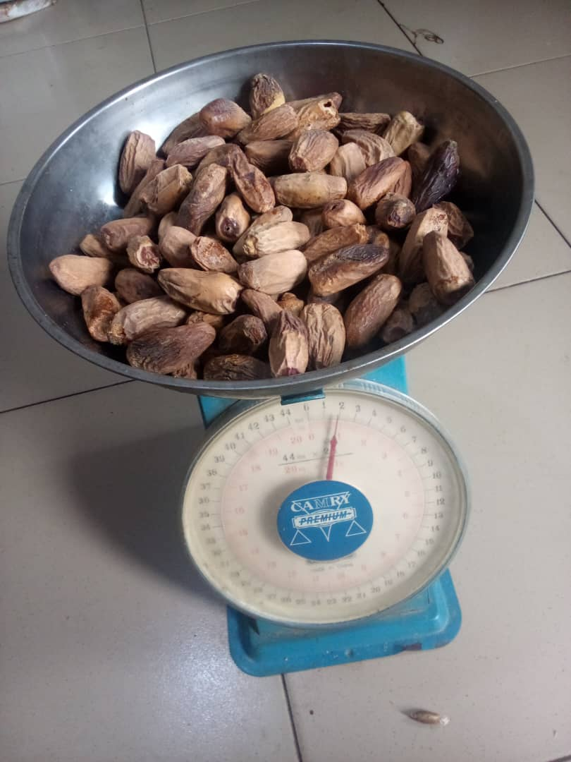
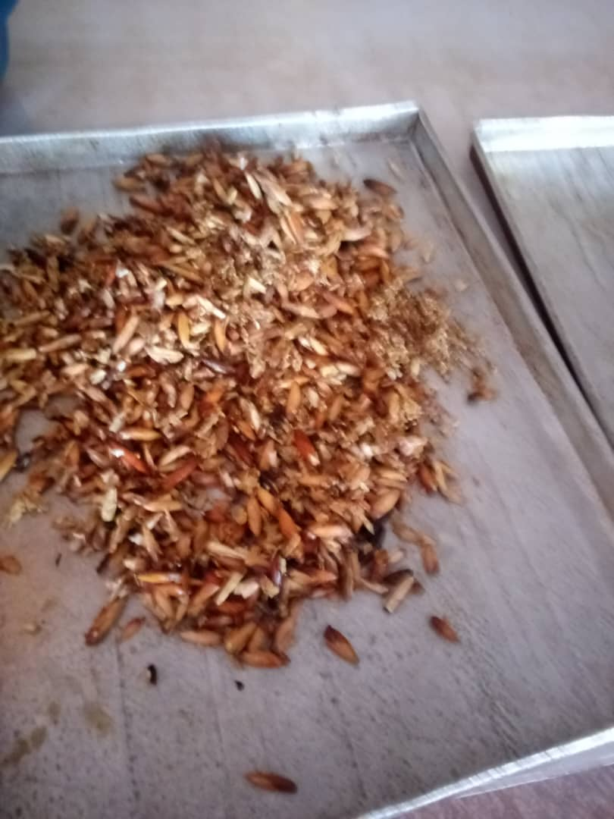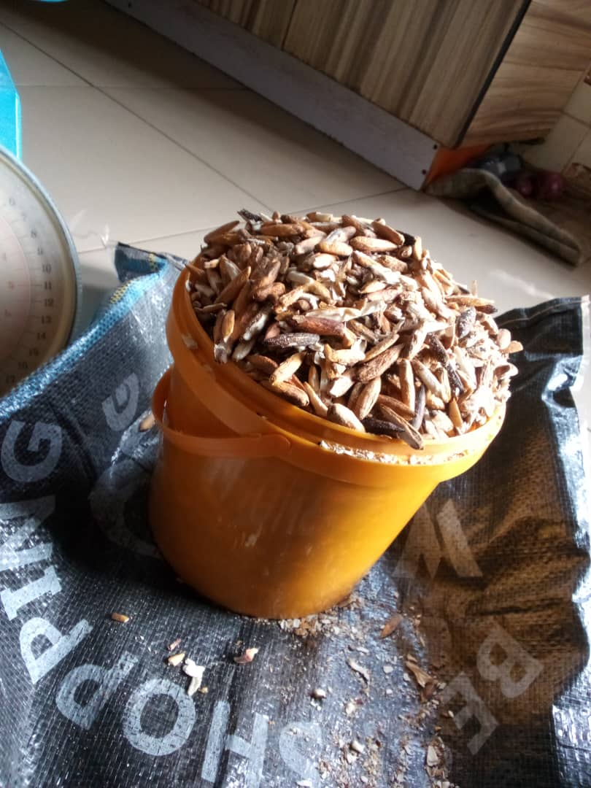

CRACKING MACHINE
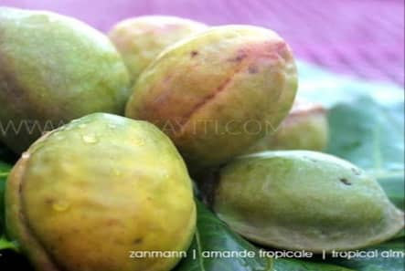
Dried Almond fruits
Cracking of dried Almond fruits Almond kernels

Dates - sweeteners
Almond fruits
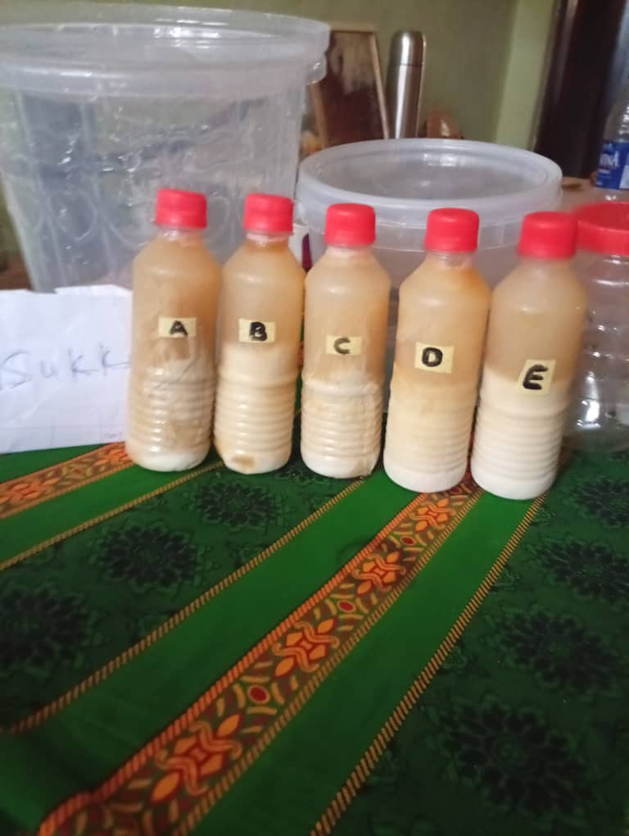
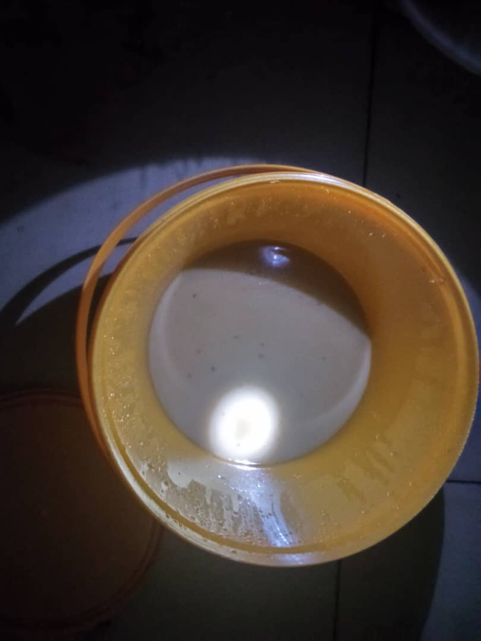

Almond Milk

Bottled Almond milk
Fig. 1: Processing steps of Almond milk

2.3 Experimental Design
The research was designed to produce milk from almond seeds at different soaking time as shown in Table 1. A total of five samples were produced from almond seed. The different soaking time used were 0, 6, 12, 18 and 24 h for samples A, B, C, D and E respectively and were stored in refrigerator until further use.

2.4 Proximate Analysis
2.4.1 Determination of Moisture Content
The moisture content of the samples was determined by the hot air oven method using standard method of AOAC (2019). Two grams (2g) of each sample (W₂) was weighed into a petri dish (W₁) which was previously washed and dried in an oven at 105 °C for 30 min. Thereafter, the sample was dried at l05 °C for 1 h until a constant weight of the sample was obtained. The sample was cooled in a desiccator and reweighed (W₃). The weight loss obtained as the moisture content was calculated as shown in equation.1.
% Moisture Content = $\frac{W_{2}- W_{3}}{{ W}_{2} - W_{1}}$ x 100 ………………………………………. Eqn. 1
Where W₁ = Weight of empty crucible
W₂ = Weight of sample before drying
W₃ = weight of sample after drying
2.4.2 Determination of Protein Content
The crude protein of the samples was determined by the Kjeldahl method as described by AOAC (2019). Two grams of each sample (W) was put into a Kjeldahl flask. Three grams of anhydrous sodium sulphate and two grams of concentrated tetraoxosulphate (IV) acid (H₂SO₄) was added to digest each of the sample. The flask with the samples were placed in an electric heater in a fume chamber and heated gently in an inclined position until blacking occurred, increased heating until a clear solution was obtained and allowed to cool. The contents of the digestion flask was diluted to 100 mL with distilled water and transferred into 200 mL volumetric flask. The flasks were placed in a Kjeldahl distillation unit, neutralized with 10 mL of 40 % sodium hydroxide (added through the funnel) and two pieces of zinc metal and liberated ammonia collected in 100 mL of 4 % boric acid with 2-4 drops of screened methyl red. The distillate was titrated with 0.01 N hydrochloric acid (HCL) until the titre value of the end point changed from green to pink. The quantity of nitrogen was calculated as shown in equation 2.
Nitrogen (%) = $\frac{T-B x 14.008 x Normality x 100}{W}$ ……………………….Eqn.2
Where
T =Titre value
B = Black value
W = Weight of sample

2.4.3 Determination of the Fat Content
The fat content of the samples was determined as described by AOAC (2019) using Solvent extraction method. The extraction flask was washed, dried, cooled in a desiccator and weighed. Two gram of each sample was weighed into the extraction thimble (B). The thimble containing the sample was placed in the Soxhlet extractor. The washed and dried flask was weighed (A) and filled to about three quarter of its volume with petroleum ether (that has the boiling point range of 40-60°C). The apparatus was set-up and extraction was carried out for a period of 2 h or 4 refluxes. The thimble containing the sample was removed and the petroleum ether was recovered leaving only the oil in the flask at the end of the extraction. The oil in the extraction flask was dried in the oven to remove traces of the solvent, cooled in a desiccator and reweighed (C). The fat content was expressed as a percentage of raw materials as shown in equation 3.

% Fat Content = $\frac{C - A}{B}$ x 100……………………………………………..Eqn. 3
Where;
A = Weight of empty flask
B= Weight of sample
C = Weight of flask + oil

2.4.4 Determination Ash Content
The ash content of each sample was determined in a muffle furnace using the standard method of AOAC (2019). A silica dish was washed, dried and cooled in a desiccator and weighed (W₁). Two grams of each sample (W₂) was added into the silica dish and transferred to the muffle furnace previously heated to 500 °C. The temperature of the furnace was allowed to reach about 500 °C after placing the dish in it. The temperature was maintained until whitish-grey colour was obtained, which was an indication that all the organic matter of the sample had been destroyed. The dish was brought out from the furnace and cooled in a desiccator and reweighed (W₃). The percentage ash content of each sample was calculated as shown in equation 4.
% Ash Content = $\frac{W_{3}- W_{1}}{W_{2} - W_{1}}$ x 100 ……………………………………………Eqn. 4
Where: W₁ = Weight of empty dish
W₂ = Weight of empty dish + sample before ashing
W₃ = Weight dish + ash

2.4.5 Determination of the Carbohydrate
The carbohydrate content of the samples was determined by difference using the standard method of AOAC (2019) as shown in equation 5.
% carbohydrate = 100 % - %( moisture + protein + fat + ash + fibre) ……… eqn. 5

2.5 Determination of the Amino Acid Composition of the Samples
The Amino acid composition of the liquid samples were determined as described by Wang and Cavins (2009) with slight modifications. A 100 cm³ of the sample was measured into 250 mL quick fit round bottom flask and dried using rotary evaporator. A clean spatula was used to remove the dried sample and defatted in Soxhlet extraction apparatus (AOAC, 2019) with 2:1 (v/v) of solvent chloroform: methanol for 15 h. A known weight of the sample was weighed into glass ampoule. A 10 mL of 4.2 M NaoH was added and oxygen expelled by passing nitrogen into the ampoule. The glass ampoule containing the sample was sealed with Bunsen burner flame and put in an oven preset at 105 ºC ± 5 ºC for 4 h hydrolyzed. Thereafter, the ampoule was allowed to cool before cut open at the tip and the content filtered to remove the humins. It should be noted that tryptophan is destroyed by 6 N HCl during hydrolysis (Benitez, 1989). The resulting filtrate was evaporated to dryness at 40 ºC under vacuum in a rotary evaporator and the residue dissolved with 5 mL of borate buffer of pH 9.0 and stored in plastic specimen bottles, and kept in the freezer. Sixty (60) microliters of the Hydrolysate were taken and dispensed into the cartridge of the analyzer and the amino acid composition of the hydrolysate was determined within 45 min using the Applied Biosystems PTH Amino Acid Analyzer. Thereafter, the amino acid composition of each of sample was calculated from the chromatogram peak using area under curve as shown in Equation 6.
eqn.6
Where NH = Net height, W = Width half height and Nleu = Normal Leucine
.

2.6 Sensory Evaluation
Sensory evaluation of the extracted almond milk samples were conducted as described by Alugwu et al. (2023) using a panel of twenty (20) semi-trained consumer panelists consisting of staff, undergraduate and post graduate students of the Department of Food Science and Technology, Enugu State University of Science and Technology, Nigeria using a nine point Hedonic scale where 1 = extremely not desirable and 9 = extremely desirable. The almond milk samples were served to the panelists in white plastic cups of similar sizes but separately labelled. The panelists were asked to assess and score the samples individually on the quality attributes of colour, consistency, taste, aroma, mouthfeel, and overall acceptability. A sachet of water was also provided to each panelists to rinse his or her mouth after each sample testing to avoid residual effect. The panelists were told to evaluate and score the milk samples as shown in Plate 1 based on the acceptability of each sample.

2.7 Statistical Analysis
The data generated were subjected to one-way analysis of variance (ANOVA) using Statistical Package for Service Solution (SPSS, version 25.0) software (2020). Means were separated using Duncan New Multiple Range Test (DNMRT) at p<0.05. Values were reported in results as means ± standard deviation (SD).

3 RESULTS AND DISCUSSION
3.1 Proximate Composition of Almond Milk Samples

The results of proximate composition of the almond milk samples obtained at different soaking periods are shown in Table 1. The moisture content of the samples increased significantly from 94.53 to 96.04 %. Sample E had the highest moisture content of the milk samples, while sample A had the least moisture content of the samples. There were no significant differences (P˃0.05) between samples A, B and C in the moisture content and between samples D and E. The higher moisture content of sample E could be attributed to the longer soaking time used in its production. According to Kulkarni et al. (2020), soaking generally increases the moisture content of plant-based milk extracts like soy milk or almond milk. This is because soaking in water helps to hydrate the plant material, making it easier to extract solids and increasing the overall liquid volume. The values of moisture content obtained in this research study were in agreement with the findings of 94.21-96.56% moisture by Okorie et al. (2024) on tigernut milk obtained using different soaking time.
The results of protein content of the samples ranged from 0.31 to 0.39 %. Sample E had the highest protein content, while sample A had the least Protein content. There were no significant differences (p > 0.05) between samples C and D, but there were significant differences (p < 0.05) among other samples. The differences in the protein content of the almond milk samples could be attributed to the different in soaking time used in the milk production. Soaking plant-based milk ingredients before extraction can lead to an increase in protein content (Okorie et al., 2024). The values of protein content obtained in this findings were low compared with the reported findings of 15.86 to 22.30% by Adekanmi et al. (2023) in tigernut based milk alternative.
The fat content of the samples ranged from 2.01 to 3.61 %. Sample A had the highest fat content, while sample E had the least fat content of the almond milk samples. There were significant differences (p<0.05) between samples A, D and E in the fat content but no significant differences (p>0.05) among samples B and C. The decrease in percentage of the fat content of sample E could be attributed to the prolonged soaking period which leads to increase of other nutrients. The values of fat content of the almond milk samples obtained in this findings were low compared with the reported findings of 6.53 to 9.17% by Okorie et al. (2024) in tigernut milk processed using different soaking time. This findings agreed with the reported of Yahaya et al. (2022) who reported that soaking slightly decreased fat content with increasing soaking time.
The ash content of the samples ranged from 0.94 to 1.14 %. Sample A had significantly (p<0.05) the highest ash content, while sample D had significantly (p<0.05) the least ash content of the samples. There were significant differences (p<0.05) among samples A and E in the ash content but no significant differences (p>0.05) between samples B, C and D. The significant amount in ash content of the samples could be as a result of the relatively high mineral content in almond milk samples. Soaking affects the ash content of milk extracts of this research and this finding agrees with reported findings by Okorie et al. (2024) who stated that increase in soaking time decreased ash content. This suggests that soaking may leach out some of these minerals. The values of ash content obtained in this research were in agreement with the study of Jermwongruttachai et al. (2021) who presented ash content results of 0.85-1.20% in milk extract from skimmed coconut. Ash content gives an indication of the mineral contents of a food sample (Schiano et al., 2020).
The carbohydrate content of the almond milk samples ranged from 0.49 to 1.01 %. Sample A had the highest carbohydrate content, while sample E had the least carbohydrate content. There were no significant differences (p˃0.05) in the carbohydrate content of the almond milk samples. The findings of this research were low compared with the reported findings of 4.20 to 18.73% by Tulashie et al. (2022) in coconut milk. The results of this research finding are lower than the reported findings of 8.36 to 12.43 % by Poongodi and Rameshkumar (2022) in coconut and soymilk blends.
Table 1: Proximate composition (%) almond milk samples at different soaking periods.

Samples Moisture Protein Fat Ash Carbohydrate
A 94.53^{b}±0.04 0.31^{d}±0.00 3.61ª±0.01 1.14ª±0.12 1.01ª±0.55
B 94.85^{b}±0.07 0.32^{c}±0.00 3.20^{b}±0.28 1.10^{ab}±0.02 0.78ª±0.13
C 94.90^{b}±0.15 0.33^{b}±0.00 2.95^{b}±0.08 1.03^{ab}±0.04 0.65ª±0.04
D 95.72ª±0.40 0.33^{b}±0.00 2.41^{c}±0.01 0.99^{ab}±0.01 0.55ª±0.42
E 96.04ª±0.06 0.39ª±0.00 2.01^{d}±0.01 0.94^{b}±0.06 0.49ª±0.40
Data are means of duplicate determination ± standard deviation. Values with different superscripts in the same column differ significantly (p˂0.05).
A - Almond milk extracted from unsoaked almond seed.
B - Almond milk extracted from almond seed soaked for 6 h.
C - Almond milk extracted from almond seed soaked for 12 h.
D - Almond milk extracted from almond seed soaked for 18 h.
E - Almond milk extracted from almond seed soaked for 24 h

3.5 Amino acid Composition

Table 2 shows the amino acid composition of the almond milk samples produced using different soaking time interval. The Table showed that essential and non- essential amino acid values were reduced by soaking except in threonine and alanine that increased in sample C, respectively. Sample A had the highest mean essential amino acids content of 4.58 g/100g, whereas sample D had the least mean essential amino acids content of 3.45 g/100g protein. The lowest essential amino acids content of sample D could be attributed to soaking effect due to protein leaching in water compared to sample A unsoaked almond seed. Whereas the highest essential amino acids content of sample A could be attributed to concentration of protein in the unsoaked almond seed. Sample A had the highest mean non-essential amino acids content of 5.50 g/100g protein, whereas sample D had the least mean non-essential amino acids content of 4.14 g/100g protein. Sample A also had the highest grand mean amino acid content of 5.04 g/100g protein, while sample B had the least grand mean amino acids content of 4.08 g/100g protein. The mean essential and total mean non-essential amino acids content decreased in the soaked seed of almond milk extract compared with the unsoaked one which is sample A. However, sample B showed a different trend in both essential and non-essential amino acids composition compared to the other samples. The result indicated that glutamic acid had the highest concentration of all the amino acids that were determined, and these values varied from 7.58 to 12.03 g/100g protein, and were comparatively higher in the unsoaked samples than the samples from the soaked seeds. This finding is in line with the previous studies that glutamic acid is usually present in abundant in plant-based foods especially legumes (Adekanmi et al., 2023). Nutritionally, studies have established that adequate intakes of essential amino acids are required in infants to prevent stunted growth and cognitive retardation; and that children with stunted growth had lower serum concentrations of all nine essential amino acids (tryptophan, isoleucine, leucine, valine, methionine, threonine, histidine, phenylalanine, and lysine) compared with no stunted children (Adebola et al., 2020). This finding indicates that these almond milk samples may be adequate in providing essential amino acids that are required for normal growth and cognitive development in young children. Besides, non-essential amino acids (arginine, glutamine, glycine, proline, and tyrosine) were adequately present in the samples. It is worth to note that some of these amino acids are conditionally essential in infant, because they cannot be produced in sufficient amount endogenously (Walther et al., 2022). The findings of this research were in agreement with the reported findings of Abdulaziz et al. (2023) who stated that almond milk, had higher non-essential amino acid than the essential amino acids. However, the samples had a low content (0.52-0.97 g/100 g protein) of methionine, a known essential amino acids. Notably, methionine is well known rich amino acid in milk protein that supports the synthesis of other amino acids like cysteine, and plays a role in methylation processes of DNA and RNA (Oyimba et al., 2022). This values obtained in this study were lower than the reported finding (2.35-2.56 g/100 g protein) of methionine by Angeles et al. (2021) in plant based milk made from coconut and soymilk blends.

Table 2: Amino acid profile of the almond milk samples (g/100g crude protein)
Amino acid/ Sample | A | B | C | D | E | Mean
Valine | 5.41ª±0.04 | 4.14^{c}±0.11 | 5.15^{b}±0.08 | 3.93^{d}±0.04 | 5.07^{b}±0.02 | 4.74±0.66
Phenylalanine | 5.71ª±0.07 | 5.24^{b}±0.01 | 5.06^{c}±0.01 | 4.64^{d}±0.02 | 5.17^{bc}±0.07 | 5.16±0.38
Methionine | 0.97ª±0.01 | 0.68^{d}±0.01 | 0.78^{c}±0.00 | 0.52e±0.01 | 0.82^{b}±0.02 | 0.75±0.17
Arginine | 5.70ª±0.05 | 4.96^{b}±0.06 | 5.00^{b}±0.01 | 4.53^{d}±0.06 | 4.81^{c}±0.01 | 5.00±0.43
Threonine | 5.14^{b}±0.01 | 3.68e±0.04 | 5.33ª±0.04 | 3.79^{d}±0.03 | 4.82^{c}±0.04 | 4.55±0.77
Tryptophan | 1.13ª±0.01 | 0.75e±0.01 | 0.83^{d}±0.01 | 0.88^{c}±0.01 | 0.96^{b}±0.01 | 0.91±0.14
Histidine | 2.61ª±0.01 | 1.84e±0.02 | 2.11^{c}±0.03 | 2.04^{d}±0.02 | 2.34^{b}±0.01 | 2.19±0.30
Isoleucine | 5.53ª±0.03 | 4.08^{d}±0.08 | 4.61^{c}±0.02 | 4.51^{c}±0.01 | 5.02^{b}±0.02 | 4.75±0.55
Leucine | 9.93ª±0.01 | 8.09^{d}±0.03 | 8.93^{c}±0.04 | 7.65e±0.02 | 9.46^{b}±0.06 | 8.81±0.94
Lysine | 3.68ª±0.01 | 3.35^{b}±0.07 | 3.08^{c}±0.08 | 3.45^{b}±0.00 | 3.36^{b}±0.02 | 3.38±0.22
Mean Essential | 4.58±2.64 | 3.68±2.12 | 4.09±2.46 | 3.59±2.07 | 4.18±2.51 | 4.02±0.40
Alanine | 4.64^{c}±0.02 | 3.64e±0.04 | 5.35ª±0.05 | 4.01^{d}±0.01 | 5.09^{b}±0.03 | 4.55±0.72
Cysteine | 1.27ª±0.00 | 1.26ª±0.01 | 1.04^{b}±0.01 | 1.10^{b}±0.01 | 0.94^{c}±0.05 | 1.12±0.14
Aspartic acid | 9.03ª±0.06 | 7.63ª±0.02 | 8.39^{c}±0.04 | 7.32e±0.02 | 8.61^{b}±0.01 | 8.20±0.71
Glycine | 3.23^{b}±0.01 | 3.32ª±0.01 | 2.33e±0.04 | 2.64^{c}±0.02 | 2.52^{d}±0.04 | 2.81±0.44
Glutamic acid | 12.03ª±0.05 | 8.86^{d}±0.01 | 10.33^{c}±0.04 | 7.58e±0.11 | 10.85^{b}±0.05 | 9.93±1.74
Tyrosine | 4.76ª±0.06 | 3.44^{d}±0.01 | 3.62^{c}±0.01 | 3.14e±0.06 | 4.16^{b}±0.06 | 3.82±0.64
Serine | 4.41ª±0.03 | 3.94^{c}±0.06 | 3.83^{d}±0.02 | 4.20^{b}±0.04 | 4.12^{b}±0.04 | 4.10±0.23
Proline | 4.63ª±0.04 | 3.64^{d}±0.03 | 4.27^{b}±0.00 | 3.15e±0.00 | 4.14^{c}±0.03 | 3.97±0.55
Mean non-essential | 5.50±3.41 | 4.47±2.50 | 4.90±3.08 | 4.14±2.25 | 5.05±3.21 | 4.80±0.53
Grand Mean | 5.04±0.65 | 4.08±0.56 | 4.50±0.57 | 3.87±0.39 | 4.62±0.62 | 4.81±0.59

Data are means of duplicate determination ± standard deviation.
Values with different superscripts in the same column differ significantly (p˂0.05).
A - Almond milk extracted from unsoaked almond seed.
B - Almond milk extracted from almond seed soaked for 6 h.
C - Almond milk extracted from almond seed soaked for 12 h.
D - Almond milk extracted from almond seed soaked for 18 h.
E - Almond milk extracted from almond seed soaked for 24 h

4.5 Sensory Properties of the samples
Table 3 shows the sensory properties of the almond milk samples produced using different soaking time intervals. The scores for colour ranged from 6.20 to 8.60. Sample C had significantly (p<0.05) the highest mean score of 8.60 and rated by the panellists as extremely acceptable. Whereas, samples A had the least mean colour score of 6.20 and rated by the panellists as slightly acceptable. There were no significant differences (p> 0.05) between samples A and E, and between sample B and D while there were significant (p<0.05 differences in colour scores of sample C and other samples. The results of this research are similar to the reported findings of 7.10-8.58 by Abdulaziz et al. (2023) in milk analogue produced from almond seed.
The scores for consistency ranged from 6.25 to 8.50. Sample C had significantly (p<0.05) the highest consistency score of 8.50 and rated by the panellists as extremely acceptable, whereas sample A had the least consistency score of 8.30 and rated by the panellists as slightly acceptable. The results of the consistency score of this research are similar to the reported findings of 6.28-8.20 by Abdulaziz et al. (2023) in almond based milk analogue. The almond milk produced from sample C was highly rated by the panellists and was the most preferred of the samples in consistency.
The scores for taste ranged from 6.20 to 8.85. Sample C had significantly (p<0.05) the highest mean score of 8.65 and rated by the panellists as extremely acceptable. While samples E had the least mean taste scores of 6.20 and rated by the panellists as slightly acceptable. There were no significant differences (p > 0.05) between samples A, B, D and E, while sample A differed significantly (p < 0.05) from these samples. The results of this research are similar to the reported findings of 6.10-8.69 by Abdulaziz et al. (2023) in almond based milk analogue. The taste values of this research were better in sample soaked for 12 h compared with the other samples.
The scores for flavour ranged from 6.15 to 8.50. Sample C had significantly (p<0.05) the highest flavour score of 8.50 and rated by panellists as extremely acceptable, whereas sample E had significantly (p<0.05) the least flavour score of 6.15 and rated by the panellists as slightly acceptable. There were no significant differences (p>0.05) between samples B and C and between samples A, B and D. The results of the flavour scores of this research are similar to the reported findings of 7.58-8.20 by Abdulaziz et al. (2023) in almond based milk analogue. The almond milk produced from sample C was more acceptable in terms of flavour compared with other samples.
The scores for mouthfeel ranged from 6.15 to 8.40. Sample C had significantly (p<0.05) the highest mean scores and rated by the panellists as very much acceptable. Whereas, samples A had the least mean mouthfeel scores of 6.15 and rated by the panellists as slightly acceptable. There were no significant differences (p > 0.05) between samples A, B, D and E, as well as samples B, C and D. The results of this research are similar to the reported findings of 5.30-8.10 by Wan et al. (2021) in coconut and almond milk blends. The findings of this research are in agreement with the reported findings of 5.43-8.63 by Clegg et al. (2021) in plant based milk produced from fermented white corn and tigernut milk blends.
The scores for overall acceptability ranged from 6.05 to 8.40. Sample C had significantly (p<0.05) the highest overall acceptability score of 8.40 and was rated by the panelists as very much acceptable. Whereas sample E had the least overall acceptability score of 6.05 and was rated by the panelists as slightly acceptable. There were no significant differences (p>0.05) between samples A, B and D; B, C and D as well as A and C. The findings of this research are in line with the reported findings of 6.17-8.23 by Clegg et al. (2021) in plant based milk produced from coconut, tigernut and cashew nut milk blends.
Table 3: Sensory properties of the almond milk samples produced using different soaking time

Samples Colour Consistency Taste Flavour Mouthfeel Overall
Acceptability
A 6.20^{c}±2.04 6.25^{b}±2.12 6.40^{bc}±2.21 6.35^{b}±2.56 6.15^{b}±2.43 6.75^{bc}±2.49
B 7.65^{b}±1.04 7.45^{b}±0.72 7.50^{b}±1.15 7.65^{ab}±1.18 7.35^{ab}±1.65 7.70^{ab}±1.30
C 8.60ª±0.82 8.50ª±0.69 8.65ª±0.49 8.50ª±0.61 8.40ª±0.75 8.40ª±0.88
D 7.15^{b}±1.50 7.10^{b}±1.45 7.45^{b}±1.47 7.20^{bc}±1.61 7.35^{ab}±1.53 7.55^{ab}±1.57
E 7.25^{c}±1.37 6.50^{b}±2.33 6.20^{b}±2.31 6.15^{c}±2.21 6.25^{b}±2.31 6.05^{c}±2.49
Data are means of duplicate determination ± standard deviation. Values with different superscripts in the same column differ significantly (p˂0.05).
A - Almond milk extracted from unsoaked almond seed.
B - Almond milk extracted from almond seed soaked for 6 h.
C - Almond milk extracted from almond seed soaked for 12 h.
D - Almond milk extracted from almond seed soaked for 18 h.
E - Almond milk extracted from almond seed soaked for 24 h

4. CONCLUSION
This study has shown that soaking time exerts significant influence on the nutritional and sensory properties of almond milk. Extended soaking improved extractability of certain nutrients, increased bioavailability and reduced ant-nutritional factors, thereby improving the nutritional quality. Sensory evaluation indicated that moderate soaking times (neither too short nor excessive long) optimize desirable attributes particularly taste, aroma, mouthfeel and overall acceptability. Similarly soaking durations beyond optimal thresholds may lead to undesirable changes in sensory properties like off- flavour and textural defects. This research showed that soaking is a pre-processing step of almond milk production, capable of enhancing both health value and consumer satisfaction. It offers relevant guidance for food processors, nutritionists and manufacturers of plant-based beverages to established standardized methods of nutritionally enriched and sensory – pleasing almond milk.
Conflict of Interest: The authors declares that there is no conflict of interest.
Ethical Approval Committee: The research was approved by the Enugu State Ministry of Research Ethics Committee with the Ref. No. MH/MSD/REC21/898
REFERENCES
Abdulaziz, E., Dilafruz, S. and Dilnoza, S. (2023). Study of Physical and Chemical Properties of Almond Milk. International Journal of Innovative Science and Research Technology, 8(6), 1004-1007.
Abdullah, Z., Taip, F.S., Kamal, S.M.M. and Rahman, R.Z.A. (2020). The effect of drying temperature and sodium caseinate concentration on the functional and physical properties of spray-dried plant based milk. Journal of Food Science and Technology, 58 (8), 3174–3182.
Adekanmi, O. K., Olojede, A. T. and Amankwah, F. S. (2023). Nutritional analysis of tiger nut-based milk alternatives. Journal of Food Science and Nutrition, 12(3), 452–463.
Alae-Carew, C., Green, R., Stewart, C., Cook, B., Dangour, A.D. and Scheelbeek, P.F. (2022). The role of plant-based alternative foods in sustainable and healthy food systems: Consumption trends in the UK. Science of the Total Environment, 807, 151041.
Alugwu, S.U., Alugwu, B. U. and Ifeanyieze, F.O. (2023). Quality characteristics and sensory properties of bread elaborated with flour blends of wheat and African yam bean. Asian Food Science Journal, 22 (12): 32 -45
Angeles, J.C., Lado, J.P., Pascual, E.D., Laurena, A.C. and Laude, R.P. (2021). Epigenetic Considerations on Altered Phenotypes of the Coconut Endosperm. The Coconut Genome. Pp. 175-190.
AOAC (Association of Official Analytical Chemists) (2019). Official Methods of Analysis. 15th edition. Gaithersborg (edn). AOAC press, Washington DC, USA. Pp. 78-90.
Arena, A., Bisignano, C., Stassi, G., Mandalari, G., Wickham, M.S. and Bisignano, G. (2020). Immunomodulatory and antiviral activity of almond skins. Immunology Letters, 132(1-2), 18-23.
Astolfi, M.L., Marconi, E., Protano, C. and Canepari, S. (2020). Comparative elemental analysis of dairy milk and plant-based milk alternatives. Food Control, 116, 107-327.
Aydar, E.F., Tutuncu, S. and Ozcelik, B. (2020). Plant-based milk substitutes: Bioactive compounds, conventional and novel processes, bioavailability studies, and health effects. Journal of Functional Foods, 70, 103975.
Benitez, L. V., (1989) Amino acid and fatty acid profiles in aquaculture nutrition studies, Pp. 23- 35. In. S. S. De Silva (ed).Fish Nutrition Research in Asia. Proceedings of the third Asian Fish Nutrition Network meeting , Asian Fish Society Special Publication Pp, 4, 166, Asian Fisheries Society, Manila, Philippines.
Bezerra, M., Ribeiro, M. and Igrejas, G. (2021). An updated overview of almond allergens. Nutrients, 13(8), 2578.
Cardello, A.V., Llobell, F., Giacalone, D., Roigard, C.M. and Jaeger, S.R. (2022). Plant-based alternatives vs dairy milk: Consumer segments and their sensory, emotional, cognitive and situational use responses to tasted products. Food Quality and Preference, 100, 104599.
Clegg, M.E., Tarrado R.A., Reynolds, R., Kliem, K. and Stergiadis, S. (2021). A Comparative Assessment of the Nutritional Composition of Dairy and Plant-Based Dairy Alternatives Available for Sale in the UK and the Implications for Consumers’ Dietary Intakes. Food Research International, 148, 110586.
Daryani, D., Pegua, K., & Aryaa, S. S. (2024). Review of plant-based milk analogue: its preparation, nutritional, physicochemical, and organoleptic properties. Food Science and Biotechnology, 33(5), 1059-1073.
Daryani, D., Pegua, K., & Aryaa, S. S. (2024). Review of plant-based milk analogue: its preparation, nutritional, physicochemical, and organoleptic properties. Food Science and Biotechnology, 33(5), 1059-1073.
Jermwongruttanachai, P., Pathaveerat, S. and Noypitak, S. (2021). Effect of temperature denaturation of skimmed coconut to produce a new product, Coconut water. Journal of Food Processing and Preservation, 45(12), e16046.
Kim, T.J., Seo, K.H., Chon, J.W., Kim, H.J., Jeong, H. and Song, K.Y. (2022). Sensory evaluation assessment of almond milk, oat milk, soy milk (nondairy products) and kefir, yogurt, cow milk (dairy products) containing radish oil: A preliminary study. Journal of Dairy Science and Biotechnology, 40(3), 122–133.
Kulkarni, K.S.; Kasture, S.B. and Mengi, S.A. (2020). Efficacy study of Prunus amygdalus (almond) nuts in scopolamine-induced amnesia in rats. Indian Journal of Pharmacology, 42(3), 168-173.
Lipan, L., Rusu, B., Simon, E.L., Sendra, E., Hernández, F. and Vodnar, D.C. (2021). Chemical and sensorial characterization of spray dried hydro-sustainable almond milk. Journal of Science of Food and Agriculture, 101(4), 1372–1381.
Manzoor, M.F., Siddique, R., Hussain, A., Ahmad, N., Rehman, A., Siddeeg, A. (2021). Thermosonication effect on bioactive compounds, enzymes activity, particle size, microbial load, and sensory properties of almond (Prunus dulcis) milk. Ultrason Sonochemistry, 78, 105705.
Okorie, C., Onwuka, G.I. and Obasi, N.E. (2024). Effect of Different Pre-processing Methods on the Proximate Composition of Bottled Tigernut (Cyperus esculentus) Milk Varieties. Proceedings of the Second Faculty of Agriculture International Conference, Digitalisation of Agriculture and Bio-Conservation for Food Security, Nnamdi Azikiwe University, Awka, Nigeria.
Onyimba, I. A., Chomini, M. S., Job, M. O., Njoku, A. I., Onoja, J. A., Isaac, D. C., Isaac, I. C. and Ngene, A. C. (2022). Evaluation of the suitability of tigernut milk and tigernut-cow composite milks for yoghurt production. European Journal of Biology and Biotechnology, 3(2), 38–44.
Penha, C.B., Santos, V.P., Speranza, P. and Kurozawa, L.E. (2021). Plant-based beverages: Ecofriendly technologies in the production process. Innov. Food Sci. Emerg. Technol., 102760, 1–12.
Pérez-Rodríguez, M. L., Serrano-Carretero, A., García-Herrera, P., Cámara-Hurtado, M., & Sánchez-Mata, M. C. (2023). Plant-based beverages as milk alternatives? Nutritional and functional approach through food labelling. Food Research International, 173, 113244.
Pérez-Rodríguez, M. L., Serrano-Carretero, A., García-Herrera, P., Cámara-Hurtado, M., & Sánchez-Mata, M. C. (2023). Plant-based beverages as milk alternatives? Nutritional and functional approach through food labelling. Food Research International, 173, 113244.
Poongodi, V.S. and Rameshkumar, S. (2022). Development and formulation for the manufacturing of coconut milk shrikhand. International Journal of Engineering Technology and Management Sciences, 6(5), 1-7.
Reyes-Jurado, F., Soto-Reyes, N., Dávila-Rodríguez, M., Lorenzo-Leal, A.C., Jiménez-Munguía, M.T., Mani-López, E. and López-Malo, A. (2021). Plant-Based Milk Alternatives: Types, Processes, Benefits, and Characteristics. Food Reviews Int., 10, 1–32.
Samarasinghe, S.P., Chandimala, U.R. and Gunathilake, D.M. (2023). Production of plant-based milk from local almond nuts (Terminalia catappa L.) and evaluation of its sensory and nutritional properties. Tropical Agricultural Research and Extension; 26 (2): 104-110.
Schiano, A.N., Harwood, W.S., Gerard, P.D. and Drake, M.A. (2020). Consumer perception of the sustainability of dairy products and plant-based dairy alternatives. Journal of Dairy Science, 103(12), 11228-11243.
Sridhar, K., Bouhallab, S., Croguennec, T., Renard, D. and Lechevalier, V. (2022). Recent trends in design of healthier plant-based alternatives: Nutritional profile, gastrointestinal digestion, and consumer perception. Critical Reviews in Food Science and Nutrition, 6, 1–16.
Tulashie, S.K., Amenakpor, J., Atisey, S., Odai, R. and Akpari, E.E. (2022). Production of coconut milk: A sustainable alternative plant-based milk. Case Studies in Chemical and Environmental Engineering, 6, 100206.
Walther, B., Guggisberg, D., Badertscher, R., Egger, L., Portmann, R., Dubois, S., Haldimann, M., Kopf-Bolanz, K., Rhyn, P., Zoller, O., Veraguth, R. and Rezzi, S. (2022). Comparison of nutritional composition between plant-based drinks and cow’s milk. Frontier of Nutrition, 9, 988707.
Wan, S., Khubber, M., Dwivedi, Z. and Misra, N. (2021). “Strategies for lowering the added sugar in yogurts,” Food Chemistry, 344, 128573.
Yahaya, D., Seidu, O.A., Tiesaah, C.H. and Iddrisu, M.B. (2022). The role of soaking, steaming, and dehulling on the nutritional quality of Bambara groundnuts (Vigna subterranean (L) Verdc.). Frontiers in Sustainable Food System, 10, 01-10.

