Advances in Fruit Crop Breeding: Conventional and Molecular Approaches

Abstract
Fruit crop breeding has undergone remarkable transformation over the past century, evolving from traditional selection techniques to advanced molecular techniques. This is a review of the evolution of methods of breeding, including traditional approaches to breeding, which include mass selection, pure line selection, hybridization, and mutation breeding, and the innovative approaches to breeding based on molecular tools, including marker-assisted selection, genomic selection, and CRISPR/Cas9 gene editing. The breeding cycle has been reduced drastically with the integration of genomic tools, and precision in the selection of traits has also been achieved, not to mention the ability to make finer adjustments of complex characterization such as disease resistance, fruit quality, and climate resilience. Development of better varieties in mango, citrus, banana, and temperate fruits have been of great contribution by Indian research institutions to solve the local agro-climatic problems. Nevertheless, implementation is constrained by factors such as poor infrastructure, insufficiency of funding, complexity of regulations as well as a lack of skilled employees. The future opportunities are in artificial intelligence-based breeding, speed breeding, and the integration of multi-omics. The article not only synthesizes available information but also presents the successes in the Indian setting and also offers strategic advice on how the ongoing fruit crop improvement programs can be enhanced to guarantee food security and economic sustainability.
Keywords : Fruit Breeding, Molecular Markers, CRISPR, Genomic Selection, Indian Varieties, Crop Improvement.

Introduction
The role of fruit crops in the world economy is also invaluable since it serves as the source of vital nutrients, vitamins, antioxidants, and dietary fiber that is very important in human health and nutritional security. Production of fruits cover a wide range of agro-ecological borders and it plays a large role in the economic growth, creating jobs and export income especially in third world countries. The country is one of the largest fruit producers in the world and as such, India is blessed with diverse climatic conditions such as tropical to temperate zones, where the country has a wide variety of species such as mango (Mangifera indica), banana (Musa spp.), citrus (Citrus spp.), apple (Malus domestica), grapes (Vitis vinifera), and many native fruits. In spite of this extraordinary diversity, the fruit productivity in India is still significantly lower than the world standards, which requires a high level of breeding manipulations to achieve better varieties that have a higher yield capacity, better quality, and ability to resist biotic and abiotic stresses.
Historical pathway of breeding of fruits This was the result of empirical selection by ancient farmers of fruit-desirable phenotypes in a variety of natural populations. Early cultivators continued to propagate elite individuals by saving the seed or cloning by using vegetative methods like observable characteristics, including large fruit size, taste, color, production, and resistance to diseases. It was a primitive but useful technique to utilize the available genetic variation, the foundation of an ordered breeding. By the first half of the twentieth century, the method had evolved to systematic hybridization programs, it entailed crosses between well selected parents to produce new genetic combinations. These attempts were meant to pyramid desirable characters, over and above the constraints of individual genotypes and establishing varietal innovation within the fruit species.
The embodiment of this revolutionizing period was pioneers such as Luther Burbank who revolutionized the field of pomology by introducing the use of intentional crosses and testing thousands of progenies to the utmost degree. His extensive development came up with some of the most remarkable cultivars in the field of plums, apples, peaches and berries, which proved the strength of heterosis (hybrid vigor) and multi-generation selection. The principles of Burbank, such as that of combining ability of parents, progeny testing, and adaptation to local conditions, were the main pillars of further programs in other parts of the world, such as in India, where mango, citrus, and banana were also being improved.
Nevertheless, standard breeding is limited by natural constraints especially in perennial crops that bear fruits. Long generations of juveniles (3-15 years) cause the delay of trait evaluation and the release of cultivar. The polygenic characteristic of economically important traits such as yield, quality and stress resistance which are exacerbated by linkage drag; the undesirable genes being associated with desirable genes, and confounding effects on the environment reduce the accuracy of selection. This has led to the need to integrate the new biotechnological tools that will increase the cycle time, accuracy, and potential of fruit crop amelioration. The approach to molecular breeding, such as marker-assisted selection and genomic selection, is an opportunity to break these traditional breeding bottlenecks and allow the selection of complex traits at an early stage and reliable (Lobato-Gómez et al., 2021). In particular, molecular markers enable the direct query of genomic regions correlated with desirable phenotypes to simplify the selection process and to save significant amounts of time and resources that the traditional process involves (Kumar et al., 2023; Manzoor et al., 2023). This becomes further improved with the introduction of Fast-track breeding, which, in combination with other methods, such as marker-assisted selection and gene editing, contributes to a massive increase in the speed of identifying superior genotypes and lines with new characteristics, including higher yield, better nutritional content, and increased resistance to biotic and abiotic stressors (Gaurha et al., 2024).
The emergence of molecular biology and genomics at the end of the twentieth century became a paradigm shift in plant breeding as the focus shifted to genotype selection rather than phenotype selection. The first molecular markers based on DNA, Restriction Fragment Length Polymorphisms, quickly transformed into Simple Sequence Repeats, Single Nucleotide Polymorphisms and Random Amplified Polymorphic DNAs. These instruments made it possible to do genetic fingerprinting, germplasm diversity and marker-assisted selection, so breeders could find the targeted genotypes at the seedling stage without affecting the environment (Kumar et al., 2023; Manzoor et al., 2023). In fruit crops, MAS has also simplified breeding processes such as disease resistance, fruit quality, and significantly reduced the breeding cycle, which previously took decades before perennial crops with a lengthy juvenile stage were overcome (Lobato-Gomez et al., 2021).
Multicomics technologies of whole-genome sequencing, transcriptomics, metabolomics and genome-wide association studies are increasingly being incorporated into contemporary programs to uncover the genetic architecture of complex polygenic traits like yield, shelf-life and stress tolerance. The methods give high-resolution information on gene-trait relationships, which make genomic selection predictive of breeding values in population. In Indian breeding, mango and banana SNPs and GWAS have been used to improve breeding in institutions such as the Indian Institute of Horticultural Research to gain accuracy in the face of varied agro-climatic conditions.
This breeding revolution is coupled with a rapid breeding process, which hastens the superior genotype identification to lead to higher yield, nutrition, and resilience (Gaurha et al., 2024). In spite of the obstacles such as infrastructure inequalities, these inventions hold promise of sustainable fruit crop development, which is in between traditional and next-generation practices. Greater opportunities are provided by the modern biotechnological technologies, like next-generation sequencing and genomics-based methods, to select potential parents out of the germplasm collections and to create the new cultivars with a higher adaptability to environmental difficulties (Farajpour et al., 2023). This accuracy enables a more specific breeding strategy, which ensures a more efficient distribution of resources and a much greater success in the creation of new varieties that would adapt to a new global climate (Ahmad et al., 2020; Dinesh et al., 2016). The use of various molecular markers, such as AFLP, RAPD, SSRs, SCoT, and SNPs, plays a critical role in the characterization of the genomes of the fruit crops, which gives an in-depth insight into genetic diversity, disease resistance, and the evolutionary processes of a large group of fruit species (Thakur et al., 2023). Moreover, genomic-assisted breeding approaches, including the genome-wide association and genomic selection, in conjunction with genetic modification technologies, including CRISPR/Cas9 and transgenics, have become essential to learn about gene functionality and create cultivars that have the preferred fruit trait (Mathiazhagan et al., 2021). Such highly developed biotechnological methods, including multi-omics, genetic engineering, are radically expanding our knowledge on molecular pathways in fruit crops, in particular, biotic stress resistance and fruit quality (Antwi-Boasiako et al., 2024; Irfan et al., 2022; Ziogas et al., 2023).
The more recent revolutionary technologies in gene editing, specifically CRISPR/Cas9 (Clustered Regularly Interspaced Short Palindromic Repeats), have become a game-changer, with a high level of efficiency and specificity in targeting specific foci of the genome of fruits. Compared to transgenic methods that entail alien gene insertion, gene editing enables minute modifications that cannot be differentiated to natural mutation, which addresses the issue of regulatory and consumer acceptance. The application is diversified in the aspects of disease resistance, shelf-life, nutritional fortification, removal of unwanted compounds, and climate change adaptation. This paper generously covers both the traditional and molecular breeding techniques, their applications in key fruit crops with a background on the Indian contribution, the contemporary problems, and the prospects of improvement of the fruit crops in a sustainable manner. In the production of fruit crops, the combination of these innovative genomic and biotechnological ingredients, including CRISPR/Cas systems, with conventional breeding approaches is necessary to counter the multiple-level and multi-faceted problems of climate change and nutritional security (Pandolfini et al., 2023; Shiming, 2025). The new genome editing technologies, and, in particular, CRISPR/Cas9 technology have significant benefits that surpass traditional random mutagenesis, allowing specific genomic modifications to target trait enhancement (Sundarrajan et al., 2025).
Conventional Breeding Approaches

Mass Selection and Pure Line Selection
The simplest and oldest methodology of breeding, which is the mass selection, is the identification and selection of individuals of better phenotype belonging to heterogeneous populations. The method takes advantage of the genetic variation that is already available, and it selects plants with desirable traits, including; improved fruit size, improved taste, beautiful color, or resistance to disease. Although cheap and straightforward, the mass selection has been plagued with constraints such as the inability to decipher the genetic and environmental effects, degradation of genetic erosion due to inbreeding, and imprecision in ameliorating traits. However, the method is still useful in highly heritable traits and early germplasm enrichment especially in those species with significant phenotype difference like mango where many seedling selections have led to varietal diversity in the Indian states. On the other hand, the process of pure-line selection, commonly used with self-pollinating species, is a process that involves the isolation and reproduction of individual plants to form genetically homozygous lines, which would guarantee homozygosity and a predictable phenotype in future generations. This may be slow and restrictive of genetic diversity that can be used in future breeding, though this approach offers genetic purity, so this is the reason why it is important to have strong collections of germplasm. Although the differences are there, mass selection and pure-line selection are both foundation strategies that can be used to provide earlier more advanced molecular breeding methods with an initial genetic stock that has enhanced features. Additionally, other traditional breeding methods are also inclusive of backcross breeding to transfer desirable features, recurrent selection to enhance quantitative characters in cross-pollinated crops, and to hybridise to obtain desired characteristics in other parents (Anand et al., 2023).

The method can be applied to the self-pollinating species by pure line selection, which involves isolation and production of the homozygous individuals based on the multiplication of a single plant selection in heterogeneous populations. Pure lines have a genetic uniformity that is self-fertilized which leads to stability and predictability of traits. The approach was valuable in creating various strawberry and papaya varieties that have a consistent agro-climatic maturity, uniformity in fruit quality, and adaptation to selected agro-climatic conditions. The effectiveness of the technique is dependent on the initial population diversity, and the heritability of the target characteristics with a restricted range of developing new genetic combinations outside of existing variability. Although pure-line selection is characterized by genetic stability, it also presupposes the reduction of the genetic base per se, thus exposing cultivars to environmental disruptions and disease outbreaks (Begna, 2021; Soyam and Apturkar, 2021).
Figure 1: Evolution of Breeding Approaches Timeline
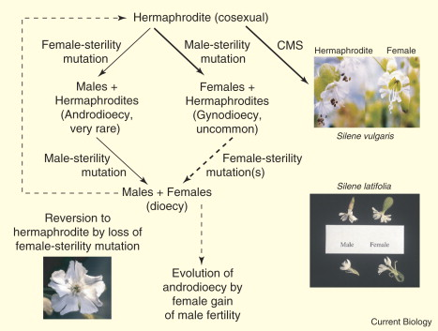

Hybridization and Heterosis Exploitation
Hybridization is the foundation of present-day plant breeding, which has made it possible to cross genetic material between divergent parents to produce new allelic combinations. Intentional crosses between complementary genotypes facilitates pyramiding of desirable trait scattered across genetic backgrounds and produce better cultivars that do not have the same restriction as the parents. Effective hybridization initiatives need careful selection of parents in terms of combining aptitude, complementary traits as well as genetic variation. Exploitation of heterosis (hybrid vigor) has been used in cross-pollinated fruit species to create F1 hybrids that are significantly superior to their parents in yield, vigor, and stress tolerance as is the case with commercial hybrid cultivars of papaya and passion fruit. The process of the overperformance of the descendants of parents is a self-destructive goal in the breeding programs that seek to achieve the greatest productivity and resilience (Oyebamiji et al., 2023). The greater size, development characteristics and productivity of hybrid progenies, which are in most cases higher than those of both parents highlight the high significance of heterosis in enhancing crops (Bhavanee et al., 2024).

Horticultural institutes in India have implemented massive hybridization programs that have resulted in many varieties of horticulture that have been modified to fit local conditions. The Indian Institute of Horticultural Research (IIHR), Bengaluru released more series cultivars of various fruits such as mango (Arka Aruna, Arka Puneet), and papaya (Arka Prabhath, Arka Surya), and banana (Arka Anamika) in which they had shown an increase in productivity, quality, and resistance to various diseases. Mango improvement was also done by Central Institute for Subtropical Horticulture (CISH), Lucknow contributors who came up with mango varieties such as Amrapali, Mallika, and Ratna which were known to be regular bearers, compact plants, and high quality of fruits. These accomplishments demonstrate the continued utility of hybridization even with the emergence of the molecular tool, especially being applicable to traits that are regulated by complementary gene action. Moreover, beneficial alleles including disease resistance or improved nutritional characteristics can be introduced into elite lines of breeding with a targeted manner by the strategic utilisation of hybridization, which increases the genetic resilience and quality traits of horticultural crops (Bura et al., 2023). These gains can then be further increased by strategic exploitation of the phenomenon of heterosis, commonly attained by means of interspecific, or inter-subspecies, hybridization in order to obtain F1 hybrids with increased vegetative biomass and possibly increased yields (Farinati et al., 2023; Ranga et al., 2024).
Figure 2: Comparative Efficiency of Traditional Breeding Based on Methods.
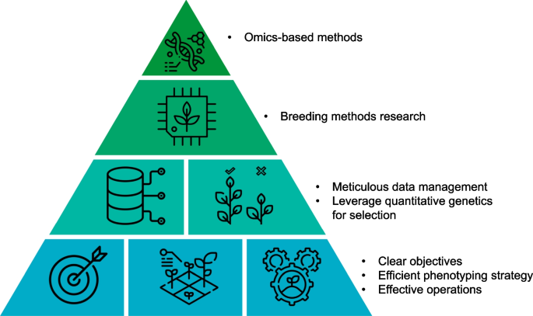

Table 1: Major Fruit Varieties Developed Through Conventional Breeding
Crop | Variety Name | Year Released | Institute
Mango | Amrapali | 1971 | IARI, Delhi
Mango | Mallika | 1972 | IARI, Delhi
Citrus | Sathgudi | 1982 | NRCC, Nagpur
Banana | Arka Anamika | 2015 | IIHR, Bengaluru
Papaya | Pusa Delicious | 1970 | IARI, Delhi
Grape | Arka Hans | 2001 | IIHR, Bengaluru
Apple | Ambri | 1985 | SKUAST, Kashmir
Backcross Breeding and Mutation Breeding
Backcross breeding is an art of introgression that is very specific and exacting as it introduces certain desired genes or traits of donor sources into the elite genetic material without interfering with the desired traits. This type of the methodology entails repeated backcrossing of hybrid offspring to the recurrent parent (elite cultivar) and it is carried out in a series of backcrosses to recover the recipient genome with the donor allele maintained. The number of backcross generations (5-6) and intense selection typically reinvigorate >99% of recurrent parent genome and, in effect, transfers monogenic or oligogenic inheritance characteristics like resistance to diseases, sterility, or desired quality characteristics. Fruits Application Uses Development of Fusarium wilt-resistant banana cultivars, citrus canker resistance, and papaya ringspot virus tolerance. Backcross efficiency with the assistance of molecular markers is much higher with foreground selection (to verify the presence of the target gene) and background selection (to speed up the repetitive achievement of parent genome recovery profiles), minimizing the number of generations, and increasing accuracy. Another traditional method is mutation breeding, which exploits induced genetic differences to improve current cultivars with respect to major agronomic characteristics, productivity, and quality, which is of particular value in fruit crops because it does not promote progeny segregation and instead improves genetic make-up during the selection process (Bhat et al., 2023). The technique has played a major role in producing new alleles that might be missing in the natural germplasm, and hence increasing the number of genetic variability to be used in the selection process (SHARMA et al., 2023). Induced mutations, especially those produced by physical mutagens such as gamma radiation, have been used in more than 70% of mutant fruit varieties to enable the selective enhancement of traits without affecting the accepted standards of industry to a large extent (Lamo et al., 2017).
Mutation breeding takes advantage of induced genetic variation by using either physical mutagens (gamma rays, X-rays, fast neutrons) or chemical mutagens (ethyl methanesulfonate, sodium azide) to produce new alleles which are not available in natural germplasm. By random mutagenesis, large genetic variation is produced, which sometimes results in commercially useful mutations in fruit color, size, maturity, lack of seeds or a new plant shape. Some of the successfules include; the mutation of the red flesh of grapefruit (named Ruby Red), various mutations of the sweet orange bud sports with better traits and dwarf apple rootstock. Mutation breeding in India was used in the breeding of Thompson Seedless grape mutations resulting in berry features with altered traits and papaya selections with increased carotenium levels. Nevertheless, this stochastic method introduces large quantities of mutations which are deleterious and others desirable, and this requires a high screening of large quantities of mutants. Also, mutations usually influence individual genes, which is not applicable to polygenic characteristics that need concerted actions of several loci. Although induced mutagenesis may be used to increase the genetic variability to breed, its limitations can be surpassed by combining it with methods of in vitro mutation (Sarkar & Mondal, 2024).

Molecular Breeding Approaches

Molecular Markers and Marker-Assisted Selection
Molecular markers transformed plant breeding because it now gave the ability to select DNA directly without depending on the environment, the stage of growth or the type of tissues. These polymorphically inherited variations found in the entire genome have various applications such as in the characterization of germplasm, genetic diversity, parentage testing, quantitative trait loci (QTL) mapping, and marker-assisted breeding. The first-generation markers such as RFLPs and RAPDs, though innovative, had technical shortcomings such as being labor intensive, having low reproducibility and low throughput. Later PCR based microsatellites (SSR) development provided better reliability, co-dominant inheritance and acceptable throughput and led to extensive use in the field of fruit crop genetics. Nonetheless, the current trend has switched unequivocally to Single Nucleotide Polymorphisms (SNPs), as the most prevalent type of genetic variation, which can be profiled at extremely large-scale with ultra-high-throughput genotyping systems at very low cost. All these SNP genotyping advancements have enabled more extensive genomic studies, such as genomic selection and genome-wide association studies, that are essential in the dissection of complex traits in fruit crops and also in shortening breeding responses (Suprasanna & Jain, 2023).
Figure 3: Molecular Marker technology distribution.
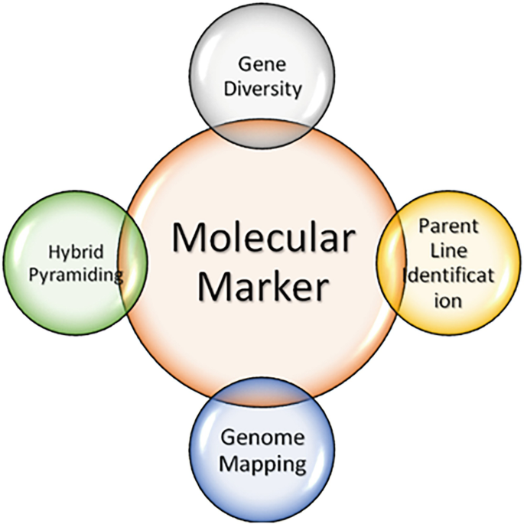
Marker-assisted selection (MAS) takes advantage of the fact that DNA markers are tightly linked with genes of interest, so the indirect selection can be made based on the marker genotype, not on the phenotypic analysis. MAS is particularly useful with low-heritability traits, late traits, costly phenotyping or sensitivity to the environment. Applications of MAS in fruit crops include disease resistance (e.g. powdery mildew in grape, apple scab resistance), quality improvement (e.g. acidity in fruits in citrus, sugar in mango), and seedlessness (e.g. watermelon, grape). It should be implemented successfully by first having prior genetic mapping to determine the association between markers and traits, confirming this association in genetically diverse populations and finally having a reliable cost effective method of doing the marker tests. In spite of conceptual attractiveness, MAS has not been widely used in fruit breeding in comparison with annual crops due to long breeding cycles that make validation difficult, trait complexity with multiple loci and inadequate development of markers in many economically valuable species.
Table 2: Applications of Molecular Markers in Fruit Crops
Fruit Crop | Marker Type | Application
Apple | SSR, SNP | MAS for scab resistance
Grape | SSR | Seedlessness selection
Citrus | SNP | CTV resistance
Mango | RAPD, SSR | Cultivar identification
Banana | SSR, SNP | Panama disease resistance
Strawberry | SNP array | Fruit firmness
Peach | SSR | Self-compatibility
Papaya | SCAR | Sex determination
Figure 4: Schematic Genomic Selection.
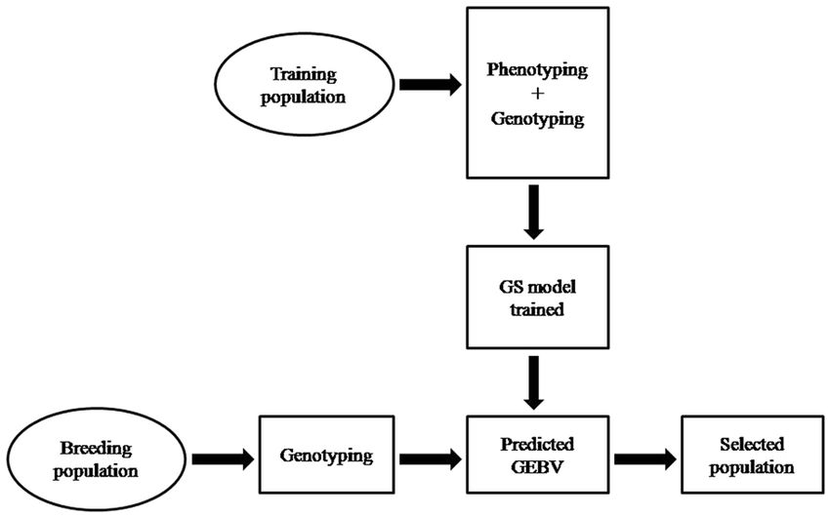

Genomic Selection and High-Throughput Phenotyping
Genomic selection (GS) is a shift in paradigm over traditional MAS, which uses genome-wide profiles of markers to predict values of breeding without prior knowledge of causal loci or marker-trait relationships. The methodology consists of training statistical prediction models based on training populations that include both the genotypic (dense marker data) and phenotypic data, and then uses these models on selection candidates who are genotyped but not phenotyped. GS finds the small-effect QTLs scattered throughout the genome and adds up to large phenotypic variance, thus overcoming issues of MAS that concentrates on several large-effect loci. The number of training population, hereditability of the trait, the density of the marker and the size of the effective population are all dependent factors in determining prediction accuracy. Simulation experiments and actual working experience with livestock and annual crops show a significant acceleration of genetic gain, and the shortening of cycle time allowed 2-3 fold higher levels of selection. In perennial fruit crops, GS has specific benefits, i.e., a significant reduction in the breeding cycle that can last many decades before genotypes express their phenotype and selection of the best ones in advance (Kerr et al., 2024; Vondracek et al., 2024).
Table 3: Genomic Resources Available for Major Fruit Crops
Fruit Crop | Genome Size (Mb) | Sequencing Status | SNP Density
Apple | 742 | Complete | High (>20M)
Grape | 475 | Complete | Very High
Strawberry | 240 | Complete | High
Peach | 227 | Complete | High
Citrus | 367 | Complete | Moderate
Banana | 523 | Complete | Moderate
Mango | 439 | Draft | Low
Use of GS in perennial fruit crops has transformative potential as it has lengthy generation periods and expensive field testing. The rapid breeding cycles, estimated to be between 15- 20 years, may be significantly shortened to 5-7 years by early-stage selection at the seedling stage, based on genomic estimated breeding values (GEBVs) and breeding timelines are transformed. The introduction of the GS studies in apple showed prediction accuracies of 0.4-0.7 on the fruit quality characteristics such as firmness, soluble solids content and acidity, confirming that this could be applied at regular intervals. The utility of GS was supported by similar studies in strawberry, grape, and citrus, accuracy of which differed depending on the trait architecture and population structure. Nonetheless, the cost of operating the scheme requires extensive upfront investments in population development training, high-density genotyping capacity, phenotype automation, and bioinformatics capacity, which is likely to be constrained where the target population is developing. Nevertheless, the long-term advantages, like increased genetic gain rate and less phenotyping expenses in new breeding generations, tend to be more than the initial investments (Biscarini et al., 2017).
In conjunction with genomic technology, high-throughput phenotyping systems, which apply computer vision, spectroscopy, and sensor-based phenotyping, allow the use of objective, rapid and in-depth trait measurements that overcome phenotyping bottlenecks in breeding. Non-destructive methods of measuring fruit morphology, color, blemishes and internal quality attributes are automated and produce high quality phenomic data to be used in predictive model training. Phenomics combined with genomics helps to deconstruct the interaction of genotype-environment interactions and determine stable and high performing genotypes in different production environments. This is essential to the success of building strong genomic models of prediction that can be accurate in predicting performance in different environmental conditions and thus maximize selection efficacy and decrease the number of field experiments (Blinkov et al., 2025).

CRISPR/Cas9 and Genome Editing Technologies
The CRISPR/Cas9 technology is the most radical development in the history of the genetics of plants since the principles of Mendelian inheritance, making it possible to specifically and precisely change the genome with more efficiency and capabilities than ever before. The system consists of two parts, including Cas9 endonuclease that produces two strands of DNA breaks at targeted sites and guide RNA (gRNA), that targets Cas9 to match to complementary target sequences on the basis of Watson-Crick matching. The introduction of breaks into the cellular DNA triggers cellular DNA repair: non-homologous end joining (NHEJ) produces small insertions/deletions resulting in gene knockouts, whereas the homology-directed repair (HDR) is a precise sequence replacement when donor template is available. In comparison to previous methods of genome editing (zinc finger nucleases, TALENs), CRISPR affords more simplified design, multiplexing of targeting, minimized off-target, and is economical democratizing access to research institutions worldwide. The accuracy of this breeding technology makes the creation of enhanced cultivars much faster by allowing the discovery of genes that are behind the desirable traits of interest and the direct manipulation of those genetic factors (Foster et al., 2019).
Figure 5: The areas of CRISPR/Cas9 application in fruits.
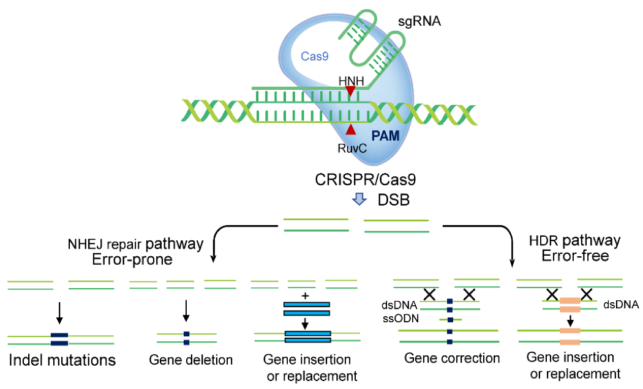
Fruit crop applications cut across a wide range of goals that deal with key production limitations and consumer requirements. Targeted disruption of susceptibility genes (S-genes) has produced powdery mildew-resistant grape, fire blight-resistant apple, and citrus canker tolerance with no penalty in terms of fitness cost to breeding resistance unlike conventional methods of resistance breeding. Quality enrichment of fruits involves brown color removal by polyphenol oxidase knockout in apples, increased sugar content by editing invertase in citrus, less acidity by malate transporter pathway editing, and an extension of shelf-life by knocking out the ethylene biosynthesis pathway. The targets of nutritional fortification are the increased concentration of carotenoids in banana and papaya, the anthocyanin concentration in strawberry and allergen concentration in peach. A desirable trait that is difficult to breed in traditional breeding methods such as seedlessness has been introduced in citrus and grape using knockout of genes that regulate ovules and seeds development. The incredible specificity and versatility of CRSIPR/Cas9 systems, especially because of the RNA-DNA recognition system to create double-strand breaks, have substantial benefits in the past technologies, such as TALENs and ZFNs (Sharma et al., 2023). This increased fine specificity and practicality of implementation enables quick and efficient genetic editing, resulting in accelerated crop enhancement by either a homology-guided repair to obtain a defined change in sequence or non-homologous end joining to produce gene knockouts (Martin-Valmaseda et al., 2023; Yu et al., 2017).
Genome editing in fruits has technical and regulatory issues in spite of its tremendous potential. The efficiency of transformation is low in most recalcitrant species, tissue culture procedures are genotype-specific and tedious and off-target mutations need extensive screening. Laws on genome-edited crops are different across countries, with some countries considering them as equivalent to conventional breeding (USA, Argentina, Japan) and others regulating them like transgenic organisms (European Union). The regulatory approach of India is still in development and there is a recent debate that SDN-1 type of edits (small indels not containing foreign DNA) will be better treated than SDN-2/SDN-3 edits. The issues of public acceptance, complexity of the intellectual property, and ethical issues concerning the germline modification require open communication between the scientists, the policy makers, and the consumers to achieve the benefits of technology in a pro responsible manner. Nevertheless, the introduction of novel genome editing tools including CRISPR/Cas9, TALENs, and ZFNs, which provide greater accuracy and less off-target in a given genomic locus, can serve as a route to circumvent some of the perceived opposition and strict regulatory control of the more conventional method of transgenic editing (Krishna et al., 2025).
Figure 6: Time to develop Variety.
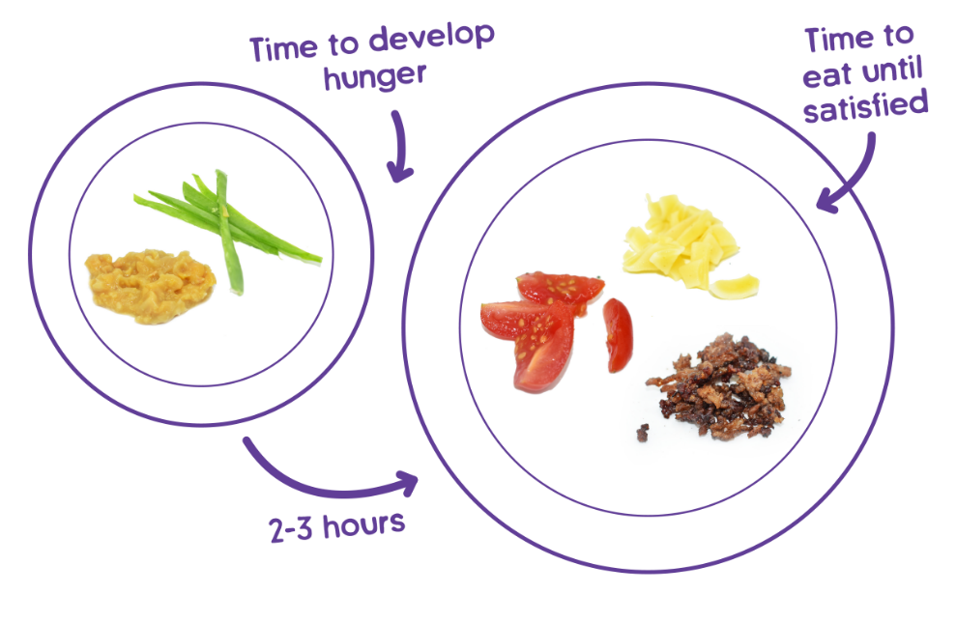

Breeding Achievements In India

Tropical and Subtropical Fruit Improvement
The high volume and variety of fruits that can be cultivated in India are due to the variety of agro-climatic conditions that range between tropical lowlands and temperate highlands making the country one of the largest in the production of fruits. In its turn, the national breeding programs have been coordinated through Indian Council of Agricultural Research (ICAR) institutes, which have systematically dealt with productivity constraints by improving the germplasm, which has led to introduction of many high-performing varieties, that are adapted to local conditions. A good example of breeding fruit is mango breeding, which has been spearheaded by Indian Agricultural Research Institute (IARI), Central Institute for Subtropical Horticulture (CISH) and regional centers where varieties such as Amrapali (dwarf, high density planting), Mallika (disease resistant, good quality), Pusa Arunima (early season) and Arka Aruna (biennial bearing control) are currently grown widely in the states. These varieties tackle very grave shortcomings on the old cultivar varieties such as irregular bearing, lengthy juvenile phase, and vulnerability to diseases such as powdery mildew and anthracnose. Equally, guava breeding has been aimed at producing guava varieties with better fruit quality, higher fruit yield, and resistance to wilt disease, which resulted in major cultivars, including Allahabad Safeda and Sardar (Singh et al., 2022). Banana improvement schemes have also been focused in coming up with disease-resistant and high-yielding hybrids, including those produced under the Grand Naine group, that have greatly improved the commercial production and export potential.
Table 4: Notable Fruit Varieties Developed by Indian Institutes
Institute | Fruit Crop | Variety | Special Features
IARI Delhi | Mango | Amrapali | Dwarf, regular bearing
CISH Lucknow | Guava | Allahabad Safeda | Large fruit, high yield
IIHR Bengaluru | Banana | Arka Anamika | Fusarium wilt resistant
NRCC Nagpur | Citrus | Nagpur Mandarin | High juice, excellent taste
ICAR-CHES Vittal | Pineapple | Lakhat | Red flesh, high TSS
IARI Delhi | Papaya | Pusa Dwarf | Gynoecious, high yield
IIHR Bengaluru | Grape | Arka Hans | Seedless, early maturity
CITH Srinagar | Apple | CITH-Ambri | Storage quality, hardy
IIHR Bengaluru | Passion fruit | Arka Purple | High pulp, disease resistant
Banana improvement programs at National Research Centre for Banana (NRCB), Trichy, and IIHR focused on work on varieties that are resistant to crippling Panama disease (Fusarium oxysporum f.sp. cubense tropical race 4) that endangers the world yield of bananas. Boosted by extensive screening, clones of the tissues having resistance were discovered, resulting in such a combination as Arka Anamika obtaining resistance to the disease in combination with favorable agronomic characteristics. The breeding work in citrus at National Research Centre of Citrus (NRCC), Nagpur focused on the development of seedless Mandarin, improvement of juice quality, and reduction of alternate bearing. Some of the varieties like Nagpur Seedless, Kinnow and Sathgudi are better adapted to the Indian environment than the introduced varieties. Breeding research on papaya was able to produce hermaphroditic varieties of papaya with better fruit traits and which were resistant to papaya ringspot virus which is a significant production limitation. Other fruits that are grown in tropics such as pineapple with varieties such as Lakhat have undergone breeding to achieve desirable flesh properties whereas grape breeding programs have targeted seedless with early maturity such as Arka Hans to meet modern demands in the market (K.M. et al., 2023).
Figure 7: Breeding Success Rates Methods.
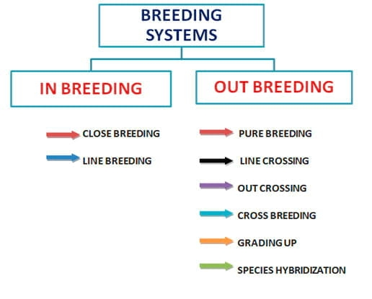
Fruit Breeding Temperate Breeding Programs.
India The practice of temperate fruit farming is concentrated in Himalayan states such as Jammu & Kashmir, Himachal Pradesh, and Uttarakhand and the crops include apple, pear, peach, plum and walnut. Sher-e-Kashmir University of Agricultural Sciences and Technology (SKUAST) is the forefront of apple improvement and it produces varieties that suit different altitudes with features that are responsive to changes in climatic conditions that have altered the temperatures of certain areas. Such varieties as SKAU-Red, Early Red One, and Firdous have better color development, lower chilling needs, and resistant to spring frost damages that are becoming more and more widespread with unpredictable weather conditions. The breeding of walnut at Regional Horticultural Research Station, Bajaura resulted in such cultivars as Lake English, Wilson and Tulip having high kernel recovery and uniform bearing, and also with resistance to blight which overcame the major constraints of production. On the same note, breeding of peach and plum have resulted in the development of varieties like Saharanur Prabhat and Santa Rosa, respectively, which have early maturity, better fruit quality and more resistance to disease and can be cultivated in various temperate conditions. In addition, breeding of peaches has been able to take advantage of hybridization to enhance the success of crossings and come up with varieties adapted to subtropical areas, which underscores the opportunity of expanding production to new locations (Rimpika & Sharma, 2021).

National Research Centre on grapes (NRCG), Pune, and IIHR had grape breeding efforts aimed at producing table grapes with enhanced export quality, seedless varieties with desirable berry traits, longer shelf lives, and peninsular Indian adaptation. Such types as Arka Hans (white seedless), Arka Shyam (black seedless) and Arka Kanchan (green seedless) have shown a better storability and a lower cracking tendency than the classical Thompson Seedless. Strawberry breeding IIHR came up with off-season varieties that would fit the subtropical conditions with less chilling needs enabling production at non-traditional times and import substitution. Nevertheless, temperature is a major limitation to the growing of fruit in temperate areas, especially the apple that has certain altitude peaks, and needs adequate chilling hours to be highly productive (Basannagari and Kala, 2013; Nautiyal et al., 2020). The decline in the number of necessary chilling hours and an increase in temperatures and unpredictable rainfall trends require the creation of low-chill varieties and genotypes resistant to heat to continue growing temperate fruits (Chhabra, 2023; Kochithara et al., 2025).
Figure 8: Expected Technology Adoption in Breeding.
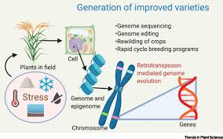
Challenges And Constraints
Technical and Resource Limitations.
Regardless of some extraordinary advancements, the breeding of fruits in India has to face complex problems, which limit the best development. The lack of infrastructure such as the lack of adequate field experimentation facilities, sufficient tissue culture laboratories, sufficient cold storage used in the conservation of germplasm, and one has outdated phenotyping equipment impedes smooth implementation of the program. There are several breeding stations that do not have climatic regulated green houses necessary in the year round affairs, in-season crossing and in keeping of separating populations. The high throughput genotyping systems are still concentrated in select few institutes which have limited accessibility by state agricultural universities and regional centers where a majority of field breeding activity takes place. The ability to analyze the complex genomic data, predictive modeling, and integration of the multi-omics data in bioinformatics is far behind parity, which imposes an analytical bottleneck even during the production of the sequencing data. Moreover, the long-lasting period of fruit crops combined with their large size requires a lengthy and tedious field experiment, which makes it more difficult to test large populations of plants and monitor numerous traits (Oguz et al., 2023). This prolonged selection process also complicates the formation of new varieties, in particular, those that adapt to climate change, requiring a high turnover in the generation of new varieties, as well as faster breeding cycles (Ebru et al., 2023; Letelier et al., 2020).

Another major constraint is human resources where there is a weakness of trained personnel in molecular breeding, bioinformatics, and advanced phenomics. The long-term nature of breeding teams due to perennial nature of fruit crops requires long-term commitment and yet what continues to be of problem is the fact that such frequent transfers and poor succession planning often interferes with the continuity of the program. The limited training opportunities and exchange programs result in young scientists being exposed to the best practices and latest technologies in the international market, limited networking, and exposure to the latest trends. Capacity building activities should focus on practical training in the latest breeding practices, statistical genetics, and computer applications as well as consolidation of the old horticultural practices. Moreover, the immense time needed to develop advanced breeding systems and infrastructure as well as the length of time to breed fruit crops puts up a huge hurdle of adaptation of advanced methods in resource-capped environments (Varshney et al., 2012; Xu, 2022).
Table 5: Major Challenges Facing Fruit Breeding Programs
Challenge Category | Specific Issue | Impact Level
Infrastructure | Limited lab facilities | High
Financial | Insufficient funding | Very High
Human Resource | Trained personnel shortage | High
Technical | Low transformation efficiency | Moderate
Regulatory | Complex approval process | High
Germplasm | Limited genetic diversity | Moderate
Coordination | Weak public-private linkage | Moderate
Regulatory and Policy Framework
The regulatory systems of genetically engineered and genome-edited living beings play a huge role in determining the path of technology uptake in breeding programs. India has highly regulated biosafety laws which are enforced under Genetic Engineering Appraisal Committee (GEAC), that involve a lot of confined field testing, environmental risk analysis, and food safety testing before commercialization. Although necessary to provide safety, 8-12 years approval periods significantly reduce the competitiveness of technology in relation to traditional breeding. The recent controversies on genome-edited crops have pointed out the issue of regulatory uncertainty, with existing regulations being designed to cover transgenic crops poorly reflecting the unique aspects of genome editing, especially SDN-1-based editing producing alterations that are indistinguishable of spontaneous mutation. This absence of various regulatory mechanisms hinders quick implementation of new traits that have been created through specific genomic manipulations hence failing to advance advancement in the enhancement of fruit crops (Zheng et al., 2025). This regulatory barrier is also exacerbated by the fact that the population currently does not trust GM organisms and is concerned with the long-term effects of gene editing, which requires open communication and comprehensive risk evaluation to bring the population on board (Puttegowda et al., 2024).
The current level of protection of intellectual property as applied to the fruit cultivars in India is still insufficient and the application of the Plant Varieties Protection Act has practical issues. Liberal enforcement allows unauthorized spreading and trading of the guarded varieties, which discourages the investment in breeding programs. The key to fostering innovation is in the creation of strong systems of variety identification by means of DNA fingerprinting, enhancement of registration mechanisms, and the enhancement of legal frameworks safeguarding the rights of breeders. At the same time, the right of farmers to save and use seeds should be accompanied by the balance with the motivation of institutional and individual breeding investments. The lack of a common legislative framework that can distinguish between genome-edited crops and genetically modified crops only adds to these problems as many countries, including India, are still formulating their own regulatory framework (Molla et al., 2024; Sardar, 2023; Tahakik et al., 2024).
Strategic Direction and Future Projections.
New Technology and Integration Policies.
In the future, breeding of fruits will extensively utilize the machine learning algorithms and artificial intelligence to predictively breed, allowing the determination of the best parental combinations, predicting hybrid performance and also optimization of crossing programs. Multi-year phenotypic and genotypic datasets can be used to train deep learning models that capture the complex interactions between genotypes and the environment, and can then be used to select stable and high-performing genotypes in a wide variety of production systems. High-throughput field phenotyping, measurements of canopy traits, fruit load, maturity measurements, and stress reactions can be measured with computer vision systems on unmanned aerial vehicles (UAVs) at scales and time scales never seen before. Such technologies make more advanced phenotyping technologies more democratic, eliminating the need to rely on manual measurements, which are costly, and enhancing the quality and repeatability of data. Moreover, the combination of robotic arms and AI with machine learning algorithms trained according to image recognition can further improve the accuracy of the processes of tissue identification and manipulation during micropropagation, and replicate interventions at the level of experts (Sota et al., 2025). The combination of AI and robotics with enhanced phenomics will simplify the breeding procedures, especially in the case of complicated traits, such as fruit size and environmental adjustability (Bu et al., 2025).
Speed breeding regimes based on photoperiodism, confined conditions, and early flower induction provide a prospect of reducing the generation times in amenable species, allowing to breed two-three generation yearly, not one as in the field setting. Although much has been done on cereals, perennial fruits demand adaptation to overcome biological limitations such as the obligatory juvenility stages and vernalization. There is some potential in emerging technologies such as rapid cycling through embryo rescue, in vitro flowering induction and the use of growth regulators in the selected species. The multi-omics integration of genomics, transcriptomics, proteomics and metabolomics can give a systems level perspective on how the traits are expressed in the organism, indicating regulatory networks and defining new targets on which breeding interventions could act. Epigenetic alterations that affect trait expression without impacting DNA sequence variations are the new frontiers that may be used to improve traits. These combined strategies and phenotyping bottleneck are combined with sophisticated phenotyping and AI-based data analysis that is vital to addressing the problem of overcoming the phenotyping bottleneck and enhancing the creation of climate-resilient fruit crops (Naqvi et al., 2024; Pacheco-Ruiz et al., 2025; Thingujam et al., 2025).
Table 6: Emerging Technologies for Future Breeding Programs
Technology | Application Area | Potential Impact
AI/Machine Learning | Predictive breeding models | Very High
Speed Breeding | Generation time reduction | High
Nanobiotechnology | Targeted delivery systems | Moderate
Digital Phenotyping | Trait measurement automation | Very High
Epigenome Editing | Gene regulation | Moderate
Synthetic Biology | Novel trait creation | High
Multi-omics Integration | Systems understanding | High
Blockchain | Variety traceability | Moderate
Strategic Recommendations for India
Realizing fruit breeding program potential in India necessitates coordinated, multi-stakeholder efforts solving technical, financial and policy aspects. The priorities are: (i) Infrastructure modernization by setting up regional breeding centers through the establishment of molecular breeding centers with genotyping platforms, tissue culture facilities and controlled environment chambers accessible to more than one breeding program; (ii) Sustained funding increase through 500-750 crore annually dedicated to fruit crop improvement to ensure that the program remains stable even without the project, (iii) Human capital development by running international training programs and post-doctoral fellowships in the latest technologies and incentivized development of young talent to get into horticultural research careers;
Enhancement of public-private liaisons can speed up the commercialization process of technologies, which has been shown to utilize the efficiency of the private sector in the multiplication of varieties, marketing, and access to farmers in addition to keeping the public sector focused on the basic research and development of germplasm. Introduction of pre-breeding careers and programs on exotic germplasm introgression, use of wild relatives and expanded genetic bases solve the problem of diversity constraints that confines modern breeding populations. The access to technologies, exchange of germplasm and capacity strengthening are brought about by international cooperation, bilateral agreements, CGIAR partnerships, and South-South cooperation. Lastly, climate change-anticipated breeding that considers heat tolerance, water-use efficiency, and extreme weather resilience cannot be overestimated in the view of the predicted rise in temperatures and fluctuations in precipitation causing unsustainable fruit production in susceptible areas.

Table 7: Strategic Recommendations for Accelerating Fruit Breeding
Priority Area | Specific Recommendation | Implementation Timeline
Infrastructure | Regional breeding hubs | 3-5 years
Funding | Dedicated allocation increase | Immediate
Training | International fellowships | 2-3 years
Technology | Genomic selection adoption | 2-4 years
Collaboration | Public-private partnerships | 1-2 years
Germplasm | Pre-breeding programs | 3-5 years
Regulation | Streamlined approval process | 1-2 years
Climate | Resilience breeding focus | Ongoing
Conclusion
Breeding of fruit crops has switched between the empirical selection to the precision genomics-enabled enhancement that provides unprecedented possibilities to solve the production constraints, improve nutritional quality and protect against climate resilience. The combination of traditional and molecular methods utilizing complementary advantages is used to speed up genetic accession and sustainability of breeding programs. Systematic improvement of germplasm by Indians has produced many successful varieties, although much more are possible, and the challenge has been the lack of infrastructure, resources and policies to exploit the opportunities. India can be a leader in the genetics of fruit and this can be achieved through strategic investments in technology platforms, human capital and facilitating policy frameworks. The new technologies such as artificial intelligence, speed breeding, and advanced gene editing all hold potentially radical consequences, although the implementation of such technologies must be associated with the proper focus on the biosafety, ethics, and fair access. The next few decades will see breeding programs produce climate-adapted, nutritionally modified, and sustainable productive varieties of fruit that will be needed to assure food security, the success of farmers, and the health of consumers in future resource-challenged and warmer uncertain climates.
References
Ahmad, R., Anjum, M. A., Naz, S., & Balal, R. M. (2020). Molecular Markers in fruit crops in breeding programs Applications- Review. Phyton, 90(1), 17. https://doi.org/10.32604/phyton.2020.011680
Anand, A., Subramanian, M., & Kar, D. (2023). Breeding processes [ Review of Breeding technologies to allocate more genetic returns]. Frontiers in Plant Science, 13, 1076094. Frontiers Media. doi.org/10.3389/fpls.2022.1076094.
Antiwi-Boasiako, A., Amponsah, P., Opoku, J. A., Coulibaly, D., and Mintah, P. (2024). Hopefully, enhancing the productivity of the Mangoes production in the shifting climate. In IntechOpen eBooks. IntechOpen. https://doi.org/10.5772/intechopen.112951
Basannagari, B., & Kala, C. P. (2013). Indian Himalayas Apple Farming, Climate change A study of the local perception and reaction. PLoS ONE, 8(10). https: doi.org.10.1371.journal.pone.0077976.
Begna, T. (2021). Traditional Interventions Breeding Virulently, in an attempt to enrich Self-Pollinating Crop. International Journal of Research Studies in Agricultural Sciences, 7 ( 1). doi.org/10.20431/2454-6224.0701001.
It provides an in-depth overview of the results and the importance of a targeted solution to the needs of small businesses and the entrepreneurial community at large. Identification of mutagenic sensitivity and its manifestation on papaya (Carica papaya L.) cv. Arka Prabhath. Journal of Horticultural Sciences, 18 (1) 27. doi:10.24154/jhs.v18i1.2143.
Bhavanee, Krishnamoorthi, Rathva, H. M., Mareguddikar, S. C., Singh, A., Singh, B. P., Nageshwar and Chittibomma, K. (2024). A number of developments in Genetic Engineering in order to enhance the Characteristics of Horticulture Crop: A Comprehensive Review [Review of Advancements in Genetic Engineering in order to enhance Characteristics of Horticulture Crop: A Comprehensive Review]. 90 Journal of Advances in Biology and Biotechnology, vol. 27, issue 2. Sciencedomain International. doi 10.9734/jabb/2024/v27i2702.
Biscarini, F., Nazzicari, N., Bink, M. C. A. M., Aruses, P., Aranzana, M. J., Verde, I., Micali, S., Pascal, T., Quilot Turion, B., Lambert, P., Linge, C. da S., Pacheco, I., Bassi, D., Stella, A., Rossini, L. (2017). Prediction of fruit weight and quality Fruits weight and quality prediction by repeated prediction of fruit weight and quality with genome-enabled method on European peach progenies. BMC Genomics, 18(1). https://doi.org/10.1186/s12864-017-3781-8
Blinkov, A. O., Kroupin, P. Yu., Dmitrieva, A. R., Кочешкова, А. A., Karlov, G. I., and Дивашук, M. G. (2025). Speed breeding: protocols, application and achievements [Review of Speed breeding: protocols, application and achievements]. Frontiers in Plant Science, 16. Frontiers Media.
Bu, H., Sun, X., Hu, Y., Gu, G., Yang, Y., & Yu, W. (2025). Progress in the Study of Fruit Size Regulation Coherent Regulatory Approach of Genetic, Hormonal, Epigenetic, and Environmental Control. Biology, 14(12), 1643. doi.org/10.3390/biology14121643.
Bura, S., Jasrotia, A., Sharma, S., Sharma, A. and Tutlani, A. (2023). Recent Popularizations in Mango breeding: A Review of the Mangifera indica. The next article that resembles the title of the first one was published a year later in the book titled International Journal of Environment and Climate Change, 13(11), 521: I would rather exist as a man-made organism than a flow-level creature or a tree-like organism.
Chhabra, O. (2023). Climate change upon climate change shattering governments world round. NeuroQuantology, 17(2). doi.org/10.48047/nq.2019.17.02.2000.
Dinesh, M. R., Ravishankar, K. V. and Sangma, D. M. (2016). The History of India Mango Breeding and Future. JH S 11(1), 1. https://doi.org/10.24154/ jhs.v11i1.95.
Ebru, N., Kafkas, Y., Celik, H., Oguz, I., Oguz, H. I., Attar, S. H., Duygu, A., Sonemez, H., Celik, N., Ebru, Y., Kafkas, J., Lichtenberg, T., Graves, M., Yurtmen, A., Ali, A., Hameed, W., Alam, Y., Korkom, V., etc. Yurtmen, M. (2023). Edible Berries - New Insights. In IntechOpen eBooks. IntechOpen. https://doi.org/10.5772/intechopen.105241
Farajpour, M., Arab, M. M., Katam, R., and Sadat -Hosseini, M. (2023). Horticultural resources Genetic. Placing the future generation of scientists in the plant science sector, 14. doi.org/10.3389/fpls.2023.1264597.
Farinati, S., Scariolo, F., Palumbo, F., Vannozzi, A., Barcaccia, G., and Lucchin, M. (2023). Heterosis of breeding of horticultural crop: a blend of ancient theoretical foundation and the new genomic perspectives. Frontiers in Horticulture, 2. https: doi.org/10.3389/fhort.2023.1250875.
Foster, T., Bassil, N., Dossett, M., Worthington, M. and Graham, J. (2019). Breeding Rubus: Genetic and Genomic Resources to breeding [Review of Genetic and genomic resources to Rubus breeding: the future]. Horticulture Research, 6(1), 116. Nature Portfolio. doi.org/10.1038/s41438-019-0199-2.
Gaurha, A. Dewangan, R. K., Minz, V., Shukla, S., Shrivastava, P. and Yamini, Y. (2024). Fast Track Breeding of Fruit Crops: A new Approach [Review of A Comprehensive Review on Fast Track Breeding of Fruit Crops: A new Approach]. PLANT ARCHIVES, 24(1). Dr. R.S. Yadav. plantarchives.2024.v24.no.1.127. doi.org.10.51470.
Irfan, A., Joyia, F. A., Mustafa, G., Mirza, S. A. and Khan, M. S. (2022). Recent Dynamics to enhance Tropical Plants: Biotechnological Interventions. In IntechOpen eBooks. IntechOpen. https://doi.org/10.5772/intechopen.108532
Kerr, S. C., Shehnaz, S., Paudel, L., Manivannan, M. S., Shaw, L. M., Johnson, A. J., Velasquez, J. T. J., Tanurdzic, M., Cazzonelli, C. I., Varkonyi-Gasic, E., and Prentis, P. J. (2024). Due to the development of tree genomics, there should be an increase in orchard production to a next generation. Frontiers in Plant Science, 14. https://doi.org/10.3389/fpls.2023.1321555.
Kulshreshtha, N., H.P., V., Krishnamurthy, D., K., J. R. S. R., Pathak, H., K.M., B., P.S., B., Kakade, V., C.B., H., Khapte, P. S., G.R., H., Krishnamurthy, D., K., J. R. S. R., Naik, B., K., J. R. S. R., and Pathak, H. (2023). Indian situation: attitude and perception with regard to Abiotic Stress-Tolerant Crop Varieties. In IntechOpen eBooks. IntechOpen. https://doi.org/10.5772/intechopen.1001916
Kochithara, E. J., Sharma, S. K., Banyal, S. K., Kumar, U., and Jaswal, S. (2025). A study of the potential of exotic fruits crops in sub-Himalayan region of India. Discover Plants., 2(1). doi.org/ 10.1007/s44372-025-00433-8.
Vennapusa, A. R., Krishna, S. S and Melmaiee, K. (2025). Enhancing quality and climatic resilient traits in vegetatively propagated polyploids: transgenic and genome editing advances, constraints and future opportunities [ Review of Enhancing quality and climate resilient characteristics in vegetatively propagated polyploids: transgenic and genome editing advances, challenges and future directions). Frontiers in Genetics, 16. Accessed on 14 March, 2021.
Radhakrishnan, T., Kumar, P., Irfan, M., Siddiqui, M. W., Liao, W., and Kumar, P. (2023). Editorial: Traditional breeding to recent biotechnological development of horticultural crops - enhancement of traits and stress resistance. Frontiers in Plant Science, 14. doi:10.3389/fpls.2023.1293682.
Lamo, K., Bhat, D. J., Kour, K., and Solanki, S. P. S. (2017). Mutation Studies in Fruit Crops: A Review [Review of Mutation Studies in Fruit Crops: A Review]. 6(12) 3620 International Journal of Current Microbiology and Applied Sciences. Excellent Publishers. doi.org/10.20546/ijcmas.2017.612.418.
Letelier, L., Gaete-Eastman, C., Peñailillo, P., Moya-Leon, M. A., and Herrera, R. (2020). Southern Species From the Biodiversity Hotspot of Central Chile: A Source of Color, Aroma, and Metabolites in a Scenario of Climate Change [Review of Southern Species From the Biodiversity Hotspot of Central Chile: A Source of Color, Aroma, and Metabolites in Global Agriculture and Food Industry in a Scenario of Climate Change. Frontiers in Plant Science, 11. Frontiers Media. doi: /10.3389/fpls.2020.01002.
Lobato-Gomez, M., Hewitt, S., Capell, T., Christou, P., Dhingra, A., and Girpon-Calva, P. S. (2021). Genome-edited and transgenic fruit: Background, constraints, benefits, and commercial opportunities [ Review of Transgenic and genome-edited fruits: background, constraints, benefits, and commercial opportunities). Horticulture Research, 8(1), 166. Nature Portfolio. doi.org/10.1038/s41438-021-00601-3.
Wani, S. H., Manzoor, I., Samantara, K., Bhat, M. S., Farooq, I., Bhat, K. M., Mir, M. A. and Wani, S. H. (2023). Evolutionary genomics Genomics Evidence Diversity Experiments on and enhancement of traits in temperate fruit and nut crops under changing climatic conditions [ Review of Advances in genomics for diversity studies and trait improvement in temperate fruit and nut crops under changing climatic scenarios]. Frontiers in Plant Science, 13. Frontiers Media. doi.org/10.3389/fpls.2022.1048217.
Martin-Valmaseda, M., Devin, S. R., Ortuño-Hernandez, G., Perez-caselles, C., Mahdavi, S. M. E., Bujdoso, G., Salazar, J. A., Martinez-goomez, P. and Alburquerque, N. (2023). CRISPR/Cas as Genome- Editing Technique in Breeding Fruit Trees [Review CRISPR/Cas as Genome-Editing Technique in Breeding Fruit Trees]. 24(23), 16656, International Journal of Molecular Sciences. Multidisciplinary Digital Publishing Institute. https:doi.org/10.3390/ijms242316656.
Mathiazhagan, M., Chidambara, B., Laxman, R.H. and Ravishankar, K. V. (2021). Tropical Fruits Genomic Approaches to Improve Tropical Fruits: Fruit Quality, Shelf Life and Nutrient Content [Review of Genomic Approaches to Improve Tropical Fruits: Fruit Quality, Shelf Life and Nutrient Content]. Genes, 12(12), 1881. Multidisciplinary Digital Publishing Institute. https://doi.org/121881/genes1212181.
Molla, K. A., Chakravorty, N. and Bansal, K. C. (2024). Genome editing of food, nutrition and health. The Nucleus, 67(1), 1. https://doi.org/10.1007/s13237-024-00492-4
Naqvi, R. Z. Mahmood, M. A., Mansoor, S., Amin, I. and Asif, M. (2024). The application of omics is applied to extend food and fiber crops using discovery and mining of important functional genes. 14. Frontiers in Plant Science, doi.org/ 10.3389/fpls.20 23.1273859.
Nautiyal, P., Bhaskar, R., Papnai, G., Joshi, N., and Supyal, V. (2020). Effects of Climatic change on the Apple Phenology and Adaptability of medium Chilling Cultivar of Uttarakhand (Lower Hills) (Anna Variety). International Journal of Current Microbiology and Applied Sciences, issue 9, vol. 9, p. 453. doi.org/10.20546/ijcmas.2020.909.057.
Ozguz, İ., Ozguz, H. I., Attar, S. H., Sönmez, D. A., Celik, H., and Kafkas, N. E. Y. (2023). Preferred Berry Fruits of International Climate Change and Dry Periods Tolerance. In IntechOpen eBooks. IntechOpen. https://doi.org/10.5772/intechopen.1002222
Oyebamiji, Y. O. Shamsudin, N. A. A., Ikmal, A. M., and Rafii, M. Y. (2023). Effects and Management systems of Heat Stress in Vegetables [Review of Heat Stress in Vegetables: Impacts and Management Strategies -A Review]. Sains Malaysiana, 52(7), 1925. Penerbit Universiti Kebangsaan Malaysia. https.
Pacheco-Ruiz, P., Osorio, S., and Vallarino, J. G. (2025). Data to decisions: converting fruit agriculture through the coming together of multi-omics, the current phenotyping and the latest bioinformatic applications. Frontiers in Plant science 16, 1707289. doi.org/10.3389/fpls.2025.1707289.
Pandolfini, T., Mezzetti, B. and Folta, K. M. (2023). Review Article: Fruits breeding: Genetic engineering technologies, volume II. Frontiers in Plant Science, 14. doi.org/10.3389/fpls.2023.1264914.
Pandey and Devi, Gireesha and Doggali, Tiwari, U, Laishram, B., and Puttegowda, K. (2024). The unpredictable: The fascinating world of innovations that will help in the future development. Google Scholar, 441. doi.org/10.33545/2618060x.2024.v7.i1f.262.
Ranga, A. D., Vikram, A., Kumar, R., Dogra, R. K., Sharma, R. and Sharma, H. R. (2024). Heterosis exploitation and combining ability potential to improve okra ( Abelmoschus esculentus L.). Scientific Reports, 14(1) 24539. doi: 10.1038/s41598-024-75764-9.
Rimpika, & Sharma, D. (2021). Enhancement in Breeding Peach, Plum and apricot. In IntechOpen eBooks. IntechOpen. https://doi.org/10.5772/intechopen.100284
Sardar, A. (2023). CRISPR Genome Editing of fruit and vegetable crops to genetic ameliorate resistance to biotic and abiotic stress [ Review of Genetic amelioration of fruit and vegetable crops to increase biotic and abiotic stress resistance through CRISPR Genome Editing]. Frontiers in Plant Science, 14. Frontiers Media. doi.org/10.3389/fpls.2023.1260102.
Sarkar, T., & Mondal, T. (2024). Recent discoveries on mutation breeding of fruits. International Journal of Agriculture and Food Science, 6 (2), 166. doi: 10.33545/2664844x.2024.v6.i2c.220.
Sharma, P., Pandey, A., Malviya, R., Dey, S., Karmakar, S., and Gayen, D. (2023). Enhancement of nutritional quality of genome editing of fruits and vegetables and ornamental, post-harvest stress tolerance, and post-harvest shelf life, and nutritional quality [Review of Genome editing to enhance nutritional quality, post-harvest shelf life and stress tolerance of fruits, vegetables and ornamentals]. Frontiers in Genome Editing, 5. Frontiers Media. https://doi.org/10.3389/fgeed.2023.1094965.
SHARMA, R., Bakshi, P., Kumar, R., Sharma, A. K., Maanik, M., Thakur, N., Kumar, V. and Gheware, K. M. (2023). Bio fortification of fruit crops to enhance nutritional value: A review [ Review of Enhancing nutritional value in fruit crops through biofortification: A comprehensive review]. Vidya, 93(11) Indian Journal of Agricultural Sciences. Indian Council of Agricultural Research. doi: /10.56093/ijas.v93i11.140995.
Shiming, H. (2025). Progress and prospects in genetic enhancement of kiwifruits (Actinidia spp): A review [ Review of Advances and challenges in kiwifruits (Actinidia spp.) genetic improvement: A comprehensive review]. Asian Journal of Agriculture and Biology. Life Sciences Society Of Pakistan, 2025, 0:140 doi:/ 10.35495/ ajab.2025.140.
Singh, K. H., Chauhan, J. S., Choudhury, P. and Thakur, A. K. (2022). Recent advances in breeding of crops, induction of varietal in seed chain and its consequences on production of food grains in India. Indian Journal of Genetics and Plant breeding, 82(3) 259, doi: 10.31742/ isgpb.82.3.1.
Sota, V., Wilms, H. J., Yucesan, B., Mendi, Y. Y., Christie, B., Nisler, J., Aslan, S. E., Purmale, L., Silvestri, C., Werbrouck, S., Fischerova, L., Aronen, T., Cvjetkovic, B. and Lambardi, M. (2025). The fruit species with economic value have been challenging to micropropagate in Europe. Plant Cell Tissue and Organ Culture (PCTOC), 162(3). doi:10.1007/s11240-035-03165-5.
Soyam, S. R., & Apturkar, A. M. (2021). A review: Breeding in chilli. International journal of chemical studies, 9, 171. doi: 10.22271/ chemist. 2021. v9.i1d. 11560.
At the end of the article, a case study of findings, research questions and conclusions will be provided. Recent developments on mutagenesis of fruit crop that will be developed commercially: A review. Plant Science Today. https.
Suprasanna, P., & Jain, S. M. (2023). Genome Editing, In Vitro and Transgenic Techniques of Enhancing Fruits Crop. Horticulturae, 9 (1), 58. https: doi.org/10.3390/horticulturae9010058.
Tahakik, R., Deshmukh, A. G., Moharil, M. P., Jadhav, P. V., Kogade, V. T., More, K. D., & Shinde, V. (2024). Green Revolution to the Gene Revolution: Crop Nutritional security maintenance of the traditional climate resistant crop with enhanced gene manipulation. Bulletin of the National Research Centre/Bulletin of the National Research Center, 48(1). https:// doi.org/10.1186/ s42269- 024-01281- 4.
Thakur, R., Singh, V., & Banerjee, D. (2023). Fruit crops can be subjected to Molecular Marker in order to unveil their properties and Genetical Diversity Analysis. E3S Web of Conferences, 453, 1020. doi: 10.1051/e3sconf/202345301020.
Thingujam, D., Gouli, S., Cooray, S. P., Chandran, K. B., Givens, S., Gandhimeyyan, R. V., Tan, Z., Wang, Y., Patam, K., Greer, S. A., Acharya, R., Moseley, D., Osman, N., and Zhang, X. Brooker, M. P., Tagert, M. L. M., and many others. Mukhtar, M. S. (2025). Climate resilient Crops: AI based Multi-Omics and State-of-Art Phenotyping to solve Global Agricultural and Societal Problems. Plants, 14(17), 2699. https://doi.org/10.3390/plants14172699
Varshney, R. K., Ribaut, J., Buckler, E. S., Tuberata, R., Rafalski, J. A., and Langridge, P. (2012). Does genomics enhance the productivity of orphan drugs? Nature Biotechnology, 30: 12, 1172. doi.org/10.1038/nbt.2440.
Vondracek, Katharina, Altpeter, Ferdinand, Liu, Tzu-Chi and Lee, Shin. (2024). The genomics and genome editing developments in terms of improving strawberry (Fragaria x ananassa). Frontiers in Genetics, 15. doi.org/10.3389/fgene.2024.1382445.
Xu, X. (2022). Significant issues of the commercial horticulture. Frontiers in Horticulture, 1. https://doi.org/10.3389/fhort.2022.980159.
Yu, Q., Wang, B., Li, N., Tang, Y., Yang, S., Yang, T., Xu, J., Guo, C., Peng, Y., Wang, Q., and Asmutola, P. (2017). Targeted Mutagenesis and Genes Replacement CRISPR/Cas9 -targeted Mutagenesis and Genes Replacement to Produce Long-shelf Life Tomato Lines. Scientific Reports, 7(1). doi: s41598-017-12262-1.
Zheng, L., Zhang, H.R., Zhang, S., Hua, Y. and Li-hu, W. (2025). Opinion: Genetic engineering and biotechnology of crops and genome adaptation to stress. Genetics 16. doi.org/10.3389/fgene.2025.1694599.
Ziogas, V., Bazakos, C. and Molassiotis, A. (2023) Editorial: The physiological and molecular factors of fruit ripening and development and using it in quality improvement acquisition. Frontiers in Plant Science, 14.https: doi.org/10.3389/fpls.2023.1138912.

