Refractance Window Drying of Nutmeg mace: Drying kinetics and Quality Characteristics in comparison with Hot-air drying

ABSTRACT
This study investigated the drying kinetics, mass transfer characteristics and quality attributes of nutmeg mace (Myristica fragrans Houtt.) dried using Refractance window drying (RWD) in comparison with conventional hot-air drying (HAD). Refractance window drying exhibited faster moisture removal and a higher effective moisture diffusivity (4.76 × 10⁻⁸ m² s⁻¹) than hot-air drying (4.56 × 10⁻⁸ m² s⁻¹). Moisture removal under both drying conditions occurred predominantly in the falling-rate period. Among the thin-layer drying models evaluated, the logarithmic model provided the best fit to the experimental moisture ratio data for both RWD and HAD. In addition, RWD yielded dried nutmeg mace with lower water activity (0.50), superior retention of the characteristic red colour and higher total phenolic content (14.26) compared with hot-air drying. The findings demonstrate that refractance window drying is an effective low-temperature dehydration technique for improving drying efficiency and preserving quality attributes of high-value nutmeg mace.
Keywords: Refractance window drying; Nutmeg mace; Drying kinetics; Effective moisture diffusivity; Thin-layer modelling; hot-air drying
1. INTRODUCTION
Nutmeg mace is the red, fleshy, lobed and net-like aril that envelops the albuminous seed of Myristica fragrans Houtt. As one of the two principal primary products of the nutmeg fruit, mace is a high-value commercial spice with considerable economic importance in the global market. The commercial grade and market value of mace are predominantly determined by its distinctive aroma and colour, which are mainly associated with the presence of lycopene and related pigment compounds. In addition, mace contains a markedly higher proportion of fragrance-defining carbazole alkaloids compared with nutmeg seed, thereby contributing significantly to its superior aromatic quality and commercial preference (Elfia and Susilo, 2023).
Nutmeg mace possesses substantial pharmaceutical and medicinal relevance due to its richness in bioactive secondary metabolites, particularly essential oil constituents such as myristicin, elemicin and several lignans. It is extensively used in traditional systems of medicine for the treatment of gastrointestinal disorders. Contemporary pharmacological studies have demonstrated that mace extracts exhibit antioxidant, anti-inflammatory, antimicrobial and neuroprotective activities and have also shown potential as broad-spectrum anticancer agents. In addition to its therapeutic applications, nutmeg mace has gained increasing attention for advanced technological uses, including the green synthesis of silver nanoparticles for agrochemical and biomedical applications (Ullagaddi, 2025).
From a processing and industrial perspective, nutmeg mace constitutes an important raw material for the extraction of essential oils used in oral-care products, perfumery and emerging applications such as active food-packaging systems. However, the retention of its characteristic aroma and colour remains a major technological challenge, as its volatile oil constituents and pigment compounds are highly susceptible to degradation under adverse environmental and processing conditions. Furthermore, nutmeg mace is harvested within a short and highly concentrated seasonal window, typically from May to July, which increases the risk of post-harvest losses and quality deterioration in the absence of timely and effective preservation interventions. Therefore, the adoption of appropriate and efficient drying strategies is essential to minimize the degradation of volatile and bioactive constituents and to ensure the preservation of its high-value functional and pharmacological attributes (Suthisamphat et al., 2020).
Refractance Window (RW) drying is recognized in food engineering as a sophisticated fourth-generation thin-film dehydration technology specifically designed for the preservation of heat-sensitive biological materials (Borse et al., 2025). Technically categorized as a variant of Cast-Tape Drying (CTD), the process involves spreading a wet product on an infrared-transparent polymeric film that floats atop circulating hot water (Kumar et al., 2024). The system operates by exploiting refractive index mismatches between the heating medium, the contact film (typically Mylar®), and the moist product to create a unique "window" for thermal radiation (He et al., 2024). A distinctive feature of this technology is its self-regulating heat transfer mechanism; as the product reaches dryness, the "window" gradually closes, naturally reducing the heat flux and preventing the product from overheating (Silva et al., 2024). Consequently, RWD is highly valued for its energy efficiency and its ability to yield high-quality products at a fraction of the capital investment and energy input required for freeze-drying (Nindo and Tang, 2007).
Although RW drying has been successfully applied to diverse high-value commodities such as saffron (Aghaei et al., 2019), aloe vera (Ayala-Aponte et al., 2021), and mango (Ochoa-Martínez et al., 2012), there is currently no documented scientific study addressing its application specifically for nutmeg mace. Furthermore, comparative data regarding drying kinetics, effective moisture diffusivity, and activation energy for nutmeg mace under RW conditions in relation to conventional hot-air drying remains notably absent from existing literature (Rurush et al., 2022). Additionally, despite the demonstrated capability of RW systems to maintain the aromatic and bioactive integrity of various medicinal and aromatic plants (Kaveh et al., 2024), detailed investigations focusing on the volatile retention and microstructural stability of nutmeg mace processed with this emerging technology have not yet been reported.
In this context, the present investigation focuses on determining the engineering properties of nutmeg mace relevant to post-harvest handling, performing a comparative evaluation of quality characteristics between RW and conventional hot-air drying, and providing a rigorous analysis of the drying behaviour and kinetics associated with both systems.
2. MATERIALS AND METHODS
2.1 Sample preparation
Fresh nutmeg mace samples were procured from a local farmer at Tavanur, Malappuram district, Kerala, India. The mace was collected at physiological maturity, corresponding to the stage at which the nutmeg fruit naturally splits into two halves, exposing the aril. The freshly harvested mace samples were manually sorted to remove extraneous matter and subsequently washed using potable water. Surface moisture was removed by gently wiping the samples prior to further experimentation. The initial moisture content of fresh nutmeg mace was in the range of 50–60% (wet basis).
2.2 Refractance window drying system
Refractance window drying of nutmeg mace was carried out using a refractance window drying unit operated with a static hot-water bath maintained at 50 °C. A polyethylene terephthalate (PET) transparent film with a thickness of 125 µm was used as the infrared-transparent interface between the heating medium and the product. The effective cross-sectional drying area of the system was 0.0725 m². Nutmeg mace samples were uniformly spread on the surface of the PET film as a thin layer with a thickness of 1 cm for all drying experiments.
2.3 Hot air-drying system
Drying experiments using conventional hot-air drying were carried out in a convective hot-air dryer operated at a drying air temperature of 45 °C, which was selected as the control condition. Nutmeg mace samples were uniformly spread on the drying trays as a single layer with a thickness of 1 cm. The air velocity inside the drying chamber was maintained at 3 m s⁻¹.
2.4 Drying experiment
Drying experiments were carried out using 100 g of fresh nutmeg mace for each experimental run. During both Refractance window drying and hot-air drying, the samples were periodically removed from the dryer and weighed at 30 min intervals using a digital balance to monitor moisture loss. Drying was continued until the samples attained a final moisture content in the range of 7–10% (wet basis). All drying experiments were performed in triplicate for each drying method to ensure reproducibility of the results.
2.5 Moisture content determination
The moisture content of the samples was determined using the standard hot-air oven method as described in Kheto et al. (2025) (Eqn 1). A representative portion of the dried sample was placed in a hot-air oven maintained at 105 °C and dried until a constant weight was attained.
${MC}_{wb}\left(\%\right)= \frac{W_{i}-W_{d}}{W_{i}} ×100$ (1)
${MC}_{wb}$= moisture content on wet basis (%)
$W_{i}$= initial mass of sample before oven drying (g)
$W_{d}$ = mass of sample after oven drying to constant weight (g)
2.6 Engineering properties of fresh nutmeg mace
The engineering properties of fresh nutmeg mace were determined in order to generate the physical data required for the design and optimisation of drying, handling and post-harvest processing operations. The principal dimensions of nutmeg mace, namely length, width and thickness, were measured for randomly selected samples using a digital vernier caliper with an accuracy of 0.01 mm. The measured dimensional parameters were used to compute the sphericity of nutmeg mace in accordance with the method described by Mohsenin (1986). The bulk density of nutmeg mace was determined by gently filling a container of known volume with the samples without applying any external compaction and recording the corresponding mass. Bulk density was calculated as the ratio of the sample mass to the occupied volume, following the procedure reported by Yoha et al. (2020). The true density of nutmeg mace was determined using the toluene displacement method as described by Mohsenin (1986). The porosity of nutmeg mace was subsequently calculated from the experimentally determined bulk and true density values using the relationship reported by Rajoriya et al. (2020). The colour characteristics of fresh nutmeg mace were determined in terms of CIE L*, a* and b* coordinates using a colour measuring instrument. The chroma (C*) and hue angle (h°) values were calculated from the measured L*, a* and b* values in accordance with the standard colourimetric relationships described by Pathare et al. (2013).
2.7 Drying characteristics
Drying experiments were conducted using 100 g of fresh nutmeg mace for each experimental run. During both refractance window drying and hot-air drying, the samples were removed at 30 min intervals and weighed using a digital balance to monitor moisture loss. Drying was continued until the samples attained a final moisture content in the range of 7–10% (wet basis). All experiments were carried out in triplicate.
2.7.1 Drying kinetics
The drying behaviour of nutmeg mace was analysed in terms of moisture ratio and drying rate. The moisture ratio (MR) was calculated using Eqn. 2 (Nguyen et al., 2022).
$MR=\frac{M_{t}}{M_{0}}$ (2)
where $M_{t}$is the moisture content at time $t$and $M_{0}$is the initial moisture content.
The drying rate (DR) indicative of the mass of water evaporated per unit time was calculated as given in Eqn. 3 (Ali et al., 2024).
$DR=\frac{M_{t+Δt}-M_{t}}{Δt}$ (3)
where $M_{t}$and $M_{t+Δt}$represent the moisture contents at time $t$and $t+Δt$, respectively, and $Δt$is the corresponding time interval.
To derive a mathematical representation of these kinetics, various semi-theoretical thin-layer models were fitted to the experimental data (Showkat et al., 2024). Model adequacy and goodness of fit were rigorously evaluated using statistical benchmarks, including the coefficient of determination (R²), root mean square error (RMSE), and information criteria such as the Akaike information criterion (AIC), mean absolute error (MAE), Nash–Sutcliffe efficiency (NSE), and Bayesian information criterion (BIC).to identify the most accurate model (Ali et al., 2024). Non-linear regression and statistical evaluation of the thin-layer drying models were performed using R statistical software.
Table 1. Thin-Layer Drying Mathematical Models and Equations
Sl. No. | Model name | Model equation
1 | Newton | MR= exp(−kt)
2 | Henderson and Pabis | MR=a exp(−kt)
3 | Page | MR=exp(−kt^{n})
4 | Modified Page | MR=exp[−(kt)^{n}]
5 | Logarithmic | MR=aexp(−kt)+c
6 | Wang and Singh | MR=1+at+bt²
7 | Approximation of diffusion | MR=a exp(−kt)+(1−a) exp(−kbt)
8 | Singh et al. (2014) | MR=aexp(−kt^{n})+b

2.7.2 Effective Moisture Diffusivity
The effective moisture diffusivity ($D_{eff}$) which represents the global transport properties of water including molecular diffusion, vapor diffusion, and capillarity was determined based on Fick’s second law of diffusion (Kheto et al., 2025). For the morphological analysis of the nutmeg mace matrix, an infinite cylinder geometry was assumed. In accordance with established analytical procedures for extended drying stages (MR<0.6), the infinite series solution of Fick's law was simplified to the first-term solution (Talukdar and Uppaluri, 2021). The effective moisture diffusivity was subsequently derived from the slope (K) of the linear relationship established between the natural logarithm of the moisture ratio (lnMR) and the processing time (t) (Nguyen et al., 2022).
The governing partial differential equation for the cylindrical coordinate system is expressed as Eqn. 4 (Kumar et al., 2022).
$\frac{∂MR}{∂t}=\frac{1}{r}\frac{∂}{∂r}\left(rD_{eff}\frac{∂MR}{∂r}\right)$ (4)
The corresponding simplified analytical solution for an infinite cylinder is given in Eqn. 5 (Talukdar and Uppaluri, 2021).
$MR= \frac{4}{λ_{1}^{2}}exp \left(-\frac{λ_{1}^{2}D_{eff}t}{r^{2}}\right)$ (5)
Where, $D_{eff} -$Effective moisture diffusivity (m²s⁻¹), r – radius of the cylinder (m), 𝝺₁ represents the first root of the Bessel function (𝝺₁= 2.4048).

2.6. Quality Characteristics Analysis
2.6.1. Water Activity ($a_{w}$)
The water activity ($a_{w}$) of both fresh and dried nutmeg mace samples was determined using a digital water activity meter (e.g., Aqualab). Approximately 2–3 g of the sample was placed in the measurement cup, and readings were taken at a constant temperature of 25 ⁰C. This measurement is critical for ensuring the microbiological stability of the dried product, with target values generally maintained below 0.600.
2.6.2. Colour Attributes
The surface colour of fresh and dehydrated samples was quantified using a colourimeter (HunterLab) calibrated with standard black and white tiles. Results were expressed in the CIELAB colour space, recording coordinates for lightness (L*), redness/greenness (a*), and yellowness/blueness (b*). The total colour difference (∆E) was calculated to determine the magnitude of colour shift during thermal processing using the following equation 7 (Minjares-Fuentes et al., 2017; Hasan et al., 2024).
$∆E = \sqrt{{(L_{0}^{*}-L_{t}^{*})}^{2}+{(a_{0}^{*}-a_{t}^{*})}^{2}+{(b_{0}^{*}-b_{t}^{*})}^{2}}$ (7)
where the subscript ‘0’ refers to the fresh or impregnated sample and ‘t’ refers to the dried product.
2.6.3. Total Phenolic Content (TPC)
The Total Phenolic Content (TPC) was determined using the Folin-Ciocalteu colourimetric method (Nguyen et al., 2022). Ground powder of dried nutmeg mace were homogenized with an appropriate solvent (e.g., 80% methanol) and centrifuged 10000 rpm to collect the supernatant. An aliquot of the extract was mixed with Folin-Ciocalteu reagent and sodium carbonate (7.5%). After incubation in the dark for 2 hours, the absorbance was measured using a spectrophotometer at a wavelength ranging from 760 nm. Results were expressed as milligrams of gallic acid equivalents (GAE) per gram of dry matter.
2.6.4. Shrinkage Percentage
The shrinkage percentage was evaluated by monitoring the volumetric reduction of the nutmeg mace during the drying process. Dimensions (length, width, and thickness) were measured in triplicate using a digital caliper (accuracy) at different stages of dehydration. The shrinkage ratio was calculated as the change in volume relative to the initial volume (V₀) according to the following equation 8 (Ayala-Aponte et al., 2021; Showkat et al., 2024).
$Shrinkage Ratio = \frac{V_{0}-V_{d}}{V_{0}}$ (8)
Where $V_{d}$ represents the volume of the dried sample. In RW drying, homogenous shrinkage is typically observed due to the unique thin-film heat transfer mechanism, which often results in less structural collapse than conventional hot-air drying.
3.0 RESULTS AND DISCUSSION
3.1 Engineering properties of fresh nutmeg mace
The engineering properties of fresh nutmeg mace were determined in order to support the design and optimisation of drying and post-harvest handling operations. The average length, width and thickness of nutmeg mace were 25 mm, 18 mm and 0.85 mm, respectively, indicating a distinctly thin and elongated geometry. Such geometry is advantageous for thin-layer drying applications because a larger exposed surface area enhances heat and mass transfer during dehydration (Tepe, 2024).
The sphericity of fresh nutmeg mace was found to be 0.75, confirming its non-spherical and flattened morphology. Low sphericity values are commonly associated with irregular biological materials and strongly influence their orientation on drying surfaces, bed packing behaviour and air–solid contact characteristics in convective drying systems (Pal et al., 2024).
The bulk density and true density of fresh nutmeg mace were 1060 kg m⁻³ and 1650 kg m⁻³, respectively. From these values, the porosity was calculated as 0.35, indicating the presence of moderate inter-particle void spaces. Porosity plays a critical role in governing air permeability and resistance to airflow through the product bed and consequently affects the overall drying performance in both convective and hybrid drying systems (Rajoriya et al., 2020). The moderate porosity observed for nutmeg mace suggests favourable conditions for air penetration and vapour removal during drying.
Fresh nutmeg mace exhibited a high initial moisture content in the range of 55–60% (wet basis), which explains the comparatively higher drying rates observed during the early stage of dehydration. High initial moisture content is a typical characteristic of fresh plant tissues and strongly influences the initial moisture removal behaviour in thin-layer drying processes (Rajoriya et al., 2020; Rurush et al., 2022).
The colour characteristics of fresh nutmeg mace were L* = 33.8, a* = 36.7 and b* = 16.1, with a chroma value of 40.1 and a hue angle of 23.6°. The high a* and chroma values reflect the intense red colour of fresh mace, which is a primary quality determinant and is closely associated with its commercial value. Instrumental colour measurement in the CIE Lab* system is widely used to establish baseline colour characteristics of plant materials and to quantify colour degradation during processing and drying (Hernández-Santos et al., 2016). These baseline colour values therefore provide an important reference for evaluating colour retention in nutmeg mace subjected to refractance window and hot-air drying.
3.2 Drying characteristics of nutmeg mace
The total drying time required to reach the target moisture content (6–10% wb) was 180 min for Refractance window drying and 240 min for Hot-air drying. The drying characteristics of nutmeg mace under refractance window drying and hot-air drying are presented in terms of drying curves and drying rate profiles as depicted in Figure 1 and Figure 2 respectively. For both drying methods, the moisture content decreased continuously with increasing drying time, indicating a typical thin-layer drying behaviour of biological materials (Santos et al., 2022; Silva et al., 2024; Adeyeye et al., 2025).

Figure 1. Drying curves of nutmeg mace under refractance window drying and hot-air drying
Refractance window drying resulted in a faster reduction in moisture content compared with hot-air drying throughout the drying period (Lalita et al., 2024; Günışık & Tontul, 2024). This accelerated kinetics is fundamentally linked to the multimodal heat transfer mechanism inherent to RW technology—integrating simultaneous conduction, convection, and radiation—which allows for efficient energy transmission from the water bath through the infrared-transparent polymeric interface (Zhang et al., 2024; Herrera et al., 2025). This synergy facilitates rapid surface heating and effectively lowers the resistance of the boundary layer, thereby driving moisture more aggressively from the internal matrix to the surface (Talukdar et al., 2025; Nuñez et al., 2025).
A detailed analysis of the profiles reveals a pronounced initial surge in moisture loss for both methods, followed by a progressive retardation of the drying rate in the final stages (Padhi & Dwivedi, 2022; Largo-Avila et al., 2024). The early phase of rapid dehydration is primarily governed by the evaporation of free and loosely bound water located near the product surface (Bordoloi & Hazarika, 2024; Arslan-Tontul et al., 2024). As the process transitions into the later stages, the migration of water becomes increasingly dependent on internal diffusion mechanisms, which are limited by the structural resistance of the nutmeg mace slabs (Nansereko et al., 2022; Kaveh et al., 2025). Significantly, neither drying method exhibited a well-defined constant-rate period; instead, the entire process occurred within the falling-rate period (Nansereko et al., 2022; Kaveh et al., 2025). This observation confirms that internal moisture diffusion is the rate-controlling mechanism for nutmeg mace, a behavior typical of high-value spice and agricultural materials (Talukdar & Uppaluri, 2021; Bordoloi & Hazarika, 2024). Ultimately, the enhanced moisture-removal efficiency of the RW system underscores its potential as a high-performance alternative to traditional convective drying for sensitive spice matrices (Hasan et al., 2024; Silva et al., 2024).

Figure 2. Drying rate curves of nutmeg mace under refractance window drying and hot-air drying
3.3 Drying kinetics and modelling of nutmeg mace
The drying kinetics of nutmeg mace under refractance window drying (RWD) and hot-air drying (HAD) were analysed by fitting thin-layer drying models to the experimental moisture ratio data in order to describe the moisture removal behaviour under both drying systems (Mahanti et al., 2021; Kumar et al., 2024).
For refractance window drying, the statistical performance of the thin-layer drying models is presented in Table 2. All the models showed good agreement with the experimental moisture ratio data, as indicated by high coefficients of determination (R² > 0.98) and low prediction errors (Ali et al., 2024; Kheto et al., 2025). Among the evaluated models, the logarithmic model exhibited one of the lowest root mean square error (RMSE = 0.0103) and mean absolute error (MAE = 0.0071) values, together with a high coefficient of determination (R² = 0.9989) (Ortiz-Jerez et al., 2022). In addition, the logarithmic model yielded comparatively lower information criteria values (AIC = −36.1761 and BIC = −36.3924), indicating better parsimony and predictive capability.

Table 2. Model fitting statistics for thin-layer drying of nutmeg mace by Refractance window drying
Model | RMSE | MAE | NSE | R² | AIC | BIC
Newton | 0.014119 | 0.011542 | 0.998809 | 0.998809 | -35.7779 | -35.886
Henderson Pabis | 0.014115 | 0.01168 | 0.998809 | 0.998809 | -33.7826 | -33.9449
Wang &Singh | 0.034088 | 0.026286 | 0.988863 | 0.988863 | -21.4384 | -21.6006
Logarithmic | 0.010313 | 0.007131 | 0.998981 | 0.998981 | -36.1761 | -36.3924
Page | 0.013419 | 0.010921 | 0.998827 | 0.998827 | -34.4904 | -34.6526
Modified Page | 0.013354 | 0.011304 | 0.998928 | 0.998928 | -32.5585 | -32.7777
Singh et al. (2014) | 0.010314 | 0.006467 | 0.99898 | 0.99898 | -38.1749 | -38.3372

Although the Singh et al. (2014) model produced marginally lower error indices and information criteria, the logarithmic model was selected as the most suitable model for representing the drying behaviour of nutmeg mace under refractance window drying due to its consistent statistical performance and its widely reported suitability for thin-layer drying of plant-based materials (Talukdar and Uppaluri, 2021; Ortiz-Jerez et al., 2022).
The fitted logarithmic model for Refractance window drying is illustrated in Fig. 3, where the predicted moisture ratio closely follows the experimental data throughout the drying period. Furthermore, the observed versus predicted moisture ratio plot for the logarithmic model (Fig. 4) shows that the data points are closely distributed along the 1:1 line, confirming the high predictive accuracy of the model for refractance window drying (Muyonga et al., 2022; Nansereko et al., 2022).
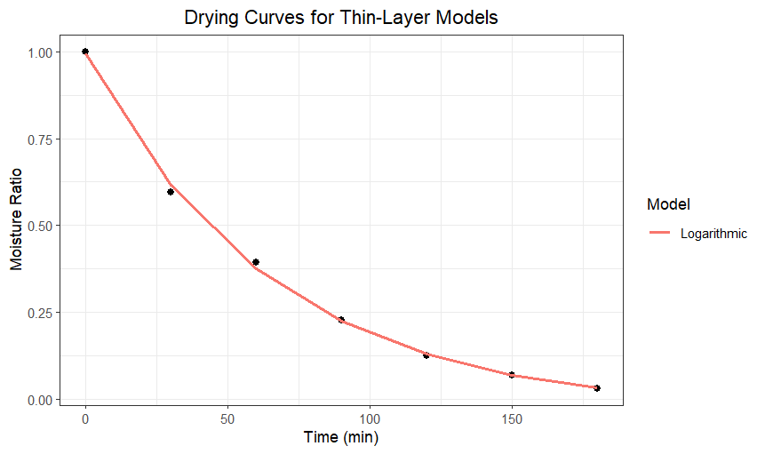
Fig. 3. Experimental and predicted moisture ratio curves of nutmeg mace during refractance window drying using the logarithmic model
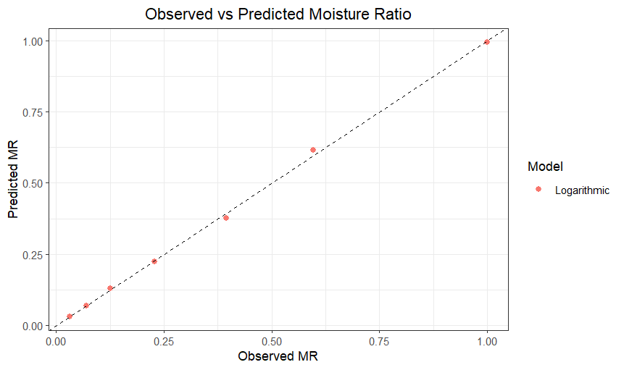
Fig. 4. Observed versus predicted moisture ratio for nutmeg mace during refractance window drying using the logarithmic model
For the evaluation of hot-air drying (HAD) kinetics, the comparative statistical performance of the thin-layer models is summarized in Table 3. All investigated semi-theoretical models demonstrated a high degree of correlation with the experimental moisture ratio data, evidenced by substantial coefficients of determination (R² >0.99) and minimal prediction errors (Santos et al., 2022; Ali et al., 2024). Among the evaluated models, the logarithmic model provided the most robust overall statistical performance for the nutmeg mace matrix, yielding the lowest root mean square error (RMSE = 0.011235) and mean absolute error (MAE = 0.009586) values, alongside an exceptionally high R² (0.99879) (Talukdar and Uppaluri, 2021). The selection of the logarithmic model was further substantiated by its superior performance in terms of information criteria, specifically achieving the lowest Akaike information criterion (AIC = −47.255) and Bayesian information criterion (BIC = −46.466), which indicate better statistical parsimony and predictive reliability (Ali et al., 2024; Showkat et al., 2024).
Table 3. Model fitting statistics for thin-layer drying of nutmeg mace by Hot air drying
Model | RMSE | MAE | NSE | R² | AIC | BIC
Logarithmic | 0.011235 | 0.009586 | 0.99879 | 0.99879 | -47.255 | -46.466
Singh_2014 | 0.013058 | 0.0109144 | 0.998373 | 0.998373 | -46.548 | -45.957
Modified_Page | 0.013638 | 0.0124741 | 0.998226 | 0.998226 | -43.767 | -42.978
Page | 0.013878 | 0.0120524 | 0.998163 | 0.998163 | -45.453 | -44.861
Wang_& Singh | 0.020112 | 0.0165889 | 0.996142 | 0.996142 | -38.774 | -38.183
Henderson_Pabis | 0.026494 | 0.0247238 | 0.993305 | 0.993305 | -33.813 | -33.222
Newton | 0.0277900 | 0.024723765 | 0.9926350 | 0.9926350 | -34.95453 | -34.56008

The high degree of fit for the logarithmic model under HAD is visually represented in Figure 5, where the predicted moisture ratio values closely align with the experimental data across the entire processing duration (He et al., 2024). Additionally, the observed versus predicted moisture ratio plot (Figure 6) demonstrates strong agreement between the experimental observations and model predictions, with the data points distributed tightly along the 1:1 (45-degree) identity line (Santos et al., 2022; Showkat et al., 2024). These findings confirm that the logarithmic model serves as a highly reliable mathematical tool for representing the dehydration kinetics of nutmeg mace under convective hot-air conditions (Talukdar and Uppaluri, 2021).
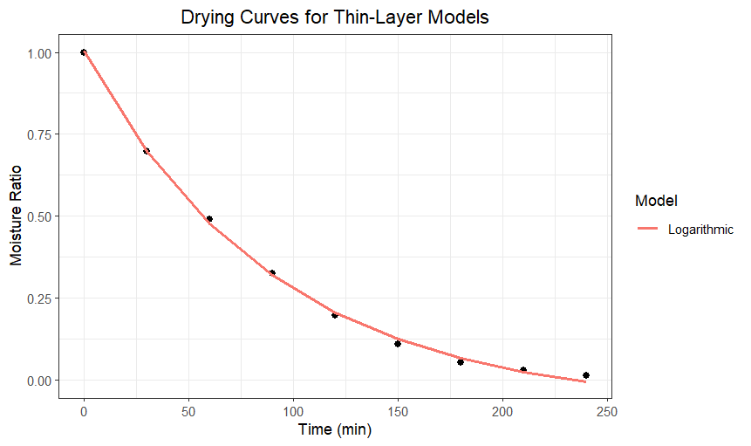
Fig. 5. Experimental and predicted moisture ratio curves of nutmeg mace during Hot air drying using the logarithmic model

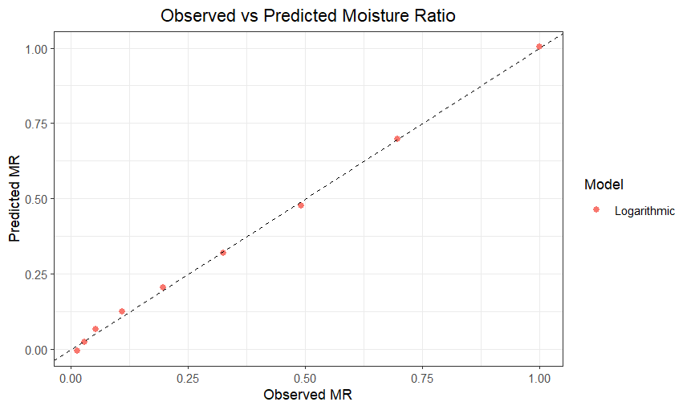
Fig. 6. Observed versus predicted moisture ratio for nutmeg mace during Hot air drying using the logarithmic model
3.4 Effective moisture diffusivity
In the present investigation, the effective moisture diffusivity (D_{eff}) values of nutmeg mace obtained during Refractance Window (RW) drying and hot-air drying (HAD) were $4.76× {10}^{-8} m^{2}s^{-1}$and $4.56× {10}^{-8} m^{2}s^{-1}$, respectively. The higher observed for RW drying signifies an accelerated rate of internal moisture transport compared to conventional hot air-drying methods (Miano and Rojas, 2024; Borse et al., 2025).
The enhanced diffusivity under RW conditions is attributed to the efficient and uniform heat transfer mechanism associated with direct contact heating through the infrared-transparent polymer film, which promotes rapid surface heating and increases the vapor pressure gradient between the interior of the nutmeg mace tissue and the surrounding environment (Kumar et al., 2024; He et al., 2024). This intensified driving force facilitates faster migration of moisture from the internal matrix toward the product surface (Bordoloi and Hazarika, 2024; Silva et al., 2024). The magnitude of the D_{eff} values obtained in this study falls within the characteristic range of 10⁻¹¹ to 10⁻⁸ m²s⁻¹ reported for various agricultural and high-moisture biological materials (Talukdar and Uppaluri, 2021). Similar increases in effective moisture diffusivity under RW drying in comparison with HAD have been documented for various fruit and vegetable matrices, where improved multimodal heat transfer (conduction, radiation, and convection) and reduced internal thermal resistance were identified as the primary contributing factors (Rurush et al., 2022; Rajoriya et al., 2020).
The slightly lower effective moisture diffusivity observed during hot-air drying can be attributed to the comparatively lower heat transfer coefficient and the reliance on convective airflow for thermal energy supply, which results in a slower development of internal moisture gradients (Kheto et al., 2025; Shrivastav et al., 2021). Furthermore, prolonged convective drying often leads to structural changes that increase the resistance to water vapor escape (Showkat et al., 2024). Overall, the higher diffusivity achieved through RW drying is fundamentally consistent with the shorter processing times and superior drying rates observed for nutmeg mace under this fourth-generation technology (Hasan et al., 2024; Shaju and Prince, 2024).
3.4 Quality characteristics of dried nutmeg mace
3.4.1. Water Activity (a_{w})
Nutmeg mace dried by refractance window (RW) drying exhibited a lower water activity (0.50) compared with hot-air drying (0.60). This lower a_{w} indicates improved product stability and a marked reduction in susceptibility to microbial proliferation and physicochemical deterioration, factors that are critical for the preservation and shelf-life of dehydrated spice products (Kumar et al., 2022; Silva et al., 2024). Achieving these stable equilibrium moisture levels through the RW system’s efficient heat transfer mechanism ensures the functional integrity and microbiological safety of high-value biological matrices (Borse et al., 2025).
3.4.2. Colour Attributes and Total Colour Difference
The colour attributes of nutmeg mace were better preserved under refractance window (RW) drying, yielding higher a* (28.6) and chroma (31.9) values compared with hot-air drying (HAD) (a*=27.3; C*=30.5). These results indicate superior retention of the characteristic red pigments, which are vital for the commercial valuation of high-grade mace (Shrivastav et al., 2021). The enhanced pigment stability is attributed to RWD’s ability to achieve rapid moisture removal at relatively low product temperatures, thereby minimizing thermal degradation (Raghavi et al., 2018). In contrast, the lower colour intensity and dullness observed in HAD samples are typically caused by prolonged exposure to heated air, which triggers non-enzymatic browning (Maillard reactions) and pigment oxidation (Hasan et al., 2024).
The overall colour change relative to fresh nutmeg mace was quantified by the total colour difference (∆E). RW-dried samples exhibited a lower ∆E (9.11) than HAD samples (10.26), confirming that the fourth-generation technology more effectively maintains the original visual profile of the spice (Lalita et al., 2024). Since surface colour is a critical determinant of consumer acceptance and marketability, the ability of RW drying to produce a "fresh-like" appearance makes it a superior alternative to traditional convective methods (Ortiz-Jerez et al., 2022). These findings are in agreement with recent literature demonstrating that RW processing results in more vibrant and visually appealing dried products (Nansereko et al., 2022).
3.4.3. Total Phenolic Content (TPC)
Nutmeg mace dried by refractance window (RW) drying exhibited a significantly higher total phenolic content (14.26) compared to hot-air dried (HAD) samples (12.48). This improved retention is primarily attributed to the shorter drying duration and reduced surface exposure time inherent to the RW process, which minimizes the oxidation of heat-sensitive bioactive constituents (Lalita et al., 2024). Phenolic compounds are highly susceptible to thermal and oxidative stress during prolonged convective drying, where direct exposure to high-velocity heated air hampering their quality attributes and leads to significant losses (Wu et al., 2024; Kumar et al., 2024).
The self-regulating heat transfer mechanism of RW technology ensures that product temperatures remain relatively low through evaporative cooling, effectively inhibiting the activity of oxidative enzymes such as polyphenol oxidase (Nguyen et al., 2022; Borse et al., 2025). Furthermore, the rapid multimodal heat transfer can facilitate the breakdown of cell wall polymers, prompting the release of bound phenolic compounds from the cellular matrix into the extractable fraction (Zhang et al., 2024; Rajoriya et al., 2020). These synergistic effects confirm that RW drying is a high-performance, gentle dehydration technique that maintains the functional and antioxidant integrity of high-value spice matrices better than conventional methods (Talukdar and Uppaluri, 2021; Kaveh et al., 2025).
3.4.4. Shrinkage Percentage
The shrinkage percentage of nutmeg mace was significantly influenced by the drying method, with Refractance Window (RW) drying achieving a lower shrinkage (33.9%) than hot-air drying (HAD) (44.0%). This indicates superior preservation of the structural integrity and a reduction in undesirable physical modifications compared to conventional methods (Showkat et al., 2024; Silva et al., 2024). The minimized volumetric contraction in the RW system is attributed to uniform and moderate heat transfer conditions, which prevent excessive cell wall collapse and internal structural stress during the moisture removal process (Ayala-Aponte et al., 2021; Kaveh et al., 2025).
Conversely, the higher shrinkage observed in HAD is a consequence of uneven moisture migration and structural damage caused by prolonged exposure to high-velocity heated air (Kumar et al., 2024; Hasan et al., 2024). The RW process facilitates homogenous shrinkage by allowing the product to spread undisturbed over the Mylar interface, resulting in a smoother morphology compared to the severe deformation and structural collapse typical of convective systems (Borse et al., 2025; Zhang et al., 2024). Furthermore, the rapid reduction of moisture at the product surface during RW drying may induce a rubbery-glass transition, forming a rigid crust that helps maintain the physical dimensions of the spice (Ochoa-Martínez et al., 2012; Talukdar and Uppaluri, 2021).
4. CONCLUSION
Refractance window drying demonstrated superior performance for the dehydration of nutmeg mace compared with conventional hot-air drying. The drying process under refractance window conditions was effectively described by the logarithmic thin-layer model for both drying systems. Refractance window drying resulted in a higher effective moisture diffusivity, indicating enhanced internal moisture transport and improved drying efficiency. In addition, refractance window dried nutmeg mace exhibited lower water activity, better retention of the characteristic red colour as reflected by lower total colour difference, higher total phenolic content and lower shrinkage than hot-air dried samples. These results confirm that refractance window drying is a promising low-temperature and energy-efficient drying technology for preserving the quality and functional attributes of high-value and heat-sensitive spice materials such as nutmeg mace.
Reference
Adeyeye, S. A. O., Ashaolu, T. J., & Babu, A. S. (2022). Food Drying: A Review. Agricultural Reviews, 46(1), 86–93. Doi: 10.18805/ag.R-2537
Aghaei, Z., Jafari, S. M., & Dehnad, D. (2019). Effect of Different Drying Methods on the Physicochemical Properties and Bioactive Components of Saffron Powder. Plant Foods for Human Nutrition. 74:171-178. Doi: https://doi.org/10.1007/s11130-019-00729-7.
Ali, S., Narwari, I. R., & Faisal, S. (2024). Response Surface Optimization of Refractance Window Drying of Bitter Gourd Slices. Journal of Agricultural Engineering (India), 61(1), 52–66. Doi: https://doi.org/10.52151/jae2024611.1829
Arslan-Tontul, S., Günışık, A., & Tontul, I. (2024). Moisture sorption isotherm and thermodynamic analysis of egg powders dried by foam-mat-assisted refractance window drying. J. Sci. Food Agric.104(14): 8646-8654. doi: 10.1002/jsfa.13692
Ayala-Aponte, A. A., Cárdenas-Nieto, J. D., & Tirado, D. F. (2021). Aloe vera Gel Drying by Refractance Window®: Drying Kinetics and High-Quality Retention. Foods, 10(7), 1445. Doi . https://doi.org/10.3390/ foods10071445
Bordoloi, T., & Hazarika, M. K. (2024). Effects of instant controlled pressure drop treatment combined with refractance window drying on infusion quality of made green tea. Journal of the Science of Food and Agriculture, 104(10), 6053–6061. Doi: https://doi.org/10.1002/jsfa.13477
Borse, S. M., Gupta, S. V., & Patil, B. N. (2025). A review on refractance window drying of fruits. International Journal of Advanced Biochemistry Research, 9(1), 472–482. DOI: https://doi.org/10.33545/26174693.2025.v9.i1f.3558
Calderón-Chiu, C., Martínez-Sánchez, C. E., Rodríguez-Miranda, J., Juárez-Barrientos, J. M., Carmona-García, R. & Herman-Lara, E. (2020). Evaluation of the combined effect of osmotic and Refractance Window drying on the drying kinetics, physical, and phytochemical properties of beet. Drying Technology, 38(12), 1663–1675. Doi: 0.1080/07373937.2019.1655439
Elfia, H. Y. & Susilo, S. (2023). An update on the pharmacology, phytochemistry, and toxicity of Myristica fragrans Houtt. as a source of treatment: A scoping review. J. Appl. Pharm. Sci. 13(10): 92-106 Doi: http://doi.org/10.7324/JAPS.2023.137812
Günışık, A., & Tontul, I. (2024). Effect of foaming and drying temperature on the physical, chemical, and functional properties of egg white powders produced using refractance window drying. Drying Technology, 42(11), 1698–1708. Doi: https://doi.org/10.1080/07373937.2024.2385808
Hasan, M. M., EL-Badry, N., Ghanem, T. H., & Nasr, A. (2024). Quality attributes of dried guava pulp using refractance window Vs. hot air drying. Al-Azhar Journal of Agricultural Research, 49(2), 34–49.
He, J., Song, W., Li, J., Ding, T., Guan, J., Wu, J., & Wang, J. (2024). Study on a Moisture Ratio Curve Model for Refractance Window Drying Based on a D-Optimal Mixture Design. Journal of Food Quality, 2024. Doi: https://doi.org/10.1155/2024/8604374
Hernández-Santos, B., Martínez-Sánchez, C. E., Torruco-Uco, J. G., Rodríguez-Miranda, J., Ruiz-López, I. I., Vajando-Anaya, E. S., Carmona-García, R., & Herman-Lara, E. (2016). Evaluation of physical and chemical properties of carrots dried by Refractance Window drying. Drying Technology. 34(12): 14114-1422.
Herrera, P. A., Santagapita, P. R., & Moreno, F. L. (2025). Refractance window drying: A new approach for producing high-quality powdered dairy products. Journal of Dairy Science, 108(3), 2324–2339.
Kaveh, M., Zomorodi, S., Gheisary, B., Elmesiry, H., Sharifian, F., Elmesiry, A. & Salem, A. 2025. Impact of various drying technologies for evaluation of drying kinetics, energy consumption, physical and bioactive properties of Rose flower. Scientific Reports, 15, 6808. Doi: https://doi.org/10.1038/s41598-025-94300-x
Kaveh, M., Zomorodi, S., Mariusz, S., & Dziwulska-Hunek, A. (2024). Determination of Drying Characteristics and Physicochemical Properties of Mint (Mentha spicata L.) Leaves Dried in Refractance Window. Foods, 13(18), 2867. https://doi.org/10.3390/foods13182867
Kheto, A., Achary, J. V., Bebartta, R. P., Sehrawat, R., Gul, K. & Mujumdar, A. S. (2025). Refractance window drying of Spanish cherry (Mimusops elengi Linn) pulp: Impacts on drying kinetics, colour, and phytochemical properties. Drying Technol. 43(1-2), 348–361. Doi: https://doi.org/10.1080/07373937.2024.2407955
Kumar, M., Madhumita, M., Prabhakar, P. K., & Basu, S. (2024). Refractance window drying of food and biological materials: Status on mechanisms, diffusion modelling and hybrid drying approach. Critical Reviews in Food Science and Nutrition, 64(11), 3458–3481, DOI: 10.1080/10408398.2022.2132210
Kumar, M., Madhumita, M., Srivastava, B., & Prabhakar, P. K. (2022). Mathematical modeling and simulation of refractance window drying of mango pulp for moisture, temperature, and heat flux distribution. J. Food Process Eng. Doi: 10.1111/jfpe.14090
Lalita, Giri, S. K., Mohapatra, D., Tripathi, m. K., Kate, A., & Wahid, A. (2024). Optimization of process parameters of refractance window drying for aonla slices and comparison with other drying techniques. Journal of the Science of Food and Agriculture, 104(13), 7854–7863. DOI 10.1002/jsfa.13615 2024 10
Largo-Avila, E., Rico-Rodríguez, F., Peñaloza-Figueroa, J. K., & López-Padilla, A. (2024). Effect of Refractance Window™ and oven drying on physicochemical and sensory properties of peach (Prunus persica L.) surplus. Frontiers in Nutrition,23:11, 1307423.doi: 10.3389/fnut.2024.1307423
Mahanti, N. K., Chakrabortya, S. K., Sudhakar, A., Verma, D. K., et al. (2021). Refractance Window-Drying vs. other drying methods and effect of different process parameters on quality of foods: A comprehensive review of trends and technological developments. Future Foods. https://doi.org/10.1016/j.fufo.2021.100024
Miano, A. C., & Rojas, M. L. (2024). Drying strategies of spent coffee grounds using refractance window method. Food Research International. 178:114007. Doi: https://doi.org/10.1016/j.foodres.2024.114007
Minjares-Fuentes, R., Rodríguez-González, V. M., González-Laredo, R. F., Eim, V., et al. (2017). Effect of different drying procedures on the bioactive polysaccharide acemannan from Aloe vera (Aloe barbadensis Miller). Carbohydrate Polymers, 168, 327–336. Doi: http://dx.doi.org/10.1016/j.carbpol.2017.03.087
Mohsenin, N. N. (1986). Physical Properties of Plant and Animal Materials: Structure, Physical Characteristics, and Mechanical Properties. New York: Gordon and Breach Science Publishers.Doi: https://doi.org/10.1002/food.19870310724
Muyonga, J. H., Natocho, J., Kigozi, J., Baidhe, E. & Nansereko, S. (2022). Drying behaviour and optimization of drying conditions of pineapple puree and slices using refractance window drying technology. J Food Sci Technol. 59(7): 2794-2803. Doi: https://doi.org/10.1007/s13197-021-05302-2
Nansereko, S., Muyonga, J., & Byaruhanga, Y. B. (2022). Influence of Drying Methods on Jackfruit Drying Behavior and Dried Products Physical Characteristics. International Journal of Food Science. Doi: https://doi.org/10.1155/2022/8432478
Nguyen, T. V. L., Nguyen, Q. D., & Nguyen, P. B. D. (2022). Drying Kinetics and Changes of Total Phenolic Content, Antioxidant Activity and Colour Parameters of Mango and Avocado Pulp in Refractance Window Drying. Polish Journal of Food and Nutrition Sciences, 72(1), 27–38. DOI: 10.31883/pjfns/144835.
Nindo, C. I. & Tang, J. (2007). Refractance Window Dehydration Technology: A Novel Contact Drying Method. Drying Technol. 25(1): 37-48. Doi: https://doi.org/10.1080/07373930601152673
Nuñez, H., Jaques, A., Belmonte, K., Elitin, J. et al. (2024). Development of an Apple Snack Enriched with Probiotic Lacticaseibacillus rhamnosus: Evaluation of the Refractance Window Drying Process on Cell Viability. Foods, 13(11), 1756. Doi: https://doi.org/10.3390/foods13111756
Ochoa-Martínez, C. I., Quintero, P. T., Ayala, A. A., & Ortiz, M. J. (2012). Drying characteristics of mango slices using the Refractance Window™ technique. Journal of Food Engineering, 109(1), 69–75. Doi:https://doi.org/10.1016/j.jfoodeng.2011.09.032
Ortiz-Jerez, M. J., Franco Sánchez, A., & Zapata Montoya, J. E. (2022). Drying kinetics and sensory characteristics of dehydrated pumpkin seeds (Cucurbita moschata) obtained by refractance window drying. Heliyon. 8(2-3). DOI: 10.1016/j.heliyon.2022.e10947
Padhi, S., Murakonda, S., & Dwivedi, M. (2022). Investigation of drying characteristics and nutritional retention of unripe green banana flour by refractance window drying technology using statistical approach. Journal of Food Measurement and Characterization, 16(5): 2375–2385. Doi: 10.1007/s11694-022-01349-7
Pal, L., Giri, S. K., Mohapatra, D., Tripathi, M. K. & Adinath Kate. (2024). Mass transfer parameters and quality characteristics of aonla slices under refractance window drying. Drying Technol. 42(3): 492-505. Doi: https://doi.org/10.1080/07373937.2023.2234473
Pathare, P. B., Opara, U. L., & Al-Said, F. A. J. (2013). Colour measurement and analysis in fresh and processed foods: A review. Food and Bioprocess Technology, 6(1), 36–60. DOI: 10.1007/s11947-012-0867-9
Raghavi, L. M., Moses, J. A., & Anandharamakrishnan, C. (2018). Refractance window drying of foods: A review. Journal of Food Engineering, 222, 267–275. https://doi.org/10.1016/j.jfoodeng.2017.11.032
Rajoriya, D., Shewale, S. R., Bhavya, M. L., & Hebbar, H. U. (2020). Far infrared assisted refractance window drying of apple slices: Comparative study on flavour, nutrient retention and drying characteristics. Innovative Food Sci. Emerging Technologies. 66: 102530. Doi: https://doi.org/10.1016/j.ifset.2020.102530
Rurush, E., Alvarado, M., Palacios, P., Flores, Y., Rojas, M. L. & Miano, A. C. (2022). Drying kinetics of blueberry pulp and mass transfer parameters: Effect of hot air and refractance window drying at different temperatures. Journal of Food Engineering, 320, 110929. Doi https://doi.org/10.1016/j.jfoodeng.2021.110929
Santos, V. C. S., De Souza, R. L., Figueiredo, R. T., & De Alsina, O. L. S. (2022). A review on refractance window drying process of fruits and vegetables: Its integration with renewable energies. Brazilian Journal of Food Technology. 25. Doi: https://doi.org/10.1590/1981-6723.15321
Shaju, A. A. & Prince, M. V. (2025). Refractance Window Drying: Technology and Product Quality Characteristics. J. Scientific Res. Reports. 31(11):539-558. Doi: https://doi.org/10.9734/jsrr/2025/v31i113689
Showkat, M., Shukla, R. M., Richa, R., Amin, T., Faisal, S., Hussain, A., Joshi, S., Dobhal, A., & Kumar, S. (2024). Synergistic Effect of Advanced Refractance Window Drying on Quality Characteristics of Potato Slices and Numerical Process Optimization. Potato Research. 68:1069–1087 Doi:https://doi.org/10.1007/s11540 024-09770-9
Shrivastav, S., Ganorkar, P. M., Prajapati, K. M., & Patel, D. B. (2021). Drying kinetics, heat quantities, and physiochemical characteristics of strawberry puree by Refractance Window drying system. Journal of Food Process Engineering, 44(9), e13776. Doi: 10.1111/jfpe.13776
Silva, N. C., Santos, A. O., Duarte, C. R., & Barrozo, M. A. S. (2024). Refractance Window Drying as an Alternative Method for Brewer’s Spent Grain Preservation. Applied Biosciences, 3, 71–86. Doi: https://doi.org/10.3390/applbiosci3010005
Suthisamphat, N., Dechayont, B., Phuaklee, P., Prajuabjinda, O., Vilaichone. R., Itharat, A., Mokmued, K. & Prommee, N. (2020). Evidence-Based Complementary and Alternative Medicine. 6p. Doi:https://doi.org/10.1155/2020/7576818
Talukdar, P., & Uppaluri, R. (2021). Process and product characteristics of refractance window dried Curcuma longa. J. Food Sci. 86(2), 443–453. doi:10.1111/1750-3841.15587
Talukdar, P., Baruah, K. N. Barman, P. J., Sharma, S.& Uppaluri, R. V. S. (2025). Development and Characterization of Refractance Window-Dried Curcuma longa Powder Fortified with NaFeEDTA and Folic Acid. A Study on Thermal, Morphological, and In Vitro Bio Accessibility Properties. Foods, 14(4), 658. Doi: https://doi.org/10.3390/foods14040658
Tepe, T. K. (2024). Effect of pretreatments on drying characteristics, rehydration properties, and total energy consumption of carrot slices: comparison between thin layer mathematical modelling and artificial neural network modelling. Biomass Conversion and Biorefinery. 14:1373-1387. Doi:https://doi.org/10.1007/s13399-023-04925-z
Ullagaddi, R. (2025). The aromatic cure: A scientific review of Nutmeg’s medicinal properties. Int. J. Sci. Res. Archieve. 15(01):1656-1663. Doi:https://doi.org/10.30574/ijsra.2025.15.1.1197
Wu, Y., Liu, Y., Jia, Y., Feng, C. H., Zhang, H., Ren, F., & Zhao, G. (2024). Effects of thermal processing on natural antioxidants in fruits and vegetables. Food Research International, 114797. DOI: 10.1016/j.foodres.2024.114797
Yoha, K. S., Moses, J. A., & Anandharamakrishnan, C. (2020). Conductive hydro drying through refractance window drying – An alternative technique for drying of Lactobacillus plantarum (NCIM 2083). Drying Technol., 38(5-6), 610–620. Doi: https://doi.org/10.1080/07373937.2019.1624972
Zhang, Q., Pertin, O., Kamdi, H. S., Durgawati. Xiao, H. W. & Sutar, P. P. (2024). Modified refractance window drying of jamun pulp (Syzygium cumini) based on innovative infrared and microwave radiation techniques. Drying Technol., 42(5): 775–794. DOI: 10.1080/07373937.2024.2317739

