Systematic Review

Nationwide Evidence of bla_{KPC}-Positive Klebsiella pneumoniae in Brazilian Clinical Isolates: A Systematic Review and Meta-Analysis

Abstract
The dissemination of Klebsiella pneumoniae carbapenemase (KPC), encoded by the bla_{KPC} gene, has become a major challenge to antimicrobial therapy. In Brazil, evidence of bla_{KPC}-positive K. pneumoniae is extensive and fragmented. This study aims to systematically synthesize published data to characterize and quantify the prevalence of bla_{KPC} among clinical K. pneumoniae isolates in Brazil. Following PRISMA guidelines, we performed a systematic review and proportion meta-analysis of studies published from 2006–2024 reporting molecular detection of bla_{KPC} in clinical K. pneumoniae isolates across Brazil. Searches in SciELO, PubMed, ScienceDirect, and LILACS identified eligible cross-sectional and case-control studies. Data was independently extracted data and appraised quality using Joanna Briggs Institute criteria. Random-effects models estimated pooled prevalence; heterogeneity, publication bias, and meta-regression were assessed. Thirty studies met inclusion criteria, totaling 5,630 isolates, of which 4,175 were screened for bla_{KPC} and 1,488 were positive. The pooled bla_{KPC} prevalence was 44.3% (95% CI= 0.405–0.481; I² = 97.3%). Subgroup analyses revealed regional heterogeneity (36.5–85.5%), and meta-regression showed a significant inverse association between study size and prevalence (p = 0.01). No publication bias was detected (Begg’s p = 0.40). bla_{KPC}-harboring K. pneumoniae is highly prevalent and geographically widespread in Brazil. Study design variability and uneven surveillance likely explain observed heterogeneity, underscoring the need for standardized molecular monitoring and coordinated infection-control strategies.

Keywords: Serino-beta-lactamases; Meta-analysis; Beta-lactamases; Brazil; Klebsiella pneumoniae; Carbapenemases.
1. Introduction
Klebsiella pneumoniae has rapidly evolved from a relatively benign commensal microorganism to one of the most problematic multidrug-resistant pathogens confronting global healthcare today [1]. This Gram-negative bacterium has not only adapted effectively to a broad range of clinical environments, but presents enhanced capacity of acquiring resistance genes, often severely limiting therapeutic options. Its impressive genomic plasticity allows it to swiftly respond to antimicrobial pressures, contributing significantly to morbidity, mortality, and healthcare-associated costs worldwide [2].
At the center of the escalating antibiotic resistance crisis is the widespread dissemination of carbapenemase-producing strains, such as those carrying the bla_{KPC} gene. This gene encodes the Klebsiella pneumoniae carbapenemase (KPC), an enzyme that confers resistance by hydrolyzing carbapenems—antibiotics traditionally reserved for treating severe multidrug-resistant infections [3]. First identified in the United States in the late 1990s, bla_{KPC} variants rapidly spread across continents, becoming a global public health concern by severely limiting treatment options [4].
Brazil's detection of bla_{KPC}-positive K. pneumoniae began in the early 2000s, marking a significant turning point in national antimicrobial resistance (AMR) epidemiology. What initially appeared as isolated events quickly transformed into persistent endemicity in several Brazilian hospitals and regions, with some institutions reporting alarmingly high detection rates [5-7].
The fragmented nature of published research, primarily restricted to local or regional studies, has made it challenging to fully grasp the published evidence on KPC-producing K. pneumoniae. Our study aims to systematically integrate existing prevalence data on the bla_{KPC} gene among Brazilian clinical K. pneumoniae isolates based on published data.
2. Material and Methods
2.1 Study design
This is a systematic review and meta-analysis that aims to investigate data on the molecular detection of serino-beta-lactamase encoding gene bla_{KPC} in clinical-related K. pneumoniae isolates in the Brazilian territory. This study followed the recommendations of the Preferred Report Items of a Systematic Review and Meta-Analyses (PRISMA) 2020 and was registered with the International Prospective Register of Systematic Reviews (PROSPERO) under registration number CRD420251117220 [8-9]. A proportion meta-analysis was conducted in this study to investigate the prevalence of bla_{KPC}.
2.2 Search strategy and eligibility criteria
The POT strategy was used to construct the guiding question for this systematic review, which consisted of the following: “What is the prevalence of bla_{KPC} gene in Brazilian clinical related samples of K. pneumoniae?”. The anagram for its formation comprised “P” for problem (Carbapenemases-CR-KP), “O” for outcome (frequency of bla_{KPC} in K. pneumoniae in Brazil) and “T” for type of study (original studies). The keywords used to search the databases were: Beta-lactamases; Brazil; bla_{KPC}; Klebsiella pneumoniae; serino-beta-lactamases; Bacteria; Carbapenemases (AND) [10-11].
Literature searches were performed in SciELO, PubMed, ScienceDirect and LILACS—databases that together encompass most of the Brazilian scientific research. Primary studies published in Portuguese, English or Spanish from January 2006 through December 2024 were eligible if they employed analytical, case-control, cohort or cross-sectional designs. Short communications, letters to the editor, editorials and any articles not freely available in full text were excluded.
2.3 Data extraction and assessment of methodological quality
The data was collected from all the databases mentioned above and distributed in an organized form in a computer spreadsheet application (Microsoft Office Excel 365). The database search, collection, investigation, tabulation and data extraction were carried out independently by two authors (CSS and MJAS). Any inconsistencies between the analyses were resolved with the help of a third researcher (YCR). The data extracted from the articles were: authors, year of publication, title, source(s), methodology, sample type, Brazilian city/region, collection method, setting profile, gene identification method, period in which the K. pneumoniae isolates were collected and the appropriate frequencies of bla_{KPC}. Also, studies included in the present meta-analysis consisted of reports providing data on the molecular detection of bla_{KPC} in K. pneumoniae isolates by PCR and/or WGS and describing the presence of at least two clinical isolates.
The quality assessment was carried out by two investigators (CSS and MJAS) using the Joanna Briggs Institute (JBI) critical appraisal checklist for analytical cross-sectional studies (0-8) and for case-control studies (0-10). Only when the conditional answer was “Yes” were the scores for completing the checklist questions considered [12-13].
2.4 Statistical analysis
The Comprehensive Meta-Analyses – CMA program, version 3.3 (Biostat, Englewood, NJ, USA) and OpenMeta Analyst were used to carry out the statistical analysis of the meta-analysis [14]. The random effects model (Der-Simonian Laird – DL method) estimated the combined frequency of K. pneumoniae with 95% confidence intervals (95% CI). A subgroup analysis was performed to determine the frequency of bla_{KPC} isolates according to Brazilian regions. The Chi-squared and I² tests were used to determine the statistical difference groups (p<0.05 was considered statistically significant). Egger and Begg’s rank correlation test and a funnel plot were used to examine the potential for publication bias (p<0.05 was considered statistically significant). Sensitivity analysis, meta-regression and subgroup analysis based on study site were used to assess possible causes of variability, where applicable [15].
3. Results
3.1 Literature Search
After the initial screening and application of eligibility and inclusion criteria to the 393 records, 235 studies were excluded because their titles were not related to the topic and 105 were excluded as duplicates, editor’s letters, brief communications, or incomplete studies. Following full-text assessment, 23 additional studies were excluded. The sampling process is depicted in Figure 1 below.
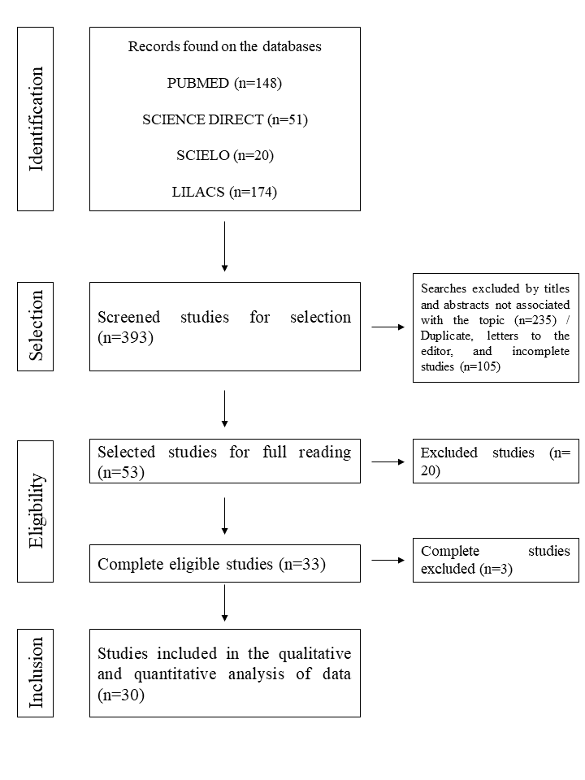
Figure 1 - Flowchart of the data collection and screening steps for bla_{KPC} studies.
3.2 Characterization of the included studies
Table 1 summarizes the 30 primary studies included in the quantitative synthesis [16-45]. Collectively, these investigations covered all Brazilian macro-regions (North, Northeast, Midwest, Southeast, and South), and two studies compiled isolates sampled from multiple regions within the country. Most studies used a retrospective cross-sectional design, with a smaller subset adopting case-control approaches. Sampling periods spanned nearly two decades, from an earliest extended surveillance window (August 2003–February 2012) to the most recent sampling period (2020–2023).
Across studies, isolates were predominantly derived from hospital-based clinical settings, including tertiary-care hospitals, several multi-institution networks, ICUs, and pediatric or specialized services. In addition, some datasets were generated through public health laboratory surveillance (LACEN). Isolate sources were heterogeneous, comprising urine, blood cultures, respiratory samples, wounds/secretions, catheter tips, cerebrospinal fluid, and other invasive specimens; several studies also included colonization screening swabs, particularly rectal swabs (and, less frequently, oropharyngeal swabs).
Study size varied markedly. The number of isolates tested for bla_{KPC} ranged from small series to large laboratory-based datasets. Importantly, some investigations tested only a subset of all available K. pneumoniae isolates during the study period (e.g., 21/1,076, 54/325, and 69/95), reflecting differences in inclusion criteria and sampling strategies across sites. Regarding molecular detection, PCR was the most frequently employed method, while whole-genome sequencing (WGS) was applied in a subset of studies either alone or combined with PCR, particularly in genomic epidemiology and outbreak-focused investigations.
Finally, methodological appraisal using Joanna Briggs Institute tools indicated generally moderate-to-high quality, with most cross-sectional studies scoring 7/8 or 8/8, and case-control studies typically achieving 9/10 or 10/10 when reported.

Table 1 - Summary of included studies: period, location, isolate, sources and bla_{KPC} frequency.
Nº | Authors/ Year | Type of study/ Sample period | Location/Region | Setting profile | Nº isolates tested for bla_{KPC} / Nº of total Kp isolates | Isolates  source | Results (bla_{KPC}) | Carbapenemases  detection | JBI Score
1 | Cabral et al. 2012 | Retrospective cross-sectional / 2007-2008 | Recife, Pernambuco State / Northeast region | Clinical – Public and private hospitals | 24/24 | Urine, blood, tracheal secretion, bone fragment, abscess secretion and catheter tip | bla_{KPC} positive (10/24) | PCR | (8/8)
2 | Pinto et al. 2014 | Retrospective cross-sectional / April – December 2013 | Porto Alegre, Rio Grande do Sul State, South region | Clinical – Four tertiary care hospitals | 326/326 | Rectal swabs, urine, blood, soft tissue, peritoneal and pleural fluid | bla_{KPC} positive (223/326) | PCR | (7/8)
3 | Andrade et al., 2014 | Retrospective case-control / 2012 - 2013 | Ribeirão Preto / São Paulo | Clinical – Tertiary care hospital | 7/7 | urine, tracheal  secretion, blood, venous  catheter | bla_{KPC-2} positive (7/7) | PCR | (9/10)
4 | Biberg et al., 2015 | Retrospective case-control / 2009 - 2010 | Mato Grosso do Sul / Centro Oeste | Clinical – Regional care hospital | 44/44 | urine, blood,  surgical wound exudates, catheter tips, tracheal aspirates  and spinal cerebrospinal fluid samples. | bla_{KPC-2} positive  (36/44) | PCR | (10/10)
5 | Ribeiro et al. 2016 | Retrospective cross-sectional / June 2012 - July 2013 | São Luis, Maranhão State / Northeast region | Clinical – Public and private hospitals | 75/75 | Fluid abscess, rectal swab, blood, catheter tip, drenage secretion, nasal swab, surgical wound, tracheal secretion and urine | bla_{KPC} positive (60/75) | PCR | (8/8)
6 | Pereira et al., 2016 | Retrospective cross-sectional / January – December 2012 | Juiz de Fora, Minas Gerais State / Southeast region | Clinical –one tertiary care hospital | 21/1.076 | Urine, blood, tracheal secretion, bronchoalveolar lavage, and catheter tip | bla_{KPC} positive (20/21) | PCR | (8/8)
7 | Aires et al., 2017 | Retrospective cross-sectional / July 2013 – November 2014 | Rio de Janeiro, Niterói, Campos dos Goytacazes Rio de Janeiro State / Southeast region | Clinical / Eight healthcare institutions | 16/16 | Rectal swabs, urine, blood, catheter tip and CSF | bla_{KPC} positive (2/16) | PCR | (8/8)
8 | Vivian et al. 2017 | Retrospective cross-sectional / July 2009 - 2010 | Londrina, Paraná State, South region | Clinical / Hospital microbiology laboratory | 54/325 | Urinary tract, lower respiratory tract, bloodstream and central venous catheter, skin and soft tissue and abdomen or peritoneum | bla_{KPC} positive (54/54) | PCR | (6/8)
9 | Leite et al. 2017 | Retrospective cross-sectional / 2012 - 2013 | Maringa, Paraná State, South region | Clinical – Single hospital | 26/26 | Not reported | bla_{KPC} positive (13/26) | PCR | (8/8)
10 | Dalmolin et al. 2017 | Retrospective cross-sectional / July 2013 - August 2014 | Santa Maria, Rio Grande do Sul State / South region | Clinical – Single hospital | 27/27 | Peritoneal fluid, urine, blood, stool, recta swab, wound, sputum, tracheal aspirates88 | bla_{KPC} positive (24/27) | PCR | (8/8)
11 | Tolentino et al. 2019 | Retrospective cross-sectional / 2011 - 2014 | São Paulo, São Paulo State / Southeast region | Clinical – Single tertiary care hospital | 48/48 | Urinary tract infection, Lower respiratory tract infection, Skin and soft tissue infection, Primary bacteremia, Catheter infection, Intra-abdominal infection, Bone infection, Intravascular infection, Surgical wound infection | bla_{KPC} positive (48/48) | PCR | (7/8)
12 | Ferreira et al. 2019 | Retrospective cross-sectional / January 2014 - May 2015 | Tocantins State / North region | Clinical / Central public health laboratory (LACEN) | 25/25 | Rectal swab, tracheal aspirate, urine, cerebrospinal fluid, wound, sputum, abscess, surgical drain and catheter tip. | bla_{KPC} positive (25/25) | PCR | (8/8)
13 | Longo et al. 2019 | Retrospective cross-sectional / November 2016 - June 2017. | Rio de Janeiro State / Southeast region | Clinical – Two hospitals | 23/23 | Rectal and oropharynx screening swabs, urine and blood specimens | bla_{KPC} positive (6/23) | WGS | (7/8)
14 | Palmeiro et al. 2019 | Retrospective cross-sectional / August 2003 - February 2012 | Curitiba, Paraná State / South region | Clinical – Hospital complex | 43/43 | Various sites | bla_{KPC} positive (18/43) | PCR and WGS | (8/8)
15 | Flores et al., 2019 | Retrospective cross-sectional / March 2016 – March 2017 | Rio de Janeiro State / Southeast region | Clinical / Tertiary care hospital ICU | 103/103 | Rectal Swabs | bla_{KPC} positive  (8/103) | PCR | (7/8)
16 | Raro et al., 2020 | Retrospective cross-sectional / 2017 - 2018 | Porto Alegre, Rio Grande do Sul State, South region | Clinical / 1.000 bed hospital complex | 80/80 | Rectal swabs | bla_{KPC} positive  (71/80) | WGS | (8/8)
17 | Firmo et al., 2020 | Retrospective cross-sectional / 2016 – 2018 | Recife, Pernambuco State / Northeast region | Clinical / Three public and private hospitals | 16/16 | Urine, Surgical wound, Tracheal aspirate, Rectal swab  Blood, CSF, Bone | bla_{KPC} positive (15/16) | PCR | (8/8)
18 | Vivas et al., 2020 | Retrospective cross-sectional | Aracaju, Sergipe State / Northeast region | Clinical / Hospital microbiology laboratory | 147/147 | Not described | bla_{KPC} positive (9/147) | PCR | (8/8)
19 | de Oliveira et al., 2020 | Retrospective cross-sectional / 2017 - 2018 | Recife, Pernambuco state / Northeast region | Clinical / Public hospital | 27/27 | Different sites on infection and colonization | bla_{KPC} positive (24/27) | PCR | (8/8)
20 | Rodrigues et al., 2021 | Retrospective cross-sectional / 2018 - 2021 | Belém, Pará State / North region | Clinical / Nine different healthcare institutions in the region | 23/23 | Urine, blood, tracheal secretion, rectal swab, bronchoalveolar lavage, abdominal abscess secretion, wound secretion, nasopharyngeal secretion, soft-tissue secretion, and peritoneal fluid | bla_{KPC} positive (4/23) | PCR | (8/8)
21 | Lee et al., 2021 | Retrospective cross-sectional / 2010 - 2014 | Brasília, Distrito Federal, Mid-west region | Clinical / 12 hospitals | 69/95 | Not described | bla_{KPC} positive  (61/69) | WGS | (8/8)
22 | Silveira et al., 2021 | Retrospective cross-sectional / 2019 - 2020 | Several locations / Northeast, North, Southeast and Mid-west regions | Clinical / Hospitals | 205/205 | Blood and catheter tip | bla_{KPC} positive  (142/205) | WGS and PCR | (8/8)
23 | Migliorini et al., 2021 | Retrospective case-control / 2011 - 2017 | São Paulo, São Paulo State / Southeast region | Clinical / Tertiary care hospital | 18/18 | blood, abdominal  abscess, urine, bronchoalveolar  lavage, ascitic fluid, rectal  surveillance, swabs. | bla_{KPC-30} positive (1/18)  bla_{KPC-3} positive (1/18)  bla_{KPC-2} positive (16/18) | WSG | (10/10)
24 | Sampaio et al., 2021 | Retrospective case-control / 2015 - 2017 | São Paulo, São Paulo State / Southeast region | Santa Casa de São Paulo | 51/51 | clinical samples | bla_{KPC} positive (51/51) | PCR | (9/10)
25 | Gaspar et al., 2022 | Case-control | Ribeirão Preto / São Paulo | Clinical / Tertiary care hospital | 26/26 | blood, tracheal secretion, urine, peritoneal fluid, and  surgical wound. | bla_{KPC-2} positive (24/26) | WGS | (10/10)
26 | Rocha et al., 2022 | Retrospective cross-sectional / 2016 - 2018 | Bahia state / Northeast region | Clinical / Tertiary care hospital | 56 /56 | Rectal swab; blood culture; catheter tip; intraoperative secretion; tracheal secretion; and urine culture. | bla_{KPC} positive (53/56) | PCR and WGS | (8/8)
27 | Neto et al., 2022 | Retrospective cross-sectional / | Several locations / Northeast, Mid-west, Southeast and South regions | Clinical / Hospitals | 502/502 | Blood, urine, tracheal aspirate, rectal swab, catheter tip, sputum, tissue fragment and wound | bla_{KPC} positive  (122/502) | PCR | (8/8)
28 | Barroso et al. 2023 | Retrospective cross-sectional / 2016 - 2021 | São Paulo, São Paulo State / Southeast region | Clinical / Pediatric care hospital | 36/36 | Blood, urine, rectal swab, wound | bla_{KPC} positive  (26/36) | PCR | (7/8)
29 | dos Santos et al., 2024 | Retrospective cross-sectional / | Rondônia State / North region | Clinical / Central public health laboratory (LACEN/RO) | 2.109 / 2.109 | Not described | bla_{KPC} positive (272/2.109) | PCR | (8/8)
30 | Silva et al., 2024 | Retrospective cross-sectional / 2020 - 2023 | Juiz de Fora, Minas Gerais State / Southeast region | Clinical / University Hospital | 51/51 | Tracheal aspirate cultures | bla_{KPC} positive (44/51) | PCR | (8/8)
Legend: Kp: Klebsiella pneumoniae; PCR: Polymerase chain reaction; WGS: Whole-genome sequencing.
3.3. Prevalence of bla_{KPC} harboring isolates, results and publication bias of proportion meta-analysis
Across the 30 included studies, among a total of 5.630 K. pneumoniae, 4.175 isolates were screened for bla_{KPC} genes, of which 1.488 (35.6%) tested positive. Under a random-effects model, the pooled bla_{KPC} prevalence was 44.3% or 0.443 (95% CI= 0.405-0.481; Q = 1096.43, df = 29, p < 0.001; I² = 97.35%), reflecting extreme between-study heterogeneity (Figure 2). Begg’s rank correlation test showed no evidence of publication bias (p = 0.40), corroborated by a symmetrical funnel plot (Figure 3).
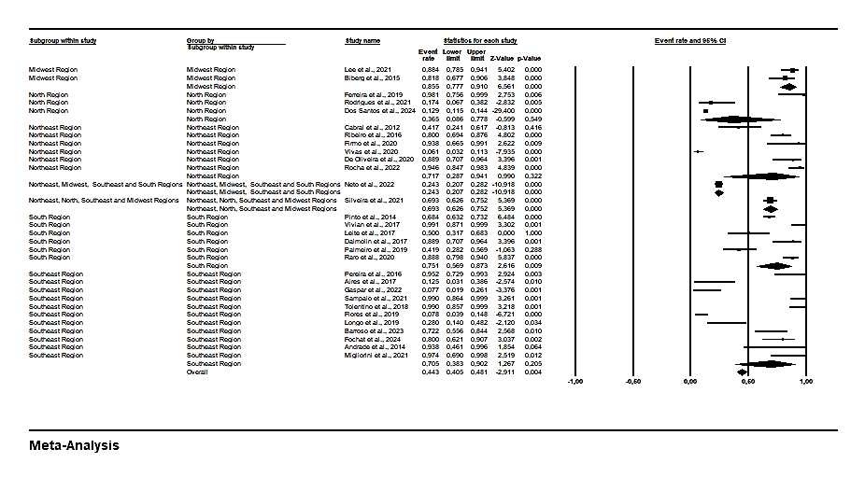
Figure 2 – Forest plot of bla_{KPC} prevalence among K. pneumoniae clinical isolates in Brazil, stratified by Brazilian macro-regions.
Legend: Forest plot of bla_{KPC} prevalence among K. pneumoniae clinical isolates in Brazil, stratified by Brazilian macro-regions. Legend: Diamonds represent pooled prevalence estimates with 95% confidence intervals (CI). Squares indicate point estimates from individual studies, with the size proportional to study weight in the meta-analysis. Horizontal lines show the 95% CI for each study.
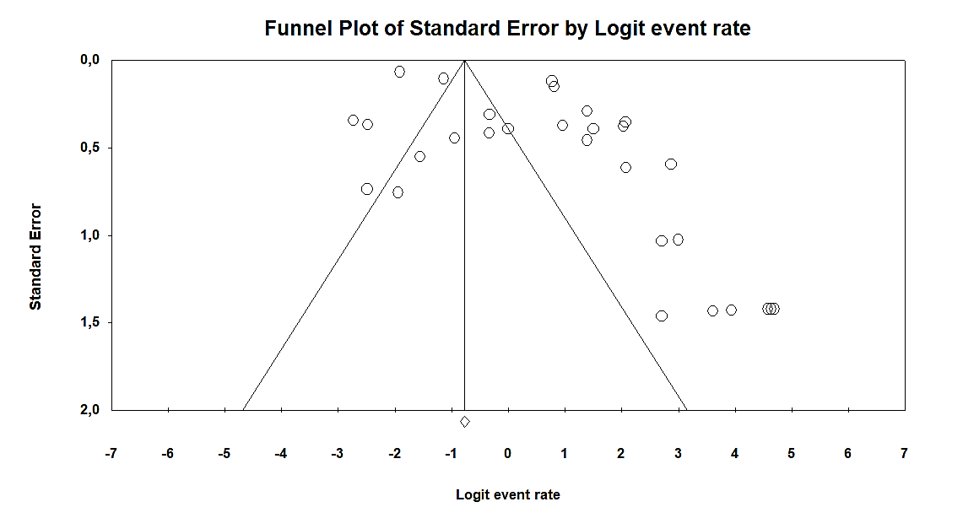
Figure 3 – Funnel plot assessing publication bias among studies included in the meta-analysis of bla_{KPC} prevalence in K. pneumoniae isolates.
Legend: The included published studies are shown as circles, which should be evenly spaced around the overall effect to form an inverted funnel. The most precise studies appear in the narrowest part of the funnel and lie closest to the true value. The standard error—plotted on the Y-axis as a measure of dispersion—is influenced by each study’s sample size; the larger the standard error, the more imprecise the study. The central line of the plot, marked on the X-axis by a diamond, represents the effect measure result examined in the meta-analysis. The lines outlining the funnel correspond to the 95% confidence intervals.
Subgroup analyses were performed by Brazilian macro-region, revealing marked geographic heterogeneity in the prevalence of K. pneumoniae harboring bla_{KPC} genes. In the Southeast (eleven studies), the pooled prevalence was 70.5% or 0.705 (95% CI= 0.383-0.902); the South (six studies), the pooled prevalence was 75.1% or 0.751 (95% CI= 0.569-0.873); the Northeast (six studies), the pooled prevalence was 71.7% or 0.717 (95% CI= 0.287-0.941); the North (three studies), the pooled prevalence was 36.5% or 0.365 (95% CI= 0.086-0.778); the Midwest (two studies), the pooled prevalence was 85.5% or 0.855 (95% CI= 0.777-0.910); the Northeast, Midwest, Southeast and South Regions (one study), the pooled prevalence was 24.3% or 0.243 (95% CI= 0.207-0.282); the Northeast, North, Southeast and Midwest Regions (one study), the pooled prevalence was 69.3% or 0.693 (95% CI= 0.626-0.752).
3.5 Meta-regression Demonstrating the Impact of Study Size on bla_{KPC} Prevalence
Meta-regression in this article was employed as an advanced exploratory analysis to investigate possible sources of heterogeneity observed in the meta-analysis of bla_{KPC} gene prevalence in clinical isolates of K. pneumoniae in Brazil. Given the extremely high degree of heterogeneity among the included studies (I² ≈ 98%), it became methodologically necessary to assess whether study characteristics could explain some of this variability, going beyond simply estimating the combined effect.
Specifically, meta-regression assessed the association between the sample size of each study (number of isolates tested) and the reported prevalence of bla_{KPC}, using the logit-transformed event rate as the dependent variable. The meta-regression results demonstrated a statistically significant inverse association between study size and reported bla_{KPC} prevalence (p = 0.01). In practical terms, this indicates that studies with fewer isolates tend to report higher prevalences, while larger studies present more moderate estimates (Figure 4).
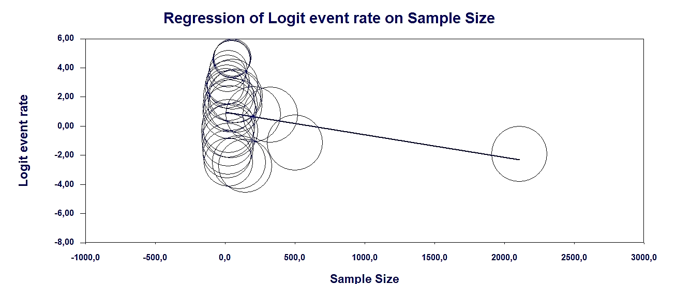
Figure 4 – Scatterplot of the meta-regression of the logit-transformed bla_{KPC} event rate against study sample size (n = number of isolates per study).
Legend: Scatterplot of the meta-regression of the logit-transformed bla_{KPC} event rate against study sample size (n = number of isolates per study). Legend: Bubble areas are inversely proportional to each study’s variance (larger bubbles = greater weight). The solid line represents the fitted regression (β = −0.0035 per isolate; p < 0.001), demonstrating that smaller studies tend to report higher logit event rates of bla_{KPC}.

4. Discussion
This systematic review and proportion meta-analysis consolidates published national evidence on the molecular detection of bla_{KPC} in Brazilian clinical K. pneumoniae isolates and demonstrate that KPC remains a widespread AMR threat across the country. These findings also support the notion that, after early detections in the 2000s, bla_{KPC} dissemination evolved into endemic and sustained circulation across Brazilian healthcare settings rather than remaining confined to isolated outbreaks.
Brazil’s pooled bla_{KPC} estimate in our meta-analysis suggests that KPC remains a central driver of carbapenem resistance in Brazilian clinical K. pneumoniae, a pattern that contrasts with several regions where other carbapenemases predominate. For example, a recent systematic review and meta-analysis focused on Africa reported a much lower pooled prevalence of bla_{KPC} (4.87%; 95% CI 3.01–6.73%) among clinical K. pneumoniae isolates, while bla_{NDM-1} and bla_{OXA-48} were more prominent [46]. Similarly, Nasiri et al. [47] reported a pooled carbapenem resistance prevalence of ~24% among K. pneumoniae and highlighted bla_{OXA-48} as a leading mechanism in Iran.
In contrast, data from higher-income settings show that KPC can still be a dominant carbapenemase. A large US multicenter surveillance study of carbapenem-resistant Enterobacterales (CRE) found KPC as the most common carbapenemase (65.5% of CRE) [48]. Finally, even within high-risk subpopulations, bla_{KPC} remains frequent internationally: a 2025 meta-analysis in carbapenem-resistant hypervirulent K. pneumoniae estimated bla_{KPC} prevalence of 58.8% (95% CI 47.8–68.9%), reinforcing that KPC continues to play a major role in clinically important lineages worldwide [49].
Regional surveillance data from Latin America and the Caribbean help contextualize our Brazilian estimates and suggest that bla_{KPC} remains highly prevalent in the region, but within a shifting carbapenemase landscape. In the CARBA-LAC (PAHO-linked) multicountry surveillance (2015–2020), bla_{KPC} was the most frequently detected carbapenemase among CRE, accounting for 78.67% (24,569/31,230) of detected genes, and the temporal trend of bla_{KPC} gene density remained stationary across bacterial groups over the study period, whereas bla_{NDM} density increased markedly, consistent with an expanding regional footprint of NDM enzymes [50]. In Brazil specifically, national molecular surveillance (SISLAB, 2015–2022) indicates a declining Enterobacterales detection rate for bla_{KPC} (from 74.5% in 2015 to 55.1% in 2022) alongside a steep increase in bla_{NDM} (from 4.1% to 39.4%), reinforcing the interpretation of an epidemiological transition in which KPC dominance is progressively challenged by NDM dissemination [51-52].
Most included studies relied on PCR-based detection, which generally reports bla_{KPC} as a binary finding and therefore limits inference about the diversity of circulating KPC variants. Even so, when variant information was available, mainly in studies using WGS or combined approaches, bla_{KPC-2} emerged as the predominant allele in Brazilian clinical-related K. pneumoniae [19,26,32]. Sporadic identification of bla_{KPC-3} and bla_{KPC-30} was also reported, indicating that Brazil’s KPC landscape is not monolithic and may include multiple introduction events and/or local diversification over time [38]. This variant heterogeneity has practical implications: different alleles may be associated with distinct lineages and mobile genetic elements, influencing transmission dynamics and outbreak persistence. Consequently, broader incorporation of WGS-based surveillance alongside routine PCR screening would strengthen resolution of variant circulation, support more precise outbreak investigation, and improve comparability of molecular epidemiology across regions and time [28,36,37,38].
A key contribution of this synthesis is the demonstration of marked geographic variability in pooled estimates, consistent with the heterogeneous Brazilian healthcare landscape and uneven intensity of surveillance. Subgroup analyses by macro-region indicated higher pooled prevalence in the Midwest (85.5%), South (75.1%), Northeast (71.7%), and Southeast (70.5%), while the North showed a lower pooled estimate (36.5%). These contrasts likely reflect differences in patient populations, hospital complexity (e.g., tertiary centers vs. mixed networks), local transmission dynamics, and laboratory capacity, as well as whether studies were conducted during endemic periods or during intensified control efforts. The included literature spans multiple settings (ICUs, tertiary hospitals, and public health laboratories), and isolates originate from both invasive clinical specimens and surveillance samples, all of which can shift observed frequencies upward or downward (Table 1).
The meta-regression provides additional insight into why prevalence estimates differ so dramatically between studies. Specifically, a statistically significant inverse association between study size and reported bla_{KPC} prevalence (p = 0.01) suggests that smaller investigations tend to report higher proportions, whereas larger datasets yield more moderate estimates. In practice, this pattern is compatible with the inclusion of outbreak-focused reports, highly selected cohorts, or single-ward/ICU series among smaller studies — contexts in which transmission is concentrated and bla_{KPC} frequencies can be inflated relative to broader hospital or regional surveillance (Figure 4).
Despite these complexities, the overall message is clear: blaKPC-producing K. pneumoniae is broadly distributed and commonly detected in Brazilian clinical contexts, demanding sustained and coordinated responses. The findings reinforce the importance of (i) robust infection prevention and control measures in high-risk wards, (ii) targeted screening policies aligned with local epidemiology, and (iii) expansion of molecular and genomic surveillance capacity to promptly detect introductions, track dissemination, and support outbreak containment.
Our results should be interpreted considering several important limitations. First, study size appears to be a major contributor to variability: smaller, single-center or ward-based reports often yielded very high prevalences, whereas larger datasets tended to produce more moderate estimates. Second, even accounting for sample size, heterogeneity remained substantial, indicating that other factors—such as sampling period, healthcare context (ICU, general wards, or screening cohorts), isolate source, and molecular approach (PCR vs. WGS)—likely also shape the observed frequencies. Third, restricting eligibility to full original articles (excluding brief communications and letters) may have reduced capture of early outbreak signals and unusual local peaks. Fourth, although the search strategy was designed to be sensitive, reliance on a defined set of keywords and database indexing practices means that some relevant studies may have been missed. Despite these constraints, this work provides a comprehensive synthesis of published evidence on bla_{KPC} in Brazilian clinical-related K. pneumoniae across all macro-regions. The review followed PRISMA guidance, applied independent screening and extraction, incorporated standardized quality appraisal, and used subgroup and meta-regression analyses to explore potential sources of heterogeneity, strengthening the rigor and transparency of the conclusions.
5. Conclusions
This systematic review and proportion meta-analysis shows that bla_{KPC} is widely detected in clinical-related K. pneumoniae isolates in Brazil, with a pooled prevalence of 44.3% and very high heterogeneity, indicating substantial variation across regions, settings, and study designs. Subgroup analyses revealed marked geographic differences, and meta-regression identified an inverse association between study size and prevalence, suggesting that sampling strategy and outbreak-driven datasets can inflate estimates in smaller studies. Collectively, these findings confirm bla_{KPC} among K. pneumoniae as a persistent national AMR threat and highlight the need for standardized molecular surveillance, improved reporting of denominators and clinical context (infection vs. colonization), and multicenter studies that better represent under-sampled regions. Expanding integration of genomic surveillance (WGS) with routine PCR screening and epidemiologic metadata will be essential to track variant circulation, support outbreak investigation, and inform targeted infection-control and antimicrobial-stewardship interventions across Brazil.
Data Availability Statement
The original contributions presented in the study are included in the article further inquiries can be directed to the corresponding authors.
Conflicts of Interest
The authors declare no conflicts of interest.
6. References

1. Huang, X., Yao, X., Hou, Y. et al. Global trends of antimicrobial resistance and virulence of Klebsiella pneumoniae from different host sources. Commun Med 5, 383 (2025). https://doi.org/10.1038/s43856-025-01112-1

2. Zdarska, V., Arcari, G., Kolar, M., & Mlynarcik, P. (2026). Antibiotic Resistance in Klebsiella pneumoniae and Related Enterobacterales: Molecular Mechanisms, Mobile Elements, and Therapeutic Challenges. Antibiotics, 15(1), 37. https://doi.org/10.3390/antibiotics15010037

3. Bassetti M, Giacobbe DR, Giamarellou H, Viscoli C, Daikos GL, Dimopoulos G, De Rosa FG, Giamarellos-Bourboulis EJ, Rossolini GM, Righi E, Karaiskos I, Tumbarello M, Nicolau DP, Viale PL, Poulakou G; Critically Ill Patients Study Group of the European Society of Clinical Microbiology and Infectious Disease (ESCMID); Hellenic Society of Chemotherapy (HSC) and Società Italiana di Terapia Antinfettiva (SITA). Management of KPC-producing Klebsiella pneumoniae infections. Clin Microbiol Infect. 2018 Feb;24(2):133-144. doi: 10.1016/j.cmi.2017.08.030. Epub 2017 Sep 9. PMID: 28893689.

4. Yigit, H., Queenan, A. M., Anderson, G. J., Domenech-Sanchez, A., Biddle, J. W., Steward, C. D., ... & Tenover, F. C. (2001). Novel carbapenem-hydrolyzing β-lactamase, KPC-1, from a carbapenem-resistant strain of Klebsiella pneumoniae. Antimicrobial agents and chemotherapy, 45(4), 1151-1161

5. Monteiro J, Santos AF, Asensi MD, Peirano G, Gales AC. First report of KPC-2-producing Klebsiella pneumoniae strains in Brazil. Antimicrob Agents Chemother. 2009 Jan;53(1):333-4. doi: 10.1128/AAC.00736-08. Epub 2008 Nov 17. PMID: 19015350; PMCID: PMC2612176.

6. Pillonetto, M., Wink, P. L., Melano, R. G., Jiménez-Pearson, M. A., Touchet, N. L. M., Rojas, S. Y. S., ... & Helen, C. (2025). Carbapenemases producing gram-negative bacteria surveillance in Latin America and the caribbean: a retrospective observational study from 2015 to 2020. The Lancet Regional Health–Americas, 49.

7. Kiffer, C. R., Rezende, T. F., Costa-Nobre, D. T., Marinonio, A. S. S., Shiguenaga, L. H., Kulek, D. N. O., ... & Pillonetto, M. (2023). A 7-year Brazilian national perspective on plasmid-mediated carbapenem resistance in Enterobacterales, Pseudomonas aeruginosa, and Acinetobacter baumannii complex and the impact of the coronavirus disease 2019 pandemic on their occurrence. Clinical Infectious Diseases, 77(Supplement_1), S29-S37.

8. Page, M.J.; McKenzie, J.E.; Bossuyt, P.M.; Boutron, I.; Hoffmann, T.C.; Mulrow, C.D.; Shamseer, L.; Tetzlaff, J.M.; Akl, E.A.; Brennan, S.E.; et al. The PRISMA 2020 statement: An updated guideline for reporting systematic reviews. BMJ 2021, 372, 71.

9. Carolynne Silva dos Santos, Yan Corrêa Rodrigues, Marcos Jessé Abrahão Silva. Nationwide Burden of blaKPC Gene in Brazilian Clinical Klebsiella pneumoniae Isolates: A Systematic Review and Meta-Analysis. PROSPERO 2025 CRD420251117220. Available from https://www.crd.york.ac.uk/PROSPERO/view/CRD420251117220.

10. Vireque, A.; Stolakis, V.; Berteli, T.; Bertero, M.; Kofinas, J. Search strategies for systematic reviews in reproductive medicine: A narrative review and practical guide. J. Assist. Reprod. Genet. 2025, 42, 2155–2165.

11.Galvão, T.F.; Pereira, M.G. Revisões sistemáticas da literatura: Passos para sua elaboração. Epidemiologia E Serv. Saude 2014, 23, 183–184.

12. Aromataris, E.; Munn, Z. JBI Manual for Evidence Synthesis; Joanna Briggs Institute: Adelaide, Australia, 2020. [Google Scholar]

13. Munn, Z.; Aromataris, E.; Tufanaru, C.; Stern, C.; Porritt, K.; Farrow, J.; Lockwood, C.; Stephenson, M.; Moola, S.; Lizarondo, L.; et al. The development of software to support multiple systematic review types: The Joanna Briggs Institute System for the Unified Management, Assessment and Review of Information (JBI SUMARI). Int. J. Evid. Based Healthc. 2019, 17, 36–43. [Google Scholar] [CrossRef]

14. Viechtbauer, W. Conducting meta-analyses in R with the metafor package. J. Stat. Softw. 2010, 36, 1–48. [Google Scholar] [CrossRef]

15. Tang, J.-L.; Liu, J.L. Misleading funnel plot for detection of bias in meta-analysis. J. Clin. Epidemiol. 2000, 53, 477–484. [Google Scholar] [CrossRef]

16. Cabral, A. B., Melo, R. de C., Maciel, M. A., & Lopes, A. C. (2012). Multidrug resistance genes, including bla(KPC) and bla(CTX)-M-2, among Klebsiella pneumoniae isolated in Recife, Brazil. Revista da Sociedade Brasileira de Medicina Tropical, 45(5), 572–578. https://doi.org/10.1590/s0037-86822012000500007

17. Pinto, F. de M., Simas, D. M., Baldin, C. P., Limberger, I. I., da Silva, R. C. F., Antochevis, L. C., Vieira, F. J., Ribeiro, V. B., Magagnin, C. M., Rozales, F. P., Falci, D. R. (2014). Prevalência de carbapenemases em enterobactérias resistentes a carbapenêmicos em quatro hospitais terciários de Porto Alegre. Clin Biomed Res., 34(1), 47-52. http://hdl.handle.net/10183/158869.

18. Andrade, N. L., Vitali, L. Gaspar, G. G., Bellissimo-Rodrigues, F., Martinez, R. Darini, A. L. C. (2014). Expansion and Evolution of a Virulent, Extensively Drug-Resistant (Polymyxin B-Resistant), QnrS1-, CTX-M-2-, and KPC-2-Producing Klebsiella pneumoniae ST11 International High-Risk Clone. Journal of Clinical Microbiology, 52(7), 2530-2535. https://doi.org/10.1128/jcm.00088-14.

19. Biberg, C. A., Rodrigues, A. C. S., do Carmo S. F., Chaves, C. E. V., Gales, A. C., Chang, M. R. (2015). KPC-2-producing Klebsiella pneumoniae in a hospital in the Midwest region of Brazil. Sociedade Brasileira de Microbiologia, 46(2), 501-504. https://doi.org/10.1590/S1517-838246246220140174.

20. Ribeiro, P. C. S., Monteiro, A. S., Marques, S. G., Monteiro, S. G., Monteiro-Neto, V., Coqueiro, M. M. M., Marques, A. C. G., Turri, de J. G. R., Santos, S. G., Bomfim. M. R. Q. (2016). Phenotypic and molecular detection of the blaKPC gene in clinical isolates from inpatients at hospitals in São Luis, MA, Brazil. BMC Infectious Diseases, 16(1), 737. https://doi.org/10.1186/s12879-016-2072-3.

21. Pereira, R. S., Dias, V. C., Ferreira-Machado, A. B., Resende, J. A., Bastos, A. N., Bastos, L. Q. de A., Bastos, V. Q. de A., Bastos, V. R., da Silva, V. L., Diniz, C. G. (2016). Physiological and molecular characteristics of carbapenem resistance in Klebsiella pneumoniae and Enterobacter aerogenes. J Infect Dev Ctries, 10(6), 592-599. https://doi.org:10.3855/jidc.6821.

22. Aires, C. A. M., Pereira, P. S., de Araújo, C. F. M., Chagas, T. P. G., Oliveira, J. C. R., Buonora, S. N., Albano, R. M., Carvalho-Assef, A. P. D., Asensi, M. D. (2017). Multiclonal Expansion of Klebsiella pneumoniae Isolates Producing NDM-1 in Rio de Janeiro, Brazil. Antimicrob Agents Chemother, 61(1), 01048-16. https://doi.org/10.1128/AAC.01048-16.

23. Vivian, A. C. P., Rosa, J. F., Rizek, C. F., Pelisson, M., Costa, S. F., Hungria, M., Kobayashi, R. K. T., Vespero, E. C. (2017). Molecular characterization of carbapenem-resistant Klebsiella pneumoniae isolates from a university hospital in Brazil. J Infect Dev Ctries, 11(5), 379-386. https://doi.org/10.3855/jidc.8614.

24. Leite, C. A. K., Oizumi, K. Y., Caleffi-Ferracioli, K. R., Scodro, R. B. de L., de Pádua, R. A. F., Cardoso R. F., Pires, C. T. A., Siqueira, V. L. C. (2017). β-lactamase-producing Gram-negative bacteria in an intensive care unit in southern Brazil. Braz. J. Pharm. Sci., 53(2), 16111. http://dx.doi.org/10.1590/s2175-97902017000216111.

25. Dalmolin, T. V., Bianchini, B. V., Rossi, G. G., Ramos, A. C., Gales, A. C., Trindade, P. de A., de Campos, M. M. A. (2017). Detection and analysis of different interactions between resistance mechanisms and carbapenems in clinical isolates of Klebsiella pneumoniae. Brazilian Journal of Microbiology, 48, 493-498. http://dx.doi.org/10.1016/j.bjm.2017.01.003.

26. Tolentino, F. M., Bueno, M. F. C., Franscisco, G. R., Barcelos, D. D. de P., Lobo, S. M., Tomaz, F. M. M. B., da Silva, N. S., de Andrade, L. N., Casella, T., Darini, A. L. da C., Polotto, M., Garcia, D. de O., Nogueira, M. C. L. (2019). Endemicity of the High-Risk Clone Klebsiella pneumoniae ST340 Coproducing QnrB, CTX-M-15, and KPC-2 in a Brazilian Hospital. Microbial Drug Resistance, 25(4), 528-537. http://dx.doi.org/10.1089/mdr.2018.0006.

27. Ferreira, R. L., da Silva, B. C. M., Rezende, G. S., Nakamura-Silva, R., Pitondo-Silva, A., Campanini, E. B., Brito, M. C. A., da Silva, E. M. L., Freire, C. C. M., Cunha, A. F., Pranchevicius, M. C. (2019). High Prevalence of Multidrug-Resistant Klebsiella pneumoniae Harboring Several Virulence and β-Lactamase Encoding Genes in a Brazilian Intensive Care Unit. Unit. Front. Microbiol, 9(1), 3198. https://doi.org/10.3389/fmicb.2018.03198.

28. Longo, L. G. A., de Souza, V. S., Kraychete, G. B., Justo-da-Silva, L. H., Rocha, J. A., Superti, S. V., Bonelli, R. R., Martins, I. S., Moreira, B. M. (2019). Colistin resistance emerges in pandrug-resistant Klebsiella pneumoniae epidemic clones in Rio de Janeiro, Brazil. International Journal of Antimicrobial Agents, 54(1), 579–586. https://doi.org/10.1016/j.ijantimicag.2019.08.017.

29. Palmeiro, J. K., de Souza, R. F., Schörner, M. A., Passarelli-Araujo, H., Grazziotin, A. L., Vidal, N. M., Venancio, T. M., Dalla-Costa, L. M. (2019). Molecular Epidemiology of Multidrug-Resistant Klebsiella pneumoniae Isolates in a Brazilian Tertiary Hospital. Front. Microbiol., 10(1), https://doi.org/10.3389/fmicb.2019.01669.

30. Flores, C., Biano, K., de Filippis, I., Clementino, M. M., Romão, C. M. C. P. A. (2020). Genetic Relatedness of NDM-Producing Klebsiella pneumoniae Co-Occurring VIM, KPC, and OXA-48 Enzymes from Surveillance Cultures from an Intensive Care Unit. Microbial Drug Resistance, 26(10), 1219-1226. https://doi.org/10.1089/mdr.2019.0483.

31. Raro, O. H. F., da Silva, R. M. C., Filho-Rodrigues, E. M., Sukiennik, T. C. T., Stadnik, C., Dias, C. A. G., Iglesias, J. O., Vázquez-Pérez, M. (2020). Carbapenemase-Producing Klebsiella pneumoniae From Transplanted Patients in Brazil: Phylogeny, Resistome, Virulome and Mobile Genetic Elements Harboring blaKPC-2 or blaNDM-1. Front. Microbiol. 11(1), 1563. https://doi.org/10.3389/fmicb.2020.01563.

32. Firmo, E. F., Beltrão, E. M. B., da Silva, F. R. F., Alves, L. C., Brayner, F. A., Veras, D. L., Lopes, A. C. S. (2020). Association of blaNDM-1 with blaKPC-2 and aminoglycoside-modifying enzyme genes among Klebsiella pneumoniae, Proteus mirabilis and Serratia marcescens clinical isolates in Brazil. International Society for Antimicrobial Chemotherapy, 21(1), 255-261. http://dx.doi.org/10.1016/j.jgar.2019.08.026.

33. Vivas, R., Dolabella, S. S., Barbosa, A. A. T., Jain, S. (2020). Prevalence of Klebsiella pneumoniae carbapenemase - and New Delhi metallo-beta-lactamase-positive K. pneumoniae in Sergipe, Brazil, and combination therapy as a potential treatment option. Journal of the Brazilian Society of Tropical Medicine, 52(1), 20200064. https://doi.org/10.1590/0037-8682-0064-2020.

34. de Oliveira, E. M., Beltrão, E. M. P. Scavavuzzi, A. M. L., Barros, J. F., Lopes. A. C. S. (2020). High plasmid variability, and the presence of IncFIB, IncQ, IncA/C, IncHI1B, and IncL/M in clinical isolates of Klebsiella pneumoniae with blaKPC and blaNDM from patients at a public hospital in Brazil. Journal of the Brazilian Society of Tropical Medicine, 53(1), 20200397. https://doi.org/10.1590/0037-8682-0397-2020.

35. Rodrigues, Y. C., Lobato, A. R. F., Quaresma, A. J. P. G.; Guerra, L. M. G. D.; Brasiliense, D. M. (2021). The Spread of NDM-1 and NDM-7-Producing Klebsiella pneumoniae Is Driven by Multiclonal Expansion of High-Risk Clones in Healthcare Institutions in the State of Pará, Brazilian Amazon Region. Antibiotics, 10(1), 1527. https://doi.org/10.3390/antibiotics10121527.

36. Lee, A. H. Y., Porto, W. F., Jr, C. de F., Dias, S. C., Alencar, S. A., Pickard, D. J., Hancock, R. E. W., Franco, O. L. (2021). Genomic insights into the diversity, virulence and resistance of Klebsiella pneumoniae extensively drug resistant clinical isolates. Microbial Genomics, 7(1), 000613. https://doi.org/10.1099/mgen.0.000613.

37. Silveira, M. C., Rocha-de-Souza, C. M., Santos, I. C. de O., Pontes, L. da S., Oliveira, T. R. T., Tavares-Teixeira, C. B., Cossatis, N. de A., Pereira, N. F., Conceição-Neto, O. C., da Costa, B. S., Rodrigues. D. C. S., Albano, R. M., da Silva, F. A. B., Marques, E. A., Leão. R. S., Carvalho-Assef. A. P. D. (2021). Genetic Basis of Antimicrobial Resistant Gram-Negative Bacteria Isolated From Bloodstream in Brazil. Front. Med., 8(1), 635206. https://doi.org/10.3389/fmed.2021.635206.

38. Migliorini, L. B., de Sales, R. O., Koga, P. C. M., Doi, A. M., Poehlein, A.; Toniolo, A. R., Menezes, F. G., Martino, M. D. V., Gales, A. C., Brüggemann, H., Severino, P. (2021). Prevalence of blaKPC-2, blaKPC-3 and blaKPC-30—Carrying Plasmids in Klebsiella pneumoniae Isolated in a Brazilian Hospital. Pathogens, 10(1), 332. https://doi.org/10.3390/pathogens10030332.

39. Sampaio, S. C. F., Carvalho, R. de L. B., Mimica, M. J., da Silva, C. B., Mimica, L. M. J., de Lima, A. V., Lima, K. de O., Rocha, D. A. da C., Sampaio, J. L. M. (2021). Genotyping of paired KPC-producing Klebsiella pneumoniae isolates with and without divergent polymyxin B susceptibility profiles. Brazilian Journal of Microbiology, 52(1), 1981–1989. https://doi.org/10.1007/s42770-021-00600-5.

40. Gaspar, G. G., Tamasco, G., Abichabki, N., Scaranello, A. F. T., Auxiliadora-Martins, M., Pocente, R., Andrade, L. N., Guazzaroni, M. E., Silva-Rocha, R., Bollela, V. R. (2022). Nosocomial Outbreak of Extensively Drug-Resistant (Polymyxin B and Carbapenem) Klebsiella pneumoniae in a Collapsed University Hospital Due to COVID-19 Pandemic. Antibiotics, 11(1), 814. https://doi.org/10.3390/antibiotics11060814.

41. Rocha, V. F. D., Barbosa, M. S., Leal, H. F., Silva, G. E. O., Sales, N. M. M. D., Monteiro, A. S. S., Azevedo. J., Malheiros. A. R. X., Ataide. L. A., Moreira, B. M., Reis, M. G., Bahia, F. M. M., Reis, J. N. (2022). Prolonged Outbreak of Carbapenem and Colistin-Resistant Klebsiella pneumoniae at a Large Tertiary Hospital in Brazil. Front. Microbiol., 13(1), 831770. https://doi.org/10.3389/fmicb.2022.831770.

42. Neto, O. C. C., da Costa, B. S., Pontes, L. da S., Silveira, M. C., Justo-da-Silva, L. H., Santos, I. C. de O., Teixeira, C. B. T., Tavares e Oliveira, T. R., Hermes, F. S., Galvão, T. C., Antunes, L. C. M., Rocha-de-Souza, C. M., Carvalho-Assef, A. P. D (2022). Polymyxin Resistance in Clinical Isolates of K. pneumoniae in Brazil: Update on Molecular Mechanisms, Clonal Dissemination and Relationship With KPC-Producing Strains. Front. Cell. Infect. Microbiol. 12(1), 898125. https://doi.org/10.3389/fcimb.2022.898125.

43. Barroso, M. do V., da Silva, C. R., Benfatti, L. R., Gozi, K. S., de Andrade, L. K., Andrade, L. N., Estofolete, C. F., Nogueira, M. C. L., Casella, T. (2023). Characterization of KPC-2-producing Klebsiella pneumoniae and affected patients of a pediatric hospital in Brazil. Diagnostic Microbiology and Infectious Disease, 106(2), 115932. https://doi.org/10.1016/j.diagmicrobio.2023.115932.

44. dos Santos, L. A. Cayô, R., Valiatti, T. B., Gales, A. C., de Araújo, L. F. B., Rodrigues, F. M., de Carvalho, F. M., Vaz, M. A. B., Campanharo, M. (2024). Biodiversity of carbapenem-resistant bacteria in clinical samples from the Southwest Amazon region (Rondônia/Brazil). Scientific Reports, 14(1), 9383. https://doi.org/10.1038/s41598-024-59733-w.

45. Silva, M. R. C., Meurer, I. R., Vicenti, C. M., Junqueira, M. de L., Fochat, R. C., de Souza, B. M., Silva, M. R., Garcia, P. G. (2024). Prevalência e perfil de resistência aos carbapenêmicos de Enterobacterales isoladas de aspirado traqueal de pacientes internados em um hospital universitário. Eletronic Journal Collection Health, 24(1). https://doi.org/10.25248/REAS.e14830.2024

46. Sisay, A., Kumie, G., Gashaw, Y., Nigatie, M., Gebray, H. M., & Reta, M. A. (2025). Prevalence of genes encoding carbapenem-resistance in Klebsiella pneumoniae recovered from clinical samples in Africa: systematic review and meta-analysis. BMC Infectious Diseases, 25(1), 1-22.

47. Nasiri, M. J., Mirsaeidi, M., Mousavi, S. M. J., Arshadi, M., Fardsanei, F., Deihim, B., ... & Tabarsi, P. (2020). Prevalence and mechanisms of carbapenem resistance in Klebsiella pneumoniae and Escherichia coli: a systematic review and meta-analysis of cross-sectional studies from Iran. Microbial Drug Resistance, 26(12), 1491-1502.

48. Sader, H. S., Mendes, R. E., Carvalhaes, C. G., Kimbrough, J. H., & Castanheira, M. (2023). Changing Epidemiology of Carbapenemases Among Carbapenem-Resistant Enterobacterales From United States Hospitals and the Activity of Aztreonam-Avibactam Against Contemporary Enterobacterales (2019-2021). Open forum infectious diseases, 10(2), ofad046. https://doi.org/10.1093/ofid/ofad046

49. Qala Nou, M. S., Amirian, Z., Dehghani, F., Vejdan, A. K., Rooin, R., & Dehghanmehr, S. (2025). Systematic review and meta-analysis on the carbapenem-resistant hypervirulent Klebsiella pneumoniae isolates. BMC pharmacology & toxicology, 26(1), 25. https://doi.org/10.1186/s40360-025-00857-8

50. Pillonetto, M., Wink, P. L., Melano, R. G., Jiménez-Pearson, M. A., Touchet, N. L. M., Rojas, S. Y. S., ... & Helen, C. (2025). Carbapenemases producing gram-negative bacteria surveillance in Latin America and the caribbean: a retrospective observational study from 2015 to 2020. The Lancet Regional Health–Americas, 49.

51. Kiffer, C. R., Rezende, T. F., Costa-Nobre, D. T., Marinonio, A. S. S., Shiguenaga, L. H., Kulek, D. N. O., ... & Pillonetto, M. (2023). A 7-year Brazilian national perspective on plasmid-mediated carbapenem resistance in Enterobacterales, Pseudomonas aeruginosa, and Acinetobacter baumannii complex and the impact of the coronavirus disease 2019 pandemic on their occurrence. Clinical Infectious Diseases, 77(Supplement_1), S29-S37.

52. Barros, T. B. C., Rodrigues, Y. C., Lobato, A. R. F., Dutra, L. M. G., dos Reis, H. S., Garcia, A. J. P., Sagica, F. d. E. S., Souza, C. d. O., & Brasiliense, D. M. (2025). Impact of the COVID-19 Pandemic on Carbapenem-Resistant Klebsiella pneumoniae in Northern Region, Brazil: A Shift Towards NDM Producers. Antibiotics, 14(9), 866. https://doi.org/10.3390/antibiotics14090866

